
MINISTRY OF EDUCATION, CULTURE AND RESEARCH
OF THE REPUBLIC OF MOLDOVA
Technical University of Moldova
Faculty of Computers, Informatics and Microelectronics
Department of Software Engineering and Automation

Report
on laboratory work no. 9
Operating Systems
Topic: Watching System Calls with strace (Linux)

Done by: st. gr. FAF-243, Chiril-Adam Macari

Checked by: Reițman Patricia, asist. univ.

Chișinău – 2026

Lab 9 – Watching System Calls with strace (Linux)

Purpose of the work
The purpose of this lab is to watch the "door" between a program and the kernel, the system call. I used strace, which prints every system call that a program makes. First I looked at the calls of a real command (ls -l), then I wrote a small C program that uses open, write and read directly and watched its calls, and at the end I counted one kind of call.
I did the lab in Ubuntu running in VirtualBox, in a folder ~/lab9. strace was already installed (version 6.19). The program is in the file syscalls.c.

Part 1. The calls of a real command
I created four files in the folder (a.txt, b.txt and c.txt empty, and d.txt with the word hello) and ran ls -l under strace, showing only openat, read, write and close:
strace -f -e trace=openat,read,write,close ls -l
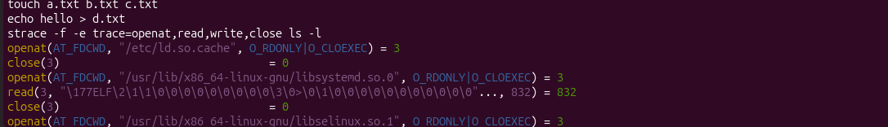
Figure 1.1 – The beginning of the strace output for ls -l
At the start I can see how ls loads its libraries: for each one there is an openat, then a read of 832 bytes (the start of the ELF file) and a close. This is the start-up of the program, before it does anything with my folder.
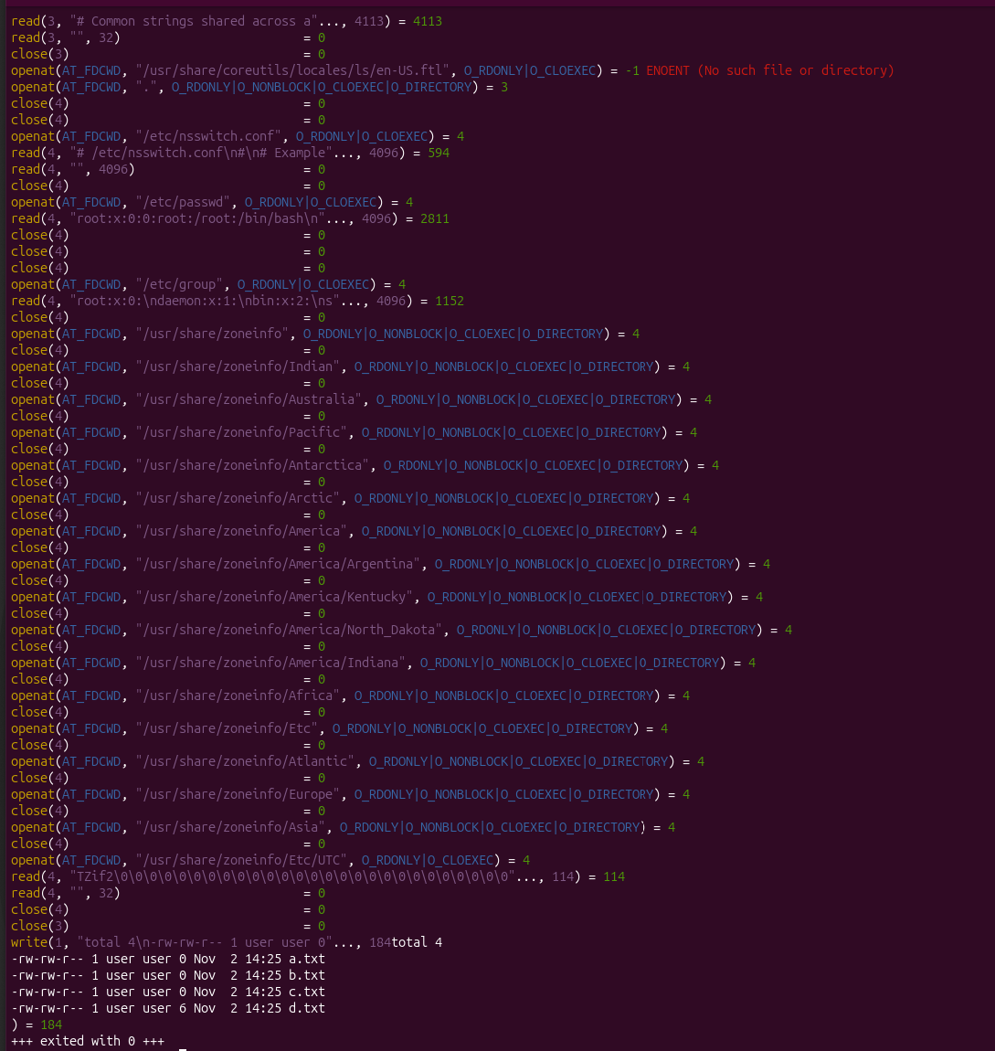
Figure 1.2 – The end of the output: the single write that prints the listing
In this part ls first looks for a translation file ls/en-US.ftl, which does not exist (-1 ENOENT). Then it opens . (the folder itself), then /etc/nsswitch.conf, /etc/passwd and /etc/group, because -l shows the owner and the group as names (user) and the files only store numbers. It also opens many folders under /usr/share/zoneinfo, probably to find the time zone for the dates. At the very end there is only one write, and it prints the whole listing.
To count the calls I used strace -c, which prints a summary table:
strace -c ls -l > /dev/null
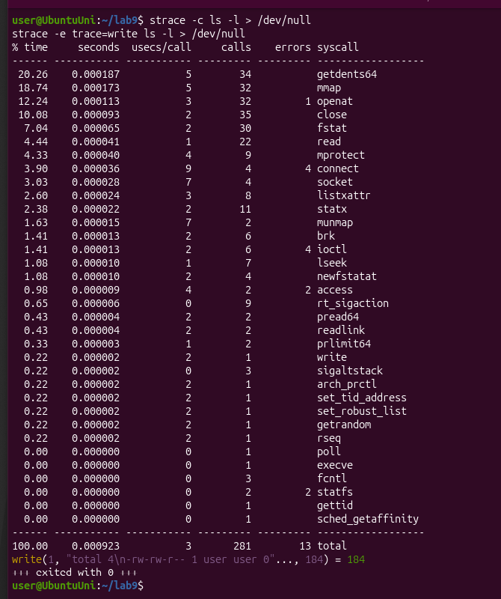
Figure 1.3 – strace -c ls -l: the summary of all calls, and the only write
One simple ls -l made 281 system calls in total (13 of them failed with an error). Most of them are the start-up of the program (mmap, openat, close, fstat) and the reading of the directory (getdents64, 34 calls). The write appears only once. The second command in the screenshot (strace -e trace=write ls -l) shows it:
write(1, "total 4\n-rw-rw-r-- 1 user user 0"..., 184) = 184
Observe
1. Which system call does ls use to print to the screen? To which descriptor does it write?
ls uses the system call write, and it writes to descriptor 1, which is stdout (the screen). In my run it was a single call that sent the whole listing, 184 bytes (Figure 1.2 and the line above). The call returned 184, so all the bytes were accepted.

Part 2. A program that calls the kernel directly
I typed the program syscalls.c. It opens note.txt for writing (with O_CREAT | O_WRONLY | O_TRUNC), writes the line hello, kernel, closes the file, opens it again for reading and reads the line back. printf is used only to show the numbers on the screen. I compiled it with the flags from the sheet and ran it:
gcc -Wall -Wextra -o syscalls syscalls.c
./syscalls
cat note.txt
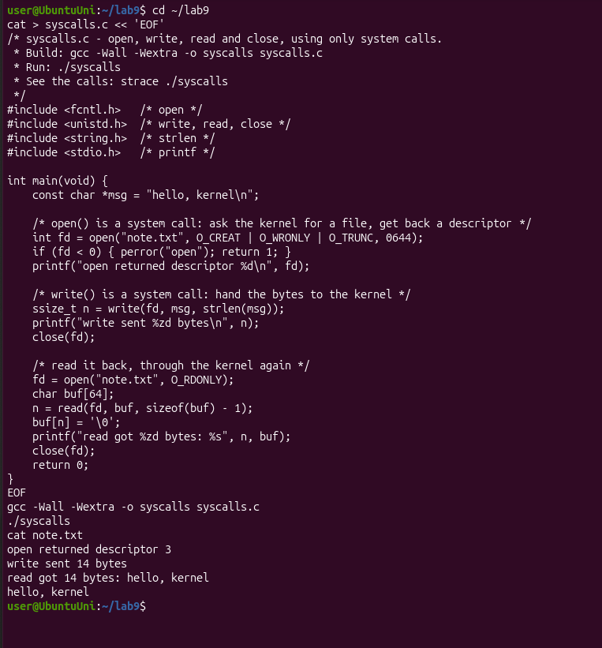
Figure 2.1 – syscalls.c compiled and run, and the content of note.txt
It compiled without any warning and printed exactly the expected output: descriptor 3, 14 bytes written and 14 bytes read. cat note.txt shows the line hello, kernel, so the file was really created.
Then I ran it under strace:
strace -e trace=openat,write,read,close ./syscalls
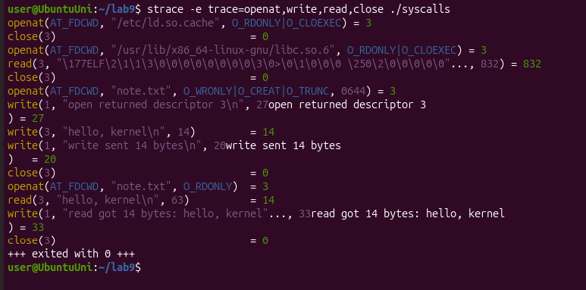
Figure 2.2 – The system calls made by syscalls
At the end of the output are the calls of my program, the same as in the sheet:
- openat(AT_FDCWD, "note.txt", O_WRONLY|O_CREAT|O_TRUNC, 0644) = 3
- write(3, "hello, kernel\n", 14) = 14
- close(3) = 0
- openat(AT_FDCWD, "note.txt", O_RDONLY) = 3
- read(3, "hello, kernel\n", 63) = 14
- close(3) = 0
I also noticed that open became openat (it is the same call, the C library calls openat with AT_FDCWD, "the current folder"). The read asks for 63 bytes because my buffer has 64 bytes and I keep one for the '\0'. Between these lines there are also three write(1, ...) calls: they are my printf lines. So printf is not a system call, it is a library function that finishes with write on descriptor 1.
Observe
1. The descriptor returned by the first openat is 3, not 0, 1 or 2. Why are those three already taken?
Every process starts with three descriptors already open: 0 is stdin, 1 is stdout and 2 is stderr. They are opened by the shell (and the terminal) before my program starts, and they are kept when the shell does fork and exec. The rule is that open always returns the lowest free number. 0, 1 and 2 are taken, so the first free one is 3. The strace output confirms that 1 is the screen: my printf lines went out with write(1, ...).

Part 3. Count one kind of call
The sheet lists this part ("Count one kind of call", about 20 minutes) but there are no instructions for it in the PDF, so this is my own interpretation: I counted the write calls of my program and the openat calls of ls -l.
First I predicted the number of write calls of ./syscalls. I counted three printf lines and one write to the file, so I expected 3 or 4. Then I checked it:
strace -c -e trace=write ./syscalls
strace -e trace=openat ls -l 2>&1 >/dev/null | grep -c openat
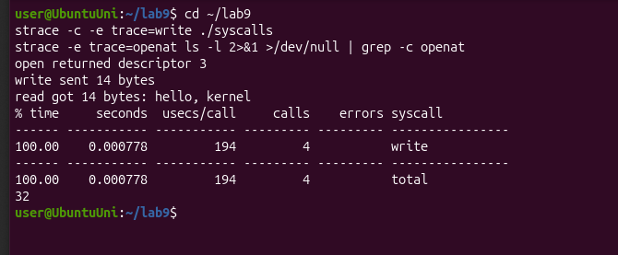
Figure 3.1 – Counting the write calls of syscalls and the openat calls of ls -l
./syscalls made exactly 4 write calls (my prediction was right): three of them come from the three printf lines (to descriptor 1) and one is my write(fd, ...) to the file note.txt (to descriptor 3). ls -l made 32 openat calls, and in strace -c the same number appeared in the openat row. In the second command, 2>&1 >/dev/null sends the text of strace (which goes to stderr) into grep and throws away the normal output of ls.

Conclusions
In this lab I could see the system calls that I only knew from the lecture. A simple command like ls -l is not simple for the kernel: it made 281 system calls, but only one of them (write to descriptor 1) printed the result. My own program showed the calls that I wrote by hand (open, write, read, close), and that printf is only a library function that uses write under it.
I also understood why the first file gets descriptor 3: 0, 1 and 2 (stdin, stdout and stderr) are already open when a process starts, and open takes the lowest free number. The only problem was that Part 3 has no instructions in the sheet, so I did my own version of it (counting write and openat calls).

