
MINISTRY OF EDUCATION, CULTURE AND RESEARCH
OF THE REPUBLIC OF MOLDOVA
Technical University of Moldova
Faculty of Computers, Informatics and Microelectronics
Department of Software Engineering and Automation

Report
on laboratory works no. 1 and 2
Operating Systems
Topic: The OS as a Resource Manager; Meet the OS You Will Build (xv6)

Done by: st. gr. FAF-243, Chiril-Adam Macari

Checked by: Reițman Patricia, asist. univ.

Chișinău – 2026

Lab 1 – The OS as a Resource Manager

Purpose of the work
The purpose of this lab is to see the operating system at work as a resource manager. By running commands in a Linux terminal, I looked at how the OS manages the four core resources (files, processes, memory and devices) and wrote down what I observed.

Setup
I did this lab on my own laptop, using Ubuntu in WSL 2 (Windows Subsystem for Linux) instead of VirtualBox.
- user: chiril
- machine: DESKTOP-19EHF62
- kernel: 6.18.33.2-microsoft-standard-WSL2
WSL 2 still runs a real Linux kernel, just inside a small virtual machine made by Microsoft, so some outputs (like PID 1 or the disk names) look a bit different than on a normal VM.

Part 1. Files and directories
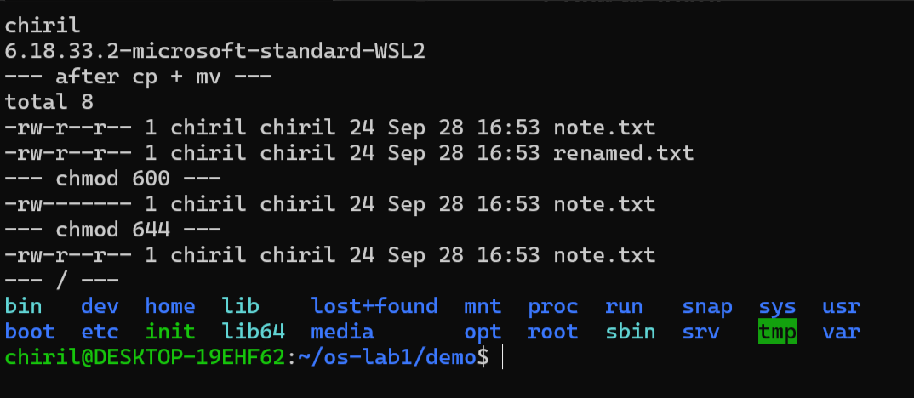
Figure 1.1.1 – Creating, copying and renaming files, chmod, and the directories under /
1. Who owns the files you just created, and which group?
The owner is chiril and the group is also chiril. When Ubuntu creates a user it also creates a group with the same name, so every file I make gets my user and my group.
2. What do the ten characters at the start of ls -l mean for note.txt after chmod 600?
After chmod 600 I got -rw-------:
- - means it is a normal file (a directory would have d)
- rw- means the owner (me) can read and write, but not execute
- --- means the group can't do anything
- --- means others can't do anything
So 600 means only I can read and change the file (6 = 4 read + 2 write, 0 for group and others). After chmod 644 it went back to -rw-r--r--, so others could read it again.
3. Name two directories directly under / and say what they hold.
- /etc has the configuration files of the system (all plain text files)
- /home has the home folders of the users, mine is /home/chiril
Other ones I recognized: /proc (live info about processes and the kernel) and /dev (device files).
Interesting output:
--- after cp + mv ---
-rw-r--r-- 1 chiril chiril 24 Sep 28 16:53 note.txt
-rw-r--r-- 1 chiril chiril 24 Sep 28 16:53 renamed.txt
Both files have 24 bytes ("hello operating systems" + the newline). mv didn't actually copy anything, it just renamed the file. I also noticed there is a file called init directly in /, which is the WSL init program from Microsoft.

Part 2. Processes
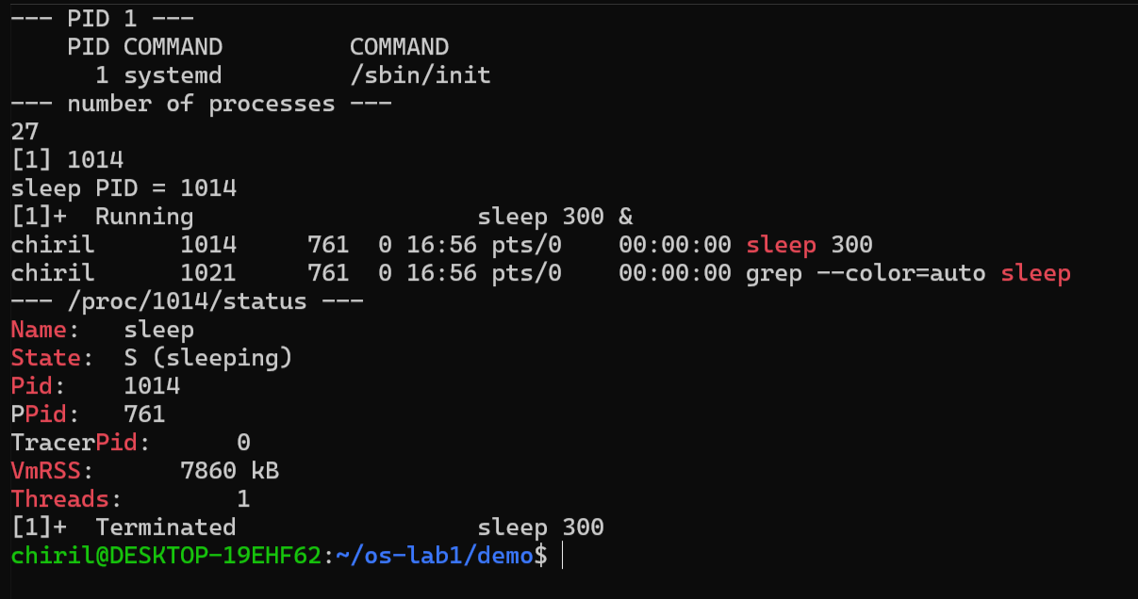
Figure 1.2.1 – PID 1, the number of processes, and a background sleep with its /proc status
1. What is the PID of process number 1, and what is it?
PID COMMAND COMMAND
1 systemd /sbin/init
PID 1 is systemd (started as /sbin/init). It is the first process the kernel starts after booting. It starts all the other services, and if a process loses its parent, systemd adopts it. Basically all other processes come from it.
2. Roughly how many processes were running on your idle VM?
ps aux | wc -l gave 27, but the first line is the header, so there were about 26 processes. That's very few, because WSL only starts the minimum. A normal Ubuntu desktop has a few hundred.
3. From /proc/<pid>/status, what does the "State:" line say for your sleeping process?
It says State: S (sleeping). The process is waiting for its 300 seconds to pass and doesn't use the CPU during this time.
Interesting output:
Name: sleep
State: S (sleeping)
PPid: 761
Threads: 1
PPid: 761 is my bash shell. In ps -ef | grep sleep both sleep (PID 1014) and grep (PID 1021) had the parent 761, so the shell created both of them. After kill, jobs showed Terminated sleep 300, so the OS really stopped the process.

Part 3. Memory
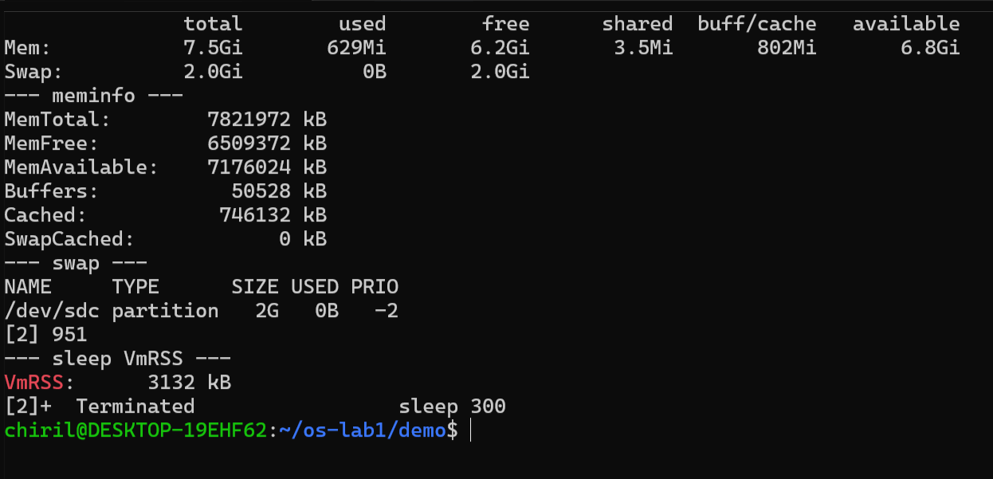
Figure 1.3.1 – free -h, /proc/meminfo, swap and the VmRSS of sleep
1. How much total RAM does the VM have, and how much is free?
total used free shared buff/cache available
Mem: 7.5Gi 629Mi 6.2Gi 3.5Mi 802Mi 6.8Gi
Swap: 2.0Gi 0B 2.0Gi
Total RAM is 7.5 GiB (MemTotal: 7821972 kB) and 6.2 GiB is free. "Available" is bigger (6.8 GiB) because Linux uses around 800 MiB as cache and can free it if a program needs it. WSL 2 takes about half of the laptop's RAM by default.
2. What is swap, and how much is configured?
Swap is space on the disk that the OS uses as extra memory. When RAM is full, the kernel moves pages that are not used right now to the disk. It is much slower than RAM, so it's more like a backup. I have 2 GiB of swap on /dev/sdc, and 0 B is used because RAM is almost empty.
3. How much resident memory (VmRSS) does a bare sleep process use, and does that surprise you?
VmRSS: 3132 kB, so about 3 MB (in Part 2 I got around 7.8 MB for the same thing). It surprised me a bit, because sleep doesn't do anything. But VmRSS counts everything that is loaded in RAM for the process, not only its own code, for example the C library (libc) and the loader. A lot of that memory is shared with other processes, so every new sleep doesn't really cost 3 MB more.

Part 4. Devices and storage
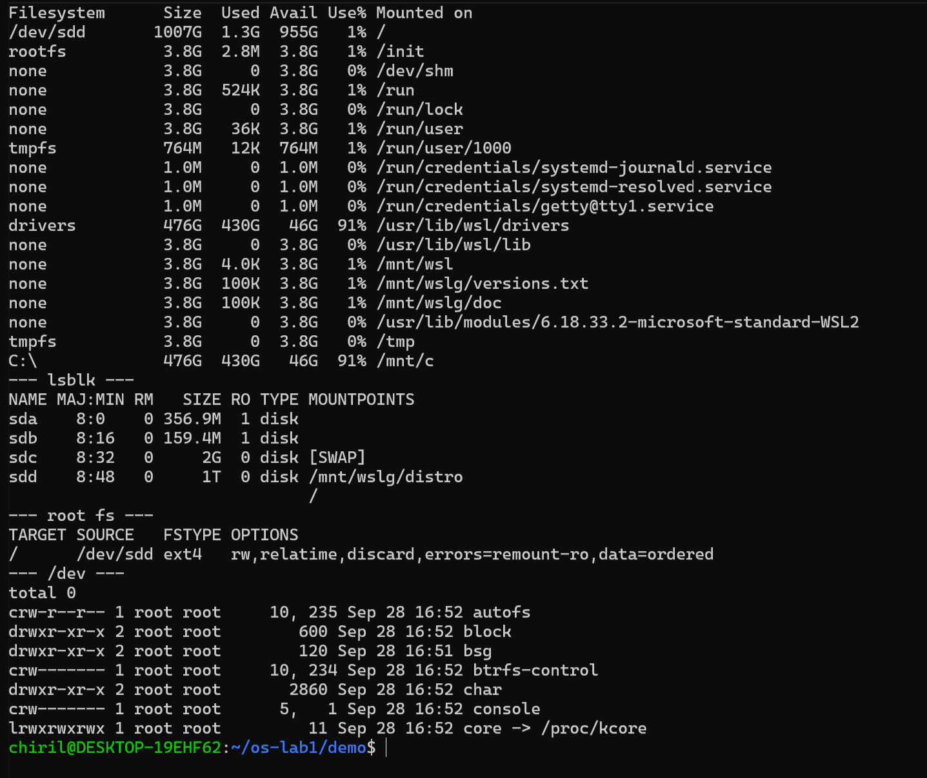
Figure 1.4.1 – df -h, lsblk, the root file system and /dev
1. Which device is your root filesystem "/" mounted on?
TARGET SOURCE FSTYPE OPTIONS
/ /dev/sdd ext4 rw,relatime,discard,errors=remount-ro,data=ordered
/ is mounted on /dev/sdd and the filesystem is ext4. lsblk shows sdd as a 1 TB disk, but only 1.3 GB is used. It's a virtual disk that WSL keeps as a file on Windows and it only grows when needed.
2. Give one entry from /dev and say what real thing it stands for.
/dev/sdd is the (virtual) disk that has my whole Linux system on it. Another one is /dev/console (crw------- ... 5, 1), which is the system console, the terminal where the kernel prints its messages. The first letter shows the type: c is a character device (read byte by byte, like a terminal) and b is a block device (like a disk). Also, instead of a size, device files have two numbers (like 5, 1) that tell the kernel which driver to use.
3. In one sentence: what does "everything is a file" mean, based on what you saw?
In Linux, disks, terminals, processes and even memory info all show up as files in the same folder tree, so I could look at all of them with the same commands (ls, cat, grep) without needing a special tool for each one.
Interesting output:
C:\ 476G 430G 46G 91% /mnt/c
My Windows C: drive shows up in Linux as a normal folder, /mnt/c, even though it's a completely different filesystem.

Conclusion (Lab 1)
The OS manages four resources: files (I saw them with ls -l and changed permissions with chmod), processes (ps aux to list them and kill to stop them) and memory (free -h and /proc/<pid>/status). It also manages devices and storage, which I saw with lsblk and df -h. In all four cases the OS is between my programs and the hardware, it decides who can use what, and it shows everything as files.

Lab 2 – Meet the OS You Will Build (xv6)

Purpose of the work
The purpose of this lab is to build xv6, a small teaching operating system, from its source code, boot it in the QEMU emulator and use it as a small Unix. I also read the code of a user program and the kernel code that answers its system calls, and wrote my first xv6 program, sleep, which makes a system call into the kernel I compiled myself.

Setup
I used the same Ubuntu in WSL 2 as in Lab 1. My Ubuntu version is pretty new, so I had two problems that are not in the lab sheet:
- The RISC-V emulator is not in qemu-system-misc anymore on this Ubuntu, so make qemu said qemu-system-riscv64: No such file or directory. I fixed it with sudo apt install qemu-system-riscv. The version I got is QEMU 10.2.1 (xv6 needs at least 7.2).
- I cloned the newest xv6 from github.com/mit-pdos/xv6-riscv, and there the sleep() system call is called pause() now (and sys_sleep is sys_pause). They renamed it so it doesn't get confused with the sleep() function inside the kernel. Because of that, the code from the lab sheet gave implicit declaration of function 'sleep', so in my sleep.c I call pause() instead. It is the same system call, so the program works like the lab asks.

Part 1. Build it and boot it
make qemu compiled the kernel and the user programs with the RISC-V compiler (riscv64-linux-gnu-gcc), made the file system image fs.img and started QEMU:
xv6 kernel is booting

hart 1 starting
hart 2 starting
init: starting sh
$
"hart" means a CPU core in RISC-V. QEMU runs 3 cores (-smp 3). Core 0 sets up the kernel while cores 1 and 2 wait, and then they print hart N starting and start working too. After that the kernel starts init (the first process, like systemd in Lab 1) and init starts the shell sh.
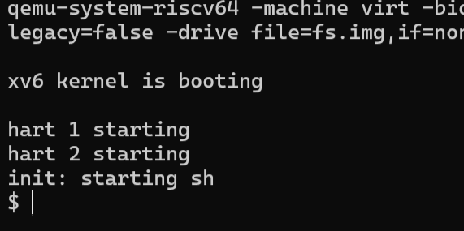
Figure 2.1.1 – xv6 booting in QEMU

Part 2. Use xv6 as the Unix it is
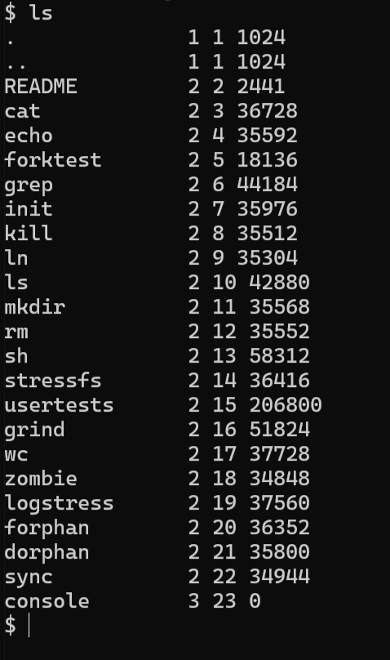
Figure 2.2.1 – ls inside xv6
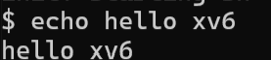
Figure 2.2.2 – echo hello xv6
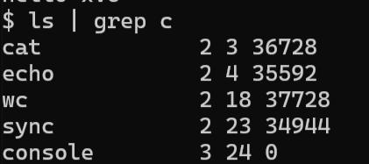
Figure 2.2.3 – The pipe ls | grep c
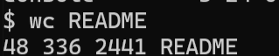
Figure 2.2.4 – wc README
$ echo hello xv6
hello xv6
$ ls | grep c
cat 2 3 36728
echo 2 4 35592
wc 2 18 37728
sync 2 23 34944
console 3 24 0
$ wc README
48 336 2441 README
1. List three programs xv6 ships with.
ls, cat and echo. From the ls list there are also grep, wc, sh, mkdir, rm, kill, ln and usertests.
2. Which two OS features must exist for a pipe to work?
- Processes: the shell has to create two processes that run at the same time, one for ls and one for grep. It does that with fork() and then exec() in each child.
- Communication between processes: the kernel makes a pipe with the pipe() system call. It is a buffer inside the kernel with a write end and a read end. The shell connects the output of ls (fd 1) to the write end and the input of grep (fd 0) to the read end with close() and dup(). ls and grep don't know about each other, they just write and read normal file descriptors and the kernel moves the data.
I checked this in the xv6 shell code (user/sh.c, case PIPE): it calls pipe(p), then fork1() two times, each child does close(1); dup(p[1]); or close(0); dup(p[0]);, and at the end the parent does wait(0) two times.
3. In one sentence: how does the xv6 shell compare to the Linux shell from Lab 1?
It works the same way at the base (a prompt, running programs with arguments, pipes |, redirection < > and & for background), but it's very minimal: there is no command history, no tab completion, no variables or $PATH, no colors, and the prompt is just $.
Other things I noticed:
- In xv6, ls prints name type inode size. Type 1 is a directory, 2 is a file and 3 is a device. console has type 3, so the terminal is also a file here, the same "everything is a file" idea from Lab 1.
- ls | grep c also showed sync and console, because grep looks for the letter c anywhere in the line.
- wc README gave 48 lines, 336 words and 2441 bytes.

Part 3. Read the source
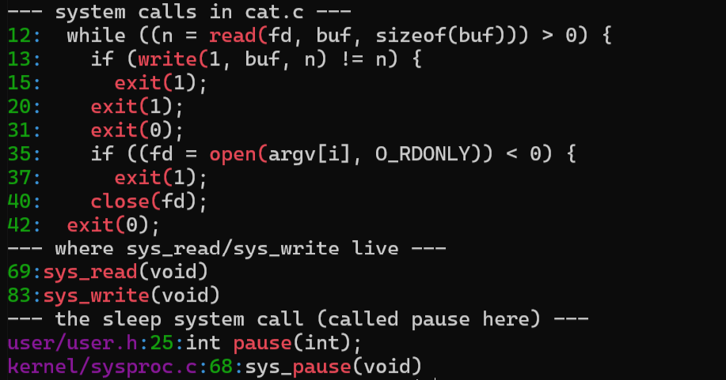
Figure 2.3.1 – System calls in user/cat.c, sys_read and sys_write, and pause
--- system calls in cat.c ---
12: while ((n = read(fd, buf, sizeof(buf))) > 0) {
13: if (write(1, buf, n) != n) {
35: if ((fd = open(argv[i], O_RDONLY)) < 0) {
40: close(fd);
42: exit(0);
--- where sys_read/sys_write live ---
69:sys_read(void)
83:sys_write(void)
--- the sleep system call (called pause here) ---
user/user.h:25:int pause(int);
kernel/sysproc.c:68:sys_pause(void)
1. Which system calls does user/cat.c use, and what does each one ask the kernel to do?
- open(path, O_RDONLY) asks the kernel to find the file, check that it can be read, and give back a file descriptor (a small number) for it.
- read(fd, buf, n) asks the kernel to copy up to n bytes from the file into buf. It returns 0 when the file ends.
- write(1, buf, n) asks the kernel to write n bytes from buf to file descriptor 1, which is the standard output (the console).
- close(fd) tells the kernel to free the file descriptor because the program is done with the file.
- exit(status) ends the process and gives the status back to the parent (the shell).
fprintf(2, ...) is not a system call itself, it's a library function that formats the text and then calls write() on fd 2 (stderr).
2. In which kernel file, and on which line, is sys_read implemented?
In kernel/sysfile.c, line 69 (and sys_write is on line 83). sys_read takes the arguments that the program sent (with argfd, argaddr, argint), checks that the file descriptor is valid, and then calls fileread(), which does the actual reading.
3. In one sentence: what is the difference between the code in kernel/ and the code in user/?
The code in kernel/ is the operating system itself, it runs in privileged (supervisor) mode and can access the hardware and all the memory, while the code in user/ is normal programs that run in user mode and can only do things like reading files or printing by asking the kernel through system calls.
How the call gets from user/ to kernel/: user/usys.pl generates a small assembly function for every system call. For example read becomes li a7, SYS_read and then ecall. ecall is the RISC-V instruction that switches the CPU into the kernel, and the kernel checks register a7 to know which system call it is (kernel/syscall.c) and calls sys_read.

Part 4. My first xv6 program: sleep
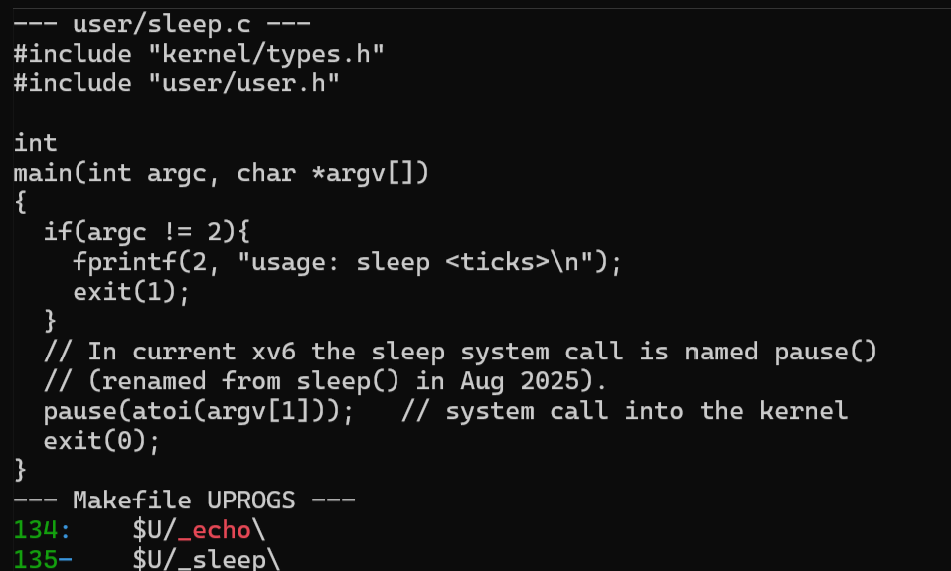
Figure 2.4.1 – user/sleep.c and the _sleep line in the Makefile
user/sleep.c:
#include "kernel/types.h"
#include "user/user.h"

int
main(int argc, char *argv[])
{
if(argc != 2){
fprintf(2, "usage: sleep <ticks>\n");
exit(1);
}
// In current xv6 the sleep system call is named pause()
// (renamed from sleep() in Aug 2025).
pause(atoi(argv[1])); // system call into the kernel
exit(0);
}
In the Makefile I added $U/_sleep\ to UPROGS, right after $U/_echo\ (line 135, with a tab). This way make compiles sleep.c and puts the program in fs.img, the file system xv6 boots with.
Testing it in xv6:
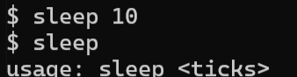
Figure 2.4.2 – Testing sleep inside xv6
$ sleep 10
$ sleep
usage: sleep <ticks>
sleep 10 waited about one second and then the prompt came back. sleep without an argument printed my usage message and exited with 1.
10 ticks is about 1 second because a tick is one timer interrupt, and in kernel/trap.c the next interrupt is set to time + 1000000, which the comment says is about a tenth of a second in QEMU.
In the kernel, sys_pause (kernel/sysproc.c, line 68) takes the number, saves the current ticks value and puts the process to sleep until ticks goes up by that number. While my process sleeps, the scheduler runs other processes, so it doesn't use the CPU. It's the same S (sleeping) state that I saw for the Linux sleep in Lab 1.

Conclusion (Lab 2)
In Lab 1 I could only look at Linux from the outside, but in xv6 I compiled the whole OS myself, booted it on emulated RISC-V hardware and used it like a small Unix. I also read both sides of a system call: cat asking with read() in user/ and sys_read answering in kernel/sysfile.c. At the end I wrote my own program, sleep, which makes a real system call into a kernel I built myself.

