
MINISTRY OF EDUCATION, CULTURE AND RESEARCH
OF THE REPUBLIC OF MOLDOVA
Technical University of Moldova
Faculty of Computers, Informatics and Microelectronics
Department of Software Engineering and Automation

Report
on laboratory work no. 3
Operating Systems
Topic: The Command Line: Shell, Pipes and Text Filters

Done by: st. gr. FAF-243, Chiril-Adam Macari

Checked by: Reițman Patricia, asist. univ.

Chișinău – 2026

Purpose of the work
The purpose of this lab is to learn to work faster in bash, to understand what the shell does to a command line before the command even runs, to redirect input and output where I want them, and to answer real questions about a data file with short pipelines of small text filters. At the end I also wrote my first bash script and ran it automatically with cron.
I did the lab in Ubuntu running in VirtualBox on my laptop (kernel 7.0.0-34-generic). Before starting I generated the data set for Part 4 with the loop from the lab sheet, and wc -l access.log printed 500 access.log, so the file was correct (it is visible at the top of Figure 1.1).

Part 1. Move fast, find help
Tab completion. I typed ls /usr/sh and pressed Tab twice. The first Tab completed the path to /usr/share/ because it is the only folder in /usr that starts with "sh". The second Tab tried to list everything inside it and asked Display all 247 possibilities? (y or n), so I pressed n. Then I typed cd /et and pressed Tab once, and it completed to cd /etc/.
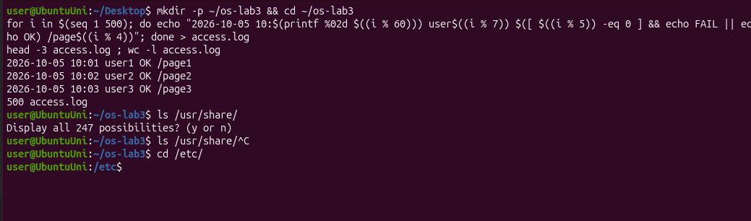
Figure 1.1 – Generating access.log and Tab completion
Ctrl+R. Ctrl+R searches backwards in the command history for the newest command that contains the letters I type. On my first try I pressed Ctrl+R before running date, typed "dat" and pressed Enter, and it ran sudo apt update, because "dat" is also inside update and that was the newest match in my history. After that I ran date, whoami and uname -r first, and then Ctrl+R with "dat" found date and ran it again.
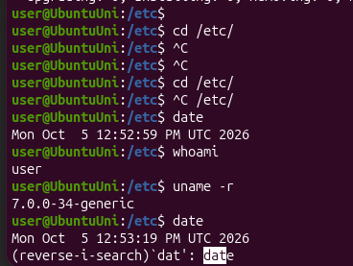
Figure 1.2 – Searching the history with Ctrl+R
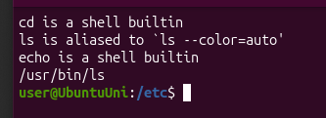
Figure 1.3 – Output of type and which
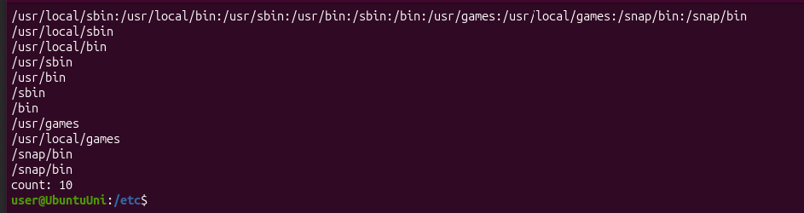
Figure 1.4 – The directories in PATH
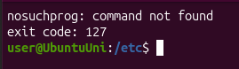
Figure 1.5 – Exit code of a missing command
Finding help. man ls opens the manual (I searched in it with /sort and n), ls --help prints a short list of options, man -k "list directory" searches the descriptions of all manual pages, and help cd shows help for a built-in command. On my Ubuntu, ls --help looks different from the usual GNU version and man -k also shows rust-ls and gnuls, because this Ubuntu version uses a Rust rewrite of the basic commands (uutils).
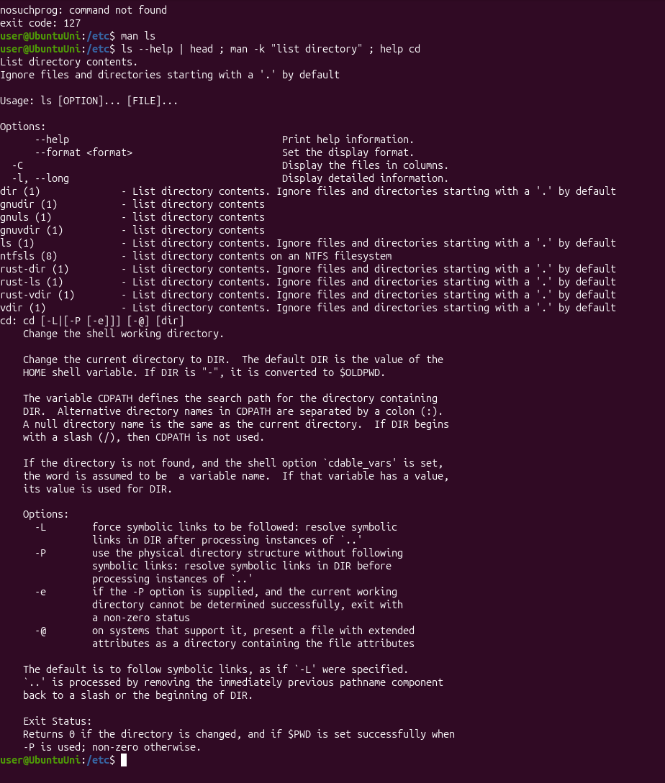
Figure 1.6 – Help without a browser: ls --help, man -k and help cd
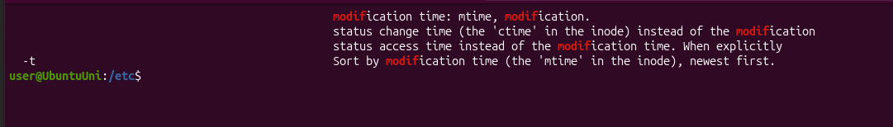
Figure 1.7 – The ls option that sorts by modification time

Observe
1. Which of cd, ls, echo are built-ins, and why MUST cd be one?
cd and echo are shell built-ins. ls is an external program, /usr/bin/ls (on Ubuntu it is also an alias for ls --color=auto). cd must be a built-in because the current directory belongs to each process. If cd were a separate program, the shell would start it as a child process, the child would change its own directory and then exit, and the shell would stay in the same place.
2. How many directories are in your PATH, and in which one is ls?
PATH has 10 entries, but /snap/bin appears two times, so there are 9 different directories. ls is in /usr/bin.
3. What exit code does a command that is not found return?
The exit code is 127. The shell printed nosuchprog: command not found and echo $? showed exit code: 127.
4. Which option of ls sorts by modification time?
-t: "Sort by modification time (the 'mtime' in the inode), newest first".

Part 2. What the shell does to your line
I created a test folder with a few files, including one with a space in its name:
Figure 2.1 – Files created in the play directory
Before running each line I chose what I thought it would print, and then I ran it:
Command | My prediction | Real output | Explanation (if different)
echo *.c | a.c b.c | a.c b.c | correct
echo file?.txt | file1.txt file2.txt | file1.txt file2.txt | correct
echo [a-b]* | a.c alfa beta.txt b.c | a.c alfa beta.txt b.c | correct
echo *.xyz | empty line | *.xyz | No file matches, so bash leaves the pattern as it is and echo prints it.
ls alfa beta.txt | one error | two errors: alfa and beta.txt not found | The space splits the name into two arguments, and ls looks for two files that don't exist.
ls "alfa beta.txt" | error | 'alfa beta.txt' | The quotes keep the name as one argument, so ls finds the file.
echo '$HOME' "$HOME" \$HOME | $HOME /home/user $HOME | $HOME /home/user $HOME | correct
echo {1..5} ; echo $((7 * 6)) | 1 2 3 4 5 and 42 | 1 2 3 4 5 and 42 | correct
echo "today is $(date +%A), I am $(whoami)" | today is Monday, I am user | today is Monday, I am user | correct
touch log{1..3}.txt && ls log* | log1.txt log2.txt log3.txt | log1.txt log2.txt log3.txt | correct

I got 7 out of 10 right. The three wrong ones were all about how bash splits words and what it does when a pattern matches nothing.
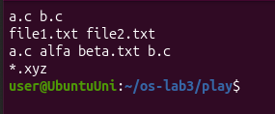
Figure 2.2 – Globbing results
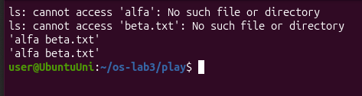
Figure 2.3 – The ls error on a name with a space, and the fix
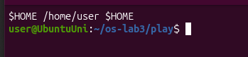
Figure 2.4 – Single quotes, double quotes and backslash
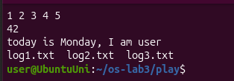
Figure 2.5 – Brace expansion, arithmetic and command substitution

Observe
1. Prediction, real output and explanation for each line.
See the table above.
2. echo knows nothing about files, yet echo *.c printed file names. Who produced them?
The shell (bash). Before running the command it expands *.c into the names of the files that match (globbing), so echo just gets a.c and b.c as arguments and prints them.
3. Why did ls alfa beta.txt fail? Give two different ways to fix it.
Bash splits the command line into words at spaces, so ls got two separate arguments, alfa and beta.txt, and neither file exists. Two fixes: put the name in quotes, ls "alfa beta.txt" (or single quotes), or escape the space with a backslash, ls alfa\ beta.txt. Both work in Figure 2.3.
4. What is the difference between single and double quotes?
Inside single quotes everything is taken literally, so '$HOME' stays $HOME. Double quotes also keep the text as one word, but the shell still replaces variables, $(...) and $((...)) inside them, so "$HOME" became /home/user. A backslash protects only the next character, so \$HOME also printed $HOME.
Note: why ls shows 'alfa beta.txt' in quotes.
ls puts quotes around names with spaces or special characters when it prints to the terminal. This way you can see exactly where the name starts and ends, and you can copy it back into a command and it will work as one argument.

Part 3. Redirection, chaining and jobs
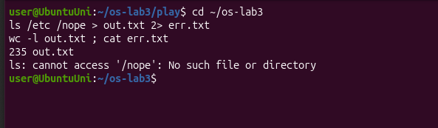
Figure 3.1 – stdout and stderr in separate files
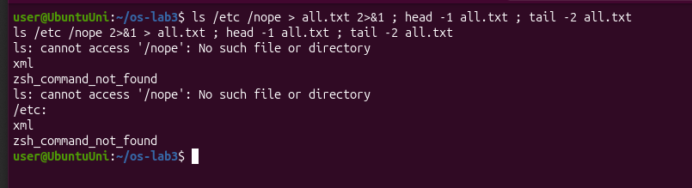
Figure 3.2 – Comparing the order of redirections
echo first > notes.md created the file, and echo second >> notes.md added a second line at the end without deleting the first, so cat showed first and second. ls /nope 2> /dev/null || echo "failed with code $?" hid the error and printed failed with code 2. In the last line all three commands joined with && worked, so it printed I am in /home/user/os-lab3/tmp.
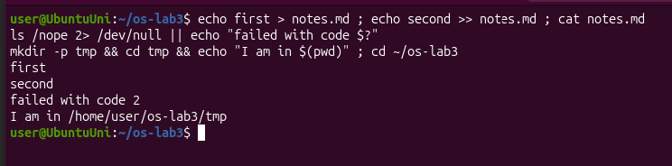
Figure 3.3 – The ; && || operators
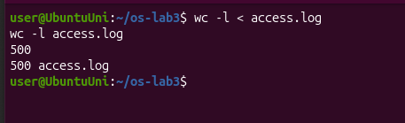
Figure 3.4 – wc -l with < and with a file name
sleep 100 & started sleep in the background and printed the job number and PID ([1] 8965). jobs showed it as Running, kill %1 stopped job number 1, and the next jobs showed Terminated.
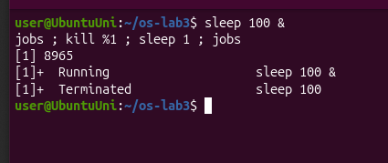
Figure 3.5 – Running a background job and stopping it

Observe
1. Which file got the error message, and which got the listing?
err.txt got the error (ls: cannot access '/nope'), because 2> redirects stderr (file descriptor 2). out.txt got the listing, because > redirects stdout (fd 1). It has 235 lines: the 234 files from /etc plus the /etc: header that ls prints when it gets more than one argument.
2. What is the difference between > all.txt 2>&1 and 2>&1 > all.txt?
The shell processes redirections from left to right, and 2>&1 means "send stderr to wherever stdout points right now". In > all.txt 2>&1, stdout already points to the file when 2>&1 is processed, so both go into the file. In Figure 3.2 the first line of the file is the error. In 2>&1 > all.txt, stderr is first pointed to the terminal (where stdout still is), and only after that stdout is moved to the file. So the error appeared on the screen, and the file started with /etc:.
3. Why does wc -l < access.log print only a number, while wc -l access.log also prints the file name?
With < the shell opens the file and gives it to wc as its standard input, so wc just reads data and doesn't know the file's name. With wc -l access.log, wc opens the file itself, so it knows the name and prints it next to the count.
4. Explain each operator in one sentence: ; && ||.
- ; runs the next command no matter what happened with the previous one.
- && runs the next command only if the previous one succeeded (exit code 0).
- || runs the next command only if the previous one failed (exit code not 0).

Part 4. Answer questions with one-liners
I wrote every answer as one command line and saved them all in oneliners.sh, with the question as a comment above each line. Each line of access.log has 5 fields separated by spaces: date, time, user, result and page, so cut -d' ' -f3 gives the user, -f4 the result and -f5 the page.
Q1. How many requests failed?
grep -c FAIL access.log counts the lines that contain FAIL: 100.
Figure 4.1 – Number of failed requests
Q2. How many different pages were requested, and which?
cut takes the page field and sort -u keeps every page only once: 4 pages, /page0, /page1, /page2 and /page3.
Figure 4.2 – Number of different pages
Q3. How many requests did each page get?
sort | uniq -c counts how many times each page appears: 125 requests for each page. 4 × 125 = 500, so the counts add up to the 500 lines of the log.
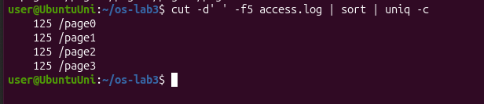
Figure 4.3 – Requests per page
Q4. Which user or users have the most failed requests, and how many?
I kept only the FAIL lines, took the user field, counted with uniq -c and sorted from biggest to smallest. Two users are tied, so at the end I used awk to print every user that has the maximum, not only the first line: user3 and user5, with 15 failed requests each. All the other users have 14, and 5 × 14 + 2 × 15 = 100, the same as Q1.
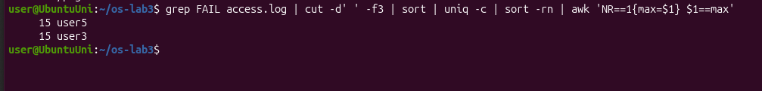
Figure 4.4 – Users with the most failed requests
Q5. How many requests did user3 make, and how many of them failed?
I searched for ' user3 ' with spaces around it, so it can't match a name like user30. user3 made 72 requests, and 15 of them failed.
Figure 4.5 – Requests and failures of user3
Q6. Print the last 3 failed requests, showing only time and user.
grep FAIL | tail -3 | cut -d' ' -f2,3 gives 10:10 user0, 10:15 user5 and 10:20 user3. These are the last 3 failed lines in the file, not the latest times, because the minutes in the log start again from 00 after 59.
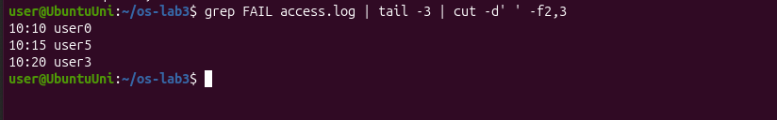
Figure 4.6 – The last 3 failed requests
Q7. Which login shells appear in /etc/passwd, and how many accounts use each?
cut -d: -f7 /etc/passwd | sort | uniq -c | sort -rn gives:
- /usr/sbin/nologin: 40 accounts
- /bin/false: 6 accounts
- /bin/bash: 2 accounts
- /bin/sync: 1 account
Most accounts are system accounts for services, and nologin or false means nobody can log in with them.
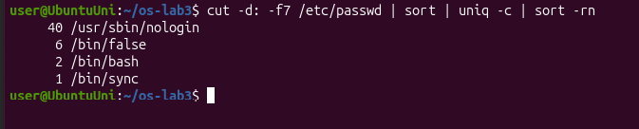
Figure 4.7 – Login shells in /etc/passwd
Q8. PREDICT, then explain: why do ls /etc | wc -l and ls -l /etc | wc -l differ by exactly one?
My prediction was that ls -l prints one extra summary line at the top, and it was correct. I got 234 and 235, and the extra line is total 1144, the total disk space used by the files in the folder (in blocks). When the output of ls goes into a pipe it prints one name per line, so wc -l counts the files exactly.
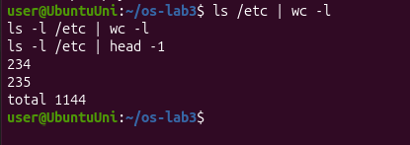
Figure 4.8 – ls /etc vs ls -l /etc
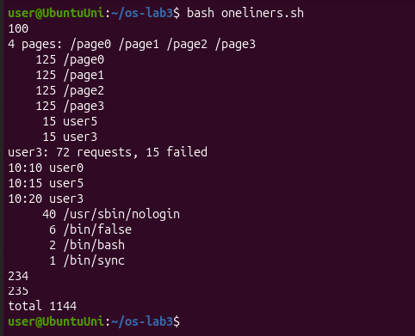
Figure 4.9 – Full run of oneliners.sh
Bonus: the lines where the minute ends in 0 and the request failed.
grep -E ' 10:[0-9]0 [^ ]+ FAIL ' access.log prints only those lines, and with -c it counts them: 50 lines. This makes sense: the minute ends in 0 when the line number is a multiple of 10, and all those lines are FAIL (FAIL is every 5th line), so there are 500 / 10 = 50.
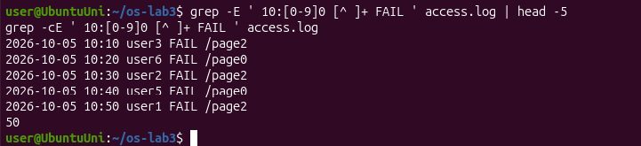
Figure 4.10 – Bonus: failed requests at minutes ending in 0

Part 5. Your first script
I completed the TODO with a for loop over 0 to 6. For each user it counts the lines with userN FAIL using grep -c:
for n in {0..6}; do
echo "user$n: $(grep -c "user$n FAIL" "$log") failures"
done
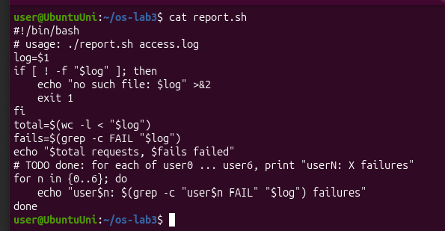
Figure 5.1 – Contents of report.sh
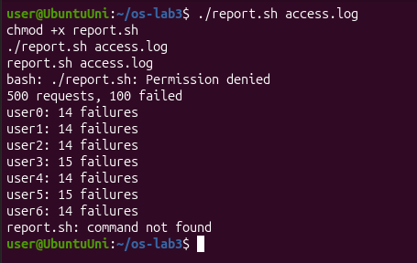
Figure 5.2 – Running the script on access.log
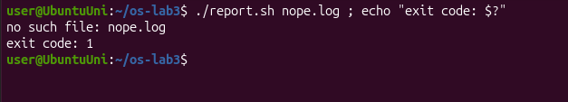
Figure 5.3 – Error handling for a missing file

Observe
1. What does the first line #!/bin/bash do, and what happens if you run ./report.sh before chmod +x?
#!/bin/bash is the shebang. When the file is run directly, it tells the system which program should run the script, here bash. Before chmod +x the file has no execute permission, so I got bash: ./report.sh: Permission denied (Figure 5.2). After chmod +x it worked: 500 requests, 100 failed and the failures for every user.
2. Why must you type ./report.sh and not just report.sh?
Without a / in the name, the shell looks for the command only in the directories from PATH, and the current folder is not in PATH. So report.sh gave command not found. ./ gives the exact path, "this file in the current folder". The current folder is not in PATH for security, so that a file named like a normal command in some folder can't be run by mistake.
3. Why does the script write the error with >&2 and end with exit 1?
>&2 sends the error to stderr instead of stdout, so it doesn't get mixed with the normal output. For example, if the output is redirected to a file, the error is still shown on the screen. exit 1 returns a non-zero exit code, so whoever ran the script (&&, ||, another script or cron) knows that it failed. In Figure 5.3 it printed no such file: nope.log and exit code: 1.
Bonus: running the script with cron.
I added this line to my crontab (with crontab -l and crontab -, which does the same as editing it in crontab -e):
* * * * * /home/user/os-lab3/report.sh /home/user/os-lab3/access.log >> /home/user/os-lab3/report.log 2>&1
The five stars mean "every minute". I used full paths because cron doesn't start in my folder and has a very small PATH, and >> ... 2>&1 adds both the output and any errors at the end of report.log. After waiting a few minutes, report.log had the report three times, once for each minute. Then I removed the job with crontab -r, and crontab -l printed no crontab for user.
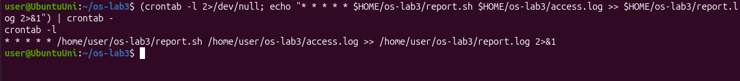
Figure 5.4 – The crontab line
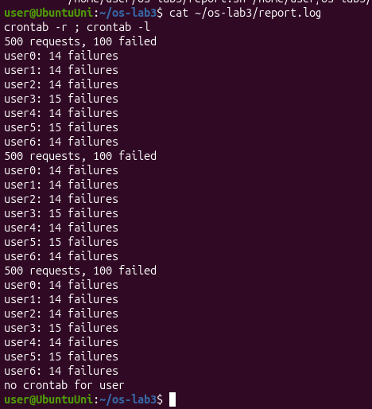
Figure 5.5 – report.log filled by cron, then the crontab removed

Conclusions
In this lab I saw that a lot happens before a command even starts: bash splits the line into words, expands *, ?, [...], {...}, $VAR, $(...) and $((...)), and sets up redirections from left to right, and only then runs the program. Most of my wrong predictions in Part 2 came from this, especially from the space in "alfa beta.txt" and from a pattern that matches nothing.
I also learned that stdout and stderr are two separate streams, and that the order of > and 2>&1 matters. With small filters like grep, cut, sort, uniq and wc joined by pipes I answered all the questions about the log in one line each, and the self-checks (500 for Q3 and 100 for Q4) confirmed the answers. Finally, I turned the one-liners into a script with argument checking, error messages on stderr and exit codes, and ran it automatically every minute with cron.

