
MINISTRY OF EDUCATION, CULTURE AND RESEARCH
OF THE REPUBLIC OF MOLDOVA
Technical University of Moldova
Faculty of Computers, Informatics and Microelectronics
Department of Software Engineering and Automation

Report
on laboratory work no. 4
Operating Systems
Topic: The xv6 Shell from the Outside

Done by: st. gr. FAF-243, Chiril-Adam Macari

Checked by: Reițman Patricia, asist. univ.

Chișinău – 2026

Purpose of the work
The purpose of this lab is to use the xv6 shell (user/sh.c) side by side with bash and find out by experiment what a shell must do and what bash adds on top. I also wrote a small program that prints the arguments it receives, to see exactly who expands * and who removes the quotes, and I fixed my sleep program from Lab 2 so it builds on the current xv6.
I did the lab in Ubuntu running in VirtualBox. Before starting I ran the course script os2026-setup.sh. It installed the RISC-V compiler and QEMU, downloaded xv6 (revision 06aad25) into ~/xv6-riscv, built it, booted it once and printed "All set". With the default 3 emulated CPUs (-smp 3) xv6 booted so slowly that it froze my whole virtual machine, so for the whole lab I started xv6 with make qemu CPUS=1, which is the same xv6 with one CPU.

Part 1. Fix sleep for the current xv6
First I checked which name my xv6 tree uses for the system call:
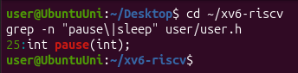
Figure 1.1 – The grep result in user.h
user/user.h declares int pause(int); on line 25 and there is no sleep, so in my user/sleep.c I call pause(). I also added $U/_sleep\ to UPROGS in the Makefile, right after $U/_echo\ (line 135, starting with a TAB and ending with the backslash).
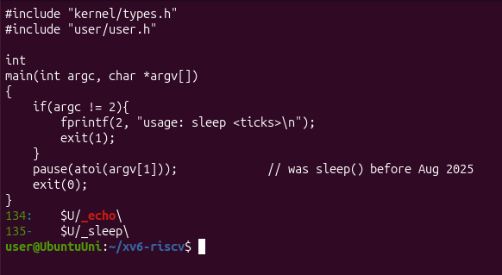
Figure 1.2 – The updated sleep.c
After make qemu CPUS=1, sleep 20 waited about two seconds (20 ticks, one tick is about 0.1 s) and then the prompt came back. sleep without an argument printed the usage message.
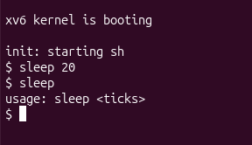
Figure 1.3 – sleep running in xv6, with and without an argument

Part 2. bash versus the xv6 shell
I ran every command once in bash, in an empty folder ~/shtest with a file named README, and once at the xv6 $ prompt.
Command | Tests | bash | xv6 | Why
echo hello > f ; cat < f | redirection | hello | hello | Both shells support > and <.
ls | grep READ | pipe | README | README 2 2 2441 | Both have pipes. xv6's ls also prints type, inode and size.
(echo a; echo b) | wc | grouping, list | 2 2 4 | 2 2 4 | Both support ( ) and ;.
echo one ; echo two | sequence | one, two | one, two | Same in both.
echo bg & | background | [1] 4443, bg, later [1]+ Done | bg | Both run it in the background, but only bash has job control (job numbers, jobs, the Done message).
ls * | globbing | README f | ls: cannot open * | xv6 does not expand *, so ls got a literal *.
echo $HOME | variables | /home/user | $HOME | xv6 has no variables.
echo "a b" | quotes | a b | "a b" | xv6 does not remove quotes; it sees two words, "a and b".
mkdir d ; cd d ; ls .. | PATH | README d f | exec cd failed + listing of / | bash finds ls with PATH. In xv6 cd works only at the start of a line, and on a separate line ls then fails (Figure 2.5).
arrow up, Tab, Ctrl+R | history, completion | all work | ^[[A, exec … failed | xv6 has no history and no completion.

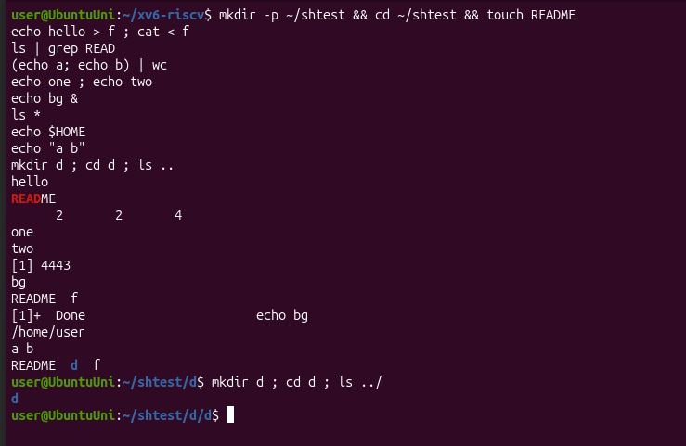
Figure 2.1 – The commands run in bash
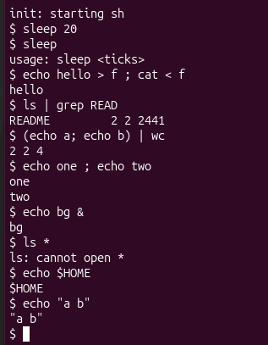
Figure 2.2 – The same commands run in xv6
In xv6, mkdir d ; cd d ; ls .. created d, but then printed exec cd failed, so I stayed in /. That's why ls .. listed the root folder (.. of / is / itself). The reason is in Part 4: xv6 handles cd only when the whole line starts with "cd ".
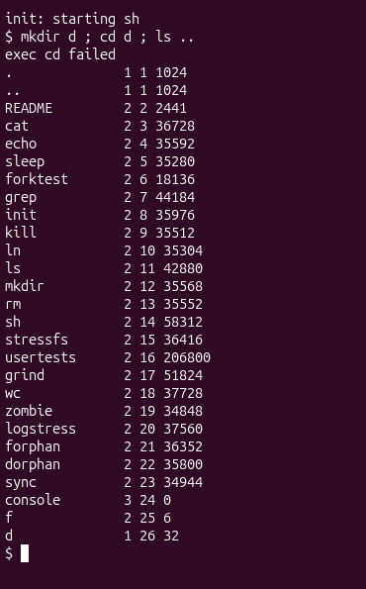
Figure 2.3 – mkdir d ; cd d ; ls .. in xv6
When I pressed arrow up, Tab and Ctrl+R in xv6, nothing useful happened. The arrow key sends the characters ESC [ A. xv6 has no history, so its console just echoes them back. My Ubuntu terminal understands ESC [ A as "move the cursor one line up", so the exec … failed message was printed over the line above, and that's why it shows d failed. In bash the same keys gave me the previous command back, completed names with Tab and searched the history with Ctrl+R.
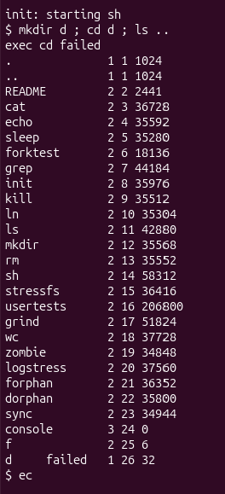
Figure 2.4 – Arrow up, Tab and Ctrl+R in xv6
Then I typed cd d on its own line, and it worked. After that ls failed with exec ls failed, but /ls (the full path) and ../ls .. both worked.
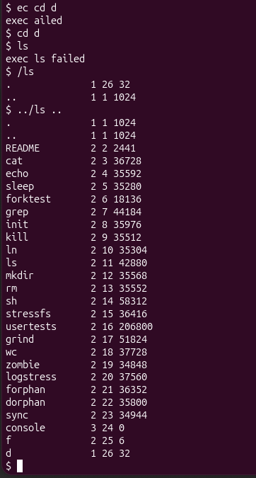
Figure 2.5 – ls failing after cd d, and the working alternative

Observe
1. List the features both shells have, and the ones only bash has.
Both shells:
- run programs with arguments
- redirection with <, > (and >>)
- pipes |
- lists with ;
- grouping with ( )
- background &
- a built-in cd
Only bash:
- wildcards (*, ?, [ ])
- variables like $HOME
- quotes and backslash
- searching programs in PATH
- history (arrow up, Ctrl+R) and Tab completion
- job control (jobs, %1, Done messages)
- && and ||, $(...)
- cd anywhere in a line
2. In xv6, ls stops working after cd d. Why? Find a way to run ls from inside d anyway.
xv6 has no PATH. When I type ls, the shell calls exec("ls"), and the kernel looks for a file named ls only in the current folder. All xv6 programs live in the root folder / (mkfs puts them there when it builds fs.img), and d is empty, so exec fails. It works if I give the path to the program: /ls (absolute path) or ../ls (relative to the parent folder), as in Figure 2.5.
3. Which missing feature would you miss most in daily work, and which would be easiest to add?
I would miss the history the most, because in bash I use arrow up all the time to repeat or fix the last command, and in xv6 I have to type everything again. I think the easiest to add would be quotes. The shell already splits the line into words in gettoken(), so it would only need to treat everything between two " as one word and drop the quote characters. It doesn't need anything new from the kernel.

Part 3. Who expands *? A program that prints its argv
I wrote user/args.c, which prints argc and every argv[i] between square brackets, and added $U/_args\ to UPROGS right after _sleep:
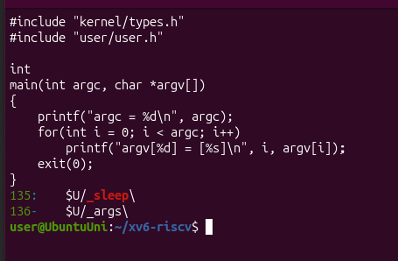
Figure 3.1 – args.c and the UPROGS line
For Linux I wrote the same program as args_linux.c, with <stdio.h> and return 0, and compiled it with gcc -o args args_linux.c in a folder ~/lab4-linux that also has some .c files (hello.c, test.c):
#include <stdio.h>

int
main(int argc, char *argv[])
{
printf("argc = %d\n", argc);
for(int i = 0; i < argc; i++)
printf("argv[%d] = [%s]\n", i, argv[i]);
return 0;
}
Then I ran the same four lines in both shells:
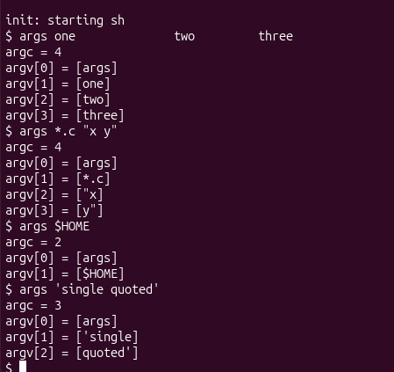
Figure 3.2 – args output in xv6
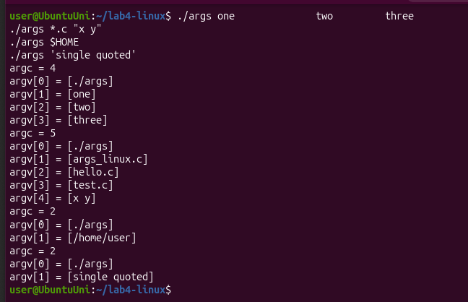
Figure 3.3 – args_linux output in bash

Observe
1. Paste both outputs for args *.c "x y". How many arguments did each program receive?
In xv6:
argc = 4
argv[0] = [args]
argv[1] = [*.c]
argv[2] = ["x]
argv[3] = [y"]
In bash:
argc = 5
argv[0] = [./args]
argv[1] = [args_linux.c]
argv[2] = [hello.c]
argv[3] = [test.c]
argv[4] = [x y]
The xv6 program received 4 arguments (with the program name), and the *.c and the quotes arrived exactly as I typed them. The Linux program received 5: bash replaced *.c with the three .c files and made x y one argument without quotes.
2. So who turns *.c into file names and removes the quotes: the program, the kernel, or the shell?
The shell. The program is the same in both cases and only prints what it gets, and the kernel's exec only copies the argument strings it is given into the new process. The only thing that was different was the shell, and that changed the result. bash expands * and $HOME and removes the quotes before it calls exec; the xv6 shell doesn't.
3. What happened to the extra spaces in one two three?
They disappeared in both shells. The shell splits the line into words at spaces and throws away all the spaces between words, so the program got only one, two and three (argc = 4). The program never sees how many spaces I typed.

Part 4. Read the shell
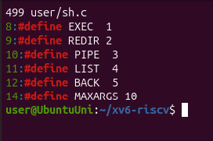
Figure 4.1 – The command kinds defined in sh.c
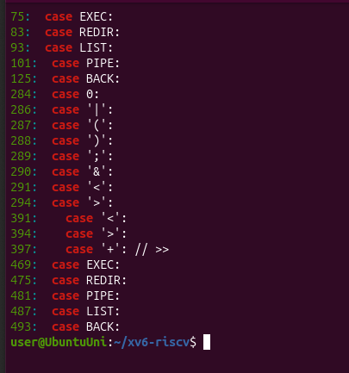
Figure 4.2 – Where each kind is run
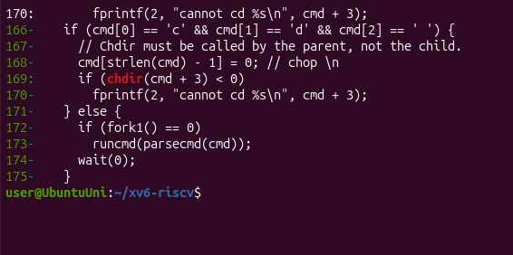
Figure 4.3 – The code that handles cd
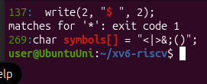
Figure 4.4 – Searching sh.c for code that handles * or $

Observe
1. Name the five kinds of command the xv6 shell knows and the character that produces each.
user/sh.c has 499 lines and defines five kinds of command (lines 8–12):
- EXEC: a simple command, just words with no special character (for example ls d)
- REDIR: produced by < or > (and >>)
- PIPE: produced by |
- LIST: produced by ;
- BACK: produced by &
Each kind is run in runcmd() (case EXEC: on line 75 to case BACK: on line 125). Parentheses ( ) only group commands; they are not a separate kind.
2. Where is cd handled, and why is it not run as a separate program?
cd is handled in main(), lines 166–170. If the line starts with "cd ", the shell calls chdir() itself; every other line is given to a child process created with fork1(). The comment explains why: "Chdir must be called by the parent, not the child". The current folder belongs to each process, so if a child changed its folder and exited, the shell would stay where it was (the same reason as in Lab 3). Because the check is only on the first characters of the line, mkdir d ; cd d in Part 2 did not work: that line went to the parser, and the child tried to exec("cd"), a program that doesn't exist.
3. Search sh.c for any code that handles * or $. What does that explain about Part 2?
There is none. The only $ in the file is the prompt, write(2, "$ ", 2) on line 137, and searching for '*' finds nothing (exit code 1). The only special characters the shell knows are <|>&;() (line 269); everything else is just split into words at spaces and passed on as it is. That explains Part 2 and Part 3: ls *, echo $HOME and echo "a b" got the *, the $HOME and the quotes literally, because nobody replaced them.

Conclusions
In this lab I saw that a shell needs surprisingly little to be useful: the xv6 shell is only 499 lines, and it can run programs, redirect input and output, connect programs with pipes, run lists and background jobs and change the folder. Everything else I'm used to from bash, like wildcards, variables, quotes, PATH, history, Tab completion and job control, is extra work that bash does on top.
The args program showed clearly that the shell, not the program and not the kernel, expands * and $ and removes quotes, because the same program received different arguments from the two shells. Reading sh.c confirmed this: it has no code for * or $, and it handles cd itself in the parent process, only at the start of a line. I also updated my sleep program to use pause(), the new name of the system call in the current xv6.

