
MINISTRY OF EDUCATION, CULTURE AND RESEARCH
OF THE REPUBLIC OF MOLDOVA
Technical University of Moldova
Faculty of Computers, Informatics and Microelectronics
Department of Software Engineering and Automation

Report
on laboratory works no. 5 and 6
Operating Systems
Topic: The File System (Linux and xv6)

Done by: st. gr. FAF-243, Chiril-Adam Macari

Checked by: Reițman Patricia, asist. univ.

Chișinău – 2026

Lab 5 – The File System with Your Own Hands (Linux)

Purpose of the work
The purpose of this lab is to check the ideas from the file system lecture on my own Linux system: the directory tree and the file types, inodes behind the names, hard and symbolic links, permissions, and the disks underneath. There is no programming in this lab, only commands, careful observation and short explanations.
I worked in Ubuntu in VirtualBox as my normal user (whoami printed user, not root), in a folder ~/os-lab5.

Part 1. The tree and the file types
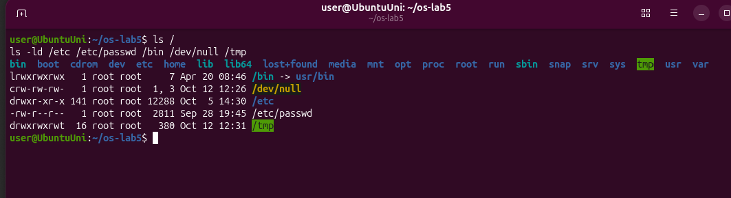
Figure 1.1 – ls / and the types of five paths
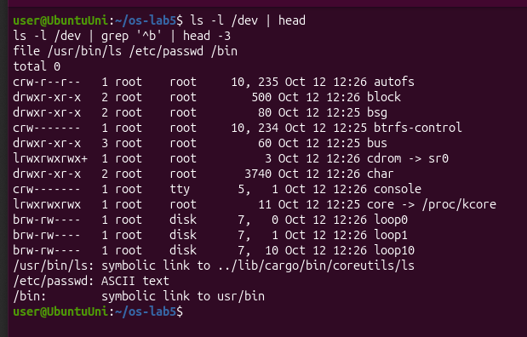
Figure 1.2 – Devices in /dev and the output of file
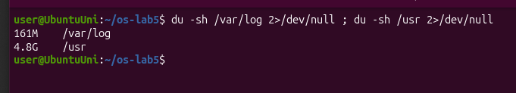
Figure 1.3 – Size of /var/log and /usr
Observe
1. For each path in the second line, write its type from the first letter of ls -l.
- /bin: l, a symbolic link
- /dev/null: c, a character device
- /etc: d, a directory
- /etc/passwd: -, a regular file
- /tmp: d, a directory (drwxrwxrwt, with the sticky bit, see Part 3)
2. What is /bin on your system: a directory or a link, and to where?
/bin is a symbolic link to usr/bin (/bin -> usr/bin, and file /bin says "symbolic link to usr/bin"). On modern Ubuntu the old /bin folder was merged into /usr/bin. I also noticed that even /usr/bin/ls is a link, to ../lib/cargo/bin/coreutils/ls, because this Ubuntu uses the Rust rewrite of the basic commands.
3. Find one character device and one block device in /dev.
- Character devices: /dev/null (crw-rw-rw-, numbers 1, 3) and /dev/console (5, 1).
- A block device: /dev/loop0 (brw-rw----, numbers 7, 0); the main disk /dev/sda is also a block device.
Instead of a size, device files show two numbers, the major and minor number, which tell the kernel which driver handles the device.
4. Which is bigger on your laptop, /var/log or /usr, and by roughly how much?
/usr is 4.8G and /var/log is 161M, so /usr is about 30 times bigger.

Part 2. Inodes and links
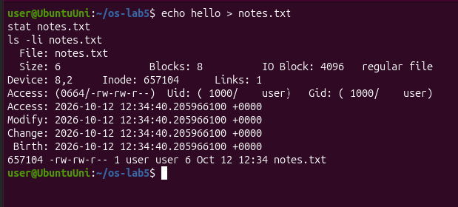
Figure 2.1 – stat and ls -li of notes.txt
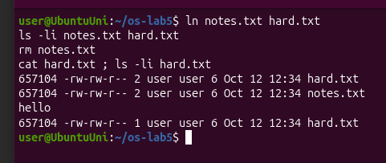
Figure 2.2 – A hard link, then removing the original
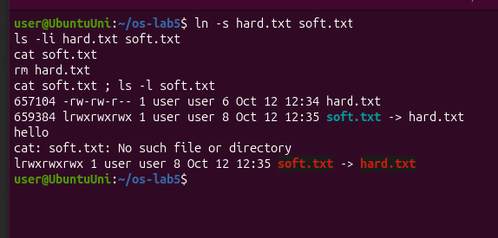
Figure 2.3 – A symbolic link, then removing its target
Before running step 4 I predicted that a new directory has 2 links and that it has 4 after creating two subdirectories. Both predictions were correct (Figure 2.4).
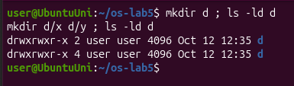
Figure 2.4 – Link count of a directory
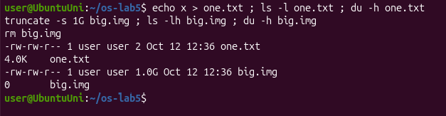
Figure 2.5 – Size is not space
Observe
1. Which number in stat is the inode, and which tells how many names the file has?
The inode is Inode: 657104, and Links: 1 tells how many names (hard links) the file has. ls -li shows the same inode number in the first column. The name notes.txt is not stored in the inode at all; it is only in the directory.
2. After rm notes.txt, why could you still read hard.txt? What does rm really remove?
After ln notes.txt hard.txt both names show the same inode 657104 with 2 links, so they are two names for one file. rm only removes a name (the entry in the directory) and lowers the link count from 2 to 1. The inode and the data stay, because another name still points to them, so cat hard.txt still printed hello. The data is freed only when the link count reaches 0 and no program has the file open.
3. Why did cat soft.txt fail at the end, although soft.txt still exists? How big is soft.txt and why exactly that size?
soft.txt has its own inode (659384); it is a small file that only stores the path hard.txt. After rm hard.txt that path points to nothing, so cat soft.txt gave No such file or directory, even though the link itself still exists (ls shows it in red). Its size is 8 bytes, because hard.txt has exactly 8 characters.
4. A new directory has 2 links, and 4 after you create two subdirectories. Explain where each link comes from.
- The name d in ~/os-lab5 points to the directory: 1 link.
- The entry . inside d points to d itself: 2 links.
- Each subdirectory x and y has a .. entry that points back to d: +2, so 4 links.
5. Why does a 2-byte file use 4.0K, and a 1 GB file use 0?
one.txt contains only x and a newline (2 bytes), but the file system gives space in whole blocks of 4 KB (stat showed IO Block: 4096 and Blocks: 8 of 512 bytes), so even a tiny file takes 4.0K. truncate -s 1G only sets the size of big.img to 1 GB without writing any data, so no blocks are used (a "sparse" file): ls shows 1.0G but du shows 0.

Part 3. Permissions
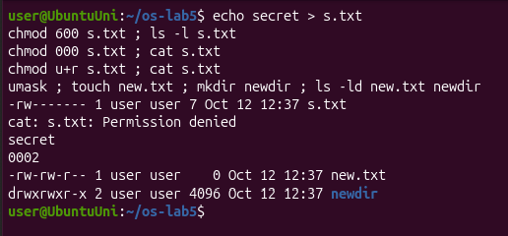
Figure 3.1 – chmod on a file and the umask
For the box experiment I predicted the results first:
Directory has only… | Command | My prediction | Real result
r (read) | ls box | shows f | f – correct
r (read) | cat box/f | Permission denied | Permission denied – correct
x (execute) | ls box | shows f | cannot open directory 'box': Permission denied – wrong
x (execute) | cat box/f | Permission denied | hi – wrong

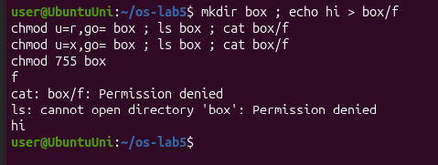
Figure 3.2 – The box experiment: r and x on a directory
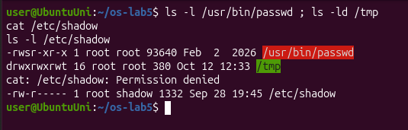
Figure 3.3 – The special bits and /etc/shadow
Observe
1. Write 600, 644, 755 and 700 as rwx strings, and give one real use for each.
- 600 = rw-------: a private file only I can read and write, for example an SSH private key.
- 644 = rw-r--r--: a normal file everyone can read but only I can change, for example /etc/passwd.
- 755 = rwxr-xr-x: a program or directory everyone can use but only the owner can change, for example /usr/bin programs or my home folders.
- 700 = rwx------: a private directory or script, for example ~/.ssh.
2. With chmod 000 you own the file but cannot read it. Why does ownership not help?
When I open a file, the kernel checks the permission bits of the class I belong to. Since I am the owner, it only looks at the owner bits, which were ---, so cat got Permission denied. Being the owner only gives the right to change the permissions with chmod; after chmod u+r I could read secret again.
3. What is your umask, and how does it explain the permissions of new.txt and newdir?
My umask is 0002. It removes the write permission for "others" from the default. New files start from 666, so new.txt got 666 − 002 = 664 (-rw-rw-r--). New directories start from 777, so newdir got 775 (drwxrwxr-x).
4. Explain the box experiment: what does r allow on a directory, and what does x allow?
A directory is a table of names. r allows reading that table, so with only r the ls box command could list the name f, but cat box/f failed because I couldn't go through the directory to the file. x allows passing through the directory to a file whose name I already know, so with only x the command cat box/f printed hi, but ls box failed because I couldn't read the list. I guessed the two x cases wrong; I thought x was not important for a directory.
5. What do the s in /usr/bin/passwd and the t in /tmp mean, and why does passwd need the s?
The s in -rwsr-xr-x is the setuid bit: the program runs with the rights of its owner (root), not of the user who started it. passwd needs it because it has to write the new password into /etc/shadow, which belongs to root and is -rw-r----- (my cat /etc/shadow got Permission denied). The t in drwxrwxrwt on /tmp is the sticky bit: everyone can create files in /tmp, but each user can delete or rename only their own files.

Part 4. Disks and the kernel as files
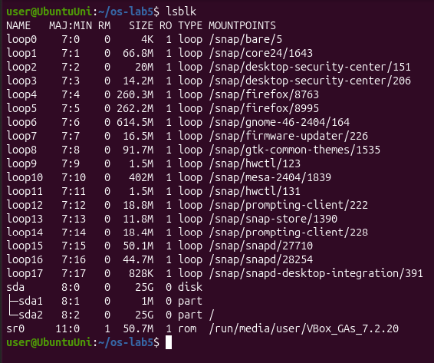
Figure 4.1 – lsblk
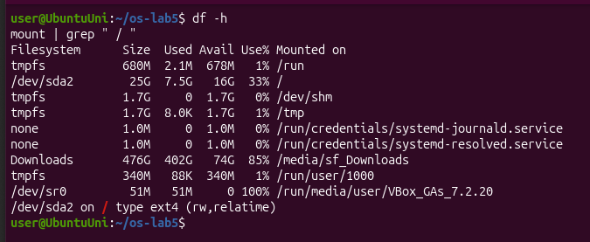
Figure 4.2 – df -h and the root mount
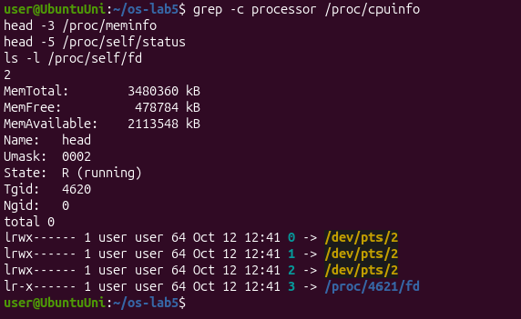
Figure 4.3 – CPU, memory and the current process in /proc
Observe
1. Draw your disk: disk name, partitions, which one is mounted at / and with what file system type.
sda 25G (virtual disk of the VM)
├─ sda1 1M small boot partition, not mounted
└─ sda2 25G ext4, mounted at / (rw,relatime)

sr0 51M VirtualBox Guest Additions CD
loop0..17 snap packages, mounted under /snap
2. How full is your root file system?
33% full: 7.5G used out of 25G, with 16G free.
3. How many CPU cores and how much RAM does your laptop have, according to /proc?
/proc/cpuinfo shows 2 processors and /proc/meminfo shows MemTotal: 3480360 kB, about 3.3 GB. These are the resources I gave to the virtual machine in VirtualBox, not the whole laptop.
4. /proc/self/status showed the name of a program. Which one, and why that one?
It showed Name: head. /proc/self always points to the process that is opening it, and the process that read /proc/self/status was head. In the same way, ls -l /proc/self/fd showed the file descriptors of ls itself: 0, 1 and 2 go to my terminal /dev/pts/2, and 3 is the /proc/.../fd directory that ls was reading.

Stretch
I did tasks (a) and (c).
(a) Magic numbers. I compressed /etc/passwd with gzip into a file named notes.txt. file still said gzip compressed data, was "passwd". The first bytes in xxd are 1f 8b, the gzip magic number (followed by 08, the deflate method), so file looks at the content and not at the .txt name.
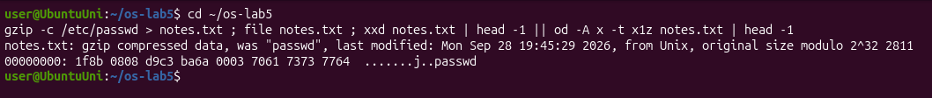
Figure 5.1 – Magic numbers of a gzip file
(c) Delete a file that is still open. I created a 200 MB file, opened it as file descriptor 3, and deleted it. /proc/$$/fd showed 3 -> '/home/user/os-lab5/bigfile (deleted)', and the used space stayed 7863 MB. Only after closing it with exec 3<&- did the used space drop to 7663 MB, exactly 200 MB less. So the space is freed only when the last name is removed and the file is no longer open.
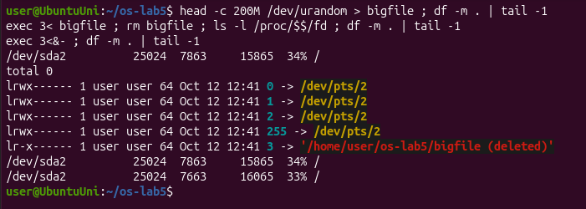
Figure 5.2 – A deleted file that is still open

Conclusions (Lab 5)
In this lab I saw that a file name and the file itself are two different things: the name is only an entry in a directory, while the file is an inode with its data, which lives as long as it has at least one name or is still open. Hard links are extra names for the same inode, symbolic links are small separate files that store a path, and directories also have links because of . and ...
Permissions are checked by the kernel for the owner, group and others. On a directory, r means listing the names and x means passing through it; I got those two wrong in my predictions. Special bits like setuid and the sticky bit solve real problems, such as passwd writing to /etc/shadow. Finally, /proc showed that the kernel exposes the CPU, the memory and even the current process as files.

Lab 6 – Inside the xv6 File System

Purpose of the work
The purpose of this lab is to look inside the xv6 file system, which has the same ideas as ext4 (inodes, directories as tables, hard links, a log) in a few hundred lines. I read what xv6 shows, wrote my own stat program (mystat), measured the limits written in kernel/fs.h, and wrote find, which walks the directory tree recursively.
I used the same ~/xv6-riscv tree as in Lab 4 (revision 06aad25), and started xv6 with make qemu CPUS=1, because with 3 emulated CPUs it is too slow in my virtual machine. Every new program got a line in UPROGS in the Makefile.

Part 1. Read what xv6 shows you
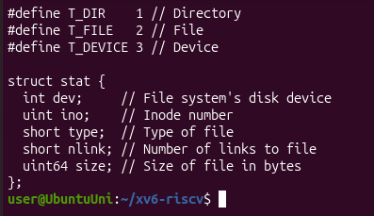
Figure 1.1 – The file types in kernel/stat.h
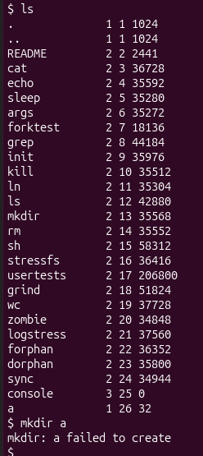
Figure 1.2 – ls in xv6 on a fresh disk
When I pasted ls, mkdir a and ls a all at once, the xv6 console mixed them up and a second mkdir a failed because a already existed. So I removed a and typed the commands one by one:
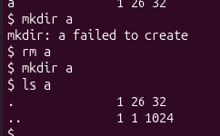
Figure 1.3 – ls of a new empty directory a
Observe
1. What do types 1, 2 and 3 mean (kernel/stat.h)?
1 is T_DIR (a directory), 2 is T_FILE (a regular file) and 3 is T_DEVICE (a device, like console).
2. Which inode number does the root directory have, and why are . and .. the same there?
The root directory has inode 1: both . and .. show 1 1 1024. . is the directory itself, and .. should be its parent, but the root has no parent, so its .. points to itself.
3. An empty directory a has size 32. A directory entry has a fixed size. How big is one entry, and which two entries does a contain?
One entry is 16 bytes: 2 bytes for the inode number (ushort inum) and 14 bytes for the name (char name[DIRSIZ], DIRSIZ = 14). An empty directory has two entries, so 2 × 16 = 32 bytes: . (inode 26, the directory itself) and .. (inode 1, the root).

Part 2. Write mystat
I completed user/mystat.c: typename() returns "directory", "file" or "device" for T_DIR, T_FILE and T_DEVICE. main() calls stat() for every argument; if it fails, it prints an error to file descriptor 2 and continues with the next one, and otherwise it prints the name, type, inode, link count and size.
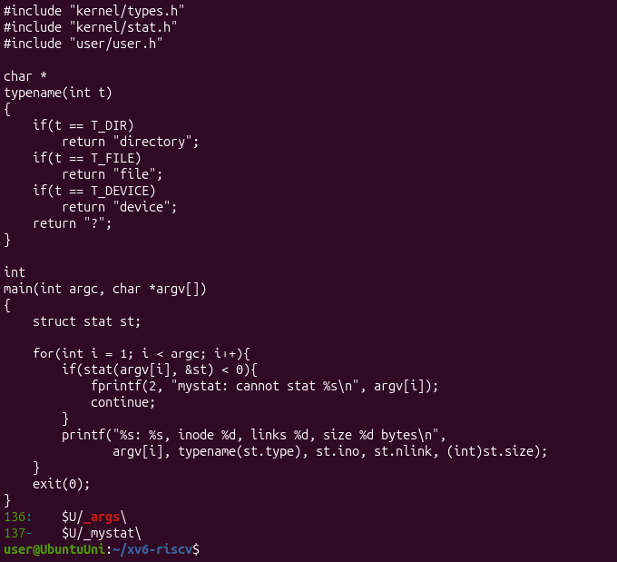
Figure 2.1 – user/mystat.c and the UPROGS line
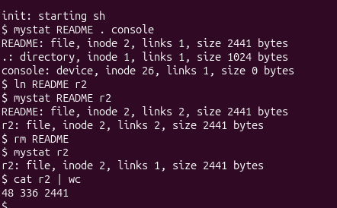
Figure 2.2 – mystat with a hard link and after rm
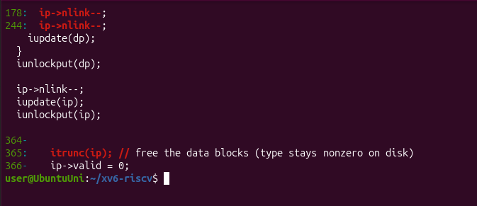
Figure 2.3 – sys_unlink decrements nlink, and iput frees the blocks
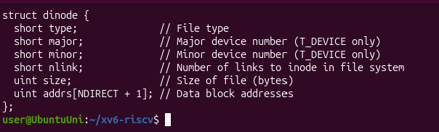
Figure 2.4 – struct dinode in kernel/fs.h
Observe
1. Paste the outputs after ln and after rm. What changed and what did not?
After ln README r2:
README: file, inode 2, links 2, size 2441 bytes
r2: file, inode 2, links 2, size 2441 bytes
After rm README:
r2: file, inode 2, links 1, size 2441 bytes
Only the link count changed, 1 → 2 → 1. The inode number (2), the size (2441 bytes) and the content did not change: cat r2 | wc still gave 48 336 2441. ln only added a second name for inode 2, and rm only removed one name.
2. Find the line in kernel/sysfile.c (sys_unlink) that decrements the link count. When are the data blocks freed?
It is line 244 in sys_unlink: ip->nlink--;, followed by iupdate(ip), which writes the inode back to the disk. (Line 178 with the same code is in sys_link, where it undoes the increment if the link fails.) The data blocks are not freed in sys_unlink. They are freed later in iput() in kernel/fs.c, by itrunc(ip); // free the data blocks on line 365, when the last reference to the inode is dropped and nlink == 0. So if a program still has the file open, the blocks are freed only when it closes the file, the same as in Lab 5, Stretch (c).
3. xv6 has no symbolic links and no permissions. Look at struct dinode in kernel/fs.h: which fields does an xv6 inode have?
- type: file, directory or device
- major and minor: the device numbers, only for devices
- nlink: the number of names that point to the inode
- size: the size in bytes
- addrs[NDIRECT + 1]: 12 direct block addresses and 1 indirect block
There is no owner, no permission bits and no timestamps, which is why xv6 has no chmod, and there is no field for a symlink target.

Part 3. Measure the limits
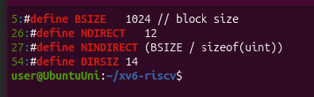
Figure 3.1 – The limits in kernel/fs.h
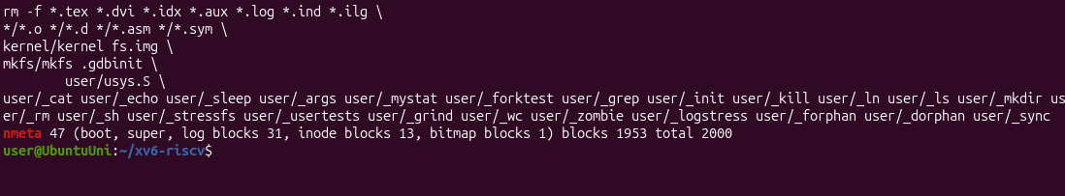
Figure 3.2 – The disk layout printed by mkfs
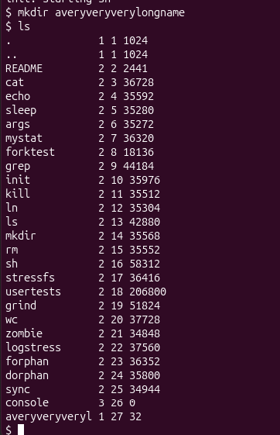
Figure 3.3 – A directory with a long name
Observe
1. What does ls show for averyveryverylongname, and which constant explains it?
ls shows averyveryveryl, only the first 14 characters. DIRSIZ is 14, so a directory entry has room for only 14 characters of the name, and the rest was cut off.
2. Compute the largest file xv6 can hold.
- BSIZE = 1024 bytes per block.
- NDIRECT = 12 direct blocks.
- NINDIRECT = BSIZE / sizeof(uint) = 1024 / 4 = 256 block numbers fit in the indirect block.
- The largest file is (12 + 256) × 1024 = 268 × 1024 = 274,432 bytes, which is about 268 KB.
3. From the nmeta line: how many blocks does the whole disk have, and how many are for the log, the inodes, and the data?
The line is nmeta 47 (boot, super, log blocks 31, inode blocks 13, bitmap blocks 1) blocks 1953 total 2000:
- Total: 2000 blocks (2000 × 1 KB, about 2 MB).
- Metadata: 47 blocks:
- 1 boot block
- 1 superblock
- 31 log blocks
- 13 inode blocks: an inode is 64 bytes, so 16 fit in a block, about 200 inodes in total
- 1 bitmap block
- Data: 1953 blocks.

Part 4. Write find
I wrote user/find.c, starting from user/ls.c:
- Start: find(path, name) opens the path and calls fstat. If the last part of the path (after the last /) is equal to name (strcmp), it prints the path.
- Directories: if the path is a directory, it reads the struct dirent entries one by one, skips free slots (inum == 0), and never goes into . and .., because that would loop forever. It builds the full path path/entry in a buffer and calls find again on it (recursion).
- Closing: every directory is closed with close(fd) after it is read, because a process can have only 16 open files.
- Stretch: an optional third argument -n also prints the inode number.
void
find(char *path, char *name)
{
...
if(strcmp(lastname(path), name) == 0)
printf("%s\n", path); // or "%s %d\n" with -n
if(st.type != T_DIR){ close(fd); return; }
...
while(read(fd, &de, sizeof(de)) == sizeof(de)){
if(de.inum == 0)
continue; // free slot
memmove(p, de.name, DIRSIZ);
p[DIRSIZ] = 0;
if(strcmp(p, ".") == 0 || strcmp(p, "..") == 0)
continue; // never go back up
find(buf, name); // recurse
}
close(fd);
}
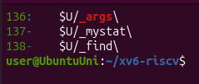
Figure 4.1 – The UPROGS lines for mystat and find
I tested it on a fresh disk (make clean ; make qemu) with the commands from the lab sheet. find . r2 printed all three files: ./a/b/r2, ./a/r2 and ./r2. The first find a b gave exec find failed. The program was not the problem (it had just worked a second earlier); the line I sent got an invisible character, so the shell looked for a program with a different name. When I typed find a b again by hand it printed a/b (Figure 4.3).
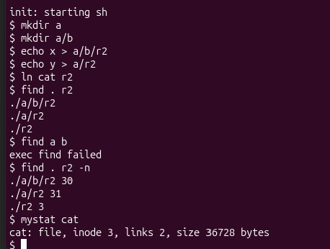
Figure 4.2 – Testing find, and the -n stretch
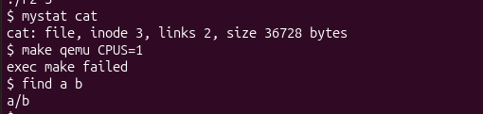
Figure 4.3 – find a b typed again
Stretch: which of the three r2 files are the same file as cat?
find . r2 -n printed ./a/b/r2 30, ./a/r2 31 and ./r2 3, and mystat cat showed cat: file, inode 3, links 2. So ./r2 is the same file as cat: it has the same inode 3, and cat now has 2 links because of ln cat r2. The other two, a/r2 and a/b/r2, are different files (inodes 31 and 30) that just have the same name.

Conclusions (Lab 6)
The xv6 file system works with the same ideas as the Linux one from Lab 5, but it is much simpler. A directory is just a file with 16-byte entries (an inode number and a 14-character name), and an inode stores only the type, the link count, the size and the block addresses, with no owner, permissions or timestamps. With mystat I saw that a hard link is only a second name for the same inode, that rm only decrements nlink (line 244 in sys_unlink), and that the blocks are freed later in iput().
From kernel/fs.h I calculated the limits: names of at most 14 characters, and files of at most 268 KB, because of 12 direct blocks and one indirect block. Writing find showed how a program walks the tree: open a directory, read the entries, skip . and .., and call itself recursively for every entry.

