
MINISTRY OF EDUCATION, CULTURE AND RESEARCH
OF THE REPUBLIC OF MOLDOVA
Technical University of Moldova
Faculty of Computers, Informatics and Microelectronics
Department of Software Engineering and Automation

Macari Chiril-Adam, FAF-243

Report
Lab Work No.1
Techniques and Mechanisms of Software Design
Creational Design Patterns

Checked by: asist. univ. Istrati Daniel

Chișinău – 2026

1. Objectives
- Get familiar with the Creational Design Patterns;
- Choose a specific domain, define its main classes and the instantiation mechanisms they need;
- Implement at least 3 Creational Design Patterns for the chosen domain.

2. Theoretical Background

2.1 Overview
Creational design patterns deal with object instantiation. Instead of creating objects directly with new all over the code, they move the creation logic into dedicated places, so the rest of the program does not depend on how, when or which concrete objects are created. This makes the code more flexible: the type of object, the way it is assembled or the number of instances can change without modifying the code that uses it.
The creational patterns are usually divided into two groups:
- Class-creation patterns use inheritance to decide which class gets instantiated. A subclass overrides a method to choose the concrete type (Factory Method).
- Object-creation patterns use delegation: the creation is handed over to another object (Abstract Factory, Builder, Prototype, Singleton, Object Pool).
Pattern | Group | Main idea
Singleton | Object | Exactly one instance of a class, with a global access point
Factory Method | Class | Subclasses decide which concrete class to instantiate
Abstract Factory | Object | Creates whole families of related objects
Builder | Object | Builds a complex object step by step
Prototype | Object | Creates new objects by cloning an existing one
Object Pool | Object | Reuses a set of already created, expensive objects

2.2 Singleton
Intent. Ensure that a class has only one instance at any time and provide a global point of access to it.
Structure. The class keeps a private static field with its only instance, has a private constructor (so no one else can call new) and exposes a static method, usually getInstance(), that creates the instance the first time and returns the same one afterwards.
Thread safety. If two threads call getInstance() at the same moment, a naive implementation can create two instances. Common thread-safe variants in Java:
- Eager initialization: the instance is created when the class is loaded (private static final Singleton INSTANCE = new Singleton();). Simple, but the object is created even if never used.
- Synchronized method: getInstance() is synchronized. Correct, but every call pays the cost of locking.
- Double-checked locking: checks the instance once without a lock and once inside a synchronized block; the field must be volatile. Lazy and fast after the first call.
- Holder class (Bill Pugh): a static nested class holds the instance; the JVM loads it only on first use, which is lazy and thread-safe without explicit locks.
- Enum singleton: enum Singleton { INSTANCE; }. Thread-safe and also safe against serialization and reflection.
When to use. Objects that must exist exactly once because a second instance would break something: an ID or sequence generator, the application configuration, a logger.
Drawbacks. It introduces global state, hides dependencies and makes unit testing harder, so it should be used only when "exactly one" is a real requirement.
What should not be a Singleton. A database, a repository or a service that stores application data should not be a Singleton, even if the program uses only one of them. Tests need a fresh, empty instance (or a fake one) for every test case, a real application may need several databases or connections, and a globally accessible data store hides which classes depend on it. Such objects should be created once by the client and passed to the classes that need them (dependency injection, as in the Dependency Inversion Principle). The Singleton fits objects whose uniqueness is part of their meaning, where a second instance would cause wrong behaviour: an ID or sequence generator, the application configuration, a logger.
In the hotel domain. Confirmation codes (RES-0001, RES-0002, ...) must be unique in the whole hotel. If two generators existed, both would start counting from 1 and two guests would receive the same code, so the generator must exist exactly once.

2.3 Factory Method
Intent. Define an interface for creating an object, but let subclasses decide which class to instantiate.
Structure. Product (common interface), Concrete Products, Creator (declares the abstract factory method and usually contains logic that uses the product) and Concrete Creators (override the factory method to return a specific product).
When to use. When a class cannot know in advance which concrete objects it must create, or when the creation of a product should be extended later by adding new subclasses instead of changing existing code (Open/Closed Principle).
Pros and cons. Removes the dependency of the client on concrete classes and keeps creation code in one place, but every new product needs a new creator subclass.
In the hotel domain. Each room type (single, double, suite) has its own factory. Opening a new room type means adding a new factory, without changing the code that opens rooms.

2.4 Abstract Factory
Intent. Provide an interface for creating families of related or dependent objects without specifying their concrete classes.
Structure. An Abstract Factory interface declares one creation method per product type (each of them is a factory method). Concrete Factories implement it for one family. The client works only with the abstract factory and the abstract products, so the products it receives always belong to the same family.
When to use. When the system must work with several families of products that have to be used together (for example, UI widgets for Windows vs macOS) and the family can be switched as a whole.
Pros and cons. Guarantees consistent families and makes switching families easy, but adding a new kind of product requires changing the abstract factory and all of its implementations.
Difference from Factory Method. Factory Method creates one product and relies on inheritance; Abstract Factory creates a family of products and relies on composition (the client receives a factory object).
In the hotel domain. A RoomThemeFactory could create matching sets of furniture, decorations and welcome packs for a "Classic" or a "Modern" room theme.

2.5 Builder
Intent. Separate the construction of a complex object from its representation, so that the same construction process can create different representations.
Structure. Builder (step-by-step construction methods), Concrete Builder (assembles the parts and returns the result), Director (knows the order of steps for common configurations) and Product (the complex object). In Java it is often implemented as a static nested Builder class with chained ("fluent") methods and a final build() call.
When to use. When an object has many parameters, most of them optional, and a constructor with a long list of arguments ("telescoping constructor") would be hard to read and easy to misuse. It also allows validating the object once, before it is created, and makes the result immutable.
Pros and cons. Readable creation code, immutable objects and validation in one place, at the cost of an extra class.
In the hotel domain. A reservation has 4 required fields (guest, room, check-in, check-out) and many optional ones (number of guests, breakfast, parking, airport transfer, special requests).

2.6 Prototype
Intent. Create new objects by copying an existing object (the prototype) instead of building them from scratch.
Structure. A Prototype interface declares a clone() method; Concrete Prototypes implement it. Often a prototype registry (a collection that caches ready-made prototypes) returns copies on request. In Java this can be done with Cloneable and clone(), or more safely with a copy constructor.
Shallow vs deep copy. A shallow copy duplicates only the object itself, so it shares the referenced objects (lists, nested objects) with the original; a deep copy duplicates them too. Choosing the wrong one leads to copies that unexpectedly change together.
When to use. When creating an object is expensive (loading data, complex setup) or when the system needs many objects that differ only slightly from a few preconfigured ones.
In the hotel domain. A preconfigured "conference package" (meeting room, coffee breaks, projector) could be cloned and then slightly adjusted for each company.

2.7 Object Pool
Intent. Keep a set of initialized objects ready to use, instead of creating and destroying them on demand. A client acquires an object from the pool, uses it and releases it back.
When to use. When objects are expensive to create and are needed often but only for a short time, and the number of objects in use at the same time is limited. Classic examples are database connection pools and thread pools.
Things to watch. Objects must be reset to a clean state when they are returned; the pool must be thread-safe; and a client that never releases an object makes the pool run empty.
In the hotel domain. A limited number of shuttle buses or key-card encoders can be modelled as a pool: a reception desk takes one, uses it and gives it back.

2.8 Choosing a Pattern
Problem | Pattern
Only one instance may exist and everyone must share it | Singleton
The concrete class to create should be decided by subclasses | Factory Method
Several related objects must be created as a consistent family | Abstract Factory
The object has many optional parts or needs validation before creation | Builder
New objects should be copies of a preconfigured object | Prototype
Expensive objects should be reused instead of re-created | Object Pool

The patterns are often combined. For example, an Abstract Factory is usually implemented with Factory Methods, and factories or builders are frequently Singletons.

3. Used Design Patterns
- Singleton — ReservationNumberGenerator, which hands out unique confirmation codes;
- Factory Method — RoomFactory and its subclasses SingleRoomFactory, DoubleRoomFactory, SuiteFactory;
- Builder — Reservation.Builder together with the ReservationDirector.

4. Implementation

4.1 Domain and Project Structure
The project models a small hotel. Rooms of different types are opened through factories, reservations with optional extras are created with a builder, and every confirmed reservation receives a unique code from a single number generator. Rooms and reservations are stored in a BookingSystem, which is a regular class: the client creates it once and passes it to the parts that need it. The packages are separated by responsibility, as required: client contains the program that uses the domain, and domain contains the models, the factories, the builder director and the services.
src/main/java/hotel/
├── client/
│ └── Main.java demo: uses all three patterns
└── domain/
├── models/
│ ├── Room.java abstract product
│ ├── SingleRoom.java concrete products
│ ├── DoubleRoom.java
│ ├── Suite.java
│ ├── RoomType.java
│ └── Reservation.java product + nested Builder
├── factory/
│ ├── RoomFactory.java Factory Method: abstract creator
│ ├── SingleRoomFactory.java concrete creators
│ ├── DoubleRoomFactory.java
│ └── SuiteFactory.java
├── builder/
│ └── ReservationDirector.java Builder: director with preset packages
└── service/
├── ReservationNumberGenerator.java Singleton
└── BookingSystem.java rooms + reservations (injected, not a Singleton)
Figure 1 shows the architecture of the project: the packages, the classes that belong to each pattern and how they depend on each other. The numbered arrows from Main follow the order in which the client uses the patterns.
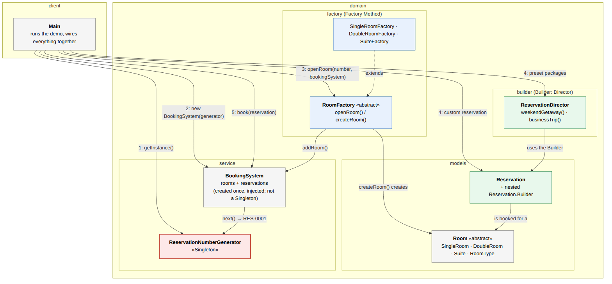
Figure 1. Architecture of the hotel booking system (red: Singleton, blue: Factory Method, green: Builder)

4.2 Singleton — ReservationNumberGenerator
Every confirmed reservation gets a confirmation code such as RES-0001. The codes must be unique in the whole hotel, so there must be exactly one generator. Its constructor is private, and the only way to get the object is getInstance(), which uses double-checked locking with a volatile field. That makes the creation thread-safe while avoiding a lock on every call after the instance exists. The next() method is synchronized, so two desks booking at the same moment can never receive the same code.
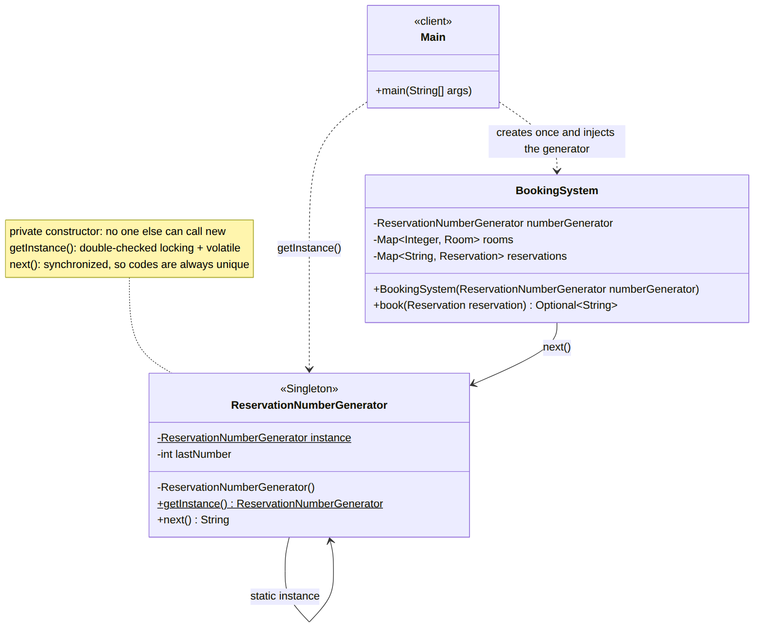
Figure 2. Singleton: ReservationNumberGenerator holds its only instance in a static field; BookingSystem receives it through the constructor
public final class ReservationNumberGenerator {

// volatile: every thread sees the fully constructed instance
private static volatile ReservationNumberGenerator instance;

private int lastNumber = 0;

// private constructor: nobody outside can call "new ReservationNumberGenerator()"
private ReservationNumberGenerator() {
System.out.println("[ReservationNumberGenerator] Single instance created");
}

// thread-safe lazy initialization with double-checked locking
public static ReservationNumberGenerator getInstance() {
if (instance == null) {
synchronized (ReservationNumberGenerator.class) {
if (instance == null) {
instance = new ReservationNumberGenerator();
}
}
}
return instance;
}

// synchronized: two desks booking at the same moment never get the same code
public synchronized String next() {
lastNumber++;
return String.format("RES-%04d", lastNumber);
}
}
BookingSystem, which stores the rooms and reservations, is deliberately not a Singleton. It works like an in-memory database, and a database should be injected rather than accessed globally (see section 2.2). The client creates one BookingSystem and passes it to the factories and to the booking code. The generator is also passed to BookingSystem through its constructor, so the dependency is visible instead of hidden behind a getInstance() call inside the class:
// the generator is injected, so the dependency is visible in the constructor
public BookingSystem(ReservationNumberGenerator numberGenerator) {
this.numberGenerator = numberGenerator;
}
// returns the confirmation code, or empty if the room is already taken for those dates
public synchronized Optional<String> book(Reservation reservation) {
if (!isAvailable(reservation.getRoom(), reservation.getCheckIn(), reservation.getCheckOut())) {
return Optional.empty();
}
String code = numberGenerator.next();
reservations.put(code, reservation);
return Optional.of(code);
}
// one booking system for the whole program, passed to everyone who needs it
BookingSystem bookingSystem = new BookingSystem(ReservationNumberGenerator.getInstance());
The client checks thread safety by starting 5 threads ("reception desks") that call getInstance() at the same time and collecting the objects they receive:
// 5 reception desks ask for the generator at the same time
Set<ReservationNumberGenerator> seen = ConcurrentHashMap.newKeySet();
List<Thread> desks = new ArrayList<>();
for (int i = 0; i < 5; i++) {
desks.add(new Thread(() -> seen.add(ReservationNumberGenerator.getInstance())));
}
for (Thread desk : desks) desk.start();
for (Thread desk : desks) desk.join();
System.out.println("Distinct instances seen by 5 threads: " + seen.size());

4.3 Factory Method — RoomFactory
RoomFactory is the abstract creator. It declares the factory method createRoom() and contains the common logic in openRoom(), which creates a room and registers it in the booking system it receives as a parameter. openRoom() works only with the abstract Room, so it never needs to know which concrete class was created. That decision belongs to the subclasses.
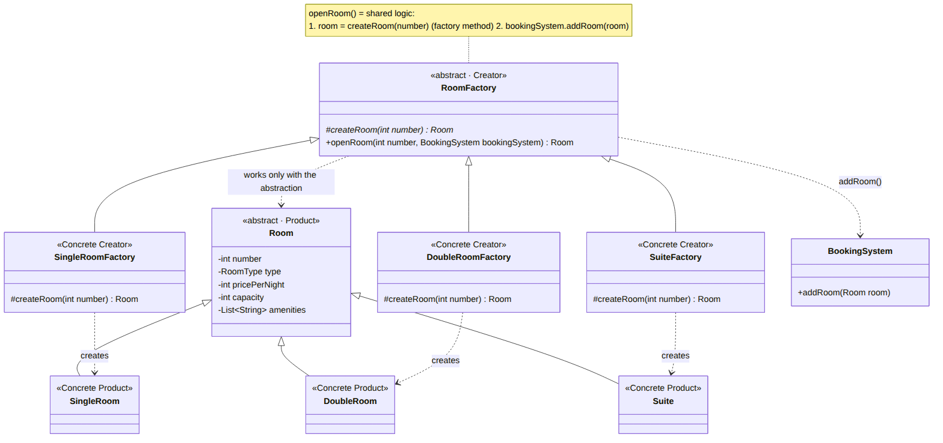
Figure 3. Factory Method: each concrete creator overrides createRoom() and creates its own concrete product
public abstract class RoomFactory {

// the factory method
protected abstract Room createRoom(int number);

public Room openRoom(int number, BookingSystem bookingSystem) {
Room room = createRoom(number);
bookingSystem.addRoom(room);
return room;
}
}
Each concrete creator overrides only the factory method and returns its own type of room:
public class SuiteFactory extends RoomFactory {
@Override
protected Room createRoom(int number) {
return new Suite(number);
}
}
The client picks a factory by room type and uses it through the RoomFactory abstraction, without referring to SingleRoom, DoubleRoom or Suite directly. Adding a new room type (for example, a family room) means adding one product class and one factory, with no changes to RoomFactory or to the existing factories.
Map<RoomType, RoomFactory> factories = Map.of(
RoomType.SINGLE, new SingleRoomFactory(),
RoomType.DOUBLE, new DoubleRoomFactory(),
RoomType.SUITE, new SuiteFactory());

// the client only knows RoomFactory, not the concrete room classes
factories.get(RoomType.SINGLE).openRoom(101, bookingSystem);
factories.get(RoomType.SINGLE).openRoom(102, bookingSystem);
factories.get(RoomType.DOUBLE).openRoom(201, bookingSystem);
factories.get(RoomType.DOUBLE).openRoom(202, bookingSystem);
factories.get(RoomType.SUITE).openRoom(301, bookingSystem);
The rooms created by the factories are registered in the booking system, and the reservations built later are made for these rooms, so the three patterns work on the same objects.

4.4 Builder — Reservation.Builder and ReservationDirector
A Reservation has 4 required fields and 5 optional ones. Its constructor is private and takes a Builder, so a reservation can only be created through the builder. The required fields are passed to the builder's constructor, the optional ones are set with chained methods, and build() validates the data before the object is created.
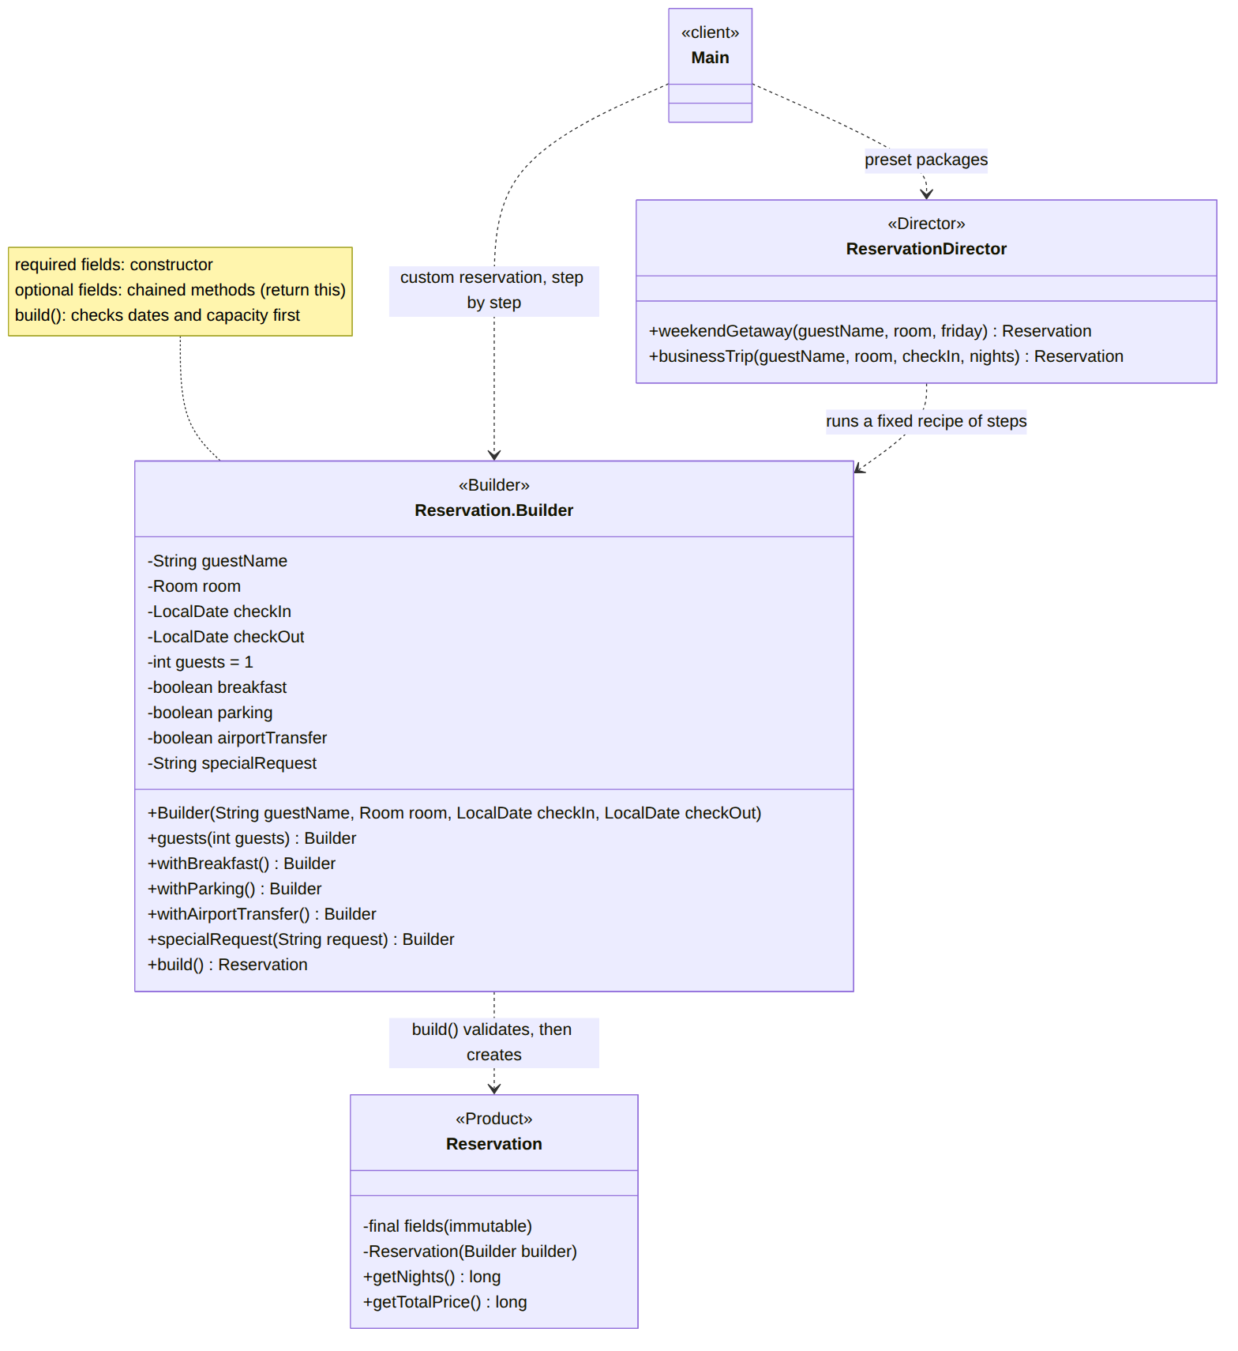
Figure 4. Builder: the client builds custom reservations directly or uses the Director's preset recipes; only build() can create a Reservation
// private: the only way to create a Reservation is through the Builder
private Reservation(Builder builder) {
this.guestName = builder.guestName;
this.room = builder.room;
this.checkIn = builder.checkIn;
this.checkOut = builder.checkOut;
this.guests = builder.guests;
this.breakfast = builder.breakfast;
this.parking = builder.parking;
this.airportTransfer = builder.airportTransfer;
this.specialRequest = builder.specialRequest;
}
public Builder withBreakfast() {
this.breakfast = true;
return this;
}
public Reservation build() {
if (!checkOut.isAfter(checkIn)) {
throw new IllegalStateException("Check-out must be after check-in");
}
if (guests < 1 || guests > room.getCapacity()) {
throw new IllegalStateException("Room " + room.getNumber() + " (" + room.getType()
+ ") fits at most " + room.getCapacity() + " guest(s), requested " + guests);
}
return new Reservation(this);
}
Thanks to the builder, the client code reads almost like a sentence and only mentions the options it actually needs:
Reservation custom = new Reservation.Builder("Maria Popescu", double201, nov10, nov13)
.guests(2)
.withBreakfast()
.withParking()
.specialRequest("Room on a high floor")
.build();
The ReservationDirector plays the role of the Director from the classic Builder structure. It knows the construction steps for the hotel's standard packages, so the same builder produces different representations (a weekend getaway, a business trip) without the client repeating the steps:
public Reservation weekendGetaway(String guestName, Room room, LocalDate friday) {
return new Reservation.Builder(guestName, room, friday, friday.plusDays(2))
.guests(2)
.withBreakfast()
.specialRequest("Late check-out")
.build();
}

public Reservation businessTrip(String guestName, Room room, LocalDate checkIn, int nights) {
return new Reservation.Builder(guestName, room, checkIn, checkIn.plusDays(nights))
.withBreakfast()
.withParking()
.withAirportTransfer()
.build();
}

4.5 Runtime Flow
The sequence diagram in Figure 5 shows how the three patterns cooperate when the first reservation is made. The client gets the single number generator and creates the booking system with it (Singleton). It opens room 201 through a factory, which decides the concrete room class (Factory Method). It then builds and validates Maria's reservation step by step (Builder). Finally, the booking system checks that the room is free and asks the generator for the confirmation code RES-0001.
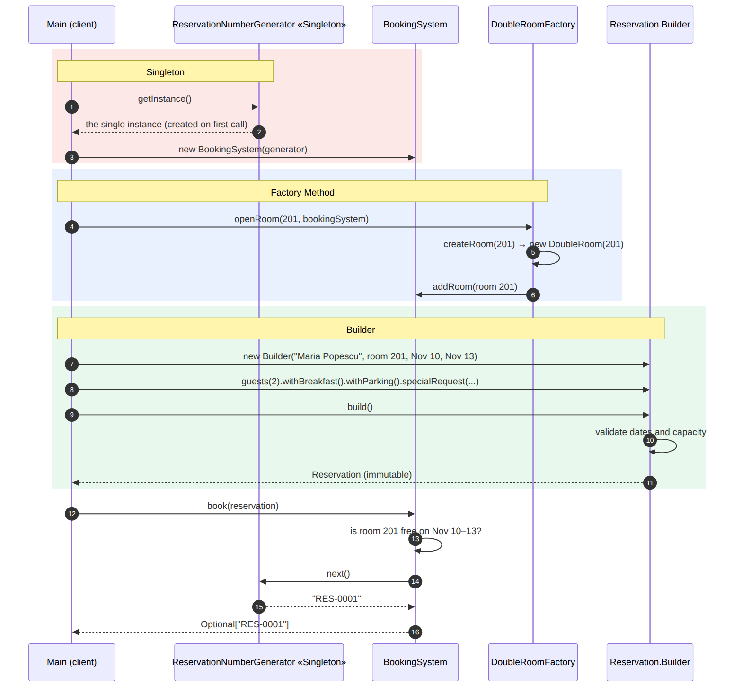
Figure 5. Sequence diagram: how Singleton, Factory Method and Builder work together to create and book the first reservation

5. Results
Running hotel.client.Main produces the following output:
=== 1. Singleton: ReservationNumberGenerator ===
[ReservationNumberGenerator] Single instance created
Distinct instances seen by 5 threads: 1
getInstance() == getInstance(): true

=== 2. Factory Method: opening rooms ===
Room 101 (SINGLE) - 60 EUR/night, up to 1 guest(s), Wi-Fi, Work desk
Room 102 (SINGLE) - 60 EUR/night, up to 1 guest(s), Wi-Fi, Work desk
Room 201 (DOUBLE) - 90 EUR/night, up to 2 guest(s), Wi-Fi, Queen bed, City view
Room 202 (DOUBLE) - 90 EUR/night, up to 2 guest(s), Wi-Fi, Queen bed, City view
Room 301 (SUITE) - 180 EUR/night, up to 4 guest(s), Wi-Fi, King bed, Living room, Jacuzzi

=== 3. Builder: creating reservations ===
BOOKED RES-0001 | Maria Popescu | room 201 (DOUBLE) | 2026-11-10 -> 2026-11-13 (3 nights) | 2 guest(s) | extras: breakfast parking | request: Room on a high floor | total: 390 EUR
BOOKED RES-0002 | Ion Rusu | room 301 (SUITE) | 2026-11-13 -> 2026-11-15 (2 nights) | 2 guest(s) | extras: breakfast | request: Late check-out | total: 420 EUR
BOOKED RES-0003 | Elena Ciobanu | room 101 (SINGLE) | 2026-11-10 -> 2026-11-12 (2 nights) | 1 guest(s) | extras: breakfast parking airport-transfer | request: - | total: 200 EUR
Invalid reservation not built: Room 101 (SINGLE) fits at most 1 guest(s), requested 3
REJECTED | Victor Moraru | room 301 (SUITE) | 2026-11-14 -> 2026-11-16 (2 nights) | 1 guest(s) | extras: none | request: - | total: 360 EUR
Total reservations: 3, total revenue: 1010 EUR
The output confirms that each pattern behaves as intended:
- Singleton: five threads requested the number generator at the same time, yet the constructor ran only once and all of them received the same object. The three confirmed reservations received consecutive, unique codes (RES-0001 to RES-0003).
- Factory Method: five rooms of three types were created through the RoomFactory abstraction and registered in the booking system, each with the price, capacity and amenities of its type.
- Builder: one custom reservation and two preset packages from the Director were built and booked, with totals computed from the chosen extras (for example, 3 nights × 90 EUR + breakfast 3 × 2 × 15 EUR + parking 3 × 10 EUR = 390 EUR). The builder refused to create a reservation for 3 guests in a single room.
- Booking system: the booking for the suite on 14–16 November was rejected because it overlaps the weekend package, and it did not consume a confirmation code. This works because the client created one BookingSystem and passed the same object to every part of the program, without making it a Singleton.

6. Conclusions
In this laboratory work I studied the creational design patterns and implemented three of them in a hotel booking system. Each pattern solved a concrete problem of the domain:
- Singleton guarantees that the hotel has exactly one reservation number generator, so confirmation codes are never duplicated. Making it thread-safe with double-checked locking and a synchronized next() method was essential, since several reception desks can book at the same time. An important lesson was choosing what to make a Singleton: the booking system stores data like a database, so it is injected instead, which keeps it replaceable and testable.
- Factory Method removed the dependency of the client on concrete room classes. New room types can be added by writing a new factory, without touching the existing code, which also follows the Open/Closed Principle from the previous laboratory work.
- Builder made it possible to create reservations with many optional parameters in a readable way, to validate them before creation and to keep them immutable. The Director added reusable presets for the hotel's standard packages.
The patterns also complement each other: the factories create the rooms, the builder creates reservations for those rooms, and the Singleton numbers every confirmed booking. The remaining patterns — Abstract Factory, Prototype and Object Pool — solve related problems (families of objects, cloning, and reusing expensive objects). They were described in the theoretical part with examples of how they could extend this project.
Overall, creational patterns move the responsibility of creating objects away from the code that uses them, which results in code that is easier to extend, test and maintain.

References
- Vasile Drumea, Creational Design Patterns, lecture slides, Software Design Techniques and Mechanisms, Technical University of Moldova.
- E. Gamma, R. Helm, R. Johnson, J. Vlissides, Design Patterns: Elements of Reusable Object-Oriented Software, Addison-Wesley, 1994.
- SourceMaking, Creational patterns: https://sourcemaking.com/design_patterns/creational_patterns

