The Effects of T. Cruzi Infection on the Fertility and Fercundity of Cimex *lectularius*.

Introduction

Methods

Data Analysis:

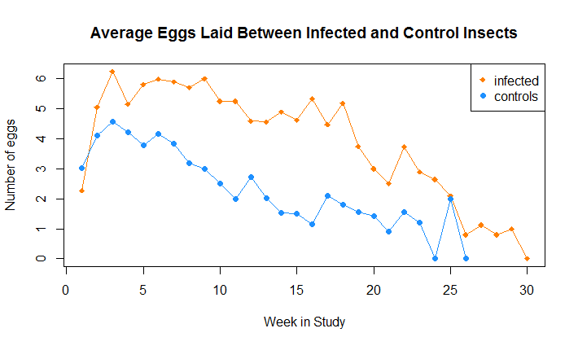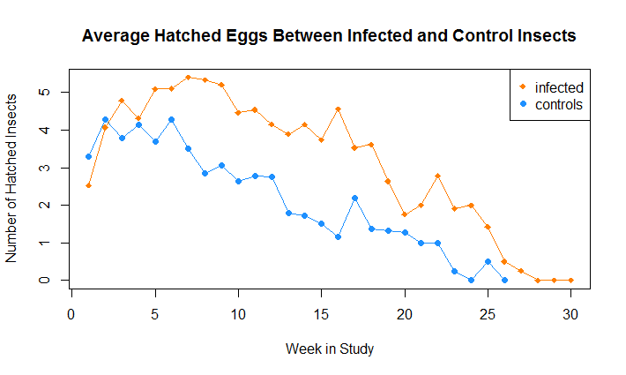Data was analyzed in R version 3.2.1. First we created a contingency table to identify the number of insects in each group. We found that the infected had laid X eggs and X hatched having a X% viability. The controlled insects had laid Y eggs and Y hatched having a Y% viability. The percapita egg rate was X and Y respectively. The per capita hatch rate was X and Y. We then used the chi squared test to test for significance. The results were Z. The number of eggs laid and the number of eggs hatched were plotted by controls and then each treatment group. Those graphs are placed below.

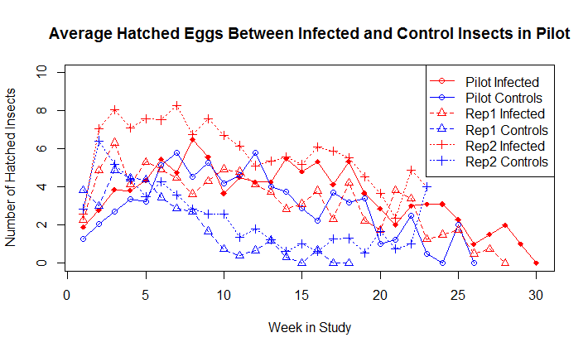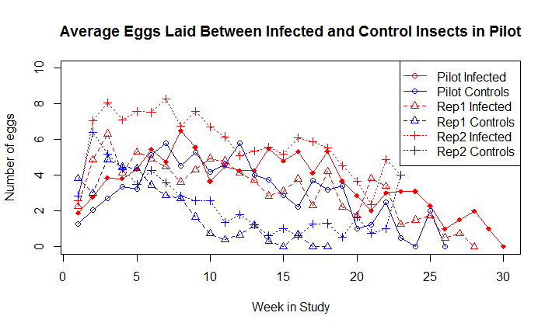

However, there are many known confounders in this data that must still be explored. The insects were not all started on the same day, so humidity , temperature, and the varying death rates between infected and controls may affect the results.