Main DDR - Detailed Diagnostic Report
Prepared for AI DDR Report Generation Assignment
Candidate: Ajay Chirmade
Use Case: AI system that combines inspection observations and thermal findings into a client-ready report
Source Documents Used: Sample Inspection Report and Sample Thermal Report

1. Property Issue Summary
The property shows three main issue groups: moisture intrusion near the living room ceiling, suspected moisture behind the bathroom shared wall, and abnormal heat concentration in the electrical panel. The kitchen wall has minor hairline cracks, but no supporting image was available in the sample inspection report. The electrical panel issue is the most urgent because the thermal report shows a hotspot reading of 72 C near the breaker bank.

2. Area-wise Observations
Area | Merged Observation | Severity | Reasoning
Living Room Ceiling | Water staining and a damp patch were observed near the ceiling corner. Thermal scanning also showed a cooler zone in the same area, which supports the possibility of retained moisture. | Medium | Possible leakage or waterproofing failure. Repair should be planned soon to prevent spread.
Bathroom Shared Wall | Damp smell and moisture marks were observed. Thermal review suggested an irregular cool pattern, but exact reading was not available. | Medium | Likely hidden plumbing leakage or trapped moisture. Further moisture meter testing is needed.
Kitchen Wall | Minor hairline cracks were seen near the wall edge. No image was captured for this point. | Low | Likely plaster shrinkage or minor settlement. Monitor and repair if cracks widen.
Electrical Panel | Inspection noted the panel cover felt warmer than surrounding wall. Thermal image confirmed abnormal heat concentration near breaker bank with a maximum reading of 72 C. | High | Immediate electrical inspection is recommended because overheating may indicate loose connection, overload, or component failure.

Observation Images

Living Room Ceiling
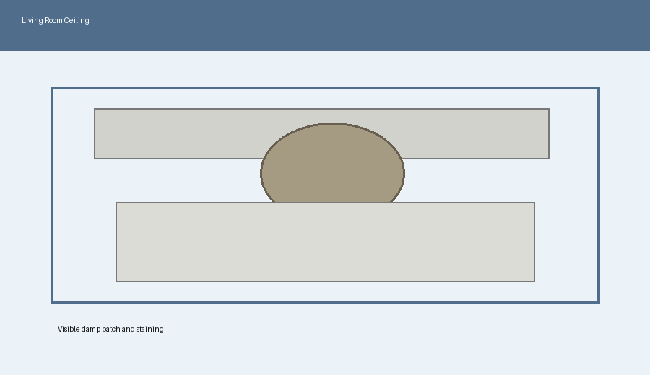
Visual evidence: damp patch near ceiling corner

Living Room Ceiling
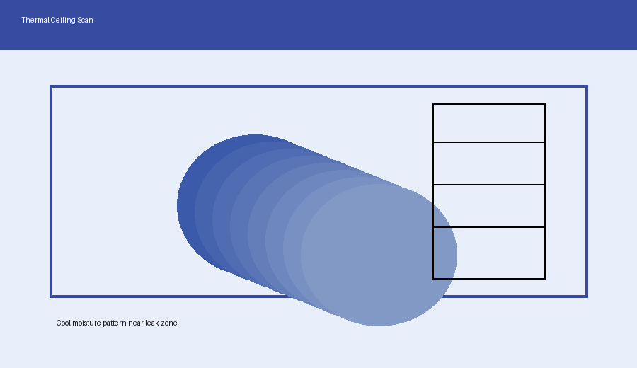
Thermal evidence: cooler zone matching damp area

Bathroom Shared Wall
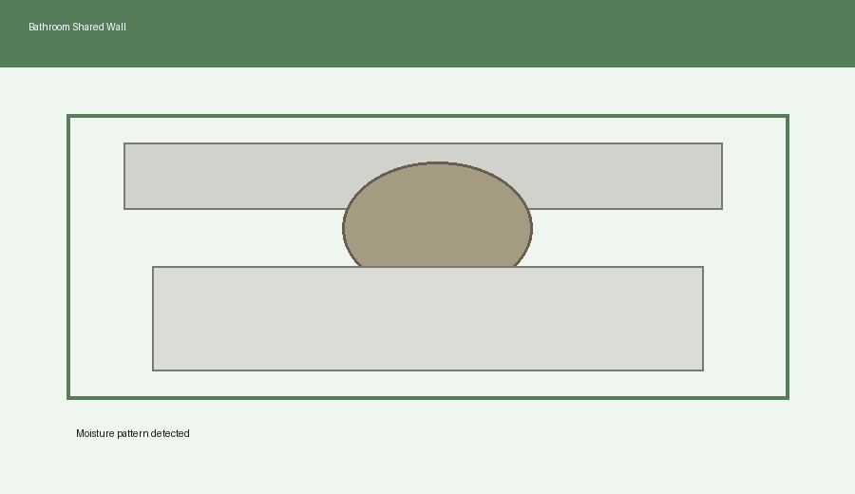
Visual evidence: moisture staining on shared wall

Electrical Panel
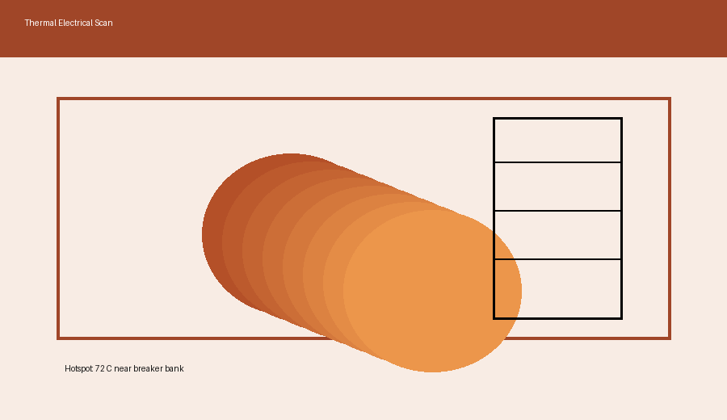
Thermal evidence: hotspot near breaker bank

3. Probable Root Cause
The probable causes are plumbing leakage, weak waterproofing around wet areas, retained moisture inside walls or ceiling, and possible electrical load imbalance or loose panel connection. The kitchen crack appears more consistent with plaster shrinkage or minor settlement rather than a major structural defect based on the available sample data.

4. Severity Assessment with Reasoning
High severity: Electrical panel overheating because the thermal report shows a 72 C hotspot. This should be treated as urgent due to possible fire and safety risk.
Medium severity: Living room ceiling and bathroom shared wall moisture because continued dampness can damage finishes, create mold risk, and spread if the source remains active.
Low severity: Kitchen wall hairline cracks because no major displacement or structural distress is available in the sample data.

5. Recommended Actions
- Arrange immediate inspection of the electrical panel by a licensed electrician.
- Check breaker load, wire connections, and signs of insulation damage.
- Trace the source of moisture near the ceiling and bathroom wall.
- Repair leakage source before repainting or cosmetic work.
- Use moisture meter testing and plumbing pressure testing for confirmation.
- Seal kitchen hairline cracks after monitoring for movement.

6. Additional Notes
The report was generated using sample input documents because the company did not provide original inspection and thermal files. The workflow is designed to generalise to similar inspection documents by separating extraction, merging, validation, severity assessment, and report writing steps.

7. Missing or Unclear Information
- Exact plumbing layout: Not Available
- Age of electrical panel: Not Available
- Moisture meter reading for bathroom shared wall: Not Available
- Kitchen wall image: Image Not Available
- Certified electrician comment: Not Available

