Sample Inspection Report
Prepared for AI DDR Report Generation Assignment
Property Type: Residential apartment
Inspection Date: 20 May 2026
Inspector Notes: The inspection was completed visually. Some hidden plumbing areas could not be opened during inspection.
Area | Observation | Risk Indication | Evidence
Living Room Ceiling | Water staining and damp patch observed near the ceiling corner. | Possible leakage or waterproofing failure. | Image attached below
Bathroom Shared Wall | Damp smell and moisture marks observed on the wall surface. | Possible hidden pipe leakage. | Image attached below
Kitchen Wall | Minor hairline cracks observed near the wall edge. | Likely settlement or plaster shrinkage. | No image captured
Electrical Panel | Panel cover felt warmer than surrounding wall. | Possible load imbalance or loose connection. | Thermal validation required

Supporting Photos
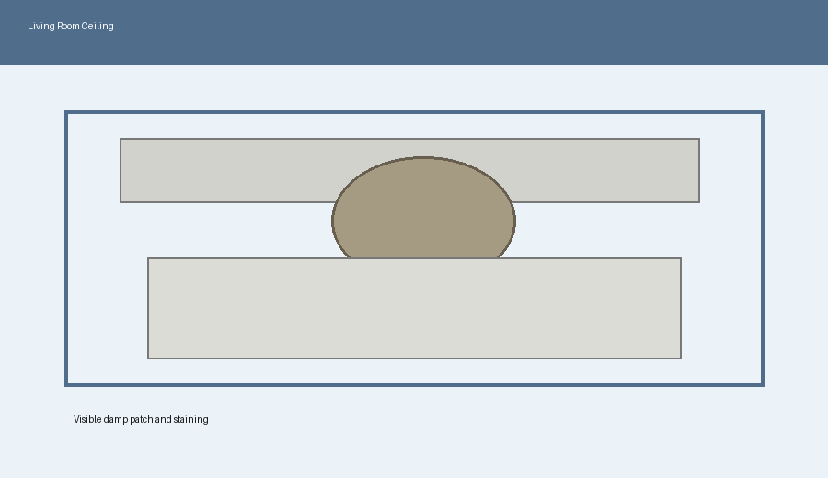
Living Room Ceiling - damp patch near ceiling corner
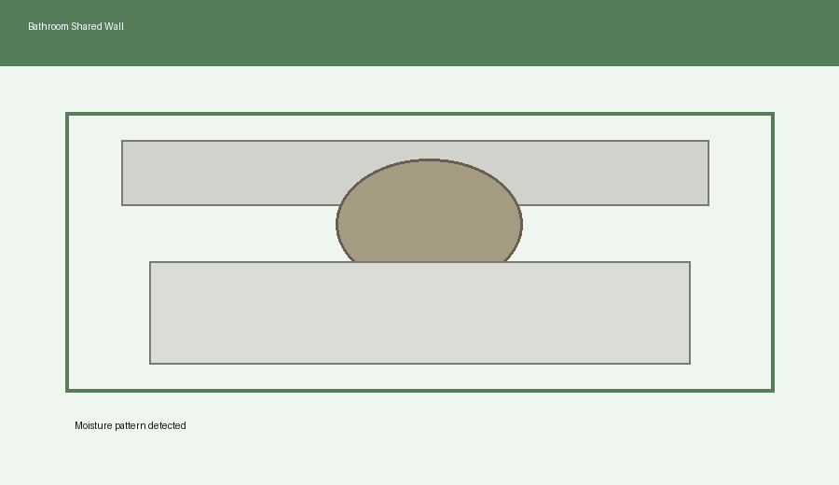
Bathroom Shared Wall - moisture staining

