Sample Thermal Report
Prepared for AI DDR Report Generation Assignment
Thermal Scan Date: 20 May 2026
Device Notes: Thermal values are indicative and should be verified by a certified technician where safety risk exists.
Area | Thermal Finding | Measured Reading | Interpretation | Evidence
Electrical Panel | Abnormal heat concentration near breaker bank. | 72 C maximum | High electrical heat signature requiring urgent check. | Thermal image attached
Living Room Ceiling | Cooler zone matching visual damp patch. | 6 C lower than surrounding ceiling | May indicate retained moisture. | Thermal image attached
Bathroom Shared Wall | Irregular cool pattern behind wall. | Not Available | Moisture suspected but exact source unclear. | Image not captured

Thermal Images
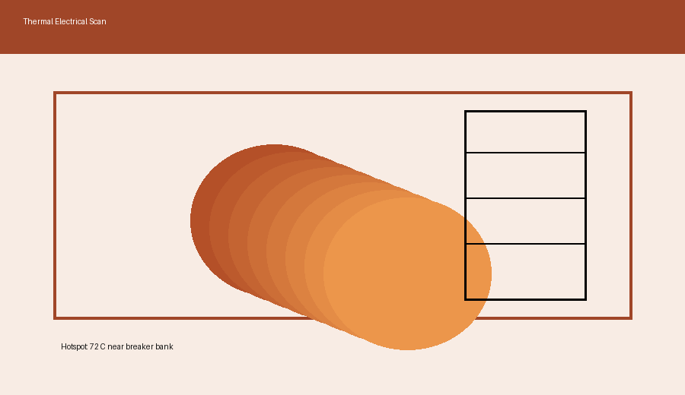
Electrical Panel - hotspot near breaker bank
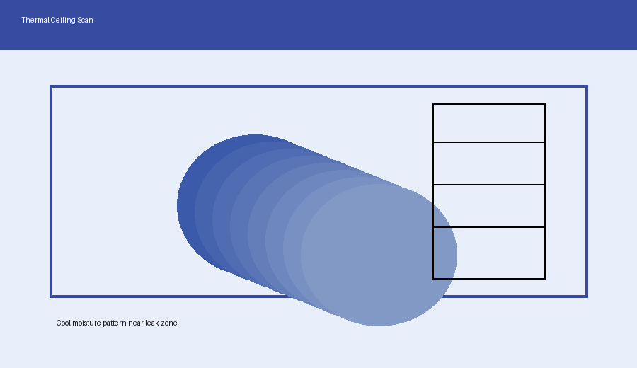
Living Room Ceiling - thermal variation matching damp area

