实验一报告

# 回答问题

请一边熟悉sakila数据库，一边回答以下问题：

1. sakila.mwb模型中，表结构里每个字段前面的小标记分别表示什么意思？ （观察字段的属性）

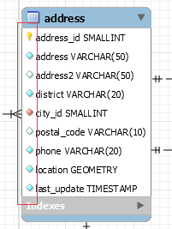

|  |  |
| --- | --- |
| 标记 | 意义 |
|  | 主键 |
|  | 非空的键 |
|  | 默认为空的键 |
|  | 来自其他表的非空外键 |

2. 图中哪部分体现影片-演员关系？换句话说，如果要找出演某个影片的演员名字，访问哪几张表可以获得信息？

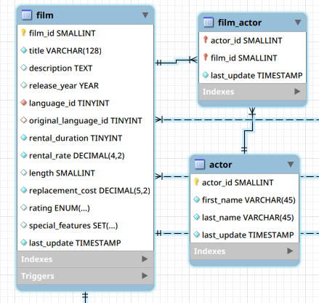这三个表体现了影片-演员关系：film、film_actor、actor

3. 如果已知某个顾客姓名，要找到他租借的所有影片名，需要访问哪几张表？

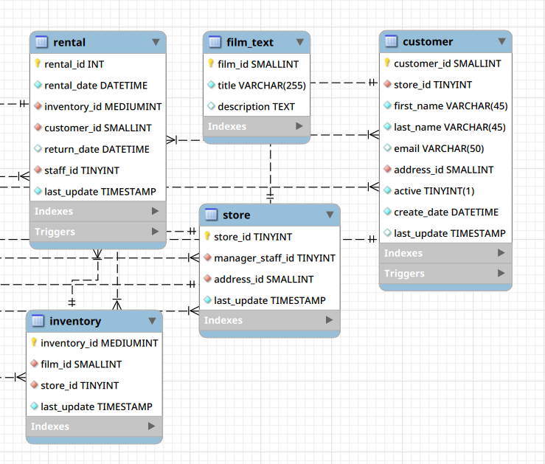需要访问 rental、film_text、custormer、inventory、store这几张表

4. film和language表间的2条虚线表示什么意思？

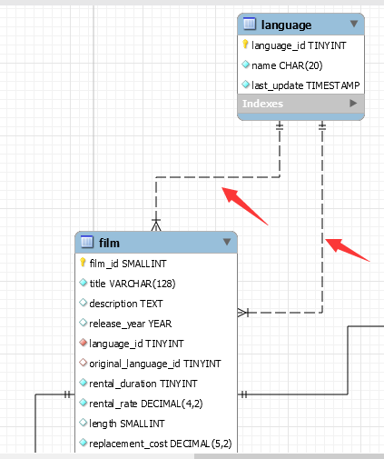

film表中引用了两个外键：language_id、original_language_id，设置的外键都来自于表languague的主键language_id

# 实验截图

*（注意截图清晰，截图时需要体现SQL语句、执行结果、Output窗口）*

1. 请列出所有商店的详细地址，显示商店id，商店地址，所在区域，所在城市，所在国家；

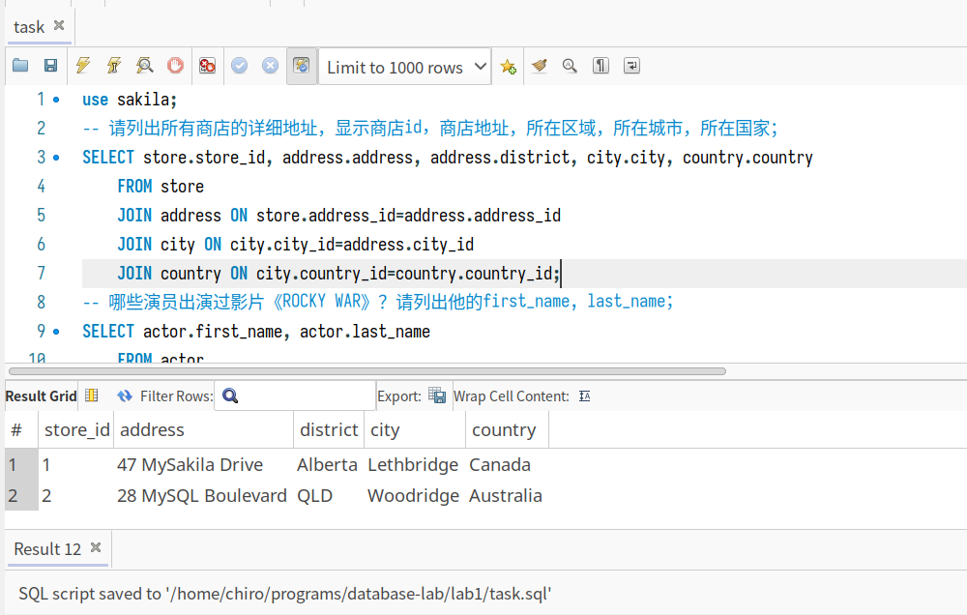

SELECT store.store_id, address.address, address.district, city.city, country.country

FROM store

JOIN address ON store.address_id=address.address_id

JOIN city ON city.city_id=address.city_id

JOIN country ON city.country_id=country.country_id;

1. 哪些演员出演过影片《ROCKY WAR》？请列出他的first_name, last_name；

SELECT actor.first_name, actor.last_name

FROM actor

JOIN film_actor ON actor.actor_id=film_actor.actor_id

JOIN film_text ON film_text.film_id=film_actor.film_id

WHERE film_text.title="ROCKY WAR";

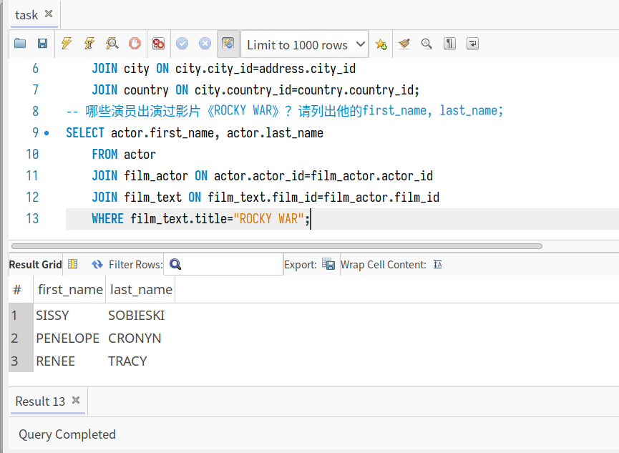

1. 找出租DVD花费最高的前5名，请列出他们的first_name, last_name和每个人花费的金额；

SELECT customer.first_name, customer.last_name, SUM(payment.amount)

FROM customer

JOIN rental ON rental.customer_id=customer.customer_id

JOIN payment ON payment.rental_id=rental.rental_id

GROUP BY customer.customer_id

ORDER BY SUM(payment.amount) DESC

LIMIT 5;

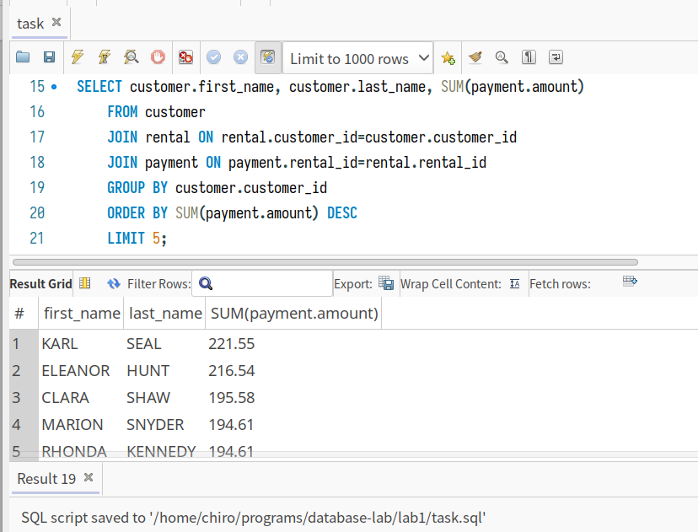

1. 哪个影片获得了总体最高的租金？请列出影片id、影片名、总租金；

SELECT film_text.film_id, film_text.title, SUM(payment.amount)

FROM payment

JOIN rental ON rental.rental_id=payment.rental_id

JOIN inventory ON inventory.inventory_id=rental.inventory_id

JOIN film_text ON film_text.film_id=inventory.film_id

GROUP BY film_text.film_id

ORDER BY SUM(payment.amount) DESC

LIMIT 1;

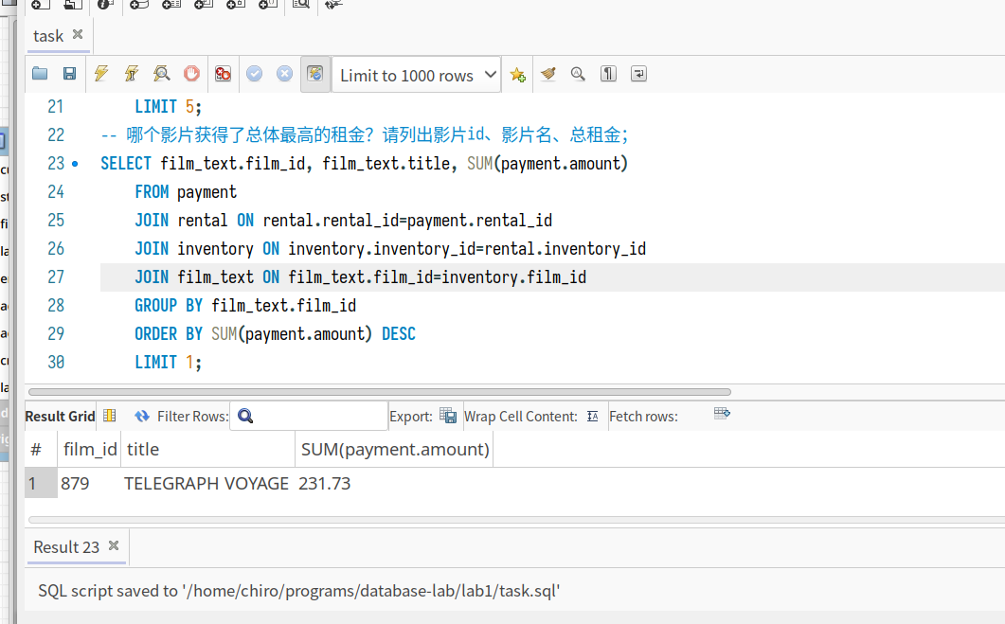

1. 哪个演员出演的电影超过35部？ 请列出演员id、演员名、出演的电影数；

SELECT actor.actor_id, actor.first_name, actor.last_name, COUNT(*)

FROM actor

JOIN film_actor ON actor.actor_id=film_actor.actor_id

GROUP BY actor.actor_id ORDER BY COUNT(*) DESC LIMIT 1;

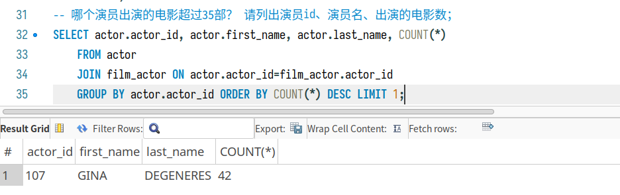

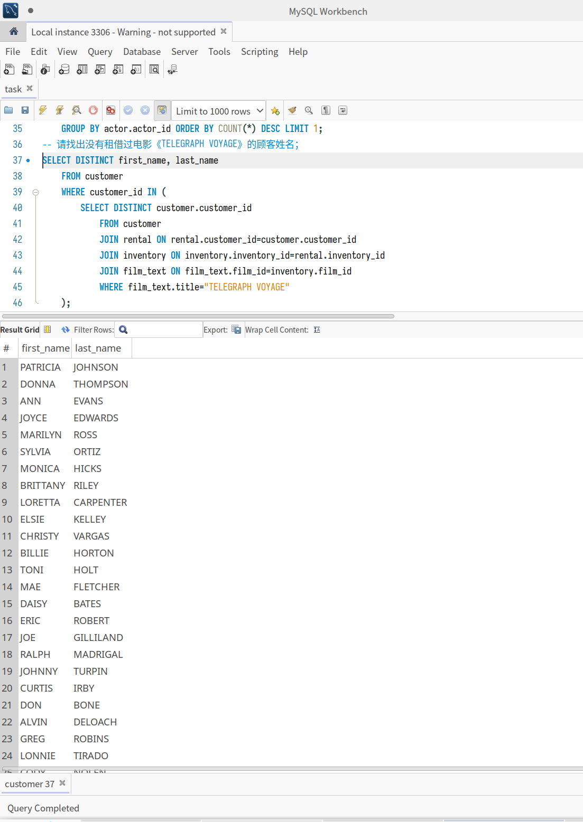

1. 请找出没有租借过电影《TELEGRAPH VOYAGE》的顾客姓名；

SELECT DISTINCT first_name, last_name

FROM customer

WHERE customer_id IN (

SELECT DISTINCT customer.customer_id

FROM customer

JOIN rental ON rental.customer_id=customer.customer_id

JOIN inventory ON inventory.inventory_id=rental.inventory_id

JOIN film_text ON film_text.film_id=inventory.film_id

WHERE film_text.title="TELEGRAPH VOYAGE"

);

1. 查询演过《ELEPHANT TROJAN》和《SPLASH GUMP》这两部电影的演员，列出其姓名；

SELECT DISTINCT actor.first_name, actor.last_name

FROM actor

JOIN film_actor ON film_actor.actor_id=actor.actor_id

JOIN film_text ON film_actor.film_id=film_text.film_id

WHERE film_text.title="ELEPHANT TROJAN" AND actor.actor_id IN (

SELECT actor.actor_id

FROM actor

JOIN film_actor ON film_actor.actor_id=actor.actor_id

JOIN film_text ON film_actor.film_id=film_text.film_id

WHERE film_text.title="SPLASH GUMP"

);

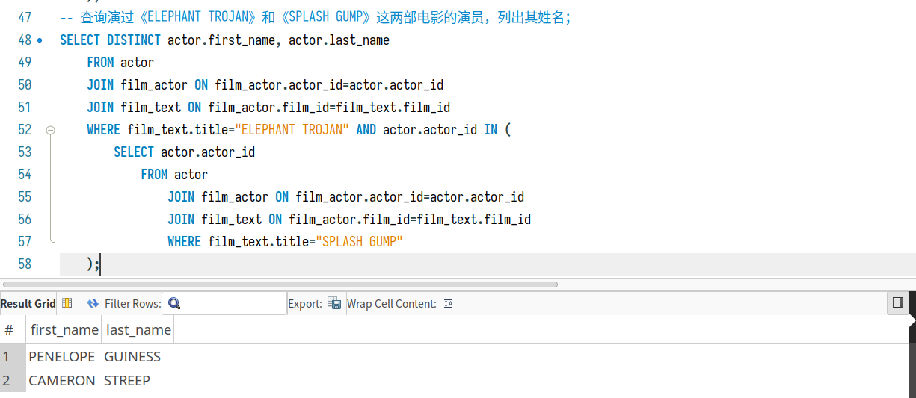

1. 统计每种类型的影片数，显示类型编号、类型名称、该类型影片数；

SELECT category.category_id, category.name

FROM film_category

JOIN category ON film_category.category_id=category.category_id

GROUP BY category.category_id;

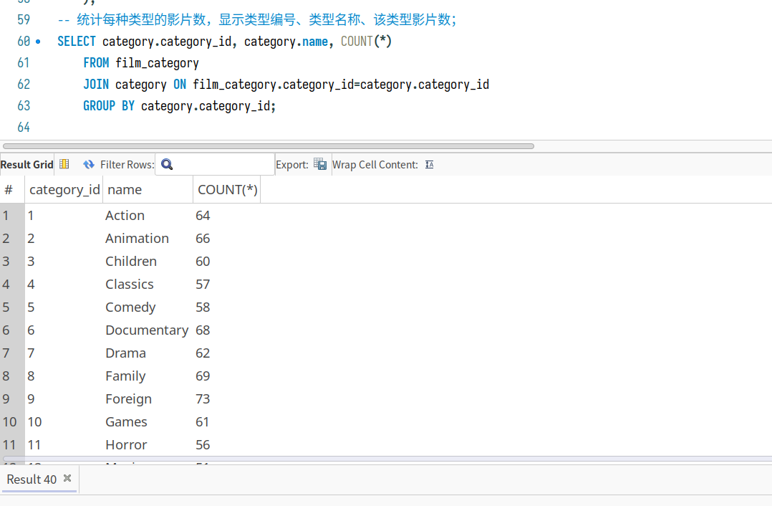

1. 有哪些影片是2个商店都有库存的？

SELECT DISTINCT film_text.title

FROM inventory

JOIN film_text ON film_text.film_id=inventory.film_id

GROUP BY inventory.film_id

HAVING COUNT(DISTINCT inventory.store_id) > 1;

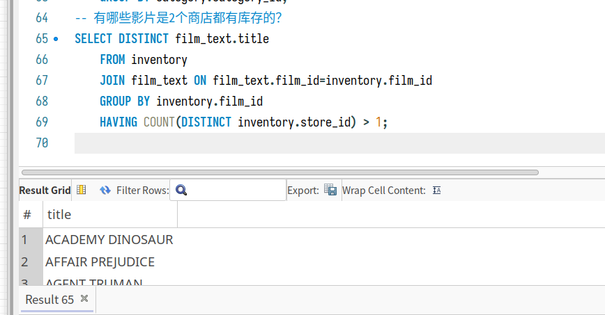

1. 查询单次租借影片时间最长的6位客户，列出其first_name、last_name和当次租借时长；

SELECT customer.first_name, customer.last_name, TIMESTAMPDIFF(DAY, rental.rental_date, rental.return_date) as rental_days

FROM rental

JOIN customer ON customer.customer_id=rental.customer_id

ORDER BY rental_days DESC

LIMIT 6;

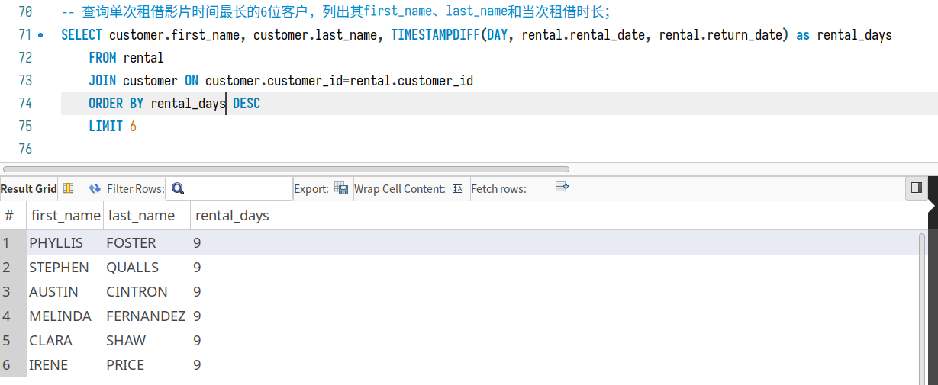

1. 在customer表中新增一条数据，注意customer表与其他表的关系；

INSERT INTO customer (

store_id, first_name, last_name, email, address_id, active

) VALUES (

(SELECT store_id FROM store ORDER BY store_id DESC LIMIT 1),

"Chiro",

"Liang",

"Chiro2001@163.com",

(SELECT address_id FROM address ORDER BY address_id DESC LIMIT 1),

1

);

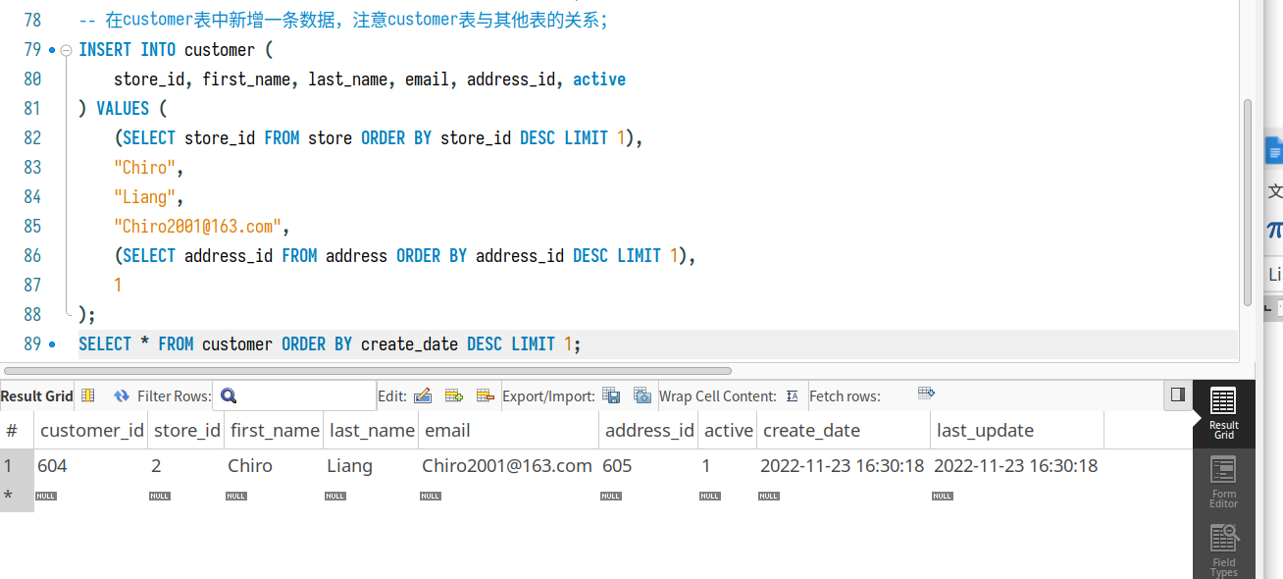

1. 修改刚才在customer表中新增的那条数据；

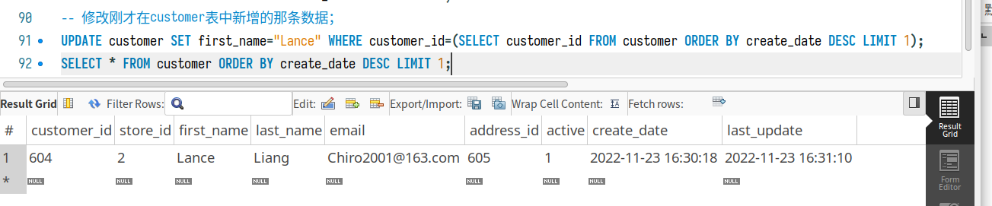

UPDATE customer SET first_name="Lance" WHERE customer_id=(SELECT customer_id FROM customer ORDER BY create_date DESC LIMIT 1);

SELECT * FROM customer ORDER BY create_date DESC LIMIT 1;

1. 删除第11步新增的那条数据。

DELETE FROM customer WHERE customer_id=604;

SELECT * FROM customer ORDER BY create_date DESC LIMIT 1;

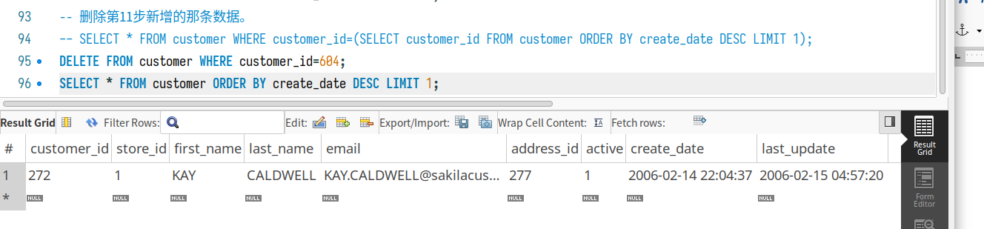

# 思考题

1. 如果insert一条数据到actor表，但actor_id和已有数据重复，会发生什么？同学们请自己尝试一下，截图并分析原因。

SELECT * FROM actor WHERE actor_id=1;

INSERT INTO actor (actor_id, first_name, last_name) VALUES (1, "Chiro", "Liang");

SELECT * FROM actor WHERE actor_id=1;

首先查询一下原数据：

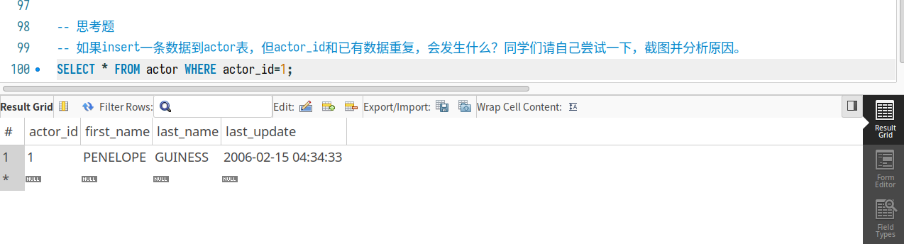在执行插入语句的时候 SQL 提示语句执行有错误，Query interrupted.

执行插入后再查询：

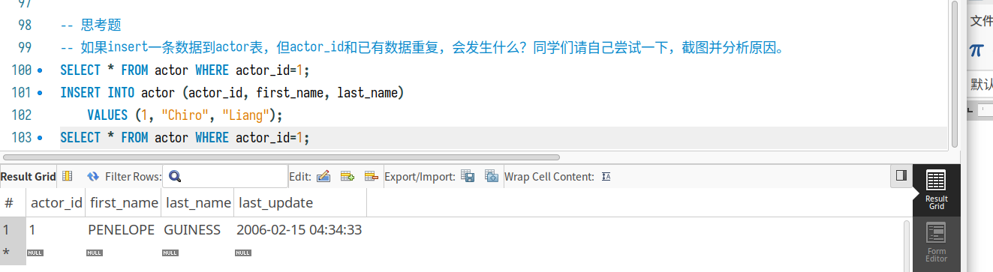查询内容不变。

具体报错为：

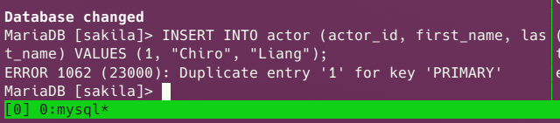

即主键冲突时，无法插入相同主键数据。

1. insert语句还用了一个函数NOW()，是做什么的呢？

NOW() 函数返回当前日期和时间。因为表中的 create_time和update_time都已经配置过自动添加值，所以不使用 NOW() 函数来填充 update_time 和create_time 也是可以的。