|  |
| --- |
| 哈尔滨工业大学(深圳) |
| **《数据库》实验报告** |
|  |
| **实验五**  **查询处理算法的模拟实现**  学 院: 计算机科学与技术   |  |  | | --- | --- | | 姓 名: | 梁鑫嵘 | | 学 号: | 200110619 | | 专 业: | 计算机科学与技术 | | 日 期: | 2023-01-03 | |

# 实验目的

*阐述本次实验的目的。*

*理解索引的作用,掌握关系选择、连接、集合的交、并、差等操作的实现算*

*法,理解算法的 I/O 复杂性。*

# 实验环境

*阐述本次实验的环境。*

*系统：Arch Linux / Windows 11*

*软件：CLion, GCC, MingW-w64, CodeBlocks*

# 实验内容

*阐述本次实验的具体内容。*

*磁盘上储存着关系R与S，其中各有两个属性。基于这些数据完成：*

1. 基于线性搜索的关系选择算法
2. 两阶段多路归并排序算法(TPMMS)
3. 基于索引的关系选择算法
4. 基于排序的连接操作算法(Sort-Merge-Join)
5. 基于排序或散列的两趟扫描算法

# 实验过程

*对实验中的5个题目分别进行分析，并对核心代码和算法流程进行讲解，用自然语言描述解决问题的方案 。并给出程序正确运行的结果截图。*

*在本次实验中实现了一些基础设施，例如：*

* lambda函数：用于构建迭代器（请忽略相关的编辑器报错）
* 迭代器iterator：用于迭代磁盘或内存中的缓冲区队列内容
* 缓冲区队列buffered_queue：用于线性写入磁盘或管理缓冲区内容
* 磁盘缓存cache：用于利用缓冲区减少磁盘IO

以下代码等均一定程度上依赖上述基础设施。

1. **实现基于线性搜索的关系选择算法**

问题分析：线性搜索，即从头到尾遍历一次，遍历过程中找到需要选择出的数据，同时将找到的数据写入磁盘。为此，可以建立写入队列，然后使用磁盘迭代器对磁盘对应块上的数据项目进行迭代，比对每次得到的数据是否符合要求，如果符合要求则通过写入队列写入缓冲区再写入磁盘。

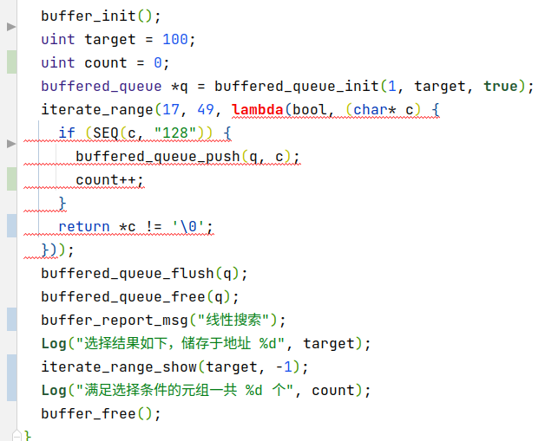图为核心代码，见question1.c。

实验结果：

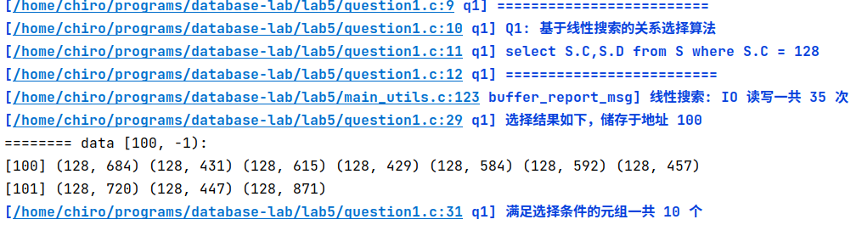

1. **实现两阶段多路归并排序算法（TPMMS）**

问题分析：为实现TPMMS算法，首先需要将数据分组并在组内排序。

由于内存中最多储存BLK=8个缓存块，所以每个组最大为8个块，分块代码如下：

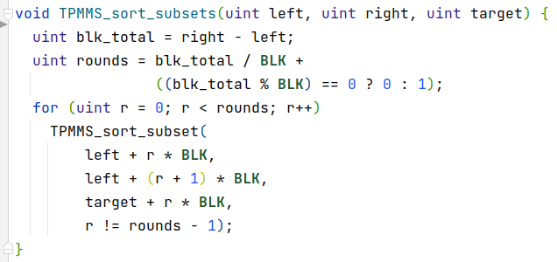块内排序的实现方法是加载至多BLK个块插入缓冲区队列buffered_queue中，然后在缓冲区队列中进行内存中的内排序。内排序算法使用了简单的冒泡排序。

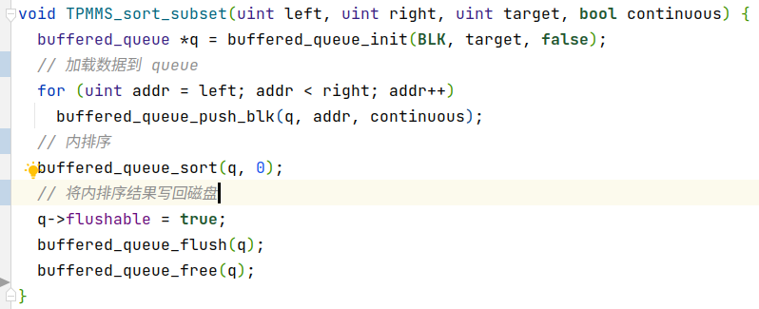每个数据分组排序完成后在磁盘上得到了rounds个有序的列表，接下来对这rounds个有序列表进行归并排序。这里需要申请rounds个对应地址范围的迭代器，并每次选择数据最小的一个迭代器插入写地址队列。由于每个迭代器都会占用一个缓冲区块，而且写地址队列也会占用一个缓冲区块，所以最多每次合并BLK-1个有序队列。鉴于数据量大小，可以假定rounds<BLK-1。

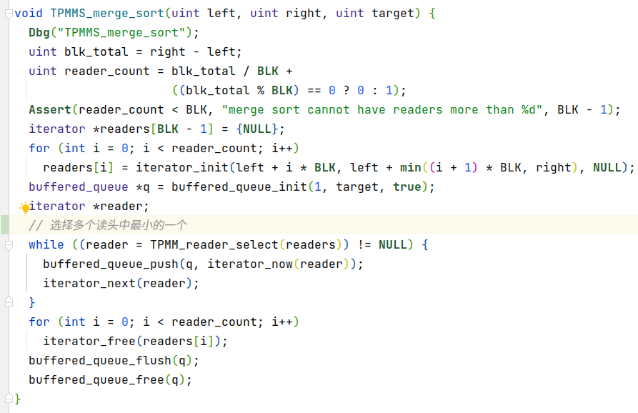归并排序结束，TPMMS算法也就结束了。算法执行代码如下：

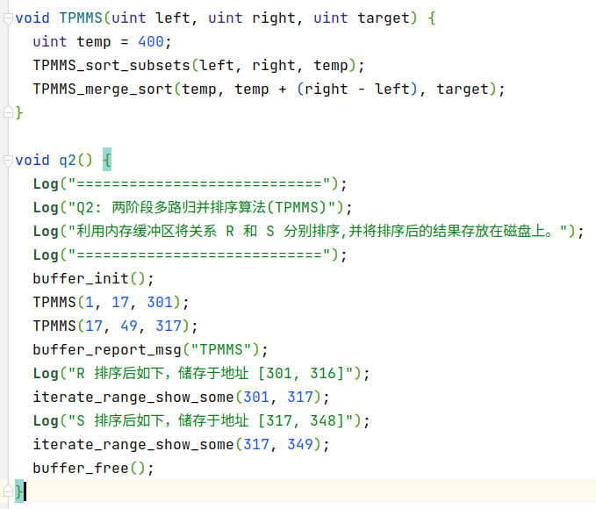 实验结果：

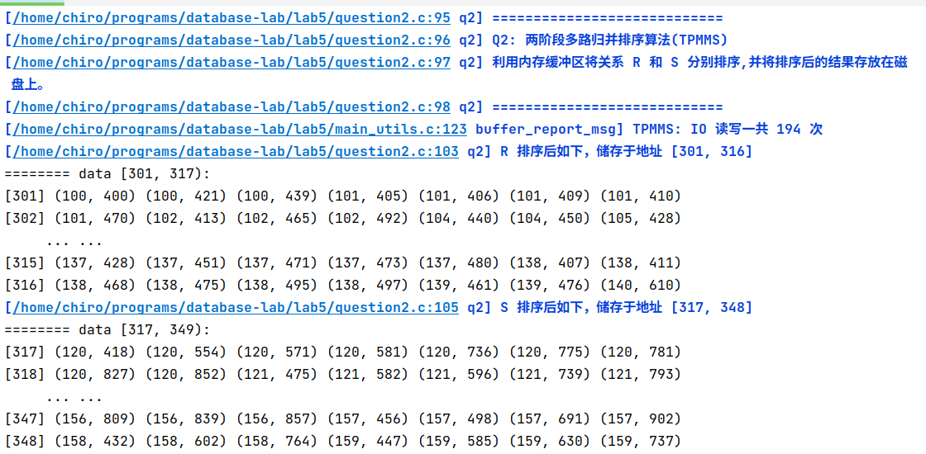 限于图片大小，只展示了排序后数据的开头与结尾，具体请查看对应文件。

1. **实现基于索引的关系选择算法**

问题分析：问题的关键在如何实现索引以及索引的储存。这里实现的索引格式是元组(key, addr)，key为索引键，addr为其出现在哪一个磁盘块。读取索引后迭代这些索引，找到key和所求对应的key相等的元组，再依据这个元组指向的磁盘块地址取到磁盘上有序列表中的某一块，最后从这个块中所求key开始迭代，一直迭代到键不为所求的key。把迭代过程中找到的结果写入写入缓冲区队列。以下为如何建立索引：

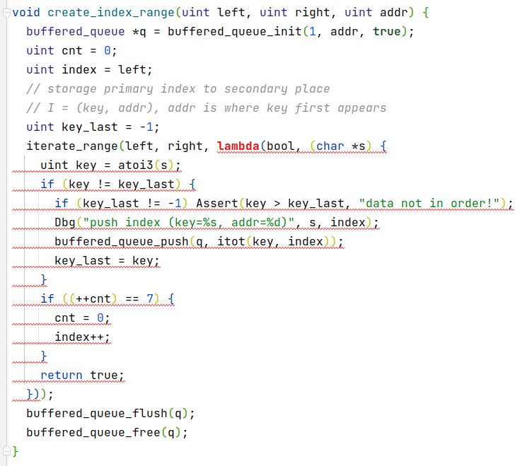建立索引后如何读取索引以及如何根据索引遍历磁盘块上的内容：

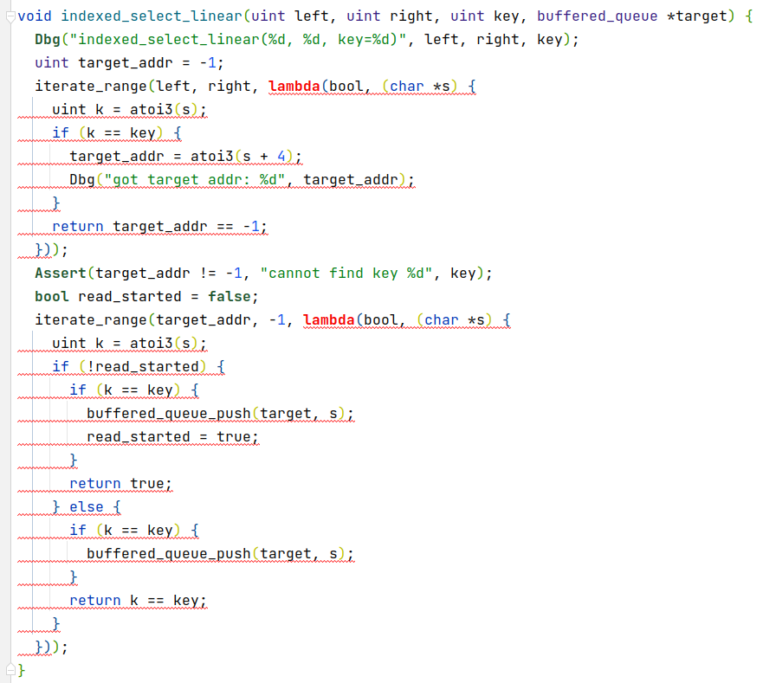总的实验流程：

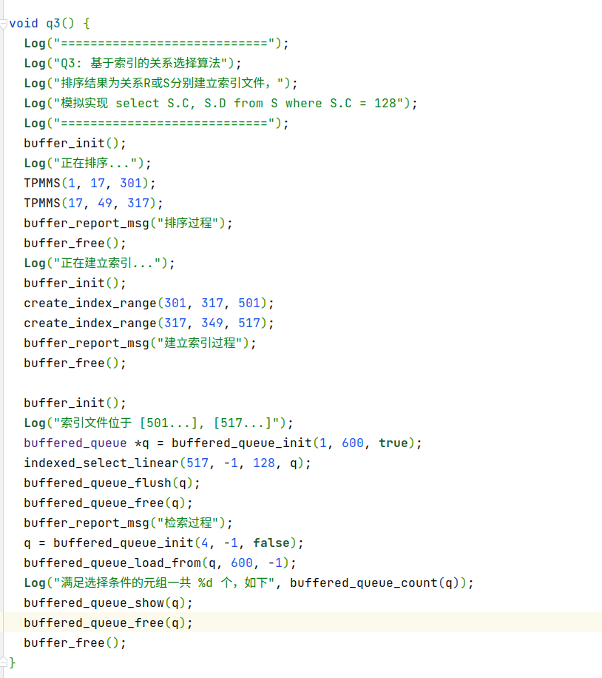

实验结果：

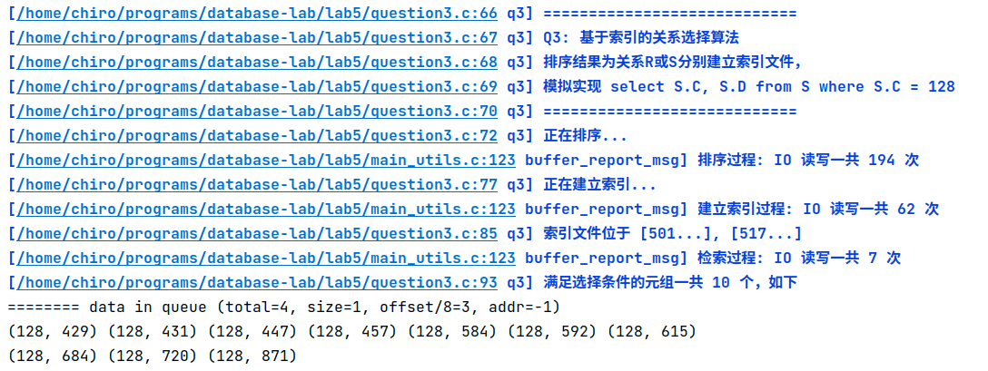其仅用7次IO就将数据找出并写入磁盘，与第一个问题实现的基于线性搜索的关系选择算法中的35次相比有巨大的提升。

1. **实现基于排序的连接操作算法（Sort-Merge-Join）**

问题分析：首先对两个源数据区域进行排序，然后使用Sort-Merge-Join算法同时迭代两个迭代器，将比对得到满足条件的结果元组写入写入缓冲区队列。

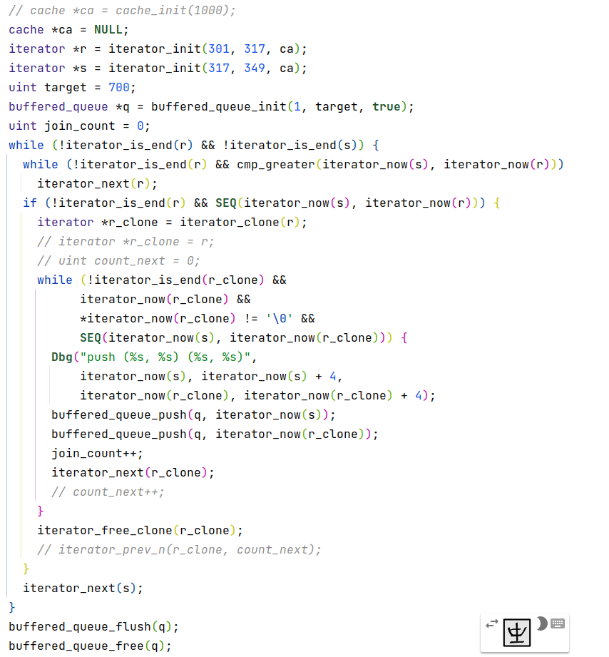

实验结果：

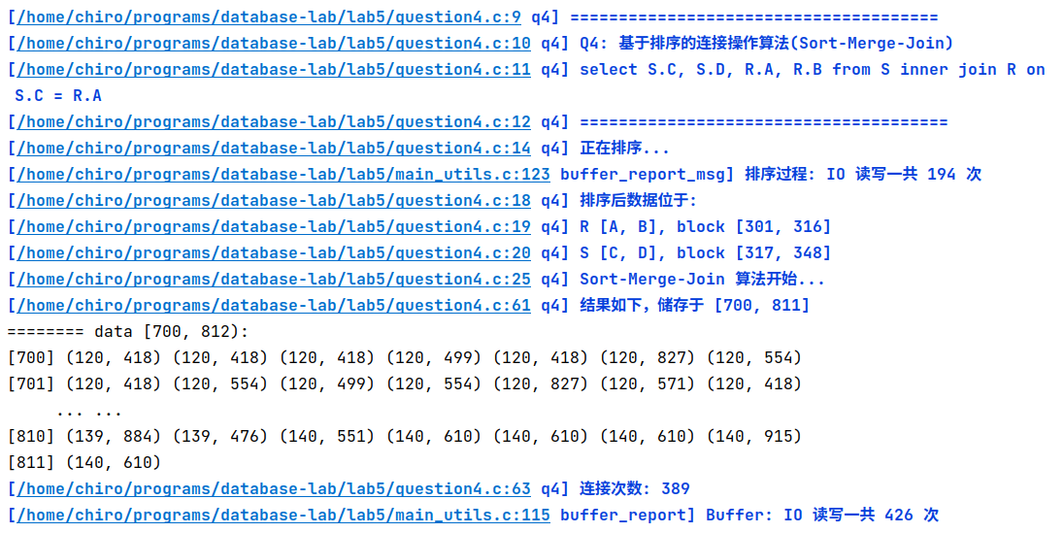

一个重要的点的是，由于算法中需要实现指针回退功能，而这部分功能原本由LRU Cache完成，但是LRU Cache管理的缓冲区无法同时对两个迭代器使用，于是只能使用克隆迭代器再释放的方法，增加了IO次数，需要后期改进。

1. **实现基于散列()的两趟扫描算法，实现交、并、差其中一种集合操作算法**

问题分析：见下方附加题

实验结果：见下方附加题

# 附加题

*对剩余的两种集合操作进行问题分析，并给出程序正确运行的结果截图。*

由于基于排序的两趟扫描算法与TPMMS十分相像，于是这里基于已经实现的TPMMS中的部分算法完成基于排序的两趟扫描算法的三种集合操作。

首先将两趟扫描算法抽象为一个函数，这个函数会首先对两个数据源排序并去重，然后调用第二趟的函数钩子。

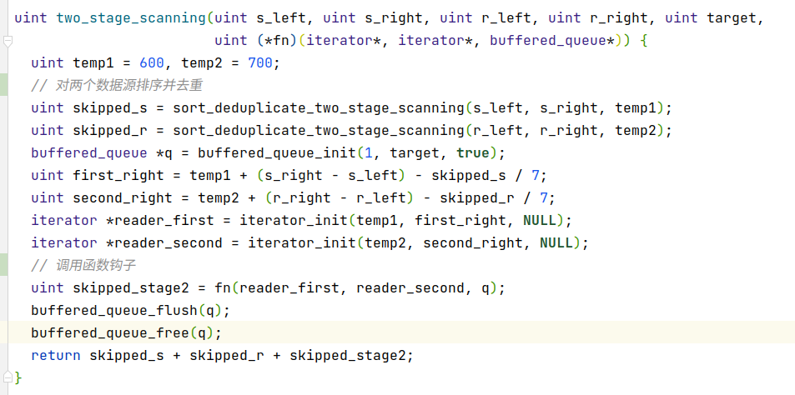 对三种集合操作实现三个函数钩子即可，函数钩子的输入是两个迭代器，输出是一个写入缓冲区队列。

对求R、S并集的实现，和归并排序类似，不过每次插入时需要保证和上次插入的值不一样。

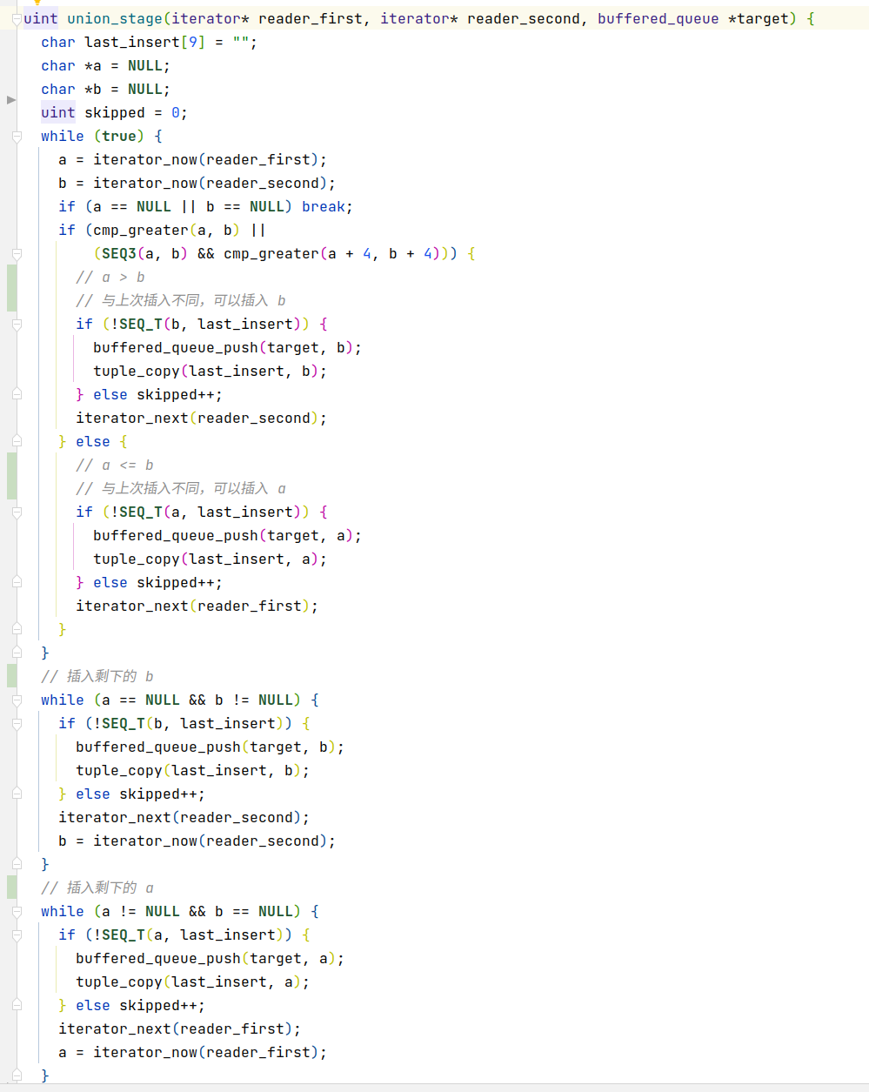 对求R、S交集的实现，也和归并排序类似，不过对当前最小值。需要和上一次最小值的值相同才插入队列。

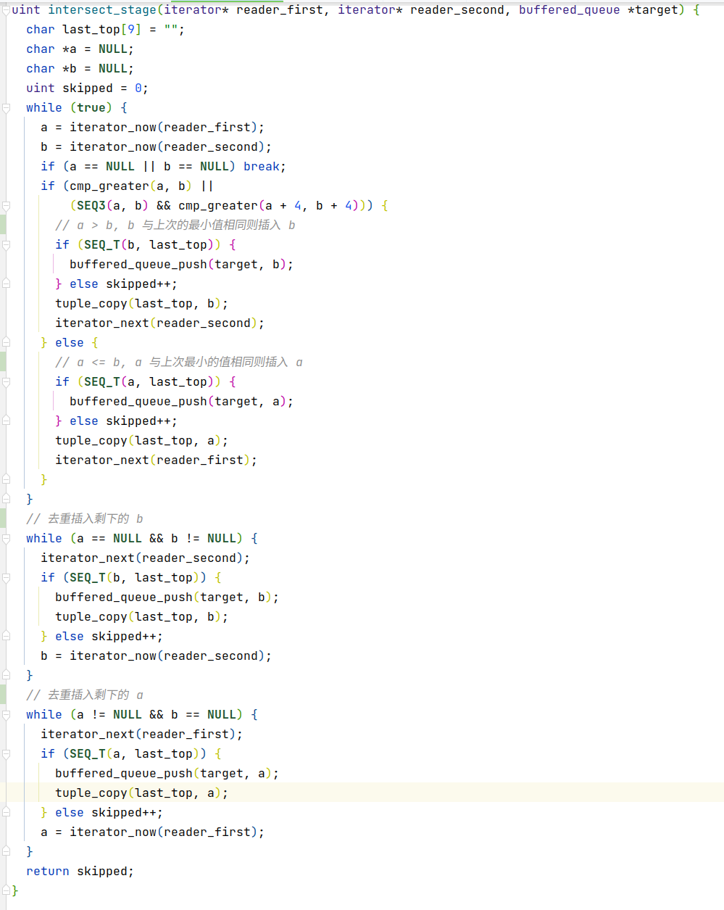 最后是对于S – R的实现，仔细分类讨论即可。

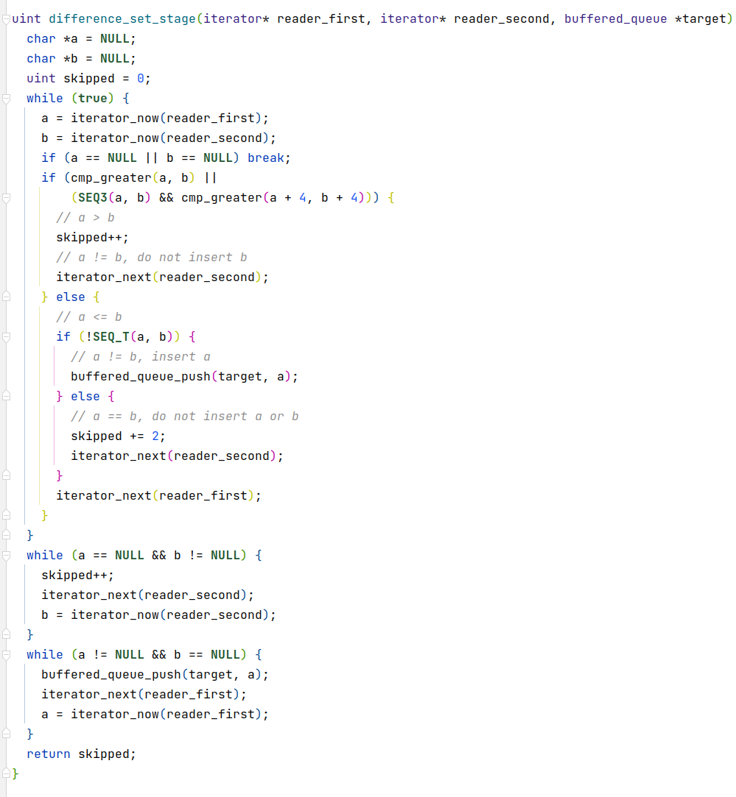实验结果：

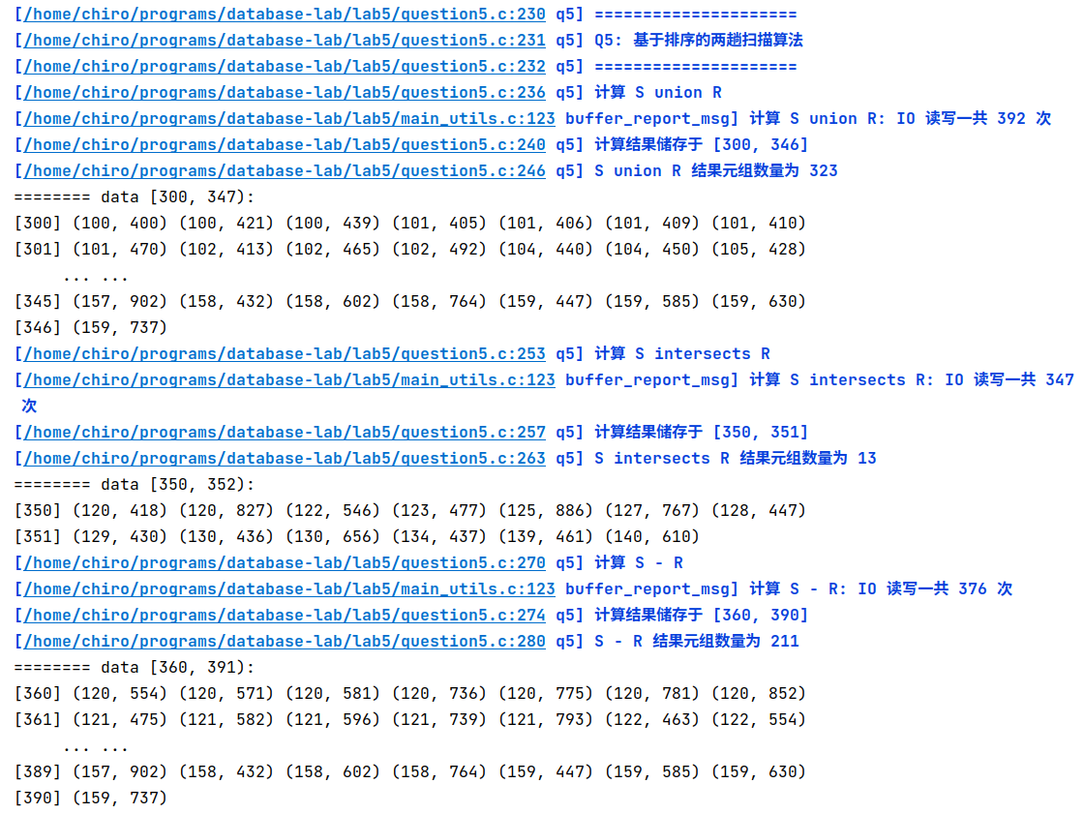

# 总结

*总结本次实验的遇到并解决的问题、收获及反思。*

在本次实验中，由于规定了实现语言是C语言，许多使用习惯了的高级语言特性需要自己手搓，还经常出现内存问题，所以实验难度较高。本实验中通过使用GCC中的lambda函数、调试宏、单元测试、差分测试、CMake等保证了C语言项目的规范、严谨、正确性。本实验提供了extmem调用接口来完成对磁盘的读写，所以如果能使用我们都学过的有更多抽象特性的语言，写起来会轻松很多。

由于手搓的东西比较多，代码量也相对比较大，许多人一个文件写了1200+行。既然已经使用CodeBlocks，可以建立多文件的代码框架，减少大文件，以方便同学们完成实验。

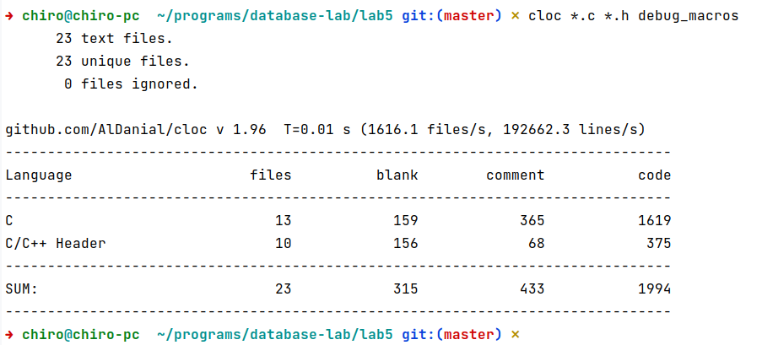与OS实验5相比，其使用了更通用的CMake构建系统，能适配更多IDE/编辑器，能更加方便同学们的使用习惯。

附录：整个实验程序的完整输出：

**[main.c:8 main] Lab5 program launched!**

**[main.c:10 main] 表结构和数据存储位置:**

**[main.c:11 main] R [A, B], block [1, 16]**

**[main.c:12 main] S [C, D], block [17, 48]**

**[question1.c:9 q1] =========================**

**[question1.c:10 q1] Q1: 基于线性搜索的关系选择算法**

**[question1.c:11 q1] select S.C,S.D from S where S.C = 128**

**[question1.c:12 q1] =========================**

**[main_utils.c:123 buffer_report_msg] 线性搜索: IO 读写一共 35 次**

**[question1.c:28 q1] 选择结果如下，储存于地址 100**

======== data [100, -1):

[100] (128, 684) (128, 431) (128, 615) (128, 429) (128, 584) (128, 592) (128, 457)

[101] (128, 720) (128, 447) (128, 871)

**[question1.c:30 q1] 满足选择条件的元组一共 10 个**

**[question2.c:88 q2] ============================**

**[question2.c:89 q2] Q2: 两阶段多路归并排序算法(TPMMS)**

**[question2.c:90 q2] 利用内存缓冲区将关系 R 和 S 分别排序,并将排序后的结果存放在磁盘上。**

**[question2.c:91 q2] ============================**

**[main_utils.c:123 buffer_report_msg] TPMMS: IO 读写一共 194 次**

**[question2.c:96 q2] R 排序后如下，储存于地址 [301, 316]**

======== data [301, 317):

[301] (100, 400) (100, 421) (100, 439) (101, 405) (101, 406) (101, 409) (101, 410)

[302] (101, 470) (102, 413) (102, 465) (102, 492) (104, 440) (104, 450) (105, 428)

[303] (105, 476) (105, 497) (106, 461) (107, 411) (107, 434) (107, 477) (108, 436)

[304] (108, 482) (109, 404) (109, 409) (109, 472) (110, 405) (110, 413) (110, 450)

[305] (110, 491) (111, 445) (112, 467) (114, 410) (114, 414) (114, 425) (115, 401)

[306] (116, 414) (116, 420) (116, 421) (116, 424) (116, 452) (116, 470) (117, 403)

[307] (117, 412) (117, 426) (117, 438) (117, 442) (117, 475) (118, 414) (118, 478)

[308] (119, 406) (119, 428) (119, 431) (120, 418) (120, 499) (120, 827) (121, 438)

[309] (121, 464) (122, 474) (122, 546) (123, 422) (123, 452) (123, 477) (124, 410)

[310] (124, 412) (124, 426) (124, 468) (124, 499) (125, 886) (126, 423) (126, 485)

[311] (127, 767) (128, 447) (128, 453) (128, 459) (129, 402) (129, 430) (129, 455)

[312] (129, 475) (129, 488) (130, 411) (130, 417) (130, 436) (130, 495) (130, 656)

[313] (131, 454) (131, 479) (131, 492) (132, 422) (132, 483) (133, 428) (133, 441)

[314] (133, 455) (133, 467) (134, 437) (134, 459) (134, 486) (135, 441) (137, 420)

[315] (137, 428) (137, 451) (137, 471) (137, 473) (137, 480) (138, 407) (138, 411)

[316] (138, 468) (138, 475) (138, 495) (138, 497) (139, 461) (139, 476) (140, 610)

**[question2.c:98 q2] S 排序后如下，储存于地址 [317, 348]**

======== data [317, 349):

[317] (120, 418) (120, 554) (120, 571) (120, 581) (120, 736) (120, 775) (120, 781)

[318] (120, 827) (120, 852) (121, 475) (121, 582) (121, 596) (121, 739) (121, 793)

[319] (122, 463) (122, 546) (122, 554) (122, 646) (122, 682) (122, 756) (122, 760)

[320] (123, 468) (123, 477) (123, 532) (123, 587) (123, 733) (123, 791) (123, 794)

[321] (123, 889) (124, 424) (124, 566) (124, 605) (124, 767) (124, 844) (124, 854)

[322] (125, 496) (125, 587) (125, 625) (125, 725) (125, 808) (125, 886) (125, 901)

[323] (126, 685) (126, 774) (126, 919) (127, 680) (127, 743) (127, 767) (127, 816)

[324] (128, 429) (128, 431) (128, 447) (128, 457) (128, 584) (128, 592) (128, 615)

[325] (128, 684) (128, 720) (128, 871) (129, 430) (129, 486) (129, 492) (129, 535)

[326] (129, 591) (129, 683) (129, 844) (130, 436) (130, 474) (130, 476) (130, 516)

[327] (130, 556) (130, 656) (130, 766) (130, 790) (131, 472) (131, 617) (131, 718)

[328] (131, 799) (131, 808) (131, 892) (132, 606) (132, 640) (133, 456) (134, 437)

[329] (134, 457) (134, 485) (134, 494) (134, 552) (134, 756) (134, 883) (134, 900)

[330] (135, 542) (135, 671) (135, 691) (135, 747) (135, 919) (136, 434) (136, 454)

[331] (136, 608) (136, 711) (136, 743) (136, 810) (137, 442) (137, 460) (137, 585)

[332] (137, 660) (137, 733) (137, 831) (137, 854) (137, 895) (137, 912) (138, 512)

[333] (138, 598) (138, 639) (138, 674) (138, 700) (138, 816) (139, 461) (139, 488)

[334] (139, 576) (139, 802) (139, 815) (139, 878) (139, 884) (140, 551) (140, 610)

[335] (140, 915) (141, 504) (141, 629) (141, 636) (141, 732) (141, 754) (142, 450)

[336] (142, 679) (142, 718) (142, 748) (142, 841) (143, 465) (143, 732) (144, 609)

[337] (144, 650) (144, 667) (144, 838) (145, 456) (145, 521) (145, 540) (145, 546)

[338] (145, 570) (145, 625) (145, 689) (145, 805) (145, 840) (146, 445) (146, 463)

[339] (146, 690) (146, 721) (146, 833) (146, 834) (146, 843) (147, 552) (147, 561)

[340] (147, 663) (147, 750) (148, 547) (148, 570) (148, 616) (148, 635) (148, 756)

[341] (148, 854) (148, 876) (149, 523) (149, 573) (149, 763) (149, 839) (149, 873)

[342] (150, 709) (150, 835) (150, 839) (150, 890) (151, 444) (151, 457) (151, 461)

[343] (151, 578) (151, 644) (151, 704) (152, 573) (152, 634) (152, 717) (152, 826)

[344] (153, 456) (153, 573) (153, 613) (153, 641) (153, 642) (154, 460) (154, 528)

[345] (154, 585) (154, 593) (154, 728) (154, 810) (155, 464) (155, 544) (155, 600)

[346] (155, 668) (155, 916) (156, 433) (156, 479) (156, 482) (156, 600) (156, 698)

[347] (156, 809) (156, 839) (156, 857) (157, 456) (157, 498) (157, 691) (157, 902)

[348] (158, 432) (158, 602) (158, 764) (159, 447) (159, 585) (159, 630) (159, 737)

**[question3.c:66 q3] ============================**

**[question3.c:67 q3] Q3: 基于索引的关系选择算法**

**[question3.c:68 q3] 排序结果为关系R或S分别建立索引文件，**

**[question3.c:69 q3] 模拟实现 select S.C, S.D from S where S.C = 128**

**[question3.c:70 q3] ============================**

**[question3.c:72 q3] 正在排序...**

**[main_utils.c:123 buffer_report_msg] 排序过程: IO 读写一共 194 次**

**[question3.c:77 q3] 正在建立索引...**

**[main_utils.c:123 buffer_report_msg] 建立索引过程: IO 读写一共 62 次**

**[question3.c:85 q3] 索引文件位于 [501...], [517...]**

**[main_utils.c:123 buffer_report_msg] 检索过程: IO 读写一共 7 次**

**[question3.c:93 q3] 满足选择条件的元组一共 10 个，如下**

======== data in queue (total=4, size=1, offset/8=3, addr=-1)

(128, 429) (128, 431) (128, 447) (128, 457) (128, 584) (128, 592) (128, 615)

(128, 684) (128, 720) (128, 871)

**[question4.c:9 q4] ======================================**

**[question4.c:10 q4] Q4: 基于排序的连接操作算法(Sort-Merge-Join)**

**[question4.c:11 q4] select S.C, S.D, R.A, R.B from S inner join R on S.C = R.A**

**[question4.c:12 q4] ======================================**

**[question4.c:14 q4] 正在排序...**

**[main_utils.c:123 buffer_report_msg] 排序过程: IO 读写一共 194 次**

**[question4.c:18 q4] 排序后数据位于:**

**[question4.c:19 q4] R [A, B], block [301, 316]**

**[question4.c:20 q4] S [C, D], block [317, 348]**

**[question4.c:25 q4] Sort-Merge-Join 算法开始...**

**[question4.c:61 q4] 结果如下，储存于 [700, 811]**

======== data [700, 812):

[700] (120, 418) (120, 418) (120, 418) (120, 499) (120, 418) (120, 827) (120, 554)

[701] (120, 418) (120, 554) (120, 499) (120, 554) (120, 827) (120, 571) (120, 418)

[702] (120, 571) (120, 499) (120, 571) (120, 827) (120, 581) (120, 418) (120, 581)

[703] (120, 499) (120, 581) (120, 827) (120, 736) (120, 418) (120, 736) (120, 499)

[704] (120, 736) (120, 827) (120, 775) (120, 418) (120, 775) (120, 499) (120, 775)

[705] (120, 827) (120, 781) (120, 418) (120, 781) (120, 499) (120, 781) (120, 827)

[706] (120, 827) (120, 418) (120, 827) (120, 499) (120, 827) (120, 827) (120, 852)

[707] (120, 418) (120, 852) (120, 499) (120, 852) (120, 827) (121, 475) (121, 438)

[708] (121, 475) (121, 464) (121, 582) (121, 438) (121, 582) (121, 464) (121, 596)

[709] (121, 438) (121, 596) (121, 464) (121, 739) (121, 438) (121, 739) (121, 464)

[710] (121, 793) (121, 438) (121, 793) (121, 464) (122, 463) (122, 474) (122, 463)

[711] (122, 546) (122, 546) (122, 474) (122, 546) (122, 546) (122, 554) (122, 474)

[712] (122, 554) (122, 546) (122, 646) (122, 474) (122, 646) (122, 546) (122, 682)

[713] (122, 474) (122, 682) (122, 546) (122, 756) (122, 474) (122, 756) (122, 546)

[714] (122, 760) (122, 474) (122, 760) (122, 546) (123, 468) (123, 422) (123, 468)

[715] (123, 452) (123, 468) (123, 477) (123, 477) (123, 422) (123, 477) (123, 452)

[716] (123, 477) (123, 477) (123, 532) (123, 422) (123, 532) (123, 452) (123, 532)

[717] (123, 477) (123, 587) (123, 422) (123, 587) (123, 452) (123, 587) (123, 477)

[718] (123, 733) (123, 422) (123, 733) (123, 452) (123, 733) (123, 477) (123, 791)

[719] (123, 422) (123, 791) (123, 452) (123, 791) (123, 477) (123, 794) (123, 422)

[720] (123, 794) (123, 452) (123, 794) (123, 477) (123, 889) (123, 422) (123, 889)

[721] (123, 452) (123, 889) (123, 477) (124, 424) (124, 410) (124, 424) (124, 412)

[722] (124, 424) (124, 426) (124, 424) (124, 468) (124, 424) (124, 499) (124, 566)

[723] (124, 410) (124, 566) (124, 412) (124, 566) (124, 426) (124, 566) (124, 468)

[724] (124, 566) (124, 499) (124, 605) (124, 410) (124, 605) (124, 412) (124, 605)

[725] (124, 426) (124, 605) (124, 468) (124, 605) (124, 499) (124, 767) (124, 410)

[726] (124, 767) (124, 412) (124, 767) (124, 426) (124, 767) (124, 468) (124, 767)

[727] (124, 499) (124, 844) (124, 410) (124, 844) (124, 412) (124, 844) (124, 426)

[728] (124, 844) (124, 468) (124, 844) (124, 499) (124, 854) (124, 410) (124, 854)

[729] (124, 412) (124, 854) (124, 426) (124, 854) (124, 468) (124, 854) (124, 499)

[730] (125, 496) (125, 886) (125, 587) (125, 886) (125, 625) (125, 886) (125, 725)

[731] (125, 886) (125, 808) (125, 886) (125, 886) (125, 886) (125, 901) (125, 886)

[732] (126, 685) (126, 423) (126, 685) (126, 485) (126, 774) (126, 423) (126, 774)

[733] (126, 485) (126, 919) (126, 423) (126, 919) (126, 485) (127, 680) (127, 767)

[734] (127, 743) (127, 767) (127, 767) (127, 767) (127, 816) (127, 767) (128, 429)

[735] (128, 447) (128, 429) (128, 453) (128, 429) (128, 459) (128, 431) (128, 447)

[736] (128, 431) (128, 453) (128, 431) (128, 459) (128, 447) (128, 447) (128, 447)

[737] (128, 453) (128, 447) (128, 459) (128, 457) (128, 447) (128, 457) (128, 453)

[738] (128, 457) (128, 459) (128, 584) (128, 447) (128, 584) (128, 453) (128, 584)

[739] (128, 459) (128, 592) (128, 447) (128, 592) (128, 453) (128, 592) (128, 459)

[740] (128, 615) (128, 447) (128, 615) (128, 453) (128, 615) (128, 459) (128, 684)

[741] (128, 447) (128, 684) (128, 453) (128, 684) (128, 459) (128, 720) (128, 447)

[742] (128, 720) (128, 453) (128, 720) (128, 459) (128, 871) (128, 447) (128, 871)

[743] (128, 453) (128, 871) (128, 459) (129, 430) (129, 402) (129, 430) (129, 430)

[744] (129, 430) (129, 455) (129, 430) (129, 475) (129, 430) (129, 488) (129, 486)

[745] (129, 402) (129, 486) (129, 430) (129, 486) (129, 455) (129, 486) (129, 475)

[746] (129, 486) (129, 488) (129, 492) (129, 402) (129, 492) (129, 430) (129, 492)

[747] (129, 455) (129, 492) (129, 475) (129, 492) (129, 488) (129, 535) (129, 402)

[748] (129, 535) (129, 430) (129, 535) (129, 455) (129, 535) (129, 475) (129, 535)

[749] (129, 488) (129, 591) (129, 402) (129, 591) (129, 430) (129, 591) (129, 455)

[750] (129, 591) (129, 475) (129, 591) (129, 488) (129, 683) (129, 402) (129, 683)

[751] (129, 430) (129, 683) (129, 455) (129, 683) (129, 475) (129, 683) (129, 488)

[752] (129, 844) (129, 402) (129, 844) (129, 430) (129, 844) (129, 455) (129, 844)

[753] (129, 475) (129, 844) (129, 488) (130, 436) (130, 411) (130, 436) (130, 417)

[754] (130, 436) (130, 436) (130, 436) (130, 495) (130, 436) (130, 656) (130, 474)

[755] (130, 411) (130, 474) (130, 417) (130, 474) (130, 436) (130, 474) (130, 495)

[756] (130, 474) (130, 656) (130, 476) (130, 411) (130, 476) (130, 417) (130, 476)

[757] (130, 436) (130, 476) (130, 495) (130, 476) (130, 656) (130, 516) (130, 411)

[758] (130, 516) (130, 417) (130, 516) (130, 436) (130, 516) (130, 495) (130, 516)

[759] (130, 656) (130, 556) (130, 411) (130, 556) (130, 417) (130, 556) (130, 436)

[760] (130, 556) (130, 495) (130, 556) (130, 656) (130, 656) (130, 411) (130, 656)

[761] (130, 417) (130, 656) (130, 436) (130, 656) (130, 495) (130, 656) (130, 656)

[762] (130, 766) (130, 411) (130, 766) (130, 417) (130, 766) (130, 436) (130, 766)

[763] (130, 495) (130, 766) (130, 656) (130, 790) (130, 411) (130, 790) (130, 417)

[764] (130, 790) (130, 436) (130, 790) (130, 495) (130, 790) (130, 656) (131, 472)

[765] (131, 454) (131, 472) (131, 479) (131, 472) (131, 492) (131, 617) (131, 454)

[766] (131, 617) (131, 479) (131, 617) (131, 492) (131, 718) (131, 454) (131, 718)

[767] (131, 479) (131, 718) (131, 492) (131, 799) (131, 454) (131, 799) (131, 479)

[768] (131, 799) (131, 492) (131, 808) (131, 454) (131, 808) (131, 479) (131, 808)

[769] (131, 492) (131, 892) (131, 454) (131, 892) (131, 479) (131, 892) (131, 492)

[770] (132, 606) (132, 422) (132, 606) (132, 483) (132, 640) (132, 422) (132, 640)

[771] (132, 483) (133, 456) (133, 428) (133, 456) (133, 441) (133, 456) (133, 455)

[772] (133, 456) (133, 467) (134, 437) (134, 437) (134, 437) (134, 459) (134, 437)

[773] (134, 486) (134, 457) (134, 437) (134, 457) (134, 459) (134, 457) (134, 486)

[774] (134, 485) (134, 437) (134, 485) (134, 459) (134, 485) (134, 486) (134, 494)

[775] (134, 437) (134, 494) (134, 459) (134, 494) (134, 486) (134, 552) (134, 437)

[776] (134, 552) (134, 459) (134, 552) (134, 486) (134, 756) (134, 437) (134, 756)

[777] (134, 459) (134, 756) (134, 486) (134, 883) (134, 437) (134, 883) (134, 459)

[778] (134, 883) (134, 486) (134, 900) (134, 437) (134, 900) (134, 459) (134, 900)

[779] (134, 486) (135, 542) (135, 441) (135, 671) (135, 441) (135, 691) (135, 441)

[780] (135, 747) (135, 441) (135, 919) (135, 441) (137, 442) (137, 420) (137, 442)

[781] (137, 428) (137, 442) (137, 451) (137, 442) (137, 471) (137, 442) (137, 473)

[782] (137, 442) (137, 480) (137, 460) (137, 420) (137, 460) (137, 428) (137, 460)

[783] (137, 451) (137, 460) (137, 471) (137, 460) (137, 473) (137, 460) (137, 480)

[784] (137, 585) (137, 420) (137, 585) (137, 428) (137, 585) (137, 451) (137, 585)

[785] (137, 471) (137, 585) (137, 473) (137, 585) (137, 480) (137, 660) (137, 420)

[786] (137, 660) (137, 428) (137, 660) (137, 451) (137, 660) (137, 471) (137, 660)

[787] (137, 473) (137, 660) (137, 480) (137, 733) (137, 420) (137, 733) (137, 428)

[788] (137, 733) (137, 451) (137, 733) (137, 471) (137, 733) (137, 473) (137, 733)

[789] (137, 480) (137, 831) (137, 420) (137, 831) (137, 428) (137, 831) (137, 451)

[790] (137, 831) (137, 471) (137, 831) (137, 473) (137, 831) (137, 480) (137, 854)

[791] (137, 420) (137, 854) (137, 428) (137, 854) (137, 451) (137, 854) (137, 471)

[792] (137, 854) (137, 473) (137, 854) (137, 480) (137, 895) (137, 420) (137, 895)

[793] (137, 428) (137, 895) (137, 451) (137, 895) (137, 471) (137, 895) (137, 473)

[794] (137, 895) (137, 480) (137, 912) (137, 420) (137, 912) (137, 428) (137, 912)

[795] (137, 451) (137, 912) (137, 471) (137, 912) (137, 473) (137, 912) (137, 480)

[796] (138, 512) (138, 407) (138, 512) (138, 411) (138, 512) (138, 468) (138, 512)

[797] (138, 475) (138, 512) (138, 495) (138, 512) (138, 497) (138, 598) (138, 407)

[798] (138, 598) (138, 411) (138, 598) (138, 468) (138, 598) (138, 475) (138, 598)

[799] (138, 495) (138, 598) (138, 497) (138, 639) (138, 407) (138, 639) (138, 411)

[800] (138, 639) (138, 468) (138, 639) (138, 475) (138, 639) (138, 495) (138, 639)

[801] (138, 497) (138, 674) (138, 407) (138, 674) (138, 411) (138, 674) (138, 468)

[802] (138, 674) (138, 475) (138, 674) (138, 495) (138, 674) (138, 497) (138, 700)

[803] (138, 407) (138, 700) (138, 411) (138, 700) (138, 468) (138, 700) (138, 475)

[804] (138, 700) (138, 495) (138, 700) (138, 497) (138, 816) (138, 407) (138, 816)

[805] (138, 411) (138, 816) (138, 468) (138, 816) (138, 475) (138, 816) (138, 495)

[806] (138, 816) (138, 497) (139, 461) (139, 461) (139, 461) (139, 476) (139, 488)

[807] (139, 461) (139, 488) (139, 476) (139, 576) (139, 461) (139, 576) (139, 476)

[808] (139, 802) (139, 461) (139, 802) (139, 476) (139, 815) (139, 461) (139, 815)

[809] (139, 476) (139, 878) (139, 461) (139, 878) (139, 476) (139, 884) (139, 461)

[810] (139, 884) (139, 476) (140, 551) (140, 610) (140, 610) (140, 610) (140, 915)

[811] (140, 610)

**[question4.c:63 q4] 连接次数: 389**

**[main_utils.c:115 buffer_report] Buffer: IO 读写一共 426 次**

**[question5.c:240 q5] =====================**

**[question5.c:241 q5] Q5: 基于排序的两趟扫描算法**

**[question5.c:242 q5] =====================**

**[question5.c:246 q5] 计算 S union R**

**[main_utils.c:123 buffer_report_msg] 计算 S union R: IO 读写一共 392 次**

**[question5.c:250 q5] 计算结果储存于 [300, 346]**

**[question5.c:256 q5] S union R 结果元组数量为 323**

======== data [300, 347):

[300] (100, 400) (100, 421) (100, 439) (101, 405) (101, 406) (101, 409) (101, 410)

[301] (101, 470) (102, 413) (102, 465) (102, 492) (104, 440) (104, 450) (105, 428)

[302] (105, 476) (105, 497) (106, 461) (107, 411) (107, 434) (107, 477) (108, 436)

[303] (108, 482) (109, 404) (109, 409) (109, 472) (110, 405) (110, 413) (110, 450)

[304] (110, 491) (111, 445) (112, 467) (114, 410) (114, 414) (114, 425) (115, 401)

[305] (116, 414) (116, 420) (116, 421) (116, 424) (116, 452) (116, 470) (117, 403)

[306] (117, 412) (117, 426) (117, 438) (117, 442) (117, 475) (118, 414) (118, 478)

[307] (119, 406) (119, 428) (119, 431) (120, 418) (120, 499) (120, 554) (120, 571)

[308] (120, 581) (120, 736) (120, 775) (120, 781) (120, 827) (120, 852) (121, 438)

[309] (121, 464) (121, 475) (121, 582) (121, 596) (121, 739) (121, 793) (122, 463)

[310] (122, 474) (122, 546) (122, 554) (122, 646) (122, 682) (122, 756) (122, 760)

[311] (123, 422) (123, 452) (123, 468) (123, 477) (123, 532) (123, 587) (123, 733)

[312] (123, 791) (123, 794) (123, 889) (124, 410) (124, 412) (124, 424) (124, 426)

[313] (124, 468) (124, 499) (124, 566) (124, 605) (124, 767) (124, 844) (124, 854)

[314] (125, 496) (125, 587) (125, 625) (125, 725) (125, 808) (125, 886) (125, 901)

[315] (126, 423) (126, 485) (126, 685) (126, 774) (126, 919) (127, 680) (127, 743)

[316] (127, 767) (127, 816) (128, 429) (128, 431) (128, 447) (128, 453) (128, 457)

[317] (128, 459) (128, 584) (128, 592) (128, 615) (128, 684) (128, 720) (128, 871)

[318] (129, 402) (129, 430) (129, 455) (129, 475) (129, 486) (129, 488) (129, 492)

[319] (129, 535) (129, 591) (129, 683) (129, 844) (130, 411) (130, 417) (130, 436)

[320] (130, 474) (130, 476) (130, 495) (130, 516) (130, 556) (130, 656) (130, 766)

[321] (130, 790) (131, 454) (131, 472) (131, 479) (131, 492) (131, 617) (131, 718)

[322] (131, 799) (131, 808) (131, 892) (132, 422) (132, 483) (132, 606) (132, 640)

[323] (133, 428) (133, 441) (133, 455) (133, 456) (133, 467) (134, 437) (134, 457)

[324] (134, 459) (134, 485) (134, 486) (134, 494) (134, 552) (134, 756) (134, 883)

[325] (134, 900) (135, 441) (135, 542) (135, 671) (135, 691) (135, 747) (135, 919)

[326] (136, 434) (136, 454) (136, 608) (136, 711) (136, 743) (136, 810) (137, 420)

[327] (137, 428) (137, 442) (137, 451) (137, 460) (137, 471) (137, 473) (137, 480)

[328] (137, 585) (137, 660) (137, 733) (137, 831) (137, 854) (137, 895) (137, 912)

[329] (138, 407) (138, 411) (138, 468) (138, 475) (138, 495) (138, 497) (138, 512)

[330] (138, 598) (138, 639) (138, 674) (138, 700) (138, 816) (139, 461) (139, 476)

[331] (139, 488) (139, 576) (139, 802) (139, 815) (139, 878) (139, 884) (140, 551)

[332] (140, 610) (140, 915) (141, 504) (141, 629) (141, 636) (141, 732) (141, 754)

[333] (142, 450) (142, 679) (142, 718) (142, 748) (142, 841) (143, 465) (143, 732)

[334] (144, 609) (144, 650) (144, 667) (144, 838) (145, 456) (145, 521) (145, 540)

[335] (145, 546) (145, 570) (145, 625) (145, 689) (145, 805) (145, 840) (146, 445)

[336] (146, 463) (146, 690) (146, 721) (146, 833) (146, 834) (146, 843) (147, 552)

[337] (147, 561) (147, 663) (147, 750) (148, 547) (148, 570) (148, 616) (148, 635)

[338] (148, 756) (148, 854) (148, 876) (149, 523) (149, 573) (149, 763) (149, 839)

[339] (149, 873) (150, 709) (150, 835) (150, 839) (150, 890) (151, 444) (151, 457)

[340] (151, 461) (151, 578) (151, 644) (151, 704) (152, 573) (152, 634) (152, 717)

[341] (152, 826) (153, 456) (153, 573) (153, 613) (153, 641) (153, 642) (154, 460)

[342] (154, 528) (154, 585) (154, 593) (154, 728) (154, 810) (155, 464) (155, 544)

[343] (155, 600) (155, 668) (155, 916) (156, 433) (156, 479) (156, 482) (156, 600)

[344] (156, 698) (156, 809) (156, 839) (156, 857) (157, 456) (157, 498) (157, 691)

[345] (157, 902) (158, 432) (158, 602) (158, 764) (159, 447) (159, 585) (159, 630)

[346] (159, 737)

**[question5.c:263 q5] 计算 S intersects R**

**[main_utils.c:123 buffer_report_msg] 计算 S intersects R: IO 读写一共 347 次**

**[question5.c:267 q5] 计算结果储存于 [350, 351]**

**[question5.c:273 q5] S intersects R 结果元组数量为 13**

======== data [350, 352):

[350] (120, 418) (120, 827) (122, 546) (123, 477) (125, 886) (127, 767) (128, 447)

[351] (129, 430) (130, 436) (130, 656) (134, 437) (139, 461) (140, 610)

**[question5.c:280 q5] 计算 S - R**

**[main_utils.c:123 buffer_report_msg] 计算 S - R: IO 读写一共 376 次**

**[question5.c:284 q5] 计算结果储存于 [360, 390]**

**[question5.c:290 q5] S - R 结果元组数量为 211**

======== data [360, 391):

[360] (120, 554) (120, 571) (120, 581) (120, 736) (120, 775) (120, 781) (120, 852)

[361] (121, 475) (121, 582) (121, 596) (121, 739) (121, 793) (122, 463) (122, 554)

[362] (122, 646) (122, 682) (122, 756) (122, 760) (123, 468) (123, 532) (123, 587)

[363] (123, 733) (123, 791) (123, 794) (123, 889) (124, 424) (124, 566) (124, 605)

[364] (124, 767) (124, 844) (124, 854) (125, 496) (125, 587) (125, 625) (125, 725)

[365] (125, 808) (125, 901) (126, 685) (126, 774) (126, 919) (127, 680) (127, 743)

[366] (127, 816) (128, 429) (128, 431) (128, 457) (128, 584) (128, 592) (128, 615)

[367] (128, 684) (128, 720) (128, 871) (129, 486) (129, 492) (129, 535) (129, 591)

[368] (129, 683) (129, 844) (130, 474) (130, 476) (130, 516) (130, 556) (130, 766)

[369] (130, 790) (131, 472) (131, 617) (131, 718) (131, 799) (131, 808) (131, 892)

[370] (132, 606) (132, 640) (133, 456) (134, 457) (134, 485) (134, 494) (134, 552)

[371] (134, 756) (134, 883) (134, 900) (135, 542) (135, 671) (135, 691) (135, 747)

[372] (135, 919) (136, 434) (136, 454) (136, 608) (136, 711) (136, 743) (136, 810)

[373] (137, 442) (137, 460) (137, 585) (137, 660) (137, 733) (137, 831) (137, 854)

[374] (137, 895) (137, 912) (138, 512) (138, 598) (138, 639) (138, 674) (138, 700)

[375] (138, 816) (139, 488) (139, 576) (139, 802) (139, 815) (139, 878) (139, 884)

[376] (140, 551) (140, 915) (141, 504) (141, 629) (141, 636) (141, 732) (141, 754)

[377] (142, 450) (142, 679) (142, 718) (142, 748) (142, 841) (143, 465) (143, 732)

[378] (144, 609) (144, 650) (144, 667) (144, 838) (145, 456) (145, 521) (145, 540)

[379] (145, 546) (145, 570) (145, 625) (145, 689) (145, 805) (145, 840) (146, 445)

[380] (146, 463) (146, 690) (146, 721) (146, 833) (146, 834) (146, 843) (147, 552)

[381] (147, 561) (147, 663) (147, 750) (148, 547) (148, 570) (148, 616) (148, 635)

[382] (148, 756) (148, 854) (148, 876) (149, 523) (149, 573) (149, 763) (149, 839)

[383] (149, 873) (150, 709) (150, 835) (150, 839) (150, 890) (151, 444) (151, 457)

[384] (151, 461) (151, 578) (151, 644) (151, 704) (152, 573) (152, 634) (152, 717)

[385] (152, 826) (153, 456) (153, 573) (153, 613) (153, 641) (153, 642) (154, 460)

[386] (154, 528) (154, 585) (154, 593) (154, 728) (154, 810) (155, 464) (155, 544)

[387] (155, 600) (155, 668) (155, 916) (156, 433) (156, 479) (156, 482) (156, 600)

[388] (156, 698) (156, 809) (156, 839) (156, 857) (157, 456) (157, 498) (157, 691)

[389] (157, 902) (158, 432) (158, 602) (158, 764) (159, 447) (159, 585) (159, 630)

[390] (159, 737)