Prototype solution to ‘spoof’ the XKR Mercedes TCM (EGS51 for the W5A580/722.6/NAG1 transmission) in the 4.0 XKR to change the rear axle ratio.
Of course reprogramming the EGS51 TCM would be much better, but there is no readily available developer info I can find to create the appropriate EEPROM profile, and not much interest anymore it seems in this old unit.

This technique might work for other transmissions/TCMs besides the 722.6 (e.g. ZF), or it might not…..

Disclaimer

This is not an industrial/automotive grade solution, it is not a commercial or production solution, use at your own risk, not for on-road use, prototype solution for private testing only, no warranty expressed or implied.

Overview

The solution is based on an Arduino driven canbus repeater to intercept the messages between the TCM and the rest of the canbus (ECU, ABS, INST).
Two MCP2515 based canbus modules are used, one facing the TCM side of the bus, and the other facing the ECU/ABS side of the bus.
Since the TCM module is conveniently located next to the the ECU in the 2002 XKR, it is easy to snip the canbus wires at the TCM connection, and bridge in the repeater module.
The repeater module receives the messages on the TCM side, and sends them onwards on the ECU/ABS side, and vice versa.
The ABS wheel speed messages towards the TCM are intercepted, and the wheel speed values for all 4 wheels are scaled appropriately so that the TCM is not aware of the different axle ratio, and then sent on.

The code is based on interrupts triggered when a message is received on either canbus. The Arduino communicates with the canbus modules using SPI interface. The interrupt service routines (ISR), one for each direction, read the new message, and then send it back out on the other bus. The ABS facing one also checks for the ABS wheel bus message ID (SID 0x4B0) on ABS side of the bus, and if found it executes the code to scale the speeds. The wheel speeds are big endian 2 byte. Testing to date is limited to a 3.27 axle with 3.06 TCM, but the code includes estimates for the factors for other combinations. The spreadsheet “axle ratio change algorithms” allows computation for factors not listed in the code.

To reduce PCB design efforts, a base PCB design mounts modules that can be purchased on eBay or elsewhere, which saves time and eliminates the need to assemble a board using surface mount components. The compromise is obviously that the solution is bigger.

The design can mount up to 3 canbus modules, the idea being that the third module could be used for off-board telemetry and control. Current testing has only used 2 modules. By not adding the third module, there are convenient connections to add an ICSP connector to program the Arduino, which is used for this specific project.

Notes on areas for future improvements

The PCB design could benefit from a bit of tweaking, since canbus module footprints are mechanically slightly off, but it works. Obviously a specific 2 module design could be created with an ICSP header, as a project specific version.

A full SMD design using industrial grade design principles would be an optimized solution.

Materials

Materials needed, descriptions follow:
- base PCB
- Arduino Pro Mini
- 2 canbus modules (“MCP2515 CAN Bus Module TJA1050 Receiver SPI “)
- 3 decoupling capacitors, 100nF
- 1 resistor, 120 ohm
- connectors
- 0.1” headers
- enclosure
- standoffs, grommet, grounding terminal ring, etc.
- heat shrink tubing
- automotive fuse holder and 1A or lower fuse

Tools needed
- PC with Arduino IDE (integrated development environment) software loaded, or alternative software environment
- Solution to program arduino pro mini using ICSP (In Circuit Serial Programming), e.g. an Arduino Uno with custom cable
- heat gun for heat shrink to connect to car wiring
- drill and drill bits to prepare enclosure
- soldering iron and pliers/cutters/strippers etc.

Base PCB

The schematic and pcb design were created with Kicad. The Gerber files for uploading to PCB fabrication house (e.g. JLC PCB) are in the zip file. There are schematics/footprints for the Arduino Pro Mini and Canbus modules.

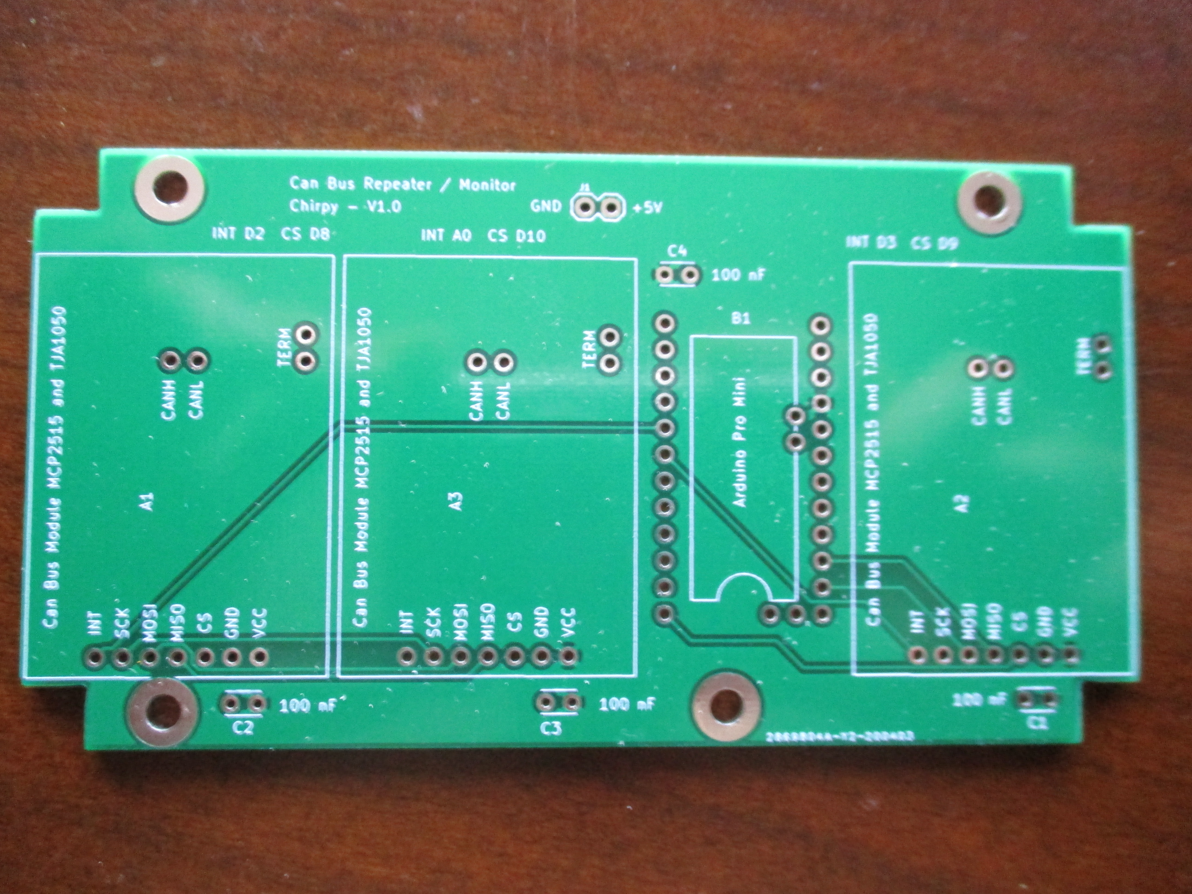

Assembling the PCB

Get a Pro Mini Arduino without the headers already mounted, so these can be used underneath the module to mount to the PCB. There is no need to add the 2 pins for A4/A5 for this application. Also the FTDI pins do not need to be added since programming will be with ICSP. So only the headers on both long sides are needed.

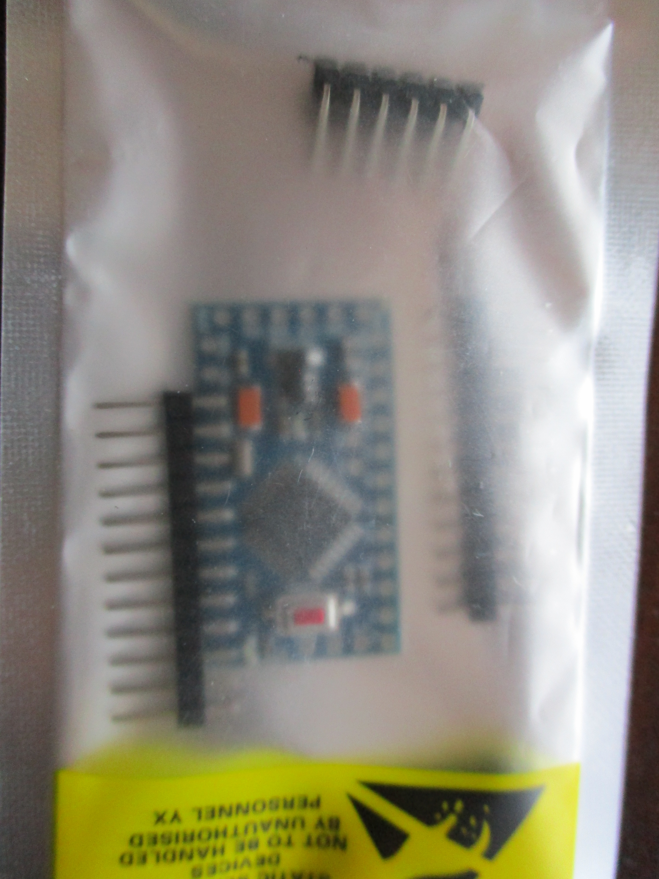

The Canbus module is typically described on eBay and elsewhere as “MCP2515 CAN Bus Module TJA1050 Receiver SPI”. Make sure to check what crystal speed is used to clock the board, the code is setup for 8 MHz, if it comes with 16 MHz then change the code to suit.

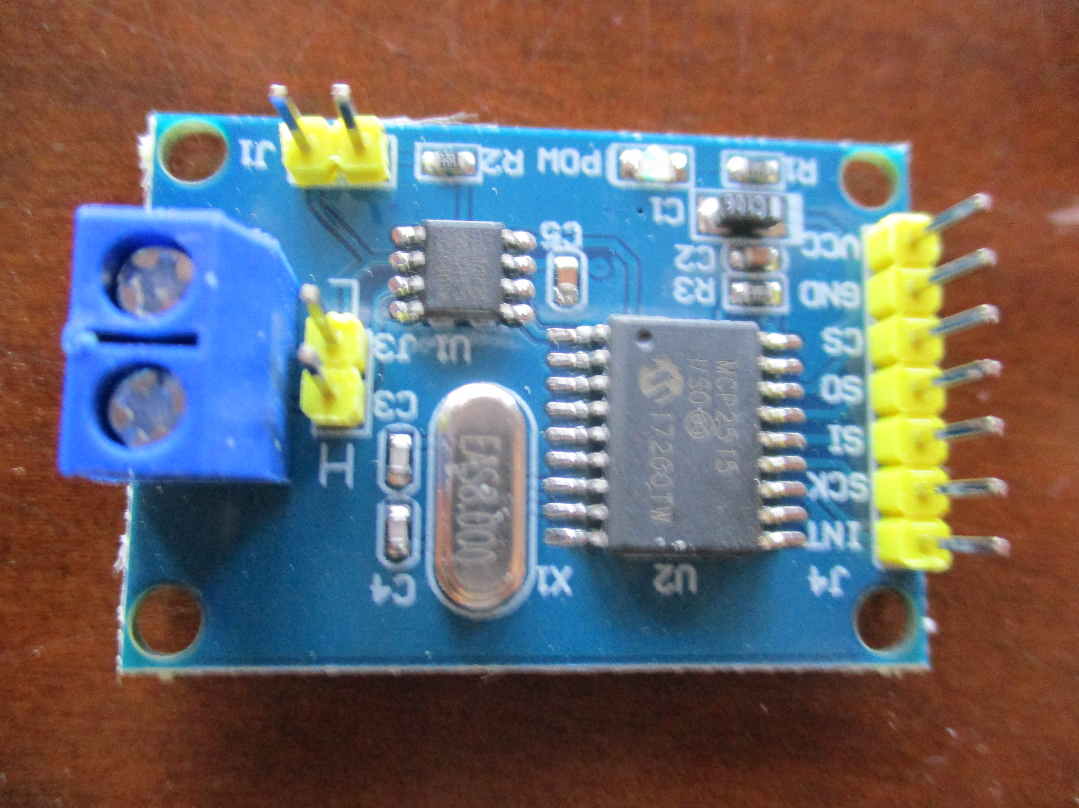

To mount to the PCB, de-solder and remove the yellow headers on top of the board, and re-use, or use new headers underneath. Optionally no need to re-use the J1 header, the J3 header is enough to mechanically secure the board on the PCB along with the main 7 pin header.

The TCM is not at the end of the canbus, so once it is isolated from the rest of the bus, 120 ohm terminations at both ends need to be added.

Short the jumper J1 for the canbus module facing the TCM (module with interrupt D2) to link in the 120 ohm terminating resistor R1 on the board, and also add a 120 ohm terminating resistor to the screw terminals on this same TCM facing module assuming the wiring to the TCM is only a few cm. Otherwise for a longer cable to the TCM module, add a 120 ohm terminating resistor close to the TCM connection instead of adding to the screw terminal on the canbus module.

Do not short the jumper J1 or add any resistors to the module facing the ABS/ECU side of the bus.

Connectors are needed to get power, canbus connectivity, and for ICSP programming.
Example below - these are not automotive grade….

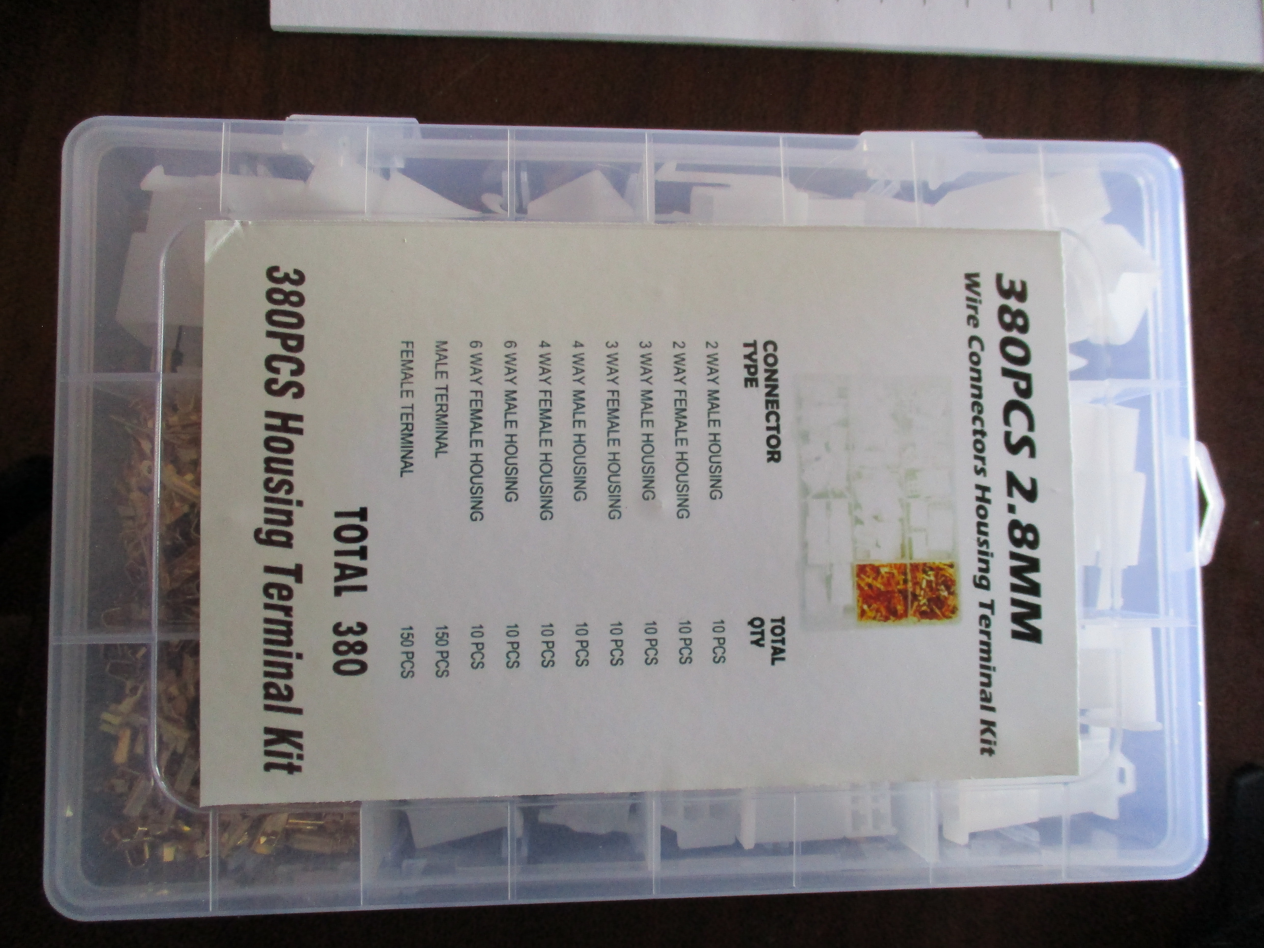

To program the module in place, run the ICSP connector outside the enclosure, otherwise keep it inside for bench programming.

Using male and female 2 pin connectors to splice into the canbus allows the module to be removed and the canbus connection at the tcm to be easily restored (as per image below). Wires to cut and splice are EM72-H (Yellow) and EM72-L (Green). Module next to the Arduino (interrupt D3, blue wires) connects to ECU side of bus (High to Yellow, Low to Green). The other module (with terminations, interrupt D2, brown wires) connects to the TCM side of the bus (High to Yellow, Low to Green).

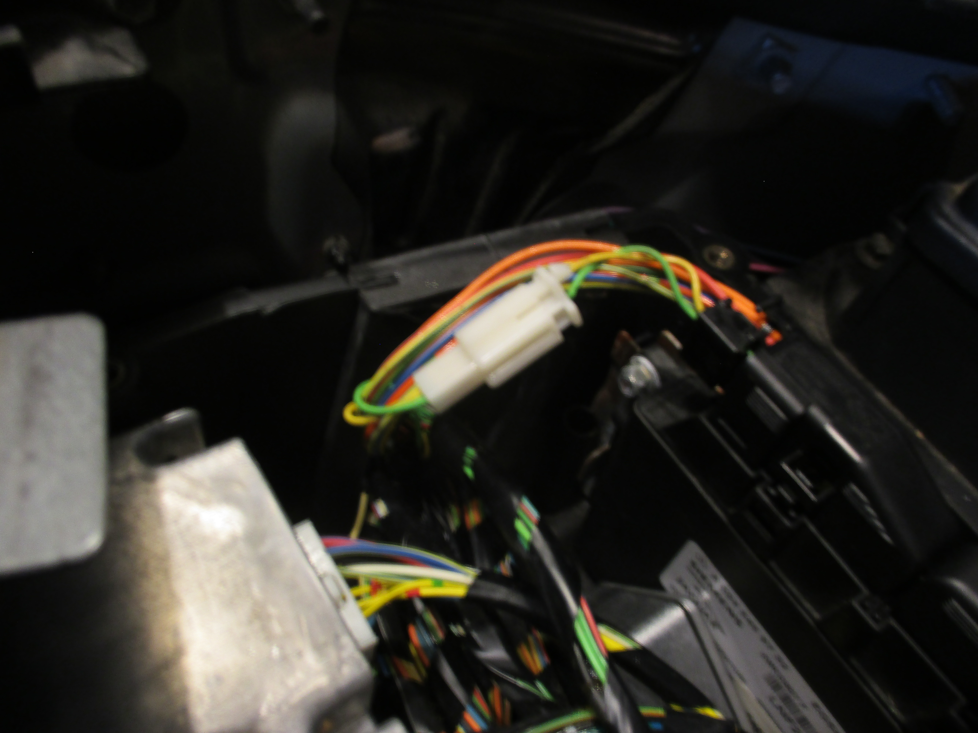

Use a 3 pin connector for power (or something different from the 2 pin to ensure canbus connectors are not mixed up with the power connector)
- 5V power is available at the ECU connectors. Use an in-line fuse. Orange/Yellow cable at either EMS83-05 or EMS82-01 (sensor supply voltage 2) – see car electrical schematic. Or alternatively tap into 12V and add a 12V to 5V regulator. GND is available at EMS83-13 or EMS82-07 (sensors ground – Black/Green)

The ICSP connections are made using a 6 pin connector on the board at the third module connection (5V, GND, SCK, MISO, MOSI), plus direct solder connecton at the Pro Mini for RST (the brown wire)

A programming cable with the corresponding 6 pin connector is needed for connect to the ICSP programmer.

The board is designed to fit into a 4.49 x 2.52 x 1.18 cm aluminum diecast box
(e.g. from www.mpja.com)

Mount the board (e.g. with standoffs) and run the cables through a hole/grommet

Solution looks like this.

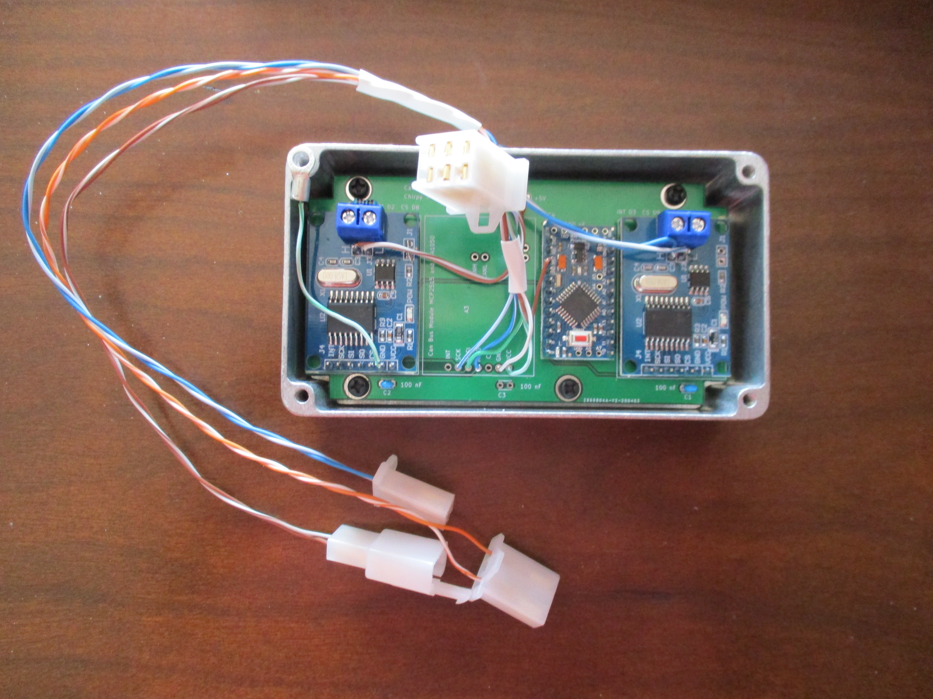

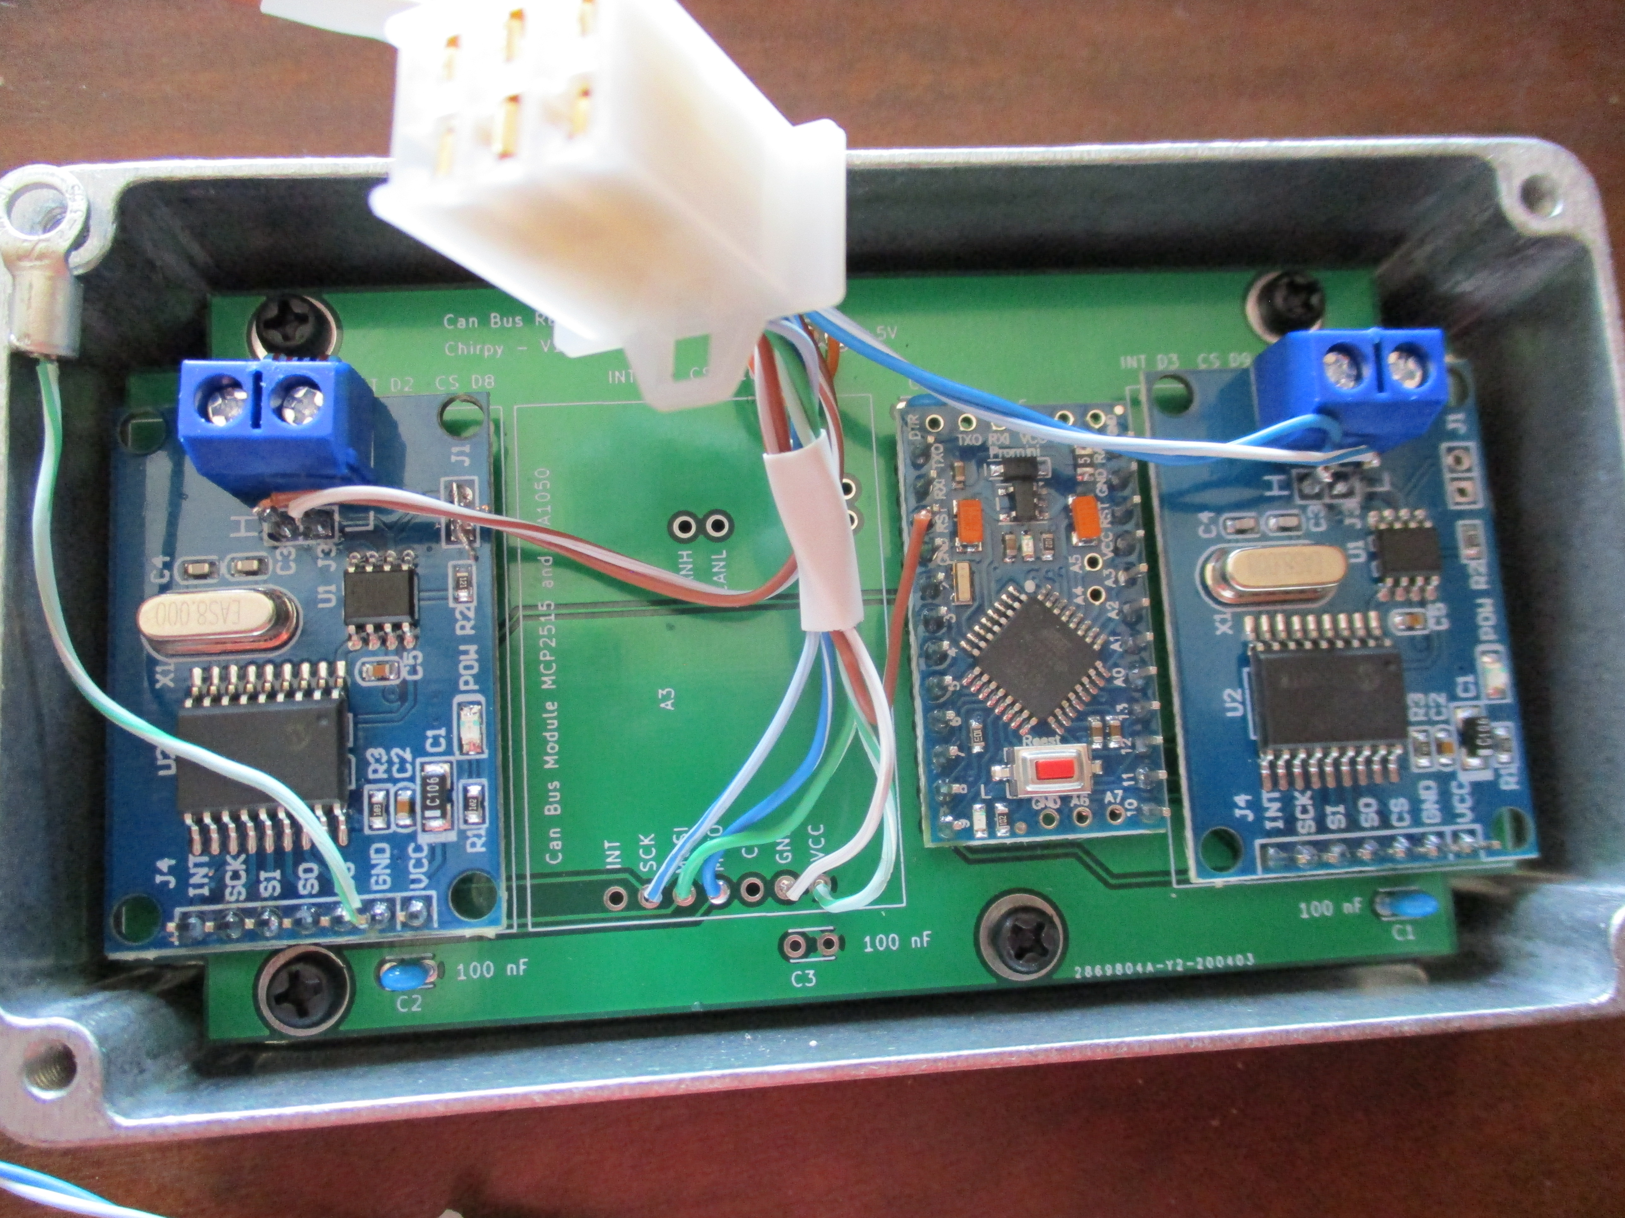
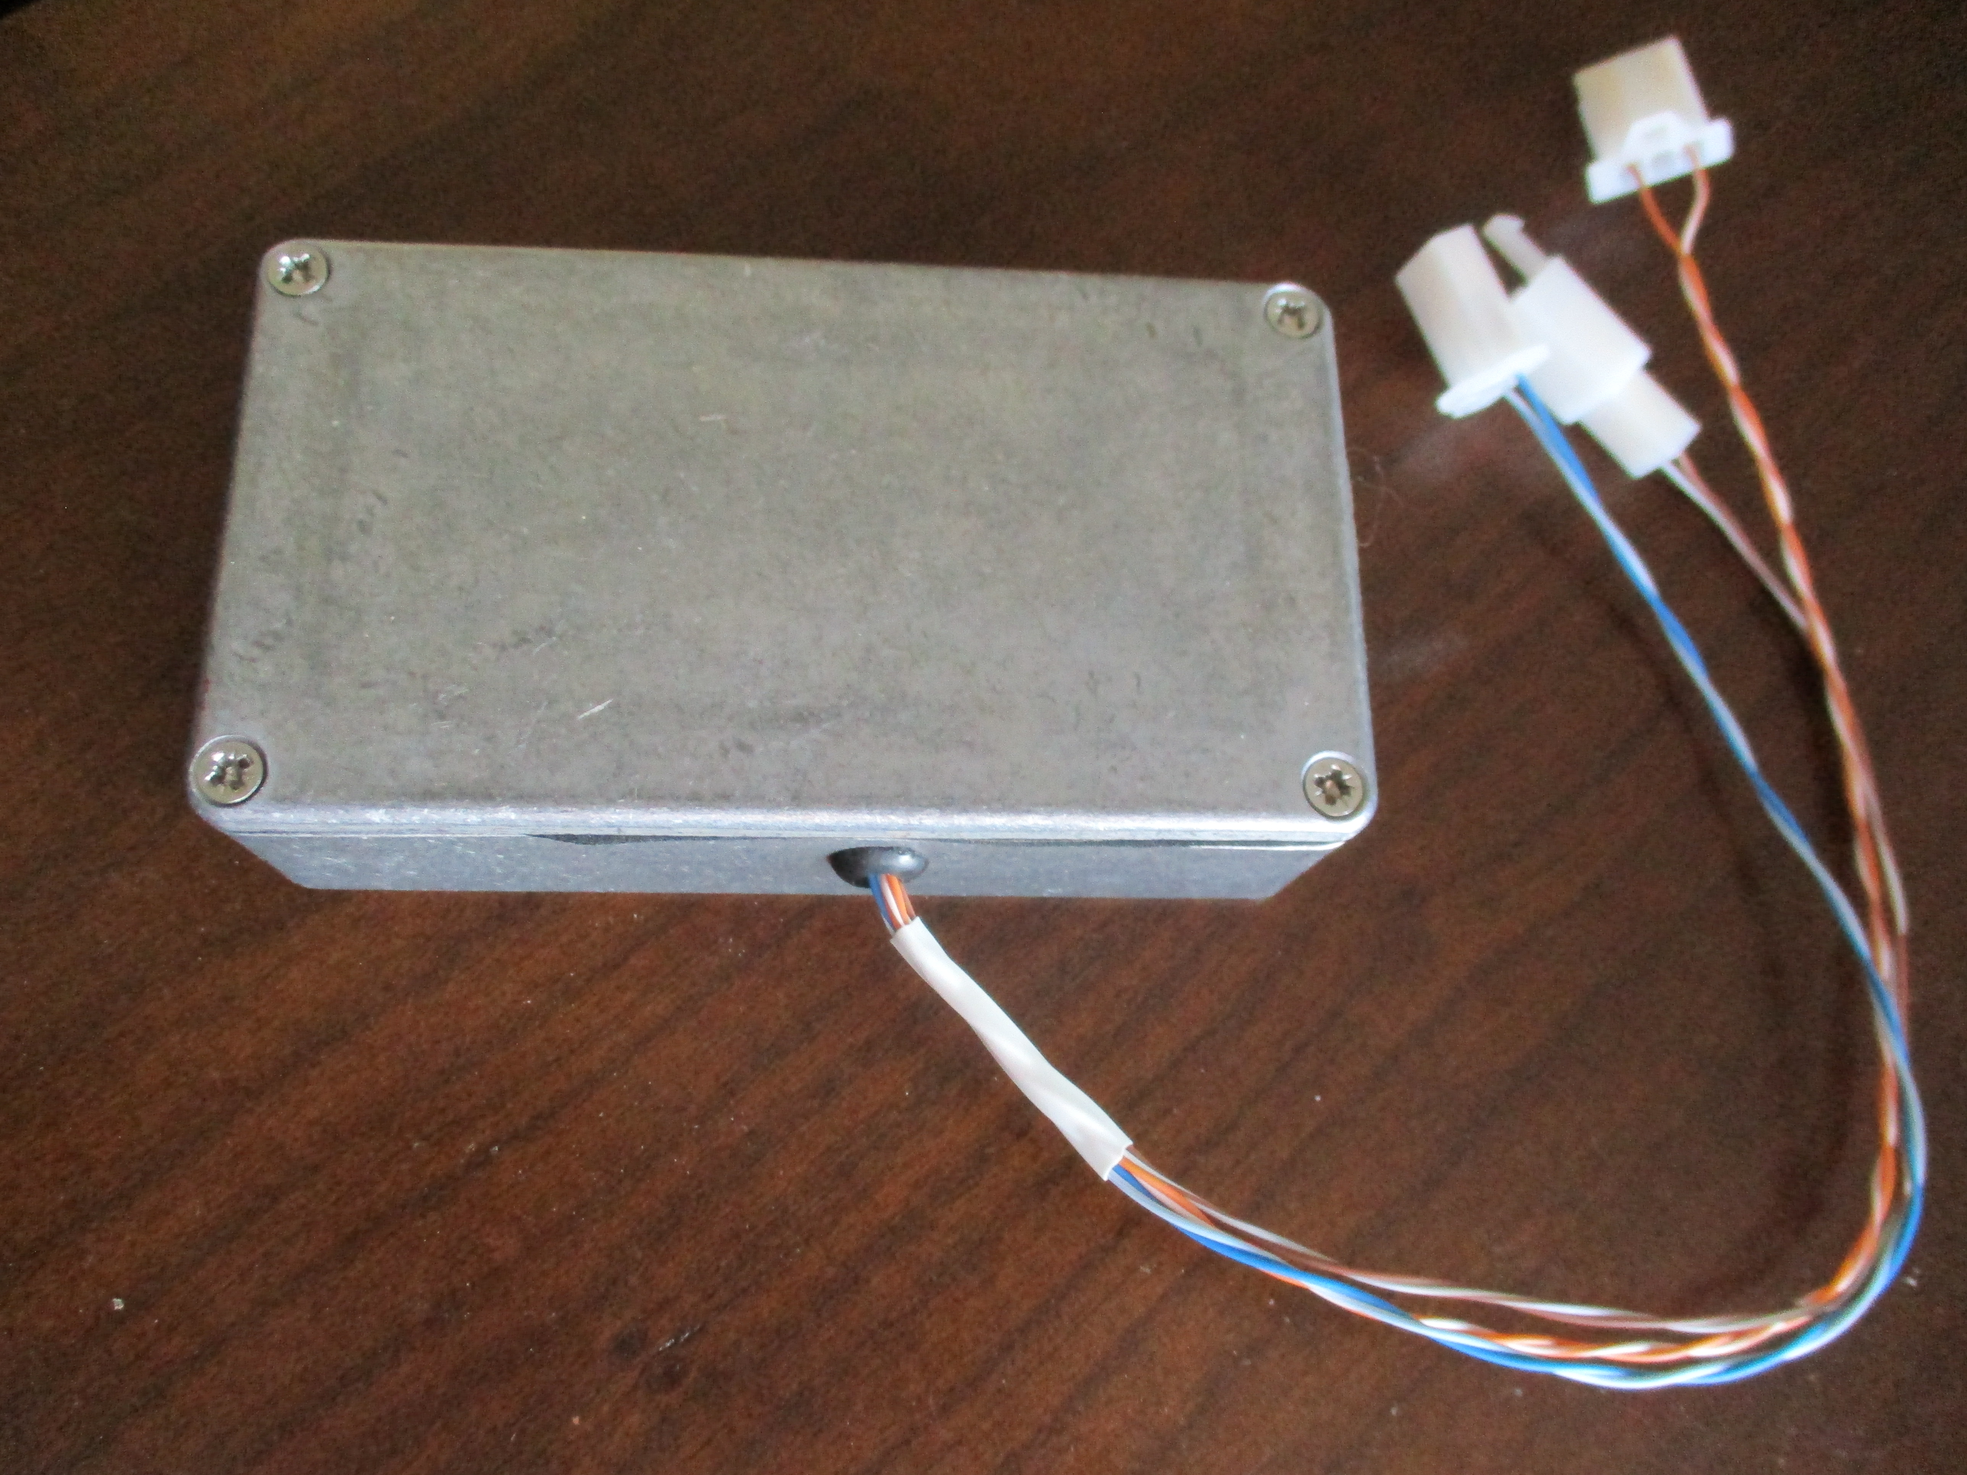

Programming the Arduino

Recommendation is to use ICSP (e.g. using Arduino as ISP as the programmer), since the Pro Mini usually comes with a lousy bootloader, and this can also allegedly cause issues with watchdog operation as well. A slow bootloader will cause ECU/TCM modules to throw canbus communication error trouble codes, since the module takes too long to boot up (can be over 1 second).

