**What is LVM and why is it required?**

LVM (Logical Volume Management) is basically a tool that provides logical volume management for the Linux kernel. It is being introduced simply to make physical storage device management easier. It also includes allocating disks, striping, mirroring, resizing logical volumes. Its main advantages are increased abstraction, flexibility, and control. It simply allows for flexible disk space management. It is especially required to resize the size of the file system online. In Linux, the size of the LVM partition can be extended using “lvextend” command and can be reduced using “lvreduce” commands, respectively.

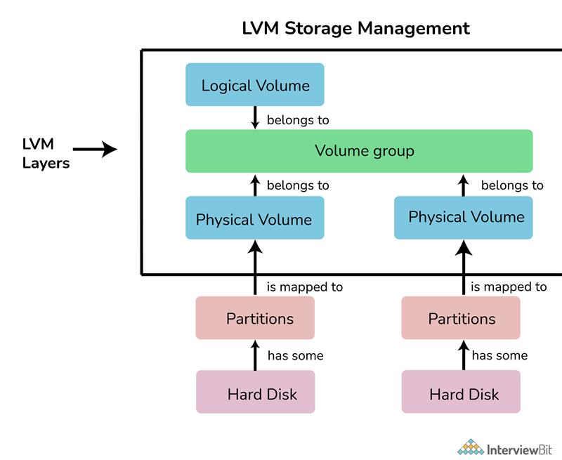

**What is a “/proc” file system?**

Proc file system is a pseudo or virtual file system that provides an interface to the kernel data structure. It generally includes useful information about processes that are running currently. It can also be used to change some kernel parameters at runtime or during execution. It is also regarded as a control and information center for the kernel. All files under this directory are named virtual files.

**17. What do you mean by the daemons?**

Daemons also referred to as the background process, is a long-running Linux program that runs in the background. They do not have any controlling terminal, therefore, they run in the background. These are the processes that are generally started when the system is bootstrapped and terminate or end only when the system is shut down. It is simply the way of extending the functionality of the base OS. It provides and offers several functions that are not available in OS. Its main purpose is to handle periodic requests and then forward the requests to the appropriate programs for execution.

**18. Name daemon that controls the print spooling process.**

The daemon that controls that print spooling process is the Line printing daemon.

**19. What is a Zombie Process?**

Zombie Process, also referred to as a defunct or dead process in Linux, is a process that has finished the execution, but its entry remains in the process table. It usually happens due to a lack of correspondence between parent and child processes. This process occurs for the child process because the parent process needs to read the status of the child process. Once it is completed using the wait system call, this process is removed from the process table.

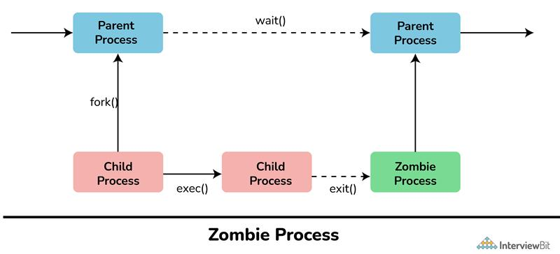

**20. What is the difference between cron and anacron?**

**Cron:** It is a program in Linux that is used to execute tasks at a scheduled time. It works effectively on machines that run continuously.   
  
**Anacron:** It is a program in Linux that is used to execute tasks at certain intervals. It works effectively on machines that are powered off in a day or week.

| **Cron** | **Anacron** |
| --- | --- |
| It is a daemon. | It is not a daemon. |
| It can be scheduled by any normal user. | It can only be used by super users. |
| It is considered ideal for servers. | It is considered ideal for desktops and laptops. |
| It expects the system to run 24*7 | It does not expect the system to run 24*7 |
| Its minimum granularity is in minutes. | Its minimum granularity is only in days |
| It is used to execute scheduled commands. | It is used to execute commands periodically. |

**21. What is load average in Linux?**

Load average, as the name suggests, is the average system load on Linux servers being calculated over a given period of time. The load average of Linux servers can be found using “top” and “uptime” commands. It is simply used to keep track of system resources. It is represented by a decimal number starting at 0.00.  It tells you the load that the system has been under.

**22. What do you mean by Shell Script?**

Shell Script, as name suggests, is a script especially written for shell. Here, script means programming language that is being used to control applications. It simply allows the execution of different commands that are entered in the shell.  It generally helps you to create complex programs containing conditional statements, loops, and functions. It is very easy to debug, can simplify everyday automation processes, and is much quicker as compared to writing big programs.

**23. What is INODE and Process Id?**

**INODE:** It is a unique name given to each file by OS. Each inode has a unique inode number within a file system. It stores various information about files in Linux such as ownership, file size, file type, access mode, number of links, etc.    
  
**Process Id (Identifier):** It is a unique Id given to each process. It is simply used to uniquely identify an active process throughout the system until the process terminates.

**24. Name the first process that is started by the kernel in Linux and what is its process id?**

The first process started by the kernel in Linux is “init” and its process id is 1.

**25. What is CLI and GUI?**

**CLI (Command Line Interface):** It is basically a command-line program that usually accepts text as input to execute or run functions of the operating system. It allows users to type declarative commands simply to give instructions to the computer to perform or execute operations. It usually requires less memory to use as compared to other interfaces as well as it does not require Windows and a low-resolution monitor can be used. It usually provides greater flexibility of use and can also be used to perform things easily that are most difficult to do with GUI.    
  
**GUI (Graphical User Interface):** It is basically a human-computer interface that allows users to interact with electronic devices through graphical icons and visual indicators. The use of these graphical elements or icons makes it easier for users to interact with the system. It is visually intuitive and allows higher productivity. It is usually a combination of graphical and textual interaction that uses menus, buttons, message boxes, etc.

**What is a maximum length for a filename under Linux?**

The maximum length for a filename under Linux is 255 bytes.

**11. Name the Linux that is specially designed by Sun micro system.**

Linux that is specially designed by Sun micro system is Solaris.

**12. Under the Linux system, what is the typical size for swap partitions?**

The typical size for a swap partition under a Linux system should be twice the amount of physical memory or RAM available on the system.

**What do you mean by a Process States in Linux?**

Linux Process is a type of process that can be in a number of different states. The process enters these states from start till end. Process states in Linux are as follows:

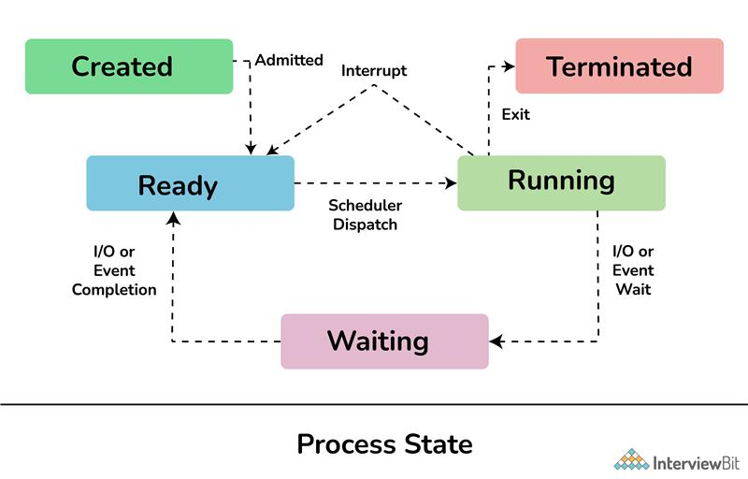

* **New/Ready:** In this state, a new process is created and is ready to run.
* **Running:** In this state, the process is being executed.
* **Blocked/Wait:** In this state, the process is waiting for input from the user and if doesn't have resources to run such as memory, file locks, input, then it can remain in a waiting or blocked state.
* **Terminated/Completed:** In this state, the process has completed the execution or terminated by the OS.
* **Zombie:** In this state, the process is terminated but information regarding the process still exists and is available in the process table.

**What is swap space?**

Swap space, as the name suggests, is basically a space on a hard disk that is used when the amount of physical memory or RAM is full. It is considered a substitute for physical memory. Its main function is to substitute disk space for RAM memory when real RAM does not have enough space to hold all programs that are executing, and more space is required. In simple words, it can be used as an extension of RAM by Linux.

**What is LILO?**

LILO (Linux Loader) is basically a bootloader for Linux that is used to load Linux into memory and start the OS. It is also known as a boot manager that facilitates a dual boot of a computer. It can function as either a master boot program or secondary boot program and performs various functions such as locating kernel, identifying other supporting programs, loading memory, and starting the kernel. If you want to use Linux OS, then you need to install a special bootloader i.e., LILO for it as it allows fast boot of Linux OS.

**4. What is the difference between a process and a thread in Linux?**

Processes and threads are both important components of multitasking in Linux, but they perform different functions. Processes are independent programs with their own memory space and resources, meaning each process is isolated from other processes. Thus, they offer a high level of security.

Threads, on the other hand, are units of execution that exist within a process. All threads within a process share the same resources. Multiple threads can be executed simultaneously, making them useful for tasks requiring cooperation and concurrency.

