Report View

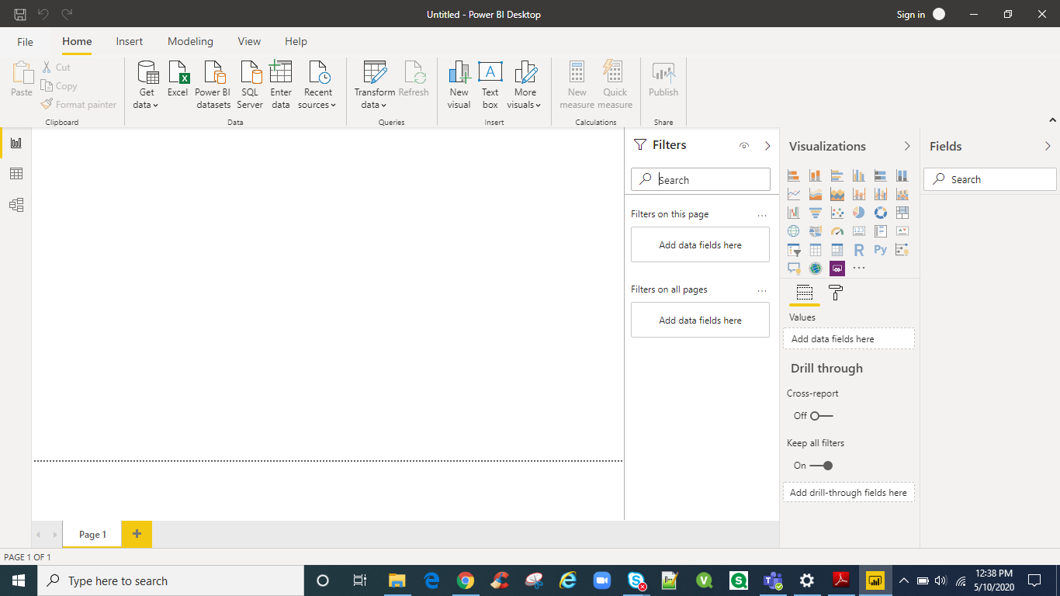

Data View

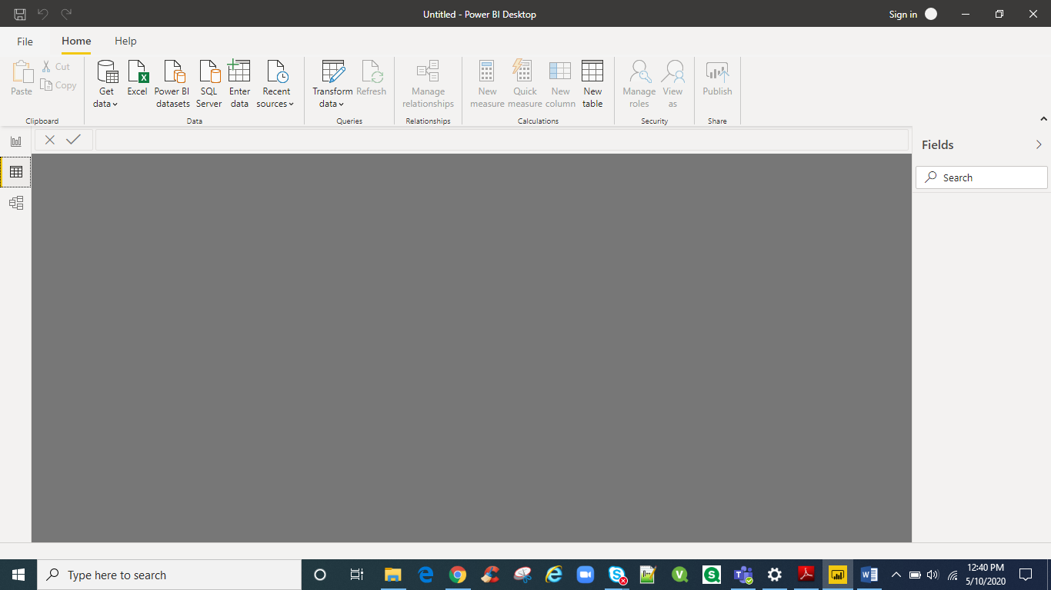

Model View

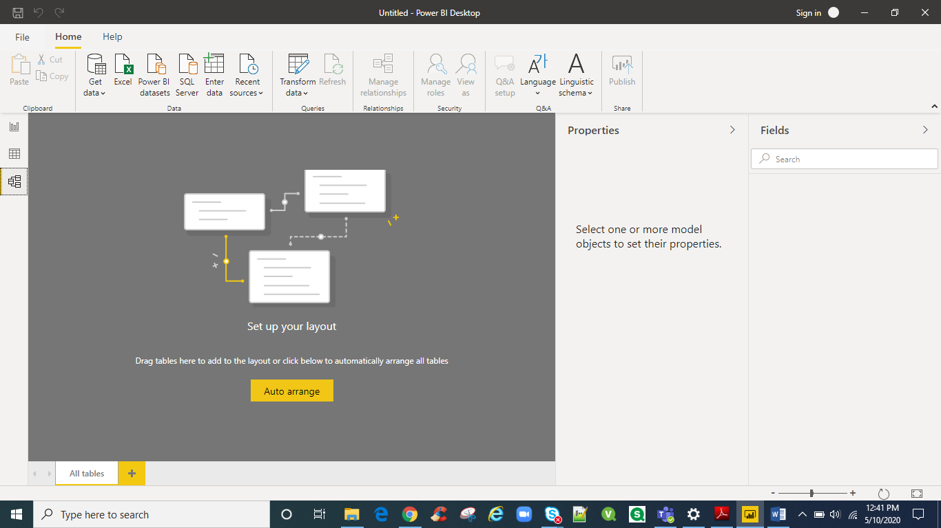

Power Query Editor

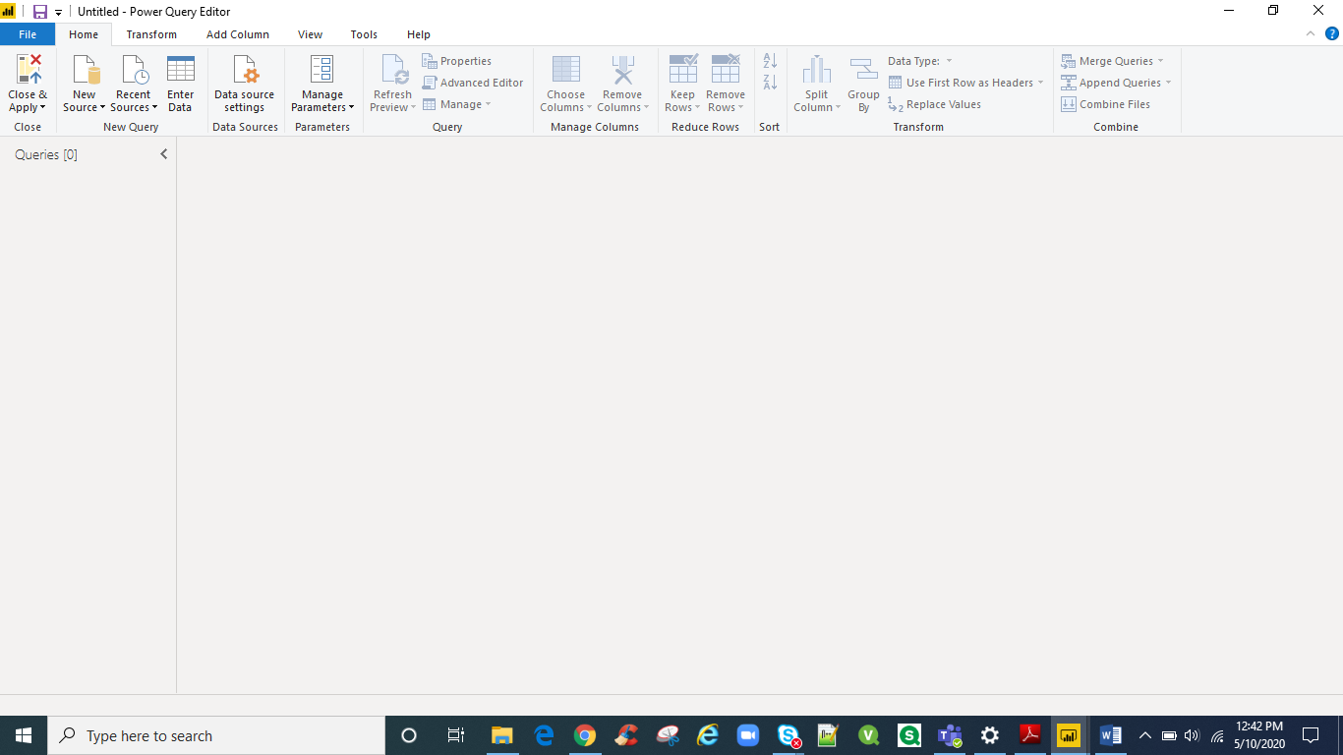

Advanced Editor

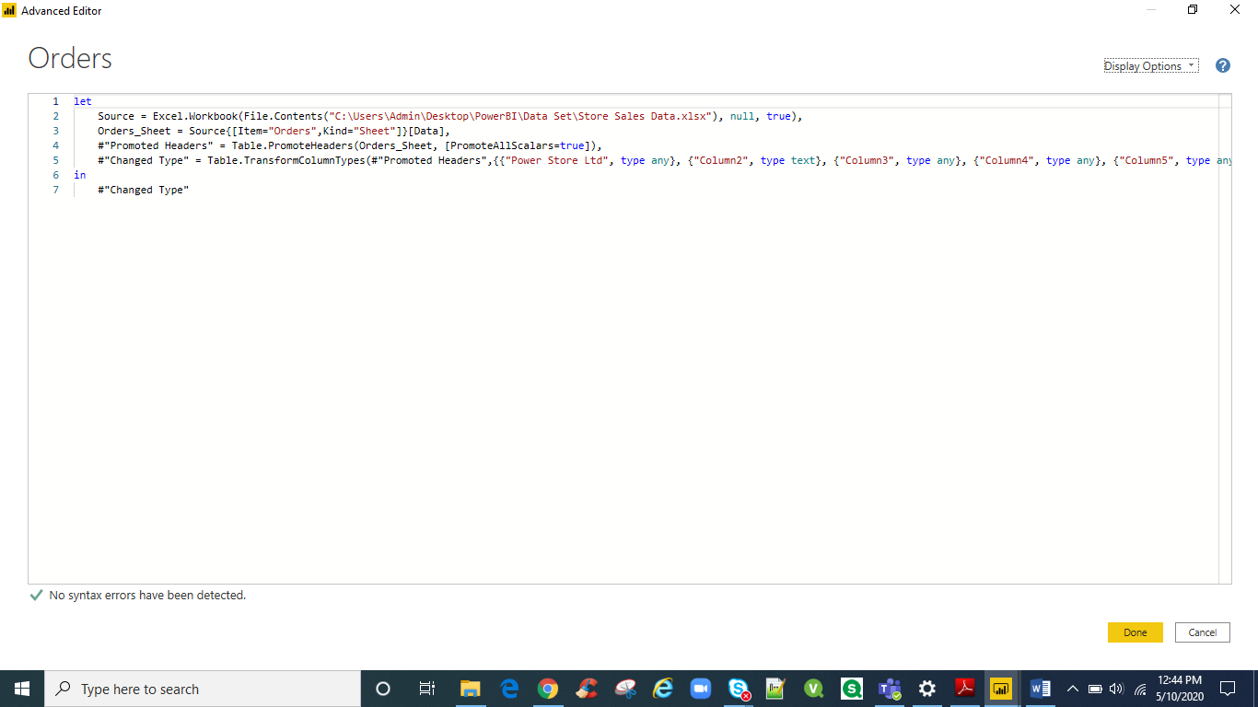

**Power BI Desktop:**

This offering is free to any single user and includes data cleaning and preparation, custom visualizations and the ability to publish to the Power BI service.

**Power BI Pro:**

The Pro plan costs $9.99/user/month. (754.59 Indian Rupee) It includes data collaboration, data governance, building dashboards with a 360-degree real-time view and the ability to publish reports anywhere. Users can try it a free trial for 60 days before purchasing the subscription.

**Power BI Premium:**

The Premium plan starts at $4,995 (3, 77,297.32 Indian Rupee) a month per dedicated cloud compute and storage resource.