Browser Object Model

# Browser Object Model

1. [Browser Object Model (BOM)](https://www.javatpoint.com/browser-object-model)

The **Browser Object Model** (BOM) is used to interact with the browser.

The default object of browser is window means you can call all the functions of window by specifying window or directly. For example:

1. window.alert("hello javatpoint");

is same as:

1. alert("hello javatpoint");

You can use a lot of properties (other objects) defined underneath the window object like document, history, screen, navigator, location, innerHeight, innerWidth,

#### **Note: The document object represents an html document. It forms DOM (Document Object Model).**

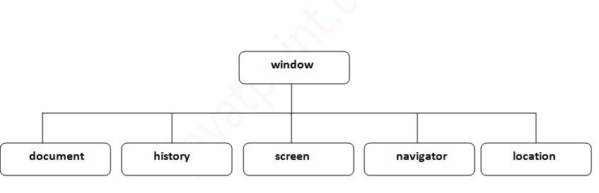

# Window Object

The **window object** represents a window in browser. An object of window is created automatically by the browser.

Window is the object of browser, **it is not the object of javascript**. The javascript objects are string, array, date etc.

## **Methods of window object**

The important methods of window object are as follows:

|  |  |
| --- | --- |
| **Method** | **Description** |
| alert() | displays the alert box containing message with ok button. |
| confirm() | displays the confirm dialog box containing message with ok and cancel button. |
| prompt() | displays a dialog box to get input from the user. |
| open() | opens the new window. |
| close() | closes the current window. |
| setTimeout() | performs action after specified time like calling function, evaluating expressions etc. |

1. **<script** type="text/javascript"**>**
2. function msg(){
3. alert("Hello Alert Box");
4. }
5. **</script>**
6. **<input** type="button" value="click" onclick="msg()"**/>**

# Document Object Model

The **document object** represents the whole html document.

When html document is loaded in the browser, it becomes a document object. It is the **root element** that represents the html document. It has properties and methods. By the help of document object, we can add dynamic content to our web page.

As mentioned earlier, it is the object of window. So

1. window.document

## **Properties of document object**

Let's see the properties of document object that can be accessed and modified by the document object. 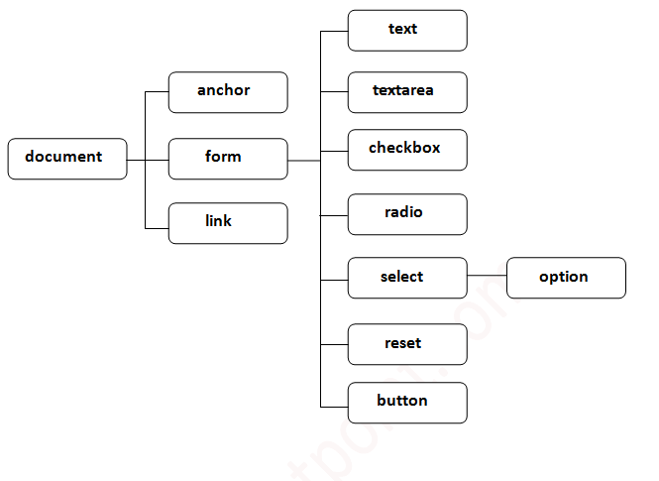

# document.getElementById() method

1. **<script** type="text/javascript"**>**
2. function getcube(){
3. var number=document.getElementById("number").value;
4. alert(number*number*number);
5. }
6. **</script>**
7. **<form>**
8. Enter No:**<input** type="text" id="number" name="number"**/><br/>**
9. **<input** type="button" value="cube" onclick="getcube()"**/>**
10. **</form>**

# Javascript - document.getElementsByName()

The **document.getElementsByName()** method returns all the element of specified name.

The syntax of the getElementsByName() method is given below:

1. document.getElementsByName("name")
2. **<script** type="text/javascript"**>**
3. function totalelements()
4. {
5. var allgenders=document.getElementsByName("gender");
6. alert("Total Genders:"+allgenders.length);
7. }
8. **</script>**
9. **<form>**
10. Male:**<input** type="radio" name="gender" value="male"**>**
11. Female:**<input** type="radio" name="gender" value="female"**>**
13. **<input** type="button" onclick="totalelements()" value="Total Genders"**>**
14. **</form>**

J