**PROJECT CODE:**  
  
**EXPLORATORY DATA ANALYSIS PART:**

import cudf

import numpy as np

import pandas as pd

import matplotlib.pyplot as plt

import seaborn as sns

from sklearn.feature_selection import chi2, f_classif

from sklearn.preprocessing import LabelEncoder

from scipy.stats import zscore

df = cudf.read_csv('credit_risk_dataset.csv')

df = df.dropna()

print(df.head())

print(df.shape)

print(df.dtypes)

print(df.isnull().sum())

print(df.describe())

loan_status_counts = df['loan_status'].value_counts().to_pandas()

loan_status_counts.plot(kind='bar')

plt.xlabel('Loan Status')

plt.ylabel('Frequency')

plt.title('Distribution of Loan Status')

plt.show()

person_age_hist = df['person_age'].to_pandas()

person_age_hist.hist()

plt.xlabel('Person Age')

plt.ylabel('Frequency')

plt.title('Distribution of Person Age')

plt.show()

person_income_hist= df['person_income'].to_pandas()

person_income_hist.hist()

plt.xlabel('Person Income')

plt.ylabel('Frequency')

plt.title('Distribution of Person Income')

plt.show()

person_home_hist= df['person_home_ownership'].value_counts().to_pandas()

person_home_hist.hist()

plt.xlabel('Person Home Ownership')

plt.ylabel('Frequency')

plt.title('Distribution of Person Home Ownership')

plt.show()

person_emp_hist= df['person_emp_length'].to_pandas()

person_emp_hist.hist()

plt.xlabel('Person Employment Length')

plt.ylabel('Frequency')

plt.title('Distribution of Person Employment Length')

plt.show()

loan_intent_counts = df['loan_intent'].value_counts().to_pandas()

loan_intent_counts.plot(kind='bar')

plt.xlabel('Loan Intent')

plt.ylabel('Frequency')

plt.title('Distribution of Loan Intent')

plt.show()

loan_grade_hist=df['loan_grade'].value_counts().to_pandas()

loan_grade_hist.hist()

plt.xlabel('Loan Grade')

plt.ylabel('Frequency')

plt.title('Distribution of Loan Grade')

plt.show()

df['loan_amnt'].to_pandas().hist()

plt.xlabel('Loan Amount')

plt.ylabel('Frequency')

plt.title('Distribution of Loan Amount')

plt.show()

df['loan_int_rate'].to_pandas().hist()

plt.xlabel('Loan Interest Rate')

plt.ylabel('Frequency')

plt.title('Distribution of Loan Interest Rate')

plt.show()

df['loan_percent_income'].to_pandas().hist()

plt.xlabel('Loan Percent Income')

plt.ylabel('Frequency')

plt.title('Distribution of Loan Percent Income')

plt.show()

le = LabelEncoder()

df['person_home_ownership'] = le.fit_transform(df['person_home_ownership'].to_numpy())

df['loan_intent'] = le.fit_transform(df['loan_intent'].to_numpy())

df['loan_grade'] = le.fit_transform(df['loan_grade'].to_numpy())

df['cb_person_default_on_file'] = le.fit_transform(df['cb_person_default_on_file'].to_numpy())

corr = df.corr()

plt.figure(figsize=(12,10))

sns.heatmap(corr.to_pandas(), annot=True, cmap='coolwarm')

plt.title('Correlation Matrix')

plt.show()

cat_vars = ['person_home_ownership', 'loan_intent', 'loan_grade', 'cb_person_default_on_file']

chi_scores = chi2(df[cat_vars].to_pandas(), df['loan_status'].to_pandas())

p_values = pd.Series(chi_scores[1], index=cat_vars)

p_values.sort_values(ascending=False, inplace=True)

print(p_values)

num_vars = ['person_age', 'person_income', 'person_emp_length', 'loan_amnt', 'loan_int_rate', 'loan_percent_income', 'cb_person_cred_hist_length']

f_scores = f_classif(df[num_vars].to_pandas(), df['loan_status'].to_pandas())

p_values = pd.Series(f_scores[1], index=num_vars)

p_values.sort_values(ascending=False, inplace=True)

print(p_values)

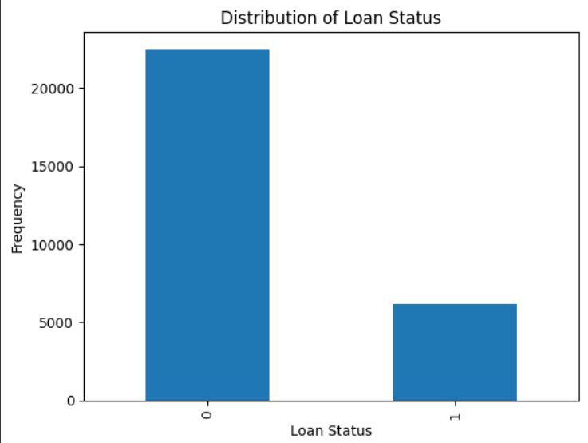**HISTOGRAMS FOR DISTRIBUTIONS OF EACH FEATURES:**

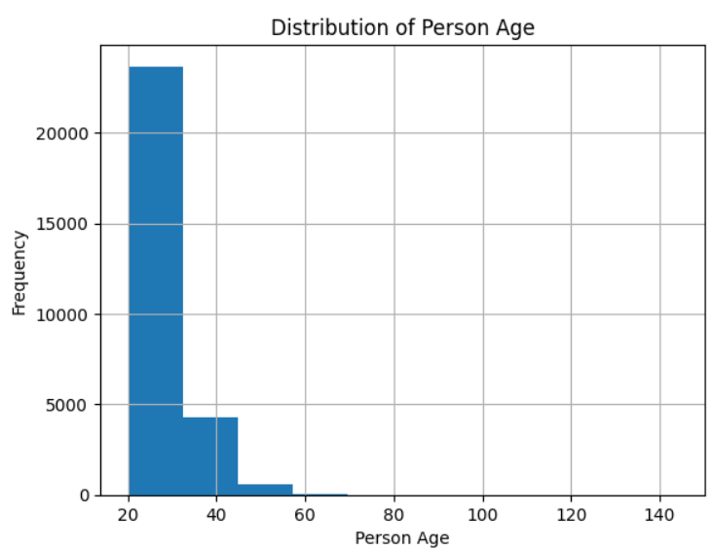

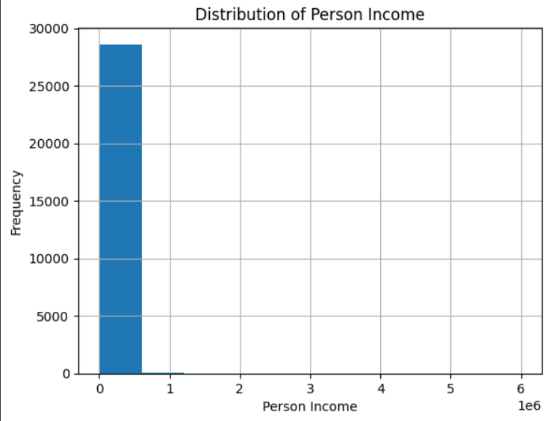

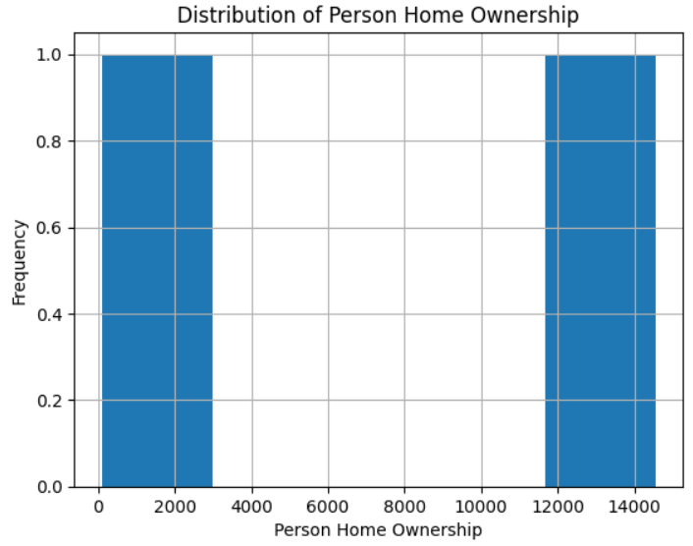

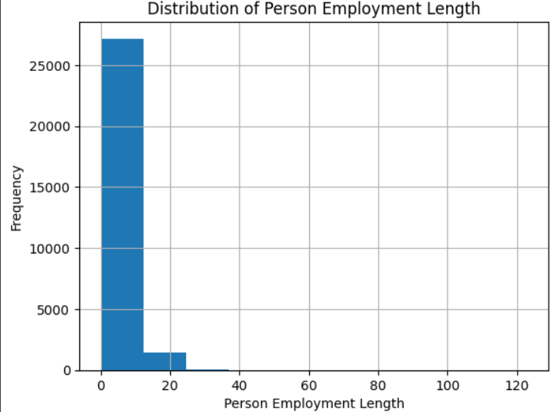

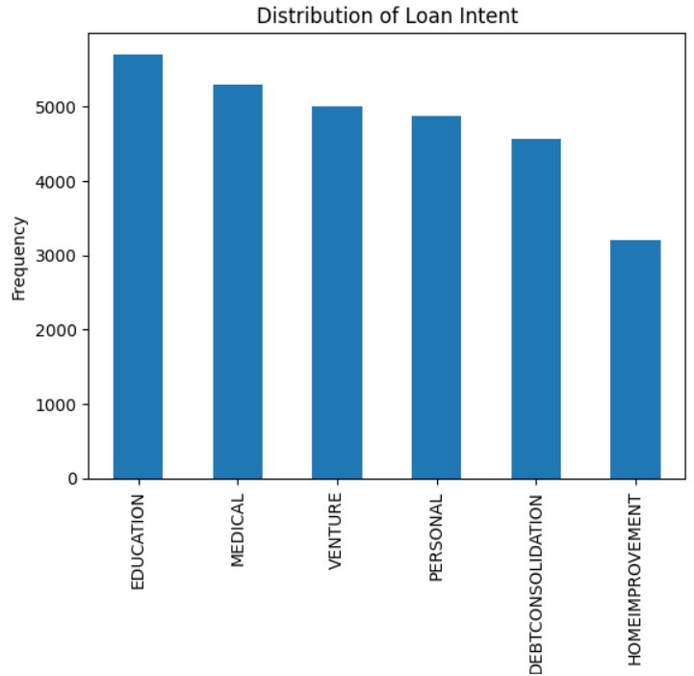

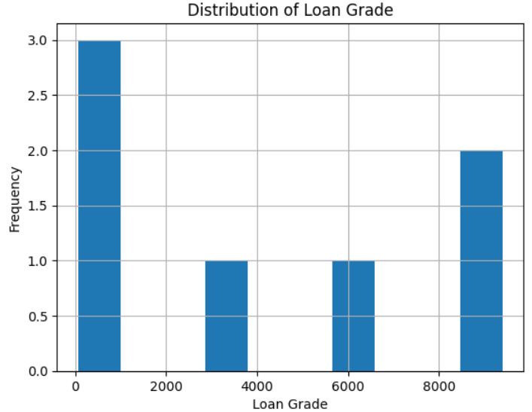

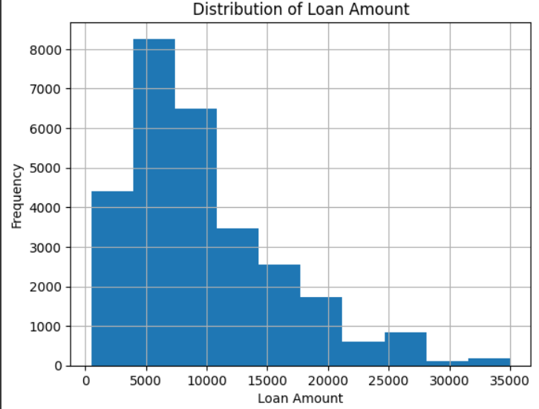

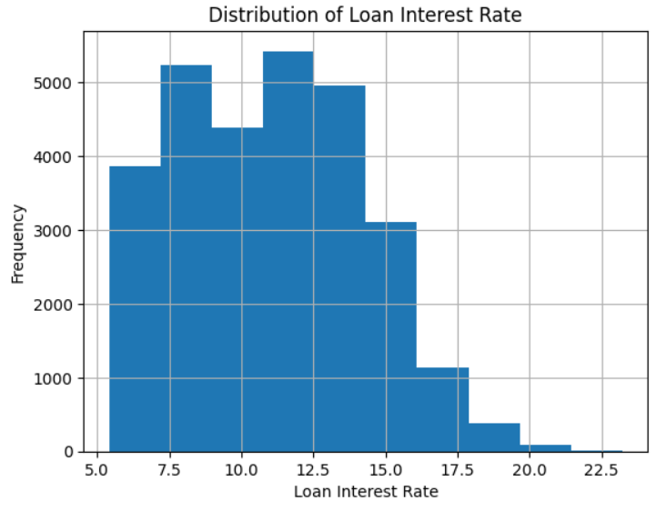

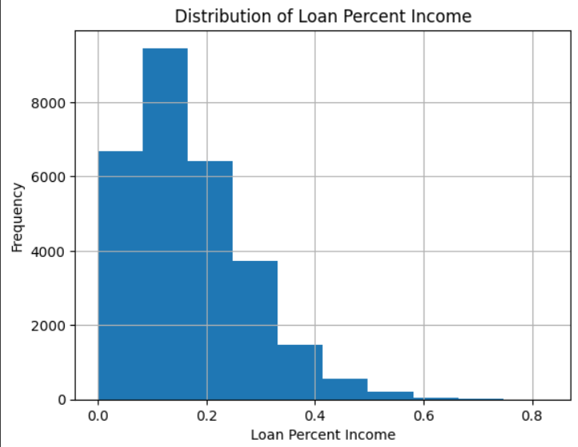

**CORRELATION MATRIX:**

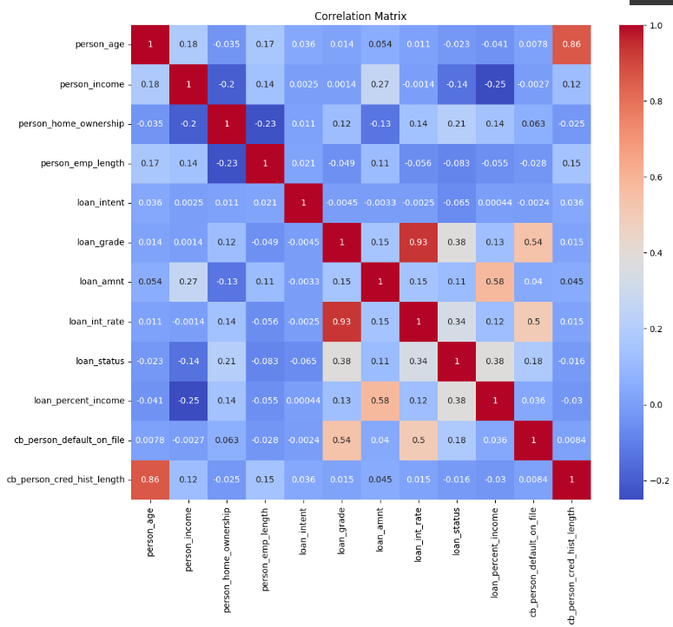

**MODEL BUILDING FOR PREDICTION PART:**

import torch

import cudf

import numpy as np

import matplotlib.pyplot as plt

import seaborn as sns

from sklearn.model_selection import train_test_split

from sklearn.preprocessing import StandardScaler, LabelEncoder, OneHotEncoder

from sklearn.neighbors import KNeighborsClassifier

from sklearn.linear_model import LogisticRegression

from sklearn.svm import SVC

from sklearn.tree import DecisionTreeClassifier

from sklearn.ensemble import RandomForestClassifier

from sklearn.metrics import accuracy_score

from scipy.stats import zscore

df = cudf.read_csv('credit_risk_dataset.csv')

df = df.dropna()

X = df.drop('loan_status', axis=1)

y = df['loan_status']

X_train, X_test, y_train, y_test = train_test_split(X, y, test_size=0.25, random_state=42)

scaler = StandardScaler()

X_train_num = X_train.drop(['person_home_ownership', 'loan_intent', 'loan_grade', 'cb_person_default_on_file'], axis=1)

X_train_num = scaler.fit_transform(X_train_num.to_numpy())

X_test_num = X_test.drop(['person_home_ownership', 'loan_intent', 'loan_grade', 'cb_person_default_on_file'], axis=1)

X_test_num = scaler.transform(X_test_num.to_numpy())

encoder = OneHotEncoder(sparse=False)

X_train_cat = X_train[['person_home_ownership', 'loan_intent', 'loan_grade', 'cb_person_default_on_file']]

X_train_cat = encoder.fit_transform(X_train_cat.to_pandas())

X_test_cat = X_test[['person_home_ownership', 'loan_intent', 'loan_grade', 'cb_person_default_on_file']]

X_test_cat = encoder.transform(X_test_cat.to_pandas())

X_train = np.concatenate((X_train_num, X_train_cat), axis=1)

X_test = np.concatenate((X_test_num, X_test_cat), axis=1)

X_train = torch.tensor(X_train, dtype=torch.float32).cuda()

y_train = torch.tensor(y_train.values, dtype=torch.float32).cuda()

X_test = torch.tensor(X_test, dtype=torch.float32).cuda()

y_test = torch.tensor(y_test.values, dtype=torch.float32).cuda()

models = [

    KNeighborsClassifier(),

    LogisticRegression(max_iter=10000),

    SVC(),

    DecisionTreeClassifier(),

    RandomForestClassifier()

]

model_names = ['KNN', 'Logistic Regression', 'Support Vector Machines', 'Decision Trees', 'Random Forest']

accuracies = []

for model in models:

    model.fit(X_train.cpu().numpy(), y_train.cpu().numpy())

    accuracy = accuracy_score(y_test.cpu().numpy(), model.predict(X_test.cpu().numpy()))

    accuracies.append(accuracy)

results = dict(zip(model_names, accuracies))

for name, acc in results.items():

    print(f'{name}: {acc:.2f}')

plt.figure(figsize=(10, 5))

plt.bar(results.keys(), results.values(), color=['blue', 'orange', 'green', 'red', 'purple'])

plt.xlabel('Model')

plt.ylabel('Accuracy')

plt.title('Comparison of Model Performance')

plt.show()

**FINAL OUTPUT OF MULTIPLE MODELS:**  
  
**Executing the code in the Google CoLab and below is the screenshot of the execution:**

