**PROJECT CODE:**  
  
**EXPLORATORY DATA ANALYSIS PART:**

import cudf

import numpy as np

import pandas as pd

import matplotlib.pyplot as plt

import seaborn as sns

from sklearn.preprocessing import LabelEncoder

df = cudf.read_csv('insurance.csv')

print(df.head())

print(df.shape)

print(df.dtypes)

print(df.isnull().sum())

print(df.describe())

df['charges'].to_pandas().hist()

plt.xlabel('Charges')

plt.ylabel('Frequency')

plt.title('Distribution of Charges')

plt.show()

df['age'].to_pandas().hist()

plt.xlabel('Age')

plt.ylabel('Frequency')

plt.title('Distribution of Age')

plt.show()

df['sex'].value_counts()

df['sex'].to_pandas().hist()

plt.xlabel('Sex')

plt.ylabel('Frequency')

plt.title('Distribution of Sex')

plt.show()

df['bmi'].to_pandas().hist()

plt.xlabel('BMI')

plt.ylabel('Frequency')

plt.title('Distribution of BMI')

plt.show()

df['children'].value_counts()

df['children'].to_pandas().hist()

plt.xlabel('Children')

plt.ylabel('Frequency')

plt.title('Distribution of Children')

plt.show()

df['smoker'].value_counts()

df['smoker'].to_pandas().hist()

plt.xlabel('Smoker')

plt.ylabel('Frequency')

plt.title('Distribution of Smoker')

plt.show()

df['region'].value_counts()

df['region'].to_pandas().hist()

plt.xlabel('Region')

plt.ylabel('Frequency')

plt.title('Distribution of Region')

plt.show()

df_pandas = df.to_pandas()

le = LabelEncoder()

df_pandas['sex'] = le.fit_transform(df_pandas['sex'])

df_pandas['smoker'] = le.fit_transform(df_pandas['smoker'])

df_pandas['region'] = le.fit_transform(df_pandas['region'])

df = cudf.from_pandas(df_pandas)

corr = df.corr()

plt.figure(figsize=(12,10))

sns.heatmap(corr.to_pandas(), annot=True, cmap='coolwarm')

plt.title('Correlation Matrix')

plt.show()

sns.pairplot(df_pandas, x_vars=['age', 'bmi', 'children'], y_vars='charges', hue='sex', kind='reg')

plt.show()

sns.pairplot(df_pandas, x_vars=['age', 'bmi', 'children'], y_vars='charges', hue='sex', kind='reg')

plt.show()

sns.pairplot(df_pandas, x_vars=['age', 'bmi', 'children'], y_vars='charges', hue='region', kind='reg')

plt.show()

sns.boxplot(x='sex', y='charges', data=df_pandas)

plt.show()

sns.boxplot(x='smoker', y='charges', data=df_pandas)

plt.show()

sns.boxplot(x='region', y='charges', data=df_pandas)

plt.show()

**DESCRIBE():**

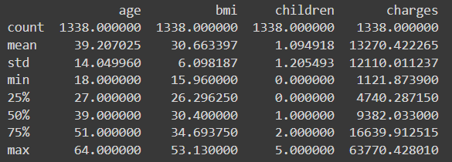

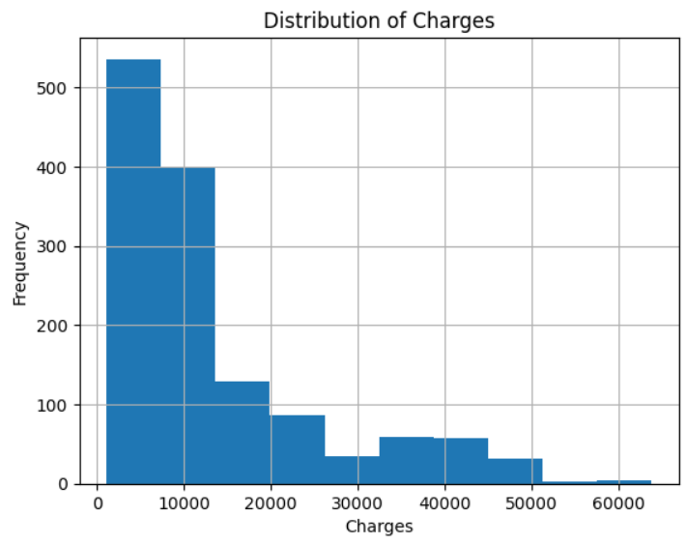**HISTOGRAMS:**

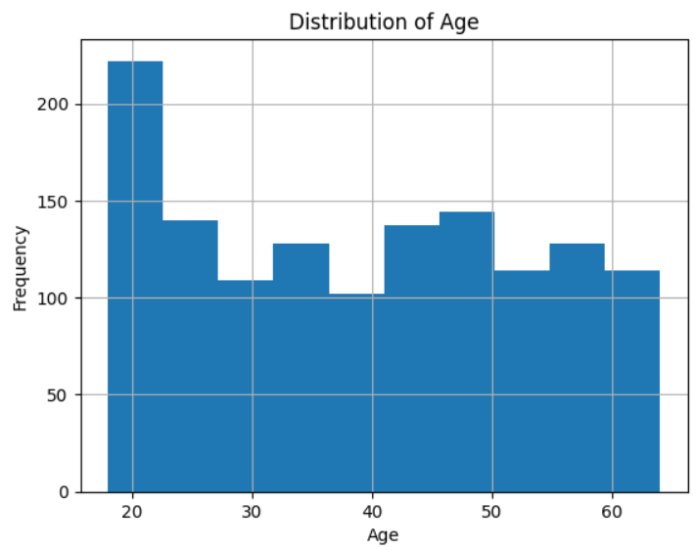

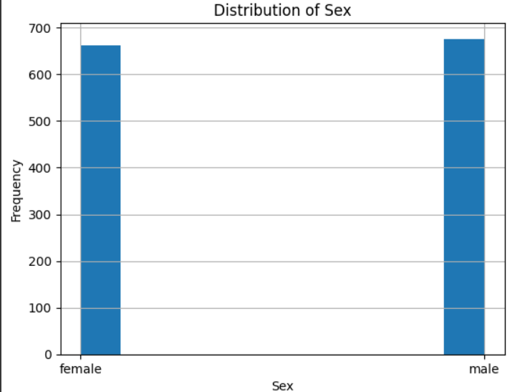

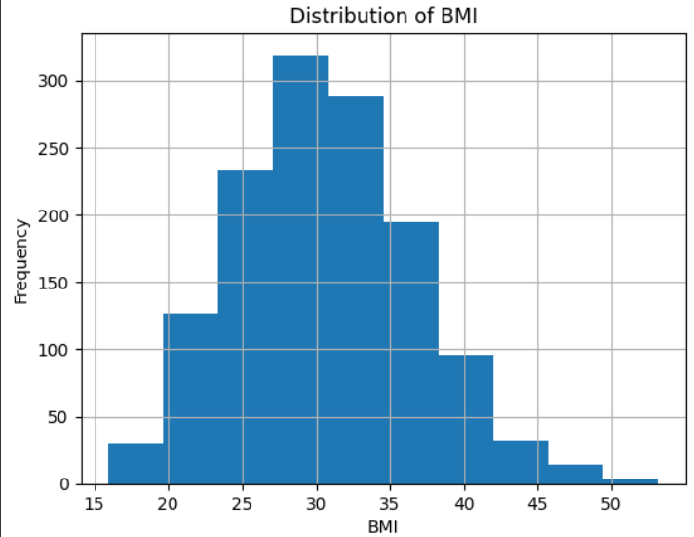

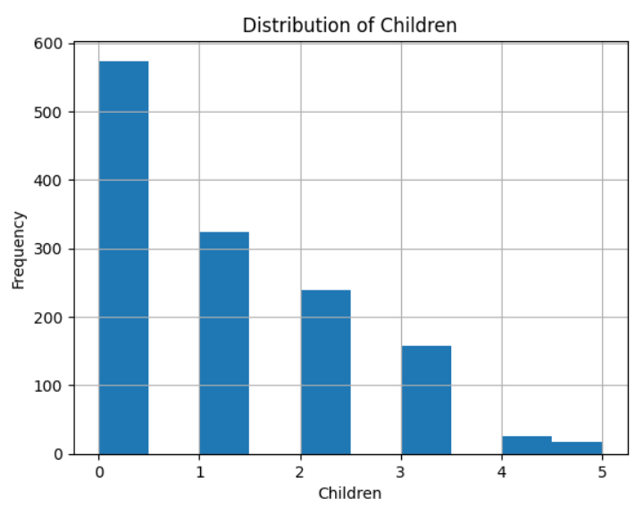

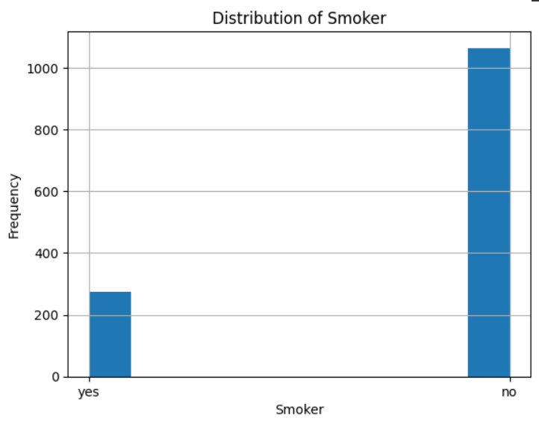

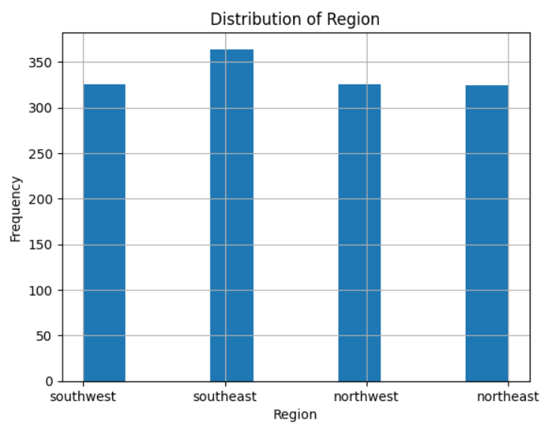

**CORRELATION MATRIX:**

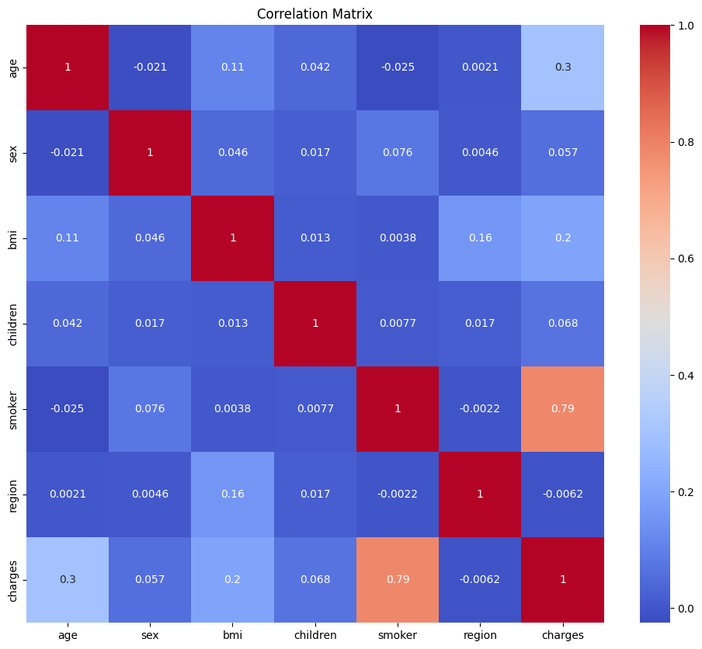

**PAIR PLOTS:** 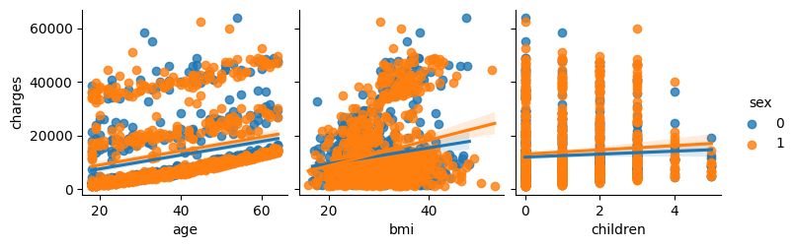

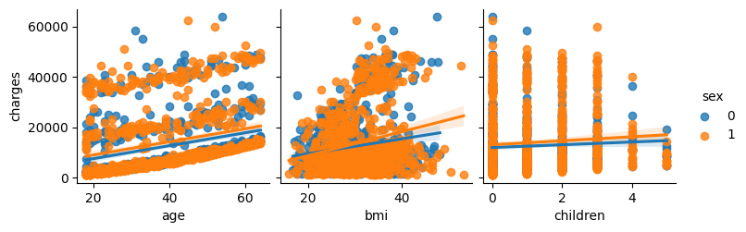

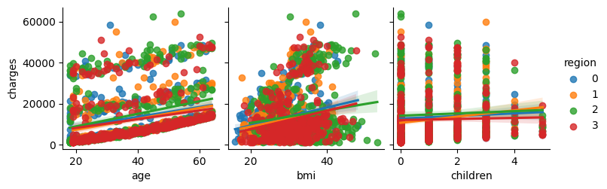

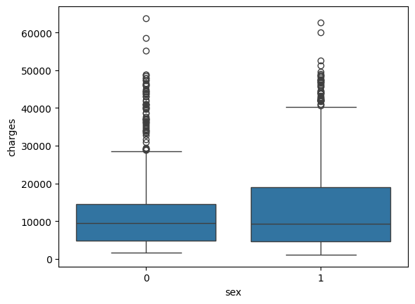**BOX PLOTS:**

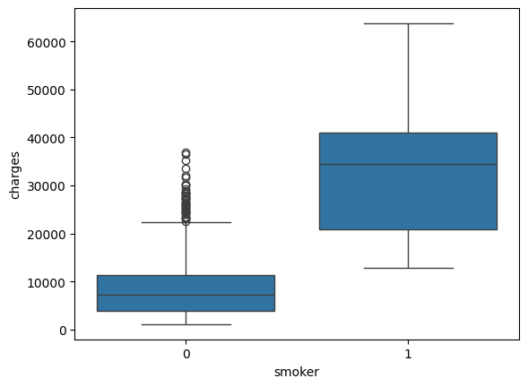

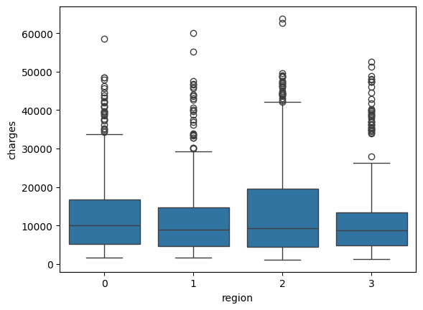

**MODEL BUILDING FOR PREDICTION PART:**

import cudf

import cupy as cp

import matplotlib.pyplot as plt

from sklearn.model_selection import train_test_split

from sklearn.preprocessing import StandardScaler, OneHotEncoder

from sklearn.metrics import mean_absolute_error, accuracy_score

import torch

import torch.nn as nn

import torch.optim as optim

from sklearn.neighbors import KNeighborsRegressor

from sklearn.linear_model import LinearRegression

from sklearn.svm import SVR

from sklearn.tree import DecisionTreeRegressor

from sklearn.ensemble import RandomForestRegressor

device = torch.device('cuda' if torch.cuda.is_available() else 'cpu')

print('Using device:', device)

df = cudf.read_csv('insurance.csv')

df = df.dropna()

X = df.drop('charges', axis=1)

y = df['charges']

X_train, X_test, y_train, y_test = train_test_split(X, y, test_size=0.25, random_state=42)

scaler = StandardScaler()

X_train_num = X_train.drop(['sex', 'smoker', 'region'], axis=1)

X_train_num = cp.asarray(scaler.fit_transform(X_train_num.values.get()))

encoder = OneHotEncoder(sparse=False)

X_train_cat = X_train[['sex', 'smoker', 'region']]

X_train_cat = encoder.fit_transform(X_train_cat.to_pandas())

X_train_cat = cp.asarray(X_train_cat)

X_train = cp.concatenate((X_train_num, X_train_cat), axis=1)

X_test_num = X_test.drop(['sex', 'smoker', 'region'], axis=1)

X_test_num = cp.asarray(scaler.transform(X_test_num.values.get()))

X_test_cat = X_test[['sex', 'smoker', 'region']]

X_test_cat = encoder.transform(X_test_cat.to_pandas())

X_test_cat = cp.asarray(X_test_cat)

X_test = cp.concatenate((X_test_num, X_test_cat), axis=1)

X_train_tensor = torch.tensor(X_train, dtype=torch.float32, device=device)

y_train_tensor = torch.tensor(y_train.values, dtype=torch.float32, device=device)

X_test_tensor = torch.tensor(X_test, dtype=torch.float32, device=device)

y_test_tensor = torch.tensor(y_test.values, dtype=torch.float32, device=device)

class NeuralNet(nn.Module):

    def __init__(self, input_size):

        super(NeuralNet, self).__init__()

        self.fc1 = nn.Linear(input_size, 64)

        self.fc2 = nn.Linear(64, 1)

    def forward(self, x):

        x = torch.relu(self.fc1(x))

        x = self.fc2(x)

        return x

class SklearnModel:

    def __init__(self, model):

        self.model = model

    def fit(self, X, y):

        self.model.fit(X, y)

    def predict(self, X):

        return self.model.predict(X)

models = [

    SklearnModel(KNeighborsRegressor()),

    SklearnModel(LinearRegression()),

    SklearnModel(SVR()),

    SklearnModel(DecisionTreeRegressor()),

    SklearnModel(RandomForestRegressor())

]

model_names = ['KNN', 'Linear Regression', 'Support Vector Regression', 'Decision Trees', 'Random Forest']

errors = []

for model in models:

    if isinstance(model, NeuralNet):

        model.to(device)

        criterion = nn.L1Loss()

        optimizer = optim.Adam(model.parameters())

        for epoch in range(50):

            model.train()

            optimizer.zero_grad()

            outputs = model(X_train_tensor)

            loss = criterion(outputs.squeeze(), y_train_tensor)

            loss.backward()

            optimizer.step()

        model.eval()

        with torch.no_grad():

            y_pred = model(X_test_tensor)

            error = mean_absolute_error(y_test_tensor.cpu().numpy(), y_pred.cpu().numpy())

            errors.append(error)

    else:

        X_train_np = cp.asnumpy(X_train)

        y_train_np = cp.asnumpy(y_train)

        X_test_np = cp.asnumpy(X_test)

        model.fit(X_train_np, y_train_np)

        y_pred = model.predict(X_test_np)

        error = mean_absolute_error(cp.asnumpy(y_test), y_pred)

        errors.append(error)

results = dict(zip(model_names, errors))

for name, error in results.items():

    print(f'{name}: {error:.2f}')

plt.figure(figsize=(10,8))

plt.bar(results.keys(), results.values(), color=['blue', 'orange', 'green', 'red', 'purple'])

plt.xlabel('Model')

plt.ylabel('Mean Absolute Error')

plt.title('Comparison of Model Performance')

plt.show()

**FINAL OUTPUT :**

KNN: 3532.65

Linear Regression: 4243.65

Support Vector Regression: 8478.46

Decision Trees: 2868.22

Random Forest: 2576.46

