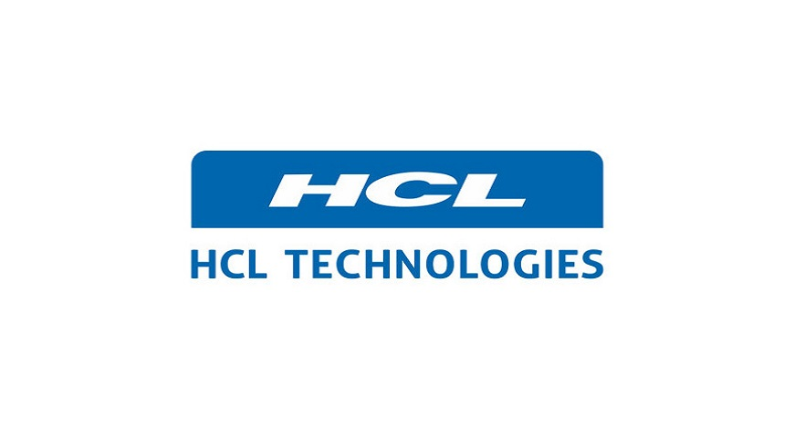

**PROJECT TITLE**

**HCL PASSWORD MANAGEMENT SYSTEM**

TABLES

* 1. Project Overview ----------------------------------------------------------3
  2. Scope-------------------------------------------------------------------------4
  3. Out Of Scope----------------------------------------------------------------6
  4. Intended Audience---------------------------------------------------------6
  5. High Level Use Case--------------------------------------------------------6
  6. User Interface Modules---------------------------------------------------7
  7. Feasibility Study------------------------------------------------------------8
  8. Technical Architecture----------------------------------------------------9
  9. Technical Detailed Architecture------------------------------------------10
  10. Testing--------------------------------------------------------------------------23
  11. Sequence Diagram-----------------------------------------------------------25
  12. Database Entity Relationship Diagram----------------------------------26
  13. Forms----------------------------------------------------------------------------28
  14. Non-Functional Requirements---------------------------------------------32
  15. Standards-----------------------------------------------------------------------34
  16. Benefits--------------------------------------------------------------------------36
  17. Limitations----------------------------------------------------------------------37
  18. Conclusion----------------------------------------------------------------------37

**OUTLINE OF PROJECT:**

Password manager software stores multiple passwords in a single database that can be accessed from various devices. For accessing the software, you just need to enter the master password.

The password manager software supports filling out the form (name and other details) in a single click. This benefits users to get their tasks done quickly, saving their time. At the same time, it keeps the intact information safe in a centralized database.

**ROLES ALLOCATED:-**

* Coding Part: ChiruSandeep
* Documentation : PL.SundarVelayutham
* Manual Testing : Selvapraviya
* Automation Testing **:** Anjali and Srinivas
* User Interface: Swapna

**1.1 PROJECT OVERVIEW:-**

To build the software Password Manager, follow the appropriate path, this will help you build robust and leading software for your business. Follow the below-mentioned steps to build top-notch password management software using Java.

1. Planning:-

It is the initial phase of the development process where specialists need to explore,

gather vital elements, and examine all software features (of the present, past, and

future). In order to build the leading software developers should understand the

client's requirements mean what precisely they want.

1. Feasibility analysis:-

Secondly, the developers should jot down the entire project detail; this helps of

examine the project's feasibility. This step also allows experts to estimate the exact

cost software development.

1. Product Design

This is a major part of software development. Once after doing the feasibility analysis, make creative design for the password management application.

1. Coding

It is a decisive phase of the software development process. In order to develop the robust password manager software Expert Java app developers in India mainly focus on the coding part.

#### Implementation, Integration, and Testing

After completing the coding part and programs, perform software integration. Later run the software to check whether it is working appropriately or not. If in case, bugs have been tested, then fix the same.

#### Installation and Maintenance

Once after doing the software testing, install in on the device. Once after installing the same, maintain it.

**1.2 SCOPE:-**

* PURPOSE OF THE PROJECT:-

The main purpose of the project is to develop an application called Online Password Manager. With increase in the usage of Internet and ATM, even common citizens who are not having computer to maintain a number of accounts and related passwords to go ahead with their day-to-day activities. These accounts could range from email accounts, social networking accounts, on-shopping accounts, bank accounts, on-line stocks trading accounts, credit card accounts and many others. One issue with maintaining all these accounts is that one has to remember a number of passwords. Quite a few people, unknowingly, either have the same password for all the accounts or write down all the passwords on a piece of paper and carry with them or have passwords that are very easy to remember that can be guessed easily by others, all of which are very risky and may lead to misuse of accounts, data loss or even financial loss. There is no proper way for a common person to save all these passwords securely and retrieve them when required.

* EXISTING SYSTEM :-

With increase in the usage of Internet and ATM, even common citizens who are not having computer to maintain a number of accounts and related passwords to go ahead with their day-to-day activities. These accounts could range from email accounts, social networking accounts, on-shopping accounts, bank accounts, on-line stocks trading accounts, credit card accounts and many others. One issue with maintaining all these accounts is that one has to remember a number of passwords.

Quite a few people, unknowingly, either have the same password for all the accounts or write down all the passwords on a piece of paper and carry with them or have passwords that are very easy to remember that can be guessed easily by others, all of which are very risky and may lead to misuse of accounts, data loss or even financial loss. There is no proper way for a common person to save all these passwords securely and retrieve them when required

* SYSTEM DETAILS:-

After analyzing the requirements of the task to be performed, the next step is to analyze the problem and understand its context. The first activity in the phase is studying the existing system and other is to understand the requirements and domain of the new system. Both the activities are equally important, but the first activity serves as a basis of giving the functional specifications and then successful design of the proposed system. Understanding the properties and requirements of a new system is more difficult and requires creative thinking and understanding of existing running system is also difficult, improper understanding of present system can lead diversion from solution.

* PROPOSED SYSTEM:-

There is a need for a centralized web based application to allow users to save all their passwords in a secured and format on the Internet so that they can be retrieved. This application not only allows the passwords to be saved in the centralized database it also facilities to retrieve the password whenever required

The way it works is:

Users register.

They save their entire password.

If required the password is retrieved.

* PROCESSES INVOLVED:-

.Access Management process for User registration

.User Account and Password details setup and maintenance Process

.Password encryption process during setup and retrieval

1.3 OUT OF SCOPE:-

It’s completely a Local Host project, if later on Client wants to make it Web Host. Then Web host stores all the pages of your website and makes them available to computers connected to the Internet.

So that if once the user forgets the password of the application it can be retrieved by the process:-

1. Enter your client ID.

2. Enter the email address associated with your account.

3. Enter the CAPTCHA code.

4. Click “Retrieve password now”

1.4 INTENDED AUDIENCE:-

Password managers began as free or low-cost apps for consumers, tracking passwords and sign-ins to websites and applications, making it possible for users to create and manage long, hard-to-guess and unique passwords for all their accounts. Most work by encrypting the password lists with a single master password that only the user knows, so that even the password manager company employees themselves -- or hackers -- couldn't get into the password lists.

All the major password managers also have mobile apps, making it easy for users to log into their accounts from any device. They also support multi-factor authentication for additional security.

1.5 HIGHLEVEL USE CASE:-

Use cases model the system from the end users point of view, with the following objectives to define the functional and operational requirements of the system by defining a scenario of usage. To provide a class and unambiguous description of how the end user and the system interact with one another.

ADMIN

USER

1.6 USER INTERFACE MODULES

* ***Access management Module****:*This module is used by users to register to the webapplication.
* ***User Accounts setup and maintenance Module:*** This module allows the users to setuptheir various account details and respective passwords.
* ***User Edit Accounts setup Module:*** This module allows the users to setuptheir various account details and respective passwords.
* ***Archiving and cleanup Module****:*Allows Admin users to Cleanup old data onthe system.

ADVANTAGES:-

The project is identified by the merits of the system offered to the user. The merits of this project are as follows

1. This module is used by users to register to the web application.
2. This module allows the users to setup their various account details and respective passwords.

1.7 FEASIBILITY STUDY:-

Preliminary investigation examine project feasibility, the likelihood the system will be useful to the organization. The main objective of the feasibility study is to test the Technical, Operational and Economical feasibility for adding new modules and debugging old running system. All system is feasible if they are unlimited resources and infinite time. There are aspects in the feasibility study portion of the preliminary investigation:

.Technical Feasibility

.Operation Feasibility

.Economical Feasibility

* TECHNICAL FEASIBILITY:-

The technical issue usually raised during the feasibility stage of the investigation includes the following:

1. Does the necessary technology exist to do what is suggested?
2. Do the proposed equipments have the technical capacity to hold the data required to use the new system?
3. Will the proposed system provide adequate response to inquiries of users?
4. Can the system be upgraded if developed?
5. Are there technical guarantees of accuracy, reliability, ease of access and data security?

1.8 TECHNICAL ARCHITECTURE:-

* SYSTEM REQUIREMENTS:

Requirement Specification plays an important role to create quality software solution; Requirements are refined and analysed to assess the clarity. Requirements are represented in a manner that ultimately leads to successful software implementation. Each requirement must be consistent with the overall objective. The development of this project deals with the following requirements:

* Hardware Requirements
* Software Requirements

HARDWARE REQUIREMENTS:

The selection of hardware is very important in the existence and proper working of any software. In the selection of hardware, the size and the capacity requirements are also important.

|  |  |
| --- | --- |
| **CONTENT** | **DESCRIPTION** |
| HDD | 10 GB Min |
| RAM | 1 GB Min |

SOFTWARE REQUIREMENTS:

The software requirements specification is produces at the culmination of the analysis tasks. One of the most difficult tasks is that, the selection of the software, once system requirement is known by determining whether a particular software package fits the requirements.

|  |  |
| --- | --- |
| **CONTENT** | **DESCRIPTION** |
| OS | Windows 10 |
| DATA BASE | Oracle |
| TECHNOLOGIES | Core Java, JDBC , JSP, HTML,EXCEL,SELENIUM AND FRAMEWORKS |
| IDE | My Eclipse |
| BROWSER | Mozilla Firefox, IE 6., Google Chrome |

1.9 TECHNICAL DETAILED ARCHITECTURE:-

* INTRODUCTION TO JAVA:-

Initially the language was called as “oak” but it was renamed as “Java” in 1995. The primary motivation of this language was the need for a platform-independent (i.e., architecture neutral) language that could be used to create software to be embedded in various consumer electronic devices.

Java is a programmer’s language.

1. Java is cohesive and consistent.
2. Except for those constraints imposed by the Internet environment, Java gives the programmer, full control.
3. Finally, Java is to Internet programming where C was to system programming.

* IMPORTANCE OF JAVA TO THE INTERNET**:**

**J**ava has had a profound effect on the Internet. This is because; Java expands the Universe of objects that can move about freely in Cyberspace. In a network, two categories of objects are transmitted between the Server and the Personal computer. They are passive information and Dynamic active programs. The Dynamic, Self-executing programs cause serious problems in the areas of Security and probability. But, Java addresses those concerns and by doing so, has opened the door to an exciting new form of program

* JAVA CAN BE USED TO CREATE TWO TYPES OF PROGRAMS:

Applications and Applets: An application is a program that runs on our Computer under the operating system of that computer. It is more or less like one creating using C or C++. Java’s ability to create Applets makes it important. An Applet is an application designed to be transmitted over the Internet and executed by a Java –compatible web browser. An applet is actually a tiny Java program, dynamically downloaded across the network, just like an image. But the difference is, it is an intelligent program, not just a media file. It can react to the user input and dynamically change.

* FEATURES OF JAVA SECURITY:

Every time you that you download a “normal” program, you are risking a viral infection. Prior to Java, most users did not download executable programs frequently, and those who did scan them for viruses prior to execution. Most users still worried about the possibility of infecting their systems with a virus. In addition, another type of malicious program exists that must be guarded against. This type of program can gather private information, such as credit card numbers, bank account balances, and passwords. Java answers both these concerns by providing a “firewall” between a network application and your computer. When you use a Java-compatible Web browser, you can safely download Java applets without fear of virus infection or malicious intent.

* PORTABILITY:

For programs to be dynamically downloaded to all the various types of platforms connected to the Internet, some means of generating portable executable code is needed .As you will see, the same mechanism that helps ensure security also helps create portability. Indeed, Java’s solution to these two problems is both elegant and efficient.

* THE BYTE CODE:

The key that allows the Java to solve the security and portability problems is that the output of Java compiler is Byte code. Byte code is a highly optimized set of instructions designed to be executed by the Java run-time system, which is called the Java Virtual Machine (JVM). That is, in its standard form, the JVM is an interpreter for byte code. Translating a Java program into byte code helps makes it much easier to run a program in a wide variety of environments. The reason is, once the run-time package exists for a given system, any Java program can run on it.

Although Java was designed for interpretation, there is technically nothing about Java that prevents on-the-fly compilation of byte code into native code. Sun has just completed its Just In Time (JIT) compiler for byte code. When the JIT compiler is a part of JVM, it compiles byte code into executable code in real time, on a piece-by-piece, demand basis. It is not possible to compile an entire Java program into executable code all at once, because Java performs various run-time checks that can be done only at run time. The JIT compiles code, as it is needed, during execution.

* JAVA VIRTUAL MACHINE (JVM):

Beyond the language, there is the Java virtual machine. The Java virtual machine is an important element of the Java technology. The virtual machine can be embedded within a web browser or an operating system. Once a piece of Java code is loaded onto a machine, it is verified. As part of the loading process, a class loader is invoked and does byte code verification makes sure that the code that’s has been generated by the compiler will not corrupt the machine that it’s loaded on. Byte code verification takes place at the end of the compilation process to make sure that is all accurate and correct. So byte code verification is integral to the compiling and executing of Java code.

* JAVA ARCHITECTURE:

Java architecture provides a portable, robust, high performing environment for development. Java provides portability by compiling the byte codes for the Java Virtual Machine, which is then interpreted on each platform by the run-time environment. Java is a dynamic system, able to load code when needed from a machine in the same room or across the planet.

* COMPILATION OF CODE:-

When you compile the code, the Java compiler creates machine code (called byte code) for a hypothetical machine called Java Virtual Machine (JVM). The JVM is supposed to execute the byte code. The JVM is created for overcoming the issue of portability. The code is written and compiled for one machine and interpreted on all machines. This machine is called Java Virtual Machine. During run-time the Java interpreter tricks the byte code file into thinking that it is running on a Java Virtual Machine. In reality this could be a Intel Pentium Windows 95 or SunSARC station running Solaris or Apple Macintosh running system and all could receive code from any computer through Internet and run the Applets.

* SIMPLE:-

Java was designed to be easy for the Professional programmer to learn and to use effectively. If you are an experienced C++ programmer, learning Java will be even easier. Because Java inherits the C/C++ syntax and many of the object oriented features of C++. Most of the confusing concepts from C++ are either left out of Java or implemented in a cleaner, more approachable manner. In Java there are a small number of clearly defined ways to accomplish a given task.

* OBJECT-ORIENTED:-

Java was not designed to be source-code compatible with any other language. This allowed the Java team the freedom to design with a blank slate. One outcome of this was a clean usable, pragmatic approach to objects. The object model in Java is simple and easy to extend, while simple types, such as integers, are kept as high-performance non-objects.

* ROBUST:-

The multi-platform environment of the Web places extraordinary demands on a program, because the program must execute reliably in a variety of systems. The ability to create robust programs was given a high priority in the design of Java. Java is strictly typed language; it checks your code at compile time and run time. Java virtually eliminates the problems of memory management and deallocation, which is completely automatic. In a well-written Java program, all run time errors can –and should –be managed by your program.

* HYPER TEXT MARKUP LANGUAGE:-

Hypertext Markup Language (HTML), the languages of the World Wide Web (WWW), allows users to produces Web pages that include text, graphics and pointer to other Web pages (Hyperlinks).

HTML is not a programming language but it is an application of ISO Standard 8879, SGML (Standard Generalized Markup Language), but specialized to hypertext and adapted to the Web. The idea behind Hypertext is that instead of reading text in rigid linear structure, we can easily jump from one point to another point. We can navigate through the information based on our interest and preference. A markup language is simply a series of elements, each delimited with special characters that define how text or other items enclosed within the elements should be displayed. Hyperlinks are underlined or emphasized works that load to other documents or some portions of the same document.

HTML can be used to display any type of document on the host computer, which can be geographically at a different location. It is a versatile language and can be used on any platform or desktop.

HTML provides tags (special codes) to make the document look attractive. HTML tags are not case-sensitive. Using graphics, fonts, different sizes, color, etc., can enhance the presentation of the document. Anything that is not a tag is part of the document itself.

ADVANTAGES:-

1. A HTML document is small and hence easy to send over the net. It is small because it does not include formatted information.
2. HTML is platform independent.
3. HTML tags are not case-sensitive.

Basic HTML Tags:

**<! -- -->** Specifies comments

**<A>………. </A>** Creates hypertext links

**<B>………. </B>** Formats text as bold

**<BIG>………. </BIG>** Formats text in large font.

**<BODY>…</BODY>** Contains all tags and text in the HTML document

**<CENTER>...</CENTER>** Creates text

**<DD>…</DD>** Definition of a term

**<DL>...</DL>** Creates definition list

**<FONT>…</FONT>** Formats text with a particular font

**<FORM>...</FORM>** Encloses a fill-out form

**<FRAME>...</FRAME>** Defines a particular frame in a set of frames

**<H#>…</H#>** Creates headings of different levels

**<HEAD>...</HEAD>** Contains tags that specify information about a document

**<HR>...</HR>** Creates a horizontal rule

**<HTML>…</HTML>** Contains all other HTML tags

**<META>...</META>** Provides meta-information about a document

**<SCRIPT>…</SCRIPT>** Contains client-side or server-side script

**<TABLE>…</TABLE>** Creates a table

**<TD>…</TD>** Indicates table data in a table

**<TR>…</TR>** Designates a table row

**<TH>…</TH>** Creates a heading in a table

* JDBC:-

Java Database Connectivity or in short JDBC is a technology that enables the java program to manipulate data stored into the database. Here is the complete tutorial on JDBC technology.

* What is JDBC?

JDBC is Java application programming interface that allows the Java programmers to access database management system from Java code. It was developed by Java Soft, a subsidiary of Sun Microsystems.

JDBC has four Components:

1. The JDBC API.
2. The JDBC Driver Manager.
3. The JDBC Test Suite.
4. The JDBC-ODBC Bridge

* The JDBC API:-

The JDBC application programming interface provides the facility for accessing the relational database from the Java programming language. The API technology provides the industrial standard for independently connecting Java programming language and a wide range of databases. The user not only execute the SQL statements, retrieve results, and update the data but can also access it anywhere within a network because of it's "Write Once, Run Anywhere" (WORA) capabilities.

Due to JDBC API technology, user can also access other tabular data sources like spreadsheets or flat files even in the a heterogeneous environment. JDBC application programming interface is a part of the Java platform that has included Java Standard Edition (Java SE) and the Java Enterprise Edition (Java EE) in itself.

The JDBC API has four main interface:

The latest version of JDBC 4.0 application programming interface is divided into two packages

1) java.sql

2) javax.sql.

Java SE and Java EE platforms are included in both the packages.

* THE JDBC DRIVER MANAGER:-

The JDBC Driver Manager is a very important class that defines objects which connect Java applications to a JDBC driver. Usually Driver Manager is the backbone of the JDBC architecture. It's very simple and small that is used to provide a means of managing the different types of JDBC database driver running on an application. The main responsibility of JDBC database driver is to load all the drivers found in the system properly as well as to select the most appropriate driver from opening a connection to a database. The Driver Manager also helps to select the most appropriate driver from the previously loaded drivers when a new open database is connected.

* THE JDBC TEST SUITE:-

The function of JDBC driver test suite is to make ensure that the JDBC drivers will run user's program or not . The test suite of JDBC application program interface is very useful for testing a driver based on JDBC technology during testing period. It ensures the requirement of Java Platform Enterprise Edition (J2EE).

* THE JDBC-ODBC BRIDGE:-

The JDBC-ODBC bridge, also known as JDBC type 1 driver is a database driver that utilize the ODBC driver to connect the database. This driver translates JDBC method calls into ODBC function calls. The Bridge implements Jdbc for any database for which an Odbc driver is available. The Bridge is always implemented as the sun.jdbc.odbc Java package and it contains a native library used to access ODBC. Now we can conclude this topic:

This first two component of JDBC, the JDBC API and the JDBC Driver Manager manages to connect to the database and then build a java program that utilizes SQL commands to communicate with any RDBMS. On the other hand, the last two components are used to communicate with ODBC or to test web application in the specialized environment.

**JDBC ARCHITECTURE:-**

1. Database connections
2. SQL statements
3. Result Set
4. Database data
5. Prepared statements
6. SQL Statements
7. Result Set
8. Database Set
9. Binary Large Objects(BLOBs)
10. Character Large Objects(CLOBs)
11. Callable Statements
12. Database Drivers
13. Database Manager

The JDBC API uses a Driver Manager and database-specific drivers to provide transparent connectivity to heterogeneous databases. The JDBC driver manager ensures that the correct driver is used to access each data source. The Driver Manager is capable of supporting multiple concurrent drivers connected to multiple heterogeneous databases. The location of the driver manager with respect to the JDBC drivers and the servlet is shown in Figure

LAYERS OF THE JDBC ARCHITECTURE:-

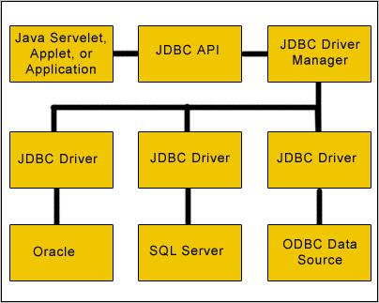

A **JDBC** *driver* translates standard *JDBC* calls into a network or database protocol or into a database library API call that facilitates communication with the database. This translation layer provides JDBC applications with database independence. If the back-end database changes, only the JDBC driver need be replaced with few code modifications required. There are four distinct types of JDBC drivers.

JDBC DRIVER AND ITS TYPES:-

Type 1 JDBC-ODBC Bridge:-Type 1 drivers act as a*"bridge"*between **JDBC** and anotherdatabase connectivity mechanism such as **ODBC.** The **JDBC- ODBC** bridge provides JDBC access using most standard ODBC drivers. This driver is included in the Java 2 SDK within the **sun.jdbc.odbc** package. In this driver the java statements are converted to jdbc statements. AJDBC statement calls the ODBC by using the **JDBC-ODBC Bridge.** And finally the query is executed by the database. This driver has serious limitation for many applications

TYPE 1 JDBC ARCHITECTURE

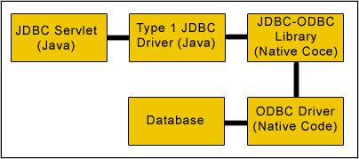

Type 2 Java to Native API:-Type 2 drivers use the **Java Native Interface (JNI)** to make callsto a local database library API. This driver converts the JDBC calls into a database specific call for databases such as SQL, ORACLE etc. This driver communicates directly with the database server. It requires some native code to connect to the database. Type 2 drivers are usually faster than Type 1 drivers. Like Type 1 drivers, Type 2 drivers require native database client libraries to be installed and configured on the client machine.

TYPE 2 JDBC ARCHITECTURE

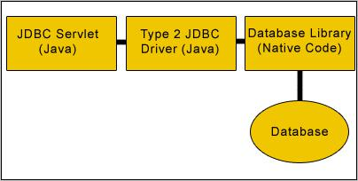

Type 3 Java to Network Protocol Or All- Java Driver:-

Type 3 drivers are pure Java driversthat use a proprietary network protocol to communicate with JDBC middleware on the server. The middleware then translates the network protocol to database-specific function calls. Type 3 drivers are the most flexible JDBC solution because they do not require native database libraries on the client and can connect to many different databases on the back end. Type 3 drivers can be deployed over the Internet without client installation.

Java-------> JDBC statements------> SQL statements ------> databases.

TYPE 3 JDBC ARCHITECTURE

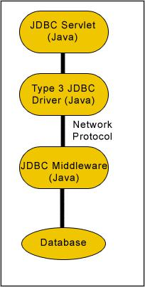

Type 4 Java to Database Protocol:-

Type 4 drivers are pure Java drivers that implement aproprietary database protocol (like Oracle's SQL*Net) to communicate directly with the database. Like Type 3 drivers, they do not require native database libraries and can be deployed over the Internet without client installation. One drawback to Type 4 drivers is that they are database specific. Unlike Type 3 drivers, if your back-end database changes, you may save to purchase and deploy a new Type 4 driver (some Type 4 drivers are available free of charge from the database manufacturer). However, because Type drivers communicate directly with the database engine rather than through middleware or a native library, they are usually the fastest JDBC drivers available. This driver directly converts the java statements to SQL statements.

TYPE 4 JDBC ARCHITECTURE

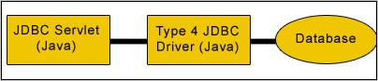

So, you may be asking yourself, "Which is the right type of driver for your application?" Well, that depends on the requirements of your particular project. If you do not have the opportunity or inclination to install and configure software on each client, you can rule out Type 1 and Type 2 drivers. However, if the cost of Type 3 or Type 4 drivers is prohibitive, Type 1 and type 2 drivers may become more attractive because they are usually available free of charge. Price aside, the debate will often boil down to whether to use Type 3 or Type 4 driver for a particular application. In this case, you may need to weigh the benefits of flexibility and interoperability against performance. Type 3 drivers offer your application the ability to transparently access different types of databases, while Type 4 drivers usually exhibit better performance and, like Type 1 and Type 2 drivers, may be available free if charge from the database manufacturer

* JAVA SERVER PAGES (JSP):-

Java server Pages is a simple, yet powerful technology for creating and maintaining dynamic-content web pages. Based on the Java programming language, Java Server Pages offers proven portability, open standards, and a mature re-usable component model. The Java Server Pages architecture enables the separation of content generation from content presentation. This separation not eases maintenance headaches; it also allows web team members to focus on their areas of expertise. Now, web page designer can concentrate on layout, and web application designers on programming, with minimal concern about impacting each other’s work.

FEATURES OF JSP:-

Portability:

Java Server Pages files can be run on any web server or web-enabled application server that provides support for them. Dubbed the JSP engine, this support involves recognition, translation, and management of the Java Server Page lifecycle and its interaction components.

Components

It was mentioned earlier that the Java Server Pages architecture can include reusable Java components. The architecture also allows for the embedding of a scripting language directly into the Java Server Pages file. The components current supported include Java Beans, and Servlets.

Processing

A Java Server Pages file is essentially an HTML document with JSP scripting or tags. The Java Server Pages file has a JSP extension to the server as a Java Server Pages file. Before the page is served, the Java Server Pages syntax is parsed and processed into a Servlet on the server side. The Servlet that is generated outputs real content in straight HTML for responding to the client.

Access Models:

A Java Server Pages file may be accessed in at least two different ways. A client’s request comes directly into a Java Server Page. In this scenario, suppose the page accesses reusable Java Bean components that perform particular well-defined computations like accessing a database. The result of the Beans computations, called result sets is stored within the Bean as properties. The page uses such Beans to generate dynamic content and present it back to the client.

In both of the above cases, the page could also contain any valid Java code. Java Server Pages architecture encourages separation of content from presentation.

Steps in the execution of a JSP Application:-

1. The client sends a request to the web server for a JSP file by giving the name of the JSP file within the form tag of a HTML page.
2. This request is transferred to the JavaWebServer. At the server side JavaWebServer receives the request and if it is a request for a jsp file server gives this request to the JSP engine.
3. JSP engine is program which can understand the tags of the jsp and then it converts those tags into a Servlet program and it is stored at the server side. This Servlet is loaded in the memory and then it is executed and the result is given back to the JavaWebServer and then it is transferred back to the result is given back to the JavaWebServer and then it is transferred back to the client.

SYSTEM INTRODUCTION:-

Software design sits at the technical kernel of the software engineering process and is applied regardless of the development paradigm and area of application. Design is the first step in the development phase for any engineered product or system. The designer’s goal is to produce a model or representation of an entity that will later be built. Beginning, once system requirement have been specified and analyzed, system design is the first of the three technical activities -design, code and test that is required to build and verify software.

The importance can be stated with a single word “Quality”. Design is the place where quality is fostered in software development. Design provides us with representations of software that can assess for quality. Design is the only way that we can accurately translate a customer’s view into a finished software product or system. Software design serves as a foundation for all the software engineering steps that follow. Without a strong design we risk building an unstable system – one that will be difficult to test, one whose quality cannot be assessed until the last stage.

During design, progressive refinement of data structure, program structure, and procedural details are developed reviewed and documented. System design can be viewed from either technical or project management perspective. From the technical point of view, design is comprised of four activities – architectural design, data structure design, interface design and procedural design.

1.10 LEVELS OF TESTING

Since the errors in the software can be injured at any stage. So, we have to carry out the testing process at different levels during the development. The basic levels of testing are Unit, Integration, System and Acceptance Testing.

The Unit Testing is carried out on coding. Here different modules are tested against the specifications produced during design for the modules. In case of integration testing different tested modules are combined into sub systems and tested in case of the system testing the full software is tested and in the next level of testing the system is tested with user requirement document prepared during SRS.

There are two basic approaches for testing. They are

* FUNCTIONAL TESTING:

In Functional Testing test cases are decided solely on the basis of requirements of the program or module and the internals of the program or modules are not considered for selection of test cases. This is also called Black Box Testing.

* STRUCTURAL TESTING:

In Structural Testing test cases are generated on actual code of the program or module to be tested. This is called White Box Testing.

TESTING PROCESS:-

A number of activities must be performed for testing software. Testing starts with test plan. Test plan identifies all testing related activities that need to be performed along with the schedule and guide lines for testing. The plan also specifies the levels of testing that need to be done, by identifying the different testing units. For each unit specified in the plan first the test cases and reports are produced. These reports are analyzed.

TEST PLAN:

Test plan is a general document for entire project, which defines the scope, approach to be taken and the personal responsible for different activities of testing. The inputs for forming test plans are

•Project plan

•Requirements document

•System design

* TEST CASE SPECIFICATION:

Although there is one test plan for entire project test cases have to be specified separately for each test case. Test case specification gives for each item to be tested. All test cases and outputs expected for those test cases.

* TEST CASE EXECUTION AND ANALYSIS:

The steps to be performed for executing the test cases are specified in separate document called test procedure specification. This document specify any specify requirements that exist for setting the test environment and describes the methods and formats for reporting the results of testing.

* UNIT TESTING:

Unit testing mainly focused first in the smallest and low level modules, proceeding one at a time. Bottom-up testing was performed on each module. As developing a driver program, that tests modules by developed or used. But for the purpose of testing, modules themselves were used as stubs, to print verification of the actions performed. After the lower level modules were tested, the modules that in the next higher level those make use of the lower modules were tested. Each module was tested against required functionally and test cases were developed to test the boundary values.

* INTEGRATING TESTING:-

Integration testing is a systematic technique for constructing the program structure, while at the same time conducting tests to uncover errors associated with interfacing. As the system consists of the number of modules the interfaces to be tested were between the edges of the two modules. The software tested under this was incremental bottom-up approach.

Bottom-up approach integration strategy was implemented with the following steps.

1. Low level modules were combined into clusters that perform specific software sub functions.

1. The clusters were then tested.

* SYSTEM TESTING:

System testing is a series of different tests whose primary purpose is to fully exercise the computer-based system. It also tests to find discrepancies between the system and its original objective, current specifications.

1.11 SEQUENCE DIAGRAM:

DATA BASE

SYSTEM

USER

REMOVES DELETED CREDENTIALS FROM DATA BASE

DELETE CREDENTIALS

UPDATES STORED CREDENTIALS

EDIT CREDENTIAL FORM

STORE CREDENTIALS

ADD CREDENTIAL FORM

DISP HOME PAGE

VERIFIES

DISP HOME PAGE

REQ FOR REG

REG FORM

FILL IN DETAILS

SIGN UP

STORE USER DETAILS

ENTER USER CREDENTIALS

SIGN IN

1.12Entity-Relationship Diagram:-

E-R data model is a high level conceptual model that describes data as entities, attributes and relationship. The data modeling process is iterative. E-R diagrams enable designers and users to express their understanding of what the planned database is intended to do and how it might work, and to communicate about the database through a common language.

Entity Classes and Attributes:

* Entity class is represented by rectangles.
* Attributes are represented by ovals.
* Key attributes is represented by an underline.
* Multi- value attribute is represented with an oval with a double border.
* Derived attribute is represented with an oval dashed border.
* Composite attribute is represented with an oval that connects to additional ovals.

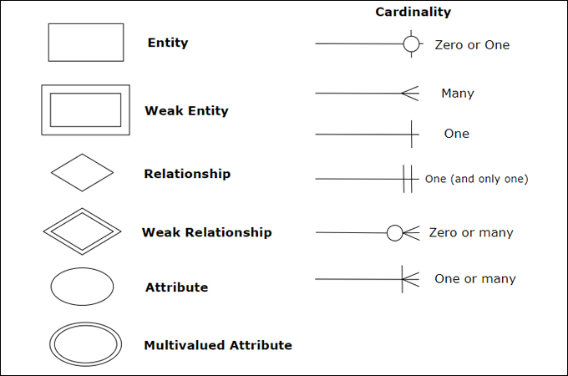

HOME WEB PAGE

SYSTEM

DATA BASE

USER

1.13 FORMS:

LOGIN PAGE

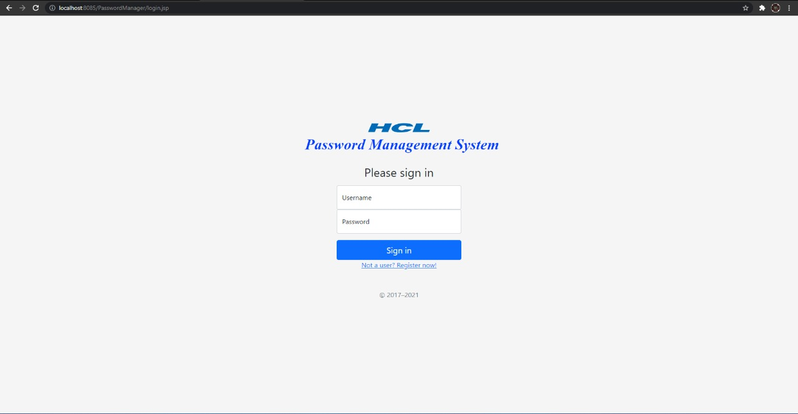

REGISTER PAGE

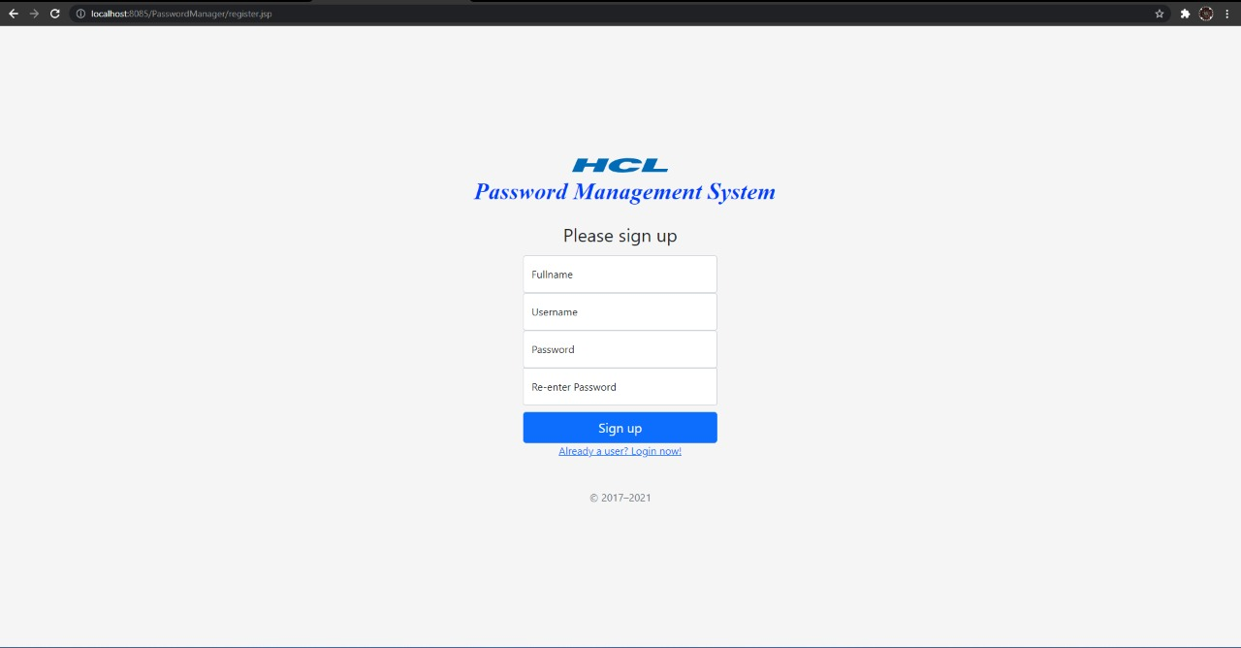

HOME PAGE

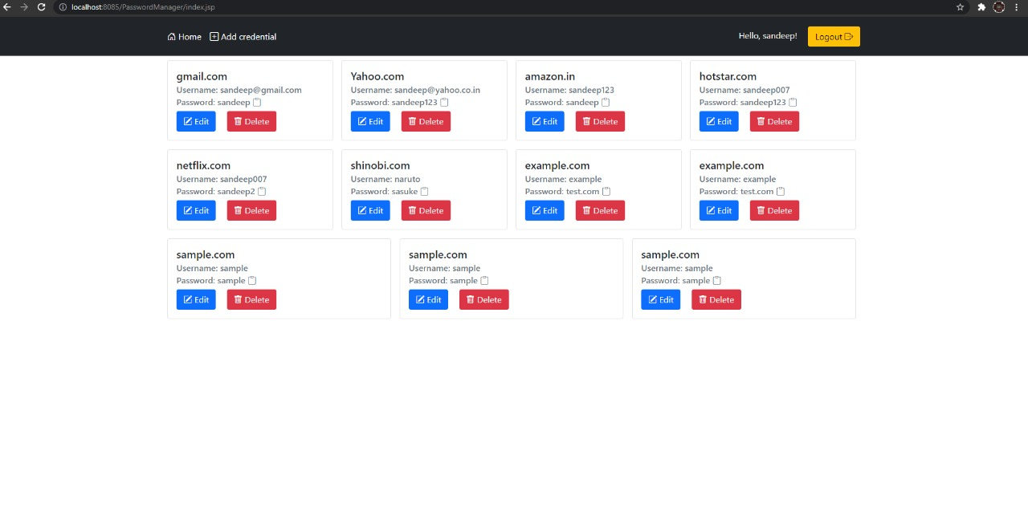

ADD CREDENTIAL PAGE

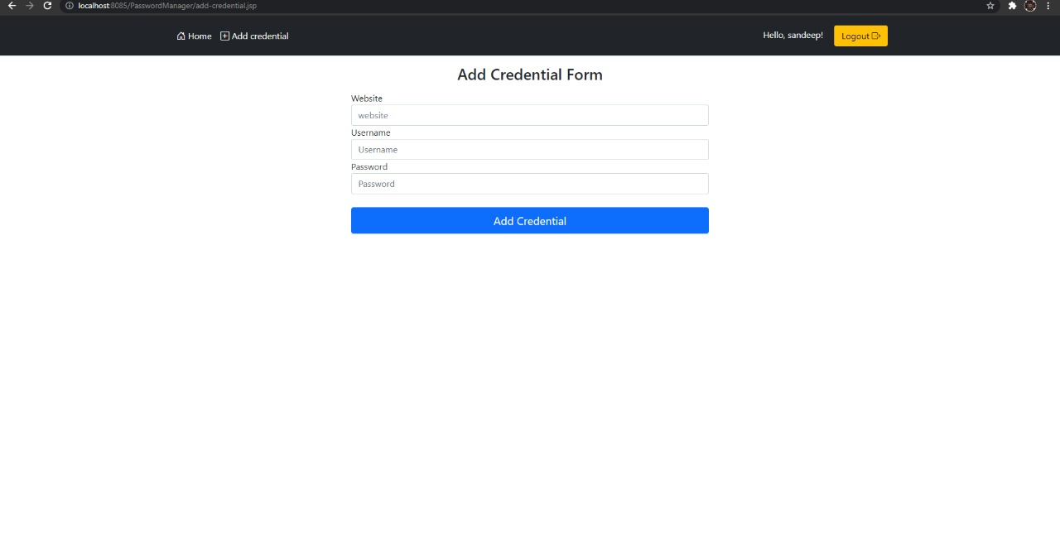

EDIT CREDENTIAL PAGE

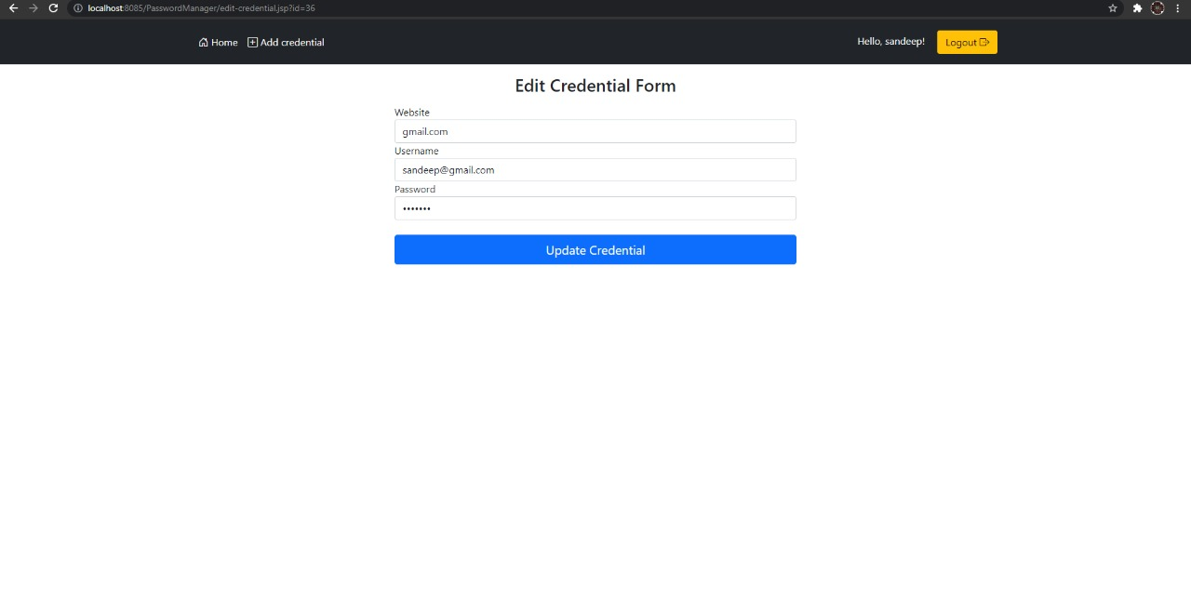

USER TABLE

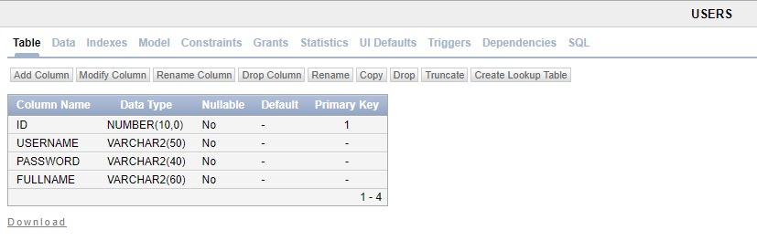

USER DATA

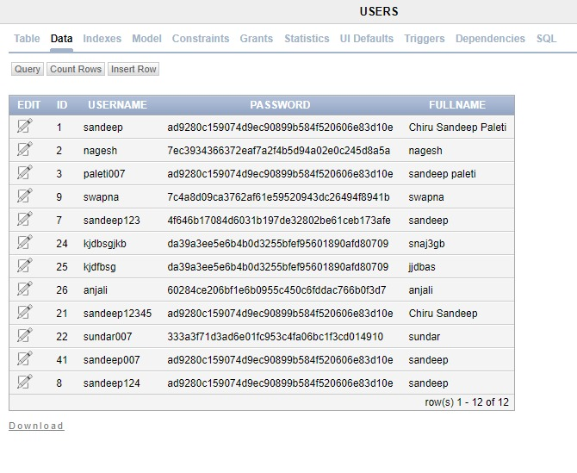

PASSWORD_STORE TABLE

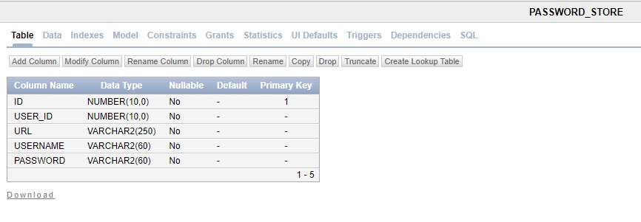

PASSWORD_STORE DATA

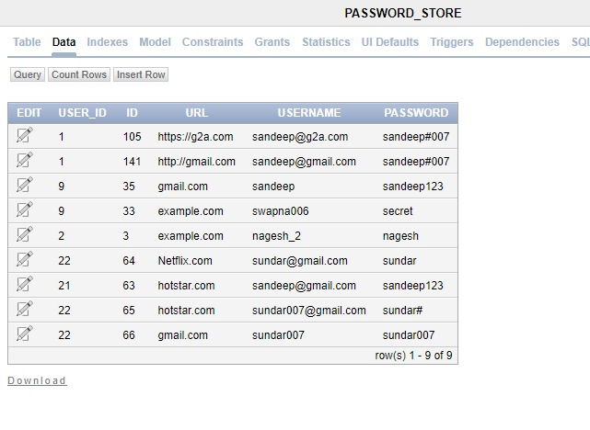

1.14 NON FUNCTIONAL REQUIERMENTS:-

* SECURITY INTRODUCTION

The protection of computer based resources that includes hardware, software, data, procedures and people against unauthorized use or natural

Disaster is known as System Security.

System Security can be divided into four related issues:

* Security
* Integrity
* Privacy
* Confidentiality
* **SYSTEM SECURITY** refers to the technical innovations and procedures applied to thehardware and operation systems to protect against deliberate or accidental damage from a defined threat.
* **DATA SECURITY** is the protection of data from loss, disclosure, modification and destruction.
* **SYSTEM INTEGRITY** refers to the power functioning of hardware and programs, appropriatephysical security and safety against external threats such as eavesdropping and wiretapping.
* **PRIVACY** defines the rights of the user or organizations to determine what information they arewilling to share with or accept from others and how the organization can be protected against unwelcome, unfair or excessive dissemination of information about it.
* **CONFIDENTIALITY** is a special status given to sensitive information in a database tominimize the possible invasion of privacy. It is an attribute of information that characterizes its need for protection.

**SECURITY IN SOFTWARE**

System security refers to various validations on data in form of checks and controls to avoid the system from failing. It is always important to ensure that only valid data is entered and only valid operations are performed on the system. The system employees two types of checks and controls:

* CLIENT SIDE VALIDATION:-

Various client side validations are used to ensure on the client side that only valid data is entered. Client side validation saves server time and load to handle invalid data. Some checks imposed are:

JavaScript in used to ensure those required fields are filled with suitable data only. Maximum lengths of the fields of the forms are appropriately defined.

Forms cannot be submitted without filling up the mandatory data so that manual mistakes of submitting empty fields that are mandatory can be sorted out at the client side to save the server time and load.

Tab-indexes are set according to the need and taking into account the ease of user while working with the system.

* SERVER SIDE VALIDATION:-

Some checks cannot be applied at client side. Server side checks are necessary to save the system from failing and intimating the user that some invalid operation has been performed or the performed operation is restricted. Some of the server side checks imposed is:

Server side constraint has been imposed to check for the validity of primary key and foreign key. A primary key value cannot be duplicated. Any attempt to duplicate the primary value results into a message intimating the user about those values through the forms using foreign key can be updated only of the existing foreign key values.

1.User is intimating through appropriate messages about the successful operations or exceptions occurring at server side.

2.Various Access Control Mechanisms have been built so that one user may not agitate upon another. Access permissions to various types of users are controlled according to the organizational structure. Only permitted users can log on to the system and can have access

according to their category. User- name, passwords and permissions are controlled o the server side.

3.Using server side validation, constraints on several restricted operations are imposed.

1.15 STANDARS:

Open Standards:-

At its core, an [open standard is a collection of guidelines](https://heretto.com/should-i-use-an-open-standard-for-my-documentation) that keep technologies able to remain accessible to everyone. Open standards are community-oriented, available to everyone who wants access, and relatively transparent.

Open standards make sure that people play by the same rules within a free environment. Anyone can come to play, but there are some guidelines to make sure there’s an overarching semblance of order.

Closed Standards:-

A much easier definition, closed standards are proprietary and controlled by an owning entity. For instance, when you buy a license for Microsoft Word, you’re unable to change how the software works because it’s owned by [Microsoft](https://heretto.com/ms-word-falls-short-for-documentation/).

You play by their rules because they own their rules and users can’t amend them. When they change their own rules, you’re required to abide by them Period.

* Microsoft Word:-

You don’t need much introduction to Microsoft’s word-processing software. One of the most widely used programs for writing of all kinds, MS Word is commonly used for technical documentation.

The trouble is, MS Word isn’t a technical writing software, so its limitations lie within the fact that the closed standard wasn’t built for technical documentation in the first place.

Despite its design, MS Word remains one of the foremost word processing software programs for technical writing simply by default. It’s top of mind, easy to start using, and many company computers already have Word software included.

* Wiki:-

Perhaps you’re familiar with the world’s largest wiki, Wikipedia? Then you’re familiar with how a wiki works. It’s an open-source platform that allows community contribution to the body of knowledge. Of course, as you may know already, one cannot simply submit anything they want. There’s a system of review that determines the validity of the content and deems whether or not it’s appropriate to publish.

Wikis are easy to learn and use. In the beginning, this may work for writing documentation. However, as your content matures, wikis can become unwieldy for managing larger bodies of content while ensuring quality and accuracy.

SCALABILITY:-

* Microsoft Word:-

Each document created in Word is its own document. Therefore, to scale an organization’s content, let’s use this example.

Say your organization has 1,000 different pieces of content written in Word Documents. If your company description was updated and needed to be changed in those pieces of content, your writing team would need to open 1,000 documents and make the same changes 1,000 times.

* Wiki:-

Wikis are easy to contribute to, which makes scaling easy at first. Down the road, when the number of contributing authors grows and the library of content grows, keeping track of the updates becomes challenging.

It’s not so much the authoring part that’s a scaling challenge, but the content management piece. In a large content library, changes can slip through the cracks because there’s no consistent source of truth as a foundation for content management.

Consistency in content production is vital to scaling your content effectively. Even more important is your company’s content credibility. Being poorly able to scale your content with company growth will take away from the authority you want your organization’s content to confidently wield. Wikis lack sufficient power to maintain that support.

## History:-

|  |  |  |  |
| --- | --- | --- | --- |
| [Microsoft Word](https://www.microsoft.com/en-us/microsoft-365/word) | Closed | 1983 | Charles Simonyi, Richard Brodie (Microsoft) |
| [Wiki](http://wiki.c2.com/) | Open | 1994 | Ward Cunningham |

1.16 BENEFITS:

The project is identified by the merits of the system offered to the user. The merits of this project are as follows: -

* It’s a web-enabled project.
* This project offers user to enter the data through simple and interactive forms. This is very helpful for the client to enter the desired information through so much simplicity.
* The user is mainly more concerned about the validity of the data, whatever he is entering. There are checks on every stages of any new creation, data entry or updation so that the user cannot enter the invalid data, which can create problems at later date.
* Sometimes the user finds in the later stages of using project that he needs to update some of the information that he entered earlier. There are options for him by which he can update the records. Moreover there is restriction for his that he cannot change the primary data field. This keeps the validity of the data to longer extent.
* User is provided the option of monitoring the records he entered earlier. He can see the desired records with the variety of options provided by him.
* From every part of the project the user is provided with the links through framing so that he can go from one option of the project to other as per the requirement. This is bound to be simple and very friendly as per the user is concerned. That is, we can sat that the project is user friendly which is one of the primary concerns of any good project.
* Data storage and retrieval will become faster and easier to maintain because data is stored in a systematic manner and in a single database.
* Decision making process would be greatly enhanced because of faster processing of information since data collection from information available on computer takes much less time then manual system.
* Allocating of sample results becomes much faster because at a time the user can see the records of last years.
* Easier and faster data transfer through latest technology associated with the computer and communication.
* Through these features it will increase the efficiency, accuracy and transparency.

1.17 LIMITATIONS:-

* The size of the database increases day-by-day, increasing the load on the database back up and data maintenance activity.
* Training for simple computer operations is necessary for the users working on the system.

1.18 CONCLUSION:-

It has been a great pleasure for me to work on this exciting and challenging project. This project proved good for me as it provided practical knowledge of not only programming in JAVA and Servelets web based application and no some extent Windows Application will be great demand in future. This will provide better opportunities and guidance in future in developing projects independently and TOMCAT Server, but also about all handling procedure related with **“HCL Password Management”.** It also provides knowledge about the latesttechnology used in developing web enabled application and client server technology that will be great demand in future. This will provide better opportunities and guidance in future in developing projects independently.

KIND INFORMATION:-

NOTE:

To get to know more about Project Code please click the below link it will direct you to GIT HUB, We have posted our Complete working code for your reference