Gradient Categorization, Linguistic Diversity, and Second Language Acquisition:
Perceptual Learning of L2 Phonemic Contrasts Using a Multilingual Training Paradigm

by

Chisom O. Obasih

M.S., Psychology, Carnegie Mellon University, 2023
B.S., Neuroscience, University of Pittsburgh, 2019
B.A., Japanese, University of Pittsburgh, 2019

Dissertation Submitted in Partial Fulfillment of the
Requirements for the Degree of
Doctor of Philosophy

in the
Department of Languages, Cultures & Applied Linguistics
Program in Applied Linguistics & Second Language Acquisition

Carnegie Mellon University
August 2025

Abstract
The present study investigated whether exposure to linguistic diversity promotes gradient speech categorization and facilitates second language (L2) speech learning. Speech categorization, or the mapping of continuous acoustic signals onto discrete language units such as phonemes, is a core challenge in adult L2 speech acquisition. Some individuals show gradient patterns of speech categorization, in which the continuous nature of acoustic speech cues are retained in the mental representations of speech categories. Gradient categorization has been found to perceptual flexibility and multiple acoustic cue integration, which may be advantageous for learning new L2 phonemes. Exposure to linguistically diverse environments has been associated with gradient categorization and perceptual flexibility, and specific language experience may support L2 perception when learners have familiarity with phonemic contrasts similar to those in the target language. From these observations, I hypothesized that exposing learners to some form of specific “linguistic diversity” may push them towards gradient perception and the perceptual flexibility needed for efficient L2 speech category learning.
To test this hypothesis, three studies were conducted to explore the relationships among categorization gradiency, linguistic diversity, and L2 learning of the Japanese phonemic length contrasts in vowels (e.g., toru vs. tooru) and consonants (e.g., kata vs. katta). Study 1 assessed whether experiential linguistic diversity, measured with a Linguistic Diversity Questionnaire, predicted gradiency in L1 and L2 categorization, measured with a Visual Analog Scale (VAS) task. Study 2 manipulated linguistic diversity exposure through short-term perceptual discrimination training with naïve L1 monolingual English speakers (training on Japanese alone vs. Japanese and Modern Standard Arabic) and assessed changes in gradiency and L2 discrimination, measured with a perceptual discrimination task. Study 3 extended this training to L2 Japanese learners in a classroom setting and evaluated changes in gradiency, L2 discrimination, and L2 listening accuracy, measured with a Multiple-Choice Partial Dictation (MCPD) listening assessment.
Across all three studies, individual differences in categorization strategies were evident within and across participants, but neither experiential nor manipulated linguistic diversity significantly predicted nor affected gradiency. Additionally, naïve, but not classroom, learners improved in L2 learning outcomes following training, though learning was not modulated by the linguistic diversity condition. Overall, the results of the three studies did not support the hypothesis that exposure to specific linguistic diversity promotes gradient perception and the perceptual flexibility needed for efficient L2 speech category learning. Instead, the findings showcase the diversity of individual differences in categorization gradiency, highlight the phoneme- and context-specific nature of categorization behavior, and provide one of the first few within-participant comparisons of L1 and L2 categorization gradiency. The implications of the findings in the context of extant literature are that gradient categorization may be a stable trait, rather than manipulable by short-term exposure, and that the effects of linguistic diversity on perception and learning are likely to manifest over a longer time period than utilized in this study. This dissertation contributes to the fields of applied psycholinguistics and SLA by offering the first exploration into connecting gradient categorization, linguistic diversity, and L2 speech learning.
Keywords: gradient categorization, linguistic diversity, speech perception, perceptual learning, L2 speech learning, phonetic training
Table of Contents
Abstract ii
Dedication viii
Acknowledgements ix
Chapter 1. Introduction 1
1.1 Background and Motivation 1
1.2 Research Questions 6
1.3 Chapters Overview 7
1.4 A Note on Transcription Conventions 8
1.5 Open Science Statement 9
Chapter 2. Literature Review 10
2.1 The role of gradient categorization in speech perception 10
2.1.1 Competing theories of speech perception: categorical perception vs. gradient categorization 10
2.1.2 Measuring gradient categorization in speech perception 17
2.1.3 Some evidence of the role of gradient categorization in L1 speech perception 20
2.2 The role of gradient categorization in speech learning 25
2.2.1 Perceptual learning of speech in children vs. adults 25
2.2.2 Psycholinguistic models of L2 speech perception and category learning 27
2.2.2.1 Revised Speech Learning Model (SLM-r) 29
2.2.2.2 Perceptual Assimilation Model for L2 (PAM-L2) 30
2.2.2.3 Second Language Linguistic Perception Revised (L2LP-revised) 32
2.2.3 The potential role of gradient categorization in L2 speech perception and learning 34
2.3 The role of linguistic diversity and language experience in L2 speech perception and learning 40
2.4 Target L2 phonemic contrast 46
2.4.1 L2 acquisition of Japanese length contrasts 46
2.4.2 Length contrasts in Modern Standard Arabic 50
2.5 Specific aims and research plan 52
Chapter 3. Study 1 54
3.1 Methodology 54
3.1.1 Participants 55
3.1.2 VAS Task: Measuring categorization gradiency and secondary cue use 56
3.1.2.1 Speech stimuli 56
3.1.2.2 Procedure 62
3.1.2.3 VAS data preprocessing 64
3.1.3 Linguistic Diversity Questionnaire (LDQ): Measuring experiential linguistic diversity 70
3.1.3.1 Design and procedure 70
3.1.3.2 LDQ data scoring 73
3.2 Analyses and Results 77
3.2.1 Analysis models and predictions 77
3.2.2 Descriptive statistics 85
3.2.2.1 VAS responses 85
3.2.2.2 LDQ responses 92
3.2.3 Multivariate model outcomes for VAS slope, response variability, and secondary cue use 94
3.2.3.1 Effect of predictors on VAS slope 97
3.2.3.2 Effect of predictors on response variability 100
3.2.3.3 Effect of predictors on secondary cue use 101
3.2.4 Univariate model outcomes for secondary cue use 105
3.2.4.1 Effect of VAS slope and response variability on secondary cue use 107
3.3 Study 1 Discussion 111
3.3.1 The effect of experiential linguistic diversity on gradiency, response variability, and secondary cue use 112
3.3.2 The effects of gradiency and response variability on secondary cue use 116
3.3.3 Individual differences in categorization patterns within and across languages 117
3.3.4 Limitations 118
Chapter 4. Study 2 120
4.1 Methodology 122
4.1.1 Participants 124
4.1.2 VAS task 126
4.1.2.1 Stimuli 126
4.1.2.2 Procedure 127
4.1.2.3 Data pre-processing 128
4.1.3 AX discrimination perceptual training and pre-posttests 130
4.1.3.1 Stimuli 130
4.1.3.2 Procedure 132
4.1.3.3 Data cleaning 136
4.1.4 LDQ 140
4.2 Analyses and Results 142
4.2.1 Analysis models and predictions 142
4.2.2 VAS pre- and posttraining results 146
4.2.2.1 Descriptive statistics 146
4.2.2.2 Effect of predictors on change in VAS slope and response variability 149
4.2.3 AX discrimination pre- and posttest results 153
4.2.3.1 Effect of predictors on change in discrimination sensitivity 153
4.2.3.2 Effect of predictors on change in discrimination reaction time 157
4.3 Study 2 Discussion 162
4.3.1 Limitations 164
Chapter 5. Study 3 166
5.1 Methodology 168
5.1.1 Participants 171
5.1.2 VAS task 172
5.1.2.1 Stimuli 172
5.1.2.2 Procedure 173
5.1.2.3 Data pre-processing 173
5.1.3 AX discrimination perceptual training and pre-posttests 175
5.1.3.1 Stimuli 175
5.1.3.2 Procedure 175
5.1.3.3 Data cleaning 177
5.1.4 Multiple-choice partial dictation (MCPD) listening assessment 178
5.1.4.1 Stimuli 178
5.1.4.2 Procedure 180
5.1.4.3 Data cleaning 181
5.1.5 LDQ 181
5.2 Analyses and Results 183
5.2.1 Analysis models and predictions 183
5.2.2 AX discrimination training results 190
5.2.3 VAS pre- and posttraining results 194
5.2.4 AX discrimination pre- and posttest results 199
5.2.4.1 Discrimination sensitivity results 200
5.2.4.2 Discrimination reaction time results 202
5.2.5 MCPD pre- and posttest listening assessment accuracy results 204
5.3 Study 3 Discussion 206
5.3.1 Limitations 208
Chapter 6. General Discussion 210
6.1 Results Summary 210
6.2 Implications 211
6.2.1 Gradient categorization and linguistic diversity 211
6.2.1.1 Categorization gradiency 211
6.2.1.2 Secondary cue use 213
6.2.1.3 Individual differences in gradient categorization and secondary cue use 214
6.2.2 Gradient categorization, specific LD, and L2 phoneme acquisition 215
6.2.3 Linguistic diversity and L2 phoneme acquisition 217
6.2.3.1 Implications for specific LD via perceptual training 217
6.2.3.2 Implications for experiential LD 218
6.3 Limitations and Future Directions 220
6.4 Conclusion 222
Appendix A: Linguistic Diversity Questionnaire 224
Appendix B: Explanations and Examples of MLD-A and MLD-P Scores from LDQ 233
Appendix C: Visualization of Two-Dimensional VAS Continua from Study 1 237
Appendix D: AX Discrimination Task Word Lists 240
Appendix E: Multiple-Choice Partial Dictation Task Sentences and Translations 244
References 247

Dedication
Dedicated to my father, Dr. Kem Obasih, my inspiration. Thank you for always believing in me, for teaching me, and for loving me. You make me so proud and honored to say that I am the daughter of an immigrant.

Acknowledgements
The past five years have not been an easy journey, but I have so many people to thank for being my village of support. My graduate experience was unique here at CMU in that I started in the Department of Psychology for three years and finishing my last two in the Department of Languages, Cultures & Applied Linguistics. That means I have the unique experience and absolute pleasure in working with double the number of amazing faculty members to learn from, double the amount of lifelong friends I have created, and double the number of people to thank. My dissertation is long enough as it is, but please allow me to indulge in a few more pages.
First, I want to thank the two amazing scientists who have served as my advisors and mentors. To Dr. Lori Holt, my first advisor, thank you for setting me up for success. I started off as a clueless undergrad and you gave me opportunities to grow and develop my own research ideas. When I had no idea what I was going to do after graduation, you let me continue working in the lab. I’m not sure if you know how life changing of an opportunity that was for me, but I am forever grateful. It allowed me to stay in Pittsburgh, which has now been my home for 10 years, and allowed me to purse graduate studies at CMU. I learned so much from you and I’m so lucky to have had such a prolific scientist in the field be my mentor. Thank you for always believing in me.
To Dr. Seth Wiener, my current advisor, thank you for continuing to develop my scientific career. I feel just as lucky to have met you before I even started graduate school. I was always inspired by your work and it felt like such a natural choice when the opportunity arose to transfer to LCAL. Thank you for taking me under your wing and giving me another academic home. And thank you for championing me to pursue my research and career goals.
I also want to thank my other committee members. To Dr. Ethan Kutlu, thank you for doing the work that inspired this entire dissertation project, and thank you always for guiding me through the complex statistics and for your warm encouragement throughout. To Dr. Sanghee Kang, thank you for joining my committee under such short notice, and for your insightful comments whenever I presented my work that always challenged me to look at my research from a new perspective.
I also give a special shoutout to three others, Dr. Natalie Amgott, Dr. Christina Bjorndahl, and Dr. Katherine Burns. To Natalie, thank you so much for serving on my committee during your time at CMU. I appreciate how much you welcomed me during my first year at LCAL and for providing a vital qualitative perspective to my dissertation project, and I learned so much from you in such a short amount of time. To Christina, thank you so much for providing immeasurable help and support as I was prepping my research materials, both emotionally and in helping me figure out how to use Praat to create my speech stimuli. It simply would have been impossible without your help. To Katie, thank you for giving me such a wonderful introduction to SLA. Your warm guidance during the SLA theories class was part of what made the decision to transfer to LCAL all the easier.
I am grateful to the individuals who recorded their voices for the Japanese and Modern Standard Arabic speech stimuli, and I am grateful to Joseph Garcia and Seth McCombie, who graciously lent me their Arabic expertise to checked over the MSA word list and help me with gaps in my knowledge. I also very much appreciate Yumiko Adachi, who provided so much help in the creation of the Japanese materials. Of course, this research could not have been carried out without the individuals who participated across the three studies. I am forever grateful for their time and effort. This material is based upon work supported in part by the National Science Foundation Graduate Research Fellowship under Grant Numbers DGE1745016 and DGE2140739. Additionally, this dissertation project was generously funded by the Duolingo Dissertation Grant for Second Language Learning, sponsored by Duolingo. I thank both of these funding bodies for providing vital financial support throughout my graduate career.
I thank all of the wonderful professors I met in both the Psych and LCAL departments, who all introduced me to the diverse ways in which science can be performed and instilled in me a deep respect for quantitative and qualitative research. I thank all of the fabulous friends I made first in the Psychology department and then the new fabulous friends I made in the LCAL department! I have the privilege of having literally a few dozen people who I get to call my friends - too many to name here, but I want you all to know how grateful I am that you are my friends.
To my LAPP Lab labmates, Adam Bramlett, Bota Tusmagambet, Yumiko Adachi, and Bianca Brown, thank you for being such brilliant lab mates. I felt behind in my knowledge of linguistics, and I learned so much from you guys. I loved nerding out with everyone, you all made me smarter. To my OG Holt Lab labmates, Austin Luor, Alana Hodson, and Jenah Black. You guys rock and you ARE my rock. I love you three so much, thank you for making graduate school so special for me! To my OG lab manager, Christi Gomez, the GOAT. You made my research life easier, and you made my personal life actively better. Thank you for being a parental support system for me when I was so far away from home, but more than that, thank you for being a friend. To my friends outside of graduate school, my Pitt family, thank you. Thank you for letting me endlessly complain about graduate school, something I did to myself, and for always supporting me in my times of need. Y’all are real ones.
To my mental health care team, my psychiatrist Dr. Gregory Thorkelson and my therapist Leigh Montgomery. Dr. Thorkelson, thank you for providing me care as a whole person. Leigh, thank you for giving me space to be my whole self and for giving me the tools I needed to truly succeed. Thank you. I don’t know how else to thank you both without oversharing, as I am apt to do.
To my family, my father, my siblings and their spouses, and my extended family: Thank you for supporting me always. Because of my family, I am able say: God is good, all the time. And all the time, God is good.
I have one last person to thank, and that is my fiancé, Noah Satterlee. I cannot emphasize enough how much I could not have done any of this without you. You were there for me during all the hard times, you believed in me, you held me and made me laugh when I cried, you made sure I ate real food, you took care of me when I couldn’t take care of myself. I love you more than I can express. Thank you.

Introduction

Background and Motivation
Early in the foreign language learning process, one of the first difficulties adult learners face is accurately perceiving and producing the sounds of the target language. Specifically in the skill domain of listening, learners must perceptually identify and discriminate between new phonemes. The degree of difficulty of this problem is highly dependent on the similarities and differences between the sound inventories of the learners’ first language(s) (L1s) and their target language. Nevertheless, learning new speech categories is difficult for adult learners who face interference from the already-mapped speech categories of their L1, as described by psycholinguistic models of speech category learning like the Perceptual Assimilation Model for L2 (PAM-L2: Best & Tyler, 2007), the Revised Speech Learning Model (SLM-r: Flege & Bohn, 2021), and the Revised Second Language Linguistic Perception Model (L2LP-revised: van Leussen & Escudero, 2015).
The challenge of learning foreign language speech sounds and phonemes has often been characterized as a category learning problem from perceptual and cognitive perspectives. Categorization and category learning are fundamental to language acquisition. Some cognitive scientists assert that phonetic categories are the “basic perceptual units of language” (Myers, 2014) or the “target of learning” for second language (L2) speech acquisition (Baese-Berk et al., 2022). Flege & Bohn (2021) define the role of phonetic categories as the medium by which meaningful speech segments are accessed during lexical access and as the representation of articulatory gestures of the language-specific phonology. With its place near the lowest level of the cognitive processing ladder, just above the perceptual processing step, a strong foundation of the phonetics and phonology of the target language is crucial in L2 speech processing. From this strong foundation, phonetic and phonological categories guide the processing and learning of other language structures and functions, such as word forms, grammar, semantics, syntax, lexicon, and sentence-processing to name a few (Werker & Yeung, 2005). Other work has noted the importance of lower-level perception and the integration of bottom-up and top-down processes that is needed for L2 listening (Field, 2009; Field, 2003; Siegal & Siegel, 2015; Tsui & Fullilove, 1998).
One of the main goals of speech categorization is to solve the problem of the lack of invariance, which describes the problem that there is generally no one-to-one mapping between particular acoustic signals and particular speech sounds (Appelbaum, 1996; Pisoni & Lively, 1995). The same word or speech sound can be uttered by different people, and even by the same person at different time points in different contexts, with remarkable variability in their acoustic attributes. These sounds can vary along continuous dimensions, such as duration, fundamental frequency (F0), amplitude, and so on. Yet, the dominant theoretical framework of speech categorization purports that the nature of speech is such that these acoustically variable speech signals must be mapped to the discrete speech sound units that are used to construct the mental lexicon (cf. Goldinger, 1998; Port, 2007 for examples of exemplar-based viewpoints that categorization is a process of comparing incoming stimuli to stored memory traces of speech).
Early speech perception research observed the phenomenon of categorical perception (Liberman et al., 1957) and accepted it as the perceptual system’s solution to the problem of the lack of invariance. Categorical perception (CP) describes the behavior of the auditory perceptual system that when listeners are asked to judge a continuum of speech stimuli that vary in equal steps along an auditory dimension between two speech categories (e.g., consonants /b/ vs. /p/), that the perceptual system seems to encode continuous acoustic information into discrete perceptual units or categories in such a way as to suggest that the perceptual system eliminates within-category differences and enhances between-category differences (Harnad, 2003). CP came to be seen as the goal of the perceptual system and the gold standard of L1 speech perception, especially given the evidence that the hallmark measures of categorical perception scaled with experience in L2. Highly experienced L2 speakers showed near-L1 like behaviors, but inexperienced L2 learners showed very poor categorical perception behaviors, presumed to have been due to poorly-defined category structures and boundaries in L2 learners (e.g., MacKain et al., 1981).
However, even during the rise in popularity of the CP theoretical framework, some researchers found evidence that CP is not universal, neither across speech sounds nor individuals, suggesting that the perceptual system may be encoding within-category differences, or in other words, that at least some speech may be processed continuously instead of categorically (Hary & Massaro, 1982; Massaro & Cohen, 1983). Some researchers have attempted to reframe speech perception as a process of categorization, which adds nuance to suggest that while the perceptual system needs to map variable acoustic signals to discrete speech categories, it may still do so while remaining sensitive to within-category differences (Holt & Lotto, 2010; McMurray, 2022). Behavioral and physiological evidence from recent research has shown that listeners do in fact encode information gradiently and has supported the perspective that not only is the perceptual encoding of continuous acoustic information not a deficiency of the perceptual system, but it may actually be beneficial in L1 speech perception, for example, in cases of ambiguity (e.g., Toscano et al., 2010; Brown-Schmidt & Toscano, 2017; Desmeules-Trudel & Zamuner, 2019; Kapnoula et al., 2021; Kapnoula & McMurray, 2021; Ou et al., 2021).
These works fall under a framework themed around gradiency, gradient perception, and gradient categorization. Gradient perception can be measured by a more gradient task, the visual analog scale (VAS), which mirrors the classical categorical perceptual identification tasks in asking listeners to judge a continuum of equally varying speech stimuli, except that the task allows listeners to pick anywhere on a continuous scale how much the presented stimulus sounds like one end or the other of the phonemic contrast continuum. The measurements from the VAS task provides parametric measurements of both slope and response variability that allows for the disambiguation between categorical, gradient, and noisy perceptual response patterns (Apfelbaum et al., 2022; Kutlu et al., 2022; Sorensen et al., 2024).
Other work in gradient categorization has shown evidence of gradient perception strategies, disambiguated from noisy perception, in bilinguals (Kutlu et al., 2022). This aligns with the idea that bilinguals need perceptual flexibility and adaptive acoustic cue integration to process both languages. This also aligns with evidence that individuals that tend to perceive speech more gradiently have been found to be more likely to integrate secondary cues in ambiguous speech perception (e.g., Kong & Edwards, 2011, 2016; Kapnoula et al., 2017, 2021; Kapnoula & McMurray, 2021).
The role of gradient categorization in non-L1 perception and implications for L2 phonological learning is less clear. A few studies have explored how categorization gradiency and consistency for L1 speech may be correlated with L2 perception, learning, and proficiency. Some studies using naïve L1 listeners with no knowledge of the L2 found that categorization consistency correlated with success in the perception and learning of novel L2 contrasts but that gradiency had no influence (Fuhrmeister et al., 2023; Honda et al., 2024), while another study using naïve L1 listeners showed that those with more gradient categorization were more successful in learning L2 contrasts and reweighting acoustic cues to be more attuned to the L2 (J. Lee & Park, 2024). One study using highly proficient L2 listeners found that categorization gradiency, but not consistency, was correlated with L2 proficiency such that gradient categorization patterns in L1 was correlated with higher L2 vocabulary knowledge (Kapnoula & Samuel, 2024). Fewer studies have measured categorization gradiency in both L1 and L2 speech within the same individuals. One study found that neither categorization gradiency in L1 nor L2 was correlated with L2 proficiency (Kong, 2019), while another study showed that more categorical perceptual patterns, rather than gradient perceptual patterns, were predicted by higher L2 proficiency (Kong & Kang, 2023). These conflicting results may be attributed to differences in learner populations, implementation of the VAS task, analysis of gradiency, diversity of L2 proficiency, and operationalization of non-L1 learning and proficiency. It is clear that more research is needed to elucidate relationship between categorization gradiency and proficient L2 perception and learning.
Despite these mixed results, I hypothesize that gradient perception is relevant to L2 speech category learning given that L2 speech category acquisition necessitates processes such as category remapping through boundary shifting and category creation through cue integration, among other processes (for reviews, see Baese-Berk et al., 2022; Nagle & Baese-Berk, 2022). Consequently, perceptual flexibility and adaptive acoustic cue integration may be advantageous for learning L2 speech categories. As gradient perception is correlated with perceptual flexibility and adaptive acoustic cue integration, this suggests that gradient perception may be advantageous for learning L2 speech categories.
Other work has shown that monolinguals who are exposed to more linguistically diverse social network show evidence of brain activity exhibiting sensitivity to foreign language lexical items (Bice & Kroll, 2019). Very recent results have shown that linguistically diverse social networks are highly predictive of gradient response profiles (Kutlu et al., 2024). Linguistic diversity here means the number of languages that the individual is exposed to from persons in their social network. This may suggest a bidirectional influential relationship between multilingualism and gradient categorization, such that being exposed to more languages may result in gradient perception and gradient perception may result in perceptual flexibility to enable the proficient processing of L2 speech sounds.
Of particular note is that this may not be a generalized “multilingual advantage” over monolingualism. One study found that bilinguals with knowledge of a language with a particular phonemic contrast better perceived an unrelated language that had a similar phonemic contrast, compared to bilinguals whose known languages did not have a similar contrast (Patihis et al., 2015). That is, if a multilingual advantage for non-L1 perception exists, it might be limited to a narrower set of L2 contrasts. An interesting extension to this line of research is whether perceptual training with a non-target language that shares similar phonemic contrasts with a learner’s target language can provide an additional advantage above and beyond exposure to broad, non-specific linguistic diversity.

Research Questions
What still remains unclear in the literature is the degree to which gradient perception in L1 and L2 are connected, the degree to which gradient categorization is beneficial in the perception and learning of L2 contrasts, and whether the perceptual benefits of linguistic diversity and language experience can be simulated in naïve and experienced L2 learners through perceptual training with specific linguistic diversity. The present dissertation is guided by the following research questions in order to address these uncertainties:
RQ1. Is increased experience with linguistic diversity (hereafter, experiential linguistic diversity) from one’s language history, usage, and exposure predictive of higher degrees of gradient categorization of L2 speech as it is with L1 speech? If so, do higher degrees of L2 gradient categorization predict the degree of usage of the secondary acoustic cue in the perception of L2 phonemic contrasts, as we see with L1 gradiency and secondary cue use?
RQ2. Can we promote gradient categorization in listeners through specific exposure to linguistic diversity via perceptual training? If so, does gradient categorization increase perceptual sensitivity to discriminate between target language phonemic contrasts?
RQ3. Does specific exposure to linguistic diversity through perceptual training lead to improvements in L2 speech perception and listening?
Broadly, the motivation for this dissertation project was to devise strategies to make the learning of new L2 speech sounds easier for adult learners of a foreign language. To this end, I experimented with a novel perceptual training method that makes use of linguistically diverse input as a way to improve perception of L2 categories that share common acoustic characteristics and to improve the perceptual discrimination of difficult L2 phonemic contrasts. This body of work contributes to the fields of applied linguistics and psycholinguistics by laying the groundwork for improved L2 pedagogy and theoretical advances in speech sound acquisition and learning.

Chapters Overview
This dissertation is organized into six chapters. Following this introductory chapter, Chapter 2 provides a detailed review of the relevant theoretical and empirical literature on the role of gradient categorization on speech perception and speech learning, the role of linguistic diversity and language experience in L2 speech perception and learning, and the target L2 phonemic contrast, ending with a statement of the specific aims. Chapters 3 through 5 presents the empirical research undertaken to answer the research questions and address the specific aims. Chapter 3 presents Study 1, which examined the relationship between experiential linguistic diversity, L1 and L2 categorization, and perceptual flexibility through secondary cue integration. Chapter 4 presents Study 2, which investigated the effects of short-term specific linguistic diversity perceptual training on L1 and L2 categorization and L2 phoneme discrimination. Chapter 5 presents Study 3, which explored the effects of long-term specific linguistic diversity perceptual training in addition to classroom instruction on L1 and L2 categorization, L2 phoneme discrimination, and L2 speech perception and listening. Finally, Chapter 6 presents the general discussion, where the findings across the three studies are summarized to consider theoretical and practical implications, discuss limitations, and offer avenues for future research.

A Note on Transcription Conventions
Throughout this dissertation, the distinction between phones (language-agnostic) and phonemes (language-specific) is particularly relevant. As such, phones are denoted using phonetic transcription conventions, including square brackets [] and diacritics. Phonemes are denoted using phonemic transcription conventions, including slashes // and phonemic symbols. Throughout, I use Hepburn-style romanization for Japanese words. Hepburn romanization tends to follow English orthography for a few select consonants rather than systematically following Japanese phonology (Gottlieb, 2010). For example, for in the hiragana characters し [ɕi],じ [dʑi], ち [tɕi], and つ [tsɯ], the consonants [ɕ, dʑ, tɕ] are allophonic realizations of [s, z, t] before [i] for native Japanese words, and the consonant [ts] is an allophonic realization of [t] specifically before [ɯ] (Labrune, 2012). In Kunrei-shiki (lit. ‘cabinet style’) romanization, another form of romanization often used by the Japanese government, these four characters would be transcribed as si, zi, ti, and tu to reflect their allophonic counterparts. However, using Hepburn romanization, these would be transcribed as shi, ji, chi, tsu as spellings that correspond with typical English pronunciations. To reflect geminated consonants for digraph characters, such as sh, ch, and ts, the first letter is doubled to produce ssh, cch, and tts. Out of ease, I choose to use Hepburn-style romanization, with the exception of transcribing vowel length, where I use double letters instead of the macron diacritic. When relevant, I distinguish phonologically long vowels from sequences of identical short vowels that arise at morphological boundaries using a period, e.g., 数理＝すうり [sɯːɾi] suuri ‘mathematical theory’ from suu ‘numbers’ and ri ‘principle/logic’ vs. 酢売り＝すうり [sɯɯɾi] su.uri ‘vinegar seller’ from su ‘vinegar’ and uri ‘seller’ (Labrune, 2012). Romanized transcriptions of Japanese target words are italicized. Translated English glosses are in single quotes.

Open Science Statement
In the enthusiastic interest of scientific transparency and reproducibility, the materials created and used in the undertaking of this dissertation project are freely available. For the static dissertation document, the appendix contains key study materials. The full collection of study materials, including stimuli and task materials, raw and cleaned anonymized data, and data analysis code, can be found in the supplementary materials available through the following webpages: OSF Project and Gorilla Open Materials Page. The supplementary materials may be continually updated at request. All data wrangling, analyses, and visualization were performed using R (v.4.4.3, R Core Team, 2025).

Literature Review

The role of gradient categorization in speech perception

Competing theories of speech perception: categorical perception vs. gradient categorization
It is widely understood that speech perception involves processing continuous acoustic information into recognizable speech and that the perceptual system must contend with the issue of linguistic and extralinguistic variability. What is less understood is the nature of the information that is processed from physical speech stimulus to the mental lexicon. Two camps of theoretical frameworks approach the nature of speech representations differently: the prototype-based abstractionist viewpoint and the exemplar-based memory viewpoint (see Nguyen et al., 2009 for a review). By far the more popular viewpoint is the abstractionist framework, which posits that the representation of speech units arises from the encoding of fine acoustic detail into discrete phonetic representations which govern the rules of phonemic representations; the resulting phonetic and phonological categories are centered on prototypes abstracted from each speech encounter, against which incoming input are compared (Kingston, 2003; Miller, 1997; Pierrehumbert, 1990; Samuel, 1982; Stevens, 2002). The alternative memory trace viewpoint posits all information conveyed in a speech stimulus, including both linguistic and talker information, are stored in memory and incoming input are grouped into the category with the most similar exemplars (Goldinger, 1998; Goldinger, 1996; K. Johnson et al., 2005; K. Johnson, 1997a, 1997b; Medin & Schaffer, 1978; Pierrehumbert, 2001; Port, 2007). Other researchers have been advocating against either extreme by embracing the integration of both viewpoints and positing that the perceptual system both creates discrete representations of speech sounds based on the encoding of relevant acoustic cues and stores talker-specific information, through memory traces of word exemplars and/or through connecting talker characteristics to talker-related acoustic cues (Pisoni & Lively, 1995; Nguyen et al., 2009; Cutler et al., 2010; Rhodes et al., 2019; Crinnion et al., 2020). As it is most relevant to the constructs investigated here, this dissertation largely follows the abstractionist framework and the viewpoint that speech categorization occurs through the encoding of variable acoustic information into discrete category representations.
There is evidence that speech perception can take place at all three acoustic, phonetic, and phonemic levels, meaning that listeners can process speech sounds in order to distinguish differences in acoustic properties, phonetic features, and phonemic segments (Werker & Logan, 1985). As much of the goals of early speech perception was to understand how the perceptual system overcomes the problem of the lack of invariance, researchers attempted to understand what information is being encoded at each level of processing, when and how linguistically-irrelevant variability was handled, and how perceptual categories interact with speech perception. This cooccurred with research that searched for acoustic invariance amidst the multidimensional variability of speech signals, or in other words, the search for acoustic correlates corresponding to specific speech categories, for example, the relevancy of voice onset time (VOT) in distinguishing between voiced vs. voiceless segments, among other acoustic cues (Blumstein & Stevens, 1979; Delattre et al., 1955; Stevens, 1980).
The earliest theoretical claim of perceptual encoding was categorical perception for English voiced stop consonants, which was first empirically measured by Liberman and colleagues at Haskins Laboratory (Liberman et al., 1957; Liberman, Harris, Kinney, et al., 1961). The classical categorical perception paradigms derived from these seminal studies are identification and discrimination tasks that ask listeners to identify/discriminate between acoustic tokens that vary in equal steps along a continuous dimension. From these tasks, three behavioral measures characterize categorical perception: 1) a sudden shift in identification choice at the category boundary along the continuous acoustic dimension, resulting in a steep sigmodal curve separating the continuum into two different phonemic contrasts; 2) discrimination choices resulting in a mountain-shaped curve, indicating lower discrimination accuracy between two contrasts at either end of the continuum and increased discrimination accuracy between two contrasts on either side of the category boundary; and 3) alignment of the category boundary at the same location along the continuum for both the identification and discrimination tasks. Figure 2.1 depicts an example of canonical categorical perception behavior from identification and discrimination tasks (McMurray, 2022).
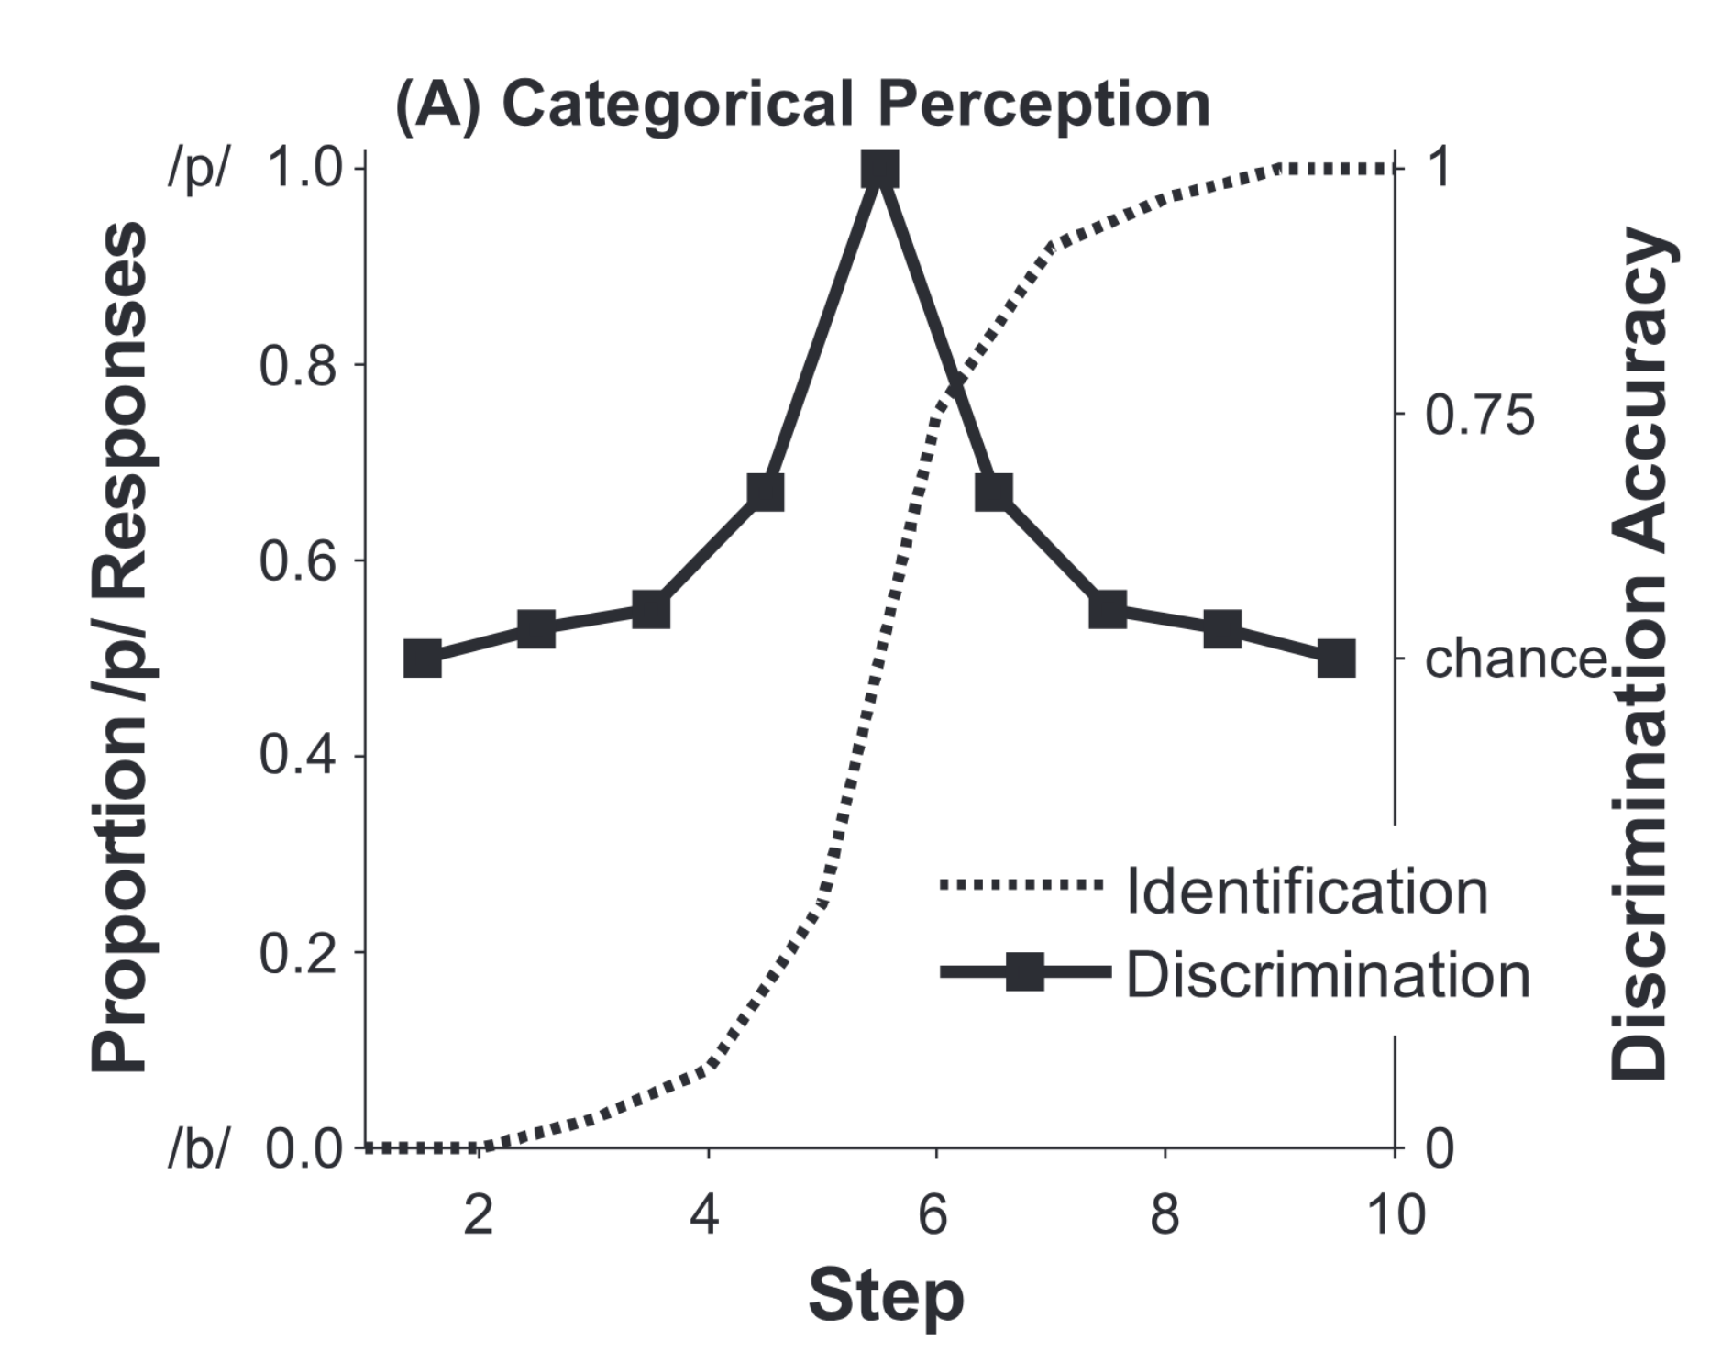
Figure 2.1: Hypothetical 2AFC identification and discrimination data showing canonical categorical perception behavior (from McMurray, 2022). The dotted S-shaped curve is proportion of /p/ responses (y-axis, left) in a 2AFC identification task as a function of continuum step along an acoustic dimension that varies from /b/ to /p/. The solid black line with squares is the mean discrimination accuracy between two tokens at neighboring continuum steps (e.g., discrimination between Step 1 and Step 2, Step 2 and Step 3, etc.). Canonical categorical perception behavior is the alignment of the inflection point of the identification curve with the peak of the discrimination accuracy curve.
These behaviors seemed to suggest that, for the identification task, tokens on either side of the category boundary are consistently identified with high accuracy, despite the fact that tokens vary in feature value at each step along the acoustic dimension, with a sudden switch in identification choice at the point along the continuum that marks the category boundary. For the discrimination task, these behaviors seemed to suggest that within-category tokens were more difficult to discriminate between than between-category tokens despite being the same distance from each other along the continuum.
As a theory, categorical perception posits that categories influence the perception of auditory input characterized across continuous, multidimensional perceptual space. In other words, the theory suggests that after acquiring perceptual categories, perception itself is warped such that within-category differences are minimized and between-category differences are enhanced, thereby producing an asymmetry in the distance between stimuli in the perceptual space that is dependent on if the distance crosses a perceptual boundary or not (Goldstone & Hendrickson, 2010; Harnad, 2003, 1987). Essentially, if a set of stimuli is separated along a physical dimension by a given distance, the distance is perceived as smaller if the stimuli are on the same side of a perceptual boundary, while it is perceived as larger if the stimuli are on opposite sides of a perceptual boundary. As such, categorical perception is a theory on how perceptual categories influence the perceptual encoding of incoming stimuli, also known as perceptual warping.
Subsequently, the field sought out to find evidence of categorical perception in more speech perception contexts. For adult L1 speech perception, following the original Haskins Laboratories studies, additional studies investigated categorical perception of other classes of phonemes and speech stimuli, including English fricatives (Cutting & Rosner, 1974; Ferrero et al., 1982), and a variety of synthesized English stop consonants and vowels (Liberman, Harris, Eimas, et al., 1961; Van Hessen & Schouten, 1999), which found that the strength of categorical perception increased with increasing complexity of the synthesized speech as it approaches that of natural speech. Categorical perceptual greatly influenced the field of speech perception from the influx of studies that compared categorical perception in L1 and non-L1 users. For example, these studies found evidence of categorical perception of Mandarin Chinese lexical tone (Hallé et al., 2004; Shen & Froud, 2016; Xu et al., 2006), Thai lexical tone (Burnham & Jones, 2002) and English /r/-/l/ (Miyawaki et al., 1975) for L1 listeners but not for naïve non-L1 listeners. J. Kim (2013) found evidence of categorical perception of lexical pitch accent for users of a dialect of Korean that uses lexical pitch accent, and did not find evidence of categorical perception in Korean listeners of a dialect that does not use lexical pitch accent. Shen & Froud (2016) also found that L2 learners had comparably high categorical perception similar to L1 listeners. This evidence seemed to suggest that categorical perception is the standard for L1 speech perception, and proponents of categorical perception assumed a direct correlation between behavioral outcome (perceptual warping) and learning mechanism; if having acquired categories leads to categorical perception, as is the case in adults, then behavioral evidence of categorical perception must mean that these infants had already acquired phonetic categories.
A few studies attempted to verify the correlation between mechanism and behavior (Pollack & Pisoni, 1971; Schouten et al., 2003). Categorical perception was challenged as the processing mechanism of at least some speech categories, such as vowels. Fry et al. (1962) provided evidence that English vowels were not perceived categorically, but instead were perceived in a gradient fashion as stimuli features changed in value along the continuum of the most informative acoustic dimension. Rapidly following was the wave of experiments providing evidence against categorical perception of segmental and suprasegmental speech categories, even those that had been previously shown to produce categorical perception behaviors (Abramson, 1979; Carney et al., 1977; Hary & Massaro, 1982; Ladd & Morton, 1997; Massaro & Cohen, 1983; Pisoni & Lazarus, 1974; Samuel, 1977; Utsugi et al., 2008).
The weakening evidence for categorical perception put its traditional identification and discrimination tasks under scrutiny. Skeptics have noted that these tasks collect measures that are as much of a product of the task demands as they are of categorical perception as a perceptual phenomenon, and that discrimination tasks are subject to influence from working memory as a confounding factor (Gerrits & Schouten, 2004). Recent work has also revealed that reduced within-category discrimination and increased between-category discrimination, behaviors that suggest perceptual warping, can occur in the absence of robust category representations (Schatz et al., 2021; Feldman et al., 2021). This directly challenges the extrapolated assumption of categorical perception that warped perceptual processing, as shown in discrimination outcomes, reflected already acquired category knowledge. Additionally, forced choice identification tasks by definition force the listener to choose one category label or another when presented with a stimulus, which makes it impossible to measure potential gradient processing of within-category variation. When given only discrete options for decision-making, a listener will necessarily only report to perceive objects categorically, as they are not given any response choices to communicate possible gradient processing. Thus, categorical perception and the tasks used to measure it may not reflect the construct of category acquisition and knowledge as initially posited (see McMurray, 2022 for a full synthesis).
In light of evidence that speech categories may be encoded with the continuous information present in the auditory signal, researchers began to rethink the role of categorical perception in speech perception and instead reconsidered speech perception as a process of categorization that uses general auditory processes (Holt & Lotto, 2010; Holt & Lotto, 2008). Unlike categorical perception, categorization does not require that phonetically irrelevant within-category variation be discarded. Instead, categorization compresses, but retains, acoustic features of the input when mapping onto the perceptual space, which enables the extralinguistic features to remain accessible to the speech system. With such within-category variation accessible, the speech system is free to engage in gradient perception. In line with gradient perceptual strategies, there is evidence that phonetic categories themselves are mapped as gradient representations (Miller, 1997), which also aligns with the prototype-based framework of category representations (Stevens, 2002). A phonetic category may be robustly represented by relatively tight clustering around values somewhere along the relevant dimension that signify category membership (Delattre et al., 1955; Stevens, 1980), and category membership may be graded based on distance from the category center.
This gradient encoding strategy offers a compelling solution to the problem of the lack of invariance. Encoding both phonetically-relevant and phonetically-irrelevant cue features in a gradient fashion allows for the perceptual system to create both flexible and stable perceptual categories (McMurray & Jongman, 2011; Oden & Massaro, 1978). Perceptual flexibility primes the speech system to be sensitive to context changes, and perceptual stability allows the speech system to function in the face of these changes. In other words, stable categories are necessary to ascribe functional equivalence to variable sounds, yet perceptual flexibility is just as necessary to adapt to irregular or novel input, such as those introduced by coarticulatory, prosodic, or pragmatic contextual effects, and those introduced by idiosyncratic speech or foreign-accented speech (Baese-Berk, 2018). The flexibility and adaptability of the speech system can shift boundaries based on non-phonetic cues to attune to persistent change, and enables robust generalization when encountering further novel speech contexts (Kleinschmidt & Jaeger, 2015). Indeed, gradient perception supports both the flexibility and stability necessary for speech learning, adaptation, and generalization (McMurray, 2023, 2022).

Measuring gradient categorization in speech perception
In order to measure whether listeners use continuous acoustic information in the encoding of speech sounds, researchers must use more gradiently-oriented tasks (Apfelbaum et al., 2022). Early on, researchers who suspected continuous perception provided evidence of this perceptual strategy by showing that discrimination reaction times increased for ambiguous stimuli at the perceptual boundary (Pisoni & Tash, 1974), that lexical decision reaction time increased as a function of subphonemic distance (Andruski et al., 1994), and that analyzing identification rating scores as a distribution across the continuum instead of as the average rating score showed that empirical rating distribution data matched the predicted distribution of continuous identification rather than categorical identification (Massaro & Cohen, 1983).
Since then, online measures of speech perception have regularly been employed to show the use of continuous acoustic detail. These online measures evaluate speech perception in real time using techniques such as eye-tracking, electroencephalography (EEG), and magnetoencephalography (MEG), and procedures such as lexical decision tasks, visual world paradigms, and auditory oddball tasks. These tasks can also employ stimuli that synthetically vary in equal steps along a continuum, much like classical categorical perception tasks, but in such a way as to truly evaluate the effect on processing behavior as a function of steps along the continuum. In lexical decision tasks and the visual world paradigm, participants must make a lexical decision, often times among phonologically similar lexical competitors. Participants eye movements are monitored as they see visual representations of competing lexical items and hear a word which is only lexically disambiguated part-way through the word (e.g., pencil vs. pendant vs. penthouse). These studies have consistently shown that L1 listeners use continuous acoustic detail and phonetic cues and show sensitivity to within-category variation during word recognition through phoneme categorization (Clayards et al., 2008; Desmeules-Trudel & Zamuner, 2019; McMurray et al., 2008; Ou et al., 2021), lexical tone categorization (Qin et al., 2019), lexical access (McMurray et al., 2002), and downstream referential disambiguation (Brown-Schmidt & Toscano, 2017).
In auditory oddball tasks, participants hear a number of words with equal probability and must detect a predetermined target word amongst competing non-target words for each trial. Certain patterns of brain activity, as measured by an event-related potential (ERP), responds to non-target “oddball” stimuli, and the amplitude of the wave pattern has been shown to vary as a function of acoustic distance between the target and non-target stimuli, indicating neural patterns that recognize and encode continuous acoustic information (Getz & Toscano, 2021; Toscano et al., 2010). EEG and MEG have also been used with classical identification tasks and have similarly provided evidence of gradient perception (Gwilliams et al., 2018; Ou & Yu, 2022)
A paradigm that is gaining popularity to measure categorization and gradiency is the visual analog scale (VAS), the prototype of which was first used by Massaro & Cohen (1983), which offers an alternative to the 2AFC identification task. Like the 2AFC task, in the VAS task, listeners hear a series of speech tokens that vary in equal steps along a continuous auditory dimension from one member of a phonemic contrast to another (e.g., /b/-/p/ that varies along the voice-onset-time (VOT) dimension). Unlike the 2AFC task, the VAS task allows listeners to report what they heard as a function of how much they think it sounds like one end of the continuum versus the other (Apfelbaum et al., 2022; Kutlu et al., 2022).
The VAS task is advantageous over the 2AFC task in two related ways. First, comparing VAS responses to 2AFC responses offers a more specific deduction of the perceptual strategy used by listeners when encountering ambiguous stimuli at the midpoint between the contrast pair. In the 2AFC task, listeners are forced to categorize an ambiguous stimulus that may lie at the category boundary as one of the two choices, while the VAS task allows listeners to report what they may perceive to be a sound that actually lies in between the two endpoints. A listener with categorical tendencies may consistently perceive an ambiguous stimulus as a good exemplar of a category and thus rate it close to the endpoint, while a listener with gradient tendencies may rate the same stimulus somewhere close to its location on the continuum. Either way, the VAS task allows for both behaviors to be captured.
The second advantage of the VAS task is that plotting VAS data offers an opportunity to deduct the perceptual source of a shallow 2AFC slope. One way to analyze gradiency from VAS data (among several) is by fitting the data with a sigmoid S-shaped curve function, which predicts rating results for each step along the continuum, and the slope is measured at the inflection point; this type of data modeling is also done on 2AFC data. Categorical data would result in a steep slope as the ratings quickly transition from one side of the rating scale to the other at the inflection point along the continuum, which mimics the canonical categorical perception steep slope that would arise from plotting 2AFC data. Gradient VAS data would result in a shallow slope as the ratings gradually move along the full range of the rating scale. Typically, a shallow slope in the plotting of 2AFC data was interpreted as non-categorical perception. A shallow slope itself came to be interpreted as a perceptual deficit, given that non-category perceptual behavior was found in children with communication disorders (Thibodeau & Sussman, 1979) and individuals with dyslexia (Noordenbos & Serniclaes, 2015). While it is possible that a shallow identification curve may suggest perceptual deficits, a shallow slope may also be a result of gradient category representations. Shallow slopes with inconsistent ratings, especially for ambiguous stimuli are likely to result from the former while shallow slopes with consistent ratings at each step of the continuum are likely to result from the latter. Overall, the VAS is a compelling alternative that allows for proper investigations of gradiency in categorization and de-emphasis of the steep vs. shallow identification curve dichotomy (Apfelbaum et al., 2022; Kutlu et al., 2022).

Some evidence of the role of gradient categorization in L1 speech perception
A number of studies have used a variety of techniques in tandem with the VAS task to provide not only evidence of the use of gradient categorization strategies in L1 speech perception of English phonemes, but the benefit of gradient categorization as well. Researchers first sought to characterize individual differences in perceptual categorization strategies and link these categorization to other perceptual behaviors, such as acoustic cue sensitivity and cue weighting strategies, word recognition in ambiguous and adverse conditions, and components of executive function (Kong & Edwards, 2011, 2016; Kapnoula et al., 2017, 2021; Kapnoula & McMurray, 2021; D. Kim et al., 2020).
By far the most influential and consistent findings of these papers is that individuals differ in their degree of categorization gradiency, and this correlates with multiple cue integration. With VAS being used to measure categorization gradiency, these studies found that more gradient categorization (more shallow VAS slope) was found to correlate with increased secondary cue use, whether measured by anticipatory eye movement (AEM) eye-tracking (Kong & Edwards, 2016, 2011), 2AFC identification (Kapnoula et al., 2017, 2021), and the VAS task itself (Kapnoula & McMurray, 2021; D. Kim et al., 2020). This correlation between gradiency along the primary cue and secondary cue use was also found for the voicing contrast /t/-/d/ (Kong & Edwards, 2011, 2016; Kapnoula et al., 2017; Kapnoula & McMurray, 2021) and /b/-/p/ (Kapnoula et al., 2017, 2021; Kapnoula & McMurray, 2021) using VOT/F0, and the vowel contrast /ɛ/-/æ/ using spectral quality and vowel duration (D. Kim et al., 2020).
This correlation between gradiency and secondary cue integration is relevant for the purpose of perceptual flexibility, especially as it relates to down-stream, higher-level speech processes. For L1 speech perception, acoustic cue sensitivity is implicated in listeners’ ability to rapidly adapt to variant patterns of speech input, such as those that may be encountered from foreign-accented speech. In these situations where familiar phoneme categories are distributed along known acoustic cues in unfamiliar ways (e.g., when the canonical correlation between VOT and F0 for English voicing contrasts is reversed), even after short or passive exposure to the unfamiliar distribution, listeners are able to shift their weighting of the acoustic cues to adapt to the distribution of the input and accurately identify phonemes that have shifted in location in the dimensional space (e.g., Idemaru & Holt, 2011, 2014; Liu & Holt, 2015; Lehet & Holt, 2017, 2020; X. Zhang & Holt, 2018; X. Zhang et al., 2021; Hodson et al., 2023). This evidence aligns with other results that have shown that speech perception involves the optimal integration of acoustic cues (Clayards et al., 2008) and that some listeners are better than others at making use of multiple cues (Clayards, 2018). Given the correlation between gradiency and secondary cue use, it is possible that gradiency is related to the perceptual flexibility necessary for this kind of perceptual adaption. D. Kim et al. (2020) measured categorization gradiency, secondary cue use, perceptual adaptation to an artificial accent, and various measures of executive function. While the results confirmed a correlation between increased gradiency and increased secondary cue use, there was no evidence of a correlation between gradiency and perceptual adaptability. Perceptual adaptability was instead correlated with inhibitory control.
There are other forms of down-stream speech perception, including word recognition in various adverse conditions, that may be correlated with perceptual flexibility. One such situation is speech perception in noise, whether that be non-speech noise or overlapping talkers; it is possible that in noisy environments, certain acoustic cues that inform category membership are masked, in which case it would be advantageous for the listener to have the perceptual flexibility to attend to other acoustic cues that redundantly inform category membership, i.e. secondary acoustic cues (e.g., Fogerty, 2011; S. Lee & Bahng, 2012; for reviews, see Assmann et al., 2006; Mattys et al., 2012). Another situation that benefits from perceptual flexibility is encountering lexical garden paths, such that the availability of fine-grained acoustic details at higher levels of speech processing can affect lexical activation during temporarily ambiguous speech when multiple lexical competitors compete for word recognition (Andruski et al., 1994; McMurray et al., 2002; McMurray et al., 2008). Gradient VAS slopes were not found to correlate with speech perception in noise outcomes, which instead were found to correlate with inhibitory control, attention switching, and working memory (Kapnoula et al., 2017, 2021). However, gradiency did predict increased likelihood of recovering from lexical garden paths, as measured from visual world paradigm eye-tracking tasks (Kapnoula et al., 2021; Kapnoula & McMurray, 2021). A number of these studies have linked VAS evidence with measures of executive function to suggest that gradient perceptual patterns may interact, albeit weakly, with components of executive function such as working memory (Kapnoula et al., 2017; D. Kim et al., 2020) and inhibitory control (Kapnoula & McMurray, 2021) to exert more controlled constraints at higher levels of speech processing.
This evidence comes together to show that the role of gradient categorization in speech perception is carried out at multiple levels, from lower sensory levels to higher cognitive levels. Different patterns of categorization strategies have not been able to be captured by typical categorization tasks of forced choice identification and discrimination (Hary & Massaro, 1982; Massaro & Cohen, 1983; Gerrits & Schouten, 2004); in fact, VAS slopes and 2AFC slopes were not found to be correlated, which seems to suggest that these two tasks capture different constructs altogether (Kapnoula et al., 2017). In investigating the role of different categorization strategies, it becomes necessary to consider how the perceptual system handles continuous auditory information when mapping from level to level. Figure 2.2, from Kapnoula & McMurray (2021), shows how gradient vs. categorical combinations at the levels of cue encoding and cue-to-representation mapping. Figure 2.2A depicts both categorical cue encoding and mapping, as theorized by the framework of categorical perception. Figures 2.2B and 2.2C both depict gradient cue encoding, but Figure 2.2B shows how gradient cue encoding can be categorically mapped to representations, while Figure 2.2C shows gradient cue encoding and gradient mapping to representations.
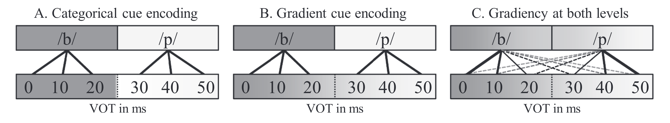
Figure 2.2: Categorical vs. gradient cue encoding and category mapping behaviors (from Kapnoula & McMurray, 2021). The bottom level represents encoding of continuous acoustic cues and the top level represents higher-level categories, depicted here as phonemes, that are activated by the cue value. A. Cues are categorically encoded and categorically mapped, leading to the activation of discrete categories. B. Cues are gradiently encoded but categorically mapped, leading to the activation of discrete categories. C. Cues are gradiently encoded and mapped, leading to the gradient activation of categories.
Evidence from EEG and MEG studies have supported the idea that in general, the perceptual system encodes the continuous information of incoming auditory signals in a linear fashion, which discounts the hypothetical system depicted in Figure 2.2A and favors the systems shown in Figures 2.2B and 2.2C (Toscano et al., 2010; Pereira et al., 2018; Gwilliams et al., 2018; Kapnoula & McMurray, 2021; Ou & Yu, 2022). Neural data have been compared to behavioral data to show that individual differences in phoneme categorization, which is the evidence that we see from VAS and eye-tracking tasks, occur from differences in how individuals map subphonetic continuous detail to more abstract speech categories. For gradient listeners, continuous phonetic information is encoded linearly and mapped to phonemic categories gradiently, as shown in Figure 2.2C, while for categorical listeners, continuous information is encoded linearly until reaching category boundaries, where linear encoding is warped, and that the continuous information tends to be mapped rather categorically, as shown in Figure 2.2B (Kapnoula & McMurray, 2021; Ou & Yu, 2022). While gradient categorization has not been implicated in all downstream speech recognition processes, such as speech perception in noise (Kapnoula et al., 2017, 2021) and speech adaptability (D. Kim et al., 2020), the benefit of gradient categorization is still clear at multiple levels for its role in perceptual flexibility through multiple cue integration (Kong & Edwards, 2011, 2016; Kapnoula et al., 2017, 2021; D. Kim et al., 2020; Kapnoula & McMurray, 2021; Ou et al., 2021) and through making subphonemic continuous details available in order to resolve lexical ambiguity during word recognition and lexical activation (Desmeules-Trudel & Zamuner, 2023; Kapnoula et al., 2017, 2021; Kapnoula & McMurray, 2021; Ou et al., 2021; Ou & Yu, 2022).

The role of gradient categorization in speech learning

Perceptual learning of speech in children vs. adults
Categorization is likely to have much more of a relevant role in speech learning and perceptual adaptation to novelty (Holt & Lotto, 2010). Perceptual learning involves the reorganization of perceptual categories, which can further be described as the process by which the auditory system creates and continually updates category boundaries, the rules for sound-to-meaning mappings, and the attachment of category labels to perceptual units (Samuel & Kraljic, 2009; Samuel, 2011). A unified perspective of abstract and exemplar category representation suggests that learning speech categories depends on characteristics of the distribution of input, or bottom-up factors, just as much as it depends on the function of the input, or top-down factors (Pierrehumbert, 2003). This is a popular perspective that has been supported by time-sensitive measures of neural activity during non-learning speech perception as well (Getz & Toscano, 2021). Bottom-up factors typically arise from statistical learning or distributional learning, through which listeners acquire sensitivity to the statistical structure and distributional regularities of speech; in the case of speech, this includes tracking the probability of cooccurrence between certain sounds and the distribution of acoustic features across sounds (Erickson & Thiessen, 2015). Top-down factors include higher-level constructs, such as lexical, syntactic, and semantic knowledge, among others.
Infants can take advantage of their perceptual blank slate during L1 acquisition to make use of both bottom-up (statistical distribution) and top-down (developing lexicon) information as they steadily learn phonetic and phonological categories (E. K. Johnson, 2016). Research in L1 acquisition measuring discrimination behavior through infant habituation tasks has found that up to approximately 6-months-old, infants are able to discriminate between speech sounds of any language regardless of language background, and that sometime between 6-12 months of age, cross-linguistic discrimination ability declines while L1-specific discrimination ability strengthens (for reviews, see Feldman et al., 2021; Galle & McMurray, 2014; Tsuji & Cristia, 2014; Werker & Lalonde, 1988; Werker & Polka, 1993; Werker & Curtin, 2005). Statistical learning and distributional learning through L1 language experience seems to play a larger role, especially early on, in increasing sensitivity to L1 speech sounds (Maye et al., 2002; Maye et al., 2008; Kuhl, 2004; Romberg & Saffran, 2010; Thiessen & Erickson, 2013), and infants steadily learn to use their developing lexicon to incorporate top-down constraints in the development of their speech perceptual space (Feldman, Griffiths, et al., 2013; Martin et al., 2013; Yeung & Werker, 2009). In this way, distributional statistical learning (bottom-up constraints) and word learning (top-down constraints) work together to facilitate the development of parallel phonological and lexical systems and the mappings between them (Erickson & Thiessen, 2015; Werker & Yeung, 2005).
However, even during the 6-12 month period, infants remain sensitive enough such that distributional learning through even short-term exposure to live foreign language speech can lead to successful discrimination of foreign language contrasts once more (Kuhl et al., 2003). The ability of infants and young children to remain sensitive enough to the distribution of foreign languages suggests that increasing sensitivity to L1 statistical structure does not necessarily entail pruning of sensitivity towards foreign language sounds (Galle & McMurray, 2014). One possible explanation for this is that infants are not necessarily learning the phonetic categories of their L1, but instead building their perceptual space according to the acoustic distributions to which they are exposed (Feldman et al., 2021). Computation models of learning have shown that distributional statistical learning on its own does not support phonetic category learning (McMurray et al., 2009; Schatz et al., 2021), but does lead to behavior that reflects perceptual space learning (Matusevych et al., 2023), while lexical knowledge fine tunes the space to develop phonetic categories (Feldman et al., 2009). This perceptual space learning may explain why foreign language speech learning is much easier for children than for adults; children continue to develop stable L1 speech categories through adolescence (McMurray et al., 2009), which may indicate that early on, their perceptual space is much more flexible and susceptible to change from the distribution of the speech environment. Some researchers theorize that all of the same learning mechanisms that are present in infancy are also available to adults (McMurray, 2023; Thiessen et al., 2016). There is evidence that during perceptual learning of speech, adults can use distributional learning (e.g., Escudero & Williams, 2014; Escudero et al., 2011), lexical knowledge (e.g., Norris et al., 2003; McQueen et al., 2006; Feldman, Myers, et al., 2013), or both (e.g., Hayes-Harb, 2007; Wiener et al., 2018). So while the learning mechanisms available are the same, adults differ in both their internal (perceptual space) and external (type of input) ecologies for language learning (McMurray, 2023). Thus, distributional space learning will lead to different outcomes when starting with a still developing perceptual space compared to a fully developed perceptual space.

Psycholinguistic models of L2 speech perception and category learning
While adults are capable of being sensitive to distributional information, adjusting the perceptual space based on statistics, and using lexical knowledge to fine tune phonetic categories, the process is much more difficult than for children. For adults, L1 phonological knowledge does impact learners’ ability to use statistical information (Finn & Hudson Kam, 2008), and how the perceptual system is organized around acoustic cues based on language experience also influences the processing of incoming statistical information (Emberson et al., 2013). This means that the distribution of acoustic information of L2 input is processed by a system already biased to listening for L1 acoustic properties. Consequently, adults’ perception of L2 speech and learning of L2 categories is influenced by the presence of L1 categories in their L1-constrained perceptual space. There is a plethora of research showing the constraints of language experience on foreign language speech learning (Bohn & Munro, 2007).
Major psycholinguistic models of L2 speech perception and learning view L2 speech perception through the lens of L1 influence. These models include the Revised Speech Learning Model (SLM-r: Flege & Bohn, 2021), the Perceptual Assimilation Model extended to L2 (PAM-L2: Best & Tyler, 2007), and the Second Language Linguistic Perception Model Revised (L2LP-revised: van Leussen & Escudero, 2015). These models all theorize how learners perceive L2 sounds, how L2 phonetic categories are formed, the nature of learned L2 phonetic categories, and the learning mechanisms that map sound to meaning. They subsequently make predictions on the perceptual system behaviors in various contexts of encountering novel L2 sounds and contrasts. Additionally, they all agree that the degree of difficulty in L2 speech acquisition is learner-specific and dependent on a number of linguistic and individual factors (Baese-Berk et al., 2022; Nagle & Baese-Berk, 2022). I argue that gradient categorization tendencies are an example of combined linguistic and individual factors and that these models correspond well to the gradient categorization viewpoint that the perceptual system is capable of gradient mapping of acoustic cues to category representations. Although it was found that categorization gradiency is not a stable characteristic across all speech contrasts within an individual’s perceptual system, such that an individual may be gradient for some acoustic cues but not for others (Kapnoula et al., 2021), it is clear that for a given acoustic cue informative of a phonemic contrast, gradiency varies across individuals and consistently predicts secondary cue integration, at least in English (e.g., Kong & Edwards, 2011, 2016; Kapnoula et al., 2017, 2021; D. Kim et al., 2020; Kapnoula & McMurray, 2021). I believe that gradiency and multiple cue integration is especially meaningful in the perceptual learning of L2 contrasts, especially those that vary along one or more acoustic cues to which a learner of a particular L1 may not be accustomed to paying attention.

Revised Speech Learning Model (SLM-r)
The SLM-r (Flege & Bohn, 2021) argues that L2 sounds are perceived based on degree of phonetic similarity to the closest L1 categories (see also Flege, 1995a) The greater the dissimilarity between the distributions of the L2 phoneme and L1 phoneme, the more likely a new, separate L2 phonetic category is to form. The model hypothesizes that perceived similarity is influenced by the quantity and quality of L2 input, the precision and organization of L1 phonetic categories, and individual auditory processing abilities. L2 input is relevant in that L2 learners that are exposed to more of the L2 in meaningful contexts are more likely to use both the distributional information of acoustic features (bottom-up factors) and meaningful functions (top-down factors) to perceive dissimilarities between the L2 sounds and closest L1 category. The precision and organization of L1 phonetic categories is relevant in that learners with more precisely defined L1 categories will be able to perceive the acoustic and phonetic differences between related L1 and L2 sounds, and this interacts with individual differences in L1 category mapping, which itself is a function of L1 cue-weighting factors and L1 input (e.g., dialectal input). Individual auditory processing abilities is relevant in that those with greater general auditory acuity, or the precise encoding of acoustic information, are more likely to be able to process the dissimilarities between L1 and L2 sounds to create separate L2 categories.
In terms of the category formation process, the SLM-r predicts that L2 sounds that are too similar to the nearest L1 category are not likely to be processed into a separate L2 category, but that while the sounds are perceived as similar, encoding subtle differences in the acoustic properties of the L2 sound will result in a L1-L2 composite category (for empirical work, see Flege et al., 2003; Flege & Wang, 1989; Guion et al., 2000). For L2 sounds that are perceived as dissimilar, the model predicts first that a link is formed between the L2 sound and the closest L1 category, and after the accumulation of input, a functionally equivalent class of L2 phonemes that are similar to each other in acoustics and higher-level form are grouped together. Finally, as the proto-L2 category has stabilized as separate, the link to the nearest L1 category is cut. Clearly, the SLM-r model is positioned to accept the framework of gradient categorization. Gradient encoding and category representations are necessary for each step in the L2 perception process as defined by the SLM-r, as the first step depends on the continuous degree of similarity or dissimilarity between the L2 sound and the nearest L1 category. Precise gradient perception is especially crucial in determining whether L2 sounds go on to form a L1-L2 composite category or form a new category.

Perceptual Assimilation Model for L2 (PAM-L2)
The PAM-L2 (Best & Tyler, 2007) is similar to the SLM-r in that it argues that L2 sounds are perceived on basis of their phonetic goodness-of-fit to an existing L1 category, and those which are deemed to be good exemplars of L1 categories are assimilated (see also Best, 1995; Tyler, 2019, 2021). PAM-L2 assumes a shared L1-L2 perceptual space and makes a distinction between phonetic categories and phonological categories, such that the formation of new L2 phonetic categories is related to but separate from the formation of new L2 phonological categories. That is, L2 phonetic category formation is dependent on perceived goodness-of-fit to an L1 phonetic category (the less “good” of an exemplar the L2 phone is, the more likely a new L2 phonetic category will form) and L2 phonological category formation is dependent on ease of discrimination into different lexical functions (the easier it is to discriminate between two L2 phonemes in minimal pair contexts, the more likely a new L2 phonological category will form).
PAM-L2 predicts outcomes on the learning of new phonetic and phonological categories on the basis of L2 contrasts. L2 sounds that are phonetically (acoustically) and phonologically (functionally) similar to L1 sounds are assimilated into L1 categories as “good” exemplars. An L2 contrast where both sounds are assimilated as “good” exemplars into separate L1 categories will be easily discriminated, and new L2 categories are unlikely to form. L2 sounds that are phonetically dissimilar to the nearest L1 phonetic category may first be assimilated to the category as a “bad” exemplar, after which a new L2 phonetic category may arise depending on the degree of dissimilarity. The likelihood of learning the new L2 phonological category is dependent the functional load the contrast serves in the L2; if the contrast is present across many minimal pairs or featured in high frequency words, the lexical relevancy of the contrast will apply a top-down constraint on the phonological space to encourage learning of the L2 phonological categories. An L2 contrast where one sound is assimilated as a “good” exemplar and one sound is assimilated as a “bad” exemplar into the same L1 category will at first be somewhat harder to discriminate, though still relatively easy based on phonetic differences. The phonetic dissimilarity will eventually lead to the “bad” exemplar forming a new L2 phonetic category, and the ease of phonetic discrimination will make it easier to learn the phonological distinction, leading to a new L2 phonological category. The “good” exemplar may either remain assimilated into a combined L1-L2 phonetic category or go on to form a new L2 phonetic category, depending on the degree of phonetic similarity to the L1 category. An L2 contrast where both sounds are perceived as equally “good” or “bad” exemplars of the same L1 category will be very difficult to discriminate at first, and the listener must learn to perceive the fine-grained acoustic differences in order to form new phonetic categories, and from there learn new phonological categories.
It is possible for L2 sounds to fail to be perceived as any L1 category and fail to be assimilated, and uncategorized sounds are likely to be perceived as a mixture of similarities to several L1 categories. An L2 contrast where both members are uncategorized may either be difficult or easy to discriminate, depending on if the set of L1 categories that are closest to each sound overlap. Low overlap will likely lead to two new separated L2 phonetic and phonological categories; high overlap may lead to both sounds of the contrast forming one new L2 phonetic and phonological category, and the L2 contrast will remain difficult to perceive. Here too we see that gradient categorization fits in well with the postulates of PAM-L2. Gradient encoding and gradient category representations would enable more precise phonetic comparison between L1 and L2 speech sounds and more specific goodness ratings of L1 category membership. Just as well, learners with more precise perception will better accumulate the speech input needed to separate L2 contrasts that are first assimilated into the same L1 category.

Second Language Linguistic Perception Revised (L2LP-revised)
Like SLM-r and PAM-L2, L2LP-revised model (van Leussen & Escudero, 2015) assumes that L2 sounds are perceived against an L1-attuned perceptual space and L1-specific sound-to-meaning mapping rules (Escudero, 2005). Unlike the other two models, L2LP-revised assumes that L2 perception occurs on a copy of the L1 speech system, such L2 perception starts with L1 bias, but learning updates the structure and mapping rules on the copy; in other words, that the L1 and L2 perceptual spaces are separate, but the L2 space starts as a copy of the L1 space and updates through L2 exposure. L2LP-revised is a computation model that proposes information encoding in the speech system at four levels of representation (acoustic, phonetic, phonemic, and lexical) connected by three types of connection (cue connections that encode perception between acoustic forms and phonetic forms, phonological connects that encode recognition between phonetic forms and phonemic forms, and lexical connections that connect phonemic forms to lexical forms). The acoustic and phonetic levels are explicitly distinguished from the phonemic and lexical levels as pre-lexical and lexical stages of speech perception, respectively.
The model proposes speech perception occurs through the flow of speech information from level to level through the connections using the most optimal path as determined in the weights of the connections. Learning alters the strength and weights of the connections, thus updating the most optimal path as necessary for efficient and effect speech recognition. The learning mechanism is modeled to be error-driven and highly meaning-driven, as the model was constructed from a trickle-down lexicon-driven perceptual learning framework, meaning that top-down meaningful information drives learning more so than bottom-up structural information. However, bottom-up structural information is still relevant as the model identifies that within the new L2 perceptual space, learners need to shift L1 category boundaries, create new categories, and merge or delete existing categories in order to update connection weights to create the most optimal path from acoustic input to lexical recognition. I argue that gradient categorization is relevant for the pre-lexical stage of speech processing proposed by L2LP-revised.
The model makes predictions on the perception and learning of L2 contrasts in similar scenarios as predicted in PAM-L2 (for empirical work, see Escudero & Boersma, 2004; Boersma & Escudero, 2008; Escudero, 2009). A learner may encounter an L2 contrast that requires the creation of a new L2 category. The category may be formed by creating a boundary that divides an existing L1 category into two along a familiar primary acoustic cue or learning to integrate a novel acoustic cue and placing a new boundary along an auditory dimension. A learner may also encounter an acoustic contrast where the sounds are similar to the contrasts in the L1 but requires shifting the boundary to a different location along the primary acoustic cue. Additionally, a learner may encounter a single L2 sound whose distribution of production spans across two different L1 categories, which reduces the optimal path of lexical recognition for lexical items with this L2 sound. In all cases, gradient encoding of acoustic features as well as gradient category representations lead to more optimal perception and adjusting of category mappings. The L2LP model proposes that sound-to-meaning mappings are carried in the weights of connections between representation levels, thus the weighted connections in and of themselves are the gradient encoding. For example, within-category sounds that are closer or further away from the category boundary with a contrast will have different connection weights to the downstream representations, thus enabling both within-category and between-category discrimination. Further, acoustic features that correspond to the center of a speech category would have the strongest weights connecting them to downstream representations. Subsequently, using error-driven mechanisms from meaning-driven lexical influence, learners with more gradient perceptual patterns would be more able to update and fine-tune the pre-lexical and lexical connections towards the most optimal path for L2 speech perception.

The potential role of gradient categorization in L2 speech perception and learning
As I have discussed, all of these models of L2 speech perception and category learning align with the gradient categorization framework. With the rise in the investigation of gradiency in L1 speech perception, newer studies have since been conducted released to investigate individual differences in gradient categorization and its possible role in L2 speech perception and category learning. Given that more gradient patterns of categorization predict higher weighting of secondary cues in L1 speech (Kong & Edwards, 2011, 2016; D. Kim et al., 2020; Kapnoula et al., 2017, 2021; Kapnoula & McMurray, 2021), it can be hypothesized that gradiency also predicts secondary cue use in L2 perception. This kind of perceptual flexibility for input-driven speech learning would be beneficial for cue reweighting, which may help reorganize the perceptual system to be more sensitive to L2 speech patterns (Ellis, 2006; van Leussen & Escudero, 2015; MacWhinney, 1997). This is supported by evidence that showed that L2 learners tend to weight acoustic cues differently than L1 listeners (e.g., Aoyama et al., 2004), and that L2 learners who use more L1-like cue weighting strategies tended to have more success in the learning of difficult L2 contrasts (e.g., Chandrasekaran et al., 2010), while those who maintained L2-like cue weighting strategies continued to struggle (Lotto et al., 2004).
Studies investigating gradiency as it relates to L2 learners have mostly investigated the relationship between specifically L1 gradiency and L2 learning performance by naïve listeners with no experience with the L2 of interest. Fuhrmeister et al. (2023) investigated whether individual differences in L1 English categorization gradiency and consistency, predicted success in the learning and perception of difficult L2 contrasts. The authors used a different form of the VAS scale where listeners rated their judgement of continuum stimuli along 7 discrete points along the VAS task corresponding to the number of steps on the continuum in order to measure both categorization gradiency and categorization consistency for each continuum step. This is one method to elucidate whether a shallow VAS slope corresponds to noisy categorization or gradient categorization. The participants underwent a training paradigm and were tested on their perception of L2 speech before and after training. The results of the first experiment showed that although the participants showed signs of learning the contrast after training, neither categorization gradiency or consistency of English contrasts /b/-/d/ and /s/-/ʃ/ were correlated with performance in the perception or learning of Hindi voiced retroflex vs. dental contrast /ɖ/-/d̪/. The authors attributed the null results to low statistical power. In the second experiment, recruiting more participants and using a simpler procedure, they found that L1 categorization consistency, but not gradiency, weakly predicted success in the discrimination sensitivity to the Hindi contrast /ɖ/-/d̪/ contrast and Polish voiceless alveolo-palatal and retroflex fricative contrast /ɕ/-/ʂ/.
Honda et al. (2024) measured categorization patterns in L1 listeners on the English stop consonant /d/-/t/ contrast and vowel /ɛ/-/æ/ contrast and compared the results to the listeners’ naïve perception of German vowels (/øː/ vs. /œ/, /yː/ vs. /ʏ/) and consonants (/ʃ/ vs. /ç/). They replicated the finding of Fuhrmeister et al. (2023) that L1 categorization consistency, but not gradiency, predicted L2 perception outcomes by naïve L1 listeners. An interesting finding of the study was that the authors used the VAS task to measure both gradiency and consistency and 2AFC to measure consistency and found that VAS slopes and 2AFC slopes do not correlate, while the measure of VAS consistency and 2AFC slope do correlate. Thus, as initially suggested by Kapnoula et al. (2017), their results showed that VAS and 2AFC do not measure the same construct of categorization, but instead that VAS measures gradiency (and can capture consistency) while 2AFC measures consistency.
J. Lee & Park (2024) trained naïve L1 English users to learn L2 Korean three-way lenis-fortis-aspirated contrast /p/-/p*/-/pʰ/. They first measured categorization gradiency and secondary cue use of the English /d/-/t/ contrast and tested listeners before and after high-variability phonetic training on discrimination sensitivity, secondary cue use, and learning generalization of the Korean contrast, the three phonemes of which are distinguished by the equal weighting of the informativeness of VOT and F0. In measuring L1 secondary cue use for the stop consonant contrast, which uses VOT as the primary cue and F0 as the secondary cue, this was an attempt to measure the transfer of L1 secondary cue sensitivity to L2 learning that relies on familiar cues that are used in different ways. Here, the results did show that those with more gradient categorization of the L1 contrast (who showed higher secondary cue use) had more success in L2 contrast learning, generalized to novel stimuli, and increased their reliance on the F0 cue in perception of the L2 Korean contrast, compared to those with more categorical categorization.
Instead of using naïve listeners, Kapnoula & Samuel (2024) investigated the relationship between L1 gradiency and its potential long-term/broader effects on L2 proficiency in highly proficient L2 learners. Using the VAS task, they measured L1 Spanish gradiency, consistency, and secondary cue use of the Spanish /b/-/p/ contrast, which has a different category boundary along the VOT dimension compared to English /b/-/p/. L2 English proficiency was measured using a word knowledge test. Here too, L1 categorization gradiency (as measured by boundary warping such that lower boundary warping indicated higher gradiency) was found to predict higher L2 English vocabulary knowledge. Interestingly, gradiency was not associated with secondary cue use of F0, as it seemed that Spanish speakers did not use F0 at all in /b/-/p/ categorization (the difference between English and Spanish weighting of VOT and F0 for their respective /b/-/p/ contrasts is discussed in the paper). Another interesting finding is that categorization consistency did not predict L2 vocabulary knowledge, which contradicts the findings from Fuhrmeister et al. (2023) and Honda et al. (2024). This contradiction is no doubt in part due to the differences in measurement of L2 success.
To the best of my knowledge, only two studies have used the VAS scale to measure categorization gradiency for both L1 and L2 speech (although see Kutlu et al. (2022) for a study that used a heterogeneous sample of monolingual L1 English users, heritage-Spanish English-dominant users, L1 Spanish L2 English users, and L2 Spanish L1 English-dominant users, and measured their categorization gradiency of English contrasts). Kong (2019) measured gradiency of L1 English /d/-/t/ contrast and L2 Korean /t/-/tʰ/ contrast in L1 English residents of South Korea. Although there was a positive trend in the correlation between L1 and L2 gradiency, the correlation test was not significant. Further, neither L1 nor L2 gradiency was found to correlate significantly with L2 Korean proficiency, as measured by the Test of Proficiency in Korean. In contrast with previous studies, the author found no significant correlations between gradiency and secondary cue use in L1 English, nor any significant correlation between L2 gradiency and L2 cue use. The most interesting results showed that L2 proficiency with correlated with lower weighting of the VOT dimension and higher weighting of the F0 dimension for L2 Korean perception, suggesting that more proficient learners showed more L1-like perceptual weighting strategies. The benefit of measuring gradiency and cue weighting using the VAS is shown here is that these results emphasize individual differences in the way in which the primary and secondary cues are weighted for L1 vs. L2 speech, rather than a more simplified finding that gradiency leads to increased secondary cue use, as was found when only investigating L1 English speech.
Lastly, Kong & Kang (2023) investigated L1 Korean and L2 English gradiency with the VAS task using the same contrasts as in Kong (2019). Acoustic sensitivity was measured using a 2AFC task for L2 English and a 3AFC task (/t/-/t*/-/tʰ/) for L1 Korean. L2 English proficiency was measured from participants’ latest scores from the Test of English for International Communication (TOEIC). On average, there was a significantly positive relationship between L1 and L2 gradiency such that listeners that showed gradient L1 categorization also tended to show gradient L2 categorization. On average, listeners were more gradient in their L2 than they were in their L1. However, the study did not include a measure of categorization consistency, thus it is difficult to distinguish gradient slopes from noisy slopes. In terms of L1 gradiency and cue sensitivity, because VOT and F0 can be equally weighted to categorize Korean /t/-/tʰ/, and some listeners weight VOT more while others weight F0 more, there was no unified relationship between categorization gradiency and secondary cue use. When split between participants who weighted VOT vs. F0 as the primary cue, more gradient categorization predicted more integration of the secondary cue of VOT for those who use F0 as the primary cue, but no significant trend in any direction was found in the integration of F0 for those that use VOT as the primary cue. In terms of L2 gradiency and cue sensitivity, the results showed that greater sensitivity to VOT (primary cue for English) was correlated with more categorical responses, while greater sensitivity to F0 (secondary cue for English) was correlated with more gradient responses. The latter result is consistent with the L1 findings that gradient categorization is correlated with secondary cue sensitivity. However, the most surprising finding of the study was that higher L2 proficiency was correlated with more categorical responses. The authors offer an argument that these results of L2 gradiency, cue sensitivity, and proficiency may suggest that, rather than reflecting cue weighting strategies used by L1 English listeners, the correlations between L2 gradiency and increased secondary cue use and L2 gradiency and lower L2 proficiency may reflect overreliance of the secondary cue in a way that reflects cue weighting biased by L1 Korean cue-weighting strategies. Overreliance of secondary cues and under-reliance of primary cues has been implicated in poor L2 speech perception (e.g., Lotto et al., 2004). However, recall that shallow slopes with inconsistent ratings at each step of the continuum are likely to be a result of inefficient categorization (i.e. noisy categorization), while shallow slopes with consistent ratings are likely to result from gradient categorization (Kutlu et al., 2022). Given that this study did not measure rating consistency, again, it is difficult to distinguish noisy slopes from gradient slopes and difficult to extrapolate the reason why shallow VAS slopes were associated with lower L2 proficiency.
The culmination of this conflicting evidence reflects that the role of gradient categorization in L2 speech perception and category learning is still unclear. The contradictions may arise from the lack of consistency across VAS data extraction, data analysis plans, and construct measures. Some studies measured the VAS slope using logistic regression S-shaped curvefitting on data plotting rating scores per continuum step (Fuhrmeister et al., 2023; Honda et al., 2024; Kapnoula & Samuel, 2024), while others measured the slope from a polynomial curve fitted on counts of rating scores plotted as a histogram, unrelated to continuum location (Kong & Kang, 2023; Kong, 2019; J. Lee & Park, 2024). The results conflicted even among studies using the same type of VAS fitting function. Moreover, the studies differed both in how they measured and extracted data on acoustic cue sensitivity, and on which cues they studied to relate categorization in L1 and L2, with some studies measuring L2 gradiency/proficiency/learning for contrasts that use acoustic cues that may or may not be shared with the L1. Also, studies differed in how they operationalized L2 performance/proficiency. Lastly, the methods of statistical analysis to relate categorization patterns to other measurements varied across studies, with most studies using some form of regression modeling, and some studies using correlational analyses. It is clear that more research needs to be conducted, and, as appropriate for the research questions, researchers must pay special attention to the acoustic cues under study, how the L1 and L2 under study relate in their usage of the acoustic cues, and how “secondary cue use” is interpreted as “cue sensitivity” in how it relates to cue-weighting strategies used by L1 and L2 listeners.

The role of linguistic diversity and language experience in L2 speech perception and learning
The research remains clear that there are individual differences in gradient categorization of speech, across groups of monolinguals and L2 learners, and, as was recently shown, heritage bilinguals (Kutlu et al., 2022). More specifically, categorization strategies can vary both across and within individuals for different phonemic contrasts. For a given contrast, why do some individuals have perceptual strategies and category representations that are more gradient than others? One possibility is language experience and exposure.
A recent study on L1 English monolingual children has shown that children exposed to a more linguistically diverse social network showed more gradient categorization of English phonemes compared to children exposed to a less linguistically divers social network (Kutlu et al., 2024). This was simply measured as the number of people with whom the child interacted that knew languages other than English, suggesting that even a generalized, non-specific exposure to multiple languages may lead children to develop greater perceptual flexibility compared to their peers.
This finding aligns well with other literature on linguistic diversity and language experience. Of note, language experience does not have to mean being multilingual. Increasingly, the field of bi/multilingualism research is acknowledging the multidimensionality and range of experiences of monolinguals, bilinguals, and multilinguals and expanding their tools to collect and reflect these differences (de Bruin, 2019; DeLuca et al., 2019; Gullifer et al., 2021; Kałamała et al., 2023, 2022; Kremin & Byers-Heinlein, 2021; Luk & Bialystok, 2013; Luk, 2015; Marian & Hayakawa, 2021; Rothman, 2008; Titone & Tiv, 2023). The field of bilingualism research is very split on the “bilingual advantage” that purports that bilinguals have an advantage in domain-general cognitive and executive function processes over monolinguals, and the evidence has been inconsistent (for reviews, see Takahesu Tabori et al., 2018; Luk, 2015). One difficulty in finding consistent evidence of the “bilingual advantage” is the aforementioned diversity and dynamicity of bilingual and monolingual experiences. Bi/multilinguals differ in in the quantity and quality of multilingual, their proficiency, usage, and switching and mixing of their known languages, and their sociolinguistic and sociocultural interactions with their language identity, and these differences complexly interact to result in brain structure and function differences that may or may not differ from so-called monolinguals (de Bruin, 2019; DeLuca et al., 2019; Luk, 2015). Just as well, so-called monolinguals themselves are not a monolith and may be exposed to a variety of dialects, languages, and social contexts (Castro et al., 2022), which interact to produce individual differences in cognitive processes to such a degree that monolingualism need not be a disadvantage in and of itself (Luk, 2015).
Individual differences in language perception outcomes among monolinguals that may arise from varying degrees of exposure to linguistic diversity are starting to be captured through neurological evidence. A particularly pivotal study from Bice & Kroll (2019) showed that after a language learning task training naïve L1 English listeners to learn Finnish sounds and words, between two groups of functional “monolinguals,” those living in a more linguistically diverse region in the United States (California) showed brain patterns of sensitivity to the non-L1 speech compared to monolinguals in a less linguistically diverse region (Pennsylvania), despite similar language histories and despite no differences in behavioral outcomes. This may suggest that non-generalized ambient exposure to linguistic diversity can shape the perceptual system of monolinguals to be more sensitive to non-L1 speech sounds, at least at lower levels of activation.
On the other hand, frequent exposure to a particular language may lead the perceptual system to become attuned to that specific language, despite not speaking it. In terms of frequent exposure, non-Spanish speaking English speakers that grew up and currently lived in California and Texas showed evidence of implicit lexical and phonotactic knowledge of Spanish, despite never having learned it (Todd et al., 2023). Similarly, non-Māori-speaking New Zealanders showed evidence of having implicit proto-lexical knowledge of Māori through lifelong exposure (Oh et al., 2020).
These studies showed the role of input from exposure to linguistic diversity on L2 speech perception and learning for a diverse group of monolinguals. Nonetheless, there may be possible advantages of bi/multilingualism for L2 speech perception and learning. Evidence for a general, non-specific benefit is conflicting. On the one hand, Werker (1986) found that mono-, bi- and trilingual users of English performed no differently from each other in the perception of difficult place-of-articulation (POA) contrasts present in Hindi and Thompson (an endangered indigenous language spoken in British Columbia, Canada), languages with which none of the participants were familiar. The POA contrasts for Hindi (dental /t̪/ vs. retroflex /ʈ/) and Thompson (velar ejective /k’/ vs. uvular ejective /q’/) were likely very difficult for all participants in the study not only because these contrasts likely assimilate into a single category for English listeners, but also because one or both members of each contrast do not exist in English, nor any of the other languages known by the bi- and trilingual participants in the study. The participants likely would not be familiar with the acoustic cue primarily used to distinguish these contrasts as they may rely on cues not used in their languages. On the other hand, although the sample size was small, Enomoto (1994) found that a group of bilinguals with knowledge of English performed better than a group of English monolinguals in the perception of length contrasts in Japanese, a language with which none of the participants were familiar. The group of bilinguals contained those with knowledge of languages that do contrast consonant and/or vowel length phonemically, and those with knowledge of languages that do not, and the results showed that performance was no different between these groups of bilinguals. Enomoto noted that length contrasts may be easier for naïve listeners of English (whether monolingual or bilingual) compared to the contrasts used by Werker (1986) given that long vowels/consonants do exist as segments in English, but instead of serving as a phonemic contrast, long vowels or consonants tend to appear only at word or morphological boundaries (e.g., unknown), at least for North American English. Although the sample size was small, this indicates the presence of a bi/multilingual advantage, and whether the advantage is language-specific or non-specific likely depends on the acoustic, phonetic, and phonological similarities between languages and the specific characteristics of the novel contrast to be learned.
More recent studies have attempted to tease apart any potential language-specific benefits from non-specific benefits by directly comparing different groups of multilingual listeners to each other in addition to monolinguals rather than collapsing across multilingual speakers with different language backgrounds. Patihis et al. (2015) compared monolingual English, bilingual English-Spanish, bilingual English-Armenian, and a diverse set of trilingual naïve listeners in their performance on a discrimination task for the Korean lenis-fortis-aspirated contrast for bilabial, dental/alveolar, and velar stop consonants. The results showed that bilingual English-Armenian listeners performed better than bilingual English-Spanish listeners and monolingual English listeners, who performed at similar levels to each other. This suggests a language-specific advantage rather than a non-specific bilingual advantage, as Armenian has a similar phonemic contrast as the Korean contrast used in the study. Further, the various languages trilingual group (which contained a few individuals with knowledge of at least one language with a similar phonemic contrast but mostly individuals with knowledge of languages that do not contain a similar phonemic contrast) did not perform significantly better than the Armenian-English bilingual group, further providing evidence against the idea of non-specific multilingual advantage. These results were corroborated when collapsing across monolingual, bilingual, and trilingual individuals whose languages did not contain a similar contrast compared to those who did, who performed significantly better, despite none of these participants having experience with Korean.
Another study similarly showed that experience with a language that meaningfully uses a specific acoustic cue is beneficial in perceiving a foreign language that uses the same cue, even if the cue is used in different ways. Wiener & Goss (2019) compared various groups of English, Mandarin, and Japanese speakers on their perception of Japanese pitch accent, a suprasegmental element in Japanese that uses F0 contour as the primary acoustic cue that differentiates different pitch accent patterns. The authors showed that L1 and L2 speakers of Mandarin, a language that uses F0 as a primary cue for lexical tone, performed better than L1 speakers of English without knowledge of Mandarin, even L1 English L2 Japanese speakers. Additionally, the L1 Mandarin-L2 English-L3 Japanese speakers outperformed all other groups, including L1 Mandarin monolinguals and L1 Japanese monolinguals. This suggests an additive benefit of specific language knowledge, such that those with knowledge of Mandarin, a language with lexical contrasts that heavily relies on sensitivity to F0, seem to have an advantage in the perception of Japanese pitch accent patterns, another lexical contrast that uses F0, above those with knowledge of just Japanese.
The evidence from Patihis et al. (2015) and Wiener & Goss (2019) may suggest that the participants with knowledge of languages that share a similar or identical phonemic contrast were more successful because this language knowledge facilitates familiarity with the informative acoustic cues of the novel contrast. This works well with the idea that difficulty in perception and acquisition of novel non-L1 contrasts depends as much on the specific acoustic cues informing category membership as it does the identity of the phonemes themselves. These two factors interact with each other, as well as endogenous and exogenous variables, to create complex language-specific, contrast-specific, and individual-specific differential outcomes in L2 language learning. The evidence discussed in this section may suggest that linguistic diversity, multilingualism, and specific language experience may impact an individual’s perceptual system to be sensitive to and optimally integrate particular acoustic, phonetic, and phonological cues in a way that can be advantageous for the learning of a particular target L2 phonemic contrast easier.

Target L2 phonemic contrast
To investigate the ways in which linguistic diversity, multilingualism, and specific language experience may be advantageous in the learning of a difficult target L2 phonemic contrast, in Studies 2 and 3, I investigated the perception and learning of Japanese phonemic length contrasts. Short and long instances of vowel and consonant length are highly featured across the Japanese language and serve phonemically meaningful functions to distinguish word meanings and verb tenses, among other linguistic functions. Thus, phonemic length is a phonemic contrast of high importance for L2 learners to acquire. In the following sections, I describe the acoustic and perceptual characteristics of phonemic length in Japanese and in another language that will serve as the “specific” linguistic diversity in the present research, Modern Standard Arabic.

L2 acquisition of Japanese length contrasts
Vowel length is phonemically contrastive for all five vowels of Japanese /a, i, u, e, o/. Vowel length contrastive in word-initial, word-medial, and word-final positions. Consonant length is phonemically contrastive for most Japanese voiceless obstruent and nasal consonants. Consonant length is most commonly seen for the voiceless stop consonants /t, tt, k, kk/, the voiceless fricatives /s, ss, ɕ, ɕɕ/, the voiceless affricate /tɕ, ttɕ /, and the nasal consonants /m, mm, n, nn/, although the latter is sometimes interpreted as the syllable-coda nasal /N/ + nasal consonant /n/ rather a geminate, as reflected in the orthography of Japanese, for example, みんな minna ‘all’ is phonologically /miNna/ instead of *みっな /miQna/, where /Q/ represents the geminating character っ (Labrune, 2012, p. 136). In terms of less frequent consonant length contrasts, singleton /p/ and /ts/ and geminate /pp/ and /tts/ all exist as sounds in Japanese, but they are not primarily contrastive except in some foreign loanwords. Voiced obstruent geminates /bb, dd, gg, zz, rr, etc./ and voiceless fricative /hh/ are very rare in Japanese, but they do appear in loanwords or onomatopoeia words. Geminates, and thus the consonant length contrast, are restricted to word-medial positions (Labrune, 2012; Kawahara, 2015; Sano, 2019).
Duration is the primary acoustic cue for length contrasts, i.e., vowel duration for vowels, closure duration for stop consonants and affricates, frication duration for fricatives, or nasal murmur duration for nasal consonants (Fujisaki et al., 1975). Rather than absolute duration, long and short segments are contrasted by duration ratio, which seems to remain reliable across different speaking rates (Hirata & Whiton, 2005; Hirata, 2004b; Hirata & Lambacher, 2004). Acoustic analysis has revealed that short-to-long vowel duration ratio can range on average from 1:1.35 – 2.60 across slow, normal, and fast speech rates and across accented and unaccented vowels (Arai et al., 2007; Hirata, 2004b; Kozasa, 2005). The ratio of singleton-to-geminate duration has been shown to range anywhere from 1:1.4 – 1:2.74 across voiceless obstruents and nasals (Arai et al., 2007; Sano, 2019; see Kawahara, 2015 for a review).
There are a number of secondary cues that contribute to contrasting long and short segments, including durational and spectral qualities of surrounding segments (see the Introduction of Takeyasu & Giriko, 2017 for a comprehensive review). One of the more highly salient secondary cues that can be used to contrast long from short segments near the category boundary is fundamental frequency (F0). For vowels, F0 contour can be used to discriminate between long and short vowels when duration is ambiguous, with a flat pitch contour generally corresponding with short vowels and a dynamic pitch contour (i.e. rising or falling) generally corresponding with long vowels (Kinoshita et al., 2002; Kozasa, 2005; Takiguchi et al., 2010; C. T. J. Hui & Arai, 2020), although this pattern may be disrupted in word-final positions (Takiguchi et al., 2010), potentially due to word-final vowel shortening (Kubozono, 2008), flat pitch accent patterns of long vowels in word-final positions, or utterance-final pitch fall (Deguchi, 2015). For consonants, acoustic analysis has shown that for singleton-geminate pairs produced with a falling pitch accent, the drop in pitch from the pre-consonant vowel to the post-consonant vowel is lower after geminates than after singletons (Kawahara, 2006; Idemaru & Guion, 2008). Perceptually, pitch accent patterns tend to influence judgement such that words with a falling pitch accent pattern are more likely to be judged as containing a geminated consonant compared to words with a flat pitch accent pattern that are of the same duration (Hirata, 1990; Ofuka, 2003; both cited by Ren, 2022; Kubozono et al., 2011).
The acquisition of length contrasts is usually quite difficult for L1 American English learners (e.g., Han, 1992; Hirata, 2004c; Hayes-Harb & Masuda, 2008; see Hirata, 2015 for a review). This is likely because length is not phonologically contrastive in American English for either vowels or consonants, although long consonants can contrast utterances at word or morphological boundaries (e.g. this sin vs. this inn). Part of the difficulty too is that Japanese is a mora-timed language while English is a stress-timed language (with stress placed on syllables); a mora is a time unit of speech, containing one or two phoneme segments for Japanese, for which duration is held roughly constant across morae for a given speech rate (Han, 1994). A mora unit in Japanese can be a single vowel, a consonant-vowel pair, the moraic syllable-coda nasal /N/, or the gemination of a consonant /Q/; consequently vowel and consonant length contrasts are not only phonetically differentiated by duration, but phonologically differentiated in number of mora, such that short vowels and singletons are one mora long, and long vowels and geminates are two morae long (for reviews, see Warner & Arai, 2001; Kubozono, 2017). A syllable unit can consist of one or more morae, which often causes confusion for L1 English listeners, who are unfamiliar with mora-timing. For example, ka.ta ‘shoulder’ is two morae and two syllables long, while ka.t.ta ‘won’ is three morae and two syllables long (period dots symbolize mora separation). This unfamiliar rhythmic usage of duration may contribute to the difficulties of learning Japanese length contrasts for L1 American English learners (e.g., Cutler & Otake, 1994).
Although some naïve L1 American listeners acoustically show sensitivity to duration as an acoustic cue more so than others (e.g., Hisagi & Strange, 2011), there is little to no lexical influence in American English that would drive separate category formation. The PAM-L2 (Best & Tyler, 2007) would predict that the short and long counterparts of the same segment would be assimilated into a single category for early learners, which was shown for naïve L1 American English listeners in perceiving Japanese vowel length contrasts and rating their category goodness against American English vowels (Nishi et al., 2008). Nonetheless, after initial difficulty with phonological categorization, L1 English listeners have been shown to improve their perception of vowel and consonant length contrasts and show signs of learning after classroom experience and increased exposure to Japanese (e.g., Hayes-Harb & Masuda, 2008) and after perceptual training (Tajima et al., 2003; Hirata, 2004c; cf. Hirata et al., 2007 who found small effect sizes; and Tajima et al., 2008 who found no significant difference in learning between the trained group and control group).
As mentioned, L1 American English learners are not completely insensitive to temporal acoustic cues, as VOT is a primary cue for voicing contrasts (Lisker & Abramson, 1964) and vowel duration is a secondary cue for tense-lax contrasts (Hillenbrand et al., 2000). Evidence shows that naïve L1 American English listeners who were better at selectively attending to durational cues showed higher sensitivity to the length contrast as measured by neural activity patterns, and this has implications for the role of cue flexibility and cue reweighting (Hisagi et al., 2010). Additionally, listeners who struggle with the durational cues may benefit from integrating F0 contour as a secondary cue (Deguchi, 2015). The ability to flexibly shift cue weighting strategies may or may not be related to individual differences in categorization gradiency, and it is possible that if L2 learners of Japanese show multiple cue integration in L1 English, they may be able to direct their attention to the primary cue of duration and supplement perception by using the secondary cue of F0 pitch contour.

Length contrasts in Modern Standard Arabic
Many languages have either a vowel length contrast (e.g., Thai, German) or a consonant length contrast (e.g., Italian, Hindi), but few have both vowel and consonant length contrasts whose durations are independent of each other. Examples of languages other than Japanese that have both include Arabic, Tamil, and Finnish. Arabic was chosen to be used in the linguistic diversity perceptual training paradigm due to the fact that there are likely more L1 English speakers learning Arabic compared to Tamil or Finnish, and thus the results of these experiments could be generalized to a wider population of L1 English users learning an L2 in adulthood. Specifically, the training paradigm makes use of minimal pairs from Modern Standard Arabic (MSA).
It should be noted that MSA is a language for which there are no “native” speakers, as it was developed as a standardized literary system; instead, the L1 of Arabic speakers is their regional dialect, and MSA must be learned through formal schooling to be used in formal written and spoken contexts (Watson, 2002, p. 8). Fluent speakers of MSA are more often than not limited to those who are well-educated. Nonetheless, L2 learners of Arabic necessarily learn MSA, and thus will likely be first exposed to the acoustics of MSA length contrasts before the acoustics of length contrasts in regional Arabic dialects. As the distinction between MSA and regional dialects of Arabic is both linguistically and culturally critical, I specifically use the term MSA throughout, rather than the generic “Arabic.”
Vowel length is contrastive for MSA vowels /i, ii, a, aa, u, uu/, which is also true for many dialects of Arabic. Some Arabic dialects also contain the sounds /ee, oo/, but they are not contrasted with short counterparts /e, o/, which tend to occur as allophones (Alqarhi, 2019; Fathi, 2013; Mustafawi, 2018). Long vowels can only occur in word-medial and word-final positions, and length contrasts tend to be restricted to word-medial positions due to word-final vowel shortening of long vowels (Fathi, 2013; Kiparsky, 2003; McCarthy, 2005). All consonants in MSA and the various dialects of Arabic can be geminated, but geminates, and thus consonant length contrasts, are largely restricted to word-medial and word-final positions in MSA, although some dialects of Arabic also allow word-initial geminates (Alqarhi, 2019; Davis & Ragheb, 2014; Kiparsky, 2003).
Like Japanese, the primary acoustic cue for length contrasts is duration. A few studies have directly compared the acoustics of vowel length in Japanese and MSA, and found that short-to-long ratio was very similar between the two languages, despite some differences in the raw durations of short and long vowels (Tsukada, 2009a, 2009b; Aldholmi, 2022). One acoustic study on the durational values for Lebanese Arabic vowel and consonant length contrasts similarly confirmed that the two languages show a similar range of short-long duration ratios (Khattab & Al-Tamimi, 2014). I hypothesized that the slight differences in the acoustic realizations of length contrasts between Japanese and MSA would theoretically further aid the perceptual training given that the primary acoustic cue informing the category boundary, that is, short-long duration ratio, is largely the same between the languages.

Specific aims and research plan
The key pieces from the literature review that motivated this dissertation project were 1) the evidence that more gradient categorization is typically associated with stronger perceptual flexibility and acoustic cue integration in L1 perception (Section 2.1.3); 2) the argument that L2 perceptual learning involves reorganizing the speech perceptual space, and that perceptual flexibility, cue sensitivity, and optimal cue integration are all necessary for successful reorganization (Section 2.2.2); and 3) the specific piece of evidence that increased exposure to linguistic diversity is associated with more gradient patterns of categorization compared to categorical or noisy patterns (Kutlu et al., 2024), combined with the specific pieces of evidence that there is a perceptual advantage from having experience with languages that have a similar phonemic contrast as the target novel contrast (Patihis et al., 2015) or use a similar primary acoustic cue (Wiener & Goss, 2019). These observations all led to the hypothesis that exposing learners to some form of specific “linguistic diversity” may push them towards gradient perception and the perceptual flexibility needed for efficient L2 speech category learning.
The following specific aims further describe the research plan of the experiments that were conducted to answer the major research questions.
Aim 1 was to determine whether experiential linguistic diversity from listeners’ language history, usage, and exposure predicts (1) degree of gradient categorization of L1 and L2 speech and (2) perceptual flexibility and acoustic cue integration. Here, experiential linguistic diversity was operationalized as language entropy, a measure of “the relative balance or diversity in language usage and exposure” in various everyday communicative contexts, such that higher values of language entropy indicate “more balanced language usage and greater language diversity” (Gullifer & Titone, 2020, p. 284). Everyday communicative contexts include entertainment contexts (television, music, video games, social media, etc.) and interpersonal contexts (family, friends, co-workers, community, etc.). This answered RQ1.
Aim 2 was to investigate the effects of short-term exposure to specific linguistic diversity through perceptual training on (1) gradient categorization of L1 and L2 speech and (2) L2 phoneme discrimination. Here, specific linguistic diversity was operationalized as the number of languages used in the perceptual discrimination training task. This answered RQ2.
Aim 3 was to investigate the effects of long-term exposure to specific linguistic diversity through perceptual training, in conjunction with foreign language classroom instruction, on the (1) gradient categorization of L1 and L2 speech, (2) L2 phoneme discrimination, and (3) L2 speech perception and listening. This answered RQ2 and RQ3.
The chapters that follow present the three empirical studies that were conducted to address these specific aims.

Study 1
RQ1 asked: Is increased experience with linguistic diversity (hereafter, experiential linguistic diversity) from one’s language history, usage, and exposure predictive of higher degrees of gradient categorization of L2 speech as it is with L1 speech? If so, do higher degrees of L2 gradient categorization predict the degree of usage of the secondary acoustic cue in the perception of L2 phonemic contrasts, as we see with L1 gradiency and secondary cue use?
To answer each part of this research question, I conducted a quasi-experimental study that employed the use of a questionnaire and speech categorization rating task to investigate the degree to which experiential linguistic diversity from listeners’ language history, usage, and exposure predicts (1) gradient categorization of L1 English and L2 Japanese speech and (2) perceptual flexibility and secondary cue use. I hypothesized that listeners who use and/or are exposed to more linguistic diversity would display more gradient response patterns for L1 English, as well as increased secondary cue use, indicating higher perceptual flexibility. On the other hand, I hypothesized that those with less experience with linguistic diversity would display more categorical response patterns for L1 English and a lower degree of secondary cue integration. As for L2 Japanese, I hypothesized that those with more experience with linguistic diversity would show less noisy response patterns and more secondary cue integration than those with less experience.

Methodology
Table 3.1 describes the general procedure for Study 1. Participants were recruited and monetarily compensated through the participant recruitment platform Prolific (www.prolific.com). After joining the study on Prolific, participants performed the experiment entirely online, restricted to only desktop or laptop computers, through the experiment builder and data collection platform Gorilla.sc (Anwyl-Irvine et al., 2020). All participants provided informed consent approved by the Carnegie Mellon University Institute Review Board (IRB). After completing the consent form, participants underwent a system check to ensure the auto play of sound at a comfortable level and a short task to ensure compliance with the use of wired binaural headphones (Milne et al., 2021). The participants then completed the Visual Analog Scale (VAS) task and Linguistic Diversity Questionnaire (LDQ), after which they read a short debriefing on the purpose of the experiment. All study parts took approximately an hour to complete.
Table 3.1: Order and Description of Tasks for Study 1.
Task Order | Task | Purpose | Approximate duration (mins)
1 | Consent form, system and headphone checks | - Obtain consent  - Ensure browser auto plays audio and volume is set to comfortable listening level  - Ensure participant is wearing wired binaural headphones | 5
2 | L1 and L2 VAS | - Measure L1 and L2 speech categorization gradiency  - Measure L1 and L2 secondary cue use | 30
3 | LDQ | - Measure experiential linguistic diversity from active and passive use of and exposure to known and unknown languages | 25
Key: VAS = Visual Analog Scale; LDQ = Linguistic Diversity Questionnaire

Participants
Participants were 100 adult (aged 18-40 years) monolingual or multilingual L1 English users, who confirmed through self-report having normal hearing and no history of learning disability, memory impairment, or auditory processing disorder. Given that the aim of this experiment is to determine the effect of experiential exposure to linguistic diversity on gradient speech categorization, I was interested in participants with a broad range of linguistic backgrounds. For the purpose of the research design, the only language requirement was that participants must be an L1 English user, but recruitment was open to both mono- and multi-lingual participants, including participants with knowledge of both English and Japanese. Here, an L1 user is defined as someone for whom English a) was the first language acquired and used in the home before the age of five; b) is the primary language used in daily life; and c) is a language that the participant self-identifies as being a fluent in Brown et al. (2023). English need not be the only first language acquired. To filter for L1 English users, pre-screening took place through the Prolific system of self-reported attributes. The following Prolific questions were used for pre-screening, which only allowed participants to find the study if they answered as indicated:
- What is your first language?” (Answer must include English)
- What language(s) did you speak earliest in life?” (Answer must include English)
- Which of the following languages are you fluent in?” (Answer must include English)
- Which of the following is your primary spoken language?” (Answer must include English)
Of the 100 participants recruited, all 100 completed the VAS task but two participants did not complete the LDQ. An additional 22 participants did not provide usable answers to the questionnaire. These 24 participants who did not adequately complete the questionnaire were filtered from the data, resulting in n = 76 for the statistical analyses (36 female, 39 male, 1 non-binary; mean age = 30.6, SD = 5.9, range = 18-40). Due to IRB restrictions, participation was limited to persons present in the United States at the time of the study, excluding 11 states with certain data privacy laws.

VAS Task: Measuring categorization gradiency and secondary cue use

Speech stimuli
The VAS task was used to measure gradient categorization of L1 (English) and L2 (Japanese) speech and perceptual flexibility. Listeners were asked to judge a series of stimuli from a continuum that varies in equal steps along auditory dimensions between a pair of phonemic contrasts.
The speech contrasts used were the English stop consonant voicing contrast using /d/-/t/ (indent-verb vs. intent), the English vowel tense-lax contrast using /i/-/ɪ/ (reason vs. risen), the Japanese consonant gemination contrast using /t/-/tt/ (kita ‘come-past tense’ vs. kitta ‘cut- past tense’), and the Japanese vowel length contrast using /o/-/oː/ (toru ‘take’ vs. tooru ‘pass through’). These words were chosen to match in number of syllables and to have the contrast occur word-medially. Specifically for indent vs. intent, the words were chosen to have the stress fall on the second syllable to avoid flapping, or the phonological process in which intervocalic [t] is pronounced as a flap [ɾ] when the second syllable is unstressed. These English contrasts were chosen in order to assess categorization of L1 phonemes along temporal-based cues (i.e., VOT for the voicing contrast and vowel duration as the secondary cue for the tense-lax contrast) to relate them to the primary cue of the target L2 phonemes, i.e., consonant and vowel duration. These were also chosen in order to have both a consonant and vowel contrast for both English and Japanese.
The continua were synthesized from naturally recorded speech of each endpoint word embedded in carrier sentences (English: “Please say ‘__’ again”; Japanese: また「__」と言ってください mata __ to itte kudasai). The target word was surrounded by quotation marks/brackets for the talker to add a slight but natural pause in between the target word and the rest of the carrier sentence. The speech for both English and Japanese were recorded by the same 37-year-old female Japanese-English bilingual speaker who is fluent in both languages. The speaker was born in Japan and spent her childhood in France, the UK, and Japan. At the time of recording, the speaker had lived in the US for 13 years and speaks American English without any discernible foreign accent. The speaker was recorded in a sound-attenuated booth with a Shure SM48 microphone fitted with foam windscreen connected via XLR cable to a Focusrite Scarlett 4i4 3rd Gen USB audio interface connected to a 2021 M1 MacBook Pro laptop. The speech was recorded in mono via Praat (Boersma & Weenink, 2024) with a sampling rate of 44,100 Hz. The speaker was presented with each sentence individually on a computer screen and asked to produce each sentence twice at a natural speaking rate. After denoising the recordings using the Praat function Filter -> Reduce noise, the best production of the two repetitions was chosen and the target word excised for further processing. The stimuli for each pair were chosen to minimize the differences in acoustic variation for the non-contrasting segments shared between the minimal pair.
For each of the four pairs, I constructed a 7x5 two-dimensional continuum using Praat (v.6.4.12) by orthogonally manipulating the primary acoustic cue in seven equal steps and the secondary acoustic cue in five equal steps between each endpoint. This created a total of 35 synthesized tokens for each continuum. All continua synthesis involved using Praat’s Pitch Synchronous Overlap and Add (PSOLA) algorithm. Table 3.2 describes the acoustic characteristics of each step of the primary and secondary dimension manipulations. The endpoint values were all based on the values measured in the natural recordings. Step 1 values always corresponded with the left word, and Step 7 (of the primary dimension) and Step 5 (of the secondary dimension) always corresponded with the right word of the pair in the column headings. All manipulations involving pitch (F0) were interpolated using the log scale, and formant frequencies were interpolated using the Bark scale. The final stimuli for all continua were RMS normalized to 67 dB using the Scale intensity function in Praat, were appended with at least 50 ms of silence before and after the word, and were saved in both .wav and .mp3 formats. Specific details of the synthesis process, Praat scripts, and the audio stimuli are available in the supplementary materials online.
Table 3.2: Acoustic Characteristics of Two-Dimensional VAS Continua.
Continuum Step | indent-intent  /d/-/t/ | reason-risen  /i/-/ɪ/ | kata-katta  /t/-/tt/ | toru-tooru  /o/-/oː/
Primary Dimension | VOT (ms) | F1/F2/F3 (Hz)¹ | Stop Closure Duration (ms) | Vowel Duration (ms)
1 | 21 | 364/2932/3328 | 99.6 | 104
2 | 32 | 379/2779/3274 | 113 | 142
3 | 42 | 395/2636/3221 | 126 | 179
4 | 52 | 411/2501/3169 | 139 | 216
5 | 62 | 426/2373/3118 | 153 | 254
6 | 73 | 443/2253/3068 | 166 | 292
7 | 83 | 459/2139/3019 | 179 | 329
Secondary Dimension | Vowel Onset F0 (Hz) | Vowel Duration (ms)² | Pitch Drop (Hz)³ | Pitch Contour (Hz)⁴
1 | 177 | 234 | 315/117 | 281/275/173
2 | 186 | 207 | 319/105 | 288/245/165
3 | 195 | 179 | 322/93.4 | 296/218/158
4 | 204 | 152 | 326/83.4 | 303/194/150
5 | 214 | 125 | 330/74.4 | 311/173/144
¹Values at vowel midpoint
²Vowel duration includes [ɹ]
³Max F0 of first syllable/min F0 of second syllable
⁴F0 at start of first syllable/F0 at end of first syllable/F0 at end of second syllable
Note for the toru-tooru continuum: The pitch accent of toru is HL while the pitch accent of tooru is HLL, so the F0 landmarks occur at different time points between the two words. F0 was interpolated between the words at each of the primary dimension duration steps, which resulted in slightly different, though comparable, F0 values across the different duration continua. The Secondary Dimension Steps 1-5 pitch contour values reported here are from the Duration Step 4 continuum.
For the /d/-/t/, the primary dimension varied along the cue of voice-onset-time (VOT) and the secondary dimension varied along the cue of vowel onset F0 following the stop consonant. Both dimensions were manipulated orthogonally using the progressive cutback and replacement approach (Winn, 2020). This method creates synthesizes a continuum by incrementally deleting the consonant onset of the voiced sound and replacing it with equivalent amounts of the burst onset from the voiceless sound, dictated by the set VOT-to-vowel-cutback ratio. F0 manipulation occurs after the step of vowel cutback from the voiced sound and before the appending of the aspiration burst from the voiceless sound. Because the contrast occurs in a word-medial position, the script, adapted from Winn (2022b), first constructed the continuum on the second syllable -/ent/, after which the first syllable /ɪn/ was appended to all tokens. Additionally, because the progressive cutback and replacement approach made it so the -/ent/ of the second syllable was sourced from the indent recording, the /ɪn/ was sourced from the intent recording, and a closure duration intermediate of that of indent and intent was used to append the two syllables.
For the /i/-/ɪ/ continuum, the primary dimension varied along the cue of formant frequencies of F1/F2/F3, and the secondary dimension varied along the cue of vowel duration. To make the formant continuum, the script, adapted from Winn (2022a), used reason as the base word and interpolated the F1/F2/F3 values of the vowel segment to those of risen (see Appendix C for visualization). I had manipulated the pitch contour of the vowel segment of reason by multiplying it by 0.7 and shifting it up 50 Hz to better match the pitch contour of risen, in order for the Step 7 token of the formant continuum to better sound like the natural recording of risen. To make the duration continua, the script, adapted from Winn (2014), used the seven steps of the formant continuum as the base word and interpolated to the shorter vowel duration of risen. Notably, due to the difference in formant transition amplitude and rate from [ɹ] to the different vowels, [ɹ] was treated as a semi-vowel and included in the vowel segment for both the formant and duration manipulations. Including the formant transitions from [ɹ] to the vowel in the manipulations ensured that the stimuli sounded relatively more natural as they morphed from one endpoint to the other.
For the /t/-/tt/ continuum, the primary dimension varied along the cue of stop closure duration, and the secondary dimension varied along the cue of pitch drop from the first syllable vowel to the second syllable vowel. It was necessary first to make the pitch drop continuum, as the script to interpolate pitch between two words, adapted from Winn (2021) and Bujok (2023), needed to work on sounds with the same timing landmarks for the relevant segments. As such, the script separately interpolated pitch between the first syllables of kata and katta and the second syllables of kata and katta, using kata as the base word for both syllables and interpolating to the pitch of katta; this was possible because the durations of the syllables in the natural recordings were roughly equivalent between the two words (see Appendix C for visualization). The syllables were then concatenated with a stop closure silence in between that had a duration derived from the natural recording of kata. Finally, the duration of the stop closure, at each step of the pitch drop continuum, was interpolated between the values for kata and katta.
For the /o/-/oː/ continuum, the primary dimension varied along the cue of vowel duration, and the secondary dimension varied along the cue of pitch accent contour. As with the /t/-/tt/ continuum, it was necessary to interpolate the pitch contour between sounds with the same timing landmarks for the relevant segments, which means that pitch needed to be interpolated at each step of the vowel duration continuum. However, because synthetically lengthening vowels begins to sound unnatural after exceeding a 2.4x duration ratio (Winn, 2020), using just one word as the base and interpolating to the value of the other was undesirable for the duration continuum (104 ms for toru to 329 ms for tooru, resulting in a 3.16x duration ratio). This was also undesirable for the pitch contour continuum because, unlike the /t/-/tt/ continuum, the interpolation of pitch contour between different vowel lengths did not have as simple of a solution as interpolating pitch separately for each syllable, as was possible between different consonant lengths. The pitch accent pattern for toru is HL (high-low), while the pitch accent pattern for tooru is HLL; by virtue of lengthening the vowel, the number of morae over which the pitch drops is different, which changes the location of the pitch drop across syllables. The pitch drops to low after the first syllable for toru while the pitch drops to low at the midpoint of the first syllable for tooru, keeping in mind that both words have the same number of syllables despite the difference in morae. To solve both of these problems, toru and tooru were each used as a base word for the duration continuum, resulting in two continua that were identical in duration steps but different in their pitch contours. From here, pitch contour was interpolated between the corresponding duration steps. For the pitch interpolation process, toru served as the base for Steps 1-4 of the duration continuum (104 ms to 216 ms for a 2.08x ratio) and tooru served as the base for Steps 4-7 (216 ms to 329 ms for a 1.52x ratio). The best sounding tokens for the five steps of the pitch continuum at Step 4 of the duration continuum was chosen between the toru-origin tokens and tooru-origin tokens, based on my personal judgement of token naturalness. The final set of stimuli used toru as the base word for all five steps of the pitch continuum for Steps 1-3 of the vowel duration continuum and Step 1 of the pitch continuum for Step 4 of the duration continuum. Then, tooru was used as the base word for Steps 2-5 of the pitch continuum for Step 4 of the duration continuum and for all five steps of the pitch continuum for Steps 5-7 of the duration continuum. For a graphical representation of the base words used for the 7x5 continuum matrix for toru-tooru, see Appendix C.

Procedure
Listeners received detailed instructions on how to complete the VAS task. Because the task also involved categorizing non-L1 words they have possibly never heard before, participants were given the chance to listen to the natural speech recordings of all eight words (i.e., indent, intent, reason, risen, kata, katta, toru, tooru) and a chance to interact with the sliding scale used in the task. In each experimental trial (see Figure 3.1), the participant heard a stimulus token while viewing a fixation cross, after which they were presented a horizontal line in the center of the screen with each word of the contrast pair at either end. To avoid biasing the participants, there are no anchor points anywhere along the line, such as at either endpoint or in the center (Paul-Dauphin et al., 1999). The anchor point appeared after the participant clicked anywhere on the line with a number indicator from 0-100 appearing above it corresponding to the location of the anchor point. Participants were instructed to move the anchor point along the line based on their judgement of how close the token sounded to one word or the other. Although the participant did not hear the token more than once in a given trial, they were able to adjust their rating any number of times and submit their response by clicking a button to move on to the next trial. There was a 150 ms buffer from the end of a trial at response submission to the presentation of the stimulus for the next trial, and a 150 ms buffer after the stimulus finished playing before presentation of the scale.
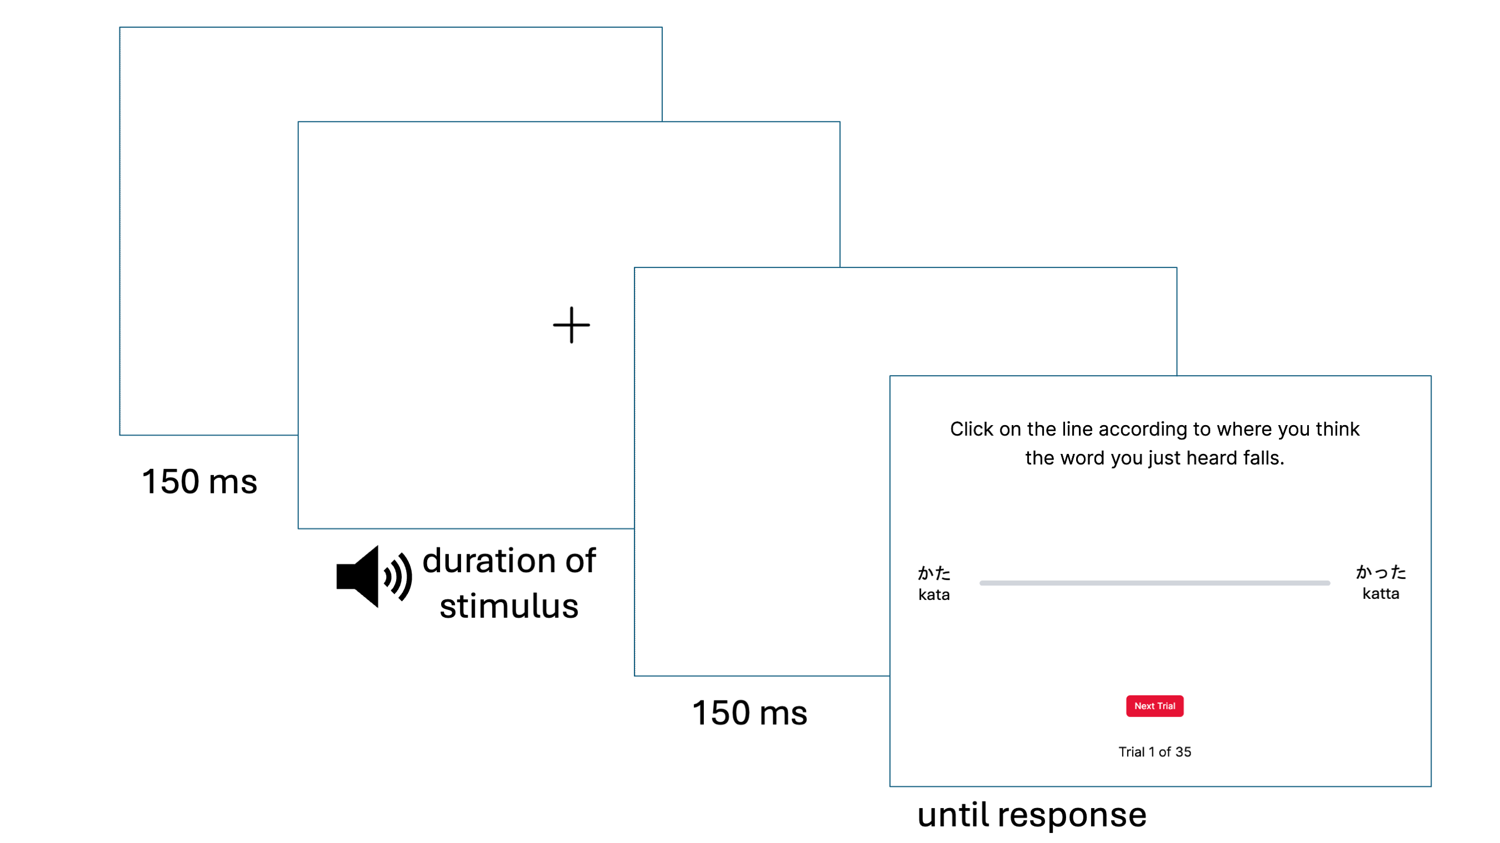
Figure 3.1: Procedure of VAS Trial.
For the English contrast pair continua, the words on either side of the VAS sliding scale on the screen were written in English. For the Japanese contrast pair continua, the words on either side of the VAS sliding scale were written in both hiragana and romaji (Roman letters). The romanization of the Japanese words were kata, katta, toru, and tooru. For each contrast pair, the left-right position of each word on the endpoints was randomized to be counterbalanced across participants (but consistent within-participant across the trials of a given continuum).
Trials were blocked by continuum (i.e., trials within a block are derived from the same continuum). Within each block, the 35 continuum tokens (7 primary cue x 5 secondary cue) were presented three times in randomized order, for a total of 105 trials per continuum block. To avoid fatigue, each block of 105 trials was divided into three mini-blocks of 35 trials each with a timed 20-second break in between. Each participant was presented with all four continua, for a grand total of 420 trials, with a timed 60-second break in between continuum blocks. The VAS task took approximately 20-30 minutes to complete.
In order to reduce the cognitive load that may be associated with switching between continua and languages, the two blocks per continua were always presented in succession. Additionally, to reduce task confusion especially for participants naïve to or having low proficiency with Japanese, the English continuum blocks were presented first, followed by the Japanese continuum blocks. This followed the only precedent with regards to the order of the presentation of blocks for both L1 and non-L1 continua, set by Kong & Kang (2023). Participants were randomized into conditions that counterbalanced the order of within-language continuum blocks.

VAS data preprocessing
Figure 3.2 (Apfelbaum et al., 2022) displays hypothetical VAS data plotted on a graph with one-dimensional continuum step along the x-axis (Step 1-7) and response rating on the y-axis (0-100, with 0 representing one side of the rating scale (e.g., indent) and 100 representing the other side (e.g., intent) on the y-axis. When plotted as such, VAS data is typically fit with a logistic curve function from which four parameters are estimated: (1) the minimum and (2) maximum asymptotes of the curve, (3) the cross-over/inflection point, which is the location on the x-axis where the curve crosses 50% of the way between the minimum and maximum asymptotes, i.e., the category boundary, and (4) the slope derived from the curve at the cross-over point. As each token is repeated multiple times, response variability can also be measured as the deviation of each VAS rating from the mean response rating predicted by the logistic curve at each step of the continuum (Apfelbaum et al., 2022; Kutlu et al., 2022). The slope and response variability measures from VAS data are best analyzed together to jointly represent a measurement of gradiency. Shallower slopes may be an indicator of gradient categorization, especially in comparison to steeper slopes which theoretically indicate categorical response patterns, but shallow slopes can be further disambiguated using response variability. Shallow slopes with low response variability theoretically represent consistent, “true” gradient response patterns (Panel B), while shallow slopes with high response variability theoretically represent inconsistent, noisy response patterns (Panel C).
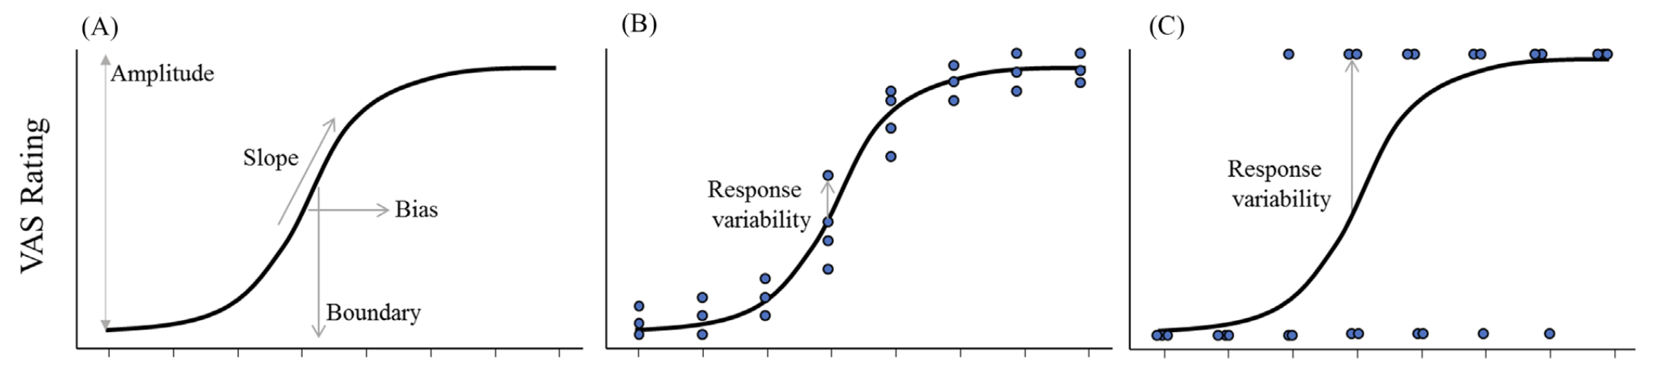
Figure 3.2: Hypothetical one-dimensional VAS response data resulting in a shallow response curve (from Apfelbaum et al., 2022). A. Parameters of a logistic curve that can be estimated from averaged response data. B. A shallow response curve with individual trial responses showing a gradient response pattern with low response variability. C. A shallow response curve with individual trial responses showing a categorical response pattern with high response variability.
However, two-dimensional VAS data results in multiple category boundaries (along the primary dimension) at the different steps of the secondary dimension. A single parameter of category boundary must be estimated with an alternative function that must take into account use of both the primary and secondary acoustic cues. Figure 3.3 (Kapnoula et al., 2017) provides two hypothetical response patterns from two-dimensional VAS data when plotted on a graph with the primary acoustic cue on the x-axis and the secondary acoustic cue on the y-axis, (in these examples, voice onset time (VOT) and fundamental frequency (F₀) respectively). VAS ratings are plotted with a third dimension of color gradient. Starting from the cross-over point along the primary cue, a category boundary is drawn using both dimensions. Relative use of the primary and secondary cues is calculated as the angle between the x-axis and the boundary line, $θ$ (theta).
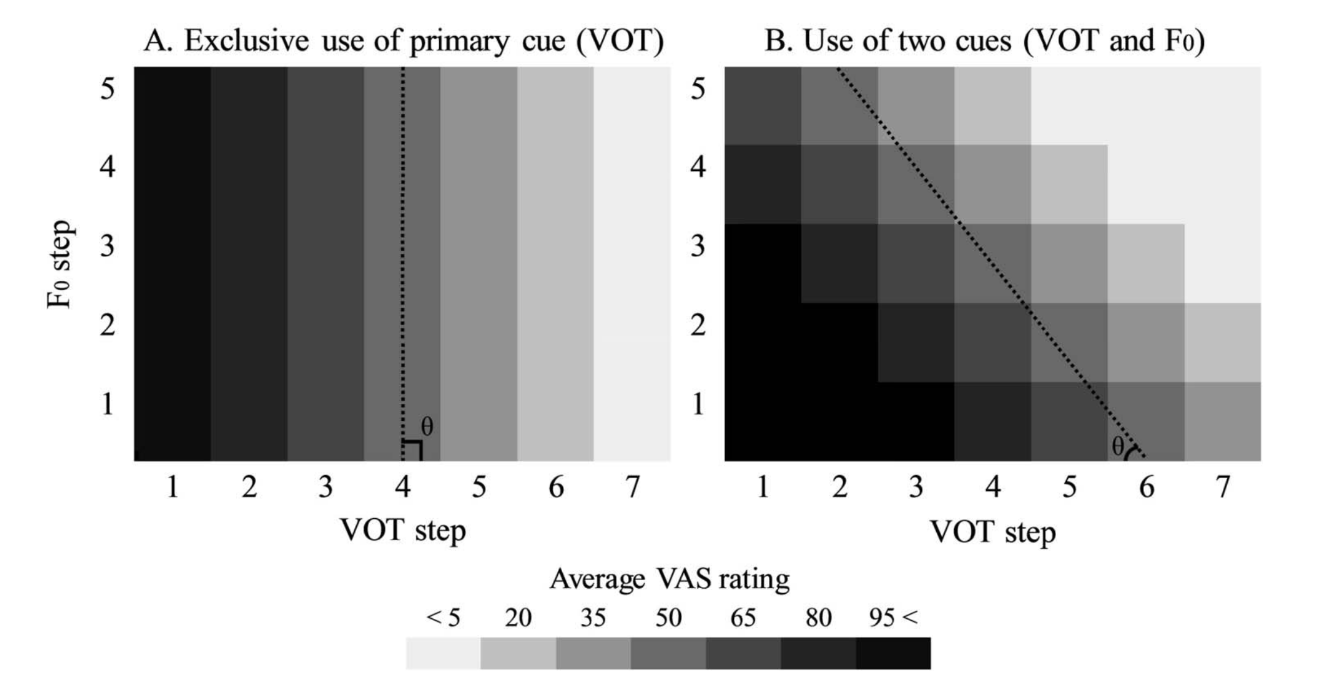
Figure 3.3: Hypothetical one-dimensional VAS response data resulting in a shallow response curve (from Apfelbaum et al., 2022). A. Parameters of a logistic curve that can be estimated from averaged response data. B. A shallow response curve with individual trial responses showing a gradient response pattern with low response variability. C. A shallow response curve with individual trial responses showing a categorical response pattern with high response variability.
Crucially, unlike one-dimensional logistic curve fitting, slope cannot be simply derived from the two-dimensional category boundary, as there is no way to model the logistic curve in the three-dimensional space (with response as the third dimension). Thus, parameter estimates of two-dimensional VAS data must be analyzed to assess gradiency and secondary cue use separately using a rotated logistic function; Figure 3.4 provides a visualization of the fitting process (Kapnoula et al., 2017). The rotated logistic function estimates minimum (b₁) and maximum asymptotes (b₂), the two-dimensional category boundary (x₀, y₀), where x₀ is the location of the boundary along the primary cue and y₀ is the location of the boundary along the secondary cue, multiple cue integration ($θ$), and finally slope (s). Here, slope is calculated after the coordinate space is rotated such that the rotated x-axis is orthogonal to the two-dimensional category boundary. From there, a standard logistic curve function is fit, and slope is calculated at the inflection point of the curve where VAS response is 50. This slope estimate serves as a proxy measurement for gradient use of the full scale independent of secondary cue use and does not conflate between the slope of the two-dimensional category boundary and the gradiency measure slope (Kapnoula et al., 2017, 2021; Kapnoula & McMurray, 2021; Kapnoula & Samuel, 2024).
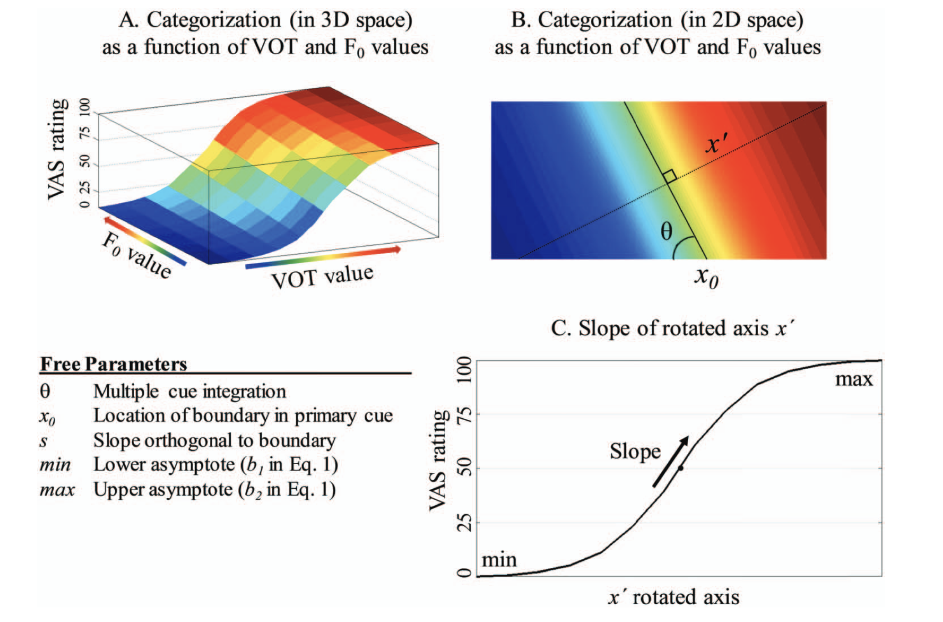
Figure 3.4: Visualization of the rotated logistic curve fitting process (from Kapnoula et al., 2017). A. Two-dimensional response plane to a voiced-unvoiced stop consonant contrast in 3-D space as a function of VOT as the primary cue and F0 as the secondary cue, with color representing average VAS rating per matrix cell (lower front edge are acoustic properties associated with the voiced consonant, upper back edge are acoustic properties associated with the unvoiced cosonant). B. Flattened two-dimensional response plane with the diagonal category boundary at the crossover point (x0) along the primary cute dimension, rotated x-axis (x') orthogonal to the category boundary, and theta angle used to rotate the coordinate space to x'. C. VAS response curve plotted along the rotated x-axis, where a standard logistic function is fit to estimate categorization slope, and other logistic curve parameters, independent of secondary cue use.
The rotated logistic function was fit to each participant’s VAS data (separately for each of the four continua) using a constrained gradient descent algorithm that minimized least squared error with the Nonlinear Curvefitting for Psycholinguistics Data MATLAB package (software freely available at McMurray, 2017). The data were cleaned prior to fitting the rotated logistic function. All 100 participants performed the VAS task as expected, resulting in a total of 42000 data points (100 participants x 420 trials). Across all participants, the data were filtered to first remove individual trials with a reaction time of over 10 seconds. This threshold was chosen to exclude trials unlikely to reflect task engagement, including trials where participants were away from their machines (i.e., reaction times at 30 minutes), while minimizing unnecessary data loss. Reaction time then log-transformed to normalize the RT distribution and the data were further filtered on a per participant basis to remove trials with log-transformed RTs three median absolute deviations (MAD) above or below the participant’s median log RT. This resulted in a total of 40683 data points that were used the curve fitting process. More details on the fitting process are available in the supplementary materials online.
The data were fit within grouping variables of participant and continuum pair, thus producing four rows of estimates per participant. The primary estimates of interest from the curve fitter were VAS slope (proxy measure of gradiency), response variability (proxy measure of gradiency and consistency), and theta (proxy measure of secondary cue use). As mentioned, from the rotated logistic function, the estimate of VAS slope is a single index of gradient use of the full scale that is independent of secondary cue use. Smaller/more negative values indicate a shallower response curve, or gradient/noisy response patterns, and larger/more positive values indicate a steeper response curve, or categorical response patterns. Because these two-dimension-based VAS slope values are not intuitively interpretable, and also because the distribution of slope values had high kurtosis, VAS slope was natural log-transformed and grand mean centered. The log transformation roughly normalized the distribution. The log-transformed VAS slope values were used in the analysis models, often labeled as “Slope” for simplicity.
The estimate of response variability is calculated as the standard deviation of the residuals per fit, also known as the root mean square error (RMSE), or the square root of the averaged squared residuals (Kapnoula et al., 2017). Low RMSE indicates responses relatively close to the curve (low variability) while high RMSE indicates responses relatively far from the curve (high variability). Response variability remained untransformed in the analysis models, labeled as “Response Variability”.
Lastly, as mentioned, the estimate of theta is a continuous measure of secondary cue usage, with 90°indicating exclusive use of the primary cue (Figure 3.3A), and decreasing values (toward 0°) indicating increasing reliance on the secondary cue. Theta values near 45° reflect relatively equal use of the primary and secondary cues (Figure 3.3B), while theta values near 0° reflect near exclusive use of the secondary cue. Values greater than 90° indicate an opposite trend: increasing values indicate increasing use of the secondary cue but also reversed cue mapping, seemingly reflecting response patterns where the primary and/or secondary cues are used in a way that is opposite to the expected categorization (e.g., categorizing acoustically [d]-like tokens as [t]-like, based on VOT and/or F0). Theta values at 135° indicate relatively equal use of the primary and secondary cue, with one or both cues being reversed, while theta values at 180° indicate exclusive use of the secondary cue with categorization occurring in a reversed manner relative to the expected responses. To capture these dimensions of theoretical interest, the theta variable was transformed to be centered on exclusive use of primary cue, computed as newTheta = (90 - Theta), such that 0 = exclusive use of the primary cue, +45 = balanced use of both cues with the expected categorization mapping, and +90 = exclusive use of the secondary cue with the expected categorization, whereas the negative range indicates the same trend of increasing use of the secondary cue from 0 to -90, but with one or both cues being reversed. The transformed theta values were used in the analysis models, often labeled as “Theta” for simplicity.

Linguistic Diversity Questionnaire (LDQ): Measuring experiential linguistic diversity

Design and procedure
After the VAS task, participants completed a questionnaire that gathered information on their language history, usage, and exposure, which was used to measure usage of and exposure to linguistic diversity through experiences (see Appendix A). The questionnaire measured overall experiential diversity through two primary factors: the diversity of known languages (used and studied) and the diversity of regular exposure in a typical week to both known and unknown languages in various situational contexts, such as through media consumption, social environment, and interpersonal connections. These factors also differ in that the diversity of known languages measures linguistic diversity of active language use and exposure while the diversity of known and unknown languages measures the diversity of passive language use and exposure. Here, passive language use and exposure is defined using the same convention as Castro et al. (2022):
By passive exposure […] we refer to situations in which foreign languages are present in the environment but the individual does not interact with these languages in any manner (e.g., by working with people who speak a different language and who often communicate between themselves in that language; by living in a neighbourhood with a high number of foreign language speakers). By passive use of languages, we refer to the intentional use of foreign languages in activities that involve some reading or listening but do not require speaking or writing. (p. 3)
The first half of the questionnaire, assessing known languages, used questionnaire items sourced directly from the Language History Questionnaire (LHQ3: P. Li et al., 2020). The LHQ3 has four modules with items that gauge participants’ linguistic background (first language(s) acquired at home, and additional languages acquired, age and manner of acquisition, immersion), proficiency (self-reported proficiency in L1(s) and Ln(s) in reading, writing, listening, and speaking), usage (which language(s) used in various contexts, habits, and social situations), and dominance (dominant language(s) based on proficiency and usage). Measurement types include rating proficiency on a 7-point scale from 1 (“Very Poor”) to 7 (“Excellent”), reporting usage in various contexts as hours per day, and rating usage on a 7-point frequency scale from 1 (“Never”) to 7 (“All the time”).
The second half of the questionnaire, assessing regular exposure to both known and unknown languages, used questionnaire items primarily inspired by and modified from the Language Background Questionnaire (LBQ) used by Yow & Li (2015) and X. Li et al. (2021); additional modifications were inspired by the Language Experience and Proficiency Questionnaire (LEAP-Q: Marian et al., 2007) and the survey used by Castro et al. (2022) to probe the degree of non-L1 language contact and exposure by monolinguals. The purpose of this portion of the questionnaire was to gauge the exposure to and use of linguistic diversity in ways that are typically not assessed, especially for “functional” monolinguals who may frequently encounter multilingual environments (e.g., a person who does not speak French residing in France, a person who does not speak Chinese and lives with two roommates who speak Chinese to each other, a person who does not speak Arabic who regularly hears Arabic at their mosque).
For these questionnaire items, participants were asked to estimate how many hours per day (while thinking of their typical week) they spend in 10 contexts, divided into two main categories of entertainment contexts and interpersonal contexts (see Table 3.3). Then, for each context, participants were asked to list up to four languages they may use in that context, and the number of hours per language. The participant was prompted to include their L1(s), Ln(s), any additional languages learned (no matter their proficiency), and any unfamiliar languages to which they are exposed (unfamiliar is based on the participant’s own judgement). The number of hours reported per language was not to exceed the number of hours per day listed for that context in the previous questions, but participants were told the numbers did not have to add up nicely if there was overlap in language usage per context (for example, if a person watches Japanese anime with English subtitles, the time spent passively listening to Japanese and passively reading English would overlap). Lastly, participants were asked to report anything else they would like to add about their language history, experience, usage, and exposure. The questionnaire took approximately 25 minutes to complete, with times varying according to how much information the participant chose to report.
Table 3.3: Categories of Passive Language Use and Exposure Contexts Queried in Part 2 of the Linguistic Diversity Questionnaire.
Category | Context | Context Label
Entertainment contexts | Watching TV, film, videos on websites like YouTube or Twitch (with or without subtitles) | Watching
 | Listening to radio, music, podcasts, audiobooks | Listening
 | Playing video games, mobile games, online games | Games
 | Using social media or browsing the internet, (with or without the use of automatic translation tools) – include here interacting with generative AI and using language learning apps | Online
Interpersonal contexts (in person or digitally) | At home (e.g., with your partner, child(ren), roommates) | Home
 | With family (parents, siblings, grandparents, caregivers, extended family – note: this may be the same as the context above for you) | Family
 | In social contexts with friends, neighbors, peers from hobbies or communities (e.g., religious community, neighborhood coalition, online community) | Social
 | In work or school contexts with co-workers/colleagues/classmates (this context can include taking language classes) | Work/school
 | Out of home in commercial or official contexts (e.g., restaurants, stores, doctor’s office, bank) | Out of home
None of these | Situations and settings not listed above. Please specify: | Other

LDQ data scoring
Experiential linguistic diversity was calculated as two indices based on the two factors of active use of and exposure to known languages and passive use of and exposure to known and unknown languages as measured by the linguistic diversity questionnaire. It is important to acknowledge that it is difficult to capture the degree to which use of and exposure to linguistic diversity aligns with the conventional usage of the terms “monolingual,” “bilingual,” and “multilingual.” These terms have tended to be ill-defined categories that simplify and often mask the heterogeneity and multidimensionality of experiences within and across groups (de Bruin, 2019; Castro et al., 2022; DeLuca et al., 2019; Gullifer et al., 2021; Kałamała et al., 2023, 2022; Kremin & Byers-Heinlein, 2021; Luk & Bialystok, 2013; Luk, 2015; Surrain & Luk, 2019; Titone & Tiv, 2023). As such, although this dissertation also uses the terms “(functional) monolingual” and “multilingual” (inclusive of bilinguals), in an attempt to reflect the multidimensionality of mono/multilingualism, linguistic diversity will be quantified as a continuous variable. It is equally important to acknowledge that reducing experiences to aggregated values in itself is problematic and still does not capture the full range and complexities of each individual’s experiences (Marian & Hayakawa, 2021). However, because linguistic diversity is a predictor variable in the primary analyses being conducted, I believe that quantification by way of a continuous measure is the most appropriate method. Specifically, I calculated a continuous measure of multilingualism called “language entropy” (Gullifer & Titone, 2020), a form of Shannon entropy (Shannon, 1948), that was devised to measure the diversity and balance of language use in everyday contexts. Language entropy has been used to explain individual differences in the degree to which multilingualism affects cognitive behaviors in a gradient manner (van den Berg et al., 2022; DeLuca et al., 2019; Gullifer et al., 2018; Gullifer et al., 2021; Kepinska et al., 2023; X. Li et al., 2021; Sulpizio et al., 2020; Wagner et al., 2023).
For active use of and exposure to known languages, a measure of Multilingual Language Diversity (MLD) was calculated according to the aggregate score calculation conventions used by the LHQ3 (P. Li et al., 2020):
$$MLD=-\sum_{i=1}^{n}{PD_{i}\log_{2}(PD_{i})} (1)$$
The MLD score is a modified form of language entropy (Gullifer & Titone, 2020) that is calculated from the LHQ3 aggregated score of proportion of dominance (PD_{i}) for each i-th language. PD_{i} is calculated from language dominance (Equation 3 of P. Li et al., 2020), which itself is an aggregated score combining self-reported language proficiency (Equation 1 of P. Li et al., 2020) and language usage reported in hours of use per day in different contexts.
The range of values for language entropy using the standard equation from Gullifer & Titone (2020) is 0 to $\log_{2}n$, where n represents the total number of languages reported. Complete usage of one language means that maximum language entropy (H) is $\log_{2}1=0$, equal usage of two languages means maximum $H=\log_{2}2=1$, and equal usage of three languages means maximum $H=\log_{2}3≈1.58$. Using the LHQ3, participants can report use of up to four languages, which means that the range of MLD scores across participants is from 0 to 2 given that $\log_{2}4=2$, which indicates equal dominance between four languages. The range of MLD from 0 to 2 allows for a continuous measure of linguistic diversity that captures both the number of languages and diversity of usage, as use of two languages is captured from values greater than 0 approaching 1, use of three languages is captured from values greater than 1 approaching 1.58, and use of four languages is captured from values greater than 1.58 approaching 2. Equation (1) was used to calculated one MLD score for active language use and exposure (MLD-A) per participant. For a detailed breakdown of the equations used to calculate MLD-A and sample calculations, see Appendix B.
For passive use of and exposure to both known and unknown languages, a modified measure of language entropy was similarly calculated. Language entropy was calculated separately for each context using the standard language entropy equation (Gullifer & Titone, 2020):
$$H_{c}=-\sum_{i=1}^{n}{P_{c,i}\log_{2}(P_{c,i})} (2)$$
where n is the total number of languages reported per context_{c} and P_{c,i} is the proportion of hours of language usage/exposure for language_{i} within context_{c}. Participants reported hours per language per context by answering the prompt: For each of the contexts […], please list up to four languages you passively use or are exposed to in a typical week. […] For each of these languages, please estimate how many hours per day you spend exposed to this language during each context. Then, P_{c,i} is calculated as the number of hours reported for language_{i} divided by the total number of hours across all languages reported for context_{c} using the following equation:
$$P_{c,i}=\frac{Hours_{c,i}}{\sum_{i=1}^{n}{H}ours_{c,i}} (3)$$
This resulted in 10 entropy values per participant, one for each of the 10 contexts. Following X. Li et al. (2021), to aggregate the entropy values and account for individual differences in time spent across different contexts, the aggregated score was computed as overall weighted language entropy, where the entropy of each context was weighted by the proportion of time spent per day in that context. The following equation was used to calculated overall weighted language entropy:
Hw=c={contexts}​HoursPerDaycK*Hc (4)
Here, c={contexts} refers to the 10 context labels described in Table 3.3. HoursPerDay_{c} is the number of hours spent per day in context_{c}, reported by answering the prompts: On a day where you engage in each of the contexts […], please estimate how many hours per day you spend in that context. K is a constant serving as a scaling factor to turn HoursPerDay_{c} into a proportion. K was set to 24 such that each context is weighted as a proportion of time spent per full 24-hour day. The weighted entropy value H_{w} represents the MLD Score for passive language use and exposure (MLD-P). Equation (4) was used to calculate one MLD-P score per participant. For a detailed breakdown of the equations used to calculate MLD-P and examples, see Appendix B.
Overall, each participant received two indices of linguistic diversity: MLD-A, as an index of linguistic diversity of known languages through active use and exposure, and MLD-P, as an index of linguistic diversity of known and unknown languages through passive use and exposure. These indices remain separate to represent related but different constructs: specifically, the MLD-P index enables the representation of diverse language use and exposure for those who are functionally monolingual by convention usage of the term, while the MLD-A index is derived from measures of the validated LHQ3 and remains consistent with previous gradient measures of multilingualism as assessed through language entropy (Gullifer et al., 2018; Gullifer et al., 2021). The inclusion of both of these scores is important to represent the multidimensionality of experiential linguistic diversity. Both MLD-A and MLD-P were used as predictor values in the regression models used to examine the effect of experiential linguistic diversity on L1 and L2 categorization.
Although 100 participants took part in the study, two participants did not finish the LDQ. An additional 22 participants did not provide usable answers to the questionnaire, and thus MLD-A and/or MLD-P scores could not be calculated with their given responses. These 24 participants were excluded from the data analysis.

Analyses and Results

Analysis models and predictions
Recall that RQ1 asks: Is increased experience with experiential linguistic diversity predictive of higher degrees of gradient categorization of L2 speech as it is with L1 speech? If so, do higher degrees of gradient categorization predict the degree of usage of the secondary acoustic cue in the perception of L2 phonemic contrasts? The research question assumes that we will see higher degrees of gradient categorization among participants for the L1 English contrasts for those with higher experiential linguistic diversity, in line with the findings from Kutlu et al. (2024), which showed that higher degrees of linguistic diversity in children’s social networks led to higher degrees of gradient speech categorization.
I had originally planned to use the same analysis method as Kutlu and colleagues, who used Latent Profile Analysis (LPA) to create a single index of gradiency based on the slopes and response variability values derived from the VAS data. LPA is a type of cluster analysis that is used to model a number of underlying homogeneous subgroups from a larger heterogeneous group based on continuous variables and is being increasingly used in learning research for its person-centered modeling approach (Hickendorff et al., 2018). The LPA from Kutlu et al. (2024) successfully supported their hypothesis of three underlying profiles of children based on slope and response variability: categorical (high slope, low variability), gradient (low slope, low variability), or noisy (low slope, high variability). The LPA model predicted posterior probabilities that estimate the probability of membership to each of the three profiles, and the greatest of the three probabilities was used to assign categorization profile membership. Using this method, I would have been able to answer the first part of RQ1 by confirming whether higher levels of experiential linguistic diversity increase the odds of membership in the gradient profile compared to the categorical profile for L1 English as well as investigate whether we see the same pattern of profile membership for L2 Japanese.
However, my data did not turn out to be suitable to fit an LPA model with the three hypothesized profiles. Figure 3.5 compares the data plotted on the two-dimensional space of response variability and VAS slope for the sample collected by Kutlu et al. (2024) (left) and the Study 1 sample for each language (center and right). For the Kutlu et al. (2024) sample, the three profiles clearly emerge in three of the four quadrants of the space, relative to the sample range. However, for the Study 1 sample, no clear patterns emerge, and data is present in all four quadrants, relative to the sample range. Note that there is no theoretical precedent of characterizing high-slope, high-variability responses, which would be the top right quadrant of the space, thus making it difficult to characterize categorization response profiles with the current sample. The differences between the two samples likely arise both from the fact that the VAS data collected by Kutlu and colleagues were responses to one-dimensional continua, as opposed to the two-dimensional continua of the present study, and the fact that the data were fit on a Bayesian hierarchical growth curve model (Sorensen et al., 2024), as opposed to the use of the Nonlinear Curvefitting program here, which is does not use Bayesian modeling. Given these two differences, it was hypothesized that the non-Bayesian nature of the Nonlinear Curvefitting estimates did not work well with the LPA modeling procedure (E. Kutlu, personal communication, May 12, 2025).
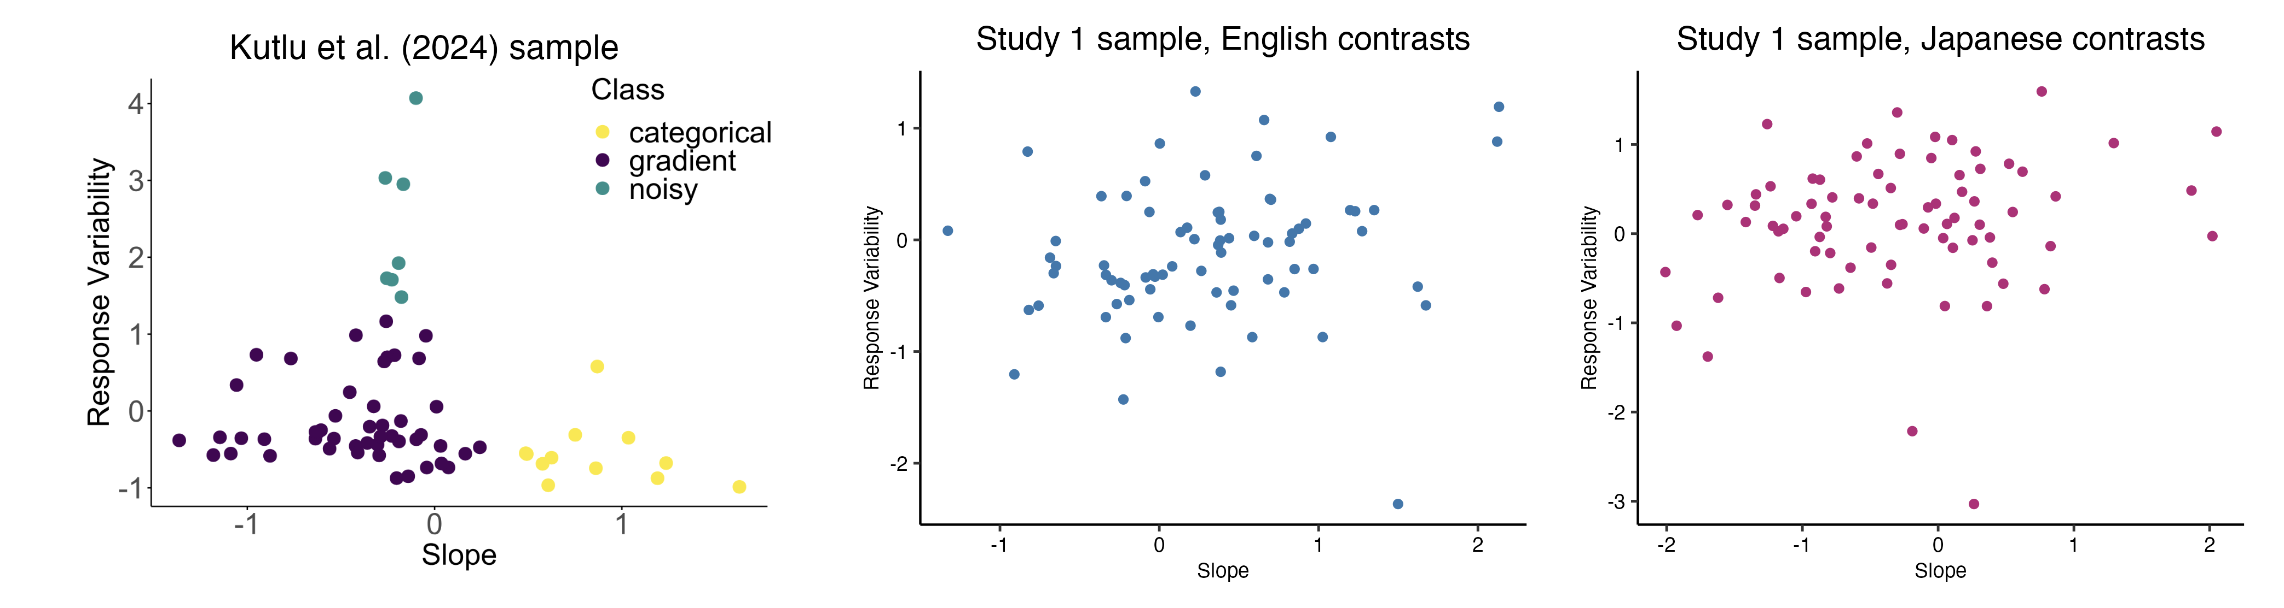
Figure 3.5: Comparison between distribution of individuals after plotting average slope and response variability VAS response data in two-dimensional space (Response Variability and Slope) between Kutlu et al. (2024) sample (left, n = 64) and the sample of the present study for English and Japanese (center and right, n = 76). Each dot represents the mean slope and response variability of a single participant, averaged across within-language contrast pairs. Note that here, response variability is represented by variance, which is the square of RMSE. Variance was not used in the Study 1 statistical analyses. The slope and variances for the sample of the present study were natural log-transformed and grand mean centered in order to better match the visualization of the Kutlu et al. (2024) sample. Note also the differences in the range of the axes between the two samples.
Because of this, I chose a different statistical method to analyze the data, which requires a reinterpretation of the research question. Instead, I ask the same question without underlying assumptions of differences between categorization of L1 and L2 contrasts. I simply ask whether increased experiential linguistic diversity is predictive of higher degrees of gradient categorization of L1 and L2 speech, and if so, do higher degrees of gradient categorization predict the degree of secondary acoustic cue usage for L1 and L2 speech? In this case, VAS slope and response variability are still both used as proxy measures for gradiency, just as separate variables. This updated research question reduces the emphasis on the hypotheses regarding directionality for the effects of language (L1 vs. L2) on gradiency or secondary cue use.
To answer the first part of the question, I fit a Bayesian multivariate mixed-effects (i.e., repeated measures) regression model to examine the effects of experiential linguistic diversity and contrast language on gradiency and secondary cue use. The model was fit using the brms R package (Bürkner, 2017). MLD-A, MLD-P, and language (L1 English vs. L1 Japanese) were used as predictor variables for the responses of VAS slope, response variability, and theta.
A multivariate regression model is more appropriate for data in which there are multiple outcome variables per observation, as is the case with estimating three different variables from the VAS data. Running a single multivariate regression model is advantageous over running multiple univariate regression models because multivariate regression also accounts for the correlation between the outcome variables of a given observation, which is likely to occur given that outcomes stemming from the same participant for the same contrast pair (i.e., one observation unit) are likely to correlate. In this way, a multivariate model is more parsimonious than multiple univariate models and better controls Type I error rates (B. Hui, 2018).
I first fit a series of multivariate models to identify the most parsimonious set of predictor variable specifications on the outcome variables of VAS Slope, Response Variability, Theta. The first model brm.fit.1 included MLD-A and MLD-P, their interactions with binary indicators of non-zero MLD scores (1 for scores above zero, and 0 for scores of zero), and interactions with language, a categorical within-subjects variable with the levels of English (L1; reference-level) and Japanese (L2). The model brm.fit.2 specified these predictor variables without the interactions, and brm.fit.3 specified interactions between each of the MLD scores and language without the binary indicators.
Model fit was evaluated using leave-one-out cross-validation (Table 3.4), such that the model with the best approximated predictive performance of the data is the one with the largest expected log predictive density (ELPD) value. The differences in ELPD across the models were minimal (< 3), with brm.fit.3 yielding the best ELPD but only marginally so. The ELPD difference between brm.fit.1 and brm.fit.3 (-0.1) is less than 2 * the standard error of the difference (0.4) and thus does not provide enough evidence to support that brm.fit.3 is meaningfully better than brm.fit.1. Given the relatively equal predictive performance between these two models, I chose to focus my interpretation on brm.fit.3, which includes interaction terms between the two MLD scores and language and is simpler in interpretation compared to brm.fit.1. It is noted that the interaction terms between the MLD scores and their binary indicators did not reach credible significance, and thus there is no interpretive value in discussing the effects of brm.fit.1 over brm.fit.3. The model also included subject-level random intercepts ID with by-subject random slopes, to capture any inherent differences between participants and allow the effects of language to vary by participant. Item-level intercepts for pair were also included to capture any inherent differences between the chosen contrast pairs. Estimates of the model parameters, including the random effects, fit of the model, and residual correlation between the response variables, are presented below in Section 3.2.3.
Table 3.4: Multivariate Bayesian Model Comparison.
Model | ELPD | Δ ELPD | SE of  Δ ELPD | Right Side of Formula
brm.fit.3 | -2681.2 | 0.0 | 0.0 | (MLD_A * language) + (MLD_P * language) + (1 + language | ID) + (1 | pair)
brm.fit.1 | -2681.3 | -0.1 | 0.4 | (MLD_A * language) + (MLD_P * language) + (MLD_A:MLD_A_binary * language) + (MLD_P:MLD_P_binary * language) + (1 + language | ID) + (1 | pair)
brm.fit.2 | -2683.3 | -2.1 | 2.5 | MLD_A + MLD_P + language + MLD_A:MLD_A_binary + MLD_P:MLD_P_binary + (1 + language | ID) + (1 | pair)
Key: ELPD = Expected Log Predictive Density (ELPD); Δ = delta (difference); SE = Standard Error. The model brm.fit.3 was used in the analyses.
As a Bayesian model, the multivariate model estimates the b coefficient, or the median of the posterior probability distribution of $β$ slopes, for the main effect of each predictor variable and their interaction effects. The model also uses the 95% highest-density interval (HDI) to describe the uncertainty around the b estimate, i.e., there is 95% chance that the true estimate is within this credible interval (CrI). In the context of this study, predictor effects are considered robust if the 95% CrI does not contain zero.
Based on my hypotheses, I predicted the following robust effects of the predictor on each of the outcome variables:
VAS slope: I predicted robust main effects for MLD-A and MLD-P with negative b estimates, reflecting a decrease in VAS slope as MLD-A/MLD-P increased. This would represent the trend of those with more experiential linguistic diversity showing shallower response trends. I predicted a main effect of language, with no particular prediction on the sign of the b estimate, reflecting a difference in VAS slope between responses for English and Japanese contrast pairs. The interaction effect was added for exploratory reasons: a significant interaction effect would indicate that MLD-A and MLD-P predict VAS slope differently between responses for the English and Japanese contrasts. The model outcomes for VAS slope are discussed below in Section 3.2.3.1.
Response variability: I predicted robust main effects for MLD-A and MLD-P with negative b estimates, reflecting decreasing response variability as MLD-A/MLD-P increased, meaning that higher experiential linguistic diversity predicts lower response variability. I predicted a main effect of language with a positive b estimate, reflecting increasing response variability for Japanese contrast pairs compared to English contrast pairs. This would indicate that response variability is higher for L2 speech than for L1 speech. Again, the interaction effect was added to explore whether MLD-A and MLD-P predict response variability differently between responses for the English and Japanese contrasts. The model outcomes for response variability are discussed below in Section 3.2.3.2.
Secondary cue use theta: The prediction for theta is more complicated, as the direction of the b estimate had different interpretations depending on the theta value. For example, I predicted robust main effects for MLD-A and MLD-P that would reflect that increased experiential linguistic diversity predicts greater secondary cue integration. However, a positive b estimate is qualitatively different for a theta value of -45 (relatively balanced use of primary and secondary cue with one or both being reversed) and 10 (mostly primary cue use in the expected direction). In the former case, a positive b estimate would indicate increasing primary cue use as theta approaches 0 from the negative direction, while in the latter case, a positive b estimate would indicate increasing secondary cue use as theta approaches 45 (balanced use of primary and secondary cue).
To address the complexity in interpretation, additional post-hoc analyses were performed. The original data of the multivariate model (n = 76 participants x 4 pairs = 304) were divided into non-overlapping subsets of theta values: positive values, i.e., range 0-90 (n = 182) and negative values, i.e., range -90-0 (n = 122). Bayesian univariate models were run using brms in R with the same predictor variables as the main analysis and theta as the response variable separately for the two subsets. These post-hoc analyses were performed to investigate potentially differential effects of experiential linguistic diversity on secondary cue usage for L1 and L2 at qualitatively different ranges of theta. The model outcomes and post-hoc outcomes for secondary cue use are discussed below in Section 3.2.3.3.
To answer the second part of RQ1 (“Do higher degrees of gradient categorization predict the degree of secondary acoustic cue usage for L1 and L2 speech?”), I similarly ran Bayesian univariate mixed-effects linear regression models brms in R with theta as the dependent variable. The model estimates the main effects of the predictor variables VAS slope, response variability, and language, as well as their interactions. Again, random intercept terms were included for subject-level ID and item-level pair, with random slopes for ID across languages. The model formula was specified as Theta ~ Slope * Response Variability * language + (1 + language|ID) + (1|pair). The same model formula was used to run separate univariate models for the two subsets of data for positive and negative theta values.
Based on my hypotheses, particularly for the positive subset, I predicted a robust main effect of contrast language with negative b estimates, which would suggest decreased secondary cue integration for responses to Japanese contrasts compared to English. I also predicted a significant interaction between VAS slope and response variability to reflect the characterizations of gradient, categorical, and noisy response profiles. That is, I predicted an interaction that would suggest that VAS slope differentially predicts degree of secondary cue use at different values of response variability, specifically that low VAS slopes would predict high secondary cue use at low levels of response variability but not high levels of response variability, and so on. I also included a three-way interaction between VAS slope, response variability, and language based on the prediction that the predictive strength of VAS slope and response variability on secondary cue use would be greater for L1 contrasts than for L2 contrasts.
Although the model of the negative subset was largely exploratory, the model was included to explore the possibility that slope and response variability values that correspond to a noisy response profile may predict the degree of reversed cue integration. The outcomes for these univariate analyses are discussed below in Section 3.2.4.

Descriptive statistics

VAS responses
Table 3.5 presents the summary statistics of the estimates from the rotated logistic curve fit for each contrast pair, averaged across n = 76 participants. The table describes the range, mean, median, and standard deviation of the variables of interest used in the regression model: log-transformed slope, response variability, and re-centered theta.
Table 3.5: Summary Statistics of Rotated Logistic Curve Estimates of VAS Slope, Response Variability, and Theta, by Contrast Pair.
Language | Contrast Pair | VAS Measure | Range | Mean | Median | SD
English | indent-intent | Slope | (-1.54, 3.05) | 0.64 | 0.45 | 0.98
 |  | Response Variability | (0.8, 34.32) | 14.88 | 14.06 | 5.58
 |  | Theta | (-60.12, 53.8) | 11.03 | 11.58 | 11.73
 | reason-risen | Slope | (-2.56, 2.75) | -0.26 | -0.41 | 0.83
 |  | Response Variability | (8.23, 38.43) | 20.18 | 18.62 | 6.59
 |  | Theta | (-89.9, 88.26) | 17.63 | 10.38 | 38.25
Japanese | kata-katta | Slope | (-2.54, 2.35) | -0.58 | -0.85 | 1.20
 |  | Response Variability | (0.66, 43.12) | 21.33 | 20.80 | 8.81
 |  | Theta | (-89.9, 89.92) | -1.16 | -5.13 | 30.25
 | toru-tooru | Slope | (-2.42, 2.72) | -0.22 | -0.36 | 1.04
 |  | Response Variability | (5.42, 34.86) | 18.53 | 17.74 | 5.34
 |  | Theta | (-49.39, 63.94) | -4.68 | -2.33 | 14.03
Notes: Slope was log-transformed and group mean-centered. Theta was re-centered around 90 by the formula (90 - original theta), transforming the original 0-180 range to -90-90, such that original 90 –> 0 = re-centered 0 –> 90 and original 90 –> 180 = re-centered 0 –> -90.
In terms of group level response patterns, Figure 3.6 shows the mean VAS responses (color) as a function of the primary dimension (x-axis) and secondary dimension (y-axis) per contrast pair, averaged across participants. As expected, the mean responses showed that participants used both the primary and secondary cues to categorize the L1 English contrasts more so than L2 Japanese contrasts. The color gradient of responses, confirmed by the mean values of theta for each of the pairs in English and Japanese, show that the two-dimensional category boundary is much more angled for the English contrasts than for the Japanese contrasts, indicated more secondary cue integration for English and near exclusive use of the primary cues for Japanese.
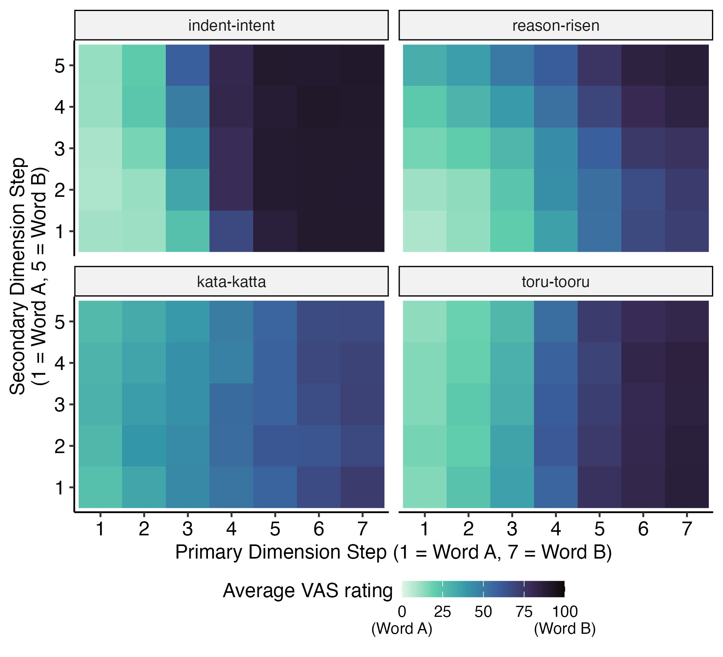
Figure 3.6: VAS response heatmaps by primary and secondary dimension steps for each of the four contrast pairs, averaged across participants. Color represents mean VAS rating per matrix cell.
As expected from the gradient categorization framework, individuals varied substantially in their use of the continuous response scale. Figure 3.7 captures the range of response patterns between and within six sample individuals. Some participants show more consistently categorical responses and heavily favored the end points of the scale, like participant 5627, while others used the entire scale in a more gradient fashion, like participants 5737 and 7187. Other participants fall somewhere in between categorical and gradient, showing bimodal distributions of responses that are near the endpoints but still span a considerable range of the scale, like participants 5386 and 5837. Some participants also showed within-subject variability in their use of the VAS scale that was consistent within-language, such as participant 5178, who responded categorically to the English contrast pairs but gradiently to the Japanese contrast pairs. Participant 7187 is an example of a listener who showed within-subject variability that was not consistent within-language, as they responded more gradiently to the pairs reason-risen and toru-tooru but relatively categorically to the pairs indent-intent and kata-katta, although less so than participant 5627.
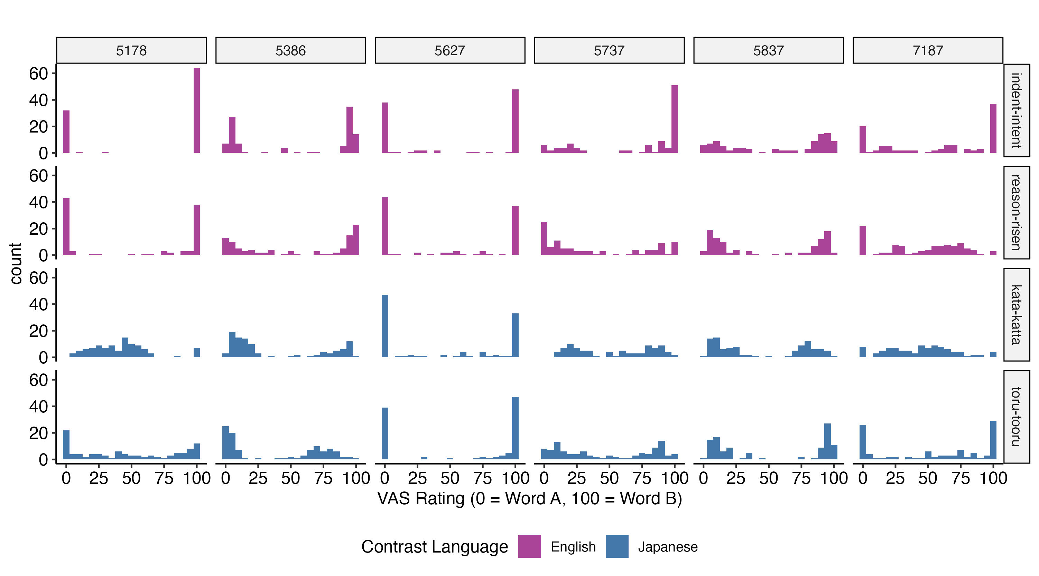
Figure 3.7: Examples of participant response histograms showing individual differences in distribution of VAS ratings for each of the four contrast pairs. Listeners varied in their use of the entire scale and varied in how consistently they used the scale both within and between contrast language.
While response histograms capture individual differences in using the full range of the VAS scale, they fail to model the relationship between stimuli characteristics, i.e., steps along the continuum, and categorization decision, i.e., VAS response. Figure 3.8 presents VAS ratings as a function of primary continuum step, with mean response curves for each of the secondary dimension steps. This figure presents the same six sample individuals as Figure 3.7, which allows for a direct visual comparison to show how the response histograms correspond to the scatterplots. This comparison is most plainly visible with participant 5178, for whom their categorical responses are evident for the English contrast pairs (with a majority of individual response data points at either 0 or 100) and their gradient responses are evident for the Japanese contrast pairs (with individual response data points spanning the entire range of the y-axis). This plot also serves to show how differently listeners made use of the secondary dimension; greater separation between the mean response curves per secondary dimension step indicate increased use of the secondary cue in categorization ratings, while overlapping response curves indicate little use of the secondary cue. For example, participants 5386, 5627, 5837, and 7187 all showed varying degrees of secondary cue use for the reason-risen contrast pair. Additionally, horizontal response curves with discernible separation indicate near complete reliance on the secondary cue to make categorization ratings. The figure additionally reveals another type of categorization pattern, that is, reversed categorization. This can occur along the primary cue or the secondary cue. Participant 5386 showed reversed categorization with regards to the primary dimension for the kata-katta contrast pair and often responded with ratings near 100 (corresponding with Word B), for the lower steps of the primary cue (which represent acoustic characteristics associated with Word A). Participant 5627 showed reversed categorization with regards to the secondary dimension for the kata-katta contrast pair, as indicated by the light colored response curve (Step 1, which represent acoustic characteristics associated with Word A) being higher on the plot (ratings on the Word B side of the scale), while the dark colored response curve (Step 5, associated with Word B) being lower on the plot (ratings on the Word A side of the scale.
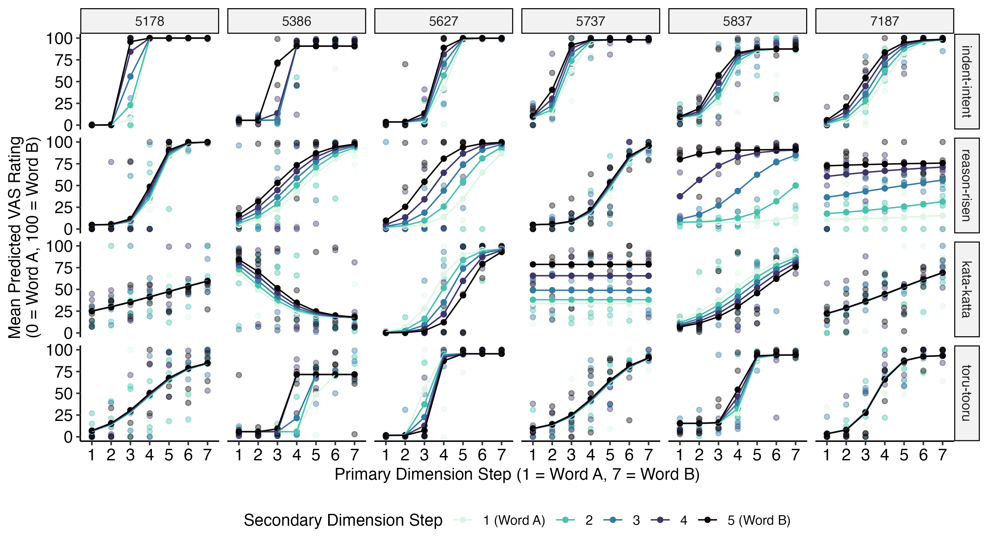
Figure 3.8: Examples of participant VAS response curves for each of the four contrast pairs as a function of primary dimension step with different colored curves for each of the secondary dimension steps, from the same six individuals. Transparent dots are responses to each trial. Solid lines depict the fitted logistic curve of the responses per secondary dimension step, with the solid dots depicting the predicted mean response per primary dimension step, as estimated by the rotated logistic curve function. Steeper curves indicate more categorical response patterns, while shallower curves indicate more gradient response patterns. Overlapping colored lines indicate the lack of use of the secondary cue in rating decisions, while separation between the colored lines indicate higher degrees of secondary cue use in rating decisions.
Lastly, Figure 3.9 displays individual-level response heatmaps, plotting mean VAS response (color) as a function of both primary and secondary dimension steps for each contrast pair, again showing the same six sample individuals. This figure also plots the estimated theta angle of the category boundary at the location of the boundary along the primary dimension. The response patterns reflected in both the histograms and the scatterplots are also reflected in the patterns of the heatmaps. For example, the heatmaps of participant 5627, who showed consistently categorical responses patterns on the histogram, are dominated by colors on the extreme ends of the color scale with few squares representing intermediate colors. On the other hand, the heatmaps of participant 7187, who showed gradient response patterns to some of the contrast pairs, present the full gradient of colors across the scale. Importantly, this figure more clearly visualizes the relative degree of secondary cue use compared to primary cue use. Angles at or near 90°reflect near exclusive use of the primary cue, whereas angled theta indicate increasing integration of the secondary cue until complete flat theta angles reflect near exclusive use of the secondary cue. For example, the scatterplots for participant 5627 revealed that they exclusively used the primary cue for the indent-intent and toru-tooru contrast pairs (overlapping secondary dimension response curves), reflected in the nearly 90°angles on the heatmaps, and had some secondary cue integration for the reason-risen and kata-katta contrast pairs (separated secondary dimension response curves), reflected in the more angled theta values approaching 45°and 135°. Comparatively, the angled and separated response curves in the scatterplot of participant 5837 for the reason-risen contrast pair is reflected in the same heatmap as the near 45°theta angle, indicating balanced use of the primary and secondary cue. Notably, the obtuse angles reflect the reversed categorization patterns that were also observed in the scatterplots, whether that occurs along the primary cue, as for participant 5386, or the secondary cue, as for participants 5627 and 5837, for the kata-katta contrast pair. Together, these figures clearly depict the diversity of individual differences in L1 and L2 VAS categorization response patterns.
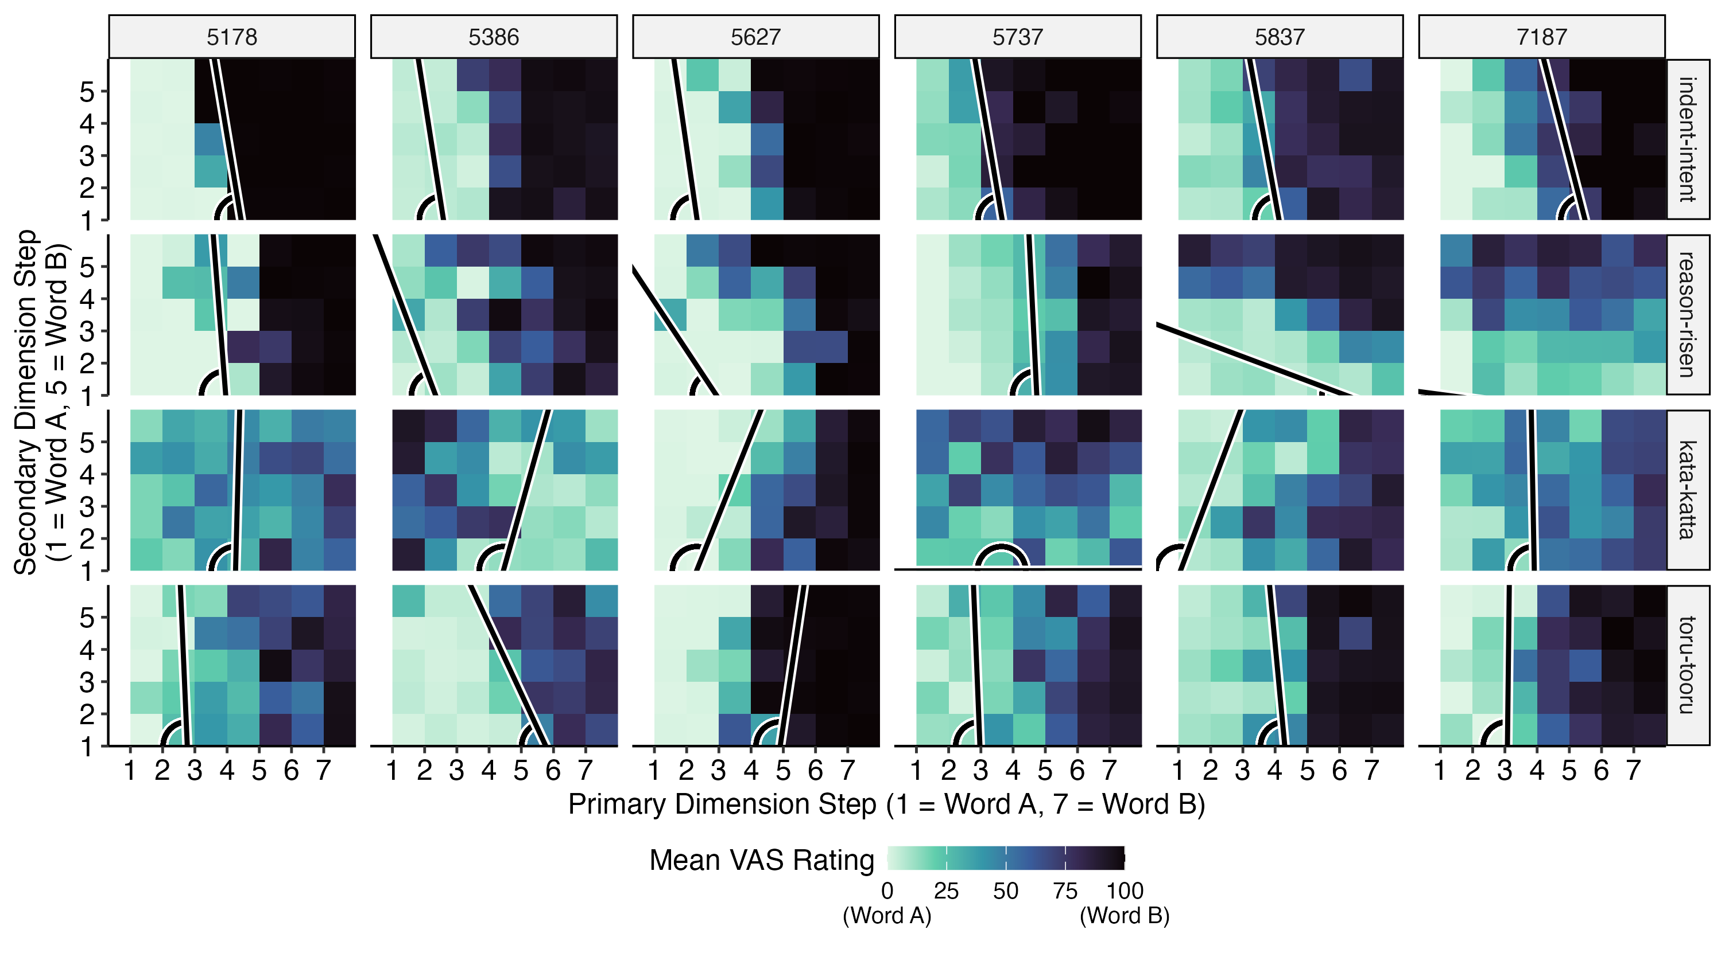
Figure 3.9: Examples of VAS response heatmaps by primary and secondary dimension steps for each of the four contrast pairs, from the same six individuals. Color represents mean VAS rating per matrix cell. The plotted angles, which represent degree of secondary cue use, were estimated from the rotated logistic curve function. The line depicts the diagonal category boundary starting at the estimated cross-over point along the primary dimension. A 90°degree angle indicates exclusive use of the primary cue, and acute angles indicate increasing use of the secondary cue. Obtuse angles indicate increasing use of the secondary cue with reversed categorization, reversed with regards to either the primary dimension or secondary dimension. Completely flat angles (0°or 180°) indicate exclusive use of the secondary cue.

LDQ responses
The predictor variables in the analysis are the measures active and passive multilingual language diversity, MLD-A and MLD-P, as the proxy measures of experiential linguistic diversity. A simple correlation test showed a moderate positive correlation between MLD-A and MLD-P (Pearson’s r(74) = .35, p = 0.002). Figure 3.10 plots the distributions of MLD-A and MLD-P scores (left column of panels), along with a scatterplot displaying their correlation (right panel). The histograms show that both distributions are zero-inflated, meaning that most participants have both MLD-A and MLD-P scores of zero.
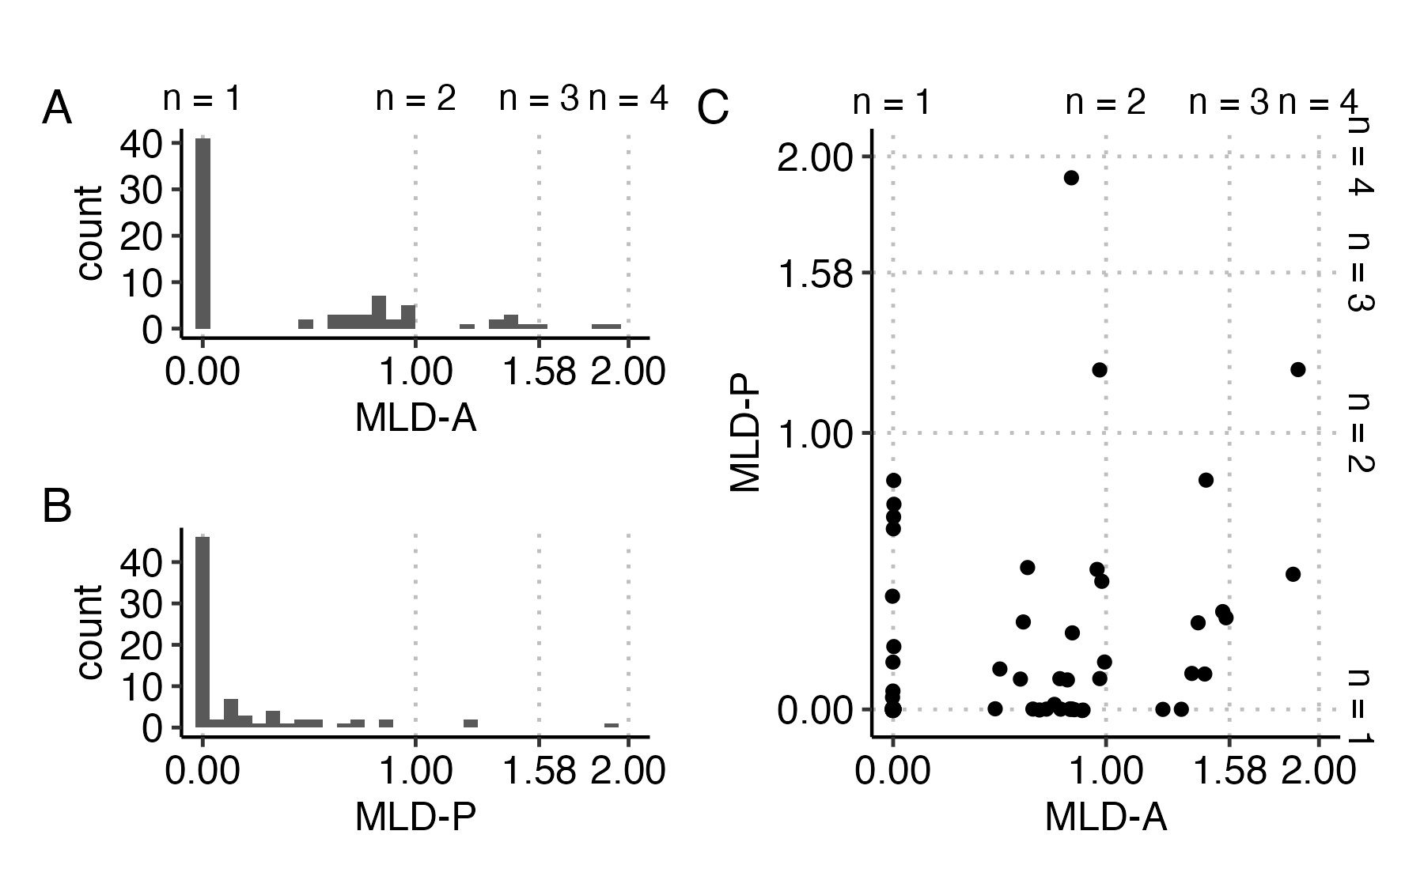
Figure 3.10: Histograms of MLD-A (A) and MLD-P (B) scores and scatterplot of correlation between MLD-A and MLD-P where each dot represents an individual (C). Grid lines indicate the score corresponding to balanced use of n languages. Scores in between these breakpoints represent imbalanced use of two, three, and four languages as MLD scores approach 1, 1.58, and 2, respectively.
The zero-inflated nature of the distributions is difficult to see in the scatterplot, where each individual point represents a participant. The scatterplot is more informative in showing the individuals who report being multilingual in some capacity, either through active experiences, passive experiences, or both, as indicated by scores above zero. Of the 76 participants, 35 had non-zero MLD-A scores, 31 had non-zero MLD-P scores, and 22 had non-zero scores for both. Of particular interest are those who reported being functionally monolingual (MLD-A = 0) with passive exposure to multiple languages (MLD-P > 0), or the points plotted on the y-axis. The data support the idea of diverse language experiences among “functional” monolinguals, who may expose themselves to passive linguistic diversity even if they do not view themselves as multilingual, and the importance of measuring a broad range of experiences.

Multivariate model outcomes for VAS slope, response variability, and secondary cue use
The results of the multivariate Bayesian mixed-effects analysis modeling the effects of experiential linguistic diversity and contrast language on VAS slope, response variability, and secondary cue use are presented below. For each of the three outcome variables, Table 3.6 presents the b estimates of the fixed effects, the median of the posterior probability distributions, and the 95% highest-density interval (HDI) as the 95% credible interval (CrI). Each estimate is also accompanied by a p-value that is calculated from the Bayesian index Probability of Direction (pd). As an index of predictor effect existence, pd is defined as the proportion of the posterior distribution that has the same sign (on the same size of zero) as the median, which can be interpreted as the probability that the true parameter is either positive or negative. A type of two-sided p-value that is comparable to p-values calculated for frequentist models can be calculated from pd through the formula p = 2 x (1 - pd). This pd-based p-value (pd-p in the tables) can be interpreted as the proportion of the posterior distribution on the opposite side of zero from the median, thus small values of pd-p reflect high confidence in the effect direction of the b estimate (Makowski, Ben-Shachar, & Lüdecke, 2019; Makowski, Ben-Shachar, Chen, et al., 2019).
Table 3.6: Fixed Effects of the Bayesian Multivariate Mixed-Effects Model Predicting VAS Slope, Response Variability, and Theta.
Predictor | Estimate | 95% CrI | pd-p
VAS Measure: Slope
Intercept (English) | -0.12 | [-1.48, 1.05] | 0.79
Language (Japanese) | -0.42 | [-1.62, 0.95] | 0.49
MLD-A | 0.13 | [-0.11, 0.39] | 0.31
MLD-P | -0.14 | [-0.55, 0.26] | 0.47
MLD-A x Language (Japanese) | -0.29 | [-0.60, 0.03] | 0.08
MLD-P x Language (Japanese) | 0.56 | [ 0.08, 1.08] | 0.03
VAS Measure: Response Variability
Intercept (English) | 17.82 | [13.87, 22.17] | 0.00
Language (Japanese) | 1.02 | [-2.45, 4.33] | 0.57
MLD-A | -0.54 | [-2.22, 1.20] | 0.55
MLD-P | -0.26 | [-2.65, 2.33] | 0.84
MLD-A x Language (Japanese) | 1.26 | [-0.42, 2.78] | 0.13
MLD-P x Language (Japanese) | -0.91 | [-3.17, 1.41] | 0.43
VAS Measure: Theta
Intercept (English) | 2.71 | [-7.62, 13.15] | 0.53
Language (Japanese) | -0.22 | [-2.18, 1.69] | 0.82
MLD-A | -0.18 | [-1.81, 1.38] | 0.83
MLD-P | 0.13 | [-1.64, 1.96] | 0.90
MLD-A x Language (Japanese) | 0.08 | [-1.67, 1.87] | 0.93
MLD-P x Language (Japanese) | -0.22 | [-2.07, 1.66] | 0.83
Key: Estimate = median of the posterior probability distribution; CrI = Credible Interval (95% highest density interval); pd-p = p-value calculated from Probability of Direction (pd)
Model formula: (Slope, Response Variability, Theta) ~ (MLD_A * Language) + (MLD_P * Language) + (1 + Language | Participant) + (1 | VAS Pair)
Notes: Language was dummy coded (English = reference level). pd-p was calculated using the bayestestR R package (v0.16.0; Makowski et al., 2019).
Note that in this model, the intercept reflects the expected value of the outcome variable for participants with MLD-A and MLD-P scores of 0 when responding to English contrast pairs, as English was the reference level for the language factor and both MLD variables were entered untransformed. Thus, all main effects and interaction terms are interpreted relative to this baseline. As such, fixed effects for language reflect predicted differences between English and Japanese for individuals with MLD-A and MLD-P scores of zero. Interaction terms reflect differences in estimates between English and Japanese across the range of MLD-A and MLD-P values. In the following sections, I describe the results of the predictors on each outcome variable, and I focus on the interaction terms between MLD scores and language, visualized in Figure 3.11, to address the research question.
Table 3.7 presents a summary of the random effects estimates for each outcome variable, including the group standard deviation and random effects correlation estimates with 95% CrI, and the residual standard deviations (sigma) for each outcome variable, or the remaining variance unexplained by the fixed and group random effects. Also included are the residual correlations between the three outcome variables with 95% uncertainty intervals (UI), and the Bayesian R² estimate with 95% quantile range, which is a probabilistic measure of how well the model fits the data for each outcome variable (Gelman et al., 2019). The residual correlation was moderately negative between slope and response variability (-0.26, 95% UI [-0.40, -0.10]), weak-to-moderately correlated between slope and theta (0.17, 95% UI [0.02, 0.31]), and negligible between response variability and theta (0.02, 95% UI [-0.13, 0.17]). The modest but non-negligible residual correlations support the use of the multivariate model over multiple univariate models.
Table 3.7: Random Effects and Model Fit of the Bayesian Multivariate Mixed-Effects Model Predicting VAS Slope, Response Variability, and Theta.
 |  | Slope |  | Response Variability |  | Theta
Group | Random Effect | SD  [95% CrI] | Int. ~ Slope Corr. | SD  [95% CrI] | Int. ~ Slope Corr. | SD  [95% CrI] | Int. ~ Slope Corr.
Participant | Intercept | 0.40  [0.26, 0.54] |  | 3.62  [2.55, 4.73] |  | 1.28  [0.00, 3.33]
 | Language (Japanese) | 0.36  [0.07, 0.68] | 0.28  [-0.30, 1.00] | 1.80  [0.37, 3.09] | 0.53  [-0.04, 1.00] | 1.41  [0.00, 3.89] | -0.14  [-1.00, 0.88]
VAS Pair | Intercept | 0.73  [0.21, 2.12] |  | 3.00  [0.97, 7.32] |  | 8.74  [3.45, 19.90]
Residual | Residual | 0.47  [0.39, 0.55] |  | 2.67  [2.23, 3.13] |  | 10.00  [8.53, 11.66]
Bayes R^{2Note}
 |  | 0.38  [0.31, 0.45] |  | 0.45  [0.38, 0.52] |  | 0.07  [0.05, 0.10]
Residual Correlation^{Note}
 | Slope ~ Response Variability |  | -0.26  [-0.40, -0.10]
 | Slope ~ Theta |  | 0.17  [0.02, 0.31]
 | Response Variability ~ Theta |  | 0.02  [-0.13, 0.17]
N_{Participant} | 76 | N_{VAS} _{Pair} | 4 | N_{observations} | 304
Key: SD = Standard Deviation (median of posterior probability distribution of SD); CrI = Credible Interval (95% highest density interval); Int. = Intercept; Corr. = Correlation
Model formula: (Slope, Response Variability, Theta) ~ (MLD_A * Language) + (MLD_P * Language) + (1 + Language | Participant) + (1 | VAS Pair)
^{Note}The estimated Bayes R² values for each response variable are presented with the 2.5% and 97.5% quantile range. The estimated Residual Correlation between the response variables is presented with the 95% uncertainty interval.

Effect of predictors on VAS slope
The 95% CrIs for the posterior estimates of MLD-A, MLD-P, and language all included zero, indicating no strong evidence for independent effects of these predictors on VAS slope. Consequently, the fixed and interaction effects are interpreted cautiously as trends rather than definitive effects.
The intercept estimate represented the predicted VAS slope for VAS responses to the English contrasts when MLD-A = 0 and MLD-P = 0. Although not statistically robust, the intercept estimate (b = -0.12, 95% CrI = [-1.48, 1.05]) indicated a baseline trend of slightly shallower VAS slopes against which the estimates of the fixed and interaction effects were compared.
While not statistically robust, the estimated main effects suggested some directional patterns. Specifically, higher MLD-A scores were associated with slightly steeper VAS slopes (b = 0.13, 95% CrI =[-0.11, 0.39]) whereas higher MLD-P scores showed a trend toward slightly shallower slopes (b = -0.14, 95% CrI [-0.55, 0.26]). Additionally, for individuals with MLD-A and MLD-P scores of zero, responses to the Japanese contrast pairs trended toward shallower VAS slopes compared to English (b = -0.42, 95% CrI [-1.62, 0.95]).
However, the interaction terms between the MLD scores and language showed weak to moderate evidence of effects, although these interaction effects are interpreted cautiously given the lack of robust main effects. For the interaction between MLD-A and language, the posterior estimate indicated a negative effect (b = –0.29, 95% CrI [-0.60, 0.03], pd-p = 0.08). Although the 95% CrI narrowly included zero, this suggests weak evidence for a negative interaction effect, though the pd-p value does not meet conventional frequentist thresholds for significance when $α$ = 0.05. Keeping in mind the weak support for the effect’s direction, the estimated interaction suggests that MLD-A predicted VAS slope differently across L1 and L2. Figure 3.11A shows the conditional effects for MLD-A on VAS slopes for each language level; for the Japanese contrasts, a one unit increase MLD-A scores predicted a 0.16 unit decrease (b = -0.16, 95% CrI [ -0.49, 0.19]) in VAS slopes, in contrast to VAS slopes for English, which had a slightly positive trend, as indicated by the MLD-A fixed effect (b = 0.13, 95% CrI =[-0.11, 0.39]).
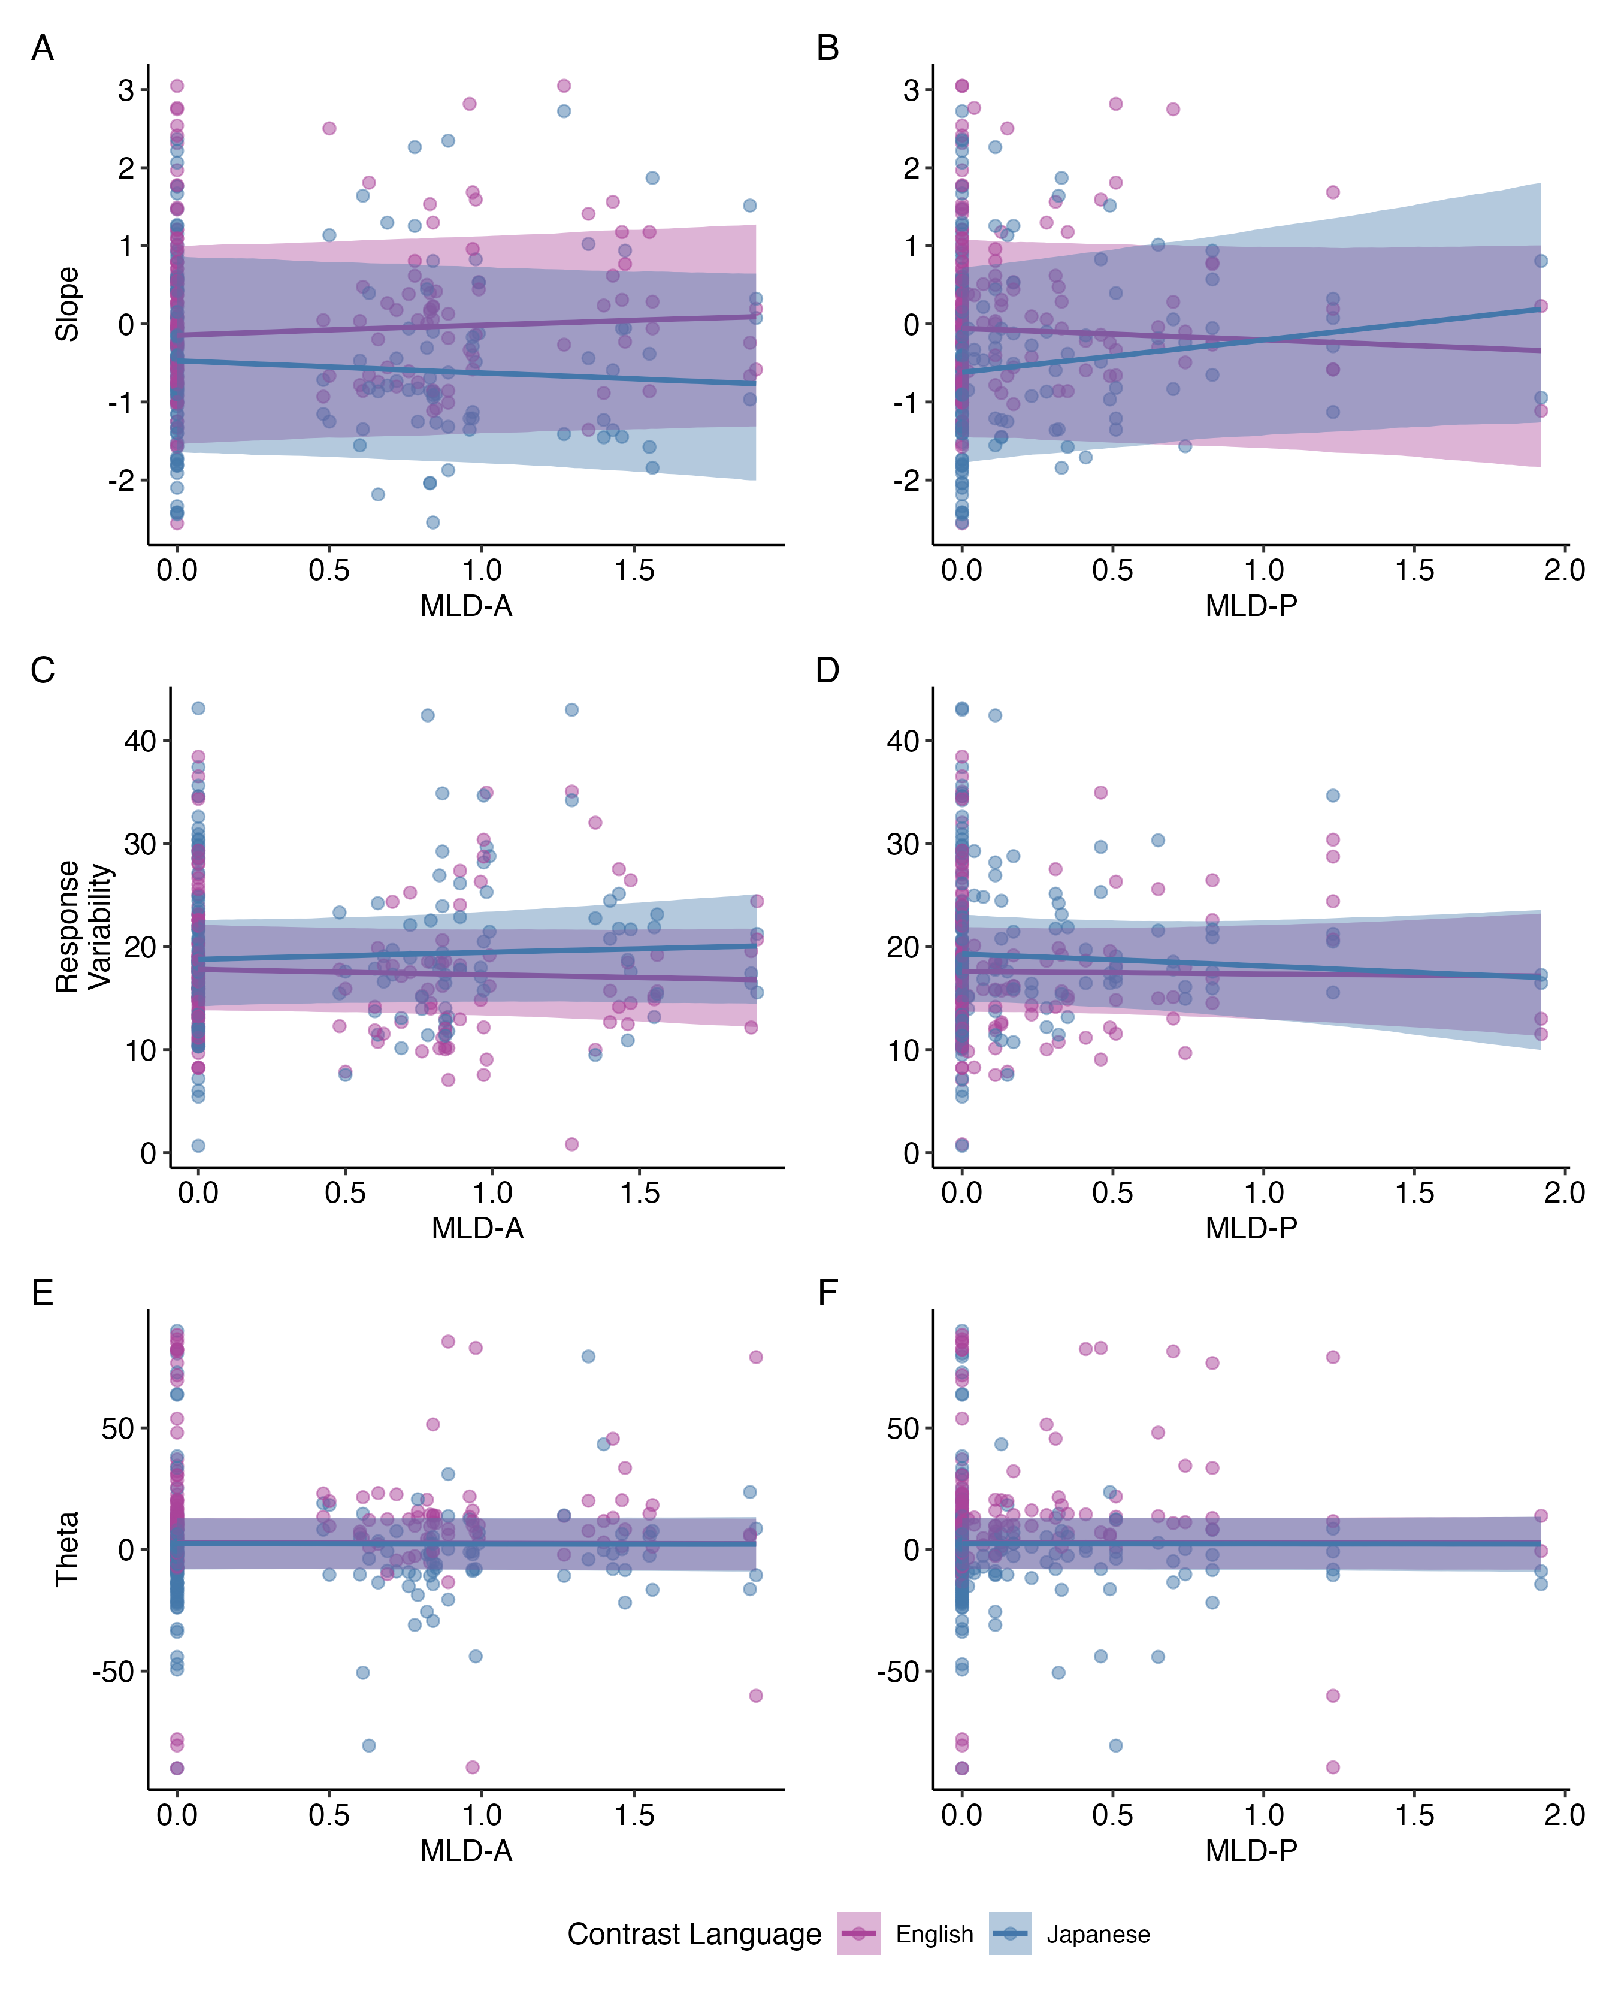
Figure 3.11: Conditional effects of MLD-A (left panels) and MLD-P (right panels) on VAS slope (top row), response variability (middle row), and theta (bottom row) for L1 English and L2 Japanese (purple and blue lines). Effects are plotted with 95% uncertainty intervals.
Similarly, the interaction between MLD-P and language suggests that MLD-P predicted VAS slope differently across L1 and L2, with moderate evidence for a positive interaction effect (b = 0.56, 95% CrI [0.08, 1.08], pd-p = 0.03). The 95% CrI excluded zero, supporting a slightly more robust effect. This interaction trend indicates that MLD-P predicted a 0.56 unit increase in VAS slope for Japanese contrasts compared to English. Figure 3.11B shows the conditional effects of MLD-P on VAS slopes between the two language levels; for the Japanese contrasts, a one unit increase in MLD-P scores predicted a 0.42 unit increase (b = 0.42, 95% CrI [-0.12, 0.93] in VAS slopes, in contrast to VAS slopes for English, which had a slightly negative trend, as indicated by the MLD-P fixed effect (b = -0.14, 95% CrI [-0.55, 0.26]).
Together, these findings cautiously show a trend suggesting that experiential linguistic diversity predicted VAS slope differently between L1 and L2, with different directional associations between MLD-A and MLD-P for Japanese relative to English. Interesting, these trends suggest that increased active experiential linguistic diversity predicted shallower L2 VAS slopes compared to L1, while increased passive experiential linguistic diversity predicted steeper L2 VAS slopes compared to L1.

Effect of predictors on response variability
Here too, the 95% CrIs for the posterior estimates of MLD-A, MLD-P, and language all included zero, indicating no strong evidence for independent effects of these predictors on response variability. As before, the fixed and interaction effects are interpreted cautiously as trends rather than definitive effects.
The intercept estimate (b = 17.82, 95% CrI [13.87, 22.17]) represented the predicted response variability for VAS responses to the English contrasts when MLD-A = 0 and MLD-P = 0. Although the 95% CrI does not contain zero, resulting in a pd-p value of 0.00, this merely indicates that there is 100% probability that the true intercept is positive. Because the values for response variability were untransformed and response variability is bounded to be positive, the significance of the intercept is not meaningful for inference.
In line with the main effects, the interaction estimates were not statistically robust. The interaction between MLD-A and language showed weak evidence of an effect (b = 1.26, 95% CrI [-0.42, 2.78], pd-p = 0.13), suggesting a possible trend that MLD-A scores may differentially predict response variability in L1 and L2. As shown in Figure 3.11C, higher MLD-A scores were associated with increased response variability for the Japanese contrasts, whereas the trend for English was slightly negative.
The interaction between MLD-P and language showed no evidence of a meaningful effect (b = -0.91, 95% CrI [-3.17, 1.41], pd-p = 0.43). Although Figure 3.11D seems to visually display a potential convergence pattern, in which higher MLD-P scores predict reduced response variability for Japanese to align more closely with that of English, the level of uncertainty prohibits a confident interpretation of this pattern.

Effect of predictors on secondary cue use
The model predicting secondary cue use did not yield strong evidence for any fixed or interaction effects. The 95% CrIs for all estimates, including the intercept, MLD-A, MLD-P, language, and their interactions, overlapped with zero, and all pd-p values were above 0.50, indicating high uncertainty. Figure 3.11 (bottom row) shows that the interactions between the MLD scores and language lack any noticeable trends. Given the absence of robust effects, exploratory post-hoc analyses were conducted to examine whether patterns of secondary cue use differed between the qualitatively distinct positive and negative ranges of theta, as it is possible effects were masked across the full range. Table 3.8 presents the posterior estimates of the univariate models side-by-side.
Table 3.8: Fixed Effects of the Post-hoc Univariate Bayesian Mixed-Effects Models Predicting Positive and Negative Ranges of Theta.
 | Positive Theta |  |  | Negative Theta
Predictor | Estimate | 95% CrI | pd-p | Estimate | 95% CrI | pd-p
Intercept (English) | 11.18 | [ 4.43, 18.03] | 0.01 | -6.15 | [-13.11, -0.72] | 0.03
Language (Japanese) | -3.40 | [-9.59, 4.33] | 0.37 | -2.86 | [ -8.61, 4.00] | 0.35
MLD-A | -0.84 | [-3.42, 1.63] | 0.52 | 0.75 | [ -4.08, 5.10] | 0.75
MLD-P | 1.13 | [-2.42, 4.69] | 0.51 | 1.04 | [ -4.42, 6.12] | 0.67
MLD-A x Language (Japanese) | 1.93 | [-2.15, 6.25] | 0.36 | -0.60 | [ -5.73, 4.50] | 0.82
MLD-P x Language (Japanese) | -2.86 | [-9.02, 3.43] | 0.38 | -0.29 | [ -6.11, 5.76] | 0.92
Key: Estimate = median of the posterior probability distribution; CrI = Credible Interval (95% highest density interval); pd-p = p-value calculated from Probability of Direction (pd)
Model formula: Theta ~ (MLD_A * Language) + (MLD_P * Language) + (1 + Language | Participant) + (1 | VAS Pair); same formula run separately on Positive Theta and Negative Theta datasets
Notes: Language was dummy coded (English = reference level). pd-p was calculated using the bayestestR R package (v0.16.0; Makowski et al., 2019).
Here too, while the directionality of the intercept terms is well supported, the intercept estimates lack meaningful interpretation because each data subset was bound in the positive or negative direction. In the model restricted to positive theta values (i.e., responses corresponding with the expected direction of categorization), none of the predictor estimates had 95% CrIs excluding zero, nor were any trends of effect directionality supported by the pd-p values. Further, while Figures 3.12A and B display potentially interesting visual trends of a convergence pattern effect for MLD-A and a divergence pattern effect for MLD-P on positive theta values across L1 and L2, these patterns should be interpreted cautiously due to the high uncertainty of the interaction estimates.
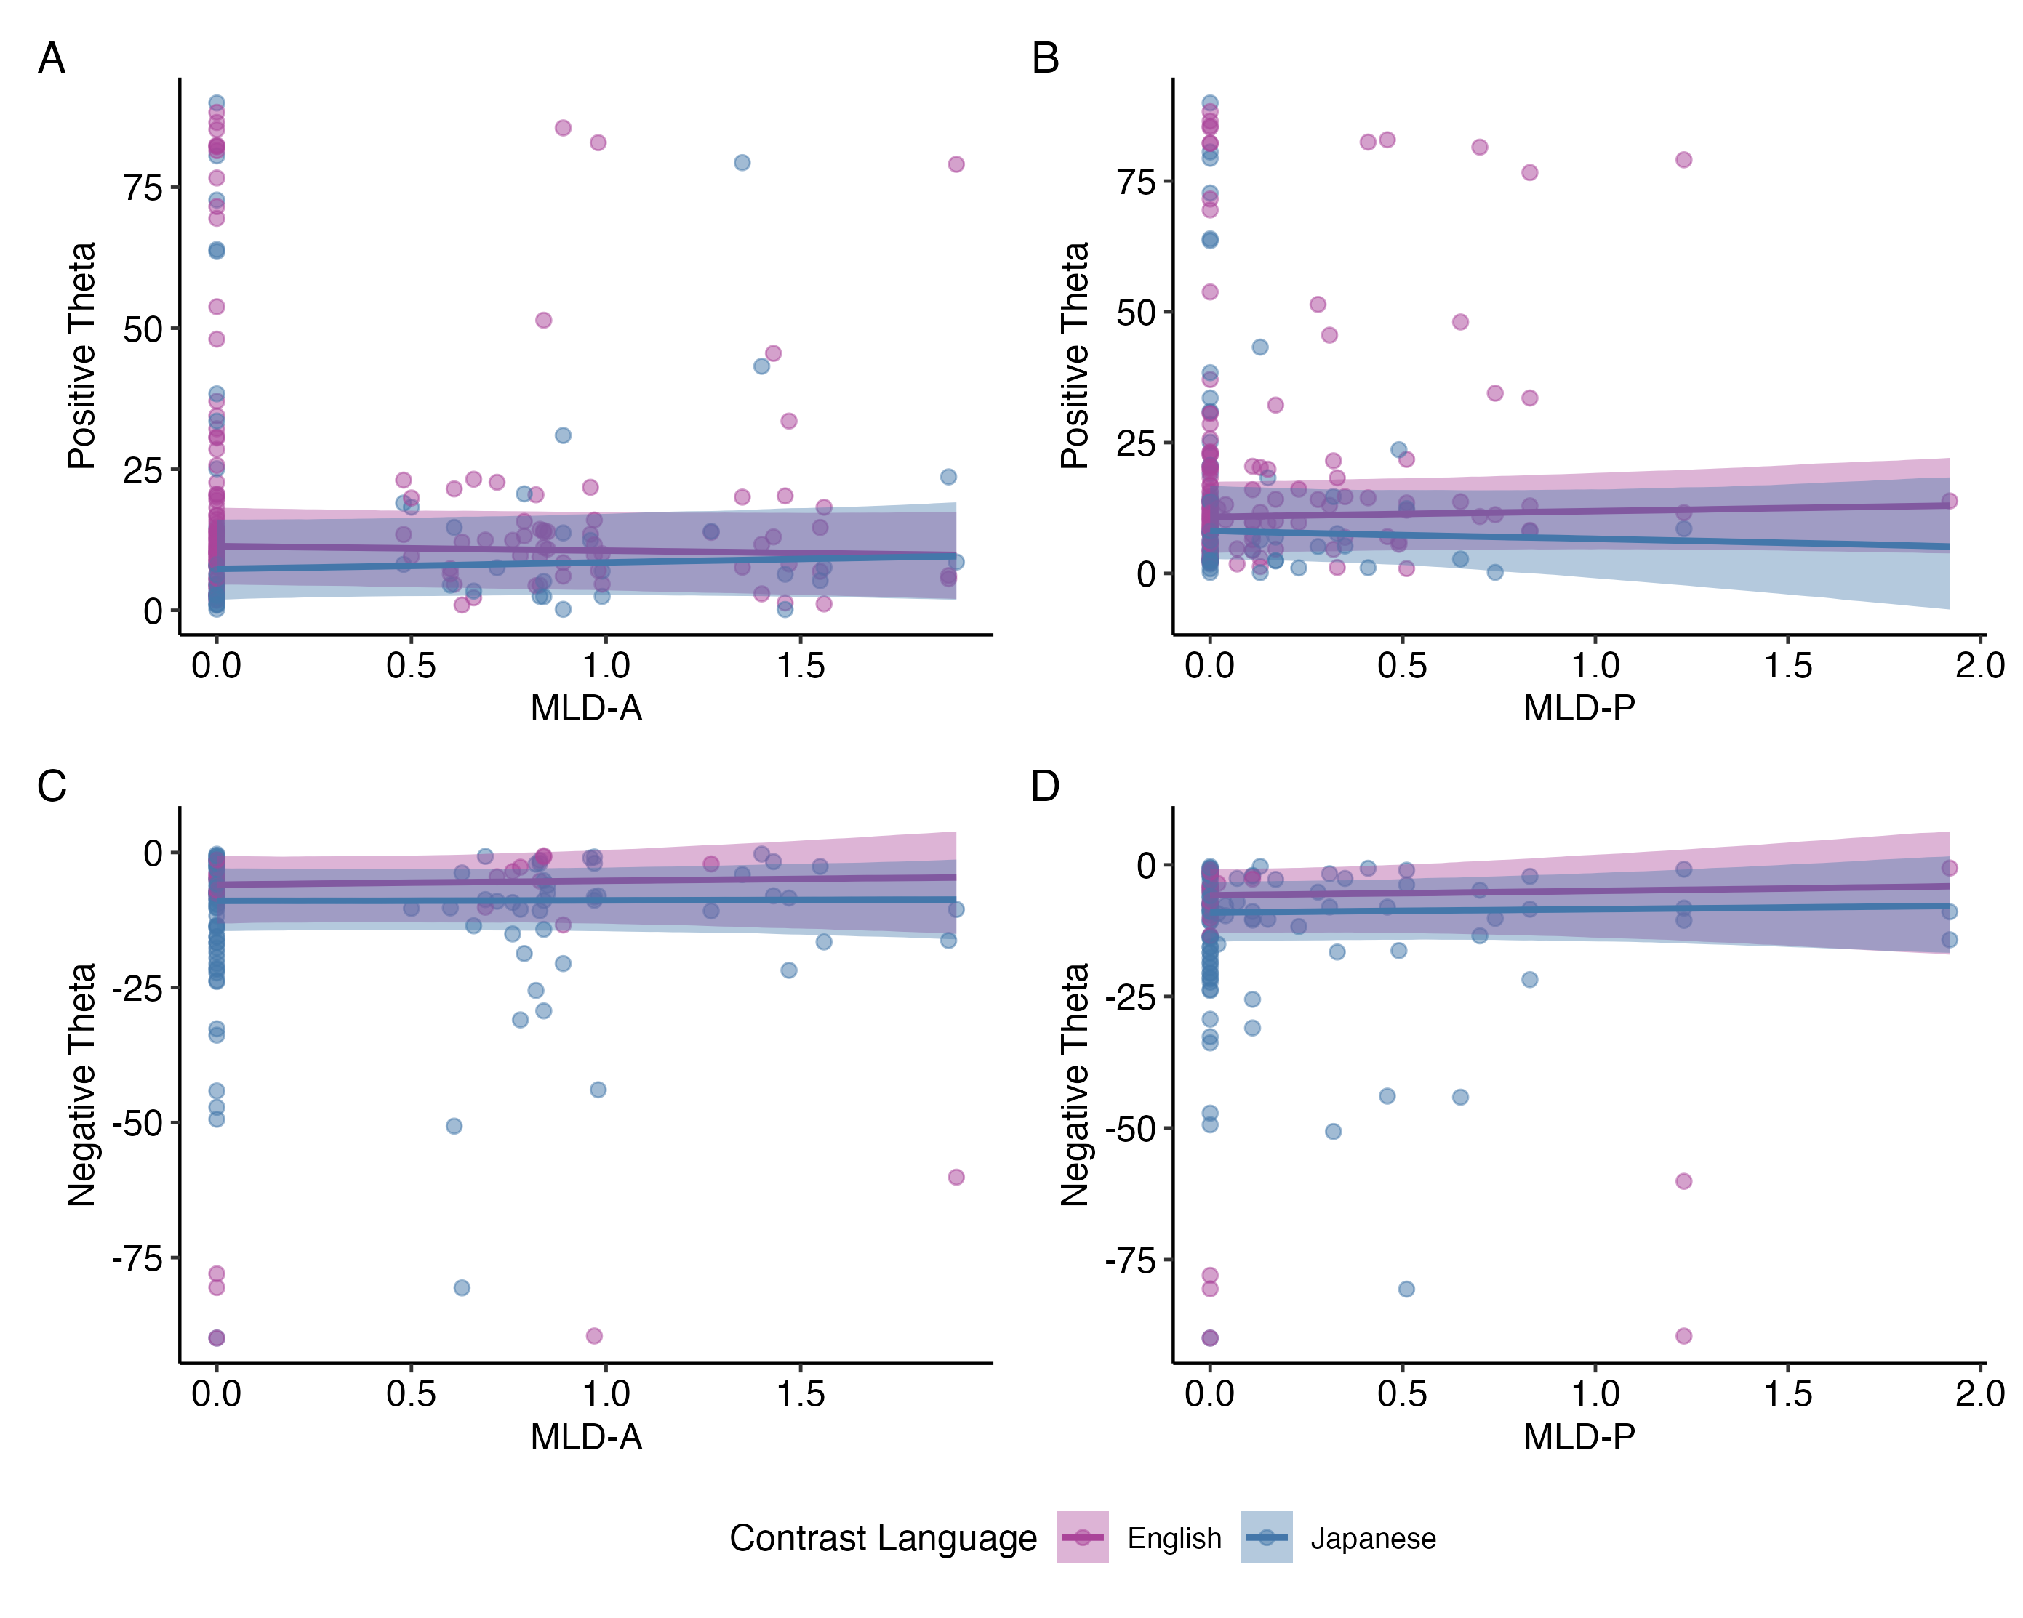
Figure 3.12: Conditional effects of MLD-A (left panels) and MLD-P (right panels) on positive (top row) and negative (bottom row) theta values for L1 English and L2 Japanese. Note that positive theta values represent degree of secondary cue integration in the expected direction of categorization while negative theta values represent degree of secondary cue integration with one or both of the cues being reversed. Effects are plotted with 95% uncertainty intervals.
Similarly, in the model restricted to negative theta values (i.e., responses suggesting reversed categorization in one or both dimensions), all fixed effect estimates had 95% CrIs that overlapped with zero and high pd-p values, again suggesting no robust effects. In this case, Figures 3.12C and D shows that the interactions between MLD scores and language lack any noticeable trend. Overall, these post-hoc analyses provide no additional evidence of predictor effects on either range of the theta values and reinforce the conclusion from the original model that these data lack the evidence to support the hypothesis that experiential linguistic diversity predict secondary cue use in either L1 or L2.
Table 3.9 presents random variance and model fit estimates: Group standard deviations and random effects correlation parameters with 95% CrI, population-level residual standard deviation with 95% CrI, and Bayes R² with 95% quantile range. It should be noted that the number of observations differed between the subsets of data for the positive and negative ranges of theta, with n = 182 for the positive range of theta and n = 122 for the negative range of theta.
Table 3.9: Random Effects and Model Fit of the Post-hoc Univariate Bayesian Mixed-Effects Models Predicting Positive and Negative Ranges of Theta.
 |  | Positive Theta |  | Negative Theta
Group | Random Effect | SD  [95% CrI] | Int. ~ Slope Corr. | SD  [95% CrI] | Int. ~ Slope Corr.
Participant | Intercept | 1.03  [0.00, 2.63] |  | 1.03  [0.00, 3.10]
 | Language (Japanese) | 1.45  [0.00, 4.31] | -0.15  [-1.00, 0.87] | 2.91  [0.00, 5.81] | -0.24  [-1.00, 0.85]
VAS Pair | Intercept | 3.79  [0.04, 10.79] |  | 2.47  [0.00, 8.80]
Residual | Residual | 5.26  [4.04, 6.71] |  | 5.03  [3.31, 6.87]
Bayes R^{2Note} |  | 0.02  [0.01, 0.04] |  | 0.04  [0.01, 0.08]
N_{Participant} |  | 76 |  | 70
N_{VAS} _{Pair} |  | 4 |  | 4
N_{observations} |  | 182 |  | 122
Key: SD = Standard Deviation (median of posterior probability distribution of SD); CrI = Credible Interval (95% highest density interval); Int. = Intercept; Corr. = Correlation
Model formula: Theta ~ (MLD_A * Language) + (MLD_P * Language) + (1 + Language | Participant) + (1 | VAS Pair); same formula run separately on Positive Theta and Negative Theta datasets
^{Note}The estimated Bayes R² values for each response variable are presented with the 2.5% and 97.5% quantile range.

Univariate model outcomes for secondary cue use
Table 3.10 presents the fixed effect outcomes of the univariate Bayesian mixed-effects analyses modeling the effects of VAS slope, response variability, and contrast language on positive and negative ranges of theta.
Table 3.10: Fixed Effects of the Univariate Bayesian Mixed-Effects Models of the Effects of VAS Slope and Response Variability on Positive and Negative Ranges of Theta.
 | Positive Theta |  |  | Negative Theta
Predictor | Estimate | 95% CrI | pd-p | Estimate | 95% CrI | pd-p
Intercept (English) | 7.12 | [ 0.28, 14.51] | 0.04 | -5.70 | [-12.25, 0.23] | 0.06
Language (Japanese) | -0.10 | [-3.75, 3.77] | 0.96 | -0.27 | [ -3.97, 3.40] | 0.89
Slope | 0.64 | [-1.87, 2.94] | 0.61 | -0.76 | [ -4.05, 2.38] | 0.65
Response Variability (RV) | 0.34 | [ 0.01, 0.63] | 0.04 | -0.03 | [ -0.40, 0.31] | 0.86
Slope x RV | -0.01 | [-0.23, 0.17] | 0.91 | -0.06 | [ -0.44, 0.26] | 0.71
Slope x Language (Japanese) | 0.93 | [-2.07, 4.28] | 0.58 | -0.52 | [ -3.72, 2.70] | 0.75
RV x Language (Japanese) | -0.21 | [-0.61, 0.18] | 0.28 | -0.13 | [ -0.47, 0.23] | 0.44
Slope x RV x Language (Japanese) | 0.13 | [-0.12, 0.36] | 0.28 | 0.14 | [ -0.19, 0.53] | 0.39
Key: Estimate = median of the posterior probability distribution; CrI = Credible Interval (95% highest density interval); pd-p = p-value calculated from Probability of Direction (pd)
Model formula: Theta ~ Slope * Response Variability * Language + (1 + Language | Participant) + (1 | VAS Pair); same formula run separately on Positive Theta and Negative Theta datasets
Notes: Language was dummy coded (English = reference level). pd-p was calculated using the bayestestR R package (v0.16.0; Makowski et al., 2019).
Table 3.11 presents the random variance and model fit estimates: Group standard deviations and random effects correlation parameters with 95% CrIs, population-level residual standard deviation with 95% CrI, and Bayes R² with 95% quantile range.
Table 3.11: Random Effects and Model Fit of the Univariate Bayesian Mixed-Effects Models of the Effects of VAS Slope and Response Variability on Positive and Negative Ranges of Theta.
 |  | Positive Theta |  | Negative Theta
Group | Random Effect | SD  [95% CrI] | Int. ~ Slope Corr. | SD  [95% CrI] | Int. ~ Slope Corr.
Participant | Intercept | 1.19  [0.00, 2.97] |  | 1.12  [0.00, 3.25]
 | Language (Japanese) | 1.49  [0.00, 4.20] | -0.32  [-1.00, 0.84] | 3.22  [0.01, 5.93] | -0.21  [-1.00, 0.85]
VAS Pair | Intercept | 4.52  [1.26, 10.64] |  | 1.85  [0.00, 6.80]
Residual | Residual | 5.29  [4.06, 6.69] |  | 4.79  [3.02, 6.77]
Bayes R^{2Note} |  | 0.05  [0.02, 0.08] |  | 0.05  [0.02, 0.09]
N_{Participant} |  | 76 |  | 70
N_{VAS} _{Pair} |  | 4 |  | 4
N_{observations} |  | 182 |  | 122
Key: SD = Standard Deviation (median of posterior probability distribution of SD); CrI = Credible Interval (95% highest density interval); Int. = Intercept; Corr. = Correlation
Model formula: Theta ~ Slope * Response Variability * Language + (1 + Language | Participant) + (1 | VAS Pair); same formula run separately on Positive Theta and Negative Theta datasets
^{Note}The estimated Bayes R² values for each response variable are presented with the 2.5% and 97.5% quantile range.
As with the univariate post-hoc analyses on the positive and negative ranges of theta, while the directionality of the intercept term is robustly supported, the bounded nature of the data for each model means that the intercept estimates they lack meaningful interpretation. In terms of the main and interaction effect terms, as VAS slope and response variability can both be considered components of categorization gradiency, both their independent and interaction effects on theta are of interest.

Effect of VAS slope and response variability on secondary cue use
In the model predicting positive theta values, response variability was the only predictor of either the main or interaction effects with a 95% CrI that excluded zero (b = 0.34, 95% CrI = [0.01, 0.63], pd-p = 0.04), indicating a statistically robust trend that response variability predicted a mild increase in secondary cue use in the expected direction of categorization. All other main and interaction effects lacked strong support, as their CrIs overlapped with zero and showed high uncertainty in directionality. In the model predicting negative theta values, none of the predictors and their interaction terms showed evidence of an effect, as all CrIs included zero and the pd-p values indicated substantial uncertainty in the directionality of the estimate.
Figure 3.13A visualizes the marginal effect of response variability on the positive range of theta, averaged across levels of other predictors. The statistically robust positive trend is contrasted to the marginal effect of response variability on negative theta, plotted in Figure 3.13B, where the relationship was not statistically robust and the trend was flat.
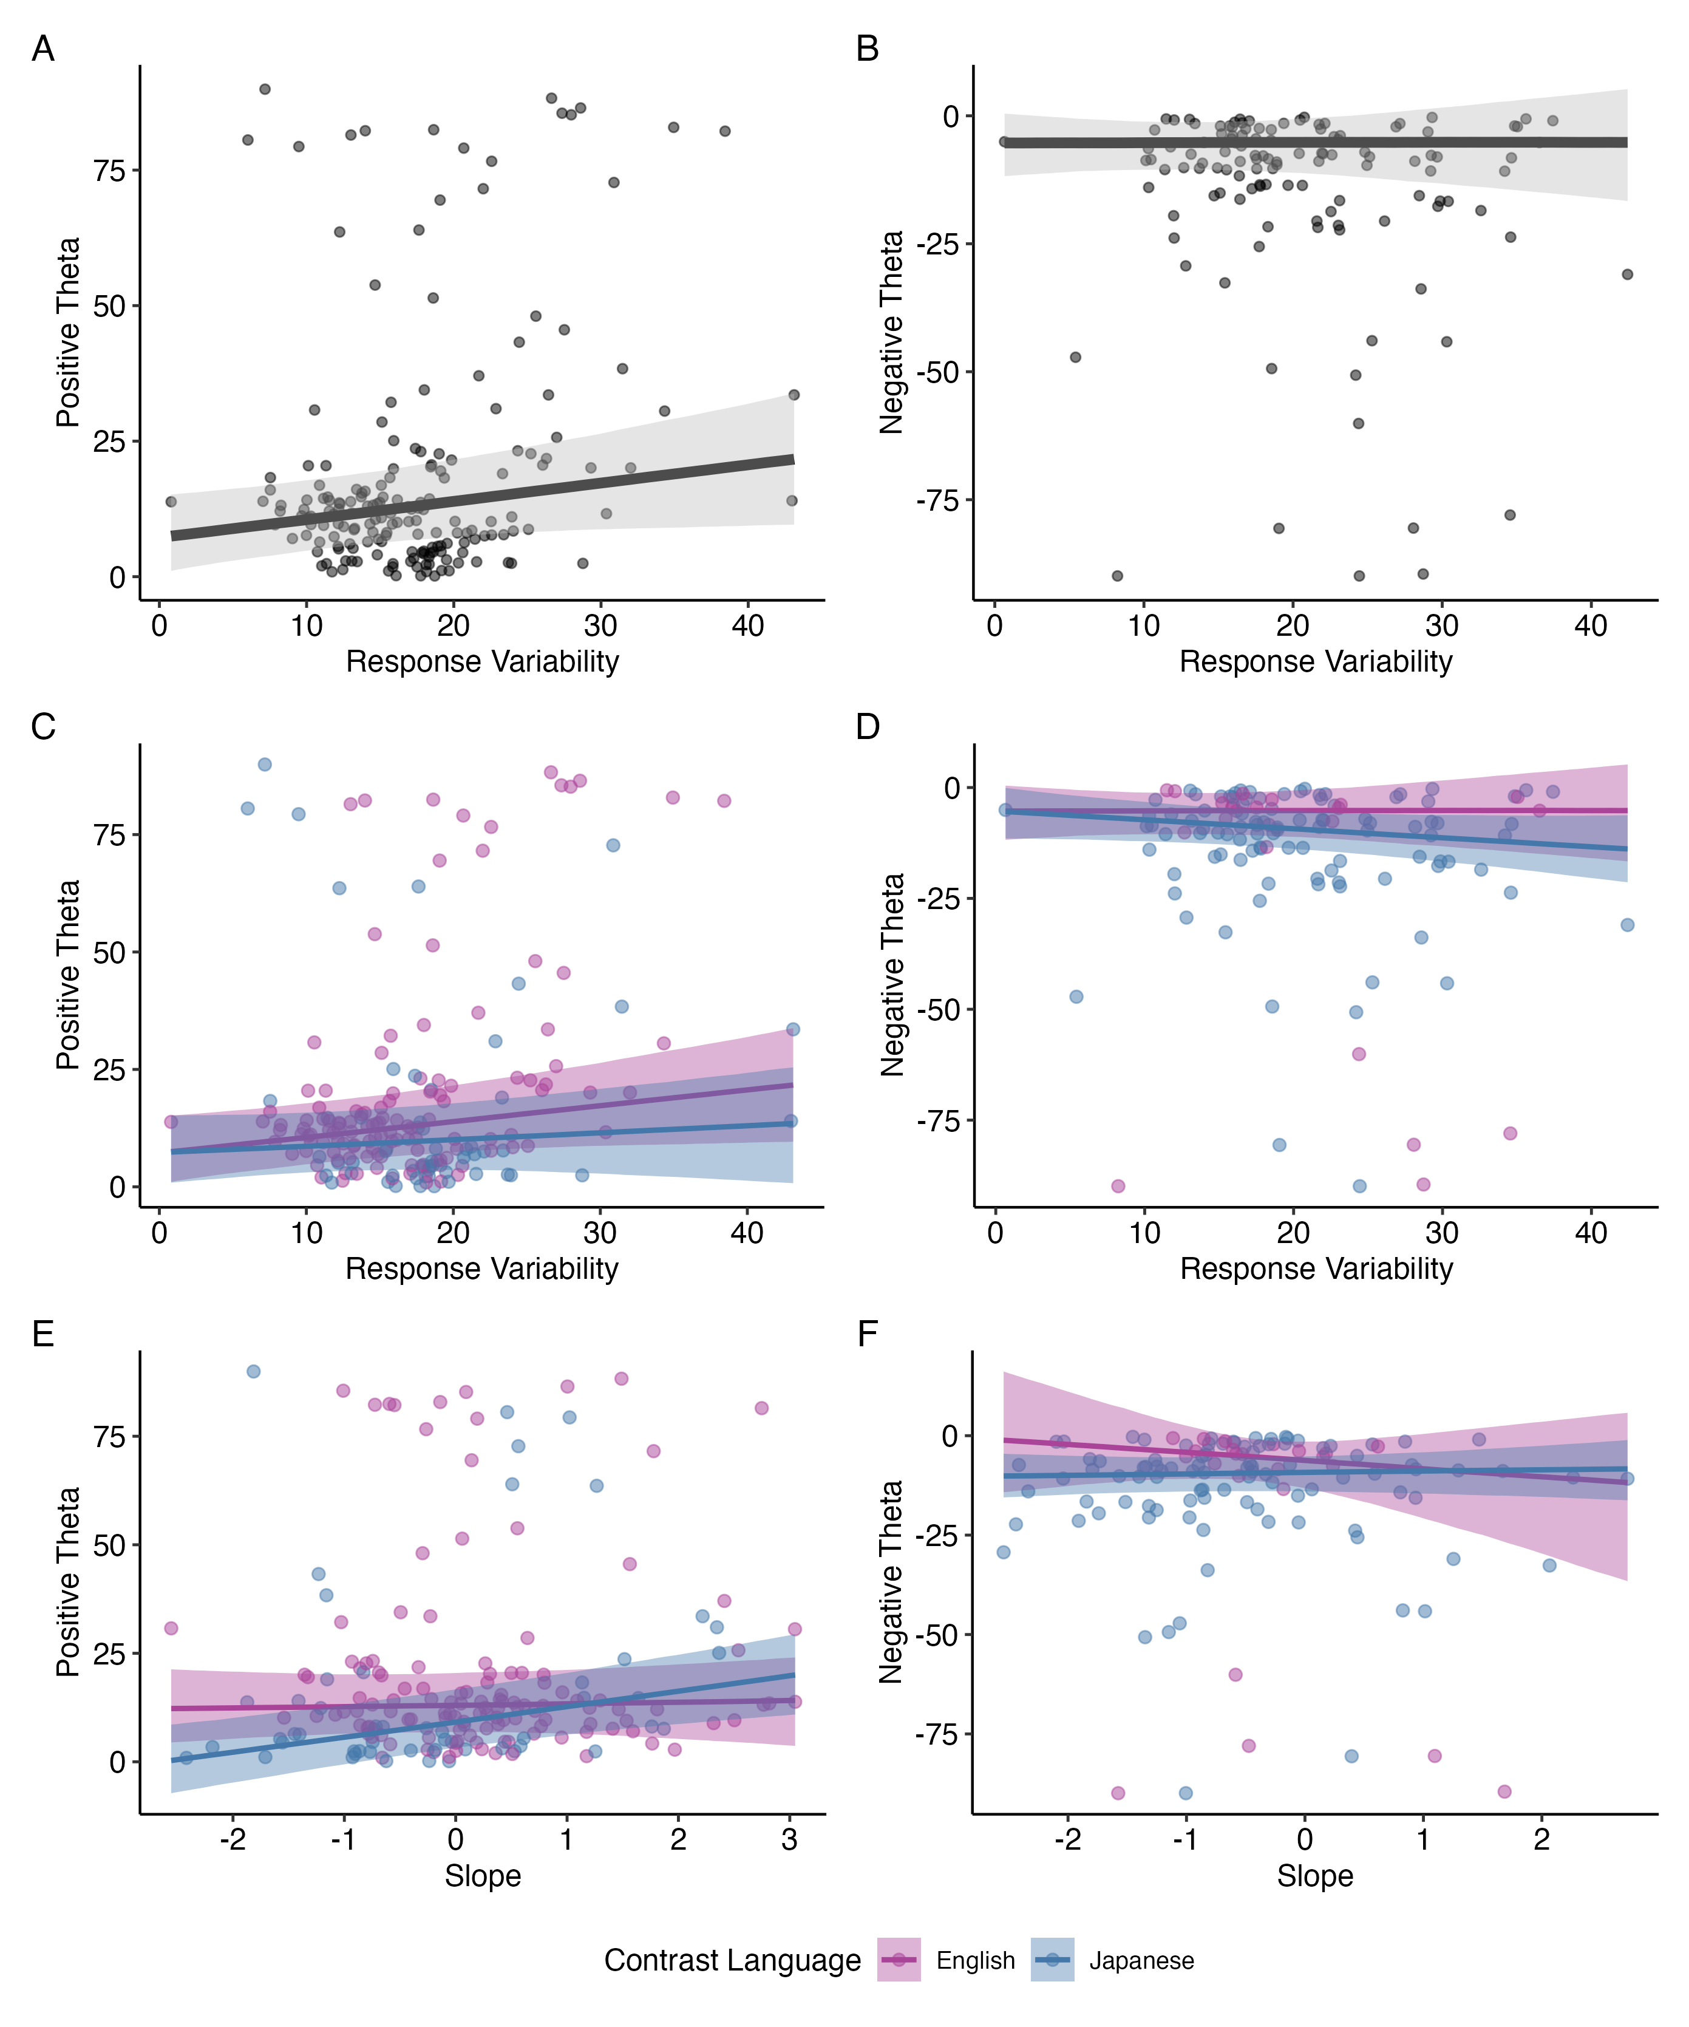
Figure 3.13: Marginal effects of response variability (top row), and conditional effects of response variability (middle row) and VAS slope (bottom row) for L1 English and L2 Japanese on positive (left column panels) and negative (right column panels) theta values. Note that positive theta values represent degree of secondary cue integration in the expected direction of categorization while negative theta values represent degree of secondary cue integration with one or both of the cues being reversed. Effects are plotted with 95% uncertainty intervals.
To explore potentially meaningful patterns, the interactions between response variability and language are plotted in panels C and D of the same figure. These panels plot the same data as panels A and B, respectively, but with separate trends for English and Japanese. While not statistically robust, these interaction trends suggest that among positive values of theta, higher response variability is associated with decreased secondary cue use/increased primary cue use (positive theta values close to zero) for Japanese relative to English. For negative theta, the interaction trend implies the reverse: greater response variability is associated with increased secondary cue integration in the reversed direction of categorization (i.e., larger negative theta values) for Japanese compared to English. These interpretations are tentative given the wide intervals and low directional certainty.
The interaction plots between VAS slope and language (bottom rows) are additionally included visualize the potential trends for how VAS slope differentially predicts secondary cue use between L1 and L2. However, the interaction terms for both positive theta values and negative values had wider 95% CrIs and low confidence in directionality of the estimate (pd-d = 0.58 for positive theta and pd-p = 0.75 for negative theta), which indicates a greater degree of uncertainty and Instead, their inclusion is to provide a fuller picture in using both response variability and VAS slope together to estimate the of categorization gradiency on secondary cue use.
Panels E and F present the interactions between VAS slope and language. These are included to illustrate possible differences in how slope may predict secondary cue use in L1 vs. L2, though neither interaction was statistically supported (pd-p = 0.58 for positive theta; pd-p = 0.75 for negative theta). The wide CrIs and lack of directional confidence indicate a high degree of uncertainty and necessitates critical evaluation of the emerging trends and caution against overinterpretation. However, their inclusion provides a more complete picture on how both response variability and VAS slope may together be used to represent categorization gradiency, and how these variables might interact with language context in predicting secondary cue integration.
Another point of interest is the joint effect of VAS slope and response variability on secondary cue use. Based on prior research, I had hypothesized that what would be canonically known as “true” gradient categorization is characterized by shallower VAS slopes and low response variability, as opposed to noisy categorization, characterized by shallow slopes and high response variability, and canonically categorical responses, characterized by steeper slopes and low response variability. However, the interaction terms between VAS slope and response variability for both positive (b = -0.01, 95% CrI [-0.23, 0.17], pd-p = 0.91) and negative (b = -0.06, 95% CrI [-0.44, 0.26], pd-p = 0.71) theta values estimated very little difference for the effect of VAS slope at different levels of response variability, with very high uncertainty as indicated by the wide CrIs that overlapped with zero and large pd-p values. Figure 3.14 illustrates the lack of integrated effect between VAS slope and response variability. If there had been differing effects for what would be considered gradient responses (low slope, low variability), noisy responses (low slope, high variability), and categorical responses (high slope, low variability), we would have seen different slopes of the trend lines for low variability (blue line) vs. high variability (red line) as Slope (x-axis) changes. Instead, the parallel trend lines suggest that VAS slope does not interact with different levels of response variability to have an impact on either positive or negative ranges of theta.
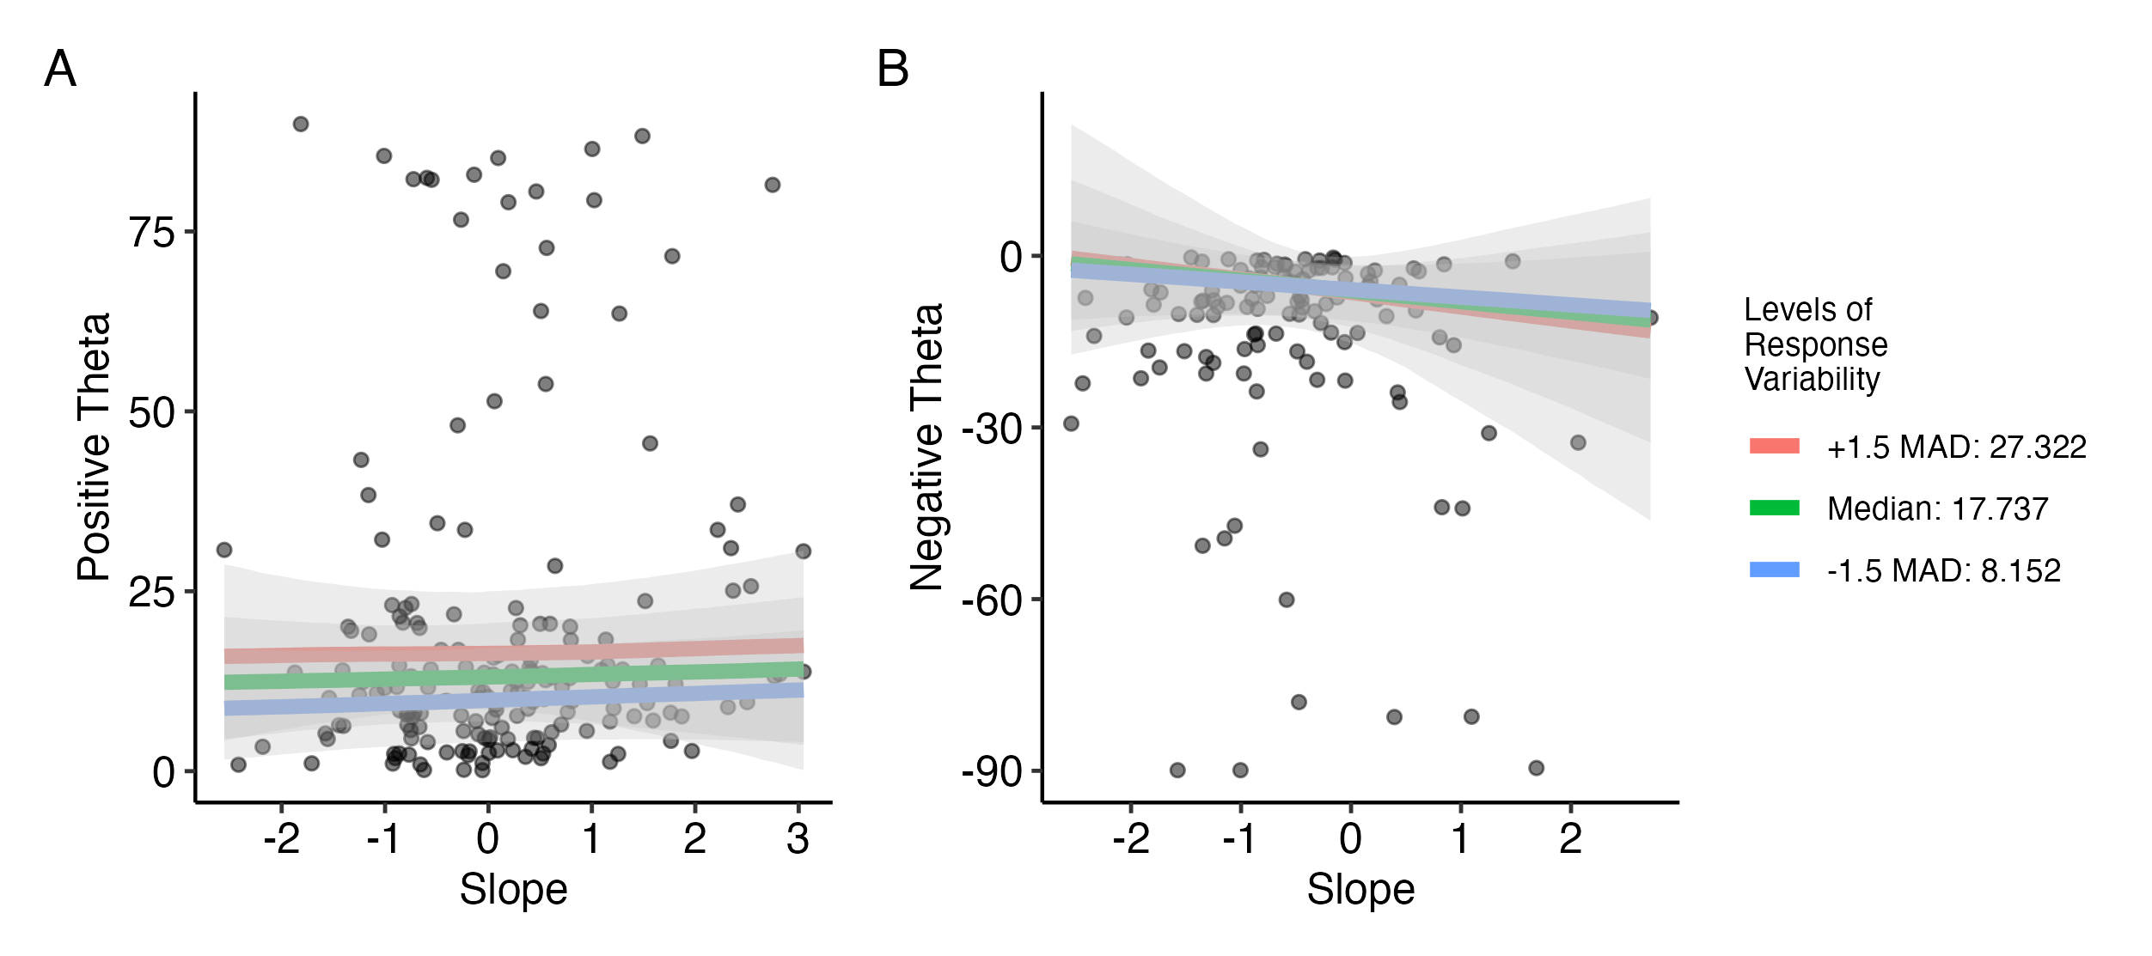
Figure 3.14: Conditional effects of VAS slope on positive and negative values of theta at different levels of response variability. Response variability is binned into three levels of median response variability of the full dataset +/- 1.5 median absolute deviations (MAD). Effects are plotted with 95% uncertainty intervals.
Overall, these findings provided limited evidence that either VAS slope or response variability, independently, together, or in interaction with language, systematically predicts secondary cue use across distinct theta ranges. Nonetheless, the patterns observed in the exploratory plots point to potential differences in how categorization gradiency, as captured by slope and response variability from VAS data, may relate to secondary cue use in L1 vs. L2. These trends, though tentative, suggest avenues for further investigation in future work.

Study 1 Discussion
In this study, I explored the effect of experiential linguistic diversity, measured with two indices of Active and Passive Multilingual Language Diversity, on speech categorization gradiency and secondary cue integration for L1 and L2 speech contrasts, as measured by VAS responses to synthesized two-dimensional continua of English and Japanese minimal pairs. I had hypothesized that more experience with linguistic diversity, whether that be through being multilingual or exposing oneself to multiple languages despite being functionally monolingual, would predict more gradient response patterns for L1 and L2 speech, as well as higher degrees of secondary cue integration, representing perceptual flexibility. The results from the Bayesian mixed-effects models mostly yielded non-robust findings of effects, especially with regards to my hypotheses. However, several trends emerged that are discussed with caution.

The effect of experiential linguistic diversity on gradiency, response variability, and secondary cue use
In the first part of RQ1, I asked, is experiential linguistic diversity predictive of gradient categorization patterns in L1 and L2? While most findings did not support my hypotheses, several trends of interest were found. The findings from the multivariate mixed effects model that were best supported by the data were the interactions between the MLD scores and contrast language for VAS slope. There was weak evidence that higher MLD-A scores predicted shallower VAS slopes for Japanese contrasts compared to English, while there was moderate evidence that higher MLD-P scores predicted steeper VAS slopes for Japanese contrasts compared to English. The opposite direction of these trends for MLD-A and MLD-P offer potentially interesting implications for what constructs MLD-A, MLD-P, and VAS slope represent.
As suggested by prior literature, slopes from VAS responses are best analyzed in conjunction with response variability (Apfelbaum et al., 2022; Kutlu et al., 2022) when characterizing gradient vs. categorical response patterns. In this study, VAS slope and VAS response variability were not able to be integrated as a single predictor, as it was in Kutlu et al. (2024). However, the trends of the predictor impact on VAS slope are still worth examining in light of prior literature that have suggested that gradiency as measured by VAS slope and gradiency as measured by response variability are actually measuring two different constructs. Several studies have found evidence that VAS slopes conceptually measure the perceptual ability to track gradual changes along a continuum, thus sensitivity to within-category differences, whereas response variability (also called response consistency in these studies) conceptually measures the degree of reliability in mapping stimulus characteristics to phonemic categories Fuhrmeister et al. (2023).
The findings with relation to MLD-A and MLD-P offer interesting insight into gradient sensitivity to acoustic cues, especially with regards to L1 vs. non-L1 speech perception. The trend of MLD-A predicting shallower slopes for Japanese compared to English lends mild support to the idea that those who actively use and are exposed to multiple languages may be primed for perceptual sensitivity to gradual changes along acoustic dimensions. This priming would become most evident in unfamiliar linguistic contexts, where the listeners do not have the explicit categories to guide consistent categorization, and thus rely more on the acoustics to make a categorization judgement rather than integrating orthographic or semantic input. The VAS is advantageous in presenting the same orthographic input a listener would receive for a 2AFC categorization task (i.e., seeing the phoneme categories in the words on screen), while allowing those who do track within-category differences to report these differences. The differences between those who use gradient vs. categorical strategies for non-L1 speech perception supports the hypothesis that speech perception is comprised of three distinct factors that use separate processing mechanisms for higher-level phonemic perception, sensory-level acoustic perception, and intermediate-level phonetically relevant perception (Werker & Logan, 1985). This may suggest that those who show gradient perception rely more on acoustically relevant perception compared, as opposed to phonetically or phonemically relevant perception.
On the other hand, the trend of MLD-P predicting steeper VAS slopes for Japanese compared to English is an interesting contrast to the above finding. The conceptualization that VAS slopes reflect gradiency as within-category acoustic sensitivity would imply that those with passive use of and exposure to multiple languages show decreased sensitivity to within-category differences. It is conceptually difficult to theorize the mechanisms that would lead to this outcome. However, the number of individuals at the higher end of MLD-P scores was quite low, meaning that it is possible that this trend was driven by a few individuals with higher MLD-P scores; although this finding was statistically robust, it must be interpreted with caution.
The findings did not support the hypotheses that experiential linguistic diversity predicted response variability, though the trends that emerged could suggest some potential associations that trended in different directions between MLD-A and MLD-P. Additionally, while there were no robust effects of MLD-A and MLD-P on the full range of theta. The post-hoc analyses also revealed no strong evidence of the effects of MLD-A and MLD-P on secondary cue use when the theta values were divided into positive and negative ranges. However, here too, a slight trend was seen in the visualization of the data that could suggest opposing associations with (positive ranges) of theta between MLD-A and MLD-P. Though mostly based on visual inspection of the data and not statistically supported, the fact that MLD-A and MLD-P had opposing, rather than matching, trends for VAS slope, response variability, and secondary cue use in the expected direction of categorization may suggest that MLD-A and MLD-P represent wholly different constructs.
In past literature, language entropy has been found to predict reported self-perception of L2 abilities (Gullifer & Titone, 2020), efficiency in L1 production with regards to executive control (Kang et al., 2023), behavioral and pupillary measurement indices of executive control (van den Berg et al., 2022), functional neural connectivity specialization related to executive functioning (X. Li et al., 2021), and structural connectivity between a diverse set of brain areas involved in bilingual language control (Gullifer et al., 2018; Sulpizio et al., 2020). However, these studies used language entropy as a measure of diversity in active language usage; to my knowledge, language entropy has not been used before to measure degree of passive language use and exposure. It is worth exploring what kind of perceptual construct may be represented by an index that quantifies degree of passive linguistic diversity and what implications this kind of exposure means for speech perception, and how passive linguistic diversity modulates neural and behavioral measures of language processing. Given the finding from Bice & Kroll (2019) had found that monolinguals in a linguistically diverse environment showed neural activity suggesting sensitivity to novel L2 categories, although their advantage over monolinguals in a less linguistically diverse environment did not appear in the behavioral measures of speech learning. Language entropy for active language use has been used to quantify the effect of language diversity on both neural and behavioral differences between multilinguals and monolinguals, but a measure such as language entropy for passive language exposure can further be used to explore why this effect manifests differently between neural and behavioral measures for monolingual speakers. A limitation of the current this analysis was that an interaction effect between MLD-A and MLD-P was not included in the statistical models, which may have been able to elucidate differential effects of one MLD score at different levels of the other.
Nonetheless, these trends were not statistically supported by these data and serve as potential avenues of follow-up research. Yet, given the zero-inflation of the distributions of both MLD-A and MLD-P scores, it is advisable to view most, if not all, of these findings with skepticism. It is entirely possible that these trends themselves are spurious and driven by the few data points at higher values of MLD-A and MLD-P rather than reflecting a group-level trend. Given the limited number of individuals who had non-zero MLD scores, it is likely that these data simply did not have enough statistical power to detect any effects.

The effects of gradiency and response variability on secondary cue use
Based on previous work D. Kim et al. (2020), I had hypothesized a strong effect of gradiency and response variability on secondary cue use suggesting that higher degrees of gradiency and lower degrees of response variability predicted secondary cue use. While an effect of response variability was found for positive values of theta, the effect suggested that secondary cue integration increased as response variability increased. Additionally, and more surprisingly, VAS slope, nor any interactions included in the model, did not show any statistically robust effects on secondary cue use. The lack of findings for the negative values of theta were also surprising, given that one could conceptually conceive that negative theta values representing reversed categorization would suggest noisy categorization that could be captured from the slope and response variability measures.
This outcome that contradicts the well-established evidence from previous findings may have occurred for a number of reasons. Most notably, past research has used a different measure of secondary cue use. Kong & Edwards (2016) used anticipatory eye movement (AEM) as measure of secondary cue use, whereas, D. Kim et al. (2020), Kapnoula et al. (2017), and Kapnoula & McMurray (2021) additionally used the 2AFC task with two-dimensional continua to extract a measure of secondary cue use. While the latter three studies all used the rotated logistic function to fit the VAS data and extract a measure of slope and secondary cue use, as the theta estimate from the curve fit, none of these studies used the theta values themselves in their subsequent analysis investigating the relationship between gradiency and secondary cue use. The exclusive use of the VAS task and theta as the only measure of secondary cue use in this study may be the prime contributing factor to these null findings. This may suggest that while theta can mathematically be conceived as measuring secondary cue use, it may conceptually be a measure of a separate construct.

Individual differences in categorization patterns within and across languages
The contrast pairs were collapsed within language for the primary analyses, yet it is notable that there were still a number of individuals who displayed different categorization patterns between contrast pairs within same language. This finding supports that of Kapnoula et al. (2021), who found that gradiency in perceiving voicing contrasts (/b/ vs. /p/) did not predict gradiency in perceiving place of articulation fricative contrasts (/s/ vs. /ʃ/). While I did not run specific analyses to quantify the degree of correlation between within-language contrasts, the group-level characterization of categorization patterns for each contrast pair presented in Table 3.5 and Figure 3.6 illustrated the variability of categorization both between- and within-language.
Although I did not replicate findings from prior studies showing that categorization gradiency predicts secondary cue use (e.g., Kapnoula et al., 2021), this study contributes to a broader understanding of how speech categorization varies across both languages and contrast types. Much of the existing literature has focused on a narrow set of phoneme contrasts (most often stop consonant voicing, and sometimes voiceless fricative place of articulation, in English), limiting the generalizability of claims about gradiency, though this has been improving with recent studies (e.g., Kutlu et al., 2024; Honda et al., 2024; D. Kim et al., 2020; Ou et al., 2021). In following recent trends, I deliberately included both consonant and vowel contrasts to examine categorization in both L1 and L2. To my knowledge, the studies from Kong (2019) and Kong & Kang (2023) are these only studies to measure categorization gradiency using the VAS for both L1 and L2 contrasts. The resulting data demonstrate that categorization patterns are not easily reducible to a single listener-level trait but rather reflect a complex interaction between the phonemic context, the contrast type, and individual perceptual strategies.
This study contributes to the growing body of literature that investigates the sources of individual differences in speech categorization patterns. Although linguistic diversity, as measured by language entropy through the MLD indices, was not found to contribute to individual differences in categorization gradiency, there was still evidently diversity in the categorization strategies. As such, the search will continue to identify sources of individual differences.

Limitations
This study had several limitations. First, the while the Part 1 of the LDQ was sourced from the fully validated LHQ (P. Li et al., 2006, 2014, 2020), Part 2 was developed by me. Due to time constraints, the construct validity of the questionnaire items from Part 2 were not able to be validated with objective and behavioral measures of the target construct, that is, diversity of passive language use and exposure. Additionally, there were many missing data pieces from several participants, or participants who did not understand what was being asked of them, which further reduces the reliability of the MLD-P aggregate score measured from this part of the questionnaire. The items in Part 2, as well as the equations used to calculate the MLD-P score, would benefit from being validated against other forms of measures such as a language exposure diary, an observational study of language usage, and other measures to confirm the ecological validity of self-reporting passive language use.
Second, although the primary research questions were concerned with categorization gradiency and secondary cue use at the language level, results from both prior research and the descriptive analysis of the present study suggest that categorization constructs are best characterized at the phoneme level. While the statistical analyses included contrast pair as a random effect, this was not enough to fully examine the effects at the contrast level. It is also likely that the data did not have the power to support the extra complexity that would have needed to be modeled by including the four-level categorical variable.
Lastly, the study is limited by the restriction of the participant pool to those only situated in the U.S. at the time of the study. Of the 76 participants included in the analysis, 35 participants had non-zero MLD-A scores, 31 participants had non-zero MLD-P scores, and just 22 participants had non-zero scores for both. The limited pool of multilinguals made it difficult to make inferences on the effect of MLD-A and MLD-P on the VAS measures, as those with non-zero scores likely influenced the regression model more so than those with scores of zero. Prolific is an international participant recruitment company based in the U.K., and of its roughly 183,000 participants active recently, approximately 53,000 participants both met the inclusion criteria (see Section 3.1.1) and currently resided in the U.S. Removing the country of residence restriction increased this number to just under 99,000 potential participants. The nearly doubled available pool of participants likely would have included English speakers living in more linguistically diverse countries, such as South Africa, and would have made the data of MLD scores much more dynamic and balanced in terms of how much those with non-zero scores affected the regression model.

Study 2
In the previous chapter, I explored how experiential linguistic diversity predicted measures of categorization gradiency and secondary cue integration in the categorization of L1 English and L2 Japanese contrasts. The next step of exploration was to consider whether linguistic diversity can be a factor that is directly manipulated for the benefit of L2 speech learning. The theoretical basis of this consideration was that exposing the perceptual system to a set of exemplars of the target contrast has differential effects based on how diverse the exemplar contrast pairs are in their category boundaries along the primary acoustic dimension. Specifically, I theorized that having more than one language represented in the speech input present the perceptual system with a broad range of what can be considered good category exemplars for each category of the target contrast. That is, for a perceptual system that is unfamiliar with using duration as primary acoustic cue to differentiate between vowels or consonants of the same quality, hearing not only multiple different minimal pairs that differ only by whether the vowel is short or long in one language, but in two languages provides an additional degree of “variability” for High-Variability Perceptual Training (HVPT) that potentially aids in the category learning of novel L2 contrasts.
In Study 2, I explored whether specific exposure to linguistic diversity, through a brief period of perceptual training, impacted measures of categorization gradiency of L1 and L2 speech. To this end, RQ2 asked: Can we promote gradient categorization in listeners through specific exposure to linguistic diversity via perceptual training? If so, does gradient categorization increase perceptual sensitivity to discriminate between target language phonemic contrasts?
To answer each part of the research question, I conducted a two-day experimental study with a pre-post design for the VAS speech categorization rating task and the AX perceptual discrimination sensitivity test to measure changes in measures of L1 English and L2 Japanese categorization gradiency and L2 Japanese perceptual sensitivity, respectively, before and after perceptual training. As the aim of this study was to determine whether specific linguistic diversity as a training manipulation can change listeners’ categorization response patterns to be more gradient-like, I had presumed it would be advantageous to recruit from a population where the sample is likely to have a larger proportion of participants with non-gradient perceptual starting points. Based on the Study 1 hypothesis that those exposed to more experiential linguistic diversity would show higher degrees of categorization gradiency, the research plan for Study 2 proposed focusing recruitment on functionally monolingual English speakers not enrolled in any foreign language classes. Additionally, recruiting from a population of monolingual English speakers naïve to Japanese speech was desirable to better assess speech learning gains in perceptual sensitivity after the training paradigm. The novel L2 target contrasts for the learners were Japanese vowel length and consonant gemination.
The perceptual training paradigm was an HVPT discrimination task. Perceptual training tasks, especially HVPT tasks, have taken a variety of forms, including discrimination and identification tasks, although use of an identification training task tends to be more popular (Sakai & Moorman, 2018). As a training task in the present study, discrimination was preferrable to identification as discrimination does not require explicit labeling or lexical knowledge of a language (Strange & Shafer, 2008), which makes discrimination ideal for a training paradigm that used non-target language items with which most participants were not familiar. Further, discrimination training has been shown to be just as effective as identification training for L2 learners (Flege, 1995b; Carlet & Cebrian, n.d.; Shinohara & Iverson, 2018), and has been shown to produce neural pattern activity changes reflecting learning (Kraus et al., 1995). High-variability was achieved through talker variability, with two speakers per training language, and a wide range of minimal pairs. As the target phonemic contrast was quantity-focused rather than quality-focused, this allowed for the inclusion of a diverse set of minimal pairs that varied in vowel quality and consonant characteristics. This theoretically encourages listeners to use phonetic features to both create perceptual constancy across talkers and different phonemic contexts, i.e., the specific vowel or consonant contrasted in the minimal pair, and focus on the phonetic features, i.e., duration, that cue the phonemic contrast (Flege, 1995b). This strategy integrates bottom-up (distributional) and top-down (lexical) influences, which motivates the use of high variability and minimal pairs, respectively (Hayes-Harb, 2007). The novelty in this study was the addition of another dimension of variability to the standard HVPT discrimination training task, that is, the use of either a one-language (low linguistic diversity) or two-language (high linguistic diversity) stimulus set of minimal pairs for speech training.
I hypothesized that listeners who underwent the high linguistic diversity training would exhibit changes in categorization gradiency measure reflecting more gradient patterns (lower slope, lower response variability) for VAS contrast pairs in either L1 English, L2 Japanese, or both. I subsequently hypothesized that those with more L1 and/or L2 gradient-like categorization patterns would exhibit higher degrees of discrimination sensitivity than those with more categorical-like (higher slope, lower response variability) or noisy-like (lower slope, higher response variability) response patterns.

Methodology
The two-day procedure of Study 2 is presented in Table 4.1. This experiment took place entirely online; participants were recruited through the online participant recruitment platform Prolific (www.prolific.com) and completed the study on the online experiment builder platform Gorilla.sc (Anwyl-Irvine et al., 2020) on a desktop or laptop computer. All participants provided informed consent approved by the Carnegie Mellon University Institute Review Board (IRB). On the first day of the study, participants underwent a system check to ensure the auto play of sound at a comfortable level and a short task to ensure compliance with the use of wired binaural headphones (Milne et al., 2021). After this, participants completed the pretraining Visual Analog Scale (VAS) task and AX discrimination pretest, followed by one 30-minute session of AX discrimination training. Participants were randomly assigned to either the Low Linguistic Diversity (Low LD) or High Linguistic Diversity (High LD) experimental condition for the AX discrimination training. On the second day of the study, participants performed the posttraining VAS task and AX discrimination posttest, which were identical to the pretraining tasks. To be able to compare the effects of different levels of specific linguistic diversity delivered during the perceptual training task, all participants across both experimental groups performed the same pre-posttraining tasks. After the two posttraining tasks, participants completed the Linguistic Diversity Questionnaire (LDQ), after which they were debriefed on the purpose of the experiment. The LDQ was used to obtain measures of experiential linguistic diversity to serve as control measures.
Table 4.1: Order and Description of Tasks for Study 2.
Task Order | Day | Task | Purpose | Approximate duration (mins)
1 | 1 | Consent form, system and headphone checks | Obtain consent, ensure browser auto plays audio and volume is set to comfortable listening level, ensure participant is wearing wired binaural headphones | 5
2 | 1 | Pre-training L1 and L2 VAS | Measure pre-training L1 and L2 speech categorization gradiency | 8-10
3 | 1 | AX discrimination pre-test | Measure pre-training sensitivity to L2 phonemic contrasts | 8-10
4 | 1 | AX discrimination training session | Perceptual learning of L2 phonemic contrasts with low or high linguistic diversity (LD) | 20-30
5 | 2 | AX discrimination post-test | Measure post-training sensitivity to L2 phonemic contrasts | 8-10
6 | 2 | Post-training L1 and L2 VAS | Measure post-training L1 and L2 speech categorization gradiency | 8-10
7 | 2 | LDQ | Measure experiential linguistic diversity from active and passive use of and exposure to known and unknown languages | 10-25
Key: VAS = Visual Analog Scale; LDQ = Linguistic Diversity Questionnaire
There is evidence that sleep is beneficial for the consolidation of perceptual learning and the learning of phonetic categories (Earle & Myers, 2014), thus Day 1 and Day 2 took place at least 24 hours apart. Participants were restricted from returning to the study until 24 hours had passed since finishing Day 1 and were asked to complete Day 2 within 24 hours of being sent the second part of the study. All participants who returned for Day 2 finished within 48 hours of finishing Day 1. Participants were monetarily compensated for their time through Prolific upon completion of each part of the study. To encourage retention, participants were offered a small bonus for completing both Day 1 and Day 2 tasks on top of their base compensation. Overall, the study took no more than two hours to complete in total, with each day taking no longer than one hour.

Participants
A total of 103 participants were recruited from Prolific. Prolific users who participated in Study 1 were excluded from the recruitment pool. Recruitment targeted young adults aged 18-40 with self-reported normal hearing and no history of learning disability, memory impairment, or auditory processing disorder. Additionally, recruitment targeted functionally monolingual L1 English users. Given the desired sample, more exclusion criteria were applied to the recruitment process. As in Study 1, an L1 user is defined as someone for whom English a) was the first language acquired and used in the home before the age of five; b) is the primary language used in daily life; and c) is a language that the participant self-identifies as being a fluent in Brown et al. (2023). As a first measure, the following Prolific questions were used for pre-screening, which only allowed participants to find the study if they answered as indicated:
- “What is your first language?” (Answer must include English)
- “What language(s) did you speak earliest in life?” (Answer must include English)
- “Which of the following languages are you fluent in?” (Answer must include English)
- “Which of the following is your primary spoken language?” (Answer must include English)
- “Were you raised monolingual?” (Answer must be the option “I was raised with my native language only”)
- “Apart from your native language, do you speak any other languages fluently?” (Answer must be the option “none just my native language”)
- “Are you an English-speaking monolingual, that is, are you fluent only in English? Or are you fluent in any other language(s)? (Answer must be the option”I only know English”)
As an additional measure, participants were screened at the time of consent using criteria that defines Functional Monolinguals as determined by Sabourin et al. (2016) from the validation of short and long versions of their Language Background Questionnaire. The goal was only to control for active verbal linguistic diversity in regular use (i.e., exclusion of both early- and late-in-life bilinguals, and those actively learning a language), not to control for all sources of linguistic diversity (e.g., passive exposure through listening), so the following screeners were the extent of the inclusion/exclusion criteria. Participants must have answered “Correct” to all of the following statements in order to continue with the rest of the study:
- “My native language is English and only English.”
- “My place of birth is in an English-speaking region.”
- “I have never lived in a non-English-speaking region.”
- “The only language I have ever been immersed in is English.”
- “My proficiency in all other languages is low or non-existent.”
- “I am not currently learning a language.”
Of the 103 participants recruited, 90 returned to complete Day 2 of the experiment. Of the 90 participants that completed both Day 1 and Day, 10 participants did not provide usable answers to the questionnaire necessary to calculate Multilingual Language Diversity (MLD) scores. This resulted in a total of n = 80 participants included in the statistical analyses (44 female, 35 male, 1 non-binary; mean age = 31.3, SD = 5.6, range = 19-40; condition Low LD n = 42, condition High LD n = 38). Due to IRB restrictions, participation was limited to persons present in the US at the time of the study, excluding 11 states with certain data privacy laws.

VAS task

Stimuli
As in Study 1, the VAS task in Study 2 was used to measure gradient categorization of L1 (English) and L2 (Japanese) speech. However, perceptual flexibility was not a construct of interest for RQ2, thus listeners were asked to judge one-dimensional speech continua rather than two-dimensional stimuli. Study 2 used a subset of the VAS stimuli from Study 1 (see Section 3.1.2.1). Listeners judged the same L1 English contrasts (minimal pairs indent-intent & reason-risen) and L2 Japanese contrasts (minimal pairs kata-katta & toru-tooru), varying along only the primary auditory dimension at the midpoint (3rd step) of the secondary dimension from the Study 1 set of stimuli. Table 4.2 summarizes the acoustic characteristics of the one-dimensional continua.
Table 4.2: Acoustic Characteristics of One-Dimensional VAS Continua.
Continuum Step | indent-intent  /d/-/t/ | reason-risen  /i/-/ɪ/ | kata-katta  /t/-/tt/ | toru-tooru  /o/-/oː/
Primary Dimension | VOT (ms) | F1/F2/F3 (Hz)¹ | Stop Closure Duration (ms) | Vowel Duration (ms)
1 | 21 | 364/2932/3328 | 99.6 | 104
2 | 32 | 379/2779/3274 | 113 | 142
3 | 42 | 395/2636/3221 | 126 | 179
4 | 52 | 411/2501/3169 | 139 | 216
5 | 62 | 426/2373/3118 | 153 | 254
6 | 73 | 443/2253/3068 | 166 | 292
7 | 83 | 459/2139/3019 | 179 | 329
Secondary Dimension | Vowel Onset F0 (Hz) | Vowel Duration (ms)² | Pitch Drop (Hz)³ | Pitch Contour (Hz)⁴
3 | 195 | 179 | 322/93.4 | 296/218/158
¹Values at vowel midpoint
²Vowel duration includes [ɹ]
³Max F0 of first syllable/min F0 of second syllable
⁴F0 at start of first syllable/F0 at end of first syllable/F0 at end of second syllable
Note for the toru-tooru continuum: The pitch accent of toru is HL while the pitch accent of tooru is HLL, so the F0 landmarks occur at different time points between the two words. F0 was interpolated between the words at each of the primary dimension duration steps, which resulted in slightly different, though comparable, F0 values across the different duration continua. The Secondary Dimension Step 3 pitch contour values reported here are from the Duration Step 4 continuum.

Procedure
Participants completed the VAS task both before and after discrimination training to gauge any changes in L1 and L2 categorization gradiency. The VAS trial procedure is the same as in Study 1 (see Section 3.1.2.2). To summarize, on each trial, participants heard a stimulus token while viewing a fixation cross, after which they were presented the horizontal scale with each word of the contrast pair at either end. Participants were instructed to move an anchor point (that appeared after clicking on the scale) to a location corresponding to their judgement of how much the token sounded like one word versus the other. As the phoneme contrasts only varied along the primary dimension, each continuum had seven tokens, which were repeated four times per block in randomized order for a total of 28 trials per block. As with Study 1, the left-right position of each word on the endpoints of the scale was randomized to be counterbalanced across participants.
Participants completed four blocks, one for each continuum. The two L1 English continua were presented first followed by the two L2 Japanese continua. Participants were randomized into conditions that counterbalanced the order of within-language continuum blocks for each the pre- and posttraining VAS tasks. There were a grand total of 112 trials (7 primary cue steps x 4 repetitions x 4 continua), which took participants approximately 8-10 minutes to complete. Participants were able to take a timed 30-second break between blocks. The pre- and posttraining VAS tasks were identical.

Data pre-processing
As mentioned in Section 3.1.2.3, one-dimensional VAS data can be fitted using a four-parameter logistic function from which four parameters can be estimated: minimum (b₁) and maximum asymptotes (b₂), slope (s), and the cross-over point along the one-dimensional continuum (x₀). Study 2 VAS response data were fit using the four-parameter logistic curve function in the Non-linear Curvefitting MATLAB package (McMurray, 2017).
The data were cleaned and filtered prior to fitting. The data (21616 trials from n = 103 participants) were first filtered to exclude trials exceeding 10 seconds in reaction time to exclude trials unlikely to reflect task engagement, while minimizing unnecessary data loss. Then, reaction times were log-transformed to normalize the distribution, and the data were further filtered to remove trials with reaction times three median absolute deviations (MAD) above or below each participant’s median log reaction time, resulting in 20894 trials. Ultimately, the data used in the logistic curve fitting process excluded those for whom MLD scores from the LDQ were not able to be calculated (17372 trials from n = 80 participants).
The logistic curve function was fit for each contrast pair at each of the pre- and posttraining time points, resulting in eight sets of VAS response curve estimates per participant. As in Study 1, response variability was calculated as the root mean square error (RMSE) of each curve (Kapnoula et al., 2017). Following initial exploratory fits, the upper and lower boundaries for the slope parameter estimate were adjusted to account for amplitude scale and an amplitude-dependent penalty was added to the least-squares error function, reducing instability in slope estimates when response amplitude was low. This was most beneficial in reducing inflation of estimated slope for noisy response data. Additional details on the fitting process are available in the supplementary materials online.
The raw VAS slope values ranged from -92.1 to 206.2 (median = 41.9, mean = 52.7 SD = 43.3). Raw slope values with low absolute values indicated shallower response curves whereas high absolute values indicated steeper response curves. Negative slopes indicated reversed categorization. The raw response variability values ranged from 0.7 to 48.4 (median = 16.2, mean = 17.7, SD = 8.5). Low response variability indicated more consistent categorization whereas high response variability indicated less consistent, noisier categorization.
As these one-dimensional VAS slope values were estimated from a different function than the two-dimensional VAS slopes, unlike Study 1, the slope values were not log-transformed; natural log transformation did not normalize the distribution. Instead, to standardize the data, both VAS slope and response variability values were each grand mean centered and scaled by one standard deviation (z-transformed) across all participants, contrast pairs, and time points. The z-transformed values were used in the analysis models. Table 4.3 presents the summary statistics of the z-transformed VAS slope and response variability estimates from the logistic curve fit for each contrast pair on Day 1 and Day 2, averaged across n = 80 participants.
Table 4.3: Summary Statistics of VAS Measures Estimated from Logistic Curve Fitting, by Contrast Pair and Day.
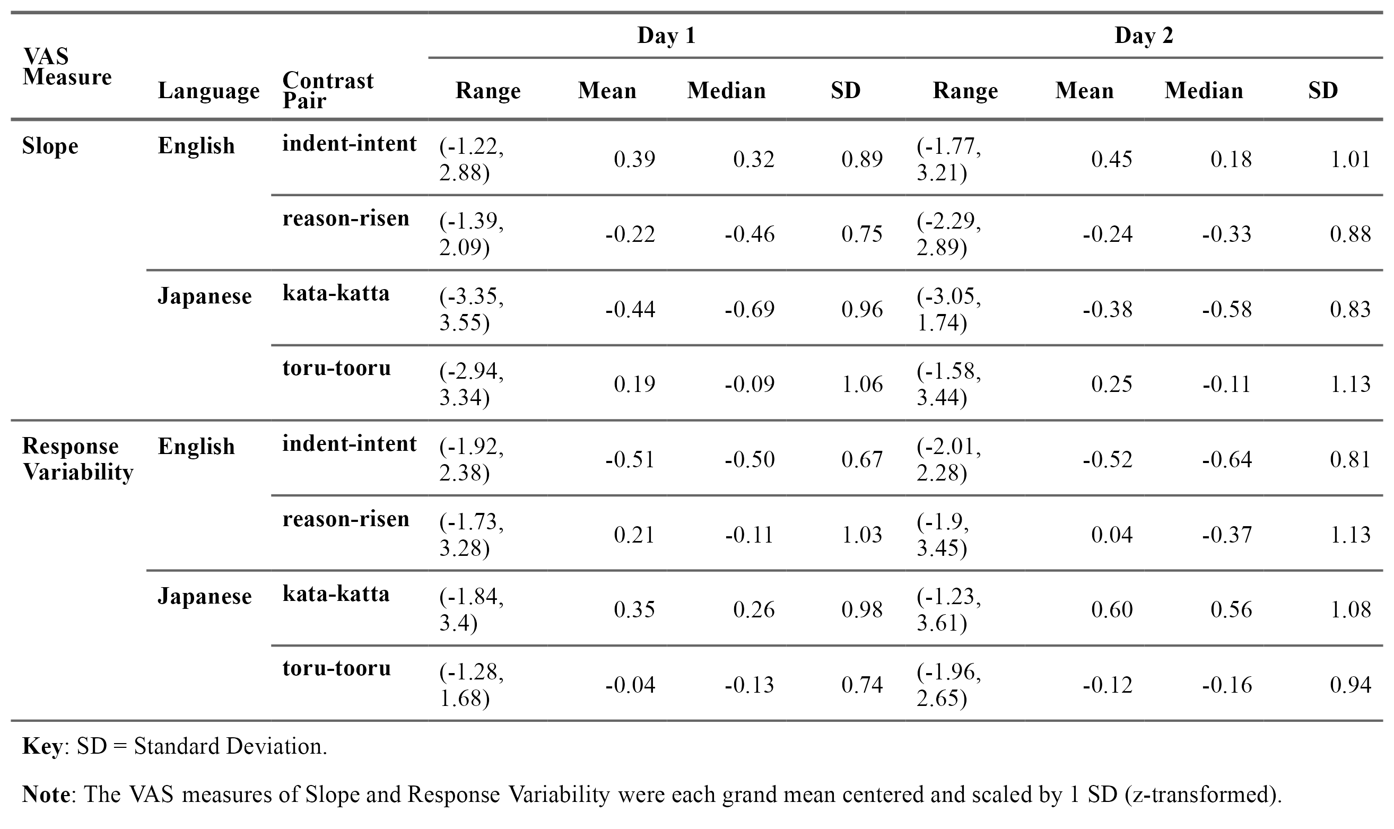

AX discrimination perceptual training and pre-posttests

Stimuli
In the AX perceptual discrimination task, participants were asked to judge whether two speech stimuli (token A and token X) presented in succession were the same or different words (token X may take on the same identity as A, or a different one, B). Specific exposure to linguistic diversity was manipulated as training condition for the perceptual discrimination training task. For the Low LD condition group, participants were tasked with learning Japanese vowel and consonant length contrast minimal pairs, while for the High LD condition group, participants learned both Japanese and Modern Standard Arabic (MSA) vowel and consonant length contrast minimal pairs. All groups were tested on discrimination sensitivity before and after training with a novel set of Japanese minimal pairs.
The Japanese minimal pair stimuli used in the Low LD and High LD training conditions and the Japanese stimuli used in the pre-posttests were recorded by two L1 Japanese users: one male (age 25, Standard Tokyo Japanese dialect) and one female (age 38, Standard Tokyo Japanese dialect; same speaker as used for the VAS stimuli). The MSA minimal pair stimuli used in the High LD training condition were recorded by two fluent users of MSA: one male (age 28, L1 General Saudi Arabic) and one female (age 24, L1 Palestinian Arabic).
Each keyword was embedded in a carrier sentence at two positions, roughly translating to “I say __ [once] again. __.” The Japanese carrier sentence was また「__」と言います。「__」(mata [__] to iimasu. [__]), and the MSA carrier sentence was أنا أقول(__) مرة أخرى. (__). (anaa aquulu (__) marrata ukhraa. (__). The speakers were recorded in a sound-attenuated booth with a Shure SM48 microphone fitted with foam windscreen connected via XLR cable to a Focusrite Scarlett 4i4 3rd Gen USB audio interface connected to a 2021 M1 MacBook Pro laptop. The speakers were presented with the carrier sentence with each keyword one-by-one on a computer screen and asked to produce each sentence three times at a natural speaking rate with a 1-2 second pause between each repetition. The speech was recorded in mono via Gorilla.sc with a sampling rate of 48,000 Hz. The Gorilla recording output were in .webm format and were converted to .wav format using FFmpeg (Tomar, 2006) for further processing in Praat.
The keywords in the second position were excised from the recordings and the best of the three repetitions (most clear production) was chosen as the token to be used in the experiment. The “best” repetitions for each word of a minimal pair were also chosen on the basis of sounding the most acoustically similar to each other across the two within-language speakers, excluding the acoustics of the contrasting phoneme. The chosen tokens were all RMS normalized to 67 dB using the Scale intensity function in Praat, were appended with at least 50 ms of silence before and after the word, and were saved in both .wav and .mp3 formats.
There were 18 Japanese minimal pairs and 18 MSA pairs used for training. For each language, there were six vowel length minimal pairs in word-medial positions, two pairs each for /a-aː, i-iː, u-uː/, and 12 consonant gemination minimal pairs in word-medial positions, three pairs each for /t-tt, k-kk, s-ss, ɕ-ɕɕ/ (the /ʃ/ consonant in MSA was treated as equivalent to the /ɕ/ consonant in Japanese). There were 25 Japanese minimal pairs used for testing: 13 vowel pairs in word-initial, word-medial, or word-final positions, /a-aː, i-iː, u-uː, e-eː, o-oː/, and 12 consonant pairs in word-medial positions, /t-tt, k-kk, s-ss, ɕ-ɕɕ, tɕ-ttɕ, n-nn/.
The minimal pairs used in training and testing varied in segment identity, word position, and speaker identity, as is typical for high-variability phonetic training, or HVPT (Logan et al., 1991; Lively et al., 1993, 1994; Bradlow et al., 1997; Bradlow et al., 1999). As such, the test items included more word positions and more contrasting segments for Japanese, beyond what was featured in training, in order to gauge generalizability and transfer of learning to novel positions and novel segments. The full stimulus list for the training and testing minimal pairs can be found in Appendix D.

Procedure
Perceptual discrimination training consisted of a single training session lasting approximately 30 minutes. Participants were instructed to judge as quickly and as accurately as possible whether the two speech stimuli were the same or different words, after which they received feedback on the correctness of their response. Participants were given specific instructions to ignore speaker identity and focus on the words themselves and to use the feedback to learn how to tell the words apart.
Figure 4.1A shows the procedure for each AX trial. Following a fixation period of 500 ms, participants heard stimulus A followed by stimulus X with an interstimulus interval (ISI) of 500 ms (Gerrits & Schouten, 2004). The participant made their response of SAME or DIFFERENT using the F or J keyboard buttons (participants were randomized into conditions that counterbalanced the mapping of SAME and DIFFERENT to the F and J keys). Reaction time was measured following the offset of stimulus X. After responding, participants saw an un-timed feedback screen, where they saw either “Correct!” in green text or “Incorrect!” in red text, as well as a confirmation of whether the pair were the “same” or “different”, with the text in either green or red depending on the correctness of their answer. Figure 4.1B shows all of the possible different feedback screens. Participants had the opportunity to re-listen to the recordings of Word A and Word X of the trial any number of times and also saw the transcriptions of the words and their meanings in English. Participants pressed the spacebar to continue to the next trial.
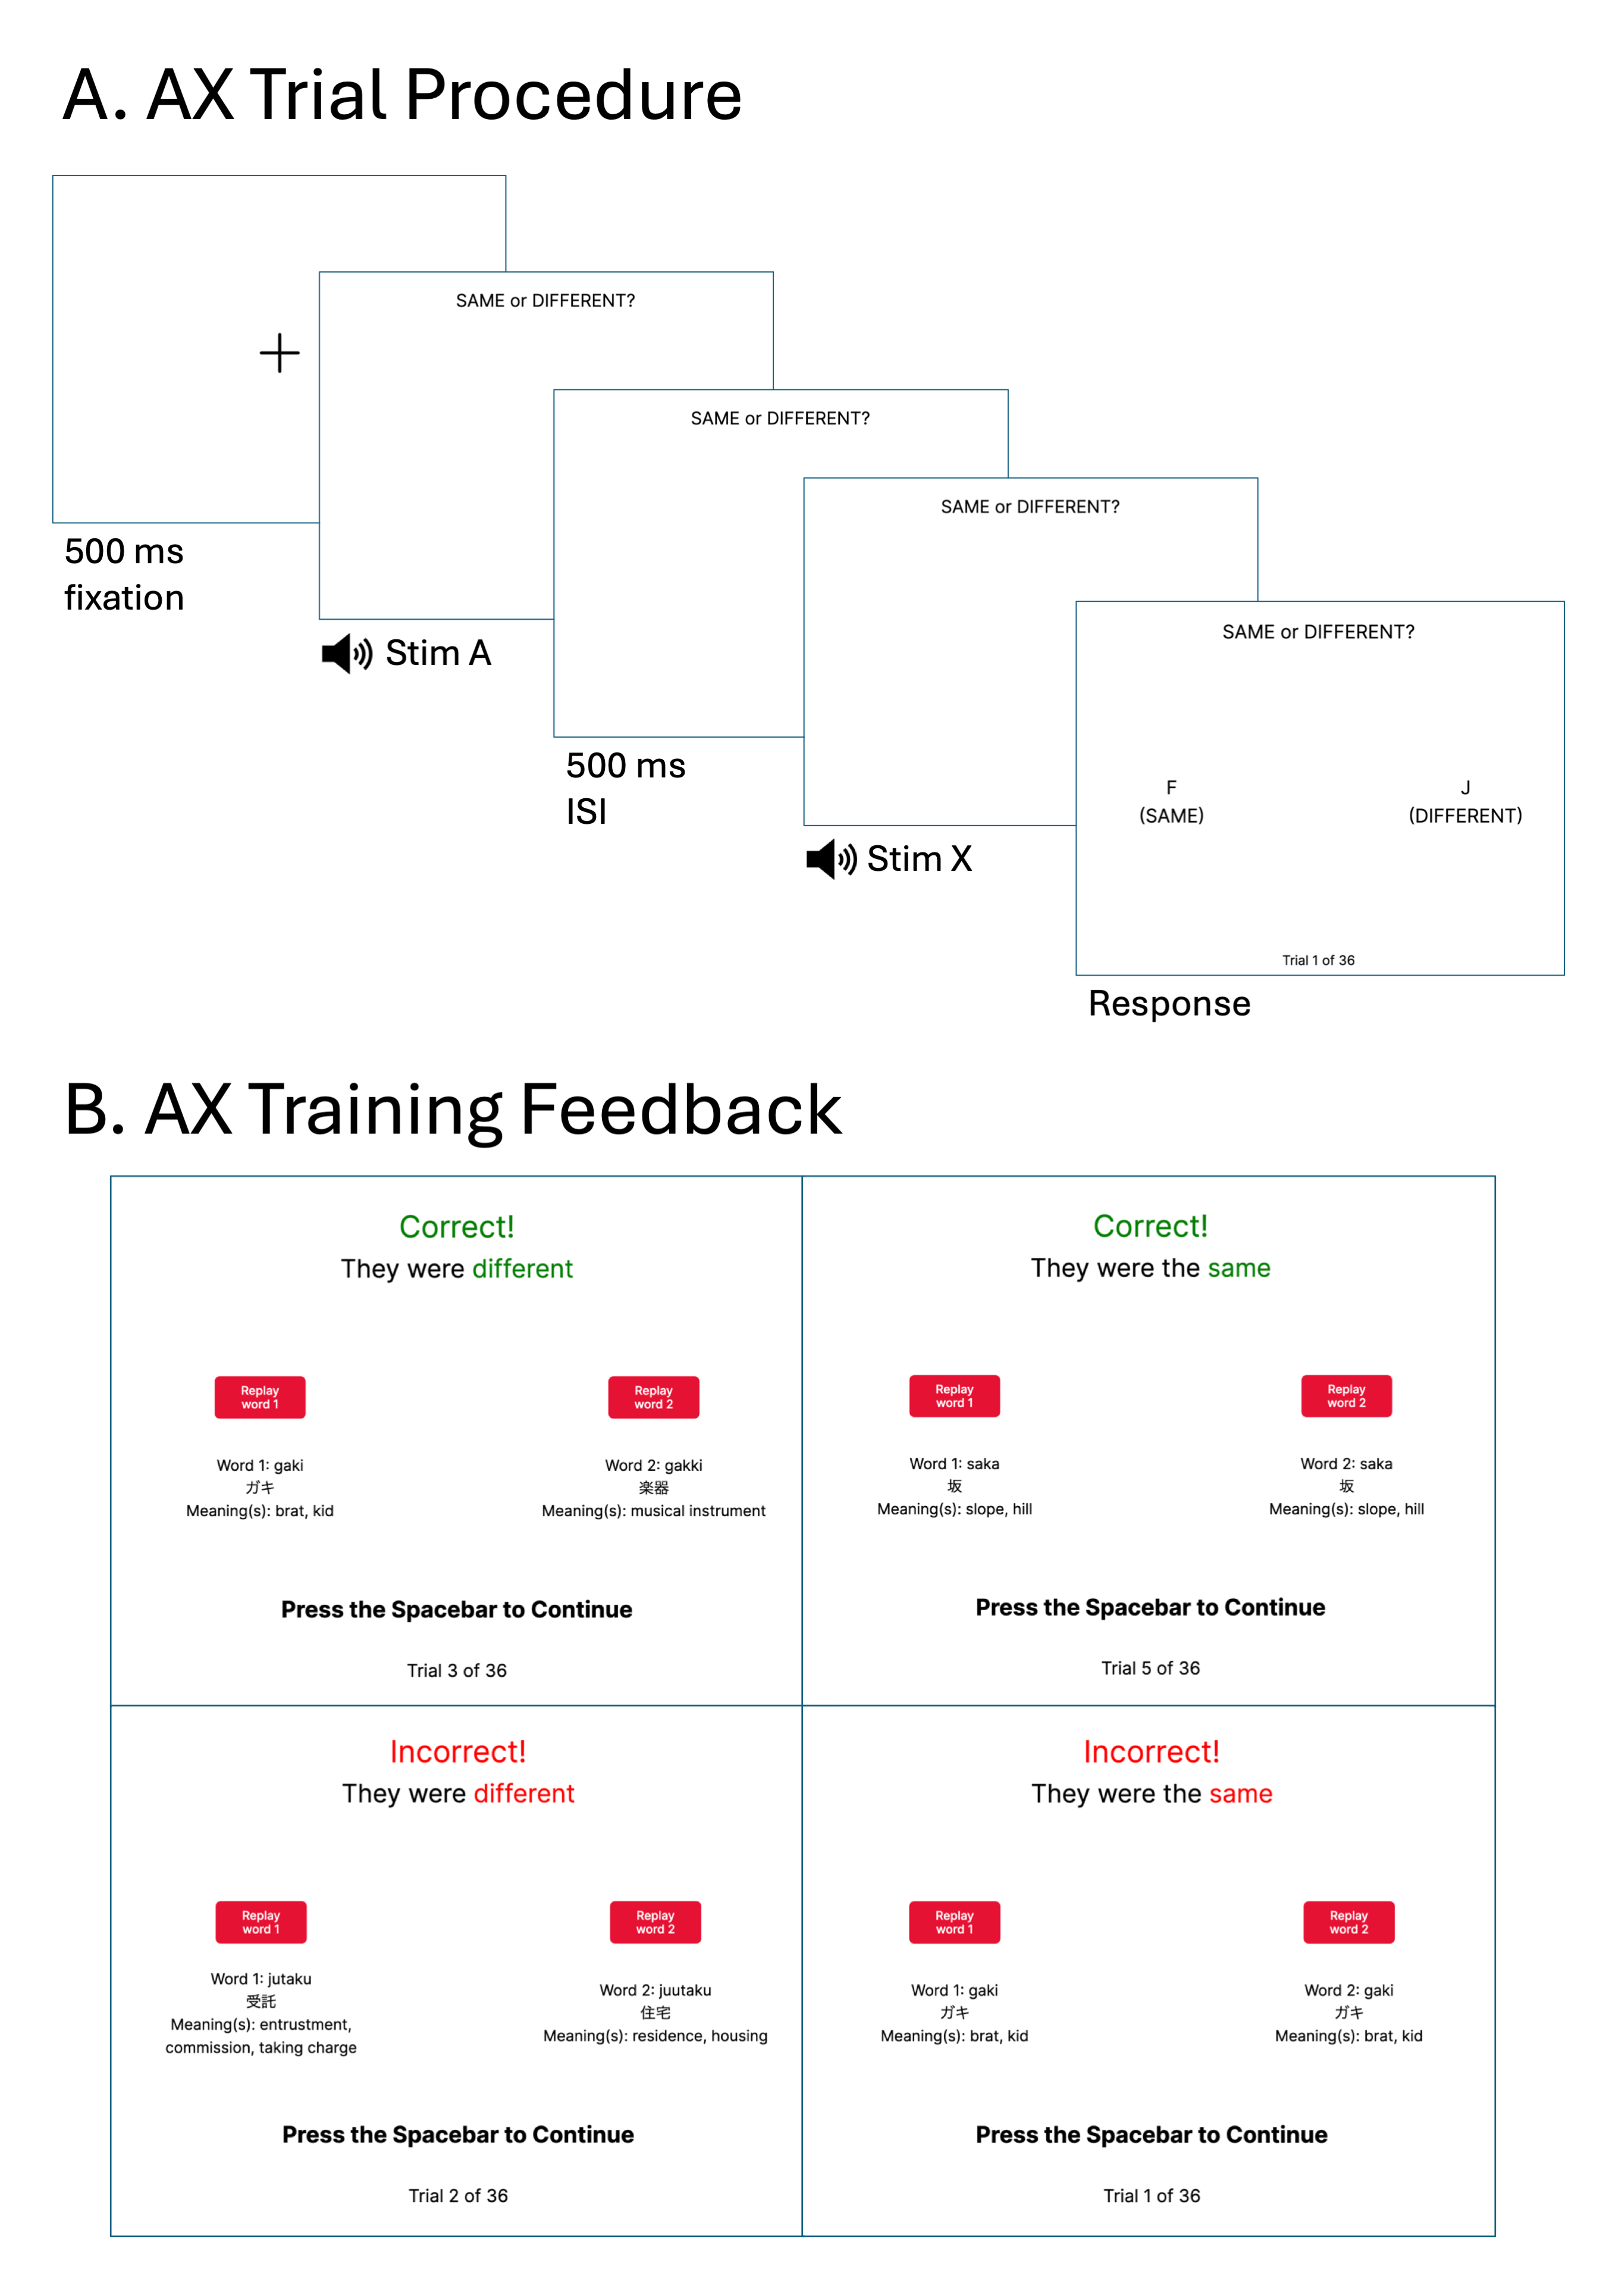
Figure 4.1: A. Procedure of AX discrimination trial procedure for both the training task and pre-posttests. B. Four possible of feedback screens displayed during AX discrimination training.
Each minimal pair was presented in four AX trial types: two “same” trial types (AA, BB) and two “different” trial types (AB, BA). The four trial types were repeated twice for each minimal pair, resulting in eight repetitions per pair. The speakers for stimuli A and X were independently randomized for each trial, meaning that trials were characterized both by the type of signal (“same” or “different”) and speaker congruency (whether A and X are spoken by the “same” or “different” speaker). This resulted in sixteen possible AX trial type x speaker congruency combinations (4²; A_{F}A_{F}, B_{F}B_{M}, A_{M}B_{F}, B_{M}A_{M}, etc.).
Participants were randomly assigned to either the Low LD (trained on Japanese minimal pairs only) or High LD (trained on Japanese and MSA minimal pairs) experimental groups. To equalize the number of training trials between the two experimental groups, the Japanese minimal pairs were repeated for the Low LD group. This decision was made based on previous research on the auditory category learning of non-speech stimuli with identification training, which showed no differences in learning outcomes when training with a full set of non-repeating stimuli versus a subset of stimuli repeated to achieve the same number of training trials (Obasih et al., 2023). Here, I made the assumption that this outcome would transfer to discrimination training with speech stimuli and that the Low LD group would not gain additional benefit from being exposed to more repetitions of the same Japanese minimal pairs compared to the High LD group.
There were 288 total training trials (High LD: 18 minimal pairs x 8 repetitions x 2 languages; Low LD: 18 minimal pairs x 16 repetitions), randomized and divided into eight blocks of 36 trials each. For the High LD group, trials were blocked by training language (and randomized within language), and block order was randomized across the four Japanese blocks and four MSA blocks. Participants were able to take a timed 20-second break between blocks. The training session took approximately 20-30 minutes to complete.
Before and after training, participants completed identical AX discrimination tests on minimal pairs not used in training. Participants were tested on novel minimal pairs in Japanese only and did not receive feedback. The trial procedure for testing was the exact same as in training, excluding the feedback, with the speaker used for stimuli A and X randomized per trial. Participants saw each of the four trial types (AA, BB, AB, BA) once per minimal pair, resulting in a total of 100 testing trials (25 minimal pairs x 4 trial types), randomized and divided into four blocks of 25 trials each. Participants were able to take a timed 15-second break between blocks. The pre-posttests took approximately 8-10 minutes to complete.

Data cleaning
Data from perceptual discrimination tasks are typically analyzed by using the Signal Detection Theory (SDT) framework (Hautus et al., 2021; MacMillan, 2002). In the case of AX speech discrimination tasks, the “signal” of interest which listeners must detect is the contrasting phonemes of minimal pairs. Participants responses to trials as “different” (they think they’ve detected the signal) and “same” (they think they’ve detected noise) are a function of some latent decision variable, which represents the amount of sensory information needed to make a response decision. The probability of responding “different” vs. “same” vary at different values of the decision variable, creating theoretical signal (responded “different”) and noise (responded “same”) distributions. Figure 4.2 (Ong & Coiera, 2011) presents a graphical representation of SDT and these theoretical signal and noise response distributions. Using SDT, one can estimate two perceptual constructs: sensitivity and bias. Sensitivity refers to the accurate detection of the signal of interest amidst noise. The estimate of sensitivity, d-prime (d’), is measured as the difference in means between the two distributions after standardizing the distributions values into z-scores (Figure 4.2A). Importantly, the calculation of d’ is unaffected by the estimate of response bias, c. Bias refers to a particular listener’s tendency to respond in particular way compared to a neutral baseline, regardless of the presence or absence of the signal (e.g., a preference for responding with “different”).
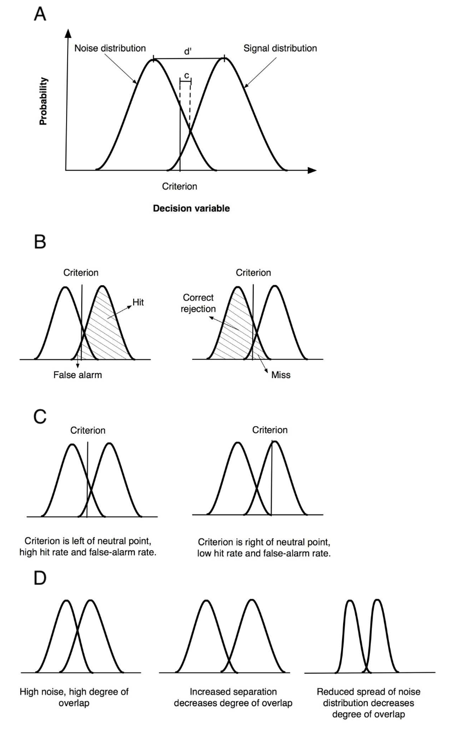
Figure 4.2: Visualization of Signal Detection Theory (from Ong and Coiera, 2011). A. Noise and signal response probability distributions as a function of a latent decision variable. D-prime (d') is calculated as the difference in distribution means and is independent from the calculation of response bias *c*. Bias *c* is calculated as the difference between the decision criterion to respond that the signal is present and the neutral point, which is the crossover between distributions. B. Types of responses for the signal response distribution (hit, false alarm) and noise response distribution (correct rejection, miss). C. The location of response criterion impacts the rate of hits and false alarms. D. Distribution attributes that affect the degree of overlap between the response distributions.
By the SDT framework, there are two ways to be correct in the AX discrimination task and two ways to be incorrect. Figure 4.2B depicts these outcomes as their parts of either the signal or noise response distribution, separated by the response criterion. An accurate response can occur by correctly detecting that two different stimuli were different (hit - signal detected) or detecting that two of the same stimuli were the same (correct rejection - noise identified). Consequently, an inaccurate response can occur by responding that two stimuli were the same when they were different (miss - signal not detected) or responding that two stimuli were different when they were the same (false alarm - noise misidentified). Thus, a simple calculation of response accuracy does not fully capture the sensory construct of perceptual sensitivity; for example, a participant who has a strong response bias and always responds with “different” would have 100% accuracy among the “different” trials but 0% accuracy among the “same” trials. Thus, to control for response bias, perceptual sensitivity is instead calculated by measuring accuracy based on the signal distribution (Figure 4.2B, left), that is, the trials where listeners responded with “different” regardless of whether the signal was present or absent. Mathematically, d’ is calculated as the z-scored hit rate minus the z-scored false alarm rate. The hypothetical participant who responds “different” 100% of the time only has a 50% sensitivity accuracy when accounting for response bias, because only half of the trials to which they responded “different” truly contained the “different” signal. Figure 4.2C shows how different values of response criterion changes the hit rate and false alarm rate, though it is critical to note the two examples still result in the same sensitivity d’ value as the distribution means are separated by the same distance, reinforcing the idea that d’ is independent response bias. Additionally, the degree to which these distributions overlap corresponds with the degree to which noise obfuscate the signal, and a listener’s sensory sensitivity dictates their ability to separate the distributions enough to maximize hits while minimizing false alarms (Figure 4.2D). The spread of the distributions also contributes to the degree of sensory strength of the signal, as a larger spread of noise further obfuscates the signal by increasing the overlap between distributions, while a lower spread of noise reduces the overlap between distributions.
Although d’ can be simply mathematically calculated, a more effective analysis method to analyze discrimination data is to estimate d’ through a statistical model. In the d’ equation, hit rate and false alarm rate are obtained by averaging over trial responses, which masks variability in response decision from trial-to-trial and across minimal pairs. A generalized linear model can be used to estimate d’ by predicting participant responses as a function of the true trial signal and other predictors that may comprise the latent decision variable. This method is preferred over using the manual calculation of d’ as a continuous outcome variable in a statistical model, as it allows for the predictor covariates to contribute to explaining trial-level and item-level variability in the estimation of d’ while still controlling for response bias.
The statistical model used to estimate d’ from the discrimination pretest and posttest data was a generalized linear mixed-effects model of a binomial distribution with a probit link transformation. The binomial model with the probit link predicts the probability of one of two responses from the participant (“different” = 1, “same” = 0), based on the true signal of the trial (“different” or “same”) and models whether other variables moderate this effect (Wright et al., 2009). This analysis method was chosen as it has been successfully used before in previous literature that examined how categorization gradiency and consistency predicted non-native discrimination sensitivity (Fuhrmeister et al., 2023).
As the statistical model estimates d’ at the trial-level, very little data pre-processing was needed. However, the data were cleaned and filtered prior to fitting the model. Starting with the full dataset (19300 trials from n = 103 participants), participants who did not return for Day 2 were first removed from the data. From the remaining data (16000 trials from n = 80 participants), reaction times (RTs) were natural log-transformed to normalize the RT distributions. The data were filtered on a per participant basis to remove trials with log-RTs three median absolute deviations (MAD) above or below the participant’s median log-RT (15654 trials). From here, all trials with raw RTs above 10 s and below 150 ms were removed from the data. The upper threshold was chosen to exclude trials unlikely to reflect task engagement while minimizing unnecessary data loss, and the lower threshold was chosen to exclude trials unlikely to reflect true cognitive processing as the RT was under the typical minimum RT needed for physiological stimulus perception and motor responses (Whelan, 2008). The final dataset consisted of 15236 trials from n = 80 participants.
The reaction time data from the discrimination pretest and posttest were also analyzed, as RT is another proxy measurement of learning; in general, faster RTs at posttest reflect faster processing after a period of training and suggest that learning has occurred. The log-transformed RTs at pre- and posttest were modeled with a linear mixed-effects model to investigate the effects of experimental condition and VAS measures on change in accurate discrimination speed. The data fit to the reaction time model were further filtered from the dataset used in the d’ estimation model to include only correct trials, resulting in 11876 trials from n = 80 participants.

LDQ
Participants completed the LDQ, which is described in detail in Section 3.1.3 and can be found in Appendix A. As in Study 1, the LDQ was used to measure active and passive use of and exposure to linguistic diversity through one’s language background, history, use, and experiences. The LDQ produced two aggregate scores for indices of experiential linguistic diversity: Active Multilingual Language Diversity (MLD-A) and Passive Multilingual Language Diversity (MLD-P). While experiential linguistic diversity was not a variable of interest for RQ2, the MLD-A and MLD-P scores were added to the statistical analyses as control variables. Figure 4.3 shows the distribution of the calculated MLD-A and MLD-P scores for the n = 80 participants included in the analyses. These histograms show that a majority of participants reported active and/or passive use of only one language, English. Of the 80 participants, 18 had non-zero MLD-A scores, 23 has non-zero MLD-P scores, and 8 had non-zero scores for both.
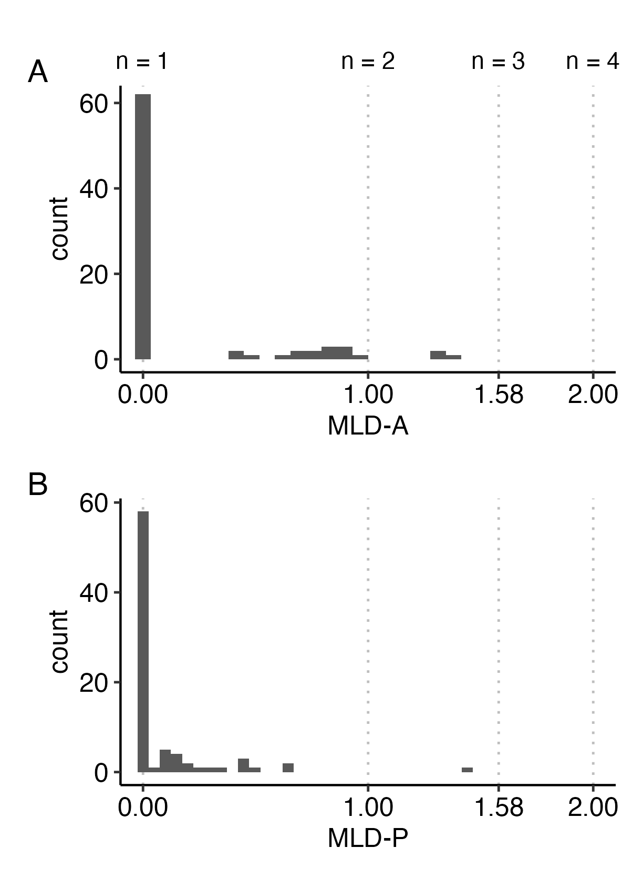
Figure 4.3: Histograms of MLD-A (A) and MLD-P (B) scores calculated from the LDQ. Grid lines indicate the score corresponding to balanced use of n languages. Scores in between these breakpoints represent imbalanced use of two, three, and four languages as MLD scores approach 1, 1.58, and 2, respectively.

Analyses and Results

Analysis models and predictions
Recall that RQ2 asks: Can we promote gradient categorization in listeners through specific exposure to linguistic diversity via perceptual training? If so, does gradient categorization increase perceptual sensitivity to discriminate between target language phonemic contrasts? Much like Study 1, the original research plan for Study 2 had involved using the L1 and L2 slope and response variability VAS measures estimated by the logistic curve fit in latent profile analysis (LPA) to bin participants into the three a priori response profiles hypothesized by the work of Kutlu et al. (2024) of categorical (high slope, low variability), gradient (low slope, low variability), and noisy (low slope, high variability) response patterns. Using the estimated LPA profiles at each the pretraining and posttraining time points, the analysis plan then proposed to use latent transition analysis (LTA) to estimate the transition probability of an individual transitioning to Profile B at Time 2 given profile membership in Profile A at Time 1 (Nylund-Gibson et al., 2023) for L1 and L2 categorization. The LTA transition probabilities would have been used in the subsequent statistical analyses to answer RQ2 and explore the extent to which the AX training condition predicted transitioning to the gradient response pattern profile at Time 2 given categorical or noisy profile membership at Time 1. However, here too, the Study 2 sample’s estimated slope and response variability data did not support the 3-profile hypothesis at either Time 1 or Time 2. Thus, instead of combining them, I used the z-transformed slope and response variability values separately in the subsequent analyses to answer RQ2.
To answer the first part of the question, I fit a Bayesian multivariate mixed-effects regression model to examine the effects of specific linguistic diversity delivered via perceptual discrimination training on changes in VAS slope and response variability. The model was fit using the brms R package (Bürkner, 2017). VAS slope and response variability were the response variables. Day (pretraining on Day 1 vs. posttraining on Day 2), VAS contrast language (L1 English vs. L2 Japanese), and AX discrimination training condition (Low LD vs. High LD) were used as predictor variables, including their interactions, while MLD-A, MLD-P, and the baseline AX discrimination sensitivity (d’) at pretest were used as control variables. The AX pretest d’ value was manually calculated using the dprime function of the psycho R package (Makowski, 2018).
The random effects included random intercepts by participant and AX word pair, which allows for VAS slope and response variability to vary across participants and contrast pairs on day 1. Random slopes for day and contrast language were also modeled by participant. The residual correlation between VAS slope and response variability was moderately negative (median = -0.36, 95% CrI [-0.44, -0.26]), which robustly supports the use of the multivariate model over multiple univariate models.
While mostly exploratory, I did hypothesize a change in VAS measures after a short period of training, so I predicted a significant effect of Day and a significant interaction with AX training condition such that the changes in VAS slope and response variability from Day 1 to Day 2 would be different between the two training conditions. Specifically, I predicted that both groups would show changes in VAS measures towards more shallow slopes and lower response variability, but that this effect would be stronger for the High LD condition group. The addition of the interaction terms with VAS contrast language was largely exploratory, as I did not have specific predictions as to how the changes in VAS measures would be different between L1 and L2 categorization.
To answer the second part of the question, I ran a generalized linear mixed-effects model of the binomial distribution with the probit link function to examine the effects of the linguistic diversity training paradigm and L1/L2 VAS categorization measures on changes in L2 discrimination sensitivity. Discrimination sensitivity was modeled at the trial level by predicting participant response (“different” = 1, “same” = 0) as a function of the true signal of the trial (numerically transformed such that “different” = 0.5, “same” = -0.5), day (pretest on Day 1 vs. posttest on Day 2), and AX training condition (simple effects coded: Low LD = -0.5, High LD = 0.5) and their three way interactions. These three predictor variables were also interacted with L1 and L2 VAS slope and response variability (averaged between the within-language contrast pairs to obtain a singular estimate of slope and response variability for L1 English and L2 Japanese). The effect coefficient of signal using the probit link function represents the SDT measure of sensitivity (d’), and interaction effects with signal represent changes in d’ as a function of the interacting predictor. MLD-A and MLD-P were included as control variables, as well as the congruency of speaker identity (i.e., whether the speaker for Word A and Word X was the same or different) to control for the fact that discrimination may be easier for trials for which the speaker is congruent between stimuli A and X. Speaker congruency (Speaker Signal in the model) as a control variable was simple effects coded (“different” = 0.5, “same” = -0.5).
The model also included random intercepts and random slopes for signal, by participant and AX word pair, which accounts for inherent differences between participants in discrimination ability and inherent differences in difficulty between different stimuli word pairs of stimuli. A random slope of the interaction between signal and day was also modeled by participant to allow participants to vary in their degree of change in d’ from Day 1 to Day 2.
The AX discrimination reaction time data were analyzed using a linear mixed-effects model to predict log-transformed RT of correct trials as a function of day, AX training condition, and their interactions with L1 and L2 VAS slope and response variability. The model also included MLD-A, MLD-P, and speaker congruency as control variables. Random intercepts were modeled by participant and AX word pair, as well as a random slope for day by participant.
For both of these models, I predicted that both experimental groups would improve in discrimination sensitivity, resulting in higher d’ scores and faster RTs for Day 2, and I predicted a significant interaction with experimental group based on the hypothesis that those in the High LD experimental group would show greater improvements in both measures than the Low LD group. I had initially predicted that those showing gradient categorization patterns after training would also see greater improvement in the discrimination measures, compared to those showing posttraining categorical and noisy categorization patterns. However, due to being unable to use LTA probabilities of profile membership across time as a predictor variable, the inclusion of the L1 and L2 VAS measures in the current models are largely exploratory rather than confirmatory.

VAS pre- and posttraining results

Descriptive statistics
Figure 4.4 shows some examples of the VAS response curve fitting output. The figure serves to display the diversity of response patterns among participants. Figure 4.4A shows examples of categorical, gradient, and in-between response curves at levels of low, mid, and high response variability. Figure 4.4B shows several examples of noisy or unconventional response curves. For example, the middle row of Figure 4.4B shows three participants who had low amplitude between the minimum and maximum asymptotes of the curve, indicating consistent use of only a small range of ratings across the entire continuum. The bottom row also shows examples of reversed categorization, as these participants responded with high ratings (near 100, Word B) at lower steps of the primary acoustic dimension (which correspond with Word A), and vice versa. Although this figure shows just a small subset of the data, these responses patterns from the VAS task showcase the range of individual differences in categorization gradiency and consistency across the different L1 and L2 phoneme pairs.
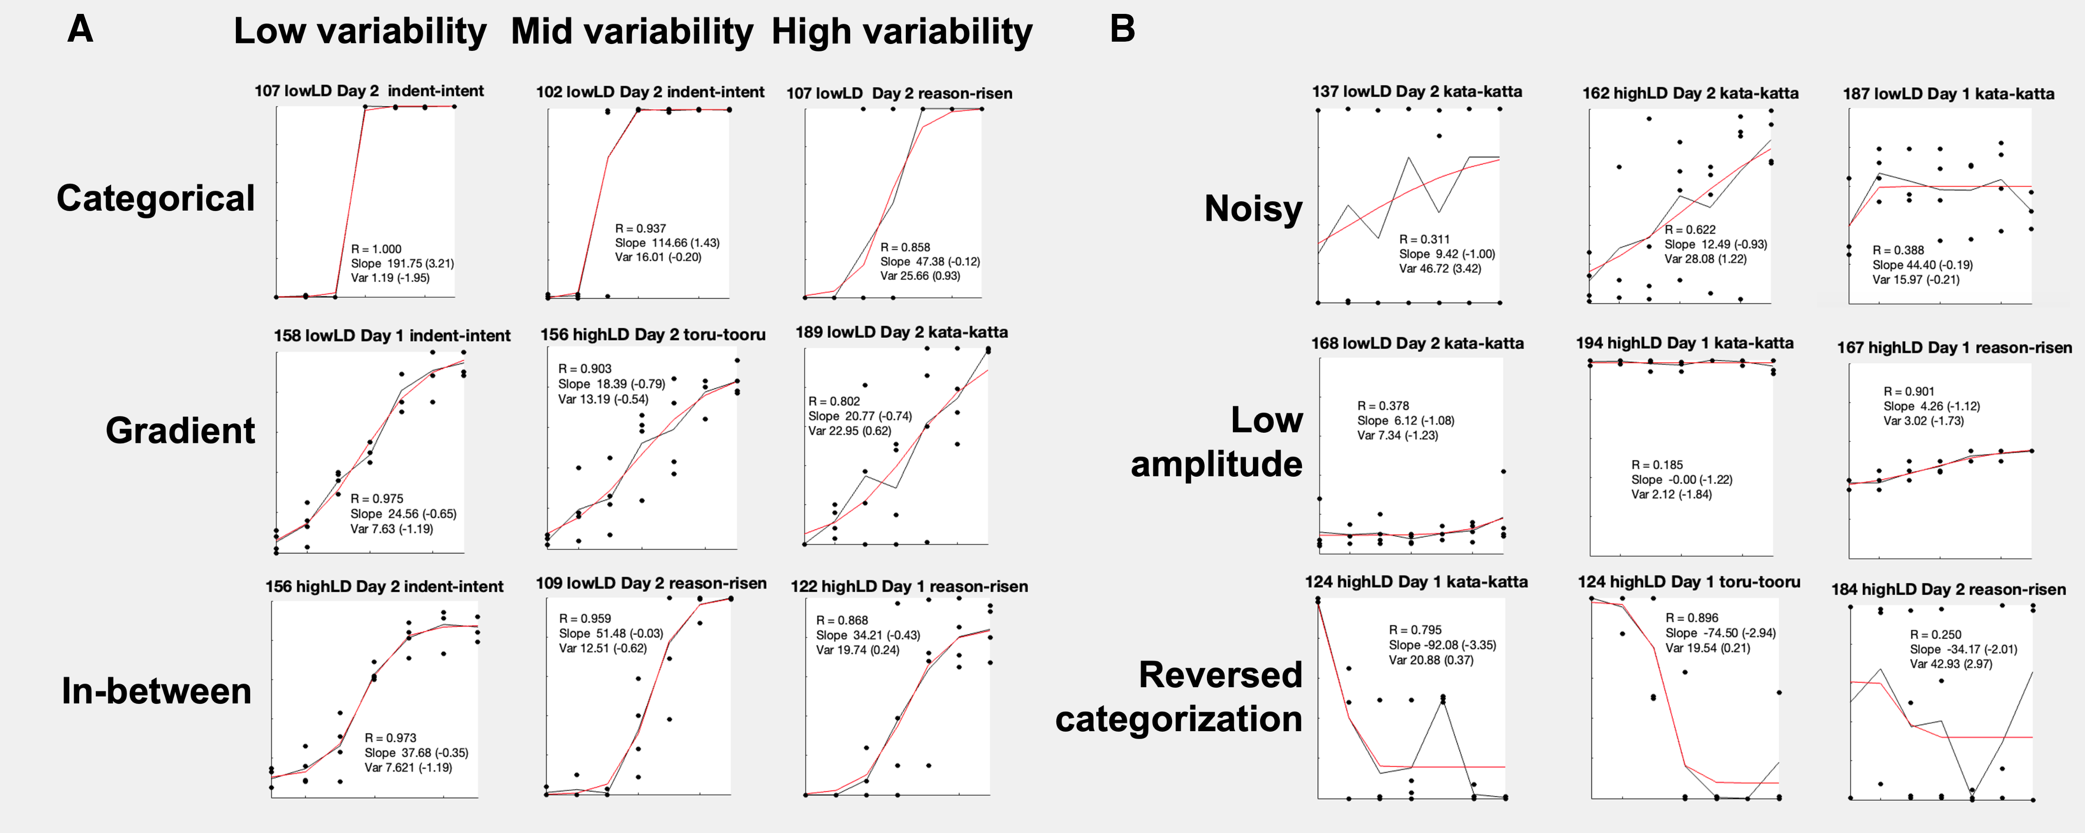
Figure 4.4: Examples of VAS response curves as a function of primary dimension step from the logistic curve fitting process. Above each subplot is the participant ID, their AX training condition, and the day and contrast pair for which the response curve was estimated. The x-axis represents primary dimension step (steps 1-7) and the y-axis represents VAS rating (0-100). Each subplot shows the mean curve (black line) at each step of the primary dimension based on the observed data (black points) compared to the estimated logistic curve (red line). Each subplot is labeled with the correlation between the data and the fit (R), and the raw values of estimated slope and response variability (z-scored slope and response variability in parentheses). A. Examples of categorical, gradient, and in-between response curves with low, mid, and high levels of response variability. B. Examples of unconventional response patterns, including noisy patterns with extremely high response variability, response curves with low amplitudes between the min and max asymptotes and extremely low response variability, and reversed categorization patterns with high response variability, suggesting noisy and potentially confused categorization patterns.
Figure 4.5A plots the two-dimensional space of the VAS slope and response variability measures from the curve fit estimation, by day, VAS pair, and AX training condition. Each subplot has two dots per participant, one per day, and Figure 4.5B adds arrows to plot the trajectory of each participant’s change in VAS slope and response variability from Day 1 to Day 2, along with the group-level Day 1 and Day 2 spread for each subplot (dashed ellipses).
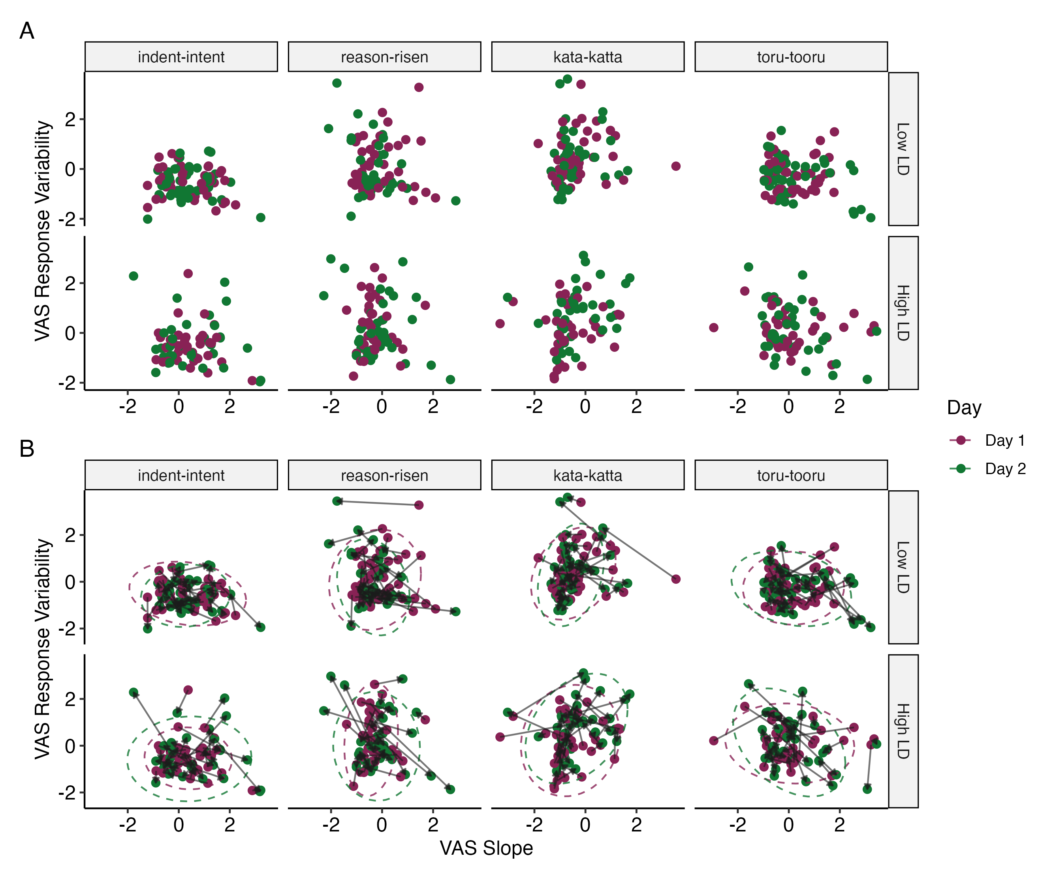
Figure 4.5: A. VAS slope (x-axis) and response variability (y-axis) of each participant on Day 1 (raspberry dots) and Day 2 (green dots) by contrast pair and AX training condition (Low LD n = 42, High LD n = 38). B. Same as A, but with directional arrows and summary ellipses. The directional arrows plot the change in VAS slope and response variability from Day 1 to Day 2 by participant. The colored dashed ellipses represent the 95% confidence interval about the x-y coordinates representing the pair-by-condition group mean for slope and response variability on Day 1 (raspberry) and Day 2 (green), assuming a bivariate t-distribution.
This figure has several purposes. It shows individual-level trajectories for change in slope and response variability from pretraining to posttraining. It also shows group level trends by contrast pair and AX training condition. This figure would reveal if, for example, there was a group-level trend that reflected a change towards gradient response patterns (low slope, low variability); we would expect to see most of the arrows pointing down and to the right , and the green ellipses would also be shifted relative to the raspberry ellipse to indicate such a trend. If there was a group-level trend that reflected a change towards categorical response patterns (high slope, low variability), we would expect to see most of the arrows pointing down and to the left, and for the green ellipse to be shifted as well. Similarly, if there were differential effects in change in slope and response variability based on training condition, assuming no difference at pretraining between the condition groups, we would see clear differences in the change from the raspberry ellipse to the green ellipse between the Low LD and High LD groups.
Instead, on visual inspection, the overall directions of the arrows indicate that there was not a consistent group-level trend in any particular direction from before to after training for either of the training condition groups nor for any of the contrast pairs. The change in the Day 1 to Day 2 ellipses further imply that any group-level changes reflected a change in the spread of the bivariate distributions rather than the location means for slope and response variability. For example, the Day 1 to Day 2 change in VAS slope and response variability for the indent-intent contrast pair for the Low LD training condition indicate that the group’s distribution decreased in spread for VAS slope (smaller diameter of the green ellipse in the horizontal plane of direction), while the High LD training condition shows that the group distribution increased for both VAS slope and response variability (larger diameter of the green ellipse in both planes of direction). This figure serves to visualize both individual and group-level trends in changes in VAS slope and response variability, which are further statistically explored using the Bayesian multivariate mixed effects model.

Effect of predictors on change in VAS slope and response variability
The results of the Bayesian multivariate mixed-effects model predicting change in the VAS response curve measures of slope and response variability from pretraining (Day 1) to posttraining (Day 2) are presented in Table 4.4. The model estimated the median of the posterior probability distribution b of the predictor and interaction effects, the 95% highest-density interval (HDI) as the 95% credible interval (CrI), and the p-value based on the Probability of Direction (pd) reflecting the degree of confidence in the direction (positive or negative) of the effect. The random effects parameters of the model, including the standard deviation of the random intercepts and slopes, their correlations, and indices of model fit are presented in Table 4.5.
Table 4.4: Fixed Effects of the Bayesian Multivariate Mixed-Effects Model Predicting VAS Slope and Response Variability by Day.
 |  | VAS Slope |  |  | VAS Response Variability
Predictor |  | Estimate | 95% CrI | pd-p | Estimate | 95% CrI | pd-p
Day 1:
 | Intercept (Day 1) | -0.08 | [-0.76, 0.67] | 0.75 | 0.01 | [-0.67, 0.69] | 0.97
 | Contrast Language | -0.17 | [-1.19, 0.90] | 0.70 | 0.28 | [-0.76, 1.29] | 0.52
 | AX Training Condition | -0.08 | [-0.35, 0.21] | 0.59 | 0.07 | [-0.22, 0.34] | 0.64
 | Contrast Language x  AX Training Condition | -0.08 | [-0.40, 0.25] | 0.64 | 0.13 | [-0.20, 0.48] | 0.45
Change from Day 1 to 2:
 | Change from Day 1 to 2 | 0.01 | [-0.10, 0.12] | 0.86 | -0.03 | [-0.13, 0.08] | 0.64
 | Contrast Language | -0.04 | [-0.24, 0.17] | 0.68 | 0.15 | [-0.05, 0.35] | 0.16
 | AX Training Condition | 0.15 | [-0.06, 0.37] | 0.17 | 0.15 | [-0.05, 0.37] | 0.15
 | Contrast Language x  AX Training Condition | -0.09 | [-0.47, 0.31] | 0.64 | 0.10 | [-0.28, 0.50] | 0.60
Key: Estimate = median of the posterior probability distribution; CrI = Credible Interval (95% highest-density interval); pd-p = p-value calculated from Probability of Direction (pd)
Model formula: (VAS Slope, VAS Response Variability) ~ Day * Contrast Language * AX Training Condition + MLD-A + MLD-P + Day 1 Discrimination Sensitivity + (1 + Day + Contrast Language | Participant) + (1 | VAS Pair); italics = control variables (effects not included in table)
Notes: The variable Day was dummy coded (Day 1 = reference level). VAS Contrast Language was simple effects coded (English = -0.5, Japanese = 0.5). AX Training Condition was simple effects coded (Low LD = -0.5, High LD = 0.5). pd-p was calculated using the bayestestR R package (v0.16.0; Makowski et al., 2019).
The analysis revealed that there were no robust effects on VAS slope and response variability, as all the predictors had credible intervals that contained zero. These results suggest that not only did AX training condition have no effect on changing VAS slope and response variability for either L1 or L2, but that VAS slope and response variability at the group-level did not significantly change at all from pretraining to posttraining.
Table 4.5: Random Effects and Model Fit of the Bayesian Multivariate Mixed-Effects Model Predicting VAS Slope and Response Variability by Day.
 |  | VAS Slope |  |  | VAS Response Variability
Group | Random Effect | SD  [95% CrI] | Int. ~ Slope Corr. | Slope ~ Slope Corr. | SD  [95% CrI] | Int. ~ Slope Corr. | Slope ~ Slope Corr.
Participant | Intercept | 0.52  [0.42, 0.64] |  |  | 0.53  [0.42, 0.65]
 | Day | 0.06  [0.00, 0.18] | -0.09  [-0.89, 0.81] |  | 0.10  [0.00, 0.25] | 0.35  [-0.42, 0.99]
 | Contrast Language | 0.38  [0.19, 0.57] | 0.09  [-0.35, 0.49] | -0.18  [-0.97, 0.70] | 0.45  [0.29, 0.61] | -0.06  [-0.42, 0.31] | -0.31  [-0.95, 0.61]
VAS Pair | Intercept | 0.50  [0.16, 1.31] |  |  | 0.46  [0.15, 1.25]
Residual | Residual | 0.57  [0.51, 0.63] |  |  | 0.54  [0.48, 0.59]
Bayes R^{2Note}
 |  | 0.40  [0.34, 0.46] |  |  | 0.48  [0.42, 0.53]
Residual Correlation^{Note}
 | VAS Slope ~  VAS Resp. Var. |  |  | -0.36  [-0.44, -0.26]
N_{Participant} | 80 | N_{VAS} _{Pair} | 4 | N_{observations} | 640
Key: SD = Standard Deviation; CrI = Credible Interval (95% highest density interval); Int. = Intercept; Cor. = Correlation; Resp. Var. = Response Variability
Model formula: (VAS Slope, VAS Response Variability) ~ Day * Contrast Language * AX Condition Group + MLD-A + MLD-P + Day 1 Discrimination Sensitivity + (1 + Day + Contrast Language | Participant) + (1 | VAS Pair); italics = control variable
^{Note}The estimated Bayes R² values for each response variable are presented with the 2.5% and 97.5% quantile range. The estimated Residual Correlation between the response variables is presented with the 95% uncertainty interval.
Figure 4.6 shows the estimated marginal effects for VAS slope and response variability at the contrast language by training condition group level, estimated and visualized using the emmeans R package (Lenth, 2025). As evidenced by the wide CrIs, these figures show that at the group level, there was no strong evidence that participants changed in their VAS measures from pre- to posttraining, for L1 or L2, nor did the two training condition groups show robustly different trends. Thus, the hypothesis proposing that specific linguistic diversity delivered via a perceptual training paradigm would push listeners to more gradient VAS response patterns was not supported.
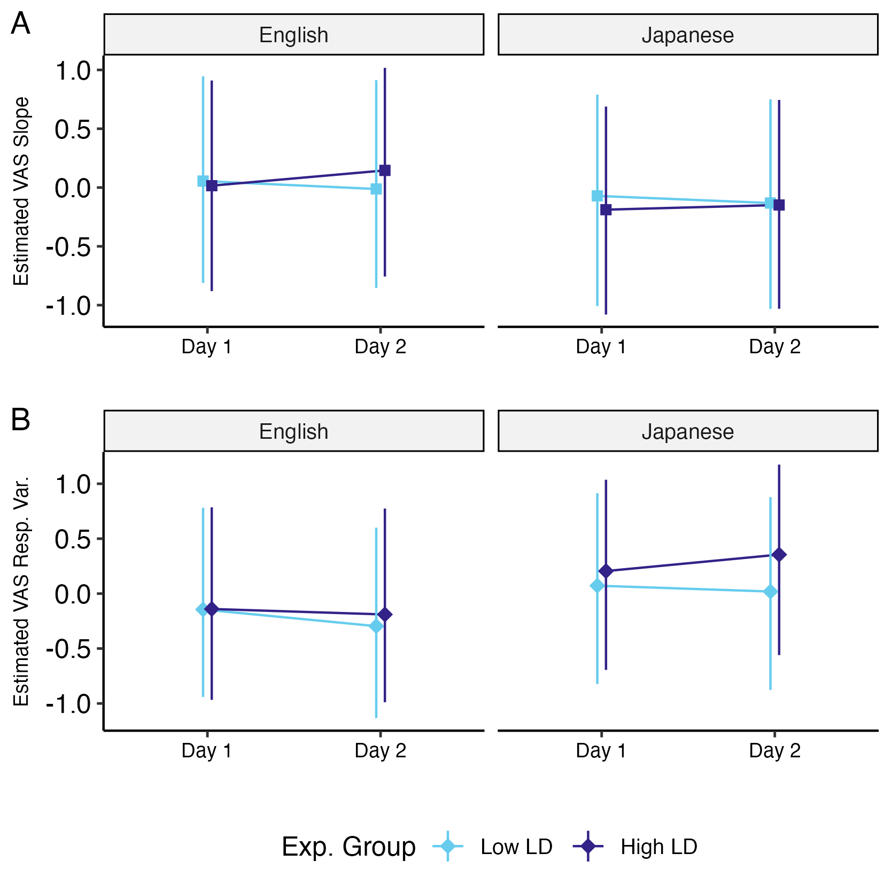
Figure 4.6: Estimated marginal effects for VAS slope (A) and response variability (B) at Day 1 and Day 2 by VAS contrast language and AX training condition, at mean values of covariates. The figure plots the estimated median of the marginal effects with 95% highest density interval as the credible interval (CrI).

AX discrimination pre- and posttest results

Effect of predictors on change in discrimination sensitivity
The generalized linear mixed-effects model was run to examine the effects of training condition and VAS measures on change in AX discrimination sensitivity from pre- to posttest. As shown in Figure 4.7, both groups showed improvement in d’ scores from Day 1 to Day 2, indicating increased sensitivity after training. However, both groups showed similar degrees of improvement, suggesting no clear differential effects of training condition on d’ improvement.
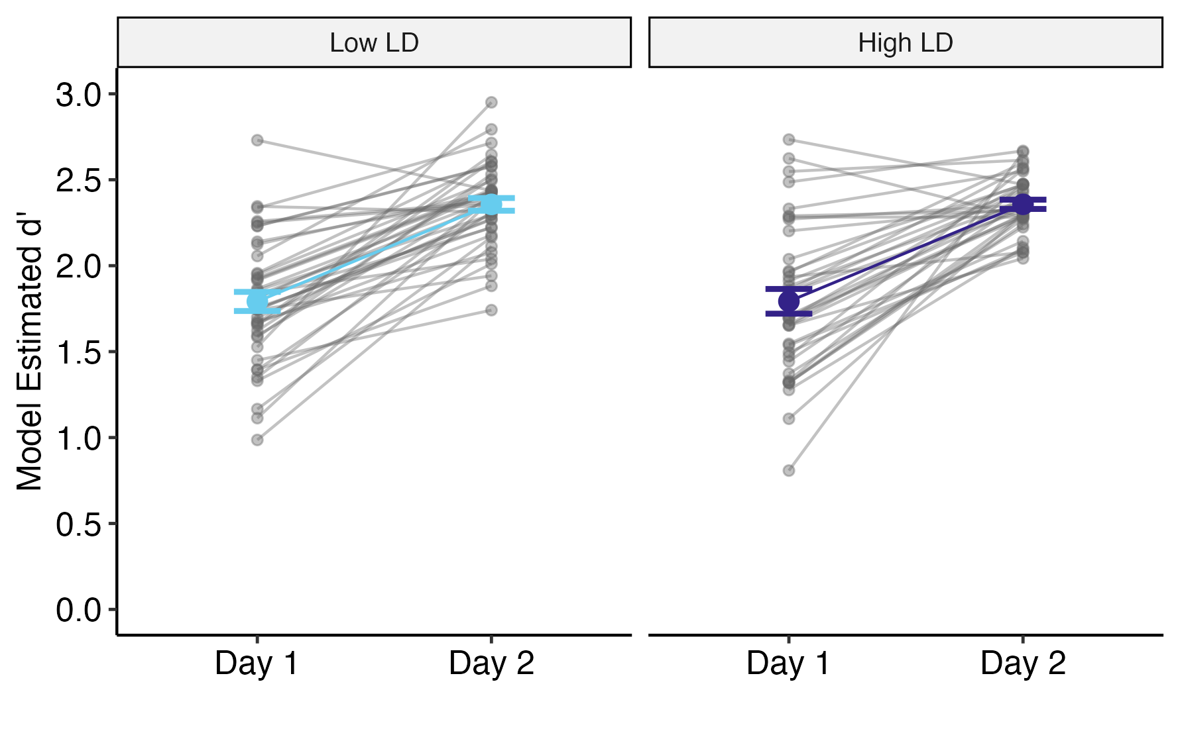
Figure 4.7: Model-estimated Day 1 and Day 2 d' values by experimental condition group. Gray lines represent individual participant trajectories from Day 1 to Day 2. Colored points and error bars indicate group means with standard error of the mean.
Table 4.6 presents the results of the model. Only the effects of Signal, which is the model estimate of d’, and its interactions with other predictors are presented in the table, as d’ was the main effect of interest. There was a significant main effect of signal (b = 1.79, 95% CI [1.51, 2.07], p < .001), which indicates that the mean d’ score on Day 1 was 1.79, representing the baseline sensitivity across mean values of all other factors. Statistically, this d’ value indicated that participants on average responded “different” more than “same” when the true signal was “different”. There was additionally a significant interaction between Day and Signal (b = 0.57, 95% CI [0.34, 0.79], p < .001), which indicates that on average, participants increased in perceptual sensitivity and responded with “different” more than “same” to a greater degree for “different” trials after training, as was shown in Figure 4.7. However, the only gradiency measure that significantly predicted d’ was L1 English Response Variability on Day 1. The interaction between Signal and L1 Resp. Var. suggested that higher L1 response variability predicted (b = -0.25, 95% CI [-0.51, 0.00], p = 0.048), indicating that having a higher L1 response variability predicted lower perceptual sensitivity before training. No other VAS measures, for either L1 or L2, significantly predicted discrimination pretest baseline sensitivity or change in sensitivity after training.
Table 4.6: Fixed Effects of the Binomial Generalized Linear Mixed-Effects Model Predicting AX Discrimination Sensitivity by Day.
Predictor |  | Estimate [95% CI] | SE | z | p
Day 1:
 | Signal (d’) | 1.79 [1.51, 2.07] | 0.14 | 12.50 | < .001***
 | d’ x Low LD vs. High LD | 0.12 [-0.24, 0.49] | 0.19 | 0.67 | 0.506
 | d’ x L1 VAS Slope | 0.05 [-0.27, 0.36] | 0.16 | 0.29 | 0.772
 | d’ x L1 VAS Resp. Var. | -0.25 [-0.51, 0.00] | 0.13 | -1.98 | 0.048*
 | d’ x L2 VAS Slope | -0.05 [-0.28, 0.18] | 0.12 | -0.43 | 0.667
 | d’ x L2 Resp. Var. | 0.18 [-0.16, 0.53] | 0.18 | 1.05 | 0.294
 | d’ x L1 VAS Slope x L1 VAS Resp. Var. | -0.11 [-0.51, 0.29] | 0.20 | -0.55 | 0.584
 | d’ x L2 VAS Slope x L2 VAS Resp. Var. | 0.16 [-0.26, 0.59] | 0.22 | 0.76 | 0.450
 | d’ x Low LD vs. High LD x  L1 VAS Slope^{(A1)} | -0.35 [-0.97, 0.28] | 0.32 | -1.08 | 0.279
 | d’ x Low LD vs. High LD x  L1 VAS Resp. Var.^{(B1)} | 0.00 [-0.51, 0.52] | 0.26 | 0.02 | 0.985
 | d’ x Low LD vs. High LD x  L2 VAS Slope^{(A3)} | 0.22 [-0.23, 0.66] | 0.23 | 0.96 | 0.337
 | d’ x Low LD vs. High LD x  L2 VAS Resp. Var.^{(B3)} | -0.05 [-0.71, 0.61] | 0.34 | -0.15 | 0.878
 | d’ x Low LD vs. High LD x  L1 VAS Slope x L1 VAS Resp. Var. | -0.02 [-0.83, 0.80] | 0.42 | -0.04 | 0.967
 | d’ x Low LD vs. High LD x  L2 VAS Slope x L2 VAS Resp. Var. | 0.32 [-0.45, 1.09] | 0.39 | 0.81 | 0.419
Change from Day 1 to 2:
 | Change in d’ from Day 1 to 2 | 0.57 [0.34, 0.79] | 0.11 | 4.97 | < .001***
 | d’ x Low LD vs. High LD | -0.11 [-0.56, 0.33] | 0.23 | -0.51 | 0.611
 | d’ x L1 VAS Slope | 0.09 [-0.29, 0.47] | 0.19 | 0.45 | 0.652
 | d’ x L1 VAS Resp. Var. | 0.26 [-0.05, 0.56] | 0.16 | 1.66 | 0.097
 | d’ x L2 VAS Slope | 0.09 [-0.19, 0.36] | 0.14 | 0.60 | 0.547
 | d’ x L2 Resp. Var. | -0.29 [-0.66, 0.08] | 0.19 | -1.55 | 0.122
 | d’ x L1 VAS Slope x L1 VAS Resp. Var. | 0.07 [-0.38, 0.51] | 0.23 | 0.29 | 0.771
 | d’ x L2 VAS Slope x L2 VAS Resp. Var. | -0.16 [-0.63, 0.30] | 0.24 | -0.68 | 0.494
 | d’ x Low LD vs. High LD x  L1 VAS Slope^{(A2)} | 0.06 [-0.75, 0.88] | 0.42 | 0.16 | 0.876
 | d’ x Low LD vs. High LD x  L1 VAS Resp. Var.^{(B2)} | -0.20 [-0.82, 0.42] | 0.32 | -0.64 | 0.524
 | d’ x Low LD vs. High LD x  L2 VAS Slope^{(A4)} | -0.33 [-0.89, 0.22] | 0.28 | -1.18 | 0.239
 | d’ x Low LD vs. High LD x  L2 VAS Resp. Var.^{(B4)} | -0.05 [-0.78, 0.67] | 0.37 | -0.15 | 0.882
 | d’ x Low LD vs. High LD x  L1 VAS Slope x L1 VAS Resp. Var. | -0.06 [-1.01, 0.89] | 0.49 | -0.13 | 0.900
 | d’ x Low LD vs. High LD x  L2 VAS Slope x L2 VAS Resp. Var. | -0.11 [-0.98, 0.75] | 0.44 | -0.26 | 0.798
Key: CI = Confidence Interval; SE = Standard Error; Resp. Var. = Response Variability; Significance codes: (***) p < 0.001, (**) p < 0.01, (*) p < 0.05
Model formula (family = binomial, link = probit): Response ~ Signal * Day * AX Training Condition * (L1 VAS Slope * L1 VAS Resp. Var. + L2 VAS Slope * L2 VAS Resp. Var. + MLD-A + MLD-P + Speaker Signal) + (1 + Signal + Signal:Day | Participant) + (1 + Signal | AX Word Pair); italics = control variable (effects not included in table)
Notes: The intercept value and effects that did not interact with Signal were estimates associated with response bias c in Signal Response Theory, which were not of interest in the model interpretation and were thus not included in the table.
^{(A1)} ^{(A2)} ^{(A3)} ^{(A4)} ^{(B1)} ^{(B2)} ^{(B3)} ^{(B4)}Interaction effects which are depicted in the corresponding subplots of the figure depicting model estimated d’ as a function of VAS slope and response variability.
Figure 4.8 displays the effects of the L1 and L2 VAS measures on d’ for Day 1 and Day 2 for each participant by experimental condition. The predictor interaction effects that are visualized in each subplot are correspondingly tagged in Table 4.6. These figures clearly display the lack of differential effects of training condition on L1 and L2 VAS measures before and after training, and overall how L1 and L2 VAS measures do not predict d’ values before and after training. The effect that was found to be significant, that being L1 response variability on Day 1 averaged between condition groups, was very slight, subplot B1 of Figure 4.8. The population-level random effects parameters are presented in Table 4.7.
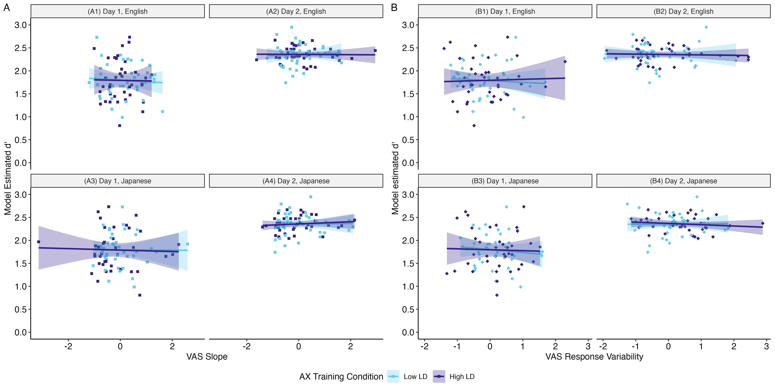
Figure 4.8: Modeled estimated d' as a function of VAS slope (A) and response variability (B) by VAS contrast language, day, and training condition (color). Each point represents an individual's d' score for the VAS-language-by-day grouping, estimated from the fixed effects and random slopes, as a function of their VAS measures, averaged within language. Trend lines are plotted with 95% confidence intervals.
Table 4.7: Random Effects of the Binomial Generalized Linear Mixed-Effects Model Predicting AX Discrimination Sensitivity by Day.
Group | Random Effect | SD | Int. ~ Slope  Corr. | Slope ~ Slope  Corr.
Participant | Intercept | 0.30
 | Signal (d’) | 0.48 | 0.32
 | Signal (d’) x Day | 0.50 | -0.36 | -0.81
AX Word Pair | Intercept | 0.30
 | Signal (d’) | 0.54 | 0.12
N_{Participant} | 80
N_{AX} _{Word} _{Pair} | 25
N_{observations} | 15236
Key: SD = Standard Deviation; Int. = Intercept; Corr. = Correlation
Model formula (family = binomial, link = probit): Response ~ Signal * Day * AX Training Condition * (L1 VAS Slope * L1 VAS Resp. Var. + L2 VAS Slope * L2 VAS Resp. Var. + MLD-A + MLD-P + Speaker Signal) + (1 + Signal + Signal:Day | Participant) + (1 + Signal | AX Word Pair); italics = control variable

Effect of predictors on change in discrimination reaction time
Reaction time was also analyzed using the linear mixed-effects model to assess factors that predict changes in perceptual discrimination sensitivity. Figure 4.9 shows that at a group level across both experimental conditions, reaction time decreased from Day 1 to Day 2, indicating that participants became quicker in accurate discrimination after training. Much like d’, there was no apparent effect of experimental condition on RT improvement.
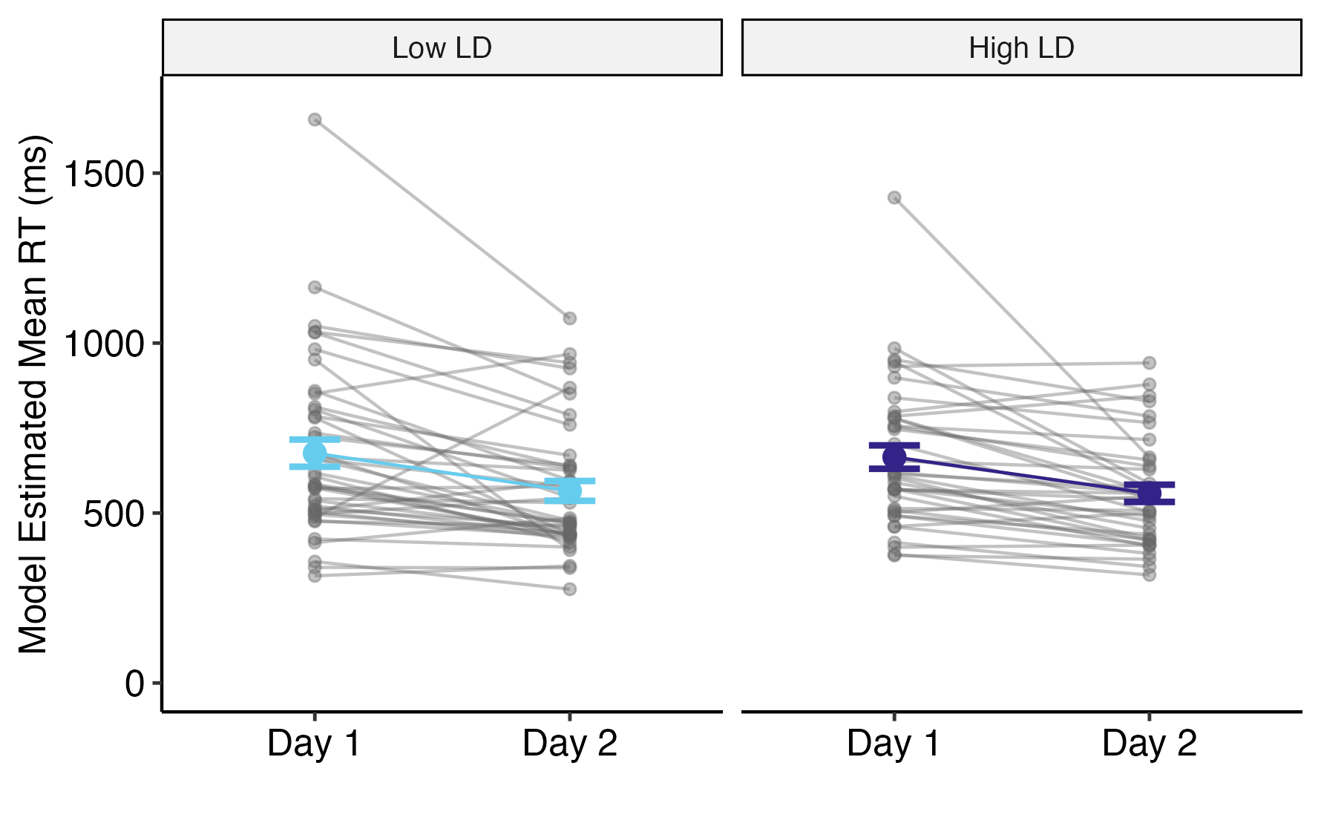
Figure 4.9: Model-estimated Day 1 and Day 2 mean reaction time values by experimental condition group. Gray lines represent individual participant trajectories from Day 1 to Day 2. Colored points and error bars indicate group means with standard error of the mean.
The fixed-effects results of the RT model are presented in Table 4.8. The model was run using natural-log transformed reaction time, and the model coefficient estimates were back-transformed into the original RT units of milliseconds by exponentiating the estimates. Thus, the slope effects for the predictor variables are multiplicative rather than additive. The statistically significant intercept estimates that the mean reaction time for accurate discrimination trials on Day 1, across mean values of all other factors, was 635.51 ms (95% CI [574.35, 703.18], p < .001). There was a significant effect of Day (b = 0.85, 95% CI [0.78, 0.92]), which indicates that participants were 15% faster in making accurate discrimination decisions after perceptual training; multiplying the intercept by the slope for Day produces the estimated mean reaction time for Day 2, which is 540.18 ms. There was also a significant effect of L2 VAS Response Variability on Day 2 (b = 1.16, 95% CI [1.02, 1.31], p = 0.02), which indicated that a one unit increase in the posttraining L2 Japanese VAS Resp. Var. value predicted reaction times that were 16% slower. Additionally, there was a significant interaction between AX training condition and L1 VAS Response Variability on Day 2 (b = 1.25, 95% CI [1.01, 1.56], p = 0.044), which indicated that the effect of a one unit increase in the posttraining L1 English Resp. Var. value on discrimination posttest RT was 25% higher for the High LD condition compared to the Low LD condition. The interactions between AX condition and the VAS measures are visualized in Figure 4.10 (each interaction represented in the figure is tagged with the corresponding subplot label in the table).
Table 4.8: Fixed Effects of the Linear Mixed-Effects Model Predicting AX Discrimination Reaction Time by Day.
Predictor |  | Exp(Estimate) [95% CI] | t | p
Day 1:
 | Intercept (Day 1) | 635.51 [574.35, 703.18] | 125.04 | < .001***
 | Low LD vs. High LD | 1.11 [0.92, 1.35] | 1.07 | 0.285
 | L1 VAS Slope | 1.02 [0.91, 1.14] | 0.27 | 0.789
 | L1 VAS Resp. Var. | 1.01 [0.90, 1.13] | 0.10 | 0.919
 | L2 VAS Slope | 1.08 [0.98, 1.18] | 1.56 | 0.118
 | L2 VAS Resp. Var. | 0.96 [0.85, 1.09] | -0.58 | 0.559
 | Low LD vs. High LD x  L1 VAS Slope^{(A1)} | 1.17 [0.93, 1.47] | 1.31 | 0.191
 | Low LD vs. High LD x  L1 VAS Resp. Var.^{(B1)} | 0.93 [0.74, 1.16] | -0.67 | 0.500
 | Low LD vs. High LD x  L2 VAS Slope^{(A3)} | 0.92 [0.76, 1.10] | -0.91 | 0.365
 | Low LD vs. High LD x  L2 VAS Resp. Var.^{(B3)} | 1.09 [0.85, 1.39] | 0.69 | 0.491
Change from Day 1 to 2:
 | Change from Day 1 to 2 | 0.85 [0.78, 0.92] | -4.18 | < .001***
 | Low LD vs. High LD | 1.11 [0.95, 1.30] | 1.34 | 0.179
 | L1 VAS Slope | 0.92 [0.81, 1.04] | -1.40 | 0.161
 | L1 VAS Resp. Var. | 0.96 [0.86, 1.07] | -0.81 | 0.419
 | L2 VAS Slope | 0.94 [0.85, 1.04] | -1.16 | 0.246
 | L2 VAS Resp. Var. | 1.16 [1.02, 1.31] | 2.32 | 0.020*
 | Low LD vs. High LD x  L1 VAS Slope^{(A2)} | 0.79 [0.62, 1.01] | -1.86 | 0.063
 | Low LD vs. High LD x  L1 VAS Resp. Var.^{(B2)} | 1.25 [1.01, 1.56] | 2.02 | 0.044*
 | Low LD vs. High LD x  L2 VAS Slope^{(A4)} | 1.08 [0.87, 1.33] | 0.70 | 0.485
 | Low LD vs. High LD x  L2 VAS Resp. Var.^{(B4)} | 0.84 [0.65, 1.07] | -1.42 | 0.155
Key: CI = Confidence Interval; Resp. Var. = Response Variability; Significance codes: (***) p < 0.001, (**) p < 0.01, (*) p < 0.05
Model formula: Log RT ~ Day * AX Training Condition * (L1 VAS Slope + L1 VAS Resp. Var. + L2 VAS Slope + L2 VAS Resp. Var. + MLD-A + MLD-P + Speaker Signal) + (1 + Day | Participant) + (1 | AX Word Pair); italics = control variable (effects not included in table)
Notes: Log-RT estimates and 95% CIs were exponentiated into the original reaction time scale (milliseconds) using the model_parameters function of the parameters R package (v0.26.0; Lüdecke et al., 2020). Non-intercept predictor terms represent multiplicative changes in RT. Standard error estimates are not reported on the original RT scale.
^{(A1)} ^{(A2)} ^{(A3)} ^{(A4)} ^{(B1)} ^{(B2)} ^{(B3)} ^{(B4)}Interaction effects which are depicted in the corresponding subplots of the figure depicting model estimated mean RT (ms) as a function of VAS slope and response variability.).
Figure 4.10 makes clear the source of the significant effects found by the model. For the effect of L2 response variability on Day 2 (subplot B4, averaged between condition groups), the effect of increasing L2 response variability predicting slower reaction times seems to come from the fact that those with lower L2 response variability improved to a greater degree than those with higher L2 response variability, who on average remained at the same mean reaction time between Day 1 and Day 2. Further, the interaction effect between L1 response variability and AX condition group on Day 2 (subplot B2) seems to show a similar trend that manifested differently between the two groups. Specifically, among both the Low LD and High LD groups, participants with lower L1 response variability improved in reaction time to a greater degree than those with higher L1 response variability, who on average remained at the same mean reaction time between Day 1 and Day 2. However, it appears that the Low LD group had a higher spread in Day 1 mean reaction times for those with lower L1 response variability, such that the improvement of reaction time on Day 2 at the group level was a much more dramatic effect than for the High LD group.
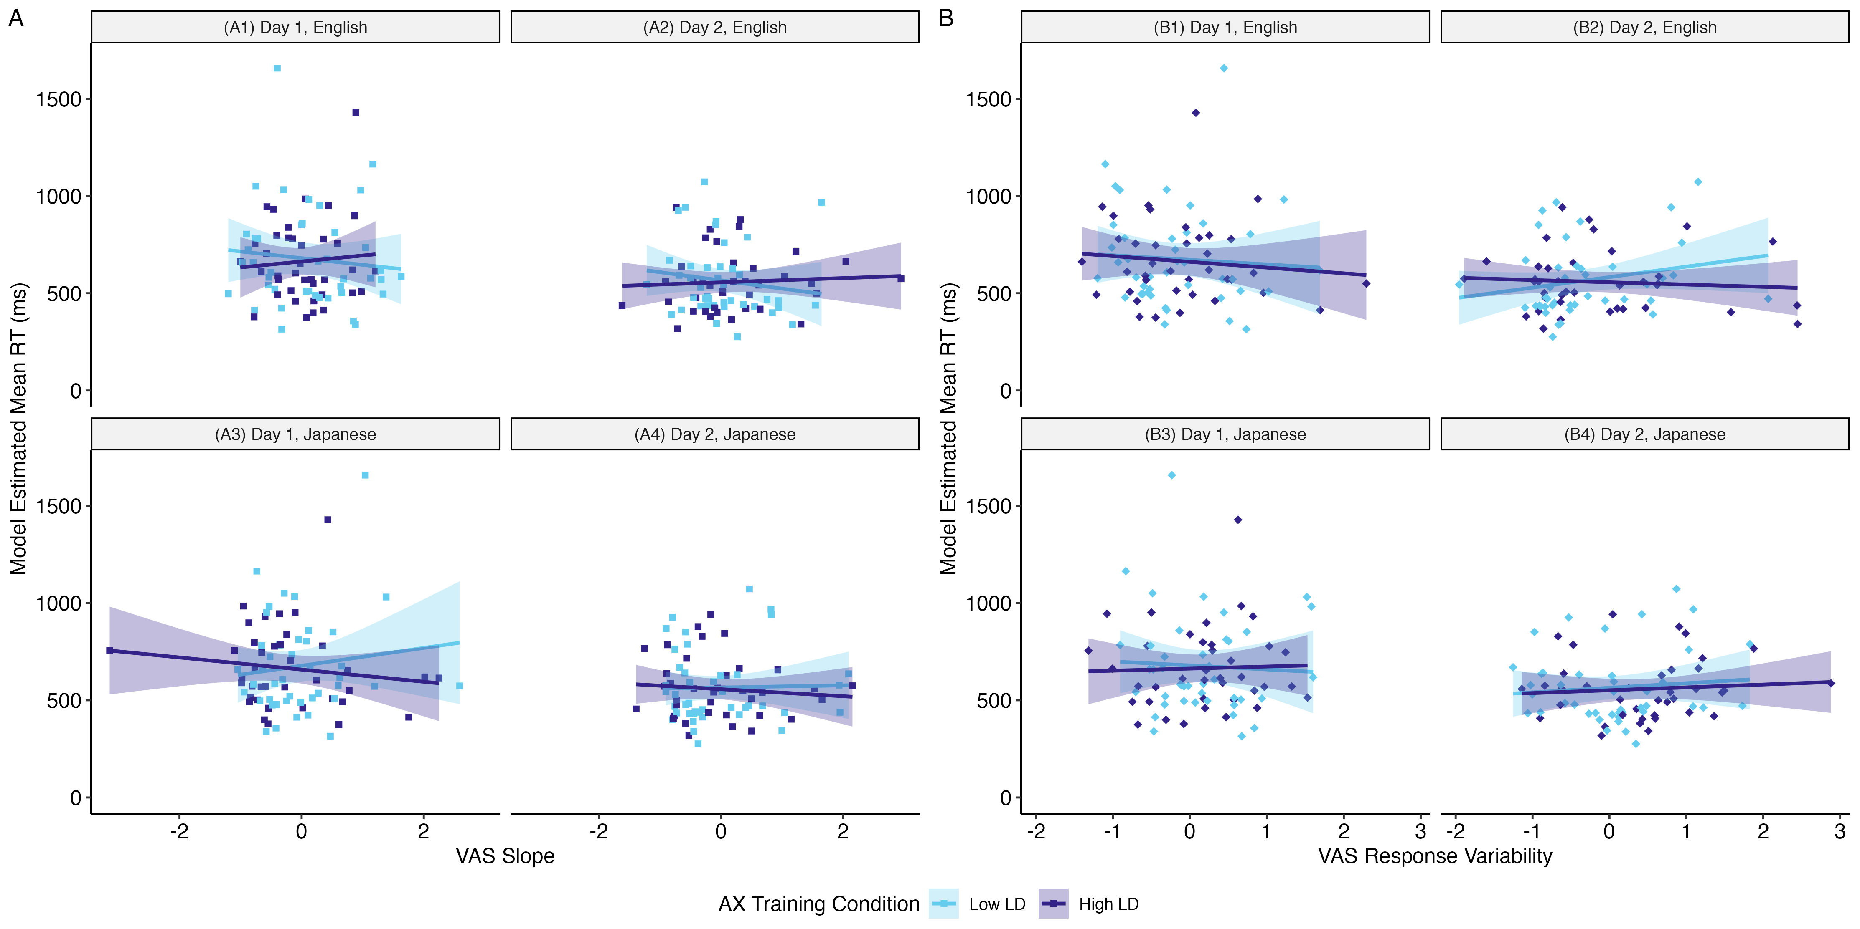
Figure 4.10: Modeled estimated mean reaction time (ms) as a function of VAS slope (A) and response variability (B) by VAS contrast language, day, and training condition (color). Each point represents an individual's mean reaction time for the VAS-language-by-day grouping, estimated from the fixed and random slopes and intercepts, as a function of their VAS measures, averaged within language. The fixed and random effects were exponentiated to get the estimates in the original reaction time scale. Trend lines are plotted with 95% confidence intervals.
The population-level random effects parameters are presented in Table 4.9. Note that the random effects are based on natural log-transformed RT that was used in the model, as back-transformation of variance effects through exponentiation is not recommended.
Table 4.9: Random Effects of the Linear Mixed-Effects Model Predicting AX Discrimination (Log-Transformed) Reaction Time by Day.
Group | Random Effect | SD | Int. ~ Slope Corr.
Participant | Intercept | 0.35
 | Day | 0.25 | -0.49
AX Word Pair | Intercept | 0.07
Residual | Residual | 0.51
Model Fit
N_{Participant} | 80 | N_{AX} _{Word} _{Pair} | 25
N_{observations} | 11876 | ICC | 0.31
Marginal R² | 0.07 | Conditional R² | 0.36
Key: SD = Standard Deviation; Int. = Intercept; Corr. = Correlation; ICC = Intra-level Correlation Coefficient
Model formula: Log RT ~ Day * AX Training Condition * (L1 VAS Slope + L1 VAS Resp. Var. + L2 VAS Slope + L2 VAS Resp. Var. + MLD-A + MLD-P + Speaker Signal) + (1 + Day | Participant) + (1 | AX Word Pair); italics = control variable
Notes: Random standard deviations are presented in the Log-RT scale.

Study 2 Discussion
The purpose of Study 2 was to investigate the effects of short-term exposure to specific linguistic diversity via perceptual training on gradient categorization of L1 and L2 speech and L2 phoneme discrimination. Naïve L1 monolingual English speakers underwent an AX discrimination perceptual training paradigm to learn novel L2 Japanese phonemic length contrasts, with participants randomly assigned to either the Low LD training, who trained only with Japanese minimal pairs, or the High LD training group, who trained with Japanese and MSA minimal pairs. Before and after training, participants performed the VAS task to obtain categorization measures for L1 English and L2 Japanese contrast pairs and an AX discrimination test to assess perceptual discrimination sensitivity.
As a whole, participants showed signs of learning after training, as they significantly improved in the sensitivity and reaction time measures from Day 1 to Day 2. However, learning gains did not differ between the two experimental conditions, which means that my hypothesis that training with High LD minimal pairs would lead to greater gains in perceptual sensitivity was not supported.
Further, I investigated whether training had an impact on VAS measures to test my hypothesis that training with High LD minimal pairs would push learners towards gradient categorization patterns (low slope, low response variability). This hypothesis not supported by the data, and more surprisingly, neither was the assumption on which this hypothesis was made. The hypothesis assumed that participants would show changes in the VAS measures from Day 1 to Day 2, however, as a whole, participants did not significantly differ in their estimates of VAS slope and response variability, for neither the L1 nor L2 contrasts.
Lastly, I explored whether change in VAS measures predicted degree of improvement in perceptual discrimination. Although the change in VAS measures was not found to predict improvements in perceptual discrimination, as no changes in VAS measures were found, VAS response variability in some cases was found to predict some degree of improvement. This effect seemed to suggest that those with lower response variability for L1 and L2 categorization decreased in their RT of accurate perceptual discrimination after training. This effect was not seen in the pre- and posttest d’ results.
The lack of effect of perceptual training on the VAS measures has a few possible explanations. For one, it may be the case that 24 hours is not enough time to reflect changes in categorization gradiency and response variability, if any changes were induced. Further, participants only engaged in a single 30-minute training session, and it is plausible that this short period of training, while enough to produce behaviors indicative of learning, was not enough to produce changes in the categorization behaviors reflected in the VAS measures. Indeed, this may also suggest that while there are individual differences in gradiency and response variability that are contrast-specific, these measures may reflect a stable trait that is resistant to change from perceptual learning, even if the measures themselves are not consistent across phoneme contrasts. Aside from the ongoing Growing Words Project measuring categorization in children (see preregistration at McMurray et al., 2019), there have not been many studies to my knowledge that have published results of longitudinal VAS measures following the same individuals. Kong & Edwards (2016) reported that participants’ VAS response patterns were consistent across two sessions separated by one week. Further, as part of the Growing Words Project, Sorensen (2024) in his dissertation analyzed longitudinal VAS data and also seemed to find no effect of time that would reflect shifts in categorization measures. These pieces of evidence suggest that categorization may be a stable trait that takes years over development to change, if at all.
The lack of effect of training condition on learning also has several possible explanations. Again, the single 30-minute training session is likely to not have been long enough exposure to linguistic diversity to produce any differential effects. Indeed, the previous literature motivating this study that found effects of environmental linguistic diversity (Bice & Kroll, 2019; Todd et al., 2023; Oh et al., 2020) or experience with a language with similar contrasts as the target contrast (Patihis et al., 2015; Wiener & Goss, 2019) on perceptual sensitivity to non-L1 languages were studies on the effects of years, if not a lifetime, of such experience with language exposure and/or knowledge. As such, the short degree of exposure presented by this experiment is unlikely to have had any detectable effects.

Limitations
This study had several limitations, primarily regarding the use of AX discrimination as the training and testing tasks. One limitation is that the “High” LD experimental manipulation was the addition of just one other language, which may not have been sufficient to simulate any possible benefits of being exposed to linguistic diversity. This study was further limited by sample size, as the number of participants in each training group possibly did not provide high enough power to detect training group effects. Another limitation is that the AX discrimination task may have lacked the sensitivity to detect differential learning outcomes between the two experimental groups. In fact, it is possible that training effects could not be detected by the behavioral measures used at all. The pivotal study from Bice & Kroll (2019) that found differences in sensitivity to non-L1 speech categories between populations of English monolinguals with different levels of exposure to linguistic diversity did not see these differences in their behavioral measures as well. Instead, the effects were present in the neural activity patterns measured with event-related potentials. As this study did not employ any neural measurements, the possibility of any effects present that were undetectable by the behavioral measures used remains unclear.

Study 3
In the previous chapter, I explored the effects of short-term exposure to specific linguistic diversity via a perceptual training paradigm on L1 and L2 categorization and the learning of novel L2 phonemic contrasts of monolingual L1 English listeners. Although listeners on average showed signs of learning following training, learning did not differ significantly between the Low LD and High LD groups, and the training did not have a significant impact on the VAS categorization measures of slope and response variability for L1 nor L2. The next step of exploration was to test the perceptual training with linguistic diversity paradigm in a relatively more ecologically valid environment. Instead of examining the effects of specific linguistic diversity in naïve listeners, it became of interest to explore the effects of the training paradigm in active L2 learners and whether the training paradigm accelerated the learning of L2 phonemes when used as a supplement to foreign language classroom instruction. Subsequently, to act as classroom supplementation, the length of perceptual training was extended over the span of weeks rather than being contained to a single 30-minute session. With this new direction in exploration, RQ3 asked: Does specific exposure to linguistic diversity through perceptual training lead to improvements in L2 speech perception and listening? This research question was asked in addition to RQ2 to gauge not only L2 speech learning when listening to isolated minimal pairs, but L2 speech learning when listening to naturalistic speech. In summary, Study 3 was conducted to investigate the effects of long-term perceptual training with specific linguistic diversity as a supplement to foreign language classroom instruction on (1) gradient categorization of L1 and L2 speech, (2) L2 phoneme discrimination, and (3) L2 speech perception and listening.
To carry out this investigation, I conducted a longitudinal experimental study comparing a control group (classroom instruction only) to two training groups who completed perceptual training with stimulus sets of vowel length and consonant gemination minimal pairs that varied in linguistic diversity (Low LD and High LD). All three experimental groups were compared using a pre-post design for (1) the VAS task to measure changes in L1 English and L2 Japanese categorization gradiency, (2) the AX perceptual discrimination task to measure changes in L2 Japanese perceptual sensitivity, and (3) a multiple-choice partial dictation listening assessment to assess changes in L2 speech perception and listening. I had hypothesized that learners who performed the perceptual training would exhibit changes in categorization gradiency reflecting more gradient patterns (lower slope, lower response variability) compared to the control group, and that this effect would be stronger for the High LD group compared to the Low LD group. I subsequently hypothesized that those who performed the perceptual training would show signs of greater L2 learning, that is, greater improvements in L2 phoneme discrimination sensitivity and L2 listening accuracy, compared to the control group, and that, again, this effect would be stronger for the High LD group.
I chose to use a multiple-choice partial dictation task as the L2 listening assessment for several reasons. Typically, dictation tests have the test-taker listen to dialogue about a paragraph in length and write down everything they hear; partial dictation tests are several sentence-length recordings rather than one or two paragraph-length recordings. Another difference of partial dictation is that test-takers are presented with the audio recordings and text transcription of the audio with certain words omitted, which the test-taker must fill in (Buck, 2001; Cai, 2014). Dictation has often been used at multiple levels of proficiency in L2 English placement exams (Cai, 2013; Henning et al., 1983; Kimura, 2016; Leeming & Wong, 2016; Wong & Leeming, 2014). As an assessment, partial dictation is a type of gap-filling integrative task that may measure constructs of both bottom-up and top-down listening processes (Buck, 2001; Cai, 2013). In terms of the bottom-up processes of interest in the present study, namely, discrimination sensitivity, dictation scores have been shown to moderately correlate with scores on a phonological discrimination test (Oller, 1971). In terms of higher-level processes and general L2 proficiency, dictation scores have been shown to correlate well with other English overall proficiency test scores, such as the TOEFL and TOEIC (Irvine et al., 1974; Leeming & Wong, 2016; Oller & Streiff, 1975; Oller, 1971; Shizuka, 2016; Wong & Leeming, 2014). Partial dictation has also been used to measure L2 Japanese proficiency (Kaga, 1991), and in fact, a popular Japanese placement test, the Simple Performance-Oriented Test (SPOT), is itself a speeded partial dictation listening test (Ford-Niwa & Kobayashi, 1999).
In the study design, I used partial dictation, and the omitted key words contained the target contrasts. Further, I chose to use multiple choice, rather than fill-in-the-blank, because it made scoring simpler and because I am interested in the learners’ perception (answer recognition) rather than production (written answer) of the target contrast in the key word. Additionally, multiple-choice allowed me to assess the learners’ acquisition of the target contrasts by presenting them with competing answer options that contain both long and short segments, meaning they must accurately perceive the audio in order to make the correct choice amidst options containing the phoneme contrasted with that of the key word. The construction of the multiple-choice partial dictation was informed by conventions suggested by Kimura (2016) and Shizuka (2016).

Methodology
The longitudinal procedure for Study 3 is presented in Table 5.1. This experiment took place entirely online. Recruitment and participant screening were conducted via email and Google Forms. After screening, participants were randomly assigned to either the Control group, the Low Linguistic Diversity (Low LD) training group, or the High Linguistic Diversity (High LD) training group. Participants completed the experiment on their personal laptop or desktop computer via Gorilla.sc (Anwyl-Irvine et al., 2020). All participants provided informed consent approved by the Carnegie Mellon University Institute Review Board (IRB).
On the first day of the study, participants underwent a system check to ensure the auto play of sound at a comfortable level and a short task to ensure compliance with the use of wired binaural headphones (Milne et al., 2021). After this, they completed the listening assessment pretest, the pretraining VAS task, and the AX discrimination pretest. At least 24 hours following the pretest battery, participants in the experimental training groups (Low LD and High LD) received an email reminder to return to the research website to complete the first of six AX discrimination training sessions. Upon completion of each training session, a 48-hour waiting period ensued, after which participants received an email reminder to return to the study for their next training session. At the start of each training session, participants were prompted to put on headphones to recalibrate their audio volume. Subsequent email reminders were sent to participants who did not complete their training sessions within 48 hours of the initial email reminder.
At least 24 hours after their final training session, participants received an email reminder to return to the research website for the final day of posttests. For participants in the control group, the email reminder to return for the final day of posttests was sent after at least 21 days had passed from their first day of the study. For the final day, all participants completed the AX discrimination posttest, the post-training VAS task, and the listening assessment posttest. After this, participants completed the LDQ and read a debriefing of the purpose of the study. The total time commitment for the study was two hours for the Control group and five hours for experimental training groups.
All participants were compensated for their participation at an hourly rate with their choice of a virtual gift card. To encourage retention, participants were offered a bonus if they completed all parts of the study up to and including the final day. Participants who dropped out early were still compensated according to the number of hours completed, but did not receive a bonus.
Table 5.1: Order and Description of Tasks for Study 3.
Task Order | Day | Task | Purpose | Approximate duration (mins)
1 | 1 | Consent form, system and headphone checks | Obtain consent, ensure browser auto plays audio and volume is set to comfortable listening level, ensure participant is wearing wired binaural headphones | 5
2 | 1 | MCPD pre-test | Measure pre-training L2 speech perception and listening through phonemic recognition and discrimination | 5
3 | 1 | Pre-training L1 and L2 VAS | Measure pre-training L1 and L2 speech categorization gradiency | 8-10
4 | 1 | AX discrimination pre-test | Measure pre-training sensitivity to L2 phonemic contrasts | 10-15
5¹ | 2-7 | AX discrimination training sessions (6 sessions over 3-4 weeks) | Perceptual learning of L2 phonemic contrasts with low or high linguistic diversity (LD) | 30/session
6 | 8 | AX discrimination post-test | Measure post-training sensitivity to L2 phonemic contrasts | 10-15
7 | 8 | Post-training L1 and L2 VAS | Measure post-training L1 and L2 speech categorization gradiency | 8-10
8 | 8 | MCPD post-test | Measure post-training L2 speech perception and listening through phonemic recognition and discrimination | 5
9 | 8 | LDQ | Measure experiential LD from active and passive use of and exposure to known and unknown languages | 10-25
¹Not performed by control group.
Key: MCPD = Multiple-Choice Partial Dictation; VAS = Visual Analog Scale; LDQ = Linguistic Diversity Questionnaire

Participants
A total of 24 participants were recruited from university-level Japanese language courses. Due to IRB restrictions, participation was limited to persons present in the US at the time of the study, excluding 11 states with certain data privacy laws. All participants were contacted via recruitment emails forwarded to students by classroom instructors. Recruitment emails were sent to Japanese instructors at 20 universities across the U.S., and six universities were represented among the 24 students who participated. As one of the priorities for Study 3 was to test the perceptual training paradigm in a more ecologically valid environment, controlling for confounding factors such as participants’ linguistic backgrounds was less of a priority compared to Study 2. As such, there were no exclusion criteria with regards to L1, and the major eligibility requirement was to be enrolled in a Japanese language course, which participants confirmed by reporting their university and course number. Participants confirmed the following eligibility criteria at screening and reconfirmed at the time of consent:
- Must be between the ages of 18-40
- Must self-report having normal hearing
- Must self-report having no history of learning disability, memory impairment, or auditory processing disorder
- Must be currently enrolled in a Japanese language course (must be able to read ひらがな hiragana)
Of the 24 recruited participants, five participants dropped out of the study partway through or did not return for the final day, and one participant was removed from the data due to experiencing technical difficulties that prohibited completion of the study. This resulted in a total of n = 18 participants included in the statistical analyses (10 female, 8 male; mean age = 21.5, SD = 3.4, range = 18-32; Control n = 6, Low LD n = 5, High LD n = 7). Table 5.2 describes the proficiency levels of the 18 participants by experimental group, based on the year of their reported course in the course sequence of their university’s Japanese language program.
Table 5.2: Distribution of Language Proficiency Levels by Experimental Group, as Determined by University Course Level.
Course Level | Control | Low LD | High LD | Total
First year | 1 | 2 | 4 | 7
Second year | 3 | 1 | 1 | 5
Third or fourth year | 2 | 2 | 2 | 6
Total | 6 | 5 | 7 | 18
Although the study was intended to last 3-4 weeks, with two training sessions per week for the experimental training groups, participants varied in the time taken to complete the study. For the experimental training groups, the time between the first and final days of the study was dictated by how closely participants adhered to the study schedule and how quickly they responded to study session reminders. Study reminders to return for the final day were sent to the Control group at least 21 days after their first day of the study, though the actual time between the first and final days varied based on how quickly participants responded to the final day reminder. The distribution of days between the first and final days ranged from 23-48 days (mean = 31 days, SD = 6.9 days), and for the experimental training groups, the distribution of days between the first and last training sessions ranged from 17-38 days (mean = 25 days, SD = 5.2 days).

VAS task

Stimuli
Study 3 used the same set of one-dimensional VAS stimuli as in Study 2 (see Section 4.1.2.1). To briefly reiterate, listeners judged the same L1 English contrasts (minimal pairs indent-intent & reason-risen) and L2 Japanese contrasts (minimal pairs kata-katta & toru-tooru), varying along only the primary auditory dimension at the midpoint (3rd step) of the secondary dimension from the Study 1 set of stimuli. Refer to Table 4.2 for a summary of the acoustic characteristics of the one-dimensional continua.

Procedure
The procedure for the pretraining and posttraining VAS task was the same as in Study 2 (see Section 4.1.2.2). As a reminder, participants completed four blocks of 28 trials each (7 continuum steps x 4 repetitions), for a total of 112 trials, which took approximately 8-10 minutes to complete. Participants were able to take a timed 30-second break between blocks. The two L1 English continua blocks were followed by the two L2 Japanese blocks. Participants were randomized into conditions that counterbalanced the order of within-language continuum blocks for each the pre- and posttraining VAS tasks. Participants in all experimental training conditions completed the VAS tasks.

Data pre-processing
Before the curve fitting process, data were cleaned and filtered. Starting with the full dataset (4707 trials from n = 24 participants), participants who did not return for the final day of the study were first removed from the data. From the remaining data (4032 trials from n = 18 participants), reaction times (RTs) were natural log-transformed to normalize the RT distributions. The data were filtered on a per participant basis to remove trials with log-RTs three median absolute deviations (MAD) above or below the participant’s median log-RT (3943 trials). The range of RTs following this filtering was from about 560 ms to about 8600 ms.
As in Study 2 (Section 4.1.2.3), the VAS pre- and posttraining data were fitted with a four-parameter logistic curve function to obtain measures of VAS slope and response variability using the Non-linear Curvefitting MATLAB package (McMurray, 2017). As before, the upper and lower boundaries for the slope parameter estimate were adjusted to account for amplitude scale and an amplitude-dependent penalty was added to the least-squares error function, reducing instability in slope estimates when response amplitude was low and/or when response patterns were noisy.
The raw VAS slope values ranged from -59.3 to 190.2 (median = 45.4, mean = 59.2, SD = 47.0). Raw slope values with low absolute values indicated shallower response curves whereas high absolute values indicated steeper response curves. Negative slopes indicated reversed categorization. The raw response variability values ranged from 1.1 to 43.2 (median = 13.8, mean = 15.1, SD = 7.6). Low response variability indicated more consistent categorization whereas high response variability indicated less consistent, noisier categorization.
To standardize the data, VAS slope and response variability values were each grand mean centered and scaled by one standard deviation (z-transformed). The z-transformed values were used in subsequent analyses. Table 5.3 presents the summary statistics of the z-transformed VAS slope and response variability estimates for each contrast pair at pretraining and posttraining, averaged across n = 18 participants.
Table 5.3: Summary Statistics of VAS Measures Estimated from Logistic Curve Fitting, by Contrast Pair and Time.
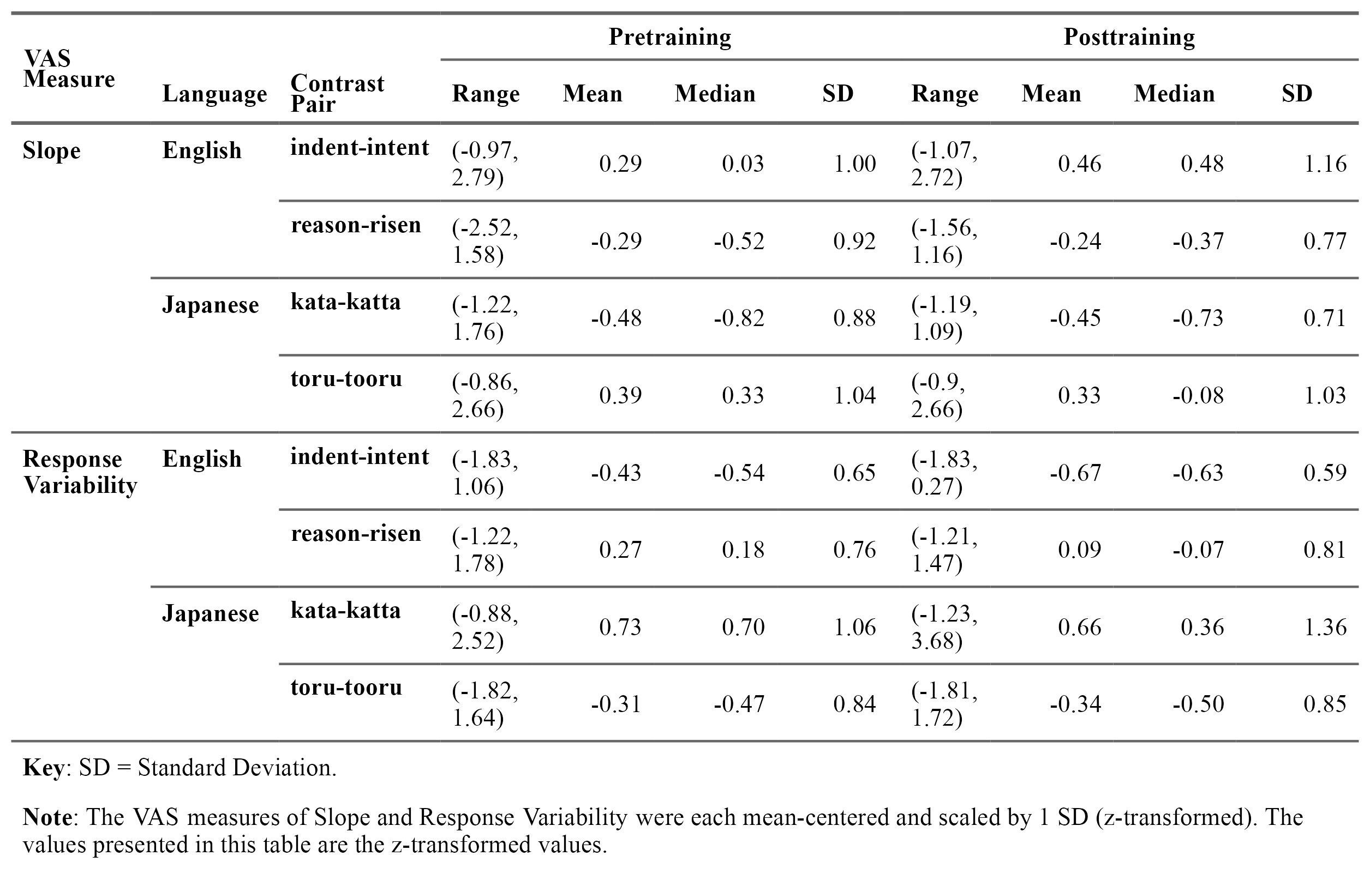

AX discrimination perceptual training and pre-posttests

Stimuli
The stimuli for the AX discrimination tasks were the same as in Study 2 (see Section 4.1.3.1 and Appendix D). To briefly reiterate, there were 18 Japanese minimal pairs and 18 MSA pairs used for training (six vowel length pairs and 12 consonant gemination pairs) and 25 additional Japanese minimal pairs used for testing (13 vowel length pairs and 12 consonant gemination pairs). There was one male and one female speaker for each language.

Procedure
Participants in the Low LD and High LD groups took part in perceptual discrimination training for six training sessions over the span of a few weeks. Each training session lasted 15-30 minutes, depending on the participant’s own speed, and the procedure of each training session was exactly as described in Study 2 (see Section 4.1.3.2). For the first training session, participants received full instructions describing the task and encouraging listeners to ignore speaker identity, focus on the words themselves, and to use the feedback to learn how to tell the words apart. Subsequent sessions provided abbreviated instructions as a refresher. Training sessions were spaced apart to have at least 48 hours of waiting time between sessions, and the experiment was configured such that participants could not start the next training session before 48 had passed since finishing the last training session.
Each training session consisted of eight blocks of 36 trials each, for a total of 288 training trials. The same set of training stimuli were used for each session. For the High LD group, this consisted of the 18 Japanese minimal pairs and 18 MSA minimal pairs, with each pair presented eight times over the course of the training session across four trial types (AA, BB, AB, BA). For the Low LD group, this consisted of the 18 Japanese minimal pairs, with each pair presented 16 times over the course of the training session across the four trial types.
The control group did not undergo any perceptual training. Instead, to assess the effects of the added perceptual training compared to receiving only classroom instructions on change in discrimination sensitivity, all participants completed the same AX discrimination pre- and posttest. The discrimination tests used 25 Japanese minimal pairs not used in training. The trial procedure was the same as the training trial procedure, excluding the feedback. Participants saw each of the four trial types (AA, BB, AB, BA) twice per minimal pair, resulting in a total of 200 testing trials, randomized and divided into four blocks of 50 trials each. Participants were able to take a timed 30-second break between blocks. The pre- and posttests took approximately 10-15 minutes to complete.

Data cleaning
The discrimination testing data were filtered prior to running the generalized linear mixed-effects model used to estimate d’. Starting with the full dataset (8625 trials from n = 24 participants), participants who did not return for the final day of the study were first removed from the data. From the remaining data (7200 trials from n = 18 participants), reaction times (RTs) were natural log-transformed to normalize the RT distributions. The data were filtered on a per participant basis to remove trials with log-RTs three median absolute deviations (MAD) above or below the participant’s median log-RT (7057 trials). Following this, all trials with raw RTs above 10 s and below 150 ms were removed from the data to exclude slow trials that were unlikely to reflect task engagement and fast trials that were unlikely to reflect true cognitive processing (Whelan, 2008). The final dataset consisted of 6760 trials from n = 18 participants. The data fit to the linear mixed-effects model estimating mean log-RT were further filtered to include only correct trials, resulting in 5884 trials.
The discrimination testing data were also analyzed with a generalized linear mixed-effects model to estimate d’ for each training session. The same cleaning process was used. Starting with the full dataset for the training groups (25918 trials from n = 17 participants), then removing those who did not come back for the final day of the study (20735 trials from n = 12 participants), trials were filtered out that were above and below 3 MAD intervals around participants’ median log-RT (20208 trials), followed by trials with raw RTs above 10 s and below 150 ms. The final training dataset consisted of 18693 trials from n = 12 participants from the Low LD and High LD training groups.

Multiple-choice partial dictation (MCPD) listening assessment

Stimuli
L2 speech perception and listening was measured with a multiple-choice partial dictation (MCPD) listening assessment, which attempted to assess perception of the target phonemic contrast in more relatively naturalistic speech (i.e., sentence context), rather than as decontextualized isolated words, as was assessed in the discrimination task. The idea of the MCPD assessment was to challenge participants to rely on phonemic recognition and discrimination to identify the spoken word, and accurately identity the correct choice amidst phonologically similar competitors among the written multiple-choice answers.
The MCPD assessment consisted of 20 Japanese sentences, each with one missing word that contained a target phoneme. The other multiple-choice options were one competing distractor, which was a word that is contrastive according to the target phonemic contrast, and two noncompeting distractors, which were phonetically/phonologically similar to the target word and/or phonemically contrastive according to a non-target phonemic contrast. The key words with the target phoneme and the competing distractor were minimal pairs featured in either the discrimination training or testing tasks. Most noncompeting distractors were real words, with a few items being phonotactically valid non-words or real words that occur at low frequency in every day Japanese speech. The sentences were structurally simple and non-specific in content to enable any of the answer options to fit in the blank space both semantically and syntactically. Some sentence frames were sourced from past literature (Hirata et al., 2007; Hirata, 2004c).
Below is a breakdown of an example sentence, with explanations for each of the distractor choices:
kinoo kare ga (kiita). ‘Yesterday he (asked).’
(*) kiita ‘asked’
( ) kita ‘came’
( ) kitta ‘cut [it]’
( ) kieta ‘disappeared’
Here, kiita is the correct answer, kita is the competing distractor that is contrastive according to the vowel length target contrast, kitta is a phonologically similar noncompeting distractor that contrasts with the correct answer by containing geminate consonant instead of a long vowel, and kieta is a phonetically similar noncompeting distractor. This sentence was used as the example trial in the instructions of the task (see Figure 5.1 in the following section).
The 20 sentences used in the assessment was recorded by the same 38-year-old female speaker who provided her voice for the VAS stimuli and the AX discrimination stimuli. The speaker recorded the MCPD sentences at the same time as the AX discrimination stimuli, using the same recording set up and procedure (see Section 4.1.3.1). The speaker was presented with each MCPD sentence one-by-one on a computer screen and asked to produce each sentence three times at a natural speaking rate with a 1-2 second pause between each repetition. The recordings selected for the stimulus set selected recordings were all RMS normalized to 67 dB using the Scale intensity function in Praat, were appended with at least 50 ms of silence before and after the sentences, and were saved in both .wav and .mp3 formats.
Of the 20 target keywords, 10 were words that were used in discrimination training and 10 were words that were used in the discrimination pre- and posttests. The 20 keywords were balanced to consist of 10 vowel length contrast targets and 10 consonant gemination contrast targets, and phonemically balanced across the length contrast, i.e., 10 target words being a short quantity phoneme and 10 target words being a long quantity phoneme. For a full list of sentences, target keywords, distractors, and their translations, see Appendix E.

Procedure
In the MCPD listening assessment, participants received instructions describing the trial procedure followed by an example trial (Figure 5.1). In each trial, participants saw a written sentence on the screen with a blank space indicating a missing word. There was a play button for participants to manually start listening to the audio recording in order to choose the correct option among four choices to fill in the blank. The positions of the correct answer and distractor choices were randomized. The “Next” button to move on to the next trial was disabled until a choice was selected, and participants could change their selection any number of times before continuing to the next trial. Participants had the option to listen to the recording one additional time. Feedback was not provided. The 20 trials were presented in randomized order, the pre- and posttests were identical. The task took less than five minutes to complete. Participants in all experimental conditions completed the MCPD listening assessments.
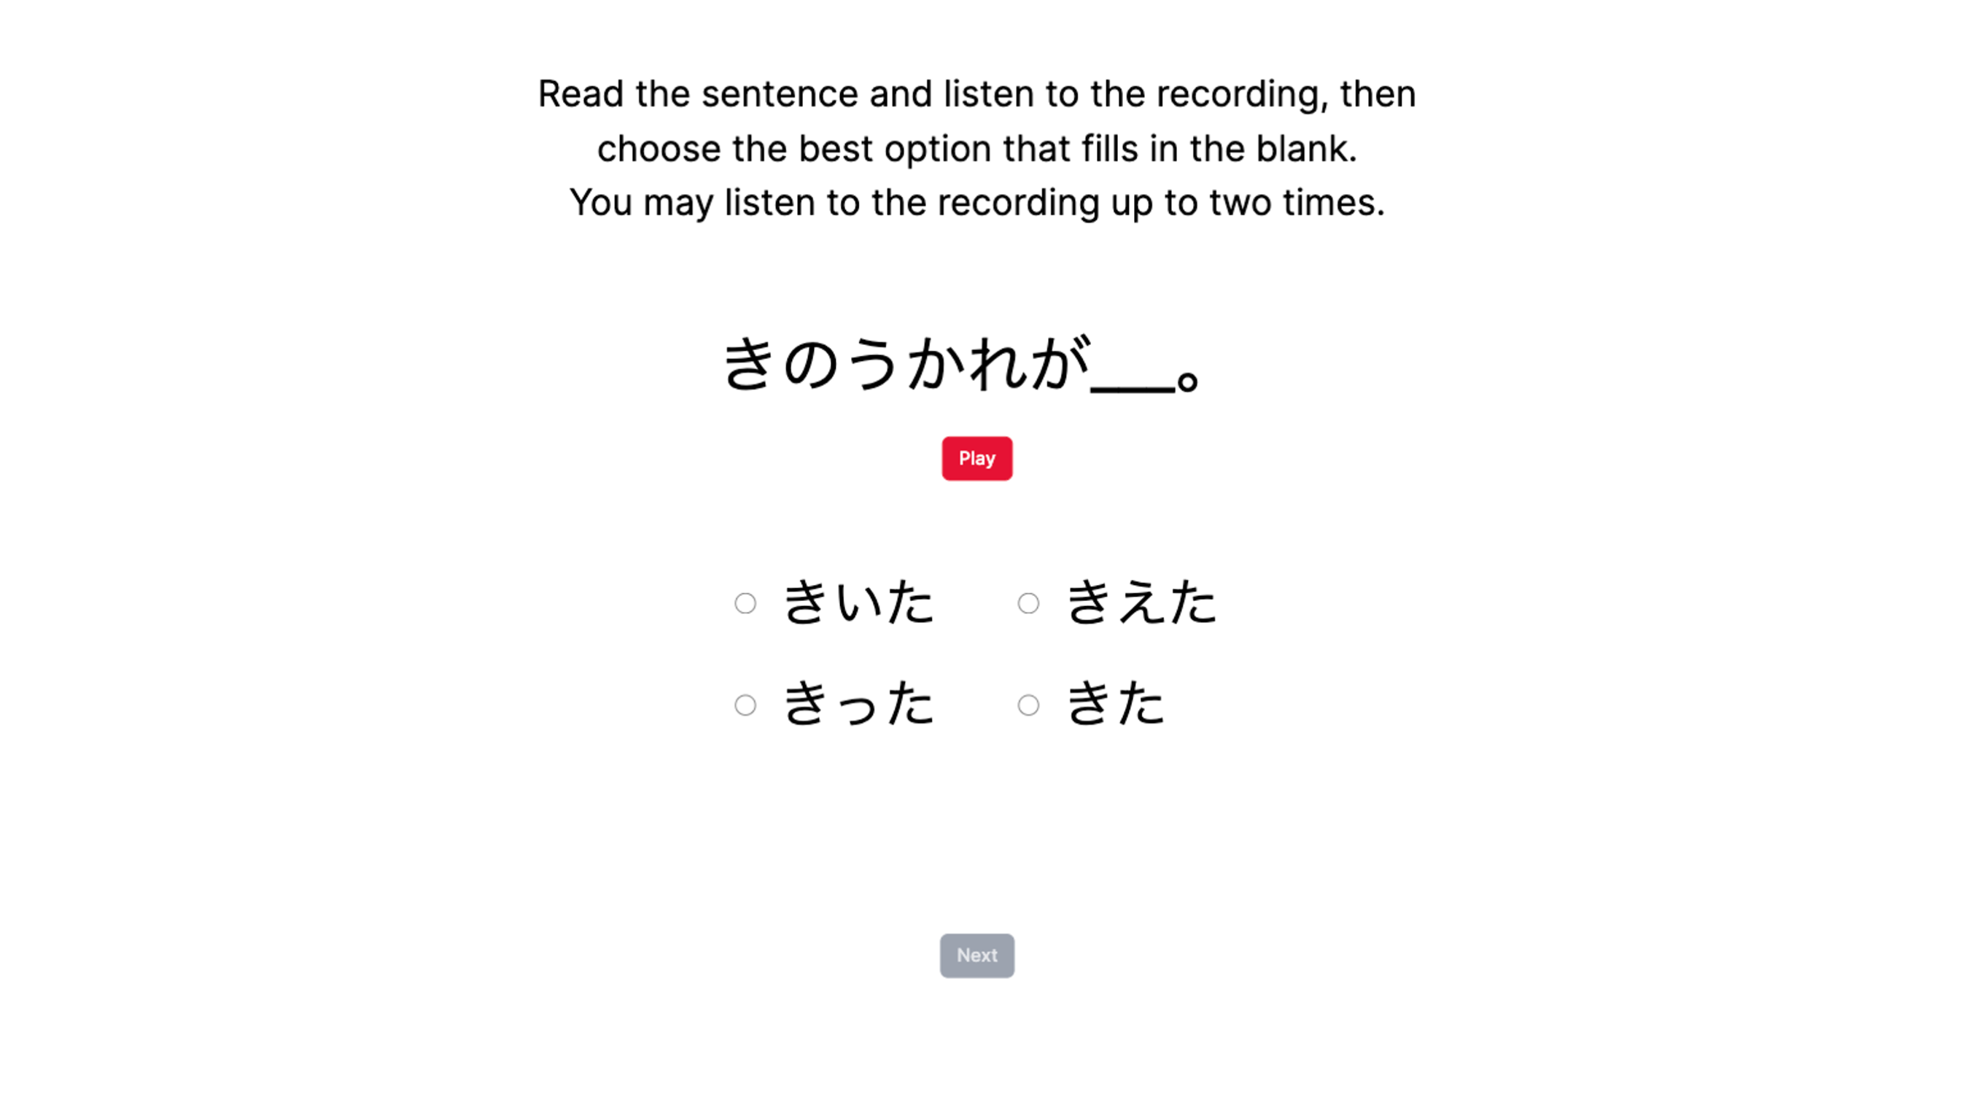
Figure 5.1: Example trial for the MCPD listening assessment.

Data cleaning
Although MCPD accuracy can be simply calculated per participant by dividing the number of correct trials but the number of total trials, I chose to use a generalized linear mixed-effects model of the binomial distribution with the logit link to estimate accuracy at the trial level. Modeling the number of correct trials out of n = 20 trials as a binomial response variable allows for the predictor covariates to contribute to explaining both trial-level and item-level variability in the estimation of accuracy.
Initial data cleaning steps followed that of the VAS and AX discrimination data pre-processing, starting with the full MCPD dataset (840 trials from n = 24 participants) and removing those who did not return for the final day of the study (720 trials from n = 18 participants). However, filtering using the MAD process only resulted in the removal of 6 trials based on their log-RT. Due to the small number of trials per participant (40 trials between pretest and posttest data), these 6 trials were retained to preserve the maximum number of trials such that all participants could have pre- to posttest accuracy trajectories modeled for all MCPD items. Thus, the final dataset consisted of 720 trials.

LDQ
Participants completed the LDQ, which is described in detail in Section 3.1.3 and can be found in Appendix A. As in Studies 1 and 2, the LDQ was used to measure active and passive use of and exposure to linguistic diversity through one’s language background, history, use, and experiences. The LDQ produced two aggregate scores for indices of experiential linguistic diversity: Active Multilingual Language Diversity (MLD-A) and Passive Multilingual Language Diversity (MLD-P).
Figure 5.2 visualizes the distributions of the MLD-A and MLD-P scores of the Study 3 participants. The distribution of MLD-A had a range of 0.53-2 and a median of 1.42 (mean = 1.38, SD = 0.377) and the distribution of MLD-P had a range of 0-1.24 and a median of 0.43 (mean = 0.513, SD = 0.338). By virtue of being foreign language students, all participants had non-zero MLD-A scores, meaning that all participants reported language experience with at least two languages. Fourteen of the 18 participants reported language experience with three or more languages, and of these 14, three participants reported language experience with four languages. Five participants reported a non-English L1. All but one participant had non-zero MLD-P scores. There was no significant correlation between MLD-A and MLD-P scores (Pearson’s r(16) = .11, p = 0.677). While experiential linguistic diversity was not a variable of interest for RQ2 and RQ3, the MLD-A and MLD-P scores were added to the statistical analyses as control variables.
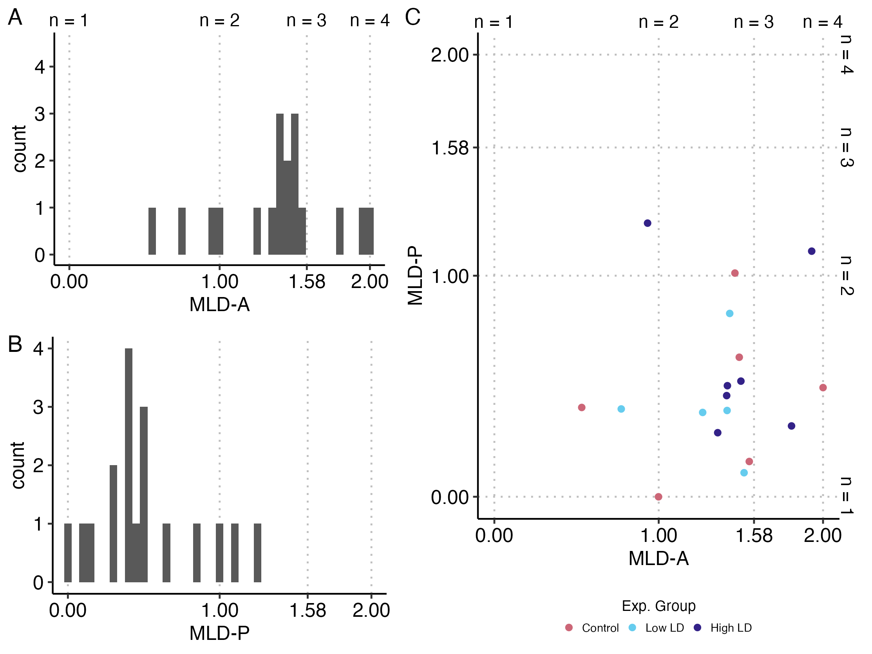
Figure 5.2: Histograms of MLD-A (A) and MLD-P (B) scores and scatterplot of correlation between MLD-A and MLD-P where each dot represents an individual (C). Grid lines indicate the score corresponding to balanced use of n languages. Scores in between these breakpoints represent imbalanced use of two, three, and four languages as MLD scores approach 1, 1.58, and 2, respectively.

Analyses and Results

Analysis models and predictions
Recall that the aim of Study 3 was to investigate the effects of long-term specific exposure to linguistic diversity through perceptual training, in conjunction with foreign language classroom instruction, and to answer RQ2 and RQ3. RQ2, which was also explored in Study 2, asked whether specific exposure to linguistic diversity through perceptual training leads listeners to more gradient categorization strategies and whether this leads to improved L2 discrimination sensitivity. Additionally, RQ3 asks: Does specific exposure to linguistic diversity through perceptual training lead to improvements in L2 speech perception and listening? To answer these research questions, I performed largely the same set of analyses as in Study 2. I ran set of five (generalized) linear mixed-effects models to explore the effects of the perceptual training paradigm on changes in (1) gradient categorization of L1 and L2 speech, (2) L2 phoneme discrimination, and (3) L2 speech perception and listening.
The small number of participants in Study 3 necessitated the simplification of some models that were similarly run in Study 2. For the models used to predict L2 discrimination ability, and additionally the model predicting L2 speech perception and listening, higher-order interaction terms between the key effects of interest, that is, time and experimental group, and the VAS covariate predictors of L1 and L2 slope and response variability became less central to the research questions. At initial modeling attempts, the reduced number of data points was not able to support such complex fixed and random effects structures, and so these interaction terms were removed to reduce multicollinearity, avoid overparameterization, and encourage model convergence. The final models all included interactions between time and experimental condition, and where relevant, time and the VAS covariate predictors, which maintained interpretable estimates with acceptable variance inflation, reflecting manageable levels of multicollinearity between the fixed effects. That being said, the limited number of participants warrant the cautious interpretation of all model outcomes.
As with Study 2, I had originally planned to analyze the VAS data using latent transition analysis, however, there was not enough data to support modeling VAS response profile membership. As such, like the previous two studies, I fit a Bayesian multivariate mixed-effects regression model to explore changes in gradient categorization of L1 and L2 speech using the brms R package (Bürkner, 2017). VAS slope and response variability were predicted by time (Pre vs. Post), VAS contrast language (L1 English vs. L2 Japanese), and experimental condition (Control vs. Low LD vs. High LD) were used as predictor variables, including their interactions. Random intercepts and random slopes for time and VAS contrast language were modeled by participant, and random intercepts were modeled by VAS contrast pair. The residual correlation between VAS slope and response variability was moderately negative (median = -0.35, 95% CrI [-0.50, -0.16]), which robustly supports the use of the multivariate model over multiple univariate models.
I had hypothesized that long-term perceptual training would have an effect on VAS measures, so I predicted a significant interaction between time and experimental group. I predicted that while VAS slope and response variability for the Control group would not change much from pretraining to posttraining, I predicted that the training groups would show changes in the VAS measures, specifically that both training groups would show changes in VAS measures towards more shallow slopes and lower response variability, but that this effect would be stronger for the High LD group compared to the Low LD group. The addition of the interaction terms with VAS contrast language was largely exploratory, as I did not have specific predictions as to how the changes in VAS measures would be different between L1 and L2 categorization.
To explore changes in L2 phoneme discrimination, I modeled discrimination sensitivity at the trial level using a generalized linear mixed-effects model of a binomial distribution with a probit link transformation. The probability of binomial participant responses (“different” = 1, “same” = 0) was predicted by the true signal of the trial (numerically transformed such that “different” = 0.5, “same” = -0.5), time (Pre vs. Post), and their interactions with each other, experimental condition (Control vs. Low LD vs. High LD), and the continuous covariates of L1 and L2 VAS slope and response variability (averaged between the within-language contrast pairs to obtain a singular estimate of slope and response variability for L1 English and L2 Japanese). The effect of signal using the probit link function represents the SDT measure of sensitivity (d’), and interaction effects with signal represent changes in d’ as a function of the interacting predictor.
Initially, the random intercepts and random slopes for the interaction between signal and time were modeled by participant and AX word pair in order to estimate participant- and item-level variation in discrimination sensitivity across both time points. However, this maximal random effects structure resulted in singular fits and failed to converge, even after extensive attempts with multiple optimizers. The model was unable to estimate individual-level changes in sensitivity over time as there was not enough variation in the degree of change in d’ from pretest to posttest among participants to justify the inclusion of the slope interaction, which contributed to the singular fit. The random structure was iteratively simplified, and the final model included uncorrelated random slopes for the signal predictor at pretest only, by participant and AX word pair, which still captures the baseline individual- and item-level variability in d’. The model was ultimately able to successfully converge without singular fit using the glmmTMB R package (Brooks et al., 2017). As intercepts and effects that do not interact with signal are estimations of the SDT measure of response bias criterion c, which were not of interest and were not modeled in the random effects structure.
To explore changes in the speed of accurate L2 phoneme discrimination with regards to reaction time (RT), I modeled the per-trial natural log-transformed RT using a linear mixed-effects model. Log-RT was predicted by time and its interactions with experimental condition and L1/L2 VAS slope and response variability. Here, random intercepts and random slopes for Pre-Post were able to be modeled by participant and AX word pair, and the model successfully converged without singular fit using the lme4 R package (Bates et al., 2015).
To explore changes in L2 speech perception and listening, I modeled per-trial MCPD accuracy using a generalized linear mixed-effects model of a binomial distribution with the logit link using lme4. The predicted log-odds of a correct trial was estimated as a function of time (Pre vs. Post) and its interactions with experimental condition, and L1/L2 VAS slope and response variability. Initially, the model included random intercepts and slopes for time by participant and trial (i.e., the keyword for the MCPD trial sentence, which each appeared once at pretest and posttest) to allow for participant-level variability in change in accuracy and item-level variability in change in difficulty (which can answer the question, for example, did participants struggle with a particular keyword at pretest that then was easier at posttest?). However, the model was reaching singular fit because of perfect correlations between the random slopes and intercepts. After simplifying both the fixed and random effects structure, only the random intercepts per participant and trial were estimated, which allowed the model to successfully converge without singular fit. Overall, the model was structured to answer RQ3, that is, whether training with specific linguistic diversity leads to improvements in L2 speech perception and listening, and addresses whether individual differences in measures of categorization gradiency predict changes in listening assessment accuracy following training.
For these three models predicting discrimination sensitivity, discrimination RT, and MCPD accuracy, I expected to see overall improvements on average for participants from pretest to posttest, reflected by a main effect of time with increased d’ scores, decreased RTs, and increased accuracy. I also predicted a significant interaction between time and experimental condition such that the training groups would improve to a greater degree compared to the Control group, and that the High LD group would show greater improvements compared to the Low LD group. Regarding the VAS covariates, I predicted that at both time points, lower values of both VAS slope and response variability, reflecting gradient categorization patterns, would predict higher accuracy, and that this effect would be stronger at posttest. However, I did not have specific predictions that differentiated the effect of the L1 vs. L2 VAS covariates.
Finally, as an exploratory analysis, discrimination sensitivity was modeled across training sessions for the Low LD and High LD experimental conditions. This was also modeled using a binomial generalized linear mixed-effects model with the probit link with glmmTMB. The probability of participants responding “different” on a trial was predicted as a function of the true signal of the trial, session (for six training sessions), training experimental group (Low LD vs. High LD), and the language of the AX training blocks in the case of the High LD training group. This model estimates d’ (the effect of signal) and changes in d’ across sessions, training groups, and across training languages for the High LD group (interaction effects with signal). Random intercepts and random slopes were estimated for signal by AX word pair. Random intercepts and slopes were estimated for signal and the interaction between signal and session by participant; these random effects were modeled as uncorrelated across participants (using the || syntax) in order to facilitate model convergence and avoid overfitting of complex random effects covariance structures. This allowed for the modeling of d’ at each of the six training sessions while simplifying the random effects structure.
All models included MLD-A and MLD-P, each grand mean centered, as control variables. When applicable, models also included the control variables of baseline AX discrimination sensitivity (d’) at pretest (manually calculated using the dprime function of the psycho R package (Makowski, 2018)) and baseline MCPD accuracy at pretest (manually calculated by dividing the number of correct trials by the total number of trials), both mean-centered. Additionally, as each participant varied in the time taken in between the first and final days of the study, a variable representing the number of days in between pretest and posttest (or the number of days in between the first and final training sessions in the case of the model predicting d’ for the training sessions) was added as a control variable, which was centered at the minimum observed value. For all models concerning the estimation of discrimination sensitivity (Pre vs. Post and training) and reaction time, the congruency of speaker identity (i.e., whether the speaker for Word A and Word B was the same or different) was also included as a control variable.
Categorical variables were contrast coded consistently between models. Time was dummy coded (Pre = reference level for Pre vs. Post models; Session 1 = reference level for AX training model). Experimental condition was orthogonally coded with two contrasts: Control group vs. Training groups (Control = -2/3, Low LD = 1/3, High LD = 1/3) and Low LD vs. High LD (Control = 0, Low LD = -1/2, High LD = 1/2). Note that for the AX training model, only the training groups were contrasted (Low LD = -0.5, High LD = 0.5). For models estimating AX discrimination results, speaker congruency (Speaker Signal in the models) was simple effects coded (same speaker = -0.5, different speakers = 0.5).
The following sections present the results of the analyses exploring the effects of the perceptual training paradigm on the gradient categorization, phoneme discrimination, and speech perception and listening. First, I provide an overview of the results from the perceptual discrimination training itself between the Low LD and High LD experimental training groups. Then, I discuss the results of the statistical models used to analyses the pre- and posttest data for the VAS task, the AX discrimination task, and the MCPD listening assessment task. The figures that accompany these results are visualizations of the estimated marginal means and slopes for the effects of interest, with covariates held at their mean values, which were estimated using the functions of the emmeans R package (Lenth, 2025).

AX discrimination training results
The fixed-effects estimates of the generalized mixed-effects model predicting d’ across training sessions is summarized in Table 5.4. Averaged across the experimental training groups, participants started off with very high sensitivity for the Japanese minimal pairs at Session 1 (b = 4.64, 95% CI [3.98, 5.29], p < .001). Interestingly, d’ significantly dropped from Session 1 to 2 by -0.27 (95% CI [-0.93, -0.01], p = 0.046) and from Session 1 to 6 by -0.74 (95% CI [-1.23, -0.25], p = 0.003). The experimental groups did not differ significantly in their average Japanese pairs d’ values at Session 1 (b = 0.43, 95% CI [-0.32, 1.17], p = 0.264), and the three-way interaction terms between d’, session, and experimental group indicate that the average difference in Japanese pairs d’ between the Low LD and High LD groups did not significantly change from Session 1 to any of the subsequent sessions. The d’ values for MSA minimal pairs, relevant only for the High LD group, were significantly lower than the d’ values for Japanese minimal pairs at Session 1 by -1.55 units (95% CI [-2.03, -1.07], p < .001). The interaction terms for between session and MSA pairs each describe the difference between the change in d’ for the Japanese pairs and change in d’ for the MSA pairs from Session 1 to the session in the interaction effect. Thus, the significant interaction between d’ x Session 3 x MSA pairs (b = 0.57, 95% CI [0.09, 1.04], p = 0.020) indicates that the difference in mean d’ between Japanese and MSA start at -1.55 at Session 1, with the d’ for MSA being lower, and changed by 0.57, suggesting that the gap between the d’ for each training language was closing (-1.55 + 0.57 = -0.98 difference in d’ between Japanese and MSA at Session 3). Similarly, the significant interaction between d’ x Session 6 x MSA pairs (b = 0.65, 95% CI [0.20, 1.10], p = 0.004) indicates that the distance between d’ for Japanese and MSA became closer from Session 1 to Session 6 by 0.65 units (-1.55 + 0.65 = -0.90 difference in d’ between Japanese and MSA at Session 6).
Table 5.4: Fixed Effects of the Binomial Generalized Linear Mixed-Effects Model Predicting AX Discrimination Sensitivity Across Training Sessions.
Predictor |  | Estimate [95% CI] | SE | z | p
Japanese Pairs:
 | Session 1 Signal (d') | 4.64 [3.98, 5.29] | 0.33 | 13.88 | < .001***
 | d' x Session 2 | -0.47 [-0.93, -0.01] | 0.24 | -2.00 | 0.046*
 | d' x Session 3 | -0.37 [-0.85, 0.12] | 0.25 | -1.48 | 0.139
 | d' x Session 4 | -0.21 [-0.68, 0.27] | 0.24 | -0.86 | 0.388
 | d' x Session 5 | 0.12 [-0.36, 0.61] | 0.25 | 0.50 | 0.617
 | d' x Session 6 | -0.74 [-1.23, -0.25] | 0.25 | -2.94 | 0.003**
 | Session 1 d' x  Low LD vs. High LD | 0.43 [-0.32, 1.17] | 0.38 | 1.12 | 0.264
 | d' x Session 2 x  Low LD vs. High LD | 0.13 [-0.43, 0.69] | 0.29 | 0.46 | 0.642
 | d' x Session 3 x  Low LD vs. High LD | -0.18 [-0.75, 0.40] | 0.29 | -0.60 | 0.547
 | d' x Session 4 x  Low LD vs. High LD | 0.22 [-0.35, 0.78] | 0.29 | 0.75 | 0.451
 | d' x Session 5 x  Low LD vs. High LD | -0.14 [-0.72, 0.45] | 0.30 | -0.45 | 0.651
 | d' x Session 6 x  Low LD vs. High LD | -0.45 [-1.05, 0.15] | 0.31 | -1.48 | 0.140
MSA Pairs (High LD Only):
 | Session 1 d'  (compared to Session 1 Japanese d') | -1.55 [-2.03, -1.07] | 0.24 | -6.35 | < .001***
 | d' x Session 2 | 0.27 [-0.20, 0.74] | 0.24 | 1.14 | 0.256
 | d' x Session 3 | 0.57 [0.09, 1.04] | 0.24 | 2.32 | 0.020*
 | d' x Session 4 | 0.32 [-0.15, 0.79] | 0.24 | 1.33 | 0.185
 | d' x Session 5 | 0.27 [-0.21, 0.76] | 0.25 | 1.12 | 0.263
 | d' x Session 6 | 0.65 [0.20, 1.10] | 0.23 | 2.84 | 0.004**
Key: CI = Confidence Interval; SE = Standard Error; MSA = Modern Standard Arabic; SD = Standard Deviation; Significance codes: (***) p < 0.001, (**) p < 0.01, (*) p < 0.05
Model formula (family = binomial, link = probit): Response ~ 1 + Signal * Training Session * (Training Experimental Group + AX Training Language + MCPD Pretest Accuracy + MLD-A + MLD-P + Days Between First and Last Training Session + Speaker Signal) + (1 + Signal + Signal:Training Session || Participant) + (1 + Signal | AX Word Pair); italics = control variables (effects not included in table)
Notes: AX Training Language was dummy coded (Japanese = reference level), thus the interaction between Signal and Language is relevant only for the High LD group who experienced training with MSA as well as Japanese. All of the MSA interactions are effects added to the predictor effects for the Japanese pairs by session. Intercept and predictor effects that did not interact with Signal were estimates associated with response bias c in SDT, which were not of interest in the model interpretation and were thus not included.
The trends for d’ across training session by experimental group and training language are better understood by the visualization of the marginal effects of the three-way interactions, which are presented in Figure 5.3. The figure shows the Low LD group (left panel) and High LD group (right panel) both decreased in d’ for the Japanese pairs at Sessions 2 and 6, leading to the significant interaction between d’ x Session 2/6 averaged between the two training groups. The figure also makes clear that there was not a significant difference between the Japanese d’ mean values between the two training groups. Additionally, the figure displays the trends that lead to the significant three-way interaction between d’ x Session 3/6 x MSA pair for the High LD group. Specifically, the effect decreasing the distance between mean Japanese and MSA d’ at Session 3 occurred due to the MSA d’ increasing for Session 3, while the same effect was found at Session 6 due to the Japanese d’ decreasing at Session 6. Overall, the results suggest that learners in the High LD did not significantly improve in discrimination sensitivity for the Japanese nor MSA pairs across training sessions, and that there was no significant difference between the Low LD and High LD groups in discrimination sensitivity for the Japanese pairs across the training sessions.
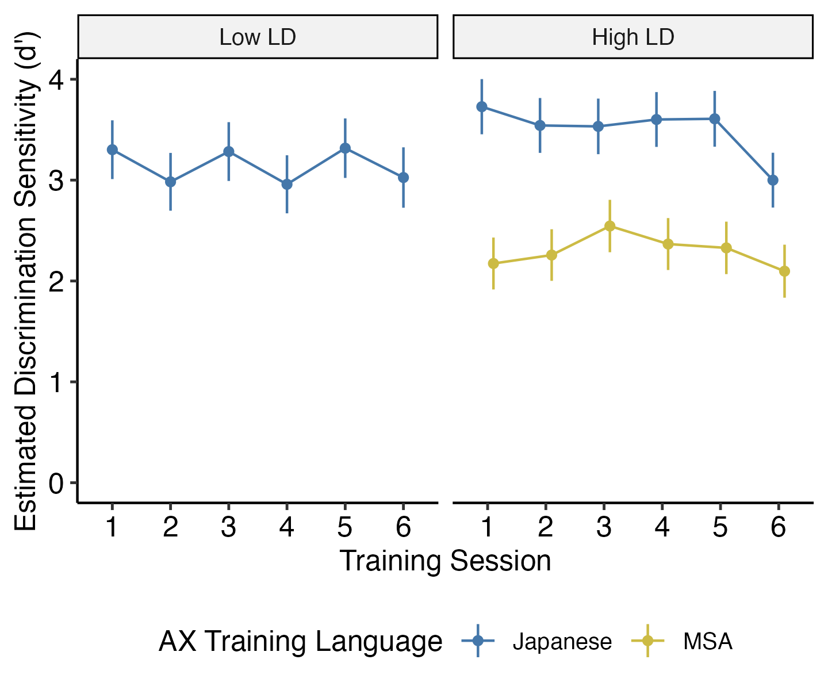
Figure 5.3: Estimated marginal slopes of signal per training session, i.e., the estimated d' value on the probit link scale, by training language (color) and experimental training group, at mean values of covariates. Error bars reflect 95% confidence intervals. Note that the Low LD group did not train with MSA minimal pairs.
The random effects of the model are presented in Table 5.5. The random slopes indicate that the standard deviation among Session 1 d’ values for participants was 0.43 and 0.16 for Session 6, the model did not find substantial variation in d’ scores for Session 2-5, which contributed to the decision not to model correlation between the random parameters.
Table 5.5: Random Effects of the Binomial Generalized Linear Mixed-Effects Model Predicting AX Discrimination Sensitivity Across Training Sessions.
Group | Random Slopes | SD
Participant | Session 1 Signal (d’) | 0.43
 | d’ x Session 2 | 0.00
 | d’ x Session 3 | 0.00
 | d’ x Session 4 | 0.00
 | d’ x Session 5 | 0.00
 | d’ x Session 6 | 0.16
AX Word Pair | Session 1 Signal (d’) | 0.54
N_{Participant} |  | 12
N_{AX} _{Word} _{Pair} |  | 36
N_{observations} |  | 18693
Key: SD = Standard Deviation
Model formula (family = binomial, link = probit): Response ~ 1 + Signal * Training Session * (Training Experimental Group + AX Training Language + MCPD Pretest Accuracy + MLD-A + MLD-P + Days Between First and Last Training Session + Speaker Signal) + (1 + Signal + Signal:Training Session || Participant) + (1 + Signal | AX Word Pair); italics = control variables (effects not included in table)
Notes: Intercept and predictor effects that did not interact with Signal were estimates associated with response bias c in SDT, which were not of interest in the model interpretation and thus the random intercepts were not included in the table. The random intercepts and slopes for Participant were modeled without correlation between random parameters (|| syntax).

VAS pre- and posttraining results
Figure 5.4 plots the two-dimensional space of the VAS slope and response variability measures from the curve fit estimation, by time (Pre vs. Post), VAS contrast pair, and experimental training. Each subplot has two dots per participant with directional arrows plotting the trajectory of each participant’s change in VAS slope and response variability from pretraining to posttraining, along with the group-level Pre vs. Post spread for each subplot (dashed ellipses). Most subplots show that there was not much change in slope or response variability at the group level, as the shape of the pretraining and posttraining ellipses remain roughly the same. Interestingly, the pretraining and posttraining ellipses seem to be less stable in shape across the contrast pairs for the Control group. However, with the small sample sizes for each experimental condition, I hesitate to make any judgements based on the visualization. Still, the figure serves to visualize both individual and group-level measurements for VAS slope and response variability, which are statistically explored using the Bayesian multivariate mixed-effects model.
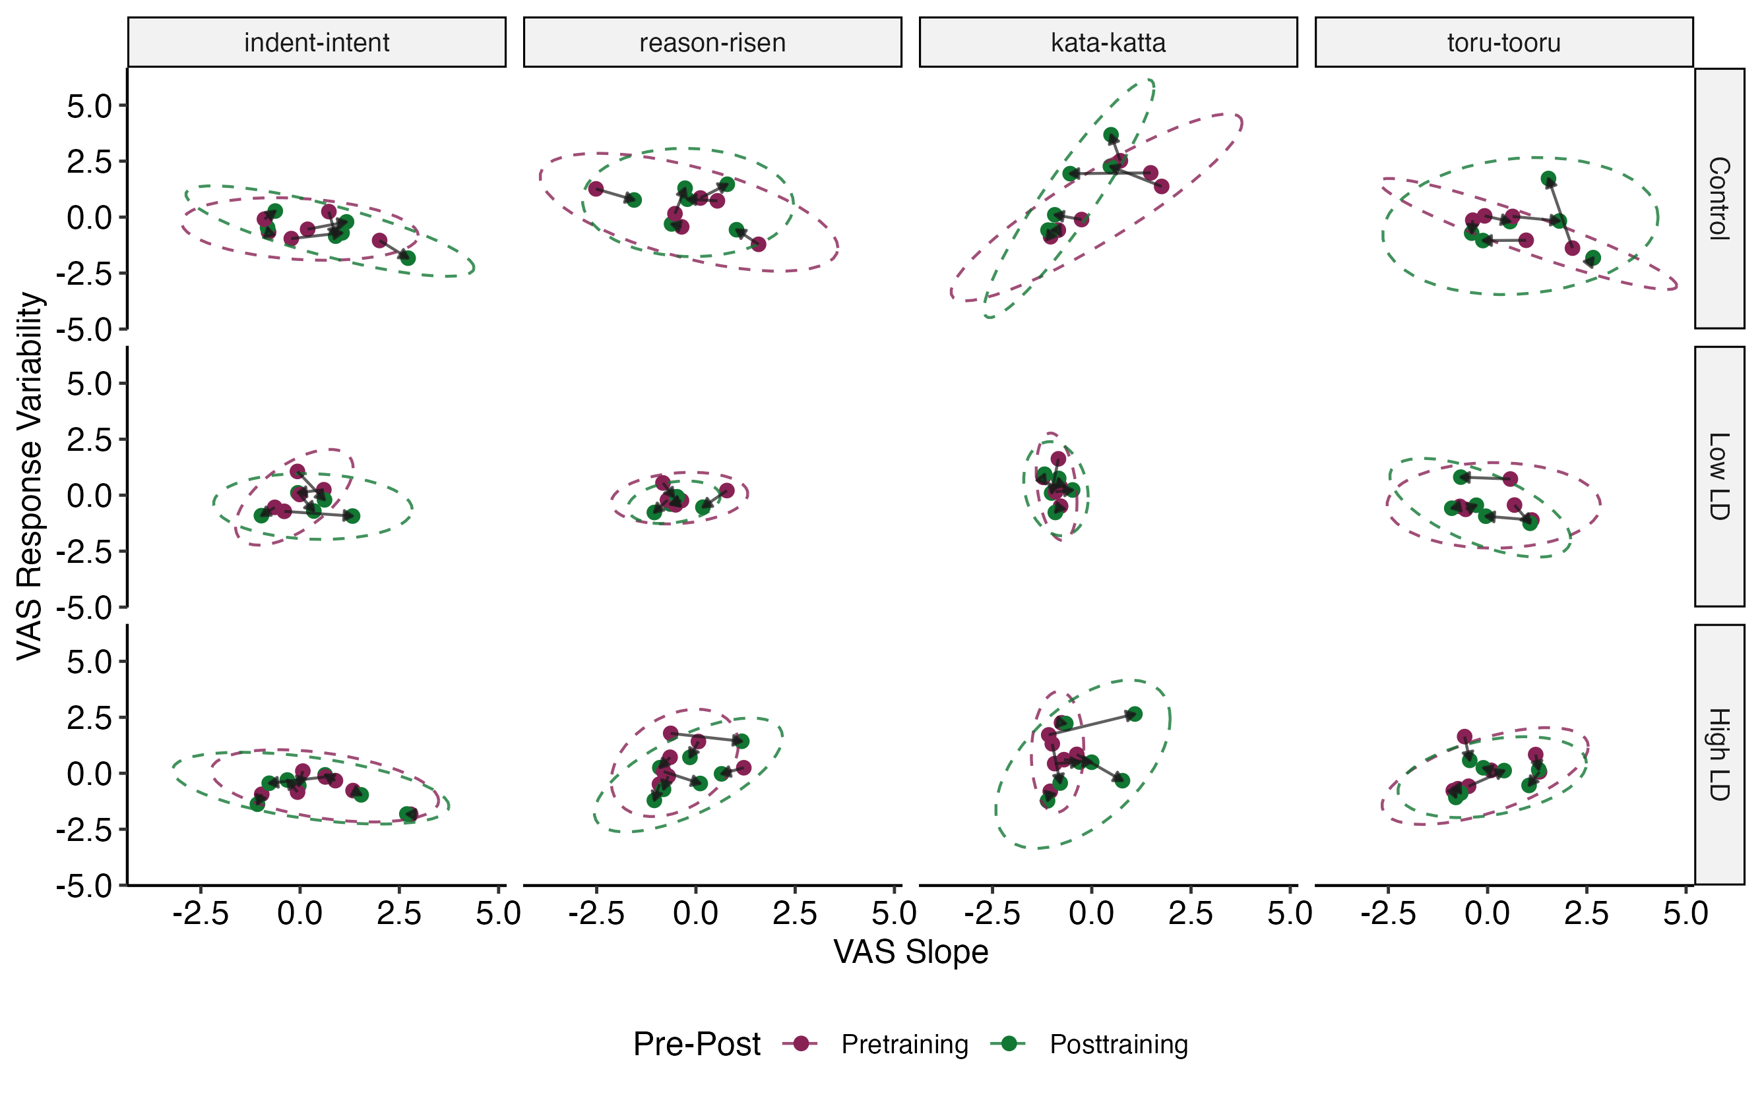
Figure 5.4: VAS slope (x-axis) and response variability (y-axis) of each participant at pretraining (raspberry dots) and posttraining (green dots) by VAS contrast pair and experimental condition (Control n = 6, Low LD n = 5, High LD n = 7) with directional arrows and summary ellipses. The directional arrows plot the change in VAS slope and response variability from pretraining to posttraining by participant. The colored dashed ellipses represent the 95% confidence interval about the x-y coordinates representing the pair-by-condition group mean for slope and response variability on pretraining (raspberry) and posttraining (green), assuming a bivariate t-distribution.
The results of the Bayesian multivariate mixed-effects model predicting change in VAS slope and response variability are presented in Table 5.6. The analysis revealed that there were almost no robust effects on VAS slope and response variability, as most the predictors had credible intervals that contained zero. The only effect considered robust was the interaction effect between VAS contrast language and the Control vs training groups at Pretest (b = -0.64, 95% CrI [-1.16, -0.12], pd-p = 0.02). However, this effect merely suggests that the difference in VAS slope between L1 and L2 was more negative for the training groups (averaged between Low LD and High LD) compared to the Control group at the time of pretraining.
Table 5.6: Fixed Effect of the Bayesian Multivariate Mixed-Effects Model Predicting Pre-Posttraining VAS Slope and Response Variability.
 |  | VAS Slope |  |  | VAS Response Variability
Predictor |  | Estimate | 95% CrI | pd-p | Estimate | 95% CrI | pd-p
Pretraining:
 | Intercept (Pretraining) | -0.13 | [-0.91, 0.63] | 0.72 | -0.13 | [-0.87, 0.59] | 0.68
 | Contrast Language | -0.02 | [-0.72, 0.71] | 0.96 | 0.14 | [-0.60, 0.88] | 0.71
 | Control vs. Training | -0.38 | [-0.97, 0.18] | 0.20 | -0.04 | [-0.49, 0.42] | 0.88
 | Low LD vs. High LD | 0.09 | [-0.53, 0.75] | 0.77 | 0.04 | [-0.51, 0.57] | 0.88
 | Contrast Language x  Control vs. Training | -0.64 | [-1.16, -0.12] | 0.02 | 0.04 | [-0.53, 0.62] | 0.89
 | Contrast Language x  Low LD vs. High LD | -0.16 | [-0.69, 0.40] | 0.58 | 0.23 | [-0.38, 0.85] | 0.47
Change from Pre to Post:
 | Change from Pre to Post | 0.04 | [-0.19, 0.26] | 0.75 | -0.14 | [-0.39, 0.11] | 0.26
 | Contrast Language | -0.12 | [-0.50, 0.26] | 0.55 | 0.11 | [-0.31, 0.50] | 0.61
 | Control vs. Training | -0.01 | [-0.45, 0.43] | 0.97 | -0.40 | [-0.86, 0.08] | 0.09
 | Low LD vs. High LD | 0.18 | [-0.30, 0.66] | 0.44 | -0.03 | [-0.55, 0.48] | 0.90
 | Contrast Language x  Control vs. Training | 0.30 | [-0.35, 0.93] | 0.38 | 0.08 | [-0.56, 0.77] | 0.82
 | Contrast Language x  Low LD vs. High LD | 0.27 | [-0.40, 0.93] | 0.41 | -0.01 | [-0.70, 0.68] | 0.99
Key: Estimate = median of the posterior probability distribution; CrI = Credible Interval (95% highest-density interval); pd-p = p-value calculated from Probability of Direction (pd)
Model formula: (VAS Slope, VAS Response Variability) ~ Pre-Post * Contrast Language * Experimental Condition + MLD-A + MLD-P + AX Pretest Sensitivity + MCPD Pretest Accuracy + Days Between Pre-Post + (1 + Pre-Post + Contrast Language | Participant) + (1 | VAS Pair); italics = control variables (effects not included in table)
Notes: VAS Contrast Language was simple effects coded (English = -0.5, Japanese = 0.5). pd-p was calculated using the bayestestR R package (v0.16.0; Makowski et al., 2019).
The interaction effect between VAS contrast language and experimental groups on VAS slope is visualized in Figure 5.5A. This figure shows that at pretraining, L1 VAS slope values were similar amongst the experimental conditions, but for the L2 VAS slope values, the Control group has a higher mean value than the two training groups. The fact that the training groups have different baseline values at pretraining may suggest a random sampling error during the random assignment of experimental groups. Another trend seen in Figure 5.5B shows that on average, the two training groups had decreasing trends for L1 and L2 VAS response variability means from pretraining to posttraining, while the Control group had flat or slightly increasing trends. The model revealed weak evidence for this trend, which was estimate of the effect of Control vs. Training on change from Pre to Post for VAS response variability, averaged across the VAS contrast languages (b = -0.40, 95% CrI [-0.86, 0.08], pd-p = 0.09). Again, with the small sample sizes for the experimental groups, this effect is highlighted with caution.
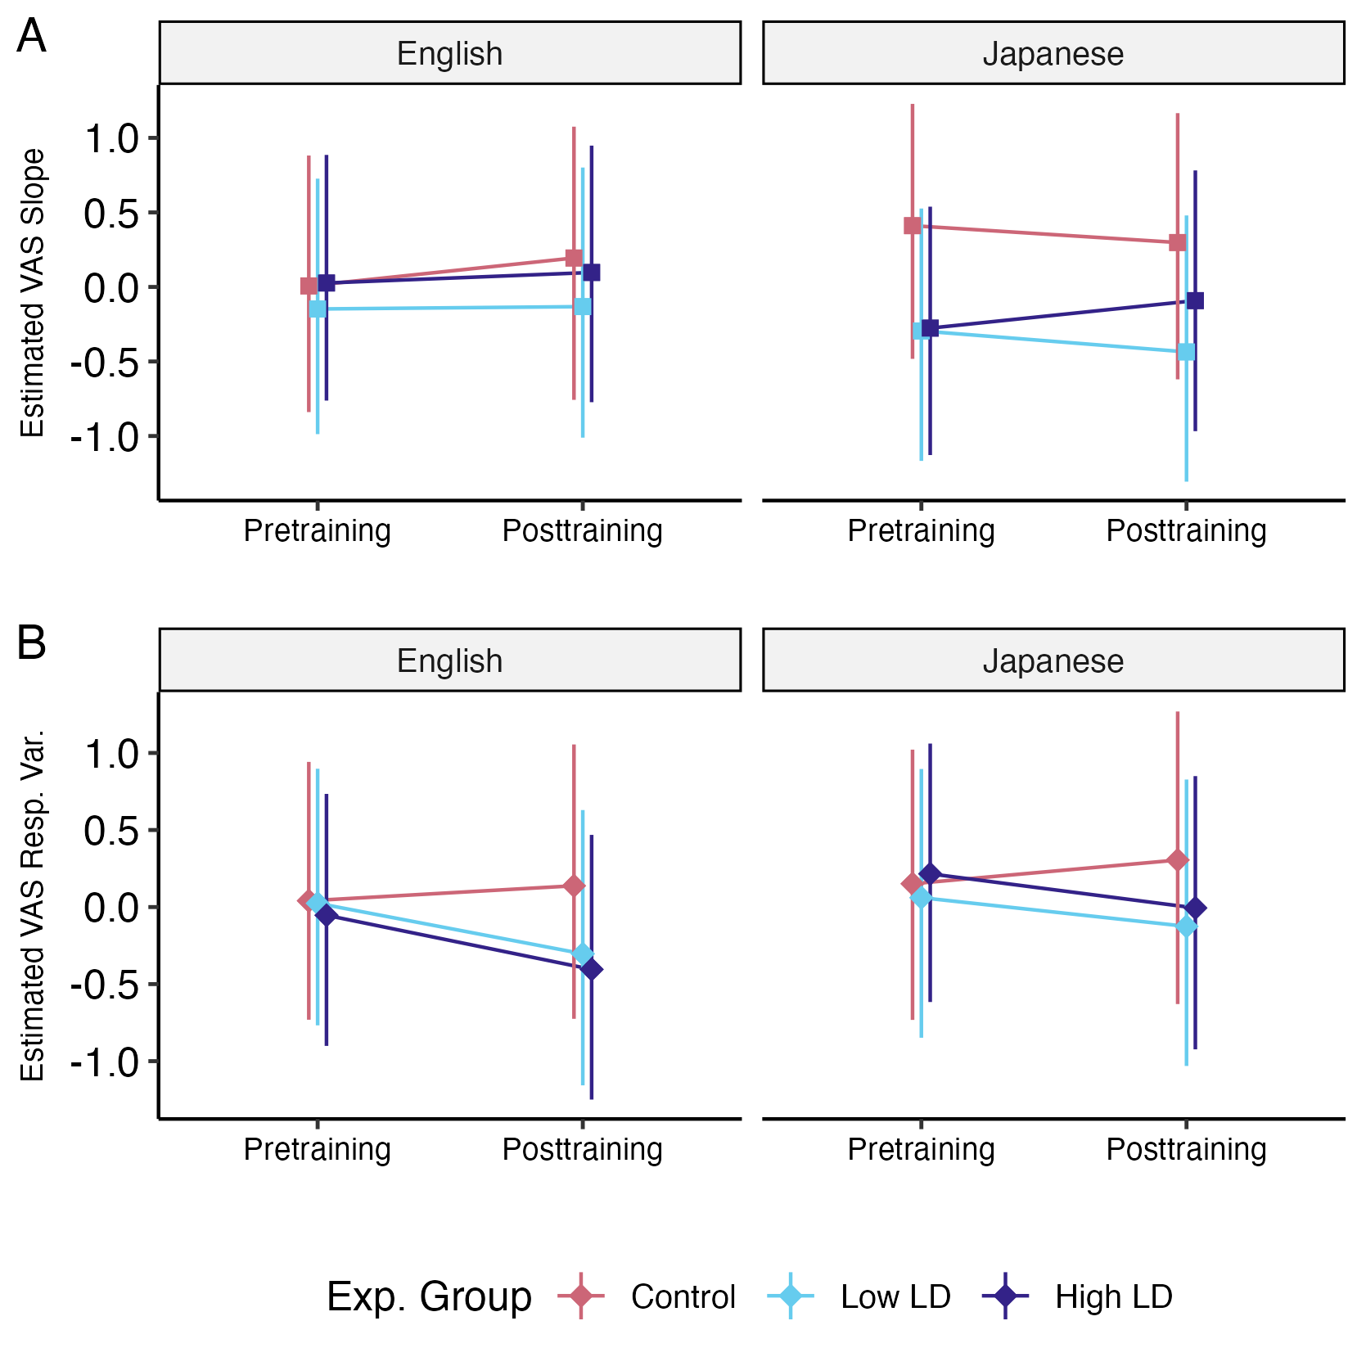
Figure 5.5: Estimated marginal effects for VAS slope (A) and response variability (B) at pre- and posttraining by VAS contrast language and experimental group, at mean values of covariates. The figure plots the estimated median of the marginal effects with 95% highest density interval as the credible interval (CrI).
The random effects parameters of the model, including the standard deviation of the random intercepts and slopes, their correlations, and indices of model fit are presented in Table 5.7.
Table 5.7: Random Effects and Model Fit of the Bayesian Multivariate Mixed-Effects Model Predicting Pre-Posttraining VAS Slope and Response Variability.
 |  | VAS Slope |  |  | VAS Response Variability
Group | Random Effect | SD  [95% CrI] | Int. ~ Slope Corr. | Slope ~ Slope Corr. | SD  [95% CrI] | Int. ~ Slope Corr. | Slope ~ Slope Corr.
Participant | Intercept | 0.59  [0.36, 0.91] |  |  | 0.39  [0.16, 0.64]
 | Pre-Post | 0.13  [0.00, 0.38] | -0.01  [-0.81, 0.86] |  | 0.15  [0.00, 0.40] | 0.25  [-0.62, 0.99]
 | Contrast Language | 0.12  [0.00, 0.36] | -0.25  [-0.99, 0.66] | 0.02  [-0.85, 0.91] | 0.38  [0.03, 0.69] | 0.65  [-0.04, 1.00] | 0.39  [-0.61, 0.99]
VAS Pair | Intercept | 0.47  [0.18, 1.05] |  |  | 0.53  [0.21, 1.15]
Residual | Residual | 0.62  [0.50, 0.72] |  |  | 0.65  [0.53, 0.77]
Bayes R^{2Note}
 |  | 0.56 [0.46, 0.63] |  |  | 0.51 [0.40, 0.60]
Residual Correlation^{Note}
 | VAS Slope ~  VAS Resp. Var. |  |  | -0.35 [-0.50, -0.16]
N_{Participant} | 18 | N_{VAS} _{Pair} | 4 | N_{observations} | 144
Key: SD = Standard Deviation; CrI = Credible Interval (95% highest density interval); Int. = Intercept; Cor. = Correlation
Model formula: (VAS Slope, VAS Response Variability) ~ Pre-Post * Contrast Language * Experimental Condition + MLD-A + MLD-P + AX Pretest Sensitivity + MCPD Pretest Accuracy + Days Between Pre-Post + (1 + Pre-Post + Contrast Language | Participant) + (1 | VAS Pair); italics = control variable
^{Note}The estimated Bayes R² values for each response variable are presented with the 2.5% and 97.5% quantile range. The estimated Residual Correlation between the response variables is presented with the 95% uncertainty interval.

AX discrimination pre- and posttest results
Figure 5.6 shows the estimated marginal effects from the AX discrimination pre- and posttests for both discrimination sensitivity (d’) and reaction time (RT). Figure 5.6A shows that the two training groups increased in d’ from pretest to posttest while the Control group had a relatively flat or slightly decreasing trend, however, the Control group and training groups had different pretest baseline d’ values. On the other hand, Figure 5.6B shows that the training groups decreased in RT from pretest to posttest, while the Control group increased in RT. These trends are discussed as results of the statistical analyses in the following sections.
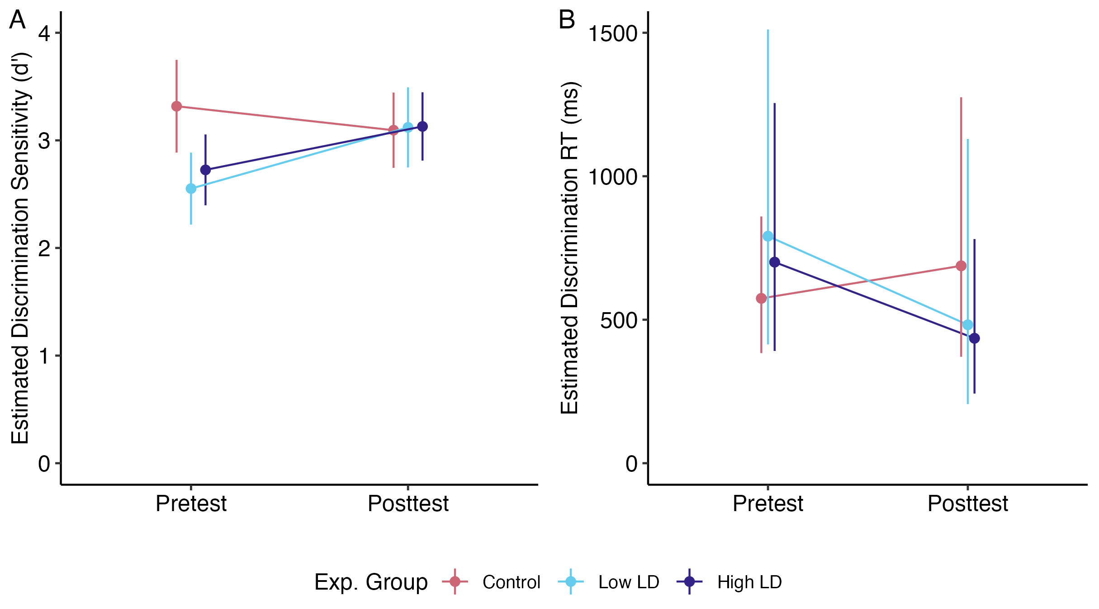
Figure 5.6: Estimated marginal effects for AX discrimination measures at pre- and posttest by experimental group, at mean values of covariates. Error bars reflect 95% confidence intervals. A. Estimated marginal slopes of signal, i.e., the estimated d' value on the probit link scale. B. Estimated marginal means of reaction time, back-transformed into the original response scale of milliseconds.

Discrimination sensitivity results
The fixed- and random-effects of the generalized mixed-effects model predicting d’ at pretest and posttest are summarized in Table 5.8. These results of the model reveal that there was no significant effect of time on d’ averaged across participants (b = 0.17, 95% CI [-0.45, 0.79], p = 0.589). Additionally, despite the trend suggested in Figure 5.6A, the interaction effect of d’ x Control vs. Training groups on change from pretest to posttest was also not significant (b = 0.71, 95% CI [-0.30, 1.72], p = 0.170). These results fail to provide evidence of improvement in L2 discrimination sensitivity from pretest to posttest.
Table 5.8: Fixed and Random Effects of the Binomial Generalized Linear Mixed-Effects Model Predicting Pre-Posttest AX Discrimination Sensitivity.
Predictor |  | Estimate [95% CI] | SE | z | p
Pretest:
 | Signal (d’) | 2.94 [2.23, 3.65] | 0.36 | 8.11 | < .001***
 | d’ x Control vs. Training Groups | -0.68 [-1.69, 0.33] | 0.52 | -1.31 | 0.189
 | d’ x Low LD vs. High LD | 0.17 [-0.59, 0.94] | 0.39 | 0.45 | 0.656
 | d’ x L1 VAS Slope | 0.18 [-0.41, 0.77] | 0.30 | 0.60 | 0.551
 | d’ x L1 VAS Resp. Var. | -0.26 [-1.11, 0.59] | 0.43 | -0.60 | 0.549
 | d’ x L2 VAS Slope | -0.50 [-1.12, 0.12] | 0.32 | -1.58 | 0.114
 | d’ x L2 VAS Resp. Var. | -0.12 [-0.70, 0.45] | 0.29 | -0.42 | 0.677
Posttest:
 | Change in d’ from Pre to Post | 0.17 [-0.45, 0.79] | 0.32 | 0.54 | 0.589
 | d’ x Control vs. Training Groups | 0.71 [-0.30, 1.72] | 0.52 | 1.37 | 0.170
 | d’ x Low LD vs. High LD | -0.16 [-0.89, 0.56] | 0.37 | -0.45 | 0.655
 | d’ x L1 VAS Slope | 0.12 [-0.60, 0.84] | 0.37 | 0.33 | 0.740
 | d’ x L1 VAS Resp. Var. | 0.09 [-0.99, 1.16] | 0.55 | 0.16 | 0.873
 | d’ x L2 VAS Slope | 0.34 [-0.51, 1.18] | 0.43 | 0.78 | 0.438
 | d’ x L2 VAS Resp. Var. | -0.14 [-0.73, 0.44] | 0.30 | -0.47 | 0.635
Random Slopes
 | Pretest Signal (d’)  SD_{Participant} | 0.42
 | Pretest Signal (d’)  SD_{AX} _{Word} _{Pair} | 0.89
 | N_{Participant} | 18
 | N_{AX} _{Word} _{Pair} | 25
 | N_{observations} | 6760
Key: CI = Confidence Interval; SE = Standard Error; Resp. Var. = Response Variability; SD = Standard Deviation; Significance codes: (***) p < 0.001, (**) p < 0.01, (*) p < 0.05
Model formula (family = binomial, link = probit): Response ~ 1 + Signal * Pre-Post * (Experimental Condition + L1 VAS Slope + L1 VAS Resp. Var. + L2 VAS Slope + L2 VAS Resp. Var. + MCPD Pretest Accuracy + MLD-A + MLD-P + Days Between Pre-Post + Speaker Signal) + (0 + Signal | Participant) + (0 + Signal | AX Word Pair); italics = control variables (effects not included in table)
Notes: Intercept and predictor effects that did not interact with Signal were estimates associated with response bias c in SDT, which were not of interest in the model interpretation and were thus not included. Random intercepts were not modeled for the same reason.

Discrimination reaction time results
The fixed-effects results of the linear mixed-effects model predicting log-RT are summarized in Table 4.8. The model estimates were back-transformed into the original RT units of milliseconds by exponentiating the coefficients, thus the slope effects for the predictor variables are multiplicative rather than additive. The model revealed that there was no significant effect of time on RT when averaging across participants (b = 0.91, 95% CI [0.64, 1.30], p = 0.608). However, there was a significant interaction of the effect of Control vs. Training groups on change from pretest to posttest (b = 0.51, 95% CI [0.30, 0.89], p = 0.018), which indicates the change in RT from pretest to posttest was 49% lower for the training groups compared to the Control group. This corroborates the difference in RT trends between the Control and training groups in Figure 5.6B, suggesting that the training groups became faster in accurate L2 discrimination after training compared to the Control group, who did not receive training.
Table 5.9: Fixed Effects of the Linear Mixed-Effects Model Predicting Pre-Posttest AX Discrimination Reaction Time.
Predictor |  | Exp(Estimate) [95% CI] | t | p
Pretest:
 | Intercept (Pretest) | 535.61 [387.47, 740.37] | 38.05 | < .001***
 | Control vs. Training Groups | 1.30 [0.78, 2.17] | 0.99 | 0.323
 | Low LD vs. High LD | 0.89 [0.59, 1.32] | -0.60 | 0.550
 | L1 VAS Slope | 1.00 [0.76, 1.31] | -0.03 | 0.974
 | L1 VAS Resp. Var. | 0.95 [0.64, 1.40] | -0.28 | 0.779
 | L2 VAS Slope | 1.21 [0.90, 1.64] | 1.24 | 0.215
 | L2 VAS Resp. Var. | 0.87 [0.65, 1.16] | -0.92 | 0.356
Posttest:
 | Change from Pre to Post | 0.91 [0.64, 1.30] | -0.51 | 0.608
 | Control vs. Training Groups | 0.51 [0.30, 0.89] | -2.36 | 0.018*
 | Low LD vs. High LD | 1.02 [0.66, 1.56] | 0.09 | 0.932
 | L1 VAS Slope | 0.87 [0.58, 1.30] | -0.68 | 0.499
 | L1 VAS Resp. Var. | 0.74 [0.39, 1.39] | -0.93 | 0.353
 | L2 VAS Slope | 1.01 [0.63, 1.62] | 0.04 | 0.968
 | L2 VAS Resp. Var. | 1.08 [0.77, 1.51] | 0.43 | 0.669
Key: CI = Confidence Interval; Resp. Var. = Response Variability; Significance codes: (***) p < 0.001, (**) p < 0.01, (*) p < 0.05
Model formula: Log RT ~ Pre-Post * (Experimental Condition + L1 VAS Slope + L1 VAS Resp. Var. + L2 VAS Slope + L2 VAS Resp. Var. + MCPD Pretest Accuracy + MLD-A + MLD-P + Days Between Pre-Post + Speaker Signal) + (1 + Pre-Post | Participant) + (1 + Pre-Post | AX Word Pair); italics = control variables (effects not included in table)
Notes: Log-RT estimates and 95% CIs were exponentiated into the original reaction time scale (milliseconds) using the model_parameters function of the parameters R package (v0.26.0; Lüdecke et al., 2020). Non-intercept predictor terms represent multiplicative changes in RT. Standard error estimates are not reported on the original RT scale.
The population-level random effects parameters are presented in Table 5.10. Note that the random effects are based on natural log-transformed RT that was used in the model, as back-transformation of variance effects through exponentiation is not recommended.
Table 5.10: Random Effects of the Linear Mixed-Effects Model Predicting Pre-Posttest AX Discrimination (Log-Transformed) Reaction Time.
Group | Random Effect | SD | Int. ~ Slope  Corr.
Participant | Intercept | 0.26
 | Pre-Post | 0.24 | 0.26
AX Word Pair | Intercept | 0.07
 | Pre-Post | 0.05 | -0.20
Residual | Residual | 0.63
Model Fit
N_{Participant} | 18 | N_{AX} _{Word} _{Pair} | 25
N_{observations} | 5884 | ICC | 0.24
Marginal R² | 0.10 | Conditional R² | 0.31
Key: SD = Standard Deviation; Int. = Intercept; Corr. = Correlation; ICC = Intra-level Correlation Coefficient
Model formula: Log RT ~ Pre-Post * (Experimental Condition + L1 VAS Slope + L1 VAS Resp. Var. + L2 VAS Slope + L2 VAS Resp. Var. + MCPD Pretest Accuracy + MLD-A + MLD-P + Days Between Pre-Post + Speaker Signal) + (1 + Pre-Post | Participant) + (1 + Pre-Post | AX Word Pair); italics = control variables
Notes: Random standard deviations are presented in the Log-RT scale.

MCPD pre- and posttest listening assessment accuracy results
The fixed- and random-effects of the generalized mixed-effects model predicting MCPD accuracy at pretest and posttest are summarized in Table 5.11. The table presents the Odds Ratio (OR) of the fixed-effects. Surprisingly, there was no significant effect of time (OR = 2.99 [0.75, 11.88], p = 0.119), indicating that participants did not improve in accuracy when averaging across experimental groups. The only significant predictor effect was for the difference in accuracy between the control and training groups at pretest, which found that the odds of accurate responses from the training groups (averaged between Low LD and High LD) were 0.24 times lower than the Control group (95% CI [0.06, 0.90], p = 0.034). As this effect was at pretest, this reflects that the Control group and training groups were starting at different baselines before the training period. This may be the result of random sampling error during the random assignment of experimental groups.
Table 5.11: Fixed and Random Effects of the Binomial Generalized Linear Mixed-Effects Model Predicting Pre-Posttest MCPD Accuracy.
Predictor |  | Odds Ratio [95% CI] | z | p
Pretest:
 | Intercept (Pretest) | 6.18 [3.06, 12.50] | 5.07 | < .001***
 | Control vs. Training Groups | 0.24 [0.06, 0.90] | -2.12 | 0.034*
 | Low LD vs. High LD | 0.91 [0.35, 2.35] | -0.20 | 0.840
 | L1 VAS Slope | 1.56 [0.71, 3.43] | 1.11 | 0.266
 | L1 VAS Resp. Var. | 0.68 [0.19, 2.42] | -0.60 | 0.547
 | L2 VAS Slope | 0.48 [0.20, 1.14] | -1.66 | 0.097
 | L2 VAS Resp. Var. | 0.68 [0.36, 1.29] | -1.17 | 0.241
Posttest:
 | Change from Pre to Post | 2.99 [0.75, 11.88] | 1.56 | 0.119
 | Control vs. Training Groups | 2.99 [0.52, 17.18] | 1.23 | 0.219
 | Low LD vs. High LD | 0.93 [0.24, 3.71] | -0.10 | 0.922
 | L1 VAS Slope | 0.56 [0.16, 1.98] | -0.90 | 0.370
 | L1 VAS Resp. Var. | 8.83 [0.66, 117.68] | 1.65 | 0.099
 | L2 VAS Slope | 1.85 [0.39, 8.73] | 0.77 | 0.439
 | L2 VAS Resp. Var. | 0.74 [0.23, 2.34] | -0.52 | 0.603
Random Effects
 | Intercept SD_{Participant} | 0.17
 | Intercept SD_{Trial} | 0.54
 | N_{Participant} | 18
 | N_{Trial} | 20
 | N_{observations} | 720
Key: CI = Confidence Interval; SE = Standard Error; Resp. Var. = Response Variability; SD = Standard Deviation; Significance codes: (***) p < 0.001, (**) p < 0.01, (*) p < 0.05
Model formula (family = binomial, link = logit): Correct ~ 1 + Pre-Post * (Experimental Condition + L1 VAS Slope + L1 VAS Resp. Var. + L2 VAS Slope + L2 VAS Resp. Var. + AX Pretest Sensitivity + MLD-A + MLD-P + Days Between Pre-Post) + (1 | Participant) + (1 | Trial); italics = control variables (effects not included in table)
Notes: Log-odds estimates and 95% CIs were exponentiated into the Odds Ratio scale using the model_parameters function of the parameters R package (v0.26.0; Lüdecke et al., 2020). Standard error estimates are not reported on the Odds Ratio scale. The random intercept SD terms are reported on the log-odds scale.
Figure 5.7 visualizes the difference in the estimated marginal mean accuracy at pretest baseline between the Control group and training groups. The trajectory of accuracy from pretest to posttest is mostly flat for the Control group, while both training groups show a positive trend from pretest to posttest. However, this trend, represented by the interaction effect between time and Control vs. Training groups, was not statistically significant in the model (OR = 2.99, 95% CI [0.52, 17.18], p = 0.219). These results fail to provide evidence of improvement in L2 listening accuracy from pretest to posttest.
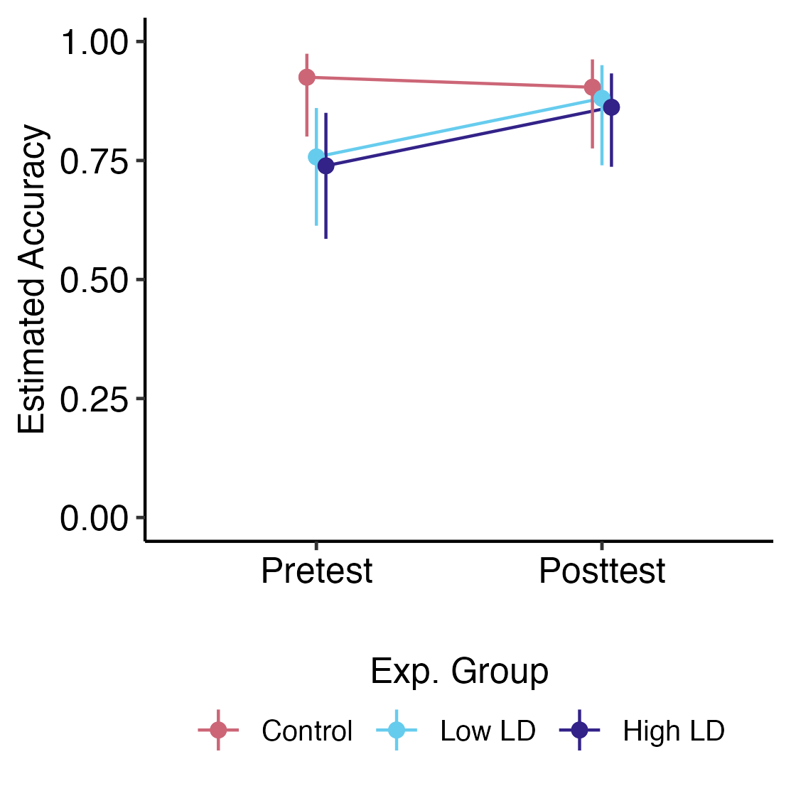
Figure 5.7: Estimated marginal mean accuracy at pre- and posttest by experimental group, plotted on the probability scale, at mean values of covariates. Error bars reflect 95% confidence intervals.

Study 3 Discussion
The purpose of Study 3 was to investigate the effects of long-term specific exposure to linguistic diversity via perceptual training, as a supplement to classroom instruction, on gradient categorization of L1 and L2 speech, L2 phoneme discrimination, and L2 speech perception and listening. Active L2 Japanese learners enrolled in Japanese language courses at the time of the study underwent six sessions of AX discrimination perceptual training across several weeks to learn L2 Japanese phonemic length contrasts, with participants randomly assigned to either the Low LD training, who trained only with Japanese minimal pairs, or the High LD training group, who trained with Japanese and MSA minimal pairs. Learners in the training groups were compared to learners in the Control group, who did not receive perceptual training and only received classroom instruction. Before and after training (or an equivalent amount of time for the Control group), learners performed the VAS task to obtain categorization measures for L1 English and L2 Japanese contrast pairs, an AX discrimination test to assess perceptual discrimination sensitivity, and the MCPD listening assessment task to assess L2 speech perception and listening using naturalistic speech stimuli.
I hypothesized that perceptual training would not only push learners towards gradient categorization patterns, but would also lead to greater improvement in the L2 speech learning measures from discrimination and MCPD tasks for the training groups compared to the Control group, and that this effect would be stronger for the High LD group compared to the Low LD. However, these hypotheses were not supported by the results. First, there was no strong evidence that participants’ VAS measures changed after the training time period, for either L1 or L2 categorization. Second, participants did not show consistent signs of L2 speech learning, for either L2 discrimination sensitivity or L2 listening accuracy, after the training time period.
The lack of learning effects was unexpected, especially when comparing these AX discrimination pre- and posttest results to those of Study 2 (Section 4.2.3). This may reflect that learners were already at ceiling and any additional gains in learning could not be measured using the AX discrimination task or MCPD task. It is possible that compared to the naïve listeners, perceptual training does not lead to learning for those with formal classroom experience with Japanese. However, previous literature would suggest that this is not the case, as HVPT has been found to benefit both learners with and without experience with the target language (e.g., Iverson et al., 2012; Georgiou, 2021; Cebrian & Carlet, 2014).

Limitations
The primary limitation of Study 3, and a more likely explanation for the lack of effects, is that the sample size was too limited to detect effects. While the visualizations of the AX discrimination and MCPD results (Figures 5.6 & 5.7, respectively) suggested possible differences between the Control group and training groups (which was statistically supported for the AX discrimination reaction time results only), the complexity of the regression models required far more individuals per experimental group to detect any possible existing training effects.
Another limitation of the study could be the alignment between the population and the training method. As these are L2 classroom learners, a simple perceptual training paradigm using isolated minimal pairs may not have provided rich enough input to have an impact on learning. It is possible that a learning effect would have been larger had participants had trained with the words in semantically meaningful context, with phrase or sentence-long stimuli. The results of previous studies suggest that the background of the participant, whether naïve or actively learning the target language, plays a role in how the training context affects learning. For example, monolingual L1 English speakers improved in perception of Japanese long vowels after perceptual training compared to a control group, but improvement was not significantly different between those who trained with words in isolation versus words in sentences (Hirata, 2004c). On the other hand, L1 Korean speakers who were active L2 learners of Japanese improved when training with both words in isolation versus words with sentences, but those who trained with sentences showed improved generalizability (Sonu et al., 2011). It is possible that proficiency level may also have an impact on the effectiveness of the training context, and the method of presentation of the target phonemes (using words in isolation, carrier sentences, or both) should be considered in relation to learners’ proficiency levels in future studies.
Additionally, possible sampling error in the random assignment to experiment conditions made it difficult to draw conclusions on pre- to posttest effects, as the Control group was observed to have different baseline values for many of the measures collected. The impact of the sampling error may also have been exacerbated by the small sample sizes, as the Control group mean values could have been easily influenced by the presence of outlier individuals. Alternatively, the distribution of proficiency levels between experimental groups may have played a role. Although higher proficiency individuals (third and fourth years) were equally dispersed among the experimental groups, there was only one first year in the Control group; this could have artificially inflated the pretest scores of the Control group compared to the Low LD and High LD groups, which had more first-year students. Given the small number of individuals with different proficiency levels distributed between the experimental groups, the effect of course level could not be examined as an additional predictor of training effects on learning. Overall, the results of Study 3 cannot be confidently discussed due to small sample sizes and the lack of statistical power.

General Discussion

Results Summary
In this dissertation, I explored the relationship between gradient categorization, linguistic diversity, and the acquisition of L2 phonemic contrasts combining existing and novel methods to measure L1 and L2 speech perception, experiential and manipulated linguistic diversity, and L2 perceptual discrimination and listening accuracy. Table 6.1 summarizes the specific relationships investigated in the present study in the context of the specific aims and research questions.
Table 6.1: Summary of the Predictors, Effects, and Outcome Variables of Interest in the Context of the Specific Aims and Research Questions.
Specific Aim | RQ | Predictor/Effect | Outcome of Interest
Aim 1 | RQ1 | Experiential LD | L1 & L2 gradient categorization
 |  |  | L1 & L2 secondary cue use
 |  | L1 & L2 gradient categorization | L1 & L2 secondary cue use
Aim 2 | RQ2 | Specific LD (short-term) | L1 & L2 gradient categorization
 |  | Specific LD (short-term) | L2 discrimination ability
 |  | L1 & L2 gradient categorization
Aim 3 | RQ2/RQ3 | Specific LD (long-term) | L1 & L2 gradient categorization
 |  | Specific LD (long-term) | L2 discrimination ability, L2 listening accuracy
 |  | L1 & L2 gradient categorization
Key: LD = Linguistic Diversity
The relationship between linguistic diversity (LD), L1 and L2 gradient categorization, and L2 speech learning was explored at various combinations of LD as a predictor/effect, L1 and L2 categorization measures as both outcome variables and predictor variables, and L2 speech learning as outcome variables. With regards to linguistic diversity (LD) as a predictor and an effect on categorization measures, experiential LD was not found to predict L1 and L2 gradient categorization or secondary cue use (RQ1), and there was no significant evidence found for the effect of training with specific LD on L1 and L2 gradient categorization (RQ2). In fact, across Studies 2 and 3, the VAS measures of slope and response variability did not significantly change from pretraining to posttraining, in either cases of short-term or long-term training. As predictor variables for secondary cue use and L2 speech learning, L1 and L2 gradient categorization measures were not consistently found to predict L1 and L2 secondary cue use (RQ1), nor L2 discrimination ability (RQ2), nor L2 listening accuracy (RQ3). With regards to LD as an effect on L2 speech learning, short-term perceptual training led to improvements in L2 discrimination ability for naïve monolingual listeners, however, specific LD was not found to have an effect on the magnitude of learning gains (RQ2). There was no significant evidence found for the effect of long-term perceptual training, with or without specific LD, on L2 discrimination ability (RQ2) nor L2 listening accuracy (RQ3) for L2 learners in Japanese language classrooms. The following sections explore the implications of these findings, and lack of findings, on the relationship between these three factors in the context of extant literature.

Implications

Gradient categorization and linguistic diversity

Categorization gradiency
In Study 1, experiential LD, measured as two indices of multilingual language diversity (MLD), was not found to predict L1 or L2 categorization gradiency, response variability, or secondary cue use. To my knowledge, this dissertation is the first study to use MLD, which is a form of language entropy, to predict gradient measures of categorization. The study from Kutlu et al. (2024), one of the studies with the key findings that motivated the hypotheses of this dissertation, had found that linguistic diversity predicted gradient response profiles in children using social network analysis, and linguistic diversity was operationalized as the number of individuals who speak a different language/dialect out of the total network size. It is possible that the difference between operationalizing LD as language entropy vs. social network diversity led to the difference in results.
Previous research that operationalized LD using forms of language entropy have found that LD is associated with particular patterns of neural connectivity and behaviors of domain-general executive control. For example, high social LD has consistently been found to be associated with increased structural connectivity between a diverse set of brain regions implicated in non-inhibition-related domain-general executive functions, as opposed to domain-specific language-related regions, including language- and task-switching, and proactive executive control (Gullifer et al., 2018; Sulpizio et al., 2020). This modulatory effect of LD on neural connectivity was additionally found in behavioral measures of increased efficiency of L1 production in the face of increasing task demands (Kang et al., 2023), and faster RTs in conflict-monitoring, task-switching, and goal maintenance behaviors (X. Li et al., 2021).
On the other hand, previous studies sought to connect VAS-measured categorization gradiency with measures of executive functioning and found an association between gradient categorization and working memory (Kapnoula et al., 2017; D. Kim et al., 2020). These studies notably did not find an association between gradiency and other executive function behaviors measured, including task-switching, cognitive control, and inhibitory control (Kong & Edwards, 2016; Kapnoula et al., 2017; D. Kim et al., 2020; cf. Kapnoula & McMurray, 2021 who did find an association between gradiency and inhibitory control).
The findings of the present study may raise questions about the sensitivity of MLD as a predictor of categorization gradiency, but the literature linking both LD and gradiency to executive function offers an alternative explanation. The lack of overlap between the executive functions associated with LD and gradiency may point to the fact that the effect of LD on neural connectivity does not extend to the mechanisms involved in perceptual categorization. Notably, the study by X. Li et al. (2021) included the finding that those with high LD experienced more conflict in inhibitory control behaviors. A seemingly unrelated finding from D. Kim et al. (2020) suggested that inhibitory control was linked to short-term perceptual adaptability, but not working memory, which was found to be associated with gradiency. D. Kim et al. (2020) suggested the explanation that “different cognitive abilities may underlie gradiency and adaptation in speech perception” (p. 14). Indeed, taking these results together, it is possible that the cognitive abilities that underlie gradiency are unrelated to the cognitive abilities found to be associated with LD.

Secondary cue use
Study 1 also did not find evidence that gradiency predicted L1 or L2 secondary cue use. The lack of effect between L1 gradiency and L1 secondary cue use does not align with previous findings that established this association (Kong & Edwards, 2016; Kapnoula et al., 2017, 2021; Kapnoula & McMurray, 2021; D. Kim et al., 2020). There are a few key differences between the listed studies and the present study. First, excluding the early study from Kong & Edwards (2016), these studies all used the rotated logistic function to estimate measures of categorization, including the estimation of the theta angle representing relative secondary cue use. However, only one study used theta in the subsequent statistical analyses link gradiency and secondary cue use (Kapnoula & McMurray, 2021). The other studies used crossover difference between 2AFC response curves at different steps of the secondary dimension as the measure of secondary cue use. Second, these studies all used secondary cue use to predict categorization gradiency, meaning secondary cue use was included as an independent variable in models with VAS slope as the dependent variable, or used correlation analyses. As previous findings of this association have not been consistent across contrasts (Kapnoula et al., 2021; Kapnoula & McMurray, 2021); Kapnoula & McMurray (2021) suggested that contrary to the assumptions from the earlier findings, “cue integration [may be] a consequence rather than a source of gradiency” (p. 16). It was for this reason I used the gradiency measures as independent variables in models with secondary cue use as the dependent variable, to assess the degree to which gradiency predicted secondary cue use. The results from this analysis suggested that gradiency cannot be used to predict secondary cue usage in the same way secondary cue usage has been used to predict gradiency, as in previous literature.

Individual differences in gradient categorization and secondary cue use
A consistent finding from the present research was the considerable individual variability in categorization gradiency, response variability, and secondary cue use. Although these individual differences were not systematically predicted by linguistic diversity, experiential or specific, these findings contribute to the growing consensus that categorization is not a unitary skill but a process that brings together multiple mechanisms. These three factors of gradiency, response variability, and secondary cue use reflect subprocesses that vary not only according to the individual, but also to context- and phoneme-specific demands. In fact, it may be the case that the three factors reflect processes at different organizational stages of the speech perception process in line with the three distinct speech processing strategies suggested by Werker & Logan (1985). In their study, they found evidence that participants could “(1) classify the syllables according to familiar phonemic categories, (2) show a perceptual sensitivity to nonnative, phonetically relevant category boundaries, and (3) discriminate syllables on the basis of any acoustic variability between individual exemplars” (p.43), which provided supported for the hypotheses of distinct processes (1) phonemic perception, (2) intermediate-level phonetic perception, and (3) auditory perception. As such, individual-, language-, and contrast-level differences in categorization and the difficulty in finding a systematic connection predicting each factor may suggest that each of the three processes are more distinct that previously hypothesized. It could be the case that, for example, response variability reflects processes at the level of (1) phonemic perception, by reflecting the noisiness of phonological representations (Fuhrmeister & Myers, 2021), secondary cue use reflects processes at the level of (2) phonetic perception, by reflecting how the perceptual system organizes the relationship between acoustic cues and speech categories (Kapnoula et al., 2021), and gradiency reflects processes at the level of (3) auditory perception, by reflecting how the auditory system faithfully encodes continuous acoustic information (Ou & Yu, 2022). The distinction of the processes reflected by these three measures may thus explain not only the variability across individuals, but the variability within individuals seen within and across the L1 and L2 contrast pairs. Future research may wish to use more fine-grained measurements, such as neuroimaging, to explore how the VAS measures each distinctly connect to phonological representations, perceptual organization, and encoding strategies, and how these differ between the perception of L1 and L2 speech.

Gradient categorization, specific LD, and L2 phoneme acquisition
In Studies 2 and 3, the manipulation of specific LD via perceptual training was not found to have a consistent effect on L1 or L2 categorization gradiency or response variability. Along with the findings from Study 1 that MLD did not predict measures of gradient categorization, this may reflect that gradiency and response variability are relatively stable traits that are not so easily malleable to the effects of perceptual training. At first glance, this may appear to contradict the wealth of literature showing evidence that humans are capable of rapid perceptual adaptation and acoustic cue-reweighting after exposure to short-term speech regularities, such as those introduced by artificial accents (e.g., Idemaru & Holt, 2011, 2014, 2020; Reinisch et al., 2014; Lehet & Holt, 2017, 2020). However, the idea that measures of gradient categorization are robust against perceptual learning aligns with the findings from D. Kim et al. (2020), who suggested that perceptual adaptation and perceptual categorization rely on different cognitive mechanisms, despite the fact that both processes involve the mapping of acoustic cues to phoneme categories. In fact, there is evidence that the gradiency of category representations develops over the course of years through adolescence (McMurray et al., 2018). Combined with the report from Kong & Edwards (2016) that participants’ VAS response patterns were consistent across two sessions separated by one week, the findings from the present study showing stability in VAS measures across 24 hours and across several weeks lend support to the idea that categorization patterns, while phoneme-specific, are stable within individuals across time.
Another goal of this dissertation, framed in the second part of RQ2, was to determine whether gradient categorization might mediate the effect of specific LD on successful L2 learning, however, neither L1 or L2 gradiency or response variability predicted changes in L2 discrimination sensitivity or L2 listening accuracy. The lack of predictive effect of gradiency is consistent with a few studies that have explored the relationship between gradiency and L2 perception and learning (Honda et al., 2024; Fuhrmeister et al., 2023), although is inconsistent with other studies that did find that gradiency predicted L2 learning performance (J. Lee & Park, 2024) or reported L2 proficiency (Kapnoula & Samuel, 2024; Kong & Kang, 2023). Further, the lack of predictive effect of response variability contradicts the findings from Honda et al. (2024) and Fuhrmeister et al. (2023), who both showed that categorization consistency, rather than gradiency, predicted better performance in non-L1 speech perception. Here too, the inconsistency in findings among previous literature and the present study may lie in the difference in operationalization of measures for L2 learning and L2 proficiency.

Linguistic diversity and L2 phoneme acquisition

Implications for specific LD via perceptual training
The manipulation of specific LD via perceptual training did not lead to differential learning results among the training groups. One possibility is that the scaling of LD in this study was insufficient and that exposing learners to just one additional language may not approximate the effects of specific linguistic diversity observed in other studies (e.g., Wiener & Goss, 2019). On the other hand, previous research has often found no additional advantage in trilinguals over bilinguals (e.g., Werker, 1986; Patihis et al., 2015), so it is possible increasing the number of training languages would not affect the results. Additionally, despite the evidence showing the benefits of specific language knowledge in the learning of specific L2 contrasts (Wiener & Goss, 2019; Patihis et al., 2015; Pajak & Levy, 2014), other research has found evidence suggesting the opposite, that there is no difference in benefit between those who have specific and non-specific multilingual language experience (e.g., Enomoto, 1994), which aligns with the results of Study 2.
Another possibility is that the duration of exposure to specific LD was just too limited to contribute to learning, even though learning did occur. The both the short-term and long-term training sessions were not as immersive or long enough to approximate the long-term effects of linguistic diversity observed in other studies (e.g., Bice & Kroll, 2019). It may also be the case that the effects of specific LD occurred at a level not measured, for example, at the level of neural patterns or structures. For example, the effects of environmental linguistic diversity (Bice & Kroll, 2019) and passive laboratory exposure to an unknown language (Kurkela et al., 2019; Gullberg et al., 2010) were found to result in changes in neural patterns measured by ERPs or structural neural connectivity found using neuroimaging, but not in the behavioral measures employed by this study.
Notably, despite the lack of differential learning effects from specific LD, improved discrimination sensitivity was observed for the naïve monolingual listeners but not for the L2 Japanese classroom learners. The finding with the naïve monolingual listeners is consistent with the vast amount of literature showing that even short-term perceptual training can lead to gains in non-L1 perceptual sensitivity (e.g., Logan et al., 1991, p. Lively1993Training; Iverson et al., 2005; Iverson et al., 2012), which has also been replicated in the literature examining non-L1 learning of Japanese length contrasts with varying effect sizes (e.g., Tajima et al., 2003; Hirata, 2004c; Hirata et al., 2007).
However, the lack of training effects for L2 Japanese classroom learners contradicts existing literature that learners with experience in the L2, including classroom experience, show learning gains from perceptual training (e.g., Motohashi-Saigo & Hardison, 2009; Hirata, 2004a; Sonu et al., 2013; Georgiou, 2021; Tajima et al., 2003). The null finding is more likely to reflect the limitations of Study 3 from the small sample sizes rather than a true null effect. Further, Study 3 was also limited due to the heterogeneity among experimental groups at baseline measurements.

Implications for experiential LD
Although neither MLD nor specific LD as a manipulation were found to predict or have an effect on the L2 learning measurements, this dissertation presents a preliminary step in characterizing a facet of multilingualism, that is, passive or indirect exposure to LD, that is not often quantitatively operationalized and not often connected with perceptual behaviors. Besides Kutlu et al. (2024), who offered a quantitative measure of LD using social network analysis, other studies linking environmental or ambient linguistic diversity to language processing and learning either binned groups categorically (Bice & Kroll, 2019) or did not compare the population of study to populations in environments with low linguistic diversity (Oh et al., 2020; Todd et al., 2023). Additionally, to the best of my knowledge, this dissertation is the first study connecting LD using language entropy to L2 categorization and learning.
A wealth of prior literature has provided evidence for the various benefits of exposure to LD. Critically, however, these studies all examine the effects of LD in children or effects from exposure to LD during childhood, and this includes the study from Kutlu et al. (2024). For example, monolingual children exposed to LD from their social network, classroom, or neighborhood environment were found perform better than purely monolingual children, and sometimes just as well as multilingual children, in areas such as cognitive abilities (Tsimpli et al., 2020), effective communication (Fan et al., 2015), reading comprehension (Dotzel et al., 2021), learning foreign labels (Akhtar et al., 2012), and social learning for infants (Howard et al., 2014). The effects of childhood exposure to LD have been found even in adults. Specifically, adults who had minimal experience with (Au et al., 2008) or frequently overheard (Au et al., 2002; Knightly et al., 2003) Spanish during their childhood had a pronunciation advantage when learning Spanish as adults compared to those with no regular experience with Spanish until later in their adolescence.
These studies all seem to suggest that learning benefits from exposure to LD stem from childhood exposure, which may indicate that LD influences cognitive behavior at a developmental trajectory spanning years. The amount of exposure to LD during the training paradigms employed in the present study, which were only on the time scale of hours in total, were likely not enough to induce the degree of perceptual benefits of LD that was seen in prior literature.
Despite this, the benefits of LD, even if limited to early development exposure, cannot be understated. Future research may wish instead to focus on producing early-childhood multilingual interventions (e.g., Festman, 2018; Van Laere et al., 2017) and encouraging out-of-school exposure to LD (e.g., Wilde et al., 2020), or alternatively, to investigate long-term late exposure interventions to replicate the effects of childhood exposure to LD.

Limitations and Future Directions
There were several limitations that constrained the interpretability and generalizability of the findings. The studies were primarily limited by small sample sizes, insufficient training time, and the choice of statistical analyses. As a result, the study instruments may not have been tuned or sensitive enough to measure the constructs of interest, namely, passive MLD, the implementation of specific LD in the training paradigm, and L2 listening. Future research should build on these foundations by addressing the following areas.
Experiential LD: Future work should prioritize validation of the LDQ. Language entropy itself has been validated as a measure of linguistic diversity (Gullifer & Titone, 2020; Gullifer et al., 2021), so validation should focus on the construct validity of the Part 2 questionnaire items. Construct validity might be assessed using factor analysis and measures of test-retest reliability (e.g., Anderson et al., 2018; Aparici et al., 2024; Mann & de Bruin, 2022; Kałamała et al., 2023). Additionally, to confirm construct validity, questionnaire items may be compared to other, more objective measures of passive language use an exposure, such as measures from language use logs (e.g., Álvarez, 2020) and social media use (e.g., Zhuravleva et al., 2016). Further, future researchers may wish to incorporate social network analysis (e.g., Kutlu et al., 2024; Tiv et al., 2022) and measures of sociolinguistic context (e.g., Wigdorowitz et al., 2022, 2023) to flesh out the construct of experiential linguistic diversity. The steps outlined in Artino Jr. et al. (2014) and Boateng et al. (2018) are further recommended for questionnaire development, with Haukås et al. (2021) serving as a good example of questionnaire development and validation with regards to multilingualism.
Training with LD: For future studies interested in using LD in a perceptual training paradigm, the research would benefit from expanding the diversity and ecological validity of the multilingual training input. For one, extending the duration of training to a semester-long intervention, or longer, would better approximate the long-term nature of exposure that likely underpins the benefits of childhood exposure to LD. Further, future work could add additional languages to the stimulus set and use natural language input rather than isolated minimal pairs. This may look like using carrier sentences for the training items, or increasing the complexity of the training items from words in isolation to semantically meaningful carrier sentences, a training paradigm introduced and implemented successfully by Hirata (2004a). Several previous studies have used computer-assisted language learning (CALL) technology to translate perceptual training paradigms to L2 classroom tools, all of which offer guidelines and serve as examples in making adaptive, multimodal, and engaging tools that make use of minimal pairs to improve both perception and production/pronunciation (Tejedor-García et al., 2020; Y. Zhang & MacWhinney, 2023; Qian et al., 2018).
As for using more languages to diversify the stimulus set, in the case of Japanese vowel length and consonant gemination, other languages besides MSA that feature length contrasts that are independent between vowels and consonants include Hungarian, Malayalam, Tamil, and Finnish. The use of minimal pairs, while simple in theory, does pose a difficulty, especially for low resource languages. Instructors may find the search for suitable minimal pairs depending on the target language and target phonemic contrasts to be prohibitive. A few researchers have begun to develop methods and tools to source minimal pairs for language teaching purposes (Levis & Cortes, 2008; Qian, 2015; Mairano & Calabrò, 2016), although this is another area of research that should be expanded.
Measures of L2 learning and categorization: Further validation of the MCPD task is needed, especially in comparison with other measures of L2 listening. Despite the null results of the current study, the VAS task remains a promising and well supported instrument for capturing gradient categorization and should continue to be used in increasing diverse phonemic and linguistic contexts. To capture categorization effects that may not be observable from behavioral measures, future research should incorporate neuroimaging measures. Using the work showing the structural connectivity associated with language entropy (DeLuca et al., 2019; Gullifer et al., 2018; X. Li et al., 2021; Sulpizio et al., 2020) and the work mapping the neural correlates of gradient categorization (Fuhrmeister & Myers, 2021; Ou & Yu, 2022), future work may aim to uncover structural or functional bridges between these two constructs. If such bridges are found, they could pave the way for more targeted interventions that leverage these structural differences for the benefit of L2 learning.

Conclusion
Overall, this dissertation made several theoretical, methodological, and applied contributions to the field of applied psycholinguistics and second language acquisition. As a theoretical contribution, this dissertation aimed to investigate the role of linguistic diversity in L2 speech learning, and whether gradient categorization is the perceptual mechanism that connects the two constructs. Not only that, but the research also attempted to elucidate whether linguistic diversity, as measured by language entropy, is a contributing factor to the individual differences found in speech categorization patterns. While the findings did not align with my hypothesis, the data contribute to the growing discussion around the gradient categorization theoretical framework by expanding the conversation to L2 speech contrasts and the impact of categorization patterns on L2 speech learning. The findings serve as a starting point for future studies to further investigate the sources of individual differences in speech categorization and the effect of these differences on speech category learning.
In terms of methodological contributions, through this research project, I developing new measurement tools and expanding existing paradigms. First, I created a new questionnaire to quantify experiential linguistic diversity for passive language use and exposure using language entropy. Second, I incorporated linguistic diversity as a novel manipulation to an existing perceptual training paradigm. Third, I developed a short, ecologically-relevant listening assessment task to assess L2 perception and listening accuracy of more naturalistic speech stimuli. These methodologies, and the findings with regards to perceptual learning, provide an applied contribution by highlighting the role of perceptual training and its possible use cases in the L2 classroom setting, especially as a learning tool focused on phonemic contrasts to supplement classroom instruction. In closing, this dissertation presents meaningful starting points for future studies interested in connecting gradient speech categorization, linguistic diversity, and L2 speech learning.

Appendix A: Linguistic Diversity Questionnaire
We are interested in your language history to investigate how one’s experiences with language are connected with how they hear and learn speech sounds. Please complete the questionnaire. The questionnaire should take about 25-30 minutes to complete. It is possible you may complete the questionnaire in a shorter amount of time.

You do not have to answer any question that you do not want to answer for any reason. For questions that require a response to move on to the next page, please enter "XXX" or "-1" if you do not want to answer the question.

Please enter your age: ____

Please specify your gender identity:
Female Male Non-binary Prefer not to say
Prefer to self-identify: ______

1) Indicate your native language(s) and any other languages you have studied or learned, the age at which you started using each language in terms of listening, speaking, reading, and writing, and the total number of years you have spent using each language.

You may enter "0" to indicate from birth.

If the field is not applicable, please enter NA. For example, Person X started listening and speaking Chinese at the age of 4, but has never written in Chinese. Person X would enter "NA" under Writing.

*Note: For "Years of use", you may have learned a language, stopped using it, and then started using it again. Please give the total number of years.
Language | Listening | Speaking | Reading | Writing | Years of use*

2) If you have lived or traveled in countries other than your country of residence for three months or more, then indicate the name of the country, your length of stay (in Months), the language you used, and the frequency of your use of the language for each country.

Leave blank if this does not apply.

*Note: For "Length of stay (in months)", you may have been to the country on multiple occasions, each for a different length of time. Add all the trips together.
1 = Never, 2 = Rarely, 3 = Sometimes, 4 = Regularly, 5 = Often, 6 = Usually, 7 = Always

Country | Length of stay (in months)* | Language | Frequency of use
 |  |  |  1,  2,  3,  4,  5,  6,  7
 |  |  |  1,  2,  3,  4,  5,  6,  7
 |  |  |  1,  2,  3,  4,  5,  6,  7
 |  |  |  1,  2,  3,  4,  5,  6,  7

3) Indicate the way you learned or acquired your non-native language(s). Check one or more boxes that apply.

Leave blank if this does not apply.

* For example, immigrating to another country where the dominant language is different from your native language, so you learn this language through immersion in the language environment.

Non-native Language | Immersion* | Classroom instruction | Self-learning
 |  |  | 
 |  |  | 
 |  |  | 
 |  |  | 

4) Indicate the age at which you started using each of the languages you have studied or learned in the following environments (Including native language).

You may enter "0" to indicate from birth.

If the field is not applicable, please enter NA. For example, Person X started listening and speaking Chinese at the age of 4, but has never used Chinese at work. Person X would enter “NA” under "At work".

Language | At home | With friends | At school | At work | Language software | Online games

5) Indicate the language used by your teachers for instruction at each educational level. If the instructional language switched during any educational level, then also indicate the “Switched to” language. If you had a bilingual education at any educational level, enter one language in “Language” and the other language in “(Switched to)” and check the box for “Both Languages.”

If an educational level is not applicable, please leave it blank.

Environment | Language | (Switched to) | Both languages
Elementary school
Middle school
High school
College (Bachelor)
Graduate school (Master)
Graduate school (Doctor)

6) Rate your current ability in terms of listening, speaking, reading, and writing in each of the languages you have studied or learned (including the native language).
1 = Very poor, 2 = Poor, 3 = Limited, 4 = Average, 5 = Good, 6 = Very Good, 7 = Excellent

Language | Listening | Speaking | Reading | Writing

7) Estimate how many hours per day you spend engaged in the following activities in each of the languages you have studied or learned (including the native language).

Language | Watching television | Listening to radio | Reading for fun | Reading for school/work | Using social media and internet | Writing for school/work

8) Estimate how many hours per day you spend speaking with the following groups of people in each of the languages you have studied or learned (including the native language).

Enter NA for situations which do not apply.

*Include significant others in this category if you did not include them as family members (e.g., married partners)

**Include anyone in the work environment in this category (e.g., if you are a teacher, include students as co-workers).

Language | Family members | Friends* | Classmates | Others (co-workers**, roommates, etc.)

9) In which language do you communicate best or feel most comfortable in terms of listening, speaking, reading, and writing in each of the following environments? You may be selecting the same language for all or some of the fields below.

If an environment is not applicable, please leave it blank.

 | Listening | Speaking | Reading | Writing
At home
At school
At work
With friends

10) Please estimate what percentage of your friends speaks each of the languages you have studied or learned (including the native language).

Note: This does not have to add up to 100%, especially if you have friends that speak more than one language.

Language | Percentage
 | ____%
 | ____%
 | ____%
 | ____%

11) Use the comment box below to indicate any additional answers to any of the questions above that you feel better describe your language background or usage.

12) Do you also speak/use any dialects of the languages you know? Please indicate the name(s) of the dialect and the degree you use them.

You are halfway done with the questionnaire.

For this part of the questionnaire, we are interested in the ways you use and are exposed to languages you do and do not know in various contexts in more detail.

13) First, think about your typical week. On a day where you engage in each of the contexts listed below, please estimate how many hours per day you spend in that context. Some of the contexts below may only happen on certain days (for example, you only work during the weekdays, or you only go grocery shopping on Sundays). Use averages if the amount of time differs depending on the day.

If a context does not apply to you, please enter “0”.

Here are some examples:

Person A has university classes only on Tuesdays and Thursdays and has class for 4.5 hours each of those days. For the context “In work or school contexts with co-workers/colleagues/classmates” they choose to list 4.5 hours per day, because that is the time spent in that context for one day.

Person B watches TV every day for about 2 hours and watches YouTube videos on Saturdays for an additional 2-3 hours. For the context “Watching TV, film, videos on websites like YouTube or Twitch (with or without subtitles)” they choose to list 3 hours, to represent the rough average of these activities for one day.

Person C goes out to dinner with their friends every Friday night for 3 hours. They also spend 4 hours with their online friends on a Discord voice chat every Saturday. They also go to church for 1 hour every Sunday. For the context “In social contexts with friends, neighbors, peers from hobbies or communities (e.g., religious community, neighborhood coalition, online community)” they choose to list 3 hours, to represent the rough average of these activities for one day.

Category | How many hours per day do you spend... | Hours
Entertainment contexts | Watching TV, film, videos on websites like YouTube or Twitch (with or without subtitles)
 | Listening to radio, music, podcasts, audiobooks
 | Playing video games, mobile games, online games
 | Using social media or browsing the internet, (with or without the use of automatic translation tools) – include here interacting with generative AI and using language learning apps
Interpersonal contexts (in person or digitally) | At home (e.g., with your partner, child(ren), roommates)
 | With family (parents, siblings, grandparents, caregivers, extended family – note: this may be the same as the context above for you)
 | In social contexts with friends, neighbors, peers from hobbies or communities (e.g., religious community, neighborhood coalition, online community)
 | In work or school contexts with co-workers/colleagues/classmates (this context can include taking language classes)
 | Out of home in commercial or official contexts (e.g., restaurants, stores, doctor’s office, bank)
None of these | Situations and settings not listed above  Please specify: __________

14) Next, we are interested in your passive language use (reading, but not writing) or exposure (listening, but not speaking), regardless of whether or not you comprehend the language. For each of the contexts from Question 13, please list up to four languages you passively use or are exposed to in a typical week. Please include your native language(s), any languages you have learned (no matter your level of proficiency), and any languages you don’t know (based on your own judgement). For each of these languages, please estimate how many hours per day you spend exposed to this language during each context.

If you passively use or are exposed to more than four languages in a given context, please list the four you use most. Feel free to add any information about additional languages in the comment box of Question 16.

Your responses from the previous question will be listed for your reference, but it’s okay if the numbers don’t add up nicely (for example, if there is overlap – like if you watch Japanese anime with English subtitles, you are passively listening to Japanese and passively reading English at the same time – this would count for the same amount of time for each language in this context).

Here are some examples:

Person D listens to music for 2 hours per day on average. They listen equally to both English and Korean music regularly, but do not know Korean. When listing languages under the context “Listening to radio, music, podcasts, audiobooks,” they choose to list English for 1 hour and Korean for 1 hour.

Person E spends about 1 hour per day communicating with their family members, either speaking on the phone or texting in the family group chat. Their parents and grandparents occasionally communicate in Spanish, about a quarter of the time, and Person E responds back in English. When listing languages under “With family (parents, siblings, grandparents, caregivers, extended family),” they choose to list Spanish for 0.25 hours and English for 0.75 hours.

a) Watching TV, film, videos on websites like YouTube or Twitch (with or without subtitles)
You listed: __ hours

Language | Hours

b) Listening to radio, music, podcasts, audiobooks
You listed: __ hours

Language | Hours

c) Playing video games, mobile games, online games
You listed: __ hours

Language | Hours

d) Using social media or browsing the internet, (with or without the use of automatic translation tools) – include here interacting with generative AI and using language learning apps
You listed: __ hours

Language | Hours

e) At home (e.g., if your partner, child(ren), roommates speak a language you don’t know)
You listed: __ hours

Language | Hours

f) With family (parents, siblings, grandparents, caregivers, extended family)
You listed: __ hours

Language | Hours

g) In social contexts with friends, neighbors, peers from hobbies or communities (e.g., religious community, neighborhood coalition, online community)
You listed: __ hours

Language | Hours

h) In work or school contexts with co-workers/colleagues/classmates (this context can include taking language classes)
You listed: __ hours

Language | Hours

i) Out of home in commercial or official contexts (e.g., restaurants, stores, doctor’s office, bank)
You listed: __ hours

Language | Hours

j) Situations and settings not listed above
You specified: ________
You listed: __ hours

Language | Hours

15) Please estimate the number of hours per day you spend awake (24 hours – [any time spent asleep]).

16) Use the comment box below to provide any other information about your language background or usage. If you passively use or are exposed to more than four languages in any of the contexts from the previous questions, feel free to add that information here.

You are now done with the questionnaire. Thank you very much for participating!

Appendix B: Explanations and Examples of MLD-A and MLD-P Scores from LDQ
The Multilingual Language Diversity score for active language use and exposure (MLD-A) is calculated as follows:
$$MLD\text{-}A=-\sum_{i=1}^{n}{PD_{i}\log_{2}(PD_{i})}$$
where PD_{i} is the proportion of dominance score calculated for language i out of n languages reported.
The MLD score for passive language use and exposure is calculated as follows:
MLD-P=c={contexts}​HoursPerDaycK*Hc
where K is a constant serving as a scaling factor to turn HoursPerDay_{c} into a proportion. K was set to 24 such that each context is weighted as a proportion of time spent per full 24-hour day. Language entropy for context c is calculated as
$$H_{c}=-\sum_{i=1}^{n}{P_{c,i}\log_{2}(P_{c,i})}$$
and where n is the number of languages reported for context c, and the proportion of hours of language usage/exposure in a context is calculated from the reported number of hours spent on language i out of the total number of hours reported from n languages for context c using the equation
$$P_{c,i}=\frac{Hours_{c,i}}{\sum_{i=1}^{n}{H}ours_{c,i}}$$
Here are examples for how MLD-A and MLD-P are calculated from two fictional participants.
Participant A is a late-in-life bilingual that reports current equal dominance (proficiency and usage) of her L1 and L2, English and Mandarin. Her MLD-A score is the sum of 0.50*log₂(0.50), for English, and 0.50*log₂(0.50), for Mandarin, multiplied by -1, which results in MLD-A = 1.
For passive use and exposure, suppose that most of her entertainment and interpersonal communicative contexts are equally in English and Mandarin, but she is only sometimes exposed to Mandarin in work contexts (6 hours of English vs. 2 hours of Mandarin), and listens to K-pop music in addition to music in English and Mandarin (2 hours of Korean vs. 30 minutes of English vs. 30 minutes of Mandarin).
For the work context, P_{work,} _{English} = 0.75 (6/(6+2)), and P_{work,} _{Mandarin} = 0.25 (2/(6+2)). The language entropy for the work context is the sum of 0.75*log₂(0.75), for English, and 0.25*log₂(0.25), for Mandarin, multiplied by -1, which results in H_{work} = 0.81. For the listening context, P_{listening,} _{Korean} = 0.66 (2/(2+0.5+0.5)), and P_{listening,} _{English} and P_{listening,} _{Mandarin} are both equal to 0.16 (0.5/(2+0.5+0.5)). Roughly (although we would use the precise fractions in the calculations), the language entropy for the listening context is the sum of 0.66*log₂(0.66), for Korean, 0.16*log₂(0.16), for English, and 0.16*log₂(0.16), for Mandarin, multiplied by -1, which results in H_{listening} = 1.25. If we assume the remaining eight contexts are equal proportions of English and Mandarin, the remaining eight language entropy values are H = 1.
Participant A reported that she spends on average 8 hours a day at work and spends on average 3 hours a day listening to music. Out of simplicity, let’s assume she reported to spend on average 2 hours per day on the other 8 contexts (keeping in mind that contexts can overlap in time). This means that the weighted sum of language entropy for the 10 contexts is the sum of (8/24)*0.81 for work, (3/24)*1.25 for listening, and (2/24)*1 for the remaining eight contexts, which results in MLD-P = 1.09.
The MLD-A score indicates that Participant A is a completely integrated bilingual in terms of active usage, while the MLD-P score indicates that Participant A is not only an integrated bilingual in terms of passive language use and exposure, but also is exposed to more than the two languages (MLD score above 1).
Participant B considers themself a functional monolingual of their L1 English. They learned Spanish in high school for 3 years, but rates their proficiency as very poor across the four skills and reports no active usage in their daily life, resulting in proportions of language dominance of 0.98 for English and 0.02 for Spanish. Their MLD-A score is 0.98*log₂(0.98) + 0.02*log₂(0.02) multiplied by -1, which results in MLD-A = 0.14, which reflects their learning of a second language as some point in their life, but mainly dominance of their L1, as their score is closer to 0.
For passive use and exposure, suppose they watch films and TV for an average of 3.5 hours per day during a typical week, with 3 hours spent watching in English and 30 minutes spent watching Japanese. Suppose also their out of home context varies depending on the day of the week but averages out to roughly 1 hour per day, with 5 minutes spent in a Mexican grocery store where they are exposed to Spanish and hour spent exposed to English. Lastly, they report that they are at home 8 hours of the day on average, where they live with two roommates who speak Hindi to each other, which they hear for about 30 minutes, and they are exposed to English for another 4 hours (assume the rest of the 8 hours are spent not exposed to any verbal language). In the remaining contexts, they only passively use or are exposed to their L1 English, which results in H = 0, and thus their hours reported in each context become irrelevant, as the number of hours will be multiplied by H = 0.
For the watching context, P_{English} = 0.86 (3/(3+0.5)) and P_{Japanese} = 0.14 (0.5/(3+0.5)). For the out of home context, P_{English} = 0.92 (55 minutes / (5 + 55 minutes)) and P_{Spanish} = 0.08 (5 minutes / (5 + 55 minutes)). For the at home context, P_{English} = 0.89 (4/(0.5+4)) and P_{Hindi} = 0.11 (0.5/(0.5+4)). Roughly, the language entropy for the watching context is the sum of 0.86*log₂(0.86), for English, and 0.14*log₂(0.14), for Japanese, multiplied by -1, which results in H_{watching} = 0.58. The language entropy for the out of home context is the sum of 0.92*log₂(0.92), for English, and 0.08*log₂(0.08), for Spanish, multiplied by -1, which results in H_{out} _{of} _{home} = 0.40. The language entropy for the at home context is the sum of 0.89*log₂(0.89), for English, and 0.11*log₂(0.11), for Hindi, multiplied by -1, which results in H_{at} _{home} = 0.51. Given the number of hours reported for each context above, this means that the weighted sum of language entropy for the 10 contexts is the sum of (3.5/24)*0.58 for watching, (1/24)*0.40 for out of home, (8/24)*0.51 for at home, and 0 for the remaining seven contexts, which results in MLD-P = 0.27.
The MLD-A score indicates that Participant B has very little active experience with an L2, and although the MLD-P score is relatively low, the MLD-P score indicates that Participant B is passively exposed an additional language besides their L1 to a greater degree compared to their active usage of language. Note that the MLD-P score is below 1 because in each context contributing to the score, Participant B is only exposed to two languages (English and another language), despite the fact that the pair of languages is different between the contexts.

Appendix C: Visualization of Two-Dimensional VAS Continua from Study 1
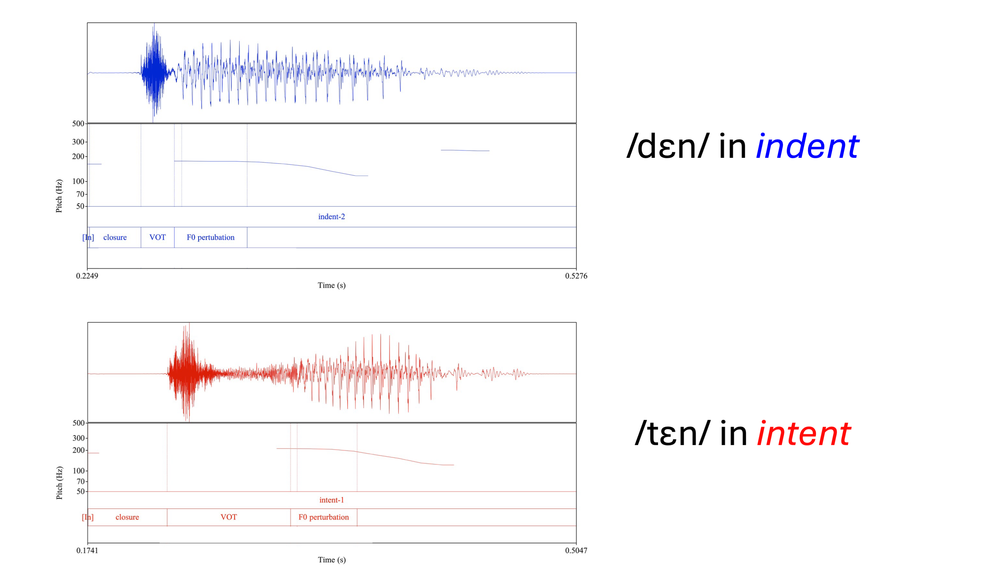
Figure C1: Waveforms showing aspiration of word-medial consonant for natural speech recordings of indent and intent.
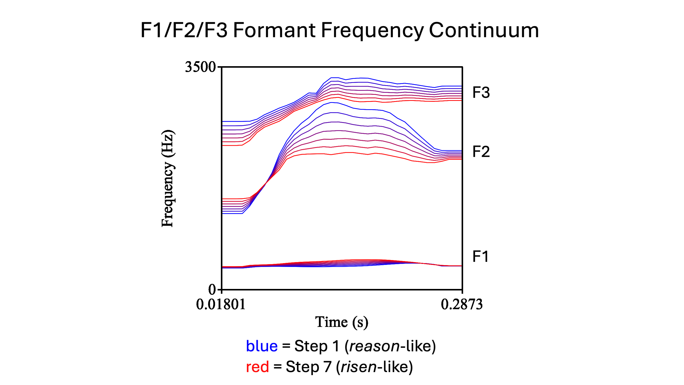
Figure C2: Visualization of the 7 steps of the F1/F2/F3 formant frequency (primary dimension) continuum for reason vs. risen.
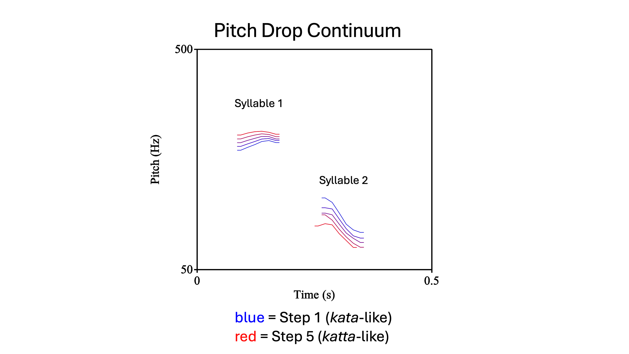
Figure C3: Visualization of the 5 steps of the pitch drop (secondary dimension) continuum for kata vs. katta, at duration step 1.
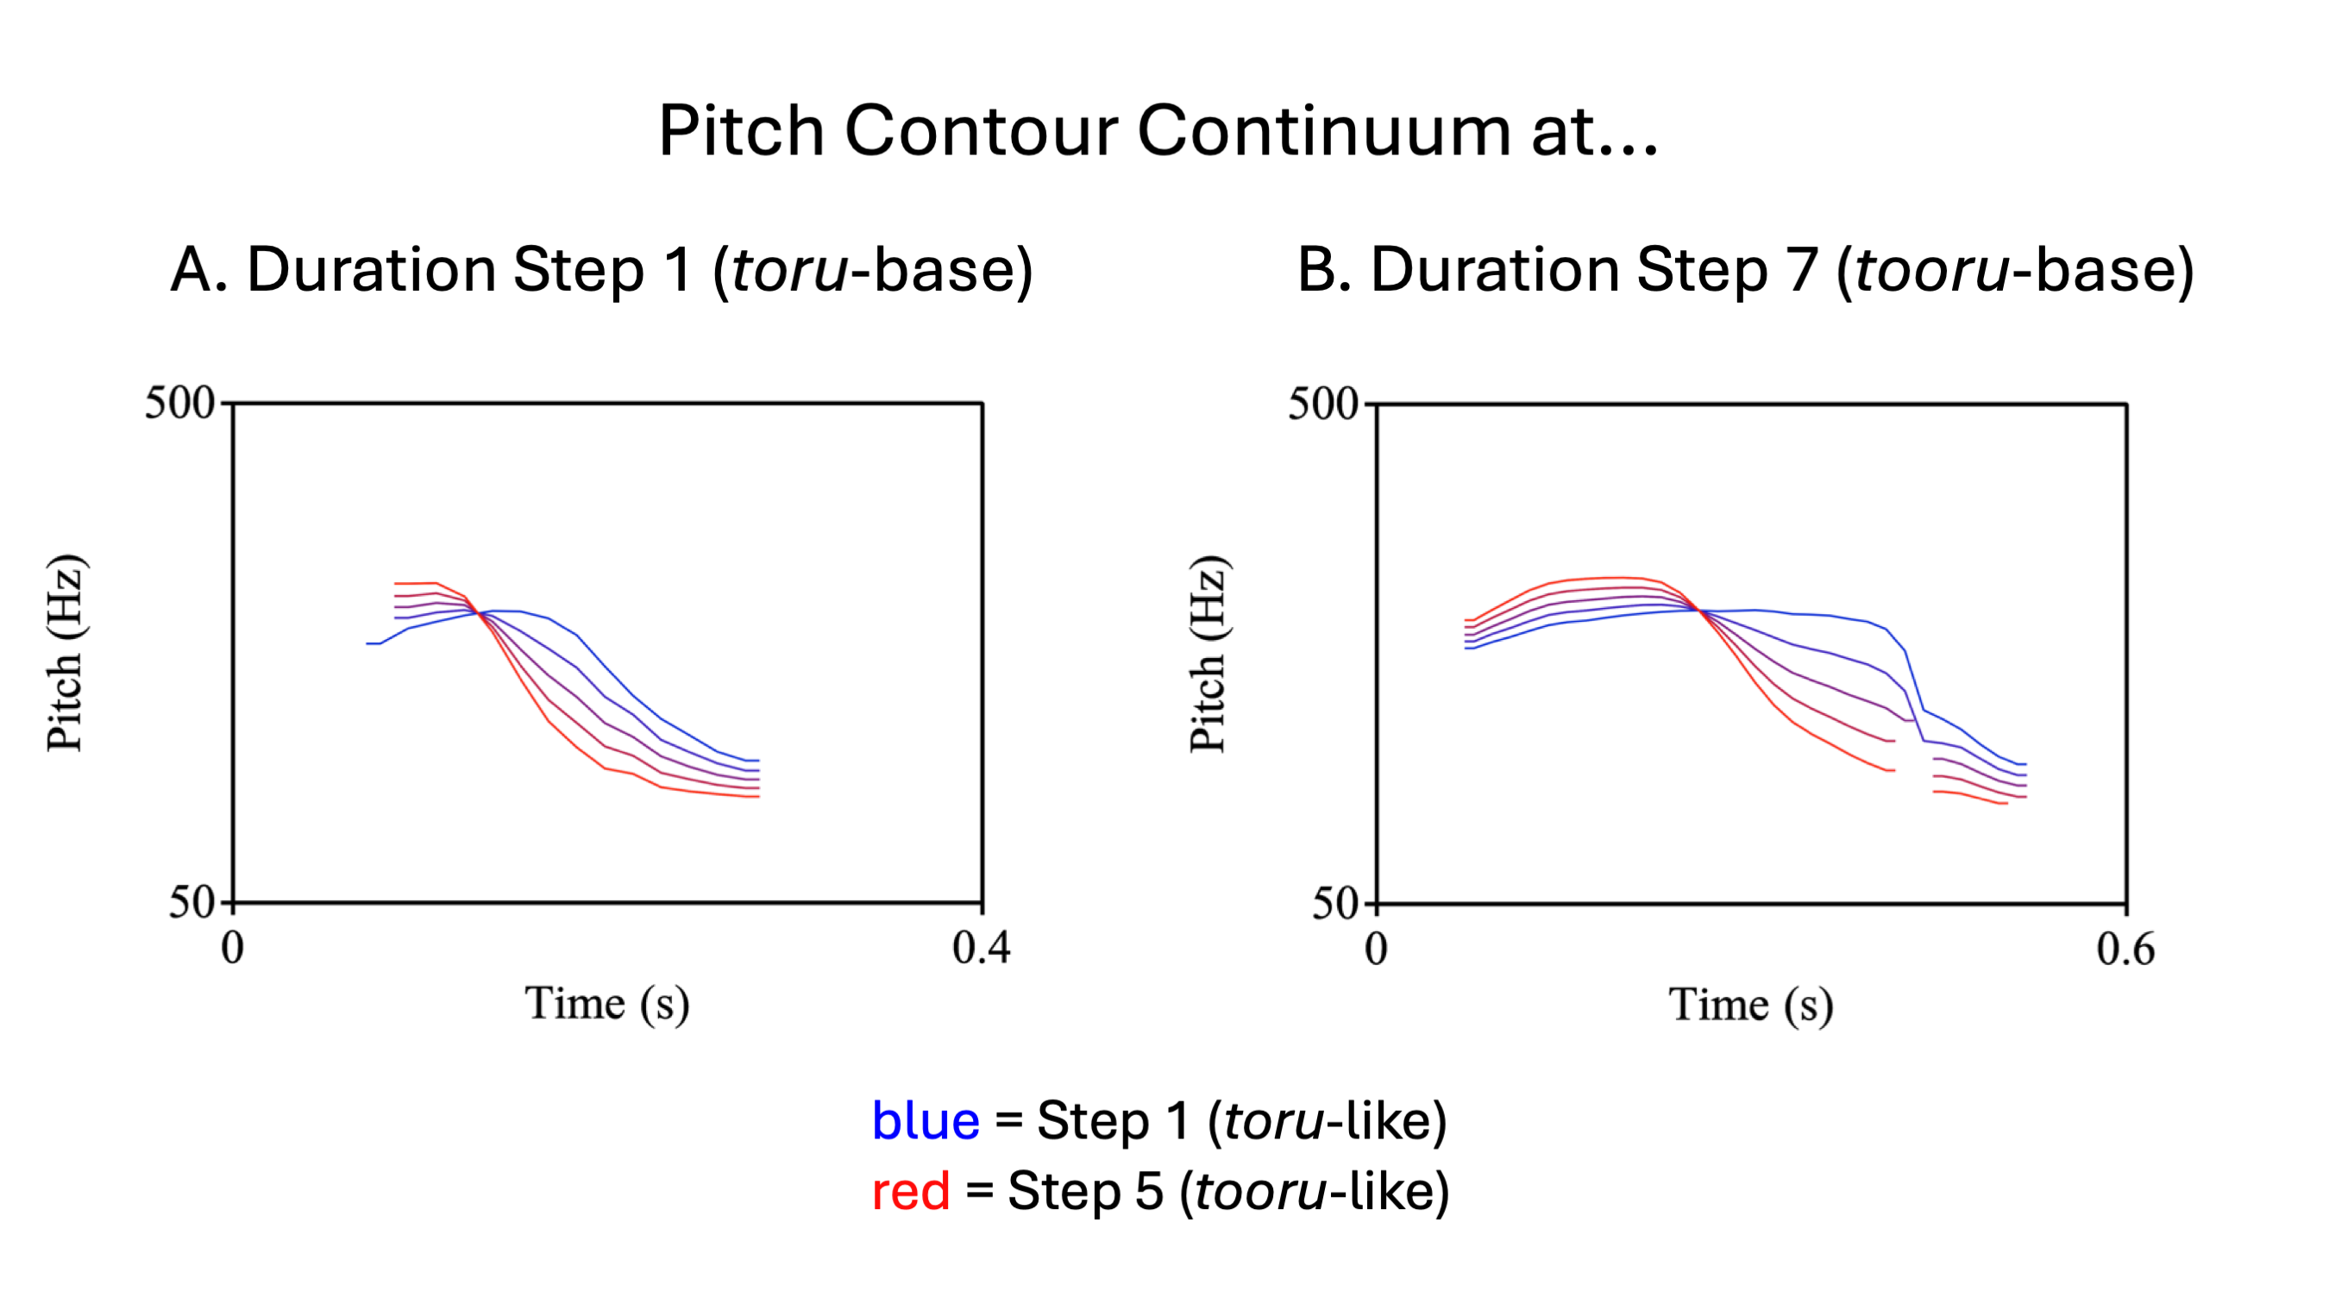
Figure C4: Visualization of the 5 steps of the pitch contour (secondary dimension) continuum for toru vs. tooru, at duration steps 1 (with toru as the base word) and 7 (with tooru as the base word).
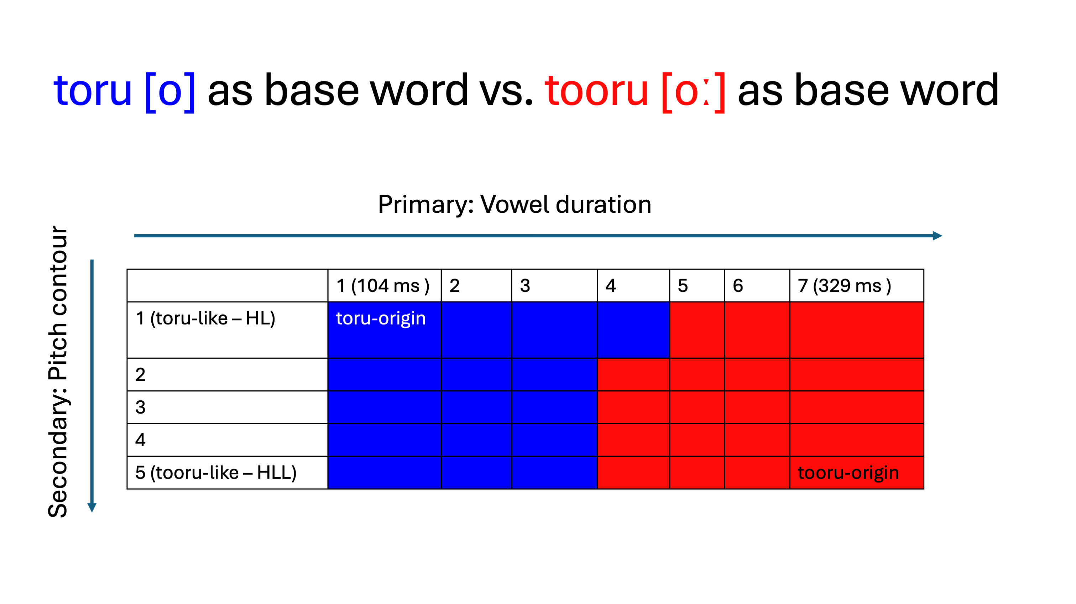
Figure C5: Graphical representation of the final stimuli choices for Vowel Duration x Pitch Contour continuum matrix for toru vs. tooru, based on which word served as the base word for continuum synthesis.

Appendix D: AX Discrimination Task Word Lists
Table D1: List of Japanese AX Discrimination Training Words

Word | hiragana | kanji | English gloss | Phoneme
obasan | おばさん | おばさん | aunt, adult/middle-aged woman | a
obaasan | おばあさん | おばあさん | grandma, elderly woman | a
haku | はく | 履く | put on/wear lower-body clothes/footwear | a
haaku | はあく | 把握 | grasp, catch, understand | a
ojisan | おじさん | おじさん | uncle, adult/middle-aged man | i
ojiisan | おじいさん | おじいさん | grandpa, elderly man | i
shiru | しる | 知る | know, understand, be familiar with, sense | i
shiiru | しいる | 強いる | force, compel, coerce | i
jutaku | じゅたく | 受託 | entrustment, commission, taking charge | u
juutaku | じゅうたく | 住宅 | residence, housing | u
yusoo | ゆそう | 輸送 | transport, transportation | u
yuusoo | ゆうそう | 郵送 | mailing, posting | u
oto | おと | 音 | sound | t
otto | おっと | 夫 | husband | t
ite | いて | いて | staying | t
itte | いって | いって | going, saying | t
heta | へた | 下手 | unskillfull | t
hetta | へった | 減った | decreased | t
saka | さか | 坂 | slope, hill | k
sakka | さっか | 作家 | author | k
gaki | がき | ガキ | brat, kid | k
gakki | がっき | 楽器 | musical instrument | k
haken | はけん | 派遣 | dispatch | k
hakken | はっけん | 発見 | discovery | k
hasan | はさん | 破産 | bankruptcy | s
hassan | はっさん | 発散 | emission, radiation | s
kasee | かせい | 火星 | Mars | s
kassee | かっせい | 活性 | chemical activity | s
iso | いそ | 磯 | husband | s
isso | いっそ | いっそ | rather, preferably | s
ishoku | いしょく | 移植 | transplanting, grafting | sh
isshoku | いっしょく | 一色 | one color; one kind | sh
nishi | にし | 西 | west | sh
nisshi | にっし | 日誌 | log, journal | sh
toshin | としん | 都心 | city center, downtown | sh
tosshin | とっしん | 突進 | rush, dash, charge | sh

Table D2: List of Modern Standard Arabic (MSA) AX Discrimination Training Words

Word | Orthography | English Gloss | Phoneme
kataba | كَتَبَ | (he) wrote | a
kaataba | كاتَبَ | (he) corresponded with | a
dakhala | دَخَلَ | (he) entered | a
daakhala | داخَلَ | (he) came over, befell, seized | a
zinah | زِنَة | weight | i
ziinah | زِينَة | decoration, embellishment | i
‘alim | عَلِمْ | (he) knew | i
‘aliim | عَلِيم | knowledgeable | i
ful(l) | فُلْ | jasmine flower | u
fuul | فُول | fava beans | u
ruḥ | رُحْ | go! [command] | u
ruuḥ | رُوح | spirit, soul | u
watara | وَتَرَ | to wrong, harm | t
wattara | وَتَّرَ | to stretch, strain, tighten | t
‘atama | عَتَمَ | to become dark, to hesitate | t
‘attama | عَتَّمَ | to darken, delay | t
matana | مَتَنَ | to be robust, strong, firm | t
mattana | مَتَّنَ | to strengthen, consolidate | t
sakata | سَكَتَ | to be silent | k
sakkata | سَكَّتَ | to silence | k
rakaza | رَكَزَ | to implant, embed | k
rakkaza | رَكَّزَ | to focus, concentrate | k
dhakara | ذَكَرَ | to mention; remember | k
dhakkara | ذَكَّرَ | to remind, point out | k
kasara | كَسَرَ | to break | s
kassara | كَسَّرَ | to shatter | s
basaṭa | بَسَطَ | to spread, extend | s
bassaṭa | بَسَّطَ | to simplify | s
rasaba | رَسَبَ | to fail - intransitive | s
rassaba | رَسَّبَ | to fail (someone) - transitive | s
bashara | بَشَرَ | to rejoice | sh
bashshara | بَشَّرَ | to bring good news, evangelize | sh
nashaṭa | نَشَطَ | to be active, energetic | sh
nashshaṭa | نَشَّطَ | to stimulate, encourage | sh
rashada | رَشَدَ | to be well guided, mature | sh
rashshada | رَشَّدَ | to guide, lead | sh

Table D3: List of Japanese AX Discrimination Testing Words

Word | hiragana | kanji | English gloss | Phoneme | Word Position
jaku | じゃく | 弱 | a little under, a little less than | a | medial
jaaku | じゃあく | 邪悪 | evil, wicked | a | medial
bai | ばい | 倍 | double, twice as much | a | medial
baai | ばあい | 場合 | situation, occasion | a | medial
okasan | おかさん | 岡さん | (surname) | a | medial
okaasan | おかあさん | お母さん | mom, mother | a | medial
itai | いたい | 痛い | painful, sore | i | initial
iitai | いいたい | 言いたい | (I) want to say | i | initial
kiroku | きろく | 記録 | record, recording, document; (sports) record | i | medial
kiiroku | きいろく | 黄色く | yellow [adverb form] | i | medial
hoshi | ほし | 星 | star | i | final
hoshii | ほしい | 欲しい | wanting, desiring | i | final
shugi | しゅぎ | 主義 | doctrine, rule, principle | u | medial
shuugi | しゅうぎ | 祝儀 | celebration; congratulatory gift; tip/gratutity | u | medial
juyoo | じゅよう | 需要 | demand, market | u | medial
juuyoo | じゅうよう | 重要 | important, major | u | medial
fuyu | ふゆ | 冬 | winter | u | final
fuyuu | ふゆう | 富裕 | wealth, riches | u | final
meshi | めし | 飯 | meal; cooked rice | e | medial
meeshi | めいし | 名詞 | noun | e | medial
heya | へや | 部屋 | room | e | medial
heeya | へいや | 平野 | open field, plain | e | medial
kaze | かぜ | 風 | wind | e | final
kazee | かぜい | 課税 | taxation | e | final
oku | おく | 奥 | inner part, depths | o | initial
ooku | おおく | 多く | many, most | o | initial
hosoo | ほそう | 舗装 | paving; pavement | o | medial
hoosoo | ほうそう | 放送 | broadcasting; broadcast | o | medial
issho | いっしょ | 一緒 | together, the same | o | final
isshoo | いっしょう | 一生 | lifetime, whole life | o | final
moto | もと | 元 | source, origin | t | medial
motto | もっと | もっと | more | t | medial
shiteiru | している | している | doing | t | medial
shitteiru | しっている | 知っている | knowing | t | medial
kako | かこ | 過去 | past | k | medial
kakko | かっこ | カッコ | parentheses | k | medial
ikoo | いこう | 移行 | transition, transfer | k | medial
ikkoo | いっこう | 一行 | party, group, company | k | medial
hasee | はせい | 派生 | derivation | s | medial
hassee | はっせい | 発生 | occurrence, incidence, outbreak | s | medial
hosoku | ほそく | 補足 | supplement, complement | s | medial
hossoku | ほっそく | 発足 | founding, launch, start-up | s | medial
shushin | しゅしん | 主審 | referee | sh | medial
shusshin | しゅっしん | 出身 | hometown, origin | sh | medial
keshoo | けしょう | 化粧 | make up | sh | medial
kesshoo | けっしょう | 決勝 | sports finals | sh | medial
shuchoo | しゅちょう | 主張 | claim, emphasis, assertion | ch | medial
shucchoo | しゅっちょう | 出張 | business trip | ch | medial
kaechau | かえちゃう | 飼えちゃう | end up being able to raise/keep a pet (or other animal) | ch | medial
kaecchau | かえっちゃう | 帰っちゃう | end up going home | ch | medial
tanin | たにん | 他人 | other people, unrelated person | n | medial
tannin | たんにん | 担任 | being in charge, homeroom teacher | n | medial
ana | あな | 穴 | hole | n | medial
anna | あんな | あんな | that sort of, that kind of | n | medial

Appendix E: Multiple-Choice Partial Dictation Task Sentences and Translations
Table E1: MCPD Sentences and Choices, Transcriptions, and Translations

 | Sentence | Correct Answer | Competing Distractor | Non-Competing Distractor 1 | Non-Competing Distractor 2
example | きのうかれがきいた。  kinoo kare ga kiita  He asked yesterday. | きいた  kiita  asked | きた  kita  came | きった  kitta  cut (it) | きえた  kieta  disappeared
1 | あのいっこうはまだですね。  ano ikkoo wa mada desu ne  (Nothing about) that group yet, huh? | いっこう  ikkoo  group; party | いこう  ikoo  transition; transfer of power | いっこ  ikko  one piece; one thing | いいこう  iikoo  [non-word]
2 | たんにんはしりません。  tannin wa shirimasen  I don't know (about) the person in charge. | たんにん  tannin  person in charge | たにん  tanin  other people | たいいん  taiin  the discharge from the hospital | たいにん  tainin  the retirement; the resignation
3 | いや、ほっそくじゃないよ。  iya, hossoku ja nai yo  No, it's not (a) launch. | ほっそく  hossoku  launch; establishment; inauguration | ほそく  hosoku  supplement; complement | ほうそく  hoosoku  law; rule | はっそく  hassoku  eight pairs (of socks/shoes)
4 | このじょうきょうにほうそうがいるとおもう。  Kono jookyoo ni hoosoo ga iru to omou  I think in this situation (we) need a broadcast. | ほうそう  hoosoo  broadcast; announcement | ほそう  hosoo  pavement | ほっそう*  hossoo  Hosso sect of Buddhism | ほうそ  hooso  rank of the emperor; the imperial throne​
5 | 「いいたい」とかいてありますか？  “iitai” to kaitearimasu ka?  Is "want to say" written? | いいたい  iitai  (I) want to say | いたい  itai  (it) hurts | いったい  ittai  (what) the heck | いんたい  intai  retirement
6 | 「じゅよう」ってどういういみですか？  “juyoo” tte dou iu imi desu ka?  What does "demand" mean? | じゅよう  juyoo  demand; request | じゅうよう  juuyoo  important; essential | じゅよ  juyo  awarding; granting | しゅよう  shuyoo  chief; main; principal
7 | かれにしゅしんについてきいてください。  kare ni shushin ni tsuite kiite kudasai  Please ask him about (the) referee | しゅしん  shushin  referee; umpire | しゅっしん  shusshin  (his) hometown | しゅうしん  shuushin  (his) going to bed | しゅじん  shujin  (his) husband
8 | かのじょはもうしている。  kanojo wa moo shiteiru  She is already doing (it). | している  shiteiru  doing | しっている  shitteiru  knows | しいている  shiiteiru  forcing | じている  jiteiru  [non-word]
9 | じぶんだけのしゅちょうです。  jibun dake no shuchoo desu  This is a claim only (by) me | しゅちょう  shuchoo  claim; assertion | しゅっちょう  shucchoo  business trip (for) | じゅちょう  juchoo  [non-word] | しゅうちょう  shuuchoo  (my) chieftain
10 | これがめしですよ。  kore ga meshi desu yo  This is (the) meal. | めし  meshi  meal; cooked rice | めいし  meeshi  noun | めっし  messhi  selflessness | まし  mashi  better; preferable
11 | もう、いってよ！  moo, itte yo!  Jeez, go/say (it) already! | いって  itte  go; say [command] | いて  ite  stay; be (here) [command] | いってい  ittee  (it's) certain | いいって  ii tte  (I) said it's fine
12 | いっしょくにきめました。  isshoku ni kimemashita  (We) decided (on) one color/kind. | いっしょく  isshoku  one color; one kind | いしょく  ishoku  (to) transplant; graft | いいしょく  ii shoku  good food | いっそく  issoku  (a) pair of shoes/socks
13 | じゅうたくのことをかんがえましょう。  juutaku no koto wo kangaemashoo  Let's think about the matter of housing. | じゅうたく  juutaku  housing; residence | じゅたく  jutaku  (the) entrustment; commission | じゅったく  juttaku  (the) 10 tables/desks | しゅうたく  shuutaku  [non-word]
14 | はあくでしょうかな。  haaku deshoo ka na  I wonder if (they will) understand? | はあく  haaku  understanding; grasp | はく  haku  put on (shoes/socks) | はっく*  hakku  (it's the) the Buddhist concept of the eight kinds of suffering | はくう  hakuu  (it's a) rain shower
15 | かせいについてもっとしりたいです。  kasee ni tsuite motto shiritai desu  I want to know/understand more about Mars. | かせい  kasee  Mars | かっせい  kassee  chemical activity | かせ  kase  handcuffs; restraints | こせい  kosee  individuality; idiosyncrasy
16 | そのことばは「おと」とよみます。  sono kotoba wa “oto” to yomimasu  This word reads "sound." | おと  oto  sound | おっと  otto  husband | おうと*  ooto  emesis; vomiting | おとう  otoo  father
17 | がきはどうなったの？  gaki wa doo natta no?  What happened to (the) kid? | がき  gaki  kid; brat | がっき  gakki  musical instrument | がくい  gakui  academic degree | かき  kaki  fence; barrier
18 | あのひと、おばさんですか？  ano hito, obasan desu ka?  Is that person (your) aunt? | おばさん  obasan  aunt; middle-aged woman | おばあさん  obaasan  grandma; elderly woman | おおばさん  Ooba san  (Mr./Ms./Mrs./Mx.) Ooba | おばいさん  Obai san  (Mr./Ms./Mrs./Mx.) Obai
19 | おじいさんをしっていますか？  ojiisan wo shitteimasu ka?  Do you know (the) elderly man? | おじいさん  ojiisan  elderly man; grandpa | おじさん  ojisan  middle-aged man; uncle | おおじさん  Ooji san  (Mr./Ms./Mrs./Mx.) Ooji | おちさん  Ochisan  Mount Ochi
20 | あれはきっとゆそうできないよ。  are wa kitto yusoo dekinai yo  (We) definitely can't transport that. | ゆそう  yusoo  transportation | ゆうそう  yuusoo  mailing | ゆっそう  yussoo  [non-word] | うそう  usoo  [non-word]
* Very low frequency word

References
Abramson, A. S. (1979). The noncategorical perception of tone categories in Thai. In B. Lindblom & S. Öhman (Eds.), Frontiers of speech communication research. https://dev.haskinslabs.org/sites/default/files/files/Reprints/HL0279.pdf
Akhtar, N., Menjivar, J., Hoicka, E., & Sabbagh, M. A. (2012). Learning foreign labels from a foreign speaker: the role of (limited) exposure to a second language. Journal of Child Language, 39(5), 1135–1149. https://doi.org/10.1017/S0305000911000481
Aldholmi, Y. (2022). Medial Vowel Temporal Acoustics in Arabic and Japanese Polysyllabic Words. Archives of Acoustics, 47(3), Article 3. https://doi.org/10.24425/aoa.2022.142006
Alqarhi, A. (2019). Arabic Phonology. English Linguistics Research, 8(4), Article 4. https://doi.org/10.5430/elr.v8n4p9
Álvarez, J. E. (2020). Measuring English language use and exposure in a naturalistic setting. Contextos: Estudios De Humanidades Y Ciencias Sociales, 47. https://revistas.umce.cl/index.php/contextos/article/view/1581
Anderson, J. A. E., Mak, L., Keyvani Chahi, A., & Bialystok, E. (2018). The language and social background questionnaire: Assessing degree of bilingualism in a diverse population. Behavior Research Methods, 50(1), 250–263. https://doi.org/10.3758/s13428-017-0867-9
Andruski, J. E., Blumstein, S. E., & Burton, M. (1994). The effect of subphonetic differences on lexical access. Cognition, 52(3), 163–187. https://doi.org/10.1016/0010-0277(94)90042-6
Anwyl-Irvine, A. L., Massonnié, J., Flitton, A., Kirkham, N., & Evershed, J. K. (2020). Gorilla in our midst: An online behavioral experiment builder. Behavior Research Methods, 52(1), 388–407. https://doi.org/10.3758/s13428-019-01237-x
Aoyama, K., Flege, J. E., Guion, S. G., Akahane-Yamada, R., & Yamada, T. (2004). Perceived phonetic dissimilarity and L2 speech learning: the case of Japanese /r/ and English /l/ and /r/. Journal of Phonetics, 32(2), 233–250. https://doi.org/10.1016/S0095-4470(03)00036-6
Aparici, M., Rosado, E., & Tolchinsky, L. (2024). Multilingual use assessment questionnaire: a proposal for assessing language and literacy experience. Frontiers in Communication, 9. https://doi.org/10.3389/fcomm.2024.1394727
Apfelbaum, K. S., Kutlu, E., McMurray, B., & Kapnoula, E. C. (2022). Don’t force it! Gradient speech categorization calls for continuous categorization tasks. The Journal of the Acoustical Society of America, 152(6), 3728–3745. https://doi.org/10.1121/10.0015201
Appelbaum, I. (1996). The lack of invariance problem and the goal of speech perception. Proceeding of Fourth International Conference on Spoken Language Processing. ICSLP ’96, 3, 1541–1544 vol.3. https://doi.org/10.1109/ICSLP.1996.607912
Arai, T., Warner, N., & Greenberg, S. (2007). Analysis of spontaneous Japanese in a multi-language telephone-speech corpus. Acoustical Science and Technology, 28(1), 46–48. https://doi.org/10.1250/ast.28.46
Artino Jr., A. R., La Rochelle, J. S., Dezee, K. J., & Gehlbach, H. (2014). Developing questionnaires for educational research: AMEE Guide No. 87. Medical Teacher, 36(6), 463–474. https://doi.org/10.3109/0142159X.2014.889814
Assmann, P., Summerfield, Q., Greenberg, S., Ainsworth, W., Popper, A., & Fay, R. (2006). The Perception of Speech Under Adverse Conditions. In Speech Processing in the Auditory System (pp. 231–308). https://doi.org/10.1007/0-387-21575-1_5
Au, T. K., Knightly, L. M., Jun, S.-A., & Oh, J. S. (2002). Overhearing a Language During Childhood. Psychological Science, 13(3), 238–243. https://doi.org/10.1111/1467-9280.00444
Au, T. K., Oh, J. S., Knightly, L. M., Jun, S.-A., & Romo, L. F. (2008). Salvaging a childhood language. Journal of Memory and Language, 58(4), 998–1011. https://doi.org/10.1016/j.jml.2007.11.001
Baese-Berk, M. M. (2018). Perceptual Learning for Native and Non-native Speech. In K. D. Federmeier & D. G. Watson (Eds.), Current Topics in Language (Vol. 68, pp. 1–29). Academic Press. https://doi.org/https://doi.org/10.1016/bs.plm.2018.08.001
Baese-Berk, M. M., Chandrasekaran, B., & Roark, C. L. (2022). The nature of non-native speech sound representations. The Journal of the Acoustical Society of America, 152(5), 3025–3034. https://doi.org/10.1121/10.0015230
Bates, D., Mächler, M., Bolker, B., & Walker, S. (2015). Fitting Linear Mixed-Effects Models Using lme4. Journal of Statistical Software, 67, 1–48. https://doi.org/10.18637/jss.v067.i01
Best, C. T. (1995). A direct realist view of cross language speech perception. In Speech Perception and Linguistic Experience: Issues in Cross-Language Research (pp. 171–204).
Best, C. T., & Tyler, M. D. (2007). Nonnative and second-language speech perception: Commonalities and complementarities. In Language Experience in Second Language Speech Learning: In Honor of James Emil Flege (pp. 13–34). https://doi.org/10.1075/lllt.17.07bes
Bice, K., & Kroll, J. F. (2019). English only? Monolinguals in linguistically diverse contexts have an edge in language learning. Brain and Language, 196, 104644. https://doi.org/10.1016/j.bandl.2019.104644
Blumstein, S. E., & Stevens, K. N. (1979). Acoustic invariance in speech production: Evidence from measurements of the spectral characteristics of stop consonants. The Journal of the Acoustical Society of America, 66(4), 1001–1017. https://doi.org/10.1121/1.383319
Boateng, G. O., Neilands, T. B., Frongillo, E. A., Melgar-Quiñonez, H. R., & Young, S. L. (2018). Best Practices for Developing and Validating Scales for Health, Social, and Behavioral Research: A Primer. Frontiers in Public Health, 6, 149. https://doi.org/10.3389/fpubh.2018.00149
Boersma, P., & Escudero, P. (2008). Learning to perceive a smaller L2 vowel inventory: An Optimality Theory account. In P. Avery, B. E. Dresher, & K. Rice (Eds.), Contrast in Phonology (pp. 271–302). Mouton de Gruyter. https://doi.org/10.1515/9783110208603.4.271
Boersma, P., & Weenink, D. (2024). Praat: doing phonetics by computer (Version 6.4.12) [Computer software]. www.praat.org
Bohn, O.-S., & Munro, M. J. (Eds.). (2007). Language Experience in Second Language Speech Learning: In honor of James Emil Flege. John Benjamins Publishing Company. https://www.torrossa.com/en/resources/an/5000621
Bradlow, A. R., Akahane-Yamada, R., Pisoni, D. B., & Tohkura, Y. (1999). Training Japanese listeners to identify English /r/and /l/: Long-term retention of learning in perception and production. Perception & Psychophysics, 61(5), 977–985. https://doi.org/10.3758/BF03206911
Bradlow, A. R., Pisoni, D. B., Akahane-Yamada, R., & Tohkura, Y. (1997). Training Japanese listeners to identify English /r/ and /l/: IV. Some effects of perceptual learning on speech production. The Journal of the Acoustical Society of America, 101(4), 2299–2310. https://www.ncbi.nlm.nih.gov/pmc/articles/PMC3507383/
Brooks, M. E., Kristensen, K., van Benthem, K. J., Magnusson, A., Berg, C. W., Nielsen, A., Skaug, H. J., Maechler, M., & Bolker, B. M. (2017). glmmTMB balances speed and flexibility among packages for zero-inflated generalized linear mixed modeling. The R Journal, 9(2), 378–400. https://doi.org/10.32614/RJ-2017-066
Brown, B., Tusmagambet, B., Rahming, V., Tu, C.-Y., DeSalvo, M. B., & Wiener, S. (2023). Searching for the “native” speaker: A preregistered conceptual replication and extension of Reid, Trofimovich, and O’Brien (2019). Applied Psycholinguistics, 44(4), 475–494. https://doi.org/10.1017/S0142716423000127
Brown-Schmidt, S., & Toscano, J. C. (2017). Gradient acoustic information induces long-lasting referential uncertainty in short discourses. Language, Cognition and Neuroscience, 32(10), 1211–1228. https://doi.org/10.1080/23273798.2017.1325508
Buck, G. (2001). Assessing Listening. Cambridge University Press. https://doi.org/10.1017/CBO9780511732959
Bujok, R. (2023, January 31). Interpolate F0 continuum [Praat script]. https://hrbosker.github.io/resources/scripts/interpolate-f0/
Bürkner, P.-C. (2017). brms: An R Package for Bayesian Multilevel Models Using Stan. Journal of Statistical Software, 80, 1–28. https://doi.org/10.18637/jss.v080.i01
Burnham, D., & Jones, C. (2002). Categorical Perception of Lexical Tone by Tonal and Non-Tonal Language Speakers. Proceedings of the 9th Australian International Conference on Speech Science & Technology, 6.
Cai, H. (2013). Partial dictation as a measure of EFL listening proficiency: Evidence from confirmatory factor analysis. Language Testing, 30(2), 177–199. https://doi.org/10.1177/0265532212456833
Cai, H. (2014). Dictation in Language Assessment. In C. A. Chapelle (Ed.), The Encyclopedia of Applied Linguistics (pp. 1–6). John Wiley & Sons, Ltd. https://doi.org/10.1002/9781405198431.wbeal1442
Carlet, A., & Cebrian, J. (n.d.). Identification vs. discrimination training: Learning effects for trained and untrained sounds. Proceedings of the 18th international congress of phonetic sciences (ICPhS 2015)., –. https://www.internationalphoneticassociation.org/icphs-proceedings/ICPhS2015/Papers/ICPHS0752.pdf
Carney, A. E., Widin, G. P., & Viemeister, N. F. (1977). Noncategorical perception of stop consonants differing in VOT. The Journal of the Acoustical Society of America, 62(4), 961–970. https://doi.org/10.1121/1.381590
Castro, S., Wodniecka, Z., & Timmer, K. (2022). Am I truly monolingual? Exploring foreign language experiences in monolinguals. PLOS ONE, 17(3), Article e0265563. https://doi.org/10.1371/journal.pone.0265563
Cebrian, J., & Carlet, A. (2014). Second-Language Learners’ Identification of Target-Language Phonemes: A Short-Term Phonetic Training Study. The Canadian Modern Language Review, 70(4), 474–499. https://doi.org/10.3138/cmlr.2318
Chandrasekaran, B., Sampath, P. D., & Wong, P. C. M. (2010). Individual variability in cue-weighting and lexical tone learning. The Journal of the Acoustical Society of America, 128(1), 456–465. https://doi.org/10.1121/1.3445785
Clayards, M. (2018). Differences in cue weights for speech perception are correlated for individuals within and across contrasts. The Journal of the Acoustical Society of America, 144(3), EL172–EL177. https://doi.org/10.1121/1.5052025
Clayards, M., Tanenhaus, M. K., Aslin, R. N., & Jacobs, R. A. (2008). Perception of speech reflects optimal use of probabilistic speech cues. Cognition, 108(3), 804–809. https://doi.org/10.1016/j.cognition.2008.04.004
Crinnion, A. M., Malmskog, B., & Toscano, J. C. (2020). A graph-theoretic approach to identifying acoustic cues for speech sound categorization. Psychonomic Bulletin & Review, 27(6), 1104–1125. https://doi.org/10.3758/s13423-020-01748-1
Cutler, A., Eisner, F., McQueen, J. M., & Norris, D. (2010). How abstract phonemic categories are necessary for coping with speaker-related variation. In C. Fougeron, B. Kühnert, M. D’Imperio, & N. Vallee (Eds.), Laboratory Phonology 10 (pp. 91–111). Berlin : De Gruyter Mouton. https://hdl.handle.net/2066/89953
Cutler, A., & Otake, T. (1994). Mora or Phoneme? Further Evidence for Language-Specific Listening. Journal of Memory and Language, 33(6), 824–844. https://doi.org/10.1006/jmla.1994.1039
Cutting, J. E., & Rosner, B. S. (1974). Categories and boundaries in speech and music. Perception & Psychophysics, 16(3), 564–570. https://doi.org/10.3758/BF03198588
Davis, S., & Ragheb, M. (2014). Geminate representation in Arabic. In S. Farwaneh & H. Ouali (Eds.), Studies in Arabic Linguistics (Vol. 1, pp. 3–20). John Benjamins Publishing Company. https://doi.org/10.1075/sal.1.04dav
de Bruin, A. (2019). Not All Bilinguals Are the Same: A Call for More Detailed Assessments and Descriptions of Bilingual Experiences. Behavioral Sciences, 9(3), Article 3. https://doi.org/10.3390/bs9030033
Deguchi, M. (2015). The Role of Pitch Contours in Teaching Vowel Length Distinctions in Japanese. In J. Levis, R. Mohammaed, M. Qian, & Z. Zhou (Eds.), Proceedings of the 6th Pronunciation in Second Language Learning and Teaching Conference (1; pp. 174–183). Iowa State University Digital Press. https://www.iastatedigitalpress.com/psllt/article/id/15259/
Delattre, P. C., Liberman, A. M., & Cooper, F. S. (1955). Acoustic Loci and Transitional Cues for Consonants. The Journal of the Acoustical Society of America, 27(4), 769–773. https://doi.org/10.1121/1.1908024
DeLuca, V., Rothman, J., Bialystok, E., & Pliatsikas, C. (2019). Redefining bilingualism as a spectrum of experiences that differentially affects brain structure and function. Proceedings of the National Academy of Sciences, 116(15), 7565–7574. https://doi.org/10.1073/pnas.1811513116
Desmeules-Trudel, F., & Zamuner, T. S. (2019). Gradient and categorical patterns of spoken-word recognition and processing of phonetic details. Attention, Perception, & Psychophysics, 81(5), 1654–1672. https://doi.org/10.3758/s13414-019-01693-9
Desmeules-Trudel, F., & Zamuner, T. S. (2023). Spoken word recognition in a second language: The importance of phonetic details. Second Language Research, 39(2), 333–362. https://doi.org/10.1177/02676583211030604
Dotzel, S., Bonefeld, M., & Karst, K. (2021). The impact of linguistic diversity on students’ reading comprehension using different diversity measures and its’ differential effects depending on students’ migration background. International Journal of Educational Research, 109, 101796. https://doi.org/10.1016/j.ijer.2021.101796
Earle, F. S., & Myers, E. B. (2014). Building phonetic categories: an argument for the role of sleep. Frontiers in Psychology, 5. https://doi.org/10.3389/fpsyg.2014.01192
Ellis, N. C. (2006). Selective Attention and Transfer Phenomena in L2 Acquisition: Contingency, Cue Competition, Salience, Interference, Overshadowing, Blocking, and Perceptual Learning. Applied Linguistics, 27(2), 164–194. https://doi.org/10.1093/applin/aml015
Emberson, L. L., Liu, R., & Zevin, J. D. (2013). Is statistical learning constrained by lower level perceptual organization? Cognition, 128(1), 82–102. https://doi.org/10.1016/j.cognition.2012.12.006
Enomoto, K. (1994). L2 Perceptual Acquisition: The Effect of Multilingual Linguistic Experience on the Perception of a “Less Novel” Contrast (5; Edinburgh Working Papers in Applied Linguistics, pp. 15–29). https://eric.ed.gov/?id=ED373553
Erickson, L. C., & Thiessen, E. D. (2015). Statistical learning of language: Theory, validity, and predictions of a statistical learning account of language acquisition. Developmental Review, 37, 66–108. https://doi.org/10.1016/j.dr.2015.05.002
Escudero, P. (2005). Linguistic perception and second language acquisition: Explaining the attainment of optimal phonological categorization [Doctoral thesis]. Utrecht University.
Escudero, P. (2009). The linguistic perception of SIMILAR L2 sounds. In Phonology in Perception (pp. 151–190). De Gruyter Mouton. https://doi.org/10.1515/9783110219234.151
Escudero, P., Benders, T., & Wanrooij, K. (2011). Enhanced bimodal distributions facilitate the learning of second language vowels. The Journal of the Acoustical Society of America, 130(4), EL206–EL212. https://doi.org/10.1121/1.3629144
Escudero, P., & Boersma, P. (2004). Bridging the Gap Between L2 Speech Perception Research and Phonological Theory. Studies in Second Language Acquisition, 26(4), 551–585. https://www.jstor.org/stable/44486780
Escudero, P., & Williams, D. (2014). Distributional learning has immediate and long-lasting effects. Cognition, 133(2), 408–413. https://doi.org/10.1016/j.cognition.2014.07.002
Fan, S. P., Liberman, Z., Keysar, B., & Kinzler, K. D. (2015). The Exposure Advantage: Early Exposure to a Multilingual Environment Promotes Effective Communication. Psychological Science, 26(7), 1090–1097. https://doi.org/10.1177/0956797615574699
Fathi, R. (2013). Vowel length in Egyptian Arabic: a different view [Ph.D.]. Université Paris Diderot.
Feldman, N. H., Goldwater, S., Dupoux, E., & Schatz, T. (2021). Do Infants Really Learn Phonetic Categories? Open Mind, 5, 113–131. https://doi.org/10.1162/opmi_a_00046
Feldman, N. H., Griffiths, T. L., Goldwater, S., & Morgan, J. L. (2013). A Role for the Developing Lexicon in Phonetic Category Acquisition. Psychological Review, 120(4). https://doi.org/10.1037/a0034245
Feldman, N. H., Grifﬁths, T. L., & Morgan, J. L. (2009). Learning Phonetic Categories by Learning a Lexicon. Proceedings of the Annual Meeting of the Cognitive Science Society, 31, 2208–2213. https://escholarship.org/uc/item/2s9953qz
Feldman, N. H., Myers, E. B., White, K. S., Griffiths, T. L., & Morgan, J. L. (2013). Word-level information influences phonetic learning in adults and infants. Cognition, 127(3), 427–438. https://doi.org/10.1016/j.cognition.2013.02.007
Ferrero, F. E., Pelamatti, G. M., Vagges, K., & Umilta’, C. (1982). Continuous and categorical perception of a fricative-affricate continuum. Journal of Phonetics, 10(3), 231–244. https://doi.org/10.1016/S0095-4470(19)30984-2
Festman, J. (2018). Vocabulary Gains of Mono- and Multilingual Learners in a Linguistically Diverse Setting: Results From a German-English Intervention With Inclusion of Home Languages. Frontiers in Communication, 3. https://doi.org/10.3389/fcomm.2018.00026
Field, J. (2003). Promoting perception: lexical segmentation in L2 listening. ELT Journal, 57(4), 325–334. https://doi.org/10.1093/elt/57.4.325
Field, J. (2009). Listening in the Language Classroom. Cambridge University Press. https://doi.org/10.1017/CBO9780511575945
Finn, A. S., & Hudson Kam, C. L. (2008). The curse of knowledge: First language knowledge impairs adult learners’ use of novel statistics for word segmentation. Cognition, 108(2), 477–499. https://doi.org/10.1016/j.cognition.2008.04.002
Flege, J. E. (1995a). Second language speech learning: Theory, findings and problems. In W. Strange (Ed.), Speech perception and linguistic experience: Issues in cross-language research (pp. 229–273). York Press.
Flege, J. E. (1995b). Two procedures for training a novel second language phonetic contrast. Applied Psycholinguistics, 16(4), 425–442. https://doi.org/10.1017/S0142716400066029
Flege, J. E., & Bohn, O.-S. (2021). The Revised Speech Learning Model (SLM-r). In R. Wayland (Ed.), Second Language Speech Learning: Theoretical and Empirical Progress (pp. 3–83). Cambridge University Press. https://doi.org/10.1017/9781108886901.002
Flege, J. E., Schirru, C., & MacKay, I. R. A. (2003). Interaction between the native and second language phonetic subsystems. Speech Communication, 40(4), 467–491. https://doi.org/10.1016/S0167-6393(02)00128-0
Flege, J. E., & Wang, C. (1989). Native-language phonotactic constraints affect how well Chinese subjects perceive the word-final English /t/-/d/ contrast. Journal of Phonetics, 17(4), 299–315. https://doi.org/10.1016/S0095-4470(19)30446-2
Fogerty, D. (2011). Perceptual weighting of individual and concurrent cues for sentence intelligibility: Frequency, envelope, and fine structure. The Journal of the Acoustical Society of America, 129(2), 977. https://doi.org/10.1121/1.3531954
Ford-Niwa, J., & Kobayashi, N. (1999). SPOT: A test measuring” control” exercised by learners of Japanese. In K. Kanno (Ed.), The Acquisition of Japanese as a Second Language (Vol. 20, pp. 53–70). Amsterdam; Philadelphia; J. Benjamins Pub; 1998. https://doi.org/10.1075/lald.20.07for
Fry, D. B., Abramson, A. S., Eimas, P. D., & Liberman, A. M. (1962). The Identification and Discrimination of Synthetic Vowels. Language and Speech, 5(4), 171–189. https://doi.org/10.1177/002383096200500401
Fuhrmeister, P., & Myers, E. B. (2021). Structural neural correlates of individual differences in categorical perception. Brain and Language, 215, 104919. https://doi.org/10.1016/j.bandl.2021.104919
Fuhrmeister, P., Phillips, M. C., McCoach, D. B., & Myers, E. B. (2023). Relationships between native and non-native speech perception. Journal of Experimental Psychology: Learning, Memory, and Cognition, 49(7), 1161–1175. https://doi.org/10.1037/xlm0001213
Fujisaki, H., Nakamura, K., & Imoto, T. (1975). Auditory Perception of Duration of Speech and Non-Speech Stimuli. In G. Fant & M. A. A. Tatham (Eds.), Auditory Analysis and Perception of Speech (pp. 197–219). Academic Press. https://doi.org/10.1016/B978-0-12-248550-3.50017-9
Galle, M. E., & McMurray, B. (2014). The development of voicing categories: A quantitative review of over 40 years of infant speech perception research. Psychonomic Bulletin & Review, 21(4), 884–906. https://doi.org/10.3758/s13423-013-0569-y
Gelman, A., Goodrich, B., Gabry, J., & Vehtari, A. (2019). R-squared for Bayesian Regression Models. The American Statistician, 73(3), 307–309. https://doi.org/10.1080/00031305.2018.1549100
Georgiou, G. P. (2021). Effects of Phonetic Training on the Discrimination of Second Language Sounds by Learners with Naturalistic Access to the Second Language. Journal of Psycholinguistic Research, 50(3), 707–721. https://doi.org/10.1007/s10936-021-09774-3
Gerrits, E., & Schouten, M. E. H. (2004). Categorical perception depends on the discrimination task. Perception & Psychophysics, 66(3), 363–376. https://doi.org/10.3758/BF03194885
Getz, L. M., & Toscano, J. C. (2021). The time-course of speech perception revealed by temporally-sensitive neural measures. WIREs Cognitive Science, 12(2), e1541. https://doi.org/10.1002/wcs.1541
Goldinger, S. D. (1996). Words and Voices: Episodic Traces in Spoken Word Identification and Recognition Memory. Journal of Experimental Psychology: Learning, Memory, Cognition, 22(5), 1166–1183.
Goldinger, S. D. (1998). Echoes of echoes? An episodic theory of lexical access. Psychological Review, 105(2), 251–279. https://doi.org/10.1037/0033-295X.105.2.251
Goldstone, R. L., & Hendrickson, A. T. (2010). Categorical perception. WIREs Cognitive Science, 1(1), 69–78. https://doi.org/10.1002/wcs.26
Gottlieb, N. (2010). The Rōmaji movement in Japan. Journal of the Royal Asiatic Society, 20(1), 75–88. https://doi.org/10.1017/S1356186309990320
Guion, S. G., Flege, J. E., Akahane-Yamada, R., & Pruitt, J. C. (2000). An investigation of current models of second language speech perception: The case of Japanese adults’ perception of English consonants. The Journal of the Acoustical Society of America, 107(5), 2711–2724. https://doi.org/10.1121/1.428657
Gullberg, M., Roberts, L., Dimroth, C., Veroude, K., & Indefrey, P. (2010). Adult Language Learning After Minimal Exposure to an Unknown Natural Language. Language Learning, 60(s2), 5–24. https://doi.org/10.1111/j.1467-9922.2010.00598.x
Gullifer, J. W., Chai, X. J., Whitford, V., Pivneva, I., Baum, S., Klein, D., & Titone, D. (2018). Bilingual experience and resting-state brain connectivity: Impacts of L2 age of acquisition and social diversity of language use on control networks. Neuropsychologia, 117, 123–134. https://doi.org/10.1016/j.neuropsychologia.2018.04.037
Gullifer, J. W., Kousaie, S., Gilbert, A. C., Grant, A., Giroud, N., Coulter, K., Klein, D., Baum, S., Phillips, N., & Titone, D. (2021). Bilingual language experience as a multidimensional spectrum: Associations with objective and subjective language proficiency. Applied Psycholinguistics, 42(2), 245–278. https://doi.org/10.1017/S0142716420000521
Gullifer, J. W., & Titone, D. (2020). Characterizing the social diversity of bilingualism using language entropy. Bilingualism: Language and Cognition, 23(2), 283–294. https://doi.org/10.1017/S1366728919000026
Gwilliams, L., Linzen, T., Poeppel, D., & Marantz, A. (2018). In Spoken Word Recognition, the Future Predicts the Past. Journal of Neuroscience, 38(35), 7585–7599. https://doi.org/10.1523/JNEUROSCI.0065-18.2018
Hallé, P. A., Chang, Y.-C., & Best, C. T. (2004). Identification and discrimination of Mandarin Chinese tones by Mandarin Chinese vs. French listeners. Journal of Phonetics, 32(3), 395–421. https://doi.org/10.1016/S0095-4470(03)00016-0
Han, M. S. (1992). The Timing Control of Geminate and Single Stop Consonants in Japanese: A Challenge for Nonnative Speakers. Phonetica, 49(2), 102–127. https://doi.org/10.1159/000261906
Han, M. S. (1994). Acoustic manifestations of mora timing in Japanese. The Journal of the Acoustical Society of America, 96(1), 73–82. https://doi.org/10.1121/1.410376
Harnad, S. (1987). Psychophysical and cognitive aspects of categorical perception: A critical overview. In S. Harnad (Ed.), Categorical Perception: The Groundwork of Cognition. Cambridge University Press. http://cogprints.org/1571/1/harnad87.cpreview.html
Harnad, S. (2003). Categorical Perception. In Encyclopedia of Cognitive Science. Nature Publishing Group/Macmillan. https://eprints.soton.ac.uk/257719/1/catperc.html
Hary, J. M., & Massaro, D. W. (1982). Categorical results do not imply categorical perception. Perception & Psychophysics, 32(5), 409–418. https://doi.org/10.3758/BF03202770
Haukås, Å., Storto, A., & Tiurikova, I. (2021). Developing and validating a questionnaire on young learners’ multilingualism and multilingual identity. The Language Learning Journal, 49(4), 404–419. https://doi.org/10.1080/09571736.2021.1915367
Hautus, M., Macmillan, N., & Creelman, C. (2021). Detection Theory: A User’s Guide (3rd ed.). Routledge. https://doi.org/10.4324/9781003203636
Hayes-Harb, R. (2007). Lexical and statistical evidence in the acquisition of second language phonemes. Second Language Research, 23(1), 65–94. https://doi.org/10.1177/0267658307071601
Hayes-Harb, R., & Masuda, K. (2008). Development of the ability to lexically encode novel second language phonemic contrasts. Second Language Research, 24(1), 5–33. https://doi.org/10.1177/0267658307082980
Henning, G., Gary, N., & Gary, J. O. (1983). Listening recall—A listening comprehension test for low proficiency learners. System, 11(3), 287–293. https://doi.org/10.1016/0346-251X(83)90046-5
Hickendorff, M., Edelsbrunner, P. A., McMullen, J., Schneider, M., & Trezise, K. (2018). Informative tools for characterizing individual differences in learning: Latent class, latent profile, and latent transition analysis. Learning and Individual Differences, 66, 4–15. https://doi.org/10.1016/j.lindif.2017.11.001
Hillenbrand, J. M., Clark, M. J., & Houde, R. A. (2000). Some effects of duration on vowel recognition. The Journal of the Acoustical Society of America, 108(6), 3013–3022. https://doi.org/10.1121/1.1323463
Hirata, Y. (1990). Tango/bun reberu ni okeru sokuon no kikitori [Perception of geminate consonants at word and sentence level]. Onsei Gakkai Kaihou, 194, 23–28.
Hirata, Y. (2004a). Computer Assisted Pronunciation Training for Native English Speakers Learning Japanese Pitch and Durational Contrasts. Computer Assisted Language Learning, 17(3-4), 357–376. https://doi.org/10.1080/0958822042000319629
Hirata, Y. (2004b). Effects of speaking rate on the vowel length distinction in Japanese. Journal of Phonetics, 32(4), 565–589. https://doi.org/10.1016/j.wocn.2004.02.004
Hirata, Y. (2004c). Training native English speakers to perceive Japanese length contrasts in word versus sentence contexts. The Journal of the Acoustical Society of America, 116(4), 2384–2394. https://doi.org/10.1121/1.1783351
Hirata, Y. (2015). L2 phonetics and phonology. In H. Kubozono (Ed.), Handbook of Japanese Phonetics and Phonology (pp. 719–762). DE GRUYTER. https://doi.org/10.1515/9781614511984.719
Hirata, Y., & Lambacher, S. G. (2004). Role of Word-External Contexts in Native Speakers’ Identification of Vowel Length in Japanese. Phonetica, 61(4), 177–200. https://doi.org/10.1159/000084157
Hirata, Y., Whitehurst, E., & Cullings, E. (2007). Training native English speakers to identify Japanese vowel length contrast with sentences at varied speaking rates. The Journal of the Acoustical Society of America, 121(6), 3837–3845. https://doi.org/10.1121/1.2734401
Hirata, Y., & Whiton, J. (2005). Effects of speaking rate on the single/geminate stop distinction in Japanese. The Journal of the Acoustical Society of America, 118(3), 1647–1660. https://doi.org/10.1121/1.2000807
Hisagi, M., Shafer, V. L., Strange, W., & Sussman, E. S. (2010). Perception of a Japanese vowel length contrast by Japanese and American English listeners: Behavioral and electrophysiological measures. Brain Research, 1360, 89–105. https://doi.org/10.1016/j.brainres.2010.08.092
Hisagi, M., & Strange, W. (2011). Perception of Japanese Temporally-cued Contrasts by American English Listeners. Language and Speech, 54(2), 241–264. https://doi.org/10.1177/0023830910397499
Hodson, A. J., Shinn-Cunningham, B. G., & Holt, L. L. (2023). Statistical learning across passive listening adjusts perceptual weights of speech input dimensions. Cognition, 238, 105473. https://doi.org/10.1016/j.cognition.2023.105473
Holt, L. L., & Lotto, A. J. (2008). Speech Perception Within an Auditory Cognitive Science Framework. Current Directions in Psychological Science, 17(1), 42–46. https://doi.org/10.1111/j.1467-8721.2008.00545.x
Holt, L. L., & Lotto, A. J. (2010). Speech perception as categorization. Attention, Perception & Psychophysics, 72(5), 1218–1227. https://doi.org/10.3758/APP.72.5.1218
Honda, C. T., Clayards, M., & Baum, S. R. (2024). Exploring individual differences in native phonetic perception and their link to nonnative phonetic perception. Journal of Experimental Psychology: Human Perception and Performance, 50(4), 370–394. https://doi.org/10.1037/xhp0001191
Howard, L. H., Carrazza, C., & Woodward, A. L. (2014). Neighborhood linguistic diversity predicts infants’ social learning. Cognition, 133(2), 474–479. https://doi.org/10.1016/j.cognition.2014.08.002
Hui, B. (2018). Analyzing Processing Time Data in Applied Linguistics and Second Language Research: A Multivariate Mixed-effects Approach. Journal of Research Design and Statistics in Linguistics and Communication Science, 5(1-2), 189–207. https://doi.org/10.1558/jrds.39117
Hui, C. T. J., & Arai, T. (2020). Pitch and duration as auditory cues to identify Japanese long vowels for Japanese learners. Acoustical Science and Technology, 41(5), 796–799. https://doi.org/10.1250/ast.41.796
Idemaru, K., & Guion, S. G. (2008). Acoustic covariants of length contrast in Japanese stops. Journal of the International Phonetic Association, 38(2), 167–186. https://www.jstor.org/stable/44526490
Idemaru, K., & Holt, L. L. (2011). Word recognition reflects dimension-based statistical learning. Journal of Experimental Psychology: Human Perception and Performance, 37(6), 1939–1956. https://doi.org/10.1037/a0025641
Idemaru, K., & Holt, L. L. (2014). Specificity of dimension-based statistical learning in word recognition. Journal of Experimental Psychology: Human Perception and Performance, 40(3), 1009–1021. https://doi.org/10.1037/a0035269
Idemaru, K., & Holt, L. L. (2020). Generalization of dimension-based statistical learning. Attention, Perception, & Psychophysics, 82(4), 1744–1762. https://doi.org/10.3758/s13414-019-01956-5
Irvine, P., Atai, P., & Oller Jr., J. W. (1974). Cloze, Dictation, and the Test of English as a Foreign Language. Language Learning, 24(2), 245–252. https://doi.org/10.1111/j.1467-1770.1974.tb00506.x
Iverson, P., Hazan, V., & Bannister, K. (2005). Phonetic training with acoustic cue manipulations: A comparison of methods for teaching English /r/-/l/ to Japanese adults. The Journal of the Acoustical Society of America, 118(5), 3267–3278. https://doi.org/10.1121/1.2062307
Iverson, P., Pinet, M., & Evans, B. G. (2012). Auditory training for experienced and inexperienced second-language learners: Native French speakers learning English vowels. Applied Psycholinguistics, 33(1), 145–160. https://doi.org/10.1017/S0142716411000300
Johnson, E. K. (2016). Constructing a Proto-Lexicon: An Integrative View of Infant Language Development. Annual Review of Linguistics, 2(Volume 2, 2016), 391–412. https://doi.org/10.1146/annurev-linguistics-011415-040616
Johnson, K. (1997a). Speech Perception Without Speaker Normalization. In K. Johnson & J. W. Mullennix (Eds.), Talker variability in speech processing (pp. 145–165). https://linguistics.berkeley.edu/~kjohnson/papers/SpeechPerceptionWithoutSpeakerNormalization.pdf
Johnson, K. (1997b). The auditory/perceptual basis for speech segmentation. OSU Working Papers in Linguistics, 50, 101–113.
Johnson, K., Pisoni, D. B., & Remez, R. E. (2005). Speaker Normalization in Speech Perception. In The Handbook of Speech Perception (pp. 363–389). John Wiley & Sons, Ltd. https://doi.org/10.1002/9780470757024.ch15
Kaga, M. (1991). Dictation as a measure of Japanese proficiency. Language Testing, 8(2), 112–124. https://doi.org/10.1177/026553229100800202
Kałamała, P., Chuderski, A., Szewczyk, J., Senderecka, M., & Wodniecka, Z. (2023). Bilingualism caught in a net: A new approach to understanding the complexity of bilingual experience. Journal of Experimental Psychology: General, 152(1), 157–174. https://doi.org/10.1037/xge0001263
Kałamała, P., Senderecka, M., & Wodniecka, Z. (2022). On the multidimensionality of bilingualism and the unique role of language use. Bilingualism: Language and Cognition, 25(3), 471–483. https://doi.org/10.1017/S1366728921001073
Kang, K., Xiao, Y., Yu, H., Diaz, M. T., & Zhang, H. (2023). Multilingual Language Diversity Protects Native Language Production under Different Control Demands. Brain Sciences, 13(11), Article 11. https://doi.org/10.3390/brainsci13111587
Kapnoula, E. C., Edwards, J., & McMurray, B. (2021). Gradient activation of speech categories facilitates listeners’ recovery from lexical garden paths, but not perception of speech-in-noise. Journal of Experimental Psychology. Human Perception and Performance, 47(4), 578–595. https://doi.org/10.1037/xhp0000900
Kapnoula, E. C., & McMurray, B. (2021). Idiosyncratic use of bottom-up and top-down information leads to differences in speech perception flexibility: Converging evidence from ERPs and eye-tracking. Brain and Language, 223, 105031. https://doi.org/10.1016/j.bandl.2021.105031
Kapnoula, E. C., & Samuel, A. G. (2024). Sensitivity to subphonemic differences in first language predicts vocabulary size in a foreign language. Language Learning, 74(4), 950–984. https://doi.org/https://doi.org/10.1111/lang.12650
Kapnoula, E. C., Winn, M. B., Kong, E. J., Edwards, J., & McMurray, B. (2017). Evaluating the sources and functions of gradiency in phoneme categorization: An individual differences approach. Journal of Experimental Psychology. Human Perception and Performance, 43(9), 1594–1611. https://doi.org/10.1037/xhp0000410
Kawahara, S. (2006). A Faithfulness Ranking Projected from a Perceptibility Scale: The Case of [+ Voice] in Japanese. Language, 82(3), 536–574. https://www.jstor.org/stable/4490204
Kawahara, S. (2015). The phonetics of sokuon, or geminate obstruents. In H. Kubozono (Ed.), Handbook of Japanese Phonetics and Phonology (Vol. 2, pp. 43–78). DE GRUYTER. https://doi.org/10.1515/9781614511984.43
Kepinska, O., Caballero, J., Oliver, M., Marks, R. A., Haft, S. L., Zekelman, L., Kovelman, I., Uchikoshi, Y., & Hoeft, F. (2023). Language combinations of multilinguals are reflected in their first-language knowledge and processing. Scientific Reports, 13(1), 1947. https://doi.org/10.1038/s41598-023-27952-2
Khattab, G., & Al-Tamimi, J. (2014). Geminate timing in Lebanese Arabic: the relationship between phonetic timing and phonological structure. Laboratory Phonology, 5(2), 231–269. https://doi.org/10.1515/lp-2014-0009
Kim, D., Clayards, M., & Kong, E. J. (2020). Individual differences in perceptual adaptation to unfamiliar phonetic categories. Journal of Phonetics, 81, 100984. https://doi.org/10.1016/j.wocn.2020.100984
Kim, J. (2013). Categorical perception of lexical pitch accent using contrastive f0 variations by (non-)native listeners. Studies in Phonetics, Phonology and Morphology, 19(2), 21.
Kimura, H. (2016). Developing a Dictation Test to Stream Learners: Quick and Dirty or Smart and Efficient? 研究論文集 = Bulletin of Miyagi Gakuin Women’s University, 123, 53–72. https://cir.nii.ac.jp/crid/1520572357150061824
Kingston, J. (2003). What are Phonetic Categories? Proceedings of the 15th International Congress of Phonetic Sciences, 285–288.
Kinoshita, K., Behne, D. M., & Arai, T. (2002). Duration and F0 as perceptual cues to Japanese vowel quantity. 7th International Conference on Spoken Language Processing (ICSLP 2002), 757–760. https://doi.org/10.21437/ICSLP.2002-253
Kiparsky, P. (2003). Syllables and Moras in Arabic. In C. Féry & R. V. D. Vijver (Eds.), The Syllable in Optimality Theory (1st ed., pp. 147–182). Cambridge University Press. https://doi.org/10.1017/CBO9780511497926.007
Kleinschmidt, D., & Jaeger, T. F. (2015). Robust Speech Perception: Recognize the Familiar, Generalize to the Similar, and Adapt to the Novel. Psychological Review, 122, 148–203. https://doi.org/10.1037/a0038695
Knightly, L. M., Jun, S.-A., Oh, J. S., & Au, T. K. (2003). Production benefits of childhood overhearing. The Journal of the Acoustical Society of America, 114(1), 465–474. https://doi.org/10.1121/1.1577560
Kong, E. J. (2019). Individual differences in categorical perception: L1 English learners’ L2 perception of Korean stops. Phonetics and Speech Sciences, 11(4), 63–70. https://doi.org/10.13064/KSSS.2019.11.4.063
Kong, E. J., & Edwards, J. (2011). Individual Differences in Speech Perception: Evidence from Visual Analogue Scaling and Eye-Tracking. Proceedings of the 17th International Congress of Phonetic Sciences (ICPhS XVII), 1126–1129.
Kong, E. J., & Edwards, J. (2016). Individual differences in categorical perception of speech: Cue weighting and executive function. Journal of Phonetics, 59, 40–57. https://doi.org/10.1016/j.wocn.2016.08.006
Kong, E. J., & Kang, S. (2023). Individual Differences in Categorical Judgment of L2 Stops: A Link to Proficiency and Acoustic Cue-Weighting. Language and Speech, 66(2), 354–380. https://doi.org/10.1177/00238309221108647
Kozasa, T. (2005). An acoustic and perceptual investigation of vowel length in Japanese and Pohnpeian [Ph.D., University of Hawai’i at Manoa]. https://www.proquest.com/docview/305010031/abstract/6C25AAD242314EBEPQ/1
Kraus, N., McGee, T., Carrell, T. D., King, C., Tremblay, K., & Nicol, T. (1995). Central Auditory System Plasticity Associated with Speech Discrimination Training. Journal of Cognitive Neuroscience, 7(1), 25–32. https://doi.org/10.1162/jocn.1995.7.1.25
Kremin, L. V., & Byers-Heinlein, K. (2021). Why not both? Rethinking categorical and continuous approaches to bilingualism. International Journal of Bilingualism, 25(6), 1560–1575. https://doi.org/10.1177/13670069211031986
Kubozono, H. (2008). Temporal neutralization in Japanese. In C. Gussenhoven & N. Warner (Eds.), Laboratory Phonology 7 (pp. 171–202). De Gruyter Mouton. https://doi.org/10.1515/9783110197105.1.171
Kubozono, H. (2017). Mora and Syllable. In N. Tsujimura (Ed.), The Handbook of Japanese Linguistics (1st ed., pp. 31–61). Wiley. https://doi.org/10.1002/9781405166225.ch2
Kubozono, H., Takeyasu, H., Giriko, M., & Hirayama, M. (2011). Pitch cues to the perception of consonant length in Japanese. Proceedings of the 17th International Congress of Phonetic Sciences, 1150–1153.
Kuhl, P. K. (2004). Early language acquisition: cracking the speech code. Nature Reviews Neuroscience, 5(11), Article 11. https://doi.org/10.1038/nrn1533
Kuhl, P. K., Tsao, F.-M., & Liu, H.-M. (2003). Foreign-language experience in infancy: Effects of short-term exposure and social interaction on phonetic learning. Proceedings of the National Academy of Sciences, 100(15), 9096–9101. https://doi.org/10.1073/pnas.1532872100
Kurkela, J. L. O., Hämäläinen, J. A., Leppänen, P. H. T., Shu, H., & Astikainen, P. (2019). Passive exposure to speech sounds modifies change detection brain responses in adults. NeuroImage, 188, 208–216. https://doi.org/10.1016/j.neuroimage.2018.12.010
Kutlu, E., Apfelbaum, K. S., Sorensen, E., Oleson, J., & McMurray, B. (2024). Social Network Diversity Leads to More Flexible Speech Perception in School-aged Children. OSF. https://doi.org/10.31234/osf.io/c9u4y
Kutlu, E., Chiu, S., & McMurray, B. (2022). Moving away from deficiency models: Gradiency in bilingual speech categorization. Frontiers in Psychology, 13. https://www.frontiersin.org/articles/10.3389/fpsyg.2022.1033825
Labrune, L. (2012). The Phonology of Japanese. Oxford University Press. https://doi.org/10.1093/acprof:oso/9780199545834.001.0001
Ladd, D. R., & Morton, R. (1997). The perception of intonational emphasis: continuous or categorical? Journal of Phonetics, 25(3), 313–342. https://doi.org/10.1006/jpho.1997.0046
Lee, J., & Park, H. (2024). Acoustic cue sensitivity in the perception of native category and their relation to nonnative phonological contrast learning. Journal of Phonetics, 104, Article 101327. https://doi.org/10.1016/j.wocn.2024.101327
Lee, S., & Bahng, J. (2012). Cue Weighting Strategy of Fricative Perception in Noise for Normal Hearing Listeners. Audiology, 8(1), 52–60. https://e-asr.org/journal/view.php?number=96
Leeming, P., & Wong, A. (2016). Using dictation to measure language proficiency: A Rasch analysis. Studies in Language Assessment, 1–25. https://doi.org/10.58379/MBSW8958
Lehet, M., & Holt, L. L. (2017). Dimension-Based Statistical Learning Affects Both Speech Perception and Production. Cognitive Science, 41, 885–912. https://doi.org/10.1111/cogs.12413
Lehet, M., & Holt, L. L. (2020). Nevertheless, it persists: Dimension-based statistical learning and normalization of speech impact different levels of perceptual processing. Cognition, 202, 104328. https://doi.org/10.1016/j.cognition.2020.104328
Lenth, R. V. (2025). emmeans: Estimated marginal means, aka least-squares means (Version 1.10.1) [Computer software]. https://rvlenth.github.io/emmeans/
Levis, J. M., & Cortes, V. (2008). Minimal Pairs in Spoken Corpora: Implications for Pronunciation Assessment and Teaching. In C. A. Chapelle, Y.-R. Chung, & J. Xu (Eds.), Selected Papers from the Fifth Annual Conference on Technology for Second Language Learning (pp. 197–208). Iowa State University.
Li, P., Sepanski, S., & Zhao, X. (2006). Language history questionnaire: A Web-based interface for bilingual research. Behavior Research Methods, 38(2), 202–210. https://doi.org/10.3758/BF03192770
Li, P., Zhang, F., Tsai, E., & Puls, B. (2014). Language history questionnaire (LHQ 2.0): A new dynamic web-based research tool. Bilingualism: Language and Cognition, 17(3), 673–680. https://doi.org/10.1017/S1366728913000606
Li, P., Zhang, F., Yu, A., & Zhao, X. (2020). Language History Questionnaire (LHQ3): An enhanced tool for assessing multilingual experience. Bilingualism: Language and Cognition, 23(5), 938–944. https://doi.org/10.1017/S1366728918001153
Li, X., Ng, K. K., Wong, J. J. Y., Lee, J. W., Zhou, J. H., & Yow, W. Q. (2021). Bilingual language entropy influences executive functions through functional connectivity and signal variability. Brain and Language, 222, 105026. https://doi.org/10.1016/j.bandl.2021.105026
Liberman, A. M., Harris, K. S., Eimas, P., Lisker, L., & Bastian, J. (1961). An Effect of Learning on Speech Perception: The Discrimination of Durations of Silence with and without Phonemic Significance. Language and Speech, 4(4), 175–195. https://doi.org/10.1177/002383096100400401
Liberman, A. M., Harris, K. S., Hoffman, H. S., & Griffith, B. C. (1957). The discrimination of speech sounds within and across phoneme boundaries. Journal of Experimental Psychology, 54(5), 358–368. https://doi.org/10.1037/h0044417
Liberman, A. M., Harris, K. S., Kinney, J. A., & Lane, H. (1961). The discrimination of relative onset-time of the components of certain speech and nonspeech patterns. Journal of Experimental Psychology, 61(5), 379–388. https://doi.org/10.1037/h0049038
Lisker, L., & Abramson, A. S. (1964). A Cross-Language Study of Voicing in Initial Stops: Acoustical Measurements. WORD, 20(3), 384–422. https://doi.org/10.1080/00437956.1964.11659830
Liu, R., & Holt, L. L. (2015). Dimension-based statistical learning of vowels. Journal of Experimental Psychology: Human Perception and Performance, 41(6), 1783–1798. https://doi.org/10.1037/xhp0000092
Lively, S. E., Logan, J. S., & Pisoni, D. B. (1993). Training Japanese listeners to identify English /r/ and /l/. II: The role of phonetic environment and talker variability in learning new perceptual categories. The Journal of the Acoustical Society of America, 94(3 Pt 1), 1242–1255. https://doi.org/https://doi.org/10.1121/1.408177
Lively, S. E., Pisoni, D. B., Yamada, R. A., Tohkura, Y., & Yamada, T. (1994). Training Japanese listeners to identify English /r/ and /l/. III. Long-term retention of new phonetic categories. The Journal of the Acoustical Society of America, 96(4), 2076–2087. https://www.ncbi.nlm.nih.gov/pmc/articles/PMC3518835/
Logan, J. S., Lively, S. E., & Pisoni, D. B. (1991). Training Japanese listeners to identify English /r/ and /l/: A first report. The Journal of the Acoustical Society of America, 89(2), 874–886. https://doi.org/https://doi.org/10.1121/1.1894649
Lotto, A., Sato, M., & Diehl, R. (2004). Mapping the task for the second language learner: the case of Japanese acquisition of /r/ and /l/. From Sound to Sense: 50+ Years of Discoveries in Speech Communication, C181–C186.
Luk, G. (2015). Who are the bilinguals (and monolinguals)? Bilingualism: Language and Cognition, 18(1), 35–36. https://doi.org/10.1017/S1366728914000625
Luk, G., & Bialystok, E. (2013). Bilingualism is not a categorical variable: Interaction between language proficiency and usage. Journal of Cognitive Psychology, 25(5), 605–621. https://doi.org/10.1080/20445911.2013.795574
MacKain, K. S., Best, C. T., & Strange, W. (1981). Categorical perception of English /r/ and /l/ by Japanese bilinguals. Applied Psycholinguistics, 2(4), 369–390. https://doi.org/10.1017/S0142716400009796
MacMillan, N. A. (2002). Signal Detection Theory. In H. Pashler & J. T. Wixted (Eds.), Stevens’ handbook of experimental psychology: Methodology in experimental psychology (3rd ed.). John Wiley & Sons, Ltd. https://doi.org/10.1002/0471214426.pas0402
MacWhinney, B. (1997). Second Language Acquisition and the Competition Model. In A. M. B. de Groot & J. F. Kroll (Eds.), Tutorials in Bilingualism: Psycholinguistic Perspectives (1st ed., pp. 113–142). Psychology Press.
Mairano, P., & Calabrò, L. (2016). Are minimal pairs too few to be used in pronunciation classes? In R. Savy & I. Alfano (Eds.), LA FONETICA NELL’APPRENDIMENTO DELLE LINGUE (Vol. 2, pp. 255–268). Officinaventuno. https://doi.org/10.17469/O2102AISV000015
Makowski, D. (2018). The psycho package: An efficient and publishing-oriented workflow for psychological science. Journal of Open Source Software, 3(22), 470. https://doi.org/10.21105/joss.00470
Makowski, D., Ben-Shachar, M. S., Chen, S. H. A., & Lüdecke, D. (2019). Indices of Effect Existence and Significance in the Bayesian Framework. Frontiers in Psychology, 10. https://doi.org/10.3389/fpsyg.2019.02767
Makowski, D., Ben-Shachar, M. S., & Lüdecke, D. (2019). bayestestR: Describing Effects and their Uncertainty, Existence and Significance within the Bayesian Framework. Journal of Open Source Software, 4(40), 1541. https://doi.org/10.21105/joss.01541
Mann, A., & de Bruin, A. (2022). Bilingual language use is context dependent: using the Language and Social Background Questionnaire to assess language experiences and test-rest reliability. International Journal of Bilingual Education and Bilingualism, 25(8), 2886–2901. https://doi.org/10.1080/13670050.2021.1988049
Marian, V., Blumenfeld, H. K., & Kaushanskaya, M. (2007). The Language Experience and Proficiency Questionnaire (LEAP-Q): Assessing Language Profiles in Bilinguals and Multilinguals. Journal of Speech, Language, and Hearing Research, 50(4), 940–967. https://doi.org/10.1044/1092-4388(2007/067)
Marian, V., & Hayakawa, S. (2021). Measuring bilingualism: The quest for a “bilingualism quotient”. Applied Psycholinguistics, 42(2), 527–548. https://doi.org/10.1017/S0142716420000533
Martin, A., Peperkamp, S., & Dupoux, E. (2013). Learning Phonemes With a Proto-Lexicon. Cognitive Science, 37(1), 103–124. https://doi.org/10.1111/j.1551-6709.2012.01267.x
Massaro, D. W., & Cohen, M. M. (1983). Categorical or continuous speech perception: A new test. Speech Communication, 2(1), 15–35. https://doi.org/10.1016/0167-6393(83)90061-4
Mattys, S. L., Davis, M. H., Bradlow, A. R., & Scott, S. K. (2012). Speech recognition in adverse conditions: A review. Language and Cognitive Processes, 27(7-8), 953–978. https://doi.org/10.1080/01690965.2012.705006
Matusevych, Y., Schatz, T., Kamper, H., Feldman, N. H., & Goldwater, S. (2023). Infant Phonetic Learning as Perceptual Space Learning: A Crosslinguistic Evaluation of Computational Models. Cognitive Science, 47(7), e13314. https://doi.org/10.1111/cogs.13314
Maye, J., Weiss, D. J., & Aslin, R. N. (2008). Statistical phonetic learning in infants: facilitation and feature generalization. Developmental Science, 11(1), 122–134. https://doi.org/10.1111/j.1467-7687.2007.00653.x
Maye, J., Werker, J. F., & Gerken, L. (2002). Infant sensitivity to distributional information can affect phonetic discrimination. Cognition, 82(3), B101–B111. https://doi.org/10.1016/S0010-0277(01)00157-3
McCarthy, J. J. (2005). The Length of Stem-final Vowels in Colloquial Arabic. In M. T. Alhawary & E. Benmamoun (Eds.), Current Issues in Linguistic Theory (Vol. 267, pp. 1–26). John Benjamins Publishing Company. https://doi.org/10.1075/cilt.267.03mcc
McMurray, B. (2017). Nonlinear Curvefitting for Psycholinguistic (and other) Data (Version 31) [MATLAB]. OSF. https://osf.io/4atgv/
McMurray, B. (2022). The myth of categorical perception. The Journal of the Acoustical Society of America, 152(6), 3819–3842. https://doi.org/10.1121/10.0016614
McMurray, B. (2023). The acquisition of speech categories: beyond perceptual narrowing, beyond unsupervised learning and beyond infancy. Language, Cognition and Neuroscience, 38(4), 419–445. https://doi.org/10.1080/23273798.2022.2105367
McMurray, B., Aslin, R. N., Tanenhaus, M. K., Spivey, M. J., & Subik, D. (2008). Gradient sensitivity to within-category variation in words and syllables. Journal of Experimental Psychology: Human Perception and Performance, 34(6), 1609–1631. https://doi.org/10.1037/a0011747
McMurray, B., Aslin, R. N., & Toscano, J. C. (2009). Statistical learning of phonetic categories: insights from a computational approach. Developmental Science, 12(3), 369–378. https://doi.org/10.1111/j.1467-7687.2009.00822.x
McMurray, B., Danelz, A., Rigler, H., & Seedorff, M. (2018). Speech categorization develops slowly through adolescence. Developmental Psychology, 54(8), 1472–1491. https://doi.org/10.1037/dev0000542
McMurray, B., & Jongman, A. (2011). What information is necessary for speech categorization? Harnessing variability in the speech signal by integrating cues computed relative to expectations. Psychological Review, 118(2), 219–246. https://doi.org/10.1037/a0022325
McMurray, B., Oleson, J., Kutlu, E., Klein-Packard, J., Jeppsen, C., & Kim, H. (2019). Growing Words. OSF. https://osf.io/vzb2k/
McMurray, B., Tanenhaus, M. K., & Aslin, R. N. (2002). Gradient effects of within-category phonetic variation on lexical access. Cognition, 86(2), B33–B42. https://doi.org/10.1016/S0010-0277(02)00157-9
McQueen, J. M., Norris, D., & Cutler, A. (2006). The Dynamic Nature of Speech Perception. Language and Speech, 49(1), 101–112. https://doi.org/https://doi.org/10.1177/00238309060490010601
Medin, D. L., & Schaffer, M. M. (1978). Context theory of classification learning. Psychological Review, 85(3), 207–238. https://doi.org/10.1037/0033-295X.85.3.207
Miller, J. L. (1997). Internal Structure of Phonetic Categories. Language and Cognitive Processes, 12(5-6), 865–870. https://doi.org/10.1080/016909697386754
Milne, A. E., Bianco, R., Poole, K. C., Zhao, S., Oxenham, A. J., Billig, A. J., & Chait, M. (2021). An online headphone screening test based on dichotic pitch. Behavior Research Methods, 53(4), 1551–1562. https://doi.org/10.3758/s13428-020-01514-0
Miyawaki, K., Jenkins, J. J., Strange, W., Liberman, A. M., Verbrugge, R., & Fujimura, O. (1975). An effect of linguistic experience: The discrimination of [r] and [l] by native speakers of Japanese and English. Perception & Psychophysics, 18(5), 331–340. https://doi.org/10.3758/BF03211209
Motohashi-Saigo, M., & Hardison, D. M. (2009). Acquisition of L2 Japanese Geminates: Training with Waveform Displays. Language Learning & Technology, 13(2), 29–47.
Mustafawi, E. (2018). Arabic phonology. In The Routledge Handbook of Arabic Linguistics. Routledge.
Myers, E. B. (2014). Emergence of category-level sensitivities in non-native speech sound learning. Frontiers in Neuroscience, 8, Article 238. https://doi.org/10.3389/fnins.2014.00238
Nagle, C. L., & Baese-Berk, M. M. (2022). Advancing the State of the Art In L2 Speech Perception-Production Research: Revisiting Theoretical Assumptions and Methodological Practices. Studies in Second Language Acquisition, 44(2), 580–605. Scopus. https://doi.org/10.1017/S0272263121000371
Nguyen, N., Wauquier, S., & Tuller, B. (2009). The dynamical approach to speech perception: From fine phonetic detail to abstract phonological categories. In F. Pellegrino, E. Marsico, I. Chitoran, & C. Coupé (Eds.), Approaches to Phonological Complexity (pp. 191–218). Walter de Gruyter. https://doi.org/10.1515/9783110223958.191
Nishi, K., Strange, W., Akahane-Yamada, R., Kubo, R., & Trent-Brown, S. A. (2008). Acoustic and perceptual similarity of Japanese and American English vowels. The Journal of the Acoustical Society of America, 124(1), 576–588. https://doi.org/10.1121/1.2931949
Nogita, A., Yamane, N., & Bird, S. (2013). The Japanese unrounded back vowel/ɯ/is in fact unrounded central/front [ʉ-ʏ].”Ultrafest VI Program and Abstract Booklet, 39-42. Ultrafest VI Program and Abstract Booklet, 39–42.
Noordenbos, M., & Serniclaes, W. (2015). The Categorical Perception Deficit in Dyslexia: A Meta-Analysis. Scientific Studies of Reading, 1–20. https://doi.org/10.1080/10888438.2015.1052455
Norris, D., McQueen, J. M., & Cutler, A. (2003). Perceptual learning in speech. Cognitive Psychology, 47(2), 204–238. https://doi.org/10.1016/S0010-0285(03)00006-9
Nylund-Gibson, K., Garber, A. C., Carter, D. B., Chan, M., Arch, D. A. N., Simon, O., Whaling, K., Tartt, E., & Lawrie, S. I. (2023). Ten frequently asked questions about latent transition analysis. Psychological Methods, 28(2), 284–300. https://doi.org/10.1037/met0000486
Obasih, C. O., Luthra, S., Dick, F., & Holt, L. L. (2023). Auditory category learning is robust across training regimes. Cognition, 237, 105467. https://doi.org/10.1016/j.cognition.2023.105467
Oden, G., & Massaro, D. (1978). Integration of featural information in speech perception. Psychological Review, 85, 172–191. https://doi.org/10.1037/0033-295X.85.3.172
Ofuka, E. (2003). Sokuon /tt/-no chikaku: Akusento gata-to sokuon/hisokuongo-no onkyooteki tokuchoo niyoru chigai [Perception of a Japanese geminate stop /tt/: The effect of pitch type and acoustic characteristics of preceding/following vowels]. Onsei Kenkyuu [Journal of the Phonetic Society of Japan], 7(1), 70–76.
Oh, Y., Todd, S., Beckner, C., Hay, J., King, J., & Needle, J. (2020). Non-Māori-speaking New Zealanders have a Māori proto-lexicon. Scientific Reports, 10(1), 22318. https://doi.org/10.1038/s41598-020-78810-4
Okada, H. (1991). Japanese. Journal of the International Phonetic Association, 21(2), 94–96. https://doi.org/10.1017/S002510030000445X
Oller, J. (1971). Dictation as a device for testing foreign language proficiency. ELT Journal, 25, 254–259. https://doi.org/10.1093/elt/XXV.3.254
Oller, J., & Streiff, V. (1975). Dictation: A test of grammar based expectancies. In R. Jones & B. Spolsky (Eds.), Testing Language Proficiency (pp. 71–88). Center for Applied Lingiuistics. https://eric.ed.gov/?id=EJ144883
Ong, M.-S., & Coiera, E. (2011). Evaluating the Effectiveness of Clinical Alerts: A Signal Detection Approach. AMIA Annual Symposium Proceedings, 2011, 1036–1044. https://www.ncbi.nlm.nih.gov/pmc/articles/PMC3243147/
Ou, J., & Yu, A. C. L. (2022). Neural correlates of individual differences in speech categorisation: evidence from subcortical, cortical, and behavioural measures. Language, Cognition and Neuroscience, 37(3), 269–284. https://doi.org/10.1080/23273798.2021.1980594
Ou, J., Yu, A. C. L., & Xiang, M. (2021). Individual Differences in Categorization Gradience As Predicted by Online Processing of Phonetic Cues During Spoken Word Recognition: Evidence From Eye Movements. Cognitive Science, 45(3), e12948. https://doi.org/10.1111/cogs.12948
Pajak, B., & Levy, R. (2014). The role of abstraction in non-native speech perception. Journal of Phonetics, 46, 147–160. https://doi.org/10.1016/j.wocn.2014.07.001
Patihis, L., Oh, J. S., & Mogilner, T. (2015). Phoneme discrimination of an unrelated language: Evidence for a narrow transfer but not a broad-based bilingual advantage. International Journal of Bilingualism, 19(1), 3–16. https://doi.org/10.1177/1367006913476768
Paul-Dauphin, A., Guillemin, F., Virion, J.-M., & Briançon, S. (1999). Bias and Precision in Visual Analogue Scales: A Randomized Controlled Trial. American Journal of Epidemiology, 150(10), 1117–1127. https://doi.org/10.1093/oxfordjournals.aje.a009937
Pereira, O., Gao, Y. A., & Toscano, J. C. (2018). Perceptual Encoding of Natural Speech Sounds Revealed by the N1 Event-Related Potential Response. Auditory Perception & Cognition, 1(1-2), 112–130. https://doi.org/10.1080/25742442.2018.1545106
Pierrehumbert, J. B. (1990). Phonological and phonetic representation. Journal of Phonetics, 18(3), 375–394. https://doi.org/10.1016/S0095-4470(19)30380-8
Pierrehumbert, J. B. (2001). Exemplar dynamics: Word frequency, lenition and contrast. In J. L. Bybee & P. J. Hopper (Eds.), Frequency and the Emergence of Linguistic Structure (pp. 137–158). John Benjamins Publishing Company. https://doi.org/10.1075/tsl.45.08pie
Pierrehumbert, J. B. (2003). Phonetic Diversity, Statistical Learning, and Acquisition of Phonology. Language and Speech, 46(2-3), 115–154. https://doi.org/10.1177/00238309030460020501
Pisoni, D. B., & Lazarus, J. H. (1974). Categorical and noncategorical modes of speech perception along the voicing continuum. The Journal of the Acoustical Society of America, 55(2), 328–333. https://doi.org/10.1121/1.1914506
Pisoni, D. B., & Lively, S. E. (1995). Variability and invariance in speech perception: A new look at some old problems in perceptual learning. In W. Strange (Ed.), Speech perception and linguistic experience: Issues in cross-language speech research (pp. 433–459). York Press Timonium, MD.
Pisoni, D. B., & Tash, J. (1974). Reaction times to comparisons within and across phonetic categories. Perception & Psychophysics, 15(2), 285–290. https://www.ncbi.nlm.nih.gov/pmc/articles/PMC3515635/
Pollack, I., & Pisoni, D. (1971). On the comparison between identification and discrimination tests in speech perception. Psychonomic Science, 24(6), 299–300. https://doi.org/10.3758/BF03329012
Port, R. (2007). How are words stored in memory? Beyond phones and phonemes. New Ideas in Psychology, 25(2), 143–170. https://doi.org/10.1016/j.newideapsych.2007.02.001
Qian, M. (2015). Extracting minimal pairs automatically with word frequency and phonetic environment controlled: Introducing a program written in PERL. In J. Levis, R. Mohammaed, M. Qian, & Z. Zhou (Eds.), Proceedings of the 6th Pronunciation in Second Language Learning and Teaching Conference (pp. 134–142). University of Iowa.
Qian, M., Chukharev-Hudilainen, E., & Levis, J. (2018). A system for adaptive high-variability segmental perceptual training: Implementation, effectiveness, transfer. Language Learning & Technology, 22, 69–96. https://doi.org/doi:10125/44582
Qin, Z., Tremblay, A., & Zhang, J. (2019). Influence of within-category tonal information in the recognition of Mandarin-Chinese words by native and non-native listeners: An eye-tracking study. Journal of Phonetics, 73, 144–157. https://doi.org/10.1016/j.wocn.2019.01.002
R Core Team. (2025). R: A language and environment for statistical computing. R Foundation for Statistical Computing. https://www.R-project.org/
Reinisch, E., Wozny, D. R., Mitterer, H., & Holt, L. L. (2014). Phonetic category recalibration: What are the categories? Journal of Phonetics, 45, 91–105. https://doi.org/10.1016/j.wocn.2014.04.002
Ren, H. (2022). Perception of Japanese singleton and geminate contrasts: A case of Chinese learners with different dialectal backgrounds. Frontiers in Psychology, 13. https://doi.org/10.3389/fpsyg.2022.1070107
Rhodes, R., Han, C., & Hestvik, A. (2019). Phonological memory traces do not contain phonetic information. Attention, Perception, & Psychophysics, 81(4), 897–911. https://doi.org/10.3758/s13414-019-01728-1
Romberg, A. R., & Saffran, J. R. (2010). Statistical learning and language acquisition. WIREs Cognitive Science, 1(6), 906–914. https://doi.org/10.1002/wcs.78
Rothman, J. (2008). Linguistic epistemology and the notion of monolingualism. Sociolinguistic Studies, 2. https://doi.org/10.1558/sols.v2i3.441
Sabourin, L., Leclerc, J.-C., Lapierre, M., Burkholder, M., & Brien, C. (2016). The language background quesitonnaire in L2 research: Teasing apart the variables. Proceedings of the 2016 Annual Conference of the Canadian Linguistic Association. Annual Meeting of the Canadian Linguistics Association, Calgary, Alberta, Canada.
Sakai, M., & Moorman, C. (2018). Can perception training improve the production of second language phonemes? A meta-analytic review of 25 years of perception training research. Applied Psycholinguistics, 39(1), 187–224. https://doi.org/10.1017/S0142716417000418
Samuel, A. G. (1977). The effect of discrimination training on speech perception: Noncategorical perception. Perception & Psychophysics, 22(4), 321–330. https://doi.org/10.3758/BF03199697
Samuel, A. G. (1982). Phonetic prototypes. Perception & Psychophysics, 31(4), 307–314. https://doi.org/10.3758/BF03202653
Samuel, A. G. (2011). Speech Perception. Annual Review of Psychology, 62(1), 49–72. https://doi.org/10.1146/annurev.psych.121208.131643
Samuel, A. G., & Kraljic, T. (2009). Perceptual learning for speech. Attention, Perception, & Psychophysics, 71(6), 1207–1218. https://doi.org/10.3758/APP.71.6.1207
Sano, S.-I. (2019). The distribution of singleton/geminate consonants in spoken Japanese and its relation to preceding/following vowels. Proceedings of the 19th International Congress of Phonetic Sciences (ICPhS), 1833–1837.
Schatz, T., Feldman, N. H., Goldwater, S., Cao, X.-N., & Dupoux, E. (2021). Early phonetic learning without phonetic categories: Insights from large-scale simulations on realistic input. Proceedings of the National Academy of Sciences, 118(7), e2001844118. https://doi.org/10.1073/pnas.2001844118
Schouten, B., Gerrits, E., & Hessen, A. (2003). The end of categorical perception as we know it. Speech Communication, 41, 71–80. https://doi.org/10.1016/S0167-6393(02)00094-8
Shannon, C. E. (1948). A mathematical theory of communication. The Bell System Technical Journal, 27(3), 379–423. https://doi.org/10.1002/j.1538-7305.1948.tb01338.x
Shen, G., & Froud, K. (2016). Categorical perception of lexical tones by English learners of Mandarin Chinese. The Journal of the Acoustical Society of America, 140(6), 4396–4403. https://doi.org/10.1121/1.4971765
Shinohara, Y., & Iverson, P. (2018). High variability identification and discrimination training for Japanese speakers learning English /r/–/l/. Journal of Phonetics, 66, 242–251. https://doi.org/10.1016/j.wocn.2017.11.002
Shizuka, T. (2016). How Multiple-Choice 1-Blank Partial Dictation Items Behave. JLTA Journal, 19(0), 66–85. https://doi.org/10.20622/jltajournal.19.0_66
Siegal, J., & Siegel, A. (2015). Getting to the bottom of L2 listening instruction: Making a case for bottom-up activities. Studies in Second Language Learning and Teaching, V(4), 637–662. https://www.ceeol.com/search/article-detail?id=330127
Sonu, M., Kato, H., Tajima, K., Akahane-Yamada, R., & Sagisaka, Y. (2013). Non-native perception and learning of the phonemic length contrast in spoken Japanese: training Korean listeners using words with geminate and singleton phonemes. Journal of East Asian Linguistics, 22(4), 373–398. https://doi.org/10.1007/s10831-013-9107-1
Sonu, M., Tajima, K., Kato, H., & Sagisaka, Y. (2011). Perceptual training of vowel length contrast of Japanese by L2 listeners: effects of an isolated word versus a word embedded in sentences. Interspeech 2011, 1137–1140. https://doi.org/10.21437/Interspeech.2011-338
Sorensen, E. (2024). Bayesian hierarchical growth curve methods with applications in linguistics and audiological sciences [Ph.D., University of Iowa; Application/pdf]. https://iro.uiowa.edu/esploro/outputs/doctoral/9984647257302771
Sorensen, E., Oleson, J., Kutlu, E., & McMurray, B. (2024). A Bayesian hierarchical model for the analysis of visual analogue scaling tasks. Statistical Methods in Medical Research, 09622802241242319. https://doi.org/10.1177/09622802241242319
Stevens, K. N. (1980). Acoustic correlates of some phonetic categories. The Journal of the Acoustical Society of America, 68(3), 836–842. https://doi.org/10.1121/1.384823
Stevens, K. N. (2002). Toward a model for lexical access based on acoustic landmarks and distinctive features. The Journal of the Acoustical Society of America, 111(4), 1872–1891. https://doi.org/10.1121/1.1458026
Strange, W., & Shafer, V. L. (2008). Speech perception in second language learners: The re-education of selective perception. In K. de Bot & D. Ayoun (Eds.), Phonology and second language acquisition (pp. 153–191). Amsterdam: Benjamins.
Sulpizio, S., Del Maschio, N., Del Mauro, G., Fedeli, D., & Abutalebi, J. (2020). Bilingualism as a gradient measure modulates functional connectivity of language and control networks. NeuroImage, 205, 116306. https://doi.org/10.1016/j.neuroimage.2019.116306
Surrain, S., & Luk, G. (2019). Describing bilinguals: A systematic review of labels and descriptions used in the literature between 2005–2015. Bilingualism: Language and Cognition, 22(2), 401–415. https://doi.org/10.1017/S1366728917000682
Tajima, K., Kato, H., Rothwell, A., Akahane-Yamada, R., & Munhall, K. G. (2008). Training English listeners to perceive phonemic length contrasts in Japanese. The Journal of the Acoustical Society of America, 123(1), 397–413. https://doi.org/10.1121/1.2804942
Tajima, K., Kato, H., Rothwell, A., & Munhall, K. G. (2003). Perception of Phonemic Length Contrasts in Japanese by Native and Non-Native Listeners. Proceedings of the 15th International Congress of Phonetic Sciences, 158588.
Takahesu Tabori, A. A., Mech, E. N., & Atagi, N. (2018). Exploiting Language Variation to Better Understand the Cognitive Consequences of Bilingualism. Frontiers in Psychology, 9. https://doi.org/10.3389/fpsyg.2018.01686
Takeyasu, H., & Giriko, M. (2017). Effects of duration and phonological length of the preceding/following segments on perception of the length contrast in Japanese. In H. Kubozono (Ed.), The Phonetics and Phonology of Geminate Consonants (pp. 85–117). Oxford University Press. https://doi.org/10.1093/oso/9780198754930.003.0005
Takiguchi, I., Takeyasu, H., & Giriko, M. (2010). Effects of a dynamic F0 on the perceived vowel duration in Japanese. Speech Prosody 2010, Paper 944–0. https://doi.org/10.21437/SpeechProsody.2010-148
Tejedor-García, C., Escudero-Mancebo, D., Cámara-Arenas, E., González-Ferreras, C., & Cardeñoso-Payo, V. (2020). Assessing Pronunciation Improvement in Students of English Using a Controlled Computer-Assisted Pronunciation Tool. IEEE Transactions on Learning Technologies, 13(2), 269–282. https://doi.org/10.1109/TLT.2020.2980261
Thibodeau, L. M., & Sussman, H. M. (1979). Performance on a test of categorical perception of speech in normal and communication disordered children. Journal of Phonetics, 7(4), 375–391. https://doi.org/10.1016/S0095-4470(19)31071-X
Thiessen, E. D., & Erickson, L. C. (2013). Discovering Words in Fluent Speech: The Contribution of Two Kinds of Statistical Information. Frontiers in Psychology, 3. https://doi.org/10.3389/fpsyg.2012.00590
Thiessen, E. D., Girard, S., & Erickson, L. C. (2016). Statistical learning and the critical period: how a continuous learning mechanism can give rise to discontinuous learning. WIREs Cognitive Science, 7(4), 276–288. https://doi.org/10.1002/wcs.1394
Titone, D. A., & Tiv, M. (2023). Rethinking multilingual experience through a Systems Framework of Bilingualism. Bilingualism: Language and Cognition, 26(1), 1–16. https://doi.org/10.1017/S1366728921001127
Tiv, M., Kutlu, E., Gullifer, J. W., Feng, R. Y., Doucerain, M. M., & Titone, D. A. (2022). Bridging interpersonal and ecological dynamics of cognition through a systems framework of bilingualism. Journal of Experimental Psychology: General, 151(9), 2128–2143. https://doi.org/10.1037/xge0001174
Todd, S., Ben Youssef, C., & Vásquez-Aguilar, A. (2023). Language structure, attitudes, and learning from ambient exposure: Lexical and phonotactic knowledge of Spanish among non-Spanish-speaking Californians and Texans. PLOS ONE, 18(4), e0284919. https://doi.org/10.1371/journal.pone.0284919
Tomar, S. (2006). Converting video formats with FFmpeg. Linux Journal, 2006(146), 10.
Toscano, J. C., McMurray, B., Dennhardt, J., & Luck, S. J. (2010). Continuous Perception and Graded Categorization: Electrophysiological Evidence for a Linear Relationship Between the Acoustic Signal and Perceptual Encoding of Speech. Psychological Science, 21(10), 1532–1540. https://doi.org/10.1177/0956797610384142
Tsimpli, I. M., Vogelzang, M., Balasubramanian, A., Marinis, T., Alladi, S., Reddy, A., & Panda, M. (2020). Linguistic Diversity, Multilingualism, and Cognitive Skills: A Study of Disadvantaged Children in India. Languages, 5(1), Article 1. https://doi.org/10.3390/languages5010010
Tsui, A. B. M., & Fullilove, J. (1998). Bottom-up or Top-down Processing as a Discriminator of L2 Listening Performance. Applied Linguistics, 19(4), 432–451. https://doi.org/10.1093/applin/19.4.432
Tsuji, S., & Cristia, A. (2014). Perceptual attunement in vowels: A meta-analysis. Developmental Psychobiology, 56(2), 179–191. https://doi.org/10.1002/dev.21179
Tsukada, K. (2009a). An acoustic comparison of vowel length contrasts in Arabic, Japanese and Thai: Durational and spectral data. International Journal of Asian Language Processing, 19(4), 127–138.
Tsukada, K. (2009b). An Acoustic Comparison of Vowel Length Contrasts in Standard Arabic, Japanese and Thai. 2009 International Conference on Asian Language Processing, 76–79. https://doi.org/10.1109/IALP.2009.25
Tyler, M. D. (2019). PAM-L2 and Phonological Category Acquisition in the Foreign Language Classroom. In Anne Mette Nyvad, Michaela Hejná, Anders Højen, Anna Bothe Jespersen, & Mette Hjortshøj (Eds.), A Sound Approach to Language Matters – In Honor of Ocke-Schwen Bohn (pp. 607–630). Dept. of English, School of Communication & Culture, Aarhus University.
Tyler, M. D. (2021). Phonetic and Phonological Influences on the Discrimination of Non-native Phones. In R. Wayland (Ed.), Second Language Speech Learning (1st ed., pp. 157–174). Cambridge University Press. https://doi.org/10.1017/9781108886901.005
Utsugi, A., Jeon, Y., & Kim, H. (2008). Toward Determining Discreteness in Downtrends of Japanese and Korean: An Approach from a Categorical Perception Experiment. Journal of the Phonetic Society of Japan, 12(2), 30–42. https://doi.org/10.24467/onseikenkyu.12.2_30
van den Berg, F., Brouwer, J., Tienkamp, T. B., Verhagen, J., & Keijzer, M. (2022). Language Entropy Relates to Behavioral and Pupil Indices of Executive Control in Young Adult Bilinguals. Frontiers in Psychology, 13. https://doi.org/10.3389/fpsyg.2022.864763
Van Hessen, A. J., & Schouten, M. E. H. (1999). Categorical Perception as a Function of Stimulus Quality. Phonetica, 56(1-2), 56–72. https://doi.org/10.1159/000028441
Van Laere, E., Rosiers, K., Van Avermaet, P., Slembrouck, S., & van Braak, J. (2017). What can technology offer to linguistically diverse classrooms? Using multilingual content in a computer-based learning environment for primary education. Journal of Multilingual and Multicultural Development, 38(2), 97–112. https://doi.org/10.1080/01434632.2016.1171871
van Leussen, J.-W., & Escudero, P. (2015). Learning to perceive and recognize a second language: the L2LP model revised. Frontiers in Psychology, 6. https://www.frontiersin.org/articles/10.3389/fpsyg.2015.01000
Wagner, D., Bekas, K., & Bialystok, E. (2023). Does Language Entropy Shape Cognitive Performance? A Tale of Two Cities. Bilingualism: Language and Cognition, 26(5), 998–1008. https://doi.org/10.1017/S1366728923000202
Warner, N., & Arai, T. (2001). Japanese Mora-Timing: A Review. Phonetica, 58(1-2), 1–25. https://doi.org/10.1159/000028486
Watson, J. C. E. (2002). The Phonology and Morphology of Arabic. Oxford University Press. https://doi-org.cmu.idm.oclc.org/10.1093/oso/9780199257591.001.0001
Werker, J. F. (1986). The effect of multilingualism on phonetic perceptual flexibility. Applied Psycholinguistics, 7(2), 141–155. https://doi.org/10.1017/S0142716400007360
Werker, J. F., & Curtin, S. (2005). PRIMIR: A Developmental Framework of Infant Speech Processing. Language Learning and Development, 1(2), 197–234. https://doi.org/10.1080/15475441.2005.9684216
Werker, J. F., & Lalonde, C. E. (1988). Cross-Language Speech Perception: Initial Capabilities and Developmental Change. Developmental Psychology, 24(5), 672–683. https://doi.org/10.1037/0012-1649.24.5.672
Werker, J. F., & Logan, J. S. (1985). Cross-language evidence for three factors in speech perception. Perception & Psychophysics, 37(1), 35–44. https://doi.org/10.3758/BF03207136
Werker, J. F., & Polka, L. (1993). Developmental changes in speech perception: new challenges and new directions. Journal of Phonetics, 21, 83–101.
Werker, J. F., & Yeung, H. H. (2005). Infant speech perception bootstraps word learning. Trends in Cognitive Sciences, 9(11), 519–527. https://doi.org/10.1016/j.tics.2005.09.003
Whelan, R. (2008). Effective Analysis of Reaction Time Data. The Psychological Record, 58(3), 475–482. https://doi.org/10.1007/BF03395630
Wiener, S., & Goss, S. (2019). Second and Third Language Learners’ Sensitivity to Japanese Pitch Accent Is Additive: An Information-Based Model of Pitch Perception. Studies in Second Language Acquisition, 41(4), 897–910. https://doi.org/10.1017/S0272263119000068
Wiener, S., Ito, K., & Speer, S. R. (2018). Early L2 Spoken Word Recognition Combines Input-Based and Knowledge-Based Processing. Language and Speech, 61(4), 632–656. https://doi.org/10.1177/0023830918761762
Wigdorowitz, M., Pérez, A. I., & Tsimpli, I. M. (2022). Sociolinguistic context matters: Exploring differences in contextual linguistic diversity in South Africa and England. International Multilingual Research Journal, 16(4), 345–364. https://doi.org/10.1080/19313152.2022.2069416
Wigdorowitz, M., Pérez, A. I., & Tsimpli, I. M. (2023). A holistic measure of contextual and individual linguistic diversity. International Journal of Multilingualism, 20(2), 469–487. https://doi.org/10.1080/14790718.2020.1835921
Wilde, V. D., Brysbaert, M., & Eyckmans, J. (2020). Learning English through out-of-school exposure. Which levels of language proficiency are attained and which types of input are important? Bilingualism: Language and Cognition, 23(1), 171–185. https://doi.org/10.1017/S1366728918001062
Winn, M. B. (2014, August). Calculate continuum steps [Praat script]. http://www.mattwinn.com/praat/Make_Duration_Continuum.txt
Winn, M. B. (2020). Manipulation of voice onset time in speech stimuli: A tutorial and flexible Praat script. The Journal of the Acoustical Society of America, 147(2), 852–866. https://doi.org/10.1121/10.0000692
Winn, M. B. (2021, December). Interpolate pitch contours of two sounds (v3) [Praat script]. https://github.com/ListenLab/Praat/blob/master/Interpolate_F0_contour_v3.txt
Winn, M. B. (2022a, November). GUI-based wizard for creating realistic vowel formant continua from modified natural speech (v43) [Praat script]. http://www.mattwinn.com/praat/Make_Formant_Continuum_v44.txt
Winn, M. B. (2022b, December). Make VOT Continuum (v33) [Praat script]. http://www.mattwinn.com/praat/Make_VOT_Continuum_v33.txt
Wong, A., & Leeming, P. (2014). Using Dictation to Measure Language Proficiency. Language Education in Asia, 5, 160–169. https://doi.org/10.5746/LEiA/14/V5/I1/A13/Wong_Leeming
Wright, D. B., Horry, R., & Skagerberg, E. M. (2009). Functions for traditional and multilevel approaches to signal detection theory. Behavior Research Methods, 41(2), Article 2. https://doi.org/10.3758/BRM.41.2.257
Xu, Y., Gandour, J. T., & Francis, A. L. (2006). Effects of language experience and stimulus complexity on the categorical perception of pitch direction. The Journal of the Acoustical Society of America, 120(2), 1063–1074. https://doi.org/10.1121/1.2213572
Yazawa, K., Whang, J., & Escudero, P. (2023). Australian English listeners’ perception of Japanese vowel length reveals underlying phonological knowledge. Frontiers in Psychology, 14. https://doi.org/10.3389/fpsyg.2023.1122471
Yeung, H. H., & Werker, J. F. (2009). Learning words’ sounds before learning how words sound: 9-Month-olds use distinct objects as cues to categorize speech information. Cognition, 113(2), 234–243. https://doi.org/10.1016/j.cognition.2009.08.010
Yow, W. Q., & Li, X. (2015). Balanced bilingualism and early age of second language acquisition as the underlying mechanisms of a bilingual executive control advantage: why variations in bilingual experiences matter. Frontiers in Psychology, 6. https://doi.org/10.3389/fpsyg.2015.00164
Zhang, X., & Holt, L. L. (2018). Simultaneous tracking of coevolving distributional regularities in speech. Journal of Experimental Psychology: Human Perception and Performance, 44(11), 1760–1779. https://doi.org/10.1037/xhp0000569
Zhang, X., Wu, Y. C., & Holt, L. L. (2021). The Learning Signal in Perceptual Tuning of Speech: Bottom Up Versus Top-Down Information. Cognitive Science, 45(3), e12947. https://doi.org/10.1111/cogs.12947
Zhang, Y., & MacWhinney, B. (2023). Using diagnostic feedback to enhance the development of phonetic knowledge of an L2: a CALL design based on the unified competition model and the implementation with the Pinyin Tutor. Language Testing in Asia, 13(1), Article 35. https://doi.org/10.1186/s40468-023-00232-6
Zhuravleva, A., De Bot, K., & Hilton, N. H. (2016). Using social media to measure language use. Journal of Multilingual and Multicultural Development, 37(6), 601–614. https://doi.org/10.1080/01434632.2015.1111894

Note that the terms “second language” or “L2” will be used throughout to mean any non-L1 language(s) learned after adolescence, which may not necessarily be the actual second language learned.
The low back vowel is romanized and phonemically represented as /u/, however it is typically phonetically realized with less lip rounding, though not to the extent that is implied by the IPA symbol [ɯ] (cf. Nogita et al. (2013) for lip rounding during careful speech). Instead, the Japanese /u/ is typically produced in natural speech with compressed lips but little to no protrusion; despite this, [ɯ] remains the closest broad transcription in IPA (Okada, 1991).
Vowel length has found to be phonemically contrastive in certain dialects of English, such as Australian English (Yazawa et al., 2023).
The pitch accent patterns by mora are to- (H) -ru (L) and to- (H) -o- (L) -ru (L).
Note that HoursPerDay_{c} is a time reported separately from the hours reported per language per context, and may or may not be equal to $\sum_{i}^{n}{H}ours_{c,i}$. This is not of concern as each of these values are used in separate proportions.
Details of the data cleaning process, including explanations for why certain responses were unusable, are discussed in the questionnaire cleaning R code in the supplementary materials online.
Note the use of median instead of mean for the b estimate, which is a more robust measure of centrality of the posterior probability distribution compared to mean, especially for skewed distributions.
Although only 76 participants were used in the analyses for this study, all 100 participants performed the VAS as expected. The cleaned data for all 100 participants were fit by the curve fitter program, resulting in VAS estimates for all pairs for all participants. A table of the descriptive statistics that includes all 100 participants, as well as figures including all 100 participants, can be found in the supplementary materials online.
The conditional effect of MLD-A on predicting VAS slope for Japanese is computed by summing the estimate of the main effect of MLD-A (which is for the language reference level of English) and the estimate of the interaction effect: 0.13 + -0.29 = -0.16.
Numbers are based on the Prolific audience checker tool (https://app.prolific.com/audience-checker)
Details of the data cleaning process, including explanations for why certain responses were unusable, are discussed in the questionnaire cleaning R code in the supplementary materials online.
Pretest d’ used as a control variable was grand mean centered. MLD-A and MLD-P as control variables were not centered, for both the reason that 0 is a meaningful MLD score and a majority of the MLD-A and MLD-P scores were 0, thus, mean centering was not appropriate in this case. This applies to all models in Study 2.
The intercept value and effects that did not interact with signal were estimates associated with response bias c in SDT, effects which were not of interest in the model interpretation and thus were not included in the results tables. See the supplementary materials online for the full fixed-effects tables from Study 2.
For both the models predicting discrimination d’ and RT, some of the control variables (including interactions with signal) were found to be significant. The effect of Speaker Signal and its interactions were often found to be significant, suggesting that speaker-same trials were easier for participants to detect the “different” signal than speaker-different trials. See the supplementary materials online for the full fixed-effects tables.
Note that this is double the number of testing trials as used in Study 2. The number of trials was doubled to increase power while adding minimal additional time to the task.
The intercept value and effects that did not interact with signal were estimates associated with response bias c in SDT, effects which were not of interest in the model interpretation and thus were not included in the results tables. See the supplementary materials online for the full fixed-effects tables from Study 3.
Control variable effects were not included in the results tables. See the supplementary materials online for the full fixed-effects tables.

