Study 1
Research question 1 (RQ1) asks: Is increased experience with linguistic diversity (hereafter, experiential linguistic diversity) from one’s language history, usage, and exposure predictive of higher degrees of gradient categorization of L2 speech as it is with L1 speech? If so, do higher degrees of L2 gradient categorization predict the degree of usage of the secondary acoustic cue in the perception of L2 phonemic contrasts, as we see with L1 gradiency and secondary cue use?
To answer each part of this research question, I conducted a quasi-experimental study that employed the use of a questionnaire and speech categorization rating task to investigate the degree to which experiential linguistic diversity from listeners’ language history, usage, and exposure predicts (1) gradient categorization of L1 English and L2 Japanese speech and (2) perceptual flexibility and secondary cue use. I hypothesized that listeners who use and/or are exposed to more linguistic diversity would display more gradient response patterns for L1 English as well as increased secondary cue use, indicating higher perceptual flexibility. On the other hand, I hypothesized that those with less experience with linguistic diversity would display more categorical response patterns for L1 English and a lower degree of secondary cue integration. As for L2 Japanese, I hypothesized that those with more experience with linguistic diversity would show less noisy response patterns and more secondary cue integration than those with less experience.

Methodology
Table 1 describes the general procedure for Study 1. Participants were recruited and monetarily compensated through the participant recruitment platform Prolific (www.prolific.com). After joining the study on Prolific, participants performed the experiment entirely online, restricted to only desktop or laptop computers, through the experiment builder and data collection platform Gorilla.sc (Anwyl-Irvine et al. 2020). All participants provided informed consent approved by the Carnegie Mellon University Institute Review Board (IRB). After completing the consent form, participants underwent a system check to ensure the auto play of sound at a comfortable level and a short task to ensure compliance with the use of wired binaural headphones (Milne et al. 2021). The participants then completed the Visual Analog Scale (VAS) task and Linguistic Diversity Questionnaire (LDQ), after which they read a short debriefing on the purpose of the experiment. All study parts took approximately an hour to complete.
Table 1: Order and description of tasks for Study 1.
Task Order | Task | Purpose | Approximate duration (mins)
1 | Consent form, system and headphone checks | - Obtain consent  - Ensure browser auto plays audio and volume is set to comfortable listening level  - Ensure participant is wearing wired binaural headphones | 5
2 | L1 and L2 VAS | - Measure L1 and L2 speech categorization gradiency  - Measure L1 and L2 secondary cue use | 30
3 | LDQ | - Measure experiential linguistic diversity from active and passive use of and exposure to known and unknown languages | 25
Note: VAS = Visual Analog Scale; LDQ = Linguistic Diversity Questionnaire

Participants
Participants were 100 adult (aged 18-40 years) monolingual or multilingual L1 English users, who confirmed through self-report having normal hearing and no history of learning disability, memory impairment, or auditory processing disorder. Given that the aim of this experiment is to determine the effect of experiential exposure to linguistic diversity on gradient speech categorization, I was interested in participants with a broad range of linguistic backgrounds. For the purpose of the research design, the only language requirement was that participants must be an L1 English user, but recruitment was open to both mono- and multi-lingual participants, including participants with knowledge of both English and Japanese. Here, an L1 user is defined as someone for whom English a) was the first language acquired and used in the home before the age of five; b) is the primary language used in daily life; and c) is a language that the participant self-identifies as being a fluent in (Brown et al. 2023). English need not be the only first language acquired. To filter for L1 English users, pre-screening took place through the Prolific system of self-reported attributes. The following Prolific questions were used for pre-screening, which only allowed participants to find the study if they answered as indicated:
- What is your first language?” (Answer must include English)
- What language(s) did you speak earliest in life?” (Answer must include English)
- Which of the following languages are you fluent in?” (Answer must include English)
- Which of the following is your primary spoken language?” (Answer must include English)
Of the 100 participants recruited, all 100 completed the VAS task but two participants did not complete the LDQ. An additional 22 participants did not provide usable answers to the questionnaire. Although all 100 participants are featured in the descriptive statistics of the VAS task, the 24 participants who did not adequately complete the questionnaire were filtered from the data, resulting in n = 76 for the statistical analyses (36 female, 39 male, 1 non-binary; mean age = 30.6, SD = 5.9, range = 18-40). Due to IRB restrictions, participation was limited to persons present in the US at the time of the study, excluding 11 states with certain data privacy laws.

VAS Task: Measuring categorization gradiency and secondary cue use

Speech stimuli
The VAS task was used to measure gradient categorization of L1 (English) and L2 (Japanese) speech and perceptual flexibility. Listeners were asked to judge a series of stimuli from a continuum that varies in equal steps along auditory dimensions between a pair of phonemic contrasts.
The speech contrasts used were the English vowel tense-lax contrast using /i/-/ɪ/ (reason vs. risen), the English stop consonant voicing contrast using /d/-/t/ (indent-verb vs. intent), the Japanese vowel length contrast using /o/-/oo/ (toru ‘take’ vs. tooru ‘pass through’), and the Japanese consonant gemination contrast using /t/-/tt/ (kita ‘come-past tense’ vs. kitta ‘cut- past tense’). These words were chosen to match in number of syllables and to have the contrast occur word-medially. Specifically for indent vs. intent, the words were chosen to have the stress fall on the second syllable to avoid flapping, or the phonological process in which intervocalic [t] is pronounced as a flap [ɾ] when the second syllable is unstressed.
The continua were synthesized from naturally recorded speech of each endpoint word embedded in carrier sentences (English: “Please say ‘__’ again”; Japanese: また「__」と言ってください mata __ to itte kudasai). The target word was surrounded by quotation marks/brackets for the talker to add a slight but natural pause in between the target word and the rest of the carrier sentence. The speech for both English and Japanese were recorded by the same 37-year-old female Japanese-English bilingual speaker who is fluent in both languages. The speaker was born in Japan and spent her childhood in France, the UK, and Japan. As of the time of recording, the speaker has lived in the US for 13 years and speaks American English without any discernable foreign accent. The speaker was recorded in a sound-attenuated booth with a Shure SM48 microphone fitted with foam windscreen connected via XLR cable to a Focusrite Scarlett 4i4 3rd Gen USB audio interface connected to a 2021 M1 MacBook Pro laptop. The speech was recorded in mono via Praat (Boersma and Weenink 2024) with a sampling rate of 44,100 Hz. The speaker was presented with each sentence individually on a computer screen and asked to produce each sentence twice at a natural speaking rate. After denoising the recordings using the Praat function Filter -> Reduce noise, the best production of the two repetitions was chosen and the target word excised for further processing. The stimuli for each pair were chosen to minimize the differences in acoustic variation for the non-contrasting segments shared between the minimal pair.
For each of the four pairs, I constructed a 7x5 two-dimensional continuum using Praat by orthogonally manipulating the primary acoustic cue in seven equal steps and the secondary acoustic cue in five equal steps between each endpoint. This created a total of 35 synthesized tokens for each continuum.
[insert concrete descriptions of cues and manipulations, and table, and don’t forget to cite Matt Winn]
For the /i/-/ɪ/ continuum, the primary acoustic cue is vowel F1/F2 formant pattern, and the secondary cue is vowel duration. For the /d/-/t/ continuum, the primary acoustic cue is VOT, and the secondary acoustic cue is vowel onset F0. For the vowel length continuum, the primary acoustic cue is vowel duration, and the secondary acoustic cue is vowel F0 contour. For the consonant length continuum, the primary acoustic cue is closure duration, and the secondary acoustic cue is change in F0 from the pre-consonant vowel to the post-consonant vowel, i.e. pitch accent pattern.
The stimulus set can be found and listened to in the supplementary materials at (osf/github).

Procedure
Listeners received detailed instructions on how to complete the VAS task. Because the task also involves categorizing non-L1 words they have possibly never heard before, participants were be given the chance to listen to the natural speech recordings of all eight words (i.e., indent, intent, reason, risen, kita, kitta, toru, tooru) and a chance to interact with the sliding scale used in the task. In each experimental trial (see Figure 1), the participant heard a stimulus token while viewing a fixation cross, after which they were presented a horizontal line in the center of the screen with each word of the contrast pair at either end. To avoid biasing the participants, there are no anchor points anywhere along the line, such as at either endpoint or in the center (Paul-Dauphin et al. 1999). The anchor point appeared after the participant clicked anywhere on the line with a number indicator from 0-100 appearing above it corresponding to the location of the anchor point. Participants were instructed to move the anchor point along the line based on their judgement of how close the token sounded to one word or the other. Although the participant did not hear the token more than once in a given trial, they were able to adjust their rating any number of times and submit their response by clicking a button to move on to the next trial. There was a 150 ms buffer from the end of a trial at response submission to the presentation of the stimulus for the next trial, and a 150 ms buffer after the stimulus finished playing before presentation of the scale.
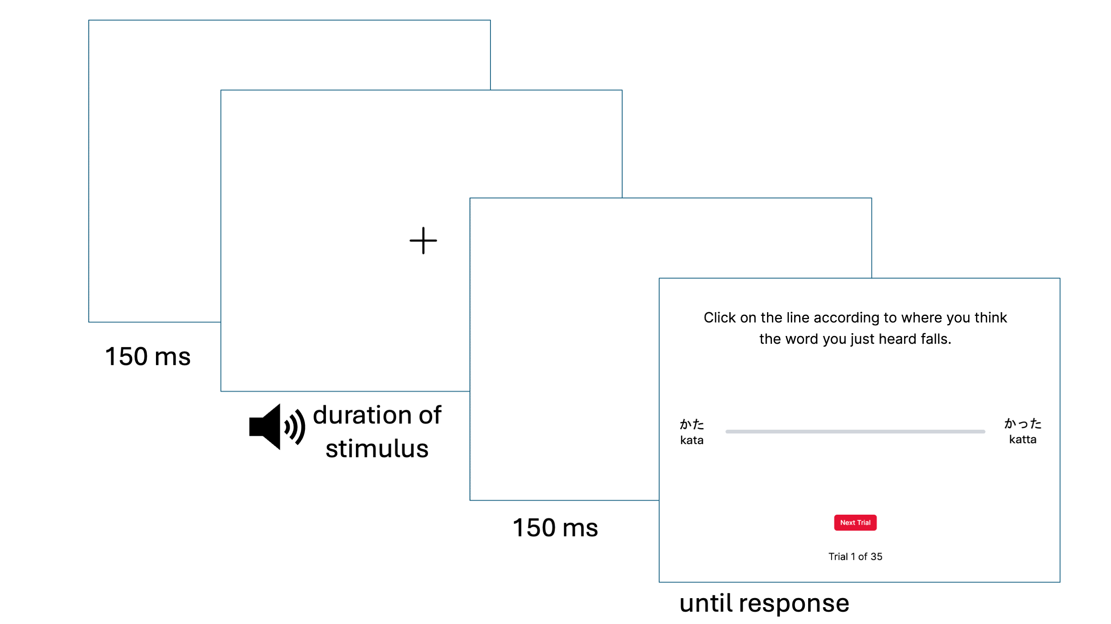
Figure 1: Example VAS Trial
For the English contrast pair continua, the words on either side of the VAS sliding scale on the screen were written in English. For the Japanese contrast pair continua, the words on either side of the VAS sliding scale were written in both hiragana and romaji (Roman letters). The romanization of the Japanese words were as they are written in the above paragraph. For each contrast pair, the left-right position of each word on the endpoints was randomized to be counterbalanced across participants (but consistent within-participant across the trials of a given continuum).
Trials were blocked by continuum (i.e., trials within a block are derived from the same continuum). Within each block, the 35 continuum tokens (7 primary cue x 5 secondary cue) were presented three times in randomized order, for a total of 105 trials per continuum block. To avoid fatigue, each block of 105 trials was divided into three mini-blocks of 35 trials each with a timed 20-second break in between. Each participant was presented with all four continua, for a grand total of 420 trials, with a timed 60-second break in between continuum blocks. The VAS task took approximately 20-30 minutes to complete.
In order to reduce the cognitive load that may be associated with switching between continua and languages, the two blocks per continua were always presented in succession. Additionally, to reduce task confusion especially for participants naïve to or having low proficiency with Japanese, the English continuum blocks were presented first, followed by the Japanese continuum blocks. This followed the only precedent with regards to the order of the presentation of blocks for both L1 and non-L1 continua, set by Kong & Kang (Kong and Kang 2023). The order of the within-language blocks was randomized to be counterbalanced across participants.

VAS data preprocessing
Figure 2 (Apfelbaum et al. 2022) displays hypothetical VAS data plotted on a graph with one-dimensional continuum step along the x-axis (Step 1-7) and response rating on the y-axis (0-100, with 0 representing one side of the rating scale (e.g., indent) and 100 representing the other side (e.g., intent) on the y-axis. When plotted as such, VAS data is typically fit with a logistic curve function from which four parameters are estimated: (1) the minimum and (2) maximum asymptotes of the curve, (3) the cross-over/inflection point, which is the location on the x-axis where the curve crosses 50% of the way between the minimum and maximum asymptotes, i.e. the category boundary, and (4) the slope derived from the curve at the cross-over point. As each token is repeated multiple times, response variability can also be measured as the deviation of each VAS rating from the mean response rating predicted by the logistic curve at each step of the continuum (Apfelbaum et al. 2022; Kutlu, Chiu, and McMurray 2022). The slope and response variability measures from VAS data are best analyzed together to jointly represent a measurement of gradiency. Shallower slopes may be an indicator of gradient categorization, especially in comparison to steeper slopes which theoretically indicate categorical response patterns, but shallow slopes can be further disambiguated using response variability. Shallow slopes with low response variability theoretically represent consistent, “true” gradient response patterns (Panel B), while shallow slopes with high response variability theoretically represent inconsistent, noisy response patterns (Panel C).
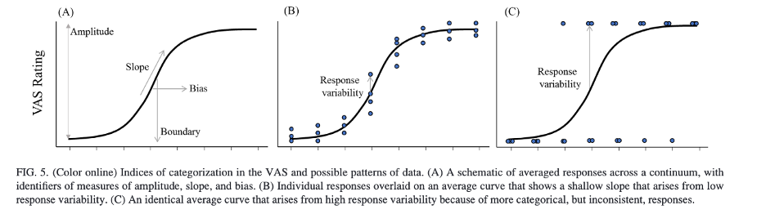
Figure 2: Hypothetical one-dimensional VAS data plotted with fitted logistic curve (from Apfelbaum et al., 2022)
However, two-dimensional VAS data results in multiple category boundaries (along the primary dimension) at the different steps of the secondary dimension. A single parameter of category boundary must be estimated with an alternative function that must take into account use of both the primary and secondary acoustic cues. Figure 3 (Kapnoula et al. 2017) provides two hypothetical response patterns from two-dimensional VAS data when plotted on a graph with the primary acoustic cue on the x-axis and the secondary acoustic cue on the y-axis, (in these examples, voice onset time (VOT) and fundamental frequency (F₀) respectively). VAS ratings are plotted with a third dimension of color gradient. Starting from the cross-over point along the primary cue, a category boundary is drawn using both dimensions. Relative use of the primary and secondary cues is calculated as the angle between the x-axis and the boundary line, $θ$ (theta).
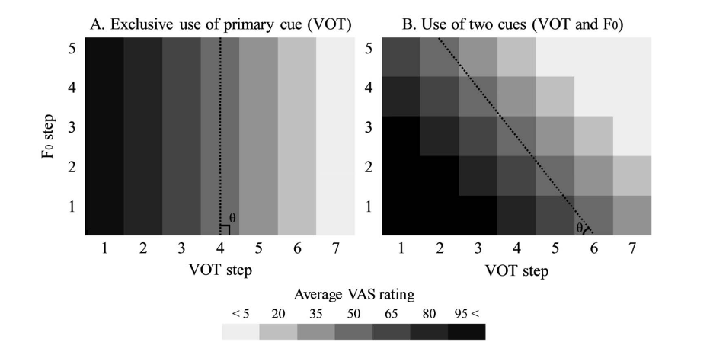
Figure 3: Hypothetical two-dimensional VAS data (from Kapnoula et al., 2017)
Crucially, unlike one-dimensional logistic curve fitting, slope cannot be derived from the two-dimensional category boundary, as there is no way to model the logistic curve in the three-dimensional space (with response as the third dimension). Thus, parameter estimates of two-dimensional VAS data must be analyzed to assess gradiency and secondary cue use separately using a rotated logistic function; Figure 4 provides a visualization of the fitting process (Kapnoula et al. 2017). The rotated logistic function estimates minimum (b₁) and maximum asymptotes (b₂), the two-dimensional category boundary (x₀, y₀), where x₀ is the location of the boundary along the primary cue and y₀ is the location of the boundary along the secondary cue, multiple cue integration ($θ$), and finally slope (s). Here, slope is calculated after the coordinate space is rotated such that the rotated x-axis is orthogonal to the two-dimensional category boundary. From there, a standard logistic curve function is fit, and slope is calculated at the inflection point of the curve where VAS response is 50. This slope estimate serves as a proxy measurement for gradient use of the full scale independent of secondary cue use and does not conflate between the slope of the two-dimensional category boundary and the gradiency measure slope (Kapnoula et al. 2017; Kapnoula, Edwards, and McMurray 2021; Kapnoula and McMurray 2021; Kapnoula and Samuel 2024).
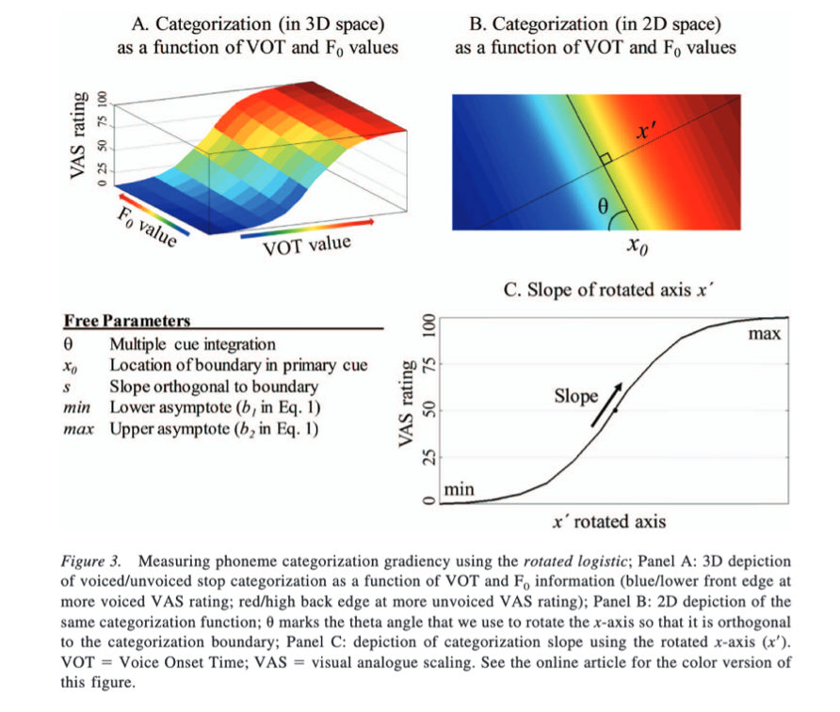
Figure 4: Visualization of the rotated logistic curve fitting process (from Kapnoula et al., 2017)
The rotated logistic function was fit to each participant’s VAS data (separately for each of the four continua) using a constrained gradient descent algorithm that minimized least squared error with the Nonlinear Curvefitting for Psycholinguistics Data MATLAB package (software freely available at McMurray 2017). The data were cleaned prior to fitting the rotated logistic function. All 100 participants performed the VAS task as expected, resulting in a total of 42000 data points (100 participants x 420 trials). Across all participants, the data were filtered to first remove individual trials with a reaction time of over 10 seconds. On a per participant basis, the data were further filtered to remove trials with reaction times three median absolute deviations (MAD) above or below the participants median reaction time. This resulted in a total of 40683 data points that were used the curve fitting process. More details on the fitting process are available in the Appendix/supplementary materials.
The data were fit within grouping variables of participant and continuum pair, thus producing four rows of estimates per participant. The primary estimates of interest from the curve fitter were VAS slope (proxy measure of gradiency), response variability (proxy measure of gradiency and consistency), and theta (proxy measure of secondary cue use). As mentioned, from the rotated logistic function, the estimate of VAS slope is a single index of gradient use of the full scale that is independent of secondary cue use. Smaller/more negative values indicate a shallower response curve, or gradient/noisy response patterns, and larger/more positive values indicate a steeper response curve, or categorical response patterns. Because these two-dimension-based VAS slope values are not intuitively interpretable, and also because the distribution of slope values had high kurtosis, VAS slope was log-transformed and mean-centered. The log-transformation roughly normalized the distribution. The log-transformed VAS slope values were used in the analysis models, often labeled as “Slope” for simplicity.
The estimate of response variability is calculated as the standard deviation of the residuals per fit, also known as the root mean square error (RMSE), or the square root of the averaged squared residuals (Kapnoula et al. 2017). Low RMSE indicates responses relatively close to the curve (low variability) while high RMSE indicates responses relatively far from the curve (high variability). Response variability remained untransformed in the analysis models, labeled as “Response Variability”.
Lastly, as mentioned, the estimate of theta is a continuous measure of secondary cue usage, with 90$∘$ indicating exclusive use of the primary cue (Figure 3A), and decreasing values (toward 0$∘$) indicating increasing reliance on the secondary cue. Theta values near 45$∘$ reflect relatively equal use of the primary and secondary cues (Figure 3B), while theta values near 0$∘$ reflect near exclusive use of the secondary cue. Values greater than 90$∘$ indicate an opposite trend: increasing values indicate increasing use of the secondary cue but also reversed cue mapping, seemingly reflecting response patterns where the primary and/or secondary cues are used in a way that is opposite to the expected categorization (e.g., categorizing acoustically [d]-like tokens as [t]-like, based on VOT and/or F0). Theta values at 135$∘$ indicate relatively equal use of the primary and secondary cue, with one or both cues being reversed, while theta values at 180$∘$ indicate exclusive use of the secondary cue with categorization occurring in a reversed manner relative to the expected responses. To capture these dimensions of theoretical interest, the theta variable was transformed to be centered on exclusive use of primary cue, computed as newTheta = (90 - Theta), such that 0 = exclusive use of the primary cue, +45 = balanced use of both cues with the expected categorization mapping, and +90 = exclusive use of the secondary cue with the expected categorization, whereas the negative range indicates the same trend of increasing use of the secondary cue from 0 to -90, but with one or both cues being reversed. The transformed theta values were used in the analysis models, often labeled as “Theta” for simplicity.

Linguistic Diversity Questionnaire (LDQ): Measuring experiential linguistic diversity

Design and procedure
After the VAS task, participants completed a questionnaire that gathered information on their language history, usage, and exposure, which was used to measure usage of and exposure to linguistic diversity through experiences (see Appendix). The questionnaire measured overall experiential diversity through two primary factors: the diversity of known languages (used and studied) and the diversity of regular exposure in a typical week to both known and unknown languages in various situational contexts, such as through media consumption, social environment, and interpersonal connections. These factors also differ in that the diversity of known languages measures linguistic diversity of active language use and exposure while the diversity of known and unknown languages measures the diversity of passive language use and exposure. Here, passive language use and exposure is defined using the same convention as Castro et al. (Castro, Wodniecka, and Timmer 2022):
By passive exposure […] we refer to situations in which foreign languages are present in the environment but the individual does not interact with these languages in any manner (e.g., by working with people who speak a different language and who often communicate between themselves in that language; by living in a neighbourhood with a high number of foreign language speakers). By passive use of languages, we refer to the intentional use of foreign languages in activities that involve some reading or listening but do not require speaking or writing. (p. 3)
The first half of the questionnaire, assessing known languages, used questionnaire items sourced directly from the Language History Questionnaire [LHQ3; P. Li et al. (2020)]. The LHQ3 has four modules with items that gauge participants’ linguistic background (first language(s) acquired at home, and additional languages acquired, age and manner of acquisition, immersion), proficiency (self-reported proficiency in L1(s) and Ln(s) in reading, writing, listening, and speaking), usage (which language(s) used in various contexts, habits, and social situations), and dominance (dominant language(s) based on proficiency and usage). Measurement types include rating proficiency on a 7-point scale from 1 (“Very Poor”) to 7 (“Excellent”), reporting usage in various contexts as hours per day, and rating usage on a 7-point frequency scale from 1 (“Never”) to 7 (“All the time”).
The second half of the questionnaire, assessing regular exposure to both known and unknown languages, used questionnaire items primarily inspired by and modified from the Language Background Questionnaire (LBQ) used by Yow & Li (Yow and Li 2015) and Li et al. (X. Li et al. 2021); additional modifications were inspired by the Language Experience and Proficiency Questionnaire [LEAP-Q; Marian, Blumenfeld, and Kaushanskaya (2007)] and the survey used by Castro et al. (Castro, Wodniecka, and Timmer 2022) to probe the degree of non-L1 language contact and exposure by monolinguals. The purpose of this portion of the questionnaire was to gauge the exposure to and use of linguistic diversity in ways that are typically not assessed, especially for “functional” monolinguals who may frequently encounter multilingual environments (e.g., a person who does not speak French residing in France, a person who does not speak Chinese and lives with two roommates who speak Chinese to each other, a person who does not speak Arabic who regularly hears Arabic at their mosque).
For these questionnaire items, participants were asked to estimate how many hours per day (while thinking of their typical week) they spend in 10 contexts, divided into two main categories of entertainment contexts and interpersonal contexts (see Table 2). Then, for each context, participants were asked to list up to four languages they may use in that context, and the number of hours per language. The participant was prompted to include their L1(s), Ln(s), any additional languages learned (no matter their proficiency), and any languages they don’t know (based on the participant’s own judgement). The number of hours reported per language was not to exceed the number of hours per day listed for that context in the previous questions, but participants were told the numbers did not have to add up nicely if there was overlap in language usage per context (for example, if a person watches Japanese anime with English subtitles, the time spent passively listening to Japanese and passively reading English would overlap). Lastly, participants were asked to report anything else they would like to add about their language history, experience, usage, and exposure. The questionnaire took approximately 25 minutes to complete, with times varying according to how much information the participant chose to report.
Table 2: Categories of passive language use and exposure contexts queried in Part 2 of the Linguistic Diversity Questionnaire.
Category | Context | Context Label
Entertainment contexts | Watching TV, film, videos on websites like YouTube or Twitch (with or without subtitles) | Watching
 | Listening to radio, music, podcasts, audiobooks | Listening
 | Playing video games, mobile games, online games | Games
 | Using social media or browsing the internet, (with or without the use of automatic translation tools) – include here interacting with generative AI and using language learning apps | Online
Interpersonal contexts (in person or digitally) | At home (e.g., with your partner, child(ren), roommates) | Home
 | With family (parents, siblings, grandparents, caregivers, extended family – note: this may be the same as the context above for you) | Family
 | In social contexts with friends, neighbors, peers from hobbies or communities (e.g., religious community, neighborhood coalition, online community) | Social
 | In work or school contexts with co-workers/colleagues/classmates (this context can include taking language classes) | Work/school
 | Out of home in commercial or official contexts (e.g., restaurants, stores, doctor’s office, bank) | Out of home
None of these | Situations and settings not listed above. Please specify: | Other

LDQ data preprocessing
Experiential linguistic diversity was calculated as two indices based on the two factors of active use of and exposure to known languages and passive use of and exposure to known and unknown languages as measured by the linguistic diversity questionnaire. It is important to acknowledge that it is difficult to capture the degree to which use of and exposure to linguistic diversity aligns with the conventional usage of the terms “monolingual,” “bilingual,” and “multilingual.” These terms have tended to be ill-defined categories that simplify and often mask the heterogeneity and multidimensionality of experiences within and across groups (de Bruin 2019; Castro, Wodniecka, and Timmer 2022; DeLuca et al. 2019; Gullifer et al. 2021; Kałamała et al. 2023; Kałamała, Senderecka, and Wodniecka 2022; Kremin and Byers-Heinlein 2021; Luk and Bialystok 2013; Luk 2015; Surrain and Luk 2019; Titone and Tiv 2023). As such, although this dissertation also uses the terms “(functional) monolingual” and “multilingual” (inclusive of bilinguals), in an attempt to reflect the multidimensionality of mono/multilingualism, linguistic diversity will be quantified as a continuous variable. It is equally important to acknowledge that reducing experiences to aggregated values in itself is problematic and still does not capture the full range and complexities of each individual’s experiences (Marian and Hayakawa 2021). However, because linguistic diversity is a predictor variable in the primary analyses being conducted, believe that quantification by way of a continuous measure is the most appropriate method. Specifically, I calculated a continuous measure of multilingualism called language entropy (Gullifer and Titone 2020), a form of Shannon entropy (Shannon 1948), that was devised to measure the diversity and balance of language use in everyday contexts. Language entropy has been used to explain individual differences in the degree to which multilingualism affects cognitive behaviors in a gradient manner (van den Berg et al. 2022; DeLuca et al. 2019; Gullifer et al. 2018; Gullifer et al. 2021; Kepinska et al. 2023; X. Li et al. 2021; Sulpizio et al. 2020; Wagner, Bekas, and Bialystok 2023).
For active use of and exposure to known languages, a measure of Multilingual Language Diversity (MLD) was calculated according to the aggregate score calculation conventions used by the LHQ3 (P. Li et al. 2020): $MLD=-\sum_{i=1}^{n}{PD_{i}\log_{2}(PD_{i})}$. The MLD score is a modified form of language entropy (Gullifer and Titone 2020) that is calculated from the LHQ3 aggregated score of proportion of dominance (PD_{i}) for each i-th language. PD_{i} is calculated from language dominance (Equation 3 of P. Li et al. 2020), which itself is an aggregated score combining self-reported language proficiency (Equation 1 of P. Li et al. 2020) and language usage reported in hours of use per day in different contexts.
The range of values for language entropy using the standard equation from Gullifer & Titone (Gullifer and Titone 2020) is 0 to $\log_{2}n$, where n represents the total number of languages reported. Complete usage of one language means that maximum language entropy (H) is $\log_{2}1=0$, equal usage of two languages means maximum ${H= log}_{2}2=1$, and equal usage of three languages means maximum ${H= log}_{2}3≈1.58$. Using the LHQ3, participants can report use of up to four languages, which means that the range of MLD scores across participants is from 0 to 2 given that $\log_{2}4=2$, which indicates equal dominance between four languages. The range of MLD from 0 to 2 allows for a continuous measure of linguistic diversity that captures both the number of languages and diversity of usage, as use of two languages is captured from values greater than 0 approaching 1, use of three languages is captured from values greater than 1 approaching 1.58, and use of four languages is captured from values greater than 1.58 approaching 2. One MLD score for active language use and exposure (MLD-A) was calculated for each participant. For a detailed breakdown of the equations used to calculate MLD-A and sample calculations, see Appendix.
[THE MATH IN THE BELOW PARAGRAPH NEEDS UPDATING]
For passive use of and exposure to both known and unknown languages, a modified measure of language entropy was similarly calculated. Language entropy was calculated separately for each context using the standard language entropy equation (Gullifer and Titone 2020): $H_{c}= - \sum_{i=1}^{n}{P_{ic}\log_{2}\left(P_{ic}\right)}$, where n is the number of languages reported and P_{ic} is the proportion of language usage/exposure for language i of context c. P_{ic} is calculated as $P_{ic}=languagehours_{ic}/\sum_{i=1}^{n}{l}anguagehours_{ic}$ This resulted in 10 entropy values per participant. Following Li et al., (X. Li et al. 2021), to aggregate the entropy values and account for individual differences in time spent across different contexts, the aggregated score was computed as weighted language entropy, weighted by the proportion of time spent in a week for each context, using the following equation: $H_{w}= - \sum_{c=1}^{10}{T_{C}*H_{C}}$, where T_{c} is the proportion of time spent in each context, converted from the reported percentage, and H_{c} is the calculated language entropy for the given context. The weighted entropy value represents the Multilingual Diversity Score for passive language use and exposure (MLD-P). One MLD-P score was calculated per participant. For a detailed breakdown of the equations used to calculate MLD-P and examples, see Appendix/supplementary material.
Overall, each participant received two indices of linguistic diversity: MLD-A, as an index of linguistic diversity of known languages through active use and exposure, and MLD-P, as an index of linguistic diversity of known and unknown languages through passive use and exposure. These indices remain separate to represent related but different constructs: specifically, the MLD-P index enables the representation of diverse language use and exposure for those who are functionally monolingual by convention usage of the term, while the MLD-A index is derived from measures of the validated LHQ3 and remains consistent with previous gradient measures of multilingualism as assessed through language entropy (Gullifer et al. 2018; Gullifer et al. 2021). The inclusion of both of these scores is important to represent the multidimensionality of experiential linguistic diversity. Both MLD-A and MLD-P were used as predictor values in the regression models used to examine the effect of experiential linguistic diversity on L1 and L2 categorization.
Although 100 participants took part in the study, two participants did not finish the LDQ. An additional 22 participants did not provide usable answers to the questionnaire, and thus MLD-A and/or MLD-P scores could not be calculated with their given responses. These 24 participants were excluded from the data analysis.

Analysis and Results

Analysis and predictions
Recall that RQ1 asks: Is increased experience with experiential linguistic diversity predictive of higher degrees of gradient categorization of L2 speech as it is with L1 speech? If so, do higher degrees of gradient categorization predict the degree of usage of the secondary acoustic cue in the perception of L2 phonemic contrasts? The research question assumes that we will see higher degrees of gradient categorization among participants for the L1 English contrasts for those with higher experiential linguistic diversity, in line with the findings from Kutlu et al. (2024), which showed that higher degrees of linguistic diversity in children’s social networks led to higher degrees of gradient speech categorization.
I had originally planned to use the same analysis method as Kutlu and colleagues, who used Latent Profile Analysis (LPA) to create a single index of gradiency based on the slopes and response variability values derived from the VAS data. LPA is a type of cluster analysis that is used to model a number of underlying homogeneous subgroups from a larger heterogenous group based on continuous variables and is being increasingly used in learning research for its person-centered modeling approach (Hickendorff et al. 2018).The LPA from Kutlu et al. (2024) successfully supported their hypothesis of three underlying profiles of children based on slope and response variability: categorical (high slope, low variability), gradient (low slope, low variability), or noisy (low slope, high variability). The LPA model predicted posterior probabilities that estimate the probability of membership to each of the three profiles, and the greatest of the three probabilities was used to assign categorization profile membership. Using this method, I would have been able to answer the first part of RQ1 by confirming whether higher levels of experiential linguistic diversity increase the odds of membership in the gradient profile compared to the categorical profile for L1 English as well as investigate whether we see the same pattern of profile membership for L2 Japanese.
However, my data did not turn out to be suitable to fit an LPA model with the three hypothesized. Figure 5 compares the data plotted on the two-dimensional space of response variability and VAS slope for the sample collected by Kutlu et al. (2024) (left) and the Study 1 sample for each language (center and right). For the Kutlu et al. (2024) sample, the three profiles clearly emerge in three of the four quadrants of the space, relative to the sample range. However, for the Study 1 sample, no clear patterns emerge, and data is present in all four quadrants, relative to the sample range. Note that there is no theoretical precedent of characterizing high-slope, high-variability responses, which would be the top right quadrant of the space, thus making it difficult to characterize categorization response profiles with the current sample. The differences between the two samples likely arise both from the fact that the VAS data collected by Kutlu and colleagues were responses to one-dimensional continua, as opposed to the two-dimensional continua of the present study, and the fact that the data were fit on a Bayesian hierarchical growth curve model (Sorensen et al. 2024), as opposed to the use of the Nonlinear Curvefitting program here, which is does not use Bayesian modeling. Given these two differences, it was hypothesized that the non-Bayesian nature of the Nonlinear Curvefitting estimates did not work well with the LPA modeling procedure (E. Kutlu, personal communication, May 12, 2025).
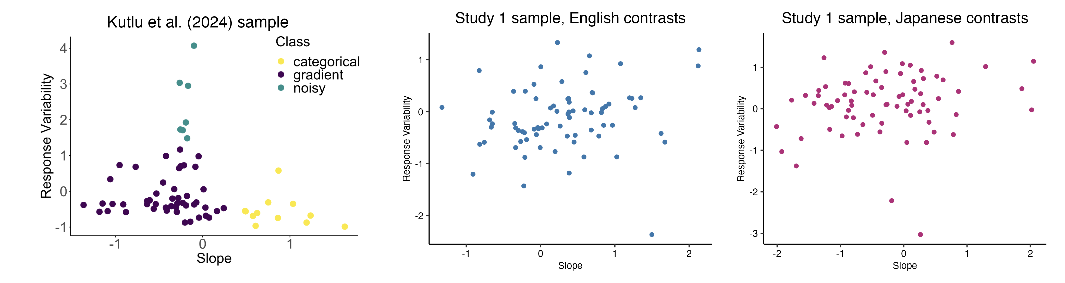
Figure 5: Comparison between distribution of individuals after plotting average slope and response variability VAS response data in two-dimensional space (Response Variability and Slope) between Kutlu et al. (2024) sample (left, n = 64) and the sample of the present study for English and Japanese (center and right, n = 76). Each dot represents the mean slope and response variability of a single participant, averaged across within-language contrast pairs. Note that here, response variability is represented by variance, which is the square of RMSE. Variance was not used in the analyses discussed below. The slope and variances for the sample of the present study were log-transformed and centered on the sample mean in order to better match the visualization of the Kutlu et al. (2024) sample. Note also the differences in range of the axes between the two samples.
Because of this, I chose a different statistical method to analyze the data, which requires a reinterpretation of the research question. Instead, I ask the same question without underlying assumptions of differences between categorization of L1 and L2 contrasts. I simply ask whether increased experiential linguistic diversity is predictive of higher degrees of gradient categorization of L1 and L2 speech, and if so, do higher degrees of gradient categorization predict the degree of secondary acoustic cue usage for L1 and L2 speech? In this case, VAS slope and response variability are still both used as proxy measures for gradiency, just as separate variables. This updated research question reduces the emphasis on the hypotheses regarding directionality for the effects of language (L1 vs. L2) on gradiency or secondary cue use.
To answer the first part of the question, I fit a multivariate mixed-effects (i.e. repeated measures) regression model to examine the effects of experiential linguistic diversity and contrast language on gradiency and secondary cue use. The model was fit using the brms R package (Bürkner 2017). MLD-A, MLD-P, and language (L1 English vs. L1 Japanese) were used as predictor variables for the responses of VAS slope, response variability, and theta.
A multivariate regression model is more appropriate for data in which there are multiple outcome variables per observation, as is the case with estimating three different variables from the VAS data. Running a single multivariate regression model is advantageous over running multiple univariate regression models because multivariate regression also accounts for the correlation between the outcome variables of a given observation, which is likely to occur given that outcomes stemming from the same participant for the same contrast pair (i.e., one observation unit) are likely to correlate. In this way, a multivariate model is more parsimonious than multiple univariate models and better controls Type I error rates (Hui 2018).
I first fit a series of multivariate models to identify the most parsimonious set of predictor variable specifications on the outcome variables of VAS Slope, Response Variability, Theta. The first model brm.fit.1 included MLD-A and MLD-P, their interactions with binary indicators of non-zero MLD scores (1 for scores above 0, and 0 for scores of 0), and interactions with language, a categorical within-subjects variable with the levels of English (L1; reference-level) and Japanese (L2). The model brm.fit.2 specified these predictor variables without the interactions, and brm.fit.3 specified interactions between each of the MLD scores and language without the binary indicators.
Model fit was evaluated using leave-one-out cross-validation (Table 3), such that the model with the best approximated predictive performance of the data is the one with the largest expected log predictive density (ELPD) value. The differences in ELPD across the models were minimal (< 3), with brm.fit.3 yielding the best ELPD but only marginally so. The ELPD difference between brm.fit.1 and brm.fit.3 (-0.1) is less than 2 * the standard error of the difference (0.4) and thus does not provide enough evidence to support that brm.fit.3 is meaningfully better than brm.fit.1. Given the relatively equal predictive performance between these two models, I chose to focus my interpretation on brm.fit.3, which includes interaction terms between the two MLD scores and language and is more simple in interpretation compared to brm.fit.1. It is noted that the interaction terms between the MLD scores and their binary indicators did not reach credible significance, and thus there is no interpretive value in discussing the effects of brm.fit.1 over brm.fit.3. The model also included subject-level random intercepts ID with by-subject random slopes , to capture any inherent differences between participants and allow the effects of language to vary by participant. Item-level intercepts for pair were also included to capture any inherent differences between the chosen contrast pairs. Estimates of the model parameters, including the random effects, fit of the model, and residual correlation between the response variables, are presented below in Section 1.2.3.
Table 3: Multivariate model comparison using expected log predictive density (ELPD) and standard error (SE) of ELPD difference (Δ). The model `brm.fit.3` was used in the analyses.
Model | ELPD | Δ ELPD | SE of Δ ELPD | Right Side of Formula
brm.fit.3 | -2681.2 | 0.0 | 0.0 | (MLD_A * language) + (MLD_P * language) + (1 + language | ID) + (1 | pair)
brm.fit.1 | -2681.3 | -0.1 | 0.4 | (MLD_A * language) + (MLD_P * language) + (MLD_A:MLD_A_binary * language) + (MLD_P:MLD_P_binary * language) + (1 + language | ID) + (1 | pair)
brm.fit.2 | -2683.3 | -2.1 | 2.5 | MLD_A + MLD_P + language + MLD_A:MLD_A_binary + MLD_P:MLD_P_binary + (1 + language | ID) + (1 | pair)
As a Bayesian model, the multivariate model estimates the b coefficient, or the median of the posterior probability distribution of $β$ slopes, for the main effect of each predictor variable and their interaction effects. The model also uses the 95% highest-density interval (HDI) to describe the uncertainty around the b estimate, i.e. there is 95% chance that the true estimate is within this credible interval (CI). In the context of this study, predictor effects are considered robust if the 95% CI does not contain zero.
Based on my hypotheses, I predicted the following robust effects of the predictor on each of the outcome variables:
VAS slope: I predicted robust main effects for MLD-A and MLD-P with negative b estimates, reflecting a decrease in VAS slope as MLD-A/MLD-P increased. This would represent the trend of those with more experiential linguistic diversity showing shallower response trends. I predicted a main effect of language, with no particular prediction on the sign of the b estimate, reflecting a difference in VAS slope between responses for English and Japanese contrast pairs. The interaction effect was added for exploratory reasons: a significant interaction effect would indicate that MLD-A and MLD-P predict VAS slope differently between responses for the English and Japanese contrasts. The model outcomes for VAS slope are discussed below in Section 1.2.3.1.
Response variability: I predicted robust main effects for MLD-A and MLD-P with negative b estimates, reflecting decreasing response variability as MLD-A/MLD-P increased, meaning that higher experiential linguistic diversity predicts lower response variability. I predicted a main effect of language with a positive b estimate, reflecting increasing response variability for Japanese contrast pairs compared to English contrast pairs. This would indicate that response variability is higher for L2 speech than for L1 speech. Again, the interaction effect was added to explore whether MLD-A and MLD-P predict response variability differently between responses for the English and Japanese contrasts. The model outcomes for response variability are discussed below in Section 1.2.3.2.
Secondary cue use theta: The prediction for theta is more complicated, as the direction of the b estimate had different interpretations depending on the theta value. For example, I predicted robust main effects for MLD-A and MLD-P that would reflect that increased experiential linguistic diversity predicts greater secondary cue integration. However, a positive b estimate is qualitatively different for a theta value of -45 (relatively balanced use of primary and secondary cue with one or both being reversed) and 10 (mostly primary cue use in the expected direction). In the former case, a positive b estimate would indicate increasing primary cue use as theta approaches 0 from the negative direction, while in the latter case, a positive b estimate would indicate increasing secondary cue use as theta approaches 45 (balanced use of primary and secondary cue).
To address the complexity in interpretation, additional post-hoc analyses were performed. The original data of the multivariate model (n = 76 participants x 4 pairs = 304) were divided into non-overlapping subsets of theta values: positive values, i.e. range 0-90 (n = 182) and negative values, i.e. range -90-0 (n = 122). Bayesian univariate models were run using brms in R with the same predictor variables as the main analysis and theta as the response variable separately for the two subsets. These post-hoc analyses were performed to investigate potentially differential effects of experiential linguistic diversity on secondary cue usage for L1 and L2 at qualitatively different ranges of theta. The model outcomes and post-hoc outcomes for secondary cue use are discussed below in Section 1.2.3.3.
To answer the second part of RQ1 (“Do higher degrees of gradient categorization predict the degree of secondary acoustic cue usage for L1 and L2 speech?”), I similarly ran Bayesian univariate mixed-effects linear regression models brms in R with theta as the dependent variable. The model estimates the main effects of the predictor variables VAS slope, response variability, and language, as well as their interactions. Again, random intercept terms were included for subject-level ID and item-level pair, with random slopes for ID across languages. The model formula was specified as Theta ~ Slope * Response Variability * language + (1 + language|ID) + (1|pair). The same model formula was used to run separate univariate models for the two subsets of data for positive and negative theta values.
Based on my hypotheses, particularly for the positive subset, I predicted robust main effect of contrast language with negative b estimates, which would suggest decreased secondary cue integration for responses to Japanese contrasts compared to English. I also predicted significant interaction between VAS slope and response variability to reflect the characterizations of gradient, categorical, and noisy response profiles. That is, I predicted an interaction that would suggest that VAS slope differentially predicts degree of secondary cue use at different values of response variability, specifically that low VAS slopes would predict high secondary cue use at low levels of response variability but not high levels of response variability, and so on. I also included a three-way interaction between VAS slope, response variability, and language based on the prediction that the predictive strength of VAS slope and response variability on secondary cue use would be greater for L1 contrasts than for L2 contrasts.
Although the model of the negative subset was largely exploratory, the model was included to explore the possibility that slope and response variability values that correspond to a noisy response profile may predict the degree of reversed cue integration. The outcomes for these univariate analyses are discussed below in Section 1.2.4.

Descriptive statistics

VAS responses
Table 4 presents the summary statistics of the estimates from the rotated logistic curve fit for each contrast pair, averaged across n = 76 participants. The table describes the range, mean, median, and standard deviation of the variables of interest used in the regression model: log-transformed slope, response variability, and re-centered theta.
Table 4: Summary statistics of rotated logistic curve estimates of slope, response variability, and theta, by contrast pair.
Language | Contrast Pair | VAS Measure* | Range | Mean | Median | SD
English | indent-intent | Slope | (-1.54, 3.05) | 0.64 | 0.45 | 0.98
 |  | Response Variability | (0.8, 34.32) | 14.88 | 14.06 | 5.58
 |  | Theta | (-60.12, 53.8) | 11.03 | 11.58 | 11.73
 | reason-risen | Slope | (-2.56, 2.75) | -0.26 | -0.41 | 0.83
 |  | Response Variability | (8.23, 38.43) | 20.18 | 18.62 | 6.59
 |  | Theta | (-89.9, 88.26) | 17.63 | 10.38 | 38.25
Japanese | kata-katta | Slope | (-2.54, 2.35) | -0.58 | -0.85 | 1.20
 |  | Response Variability | (0.66, 43.12) | 21.33 | 20.80 | 8.81
 |  | Theta | (-89.9, 89.92) | -1.16 | -5.13 | 30.25
 | toru-tooru | Slope | (-2.42, 2.72) | -0.22 | -0.36 | 1.04
 |  | Response Variability | (5.42, 34.86) | 18.53 | 17.74 | 5.34
 |  | Theta | (-49.39, 63.94) | -4.68 | -2.33 | 14.03
* Note: Slope was log-transformed and group mean-centered. Theta was re-centered around 90 by the formula (90 - original theta), transforming the original 0-180 range to -90-90, such that original 90 --> 0 = re-centered 0 --> 90 and original 90 --> 180 = re-centered 0 --> -90.
In terms of group level response patterns, Figure 6 shows the mean VAS responses (color) as a function of the primary dimension (x-axis) and secondary dimension (y-axis) per contrast pair, averaged across participants. As expected, the mean responses showed that participants used both the primary and secondary cues to categorize the L1 English contrasts more so than L2 Japanese contrasts. The color gradient of responses, confirmed by the mean values of Theta for each of the pairs in English and Japanese, show that the two-dimensional category boundary is much more angled for the English contrasts than for the Japanese contrasts, indicated more secondary cue integration for English and near exclusive use of the primary cues for Japanese.
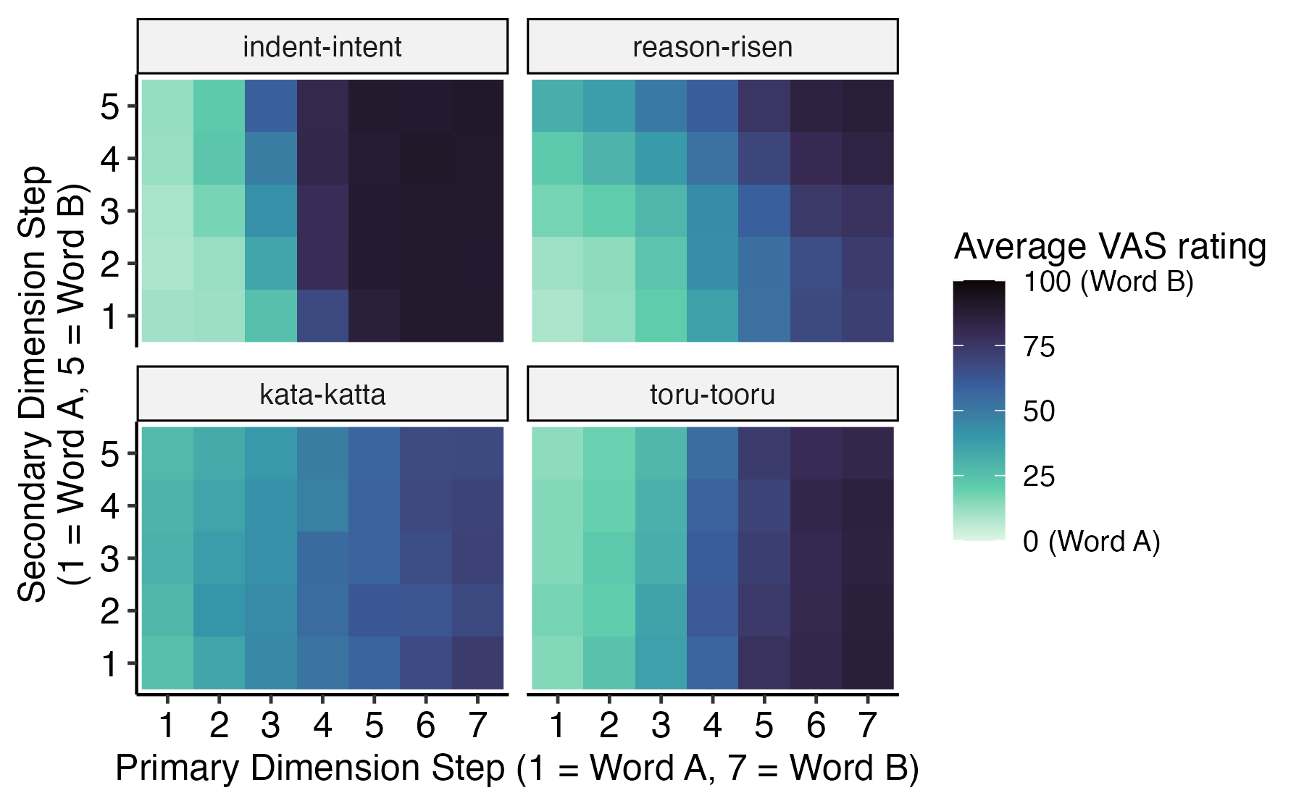
Figure 6: Two-dimensional VAS responses for English and Japanese contrast pairs, averaged across participants.
As expected from the gradient categorization framework, individuals varied substantially in their use of the continuous response scale. Figure 7 captures the range of response patterns across and within individuals. The top panel captures between-subject variability with five representative participants who are consistent in their range of VAS responses across contrast pairs. This includes a listener who uses the entire scale and can be described as canonically gradient (ID 7172, second from bottom), a listener who exclusively uses the endpoints and can be described as canonically categorical (ID 7189, bottom). We also see listeners who fall somewhere in between: ID 5098 (top) is a listener with a bimodal distribution of responses near either endpoint, ID 6015 (second from top) is a listener who favors the two endpoints but occasionally responds along the scale, and ID 6998 (third from top) is a listener with a wide unimodal distribution favoring the center of the scale. The bottom panel captures within-subject variability with five representative participants who are inconsistent in their range of VAS responses either across contrast pairs or across languages. This include listeners who show categorical patterns for the English pairs but gradient patterns for the Japanese pairs (ID 5178, top; ID 6235, bottom), and listeners who are inconsistent across contrast pairs (middle three).
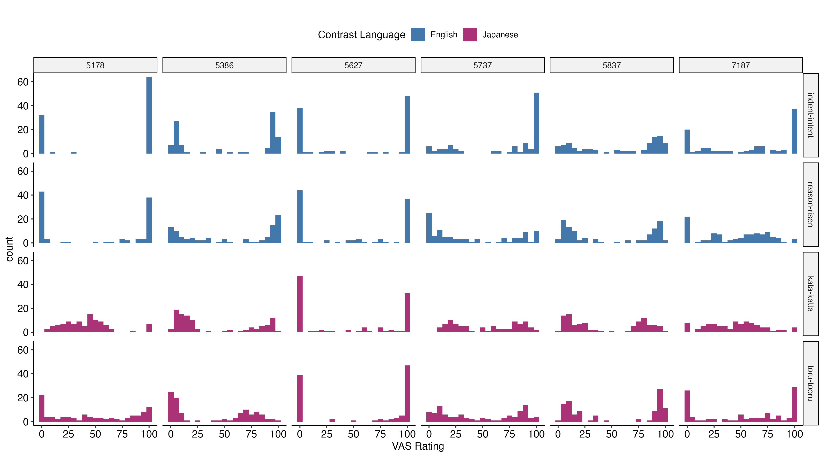
Figure 7: Histograms of sample individual VAS responses (x-axis) for each of the four contrasts to show diversity of patterns in using entire range of the scale. Responders varied in their consistency of VAS scale use both within and across contrast languages.
While response histograms capture individual differences using the full range of the VAS scale, they fail to model the relationship between stimuli characteristics, as steps along the continuum, and categorization patterns, as VAS response. Figure 8 displays sample ratings plotted along the primary continuum (collapsed across the secondary cue for ease of visualization). These plots visually capture the range of slopes (mean function, the red curve) and response variability values (individual trial responses, the black dots) across participants and contrast pairs. [insert concrete descriptors]
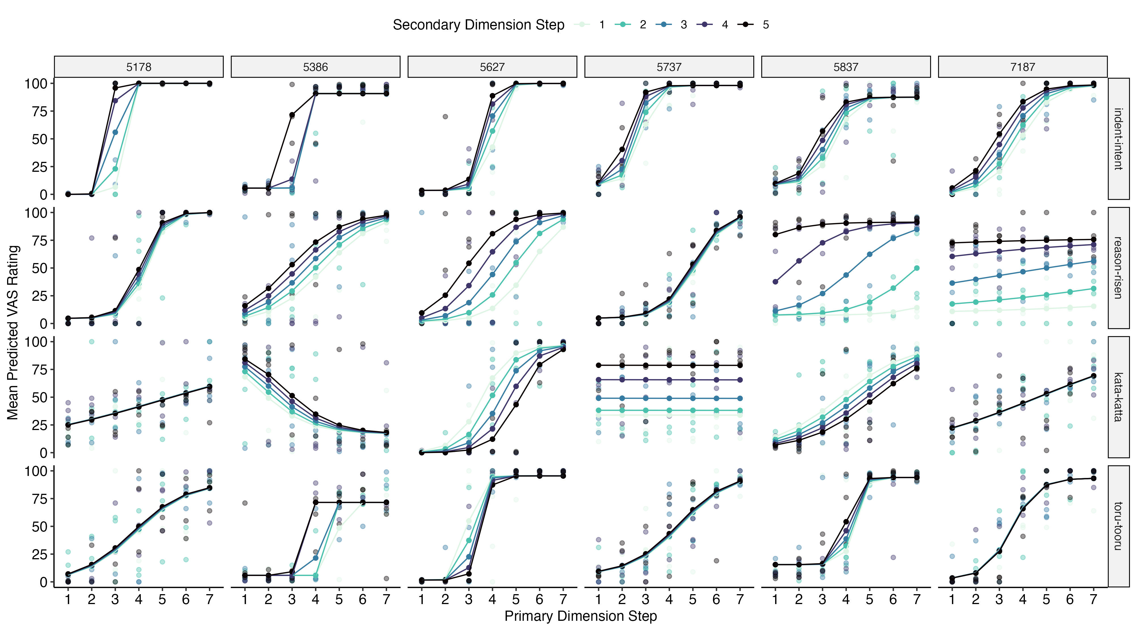
Figure 8: PLACEHOLDER FOR examples of gradiency and response variability
Lastly, individual-level raster plots (Figure 9 show the range of secondary cue use, with the theta angle of the two-dimensional category boundary plotted on top of average VAS response (color). [insert concrete descriptors] Talk about reversed cue usage! find examples of people for who it seems like the primary cue is reverse compared to the secondary cue (anybody completely flipped?)
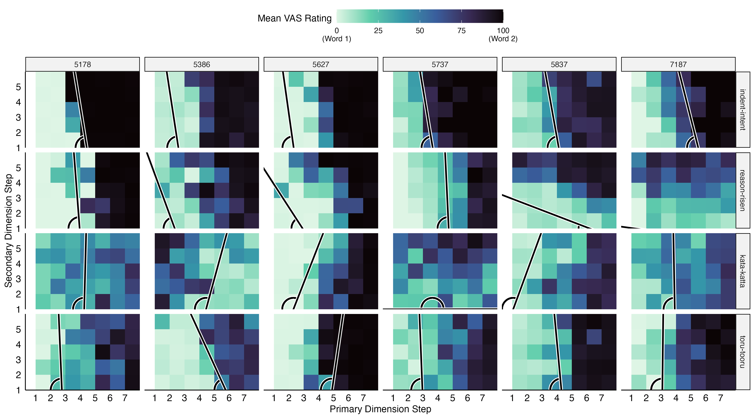
Figure 9: PLACEHOLDER FOR examples of two-dimensional response variability, category boundary, and theta

LDQ responses
The predictor variables in the analysis are the measures active and passive multilingual language diversity, MLD-A and MLD-P, as the proxy measures of experiential linguistic diversity. A simple correlation test showed a moderate positive correlation between MLD-A and MLD-P (Pearson’s r(74) = .35, p = 0.002). Figure 10 plots the distributions of MLD-A and MLD-P scores (left column of panels), along with a scatterplot displaying their correlation (right panel). The histograms show that both distributions are zero-inflated, meaning that most participants have both MLD-A and MLD-P scores of zero.
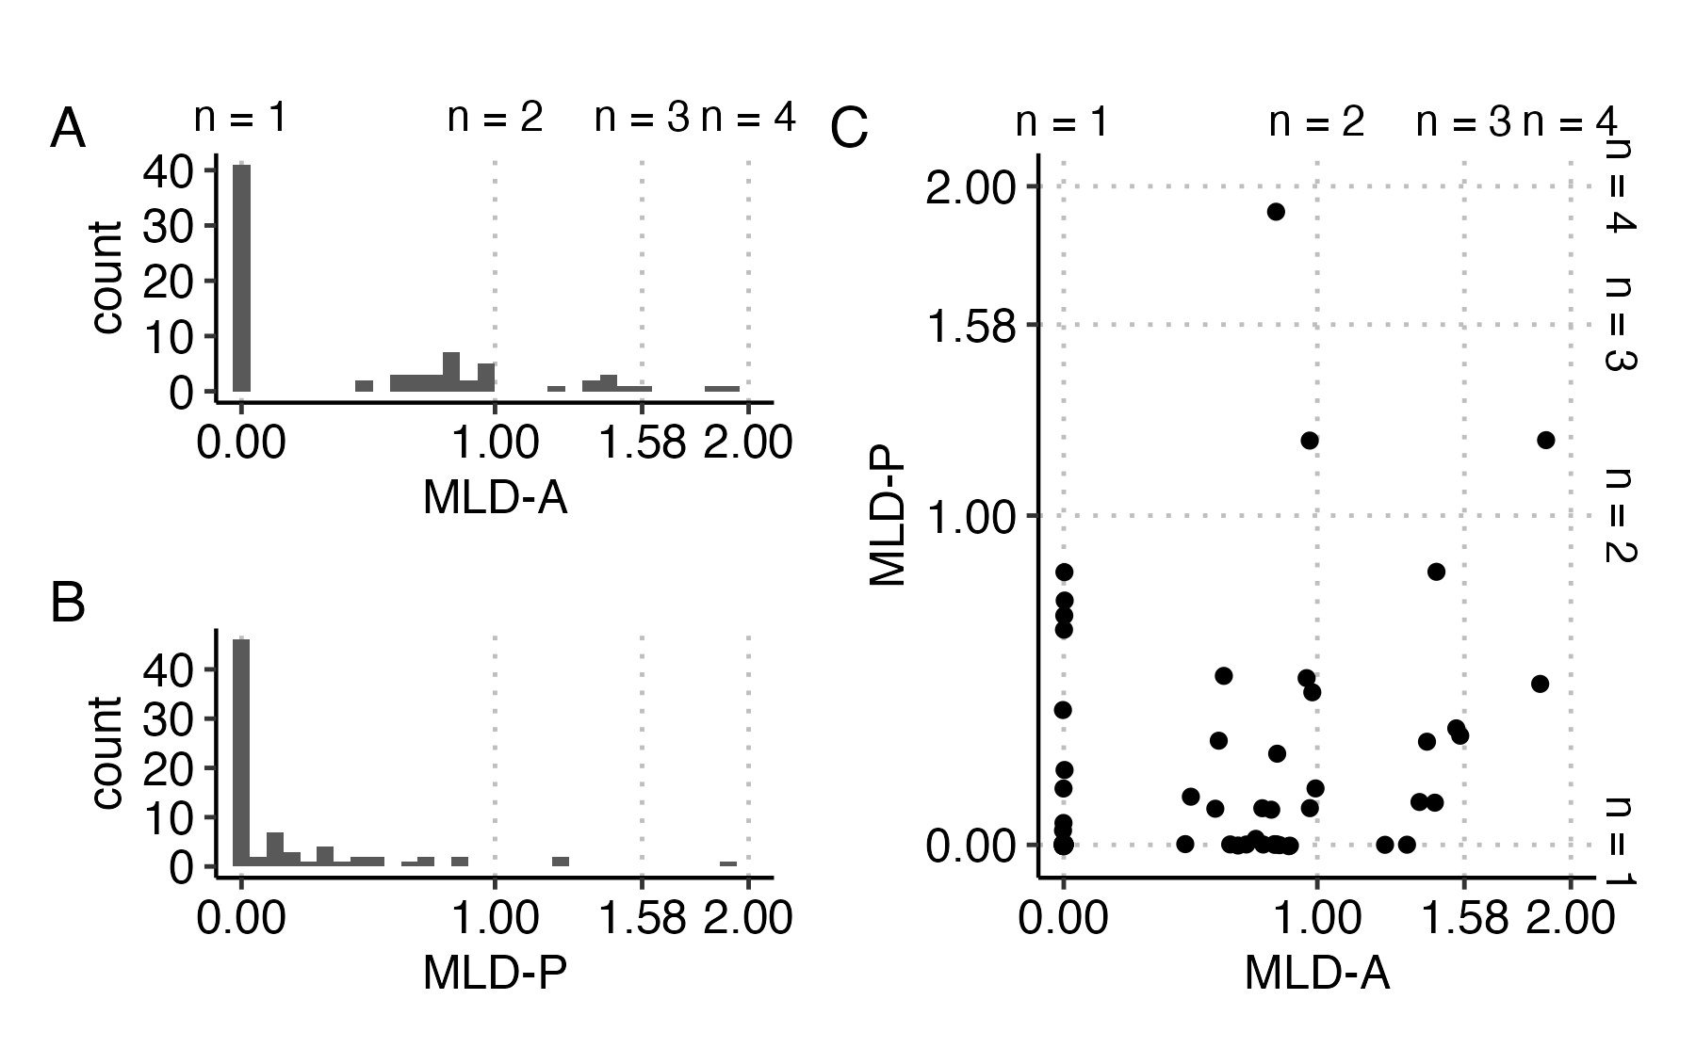
Figure 10: Histograms of MLD-A and MLD-P scores (A and B) and scatterplot of correlation between MLD-A and MLD-P where eat dot represents an individual. Grid lines indicate the score corresponding to balanced use of n languages. Scores in between these breakpoints represent imbalanced use of two, three, and four languages as MLD scores approach 1, 1.58, and 2, respectively.
The zero-inflated nature of the distributions is difficult to see in the scatterplot, where each individual point represents a participant. The scatterplot is more informative in showing the individuals who report being multilingual in some capacity, either through active experiences, passive experiences, or both. Of particular interest are those who reported being functionally monolingual with passive exposure to multiple languages, as indicated by MLD-A scores of 0 and non-zero MLD-P scores (the dots parallel to the y-axis). The data support the idea of diverse language experiences among “functional” monolinguals, who may expose themselves to passive linguistic diversity even if they do not view themselves as multilingual, and the importance of measuring a broad range of experiences.

Multivariate model outcomes for VAS slope, response variability, and secondary cue use
The results of the multivariate Bayesian mixed-effects analysis modeling the effects of experiential linguistic diversity and contrast language on VAS slope, response variability, and secondary cue use are presented below. For each of the three outcome variables, Table 5 presents the b estimates of the fixed effects, the median of the posterior probability distributions, and the 95% highest-density interval (HDI) as the 95% credible interval (CI). Each estimate is also accompanied by a p-value that is calculated from the Bayesian index Probability of Direction (pd). As an index of predictor effect existence, pd is defined as the proportion of the posterior distribution that has the same sign (on the same size of zero) as the median, which can be interpreted as the probability that the true parameter is either positive or negative. A type of two-sided p-value that is comparable to p-values calculated for frequentist models can be calculated from pd through the formula p = 2 x (1 - pd). This pd-based p-value (pd-p in the tables) can be interpreted as the proportion of the posterior distribution on the opposite side of zero from the median, thus small values of pd-p reflect high confidence in the effect direction of the b estimate (Makowski, Ben-Shachar, and Lüdecke 2019; Makowski et al. 2019).
Note that in this model, the intercept reflects the expected value of the outcome variable for participants with MLD-A and MLD-P scores of 0 when responding to English contrast pairs, as English was the reference level for the language factor and both MLD variables were entered untransformed. Thus, all main effects and interaction terms are interpreted relative to this baseline. As such, fixed effects for language reflect predicted differences between English and Japanese for individuals with MLD-A and MLD-P scores of 0. Interaction terms reflect differences in estimates between English and Japanese across the range of MLD-A and MLD-P values. In the following sections, I describe the results of the predictors on each outcome variable, and I focus on the interaction terms between MLD scores and language, visualized in Figure 11, to address the research question.
Table 5: Multivariate Bayesian mixed-effect model on the outcome variables of slope, response variability, and theta: Posterior distribution median estimate, 95% credible interval (CI), and probability of direction (pd)-based p-values of predictor main effects and interactions for each outcome variable.
Predictor | Estimate | 95% CI | pd-p
VAS Measure: Slope
Intercept | -0.12 | [-1.48, 1.05] | 0.79
MLD-A | 0.13 | [-0.11, 0.39] | 0.31
language (Japanese) | -0.42 | [-1.62, 0.95] | 0.49
MLD-P | -0.14 | [-0.55, 0.26] | 0.47
MLD-A x language (Japanese) | -0.29 | [-0.60, 0.03] | 0.08
MLD-P x language (Japanese) | 0.56 | [ 0.08, 1.08] | 0.03
VAS Measure: Response Variability
Intercept | 17.82 | [13.87, 22.17] | 0.00
MLD-A | -0.54 | [-2.22, 1.20] | 0.55
language (Japanese) | 1.02 | [-2.45, 4.33] | 0.57
MLD-P | -0.26 | [-2.65, 2.33] | 0.84
MLD-A x language (Japanese) | 1.26 | [-0.42, 2.78] | 0.13
MLD-P x language (Japanese) | -0.91 | [-3.17, 1.41] | 0.43
VAS Measure: Theta
Intercept | 2.71 | [-7.62, 13.15] | 0.53
MLD-A | -0.18 | [-1.81, 1.38] | 0.83
language (Japanese) | -0.22 | [-2.18, 1.69] | 0.82
MLD-P | 0.13 | [-1.64, 1.96] | 0.90
MLD-A x language (Japanese) | 0.08 | [-1.67, 1.87] | 0.93
MLD-P x language (Japanese) | -0.22 | [-2.07, 1.66] | 0.83
Table Error! Reference source not found. presents a summary of the random effects for each outcome variable, including the standard deviation estimates and 95% CI for the random intercepts for pairs, the random slopes and intercepts for ID and their correlations, and the residual standard deviations (sigma) for each outcome variable, or the remaining variance unexplained by the fixed and random effects. Also included are the residual correlations between the three outcome variables, and the Bayesian R² estimate with 95% quantile, which is a probabilistic measure of how well the model fits the data for each outcome variable (Gelman et al. 2019). The residual correlation was moderately negative between slope and response variability, weak-to-moderately correlated between response variability and theta, and negligible between slope and theta. The modest but non-negligible residual correlations support the use of the multivariate model over multiple univariate models.
## [1] "placeholder"
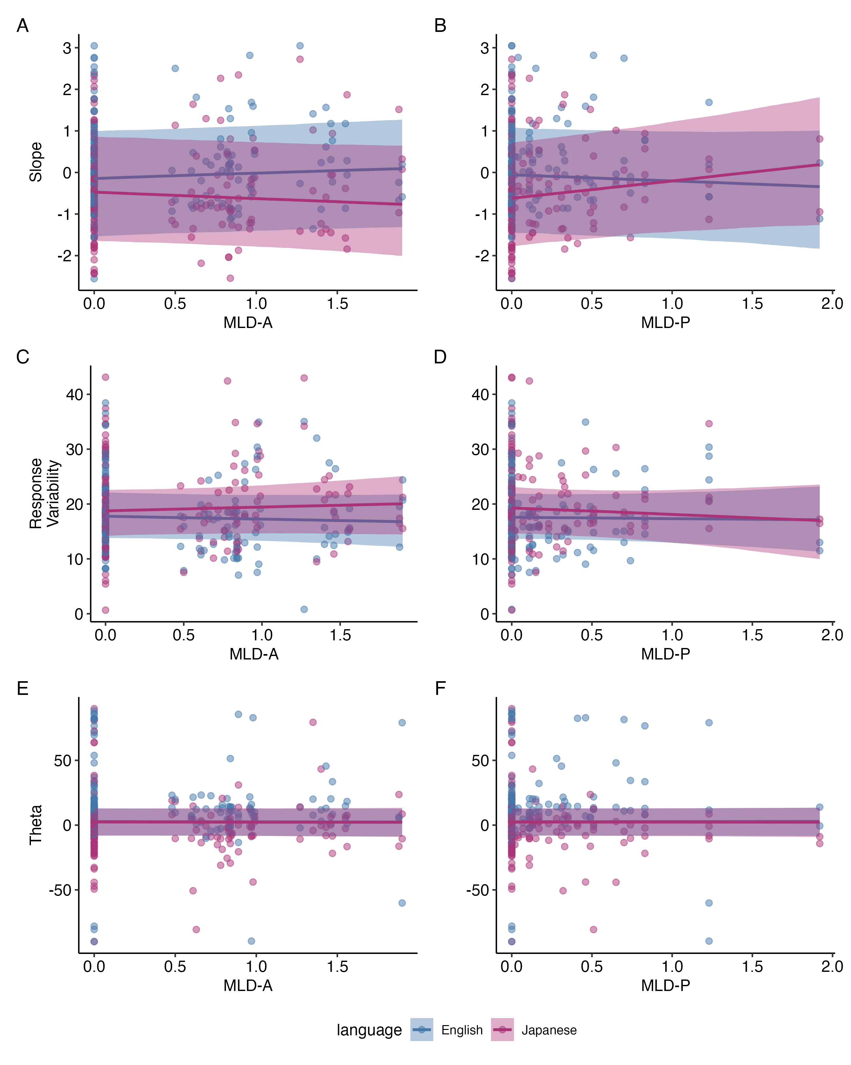
Figure 11: Conditional effects of MLD-A (left panels) and MLD-P (right panels) on VAS slope (top row), response variability (middle row), and theta (bottom row) for L1 English and L2 Japanese.

Effect of predictors on VAS slope
The 95% credible intervals (CIs) for the posterior estimates of MLD-A, MLD-P, and language all included zero, indicating no strong evidence for independent effects of these predictors on VAS slope. Consequently, the fixed and interaction effects are interpreted cautiously as trends rather than definitive effects.
The intercept estimate represented the predicted VAS slope for VAS responses to the English contrasts when MLD-A = 0 and MLD-P = 0. Although not statistically robust, the intercept estimate (b = -0.12, 95% CI = [-1.48, 1.05]) indicated a baseline trend of slightly shallower VAS slopes against which the estimates of the fixed and interaction effects were compared.
While not statistically robust, the estimated main effects suggested some directional patterns. Specifically, higher MLD-A scores were associated with slightly steeper VAS slopes (b = 0.13, 95% CI =[-0.11, 0.39]) whereas higher MLD-P scores showed a trend toward slightly shallower slopes (b = -0.14, 95% CI [-0.55, 0.26]). Additionally, for individuals with MLD-A and MLD-P scores of zero, responses to the Japanese contrast pairs trended toward shallower VAS slopes compared to English (b = -0.42, 95% CI [-1.62, 0.95]).
However, the interaction terms between the MLD scores and language showed weak to moderate evidence of effects, although these interaction effects are interpreted cautiously given the lack of robust main effects. For the interaction between MLD-A and language, the posterior estimate indicated a negative effect (b = –0.29, 95% CI [-0.60, 0.03], pd-p = 0.08). Although the 95% CI narrowly included zero, this suggests weak evidence for a negative interaction effect, though the pd-p value does not meet conventional frequentist thresholds for significance when $α$ = 0.05. Keeping in mind the weak support for the effect’s direction, the estimated interaction suggests that MLD-A predicted VAS slope differently across L1 and L2. Figure 11A shows the conditional effects for MLD-A on VAS slopes for each language level; for the Japanese contrasts, a one unit increase MLD-A scores predicted a 0.16 unit decrease (b = -0.16, 95% CI [ -0.49, 0.19]) in VAS slopes, in contrast to VAS slopes for English, which had a slightly positive trend, as indicated by the MLD-A fixed effect (b = 0.13, 95% CI =[-0.11, 0.39]).
Similarly, the interaction between MLD-P and language suggests that MLD-P predicted VAS slope differently across L1 and L2, with moderate evidence for a positive interaction effect (b = 0.56, 95% CI [0.08, 1.08], pd-p = 0.03). The 95% CI excluded zero, supporting a slightly more robust effect. This interaction trend indicates that MLD-P predicted a 0.56 unit increase in VAS slope for Japanese contrasts compared to English. Figure 11B shows the conditional effects of MLD-P on VAS slopes between the two language levels; for the Japanese contrasts, a one unit increase in MLD-P scores predicted a 0.42 unit increase (b = 0.42 95% CI [-0.12, 0.93] in VAS slopes, in contrast to VAS slopes for English, which had a slightly negative trend, as indicated by the MLD-P fixed effect (b = -0.14, 95% CI [-0.55, 0.26]).
Together, these findings cautiously show a trend suggesting that experiential linguistic diversity predicted VAS slope differently between L1 and L2, with different directional associations between MLD-A and MLD-P for Japanese relative to English. Interesting, these trends suggest that increased active experiential linguistic diversity predicted shallower L2 VAS slopes compared to L1, while increased passive experiential linguistic diversity predicted steeper L2 VAS slopes compared to L1.

Effect of predictors on response variability
Here too, the 95% CIs for the posterior estimates of MLD-A, MLD-P, and language all included zero, indicating no strong evidence for independent effects of these predictors on response variability. As before, the fixed and interaction effects are interpreted cautiously as trends rather than definitive effects.
The intercept estimate (b = 17.82, 95% CI [13.87, 22.17]) represented the predicted response variability for VAS responses to the English contrasts when MLD-A = 0 and MLD-P = 0. Although the 95% CI does not contain zero, resulting in a pd-p value of 0.00, this merely indicates that there is 100% probability that the true intercept is positive. Because the values for response variability were untransformed and response variability is bounded to be positive, the significance of the intercept is not meaningful for inference.
In line with the main effects, the interaction estimates were not statistically robust. The interaction between MLD-A and language showed weak evidence of an effect (b = 1.26 95% CI [-0.42, 2.78], pd-p = 0.13), suggesting a possible trend that MLD-A scores may differentially predict response variability in L1 and L2. As shown in Figure 11C, higher MLD-A scores were associated with increased response variability for the Japanese contrasts, whereas the trend for English was slightly negative.
The interaction between MLD-P and language showed no evidence of a meaningful effect (b = -0.91, 95% CI [-3.17, 1.41], pd-p = 0.43). Although Figure 11D seems to visually display a potential convergence pattern, in which higher MLD-P scores predict reduced response variability for Japanese to align more closely with that of English, the level of uncertainty prohibits a confident interpretation of this pattern.

Effect of predictors on secondary cue use
The model predicting secondary cue use did not yield strong evidence for any fixed or interaction effects. The 95% credible intervals for all estimates, including the intercept, MLD-A, MLD-P, language, and their interactions, overlapped with zero, and all pd-p values were above 0.50, indicating high uncertainty. Figure 11 (bottom row) shows that the interactions between the MLD scores and language lack any noticeable trends. Given the absence of robust effects, exploratory post-hoc analyses were conducted to examine whether patterns of secondary cue use differed between the qualitatively distinct positive and negative ranges of theta, as it is possible effects were masked across the full range.
Table 6 presents the posterior estimates of the univariate models side-by-side. The table also presents random effects structure: Group-level standard deviations and correlation parameters with 95% credible interval (CI), population-level residual standard deviation (sigma) with 95% CI, and Bayes R² with 95% quantile. It should be noted that the number of observations differed between the subsets of data for the positive and negative ranges of theta, with n = 182 for the positive range of theta and n = 122 for the negative range of theta.
Here too, while the directionality of the intercept terms is well supported, the intercept estimates lack meaningful interpretation because each data subset was bound in the positive or negative direction. In the model restricted to positive theta values (i.e. responses corresponding with the expected direction of categorization), none of the predictor estimates had 95% CIs excluding zero, nor were any trends of effect directionality supported by the pd-p values. Further, while Figures 12A and B display potentially interesting visual trends of a convergence pattern effect for MLD-A and a divergence pattern effect for MLD-P on positive theta values across L1 and L2, these patterns should be interpreted cautiously due to the high uncertainty of the interaction estimates.
Similarly, in the model restricted to negative theta values (i.e. responses suggesting reversed categorization in one or both dimensions), all fixed effect estimates had 95% CIs that overlapped with zero and high pd-p values, again suggesting no robust effects. In this case, Figures 12C and D shows that the interactions between MLD scores and language lack any noticeable trend. Overall, these post-hoc analyses provide no additional evidence of predictor effects on either range of the theta values and reinforce the conclusion from the original model that these data lack the evidence to support the hypothesis that experiential linguistic diversity predict secondary cue use in either L1 or L2.
Table 6: Fixed and random effects of the univariate post-hoc analyses on the positive and negative ranges of theta: Posterior distribution median estimate, 95% credible interval (CI), and probability of direction (pd)-based p-values of predictor main effects and interactions. NOTE: STILL NEED TO ADD RANDOM EFFECTS.
 | Positive Theta |  |  | Negative Theta
Predictor | Estimate | 95% CI | pd-p | Estimate | 95% CI | pd-p
Intercept | 11.18 | [ 4.43, 18.03] | 0.01 | -6.15 | [-13.11, -0.72] | 0.03
MLD-A | -0.84 | [-3.42, 1.63] | 0.52 | 0.75 | [ -4.08, 5.10] | 0.75
language (Japanese) | -3.40 | [-9.59, 4.33] | 0.37 | -2.86 | [ -8.61, 4.00] | 0.35
MLD-P | 1.13 | [-2.42, 4.69] | 0.51 | 1.04 | [ -4.42, 6.12] | 0.67
MLD-A x language (Japanese) | 1.93 | [-2.15, 6.25] | 0.36 | -0.60 | [ -5.73, 4.50] | 0.82
MLD-P x language (Japanese) | -2.86 | [-9.02, 3.43] | 0.38 | -0.29 | [ -6.11, 5.76] | 0.92
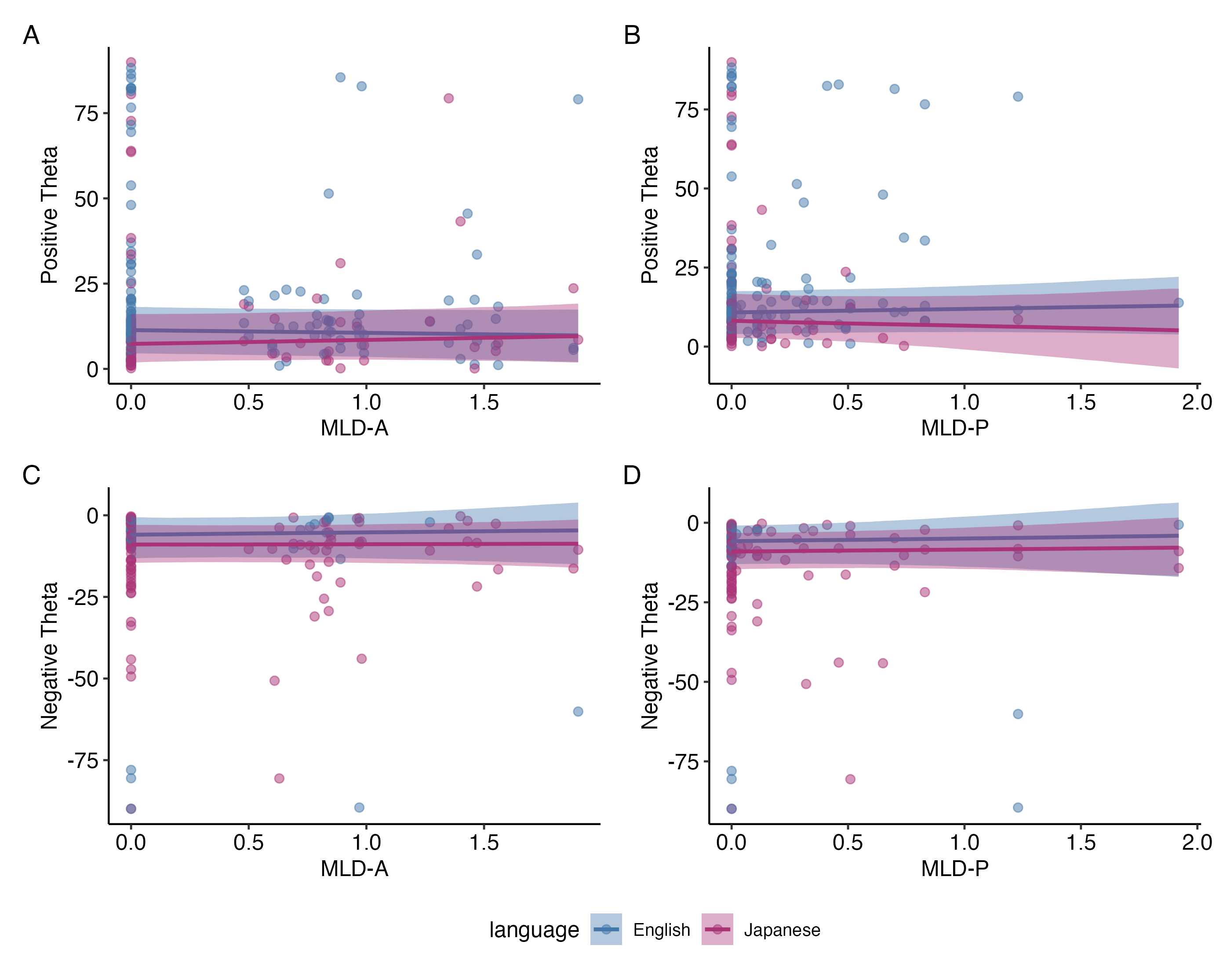
Figure 12: Conditional effects of MLD-A (left panels) and MLD-P (right panels) on positive (top row) and negative (bottom row) theta values for L1 English and L2 Japanese. Note that positive theta values represent degree of secondary cue integration in the expected direction of categorization while negative theta values represent degree of secondary cue integration with one or both of the cues being reversed.

Univariate model outcomes for secondary cue use
Table 7 presents the fixed effect outcomes of the univariate Bayesian mixed-effects analyses modeling the effects of VAS slope, response variability, and contrast language on positive and negative ranges of theta. The table also presents random effects structure: Group-level standard deviations and correlation parameters with 95% credible interval (CI), population-level residual standard deviation (sigma) with 95% CI, and Bayes R² with 95% quantile.
As with the univariate post-hoc analyses on the positive and negative ranges of theta, while the directionality of the intercept term is robustly supported, the bounded nature of the data for each model means that the intercept estimates they lack meaningful interpretation. In terms of the main and interaction effect terms, as VAS slope and response variability can both be considered components of categorization gradiency, both their independent and interaction effects on theta are of interest.
Table 7: Univariate Bayesian fixed and random effects model outcomes examining the effects of slope, response variability, and language on the positive and negative ranges of theta: Posterior distribution median estimate, 95% credible interval (CI), and probability of direction (pd)-based p-values of predictor main effects and interactions. NOTE: STILL NEED TO ADD RANDOM EFFECTS.
 | Positive Theta |  |  | Negative Theta
Predictor | Estimate | 95% CI | pd-p | Estimate | 95% CI | pd-p
(Intercept) | 7.12 | [ 0.28, 14.51] | 0.04 | -5.70 | [-12.25, 0.23] | 0.06
Slope | 0.64 | [-1.87, 2.94] | 0.61 | -0.76 | [ -4.05, 2.38] | 0.65
Response Variability | 0.34 | [ 0.01, 0.63] | 0.04 | -0.03 | [ -0.40, 0.31] | 0.86
language (Japanese) | -0.10 | [-3.75, 3.77] | 0.96 | -0.27 | [ -3.97, 3.40] | 0.89
Slope x Response Variability | -0.01 | [-0.23, 0.17] | 0.91 | -0.06 | [ -0.44, 0.26] | 0.71
Slope x language (Japanese) | 0.93 | [-2.07, 4.28] | 0.58 | -0.52 | [ -3.72, 2.70] | 0.75
Response Variability x language (Japanese) | -0.21 | [-0.61, 0.18] | 0.28 | -0.13 | [ -0.47, 0.23] | 0.44
Slope x Response Variability x language (Japanese) | 0.13 | [-0.12, 0.36] | 0.28 | 0.14 | [ -0.19, 0.53] | 0.39

Effect of VAS slope and response variability on secondary cue use
In the model predicting positive theta values, response variability was the only predictor of either the main or interaction effects with a 95% CI that excluded zero (b = 0.34, 95% CI = [0.01, 0.63], pd-p = 0.04), indicating a statistically robust trend that response variability predicted a mild increase in secondary cue use in the expected direction of categorization. All other main and interaction effects lacked strong support, as their CIs overlapped with zero and showed high uncertainty in directionality. In the model predicting negative theta values, none of the predictors and their interaction terms showed evidence of an effect, as all CIs included zero and the pd-p values indicated substantial uncertainty in the directionality of the estimate.
Figure 13A visualizes the marginal effect of response variability on the positive range of theta, averaged across levels of other predictors. The statistically robust positive trend is contrasted to the marginal effect of response variability on negative theta, plotted in Figure 13B, where the relationship was not statistically robust and the trend was flat.
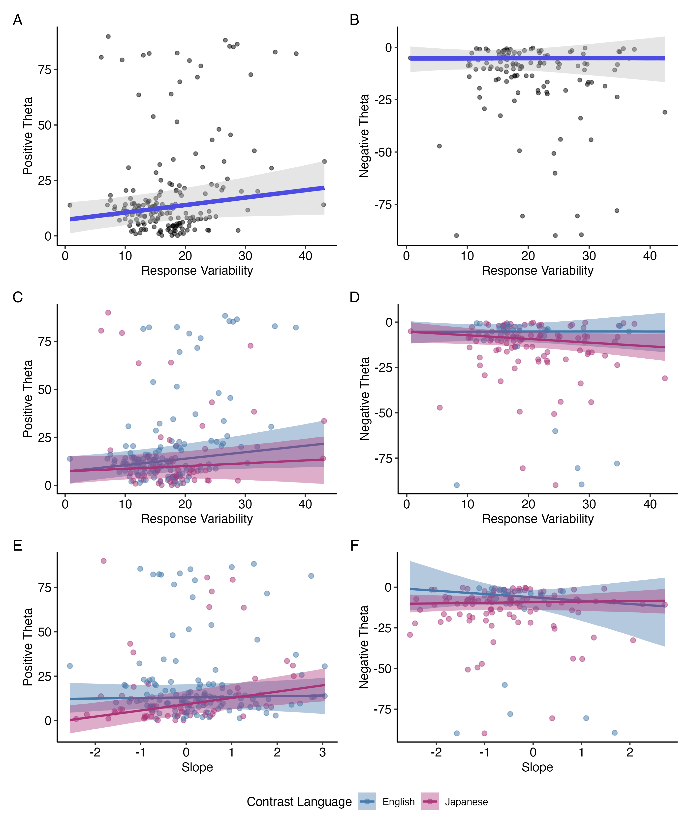
Figure 13: Marginal effects of response variability (top row), and conditional effects of response variability (middle row) and VAS slope (bottom row) for L1 English and L2 Japanese on positive (left column panels) and negative (right column panels) theta values. Note that positive theta values represent degree of secondary cue integration in the expected direction of categorization while negative theta values represent degree of secondary cue integration with one or both of the cues being reversed.
To explore potentially meaningful patterns, the interactions between response variability and language are plotted in panels C and D of the same figure. These panels plot the same data as panels A and B, respectively, but with separate trends for English and Japanese. While not statistically robust, these interaction trends suggest that among positive values of theta, higher response variability is associated with decreased secondary cue use/increased primary cue use (positive theta values close to zero) for Japanese relative to English. For negative theta, the interaction trend implies the reverse: greater response variability is associated with increased secondary cue integration in the reversed direction of categorization (i.e., larger negative theta values) for Japanese compared to English. These interpretations are tentative given the wide intervals and low directional certainty.
The interaction plots between VAS slope and language (bottom rows) are additionally included visualize the potential trends for how VAS slope differentially predicts secondary cue use between L1 and L2. However, the interaction terms for both positive theta values and negative values had wider 95% CIs and low confidence in directionality of the estimate (pd-d = 0.58 for positive theta and pd-p = 0.75 for negative theta), which indicates a greater degree of uncertainty and Instead, their inclusion is to provide a fuller picture in using both response variability and VAS slope together to estimate the of categorization gradiency on secondary cue use.
Panels E and F present the interactions between VAS slope and language. These are included to illustrate possible differences in how slope may predict secondary cue use in L1 vs. L2, though neither interaction was statistically supported (pd-p = 0.58 for positive theta; pd-p = 0.75 for negative theta). The wide CIs and lack of directional confidence indicate a high degree of uncertainty and necessitates critical evaluation of the emerging trends and caution against overinterpretation. However, their inclusion provides a more complete picture on how both response variability and VAS slope may together be used to represent categorization gradiency, and how these variables might interact with language context in predicting secondary cue integration.
Another point of interest is the joint effect of VAS slope and response variability on secondary cue use. Based on prior research, I had hypothesized that what would be canonically known as “true” gradient categorization is characterized by shallower VAS slopes and low response variability, as opposed to noisy categorization, characterized by shallow slopes and high response variability, and canonically categorical responses, characterized by steeper slopes and low response variability. However, the interaction terms between VAS slope and response variability for both positive (b = -0.01, 95% CI [-0.23, 0.17], pd-p = 0.91) and negative (b = -0.06, 95% CI [-0.44, 0.26], pd-p = 0.71) theta values estimated very little difference for the effect of VAS slope at different levels of response variability, with very high uncertainty as indicated by the wide CIs that overlapped with zero and large pd-p values. Figure 14 illustrates the lack of integrated effect between VAS slope and response variability. If there had been differing effects for what would be considered gradient responses (low slope, low variability), noisy responses (low slope, high variability), and categorical responses (high slope, low variability), we would have seen different slopes of the trend lines for low variability (blue line) vs. high variability (red line) as Slope (x-axis) changes. Instead, the parallel trend lines suggest that VAS slope does not interact with different levels of response variability to have an impact on either positive or negative ranges of theta.
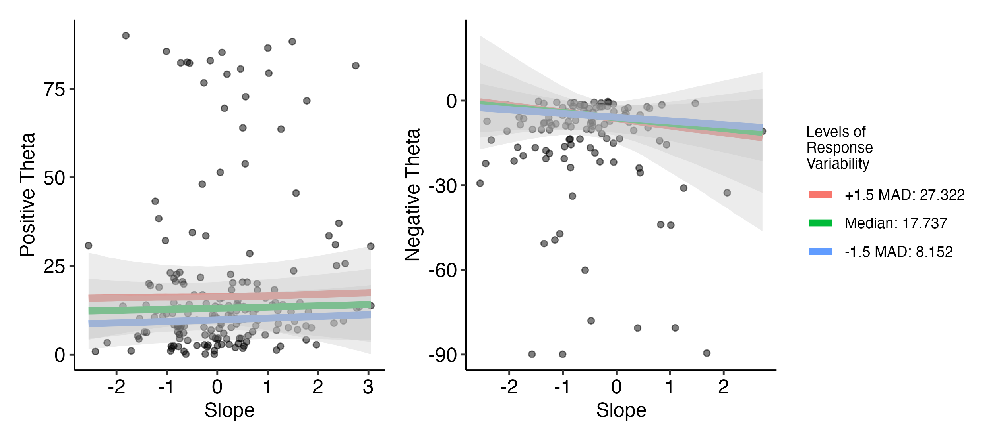
Figure 14: Conditional effects of VAS slope on positive and negative values of theta at different levels of response variability. Response variability is binned into three levels of median response variability of the full dataset +/- 1.5 median absolute deviations (MAD).
Overall, these findings provided limited evidence that either VAS slope or response variability, independently, together, or in interaction with language, systematically predicts secondary cue use across distinct theta ranges. Nonetheless, the patterns observed in the exploratory plots point to potential differences in how categorization gradiency, as captured by slope and response variability from VAS data, may relate to secondary cue use in L1 vs. L2. These trends, though tentative, suggest avenues for further investigation in future work.

Discussion
In this study, I examined the impact of experiential linguistic diversity, measured with two indices of Active and Passive Multilingual Language Diversity, on speech categorization gradiency and secondary cue integration for L1 and L2 speech contrasts, as measured by VAS responses to synthesized two-dimensional continua of English and Japanese minimal pairs. I had hypothesized that more experience with linguistic diversity, whether than be through being multilingual or exposing oneself to multiple languages despite being functionally monolingual, would predict more gradient response patterns for L1 and L2 speech, as well as higher degrees of secondary cue integration, representing perceptual flexibility.
The results from the Bayesian mixed-effects models mostly yielded non-robust findings of effects, especially with regards to my hypotheses. However, several trends emerged that will be discussed with caution.

The effect of experiential linguistic diversity on gradiency, response variability, and secondary cue use
In the first part of RQ1, I asked, is experiential linguistic diversity predictive of gradient categorization patterns in L1 and L2? While most findings did not support my hypotheses, several trends of interest were found. The findings from the multivariate mixed effects model that were best supported by the data were the interactions between the MLD scores and contrast language for VAS slope. There was weak evidence that higher MLD-A scores predicted shallower VAS slopes for Japanese contrasts compared to English, while there was moderate evidence that higher MLD-P scores predicted steeper VAS slopes for Japanese contrasts compared to English. The opposite direction of these trends for MLD-A and MLD-P offer potentially interesting implications for what constructs MLD-A, MLD-P, and VAS slope represent.
As suggested by prior literature, slopes from VAS responses are best analyzed in conjunction with response variability (Apfelbaum et al. 2022; Kutlu, Chiu, and McMurray 2022) when characterizing gradient vs. categorical response patterns. In this study, VAS slope and VAS response variability were not able integrated as a single predictor, as it was in Kutlu et al. (2024). However, the trends of the predictor impacts on VAS slope are still worth examining in light of prior literature that have suggested that gradiency as measured by VAS slope and gradiency as measured by response variability are actually measuring two different constructs. Several studies have found evidence that VAS slopes conceptually measure the perceptual ability to track gradual changes along a continuum, thus sensitivity to within-category differences, whereas response variability (also called response consistency in these studies) conceptually measures the degree of reliability in mapping stimulus characteristics to phonemic categories Fuhrmeister et al. (2023).
The findings with relation to MLD-A and MLD-P offer interesting insight into gradient sensitivity to acoustic cues, especially with regards to L1 vs. non-L1 speech perception. The finding that MLD-A predicted shallower slopes for Japanese compared to English lends mild support to the idea that those who actively use and are exposed to multiple languages may be primed for perceptual sensitivity to gradual changes along acoustic dimensions. This priming would become most evident in unfamiliar linguistic contexts, where the listeners may not have the explicit categories to guide consistent categorization, and thus rely more on the acoustics to make a categorization judgement rather than integrating orthographic or semantic input. The VAS is advantageous in presenting the same orthographic input a listener would receive for a 2AFC categorization task (i.e. seeing the phoneme categories in words on screen), while allowing those who do track within-category differences to report these differences. This is consistent with [cite paper].
On the other hand, the finding that MLD-P predicted steeper VAS slopes for Japanese compared to English is an interesting contrast to the above finding. The conceptualization that VAS slopes reflect gradiency as within-category acoustic sensitivity would imply that those with passive use of and exposure to multiple languages show decreased sensitivity to within-category differences. It is conceptually difficult to theorize the mechanisms that would lead to this outcome. However, the number of individuals at the higher end of MLD-P scores was quite low, meaning that it is possible that this trend was driven by a few individuals with higher MLD-P scores; although this finding was statistically robust, it must be interpreted with caution.
The findings did not support the hypotheses that experiential linguistic diversity predicted response variability, though the trends that emerged could suggest some potential associations that trended in different directions between MLD-A and MLD-P. Additionally, while there were no robust effects of MLD-A and MLD-P on the full range of theta. The post-hoc analyses also revealed no strong evidence of the effects of MLD-A and MLD-P on secondary cue use when the theta values were divided into positive and negative ranges. However, here too, a slight trend was seen in the visualization of the data that could suggest opposing associations with (positive ranges) of theta between MLD-A and MLD-P. Though mostly based on visual inspection of the data and not statistically supported, the fact that MLD-A and MLD-P had opposing, rather than matching, trends for VAS slope, response variability, and secondary cue use in the expected direction of categorization may suggest that MLD-A and MLD-P represent wholly different constructs. Language entropy has been used in previous research to predict [insert perceptual construct, one of the Guillifer papers], the measure has not been used before to measure degree of passive language use and exposure. It may be worth exploring what kind of perceptual construct may be represented by an index that quantifies degree of passive linguistic diversity and what implications this kind of exposure means for speech perception [go back to Bice & Kroll papers and add something here about that]. A limitation to this analysis was that an interaction effect between MLD-A and MLD-P was not included in the statistical models, which may have been able to elucidate differential effects of one MLD score at different levels of the other.
Nonetheless, these trends were not statistically supported by these data and serve as potential avenues of follow-up research. Yet, given the zero-inflation of the distributions of both MLD-A and MLD-P scores, it is advisable to view most, if not all, of these findings with skeptism. It is entirely possible that these trends themselves are spurious and driven by the few data points at higher values of MLD-A and MLD-P rather than reflecting a group-level trend. Given the limited number of individuals who had non-zero MLD scores, it is likely that these data simply did not have enough statistical power to detect any effects.

The effects of gradiency and response variability on secondary cue use
Based on previous work Kim, Clayards, and Kong (2020), I had hypothesized a strong effect of gradiency and response variability on secondary cue use suggesting that higher degrees of gradiency and lower degrees of response variability predicted secondary cue use. While an effect of response variability was found for positive values of theta, the effect suggested that secondary cue integration increased as response variability increased. Additionally, and more surprisingly, VAS slope, nor any interactions included in the model, did not show any statistically robust effects on secondary cue use. The lack of findings for the negative values of theta were also surprising, given that one could conceptually conceive that negative theta values representing reversed categorization would suggest noisy categorization that could be captured from the slope and response variability measures.
This outcome that contradicts the well established evidence from previous findings may have occurred for a number of reasons. Most notably, past research has used a different measure of secondary cue use. Kong and Edwards (2016) used anticipatory eye movement (AEM) as measure of secondary cue use, whereas, Kim, Clayards, and Kong (2020), Kapnoula et al. (2017), and Kapnoula and McMurray (2021) additionally used the 2AFC task with two-dimensional continua to extract a measure of secondary cue use. While the latter three studies all used the rotated logistic function to fit the VAS data and extract a measure of slope and secondary cue use, as the theta estimate from the curve fit, none of these studies used the theta values themselves in their subsequent analysis investigating the relationship between gradiency and secondary cue use. The exclusive use of the VAS task and theta as the only measure of secondary cue use in this study may be the prime contributing factor to these null findings. This may suggest that while theta can mathematically be conceived as measuring secondary cue use, it may possibly conceptually be a measure of a separate construct.

Individual differences in categorization patterns within and across languages
The contrast pairs were collapsed within language for the primary analyses, yet it is notable that there were still a number of individuals who displayed different categorization patterns between contrast pairs within same language. This finding supports that of Kapnoula, Edwards, and McMurray (2021), who found that gradiency in perceiving voicing contrasts (/b/ vs. /p/) did not predict gradiency in perceiving place of articulation fricative contrasts (/s/ vs. /ʃ/). Although I did not run specific analyses to quantify the degree of correlation between within-language contrasts, the group-level characterization of categorization patterns for each contrast pair presented in Table 4 and Figure 6 illustrated the variability of categorization both between- and within-language. This demonstrates gradiency and secondary cue use is not an individual-specific construct, but instead depends on both the individual and the phonemes themselves.
[I’d like to say more about individual differences]
This study contributes to the growing body of literature that investigates the sources of individual differences in speech categorization patterns. Although linguistic diversity, as measured by language entropy through the MLD indices, was not found to contribute to individual differences in categorization gradiency, there was still evidently diversity in the categorization strategies. As such, the search will continue to identify sources of individual differences.

Limitations
The stats I chose to use, the way I measured all of these constructs, especially linguistic diversity, the questionnaire, and also the limited pool of multilinguals. [though since some of this was discussed above, may not need this section, and could expound on limitations more in the general discussion]
References
Anwyl-Irvine, Alexander L., Jessica Massonnié, Adam Flitton, Natasha Kirkham, and Jo K. Evershed. 2020. “Gorilla in Our Midst: An Online Behavioral Experiment Builder.” Behavior Research Methods 52 (1): 388–407. https://doi.org/10.3758/s13428-019-01237-x.
Apfelbaum, Keith S., Ethan Kutlu, Bob McMurray, and Efthymia C. Kapnoula. 2022. “Don’t Force It! Gradient Speech Categorization Calls for Continuous Categorization Tasks.” The Journal of the Acoustical Society of America 152 (6): 3728–45. https://doi.org/10.1121/10.0015201.
Berg, Floor van den, Jelle Brouwer, Thomas B. Tienkamp, Josje Verhagen, and Merel Keijzer. 2022. “Language Entropy Relates to Behavioral and Pupil Indices of Executive Control in Young Adult Bilinguals.” Frontiers in Psychology 13 (May). https://doi.org/10.3389/fpsyg.2022.864763.
Boersma, Paul, and David Weenink. 2024. “Praat: Doing Phonetics by Computer.” www.praat.org.
Brown, Bianca, Botagoz Tusmagambet, Valentino Rahming, Chun-Ying Tu, Michael B. DeSalvo, and Seth Wiener. 2023. “Searching for the “Native” Speaker: A Preregistered Conceptual Replication and Extension of Reid, Trofimovich, and O’Brien (2019).” Applied Psycholinguistics 44 (4): 475–94. https://doi.org/10.1017/S0142716423000127.
Bruin, Angela de. 2019. “Not All Bilinguals Are the Same: A Call for More Detailed Assessments and Descriptions of Bilingual Experiences.” Behavioral Sciences 9 (3): 33. https://doi.org/10.3390/bs9030033.
Bürkner, Paul-Christian. 2017. “Brms: An R Package for Bayesian Multilevel Models Using Stan.” Journal of Statistical Software 80 (August): 1–28. https://doi.org/10.18637/jss.v080.i01.
Castro, Sofía, Zofia Wodniecka, and Kalinka Timmer. 2022. “Am I Truly Monolingual? Exploring Foreign Language Experiences in Monolinguals.” Edited by Simone Sulpizio. PLOS ONE 17 (3): Article e0265563. https://doi.org/10.1371/journal.pone.0265563.
DeLuca, Vincent, Jason Rothman, Ellen Bialystok, and Christos Pliatsikas. 2019. “Redefining Bilingualism as a Spectrum of Experiences That Differentially Affects Brain Structure and Function.” Proceedings of the National Academy of Sciences 116 (15): 7565–74. https://doi.org/10.1073/pnas.1811513116.
Fuhrmeister, Pamela, and Emily B. Myers. 2021. “Structural Neural Correlates of Individual Differences in Categorical Perception.” Brain and Language 215 (April): 104919. https://doi.org/10.1016/j.bandl.2021.104919.
Fuhrmeister, Pamela, Matthew C. Phillips, D. Betsy McCoach, and Emily B. Myers. 2023. “Relationships Between Native and Non-Native Speech Perception.” Journal of Experimental Psychology: Learning, Memory, and Cognition 49 (7): 1161–75. https://doi.org/10.1037/xlm0001213.
Gelman, Andrew, Ben Goodrich, Jonah Gabry, and Aki Vehtari. 2019. “R-Squared for Bayesian Regression Models.” The American Statistician 73 (3): 307–9. https://doi.org/10.1080/00031305.2018.1549100.
Gullifer, Jason W., Xiaoqian J. Chai, Veronica Whitford, Irina Pivneva, Shari Baum, Denise Klein, and Debra Titone. 2018. “Bilingual Experience and Resting-State Brain Connectivity: Impacts of L2 Age of Acquisition and Social Diversity of Language Use on Control Networks.” Neuropsychologia 117 (August): 123–34. https://doi.org/10.1016/j.neuropsychologia.2018.04.037.
Gullifer, Jason W., Shanna Kousaie, Annie C. Gilbert, Angela Grant, Nathalie Giroud, Kristina Coulter, Denise Klein, Shari Baum, Natalie Phillips, and Debra Titone. 2021. “Bilingual Language Experience as a Multidimensional Spectrum: Associations with Objective and Subjective Language Proficiency.” Applied Psycholinguistics 42 (2): 245–78. https://doi.org/10.1017/S0142716420000521.
Gullifer, Jason W., and Debra Titone. 2020. “Characterizing the Social Diversity of Bilingualism Using Language Entropy.” Bilingualism: Language and Cognition 23 (2): 283–94. https://doi.org/10.1017/S1366728919000026.
Hickendorff, Marian, Peter A. Edelsbrunner, Jake McMullen, Michael Schneider, and Kelly Trezise. 2018. “Informative Tools for Characterizing Individual Differences in Learning: Latent Class, Latent Profile, and Latent Transition Analysis.” Learning and Individual Differences 66 (August): 4–15. https://doi.org/10.1016/j.lindif.2017.11.001.
Honda, Claire T., Meghan Clayards, and Shari R. Baum. 2024. “Exploring Individual Differences in Native Phonetic Perception and Their Link to Nonnative Phonetic Perception.” Journal of Experimental Psychology: Human Perception and Performance 50 (4): 370–94. https://doi.org/10.1037/xhp0001191.
Hui, Bronson. 2018. “Analyzing Processing Time Data in Applied Linguistics and Second Language Research: A Multivariate Mixed-Effects Approach.” Journal of Research Design and Statistics in Linguistics and Communication Science 5 (1-2): 189–207. https://doi.org/10.1558/jrds.39117.
Kałamała, Patrycja, Adam Chuderski, Jakub Szewczyk, Magdalena Senderecka, and Zofia Wodniecka. 2023. “Bilingualism Caught in a Net: A New Approach to Understanding the Complexity of Bilingual Experience.” Journal of Experimental Psychology: General 152 (1): 157–74. https://doi.org/10.1037/xge0001263.
Kałamała, Patrycja, Magdalena Senderecka, and Zofia Wodniecka. 2022. “On the Multidimensionality of Bilingualism and the Unique Role of Language Use.” Bilingualism: Language and Cognition 25 (3): 471–83. https://doi.org/10.1017/S1366728921001073.
Kapnoula, Efthymia C., Jan Edwards, and Bob McMurray. 2021. “Gradient Activation of Speech Categories Facilitates Listeners’ Recovery from Lexical Garden Paths, but Not Perception of Speech-in-Noise.” Journal of Experimental Psychology. Human Perception and Performance 47 (4): 578–95. https://doi.org/10.1037/xhp0000900.
Kapnoula, Efthymia C., and Bob McMurray. 2021. “Idiosyncratic Use of Bottom-up and Top-down Information Leads to Differences in Speech Perception Flexibility: Converging Evidence from ERPs and Eye-Tracking.” Brain and Language 223 (December): 105031. https://doi.org/10.1016/j.bandl.2021.105031.
Kapnoula, Efthymia C., and Arthur G. Samuel. 2024. “Sensitivity to Subphonemic Differences in First Language Predicts Vocabulary Size in a Foreign Language.” Language Learning 74 (4): 950–84. https://doi.org/https://doi.org/10.1111/lang.12650.
Kapnoula, Efthymia C., Matthew B. Winn, Eun Jong Kong, Jan Edwards, and Bob McMurray. 2017. “Evaluating the Sources and Functions of Gradiency in Phoneme Categorization: An Individual Differences Approach.” Journal of Experimental Psychology. Human Perception and Performance 43 (9): 1594–1611. https://doi.org/10.1037/xhp0000410.
Kepinska, Olga, Jocelyn Caballero, Myriam Oliver, Rebecca A. Marks, Stephanie L. Haft, Leo Zekelman, Ioulia Kovelman, Yuuko Uchikoshi, and Fumiko Hoeft. 2023. “Language Combinations of Multilinguals Are Reflected in Their First-Language Knowledge and Processing.” Scientific Reports 13 (1): 1947. https://doi.org/10.1038/s41598-023-27952-2.
Kim, Donghyun, Meghan Clayards, and Eun Jong Kong. 2020. “Individual Differences in Perceptual Adaptation to Unfamiliar Phonetic Categories.” Journal of Phonetics 81 (July): 100984. https://doi.org/10.1016/j.wocn.2020.100984.
Kong, Eun Jong, and Jan Edwards. 2016. “Individual Differences in Categorical Perception of Speech: Cue Weighting and Executive Function.” Journal of Phonetics 59 (November): 40–57. https://doi.org/10.1016/j.wocn.2016.08.006.
Kong, Eun Jong, and Soyoung Kang. 2023. “Individual Differences in Categorical Judgment of L2 Stops: A Link to Proficiency and Acoustic Cue-Weighting.” Language and Speech 66 (2): 354–80. https://doi.org/10.1177/00238309221108647.
Kremin, Lena V., and Krista Byers-Heinlein. 2021. “Why Not Both? Rethinking Categorical and Continuous Approaches to Bilingualism.” International Journal of Bilingualism 25 (6): 1560–75. https://doi.org/10.1177/13670069211031986.
Kutlu, Ethan, Keith S. Apfelbaum, Eldon Sorensen, Jacob Oleson, and Bob McMurray. 2024. “Social Network Diversity Leads to More Flexible Speech Perception in School-Aged Children.” OSF. https://doi.org/10.31234/osf.io/c9u4y.
Kutlu, Ethan, Samantha Chiu, and Bob McMurray. 2022. “Moving Away from Deficiency Models: Gradiency in Bilingual Speech Categorization.” Frontiers in Psychology 13. https://www.frontiersin.org/articles/10.3389/fpsyg.2022.1033825.
Li, Ping, Fan Zhang, Anya Yu, and Xiaowei Zhao. 2020. “Language History Questionnaire (LHQ3): An Enhanced Tool for Assessing Multilingual Experience.” Bilingualism: Language and Cognition 23 (5): 938–44. https://doi.org/10.1017/S1366728918001153.
Li, Xiaoqian, Kwun Kei Ng, Joey Ju Yu Wong, Jia Wen Lee, Juan Helen Zhou, and W. Quin Yow. 2021. “Bilingual Language Entropy Influences Executive Functions Through Functional Connectivity and Signal Variability.” Brain and Language 222 (November): 105026. https://doi.org/10.1016/j.bandl.2021.105026.
Luk, Gigi. 2015. “Who Are the Bilinguals (and Monolinguals)?” Bilingualism: Language and Cognition 18 (1): 35–36. https://doi.org/10.1017/S1366728914000625.
Luk, Gigi, and Ellen Bialystok. 2013. “Bilingualism Is Not a Categorical Variable: Interaction Between Language Proficiency and Usage.” Journal of Cognitive Psychology 25 (5): 605–21. https://doi.org/10.1080/20445911.2013.795574.
Makowski, Dominique, Mattan S. Ben-Shachar, S. H. Annabel Chen, and Daniel Lüdecke. 2019. “Indices of Effect Existence and Significance in the Bayesian Framework.” Frontiers in Psychology 10 (December). https://doi.org/10.3389/fpsyg.2019.02767.
Makowski, Dominique, Mattan S. Ben-Shachar, and Daniel Lüdecke. 2019. “bayestestR: Describing Effects and Their Uncertainty, Existence and Significance Within the Bayesian Framework.” Journal of Open Source Software 4 (40): 1541. https://doi.org/10.21105/joss.01541.
Marian, Viorica, Henrike K. Blumenfeld, and Margarita Kaushanskaya. 2007. “The Language Experience and Proficiency Questionnaire (LEAP-Q): Assessing Language Profiles in Bilinguals and Multilinguals.” Journal of Speech, Language, and Hearing Research 50 (4): 940–67. https://doi.org/10.1044/1092-4388(2007/067).
Marian, Viorica, and Sayuri Hayakawa. 2021. “Measuring Bilingualism: The Quest for a “Bilingualism Quotient”.” Applied Psycholinguistics 42 (2): 527–48. https://doi.org/10.1017/S0142716420000533.
McMurray, Bob. 2017. “Nonlinear Curvefitting for Psycholinguistic (and Other) Data.” MATLAB. OSF. https://osf.io/4atgv/.
Milne, Alice E., Roberta Bianco, Katarina C. Poole, Sijia Zhao, Andrew J. Oxenham, Alexander J. Billig, and Maria Chait. 2021. “An Online Headphone Screening Test Based on Dichotic Pitch.” Behavior Research Methods 53 (4): 1551–62. https://doi.org/10.3758/s13428-020-01514-0.
Paul-Dauphin, Agnès, Francis Guillemin, Jean-Marc Virion, and Serge Briançon. 1999. “Bias and Precision in Visual Analogue Scales: A Randomized Controlled Trial.” American Journal of Epidemiology 150 (10): 1117–27. https://doi.org/10.1093/oxfordjournals.aje.a009937.
Shannon, C. E. 1948. “A Mathematical Theory of Communication.” The Bell System Technical Journal 27 (3): 379–423. https://doi.org/10.1002/j.1538-7305.1948.tb01338.x.
Sorensen, Eldon, Jacob Oleson, Ethan Kutlu, and Bob McMurray. 2024. “A Bayesian Hierarchical Model for the Analysis of Visual Analogue Scaling Tasks.” Statistical Methods in Medical Research, April, 09622802241242319. https://doi.org/10.1177/09622802241242319.
Sulpizio, Simone, Nicola Del Maschio, Gianpaolo Del Mauro, Davide Fedeli, and Jubin Abutalebi. 2020. “Bilingualism as a Gradient Measure Modulates Functional Connectivity of Language and Control Networks.” NeuroImage 205 (January): 116306. https://doi.org/10.1016/j.neuroimage.2019.116306.
Surrain, Sarah, and Gigi Luk. 2019. “Describing Bilinguals: A Systematic Review of Labels and Descriptions Used in the Literature Between 2005–2015.” Bilingualism: Language and Cognition 22 (2): 401–15. https://doi.org/10.1017/S1366728917000682.
Titone, Debra A., and Mehrgol Tiv. 2023. “Rethinking Multilingual Experience Through a Systems Framework of Bilingualism.” Bilingualism: Language and Cognition 26 (1): 1–16. https://doi.org/10.1017/S1366728921001127.
Wagner, Danika, Katerina Bekas, and Ellen Bialystok. 2023. “Does Language Entropy Shape Cognitive Performance? A Tale of Two Cities.” Bilingualism: Language and Cognition 26 (5): 998–1008. https://doi.org/10.1017/S1366728923000202.
Yow, W. Quin, and Xiaoqian Li. 2015. “Balanced bilingualism and early age of second language acquisition as the underlying mechanisms of a bilingual executive control advantage: why variations in bilingual experiences matter.” Frontiers in Psychology 6 (February). https://doi.org/10.3389/fpsyg.2015.00164.

Details of the data cleaning process, including explanations for why certain responses were unusable, are presented in the questionnaire cleaning R code in the supplementary materials.
Note the use of median instead of mean for the b estimate, which is a more robust measure of centrality of the posterior probability distribution compared to mean, especially for skewed distributions.
Although only 76 participants were used in the analyses for this study, all 100 participants performed the VAS as expected. The cleaned data for all 100 participants were fit by the curve fitter program, resulting in VAS estimates for all pairs for all participants. A table of the descriptive statistics that includes all 100 participants, as well as figures including all 100 participants, can be found in the Appendix/supplementary material to display the full range of VAS responses.
The conditional effect of MLD-A on predicting VAS slope for Japanese is computed by summing the estimate of the main effect of MLD-A (which is for the language reference level of English) and the estimate of the interaction effect: 0.13 + -0.29 = -0.16.

