Báo cáo thực hành

Họ và tên: Vương Chí Sơn

MSSV: 20156407

Lớp: CN CNTT 3 – K60

# Bài 1.4

## 1.

**import** javax.swing.JOptionPane;

**public** **class** **HelloNameDialog** {

**public** **static** **void** **main**(**String**[] args) {

**System**.***out***.println("Vuong Chi Son\n20156407");

**String** **result**;

result = **JOptionPane**.*showInputDialog*("Hay nhap ten cua ban:");

**JOptionPane**.*showMessageDialog*(**null**, "Xin chao " + result + "!");

**System**.*exit*(0);

}

}

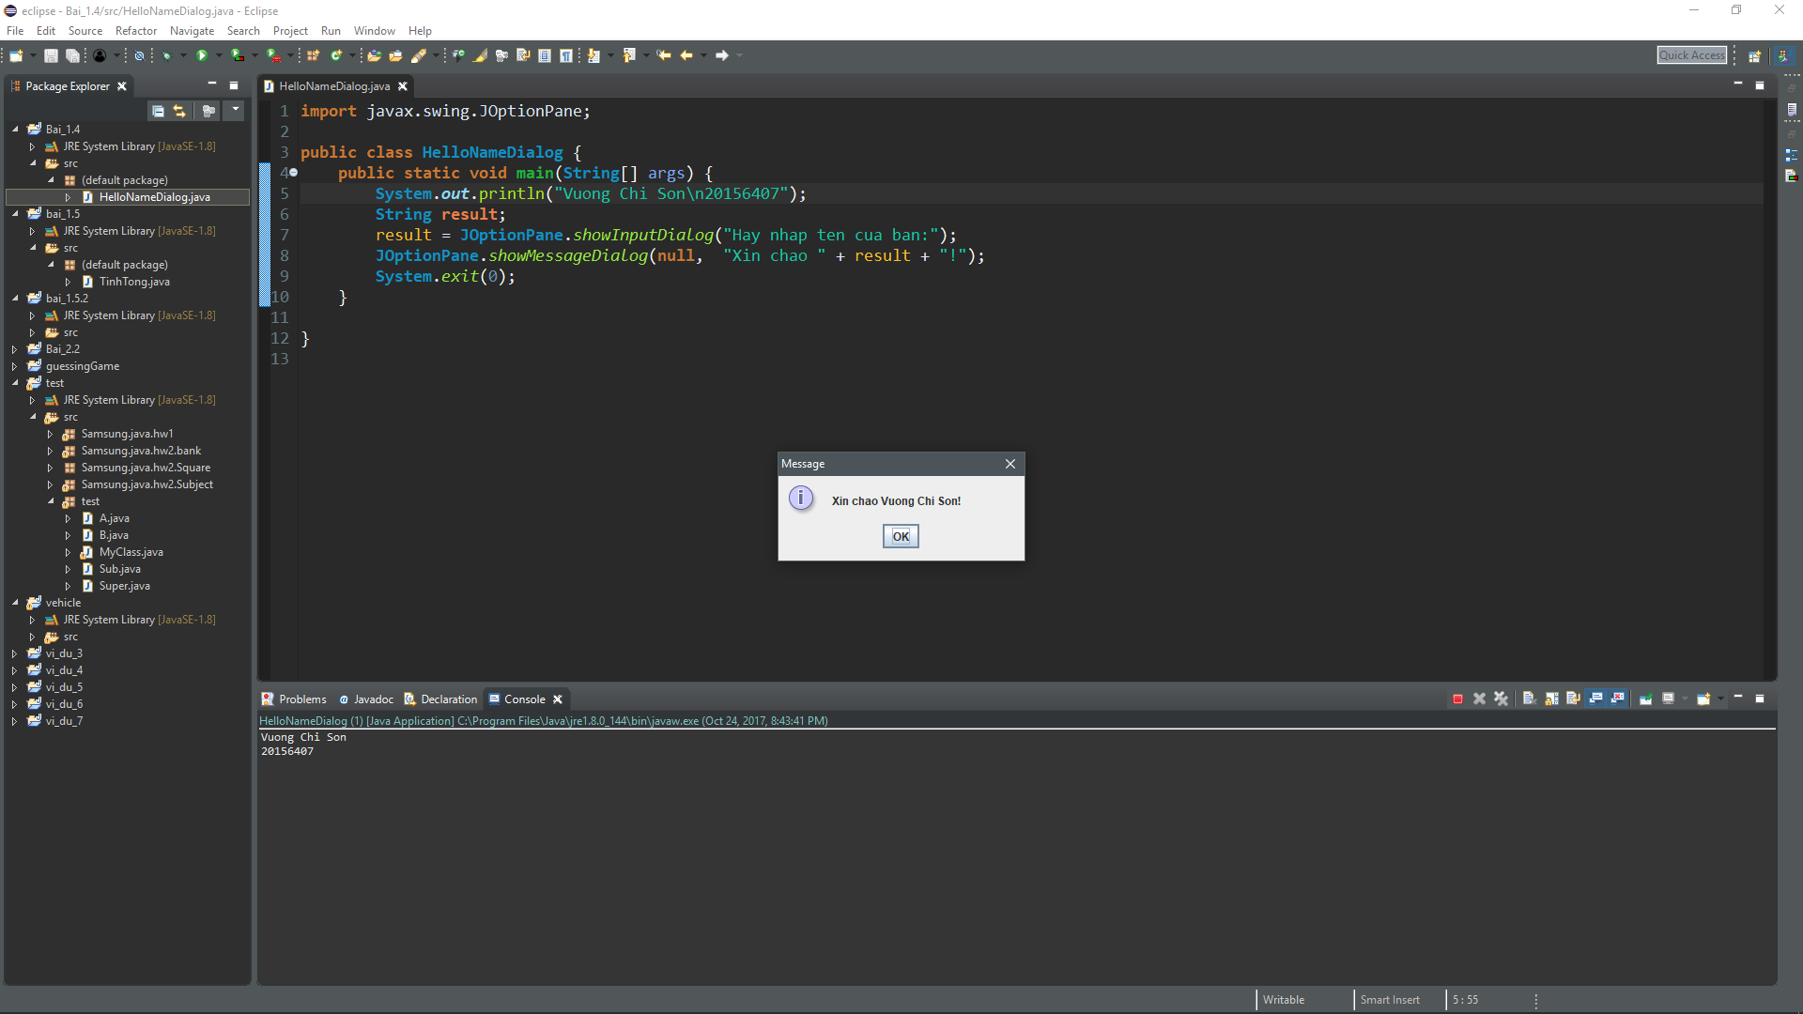

## 2.

**public** **class** **InTamGiac** {

**public** **static** **void** **main**(**String**[] args) {

**System**.***out***.println("Vuong Chi Son\n20156407");

**for**(**int** **i** = 0; i < 5; i++)

{

**for**(**int** **j** = 1; j <= 5-i; j++)

{

**System**.***out***.print(" ");

}

**for**(**int** **k** = 1; k <= 2*i + 1; k++)

{

**System**.***out***.print("*");

}

**System**.***out***.println();

}

}

}

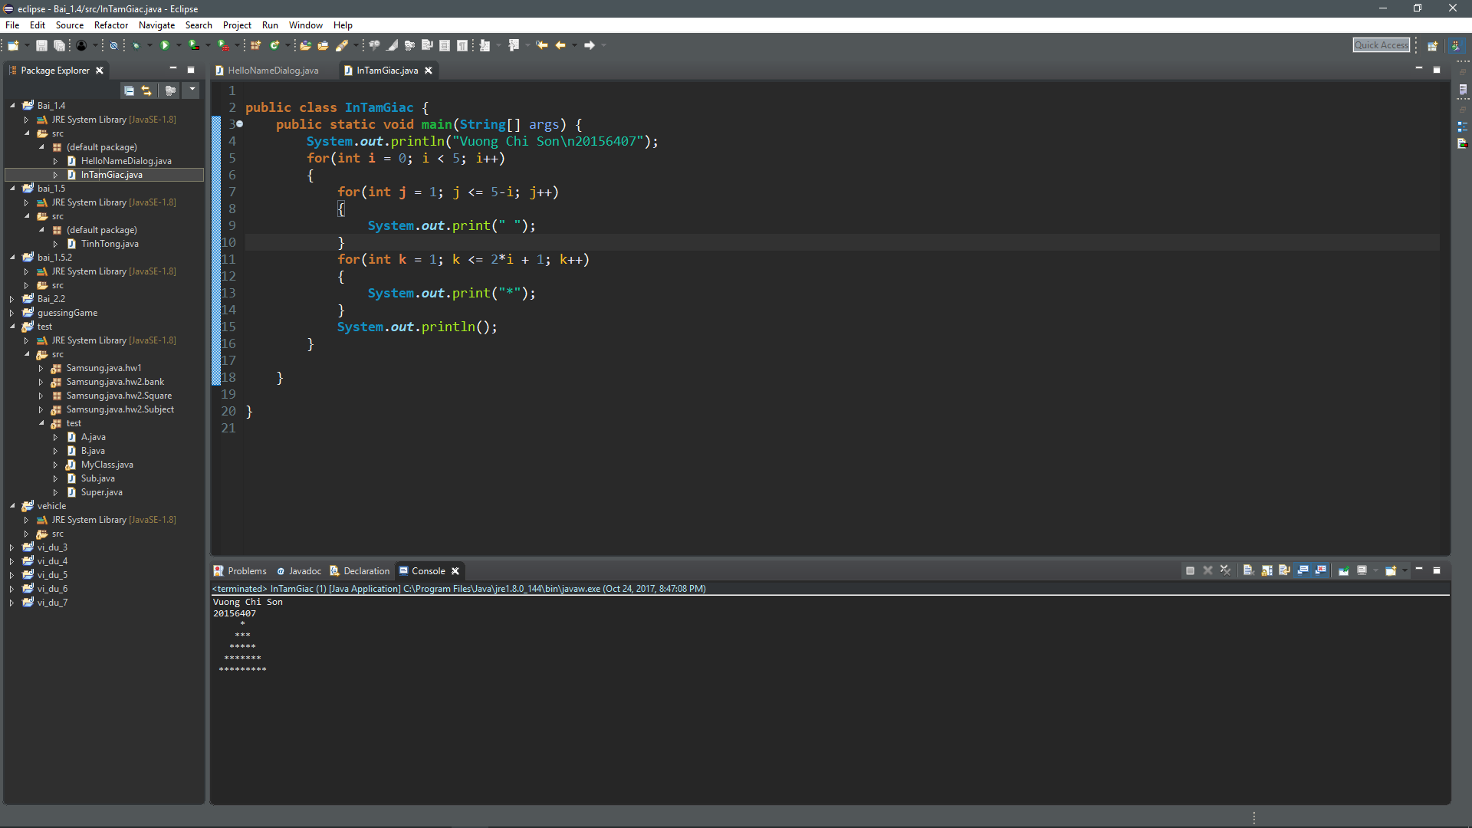

## 3.

**import** javax.swing.JOptionPane;

**public** **class** **HienThiHaiSo** {

**public** **static** **void** **main**(**String**[] args) {

**System**.***out***.println("Vuong Chi Son\n20156407");

**String** **strSo1**, **strSo2**;

**String** **strHienThi** = "Ban vua nhap ";

strSo1 = **JOptionPane**.*showInputDialog*(**null**, "Hay hap so thu 1:", "Nhap so thu nhat", **JOptionPane**.***INFORMATION_MESSAGE***);

strHienThi += strSo1 + " va ";

strSo2 = **JOptionPane**.*showInputDialog*(**null**, "Hay hap so thu 2:", "Nhap so thu hai", **JOptionPane**.***INFORMATION_MESSAGE***);

strHienThi += strSo2;

**JOptionPane**.*showMessageDialog*(**null**, strHienThi, "Hien thi hai so", **JOptionPane**.***INFORMATION_MESSAGE***);

**System**.*exit*(0);

}

}

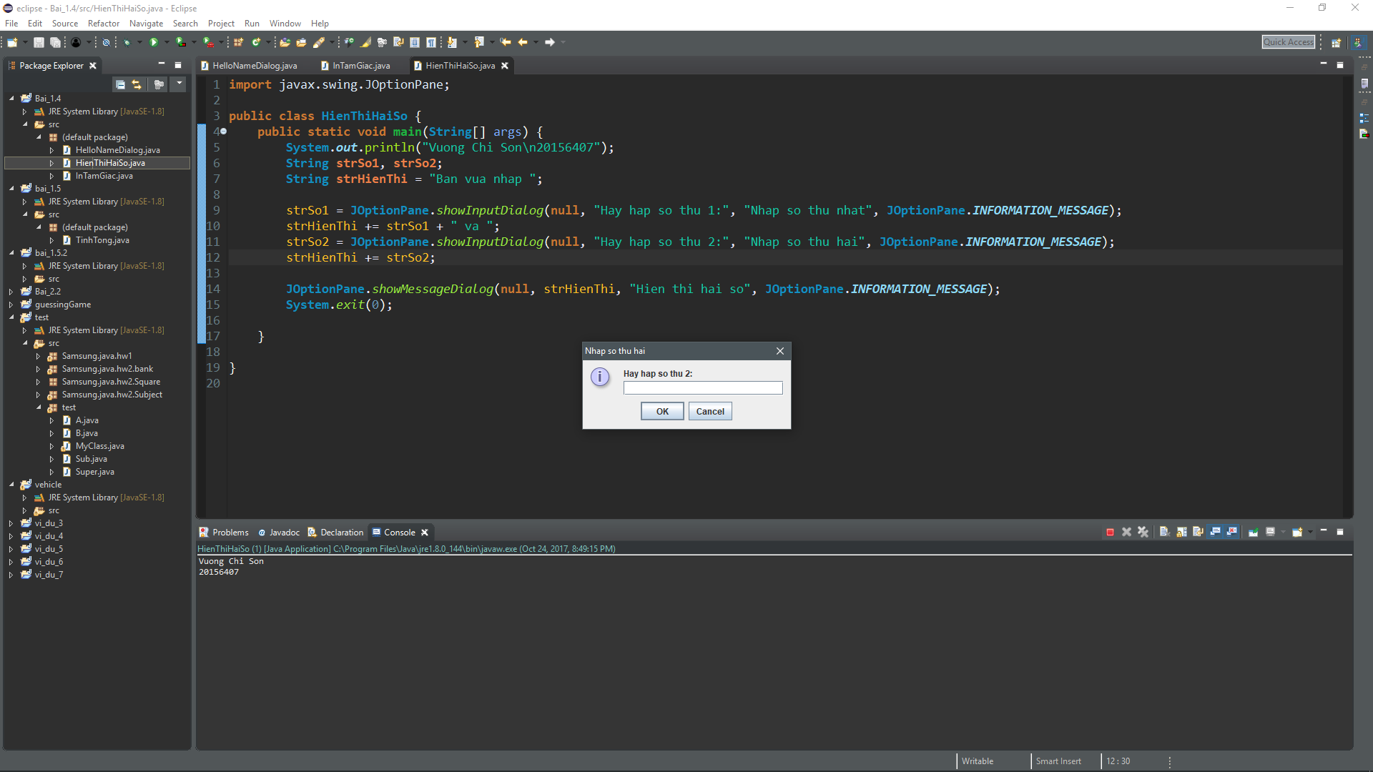

## 4.

**import** javax.swing.JOptionPane;

**public** **class** **HienThiTongHaiSo** {

**public** **static** **void** **main**(**String**[] args) {

**String** **strSo1**, **strSo2**;

**int** **so1**, **so2**;

strSo1 = **JOptionPane**.*showInputDialog*(**null**, "Hay hap so thu 1:", "Nhap so thu nhat", **JOptionPane**.***INFORMATION_MESSAGE***);

so1 = **Integer**.*parseInt*(strSo1);

strSo2 = **JOptionPane**.*showInputDialog*(**null**, "Hay hap so thu 2:", "Nhap so thu hai", **JOptionPane**.***INFORMATION_MESSAGE***);

so2 = **Integer**.*parseInt*(strSo2);

**JOptionPane**.*showMessageDialog*(**null**, "Tong hai so " + strSo1 + " va " + strSo2 + " la: " + (so1 + so2),

"Hien thi tong hai so", **JOptionPane**.***INFORMATION_MESSAGE***);

**System**.*exit*(0);

}

}

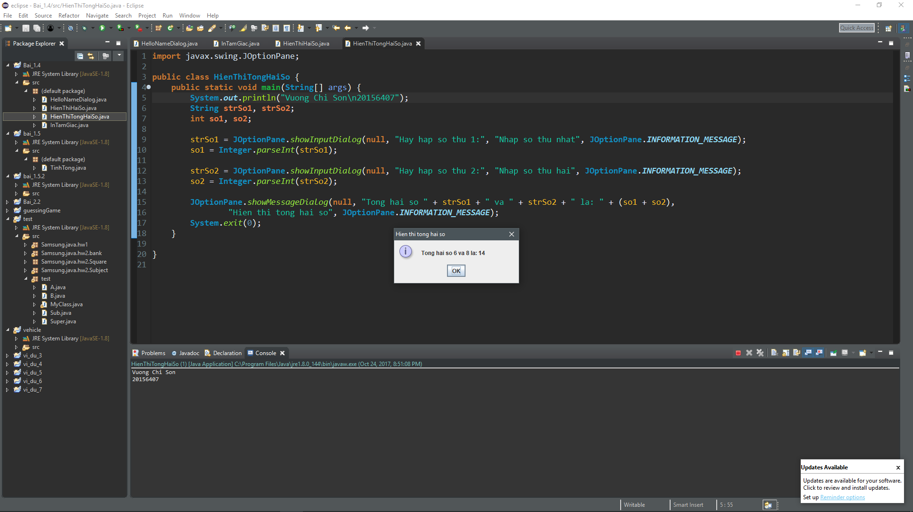

## 5.

**import** javax.swing.JOptionPane;

**public** **class** **LuaChon** {

**public** **static** **void** **main**(**String**[] args) {

**System**.***out***.println("Vuong Chi Son\n20156407");

**int** **iLuaChon**;

**String** **strLuaChon**;

iLuaChon = **JOptionPane**.*showConfirmDialog*(**null**, "Co loi xay ra. Co muon tiep tuc?", "Loi",

**JOptionPane**.***YES_OPTION***, **JOptionPane**.***ERROR_MESSAGE***);

**if**(iLuaChon == **JOptionPane**.***YES_OPTION***)

{

strLuaChon = "Co";

}

**else**

{

strLuaChon = "Khong";

}

**JOptionPane**.*showMessageDialog*(**null**, "Ban da chon " + strLuaChon);

**System**.*exit*(0);

}

}

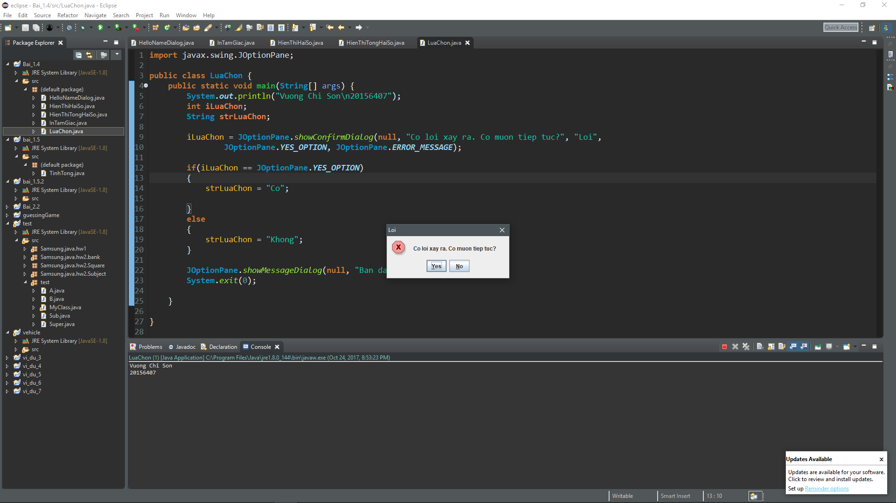

# Bài 1.5

## 1.

**import** javax.swing.JOptionPane;

**public** **class** **TinhTong** {

**public** **static** **void** **main**(**String**[] args) {

**double** **sum** = 0;

**int** **iLuaChon**;

**int** **count** = 0;

**String** **strSo**;

**do**

{

count ++;

strSo = **JOptionPane**.*showInputDialog*(**null**, "Hay nhap so thu " + count, "Tinh tong", **JOptionPane**.***INFORMATION_MESSAGE***);

sum += **Double**.*parseDouble*(strSo);

iLuaChon = **JOptionPane**.*showConfirmDialog*(**null**, "Ban co muon nhap tiep khong?");

}**while**(iLuaChon == **JOptionPane**.***YES_OPTION***);

**JOptionPane**.*showMessageDialog*(**null**, "Tong " + count + " so vua nhap la: " + sum);

**System**.*exit*(0);

}

}

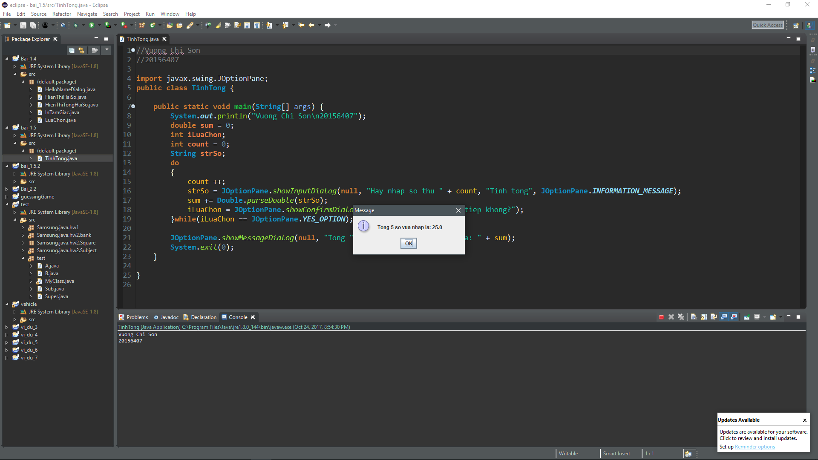

## 2.

**import** javax.swing.JOptionPane;

**public** **class** **SoNgay** {

**public** **static** **void** **main**(**String**[] args) {

**System**.***out***.println("Vuong Chi Son\n20156407");

**int** **month**, **year**, **numDay**, **iLuaChon**;

**do**

{

**do**

{

month = **Integer**.*parseInt*(**JOptionPane**.*showInputDialog*(**null**, "Nhap thang:"));

}

**while**(month < 1 || month > 12);

year = **Integer**.*parseInt*(**JOptionPane**.*showInputDialog*(**null**, "Nhap nam:"));

**switch**(month)

{

**case** 1:

**case** 3:

**case** 5:

**case** 7:

**case** 8:

**case** 10:

**case** 12:

numDay = 31;

**break**;

**case** 2:

**if** (year % 400 == 0 || (year % 4 == 0 && year % 100 != 0))

numDay = 29;

**else**

numDay = 28;

**break**;

**default**:

numDay = 30;

}

**JOptionPane**.*showMessageDialog*(**null**, "Thang " + month + " nam " + year + " co " + numDay + " ngay");

iLuaChon = **JOptionPane**.*showConfirmDialog*(**null**, "Ban co muon thu lai khong?", "Tinh tong", **JOptionPane**.***INFORMATION_MESSAGE***);

}

**while**(iLuaChon == **JOptionPane**.***YES_OPTION***);

**System**.*exit*(0);

}

}

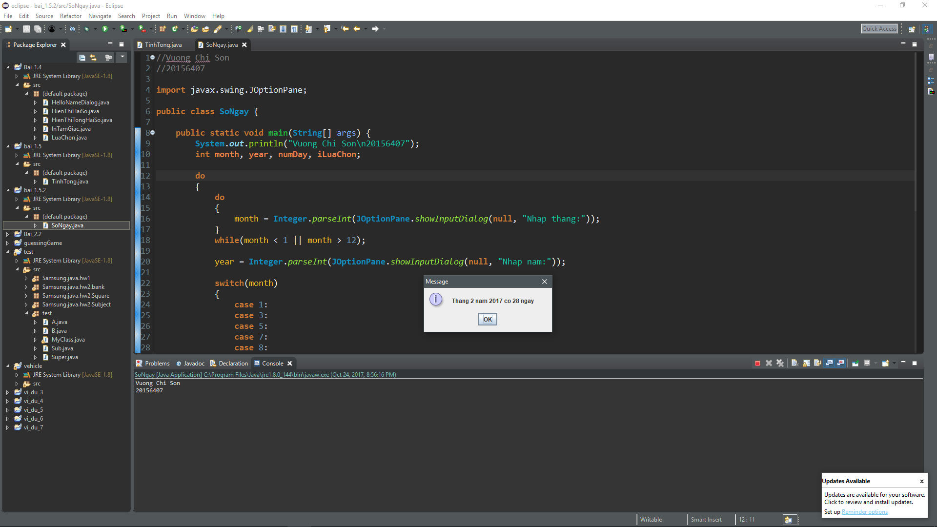

# Bài 2.1

**public** **class** **Account** {

**String** name;

**int** balance;

**void** **setData**(**String** pName, **int** pBalance)

{

name = pName;

balance = pBalance;

}

**void** **display**()

{

**System**.***out***.println("There is no argument. ");

**System**.***out***.print("Account name: " + name);

**System**.***out***.println("\tBalance: " + balance + " VND");

}

}

**public** **class** **AccountExample** {

**public** **static** **void** **main**(**String**[] args) {

**System**.***out***.println("Vuong Chi Son\n20156407");

**Account** **obj** = **new** Account();

obj.setData("Minh Nam", 100000);

obj.display();

}

}

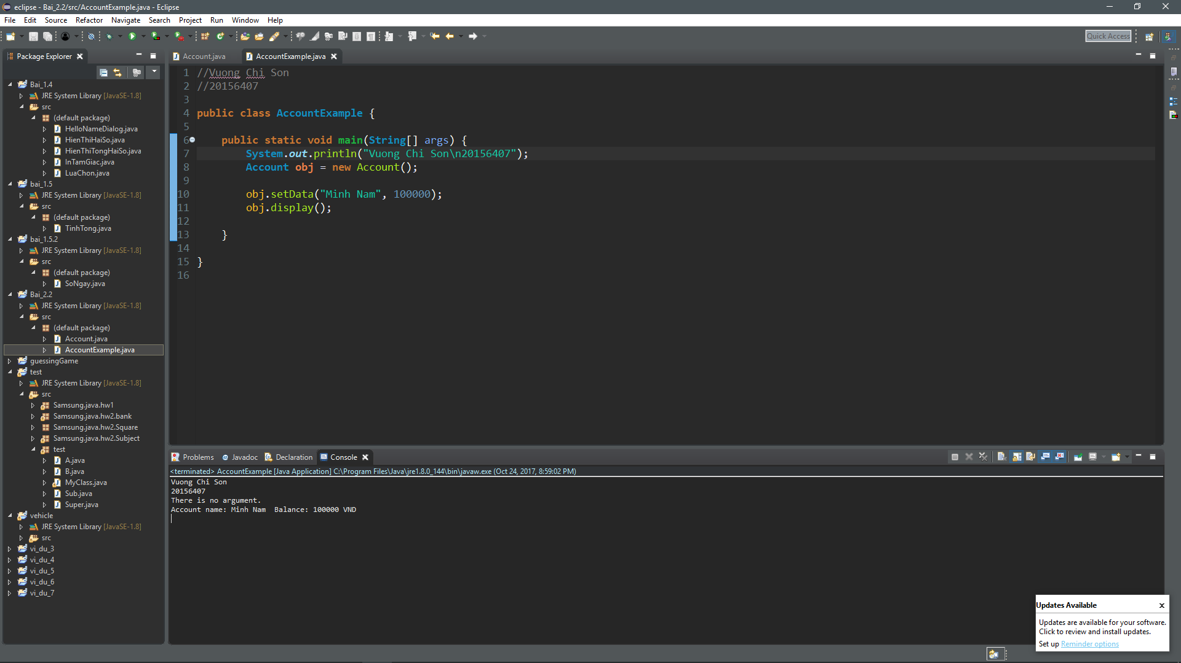

# Bài 2.2

**void** **deposit**(**long** money)

{

balance += money;

}

**boolean** **withdrawMoney**(**long** money)

{

**if**(balance >= money)

{

balance -= money;

**return** **true**;

}

**else**

**return** **false**;

}

# Bài 2.3

**public** **Account**()

{

name = "Unsigned";

balance = 0;

}

**public** **Account**(**String** pname, **int** pbalance) {

name = pname;

balance = pbalance;

}

# Bài 2.4

**public** **class** **Account** {

**private** **String** name;

**private** **int** balance;

**public** **Account**()

{

name = "Unsigned";

balance = 0;

}

**public** **Account**(**String** pname, **int** pbalance) {

name = pname;

balance = pbalance;

}

**public** **void** **setData**(**String** pName, **int** pBalance)

{

name = pName;

balance = pBalance;

}

**public** **String** **getName**()

{

**return** name;

}

**public** **int** **getBalance**()

{

**return** balance;

}

**public** **void** **display**()

{

**System**.***out***.println("There is no argument. ");

**System**.***out***.print("Account name: " + name);

**System**.***out***.println("\tBalance: " + balance + " VND");

}

**public** **void** **deposit**(**long** money)

{

balance += money;

}

**public** **boolean** **withdrawMoney**(**long** money)

{

**if**(balance >= money)

{

balance -= money;

**return** **true**;

}

**else**

**return** **false**;

}

}

# Bài 2.5

**public** **void** **display**(**String** currency)

{

**final double rateVNDtoGBP = 3.34133228E-5;**

**if (currency.equals("VND"))**

**this.display();**

**if (currency.endsWith("GBP"))**

**{**

**System.*out*.print("Account name: " + name);**

**System.*out*.println("\tBalance: " + balance * rateVNDtoGBP + " GBP");**

**}**

}

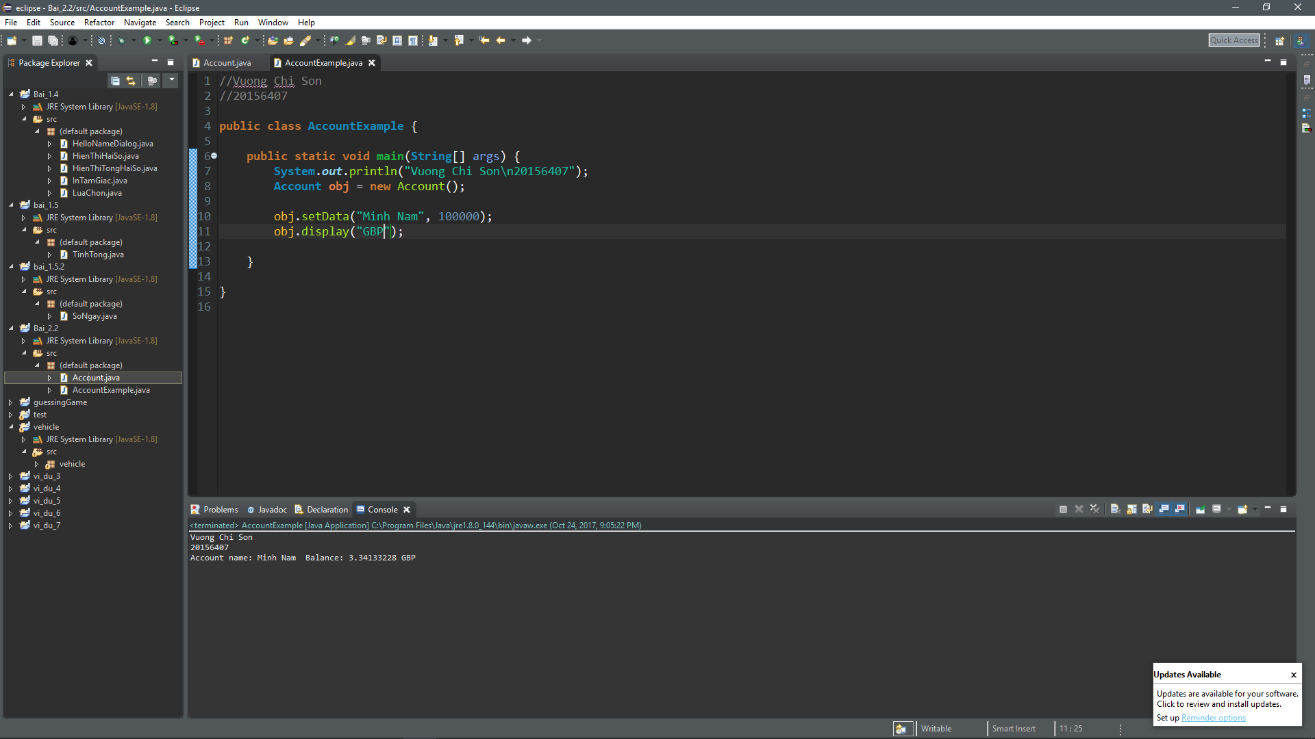

# Bài 2.6, 2.7

//Vuong Chi Son

//20156407

**package** vehicle;

**public** **class** **Vehicle** {

**private** **float** velocity;

**private** **float** turnSpeed;

**private** **float** x, y;

**private** **float** angle;

**private** **float** acceleration;

**private** **int** time;

**public** **Vehicle**() {

**this**.x = 0;

**this**.y = 0;

**this**.velocity = 0;

**this**.turnSpeed = 0;

**this**.angle = 0;

**this**.acceleration = 0;

**this**.time = 1;

}

**public** **Vehicle**(**float** velocity, **float** turnSpeed, **float** acceleration)

{

**this**.x = 0;

**this**.y = 0;

**this**.angle = 90;

**this**.velocity = velocity;

**this**.turnSpeed = turnSpeed;

**this**.acceleration = acceleration;

**this**.time = 1;

}

**public** **float** **getAcceleration**() {

**return** acceleration;

}

**public** **void** **setAcceleration**(**float** acceleration) {

**this**.acceleration = acceleration;

}

**public** **float** **getVelocity**() {

**return** velocity;

}

**public** **void** **setVelocity**(**float** velocity) {

**this**.velocity = velocity;

}

**public** **float** **getTurnSpeed**() {

**return** turnSpeed;

}

**public** **void** **setTurnSpeed**(**float** turnSpeed) {

**this**.turnSpeed = turnSpeed;

}

**public** **float** **getX**() {

**return** x;

}

**public** **void** **setX**(**float** x) {

**this**.x = x;

}

**public** **float** **getY**() {

**return** y;

}

**public** **void** **setY**(**float** y) {

**this**.y = y;

}

**public** **float** **getAngle**() {

**return** angle;

}

**public** **void** **setAngle**(**float** angle) {

**this**.angle = angle;

}

**public** **void** **ahead**(**double** distance) {

**float** **v0** = 0;

**if**(x == 0f && y == 0f)

**System**.***out***.println("Xe bat dau chuyen dong.");

**while** ( (v0 < velocity) && (distance > 0) )

{

**double** **t** = (v0 + acceleration / 2.0);

distance -= t;

x += (**float**) t * **Math**.*sin*(angle);

y += (**float**) t * **Math**.*cos*(angle);

v0 += acceleration;

display();

time++;

}

**if** (distance > 0)

{

x += (**float**) distance * **Math**.*sin*(angle);

y += (**float**) distance * **Math**.*cos*(angle);

display();

time++;

}

}

**public** **void** **turnLeft**(**double** degree) {

angle += degree;

**if**(x == 0 && y == 0)

{

**System**.***out***.printf("Giay %d:\nXe chua chuyen dong\nToa do: (%f, %f)\nGoc: %f do\n", time, x, y, angle);

time++;

**return**;

}

x += (**float**) turnSpeed * **Math**.*sin*(**Math**.*toRadians*(angle));

y += (**float**) turnSpeed * **Math**.*cos*(**Math**.*toRadians*(angle));

display();

}

**public** **void** **turnRight**(**double** degree)

{

angle -= degree;

**if**(x == 0 && y == 0)

{

**System**.***out***.printf("Giay %d:\nXe chua chuyen dong\nToa do: (%f, %f)\nGoc: %f do\n", time, x, y, angle);

time++;

**return**;

}

x += (**float**) turnSpeed * **Math**.*sin*(**Math**.*toRadians*(angle));

y += (**float**) turnSpeed * **Math**.*cos*(**Math**.*toRadians*(angle));

display();

}

**public** **void** **display**()

{

**System**.***out***.printf("Giay: %d\nToa do: (%f, %f)\nGoc: %f do\n", time, x, y, angle);

}

}

