Báo cáo thực hành buổi 2

# 3.3

//Vuong Chi Son

//2015607

**import** java.util.ArrayList;

**public** **class** **Bank** {

**private** **ArrayList**<Account> accounts;

**public** **Bank**()

{

accounts = **new** ArrayList<Account>();

}

**public** **void** **add**(**Account** acc)

{

accounts.add(acc);

}

**public** **void** **delete**(**Account** acc)

{

accounts.remove(acc);

}

**public** **void** **display**()

{

**if** (accounts.isEmpty())

**System**.***out***.println("Khong co tai khoan nao trong ngan hang");

**else**

**for**(**Account** **i** : accounts)

i.display();

}

**public** **long** **sum**()

{

**long** **sum** = 0;

**for**(**Account** **i** : accounts)

sum += i.getBalance();

**return** sum;

}

}

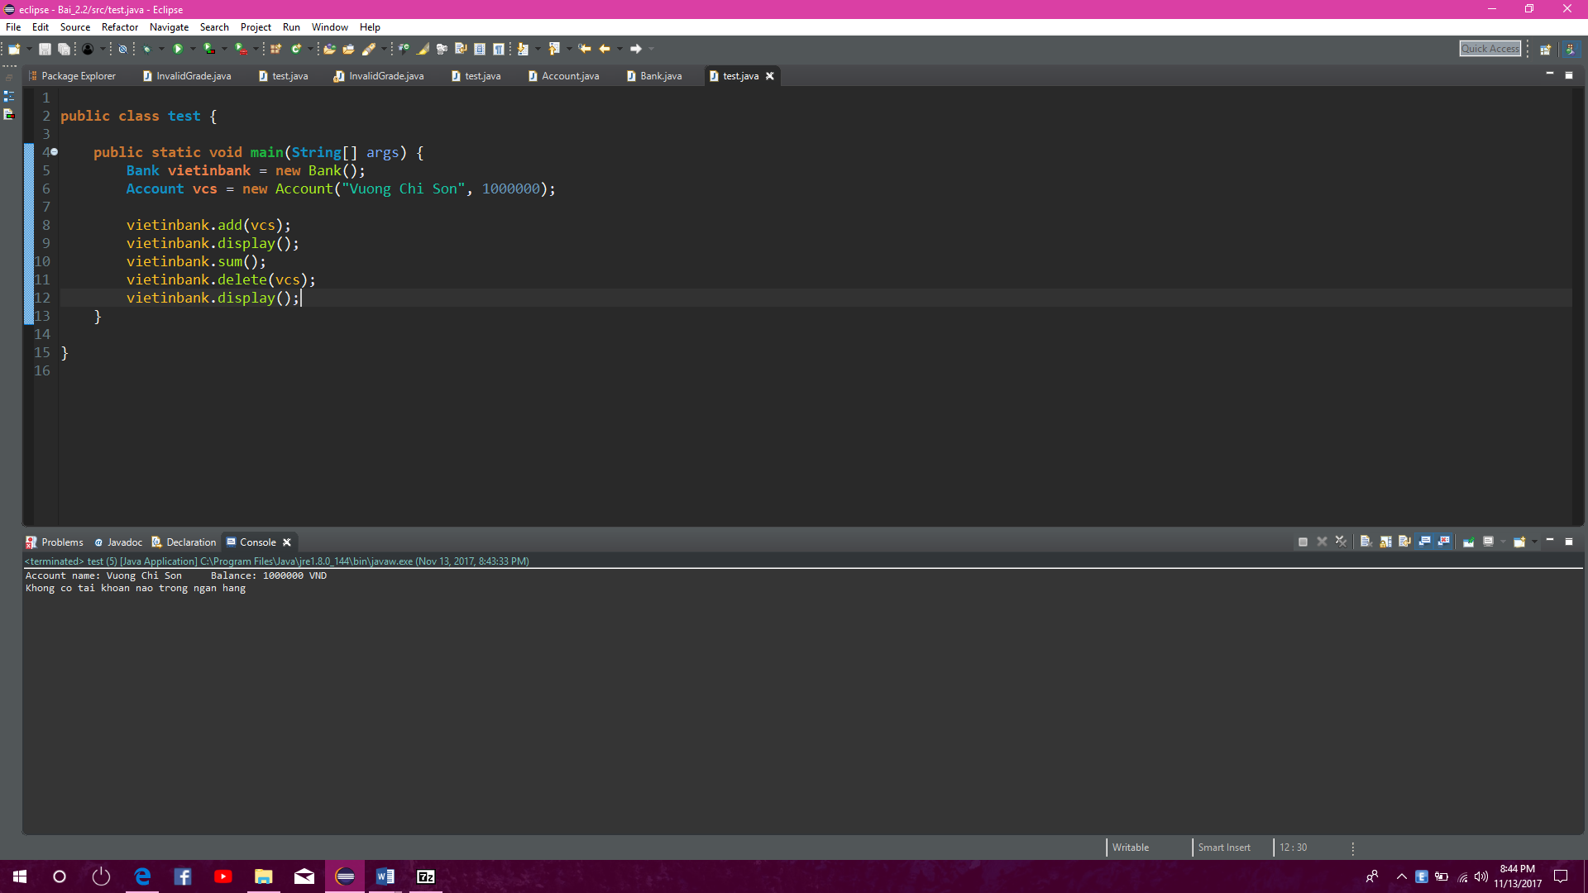

# 3.2

//Vuong Chi Son

//20156407

**import** java.util.Date;

**public** **class** **SavingAccount** **extends** **Account**{

**private** **double** laiSuat;

**private** **Date** dateCreate;

**public** **SavingAccount**()

{

**super**();

dateCreate = **new** Date();

}

**public** **SavingAccount**(**String** pname, **int** pbalance) {

name = pname;

balance = pbalance;

}

**public** **double** **getLaiSuat**() {

**return** laiSuat;

}

**public** **void** **setLaiSuat**(**double** laiSuat) {

**this**.laiSuat = laiSuat;

}

**public** **Date** **getDateCreate**() {

**return** dateCreate;

}

**public** **void** **setDateCreate**(**Date** dateCreate) {

**this**.dateCreate = dateCreate;

}

**public** **void** **tinhLai**()

{

balance += (**int**) balance * laiSuat;

}

***@SuppressWarnings***("deprecation")

**public** **void** **deposit**(**long** money)

{

**Date** **toDay** = **new** Date();

**if** (toDay.getDate() == dateCreate.getDate() && toDay.getMonth() == dateCreate.getMonth())

balance += money;

}

***@SuppressWarnings***("deprecation")

**public** **boolean** **withdrawMoney**(**long** money)

{

**Date** **toDay** = **new** Date();

**if**(balance >= money && (toDay.getDate() == dateCreate.getDate() && toDay.getMonth() == dateCreate.getMonth()))

{

balance -= money;

**return** **true**;

}

**else**

**return** **false**;

}

}

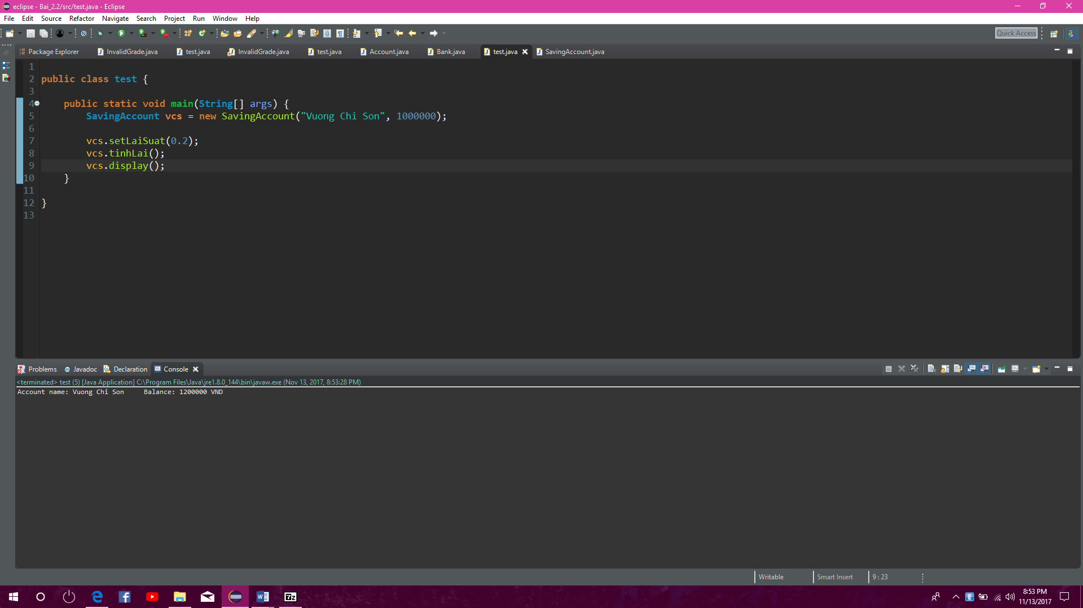

# 3.3

//Vuong Chi Son

//20156407

**package** vehicle;

**public** **class** **Vehicle** {

**protected** **float** velocity;

**protected** **float** turnSpeed;

**protected** **float** x, y;

**protected** **float** angle;

**protected** **float** acceleration;

**protected** **int** time;

**public** **Vehicle**() {

**this**.x = 0;

**this**.y = 0;

**this**.velocity = 0;

**this**.turnSpeed = 0;

**this**.angle = 0;

**this**.acceleration = 0;

**this**.time = 1;

}

**public** **Vehicle**(**float** velocity, **float** turnSpeed, **float** acceleration)

{

**this**.x = 0;

**this**.y = 0;

**this**.angle = 90;

**this**.velocity = velocity;

**this**.turnSpeed = turnSpeed;

**this**.acceleration = acceleration;

**this**.time = 1;

}

**public** **float** **getAcceleration**() {

**return** acceleration;

}

**public** **void** **setAcceleration**(**float** acceleration) {

**this**.acceleration = acceleration;

}

**public** **float** **getVelocity**() {

**return** velocity;

}

**public** **void** **setVelocity**(**float** velocity) {

**this**.velocity = velocity;

}

**public** **float** **getTurnSpeed**() {

**return** turnSpeed;

}

**public** **void** **setTurnSpeed**(**float** turnSpeed) {

**this**.turnSpeed = turnSpeed;

}

**public** **float** **getX**() {

**return** x;

}

**public** **void** **setX**(**float** x) {

**this**.x = x;

}

**public** **float** **getY**() {

**return** y;

}

**public** **void** **setY**(**float** y) {

**this**.y = y;

}

**public** **float** **getAngle**() {

**return** angle;

}

**public** **void** **setAngle**(**float** angle) {

**this**.angle = angle;

}

**public** **void** **ahead**(**double** distance) {

**float** **v0** = 0;

**if**(x == 0f && y == 0f)

**System**.***out***.println("Xe bat dau chuyen dong.");

**while** ( (v0 < velocity) && (distance > 0) )

{

**double** **t** = (v0 + acceleration / 2.0);

distance -= t;

x += (**float**) t * **Math**.*sin*(angle);

y += (**float**) t * **Math**.*cos*(angle);

v0 += acceleration;

display();

time++;

}

**if** (distance > 0)

{

x += (**float**) distance * **Math**.*sin*(angle);

y += (**float**) distance * **Math**.*cos*(angle);

display();

time++;

}

}

**public** **void** **turnLeft**(**double** degree) {

angle += degree;

**if**(x == 0 && y == 0)

{

**System**.***out***.printf("Giay %d:\nXe chua chuyen dong\nToa do: (%f, %f)\nGoc: %f do\n", time, x, y, angle);

time++;

**return**;

}

x += (**float**) turnSpeed * **Math**.*sin*(**Math**.*toRadians*(angle));

y += (**float**) turnSpeed * **Math**.*cos*(**Math**.*toRadians*(angle));

display();

}

**public** **void** **turnRight**(**double** degree)

{

angle -= degree;

**if**(x == 0 && y == 0)

{

**System**.***out***.printf("Giay %d:\nXe chua chuyen dong\nToa do: (%f, %f)\nGoc: %f do\n", time, x, y, angle);

time++;

**return**;

}

x += (**float**) turnSpeed * **Math**.*sin*(**Math**.*toRadians*(angle));

y += (**float**) turnSpeed * **Math**.*cos*(**Math**.*toRadians*(angle));

display();

}

**public** **void** **display**()

{

**System**.***out***.printf("Giay: %d\nToa do: (%f, %f)\nGoc: %f do\n", time, x, y, angle);

}

}

**package** vehicle;

**public** **class** **Bike** **extends** **Vehicle**{

**public** **void** **move**()

{

ahead(1);

}

}

**package** vehicle;

**public** **class** **Car** **extends** **Vehicle**{

**public** **void** **move**()

{

ahead(1);

turnLeft(30);

}

}

**package** vehicle;

**public** **class** **Motobike** **extends** **Vehicle**{

**public** **void** **move**()

{

turnLeft(30);

}

}

**package** vehicle;

**public** **class** **Truck** **extends** **Vehicle**{

**public** **void** **move**()

{

ahead(2);

turnLeft(20);

}

}

**package** vehicle;

**public** **class** **Map** {

**private** **Car** car;

**private** **Bike** bike;

**private** **Motobike** motobike;

**private** **Truck** truck;

**public** **Map**()

{

car = **new** Car();

bike = **new** Bike();

motobike = **new** Motobike();

truck = **new** Truck();

}

**public** **void** **update**()

{

car.move();

bike.move();

motobike.move();

truck.move();

car.display();

bike.display();

motobike.display();

truck.display();

}

}

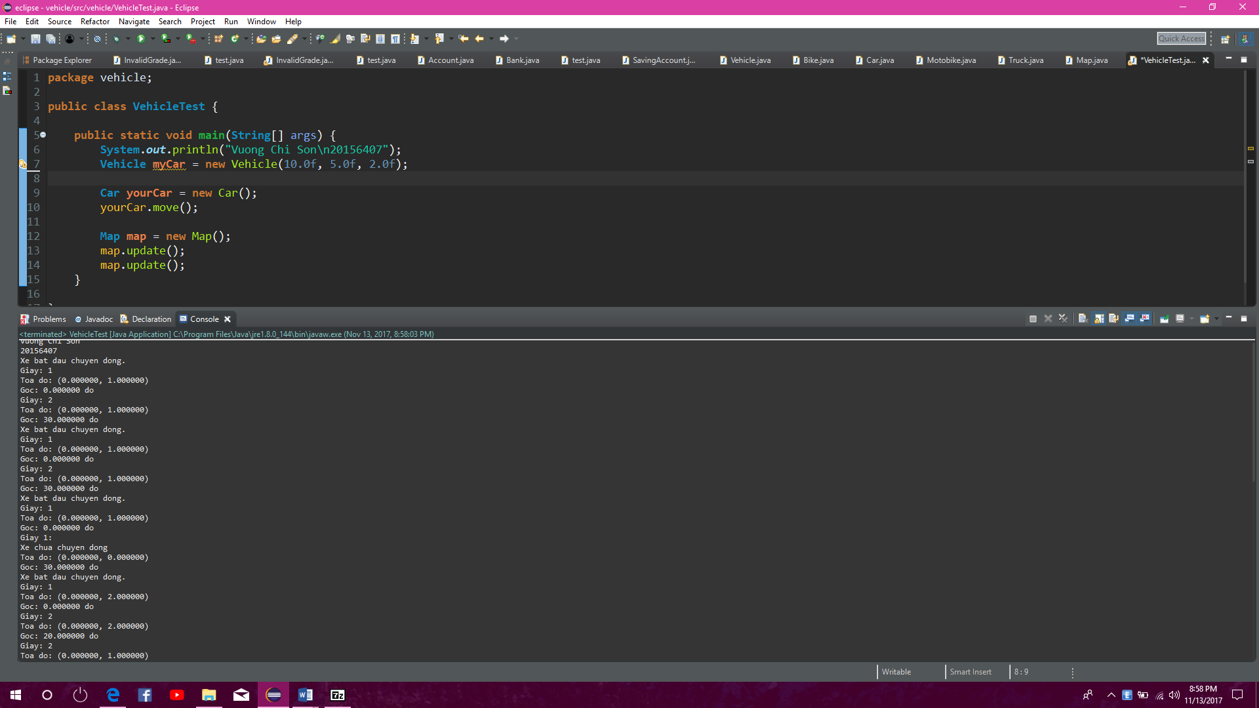

# 4.1

4.1.1: Tạo một đối tượng Account và gọi đến các phương thức rút tiềnvà gửi tiền

Lỗi không thể tạo đối tượng Account, không thể tạo một đối tượng trừu tượng

4.1.2: Tạo một đối tượng SavingAccount và gọi đến các phương thức rút tiền và gửi tiền

Lỗi biên dịch, SavingAccount phải kế thừa phương thức trừu tượng từ lớp cha

# 4.2

//Vuong Chi Son

//20156407

**public** **class** **CheckingAccount** **extends** **Account**{

**public** **void** **deposit**(**long** money)

{

balance += money;

}

**public** **boolean** **withdrawMoney**(**long** money)

{

**if**(balance >= money)

{

balance -= money;

**return** **true**;

}

**else**

**return** **false**;

}

}

//Vuong Chi Son

//20156407

**import** java.util.Date;

**public** **class** **SavingAccount** **extends** **Account**{

**private** **double** laiSuat;

**private** **Date** dateCreate;

**public** **SavingAccount**()

{

**super**();

dateCreate = **new** Date();

}

**public** **SavingAccount**(**String** pname, **int** pbalance) {

name = pname;

balance = pbalance;

}

**public** **void** **tinhLai**()

{

balance += (**int**) balance * laiSuat;

}

**public** **double** **getLaiSuat**() {

**return** laiSuat;

}

**public** **void** **setLaiSuat**(**double** laiSuat) {

**this**.laiSuat = laiSuat;

}

**public** **Date** **getDateCreate**() {

**return** dateCreate;

}

**public** **void** **setDateCreate**(**Date** dateCreate) {

**this**.dateCreate = dateCreate;

}

***@SuppressWarnings***("deprecation")

**public** **void** **deposit**(**long** money)

{

**Date** **toDay** = **new** Date();

**if** (toDay.getDate() == dateCreate.getDate() && toDay.getMonth() == dateCreate.getMonth())

balance += money;

}

***@SuppressWarnings***("deprecation")

**public** **boolean** **withdrawMoney**(**long** money)

{

**Date** **toDay** = **new** Date();

**if**(balance >= money && (toDay.getDate() == dateCreate.getDate() && toDay.getMonth() == dateCreate.getMonth()))

{

balance -= money;

**return** **true**;

}

**else**

**return** **false**;

}

}

**import** java.util.Date;

**public** **class** **CreditAccount** **extends** **Account**{

**private** **double** limit; // Han muc

**private** **double** debitInterest; // Lai suat gui

**private** **double** creditInerest; // Lai suat ghi no

**private** **Date** dateCreate; // Ngay tao TK

**public** **CreditAccount**()

{

**super**();

dateCreate = **new** Date();

}

**public** **CreditAccount**(**String** name, **int** balance, **double** limit,

**double** debitInterest, **double** creditInerest, **String** dateCreated) {

**super**(name, balance);

**this**.limit = limit;

**this**.debitInterest = debitInterest;

**this**.creditInerest = creditInerest;

**this**.dateCreate = **new** Date();

}

**public** **void** **deposit**(**long** money)

{

balance += money;

}

**public** **boolean** **withdrawMoney**(**long** money)

{

**if**(balance >= money)

{

balance -= money;

**return** **true**;

}

**else** **if** (money - balance <= limit)

{

balance -= money;

**return** **true**;

}

**else**

**return** **false**;

}

**public** **void** **tinhLai**()

{

**if** (balance > 0)

{

balance += balance * debitInterest;

}

**else**

{

balance -= balance * creditInerest;

}

}

}

# 4.3

//Vuong Chi Son

//20156407

**import** robocode.Robot;

**import** robocode.ScannedRobotEvent;

**public** **class** SimpleRobot **extends** Robot {

**public** **void** run() {

**while** (**true**) {

ahead(100);

turnGunRight(360);

back(100);

turnGunRight(360);

}

}

**public** **void** onScannedRobot(ScannedRobotEvent event) {

fire(1);

}

}

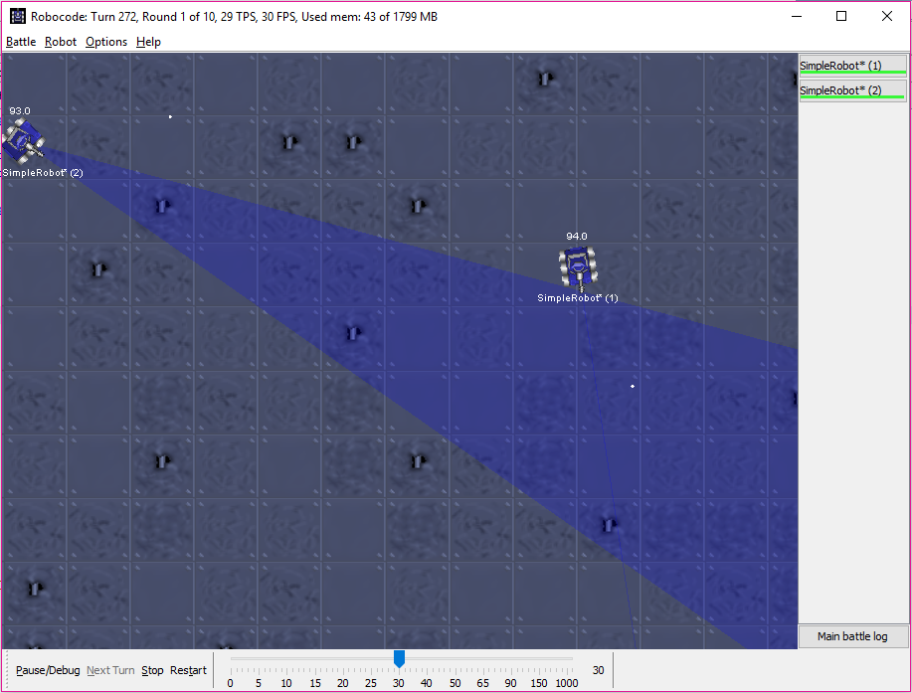

# 4.4

**//Vuong Chi Son**

**//20156407**

**import** robocode.Robot;

**import** robocode.ScannedRobotEvent;

**public** **void** run() {

setAdjustRadarForGunTurn(**true**);

**while** (**true**) {

turnRadarRight(360);

}

}

**public** **void** onScannedRobot(ScannedRobotEvent event) {

turnRight(event.getBearing());

fire(1);

ahead(event.getDistance());

}

}

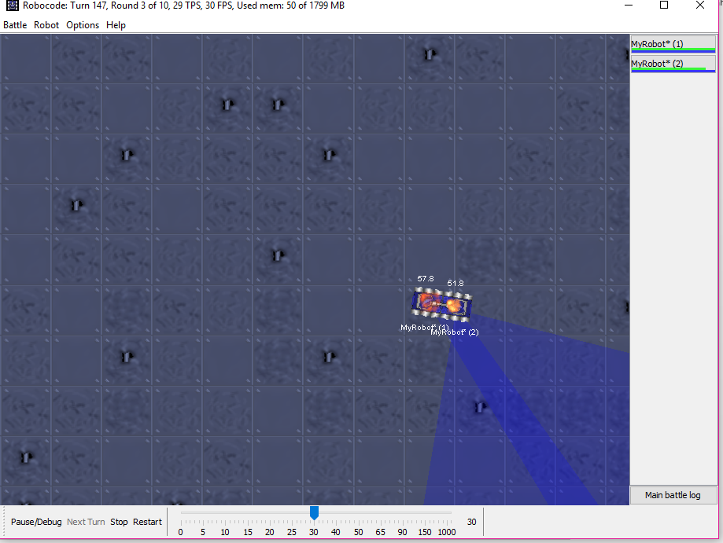

# 4.5

**//Vuong Chi Son**

**//20156407**

**import** robocode.Robot;

**import** robocode.ScannedRobotEvent;

**public** **class** MyPatrolRobot **extends** Robot {

**public** **void** run() {

setAdjustRadarForGunTurn(**true**);

**while** (**true**) {

turnRadarRight(360);

ahead(100);

turnRight(45);

}

}

**public** **void** onScannedRobot(ScannedRobotEvent event) {

turnGunRight(getHeading() - getGunHeading() + event.getBearing());

fire(1);

}

}

