Báo cáo thực hành lập trình hướng đối tượng buổi 3

# Bài 5.1

**public abstract class Account {**

**....**

**public abstract** **void** **inThongTin**();

....

}

**public** **class** **SavingAccount** **extends** **Account{**

**....**

**public void inThongTin() {**

**System.*out*.print("Account name: " + name);**

**System.*out*.println("\tBalance: " + balance + " VND");**

**System.*out*.println("Date create: " + dateCreate.toString());**

**}**

**....**

**}**

**public class CreditAccount extends Account{**

**...**

**public void inThongTin()**

**{**

**System.*out*.println("Account name: " + name);**

**System.*out*.println("Balance: " + balance + " VND");**

**System.*out*.println("Han muc: " + limit);**

**System.*out*.println("Lai suat gui: " + debitInterest);**

**System.*out*.println("Lai suat ghi no: " + creditInerest);**

**System.*out*.println("Ngay tao tai khoan: " + dateCreate.toString());**

**}**

**...**

**}**

**Account acc = new SavingAccount();**

Khi gọi **acc.inThongTin()** thì phương thức **inThongTin()** của **SavingAccount** sẽ được gọi đến. Bởi **acc** là tham chiếu kiểu **Account**, tham chiếu đến đối tượng kiểu **SavingAccount**. Mà phương thức nào được gọi đến phụ thuộc vào đối tượng, chứ không phụ thuộc vào tham chiếu.

# Bài 5.2

**public class Bank {**

**private ArrayList<Account> accounts;**

**....**

**public** **void** **inThongTin**()

{

**if (accounts.isEmpty())**

**System.*out*.println("Khong co tai khoan nao trong ngan hang");**

**else**

**for(Account acc : accounts)**

**{**

**System.*out*.println();**

**acc.inThongTin();**

**}**

}

**...**

**}**

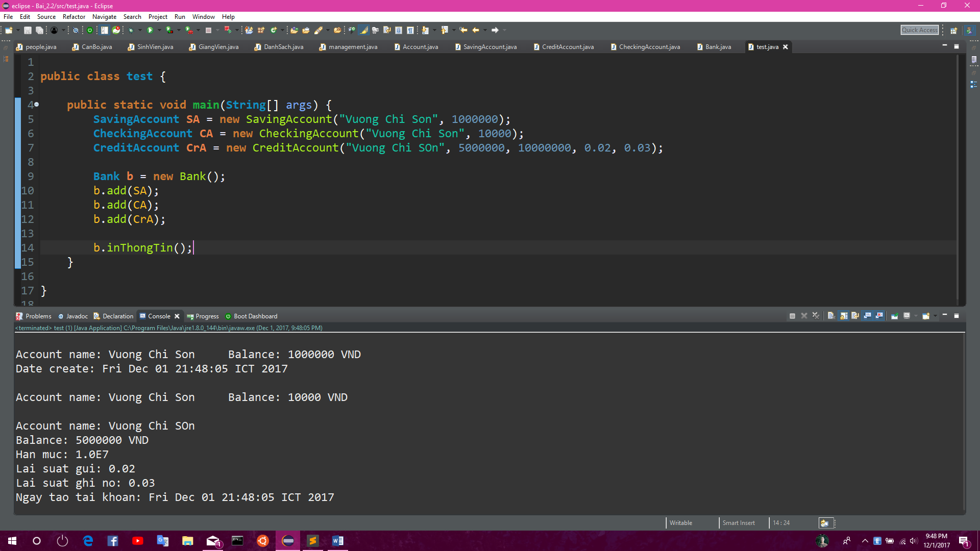

# Bài 5.3

package bai5;

import robocode.AdvancedRobot;

import robocode.ScannedRobotEvent;

public class SimpleAdvencedRobot extends AdvancedRobot {

public void run() {

setAdjustRadarForGunTurn(true);

while (true) {

setTurnRadarRight(360);

execute();

}

}

public void onScannedRobot(ScannedRobotEvent event) {

setTurnRight(event.getBearing());

setFire(1);

setAhead(event.getDistance());

}

public static void main(String[] args) {

System.out.println(“Vuong Chi Son 20156407”);

}

}

# Bài 5.4

package bai5;

import robocode.AdvancedRobot;

import robocode.RobotDeathEvent;

import robocode.ScannedRobotEvent;

public class MyAdvancedRobot extends AdvancedRobot {

public void run() {

setAdjustRadarForGunTurn(true);

setTurnRadarRight(360);

execute();

while (true) {

if (getRadarTurnRemaining() == 0) {

setTurnRadarRight(1);

}

execute();

}

}

public void onScannedRobot(ScannedRobotEvent event) {

setTurnRight(event.getBearing());

if (Math.abs(getTurnRemaining()) < 10) {

if (event.getDistance() > 200) {

setAhead(event.getDistance() / 2);

}

if (event.getDistance() < 100) {

setBack(event.getDistance() * 2);

}

setFire(1);

}

setTurnRadarRight(getHeading() - getRadarHeading() + event.getBearing());

}

public void onRobotDeath(RobotDeathEvent event) {

setTurnRadarRight(360);

}

public static void main(String[] args) {

System.out.println(“Vuong Chi Son 20156407”);

}

}

# Bài 5.5

package bai5;

import robocode.AdvancedRobot;

import robocode.HitByBulletEvent;

import robocode.RobotDeathEvent;

import robocode.ScannedRobotEvent;

public class MyDodgeBulletRobot extends AdvancedRobot {

public void run() {

setAdjustRadarForGunTurn(true);

setAdjustRadarForRobotTurn(true);

setTurnRadarRight(360);

execute();

while (true) {

if (getRadarTurnRemaining() == 0) {

setTurnRadarRight(20);

}

execute();

}

}

public void onScannedRobot(ScannedRobotEvent event) {

setTurnRight(event.getBearing());

if (Math.abs(getTurnRemaining()) < 10) {

if (event.getDistance() > 200) {

setAhead(event.getDistance() / 2);

}

if (event.getDistance() < 100) {

setBack(event.getDistance() * 2);

}

setFire(1);

}

setTurnRadarRight(getHeading() - getRadarHeading() + event.getBearing());

}

public void onRobotDeath(RobotDeathEvent event) {

setTurnRadarRight(360);

}

public void onHitByBullet(HitByBulletEvent event) {

turnRight(90 - event.getBearing());

setBack(100);

}

public static void main(String[] args) {

System.out.println(“Vuong Chi Son”);

}

}

Bài kiểm tra

# Bài 1

**package** quanLy;

**import** java.util.Scanner;

**public** **abstract** **class** **people** {

**protected** **String** hoTen;

**protected** **int** namSinh;

**protected** **String** maSoThe;

**protected** **String** ghiChu;

**public** **people**()

{

**Scanner** **input** = **new** Scanner(**System**.***in***);

**System**.***out***.printf("Ho ten: "); hoTen = input.nextLine();

**System**.***out***.printf("Nam sinh: "); namSinh = input.nextInt();

input.nextLine();

**System**.***out***.printf("Ma so the: "); maSoThe = input.nextLine();

}

**public** **people**(**String** hoTen, **int** namSinh, **String** maSoThe) {

**this**.hoTen = hoTen;

**this**.namSinh = namSinh;

**this**.maSoThe = maSoThe;

}

**public** **abstract** **void** **setGhiChu**();

**public** **void** **edit**()

{

**Scanner** **input** = **new** Scanner(**System**.***in***);

**System**.***out***.printf("Ho ten: "); hoTen = input.nextLine();

**System**.***out***.println("Nam sinh: "); namSinh = input.nextInt();

**System**.***out***.println("Ma so the: "); maSoThe = input.nextLine();

}

**public** **void** **display**()

{

**System**.***out***.println("Ho ten: " + hoTen);

**System**.***out***.println("Nam sinh: " + namSinh);

**System**.***out***.println("Ma so the: " + maSoThe);

**if** (ghiChu != **null**)

**System**.***out***.println("Ghi chu: " + ghiChu);

}

**public** **String** **getMaSoThe**() {

**return** maSoThe;

}

}

**package** quanLy;

**import** java.util.Scanner;

**public** **class** **CanBo** **extends** **people**{

**private** **long** soTienDaTieu;

**public** **long** **getSoTienDaTieu**() {

**return** soTienDaTieu;

}

**public** **CanBo**()

{

**Scanner** **input** = **new** Scanner(**System**.***in***);

**System**.***out***.println();

**System**.***out***.println("So tien tieu: "); soTienDaTieu = input.nextLong();

setGhiChu();

}

**public** **CanBo**(**String** hoTen, **int** namSinh, **String** maSoThe, **long** soTienDaTieu)

{

**super**(hoTen, namSinh, maSoThe);

**this**.soTienDaTieu = soTienDaTieu;

setGhiChu();

}

**public** **void** **edit**()

{

**this**.display();

**Scanner** **input** = **new** Scanner(**System**.***in***);

**super**.edit();

**System**.***out***.println("So tien da tieu: "); soTienDaTieu = input.nextLong();

setGhiChu();

}

**public** **void** **setGhiChu**()

{

**if** (soTienDaTieu >= 14000000)

ghiChu = "Giam doc";

**else** **if** (soTienDaTieu >= 12000000)

ghiChu = "Pho giam doc";

**else** **if** (soTienDaTieu >= 10000000)

ghiChu = "Truong phong";

**else** **if** (soTienDaTieu >= 8000000)

ghiChu = "Pho phong";

**else** **if** (soTienDaTieu >= 6000000)

ghiChu = "Nhan vien";

}

**public** **void** **display**()

{

**super**.display();

**System**.***out***.println("So tien da tieu: " + soTienDaTieu);

}

}

**package** quanLy;

**import** java.util.Scanner;

**public** **class** **SinhVien** **extends** **people**{

**private** **long** soHPNo;

**public** **long** **getSoHPNo**() {

**return** soHPNo;

}

**public** **SinhVien**()

{

**Scanner** **input** = **new** Scanner(**System**.***in***);

**System**.***out***.println("So hoc phi no: "); soHPNo = input.nextLong();

setGhiChu();

}

**public** **SinhVien**(**String** hoTen, **int** namSinh, **String** maSoThe, **long** soHPNo)

{

**super**(hoTen, namSinh, maSoThe);

**this**.soHPNo = soHPNo;

setGhiChu();

}

**public** **void** **edit**()

{

**this**.display();

**System**.***out***.println();

**Scanner** **input** = **new** Scanner(**System**.***in***);

**super**.edit();

**System**.***out***.println("So hoc phi no: "); soHPNo = input.nextLong();

setGhiChu();

}

**public** **void** **setGhiChu**()

{

**if** (soHPNo > 8000000)

ghiChu = "Quyet dinh duoi hoc";

**else** **if** (soHPNo > 5000000)

ghiChu = "Canh cao muc 2";

**else** **if** (soHPNo > 1000000)

ghiChu = "Nhac nho";

**else** **if** (soHPNo == 0)

ghiChu = "Binh thuong";

}

**public** **void** **display**()

{

**super**.display();

**System**.***out***.println("So hoc phi no: " + soHPNo);

}

}

**package** quanLy;

**import** java.util.Scanner;

**public** **class** **GiangVien** **extends** **people**{

**private** **long** soTienLuong;

**public** **long** **getSoTienLuong**() {

**return** soTienLuong;

}

**public** **GiangVien**()

{

**Scanner** **input** = **new** Scanner(**System**.***in***);

**System**.***out***.println("Luong: "); soTienLuong = input.nextLong();

setGhiChu();

}

**public** **GiangVien**(**String** hoTen, **int** namSinh, **String** maSoThe, **long** soTienLuong)

{

**super**(hoTen, namSinh, maSoThe);

**this**.soTienLuong = soTienLuong;

setGhiChu();

}

**public** **void** **edit**()

{

**this**.display();

**System**.***out***.println();

**Scanner** **input** = **new** Scanner(**System**.***in***);

**super**.edit();

**System**.***out***.println("So tien luong: "); soTienLuong = input.nextLong();

setGhiChu();

}

**public** **void** **setGhiChu**()

{

**if** (soTienLuong >= 14000000)

ghiChu = "Giang vien cao cap";

**else** **if** (soTienLuong >= 12000000)

ghiChu = "Giang vien chinh";

**else** **if** (soTienLuong >= 10000000)

ghiChu = "Giang vien 1";

**else** **if** (soTienLuong >= 8000000)

ghiChu = "Giang vien thuc hanh";

**else** **if** (soTienLuong >= 6000000)

ghiChu = "Phuc vu dao tao";

}

**public** **void** **display**()

{

**super**.display();

**System**.***out***.println("Luong: " + soTienLuong);

}

}

package quanLy;

import java.util.ArrayList;

import java.util.Scanner;

public class DanhSach {

private ArrayList<people> list;

private int num;

public DanhSach()

{

list = new ArrayList<people>();

num = 0;

}

public void add()

{

people p;

Scanner input = new Scanner(System.in);

int choise;

System.out.printf("Ban muon them Sinh vien (0), giang vien (1), hay can bo (2)? : "); choise = input.nextInt();

switch(choise)

{

case 0:

p = new SinhVien();

break;

case 1:

p = new GiangVien();

break;

case 2:

p = new CanBo();

break;

default:

return;

}

list.add(p);

num++;

}

public void edit()

{

if (num == 0 )

{

System.out.println("Danh sach rong");

return;

}

Scanner input = new Scanner(System.in);

System.out.printf("Nhap ma so can sua: "); String maSo = input.nextLine();

System.out.println();

boolean flag = false;

for(people p : list)

{

if (p.getMaSoThe().equals(maSo))

{

p.edit();

flag = true;

}

}

if (flag == false)

{

System.out.println("Ma so khong ton tai");

}

}

public void delete()

{

if (num == 0 )

{

System.out.println("Danh sach rong");

return;

}

Scanner input = new Scanner(System.in);

System.out.printf("Nhap ma so can xoa: "); String maSo = input.nextLine();

boolean flag = false;

for(people p : list)

{

if (p.getMaSoThe().equals(maSo))

{

p = null;

list.remove(p);

flag = true;

num--;

}

}

if (flag == false)

{

System.out.println("Ma so khong ton tai");

}

}

public void display()

{

if (num == 0 )

{

System.out.println("Danh sach rong");

return;

}

float tongHPNo = 0, tongLuong = 0, tongTieu = 0;

for(people p : list)

{

p.display();

System.out.println("--------------------");

try {

if(p.getClass() == Class.forName("SinhVien"))

tongHPNo += ((SinhVien) p).getSoHPNo();

else if (p.getClass() == Class.forName("GiangVien"))

tongLuong += ((GiangVien) p).getSoTienLuong();

else

tongTieu += ((CanBo) p).getSoTienDaTieu();

} catch (ClassNotFoundException e) {

// TODO Auto-generated catch block

e.printStackTrace();

}

}

System.out.println();

System.out.println("Tong hoc phi no sinh vien: " + tongHPNo);

System.out.println("Tong tien luong tra cho giang vien: " + tongLuong);

System.out.println("Tong tien da tieu: " + tongTieu);

}

}

**package** quanLy;

**import** java.util.Scanner;

**public** **class** **management** {

**public** **static** **void** **main**(**String**[] args) {

**DanhSach** **ds** = **new** DanhSach();

**Scanner** **input** = **new** Scanner(**System**.***in***);

**int** **choise**;

**while**(**true**)

{

**System**.***out***.println("\n-------------------------");

**System**.***out***.println("Vuong Chi Son 20156407");

**System**.***out***.println("1, Them");

**System**.***out***.println("2, Sua");

**System**.***out***.println("3, xoa");

**System**.***out***.println("4, Xem danh sach");

**System**.***out***.print("Lua chon cua ban (1-4, khac de thoat): ");

choise = input.nextInt();

**System**.***out***.println();

**switch**(choise)

{

**case** 1:

ds.add();

**break**;

**case** 2:

ds.edit();

**break**;

**case** 3:

ds.delete();

**break**;

**case** 4:

ds.display();

**break**;

**default**:

**System**.*exit*(0);

}

}

}

}

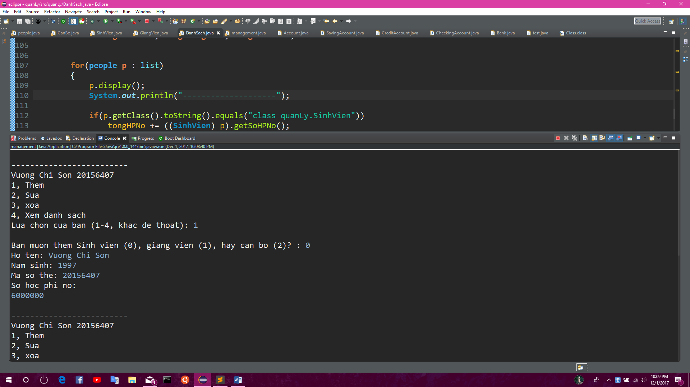

# 

# Bài 2

**public** **abstract** **class** **Account** {

....

**public** **boolean** **chuyenTien**(**Account** taiKhoanNhan, **int** soTienChuyen)

{

**if** (balance < soTienChuyen)

**return** **false**;

**else**

{

balance -= soTienChuyen;

taiKhoanNhan.setBalance(taiKhoanNhan.getBalance() + soTienChuyen);

**return** **true**;

}

}

...}

