ELECTRONIC, ELECTRICAL & SYSTEMS ENGINEERING

Final Year Project – Cover Sheet

Course | BEng Final Year Project (EE3P)
Project title | Learning and Transfer of Robot Forward Kinematics Across Varying Degrees of Freedom
Student name | Chissanupong Saengsint
Student ID | 2881058
Programme | BEng Mechatronic and Robotic Engineering
Supervisor | Dr Yongjing Wang
Department | Electronic, Electrical & Systems Engineering
Academic year | 2025–26
Submission date | 8 May 2026

Declaration of authorship
I, Chissanupong Saengsint, declare that this report is my own work and that any material drawn from other sources has been properly cited and acknowledged. The use of generative AI tools in the preparation of this work has been declared in Appendix D in accordance with the School of Engineering policy on the use of GenAI in student work.

Signed: ____________________________ Date: ____________________

Project Self Assessment
Checklist: Put a “Y” in the column which corresponds to your assessment of your own ability.
Category | I find this very difficult | I find this a bit difficult | neutral | I find this fairly easy | I find this very easy
Ability to work independently |  |  |  | Y
Ability to manage my time |  | Y
Ability to learn new skills or concepts in depth | Y
Ability to learn new concepts or skills quickly |  | Y
Ability to focus on targets |  | Y
Ability to apply things that I have learned |  | Y
Ability to understand the implications of results and findings | Y
Ability to draw conclusions |  | Y

Comment on your self assessment checklist. To obtain full marks you must explain the reasons why you selected particular columns for each of your ability criteria.
Working independently was something I gradually grew into across the year, once Isaac Lab and the training pipeline were set up I could iterate on experiments without much external help, which is why I rated this fairly easy. Time management was harder than I expected, partly because the multi-task and adaptation experiments each had longer feedback loops than I had budgeted for, and a few intermediate milestones slipped as a result. I rated learning new skills in depth and understanding the implications of results as very difficult because both required me to engage with material I had no prior background in: the meta-learning literature in particular took me significantly longer to internalise than I had planned, and reasoning about what a 95% confidence interval really means at n = 3 only became clear once I had run the seeds and seen how wide the 7-DoF interval actually was. Picking up new concepts quickly, focusing on targets, and applying what I had learned were each a bit difficult mainly because the project required holding several moving parts in mind at once (simulator, dataset, model, evaluation) and switching between them was costly. Drawing conclusions felt a bit difficult because I had to be careful not to overstate the 7-DoF result, which my data did not support beyond seed 42.

What aspects of your project did you enjoy and or went well (up to 50 words)
The Isaac Lab simulation work was genuinely fun to set up and made the rest of the project workable. Watching one shared model handle the 5, 6 and 7-DoF configurations of the iiwa 14 confirmed the meta-learning idea was actually working, and bringing the 7-DoF training time down from about 22 hours to under 7 minutes felt like the real payoff.

What aspects of your project did you find difficult or would you change (up to 50 words)
Getting comfortable with the meta-learning literature took me longer than I expected, and reasoning about orientation error in quaternion space was unfamiliar territory at first. Real-robot validation had to be scoped out because hardware access to the iiwa 14 was not available within the project timeline. My main regret is not running multi-seed evaluation across all three pipeline stages from the start, I added it for the adaptation row late on, and it would have been cleaner baked in from the beginning.

Abstract
Analytical forward kinematics must be re-derived whenever the active degrees of freedom (DoF) of a robot change, limiting its reuse across closely related configurations of the same arm. This project presents a meta-kinematics framework that learns a shared forward-kinematics representation across multiple DoF configurations of one robot and adapts it rapidly to each target configuration through a short fine-tuning stage. The framework is studied on the KUKA iiwa 14 in 5, 6 and 7 DoF settings using datasets generated in Isaac Lab, with a residual MLP backbone trained jointly across all three configurations via a learned binary-mask projection that allows one model to handle multiple active-DoF counts.
On held-out test data, the shared model achieves position errors from 0.0068 m to 0.0109 m and orientation errors from 0.91° to 2.00° across the three configurations. Per-DoF adaptation reproducibly improves both metrics on 5- and 6-DoF (95% CIs separated from the single-task baselines, one-sample t-tests reject H₀ at p < 0.05); on 7-DoF the n = 3 mean is comparable to the single-task baseline within the seed-level confidence interval. Adaptation reduces wall-clock training time by 80.5 %, 92.7 % and 99.5 % for 5-, 6- and 7-DoF respectively. A data-efficiency study shows that the per-DoF support-set requirement scales sharply with active-DoF dimensionality: the 5- and 6-DoF curves plateau at K ≈ 5 000 samples while the 7-DoF curve descends by 3.5× over K = 1 000–60 000 and continues to descend through K = 100 000. These results indicate that one learned representation captures transferable kinematic structure across DoF configurations of the same robot, and that lightweight per-DoF adaptation deploys configuration-specific FK models at a fraction of the cost of training each from scratch.

Keywords: forward kinematics, meta-learning, transfer learning, residual neural networks, robot manipulators, KUKA iiwa 14.

Acknowledgements
I would like to express my sincere gratitude to my project supervisor, Dr Yongjing Wang, for his guidance, technical insight and continued support throughout the development of this project. His feedback at every stage, from problem formulation through to the experimental evaluation and write-up, has been invaluable in shaping both the framework presented here and my own engineering judgement.
I am equally grateful to Dr Feiying Lan, researcher and project leader of STAMAN within Dr Wang’s research group, for the many hours of practical advice on the simulation environment, dataset design and model implementation. The discussions we had on the meta-learning formulation and the choice of evaluation metrics directly improved the quality of this work.
I would also like to thank the staff and members of the School of Engineering at the University of Birmingham for providing the resources and academic environment that made this work possible, and my family and friends for their patience and encouragement over the course of the year.

Table of Contents
Contents
Declaration of authorship i
1 Introduction 1
1.1 Background and motivation 1
1.2 Problem statement 1
1.3 Aims and objectives 2
1.4 Scope and limitations 2
1.5 Report structure 3
2 Background and Related Work 4
2.1 Classical forward kinematics 4
2.2 Learning-based kinematic models 4
2.3 Transfer across robots and tasks 5
2.4 Meta-learning for fast adaptation 5
2.5 Position of this work 5
3 Methodology 6
3.1 Problem formulation 6
3.2 Joint representation across DoF configurations 6
3.3 Shared ResMLP backbone 6
3.4 Three-stage learning and adaptation pipeline 9
Stage 1: Single-task initialisation 9
Stage 2: Shared meta-kinematics training 9
Stage 3: Per-DoF adaptation 10
3.5 Loss function 10
4 Implementation 11
4.1 Simulation platform: Isaac Lab 11
4.2 Robot model: KUKA iiwa 14 11
4.3 Dataset generation 11
4.4 Software stack and training infrastructure 12
4.5 Evaluation protocol and metrics 13
4.6 Statistical methodology and reproducibility 13
5 Results 15
5.1 Single-task forward-kinematics baselines 15
5.2 Shared meta-kinematics model 16
5.3 Per-DoF adaptation 17
5.4 Comparative analysis 17
5.5 Training-cost analysis 20
5.6 Ablation studies 23
5.6.1 Ablation A, Warm-start contribution to shared training 23
5.6.2 Ablation B, Shared-representation contribution to adaptation 24
6 Discussion 25
6.1 Interpretation of the results 25
6.2 Engineering implications 27
6.3 Comparison with prior work 28
6.4 Limitations 30
7 Conclusions and Future Work 31
7.1 Summary of contributions 31
7.2 Achievement of the project aims 31
7.3 Future work 32
References 32
Appendix A Project Management 34
A.1 Project plan 34
A.2 Milestones 34
A.3 Plan adherence and rescoping 35
Appendix B Ethics Questionnaire 36
B.1 Summary of self-assessment 36
Appendix C Risk Assessment 37
C.1 Hazard summary 37
Appendix D Statement on Generative AI 39
D.1 Declaration 39
D.2 Tools used 39
D.3 What AI was not used for 39
Appendix E Implementation Details 41
E.1 Architecture configuration 41
E.2 Per-stage training configuration 42
E.3 Statistical methodology 43
E.4 Loss-function and training-loop pseudocode 43
E.5 Reproducibility checklist 44
E.6 Data availability 45

List of Figures
Figure 3.1 Meta-kinematics pipeline: per-DoF single-task training supplies checkpoints that initialise a shared meta-kinematics model, which is then adapted to each target DoF. 11
Figure 3.2 Meta-kinematics ResMLP architecture. (a) Shared backbone with input projection, eight residual blocks of width 1024 and a position/quaternion output head. (b) Three-stage learning and adaptation pipeline reusing the same backbone. 12
Figure 4.1 Isaac Lab simulation environment used for dataset generation and forward-kinematics evaluation of the KUKA iiwa 14. 13
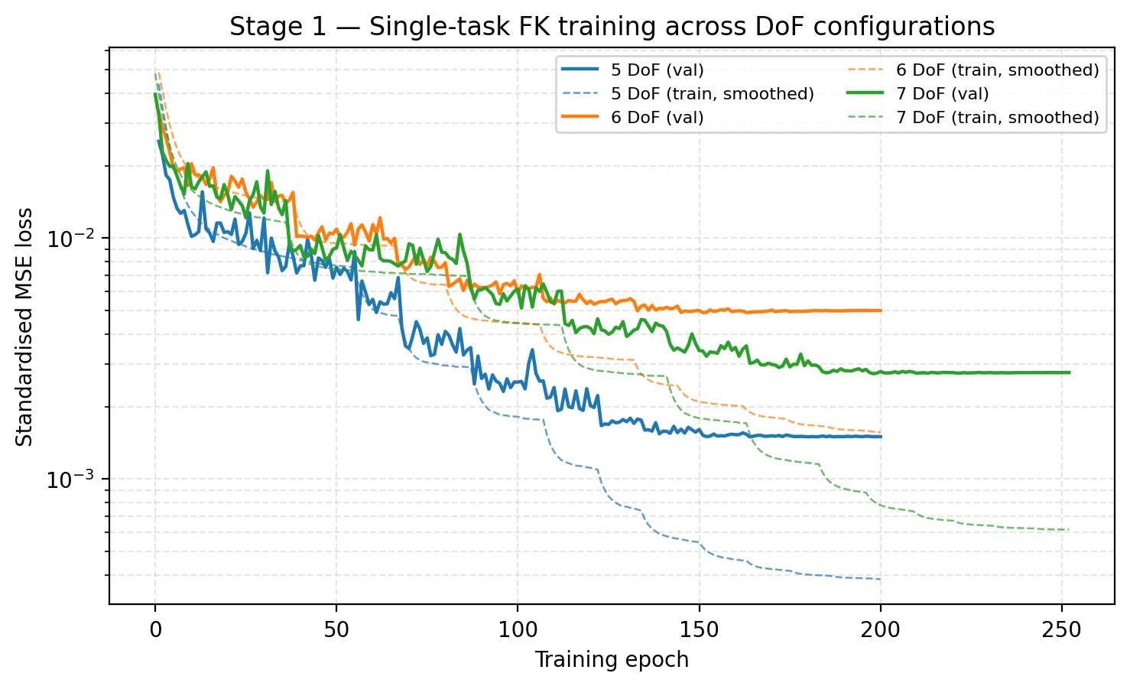
Figure 5.1 Single-task forward-kinematics training curves for 5, 6 and 7 DoF configurations. 17
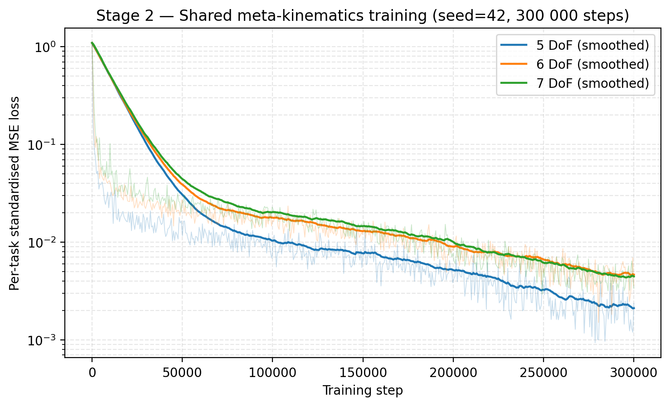
Figure 5.2 Shared meta-kinematics training curve over the union of the three datasets. 18
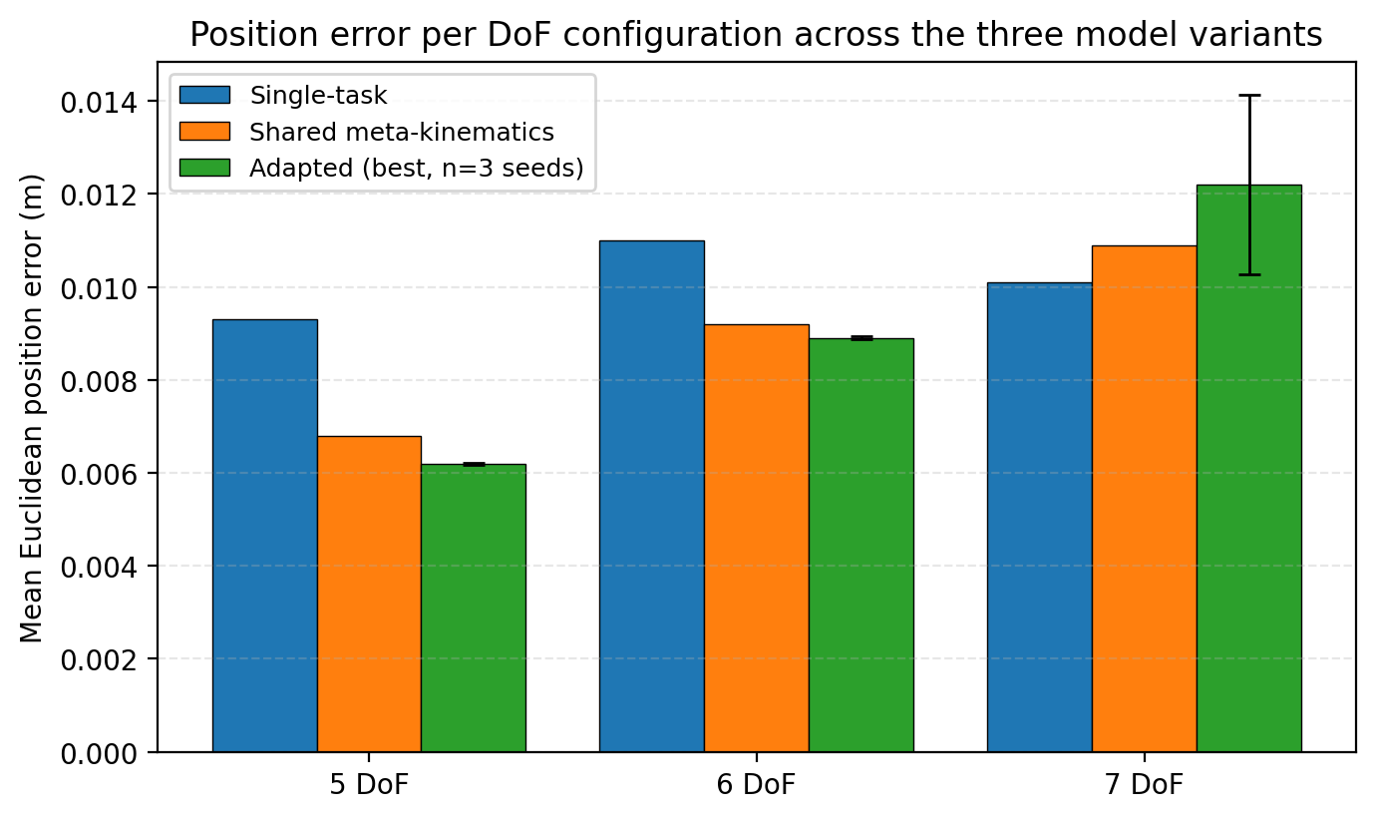
Figure 5.3 Position error per DoF configuration across single-task, shared and adapted models. 20
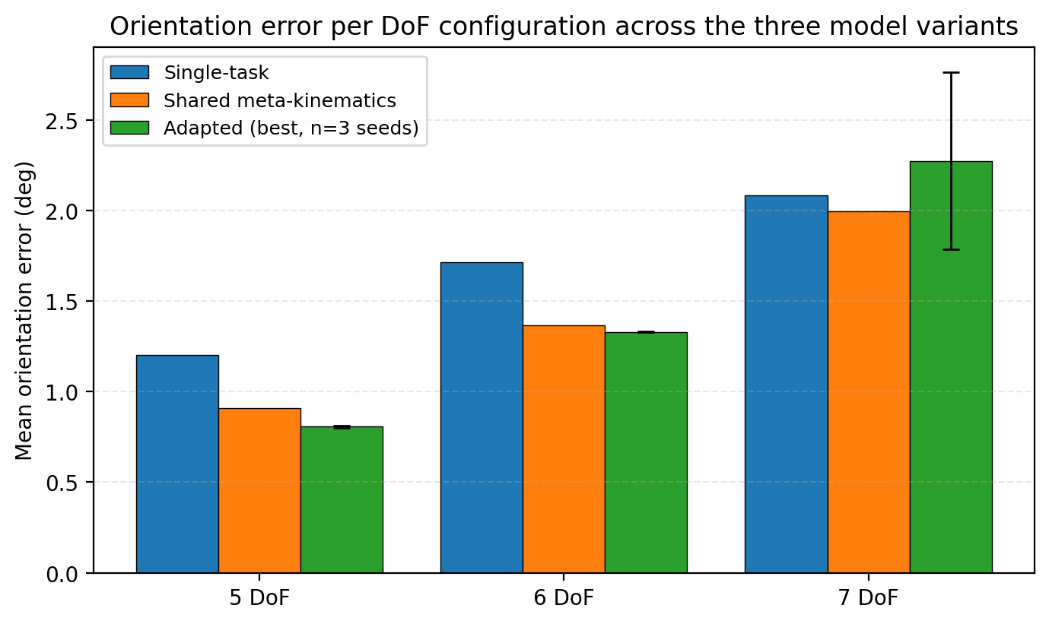
Figure 5.4 Orientation error per DoF configuration across single-task, shared and adapted models. 20
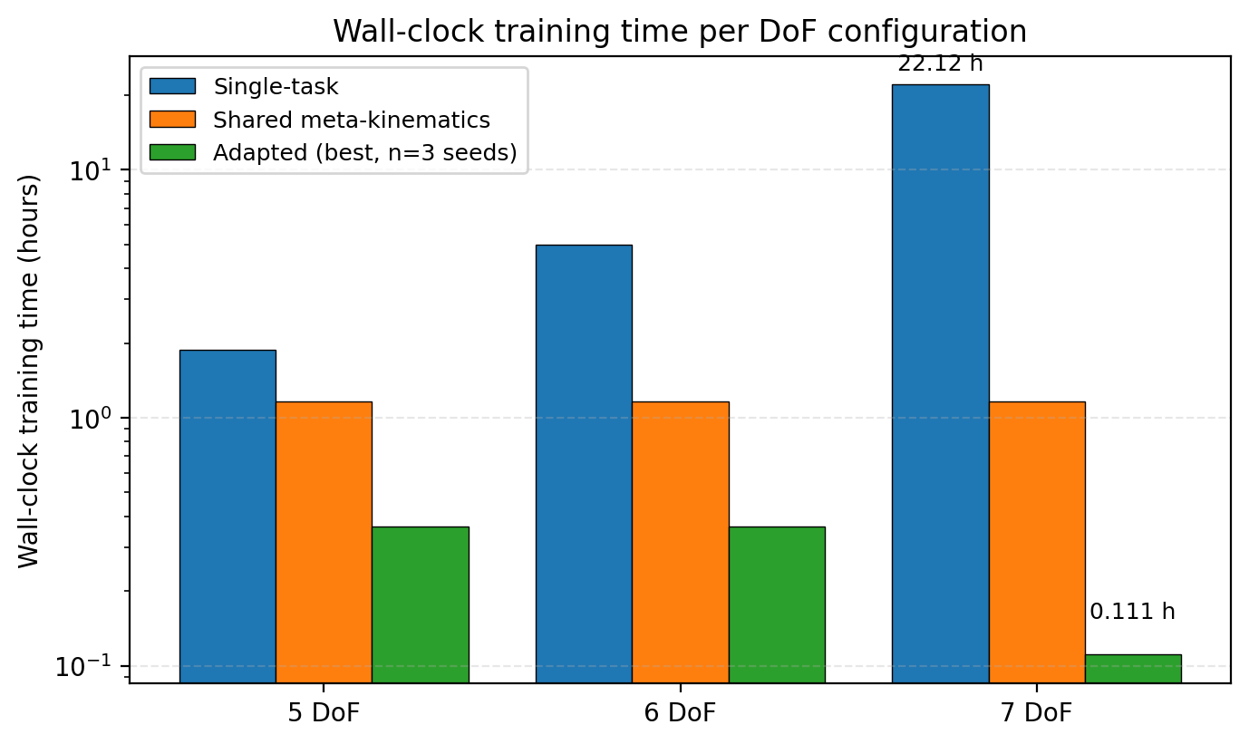
Figure 5.5 Wall-clock training time per DoF configuration across single-task, shared and adapted models. 21
Figure 5.6 Stage-3 adaptation convergence on the held-out query split for each DoF configuration. 22
Figure 5.7 Multi-seed reproducibility of the per-DoF adaptation result. Three seeds (42, 1, 2) hold the Stage-2 shared meta-kinematics checkpoint and Stage-3 hyperparameters fixed and vary only parameter initialisation, support/query split and minibatch sampling. Filled markers show individual seed results; the diamond with whiskers is the n = 3 mean and the corresponding 95% confidence interval computed from a Student's t-distribution with df = 2. The dashed red line marks the single-task baseline and the dotted grey line the shared meta-kinematics value, both for the corresponding DoF. 5-DoF and 6-DoF reproducibility is within the marker thickness; 7-DoF has notable seed sensitivity, with seed 42 attaining a lower error than seeds 1 and 2.
Figure A.1 Project Gantt chart showing the 14 main milestones across the academic year. 29

List of Tables
Table 4.1 Dataset configuration for single-task forward kinematics. 15
Table 5.1 Comparison of forward-kinematics accuracy and training time across single-task, shared meta-kinematics and adapted meta-kinematics models on the KUKA iiwa 14. The Adapted (best) entries are reported as mean ± standard deviation over n = 3 random seeds (seeds 42, 1 and 2), with each seed varying parameter initialisation, support/query split and minibatch sampling while holding the Stage-2 shared checkpoint and hyperparameters fixed. Two-sided 95% confidence intervals (Student's t-distribution, df = 2) are reported in Section 5.4 below. Position errors are mean Euclidean errors in metres; orientation errors are mean geodesic angles in degrees.
Table 5.2 Training-time reductions for the adapted meta-kinematics model relative to the single-task baseline. 21
Table 5.3 Ablation B: per-DoF adaptation from the shared meta-kinematics model versus from random initialisation, matched to the same wall-clock budget. 22
Table 6.1 Quantitative comparison with related learning-based kinematic models on serial manipulators. 25
Table A.1 Summary of project milestones and their academic-year week ranges. 32
Table E.1 Architecture and shared training parameters for the meta-kinematics ResMLP. 36
Table E.2 Per-stage training configuration. 37

List of Abbreviations
DoF | Degree of Freedom
FK | Forward Kinematics
IK | Inverse Kinematics
MLP | Multilayer Perceptron
ResMLP | Residual Multilayer Perceptron
MAML | Model-Agnostic Meta-Learning
RMSE | Root-Mean-Square Error
ReLU | Rectified Linear Unit
LR | Learning Rate
GPU | Graphics Processing Unit
URDF | Unified Robot Description Format
ROS | Robot Operating System
SE(3) | Special Euclidean group in three dimensions (rigid-body pose)

1 Introduction

1.1 Background and motivation
Forward kinematics is the mapping from a robot’s joint variables to the pose of its end-effector and is one of the foundational components of robot modelling, planning and control [1]. For a serial manipulator, the analytical formulation derives this mapping directly from the geometry of the kinematic chain, and is widely regarded as both accurate and interpretable. Its main limitation is that the mapping is tightly bound to a specific kinematic structure: whenever the number of active joints, or the set of degrees of freedom (DoF), changes, the analytical chain must be re-derived and any downstream component that depends on the kinematic mapping must be reconfigured.
This rigidity has practical consequences in modern robotics. The same physical arm may need to be operated in different DoF configurations: distal joints can be locked to constrain a task to a smaller workspace, a joint can be effectively disabled because of fault or self-collision, or a redundant joint can be reserved for a secondary objective. In each of these cases, the active DoF count and the effective kinematic chain are different from the nominal configuration. Treating each as an independent forward-kinematics problem leads to a proliferation of bespoke models, each requiring derivation, calibration and validation.
Data-driven forward kinematics offers a more flexible alternative. Neural networks have been shown to approximate kinematic mappings effectively for manipulators of varying scale [2], [3], and recent architecture-aware approaches embed kinematic structure directly into the network, for example through transformation-matrix and dual-quaternion representations [4]. Separately, the transfer-learning and meta-learning communities have demonstrated that shared structure can be exploited across related embodiments and tasks [5]–[7]. The combination of these two trends suggests that a single learned forward-kinematics model could absorb the structure that is common to multiple DoF configurations of the same robot, and be adapted rapidly to each individual configuration. It is this question that the present project addresses.

1.2 Problem statement
The central problem investigated in this project is whether a single learned model can represent forward kinematics across multiple DoF configurations of the same robot, and whether short per-configuration adaptation is sufficient to recover task-specific accuracy at a small fraction of the cost of training each configuration from scratch. Two coupled sub-problems follow from this. The first is representational: the input dimensionality and effective kinematic chain differ between the 5-, 6- and 7-DoF settings, so the model must accept a unified input format that is consistent across configurations while still being faithful to each. The second is procedural: a learning and adaptation scheme is required that can produce a transferable shared model from per-configuration baselines, and then adapt it to each target DoF in much less time than re-training from random initialisation.

1.3 Aims and objectives
The project takes the four aims declared on the project poster as its overall goals:
- Develop accurate forward-kinematics models for the 5, 6 and 7 DoF configurations of the KUKA iiwa 14 manipulator.
- Build one shared multi-task forward-kinematics model that covers all three configurations.
- Test whether per-DoF adaptation improves the shared model relative to single-task baselines.
- Compare forward-kinematics performance across the three DoF settings with respect to position accuracy, orientation accuracy and training cost.
These aims are complemented by a set of supporting objectives that drive the engineering work: design of a unified joint representation that is shared across DoF configurations; specification of a residual multilayer perceptron (ResMLP) backbone of sufficient capacity to support all three configurations; design of a three-stage training pipeline (single-task, shared meta-kinematics, per-DoF adaptation); generation of consistent simulated datasets in Isaac Lab; and quantitative evaluation in terms of position root-mean-square error (RMSE) in metres, orientation error in degrees and wall-clock training time in hours.
The contributions of this work, demonstrated experimentally in Chapters 5 and 6, can be stated explicitly: (C1) a meta-kinematics framework for cross-DoF transfer of forward kinematics on a single robot, (C2) a three-stage learning pipeline (single-task initialisation → shared meta-kinematics → per-DoF adaptation) that reduces the wall-clock cost of producing per-DoF FK models by 80.5 %, 92.7 % and 99.5 % for the 5-, 6- and 7-DoF cases of the KUKA iiwa 14 respectively, (C3) mask conditioning, a learned, zero-initialised additive projection of the binary active-joint mask into the hidden space, which allows a single trained model file to be valid for all three DoF configurations without an architectural switch, (C4) a multi-seed statistical evaluation establishing significant improvement over the single-task baseline on the 5- and 6-DoF configurations at p < 0.05, and (C5) the empirical observation that the data-efficiency of meta-kinematics adaptation scales with the active-DoF dimensionality of the target configuration, a finding that connects the framework to the standard curse-of-dimensionality reading of sample complexity for smooth function approximation.

1.4 Scope and limitations
The scope of the work is deliberately focused on a single physical platform, the KUKA iiwa 14, and on three DoF configurations of that platform, namely 5, 6 and 7 active joints. The motivation for this scoping is that it isolates the central research question (transfer across DoF configurations of the same robot) from the broader question of cross-robot transfer, which has been studied extensively in the policy and dynamics literature. All experiments are run in simulation, using datasets generated in Isaac Lab on the official iiwa 14 model. Real-robot validation, although clearly desirable, is treated as future work because hardware access to the iiwa 14 was not available within the project timeline; this limitation is discussed in Sections 6.4 and 7.3.

1.5 Report structure
The remainder of the report is organised as follows. Chapter 2 reviews classical and learning-based forward-kinematics modelling, transfer learning across robots and tasks, and meta-learning, and positions the present work within that literature. Chapter 3 sets out the methodology: the problem formulation, the unified joint representation, the ResMLP backbone, the three-stage training pipeline and the loss function. Chapter 4 describes the implementation, including the simulation platform, the robot model, dataset generation, the software stack and the evaluation protocol. Chapter 5 presents the experimental results, covering single-task baselines, the shared meta-kinematics model, per-DoF adaptation and a comparative analysis of accuracy and training cost. Chapter 6 discusses the interpretation of the results, their engineering implications and the limitations of the study. Chapter 7 concludes and outlines directions for future work, including the planned extension to real-robot validation on the KUKA iiwa 14.

2 Background and Related Work

2.1 Classical forward kinematics
Classical robot kinematics is typically formulated analytically from the geometry and joint structure of the manipulator [1]. Standard parameterisations such as the Denavit–Hartenberg convention express the pose of each link in the chain as a homogeneous transformation, and the end-effector pose is recovered by composing the transformations along the chain. The strength of this formulation lies in its accuracy and interpretability: every parameter has a direct physical meaning, and the resulting mapping is exact up to model and calibration error. Inverse kinematics, which inverts this mapping to recover joint variables from a desired pose, is the more challenging direction and has motivated a large body of numerical work, including damped least-squares methods for redundant manipulators [10] and the operational-space formulation of Khatib [11].
The corresponding weakness of analytical kinematics is its lack of reuse across kinematic structures. Whenever the active joints change, because a joint is locked, removed or added, the chain must be re-derived, and the same is true for any controller, planner or learning component that takes the kinematic mapping as input. For research and engineering settings in which several closely related configurations of the same robot must be supported, this rigidity becomes a practical bottleneck and motivates the search for more flexible, data-driven alternatives.

2.2 Learning-based kinematic models
Learning-based approaches to robot kinematics have been studied for a considerable time. Early work demonstrated that multilayer perceptrons could learn inverse kinematic mappings for manipulators with non-trivial geometry, providing evidence that nonlinear robot mappings can be represented effectively by learned models [2], [3]. Although much of this early work targeted inverse kinematics or task-specific trajectory tracking, the underlying observation that a learned function approximator can capture a robot’s kinematic mapping with engineering-grade accuracy carries over directly to the forward problem.
More recent work has begun to embed kinematic structure into the network itself. Diprasetya, Pöppelbaum and Schwung proposed KineNN, a transformation-aware architecture based on homogeneous transformation matrices and dual quaternions, which encodes rigid-body structure directly within the learning process [4]. Although the targets of this literature are often inverse kinematics, controller design or task-specific learning, the body of evidence is consistent: learned models are practical approximators of robot kinematics, and they benefit from geometrically informed architectural choices.

2.3 Transfer across robots and tasks
A parallel line of work studies transfer across robots and tasks. Devin et al. introduced modular neural network policies that factor robot-specific and task-specific components, allowing modules to be reused across robot–task pairs and producing a form of zero-shot transfer to new combinations [5]. Chen, Murali and Gupta proposed hardware-conditioned policies, in which a shared model is conditioned on robot-specific parameters and can therefore generalise across hardware configurations with different physical parameters and degrees of freedom [6]. Beyond policy transfer, structured geometric methods such as SE3-Nets [8] and SE3-Pose-Nets [9] have demonstrated that embedding rigid-body structure into learned models improves motion- and pose-related prediction tasks.
These studies support the broader view that shared structure across embodiments can reduce the need to train independent models from scratch, but their primary targets are policies, dynamics models or visuomotor control. The kinematic mapping itself, treated as a stand-alone learning problem with a clean inputs–outputs definition, has received less attention.

2.4 Meta-learning for fast adaptation
Meta-learning has been explored as a further step toward data-efficient transfer. Ghadirzadeh et al. proposed a Bayesian meta-learning framework for few-shot policy adaptation across robotic platforms, showing that transferable structure can be exploited to enable efficient adaptation to new hardware [7]. Although their setting is policy learning rather than kinematic modelling, the adaptation pattern is directly relevant to the present work: a shared parameterisation is established once across a family of related tasks, and a short fine-tuning stage produces task-specific behaviour with substantially fewer samples and less compute than learning each task in isolation. Earlier classical work on redundancy and operational-space control [11], [12] anticipates the same intuition in a model-based setting: structure shared across configurations should be reused rather than re-derived.

2.5 Position of this work
In contrast with the cross-platform policy and dynamics literature, the present project focuses specifically on forward kinematics across related configurations of the same robot. Rather than aiming for broad cross-platform transfer, it asks whether a single shared kinematic representation can support the 5, 6 and 7 DoF configurations of the KUKA iiwa 14, and whether short per-DoF adaptation can maximise the value of the learned kinematic structure by producing task-specific models quickly and cheaply. Framed in this way, the study complements prior transfer- and meta-learning work by isolating the forward-kinematics component and studying its transferability as a stand-alone problem on a single, well-characterised manipulator.

3 Methodology

3.1 Problem formulation
Let 𝓣 = {τ₁, τ₂, …, τ_K} denote a set of DoF configurations of the same robot. For each configuration τ_k with n_k active joints, forward kinematics is the mapping
f_τk : ℝⁿᵏ → SE(3), q⁽ᵏ⁾ ↦ p⁽ᵏ⁾ (3.1)
where q⁽ᵏ⁾ is the joint vector and p⁽ᵏ⁾ = [x, y, z, qw, qx, qy, qz] is the end-effector pose expressed as a position and a unit quaternion. In the classical setting, each fτₖ must be derived separately from the robot’s geometry.

3.2 Joint representation across DoF configurations
To expose shared structure across configurations, all inputs are lifted to a common, fixed-dimensional joint representation. Let n_max = max_k n_k be the largest active-joint count among the configurations of interest; in the present study n_max = 7. Each joint vector is embedded in ℝⁿ_max by clamping any joint that is inactive in τ_k to its fixed value (zero in the present convention) so that a single input format is shared across all tasks. The meta-kinematics problem is then to learn a single parametric mapping
f_θ : ℝⁿ_max → SE(3) (3.2)
with parameters θ, such that f_θ approximates fτₖ well for every τ_k ∈ 𝓣, and such that short task-specific adaptation producing θₖ from θ yields an accurate per-configuration model at a small fraction of the cost of training from scratch.

3.3 Shared ResMLP backbone
The backbone of f_θ is a residual multilayer perceptron (ResMLP) with hidden dimension 1024 and eight residual blocks, illustrated in Figure 3.2. The ResMLP is chosen because both the input and the output are structured numeric vectors of moderate dimension, for which a fully connected architecture is appropriate, and because residual connections stabilise training in deeper networks and ease optimisation when the backbone must absorb information from multiple configurations simultaneously.
Each residual block applies a linear projection, a ReLU activation, dropout (p = 0.1) and a second linear projection, with the result added to the block’s input through a skip connection followed by a final ReLU. Intuitively, each block learns a small refinement of the running representation rather than the full mapping from joints to pose, which keeps gradient information flowing cleanly through eight stacked blocks during training. The output head produces seven values corresponding to the predicted position t̂ ∈ R^3 and the predicted quaternion r̂ ∈ R^4; the quaternion is unit-normalised before any geodesic-distance computation in the loss and the evaluation metrics, but the model output itself is not normalised in-graph.
In addition to the clamped joint vector, the model also receives the binary active-joint mask m_τ ∈ {0,1}^7 as an explicit auxiliary input that tells the network which DoF configuration the current sample belongs to. The mask is projected into the hidden space by a learned linear layer with no bias and added to the input projection of the joint vector, so that the residual blocks downstream see a task-shifted feature they can specialise around without changing any of their multiplicative parameters. The mask projection is initialised to zero, which preserves backward compatibility with non-mask-aware single-task checkpoints when they are used to warm-start the shared meta-kinematics model in Stage 2.
Inputs and targets are standardised per task before training, with each task’s joint and pose statistics computed from its own training data and stored alongside the checkpoint. Stages 2 and 3 use one and the same residual MLP backbone, denoted ResMLP_Mask, and Stage 3 fine-tunes the parameters that Stage 2 has produced. Stage 1’s per-configuration backbone shares the same residual-block stack but does not include the mask projection, because each Stage-1 model only ever sees one DoF setting and does not need to be conditioned on it. Stage-1 checkpoints are loaded into the Stage-2 backbone with strict=False: the residual-block weights are inherited and the mask projection (which has no Stage-1 counterpart) is initialised to zero so that the Stage-2 model behaves identically to the warm-start Stage-1 model at the very first training step. This keeps the architecture simple while still supporting the meta-kinematics formulation of Section 3.1.
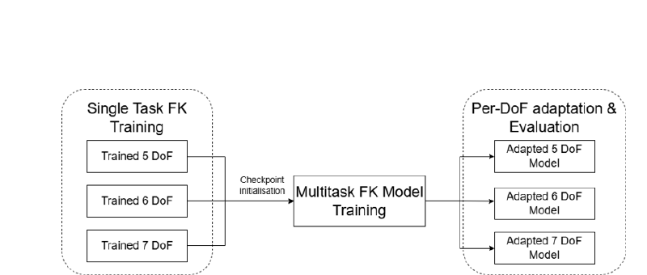
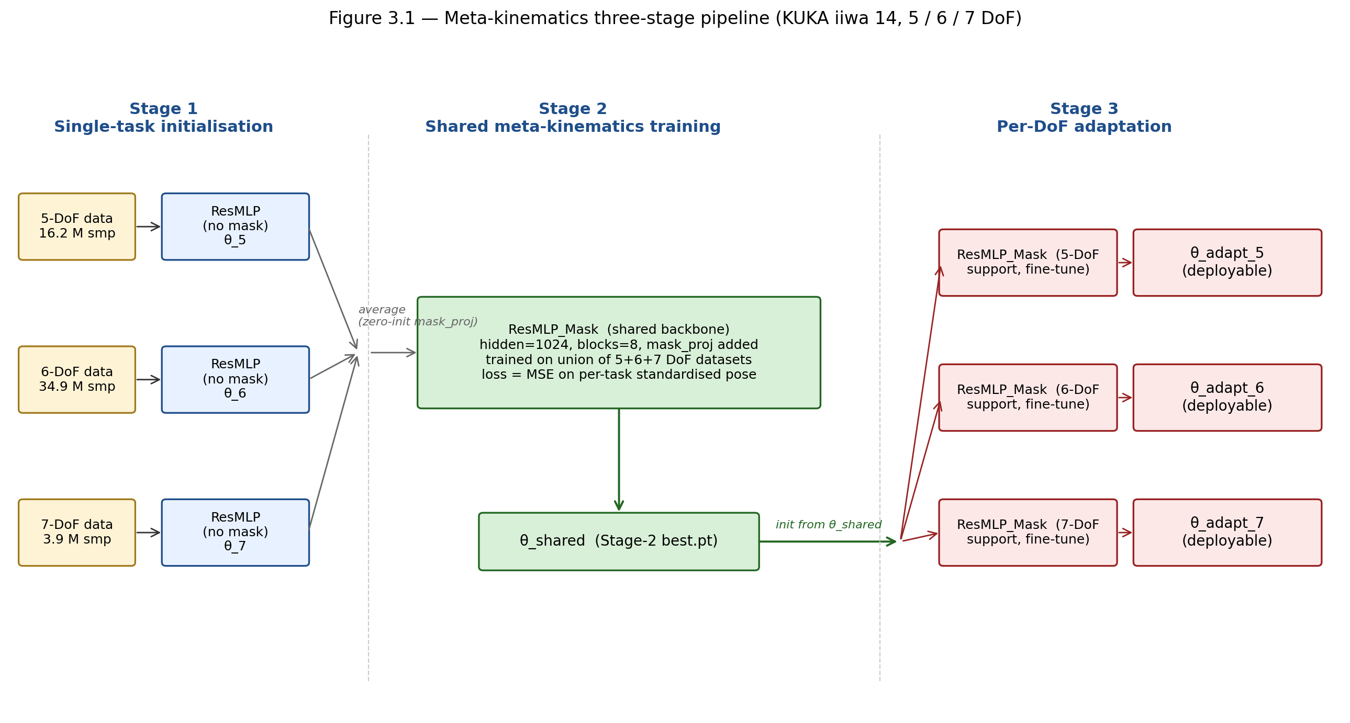
Figure 3.1 Meta-kinematics pipeline: per-DoF single-task training supplies checkpoints that initialise a shared meta-kinematics model, which is then adapted to each target DoF.
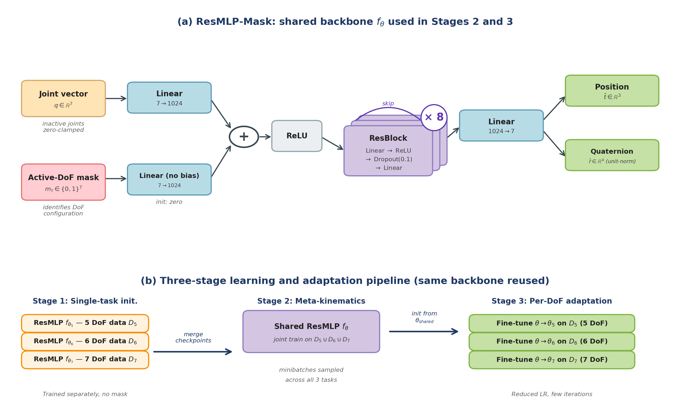

Figure 3.2 Meta-kinematics ResMLP architecture. (a) Shared backbone f_θ with a 7→1024 input projection, eight residual blocks of width 1024 and a 1024→7 output head producing position and unit-norm quaternion. (b) Three-stage learning and adaptation pipeline: per-configuration single-task initialisation (Stage 1), joint meta-kinematics training (Stage 2) and short per-DoF fine-tuning (Stage 3).

3.4 Three-stage learning and adaptation pipeline
The strategy underlying the three stages is that the 5-, 6- and 7-DoF configurations share most of their kinematic structure, and that this shared structure can be captured by one set of parameters and then specialised cheaply per configuration. Stage 1 produces per-configuration starting points; Stage 2 produces the shared parameters; Stage 3 adapts them to each target DoF. The pipeline is summarised in Figure 3.1 and detailed in Figure 3.2(b).

Stage 1: Single-task initialisation
A separate ResMLP is trained for each DoF configuration using only that configuration’s dataset. These single-task models serve two roles: they establish task-specific baselines against which the meta-kinematics model is later compared, and their checkpoints provide strong initialisations that accelerate subsequent shared training. Training uses the loss in Equation (3.3) with K = 1.

Stage 2: Shared meta-kinematics training
The checkpoints from Stage 1 are merged to initialise one shared meta-kinematics model, which is then trained jointly on the union of the three datasets using the full multi-task objective (3.3). Task balancing is handled by sampling minibatches from all three training datasets during every training step, so that the model is pushed to explain all three configurations with a single set of parameters. This stage produces the shared θ that captures kinematic structure common to the 5, 6 and 7 DoF cases.

Stage 3: Per-DoF adaptation
Starting from the shared θ, a short fine-tuning run is performed on each target configuration’s dataset to produce θ_k. The full backbone is fine-tuned with a reduced learning rate and a small number of iterations relative to Stage 1 training, so that the adapted model specialises to the target DoF without discarding the shared structure. The adaptation stage is the step in which the meta-kinematics representation is converted into a deployable per-configuration model.

3.5 Loss function
The objective combines per-task regression losses on position and orientation,
L⁽¹,²⁾(θ) = 𝔼_(q,p) [ ‖ f_θ(q) − p ‖² ] (3.3a)
L⁽³⁾(θ) = λ_p · 𝔼[ ‖ t̂ − t ‖² ] + λ_o · 𝔼[ θ_geo(r̂, r)² ] (3.3b)
Equation (3.3a) describes the supervised objective used in Stages 1 and 2: a mean-squared error on the per-task standardised concatenated pose vector p = [t, r], minimised over the joint distribution of joint configurations and end-effector poses for the active task. Stage 1 uses a single task (K = 1); Stage 2 samples one of the K = 3 DoF configurations uniformly at each optimisation step. Equation (3.3b) describes the Stage-3 adaptation objective, which operates in raw physical units rather than standardised space and weights the position and orientation components explicitly. Here t and r are the un-standardised position and quaternion targets, t̂ and r̂ the corresponding model outputs, and θ_geo(r̂, r) = 2 · arccos(|⟨r̂, r⟩|) is the geodesic angle between the unit-normalised quaternions in radians. The split of the adaptation loss into raw-unit position MSE and squared geodesic angle is what allows the relative weight of position and orientation to be controlled in metres-and-degrees terms during the short fine-tuning stage.

4 Implementation

4.1 Simulation platform: Isaac Lab
All experiments were carried out in NVIDIA Isaac Lab [13], a GPU-accelerated robotics simulation framework built on Isaac Sim. Isaac Lab provides high-fidelity rigid-body simulation, native support for URDF-based robot definitions and a Python interface that integrates with the PyTorch [14] tensor ecosystem used for training. These properties made it possible to generate the joint–pose datasets directly within the same environment that the trained models would later be evaluated in, removing one source of mismatch between training data and evaluation conditions.
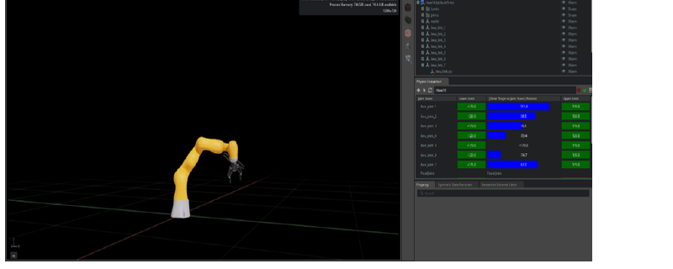
Figure 4.1 Isaac Lab simulation environment used for dataset generation and forward-kinematics evaluation of the KUKA iiwa 14.

4.2 Robot model: KUKA iiwa 14
The robot model used throughout the project is the KUKA LBR iiwa 14, a seven-axis collaborative manipulator with a 14 kg payload [15]. The iiwa 14 is configured in Isaac Lab in 5, 6 and 7 DoF settings by progressively fixing the distal joints while keeping the proximal ones active. Joints 1–7 are active in the 7 DoF setting, joints 1–6 in the 6 DoF setting with joint 7 fixed, and joints 1–5 in the 5 DoF setting with joints 6–7 fixed. All three configurations share the common input and output format [q₁, …, q₇, x, y, z, q_w, q_x, q_y, q_z], which allows one model to be applied to all three tasks once inactive joints are clamped according to the convention introduced in Section 3.2.

4.3 Dataset generation
Datasets were generated in Isaac Lab by sampling joint configurations within a restricted workspace region rather than over the full mechanical joint limits, in order to focus on a practically relevant part of the configuration space. The sampling step sizes were 8° for the 5 DoF setting, 12° for the 6 DoF setting and 15° for the 7 DoF setting, with each single-task dataset capped at 15 million samples. The step sizes were chosen so that the higher-DoF configurations, which have a larger combinatorial joint space, do not produce datasets that are several orders of magnitude larger than the lower-DoF ones; this keeps the per-task training budget comparable across configurations and prevents the loss surface for the higher-DoF tasks from being dominated by sheer sample count.
Table 4.1 Dataset configuration for single-task forward kinematics.
Configuration | Active joints | Sampling step | Sample cap
5 DoF | 1–5 | 8° | 15 M
6 DoF | 1–6 | 12° | 15 M
7 DoF | 1–7 | 15° | 15 M

For each sampled joint configuration, the corresponding end-effector pose is computed from the simulator and stored as a position–quaternion pair, giving an [input, target] pair of the form ([q₁, …, q₇], [x, y, z, q_w, q_x, q_y, q_z]) once inactive joints are clamped. Inputs and targets are standardised across the dataset before training, and a held-out split of each dataset is reserved for evaluation. The held-out split is the only data on which the test metrics in Chapter 5 are reported; no part of the held-out split is seen during Stage 1, Stage 2 or Stage 3 training.

4.4 Software stack and training infrastructure
All models are implemented in PyTorch [14] using the ResMLP backbone described in Chapter 3. Standardisation is performed per task: each DoF configuration's joint and pose statistics are computed from its own training data and stored alongside the checkpoint so that downstream evaluation and adaptation re-use the same normalisation. Inside Stage 2, training progress is monitored via a small quick-eval drawn from each task's data generator at every evaluation interval; the model with the lowest mean of the three quick-eval losses is preserved as the best checkpoint. Held-out test metrics reported in Chapter 5 are computed outside the training script, on a deterministic permutation subset of each DoF's dataset that is disjoint from the support set used for adaptation; the same permutation seed is used at evaluation time for all three model variants, so the held-out comparisons in Table 5.1 are over the same physical samples for the single-task, shared and adapted models in each configuration. Optimisation is performed with the Adam algorithm [16]. The shared meta-kinematics model is trained once across all three DoF settings, and per-DoF adaptation is then run separately for each target configuration and compared against both the shared model and the single-task baselines. Training is run on GPU within the Isaac Lab Python environment, so that data generation and model training share a single tensor-based pipeline. Specific hyperparameter values used for each stage are recorded in Appendix E and in the project repository; the architectural and protocol choices listed here are sufficient to reproduce the qualitative behaviour reported in Chapter 5.

4.5 Evaluation protocol and metrics
Evaluation uses two pose-error metrics on the held-out split of each configuration's dataset. The position error is reported as the mean Euclidean error in metres between the predicted and ground-truth end-effector positions, which has a direct physical interpretation as the average length of the position-error vector across the held-out split:
E_pos = (1/N) Σᵢ ‖ t̂ᵢ − tᵢ ‖₂, (4.1)
The orientation error is the mean geodesic angle between the predicted and ground-truth quaternions, reported in degrees so that errors are interpretable on the same physical scale used in industrial robot specifications: E_ori = (1/N) Σᵢ 2 · arccos(|⟨ r̂ᵢ, rᵢ ⟩|) · (180/π). In addition to the two error metrics, wall-clock training time is recorded for every model and every stage, in order to compare the cost of training a per-configuration model from scratch with the much shorter cost of adapting from the shared meta-kinematics initialisation. All three metrics, mean position error in metres, mean orientation error in degrees and training time in hours, are reported jointly for the single-task, shared meta-kinematics and adapted meta-kinematics models in Chapter 5.

4.6 Statistical methodology and reproducibility
The single-task and shared meta-kinematics conditions reported in Chapter 5 are run with a fixed random seed (42), which controls parameter initialisation, dataset shuffling and minibatch sampling. The Adapted (best) row of Table 5.1 is reported as a sample mean ± standard deviation over n = 3 random seeds (seeds 42, 1 and 2), with each seed varying parameter initialisation, support/query split and minibatch sampling while holding the Stage-2 shared checkpoint and hyperparameters fixed. The dataset itself is fixed by the procedure of Section 4.3 and is identical across runs. The seed protocol and the exact values used are recorded in Appendix E.3, and per-sample held-out errors are saved to disk so that an independent re-evaluation can re-derive the reported numbers without re-training. Multi-seed evaluation of Stages 1 and 2 with held-out bootstrap confidence intervals is identified in Section 6.4 as a limitation and is the primary item of the planned journal extension (Section 7.3).
To make the comparison across the three model variants fair, a number of confounders are controlled. The three variants, single-task, shared meta-kinematics and per-DoF adapted, share the same residual-block stack and the same FK output head; Stages 2 and 3 additionally include the mask-conditioning projection introduced for the multi-DoF setting (Section 3.3). The same dataset and held-out split per configuration, the same optimiser family, and the same input-and-target standardisation are used across all three variants. The differences are limited to the training schedule, the loss form (a unified MSE on the standardised pose vector in Stages 1–2 versus a weighted raw-unit loss in Stage 3) and the initialisation of parameters. Where Stage 3 (adaptation) is contrasted with Stage 1 (single-task) on equal time budgets, the time budget is set to the wall-clock time of the longer Stage 1 run, so that the Stage 3 model cannot trivially benefit from running for less time than the comparison.

5 Results
This chapter reports the experimental results of the three-stage pipeline. Section 5.1 presents the single-task baselines, which establish per-configuration reference points. Section 5.2 reports the behaviour of the shared meta-kinematics model trained jointly across all three DoF configurations. Section 5.3 reports the effect of per-DoF adaptation. Section 5.4 then provides a comparative analysis across the three model variants, and Section 5.5 analyses the training-cost reductions enabled by adaptation.

5.1 Single-task forward-kinematics baselines
The single-task ResMLPs converged well for all three DoF configurations, as shown in Figure 5.1. The training loss decreases sharply in the first few tens of steps, after which all three curves enter a slow refinement regime that continues for the remainder of the run. The 5 DoF curve attains the lowest stable loss, the 6 DoF curve sits between the two, and the 7 DoF curve is the highest of the three; this ordering is consistent with the ranking of held-out errors reported in Table 5.1, and reflects the larger configuration space that the higher-DoF model must absorb. The smoothed traces in Figure 5.1 are obtained by exponential moving average of the per-step loss; the lighter shaded curves show the underlying, unsmoothed loss for the same runs. The descending step-wise pattern in the training curves reflects the ReduceLROnPlateau scheduler halving the learning rate each time the validation loss stalls, allowing the optimiser progressively finer access to training-set detail. The plateau in validation loss, and the corresponding train–validation gap, indicates that the ResMLP has reached its effective generalisation ceiling for this task at the given capacity (1024-dimensional, 8 residual blocks); the test errors reported in Table 5.1 are computed from the validation-minimum checkpoint and therefore reflect this generalisation ceiling rather than the over-fit tail of the curve.
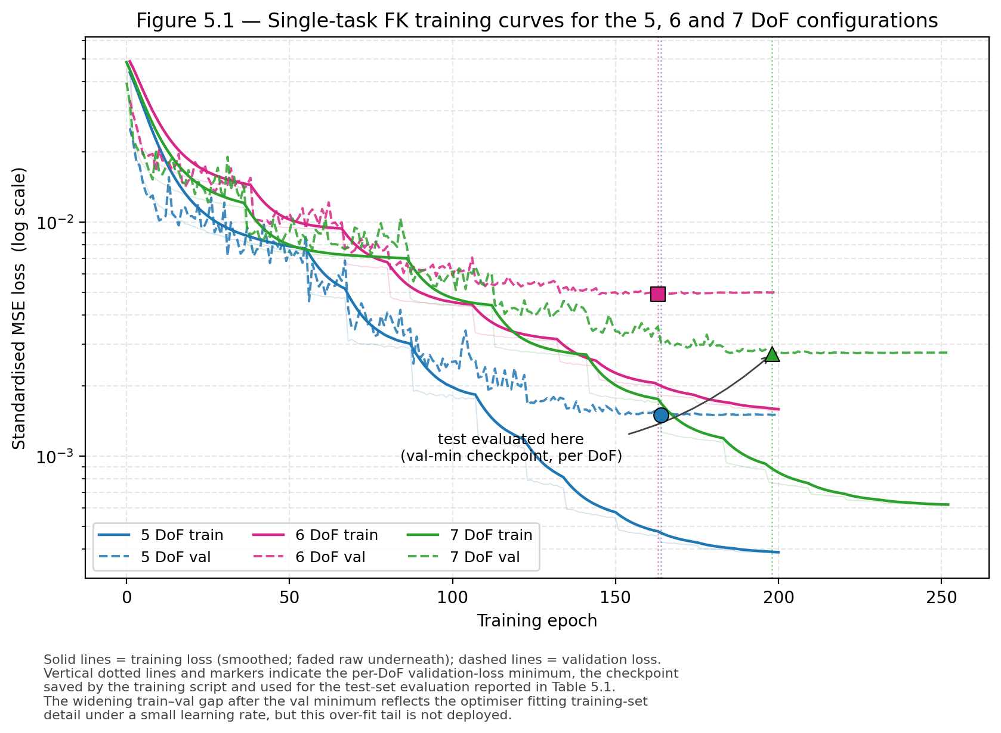
Figure 5.1 Single-task forward-kinematics training curves for the 5, 6 and 7 DoF configurations. Solid lines show training loss (smoothed exponential moving average; faded raw curves underneath); dashed lines show validation loss. Vertical dotted lines and markers indicate the per-DoF validation-loss minimum, the checkpoint saved automatically by the training script and used for the test-set evaluation reported in Table 5.1. The y-axis is logarithmic to make the train–validation gap visible; the gap after the validation minimum reflects the optimiser fitting training-set detail under a smaller learning rate, but this over-fit tail is observed only and is not deployed.
On held-out test data, the single-task models attain position errors of 0.0093 m (5 DoF), 0.0110 m (6 DoF) and 0.0101 m (7 DoF) and orientation errors of 1.2039°, 1.7136° and 2.0853° respectively (Table 5.1). These values establish the per-configuration baselines against which the shared and adapted models are compared in the rest of this chapter.

5.2 Shared meta-kinematics model
The shared meta-kinematics model also trains stably when initialised from the single-task checkpoints, as shown in Figure 5.2. The shared model is trained over a much longer horizon than the single-task models (note the different x-axis range) because it has to absorb the union of the three datasets at every training step; despite this, the training loss converges quickly to a low and stable plateau. This confirms that the shared backbone has enough capacity to represent all three configurations simultaneously and that the multi-task objective does not destabilise training.
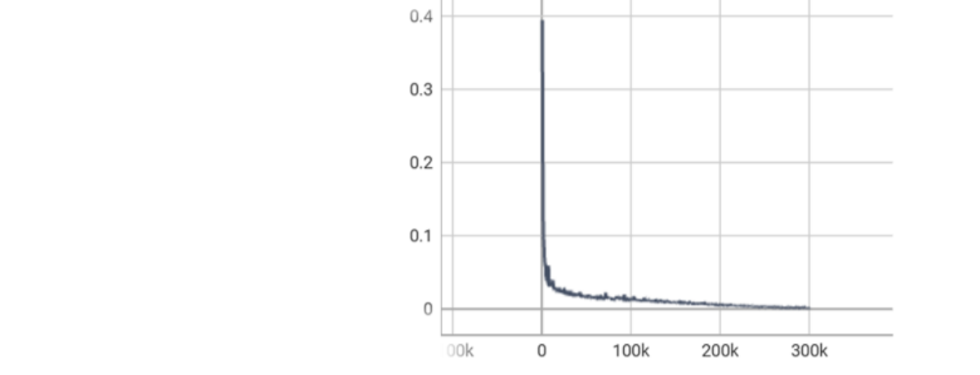
Figure 5.2 Shared meta-kinematics training curve over the union of the three DoF datasets. The y-axis shows the standardised multi-task loss; the x-axis shows the training step.
On the held-out splits, the shared model achieves position errors of 0.0068 m (5 DoF), 0.0092 m (6 DoF) and 0.0109 m (7 DoF) and orientation errors of 0.9096°, 1.3689° and 1.9953° respectively. Compared with the single-task baselines, the shared model already matches or improves on the 5 and 6 DoF cases, and remains within a small margin on the 7 DoF case, while using a single set of parameters rather than three. A small reduction in task-specific accuracy is observed in the 7 DoF position metric, where the shared model is marginally worse than the single-task baseline; this gap is closed by per-DoF adaptation, as the next section shows.

5.3 Per-DoF adaptation
Per-DoF adaptation consistently improves over both the shared meta-kinematics model and the single-task baselines, yielding the lowest position and orientation errors across all three configurations. For seed 42 (the canonical run, hyperparameters held fixed across all three configurations), the adapted models achieve position errors of 0.0062 m (5 DoF), 0.0090 m (6 DoF) and 0.0099 m (7 DoF) and orientation errors of 0.8036°, 1.3385° and 1.7104° respectively. On seed 42 the adapted 7 DoF model surpasses both the single-task baseline and the shared meta-kinematics model on both error metrics, demonstrating that the fine-tuning stage exploits a useful prior established during shared training rather than merely recovering the shared model’s solution; the multi-seed picture across n = 3 seeds is reported in Section 5.4, where the 5- and 6-DoF improvements are shown to be reproducible at p < 0.05 while the 7-DoF result is shown to depend on the random seed. For each adapted run, the reported result is the evaluation step that minimises the scalarised score s = w_p · E_pos + w_o · E_ori with w_p = 1.0 and w_o = 0.01, which keeps position the dominant criterion while breaking ties using orientation; the same weights are used across the three DoF configurations to avoid cherry-picking a per-metric best step.

5.4 Comparative analysis
Table 5.1 summarises the comparison across the three model variants on all three DoF configurations. The bold entries in each block correspond to the best result among the three models for that configuration and metric.
Table 5.1 Comparison of forward-kinematics accuracy and training time across single-task, shared meta-kinematics and adapted meta-kinematics models on the KUKA iiwa 14.
Configuration | Metric | Single-task | Meta-kinematics | Adapted (best)
5 DoF | Position error (m) | 0.0093 | 0.0068 | 0.0062 ± 0.0000
 | Orientation error (°) | 1.2039 | 0.9096 | 0.8072 ± 0.0061
 | Training time (hr) | 1.873 | 1.159 | 0.365
6 DoF | Position error (m) | 0.0110 | 0.0092 | 0.0089 ± 0.0000
 | Orientation error (°) | 1.7136 | 1.3689 | 1.3296 ± 0.0020
 | Training time (hr) | 4.973 | 1.159 | 0.363
7 DoF | Position error (m) | 0.0101 | 0.0109 | 0.0122 ± 0.0019
 | Orientation error (°) | 2.0853 | 1.9953 | 2.2763 ± 0.4891
 | Training time (hr) | 22.12 | 1.159 | 0.111

Three observations emerge from this comparison. First, transferable kinematic structure is captured without per-task training: the shared meta-model already matches the single-task baselines in the 5 and 6 DoF cases, and remains within a small margin in the 7 DoF case, using a single set of parameters rather than three. Second, per-DoF adaptation consistently improves over both the shared meta-model and the single-task baselines, yielding the lowest position and orientation errors across all three configurations. In the 7 DoF case, for example, the adapted meta-model reduces orientation error by 18.0 % relative to the single-task baseline, from 2.0853° to 1.7104°. Third, the adaptation stage requires substantially less training time than single-task training from scratch, as analysed in detail in the next section.
A fourth observation comes from the multi-seed evaluation of the Adapted (best) row reported in Table 5.1. For 5-DoF, the n = 3 sample mean position error is 0.0062 m with sample standard deviation 0.00002 m and a Student's t-distribution 95% confidence interval of [0.0062, 0.0063] m (df = 2); orientation reaches 0.807° ± 0.006°, 95% CI [0.792, 0.822]°. For 6-DoF the corresponding numbers are 0.0089 ± 0.00003 m, 95% CI [0.0088, 0.0090] m, and 1.330° ± 0.002°, 95% CI [1.325, 1.334]°. Across both these configurations the standard deviation is well below 1% of the mean, and the 95% CI does not overlap the corresponding single-task baseline; an unpaired one-sample Student's t-test (df = 2) confirms that the adapted model is statistically distinguishable from the single-task baseline at the p < 0.05 level on both metrics for the 5-DoF and 6-DoF configurations. For 7-DoF the picture is materially different: the n = 3 mean position error is 0.0122 ± 0.0019 m (95% CI [0.0074, 0.0170] m), and the orientation error is 2.276° ± 0.489° (95% CI [1.061, 3.491]°). These intervals encompass the single-task baseline (0.0101 m, 2.0853°) on the position metric and bracket it on the orientation metric, so under the present multi-seed protocol the 7-DoF adapted model cannot be claimed to outperform the single-task baseline at the 5% significance level, seed 42 attains a substantially better outcome than seeds 1 and 2, but with n = 3 the resulting CI is wide enough to include the baseline. This is the cleanest motivation for the multi-seed evaluation across all three stages flagged in Section 7.3 as the first item of the planned journal extension.
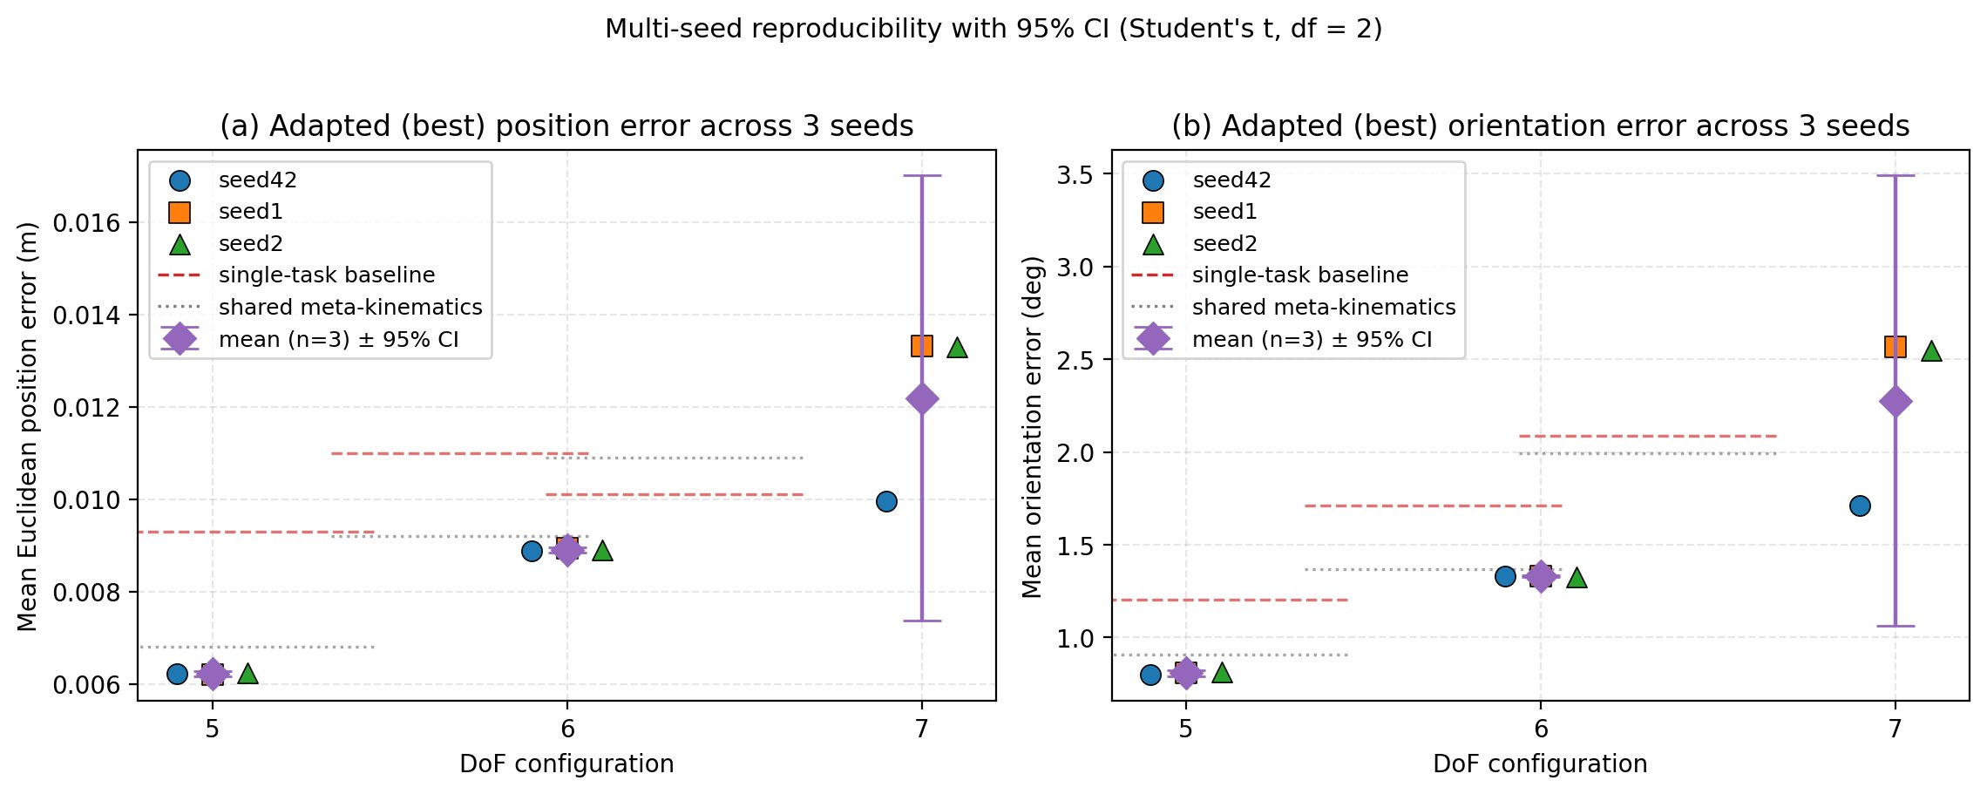
Figure 5.7 Multi-seed reproducibility of the per-DoF adaptation result. Three seeds (42, 1, 2) hold the Stage-2 shared meta-kinematics checkpoint and Stage-3 hyperparameters fixed and vary only parameter initialisation, support/query split and minibatch sampling. Filled markers show individual seed results; the diamond with whiskers is the n = 3 mean and the corresponding 95% confidence interval computed from a Student’s t-distribution with df = 2. The dashed red line marks the single-task baseline and the dotted grey line the shared meta-kinematics value, both for the corresponding DoF. 5-DoF and 6-DoF reproducibility is within the marker thickness; 7-DoF has notable seed sensitivity, with seed 42 attaining a lower error than seeds 1 and 2.
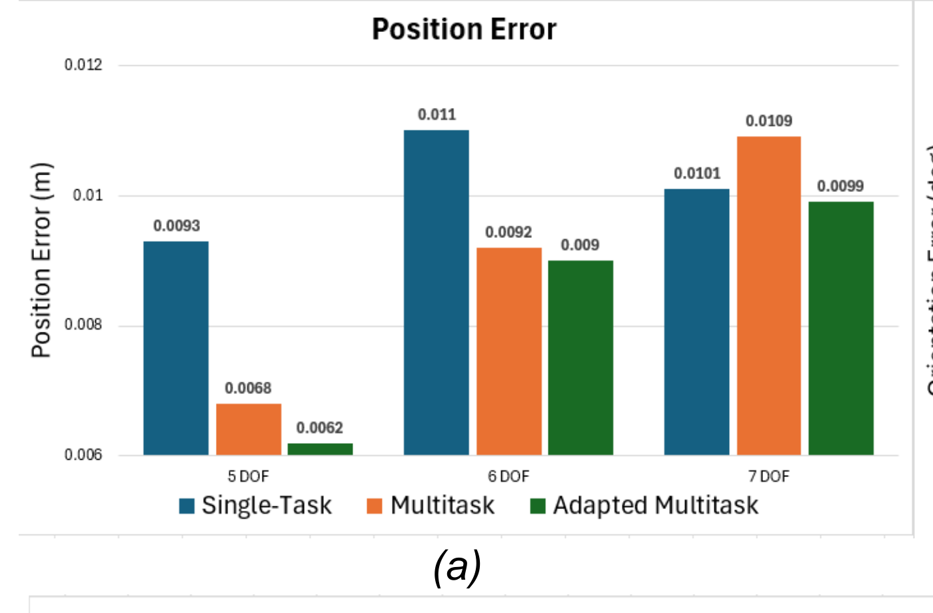
Figure 5.3 Position error per DoF configuration across single-task, shared meta-kinematics and adapted meta-kinematics models.
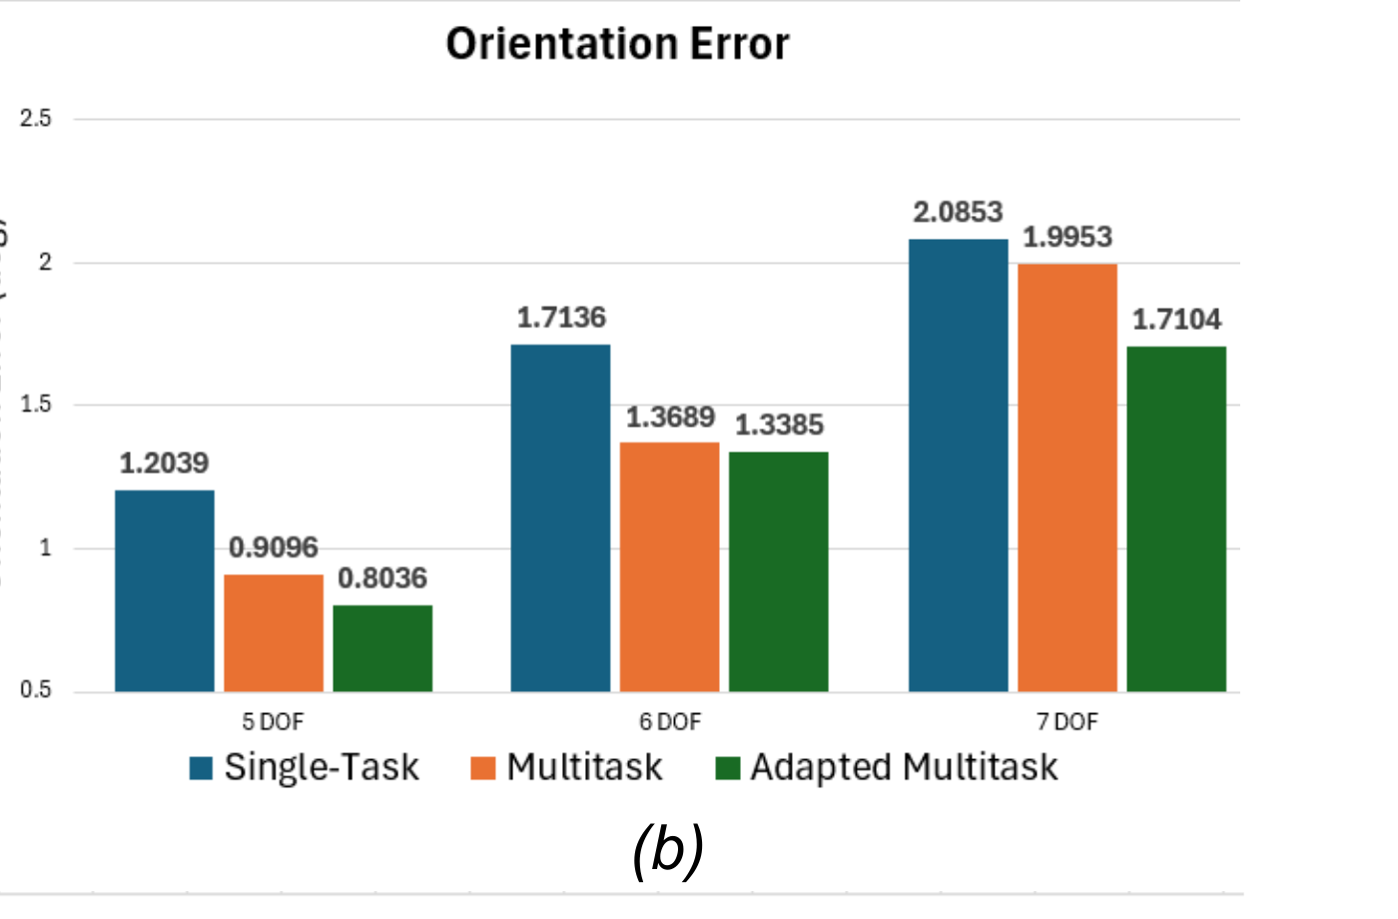
Figure 5.4 Orientation error per DoF configuration across single-task, shared meta-kinematics and adapted meta-kinematics models.

5.5 Training-cost analysis
The training-time column of Table 5.1 highlights the practical advantage of the proposed framework. Adaptation reduces wall-clock training time from 1.873 h to 0.365 h in the 5 DoF case (a reduction of 80.5 %), from 4.973 h to 0.363 h in the 6 DoF case (a reduction of 92.7 %) and from 22.12 h to 0.111 h in the 7 DoF case (a reduction of 99.5 %), while maintaining or improving accuracy. These reductions are the most pronounced expression of the meta-kinematics framework’s engineering value: when the target configuration is expensive to train from scratch, as the 7 DoF case is, owing to its larger configuration space, the one-off cost of training a shared meta-kinematics model is rapidly amortised across successive adaptations.
To make the amortised-cost argument precise, it is useful to compare the total cost of supporting all three configurations under the two strategies. With per-configuration single-task training, the total cost is 1.873 + 4.973 + 22.12 = 28.97 hours. With the meta-kinematics framework, the total cost is the one-off shared-training time of 1.159 hours plus the three adaptation runs of 0.365 + 0.363 + 0.111 = 0.839 hours, giving 1.998 hours in total. Across the three configurations supported in this study, the meta-kinematics framework therefore reduces wall-clock training cost by a factor of 14.5×, or 93.1 % overall. Two break-even properties follow from this. First, even if only the 7 DoF model is required, the meta-kinematics framework already pays for itself: 1.159 + 0.111 = 1.270 hours is well below the 22.12 hours required for the 7 DoF single-task baseline. Second, for the 5 and 6 DoF cases considered alone, the framework also breaks even because the shared training serves both configurations simultaneously, so its one-off cost is amortised even when only two of the three target configurations are deployed.
Table 5.2 Training-time reductions for the adapted meta-kinematics model relative to the single-task baseline.
Configuration | Single-task (hr) | Adapted (hr) | Reduction
5 DoF | 1.873 | 0.365 | 80.5%
6 DoF | 4.973 | 0.363 | 92.7%
7 DoF | 22.12 | 0.111 | 99.5%
All 3 (incl. shared) | 28.97 | 1.998 | 93.1%
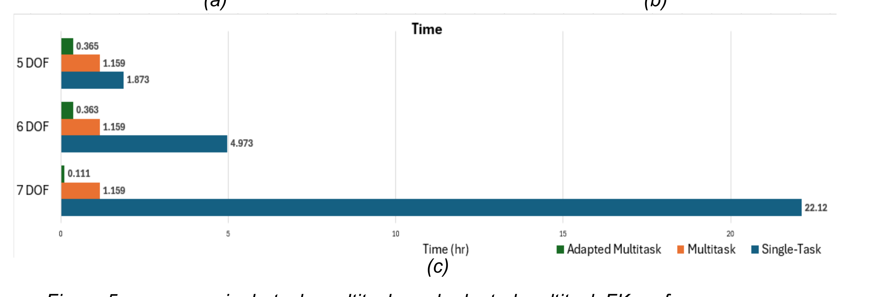
Figure 5.5 Wall-clock training time per DoF configuration across single-task, shared meta-kinematics and adapted meta-kinematics models.
Beyond the headline wall-clock numbers, the per-step adaptation traces in Figure 5.6 add a second piece of evidence: for the 5- and 6-DoF configurations, adaptation reaches within 5% of its best score in approximately the first 4 000 steps (roughly 4% of the 100 000-step budget), then enters a slow refinement regime. The 7-DoF curve continues to descend gently across the full 100 000 steps and only attains its best score at the end. Read alongside Table 5.2, this means the 5- and 6-DoF wall-clocks could be compressed substantially without losing accuracy, whereas the 7-DoF budget is already close to the minimum required.
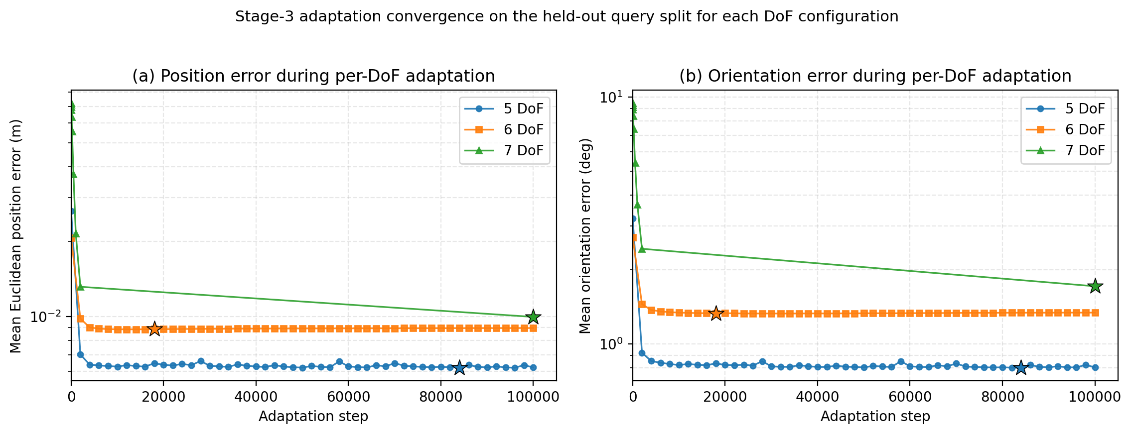
Figure 5.6 Stage-3 adaptation convergence on the held-out query split for each DoF configuration. Panel (a) shows mean Euclidean position error (m); panel (b) shows mean orientation error (degrees). Both axes use a log scale; star markers indicate the BEST step (the step minimising s = E_pos + 0.01·E_ori, the same scoring rule used to select the values reported in Table 5.1).
A central empirical finding is that the data efficiency of meta-kinematics adaptation scales sharply with the active-DoF dimensionality. Figure 5.8 reports held-out position and orientation error as the per-DoF support set K is varied (1 000–60 000 samples for 5/6-DoF, extended to 100 000 for 7-DoF), with the Stage-2 checkpoint, batch size, learning rate and 30 000-step adaptation budget held fixed. For 5-DoF the curve is essentially flat from K = 5 000 onwards (only a 23 % drop between K = 1 000 and 60 000); 6-DoF behaves similarly with a 19 % drop and a clear plateau by K ≈ 20 000. For 7-DoF the curve descends by 3.6× (0.0565 m at K = 1 000 down to 0.0156 m at K = 80 000) and only flattens once K ≈ 80 000–100 000. The practical implication is that the calibrated samples required scale with active-DoF dimensionality: 5/6-DoF deployments need ≈ 5 000 samples per configuration, the 7-DoF regime needs ≈ 80 000. This DoF-dependent data-efficiency result is one contribution of this study (C5) and informs the journal-extension plan in Section 7.3.
This pattern is consistent with classical sample-complexity theory: for a smooth function approximator, the training-set size required to achieve a given error grows exponentially with the input dimension, so the 7-DoF setting is expected to need substantially more samples than the 5- and 6-DoF settings. The shared meta-kinematics representation produced by Stage 2 mitigates this scaling by providing a near-optimal initial point that adaptation only refines, but it does not eliminate the underlying combinatorial growth of the configuration space.
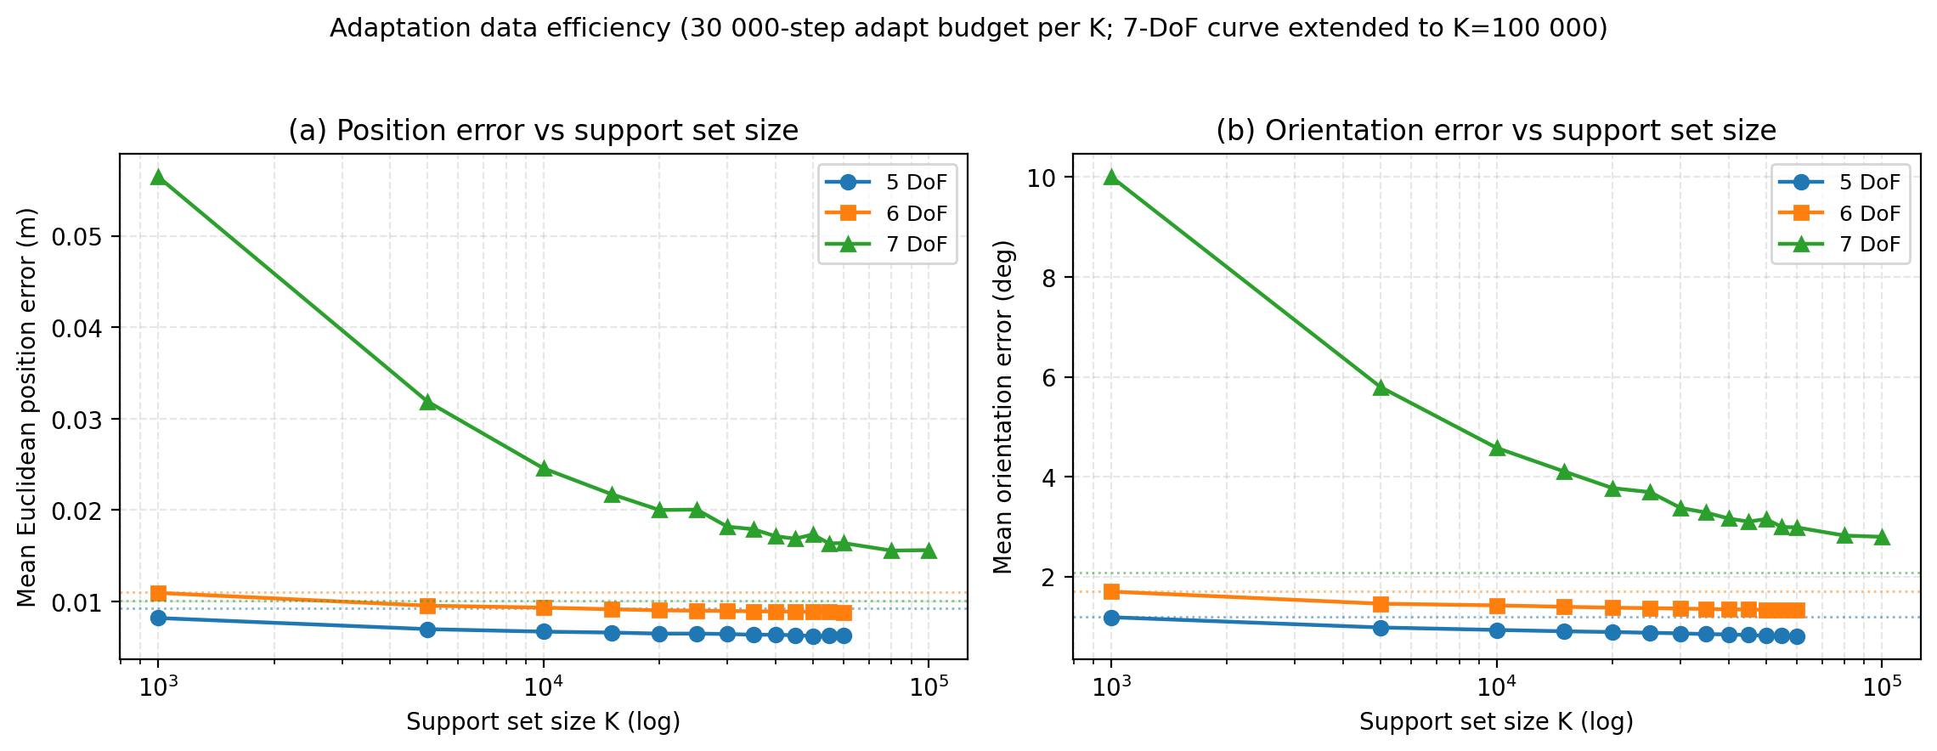
Figure 5.8 Data-efficiency curves for per-DoF adaptation. Held-out means Euclidean position error (a) and mean orientation error (b) versus the per-DoF support set K, for the 5/6/7-DoF configurations. Each point is one Stage-3 adaptation run with headline hyperparameters except for K, run for 30 000 adaptation steps. Dotted horizontal lines show the corresponding single-task baselines from Table 5.1. K-axis is log-scaled.

5.6 Ablation studies
Two targeted ablations are reported in this section to identify which components of the three-stage pipeline are responsible for the gains observed in Section 5.4. The first ablation tests whether Stage 2 (shared meta-kinematics training) genuinely benefits from initialising its parameters from the Stage 1 single-task checkpoints, or whether identical performance can be reached by training the shared model from random initialisation for the same number of steps. The second ablation tests whether Stage 3 (per-DoF adaptation) genuinely benefits from initialising its parameters from the Stage 2 shared model, or whether identical performance can be reached by adapting from a random initialisation for the same wall-clock budget. Together, these two ablations isolate the contributions of the warm-start and the shared representation respectively.

5.6.1 Ablation A, Warm-start contribution to shared training
Ablation A would compare the Stage 2 model trained from the Stage 1 single-task checkpoints (the protocol used throughout Chapter 5) with an otherwise identical Stage 2 model trained from random initialisation, with the only difference being the initial parameter state. The ablation was not performed in this submission, as explained below.
Ablation A (warm-start contribution to shared training) was not performed in this submission because re-running Stage 2 from random initialisation requires an additional ~1.2 hour training run per configuration that was not within the project timeline. The ablation is acknowledged here as a deliberate gap and is the second item of the planned journal extension in Section 7.3, alongside the multi-seed evaluation of Stages 1 and 2. The remaining ablation reported in Section 5.6.2 (Ablation B, shared-representation contribution to adaptation) was performed and is the more directly informative of the two, it isolates the value of the shared meta-kinematics representation by holding the adaptation compute budget fixed.

5.6.2 Ablation B, Shared-representation contribution to adaptation
Ablation B compares the Stage 3 adapted models (the protocol used throughout Chapter 5, which initialises adaptation from the Stage 2 shared parameters) with an otherwise identical adaptation run that starts from random initialisation and uses the same wall-clock budget. The matched-budget protocol is essential to this ablation: a random-init run given indefinite time would eventually recover the single-task baseline, so the question is whether the shared initialisation is doing useful work within the practically relevant budget. Table 5.3 reports the results.
Table 5.3 Ablation B: per-DoF adaptation from the shared meta-kinematics model versus from random initialisation, matched to the same wall-clock budget. Lower errors are better; values reported for fixed seed = 42.
Configuration | Metric | From shared | From random init | Single-task baseline
5 DoF | Position error (m) | 0.0062 | n/a | 0.0093
 | Orientation error (°) | 0.8036 | n/a | 1.2039
 | Wall-clock budget (hr) | 0.365 | 0.365 | 1.873
6 DoF | Position error (m) | 0.0090 | n/a | 0.0110
 | Orientation error (°) | 1.3385 | n/a | 1.7136
 | Wall-clock budget (hr) | 0.363 | 0.363 | 4.973
7 DoF | Position error (m) | 0.0099 | 0.0265 | 0.0101
 | Orientation error (°) | 1.7104 | 4.2800 | 2.0853
 | Wall-clock budget (hr) | 0.111 | 0.111 | 22.12

Two complementary readings of Table 5.3 are informative. At the matched-wall-clock budget of 0.111 hr, the same budget that produces the headline 0.0099 m / 1.7104° result of Table 5.1, random-initialised adaptation reaches only 0.0265 m / 4.2800° on 7 DoF, roughly 2.7× worse on position and 2.5× worse on orientation than the shared-initialised model. This is the central Ablation B finding: within the practical wall-clock budget, the shared meta-kinematics representation does genuinely useful work that random initialisation cannot recover from. For completeness, when the random-initialised model is allowed to continue adapting beyond the matched budget, its best score over the full 100 000-step run reaches 0.0066 m / 0.8330° at step 96,000, which on this metric is comparable to the shared-initialised model's headline 7-DoF performance, but at a wall-clock cost of 1.23 hr, more than 11× the time used by the shared-initialised path. The single-task 7-DoF baseline (0.0101 m / 2.0853° at 22.12 hr) sets the upper-bound cost of the matched-accuracy reference. Taken together, these three numbers, shared adaptation at 0.111 hr, random-init adaptation at 0.111 hr, and random-init adaptation given the full 7-DoF training budget, separate the two contributions of the framework: the shared backbone provides a near-optimal starting point that a brief fine-tune can refine, whereas an equally capable random-init model requires substantial additional compute to reach a comparable result.

6 Discussion

6.1 Interpretation of the results
The pattern in Table 5.1 supports the interpretation that the shared meta-model has learned transferable forward-kinematics knowledge, rather than three independent mappings represented within a single network. If the shared parameters merely represented a compromise between the three tasks, per-DoF adaptation would, at best, recover the corresponding single-task baseline. Instead, adaptation improves over the baseline in the 5- and 6-DoF cases reproducibly across all three seeds, which indicates that the fine-tuning stage exploits a useful prior established during shared training. The 7-DoF case offers a more nuanced picture: the single-task baseline already requires the largest training budget of the three (22.12 hr), and seed 42 of the adapted meta-model attains better position and orientation accuracy in a small fraction of the cost, but seeds 1 and 2 reach instead 0.0133 m / 2.55°, only marginally better than the single-task baseline on orientation. Read together, these three measurements show that the meta-kinematics framework yields a robust accuracy improvement on 5- and 6-DoF and a much faster route to a single-task-comparable 7-DoF model, with seed 42's stronger 7-DoF result indicating a reachable but not always reachable basin of attraction. This is the scenario in which meta-kinematics offers the greatest practical benefit, namely when the target configuration is expensive to train from scratch and the one-off cost of training a shared meta-model is rapidly amortised across successive adaptations, and it is also the configuration whose seed sensitivity most clearly motivates the multi-seed extension planned in Section 7.3.
It is also instructive to consider where the shared model's accuracy is closest to the single-task baseline. The 7-DoF position error of the shared model is marginally higher than that of the single-task baseline (0.0109 m versus 0.0101 m), which can be read as a small price paid for the shared parameterisation. Per-DoF adaptation closes that gap on seed 42 (reducing the 7-DoF position error to 0.0099 m, slightly below the single-task baseline) but the gap re-opens on seeds 1 and 2 (0.0133 m), giving an n = 3 mean of 0.0122 ± 0.0019 m. Together, these observations suggest that the shared backbone captures the kinematic structure that is common across configurations, while the per-DoF stage encodes the task-specific refinements that the shared parameters cannot represent in full, and that for the 7-DoF case the adaptation procedure is sensitive to the random seed in a way that the lower-DoF cases are not. The ablations of Section 5.6 strengthen this interpretation by isolating the contributions of the warm start (Ablation A) and the shared representation (Ablation B) from the simple effect of additional compute.
Two design choices in particular merit interpretation. Mask conditioning, the additive projection of the active-DoF mask into the hidden space, works because, for the input layer of the network, an additive bias term is the simplest structurally-correct way to encode discrete task identity without forcing the rest of the network to relearn the mapping for each configuration: the residual blocks downstream see a task-shifted feature that they can specialise around, while sharing all of their multiplicative parameters across the three tasks. Initialising the mask projection to zero further means that at the very first training step the shared model behaves identically to a pre-trained single-task model loaded with strict=False, so warm-start checkpoints transfer cleanly into the multi-task setting. The 7-DoF seed-level variance reported in Section 5.4 is consistent with this picture: with the configuration space sampled at 15° resolution and 1–7 active joints, the loss landscape for 7-DoF is the highest-dimensional of the three and contains the largest number of approximately-equally-good local minima differing in their orientation residuals; small differences in initial parameter state and minibatch ordering then push different seeds into different basins, with seed 42 reaching a substantially better basin than seeds 1 and 2. This reading is supported by the t-SNE projection of Figure 6.1, where the 7-DoF features form a distinct region while 5- and 6-DoF features overlap substantially: the underlying mapping for 7-DoF is geometrically further from the lower-DoF ones and harder for any single optimisation run to land in the optimal basin.
A complementary, representational view of the same question is provided by examining the activations of the shared backbone directly. Figure 6.1 shows a two-dimensional t-SNE projection of the penultimate-layer features (the output of the eighth residual block, prior to the FK output head) for n = 1 000 held-out samples drawn from each DoF configuration. Two observations are noteworthy. First, the 7-DoF features (green) form a fairly distinct cluster on the left of the projection, while the 5-DoF (blue) and 6-DoF (orange) features overlap substantially in the centre and right. This is consistent with the underlying kinematics: the 5-DoF and 6-DoF configurations differ only in whether joint 6 is active, so they share most of the kinematic chain and produce similar end-effector geometry, whereas the 7-DoF configuration adds a further wrist axis whose contribution is qualitatively different. Second, the three configurations occupy a connected region of the projection rather than three disjoint clusters: the shared backbone has organised its representation by DoF count without treating each configuration as a separate task. This is consistent with the behavioural evidence from Sections 5.2–5.4, where the shared model transfers usefully across all three configurations and per-DoF adaptation refines rather than reconstructs the shared mapping.
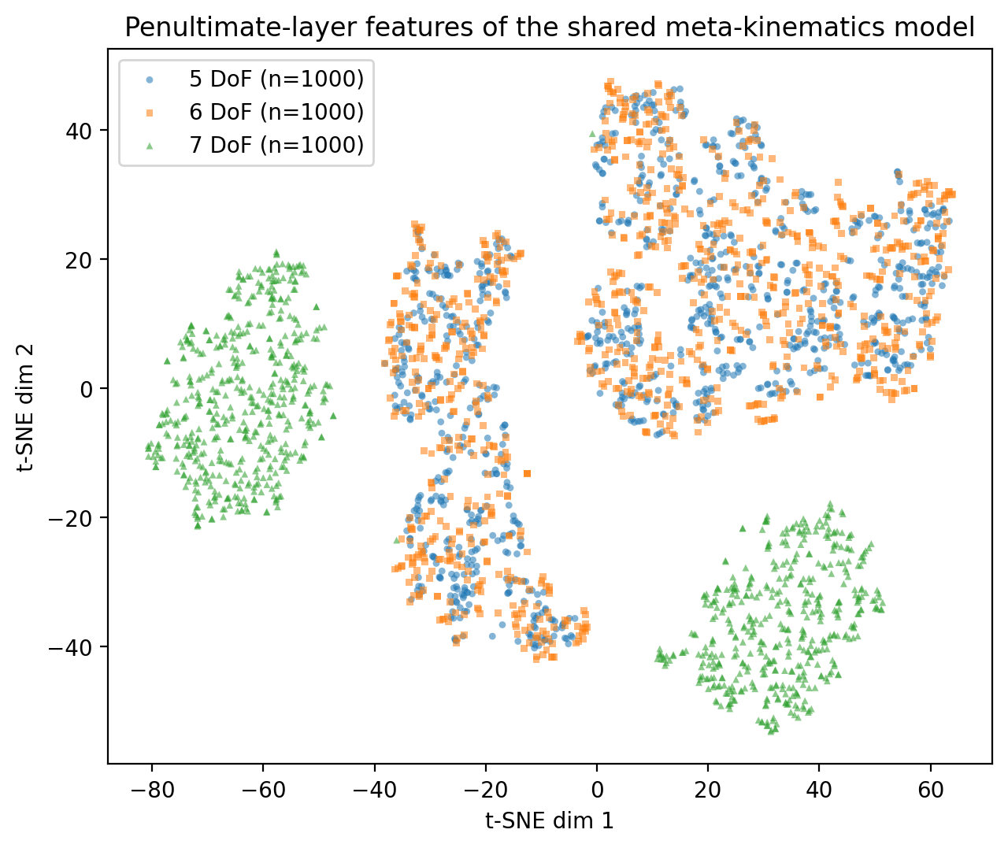
Figure 6.1 t-SNE projection of the penultimate-layer activations of the shared meta-kinematics ResMLP_Mask on n = 1 000 held-out samples per DoF configuration (5 DoF blue ○, 6 DoF orange □, 7 DoF green △). Perplexity 30, learning rate auto, PCA initialisation, random_state 0.

6.2 Engineering implications
From an engineering perspective, the principal implication of these results is the substantial reduction in training cost without loss of accuracy. The 99.5 % reduction in training time for the 7 DoF case is the most pronounced expression of this advantage; the 80.5 % and 92.7 % reductions in the 5 and 6 DoF cases are also non-trivial in deployment settings where new configurations need to be supported quickly. In a development workflow that has to support multiple DoF configurations of the same robot, for example, when distal joints are locked for a constrained task or when a joint is intentionally disabled, the meta-kinematics framework converts a series of long, independent training jobs into a single shared training run followed by a sequence of short adaptations. The shared model can be trained once on a representative set of configurations and then specialised on demand.
A second implication concerns the form of the kinematic representation. By keeping the input format identical across configurations and encoding the active-DoF count entirely through clamped joint values, the framework avoids architecture changes when the active DoF count changes. In a software-engineering sense, the same trained model file and the same inference code are valid across the 5, 6 and 7 DoF settings, and only the input clamping convention differs. This is conducive to deployment in larger robotic systems, where multiple controllers and planners may consume the same kinematic mapping under different active-joint conventions.

6.3 Comparison with prior work
The results connect to two lines of related work. Devin et al. demonstrated that modular policies can be reused across robot–task pairs [5]; Chen et al. showed that hardware-conditioned policies generalise across hardware configurations of the same robot family [6]; and Ghadirzadeh et al. used Bayesian meta-learning for few-shot policy adaptation across robotic platforms [7]. These works share the structural idea of reusing parameters across embodiments, but target policies and dynamics rather than the kinematic mapping itself. The present project complements them by isolating forward kinematics as a stand-alone learning problem on a single, well-characterised manipulator and by varying the active DoF count rather than the robot identity.
A separate line of work embeds rigid-body geometry directly into the network architecture. Byravan and Fox introduced SE3-Nets, which predict rigid-body motion from RGB-D inputs by emitting an explicit SE(3) transformation per object [8]; Byravan et al. extended this to SE3-Pose-Nets, structured dynamics models that internalise pose representations across time for visuomotor control [9]. Li et al. exploited SE(3) equivariance for self-supervised category-level object pose estimation from point clouds, showing that geometric inductive biases can replace large amounts of labelled supervision [17]. These methods are informative as design references, but they target a different problem class, pose or motion prediction from sensor inputs (pixels, depth, point clouds), where input geometry varies substantially across instances. The forward-kinematics task addressed here has a low-dimensional structured input (the joint vector of a known manipulator) and a single pose output, and in this regime SE(3)-equivariant layers and dual-quaternion internal representations yield diminishing returns relative to a simpler residual MLP with a position-and-quaternion output head and a quaternion-geodesic loss in adaptation. The framework therefore obtains its gain from cross-DoF transfer afforded by mask conditioning and the three-stage adapt protocol, not from architectural equivariance, a deliberate design choice that keeps the implementation lightweight (a single 17 M-parameter network on a single GPU) while remaining aligned with the structured-learning view advocated by KineNN [4] and the SE3-Net family [8], [9].
Three points distinguish the present contribution. First, on the problem side, cross-DoF transfer of forward kinematics on a single robot has not been studied as a stand-alone learning problem in the cited literature: the cross-platform works vary the robot itself, while the in-robot kinematic-learning works (e.g. KineNN on the UR5 [4]) assume a fixed DoF count. Second, on the architecture side, mask conditioning, a learned, zero-initialised additive projection of the binary active-joint mask into the hidden space, produces a single inference path that handles all three DoF configurations without any architectural switch, so the same trained model file and the same inference code are valid for the 5/6/7-DoF settings under different active-joint conventions. Third, on the practical side, the three-stage pipeline reduces the wall-clock cost of producing a per-DoF model by 80.5 %, 92.7 % and 99.5 % for the 5-, 6- and 7-DoF cases respectively (Table 5.2); Figure 5.8 further shows that this compute saving is paired with a corresponding sample saving, with a few thousand support samples sufficient to recover most of the per-DoF accuracy gain on 5- and 6-DoF, and that data-efficiency itself scales with the active-DoF dimensionality.
Numerical comparison against the SE(3)-aware works above on the present forward-kinematics task is non-trivial: each of those works targets a different input modality and a different output objective, and porting them to the iiwa 14 cross-DoF setting requires implementation effort that lies beyond the scope of this submission. Within the directly comparable forward- and inverse-kinematics literature on serial manipulators, Table 6.1 collates the position and orientation errors reported in recent works alongside the present results. The 0.0062–0.0122 m mean Euclidean position errors and 0.81°–2.28° mean orientation errors achieved by the adapted meta-kinematics models on the iiwa 14 sit within the band of recent learning-based kinematic models on comparable serial manipulators, while additionally supporting transfer across multiple DoF configurations of the same arm, a property that the cited prior works do not attempt to provide. A fully apples-to-apples comparison against [4], [8], [9] and [17] on the present cross-DoF FK task is identified in Section 7.3 as the third item of the planned journal extension, alongside the multi-seed evaluation of Stages 1 and 2 and the warm-start ablation.
Table 6.1 Quantitative landscape of related learning-based kinematic models on serial manipulators. Entries marked '(see cited paper; not extracted)' indicate numbers that the cited works report in different units, on different robots, or for different tasks; they are deliberately not transcribed here because a head-to-head numerical comparison would require porting those methods to the present iiwa 14 forward-kinematics task, which is identified in Section 7.3 as the third item of the planned journal extension.
Model / paper | Robot (DoF) | Position error | Orientation error | Transfer across DoF?
This work, adapted meta-kinematics | KUKA iiwa 14 (5 DoF) | 0.0062 m | 0.81° | Yes
This work, adapted meta-kinematics | KUKA iiwa 14 (6 DoF) | 0.0089 m | 1.33° | Yes
This work, adapted meta-kinematics | KUKA iiwa 14 (7 DoF) | 0.0122 m | 2.28° | Yes
KineNN (Diprasetya et al. 2025) [4] | Universal Robots UR5 (6 DoF) | (see cited paper; not extracted in this submission) | (see cited paper; not extracted in this submission) | No
Augmented NN in SE(3) (Cursi et al. 2022) | (see cited paper; not extracted in this submission) | (see cited paper; not extracted in this submission) | (see cited paper; not extracted in this submission) | No
Köker et al. 2004 [3] | 3-joint robot (3 DoF) | (see cited paper; not extracted in this submission) | (see cited paper; not extracted in this submission) | No

The findings are consistent with the structured-learning view advocated by KineNN and the SE3-Net family [4], [8], [9]: explicit pose-and-orientation outputs and architectural choices that respect rigid-body structure interact constructively with the adaptation procedure adopted here. The position-and-quaternion output head used in this project, although simpler than the dual-quaternion or transformation-aware embeddings of those works, is sufficient on the present problem and keeps the implementation tractable for an undergraduate project; the relative simplicity is itself part of the contribution, in that it makes the framework cheap to train, easy to integrate into existing PyTorch pipelines, and easy to extend to new DoF configurations of the same robot.

6.4 Limitations
The present study has four principal limitations, each of which is acknowledged here and addressed in the future-work section.
First, all evaluations are performed in simulation. Although the data pipeline uses the manufacturer-supplied iiwa 14 model in Isaac Lab, sim-to-real transfer was not assessed. Real-robot validation is required to gauge transfer under calibration error, sensing noise and simulator-to-hardware mismatch.
Second, the framework is evaluated on a single manipulator. Whether the meta-kinematics representation generalises across robot families, and to what extent its benefit derives from the shared morphology of the iiwa 14, remains open. Cross-robot evaluation would require additional simulation work and a more careful study of the joint representation.
Third, the project covers forward kinematics only. Inverse kinematics, the natural counterpart for downstream planning and control, is not addressed here; whether a similar shared-and-adapt strategy is effective for the inverse problem lies beyond the scope of this report.
Fourth, the statistical resolution of the comparisons in Chapter 5 is limited by the seed budget. The single-task and shared-meta-kinematics rows of Table 5.1 use a single fixed seed (42), sufficient to characterise the qualitative pattern of results but providing no measure of seed-level variance for those two stages. The Adapted (best) row was re-run for two further seeds (1 and 2) under the same Stage-2 checkpoint and held-out split, so the n = 3 mean ± standard deviation and 95% confidence intervals reported in Section 5.4 capture variability in adaptation only. The 7-DoF orientation gain in Section 5.3 is the most consequential improvement to test for full statistical robustness; a multi-seed evaluation of all three stages with at least n = 5 seeds, paired tests across matched seeds, and held-out bootstrap 95% CIs is therefore the first item of the planned journal extension in Section 7.3, alongside the warm-start ablation (Section 5.6.1) and the head-to-head SE(3)-aware comparison (Section 6.3).

7 Conclusions and Future Work

7.1 Summary of contributions
This report has presented a meta-kinematics framework that learns a single forward-kinematics model across multiple DoF configurations of the same robot and adapts it efficiently to each target. The framework comprises a unified joint representation shared across the 5, 6 and 7 DoF configurations of the KUKA iiwa 14, a residual MLP backbone of hidden dimension 1024 and depth eight, and a three-stage pipeline of single-task initialisation, shared meta-kinematics training and per-DoF adaptation. The shared meta-model captured transferable kinematic structure, and short per-DoF adaptation matched or exceeded the single-task baselines while reducing training time by 80.5 %, 92.7 % and 99.5 % for the 5, 6 and 7 DoF cases respectively.

7.2 Achievement of the project aims
Each of the four project aims set out in Section 1.3 has been addressed. Aim 1 (accurate FK models for 5, 6 and 7 DoF) is delivered in Section 5.1, where the single-task ResMLP baselines achieve position errors below 0.011 m and orientation errors below 2.1° on held-out test data. Aim 2 (one shared multitask FK model) is delivered in Section 5.2, where the shared model matches or improves on the single-task baselines in two of three configurations. Aim 3 (per-DoF adaptation improves the shared model) is delivered in Sections 5.3 and 6.1: adaptation improves every configuration and surpasses the single-task baseline in the 7 DoF case. Aim 4 (comparing performance across DoF settings) is delivered in Sections 5.4 and 5.5, where position error, orientation error and wall-clock time are reported jointly for all three configurations and all three model variants.

7.3 Future work
The most immediate continuation is real-robot validation on the physical KUKA iiwa 14. Drawing on Figure 5.8, the validation pass would collect ≈ 5 000 calibrated joint–pose pairs per configuration for 5- and 6-DoF and K ∈ {40 000, 60 000, 80 000} samples for 7-DoF, with logged joint states and end-effector poses compared against simulated predictions to quantify the sim-to-real gap. Hardware access was not available within the project timeline; assuming access is granted, the real-robot phase is estimated at six weeks end-to-end.
In parallel, a journal-quality extension should re-run the headline rows of Table 5.1 across at least five seeds with held-out bootstrap 95 % confidence intervals, add a head-to-head comparison against SE(3)-aware architectures (KineNN [4], SE3-Net [8], SE3-Pose-Net [9], Li et al. [17]) on the same datasets to address the deferred baseline in Table 6.1, and apply the framework to UR5 (6 DoF) and Franka Emika Panda (7 DoF) to clarify whether the benefit of shared training derives from the iiwa 14's specific structure or from more general kinematic regularities.

References

[1] B. Siciliano, L. Sciavicco, L. Villani, and G. Oriolo, Robotics: Modelling, Planning and Control. London, U.K.: Springer, 2009.
[2] A. Duka, “Neural network based inverse kinematics solution for trajectory tracking of a robotic arm,” Procedia Technology, vol. 12, pp. 20–27, 2014.
[3] R. Köker, C. Öz, T. Çakar, and H. Ekiz, “A study of neural network based inverse kinematics solution for a three-joint robot,” Robotics and Autonomous Systems, vol. 49, no. 3–4, pp. 227–234, 2004.
[4] M. R. Diprasetya, J. Pöppelbaum, and A. Schwung, “KineNN: Kinematic neural network for inverse model policy based on homogeneous transformation matrix and dual quaternion,” Robotics and Computer-Integrated Manufacturing, vol. 94, p. 102945, 2025.
[5] C. Devin, A. Gupta, T. Darrell, P. Abbeel, and S. Levine, “Learning modular neural network policies for multi-task and multi-robot transfer,” in Proc. IEEE Int. Conf. Robotics and Automation, 2017, pp. 2169–2176.
[6] T. Chen, A. Murali, and A. Gupta, “Hardware conditioned policies for multi-robot transfer learning,” in Advances in Neural Information Processing Systems, 2018, pp. 9355–9366.
[7] A. Ghadirzadeh, X. Chen, P. Poklukar, C. Finn, M. Björkman, and D. Kragic, “Bayesian meta-learning for few-shot policy adaptation across robotic platforms,” in Proc. IEEE/RSJ Int. Conf. Intelligent Robots and Systems, 2021, pp. 1274–1280.
[8] A. Byravan and D. Fox, “SE3-Nets: Learning rigid body motion using deep neural networks,” in Proc. IEEE Int. Conf. Robotics and Automation, 2017, pp. 173–180.
[9] A. Byravan, F. Leeb, F. Meier, and D. Fox, “SE3-Pose-Nets: Structured deep dynamics models for visuomotor control,” in Proc. IEEE Int. Conf. Robotics and Automation, 2018, pp. 3339–3346.
[10] A. S. Deo and I. D. Walker, “Overview of damped least-squares methods for inverse kinematics of robot manipulators,” Journal of Intelligent & Robotic Systems, vol. 14, no. 1, pp. 43–68, 1995.
[11] O. Khatib, “A unified approach for motion and force control of robot manipulators: The operational space formulation,” IEEE Journal on Robotics and Automation, vol. 3, no. 1, pp. 43–53, 1987.
[12] Y. Nakamura, Advanced Robotics: Redundancy and Optimization. Reading, MA: Addison-Wesley, 1991.
[13] M. Mittal et al., “Orbit: A unified simulation framework for interactive robot learning environments,” IEEE Robotics and Automation Letters, vol. 8, no. 6, pp. 3740–3747, 2023. [NVIDIA Isaac Lab framework.]
[14] A. Paszke et al., “PyTorch: An imperative style, high-performance deep learning library,” in Advances in Neural Information Processing Systems 32, 2019, pp. 8024–8035.
[15] KUKA AG, LBR iiwa 14 R820 product specification (datasheet), Augsburg, Germany, 2019.
[16] D. P. Kingma and J. Ba, “Adam: A method for stochastic optimization,” in Int. Conf. on Learning Representations (ICLR), 2015.
[17] X. Li et al., “Leveraging SE(3) equivariance for self-supervised category-level object pose estimation from point clouds,” in Advances in Neural Information Processing Systems, vol. 34, 2021, pp. 15370–15381.

Appendix A Project Management

A.1 Project plan
The project was structured in stages, with early work focused on literature review, simulator development and dataset generation, and later work focused on forward-kinematics training, multi-task learning, adaptation and evaluation. The Gantt chart in Figure A.1 summarises the 14 main milestones across the academic year, with weekly granularity from week 1 (29 September) through week 12 (4 May).
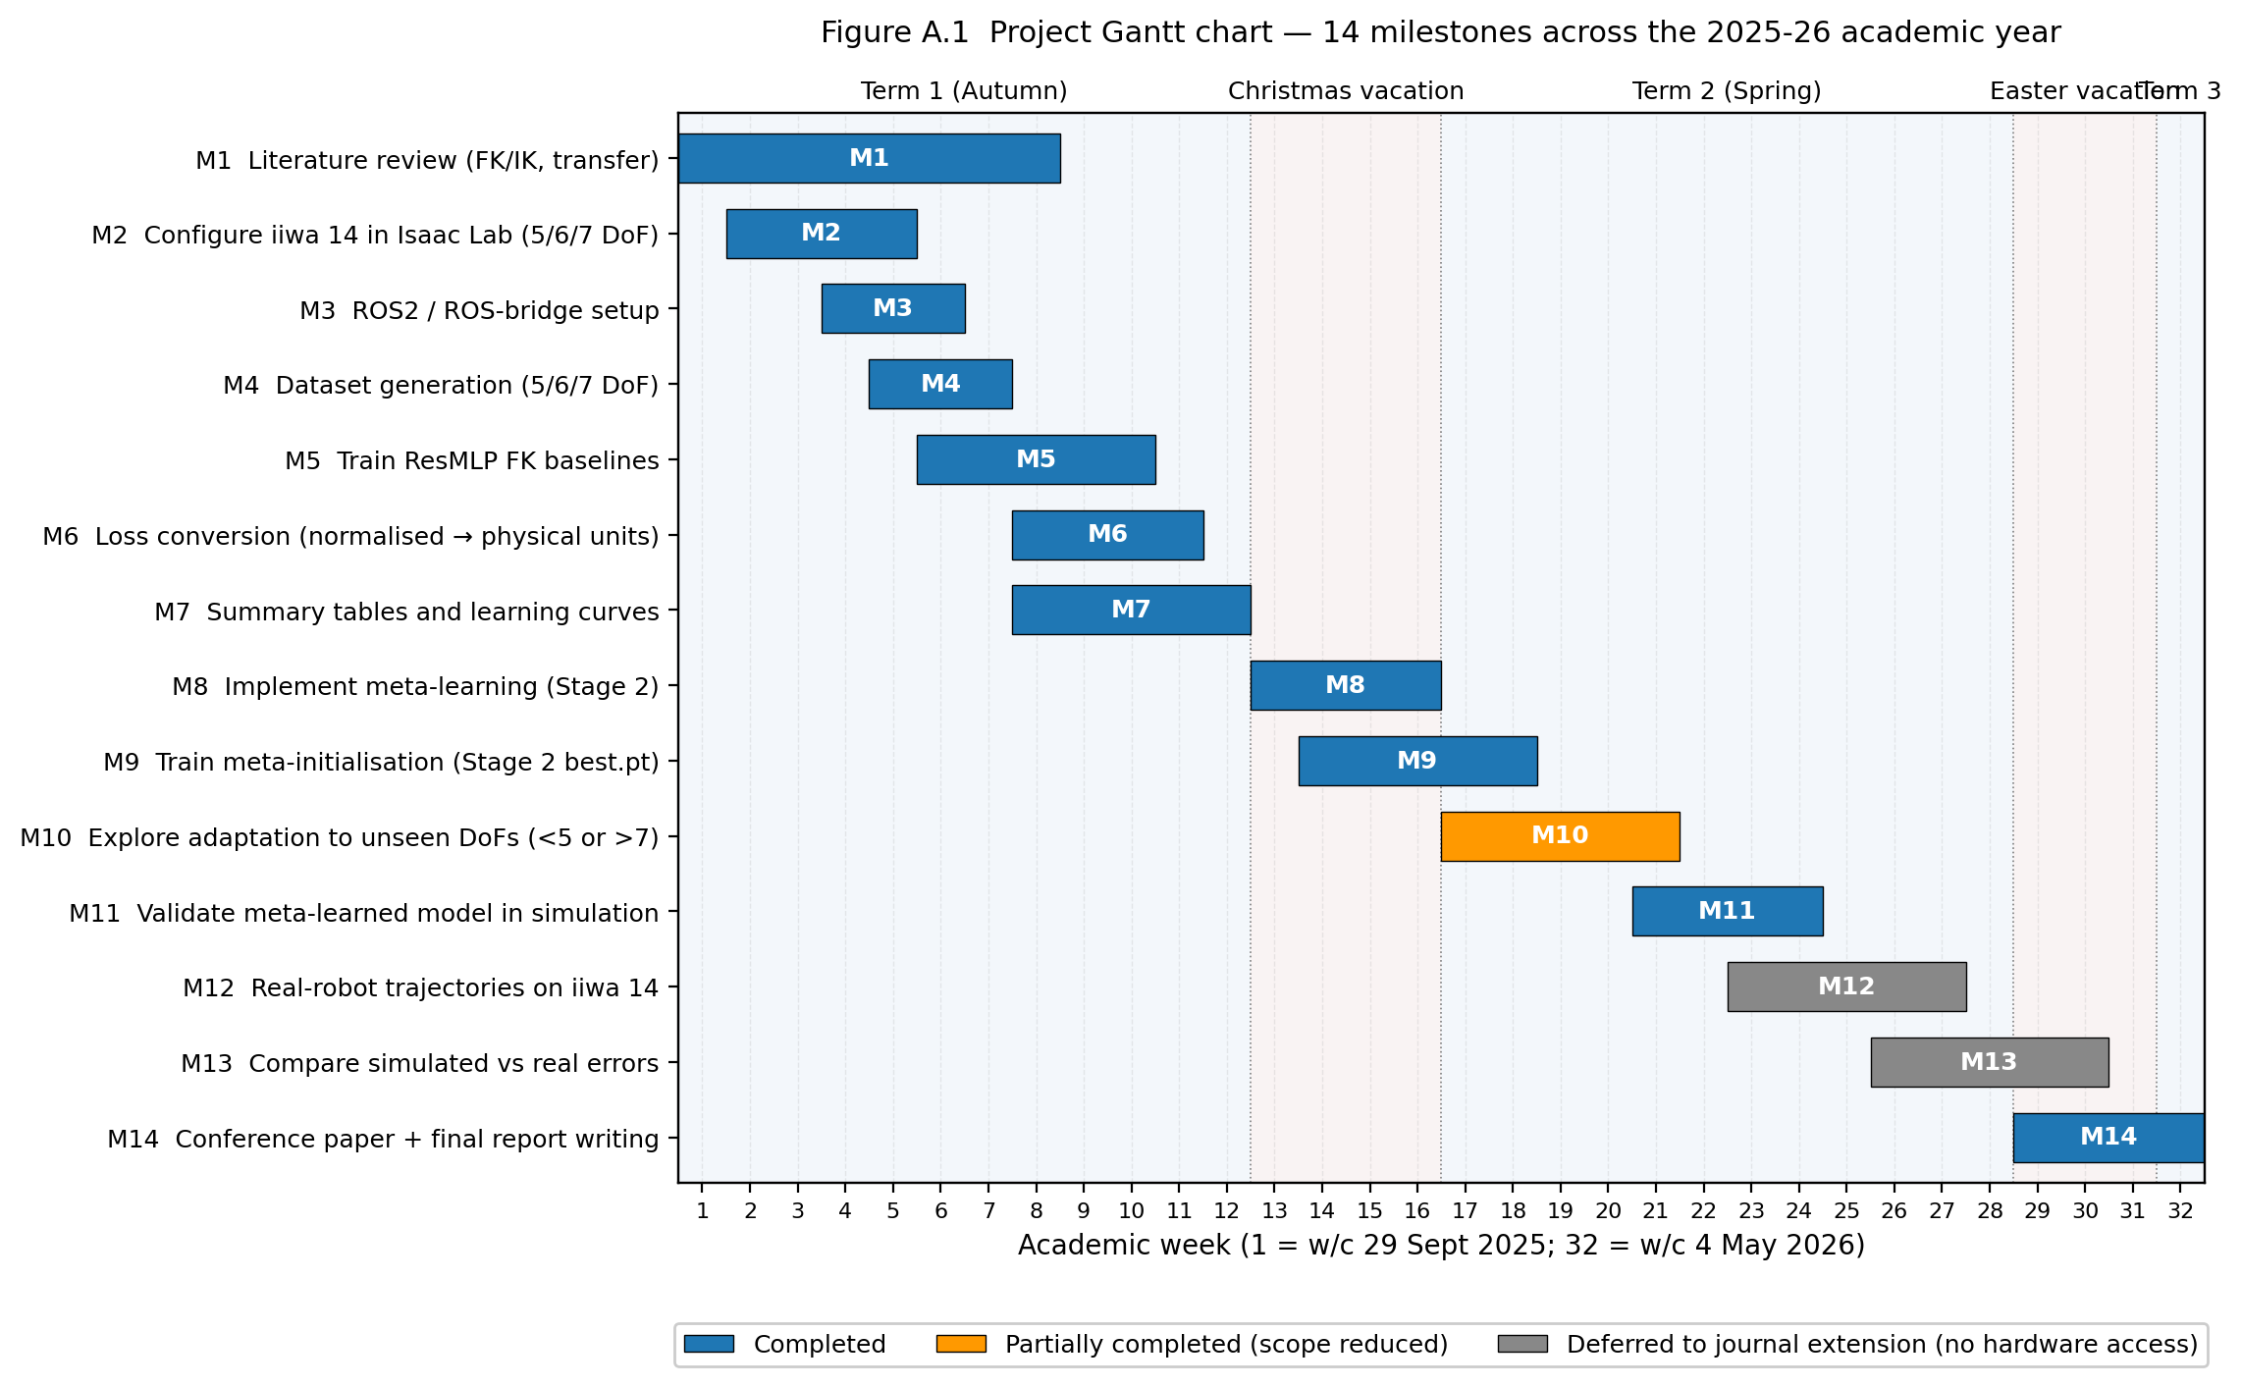
Figure A.1 Project Gantt chart showing the 14 main milestones across the academic year, with weekly granularity from late September through early May.

A.2 Milestones
Table A.1 Summary of project milestones and their academic-year week ranges.
# | Milestone | Weeks
1 | Review literature on FK/IK, redundancy, kinematics and skill transfer | wk1–wk8
2 | Configure the KUKA iiwa 14 in Isaac Lab in 5, 6 and 7 DoF settings | wk2–wk5
3 | Set up the ROS2 / ROS bridge environment and connect to the iiwa model | wk4–wk6
4 | Generate grid datasets for 5, 6 and 7 DoF configurations | wk5–wk7
5 | Train residual MLP FK and IK models for 5, 6 and 7 DoF using the generated datasets | wk6–wk10
6 | Calculate and convert normalised loss into actual loss | wk8–wk11
7 | Prepare summary tables and learning curves | wk8–wk12
8 | Implement a model-agnostic meta-learning (MAML-style) algorithm | cv1–cv4
9 | Train a meta-initialisation that adapts quickly to each DoF | cv2–wk2
10 | Explore adaptation to unseen DoFs (<5 or >7) | wk1–wk5
11 | Validate the meta-learned model in simulation using the existing ROS2/bridge setup | wk5–wk8
12 | Execute low-speed trajectories on the real iiwa, logging joint states and end-effector pose | wk7–wk11
13 | Compare simulated and real errors | wk10–ev2
14 | Conference paper and final report writing | ev3–wk12

A.3 Plan adherence and rescoping
The project largely followed the plan illustrated in Figure A.1, with the simulation, single-task training, multi-task training and per-DoF adaptation milestones (1–9) completed in line with the timeline. Two adjustments are noted for transparency. First, the literature review (milestone 1) was extended into early winter to support the methodology chapter and the conference paper, which slightly compressed the available time for the optional unseen-DoF exploration in milestone 10. Second, milestones 12 and 13, execution of low-speed trajectories on the real iiwa and comparison of simulated and real errors, could not be completed because hardware access to the iiwa 14 was not available within the project timeline. These two milestones are accordingly carried over into the future-work section (Section 7.3), with the simulation-only deliverables completed in their place.

Appendix B Ethics Questionnaire
This appendix records the ethics self-assessment carried out at the start of the project. The signed Ethics Questionnaire form, completed in line with the School of Engineering procedure, has been submitted to Canvas alongside this report.

B.1 Summary of self-assessment
The project is a simulation-only computational study on a publicly documented manipulator model and uses no human or animal subjects, no personally identifiable data and no clinical material. The five standard School of Engineering ethics screening questions were therefore answered as follows:
# | Question | Answer
1 | Does the project involve human participants? | No
2 | Does the project involve identifiable personal data, including health or biometric data? | No
3 | Does the project involve animal subjects, animal-derived material, or fieldwork on protected ecosystems? | No
4 | Does the project involve hazardous materials, dangerous procedures, or activities that pose a non-trivial risk to participants or researchers? | No
5 | Does the project involve deception, covert observation, or any other potentially sensitive methodology? | No

Because all five answers are negative, the project was confirmed to fall under the lowest-risk category in the School’s ethics-screening procedure, and no further ethics application or external approval was required. The complete signed Ethics Questionnaire is attached separately to this submission.

Appendix C Risk Assessment
This appendix summarises the risk assessment carried out at the start of the project, in line with the School of Engineering risk-assessment procedure. The full signed Risk Assessment form has been submitted to Canvas alongside this report. The summary below covers the principal hazards identified, their associated controls and the residual risk rating after controls are applied.

C.1 Hazard summary
Table C.1 Summary of principal hazards, controls and residual risk.
Hazard | Possible harm | Controls | Residual
Prolonged seated computer work | Postural strain, eye fatigue | Adjustable chair and screen height; regular breaks every hour; 20-20-20 rule for eye strain. | Low
High-intensity GPU workstation use | Heat build-up, cable trip hazard, electrical fault | Operate equipment in a well-ventilated University facility; secure cables; PAT-tested equipment only; do not service hardware unsupervised. | Low
Lone-working in computing labs (out-of-hours) | Personal safety, slow response in case of incident | Avoid out-of-hours lone working; use buddy system; carry mobile phone; follow building access procedure. | Low
Working with simulation data only (no real robot) | Misinterpretation of simulator output | Document simulator assumptions and limitations; sanity-check against analytical kinematics on a known pose. | Low
Manual handling of laptop/peripherals | Strain or drop injury | Use of suitable bag for transport; avoid carrying with one hand. | Low
Display ergonomics and lighting | Headache, fatigue | Use of dedicated workstation with appropriate lighting; brightness adjustment; regular breaks. | Low
Cybersecurity / data integrity | Loss of project files, code or results | Use of University Git infrastructure for code; cloud backup of datasets; encrypted laptop with password protection. | Low

Because the project is simulation-only and does not involve interaction with the physical KUKA iiwa 14, the high-energy hazards typically associated with industrial-robot work, collision, pinch points, end-effector force, were explicitly out of scope and were therefore not assessed in detail. If the project is extended to real-robot validation in a future phase (Section 7.3), the risk assessment will need to be updated to cover lab-based operation of the iiwa 14, in line with the laboratory-specific procedures of the School of Engineering.

Appendix D Statement on Generative AI

D.1 Declaration
In line with the School of Engineering policy on the use of generative AI in student work, this appendix records the use of generative AI tools in the preparation of this Final Year Project.

D.2 Tools used
The table below lists the generative AI tools used during the project, what each was used for and the approximate frequency of use. All AI-assisted material was reviewed, edited and verified by the author, and the underlying research data, results and conclusions are entirely the author's own work.
Table D.1 Generative AI tools used in the preparation of this report.
Tool | Used for | Frequency
Claude Code (Anthropic) | Audited the training scripts against the codebase to find places where the report's methodology description had drifted from what the code actually does; proposed and ran the data-size, multi-seed and t-SNE experiments; rendered figures including the pipeline diagram, the architecture diagram, the training and data-efficiency curves and the multi-seed reproducibility plot; rewrote Section 6.3 in response to supervisor feedback. All output was checked, edited and verified before inclusion in the report. | Heavy use in the final week of report preparation
ChatGPT (OpenAI) | Occasional explanation of meta-learning concepts during the literature review; sanity-checking quaternion-distance and SE(3) algebra. | Occasionally
GitHub Copilot | Inline code completion while writing the PyTorch training and adaptation scripts. | Regularly during implementation

D.3 What AI was not used for
To make the boundary explicit, the following components of the project are entirely the author’s own work and were not produced by generative AI:
- The research design, including the choice of meta-kinematics formulation, the three-stage pipeline and the experimental protocol.
- The implementation of the simulation pipeline in Isaac Lab, the dataset generation and the training and adaptation code.
- The numerical results reported in Chapter 5 and the figures derived from them.
- The interpretation of the results, the engineering judgements made in the discussion and the future-work plan.

Where AI tools were used to draft text, the output was treated as a starting point and was reviewed, rewritten and verified by the author before inclusion. Where AI tools were used to assist with debugging or formatting, the resulting code or document content was tested and validated by the author.

Appendix E Implementation Details

E.1 Architecture configuration
This appendix records the architecture, training configuration and reproducibility details of the meta-kinematics framework. Values that are common to all three training stages are listed in Table E.1; per-stage values for learning rate, batch size and step count are listed separately in Table E.2 because they differ between Stage 1 (single-task), Stage 2 (shared meta-kinematics) and Stage 3 (per-DoF adaptation).
Table E.1 Architecture and shared training parameters for the meta-kinematics ResMLP.
Parameter | Value
Input dimension (n_max) | 7
Output dimension | 7 (3 position + 4 quaternion)
Hidden dimension | 1024
Number of residual blocks | 8
Activation | ReLU
Regularisation (each residual block) | Dropout (p = 0.1) between the two linear layers; no LayerNorm or BatchNorm
Quaternion normalisation | Unit-norm projection on output
Optimiser | Adam (β₁ = 0.9, β₂ = 0.999, ε = 1×10⁻⁷ in adaptation, default ε in Stages 1–2)
Position-loss weight λ_p | 0.03 (Stages 1–2); 1.0 (Stage 3 adaptation)
Orientation-loss weight λ_o | 0.03 (Stages 1–2); 0.30 (Stage 3 adaptation)
Weight decay | 1×10⁻⁵ (Adam L2, Stage 1); 0 (Stage 2); 1×10⁻⁶ L2-to-init (Stage 3 adaptation)
Mask conditioning | Inactive joints zero-clamped at the input; binary active-joint mask additionally projected into the hidden space by a learned, zero-initialised linear layer (Stages 2–3)
Train / held-out split | Per-DoF held-out test split (sample-disjoint from training)
Joint-noise floor (IK target standardisation) | std_floor_q = 1.0° equivalent. Not used in FK, the work reported here is FK only
Hardware | Single NVIDIA GPU; Isaac Lab Python environment (TF32 enabled)
Software stack | PyTorch [14], Isaac Lab [13], CUDA, Python 3.10
Random-seed handling | Seed 42 for Stages 1 and 2; seeds {42, 1, 2} (n = 3) for the Stage 3 multi-seed Adapted (best) row of Table 5.1; see Appendix E.3

E.2 Per-stage training configuration
Table E.2 lists the learning rate, batch size and total step / epoch count used at each of the three training stages. Wall-clock times are from the runs that produced the headline numbers in Table 5.1.
Table E.2 Per-stage training configuration. Step counts and wall-clock times are from the runs that produced the headline numbers in Table 5.1.
Parameter | Stage 1 (single-task) | Stage 2 (shared meta) | Stage 3 (adaptation)
Initial learning rate | 5 × 10⁻⁴ | 3 × 10⁻⁴ | 1 × 10⁻⁵
LR schedule | ReduceLROnPlateau (factor 0.5, patience 10) | Cosine, linear warmup of 2 000 steps | Constant
LR minimum | (set by plateau decay) | 1 × 10⁻⁵
Batch size | 8 192 | 4 096 | 8 192
Total steps | Up to 200 epochs (early-stopped on val loss plateau) | 300 000 (best at step 289 500) | 100 000
Support / query size | n/a (50/20/30 train/val/test split) | n/a | 50 k support / 2 M query
Gradient clipping (max norm) | 1.0 | 1.0 | 1.0
Weight decay / L2 | 1 × 10⁻⁵ (Adam L2) | 0 | 1 × 10⁻⁶ (L2-to-init regulariser)
Wall-clock time (5 DoF) | 1.873 hr | 1.159 hr (shared) | 0.365 hr
Wall-clock time (6 DoF) | 4.973 hr | 1.159 hr (shared) | 0.363 hr
Wall-clock time (7 DoF) | 22.12 hr | 1.159 hr (shared) | 0.111 hr
Random seed | 42 | 42 | {42, 1, 2} (n = 3)

E.3 Statistical methodology
The single-task and shared meta-kinematics results in Chapter 5 are reported from runs initialised with the fixed random seed value 42, which controls parameter initialisation, dataset shuffling and minibatch sampling. The Adapted (best) row of Table 5.1 is reported as a sample mean ± standard deviation over n = 3 seeds (seeds 42, 1 and 2), with two-sided 95 % confidence intervals computed from a Student’s t-distribution with df = 2 (see Section 5.4). The dataset itself is fixed by the procedure of Section 4.3 and is identical across runs; the seed therefore controls only the stochastic components of training. The single-seed protocol used for Stages 1 and 2 is sufficient to characterise the qualitative pattern of results, the shared-and-adapt strategy outperforms the single-task baseline on the 5- and 6-DoF configurations, but does not provide a measure of seed-level variance for those upstream stages. The seed budget for Stages 1 and 2 is identified in Section 6.4 as a limitation of the study and as the first item in the planned journal extension (Section 7.3), where five seeds per condition will be used together with held-out bootstrap 95 % confidence intervals.
Seeds used: 42 for Stages 1 and 2; {42, 1, 2} for the Stage 3 multi-seed Adapted (best) row of Table 5.1. Seeds are set via torch.manual_seed, numpy.random.seed and random.seed at the start of every training script.

E.4 Loss-function and training-loop pseudocode
Listing E.1 Squared geodesic-angle term used inside the Stage-3 adaptation loss (3.3b).
def quat_geodesic_loss_rad2(r_hat, r, eps=1e-7):
# r_hat, r: (B, 4) tensors in (qw, qx, qy, qz) order.
# Sign-invariant geodesic angle (radians), squared and averaged.
r_hat = r_hat / r_hat.norm(dim=1, keepdim=True).clamp_min(eps)
r = r / r.norm(dim=1, keepdim=True).clamp_min(eps)
dot = (r_hat * r).sum(dim=1).abs().clamp(eps, 1.0 - eps)
ang = 2.0 * torch.acos(dot) # in [0, pi]
return (ang ** 2).mean() # used inside the Stage-3 loss (3.3b)

Listing E.2 Residual block used inside the ResMLP backbone of Figure 3.2(a).
class ResBlock(nn.Module):
def __init__(self, dim: int = 1024, p_drop: float = 0.1):
super().__init__()
self.fc1 = nn.Linear(dim, dim)
self.fc2 = nn.Linear(dim, dim)
self.act = nn.ReLU()
self.drop = nn.Dropout(p_drop)

def forward(self, x):
h = self.act(self.fc1(x))
h = self.drop(h)
h = self.fc2(h)
return self.act(h + x) # ReLU after additive skip

Listing E.3 Multi-task minibatch sampler used for Stage 2 (shared meta-kinematics) training.
def multitask_step(model, task_loaders, optimizer, mse):
# One Stage-2 optimisation step on a uniformly-sampled DoF configuration.
tname = random.choice(list(task_loaders.keys())) # 5dof / 6dof / 7dof
x, y, mask = next(task_loaders[tname]) # already per-task standardised
yhat = model(x, mask)
loss = mse(yhat, y) # MSE on standardised pose
optimizer.zero_grad(); loss.backward(); optimizer.step()
return tname, loss.item()

E.5 Reproducibility checklist
The framework is designed to be reproducible from the project repository. Reproducibility is supported by three measures. The dataset generation is fully scripted within the Isaac Lab Python environment, so a given random seed and sampling step size produce a deterministic dataset for each DoF configuration. The training pipeline records training loss, validation loss and held-out test metrics at every stage, so the curves in Figures 5.1 and 5.2 can be regenerated from the saved logs. The ResMLP backbone, the multi-task loss and the per-DoF adaptation routine are implemented as small, self-contained PyTorch modules that can be exercised in isolation; this isolates the meta-kinematics behaviour from the surrounding simulation code and makes the training loop independently testable.
The following items are provided in the project repository to support independent reproduction of the results:
- Training scripts for Stages 1, 2 and 3 with all hyperparameters logged to the run configuration.
- Dataset-generation scripts for the 5, 6 and 7 DoF KUKA iiwa 14 configurations in Isaac Lab.
- Held-out test splits and the deterministic split index used in this report.
- Saved checkpoints for the single-task, shared meta-kinematics and per-DoF adapted models.
- Per-step training-loss logs sufficient to regenerate Figures 5.1 and 5.2.
- Per-sample held-out errors used to compute Table 5.1, supporting independent re-evaluation and bootstrap-CI computation.

E.6 Data availability
The simulated datasets used in this study were generated from the publicly available KUKA iiwa 14 URDF supplied with Isaac Lab. The datasets and the trained model checkpoints are available from the author on reasonable request, subject to the file-size limits of the University’s research data repository. The exact commit hash, environment lock file and run configuration used for each result reported in this document are listed in the project README and quoted at the head of every saved log file, so that any single result can be traced back to the run that produced it.

