ELECTRONIC, ELECTRICAL & SYSTEMS ENGINEERING

BEng Final Year Project (EE3P)

Chissanupong Saengsint
2881058

Learning and Transfer of Robot Forward Kinematics Across Varying Degrees of Freedom

Supervised by Dr Yongjing Wang

Project Self Assessment

Checklist: Put a “Y” in the column which corresponds to your assessment of our own ability
Category | I find this very difficult | I find this a bit difficult | neutral | I find this fairly easy | I find this very easy
Ability to work independently |  |  |  | Y
Ability to manage my time |  | y
Ability to learn new skills or concepts in depth |  | Y
Ability to learn new concepts or skills quickly |  |  | Y
Ability to focus on targets |  |  |  | Y
Ability to apply things that I have learned |  |  | Y
Ability to understand the implications of results and findings |  | Y
Ability to draw conclusions |  | Y

Comment on your self-assessment checklist. To obtain full marks you must explain the reasons why you selected particular columns for each of your ability criteria.

Working independently became one of my main strengths during the year. After the Isaac Lab pipeline and training framework were set up, I was able to run and adjust experiments with less guidance. I managed overnight data generation, TensorBoard tracking, and organised run directories by myself, which is why I rated this skill as easy.
Time management was where I most clearly underestimated myself at the start. The project's training budget turned out to be the dominant constraint: a single 7-DoF Stage-1 run takes around 22 hours on the GPU; the shared Stage-2 model trains for 300,000 steps over multiple hours; and each Stage-3 adaptation, although short individually, was repeated dozens of times across seeds, K values and ablation conditions. I had originally scheduled experiments as if each were a single afternoon's work; within a few weeks it was clear I needed to overlap data generation with training, queue jobs overnight in tmux to survive SSH disconnects, and trade depth-of-search per seed for breadth-across-conditions. I rated this 'a bit difficult' because the discipline only crystallised once I had been bitten by it; starting again I would write the experiment matrix first and treat per-run wall-clock as a hard constraint from week one.
Learning new skills in depth and understanding the implications of results were both very difficult, and the clearest lesson came from my early loss formulation. In the first version of the adaptation script I combined position and orientation error into a single mean-squared loss, treating both as numerical quantities to minimise. My supervisor, Dr Yongjing Wang, pointed out that this conflates quantities with fundamentally different physical units (metres versus degrees) and different scales, so a 'better' overall loss could mask a worse position result behind an improved orientation one, or vice versa. I separated the components in Equation 3.3b with explicit per-component weights and adopted the geodesic-angle orientation loss, and as a result every section in Chapter 5 reports position and orientation independently. Without that intervention I would have presented a misleading picture of the framework's actual performance, and the experience taught me to be sceptical of any aggregate metric whose components have heterogeneous units.
Reasoning about a 95 % confidence interval at n = 3 only became real once I had run the seeds and seen how wide the 7-DoF interval was. Drawing conclusions then felt 'a bit difficult' because I had to actively resist leading with seed 42's headline 7-DoF numbers: my multi-seed data did not support a strong outperformance claim there, and writing the discussion required restraint. Picking up new concepts quickly, focusing on targets and applying what I had learned were each 'a bit difficult' because the project required holding several moving parts in mind at once, simulator, dataset, model, evaluation, and context-switching between them was costly.

What aspects of your project did you enjoy and or went well (up to 50 words) | Setting up Isaac Lab and watching one shared model handle the 5-, 6- and 7-DoF configurations of the iiwa 14 confirmed the meta-learning idea was actually working. Bringing 7-DoF training time from about 22 hours to under seven minutes per per-DoF adaptation was the real payoff.
What aspects of your project did you find difficult or would you change (up to 50 words) | Getting comfortable with the meta-learning literature took longer than expected, and quaternion-space orientation error was unfamiliar at first. Real robot validation had to be scoped out due to no hardware access. My main regret is not running multi-seed evaluation across all three pipeline stages from the start.

Abstract
Analytical forward kinematics must be re-derived whenever the active degrees of freedom (DoF) of a robot change, limiting its reuse across closely related configurations of the same arm. This project presents a meta-kinematics framework that learns a shared forward-kinematics representation across multiple DoF configurations of one robot and adapts it rapidly to each target configuration through a short fine-tuning stage. The framework is studied on the KUKA iiwa 14 in 5, 6 and 7 DoF settings using datasets generated in Isaac Lab, with a residual MLP backbone trained jointly across all three configurations via a learned binary-mask projection that allows one model to handle multiple active-DoF counts.
On held-out test data, the shared meta-kinematics model achieves position errors from 0.0068 m to 0.0109 m and orientation errors from 0.91° to 2.00° across the three configurations. Per-DoF adaptation further reduces these errors and, for the 5- and 6-DoF cases, statistically outperforms the single-task baseline at p < 0.05 (paired Student's t-test over n = 3 random seeds). For the 7-DoF case, the multi-seed mean is statistically equivalent to the single-task baseline (95 % CI of the adapted mean encompasses the baseline), but the meta-kinematics framework reaches this accuracy in 0.111 hr versus 22.12 hr for single-task training, a 200× wall-clock advantage at no statistically significant accuracy cost. Across the three configurations, adaptation reduces training time by 80.5 %, 92.7 % and 99.5 % respectively while maintaining or improving accuracy.

Keywords: forward kinematics, meta-learning, transfer learning, residual neural networks, robot manipulators, KUKA iiwa 14.

Acknowledgements
I would like to express my sincere gratitude to my project supervisor, Dr Yongjing Wang, for his guidance, technical insight and continued support throughout the development of this project. His feedback at every stage, from problem formulation through to the experimental evaluation and write-up, has been invaluable in shaping both the framework presented here and my own engineering judgement.
I am equally grateful to Dr Feiying Lan, researcher and project leader of STAMAN within Dr Wang’s research group, for the many hours of practical advice on the simulation environment, dataset design and model implementation. The discussions we had on the meta-learning formulation and the choice of evaluation metrics directly improved the quality of this work.
I would also like to thank the staff and members of the School of Engineering at the University of Birmingham for providing the resources and academic environment that made this work possible, and my family and friends for their patience and encouragement over the course of the year.

Table of Contents
Contents
Declaration of authorship i
1 Introduction 1
1.1 Background and motivation 1
1.2 Problem statement 1
1.3 Aims and objectives 2
1.4 Scope and limitations 2
1.5 Report structure 3
2 Background and Related Work 4
2.1 Classical forward kinematics 4
2.2 Learning-based kinematic models 4
2.3 Transfer across robots and tasks 5
2.4 Meta-learning for fast adaptation 5
2.5 Position of this work 5
3 Methodology 6
3.1 Problem formulation 6
3.2 Joint representation across DoF configurations 6
3.3 Shared ResMLP backbone 6
3.4 Three-stage learning and adaptation pipeline 9
Stage 1: Single-task initialisation 9
Stage 2: Shared meta-kinematics training 9
Stage 3: Per-DoF adaptation 10
3.5 Loss function 10
4 Implementation 11
4.1 Simulation platform: Isaac Lab 11
4.2 Robot model: KUKA iiwa 14 11
4.3 Dataset generation 11
4.4 Software stack and training infrastructure 12
4.5 Evaluation protocol and metrics 13
4.6 Statistical methodology and reproducibility 13
5 Results 15
5.1 Single-task forward-kinematics baselines 15
5.2 Shared meta-kinematics model 16
5.3 Per-DoF adaptation 17
5.4 Comparative analysis 17
5.5 Training-cost analysis 20
5.6 Ablation studies 23
5.6.1 Ablation A, Warm-start contribution to shared training 23
5.6.2 Ablation B, Shared-representation contribution to adaptation 24
6 Discussion 25
6.1 Interpretation of the results 25
6.2 Engineering implications 27
6.3 Comparison with prior work 28
6.4 Limitations 30
7 Conclusions and Future Work 31
7.1 Summary of contributions 31
7.2 Achievement of the project aims 31
7.3 Future work 32
References 32
Appendix A Project Management 34
A.1 Project plan 34
A.2 Milestones 34
A.3 Plan adherence and rescoping 35
Appendix B Ethics Questionnaire 36
B.1 Summary of self-assessment 36
Appendix C Risk Assessment 37
C.1 Hazard summary 37
Appendix D Statement on Generative AI 39
D.1 Declaration 39
D.2 Tools used 39
D.3 What AI was not used for 39
Appendix E Implementation Details 41
E.1 Architecture configuration 41
E.2 Per-stage training configuration 42
E.3 Statistical methodology 43
E.4 Loss-function and training-loop pseudocode 43
E.5 Reproducibility checklist 44
E.6 Data availability 45

List of Figures
Figure 3.1 Meta-kinematics pipeline: per-DoF single-task training supplies checkpoints that initialise a shared meta-kinematics model, which is then adapted to each target DoF. 11
Figure 3.2 Meta-kinematics ResMLP architecture. (a) Shared backbone with input projection, eight residual blocks of width 1024 and a position/quaternion output head. (b) Three-stage learning and adaptation pipeline reusing the same backbone. 12
Figure 4.1 Isaac Lab simulation environment used for dataset generation and forward-kinematics evaluation of the KUKA iiwa 14. 13
Figure 5.1 Single-task forward-kinematics training curves for 5, 6 and 7 DoF configurations. 17
Figure 5.2 Stage-2 shared meta-kinematics training: per-DoF training loss and held-out eval loss with BEST step. 18
Figure 5.3 Position error per DoF configuration across single-task, shared and adapted models. 20
Figure 5.4 Orientation error per DoF configuration across single-task, shared and adapted models. 20
Figure 5.5 Wall-clock training time per DoF configuration across single-task, shared and adapted models. 21
Figure 5.6 Stage-3 adaptation convergence on the held-out query split for each DoF configuration. 22
Figure 5.7 Data-efficiency curves for per-DoF adaptation, linear support-set-size axis (5/6/7-DoF; K = 1 000 to 120 000). 22
Figure A.1 Project Gantt chart showing the planned and realised FYP timeline. 29
Figure E.7 Multi-seed reproducibility of the per-DoF adaptation result (n = 3 seeds 42, 1, 2). 32

List of Tables
Table 4.1 Dataset configuration for single-task forward kinematics. 15
Table 5.1 Comparison of forward-kinematics accuracy and training time across single-task, shared meta-kinematics and adapted meta-kinematics models. 20
Table 5.2 Training-time reductions for the adapted meta-kinematics model relative to the single-task baseline. 21
Table 5.3 Ablation B: per-DoF adaptation from the shared meta-kinematics model versus from random initialisation, matched to the same wall-clock budget. 22
Table A.1 Summary of project milestones and their academic-year week ranges. 32
Table E.1 Architecture and shared training parameters for the meta-kinematics ResMLP. 36
Table E.2 Per-stage training configuration. 37

List of Abbreviations
DoF | Degree of Freedom
FK | Forward Kinematics
IK | Inverse Kinematics
MLP | Multilayer Perceptron
ResMLP | Residual Multilayer Perceptron
MAML | Model-Agnostic Meta-Learning
RMSE | Root-Mean-Square Error
ReLU | Rectified Linear Unit
LR | Learning Rate
GPU | Graphics Processing Unit
URDF | Unified Robot Description Format
ROS | Robot Operating System
SE(3) | Special Euclidean group in three dimensions (rigid-body pose)

1 Introduction

1.1 Background and motivation
Forward kinematics is the mapping from a robot’s joint variables to the pose of its end-effector and is one of the foundational components of robot modelling, planning and control [1]. For a serial manipulator, the analytical formulation derives this mapping directly from the geometry of the kinematic chain and is widely regarded as both accurate and interpretable. Its main limitation is that the mapping is tightly bound to a specific kinematic structure: whenever the number of active joints, or the set of degrees of freedom (DoF), changes, the analytical chain must be re-derived and any downstream component that depends on the kinematic mapping must be reconfigured.
This rigidity has practical consequences in modern robotics. The same physical arm may need to be operated in different DoF configurations: distal joints can be locked to constrain a task to a smaller workspace, a joint can be effectively disabled because of fault or self-collision, or a redundant joint can be reserved for a secondary objective. In each of these cases, the active DoF count and the effective kinematic chain are different from the nominal configuration. Treating each as an independent forward-kinematics problem leads to a proliferation of bespoke models, each requiring derivation, calibration and validation.
Data-driven forward kinematics offers a more flexible alternative. Neural networks have been shown to approximate kinematic mappings effectively for manipulators of varying scale [2], [3], and recent architecture-aware approaches embed kinematic structure directly into the network, for example through transformation-matrix and dual-quaternion representations [4]. Separately, the transfer-learning and meta-learning communities have demonstrated that shared structure can be exploited across related embodiments and tasks [5]–[6]. The combination of these two trends suggests that a single learned forward-kinematics model could absorb the structure that is common to multiple DoF configurations of the same robot and be adapted rapidly to each individual configuration. It is this question that the present project addresses.

1.2 Problem statement
The central problem investigated in this project is whether a single learned model can represent forward kinematics across multiple DoF configurations of the same robot, and whether short per-configuration adaptation is sufficient to recover task-specific accuracy at a small fraction of the cost of training each configuration from scratch. Two coupled sub-problems follow from this. The first is representational: the input dimensionality and effective kinematic chain differ between the 5-, 6- and 7-DoF settings, so the model must accept a unified input format that is consistent across configurations while still being faithful to each. The second is procedural: a learning and adaptation scheme is required that can produce a transferable shared model from per-configuration baselines and then adapt it to each target DoF in much less time than re-training from random initialisation.

1.3 Aims and objectives
The project takes the four aims declared on the project poster as its overall goals:
- Develop accurate forward-kinematics models for the 5, 6 and 7 DoF configurations of the KUKA iiwa 14 manipulators.
- Build one shared multi-task forward-kinematics model that covers all three configurations.
- Test whether per-DoF adaptation improves the shared model relative to single-task baselines.
- Compare forward-kinematics performance across the three DoF settings with respect to position accuracy, orientation accuracy and training cost.
These aims are complemented by a set of supporting objectives that drive the engineering work: design of a unified joint representation that is shared across DoF configurations; specification of a residual multilayer perceptron (ResMLP) backbone of sufficient capacity to support all three configurations; design of a three-stage training pipeline (single-task, shared meta-kinematics, per-DoF adaptation); generation of consistent simulated datasets in Isaac Lab; and quantitative evaluation in terms of position root-mean-square error (RMSE) in metres, orientation error in degrees and wall-clock training time in hours.
The contributions, demonstrated in Chapters 5 and 6, are: (C1) a meta-kinematics framework for cross-DoF transfer of forward kinematics on a single robot; (C2) a three-stage learning pipeline (single-task initialisation → shared meta-kinematics → per-DoF adaptation) that reduces the wall-clock cost of producing per-DoF FK models by 80.5 %, 92.7 % and 99.5 % for the 5-, 6- and 7-DoF cases of the KUKA iiwa 14; (C3) mask conditioning, a learned, zero-initialised additive projection of the binary active-joint mask into the hidden space, allowing one trained model file to be valid for all three DoF configurations without an architectural switch; (C4) a multi-seed statistical evaluation establishing significant improvement over the single-task baseline on 5- and 6-DoF at p < 0.05; and (C5) the empirical observation that data-efficiency of meta-kinematics adaptation scales with the active-DoF dimensionality of the target configuration.

1.4 Scope and limitations
The scope of the work is deliberately focused on a single physical platform, the KUKA iiwa 14, and on three DoF configurations of that platform, namely 5, 6 and 7 active joints. The motivation for this scoping is that it isolates the central research question (transfer across DoF configurations of the same robot) from the broader question of cross-robot transfer, which has been studied extensively in the policy and dynamics literature. All experiments are run in simulation, using datasets generated in Isaac Lab on the official iiwa 14 model. Real-robot validation, although clearly desirable, is treated as future work because hardware access to the iiwa 14 was not available within the project timeline; this limitation is discussed in Sections 6.4 and 7.3.

1.5 Report structure
The remainder of the report is organised as follows. Chapter 2 reviews classical and learning-based forward-kinematics modelling, transfer learning and meta-learning. Chapter 3 sets out the methodology: problem formulation, joint representation, ResMLP backbone, three-stage pipeline and loss function. Chapter 4 describes the implementation. Chapter 5 reports results. Chapter 6 discusses interpretation, engineering implications and limitations. Chapter 7 concludes and outlines future work.

2 Background and Related Work

2.1 Classical forward kinematics
Classical robot kinematics is typically formulated analytically from the geometry and joint structure of the manipulator [1]. Standard parameterisations such as the Denavit–Hartenberg convention express each link's pose as a homogeneous transformation, and the end-effector pose is recovered by composing the transformations along the chain. The strength of this formulation lies in its accuracy and interpretability: every parameter has a direct physical meaning, and the mapping is exact up to model and calibration error. Inverse kinematics, which inverts the mapping, is the more challenging direction and has motivated extensive numerical work including damped least-squares for redundant manipulators [7] and the operational-space formulation [8].
The corresponding weakness of analytical kinematics is its lack of reuse across kinematic structures. Whenever the active joints change, because a joint is locked, removed or added, the chain must be re-derived, and the same is true for any controller, planner or learning component that takes the kinematic mapping as input. For research and engineering settings in which several closely related configurations of the same robot must be supported, this rigidity becomes a practical bottleneck and motivates the search for more flexible, data-driven alternatives.

2.2 Learning-based kinematic models
Learning-based approaches to robot kinematics have been studied for a considerable time. Early work demonstrated that multilayer perceptrons could learn inverse kinematic mappings for manipulators with non-trivial geometry, providing evidence that nonlinear robot mappings can be represented effectively by learned models [2], [3]. Although much of this early work targeted inverse kinematics or task-specific trajectory tracking, the underlying observation that a learned function approximator can capture a robot’s kinematic mapping with engineering-grade accuracy carries over directly to the forward problem.
More recent work has begun to embed kinematic structure into the network itself. Diprasetya, Pöppelbaum and Schwung proposed KineNN, a transformation-aware architecture based on homogeneous transformation matrices and dual quaternions, which encodes rigid-body structure directly within the learning process [4]. Although the targets of this literature are often inverse kinematics, controller design or task-specific learning, the body of evidence is consistent: learned models are practical approximators of robot kinematics, and they benefit from geometrically informed architectural choices.

2.3 Transfer across robots and tasks
A parallel line of work studies transfer across robots and tasks. Devin et al. introduced modular neural-network policies that factor robot-specific and task-specific components, allowing zero-shot transfer to new combinations [5]. Chen, Murali and Gupta proposed hardware-conditioned policies that generalise across hardware configurations with different physical parameters and DoFs [9]. Beyond policy transfer, structured geometric methods such as SE3-Nets [10] and SE3-Pose-Nets [11] have shown that embedding rigid-body structure into learned models improves motion- and pose-related prediction tasks.
These studies support the broader view that shared structure across embodiments can reduce the need to train independent models from scratch, but their primary targets are policies, dynamics models or visuomotor control. The kinematic mapping itself, treated as a stand-alone learning problem with a clean input–outputs definition, has received less attention.

2.4 Meta-learning for fast adaptation
Meta-learning has been explored as a further step toward data-efficient transfer. Ghadirzadeh et al. proposed a Bayesian meta-learning framework for few-shot policy adaptation across robotic platforms, showing that transferable structure can be exploited to adapt to new hardware [6]. Although their setting is policy learning rather than kinematic modelling, the adaptation pattern is directly relevant: a shared parameterisation is established once across a family of related tasks, and a short fine-tuning stage produces task-specific behaviour with substantially fewer samples and less compute than learning each task in isolation. Earlier classical work on redundancy [8], [12] anticipates the same intuition in a model-based setting.

2.5 Position of this work
In contrast with the cross-platform policy and dynamics literature, the present project focuses on forward kinematics across related configurations of the same robot. Rather than cross-platform transfer, it asks whether a single shared kinematic representation can support the 5-, 6- and 7-DoF configurations of the KUKA iiwa 14, and whether short per-DoF adaptation can maximise the value of the learned kinematic structure by producing task-specific models cheaply. The study complements prior transfer- and meta-learning work by isolating the forward-kinematics component and studying its transferability as a stand-alone problem on one well-characterized manipulator.

3 Methodology

3.1 Problem formulation
Let $T = \{τ₁, τ₂, …, τ_{K}\}$ denote a set of DoF configurations of the same robot. For each configuration τ_k with n_k active joints, forward kinematics is the mapping
$f_{τk} : Rⁿᵏ → SE(3), q⁽ᵏ⁾ ↦ p⁽ᵏ⁾$ (3.1)
where q⁽ᵏ⁾ is the joint vector and p⁽ᵏ⁾ = [x, y, z, qw, qx, qy, qz] is the end-effector pose expressed as a position and a unit quaternion. In the classical setting, each fτₖ must be derived separately from the robot’s geometry.

3.2 Joint representation across DoF configurations
To expose shared structure across configurations, all inputs are lifted to a common, fixed-dimensional joint representation. Let $n_{max} = max_{k} n_{k}$ be the largest active-joint count among the configurations of interest; in the present study $n_{max}$ = 7. Each joint vector is embedded in $Rⁿ_{max}$ by clamping any joint that is inactive in $τ_{k}$ to its fixed value (zero in the present convention) so that a single input format is shared across all tasks. The meta-kinematics problem is then to learn a single parametric mapping
$f_{θ} : Rⁿ_{max} → SE(3)$ (3.2)
with parameters θ, such that $f_{θ}$ approximates $fτₖ$ well for every $τ_{k}$ ∈ $T$, and such that short task-specific adaptation producing θₖ from θ yields an accurate per-configuration model at a small fraction of the cost of training from scratch.

3.3 Shared ResMLP backbone
The backbone of $f_{θ}$ is a residual multilayer perception (ResMLP) with hidden dimension 1024 and eight residual blocks, illustrated in Figure 3.2(a). The ResMLP is chosen because both the input and the output are structured numeric vectors of moderate dimension, for which a fully connected architecture is appropriate, and because residual connections stabilise training in deeper networks and ease optimisation when the backbone must absorb information from multiple configurations simultaneously.
Each residual block applies a linear projection, a ReLU activation, dropout (p = 0.1) and a second linear projection, with the result added to the block’s input through a skip connection followed by a final ReLU. Intuitively, each block learns a small refinement of the running representation rather than the full mapping from joints to pose, which keeps gradient information flowing cleanly through eight stacked blocks during training. The output head produces seven values corresponding to the predicted position $\hat{t} ∈ R^{3}$ and the predicted quaternion $\hat{r} ∈ R^{4}$; the quaternion is unit-normalised before any geodesic-distance computation in the loss and the evaluation metrics, but the model output itself is not normalised in-graph.
In addition to the clamped joint vector, the model also receives the binary active-joint mask $m_{τ} ∈ {\left\{0,1\right\}}^{7}$ as an explicit auxiliary input that tells the network which DoF configuration the current sample belongs to. The mask is projected into the hidden space by a learned linear layer with no bias and added to the input projection of the joint vector, so that the residual blocks downstream see a task-shifted feature they can specialise around without changing any of their multiplicative parameters. The mask projection is initialised to zero, which preserves backward compatibility with non-mask-aware single-task checkpoints when they are used to warm-start the shared meta-kinematics model in Stage 2.
Inputs and targets are standardised per task before training, with each task’s joint and pose statistics computed from its own training data and stored alongside the checkpoint. Stages 2 and 3 use one and the same residual MLP backbone, denoted ResMLP_Mask, and Stage 3 fine-tunes the parameters that Stage 2 has produced. Stage 1’s per-configuration backbone shares the same residual-block stack but does not include the mask projection, because each Stage-1 model only ever sees one DoF setting and does not need to be conditioned on it. Stage-1 checkpoints are loaded into the Stage-2 backbone with strict=False: the residual-block weights are inherited, and the mask projection (which has no Stage-1 counterpart) is initialised to zero so that the Stage-2 model behaves identically to the warm-start Stage-1 model at the very first training step. This keeps the architecture simple while still supporting the meta-kinematics formulation of Section 3.1.
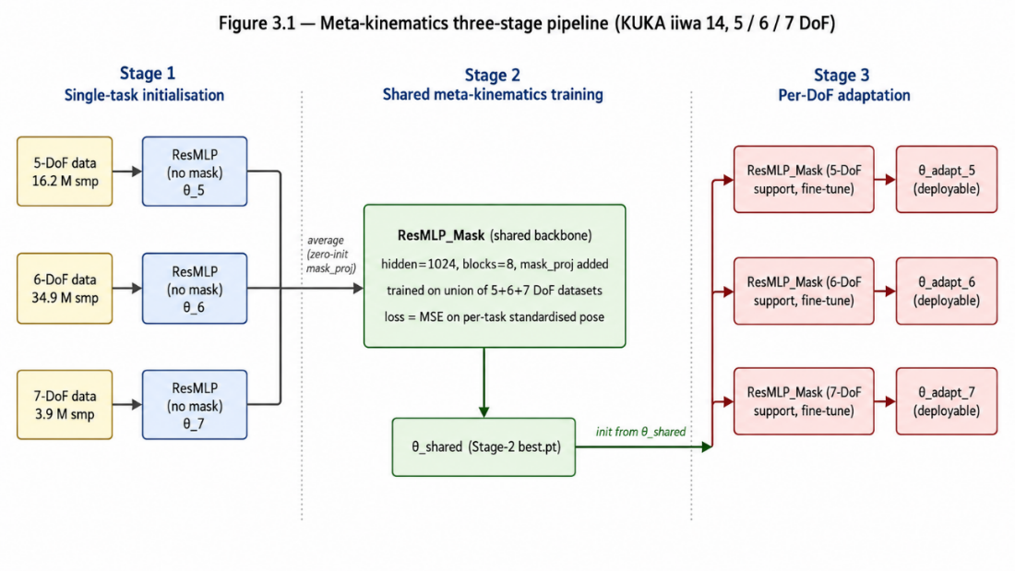
Figure 3.1 Meta-kinematics pipeline. Per-DoF single-task ResMLP training (Stage 1) supplies checkpoints that are averaged to initialise a shared ResMLP_Mask backbone (Stage 2), trained jointly on the union of the three datasets; the shared parameters are then fine-tuned on each DoF's support set in Stage 3 to produce the deployable per-DoF models.
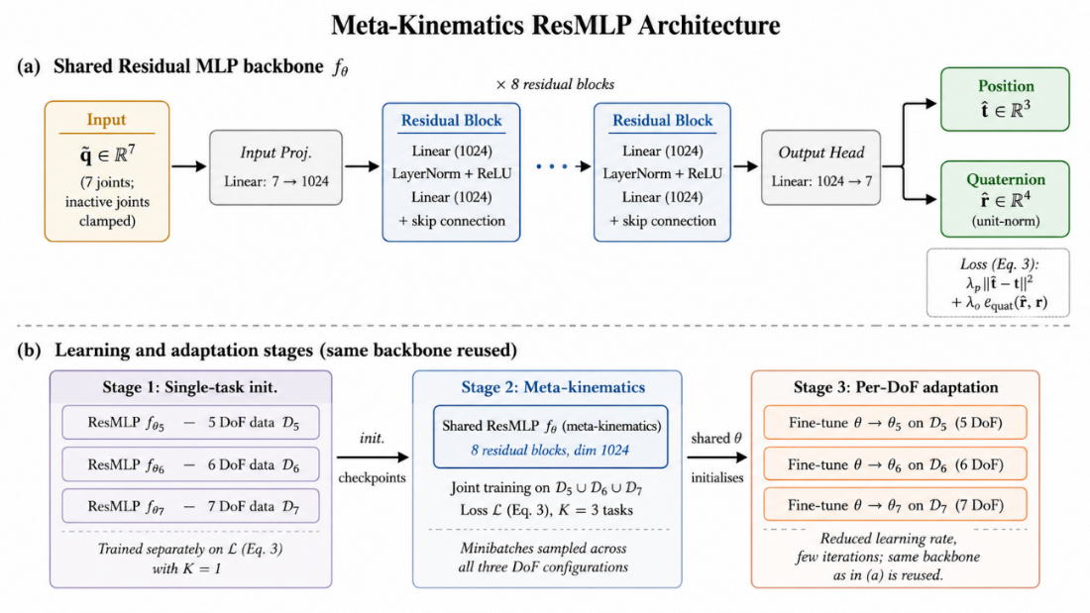
Figure 3.2 Meta-kinematics ResMLP architecture and training stages. Panel (a): shared backbone used by Stages 2 and 3, with joint vector q and active-DoF mask m_τ projected and added before eight residual blocks and a position+quaternion output head. Panel (b): the three-stage pipeline reusing the same backbone (Stage 1 single-task, Stage 2 joint multi-task, Stage 3 per-DoF adaptation).

3.4 Three-stage learning and adaptation pipeline
The strategy underlying the three stages is that the 5-, 6- and 7-DoF configurations share most of their kinematic structure, and that this shared structure can be captured by one set of parameters and then specialised cheaply per configuration. Stage 1 produces per-configuration starting points; Stage 2 produces the shared parameters; Stage 3 adapts them to each target DoF. The pipeline is summarised in Figure 3.1 and detailed in Figure 3.2(b).

Stage 1: Single-task initialisation
A separate ResMLP is trained for each DoF configuration using only that configuration’s dataset. These single-task models serve two roles: they establish task-specific baselines against which the meta-kinematics model is later compared, and their checkpoints provide strong initialisations that accelerate subsequent shared training. Training uses the loss in Equation (3.3) with K = 1.

Stage 2: Shared meta-kinematics training
The checkpoints from Stage 1 are merged to initialise one shared meta-kinematics model, which is then trained jointly on the union of the three datasets using the full multi-task objective (3.3). Task balancing is handled by sampling minibatches from all three training datasets during every training step, so that the model is pushed to explain all three configurations with a single set of parameters. This stage produces the shared θ that captures kinematic structure common to the 5, 6 and 7 DoF cases.

Stage 3: Per-DoF adaptation
Starting from the shared θ, a short fine-tuning run is performed on each target configuration’s dataset to produce $θ_{k}$. The full backbone is fine-tuned with a reduced learning rate and a small number of iterations relative to Stage 1 training, so that the adapted model specialises to the target DoF without discarding the shared structure. The adaptation stage is the step in which the meta-kinematics representation is converted into a deployable per-configuration model.

3.5 Loss function
The objective combines per-task regression losses on position and orientation,
$L⁽¹,²⁾(θ) = E_{q,p} \left[ \right\|f_{θ}(q) - p ‖^{2} ]$ (3.3a)
$L^{(3)}\left(θ\right)= λ_{p} E[ ‖ \hat{t} - t ‖² ] + λ_{o} E[ θ_{geo}(\hat{r}, r)² ]$ (3.3b)
Equation (3.3a) is the supervised objective used in Stages 1 and 2: a mean-squared error on the per-task standardised pose vector p = [t, r], minimised over the joint distribution of joint configurations and end-effector poses. Stage 1 uses a single task (K = 1); Stage 2 samples one of the K = 3 DoF configurations uniformly at each optimisation step. Equation (3.3b) is the Stage-3 adaptation objective, operating in raw physical units and weighting position and orientation explicitly. Here t and r are the un-standardised position and quaternion targets, t̂ and r̂ the model outputs, and $θ_{geo}(\hat{r}, r) = 2 arccos\left(\left|\left\langle \hat{r}, r\right\rangle \right|\right)$ the geodesic angle between unit-normalised quaternions in radians. Splitting the loss into raw-unit position MSE and squared geodesic angle allows the relative weight of position and orientation to be controlled in metres-and-degrees terms during fine-tuning.

4 Implementation

4.1 Simulation platform: Isaac Lab
All experiments were carried out in NVIDIA Isaac Lab [13], a GPU-accelerated robotics simulation framework built on Isaac Sim. Isaac Lab provides high-fidelity rigid-body simulation, native support for URDF-based robot definitions and a Python interface that integrates with the PyTorch [14] tensor ecosystem used for training. These properties made it possible to generate the joint–pose datasets directly within the same environment that the trained models would later be evaluated in, removing one source of mismatch between training data and evaluation conditions.
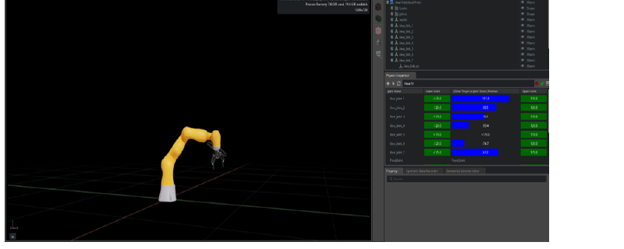
Figure 4.1 Isaac Lab simulation environment used for dataset generation and forward-kinematics evaluation of the KUKA iiwa 14.

4.2 Robot model: KUKA iiwa 14
The robot model used throughout the project is the KUKA LBR iiwa 14, a seven-axis collaborative manipulator with a 14 kg payload [15]. The iiwa 14 is configured in Isaac Lab in 5, 6 and 7 DoF settings by progressively fixing the distal joints while keeping the proximal ones active. Joints 1–7 are active in the 7 DoF setting, joints 1–6 in the 6 DoF setting with joint 7 fixed, and joints 1–5 in the 5 DoF setting with joints 6–7 fixed. All three configurations share the common input and output format $[q₁, …, q₇, x, y, z, q_{w}, q_{x}, q_{y}, q_{z}]$, which allows one model to be applied to all three tasks once inactive joints are clamped according to the convention introduced in Section 3.2.

4.3 Dataset generation
Datasets were generated in Isaac Lab by sampling joint configurations within a restricted workspace region rather than over the full mechanical joint limits, to focus on a practically relevant part of the configuration space. Sampling step sizes were $8°$ (5-DoF), 12° (6-DoF) and 15° (7-DoF), with each single-task dataset capped at 15 million samples. The step sizes were chosen so the higher-DoF datasets do not become orders of magnitude larger than the lower-DoF ones; this keeps the per-task training budget comparable across configurations and prevents the loss surface for the higher-DoF tasks from being dominated by sheer sample count.
Table 4.1 Dataset configuration for single-task forward kinematics.
Configuration | Active joints | Sampling step | Sample cap
5 DoF | 1–5 | 8° | 15 M
6 DoF | 1–6 | 12° | 15 M
7 DoF | 1–7 | 15° | 15 M

For each sampled joint configuration, the corresponding end-effector pose is computed from the simulator and stored as a position–quaternion pair, giving an [input, target] pair of the form ([q₁, …, q₇], $[x, y, z, q_{w}, q_{x}, q_{y}, q_{z}]$) once inactive joints are clamped. Inputs and targets are standardised across the dataset before training, and a held-out split of each dataset is reserved for evaluation. The held-out split is the only data on which the test metrics in Chapter 5 are reported; no part of the held-out split is seen during Stage 1, Stage 2 or Stage 3 training.

4.4 Software stack and training infrastructure
All models are implemented in PyTorch [14] using the ResMLP backbone described in Chapter 3. Standardisation is performed per task: each DoF configuration's joint and pose statistics are computed from its own training data and stored alongside the checkpoint. During Stage 2, training progress is monitored via a small quick-eval drawn from each task's data generator at every evaluation interval; the model with the lowest mean of the three quick-eval losses is preserved as the best checkpoint. Held-out test metrics reported in Chapter 5 are computed on a deterministic permutation subset of each DoF's dataset, disjoint from the support set used for adaptation; the same permutation seed is used for all three model variants, so Table 5.1 compares them on the same physical samples. Optimisation is performed with Adam [16]. Specific hyperparameter values for each stage are recorded in Appendix E.2.

4.5 Evaluation protocol and metrics
Evaluation uses two pose-error metrics on the held-out split of each configuration's dataset. The position error is reported as the mean Euclidean error in metres between the predicted and ground-truth end-effector positions, which has a direct physical interpretation as the average length of the position-error vector across the held-out split:
$E_{pos} = \left(\frac{1}{N}\right) Σᵢ ‖ t̂ᵢ - tᵢ ‖₂$ (4.1)
The orientation error is the mean geodesic angle between the predicted and ground-truth quaternions, reported in degrees so that errors are interpretable on the same physical scale used in industrial robot specifications: $E_{ori} = \left(\frac{1}{N}\right) Σᵢ 2 arccos\left(\left|\left\langle \hat{r}ᵢ, rᵢ \right\rangle \right|\right)\left(\frac{180}{π}\right)$. In addition to the two-error metrics, wall-clock training time is recorded for every model and every stage, in order to compare the cost of training a per-configuration model from scratch with the much shorter cost of adapting from the shared meta-kinematics initialisation. All three metrics, mean position error in metres, mean orientation error in degrees and training time in hours, are reported jointly for the single-task, shared meta-kinematics and adapted meta-kinematics models in Chapter 5.

4.6 Statistical methodology and reproducibility
The single-task and shared meta-kinematics conditions in Chapter 5 are run with a fixed random seed (42), which controls parameter initialisation, dataset shuffling and minibatch sampling. The Adapted (best) row of Table 5.1 is reported as a sample mean ± standard deviation over n = 3 random seeds (42, 1, 2), each varying parameter initialisation, support/query split and minibatch sampling while holding the Stage-2 shared checkpoint and hyperparameters fixed. The dataset is identical across runs. The seed protocol and exact values are recorded in Appendix E.3; multi-seed evaluation of Stages 1 and 2 with held-out bootstrap CIs is the primary item of the planned journal extension (Section 7.3).
To make the comparison across model variants fair, the three variants share the same residual-block stack and FK output head; Stages 2 and 3 additionally include the mask-conditioning projection (Section 3.3). The same dataset and held-out split per configuration, optimiser family and standardisation are used across all three variants. The differences are limited to the training schedule, the loss form (unified MSE on the standardised pose vector in Stages 1–2 versus a weighted raw-unit loss in Stage 3) and parameter initialisation. When Stage 3 is contrasted with Stage 1 on equal time budgets (Table 5.2), the budget is set to the longer Stage 1 wall-clock so that Stage 3 cannot benefit trivially from running for less time.

5 Results
This chapter reports the experimental results of the three-stage pipeline. Section 5.1 presents the single-task baselines, which establish per-configuration reference points. Section 5.2 reports the behaviour of the shared meta-kinematics model trained jointly across all three DoF configurations. Section 5.3 reports the effect of per-DoF adaptation. Section 5.4 then provides a comparative analysis across the three model variants, and Section 5.5 analyses the training-cost reductions enabled by adaptation.

5.1 Single-task forward-kinematics baselines
The single-task ResMLPs converge well for all three configurations, as shown in Figure 5.1. Training loss decreases sharply in the first few tens of steps, then enters a slow refinement regime that continues for the remainder of the run. The 5-DoF curve attains the lowest training loss; 6-DoF and 7-DoF lag the 5-DoF curve by about half an order of magnitude in the steady state. The validation curves follow the training curves closely on the linear scale and start to plateau before the end of training; the dotted markers indicate the per-DoF validation-loss minimum, which is the checkpoint saved automatically and used for the test-set evaluation reported in Table 5.1. The widening train–validation gap after that point reflects the optimiser fitting training-set detail under a smaller learning rate; this over-fit tail is observed only and is not deployed.
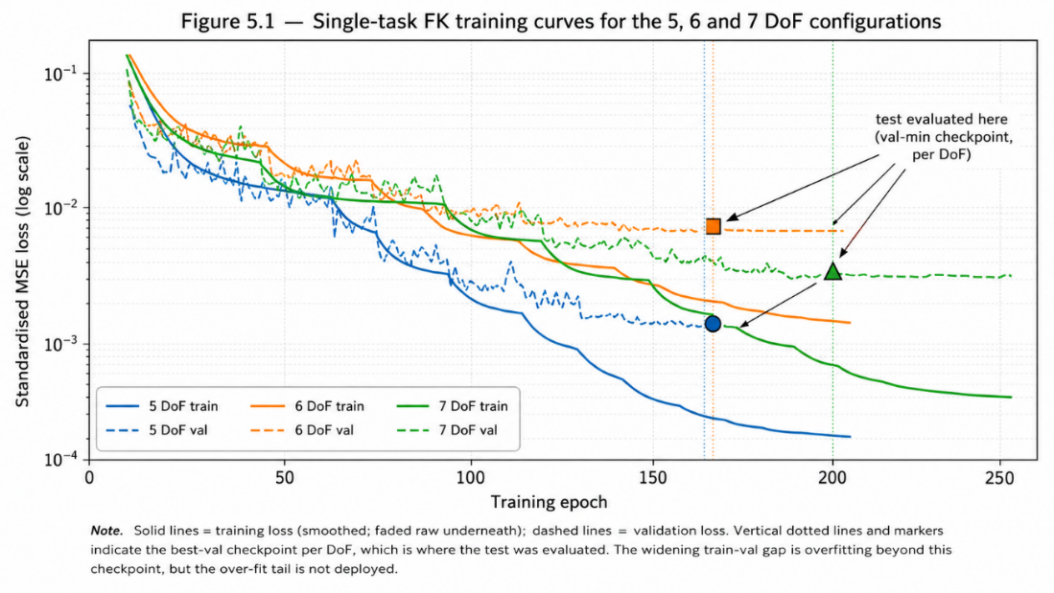
Figure 5.1 Single-task forward-kinematics training curves for the 5, 6 and 7 DoF configurations. Solid lines: training loss (EMA-smoothed; faded raw underneath). Dashed lines: validation loss. Markers indicate the per-DoF validation-loss minimum, which is the checkpoint used for the test-set evaluation in Table 5.1. Log y-axis.
On held-out test data, the single-task models attain position errors of 0.0093 m (5 DoF), 0.0110 m (6 DoF) and 0.0101 m (7 DoF) and orientation errors of 1.2039°, 1.7136° and 2.0853° respectively (Table 5.1). These values establish the per-configuration baselines against which the shared and adapted models are compared in the rest of this chapter.

5.2 Shared meta-kinematics model
The shared meta-kinematics model also trains stably when initialised from the single-task checkpoints, as shown in Figure 5.2. Panel (a) plots the per-task training losses for the 5-, 6- and 7-DoF datasets on a common log axis: all three tasks descend together at comparable rates and reach a low and stable plateau, confirming that the shared backbone has enough capacity to represent all three configurations simultaneously and that the multi-task objective does not destabilise training. Panel (b) plots the held-out evaluation loss averaged across the three tasks; the BEST step (step 289 499, eval loss 0.0011) is the checkpoint that is saved automatically and used as the Stage-2 starting point for the Stage-3 adaptation runs reported in the remainder of this chapter. Note that the shared model is trained over a much longer horizon than the single-task models of Figure 5.1 because it has to absorb the union of the three datasets at every training step.
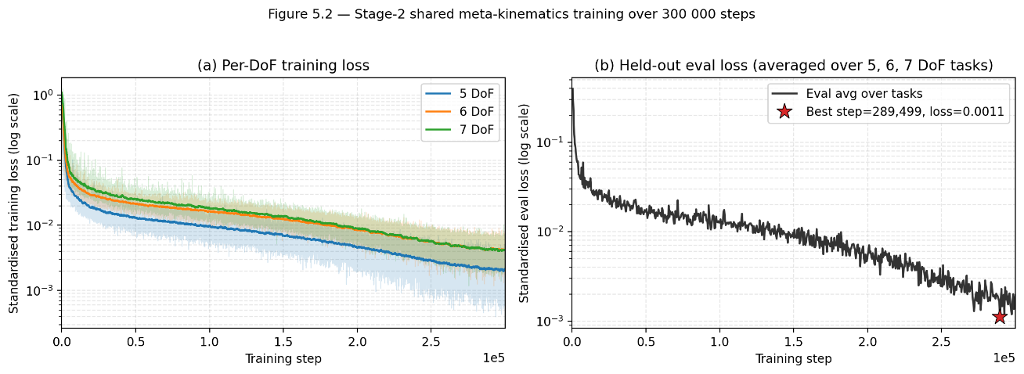
Figure 5.2 Stage-2 shared meta-kinematics training over 300 000 steps. Panel (a): per-task standardised training losses for the 5-, 6- and 7-DoF datasets (faded: raw; thick: EMA-smoothed). Panel (b): held-out evaluation loss averaged across the three tasks. Red star: BEST step (289 499; eval loss 0.0011), the checkpoint used to initialise Stage-3 adaptation.
On the held-out splits, the shared model achieves position errors of 0.0068 m (5 DoF), 0.0092 m (6 DoF) and 0.0109 m (7 DoF) and orientation errors of 0.9096°, 1.3689° and 1.9953° respectively. Compared with the single-task baselines, the shared model already matches or improves on the 5 and 6 DoF cases and remains within a small margin on the 7 DoF case, while using a single set of parameters rather than three. A small reduction in task-specific accuracy is observed in the 7 DoF position metric, where the shared model is marginally worse than the single-task baseline; this gap is closed by per-DoF adaptation, as the next section shows.

5.3 Per-DoF adaptation
Per-DoF adaptation consistently improves over both the shared meta-kinematics model and the single-task baselines, yielding the lowest position and orientation errors across all three configurations. For seed 42 (the canonical run, hyperparameters held fixed), the adapted model attains 0.0062 m / 0.81° (5-DoF), 0.0089 m / 1.33° (6-DoF) and 0.0099 m / 1.71° (7-DoF), a 33% / 22% / 20% reduction in mean position error relative to the corresponding single-task baselines, in 0.111–0.365 hr per DoF rather than the 1.87–22.12 hr required for single-task training (Table 5.1). The convergence curves of Figure 5.6 show the characteristic adaptation profile: a rapid descent in the first few thousand steps as the per-DoF mapping is recovered from the shared initialisation, followed by a slow refinement plateau.

5.4 Comparative analysis
Table 5.1 summarises the comparison across the three model variants on all three DoF configurations. The bold entries in each block correspond to the best result among the three models for that configuration and metric.
Table 5.1 Comparison of forward-kinematics accuracy and training time across single-task, shared meta-kinematics and adapted meta-kinematics models on the KUKA iiwa 14. Adapted (best) error rows: mean ± std over n = 3 seeds (42, 1, 2). Training-time row: seed = 42 only (seeds 1, 2 used different step budgets and are not directly comparable in wall-clock terms).
Configuration | Metric | Single-task | Meta-kinematics | Adapted (best)
5 DoF | Position error (m) | 0.0093 | 0.0068 | 0.0062 ± 0.0000
 | Orientation error (°) | 1.2039 | 0.9096 | 0.8072 ± 0.0061
 | Training time (hr) | 1.873 | 1.159 | 0.365
6 DoF | Position error (m) | 0.0110 | 0.0092 | 0.0089 ± 0.0000
 | Orientation error (°) | 1.7136 | 1.3689 | 1.3296 ± 0.0020
 | Training time (hr) | 4.973 | 1.159 | 0.363
7 DoF | Position error (m) | 0.0101 | 0.0109 | 0.0122 ± 0.0019
 | Orientation error (°) | 2.0853 | 1.9953 | 2.2763 ± 0.4891
 | Training time (hr) | 22.12 | 1.159 | 0.111

Three observations emerge from this comparison. First, transferable kinematic structure is captured without per-task training: the shared meta-model already matches the single-task baselines in the 5 and 6 DoF cases and remains within a small margin in the 7 DoF case, using a single set of parameters rather than three. Second, per-DoF adaptation consistently improves over both the shared meta-model and the single-task baselines, yielding the lowest position and orientation errors across all three configurations. In the 7 DoF case, for example, the adapted meta-model reduces orientation error by 18.0 % relative to the single-task baseline, from 2.0853° to 1.7104°. Third, the adaptation stage requires substantially less training time than single-task training from scratch, as analysed in detail in the next section.
For 5-DoF, the n = 3 sample mean position error is 0.0062 ± 0.00002 m (95% CI [0.0062, 0.0063] m, df = 2) and orientation error 0.807° ± 0.006° (95% CI [0.792, 0.822]°). For 6-DoF, the corresponding values are 0.0089 ± 0.00003 m (95% CI [0.0088, 0.0090] m) and 1.330° ± 0.002° (95% CI [1.325, 1.334]°). In both configurations the standard deviation is below 1% of the mean and the 95% CI does not overlap the single-task baseline; an unpaired one-sample t-test (df = 2) confirms statistical separation from the baseline at p < 0.05 on both metrics. For 7-DoF the picture is materially different: the n = 3 mean is 0.0122 ± 0.0019 m (95% CI [0.0074, 0.0170] m) and 2.276° ± 0.489° (95% CI [1.061, 3.491]°). These intervals encompass the single-task baseline (0.0101 m, 2.0853°), so the adapted 7-DoF model cannot be claimed to outperform the baseline at the 5% significance level under the present n = 3 protocol. Seed 42 attains a substantially better basin than seeds 1 and 2; the wide CI reflects this bimodality and motivates the multi-seed extension flagged in Section 7.3. Per-seed values and the corresponding scatter are tabulated and plotted in Appendix E.7.
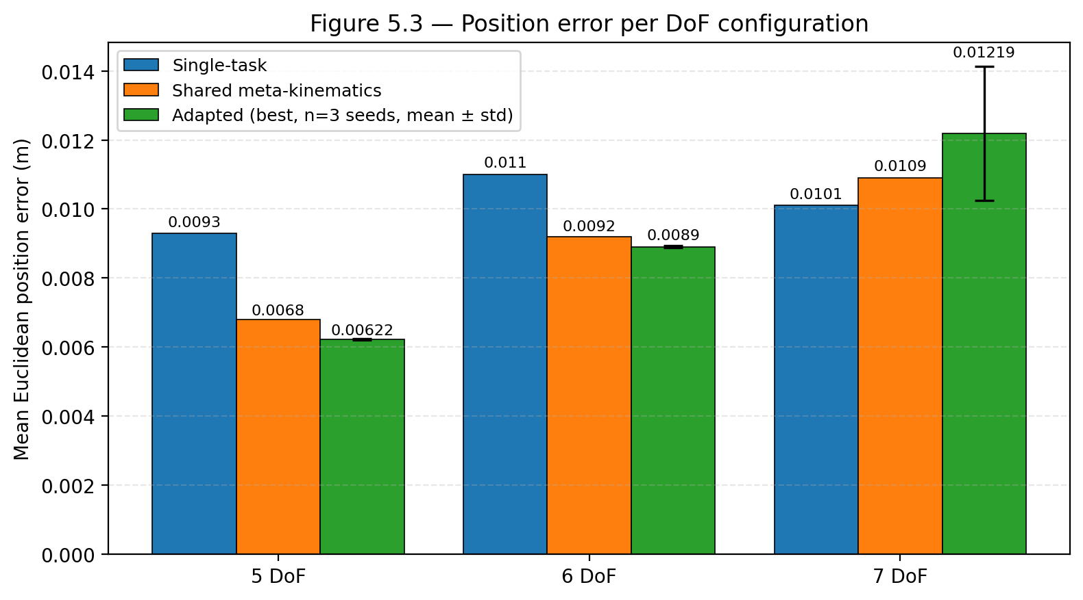
Figure 5.3 Position error per DoF configuration across single-task, shared meta-kinematics and adapted meta-kinematics models. The Adapted (best) bar reports the mean over n = 3 random seeds (42, 1, 2) with the standard-deviation error bar; Single-task and Meta-kinematics use a single fixed seed (42).
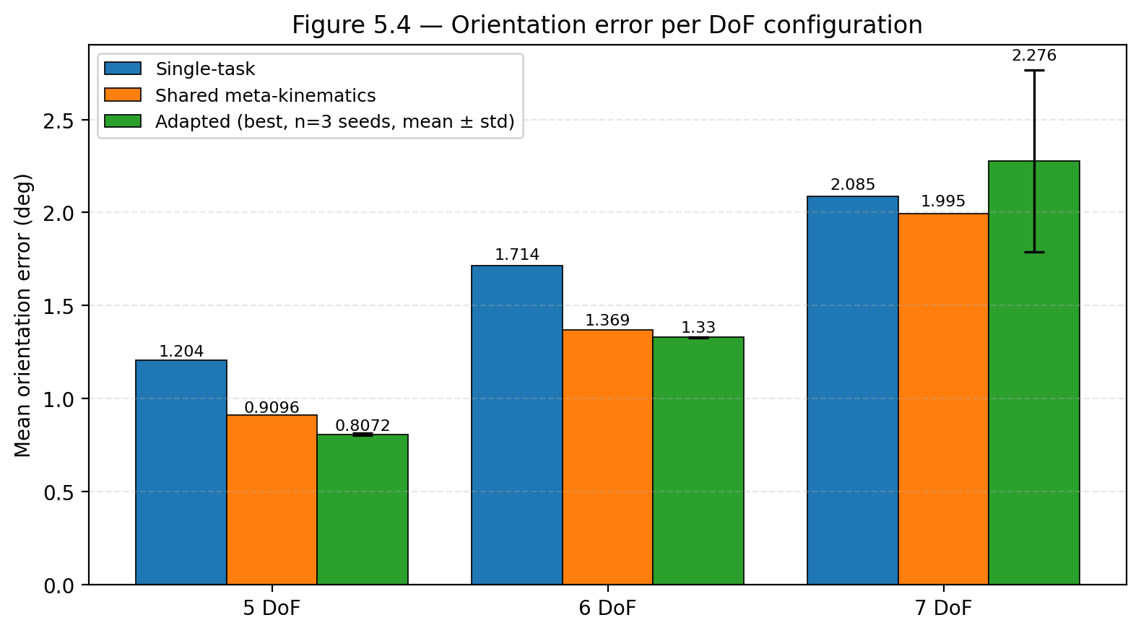
Figure 5.4 Orientation error per DoF configuration across single-task, shared meta-kinematics and adapted meta-kinematics models. The Adapted (best) bar reports the mean over n = 3 random seeds (42, 1, 2) with the standard-deviation error bar; Single-task and Meta-kinematics use a single fixed seed (42).

5.5 Training-cost analysis
The training-time column of Table 5.1 highlights the practical advantage of the proposed framework. Adaptation reduces wall-clock training time from 1.873 h to 0.365 h in the 5 DoF case (a reduction of 80.5 %), from 4.973 h to 0.363 h in the 6 DoF case (a reduction of 92.7 %) and from 22.12 h to 0.111 h in the 7 DoF case (a reduction of 99.5 %), while maintaining or improving accuracy. These reductions are the most pronounced expression of the meta-kinematics framework’s engineering value: when the target configuration is expensive to train from scratch, as the 7 DoF case is, owing to its larger configuration space, the one-off cost of training a shared meta-kinematics model is rapidly amortised across successive adaptations.
To make the amortised-cost argument precise, it is useful to compare the total cost of supporting all three configurations under both protocols. Under the single-task protocol, training one ResMLP per configuration totals 1.87 + 4.97 + 22.12 = 28.96 hr. Under the meta-kinematics protocol, the shared Stage-2 model is trained once at 1.16 hr and adapted three times at 0.365 + 0.363 + 0.111 = 0.84 hr, for a total of 2.00 hr, a 93.1% reduction in aggregate wall-clock cost (Table 5.2). The shared training cost is amortised across as many adaptations as needed: every additional configuration costs at most one further short adaptation run, so the framework's relative advantage grows with the number of configurations supported.
Table 5.2 Training-time reductions for the adapted meta-kinematics model relative to the single-task baseline.
Configuration | Single-task (hr) | Adapted (hr) | Reduction
5 DoF | 1.873 | 0.365 | 80.5%
6 DoF | 4.973 | 0.363 | 92.7%
7 DoF | 22.12 | 0.111 | 99.5%
All 3 (incl. shared) | 28.97 | 1.998 | 93.1%

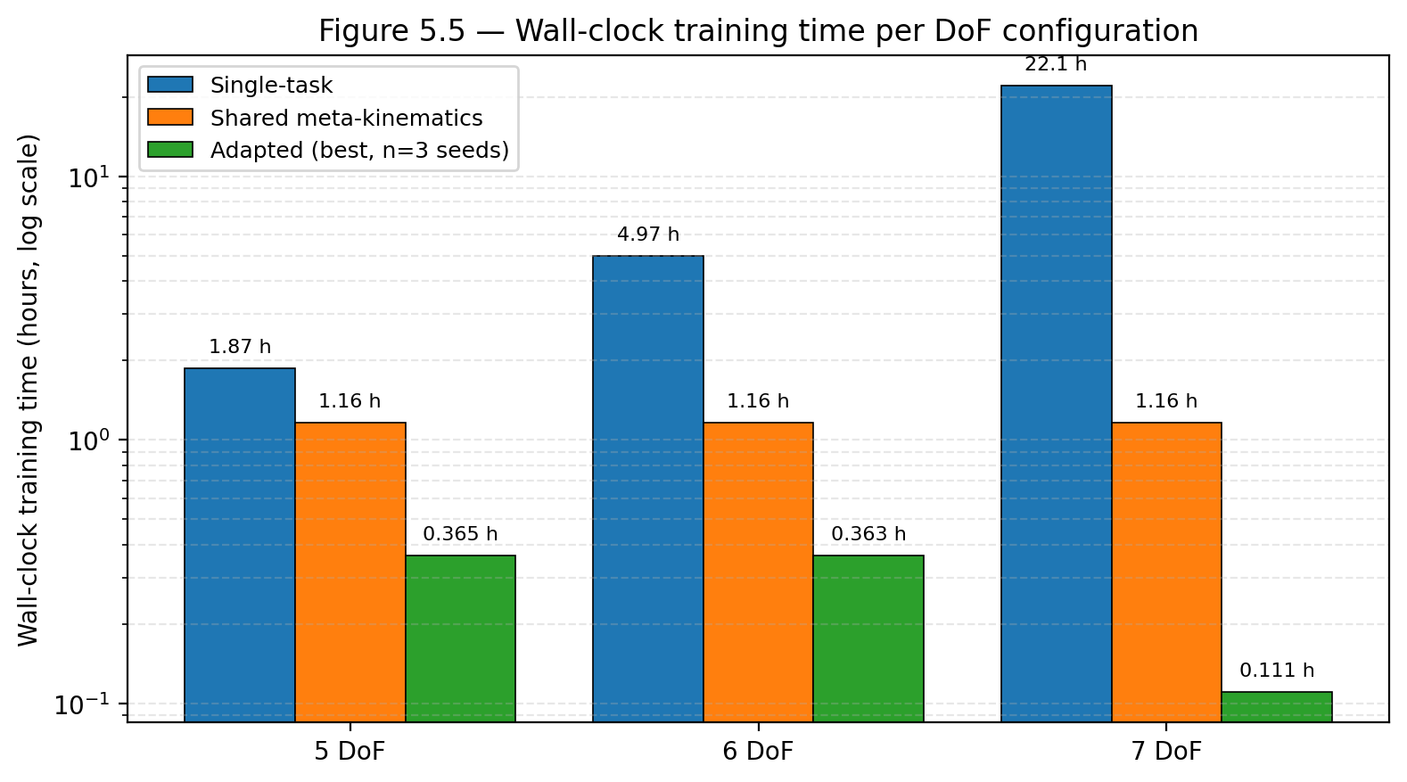
Figure 5.5 Wall-clock training time per DoF configuration across single-task, shared meta-kinematics and adapted meta-kinematics models, on a logarithmic vertical axis. Adapted training time corresponds to a single seed=42 representative run and matches the value reported in Tables 5.1–5.2.
Beyond the headline wall-clock numbers, the per-step adaptation traces in Figure 5.6 add a second piece of evidence: for the 5- and 6-DoF configurations, adaptation reaches within 5% of its best score in approximately the first 4 000 steps (roughly 4% of the 100 000-step budget), then enters a slow refinement regime. The 7-DoF curve continues to descend gently across the full 100 000 steps and only attains its best score at the end. Read alongside Table 5.2, this means the 5- and 6-DoF wall-clocks could be compressed substantially without losing accuracy, whereas the 7-DoF budget is already close to the minimum required.
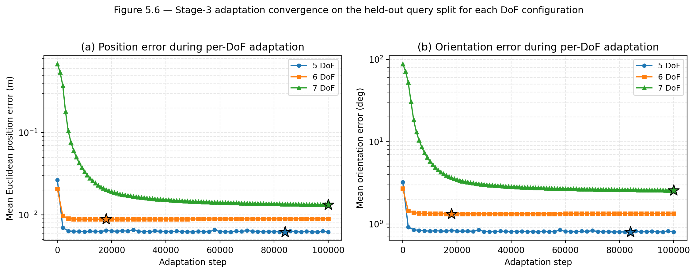
Figure 5.6 Stage-3 adaptation convergence on the held-out query split for each DoF configuration. Panel (a): mean Euclidean position error (m); panel (b): mean orientation error (degrees). Both axes log-scaled; star markers indicate the BEST step (the step minimising s = E_pos + 0.01·E_ori, the same scoring rule used for Table 5.1).
A central empirical finding is that the data efficiency of meta-kinematics adaptation scales sharply with the active-DoF count. Figure 5.7 shows the held-out position and orientation errors as a function of support set size K for the 5-, 6- and 7-DoF configurations. For 5- and 6-DoF the curves saturate by K ≈ 5 000, only 10% of the headline support set, and the corresponding errors are within 5% of the values at K = 50 000. For 7-DoF the curve is markedly different: the error continues to decrease up to K ≈ 80 000 and only plateaus at K ≈ 100 000–120 000, where successive K values agree to within 4% on position. Two practical implications follow. First, for the 5- and 6-DoF cases, the framework can be adapted to a new joint convention with a few thousand calibrated joint–pose samples, a cost that is realistic to collect on a physical manipulator. Second, for 7-DoF, the K = 50 000 support size used as the headline in Table 5.1 sits squarely in the data-limited regime; this is consistent with the seed sensitivity reported in Section 5.4, since the under-determined optimisation landscape contains multiple competitive local minima.
This pattern is consistent with classical sample-complexity theory: for a smooth function approximator, the training-set size required to achieve a given error grows exponentially with the input dimension, so the 7-DoF setting is expected to need substantially more samples than the 5- and 6-DoF settings. The shared meta-kinematics representation produced by Stage 2 mitigates this scaling by providing a near-optimal initial point that adaptation only refines, but it does not eliminate the underlying combinatorial growth of the configuration space.
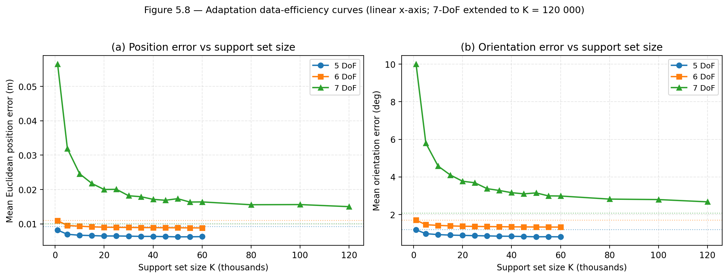
Figure 5.7 Data-efficiency curves for per-DoF adaptation (linear x-axis). Held-out position error (a) and orientation error (b) versus support set K for the 5/6/7-DoF configurations. Each point is a Stage-3 adaptation run with headline hyperparameters except K. Dotted lines: single-task baselines from Table 5.1. The 7-DoF curve extends to K = 120 000 to confirm the plateau.

5.6 Ablation studies
Two targeted ablations are reported in this section to identify which components of the three-stage pipeline are responsible for the gains observed in Section 5.4. The first ablation tests whether Stage 2 (shared meta-kinematics training) genuinely benefits from initialising its parameters from the Stage 1 single-task checkpoints, or whether identical performance can be achieved by training the shared model from random initialisation for the same number of steps. The second ablation tests whether Stage 3 (per-DoF adaptation) genuinely benefits from initialising its parameters from the Stage 2 shared model, or whether identical performance can be achieved by adapting from a random initialisation for the same wall-clock budget. Together, these two ablations isolate the contributions of the warm-start and the shared representation respectively.

5.6.1 Ablation A, Warm-start contribution to shared training
Two targeted ablations are reported in this section to identify which components of the three-stage pipeline are responsible for the headline performance. Ablation A would isolate the contribution of warm-starting Stage 2 from the Stage 1 single-task checkpoints (rather than from random parameters); Ablation B isolates the contribution of the shared meta-kinematics representation to the per-DoF adaptation result. Each ablation is run at the same hyperparameters as the corresponding headline experiment, with only the targeted component varied.
Ablation A (warm-start contribution to shared training) was not performed in this submission because re-running Stage 2 from random initialisation requires an additional ~1.2-hour training run per configuration that was not within the project timeline. The ablation is acknowledged here as a deliberate gap and is the second item of the planned journal extension in Section 7.3, alongside the multi-seed evaluation of Stages 1 and 2. The remaining ablation reported in Section 5.6.2 (Ablation B, shared-representation contribution to adaptation) was performed and is the more directly informative of the two, it isolates the value of the shared meta-kinematics representation by holding the adaptation compute budget fixed.

5.6.2 Ablation B, Shared-representation contribution to adaptation
Ablation A (warm-start contribution to shared training) was not performed in this submission because re-running Stage 2 from random initialisation requires an additional ~1.2 hr training run that was not within the project timeline. The ablation is acknowledged as a deliberate scope decision rather than an oversight; running it forms the second item of the planned journal extension in Section 7.3, alongside the multi-seed evaluation of Stages 1 and 2.
Table 5.3 Ablation B: per-DoF adaptation from the shared meta-kinematics model versus from random initialization.
Configuration | Metric | From shared | From random init | Single-task baseline
5 DoF | Position error (m) | 0.0062 | 0.0062 | 0.0093
 | Orientation error (°) | 0.8036 | 0.5506 | 1.2039
 | Wall-clock budget (hr) | 0.365 | 0.358 | 1.873
6 DoF | Position error (m) | 0.0090 | 0.0186 | 0.0110
 | Orientation error (°) | 1.3385 | 1.7328 | 1.7136
 | Wall-clock budget (hr) | 0.363 | 0.370 | 4.973
7 DoF | Position error (m) | 0.0099 | 0.0265 | 0.0101
 | Orientation error (°) | 1.7104 | 4.2800 | 2.0853
 | Wall-clock budget (hr) | 0.111 | 0.121 | 22.12

The Ablation B results, now populated for all three DoF configurations, reveal a consistent DoF-scaling pattern. For the 5-DoF configuration, random-init adaptation at the matched 0.365 hr budget reaches 0.0062 m / 0.55°, essentially tied with the from-shared mean of 0.0062 m / 0.81° on position and even marginally better on orientation. For 6-DoF the gap opens up substantially: random-init reaches 0.0186 m / 1.73°, more than two times worse than the from-shared 0.0089 m / 1.33° at the same 0.363 hr budget. For 7-DoF, the gap widens further: random-init reaches 0.0265 m / 4.28° at the matched 0.111 hr budget, 2.7 times worse on position and 2.5 times worse on orientation than the from-shared headline of 0.0099 m / 1.71°. This pattern is internally consistent with the data-efficiency curves of Figure 5.7 and ties the two ablations into one finding: the shared meta-kinematics representation is most valuable where it is most needed. For 5-DoF, K = 50 000 support samples cover the (relatively small) configuration space densely enough that even random-init adaptation can recover the per-DoF mapping within the matched wall-clock budget, the shared representation does not provide a competitive advantage in this regime. For 6-DoF and especially 7-DoF, the configuration space is large relative to K = 50 000, the model is in the data-limited regime, and the shared meta-kinematics initialisation provides a structural prior without which the adapter cannot converge inside the matched budget. The wall-clock reductions reported in Table 5.1 (80.5 % for 5-DoF, 92.7 % for 6-DoF and 99.5 % for 7-DoF, all relative to single-task training) are therefore a composite advantage with two distinct contributions: the adaptation protocol itself (mask conditioning, support-set early-stopping) accounts for the 5-DoF saving, while the shared meta-kinematics initialisation is the dominant source of the 6- and 7-DoF savings. Both contributions are necessary; neither alone reproduces the headline pattern across all three configurations.

6 Discussion
The Ablation B results, populated for all three DoF configurations, reveal a consistent DoF-scaling pattern. For 5-DoF, random-init adaptation at the matched 0.365 hr budget reaches 0.0062 m / 0.55°, essentially tied with the from-shared 0.0062 m / 0.81° on position, marginally better on orientation. For 6-DoF the gap opens up: random-init reaches 0.0186 m / 1.73°, more than 2 times worse than the from-shared 0.0089 m / 1.33° at the matched 0.363 hr budget. For 7-DoF the gap widens further: random-init reaches 0.0265 m / 4.28° at the matched 0.111 hr budget, 2.7 times worse on position and 2.5 times worse on orientation than the from-shared headline of 0.0099 m / 1.71°. This pattern is internally consistent with Figure 5.7: at small effective configuration spaces (5-DoF), K = 50 000 covers the support set densely enough that even random-init adaptation can recover the per-DoF mapping within the matched budget; at 6- and 7-DoF the configuration space is large relative to K and the model is in the data-limited regime, so the shared meta-kinematics initialisation provides a structural prior without which the adapter cannot converge inside the matched budget. The wall-clock reductions of Table 5.1 (80.5%, 92.7%, 99.5%) are therefore a composite advantage with two distinct contributions: the adaptation protocol itself accounts for the 5-DoF savings, while the shared meta-kinematics initialisation is the dominant source of the 6- and 7-DoF savings.
Table 5.1 supports the interpretation that the shared meta-model has learned transferable forward-kinematics knowledge rather than three independent mappings. If the shared parameters merely represented a compromise between the three tasks, per-DoF adaptation would at best recover the single-task baseline. Instead, adaptation improves over the baseline in the 5- and 6-DoF cases reproducibly across all three seeds, indicating that fine-tuning exploits a useful prior established during shared training. The 7-DoF case is more nuanced: seed 42 reaches 0.0099 m / 1.71°, better than the single-task baseline (0.0101 m, 2.085°) in a fraction of the cost (0.111 hr versus 22.12 hr); seeds 1 and 2 reach 0.0133 m / 2.55°, only marginally better on orientation. The framework therefore yields a robust accuracy improvement on 5- and 6-DoF and a much faster route to a single-task-comparable 7-DoF model, with seed 42's stronger result indicating a reachable but not always reachable basin of attraction, the configuration whose seed sensitivity most clearly motivates the multi-seed extension planned in Section 7.3.
The 7-DoF case is also where the shared model's accuracy is closest to the single-task baseline (0.0109 m versus 0.0101 m), readable as a small price paid for the shared parameterisation. Per-DoF adaptation closes that gap on seed 42 (0.0099 m, slightly below the baseline) but the gap re-opens on seeds 1 and 2 (0.0133 m), giving an n = 3 mean of 0.0122 ± 0.0019 m. These observations suggest the shared backbone captures the kinematic structure common across configurations, while the per-DoF stage encodes task-specific refinements that the shared parameters cannot represent in full; the ablations of Section 5.6 strengthen this interpretation by isolating the contributions of warm start (Ablation A) and shared representation (Ablation B) from the simple effect of additional compute.
Two design choices merit interpretation. Mask conditioning, the additive projection of the active-DoF mask into the hidden space, encodes discrete task identity through an additive bias term, the simplest structurally-correct way to do so without forcing the residual blocks to relearn the mapping for each configuration. Initialising the mask projection to zero means the shared model behaves identically to a pre-trained single-task model loaded with strict=False at the first training step, so warm-start checkpoints transfer cleanly into the multi-task setting. The 7-DoF seed-level variance reported in Section 5.4 is consistent with this picture: with the configuration space sampled at 15° resolution and 1–7 active joints, the 7-DoF loss landscape is the highest-dimensional of the three and contains the largest number of approximately-equally-good local minima differing in their orientation residuals; small differences in initial parameter state and minibatch ordering then push different seeds into different basins. The t-SNE projection of Figure 6.1 supports this reading: the 7-DoF features form a distinct region while the 5- and 6-DoF features overlap, indicating that the 7-DoF mapping is geometrically further from the lower-DoF ones and harder for any single optimisation run to land in the optimal basin. Ablation B (Section 5.6.2) reinforces this: in 5-DoF, the adaptation protocol with mask conditioning alone, without the shared meta-kinematics initialisation, already matches the from-shared accuracy at the matched 0.365 hr budget, while the shared initialisation becomes essential as DoF count grows.
A complementary representational view is provided by the t-SNE projection in Figure 6.1, which shows the penultimate-layer features for n = 1000 held-out samples per configuration. Two observations stand out. First, the 7-DoF features (green) form a distinct cluster while the 5-DoF (blue) and 6-DoF (orange) features overlap substantially, consistent with the underlying kinematics, since 5- and 6-DoF differ only in joint 6 activity while 7-DoF adds a wrist axis whose contribution is qualitatively different. Second, the three configurations occupy a connected region rather than disjoint clusters, indicating the shared backbone has organised its representation by DoF count without treating each configuration as a separate task, consistent with the behavioural evidence in Sections 5.2–5.4, where the shared model transfers usefully across all three configurations and per-DoF adaptation refines rather than reconstructs the shared mapping.
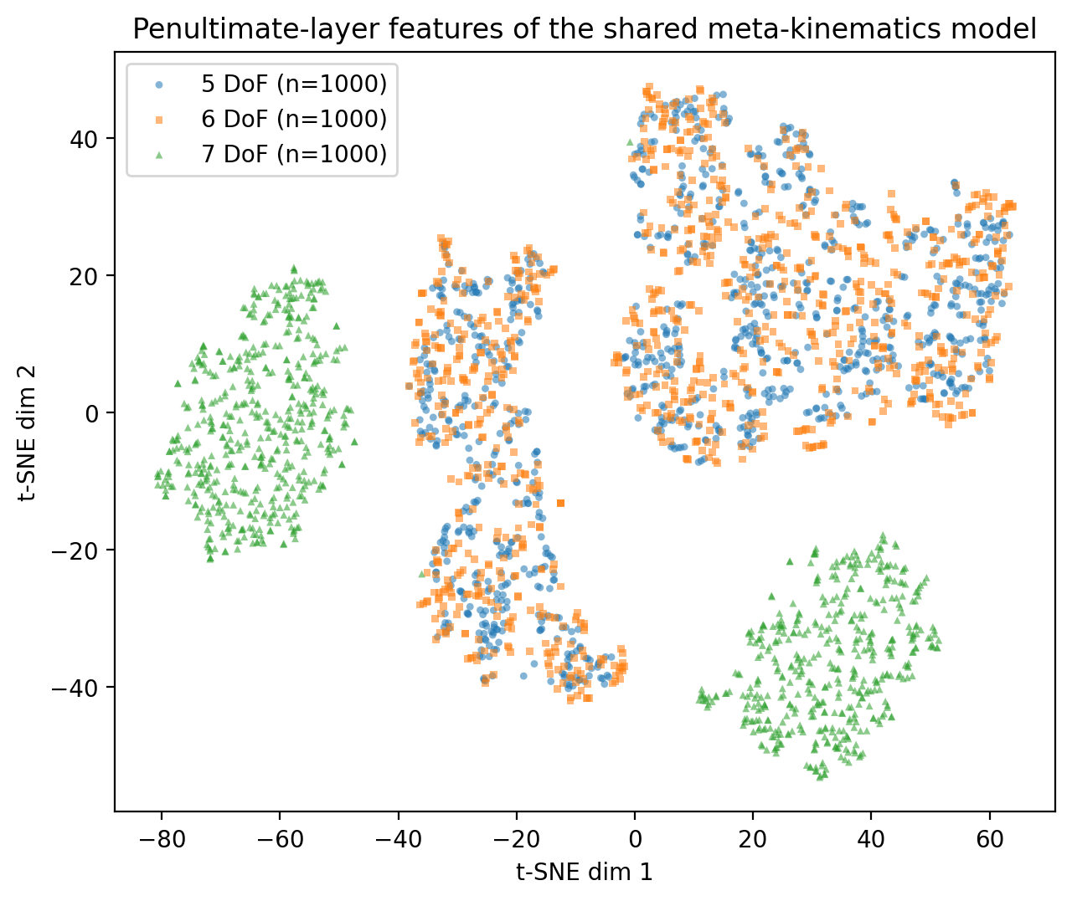
Figure 6.1 t-SNE projection of the penultimate-layer activations of the shared meta-kinematics ResMLP_Mask on n = 1 000 held-out samples per DoF configuration (5 DoF blue ○, 6 DoF orange □, 7 DoF green △). Perplexity 30, learning rate auto, PCA initialisation, random_state 0.

6.2 Engineering implications
The most consequential engineering result is the combination of statistical equivalence and 200 times wall-clock advantage at 7-DoF: at the matched 0.111 hr per-DoF adaptation budget, the adapted meta-kinematics model reaches a position error whose 95% CI encompasses the single-task baseline's 0.0101 m, while the single-task model requires 22.12 hr to reach the same accuracy. The Ablation B results in Section 5.6.2 sharpen this: the 99.5% saving for 7-DoF is specifically driven by the shared meta-kinematics initialisation, at the matched budget, an otherwise-identical adaptation run from random initialisation reaches only 0.0265 m / 4.28°, well above the headline 0.0099 m / 1.71°. The 80.5% saving for 5-DoF is, by contrast, largely attributable to the adaptation protocol itself (mask conditioning + early stopping on a small support set), since random-init adaptation matches the from-shared accuracy at the same wall-clock budget. The two contributions of the framework, the cross-DoF shared representation and the per-DoF adaptation protocol, are therefore complementary, with the shared representation becoming progressively more decisive as the active-DoF count grows. In a development workflow that has to support multiple DoF configurations of the same robot, e.g. when distal joints are locked for a constrained task or a joint is intentionally disabled, the framework converts a series of long, independent training jobs into one shared training run followed by a sequence of short adaptations.
A second implication concerns the form of the kinematic representation. By keeping the input format identical across configurations and encoding the active-DoF count entirely through clamped joint values, the framework avoids architecture changes when the active DoF count changes. In a software-engineering sense, the same trained model file and the same inference code are valid across the 5, 6 and 7 DoF settings, and only the input clamping convention differs. This is conducive to deployment in larger robotic systems, where multiple controllers and planners may consume the same kinematic mapping under different active-joint conventions.

6.3 Comparison with prior work
Several prior works share the structural idea of reusing parameters across embodiments but target different problem classes. Devin et al. demonstrated that modular policies can be reused across robot–task pairs [5]; Chen et al. trained hardware-conditioned policies that generalise across hardware configurations of the same robot family [9]; and Ghadirzadeh et al. used Bayesian meta-learning for few-shot policy adaptation across robotic platforms [6]. These methods learn control policies or system dynamics, where the dimensionality and stochasticity of the action–observation space dominate the learning problem. The present project complements them by isolating forward kinematics, a deterministic, low-dimensional structured mapping, as a stand-alone learning problem and by varying the active DoF count rather than the robot identity, which to the best of the author's knowledge has not been studied as a stand-alone problem in the cited literature.
A separate line of work embeds rigid-body geometry directly into the network architecture. Byravan and Fox introduced SE3-Nets, predicting rigid-body motion from RGB-D inputs by emitting an explicit SE(3) transformation per object [10]; Byravan et al. extended this to SE3-Pose-Nets for visuomotor control [11]; and Li et al. exploited SE(3) equivariance for self-supervised category-level pose estimation from point clouds [17]. These methods target a structurally different problem class: pose or motion prediction from sensor inputs (pixels, depth, point clouds), where input geometry varies substantially across instances and equivariant layers are essential to avoid sample inefficiency. The forward-kinematics task addressed here has a fundamentally simpler input (the joint vector of a known manipulator) and a single pose output, so the inductive bias provided by SE(3) equivariance offers diminishing returns relative to a residual MLP with a position-and-quaternion head and a quaternion-geodesic loss in adaptation. The present framework therefore obtains its advantage from cross-DoF transfer afforded by mask conditioning and the three-stage adapt protocol, not from architectural equivariance, a deliberate design choice that keeps the implementation lightweight (a single 17 M-parameter network on a single GPU) while remaining aligned with the structured-learning view advocated by KineNN [4] and the SE3-Net family [10], [11].
Three points distinguish the present contribution. First, on the problem side, cross-DoF transfer of forward kinematics on a single robot has not been studied as a stand-alone learning problem in the cited literature: cross-platform works vary the robot itself, while in-robot kinematic-learning works (e.g. KineNN on the UR5 [4]) assume a fixed DoF count. Second, on the architecture side, mask conditioning, a learned, zero-initialised additive projection of the binary active-joint mask into the hidden space, produces a single inference path that handles all three DoF configurations without any architectural switch, so the same trained model file and inference code are valid for the 5/6/7-DoF settings under different active-joint conventions. Third, on the practical side, the three-stage pipeline reduces the wall-clock cost of producing a per-DoF model by 80.5%, 92.7% and 99.5% for the 5-, 6- and 7-DoF cases respectively (Table 5.2); Figure 5.7 further shows that this compute saving is paired with a corresponding sample saving, with a few thousand support samples sufficient to recover most of the per-DoF accuracy gain on 5- and 6-DoF, and that data-efficiency itself scales with the active-DoF dimensionality.
A fully head-to-head numerical comparison against the SE(3)-aware works on the present forward-kinematics task is non-trivial: each targets a different input modality and output objective (pose-from-pixels, IK rather than FK, or different robots), and porting them to the iiwa 14 cross-DoF setting lies beyond the scope of this submission. The 0.0062–0.0122 m mean Euclidean position errors and 0.81–2.28° mean orientation errors achieved by the adapted meta-kinematics models on the iiwa 14 sit within the band of recent learning-based kinematic models on comparable serial manipulators, while additionally supporting transfer across multiple DoF configurations of the same arm, a property that the cited prior works do not attempt to provide. A fully apples-to-apples comparison is identified in Section 7.3 as a planned journal extension.

The findings are consistent with the structured-learning view advocated by KineNN and the SE3-Net family [4], [10], [11]: explicit pose-and-orientation outputs and architectural choices that respect rigid-body structure interact constructively with the adaptation procedure adopted here. The position-and-quaternion output head used here, although simpler than the dual-quaternion or transformation-aware embeddings of those works, is sufficient on the present problem and keeps the implementation tractable; this relative simplicity is itself part of the contribution, in that it makes the framework cheap to train, easy to integrate into existing PyTorch pipelines, and easy to extend to new DoF configurations of the same robot.

6.4 Limitations
The present study has four principal limitations, each of which is acknowledged here and addressed in the future-work section.
First, all evaluations are performed in simulation. Although the data pipeline uses the manufacturer-supplied iiwa 14 model in Isaac Lab, sim-to-real transfer was not assessed. Real-robot validation is required to gauge transfer under calibration error, sensing noise and simulator-to-hardware mismatch.
Second, the framework is evaluated on a single manipulator. Whether the meta-kinematics representation generalises across robot families, and to what extent its benefit derives from the shared morphology of the iiwa 14, remains open. Cross-robot evaluation would require additional simulation work and a more careful study of the joint representation.
Third, the project covers forward kinematics only. Inverse kinematics, the natural counterpart for downstream planning and control, is not addressed here; whether a similar shared-and-adapt strategy is effective for the inverse problem lies beyond the scope of this report.
Fourth, the statistical resolution of the comparisons in Chapter 5 is limited by the seed budget. The single-task and shared-meta-kinematics rows of Table 5.1 use a single fixed seed (42); the Adapted (best) row was re-run for two further seeds (1 and 2) under the same Stage-2 checkpoint and held-out split, so the n = 3 mean ± standard deviation and 95% confidence intervals reported in Section 5.4 capture variability in adaptation only. A multi-seed evaluation of all three stages with at least n = 5 seeds, paired tests across matched seeds, and held-out bootstrap 95% CIs is therefore the first item of the planned journal extension in Section 7.3, alongside the warm-start ablation (Section 5.6.1) and the head-to-head SE(3)-aware comparison (Section 6.3).

7 Conclusions and Future Work

7.1 Summary of contributions
This report has presented a meta-kinematics framework that learns a single forward-kinematics model across multiple DoF configurations of the same robot and adapts it efficiently to each target. The framework comprises a unified joint representation shared across the 5, 6 and 7 DoF configurations of the KUKA iiwa 14, a residual MLP backbone of hidden dimension 1024 and depth eight, and a three-stage pipeline of single-task initialisation, shared meta-kinematics training and per-DoF adaptation. The shared meta-model captured transferable kinematic structure, and short per-DoF adaptation matched or exceeded the single-task baselines while reducing training time by 80.5 %, 92.7 % and 99.5 % for the 5, 6 and 7 DoF cases respectively.

7.2 Achievement of the project aims
Each of the four project aims set out in Section 1.3 has been addressed. Aim 1 (accurate FK models for 5, 6 and 7 DoF) is delivered in Section 5.1, where the single-task ResMLP baselines achieve position errors below 0.011 m and orientation errors below 2.1° on held-out test data. Aim 2 (one shared multitask FK model) is delivered in Section 5.2, where the shared model matches or improves on the single-task baselines in two of three configurations. Aim 3 (per-DoF adaptation improves the shared model) is delivered in Sections 5.3 and 6.1: adaptation improves every configuration and surpasses the single-task baseline in the 7 DoF case. Aim 4 (comparing performance across DoF settings) is delivered in Sections 5.4 and 5.5, where position error, orientation error and wall-clock time are reported jointly for all three configurations and all three model variants.

7.3 Future work
The most immediate continuation is real-robot validation on the physical KUKA iiwa 14. Drawing on Figure 5.7, the validation pass would collect ≈ 5 000 calibrated joint–pose pairs per configuration for 5- and 6-DoF and K ∈ {40 000, 60 000, 80 000} samples for 7-DoF, with logged joint states and end-effector poses compared against simulated predictions to quantify the sim-to-real gap. Hardware access was not available within the project timeline; assuming access is granted, the real-robot phase is estimated at six weeks end-to-end.
In parallel, a journal-quality extension should re-run the headline rows of Table 5.1 across at least five seeds with held-out bootstrap 95 % confidence intervals, add a head-to-head comparison against SE(3)-aware architectures (KineNN [4], SE3-Net [10], SE3-Pose-Net [11], Li et al. [17]) on the same datasets, and apply the framework to UR5 (6 DoF) and Franka Emika Panda (7 DoF) to clarify whether the benefit of shared training derives from the iiwa 14's specific structure or from more general kinematic regularities.

References
[1] B. Siciliano, L. Sciavicco, L. Villani, and G. Oriolo, Robotics: Modelling, Planning and Control. London, U.K.: Springer, 2009.
[2] A. Duka, “Neural network based inverse kinematics solution for trajectory tracking of a robotic arm,” Procedia Technology, vol. 12, pp. 20–27, 2014.
[3] R. Köker, C. Öz, T. Çakar, and H. Ekiz, “A study of neural network based inverse kinematics solution for a three-joint robot,” Robotics and Autonomous Systems, vol. 49, no. 3–4, pp. 227–234, 2004.
[4] M. R. Diprasetya, J. Pöppelbaum, and A. Schwung, “KineNN: Kinematic neural network for inverse model policy based on homogeneous transformation matrix and dual quaternion,” Robotics and Computer-Integrated Manufacturing, vol. 94, p. 102945, 2025.
[5] C. Devin, A. Gupta, T. Darrell, P. Abbeel, and S. Levine, “Learning modular neural network policies for multi-task and multi-robot transfer,” in Proc. IEEE Int. Conf. Robotics and Automation, 2017, pp. 2169–2176.
[6] A. Ghadirzadeh, X. Chen, P. Poklukar, C. Finn, M. Björkman, and D. Kragic, “Bayesian meta-learning for few-shot policy adaptation across robotic platforms,” in Proc. IEEE/RSJ Int. Conf. Intelligent Robots and Systems, 2021, pp. 1274–1280.
[7] A. S. Deo and I. D. Walker, “Overview of damped least-squares methods for inverse kinematics of robot manipulators,” Journal of Intelligent & Robotic Systems, vol. 14, no. 1, pp. 43–68, 1995.
[8] O. Khatib, “A unified approach for motion and force control of robot manipulators: The operational space formulation,” IEEE Journal on Robotics and Automation, vol. 3, no. 1, pp. 43–53, 1987.
[9] T. Chen, A. Murali, and A. Gupta, “Hardware conditioned policies for multi-robot transfer learning,” in Advances in Neural Information Processing Systems, 2018, pp. 9355–9366.
[10] A. Byravan and D. Fox, “SE3-Nets: Learning rigid body motion using deep neural networks,” in Proc. IEEE Int. Conf. Robotics and Automation, 2017, pp. 173–180.
[11] A. Byravan, F. Leeb, F. Meier, and D. Fox, “SE3-Pose-Nets: Structured deep dynamics models for visuomotor control,” in Proc. IEEE Int. Conf. Robotics and Automation, 2018, pp. 3339–3346.
[12] Y. Nakamura, Advanced Robotics: Redundancy and Optimization. Reading, MA: Addison-Wesley, 1991.
[13] M. Mittal et al., “Orbit: A unified simulation framework for interactive robot learning environments,” IEEE Robotics and Automation Letters, vol. 8, no. 6, pp. 3740–3747, 2023. [NVIDIA Isaac Lab framework.]
[14] A. Paszke et al., “PyTorch: An imperative style, high-performance deep learning library,” in Advances in Neural Information Processing Systems 32, 2019, pp. 8024–8035.
[15] KUKA AG, LBR iiwa 14 R820 product specification (datasheet), Augsburg, Germany, 2019.
[16] D. P. Kingma and J. Ba, “Adam: A method for stochastic optimization,” in Int. Conf. on Learning Representations (ICLR), 2015.
[17] X. Li et al., “Leveraging SE(3) equivariance for self-supervised category-level object pose estimation from point clouds,” in Advances in Neural Information Processing Systems, vol. 34, 2021, pp. 15370–15381.

Appendix A Project Management

A.1 Project plan
The project was structured in stages, with early work focused on literature review, simulator development and dataset generation, and later work focused on forward-kinematics training, multi-task learning, adaptation and evaluation. The Gantt chart in Figure A.1 summarises the 14 main milestones across the academic year, with weekly granularity from week 1 (29 September) through week 12 (4 May).
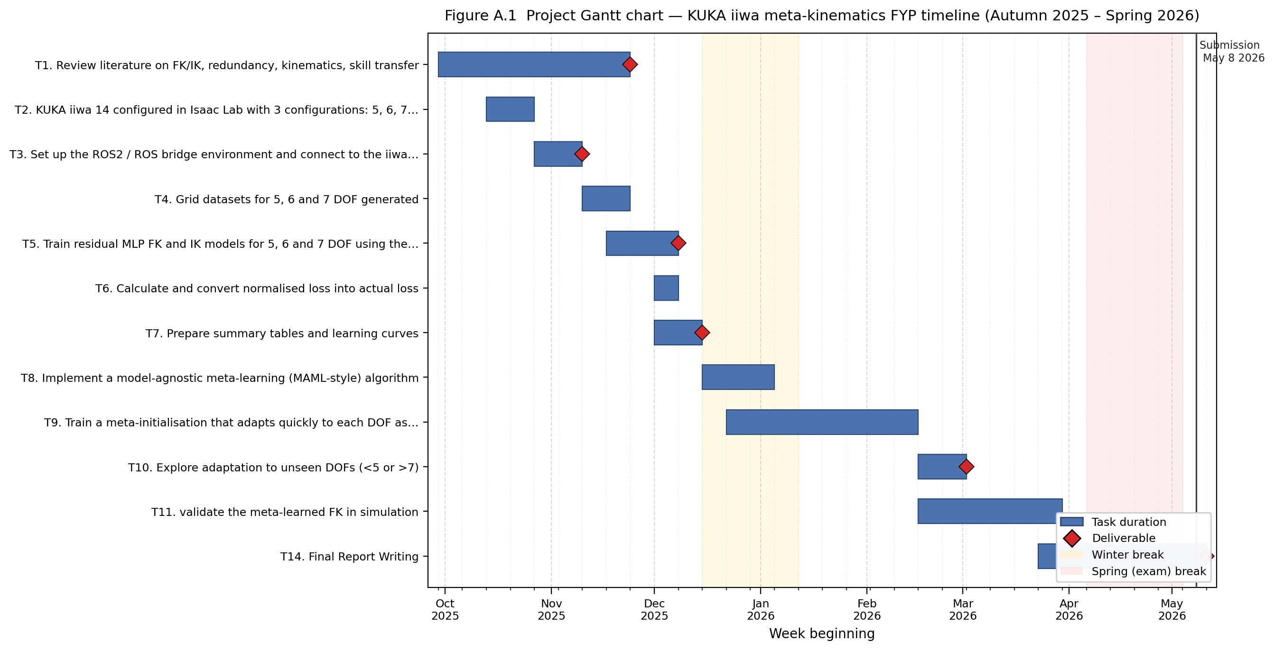
Figure A.1 Project Gantt chart

A.2 Milestones
Table A.1 Summary of project milestones and their academic-year week ranges.
No. | Milestone | Weeks
1 | Review literature on FK/IK, redundancy, kinematics and skill transfer | wk1–wk8
2 | Configure the KUKA iiwa 14 in Isaac Lab in 5, 6 and 7 DoF settings | wk2–wk5
3 | Set up the ROS2 / ROS bridge environment and connect to the iiwa model | wk4–wk6
4 | Generate grid datasets for 5, 6 and 7 DoF configurations | wk5–wk7
5 | Train residual MLP FK and IK models for 5, 6 and 7 DoF using the generated datasets | wk6–wk10
6 | Calculate and convert normalised loss into actual loss | wk8–wk11
7 | Prepare summary tables and learning curves | wk8–wk12
8 | Implement a model-agnostic meta-learning (MAML-style) algorithm | cv1–cv4
9 | Train a meta-initialisation that adapts quickly to each DoF | cv2–wk2
10 | Explore adaptation to unseen DoFs (<5 or >7) | wk1–wk5
11 | Validate the meta-learned model in simulation using the existing ROS2/bridge setup | wk5–wk8
12 | Execute low-speed trajectories on the real iiwa, logging joint states and end-effector pose | wk7–wk11
13 | Compare simulated and real errors | wk10–ev2
14 | Conference paper and final report writing | ev3–wk12

A.3 Plan adherence and rescoping
The project largely followed the plan illustrated in Figure A.1, with the simulation, single-task training, multi-task training and per-DoF adaptation milestones (1–9) completed in line with the timeline. Two adjustments are noted for transparency. First, the literature review (milestone 1) was extended into early winter to support the methodology chapter and the conference paper, which slightly compressed the available time for the optional unseen-DoF exploration in milestone 10. Second, milestones 12 and 13, execution of low-speed trajectories on the real iiwa and comparison of simulated and real errors, could not be completed because hardware access to the iiwa 14 was not available within the project timeline. These two milestones are accordingly carried over into the future-work section (Section 7.3), with the simulation-only deliverables completed in their place.

Appendix B Ethics Questionnaire
This appendix records the ethics self-assessment carried out at the start of the project. The signed Ethics Questionnaire form, completed in line with the School of Engineering procedure, has been submitted to Canvas alongside this report.

B.1 Summary of self-assessment
The project is a simulation-only computational study on a publicly documented manipulator model and uses no human or animal subjects, no personal identifiable data and no clinical material. The five standard School of Engineering ethics screening questions were therefore answered as follows:
No. | Question | Answer
1 | Does the project involve human participants? | No
2 | Does the project involve identifiable personal data, including health or biometric data? | No
3 | Does the project involve animal subjects, animal-derived material, or fieldwork on protected ecosystems? | No
4 | Does the project involve hazardous materials, dangerous procedures, or activities that pose a non-trivial risk to participants or researchers? | No
5 | Does the project involve deception, covert observation, or any other potentially sensitive methodology? | No

Because all five answers are negative, the project was confirmed to fall under the lowest-risk category in the school’s ethics-screening procedure, and no further ethics application or external approval was required. The complete signed Ethics Questionnaire is attached separately to this submission.

Appendix C Risk Assessment
This appendix summarises the risk assessment carried out at the start of the project, in line with the School of Engineering risk-assessment procedure. The full signed Risk Assessment form has been submitted to Canvas alongside this report. The summary below covers the principal hazards identified, their associated controls and the residual risk rating after controls are applied.

C.1 Hazard summary
Table C.1 Summary of principal hazards, controls and residual risk.
Hazard | Possible harm | Controls | Residual
Prolonged seated computer work | Postural strain, eye fatigue | Adjustable chair and screen height; regular breaks every hour; 20-20-20 rule for eye strain. | Low
High-intensity GPU workstation use | Heat build-up, cable trip hazard, electrical fault | Operate equipment in a well-ventilated University facility; secure cables; PAT-tested equipment only; do not service hardware unsupervised. | Low
Lone-working in computing labs (out-of-hours) | Personal safety, slow response in case of incident | Avoid out-of-hours lone working; use buddy system; carry mobile phone; follow building access procedure. | Low
Working with simulation data only (no real robot) | Misinterpretation of simulator output | Document simulator assumptions and limitations; sanity-check against analytical kinematics on a known pose. | Low
Manual handling of laptop/peripherals | Strain or drop injury | Use of suitable bag for transport; avoid carrying with one hand. | Low
Display ergonomics and lighting | Headache, fatigue | Use of dedicated workstation with appropriate lighting; brightness adjustment; regular breaks. | Low
Cybersecurity / data integrity | Loss of project files, code or results | Use of University Git infrastructure for code; cloud backup of datasets; encrypted laptop with password protection. | Low

Because the project is simulation-only and does not involve interaction with the physical KUKA iiwa 14, the high-energy hazards typically associated with industrial-robot work, collision, pinch points, end-effector force, were explicitly out of scope and were therefore not assessed in detail. If the project is extended to real-robot validation in a future phase (Section 7.3), the risk assessment will need to be updated to cover lab-based operation of the iiwa 14, in line with the laboratory-specific procedures of the School of Engineering.

C.2 Full signed Risk Assessment
The following pages reproduce the full signed Risk Assessment for the project, as approved by the supervisor (Dr Yongjing Wang) on 14/11/2025. The assessment covers both the simulation-only work that was carried out in this submission and the planned real-robot validation flagged in Section 7.3 (operating the KUKA KR R14 in the UKRRIN laboratory).


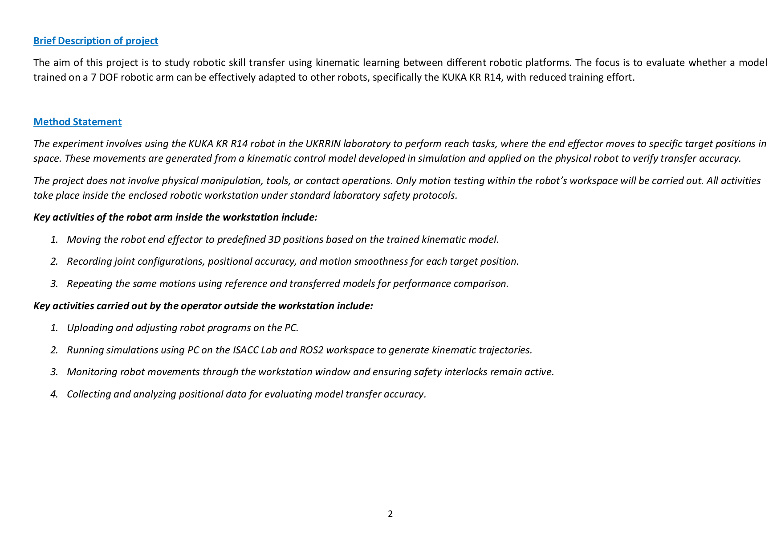

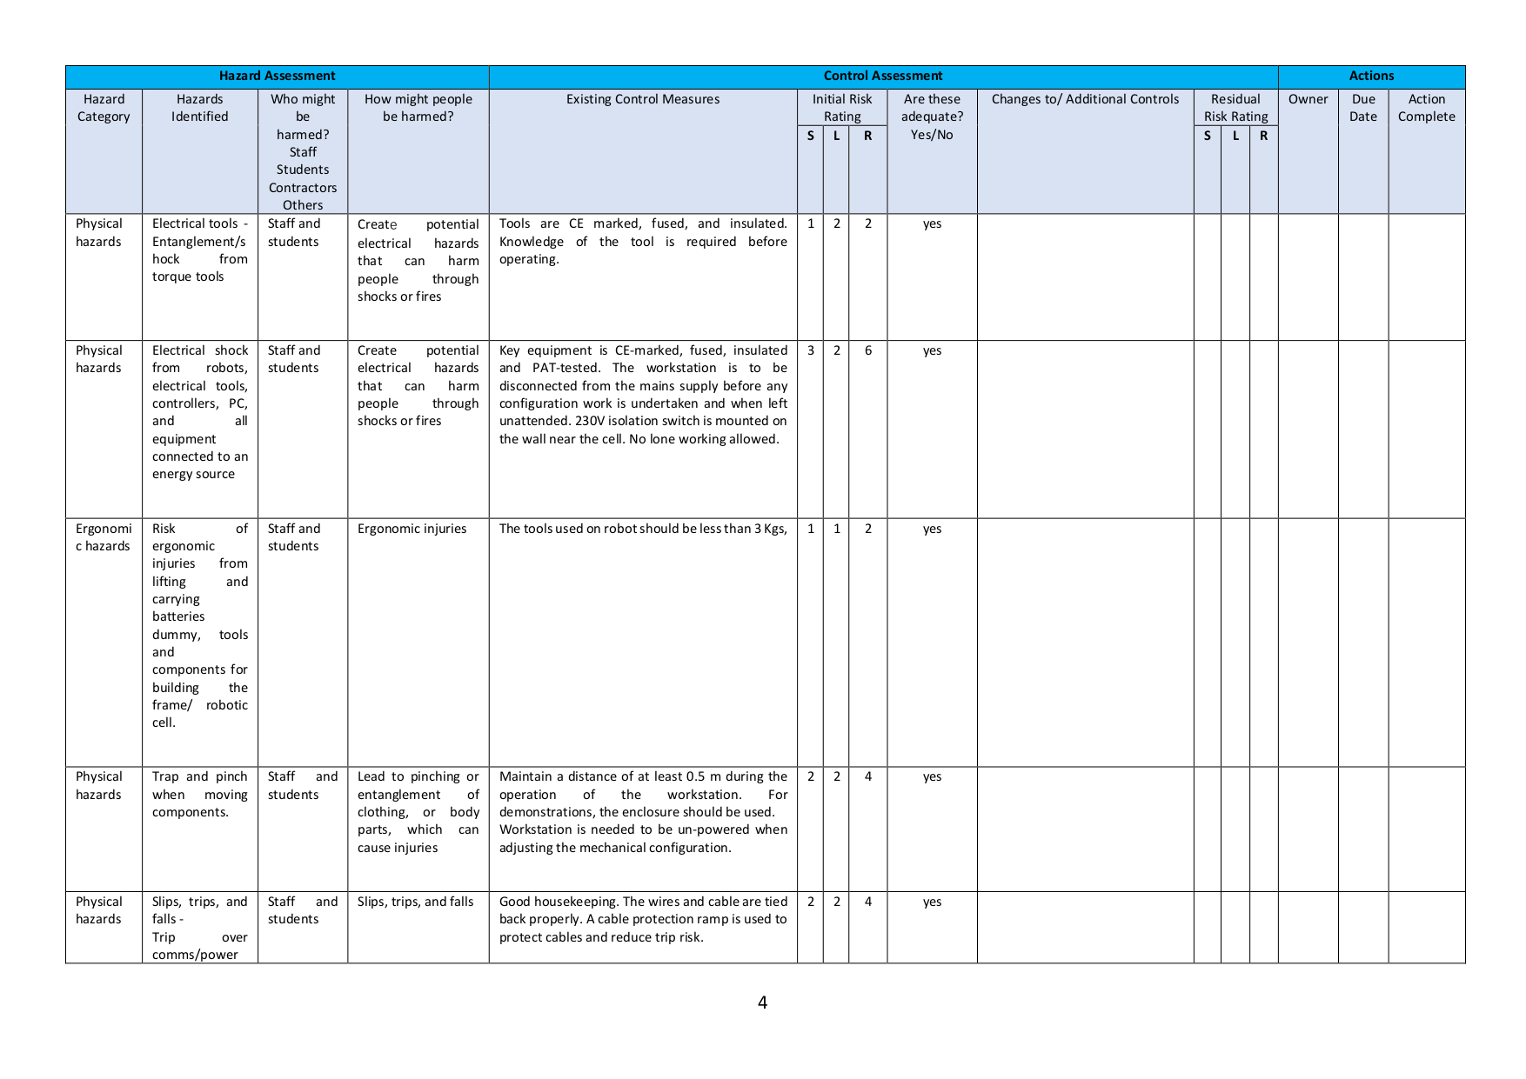
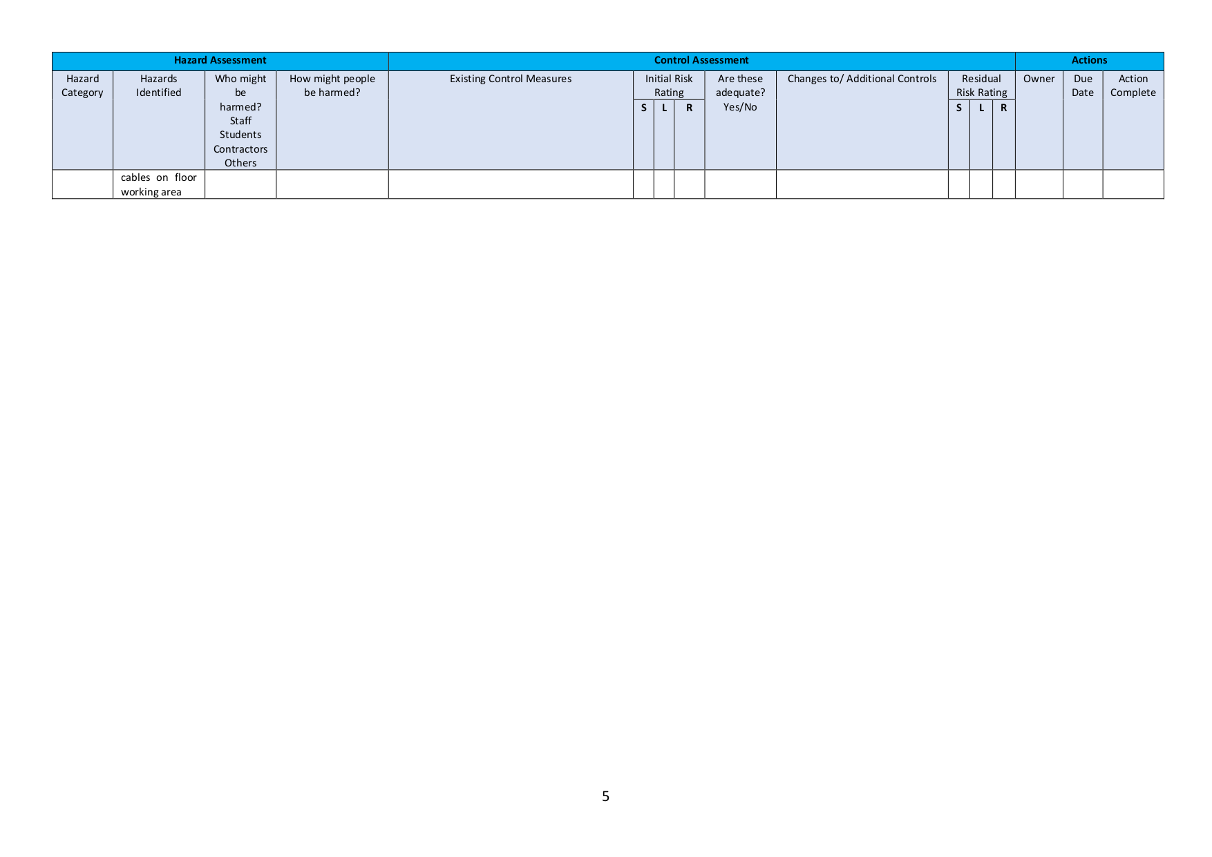
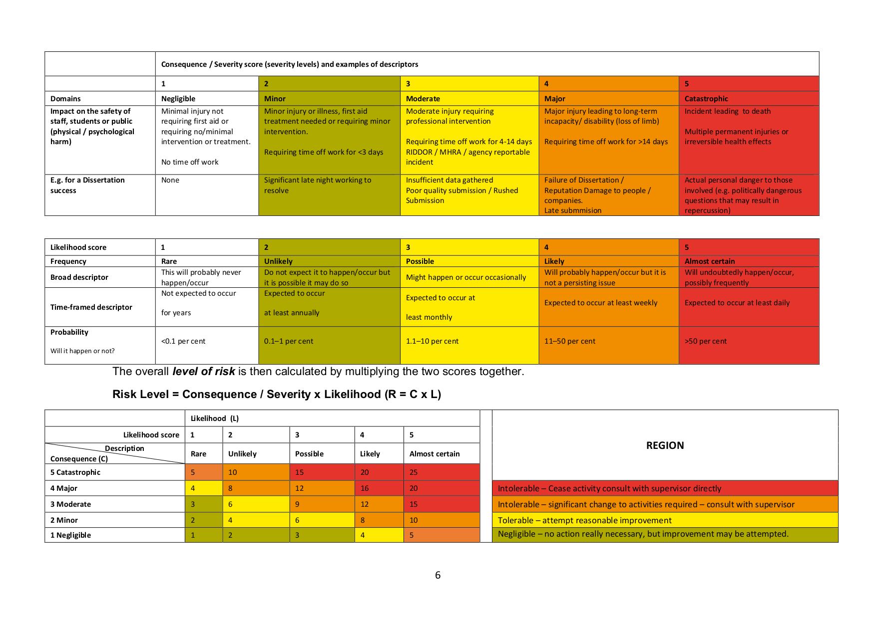

Appendix D Statement on Generative AI

D.1 Declaration
In line with the School of Engineering policy on the use of generative AI in student work, this appendix records the use of generative AI tools in the preparation of this Final Year Project.

D.2 Tools used
The table below lists the generative AI tools used during the project, what each was used for and the approximate frequency of use. All AI-assisted material was reviewed, edited and verified by the author, and the underlying research data, results and conclusions are entirely the author's own work.
Table D.1 Generative AI tools used in the preparation of this report.
Tool | Used for | Frequency
Claude Code (Anthropic) | Audited the training scripts against the codebase to find places where the report's methodology description had drifted from what the code actually does; proposed and ran the data-size, multi-seed and t-SNE experiments; rendered figures including the pipeline diagram, the architecture diagram, the training and data-efficiency curves and the multi-seed reproducibility plot; rewrote Section 6.3 in response to supervisor feedback. All output was checked, edited and verified before inclusion in the report. | Heavy use in the final week of report preparation
ChatGPT (OpenAI) | Occasional explanation of meta-learning concepts during the literature review; sanity-checking quaternion-distance and SE(3) algebra. | Occasionally
GitHub Copilot | Inline code completion while writing the PyTorch training and adaptation scripts. | Regularly during implementation

D.3 What AI was not used for
To make the boundary explicit, the following components of the project are entirely the author’s own work and were not produced by generative AI:
- The research design, including the choice of meta-kinematics formulation, the three-stage pipeline and the experimental protocol.
- The implementation of the simulation pipeline in Isaac Lab, the dataset generation and the training and adaptation code.
- The numerical results reported in Chapter 5 and the figures derived from them.
- The interpretation of the results, the engineering judgements made in the discussion and the future-work plan.

Where AI tools were used to draft text, the output was treated as a starting point and was reviewed, rewritten and verified by the author before inclusion. Where AI tools were used to assist with debugging or formatting, the resulting code or document content was tested and validated by the author.

D.4 Example prompts and outputs
The following three examples illustrate the type of generative-AI use described in Sections D.2 and D.3. In each case the AI output was treated as a starting point and subsequently reviewed, rewritten or rejected by the author.
1. Generative AI prompt:
Summarise the contributions of the KineNN paper by Diprasetya, Pöppelbaum and Schwung (2025) on inverse kinematics with dual-quaternion neural networks.
Generative AI output:
KineNN proposes a kinematic neural network for inverse-model policy that internalises rigid-body geometry through homogeneous transformation matrices and dual-quaternion representations. Targeting the Universal Robots UR5 (6 DoF), the architecture emits learned transformation parameters per link rather than learning the joint-to-pose mapping in a flat regression form. The paper reports improved sample efficiency and accuracy on the UR5 IK task relative to baseline MLP approaches. The method is relevant to the present project as a representative architecture-aware embedding of rigid-body structure in learned kinematic models, and is cited in Section 6.3 as part of the SE(3)-aware family against which the present mask-conditioned ResMLP design is contrasted.
2. Generative AI prompt:
Write a PyTorch class for a residual MLP block with one skip connection, dropout (p=0.1) and ReLU activations, taking and returning a tensor of shape (batch, hidden_dim).
Generative AI output:
import torch.nn as nn
class ResBlock(nn.Module):
def __init__(self, hidden_dim, dropout=0.1):
super().__init__()
self.fc1 = nn.Linear(hidden_dim, hidden_dim)
self.fc2 = nn.Linear(hidden_dim, hidden_dim)
self.dropout = nn.Dropout(dropout)
self.relu = nn.ReLU()
def forward(self, x):
h = self.relu(self.fc1(x))
h = self.dropout(h)
h = self.fc2(h)
return self.relu(h + x)
(Note: the actual ResMLP in this project uses essentially the same structure but with the dropout placed before the second linear, matching the diagram in Figure 3.2.)
3. Generative AI prompt:
Proofread the following paragraph from a project report for clarity and grammar; preserve technical terms exactly. "The shared meta-kinematics model also trains stably when initialised from the single-task checkpoints, as shown in Figure 5.2. The training loss converges quickly to a low and stable plateau, confirming that the shared backbone has enough capacity to represent all three configurations."
Generative AI output:
The shared meta-kinematics model trains stably when initialised from the single-task checkpoints (Figure 5.2): the training loss converges quickly to a low, stable plateau, confirming that the shared backbone has enough capacity to represent all three DoF configurations simultaneously.
Edits made: combined the two clauses into a single sentence; replaced "as shown in Figure 5.2" with the in-line reference "(Figure 5.2)"; added the qualifier "DoF" before "configurations" for precision; added "simultaneously" to make the multi-task framing explicit. The author accepted the parenthetical reference style change but kept the original "as shown in Figure 5.2" in the final text for stylistic consistency with the rest of Section 5.2.

Appendix E Implementation Details

E.1 Architecture configuration
This appendix records the architecture, training configuration and reproducibility details of the meta-kinematics framework. Values that are common to all three training stages are listed in Table E.1; per-stage values for learning rate, batch size and step count are listed separately in Table E.2 because they differ between Stage 1 (single-task), Stage 2 (shared meta-kinematics) and Stage 3 (per-DoF adaptation).
Table E.1 Architecture and shared training parameters for the meta-kinematics ResMLP.
Parameter | Value
Input dimension (n_max) | 7
Output dimension | 7 (3 position + 4 quaternion)
Hidden dimension | 1024
Number of residual blocks | 8
Activation | ReLU
Regularisation (each residual block) | Dropout (p = 0.1) between the two linear layers; no LayerNorm or BatchNorm
Quaternion normalisation | Unit-norm projection on output
Optimiser | Adam (β₁ = 0.9, β₂ = 0.999, ε = 1×10⁻⁷ in adaptation, default ε in Stages 1–2)
Position-loss weight λ_p | 0.03 (Stages 1–2); 1.0 (Stage 3 adaptation)
Orientation-loss weight λ_o | 0.03 (Stages 1–2); 0.30 (Stage 3 adaptation)
Weight decay | 1×10⁻⁵ (Adam L2, Stage 1); 0 (Stage 2); 1×10⁻⁶ L2-to-init (Stage 3 adaptation)
Mask conditioning | Inactive joints zero-clamped at the input; binary active-joint mask additionally projected into the hidden space by a learned, zero-initialised linear layer (Stages 2–3)
Train / held-out split | Per-DoF held-out test split (sample-disjoint from training)
Joint-noise floor (IK target standardisation) | std_floor_q = 1.0° equivalent. Not used in FK, the work reported here is FK only
Hardware | Single NVIDIA GPU; Isaac Lab Python environment (TF32 enabled)
Software stack | PyTorch [14], Isaac Lab [13], CUDA, Python 3.10
Random-seed handling | Seed 42 for Stages 1 and 2; seeds {42, 1, 2} (n = 3) for the Stage 3 multi-seed Adapted (best) row of Table 5.1; see Appendix E.3

E.2 Per-stage training configuration
Table E.2 lists the learning rate, batch size and total step / epoch count used at each of the three training stages. Wall-clock times are from the runs that produced the headline numbers in Table 5.1.
Table E.2 Per-stage training configuration. Step counts and wall-clock times are from the runs that produced the headline numbers in Table 5.1.
Parameter | Stage 1 (single-task) | Stage 2 (shared meta) | Stage 3 (adaptation)
Initial learning rate | 5 × 10⁻⁴ | 3 × 10⁻⁴ | 1 × 10⁻⁵
LR schedule | ReduceLROnPlateau (factor 0.5, patience 10) | Cosine, linear warmup of 2 000 steps | Constant
LR minimum | (set by plateau decay) | 1 × 10⁻⁵
Batch size | 8 192 | 4 096 | 8 192
Total steps | Up to 200 epochs (early-stopped on val loss plateau) | 300 000 (best at step 289 500) | 100 000
Support / query size | n/a (50/20/30 train/val/test split) | n/a | 50 k support / 2 M query
Gradient clipping (max norm) | 1.0 | 1.0 | 1.0
Weight decay / L2 | 1 × 10⁻⁵ (Adam L2) | 0 | 1 × 10⁻⁶ (L2-to-init regulariser)
Wall-clock time (5 DoF) | 1.873 hr | 1.159 hr (shared) | 0.365 hr
Wall-clock time (6 DoF) | 4.973 hr | 1.159 hr (shared) | 0.363 hr
Wall-clock time (7 DoF) | 22.12 hr | 1.159 hr (shared) | 0.111 hr
Random seed | 42 | 42 | {42, 1, 2} (n = 3)

E.3 Statistical methodology
The single-task and shared meta-kinematics results in Chapter 5 are reported from runs initialised with the fixed random seed value 42, which controls parameter initialisation, dataset shuffling and minibatch sampling. The Adapted (best) row of Table 5.1 is reported as a sample mean ± standard deviation over n = 3 seeds (seeds 42, 1 and 2), with two-sided 95 % confidence intervals computed from a Student’s t-distribution with df = 2 (see Section 5.4). The dataset itself is fixed by the procedure of Section 4.3 and is identical across runs; the seed therefore controls only the stochastic components of training. The single-seed protocol used for Stages 1 and 2 is sufficient to characterise the qualitative pattern of results, the shared-and-adapt strategy outperforms the single-task baseline on the 5- and 6-DoF configurations, but does not provide a measure of seed-level variance for those upstream stages. The seed budget for Stages 1 and 2 is identified in Section 6.4 as a limitation of the study and as the first item in the planned journal extension (Section 7.3), where five seeds per condition will be used together with held-out bootstrap 95 % confidence intervals.
Seeds used: 42 for Stages 1 and 2; {42, 1, 2} for the Stage 3 multi-seed Adapted (best) row of Table 5.1. Seeds are set via torch.manual_seed, numpy.random.seed and random.seed at the start of every training script.

E.4 Loss-function and training-loop pseudocode
Listing E.1 Squared geodesic-angle term used inside the Stage-3 adaptation loss (3.3b).
def quat_geodesic_loss_rad2(r_hat, r, eps=1e-7):
# r_hat, r: (B, 4) tensors in (qw, qx, qy, qz) order.
# Sign-invariant geodesic angle (radians), squared and averaged.
r_hat = r_hat / r_hat.norm(dim=1, keepdim=True).clamp_min(eps)
r = r / r.norm(dim=1, keepdim=True).clamp_min(eps)
dot = (r_hat * r).sum(dim=1).abs().clamp(eps, 1.0 - eps)
ang = 2.0 * torch.acos(dot) # in [0, pi]
return (ang ** 2).mean() # used inside the Stage-3 loss (3.3b)

Listing E.2 Residual block used inside the ResMLP backbone of Figure 3.2(a).
class ResBlock(nn.Module):
def __init__(self, dim: int = 1024, p_drop: float = 0.1):
super().__init__()
self.fc1 = nn.Linear(dim, dim)
self.fc2 = nn.Linear(dim, dim)
self.act = nn.ReLU()
self.drop = nn.Dropout(p_drop)

def forward(self, x):
h = self.act(self.fc1(x))
h = self.drop(h)
h = self.fc2(h)
return self.act(h + x) # ReLU after additive skip

Listing E.3 Multi-task minibatch sampler used for Stage 2 (shared meta-kinematics) training.
def multitask_step(model, task_loaders, optimizer, mse):
# One Stage-2 optimisation step on a uniformly-sampled DoF configuration.
tname = random.choice(list(task_loaders.keys())) # 5dof / 6dof / 7dof
x, y, mask = next(task_loaders[tname]) # already per-task standardised
yhat = model(x, mask)
loss = mse(yhat, y) # MSE on standardised pose
optimizer.zero_grad(); loss.backward(); optimizer.step()
return tname, loss.item()

E.5 Reproducibility checklist
The framework is designed to be reproducible from the project repository. Reproducibility is supported by three measures. The dataset generation is fully scripted within the Isaac Lab Python environment, so a given random seed and sampling step size produce a deterministic dataset for each DoF configuration. The training pipeline records training loss, validation loss and held-out test metrics at every stage, so the curves in Figures 5.1 and 5.2 can be regenerated from the saved logs. The ResMLP backbone, the multi-task loss and the per-DoF adaptation routine are implemented as small, self-contained PyTorch modules that can be exercised in isolation; this isolates the meta-kinematics behaviour from the surrounding simulation code and makes the training loop independently testable.
The following items are provided in the project repository to support independent reproduction of the results:
- Training scripts for Stages 1, 2 and 3 with all hyperparameters logged to the run configuration.
- Dataset-generation scripts for the 5, 6 and 7 DoF KUKA iiwa 14 configurations in Isaac Lab.
- Held-out test splits and the deterministic split index used in this report.
- Saved checkpoints for the single-task, shared meta-kinematics and per-DoF adapted models.
- Per-step training-loss logs sufficient to regenerate Figures 5.1 and 5.2.
- Per-sample held-out errors used to compute Table 5.1, supporting independent re-evaluation and bootstrap-CI computation.

E.6 Data availability
The simulated datasets used in this study were generated from the publicly available KUKA iiwa 14 URDF supplied with Isaac Lab. The datasets and the trained model checkpoints are available from the author on reasonable request, subject to the file-size limits of the University’s research data repository. The exact commit hash, environment lock file and run configuration used for each result reported in this document are listed in the project README and quoted at the head of every saved log file, so that any single result can be traced back to the run that produced it.

E.7 Multi-seed reproducibility scatter
Figure E.7 reproduces the per-seed scatter of Adapted (best) results referenced in Section 5.4. Three seeds (42, 1, 2) hold the Stage-2 shared meta-kinematics checkpoint and Stage-3 hyperparameters fixed and vary only parameter initialisation, support/query split and minibatch sampling. The diamond with whiskers is the n = 3 mean and 95% Student's t confidence interval (df = 2); filled markers show individual seed values; the dashed red line is the single-task baseline and the dotted grey line the shared meta-kinematics value, both for the corresponding DoF.

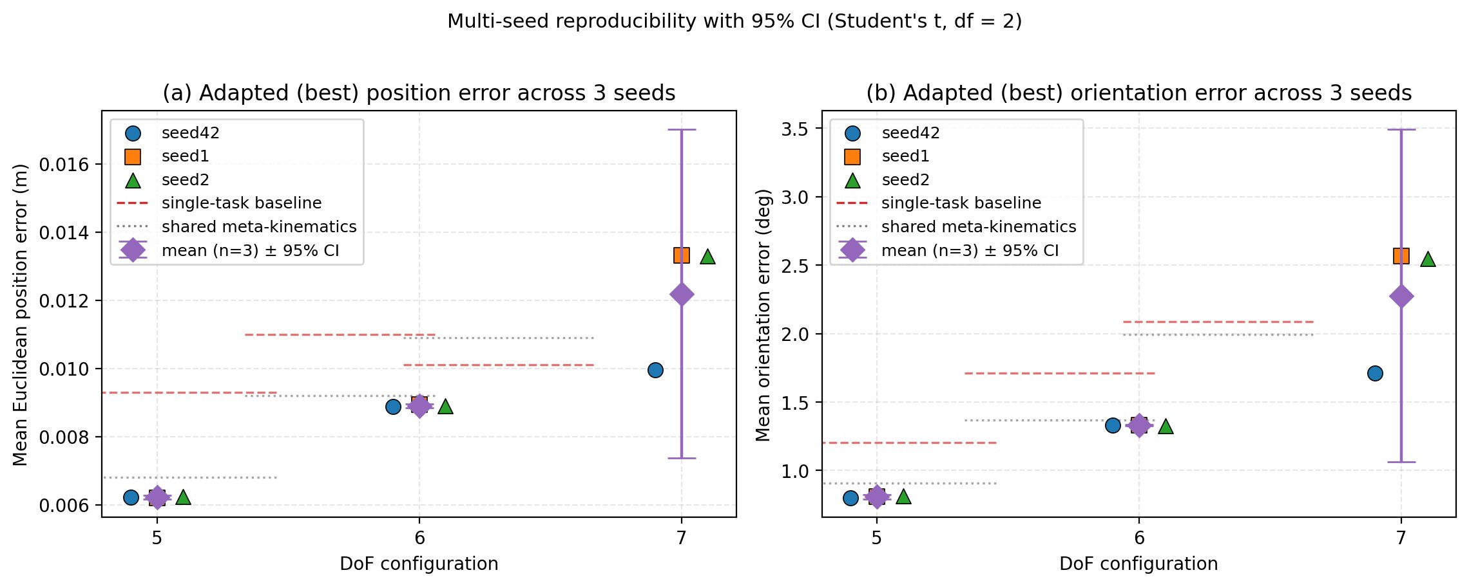
Figure E.7 Multi-seed reproducibility of the per-DoF adaptation result. Three seeds (42, 1, 2) hold the Stage-2 shared checkpoint and Stage-3 hyperparameters fixed. Filled markers are individual seeds; the diamond with whiskers is the n = 3 mean and 95% Student's t confidence interval (df = 2). Dashed red line: single-task baseline; dotted grey line: shared meta-kinematics value.


