**Systems Analysis and Design**

**Phase 1 Research**

**D23126011**

**Vasily**

# Project Description – Swift Bites

*“Introducing Swift Bites – your go-to destination for swift and scrumptious delights delivered right to your doorstep! Satisfy your cravings with our diverse menu featuring an array of cuisines from around the world. Whether you're in the mood for a sizzling pizza, a comforting bowl of noodles, or a healthy salad, Swift Bites has got you covered. Our dedicated team ensures that your order is prepared with precision and delivered piping hot, guaranteeing a delightful dining experience every time. With Swift Bites, say goodbye to long waits and hello to the convenience of delicious meals brought straight to you – because good food should always be swift!”* (*generated by chatGPT*) *[1]*

We have made a number of assumptions regarding our users:

* A sufficient number of people live in the city (more than 500k but less than 2 millions).
* The city has a sufficient number of different restaurants (more than 100).
* Users are familiar with similar food delivery applications like *Deliveroo*.

# Research Conducted

In Dublin, the food delivery industry has seen a dynamic and thriving development, led by popular platforms such as Deliveroo and Uber Eats. These services have become an integral part of the city's culinary scene, providing residents and visitors with convenient access to a variety of local cuisines. The ease of ordering through convenient apps has changed the way people eat, putting a variety of options at their fingertips. Restaurants, both existing and new, are using these platforms to reach a wider audience, contributing to the overall dynamics of Dublin's food culture.

Since the food delivery scene is quite competitive, the first step is to determine the minimum required functionality for a food ordering app. After analyzing the Deliveroo and Uber Eats applications, I identified the following features [2], [3]:

* User account – registration, log in, log out.
* Browse and Search: Allow users to browse different restaurants, cuisines, and menu items.
* Menu and Item Selection: Clearly displays restaurant menus with detailed item descriptions, prices and images, making selection easy.
* Cart and ordering: Allow users to add items to their cart, review their orders, and proceed to a secure checkout process.
* Real-time order tracking: Keep users informed about their order status in real-time, from confirmation to preparation and delivery.
* Notification system to help track stage of customer’s order.
* Ratings and Reviews System.
* User support to help customers.

There is some screenshots from competing application Deliveroo to illustrate some functionality of food delivery application.

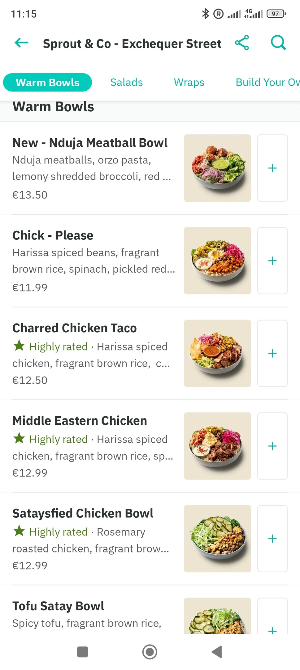Screenshot 3: Ordering different food items

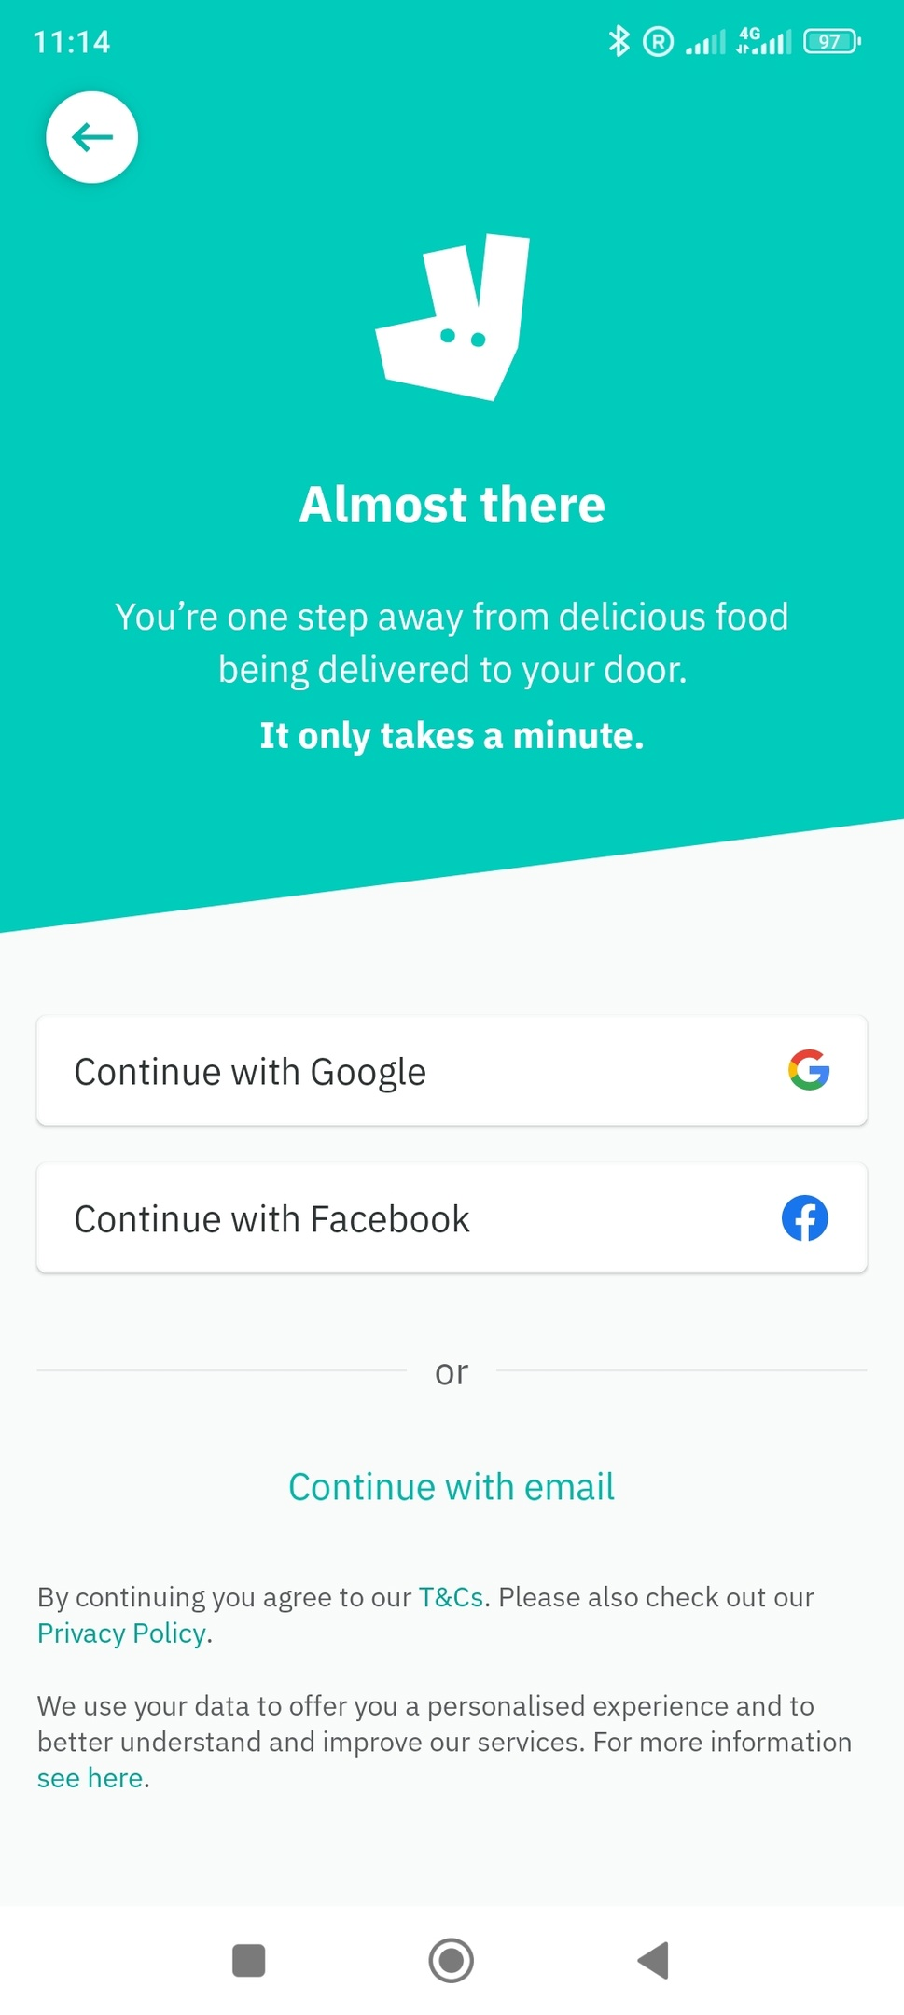Screenshot 1: Registration Page

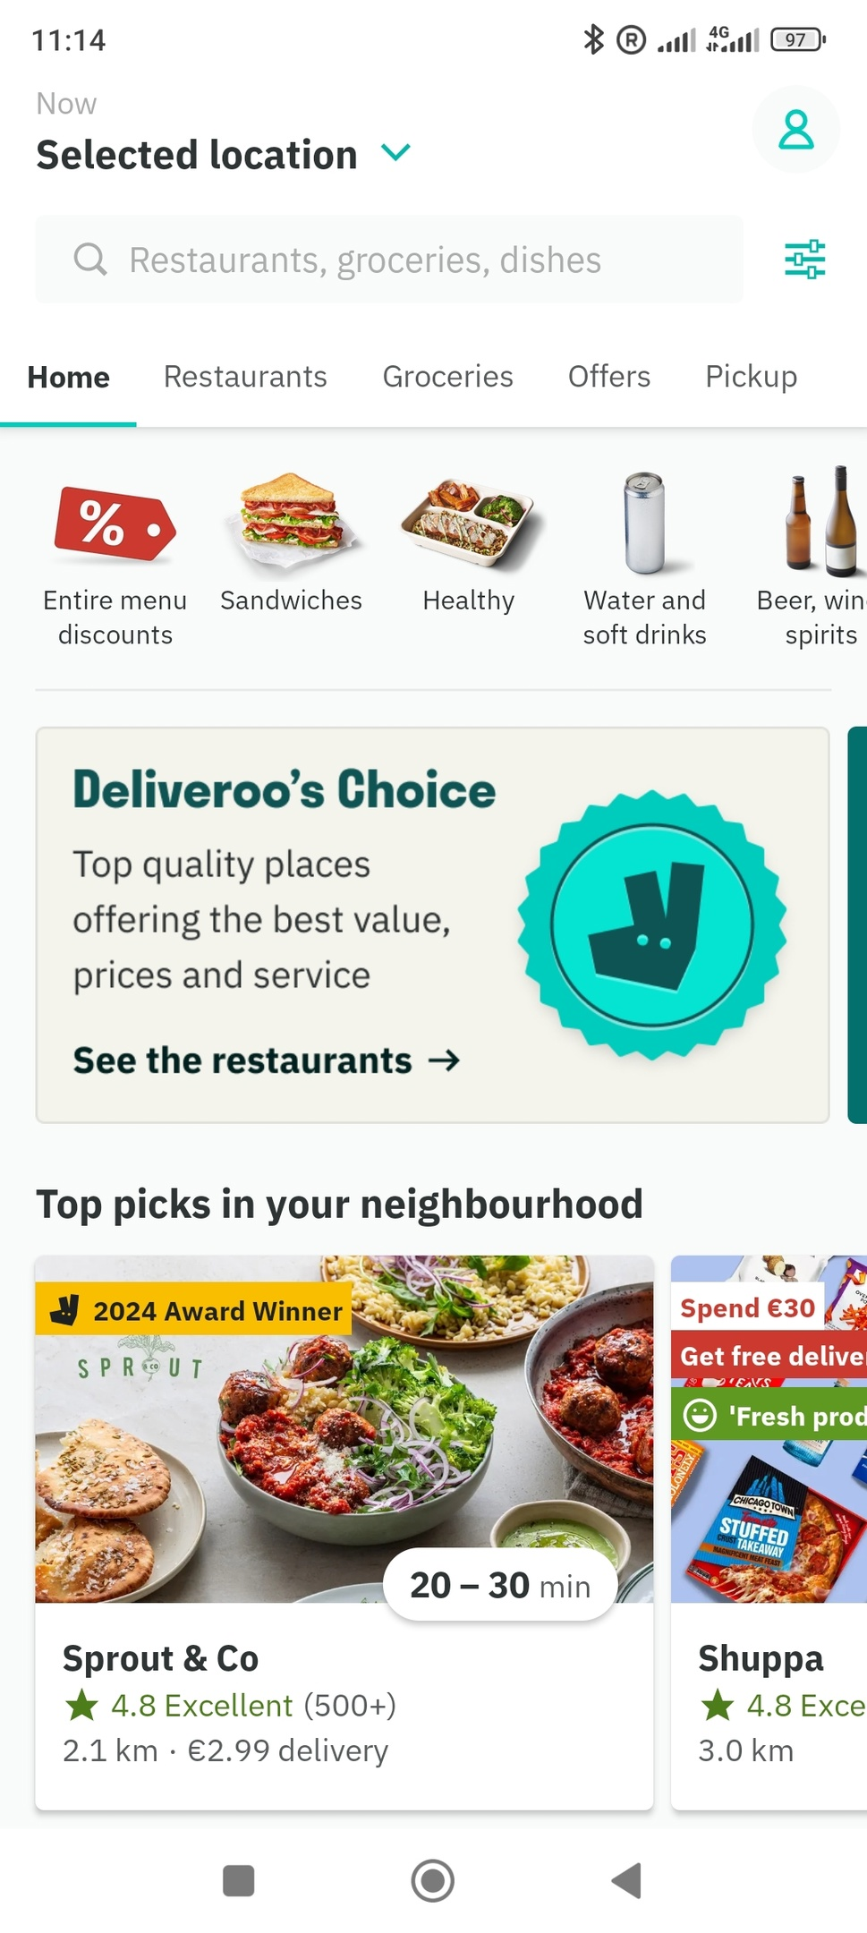Screenshot 2: Main Page

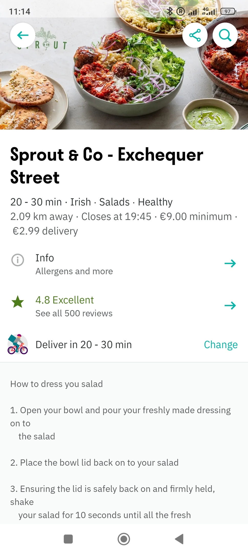Screenshot 4: Restaurant page

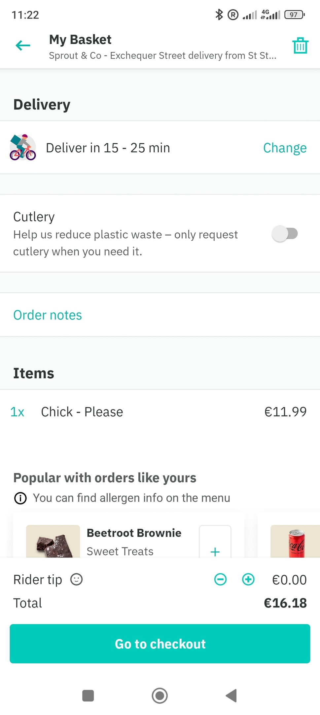Screenshot 5: Order page

Dublin is the right city for our new business. More than a million people live in Dublin, potential users of our application [4]. Dublin also has a wide variety of restaurants ready to serve as food providers [5].

# Reference

[1] “ChatGPT.” Accessed: Mar. 06, 2024. [Online]. Available: https://chat.openai.com

[2] “Deliveroo.” Accessed: Mar. 06, 2024. [Online]. Available: https://deliveroo.ie/

[3] “Uber Eats | Food delivery and takeaway | Order online from restaurants near you.” Accessed: Mar. 06, 2024. [Online]. Available: https://www.ubereats.com/ie

[4] “Dublin,” *Wikipedia*. Feb. 29, 2024. Accessed: Mar. 06, 2024. [Online]. Available: https://en.wikipedia.org/w/index.php?title=Dublin&oldid=1211051313

[5] C. Heneghan, “New report reveals the number of pubs in every constituency in Ireland,” JOE.ie. Accessed: Mar. 06, 2024. [Online]. Available: https://www.joe.ie/life-style/pubs-ireland-589592