**Systems Analysis and Design**

**Phase 1 Use Case Diagram**

**D23126011**

**Vasily**

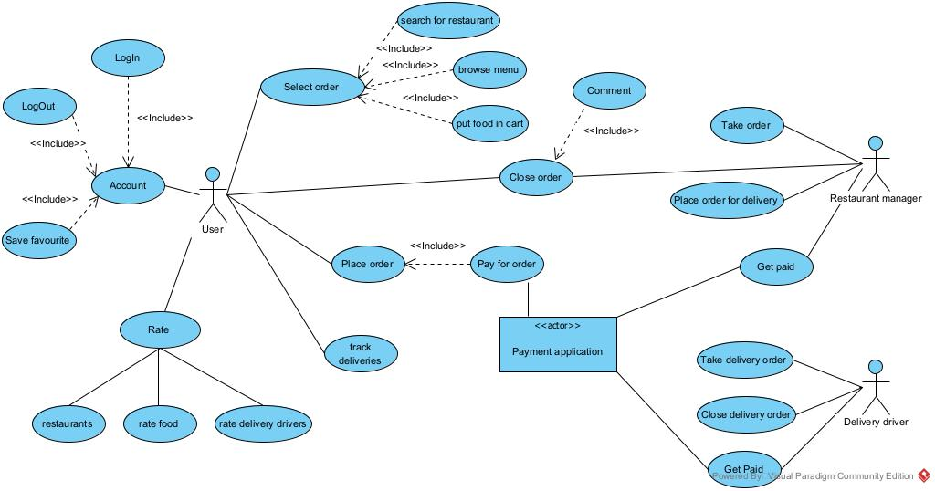

User’s use cases are:

1. Using account features
2. Select food for order
3. Place order and pay for it using third-party payment application
4. Rate everything

Restaurant manager use cases are:

1. Take order from application
2. Place order for delivery

Delivery driver use cases are:

1. Take delivery order or close it