BUSINESS PERFORMANCE
REPORT
  - E-Commerce Sales & Profitability Analysis

REPORT SNAPSHOT | VALUE
Analysis period | 03 January 2023 – 30 December 2026
Transaction line records | 10,194
Total sales | $2,326,534.35
Total profit | $292,296.81
Overall profit margin | 12.56%
Units sold | 38,654

1. Executive Summary
This report evaluates the sales and profitability performance of the business across 10,194 transaction-line records covering 2023 to 2026. The analysis uses sales, profit, quantity, product, category, region and order-date fields to assess commercial performance and identify areas requiring management attention.
The dataset records $2,326,534.35 in sales and $292,296.81 in profit from 38,654 units sold, producing an overall profit margin of 12.56%. The West is the leading region by profit ($110,798.82), while Technology is the leading category by profit ($146,543.38).
The most significant concern is Furniture: despite generating $754,747.76 in sales, it produced only $19,730.00 in profit, a margin of 2.61%. Central is the weakest region by profit margin at 7.92%. These results suggest that management should prioritise margin improvement in Furniture and investigate the cost, pricing and discount drivers behind Central's weaker performance.

Headline KPIs
Measure | Result
Total sales | $2,326,534.35
Total profit | $292,296.81
Overall profit margin | 12.56%
Units sold | 38,654
Records analysed | 10,194

2. Project Objectives and Scope
- Measure overall sales, profit, profit margin and units sold.
- Compare sales and profitability across product categories and geographic regions.
- Review annual and monthly sales and profit patterns.
- Identify products with the highest profit and the largest losses.
- Translate the findings into practical recommendations for management.
The analysis covers records dated from 03 January 2023 to 30 December 2026. The workbook identifies the geographic market as the United States and groups performance into the West, East, South and Central regions.

3. Dataset Overview and Methodology
The supplied workbook contains 10,194 transaction-line records. Relevant fields include Order Date, Ship Date, Region, Category, Sub-Category, Product Name, Sales, Quantity, Discount and Profit. The analysis was performed using Microsoft Excel features represented in the workbook, including cleaned data, PivotTables, calculated profit margin, charts and interactive slicers.
For this report, the aggregate profit margin is calculated as total profit divided by total sales. This weighted calculation is used rather than taking a simple average of individual transaction-level margin percentages.
A validation check of the cleaned data found no fully duplicated rows and no missing values in the core analytical fields (order date, ship date, region, category, product name, sales, quantity and profit). The date range and aggregate totals were also checked against the underlying cleaned records.

4. Overall Sales and Profitability
The business generated $2,326,534.35 in sales and $292,296.81 in profit. The resulting overall margin of 12.56% means that approximately 12.56 cents of profit were generated for every dollar of sales.
KPI | Value | Interpretation
Sales | $2,326,534.35 | Total recorded revenue in the dataset.
Profit | $292,296.81 | Net profit recorded in the Profit field.
Profit margin | 12.56% | Profit as a proportion of total sales.
Quantity | 38,654 | Total units recorded across transaction lines.

5. Product Category Performance
Technology generated the highest profit, followed by Office Supplies in profit. Furniture recorded the lowest profit of the three categories but contributed substantially more sales, indicating a profit margin weakness.
Category | Sales | Profit | Profit margin | Units
Technology | $839,893.28 | $146,543.38 | 26.60% | 7,017
Office Supplies | $731,893.31 | $126,023.44 | 68.86% | 23,268
Furniture | $754,747.76 | $19,730.00 | 7.54% | 8,369

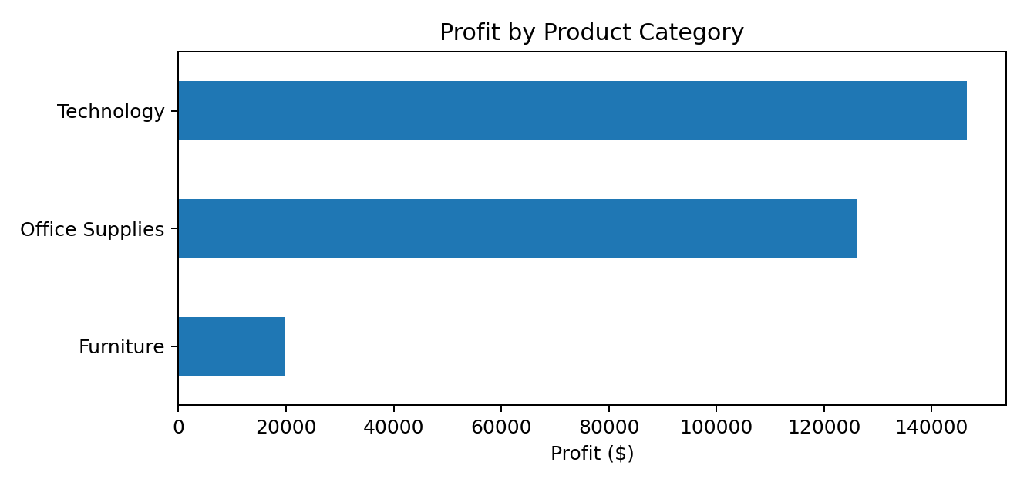
Technology achieved a 23.60% margin, while Office Supplies achieved 68.86%. Furniture's margin was only 7.54%. The contrast between Furniture's sales volume and its profit contribution should be treated as a priority for investigation.

6. Regional Performance
The West was the strongest region by both sales and profit. The East ranked second in profit. Central generated the lowest profit and the weakest margin, even though its sales exceeded those of the South.
Region | Sales | Profit | Profit margin | Units
West | $739,813.61 | $110,798.82 | 57.50% | 12,466
East | $691,828.17 | $94,883.26 | 40.87% | 11,159
South | $391,721.90 | $46,749.43 | 21.26% | 6,209
Central | $503,170.67 | $39,865.31 | -19.63% | 8,820

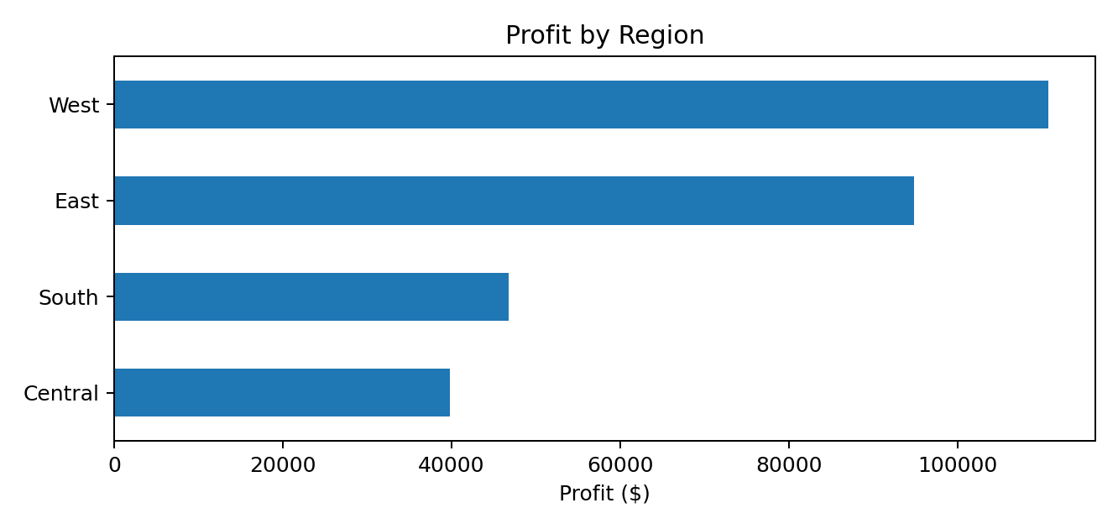
The West generated $110,798.82 in profit at a 57.50% margin. Central generated $39,865.31 at -19.63%. Management should compare Central's discounting, product mix, fulfilment costs and pricing practices with the stronger regions.

7. Annual and Monthly Performance
Annual sales increased from 2024 onward after a decline in 2024. Sales and profit both reached their highest annual totals in 2026 within the period covered by the supplied dataset.
Year | Sales | Profit | Margin | Units | Sales growth
2023 | $494,040.21 | $51,684.30 | 57.50% | 7,813 | —
2024 | $472,993.03 | $62,020.97 | 40.87% | 8,086 | -4.26%
2025 | $613,933.58 | $82,665.20 | 21.26% | 10,018 | 29.80%
2026 | $745,567.53 | $95,926.35 | -19.63% | 12,737 | 21.44%

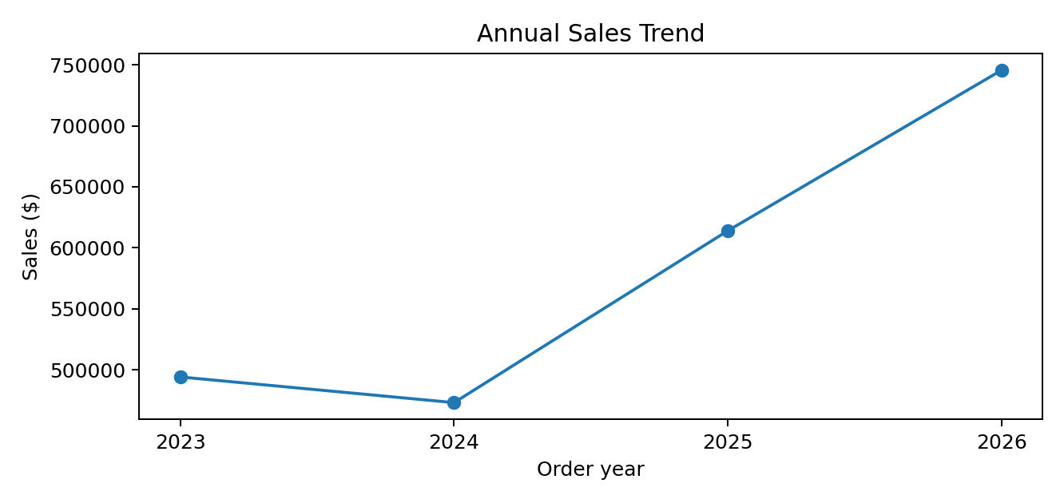
The highest-sales month in the dataset was Nov 2026, with $118,454.51 in sales. The highest-profit month was Dec 2025, with $17,926.30 in profit. These are monthly peaks across the full four-year period, not necessarily evidence of a recurring seasonal pattern.

8. Product-Level Performance
The Canon imageCLASS 2200 Advanced Copier was the highest-profit product, generating $25,199.93 in profit from $61,599.82 in sales. The remaining leading products also include office technology and equipment, indicating that a small group of high-value products contributes materially to profitability.
Top products by profit | Sales | Profit | Units
Canon imageCLASS 2200 Advanced Copier | $61,599.82 | $25,199.93 | 20
Fellowes PB500 Electric Punch Plastic Comb Binding Machine with Manual Bind | $27,453.38 | $7,753.04 | 31
Hewlett Packard LaserJet 3310 Copier | $18,839.69 | $6,983.88 | 38
Canon PC1060 Personal Laser Copier | $11,619.83 | $4,570.93 | 19
HP Designjet T520 Inkjet Large Format Printer - 24" Color | $18,374.90 | $4,094.98 | 12

The five products with the largest recorded losses are listed below. These products warrant review of pricing, discounts, acquisition costs, delivery/handling costs and any product-specific return or service issues.
Products with largest losses | Sales | Loss | Units
Cubify CubeX 3D Printer Double Head Print | $11,099.96 | $-8,879.97 | 9
Lexmark MX611dhe Monochrome Laser Printer | $16,829.90 | $-4,589.97 | 18
Cubify CubeX 3D Printer Triple Head Print | $7,999.98 | $-3,839.99 | 4
Chromcraft Bull-Nose Wood Oval Conference Tables & Bases | $9,917.64 | $-2,876.12 | 27
Bush Advantage Collection Racetrack Conference Table | $9,544.73 | $-1,934.40 | 33

9. Key Business Insights
- Technology is the strongest category by profit, contributing $146,543.38 at a 23.60% margin.
- Furniture has a substantial sales base ($754,747.76) but a weak 7.54% margin, making it the clearest category-level profitability concern.
- The West leads regional profit at $110,798.82; Central has the lowest regional margin at -19.63%.
- 2026 recorded the highest annual sales ($745,567.53) and profit ($95,926.35) in the dataset.
- Profitability is concentrated in a small group of high-performing products, while several products generated material losses; product-level margin monitoring is therefore important.

10. Recommendations to Management
Investigate Furniture margins first. Review discount levels, selling prices, procurement costs, freight/handling costs and product mix within Furniture. Consider repricing or renegotiating costs for products that repeatedly generate low or negative contribution.
Replicate practices from stronger regions. Compare West and East pricing, discounting, product mix and fulfilment performance with Central. Use the comparison to identify operational practices that may improve Central's -19.63% margin.
Protect and expand profitable Technology sales. Maintain availability of high-contribution Technology products, monitor stock-outs and assess opportunities to cross-sell complementary products without weakening margins.
Introduce product-level profit controls. Flag products with repeated negative profit for review. Establish minimum margin thresholds and require approval for discounts that push a product below its target contribution.
Manage sales growth alongside margin. Track sales, profit and margin together. Revenue growth alone should not be treated as success if the additional sales are achieved through excessive discounting or cost increases.
Use the interactive dashboard for routine monitoring. Review performance by region and category using the slicers. Monitor monthly trends and investigate material deviations from normal sales or profit levels.

11. Conclusion
The analysis shows a business with a positive overall profit margin of 12.56% and meaningful differences in performance across categories, regions and individual products. Technology and the West are the strongest contributors to profit. Furniture and Central require closer attention because their margins are comparatively weak. The largest product-level losses also indicate that sales volume should be assessed alongside contribution, not in isolation.
Management should prioritise targeted margin improvement, disciplined discounting, product-level profitability reviews and regular dashboard monitoring. These actions would help sustain growth while improving the quality of profit.

12. Notes on Interpretation
This report is based on the excel workbook and the records available in its Clean Data worksheet. It describes historical performance in the dataset and does not establish the causes of low margins. The recommended investigations are intended to identify those causes. Monthly peaks are descriptive and should not be interpreted as seasonality without additional multi-year month-to-month comparison. Profit margin figures in this report are calculated from aggregated profit divided by aggregated sales.
The workbook's dashboard and PivotTable layouts are not reproduced as screenshots in this document; the report presents the underlying results in tables and supporting charts.

