SALES DATA ANALYTICS DASHBOARD
Project Report
IBM SkillsBuild — Data Analytics with AI
Academic Internship Program
Conducted by BharatCares in association with AICTE

Submitted By | Chitesh
Project | Sales Data Analytics Dashboard
Primary Technology | Python
Dataset | excelsheet.xlsx — Raw_Data

Submitted as part of the academic internship project requirements

1. Project Overview
This project demonstrates an end-to-end data analytics pipeline on a real-world sales dataset. The workflow starts with a raw Excel file containing intentional data-quality issues, followed by systematic data cleaning and standardisation, exploratory data analysis, business-oriented analysis, and presentation of results through an interactive browser-based dashboard.
- Load and inspect the raw Excel sales dataset.
- Identify and correct data-quality issues.
- Standardise important categorical and numerical fields.
- Remove duplicate, invalid, and unusable records.
- Perform exploratory data analysis across category, region, product, and time.
- Derive business-oriented insights from the cleaned dataset.
- Generate an interactive HTML dashboard that can be opened in a browser without a dedicated server.

2. Problem Statement
Raw business datasets often contain duplicate records, inconsistent text values, invalid dates, missing identifiers, malformed currency values, and invalid quantities. These issues can produce misleading analysis if they are not addressed before aggregation and visualisation.
The purpose of this project is to build a repeatable Python-based workflow that converts the raw sales data into a clean analytical dataset and presents the resulting performance measures in an interactive dashboard.

3. Objectives
- Clean and standardise the supplied sales dataset.
- Create a reliable cleaned dataset for analysis.
- Analyse revenue, profit, orders, quantity, and profit margin.
- Compare sales performance across product categories and regions.
- Study monthly revenue and profit trends.
- Provide a searchable data table and a visible cleaning log.
- Communicate key findings through an interactive dashboard.

4. Dataset Description
The source dataset is an Excel workbook named excelsheet.xlsx. The notebook loads the Raw_Data sheet. The raw dataset contains 2,000 rows and 9 analytical columns.
Column | Type | Description
Order_ID | Integer | Unique order identifier
Order_Date | Date | Date the order was placed
Customer_ID | String | Customer identifier
Product | String | Product name
Category | String | Product category
Region | String | Sales region/city
Quantity | Numeric | Number of units ordered
Revenue | Numeric | Revenue generated by the order
Profit | Numeric | Net profit generated by the order

5. Tools and Technologies
Technology | Use in Project
Python | Core programming and data-processing language
Pandas | Data loading, cleaning, transformation, and analysis
NumPy | Numerical operations
Matplotlib | Data visualisation support
Seaborn | Statistical/data visualisation support
OpenPyXL | Reading Excel workbook data
Jupyter Notebook | Documenting and executing the analytics workflow
HTML / JavaScript | Browser-based dashboard presentation
Chart.js | Interactive dashboard charts
IBM Bob | Development environment and AI-assisted project development

6. Data Cleaning Methodology
The notebook documents a 13-step cleaning process. The same transformation logic is also implemented by the project's data-cleaning script.
Step | Operation
1 | Drop unnamed / empty columns
2 | Remove exact duplicate rows
3 | Fix Order_ID (float to integer)
4 | Parse and validate Order_Date
5 | Fill missing Customer_ID with UNKNOWN
6 | Fill missing Product with UNKNOWN
7 | Standardise Category to title case
8 | Standardise Region to title case
9 | Remove Quantity values that are missing or ≤ 0
10 | Clean Revenue by removing currency symbols, INR, and commas
11 | Fill missing Profit values with 0
12 | Add Sales column
13 | Final ordering and export

7. Cleaning Results
Measure | Result
Raw rows | 2,000
Cleaned rows | 1,891
Rows removed | 109
Raw columns | 9
Cleaned analytical columns | 9 plus derived Sales field in the analysis workflow

The cleaning dashboard records 23 exact duplicate rows removed, 24 impossible dates removed during date validation, and 62 rows removed because Quantity was missing or non-positive. The remaining records were standardised and exported as cleaned_data.csv.

Figure 1. Notebook project overview and dataset summary
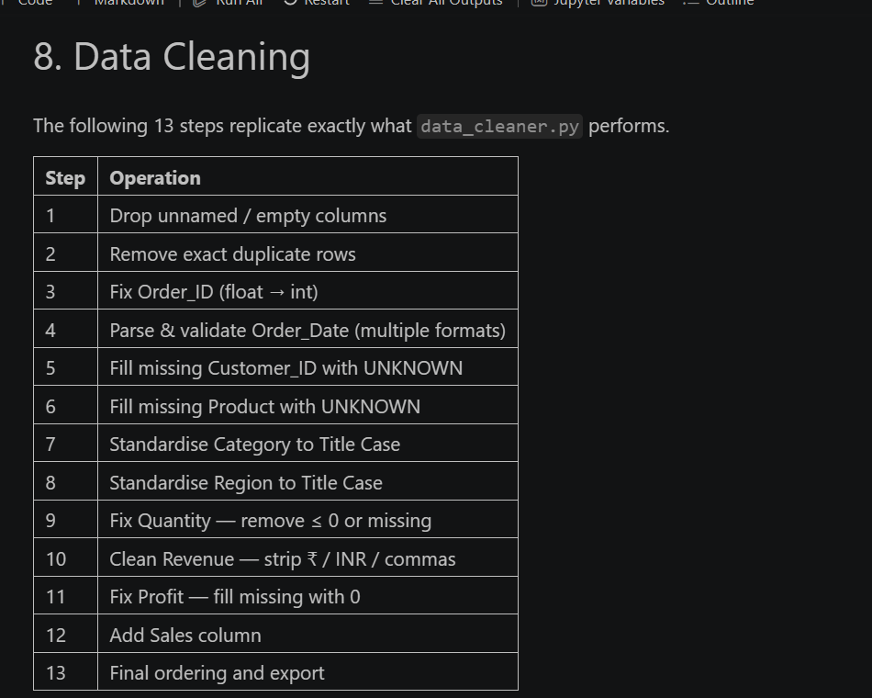

Figure 2. Documented 13-step data-cleaning methodology
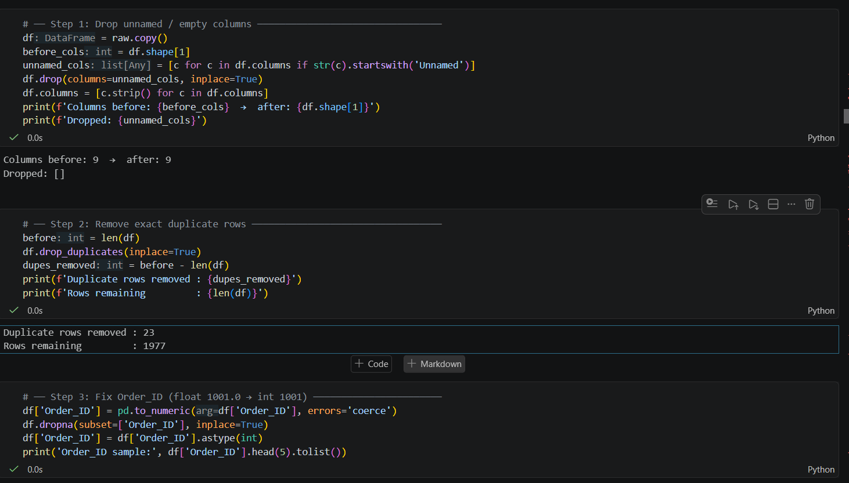

8. Exploratory Data Analysis
The analysis examines the cleaned data from multiple business perspectives. The dashboard and notebook provide category, region, product, and monthly views so that revenue and profit can be interpreted together.
- Category-level revenue and profit comparison.
- Revenue share by category.
- Order count by category.
- Revenue share and revenue ranking by region.
- Profit comparison across regions.
- Monthly revenue and profit trend.
- Top-product analysis.
- Searchable view of the cleaned records.

9. Dashboard Design
The final dashboard is browser-based and is generated as an HTML file. It is designed as a multi-section analytics interface rather than a single static chart.
Dashboard Section | Main Content
Overview | Six KPI cards, category revenue/profit, regional revenue, monthly trend
Category | Revenue vs Profit, revenue share, order counts
Region | Revenue by region, regional share, profit by region
Trend | Monthly revenue/profit, top products, monthly orders
Data Table | Scrollable/searchable cleaned data
Cleaning | Raw vs cleaned row statistics and 13-step cleaning log

10. Key Performance Indicators
KPI | Dashboard Value
Total Revenue | ₹91.12M
Total Profit | ₹14.62M
Total Orders | 1,891
Units Sold | 6,613
Average Order Value | ₹48,185
Profit Margin | 16.1%

11. Key Findings
- Electronics is the leading revenue-generating product category in the analysed dataset.
- Pune is the highest-revenue region shown in the dashboard.
- Revenue and profit vary considerably across the monthly period represented in the dataset.
- The dashboard reports an overall profit margin of approximately 16.1%.
- The analysis provides category-, region-, product-, and time-based views of sales performance.
- Data-quality problems were addressed before the main analytical views were generated.

12. Project Implementation
The project separates major tasks into reusable files. The Jupyter notebook documents the complete analytics workflow, while the Python scripts support data cleaning and dashboard generation.
File | Purpose
Chitesh_SalesDataAnalytics.ipynb | Complete documented analysis and reproducible notebook workflow
data_cleaner.py | Cleans the raw Excel dataset and exports cleaned_data.csv
dashboard.py | Reads cleaned data and generates dashboard.html
app.py | Application/dashboard support code
cleaned_data.csv | Cleaned analytical dataset
dashboard.html | Generated interactive browser dashboard
requirements.txt | Python dependencies
README.md | Project overview and run instructions

13. Installation and Execution
Install the required Python libraries:
pip install -r requirements.txt
Run the data-cleaning script:
python data_cleaner.py
Generate the dashboard:
python dashboard.py
The generated dashboard.html can then be opened in a browser. The project is designed so that the dashboard can be viewed without running a dedicated web server.

14. Python Dependencies
pandas>=2.0.0
openpyxl>=3.1.0
numpy>=1.24.0
matplotlib>=3.7.0
seaborn>=0.12.0

15. Submission Deliverables
The internship instructions require four principal submission files. The project is organised to provide:
Required Deliverable | Project File
Code File | Chitesh_SalesDataAnalytics.ipynb
Requirements File | requirements.txt
Project Report | Chitesh_SalesDataAnalytics_ProjectReport.docx
README File | README.md

16. Conclusion
This project demonstrates a complete Python-based sales analytics workflow. Starting from a raw Excel dataset with data-quality issues, the workflow cleans and standardises the records, performs exploratory analysis, derives business-oriented findings, and presents the results through an interactive dashboard.
The final project combines reproducible notebook analysis, reusable Python scripts, a cleaned dataset, documentation, dependency information, and an interactive HTML dashboard. This structure supports both technical evaluation and clear communication of the analytical results.

17. Author
Chitesh
Sales Data Analytics Dashboard
IBM SkillsBuild — Data Analytics with AI Academic Internship Program

