VR_12 Procedure
Chi Thieu, Data Team RA
Prepared Fall 2024

Used library
library(readr) : Read csv files
library(dplyr) : Data manipulation
library(tidyr) : Tidy data
library(xlsx) : Read/Write Excel files
library(caret) : Machine learning
library(tidyverse) : Data science tools
library(ggplot2) : Data visualization
library(data.table) : Data manipulation

Load data
“221004_Qualtrics_wide_warrior_DEIDENTIFIED_VR12” stores in data by using read.csv

Exploratory data analysis (EDA)
summary is used to understand the information in each column
glimpse is used to view the structure of VR_12 data
View is used to view the table with details
To understand the participants, I used group by and summarize, also count (counting rows)
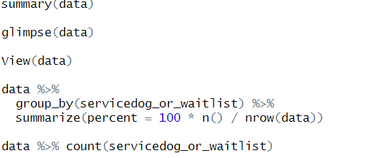

Data Preprocessing
XX

Reverse score VR_1, VR_2 and VR_7 and keep NA value

VR_1
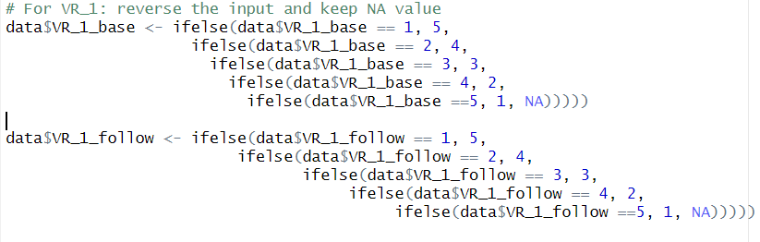

VR_2

VR_7
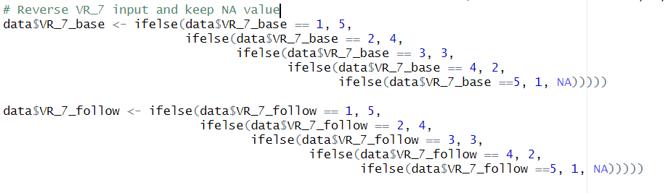

Decrease VR_6 by 1 unit and reverse the input
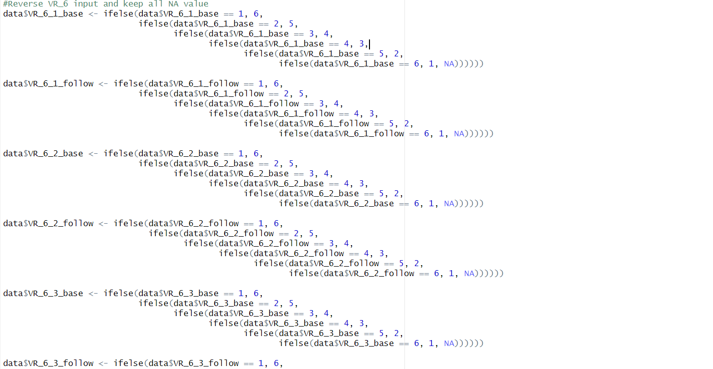

Transforming pre-processed raw data to grading score
First, Transform (normalize) input to 100 scale score:

VR_1 is marked as gh1x
VR_2_1 is marked as pf02x
VR_2_2 is marked as pf04x
VR_3_1 is marked as rp2x
VR_3_2 is marked as rp3x
VR_4_1 is marked as re2x
VR_4_2 is marked as re3x
VR_5 is marked as bp2x
VR_6_1 is marked as mh3x
VR_6_2 is marked as vt2x
VT_6_3 is marked as mh4x
VR_7 is marked as sf2x

Then, Calculate score for each assessment phase (baseline and follow-up)

IF VR_1=1 THEN gh1x=100;
IF VR_1=2 THEN gh1x=85 ;
IF VR_1=3 THEN gh1x=60;
IF VR_1=4 THEN gh1x=35 ;
IF VR_1=5 THEN gh1x=0;

pf02x = (VR_2_1-1)*50;

pf04x = (VR_2_2-1)*50;

rp2x = (5- VR_3_1)*25;

rp3x = (5- VR_3_2)*25;

re2x = (5- VR_4_1)*25;

re3x = (5- VR_4_2)*25;

bp2x = (5- VR_5)*25;

mh3x = (6- VR_6_1)*20;

vt2x = (6- VR_6_2)*20;

mh4x = (VR_6_3-1)*20;

sf2x = (VR_7-1)*25

Transform Baseline
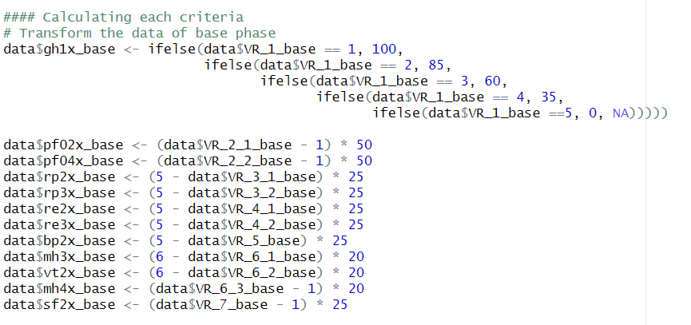

Transform Follow up
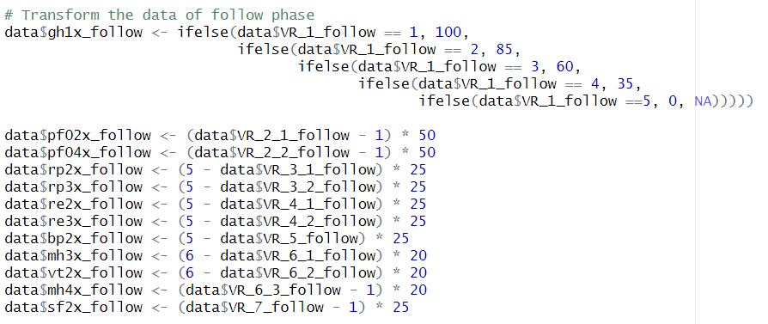

Calculate PCS and MCS for each phase

PCS = 0.0782523751*gh1x + 0.065064013*pf02x + 0.0748361349*pf04x + 0.0716978312*rp2x + 0.0741541386*rp3x + (-0.057598263)*re2x + (-0.032268941)*re3x +0.1339749098*bp2x + (-0.042411864)*mh3x + 0.0299689621*vt2x + (-0.053362399)*mh4x + 0.0046096779*sf2x + 21.046859741

MCS = -0.000915925*gh1x + -0.035498649*pf02x + -0.03157714*pf04x + -0.0251735*rp2x + -0.024652228*rp3x + 0.1266860962*re2x + 0.0808723569*re3x + -0.024371371*bp2x + 0.1094084978*mh3x + 0.0694271326*vt2x + 0.1493788958*mh4x + 0.1085734367*sf2x + 12.66204834

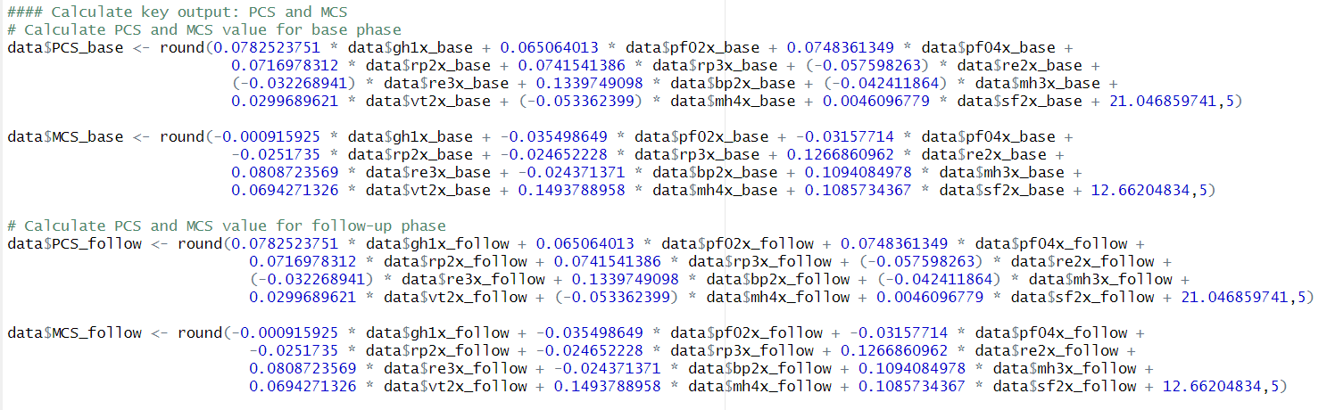

Storing transformed data to new database
Storing output of each transformation to scoring database
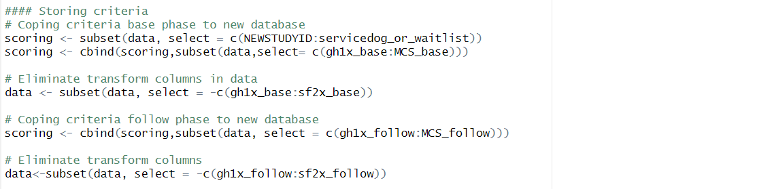

Calculate mean value and standard deviation value
Calculate mean value and standard deviation value of each transformed variable in each phase (baseline and follow-up) and stores them in scoring
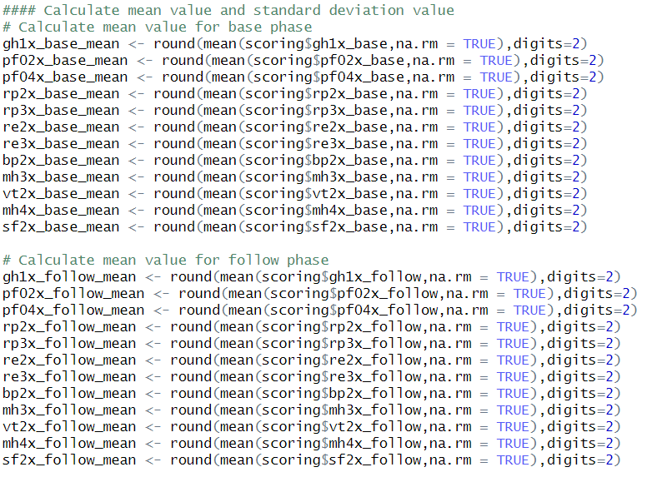
Calculate mean value of each transformed variable by participants then store in scoring_mean
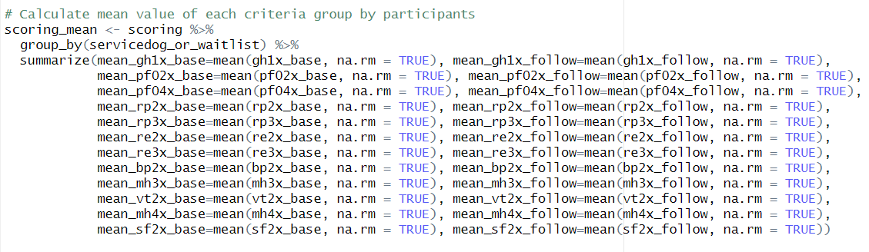
Calculate mean value and stand deviation value of PCS and MCS
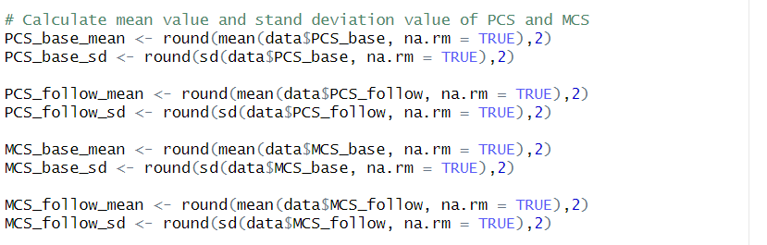
Calculate mean value and standard deviation value group by participants and store in mean_std
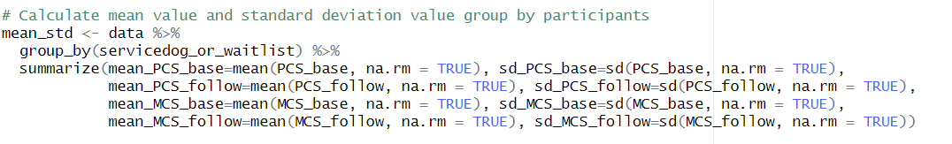

Extracting output
Stores data (preprocess data with PCS and MCS) into OutputFile1_241021.csv
Stores scoring (criteria grades) into scoringFile_241021.csv
Stores mean_std (mean and standard deviation value of each criteria in 2 phase) into mean_std_outputFile_ 241021.csv
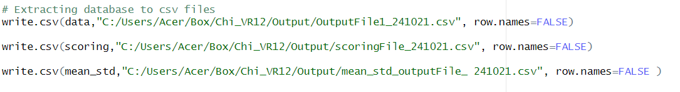

Performing t-test for PCS and MCS
Determine the effects of participants groups with PCS and MCS calculation by using two-side t-test (t.test)
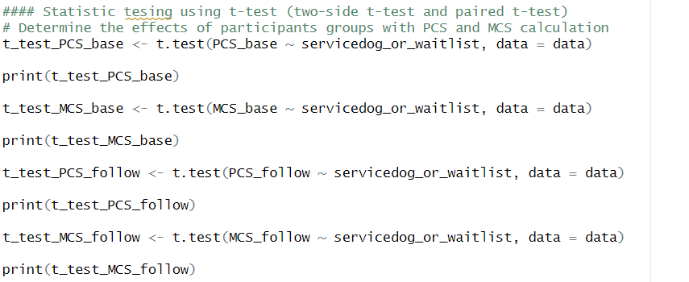
Determine relationship significance of differences in PCS and MCS scores by using paired t-test (t.test)
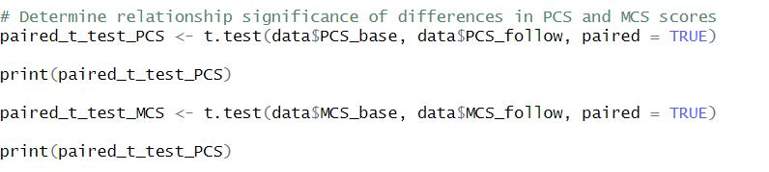
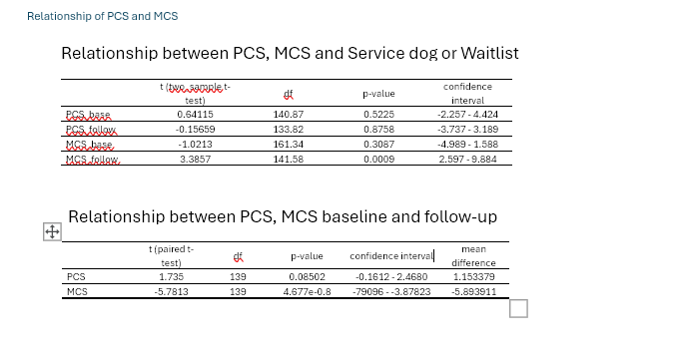

Preprocess data for visualization
Calculate frequency of each variable by using group_by and summarize
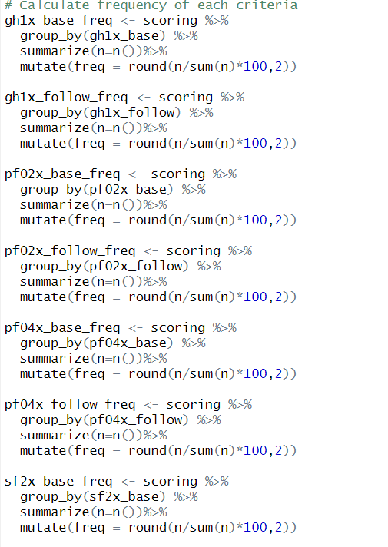
NA value in scoring cannot be used for visualization so I turned NA value to string by using is.na
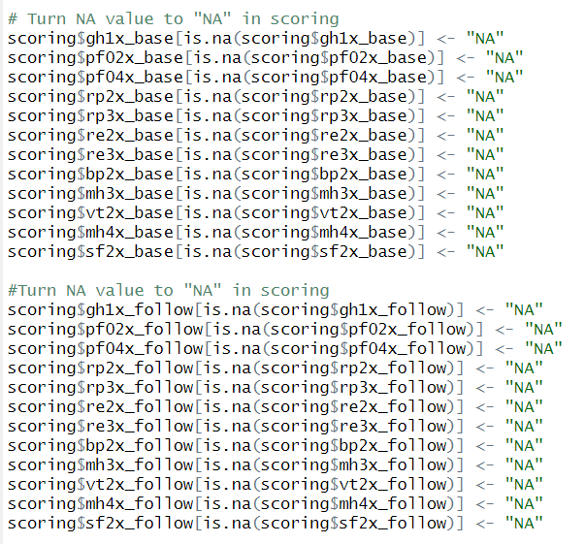

Visualization

Histograms and graphs matrix for PCS and MCS for both baseline and follow-up
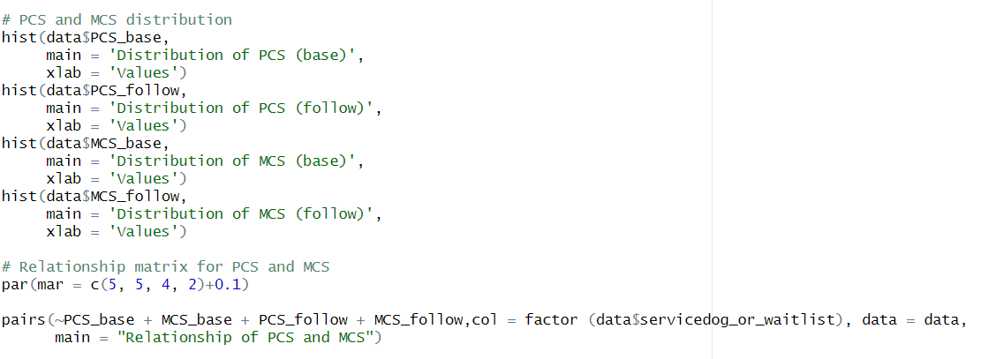
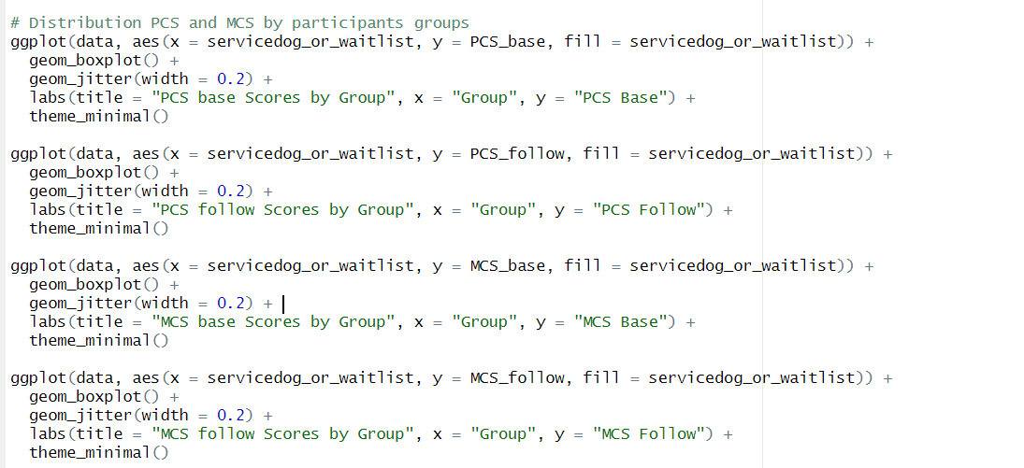

Graphs for general mean and standard deviation of PCS and MCS
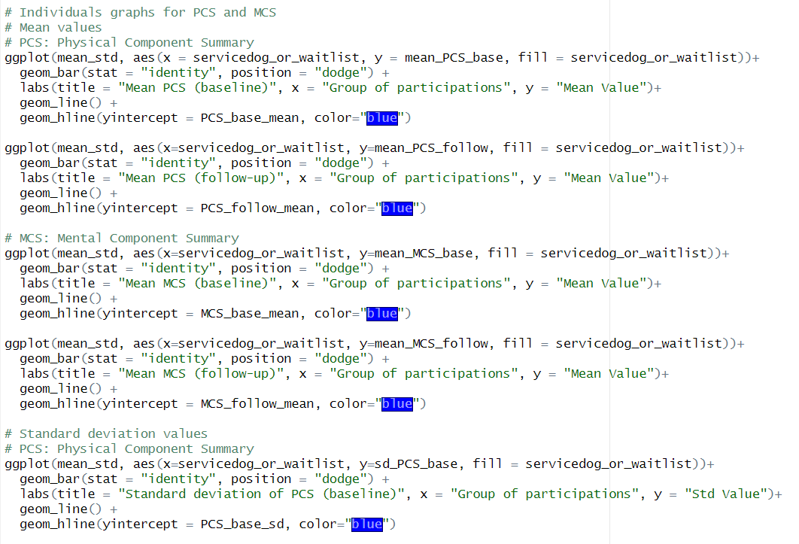

Graphs for percentages of input distribution by participants
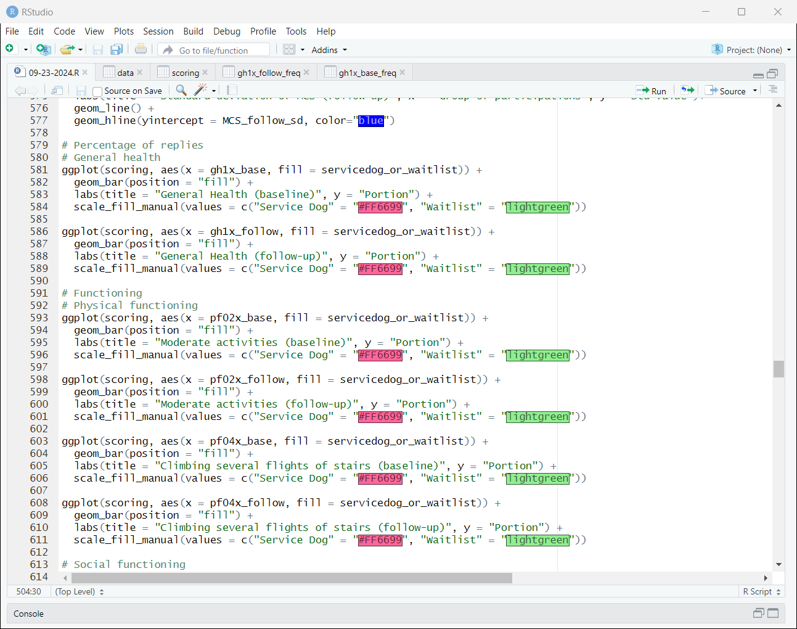
Graphs for mean value of input distribution by participants and for each criterion
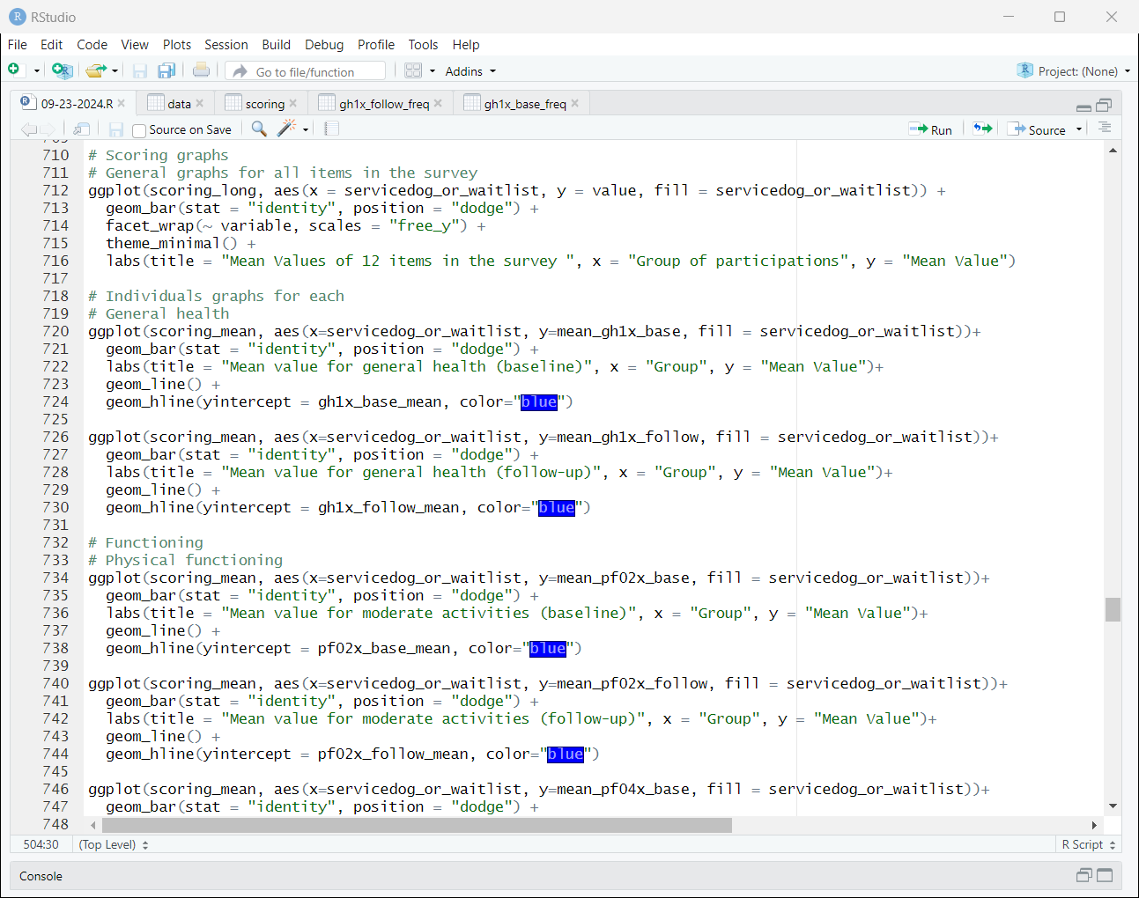
Pie graphs for response percentage for each criterion
