[Note, this VR-12 info was taken from "Box\(L2 Sensitive) Data\(L2 Sensitive) NIH Study\Data - L2\Qualtrics\Codebooks\Measure Scoring\Qualtrics_DataAdjustments.docx"]

Veterans Rand 12-Item Health Survey (VR)
The official VR-12 response values should match the table below, but many of the items/responses in our data set are opposite to this (see “VR12_codebook_240917.xlsx” for the response values in our data). Before completing the scoring algorithm, our response values will need to be adjusted to match the official VR-12 response values. This is described starting on page 5 under “Data Adjustment”, but all adjustments should be double checked to make sure the final adjusted variables match the official VR-12 response values.
VR12 item | Variable Name | Response Choice | Value
Moderate activities | PF02 | Limited a lot | 1
(Physical Functioning) |  | Limited a little | 2
 |  | Not limited at all | 3
Climbing several flights | PF04 | Limited a lot | 1
of stairs |  | Limited a little | 2
(Physical Functioning) |  | Not limited at all | 3
Accomplished less than you | VRP2 | None of the time | 1
would like |  | A little of the time | 2
(Role Limitations because of |  | Some of the time | 3
Physical Problems) |  | Most of the time | 4
 |  | All of the time | 5
Limited in the kind of work | VPR3 | None of the time | 1
or activities |  | A little of the time | 2
(Role Limitations because of |  | Some of the time | 3
Physical Problems) |  | Most of the time | 4
 |  | All of the time | 5
How much pain interferes | BP2 | Not at all | 1
with normal work |  | A little bit | 2
(Pain) |  | Moderately | 3
 |  | Quite a bit | 4
 |  | Extremely | 5
In general, you would say | GH1 | Excellent | 1
your health is |  | Very good | 2
( General Health) |  | Good | 3
 |  | Fair | 4
 |  | Poor | 5
Have a lot of energy | VT2 | All of the time | 1
(Vitality) |  | Most of the time | 2
 |  | A good bit of the time | 3
 |  | Some of the time | 4
 |  | A little of the time | 5
 |  | None of the time | 6
How much time health | SF2 | All of the time | 1
interferes w/social activities |  | Most of the time | 2
(Social Functioning) |  | Some of the time | 3
 |  | A little of the time | 4
 |  | None of the time | 5
Accomplished less than you | VRE2 | None of the time | 1
would like |  | A little of the time | 2
(Role Limitations because of |  | Some of the time | 3
Emotional Problems) |  | Most of the time | 4
 |  | All of the time | 5
Didn't do work or other | VRE3 | None of the time | 1
activities as carefully as usual |  | A little of the time | 2
(Role Limitations because of |  | Some of the time | 3
Emotional Problems) |  | Most of the time | 4
 |  | All of the time | 5
Felt calm and peaceful | MH3 | All of the time | 1
(Mental Health) |  | Most of the time | 2
 |  | A good bit of the time | 3
 |  | Some of the time | 4
 |  | A little of the time | 5
 |  | None of the time | 6
Felt downhearted and blue | MH4 | All of the time | 1
(Mental Health) |  | Most of the time | 2
 |  | A good bit of the time | 3
 |  | Some of the time | 4
 |  | A little of the time | 5
 |  | None of the time | 6

This algorithm is for VR12 complete data (no missing responses).

First, transform VR 12 items GH1 PF02 PF04 VRP2 VRP3 VRE2 VRE3 BP2 MH3 VT2 MH4 SF2 into scales of 0-100 points.

IF GH1=1 THEN gh1x=100;
IF GH1=2 THEN gh1x=85 ;
IF GH1=3 THEN gh1x=60;
IF GH1=4 THEN gh1x=35 ;
IF GH1=5 THEN gh1x=0;
pf02x = (PF02-1)*50;
pf04x = (PF04-1)*50;
rp2x = (5-VRP2)*25;
rp3x = (5-VRP3)*25;
re2x = (5-VRE2)*25;
re3x = (5-VRE3)*25;
bp2x = (5-BP2)*25;
mh3x = (6-MH3)*20;
vt2x = (6-VT2)*20;
mh4x = (MH4-1)*20;
sf2x = (SF2-1)*25;

Then calculate VR12 scores, which consists of a physical composite score (PCS) and a mental composite score (MCS)

PCS = 0.0782523751*gh1x + 0.065064013*pf02x + 0.0748361349*pf04x + 0.0716978312*rp2x +
0.0741541386*rp3x + (-0.057598263)*re2x + (-0.032268941)*re3x +0.1339749098*bp2x +
(-0.042411864)*mh3x + 0.0299689621*vt2x + (-0.053362399)*mh4x + 0.0046096779*sf2x +
21.046859741

MCS = -0.000915925*gh1x + -0.035498649*pf02x + -0.03157714*pf04x + -0.0251735*rp2x +
-0.024652228*rp3x + 0.1266860962*re2x + 0.0808723569*re3x + -0.024371371*bp2x +
0.1094084978*mh3x + 0.0694271326*vt2x + 0.1493788958*mh4x + 0.1085734367*sf2x +
12.66204834

Data Adjustment

VR_1

  - Instrument
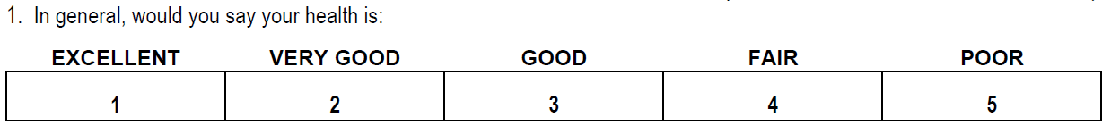

  - Survey
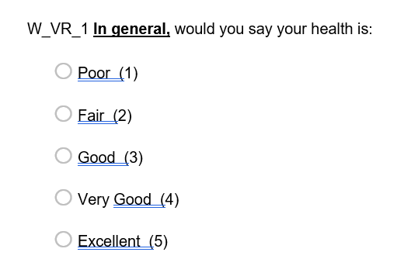

  - Adjustment
Reverse scoring

VR_2_1 and VR_2_2

  - Instrument

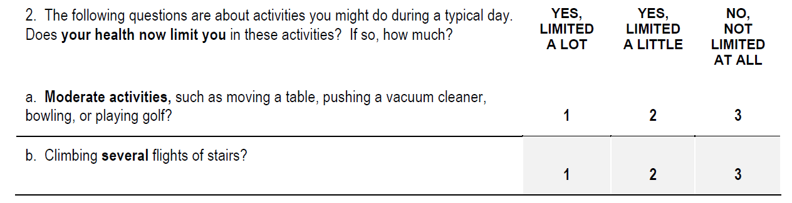

  - Survey

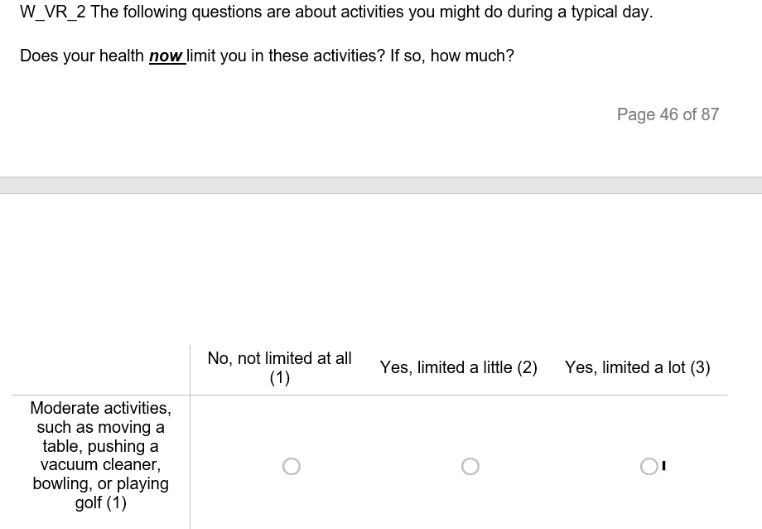

  - Adjustment
Reverse Scoring

VR_6

  - Instrument
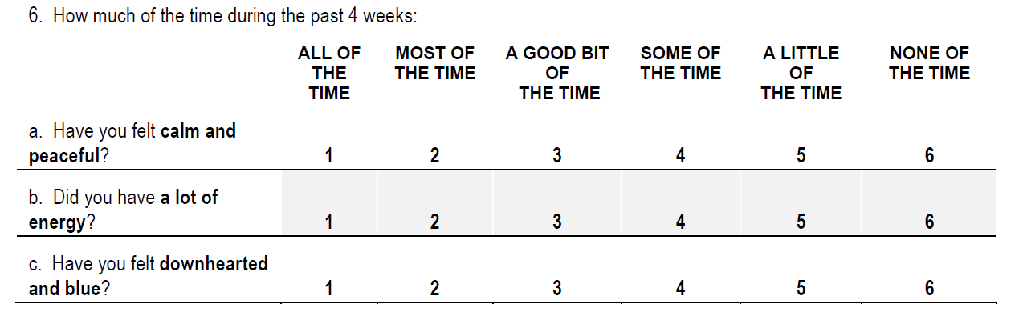
  - Survey
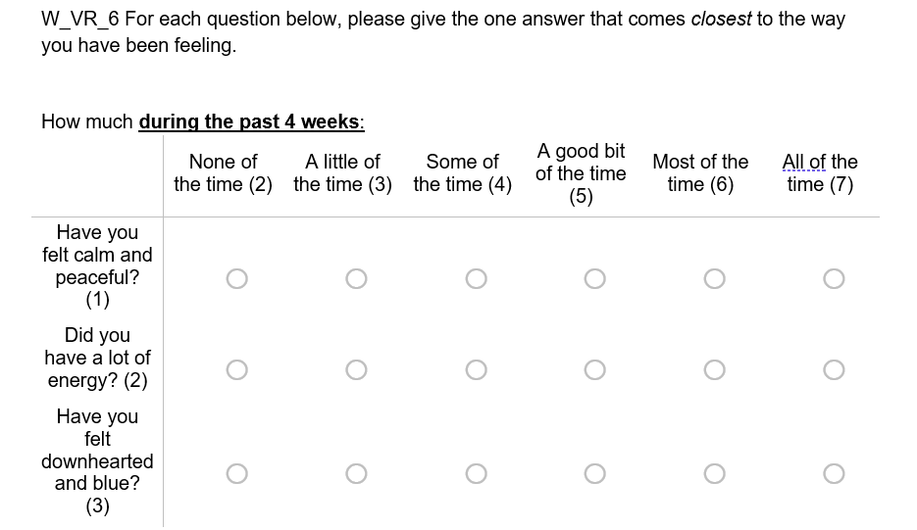
  - Adjustment
- Subtract 1 from each of the scores.
- Reverse scoring

VR_7

  - Instrument
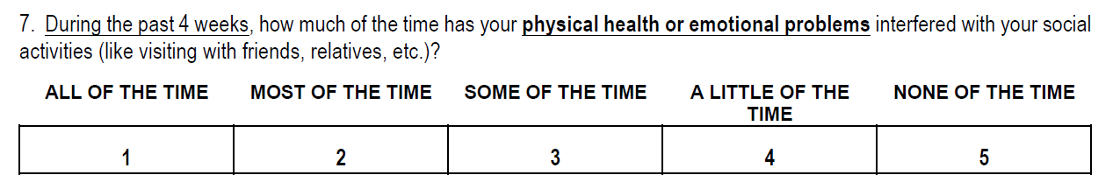
  - Survey
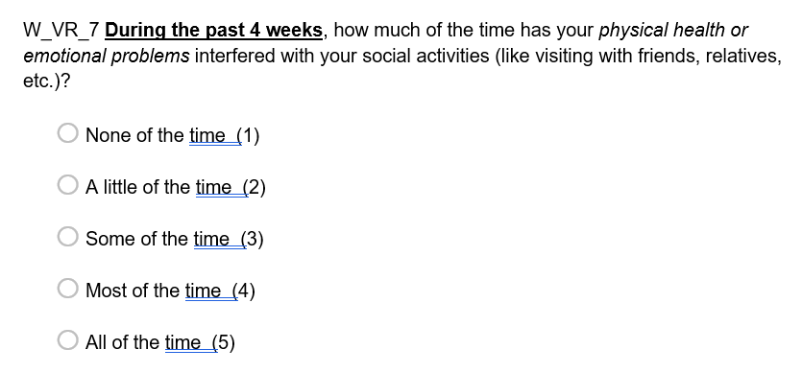
  - Adjustment
Reverse scoring

