Project report: How does the recruitment reach out affect the rate of joining study?
Chi Thieu
04/29/2025

Introduction:

Data Collection:
All fields are extracted from redcap report (Chi’s data, Chi’s data2, Recruit_Report)
“250401_SERVES-Welcome&Call_DATA_w_sample” (Instrument: Recruitment Overview + Welcome Packet + Recruitment Call + Recruitment Result)
“250401_SERVES-Welcome&Call_DATA_sampleonly” (Instrument: Recruitment Overview + Welcome Packet + Recruitment Call + Recruitment Result ) + (Filter by DAG(s) : Sample Access Only)
“250401_SERVES-AddCommunication_DATA_w_sample” (Instrument: Additional Communication + Recruitment Result)
“250401_SERVES-AddCommunication_DATA_sampleonly” (Instrument: Additional Communication + Recruitment Result) + (Filter by DAG(s) : Sample Access Only)

Procedure/Methology:
The initial data are trimmed down from all samples since sample data are most likely testing, and all moving on to the study, which might affect the rate and the correlation test.
The date and time in the “AddCommunication” are collected in the field so it split into date field and time field
Then all category are breaking down into multiple subset : welcome_set (process of sending welcoming packet), recruit_call_set (process of call recruiting process, recruit_text_set (extra communication such as text, email or call), result_set (records if the participants decide continue to study arms or not)
After that, based on the date the welcoming packet sent and the date of recruitment, the delay_days is calculated by the days different between them. And the

Finding/Results:
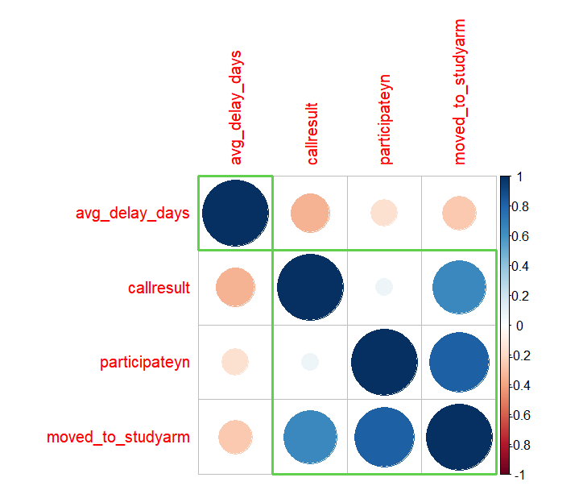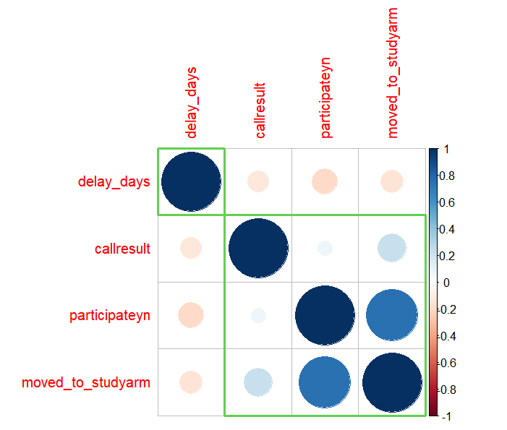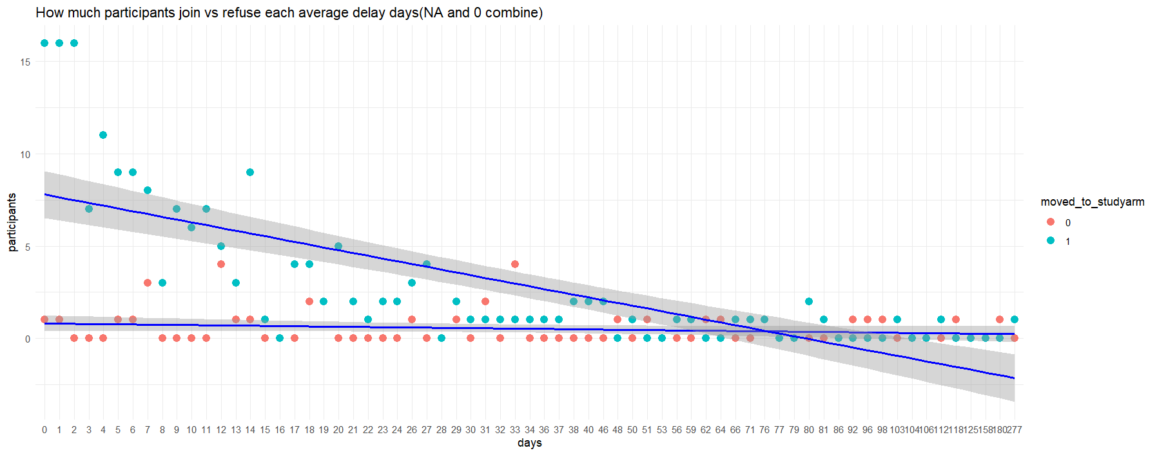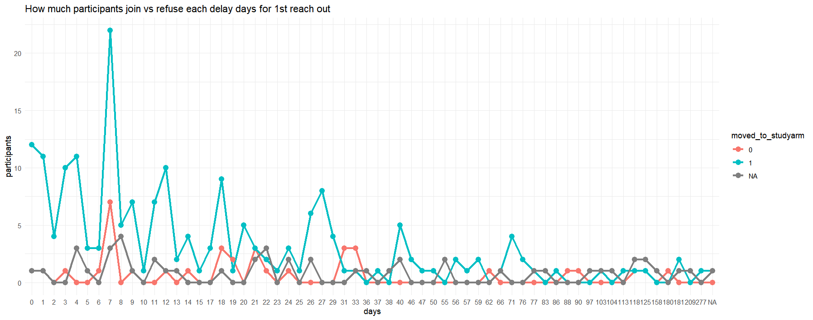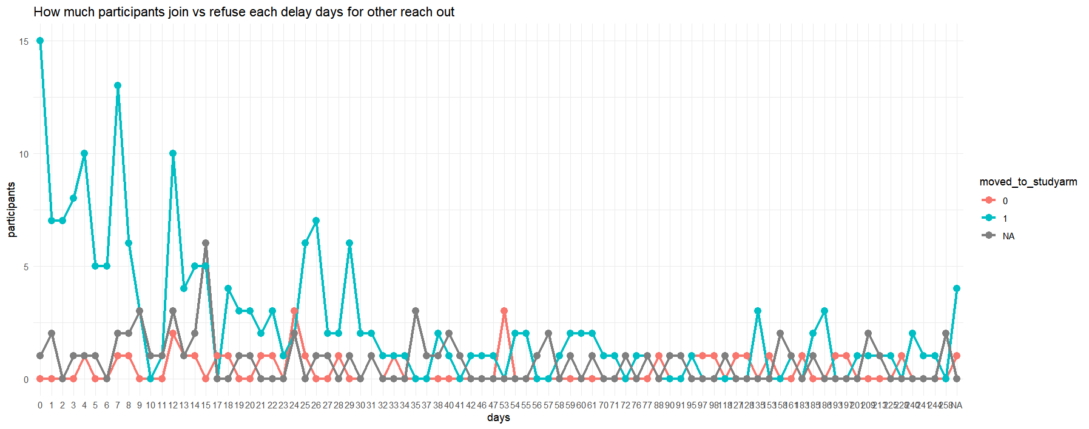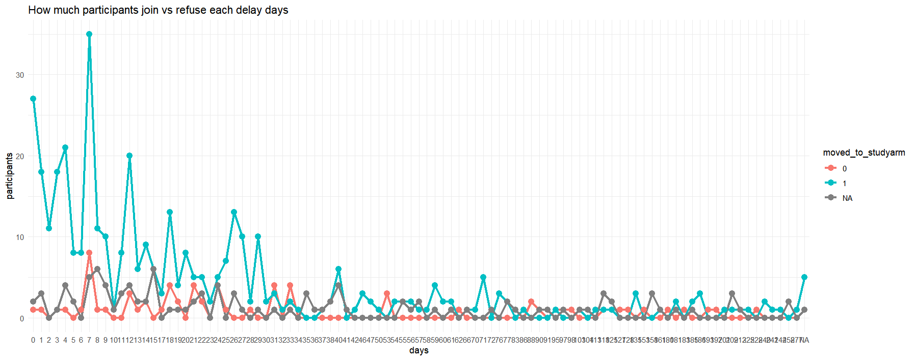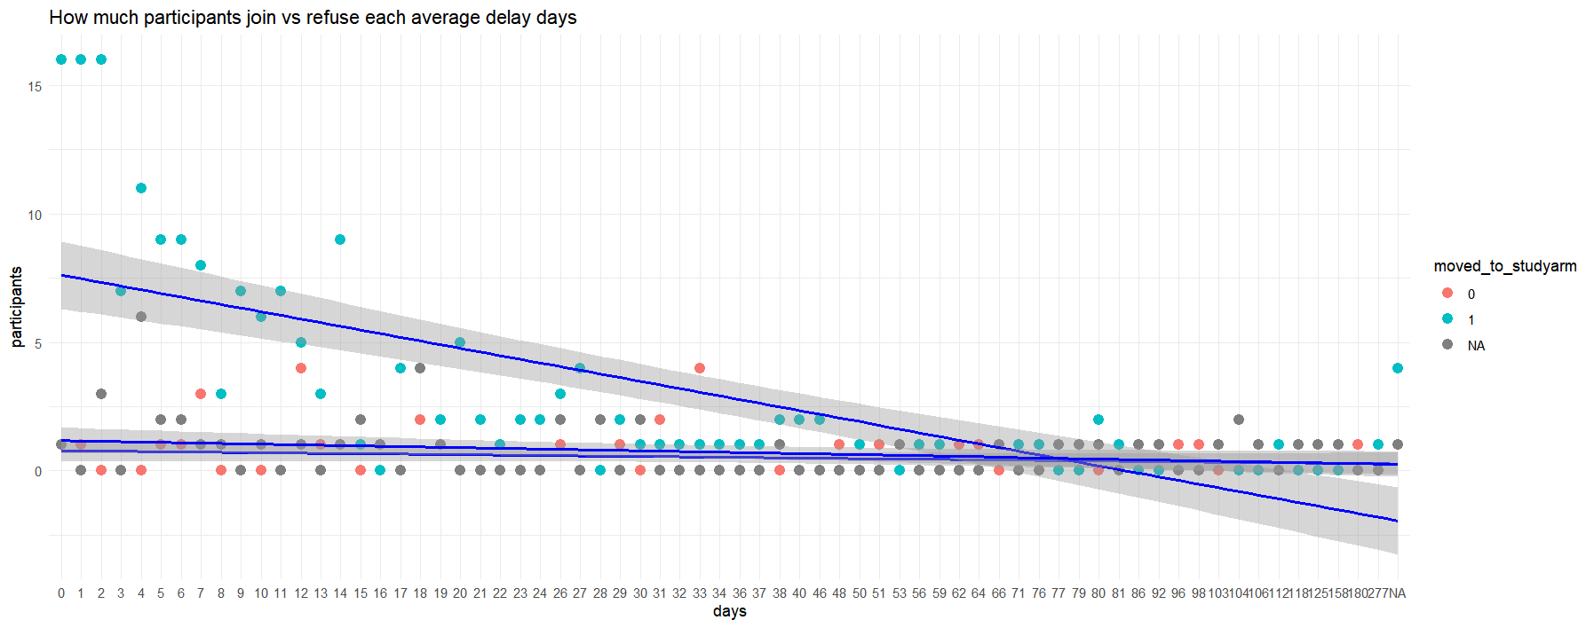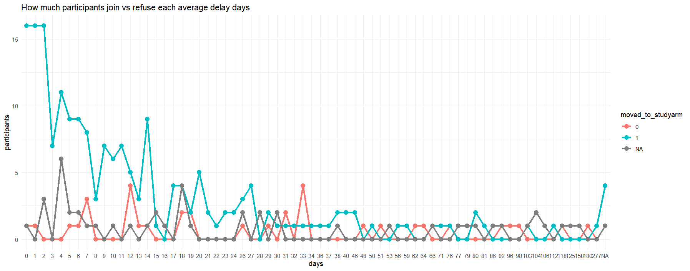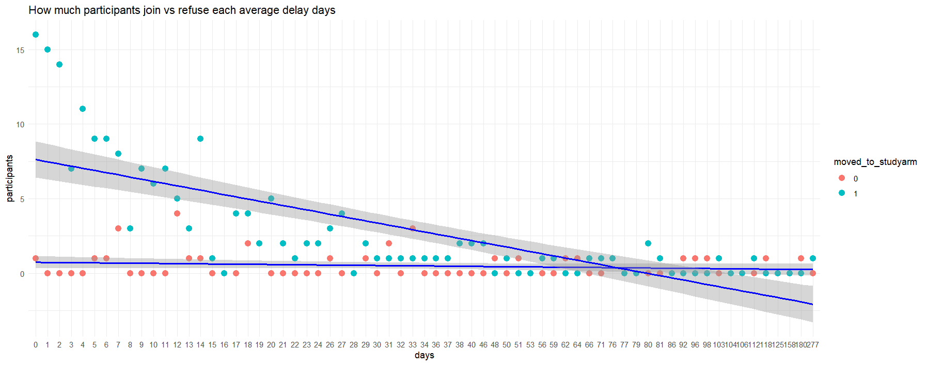

Conclusion:
Based on the correlation graph and

References:

