# Random Search Strategies In Herbivores, Carnivores and Omnivores

By: Michael Bradshaw, Jacob McKean & Chi Huynh

## Abstract:

For animals the ability to effectively search is paramount, it enables them to find food, water, mates and shelter. Without an effective search strategy an animal would struggle to survive in a resource scarce environment. It has been shown that in such environments animals employ random search strategies, specifically ones that are well simulated by the composite correlated random walk (CCRW) model. Here we explore the effectiveness of CCRW and Levy walk in explaining the movement patterns in 8 animal datasets collected from MoveBank that fall into three dietary categories: herbivores, omnivores and carnivores. We show that regardless of the diet, CCRW is a better fit for these animals' random search strategies than Levy walk.

## Background:

In large areas where food and resources are scarce, the ability for an animal to effectively search is paramount. They are required to do this inorder to find food, water, shelter, mates, and more [(Auger-Méthé et al. 2016)](https://paperpile.com/c/KA6cU5/Vv6L). It has been repeatedly shown that in such environments animals employ random search strategies [(Auger-Méthé et al. 2016; Viswanathan et al. 1999)](https://paperpile.com/c/KA6cU5/Vv6L+Px0t). How well certains strategies work is dependent on the dispersal of resources. For instance, Brownian motion has been show to work effectively as a search strategy when there is no shortage of resources [(Viswanathan et al. 1999)](https://paperpile.com/c/KA6cU5/Px0t), but in cases of sparse resources the large intermediate steps of Levy walk can be more beneficial as it allows for the exploration of new territories[(Bartumeus et al. 2002)](https://paperpile.com/c/KA6cU5/bBtU).

In Auger-Methe et al. they showed that while Levy walk is more similar to animal movement in sparse terrain than Brownian motion, composite correlated random walk (CCRW) is an even better model of how large animals search in wide open sparse environments[(Auger-Méthé et al. 2016)](https://paperpile.com/c/KA6cU5/Vv6L). The reason they give for this discovery is that CCRW is a two-phase search strategy - it begins with large steps moving it into new areas quickly but then switches to a slower more convoluted movement pattern that does an excellent job of fully covering a small area of land. This can be thought of as the animal moving quickly from one place to another, until it suspects there are resources or finds evidence of some and then slows down to do a fine search of the area.

In that original paper they evaluated 3 animal groups all with different feeding habits: caribou (herbivor), grizzly bear (omnivore) and polar bear (carnivore). With all three groups they found that CCRW better modeled their movement than Levy walk. But from the results of their study alone it is hard to make the claim that these search strategies are the best fit for all herbivores, omnivores, and carnivores. In this study we explore this topic more: do all (more many) different species in their feeding groups exhibit the same search behavior.

Research on the movement of other animals has been conducted, such as the movement of elk reintroduced to the wild [(Fryxell et al. 2008)](https://paperpile.com/c/KA6cU5/drQg), as well as the movement of carnivores like the spotted hyena[(Green and Holekamp 2019)](https://paperpile.com/c/KA6cU5/d1dC) and leopards[(Naha et al. 2021)](https://paperpile.com/c/KA6cU5/siWf).

The study on reintroduction of elk was largely focused on the dispersal of the elk, and their choices in methods of finding resources. Unlike Auger-Methé, they did not create a model to predict animal motion with random walks, but focused on the probability at which the elk would choose sedentary or large movement patterns depending on surrounding resource density. However, the bimodal movement of elk was still observed, where there were periods of sedentary behavior and periods of large movement.

The studies on carnivore movement are largely on the effect of human-animal interactions on pathing. The spotted hyena study focuses on the effect of nearby pastoralist activity, and the leopard study focuses on the shared landscape between leopards and humans in India. The human influence means the data specifically doesn’t explore the exploration of resource sparse areas that Auger-Methé does, so it can’t directly be used in our work, but the same basic principles apply. Once again, in the leopard study, two modes of movement were observed, a resting state and a travelling state, which was also observed in Auger-Methé. However, the pathing of these states were not random as in our study, but instead was closely tied to significant locations such as roads, rivers, and forests.

To perform our study, we collected and analysed movement data from eight different animals across the three diet classes. Our herbivores are: woodland caribou, Kruger African buffalo, Boutin Alberta moose, Hebblewhite Alberta-BC moose, box turtles (Adults); omnivores: grizzly bears; carnivores: polar bears, box turtles (young) and lions. The reason we have box turtles listed twice in different diet groups is because in their infancy box turtles are carnivores but after reaching adulthood they are strictly herbivores. Unlike omnivores that eat both types of food throughout their life the box turtles switch, for this reason we have divided them into two groups.

With data collected from MoveBank (movebank.org), the levy walk and CCRW models taken from Auger-Methe et al., we evaluate the fit of both models in relation to all 8 animal data sets.

## Methods:

### Data:

Data used in this paper came from two sources: Auger-Methe et al.’s supplementary information and MoveBank (movebank.org). When searching MoveBank we specifically filtered for datasets that were publicly available and had GPS coordinates. Specifying GPS coordinates greatly reduced the number of animals we could use as GPS collars are fairly large and heavy and can really only be worn by rather large animals. From there the datasets were inspected for consistent times steps. One of the assumptions of the Levy walk and CCRW models we used is that each location measurement has a consistent difference in time between them. Unfortunately, few of the MoveBank datasets were consistent in time steps. We were able to clean some of the data by removing extra time steps such that a consistent pattern could be established. Unfortunately meeting this requirement and assumption for the models caused us to be unable to use any MoveBank datasets for omnivores and most of the carnivores. For this reason the only omnivore we have is the grizzly bear data that came from Auger-Methe et al. and the only carnivores we have are the polar bear data from Auger-Methe et al., young box and tsavo lions turtles from MoveBank.

Once data was collected with consistent time steps, the GPS latitude and longitude coordinates were converted to dx and dy values and turning angle representing the change in direction at each step. The values dx and dy simply represent the difference between the current x and y coordinates and the previous ones. Turn angle was calculated as the following equations:

$angle_{i}= arctan(dy_{i},dx_{i})$

$angle_{i-1}= arctan(dy_{i-1},dx_{i-1})$

$turningangle = (angle_{i-1 }- angle_{i}) - 2π :if (angle_{i-1 }- angle_{i}) > π$

$turningangle = (angle_{i-1 }- angle_{i}) + 2π :if (angle_{i-1 }- angle_{i}) < -1π$

$turningangle = angle_{i-1 }- angle_{i} :else$

### Model analysis:

The implementations of Levy walk and CCRW we used were taken from the github repository associated with the Auger-Methe et al. paper. Our analyses were run in Rstudio with R version 3.6.3 on a 64 bit Ubuntu Bionic operating system.

## Results:

From our collected data, along with Auger-Methe‘s [(Auger-Méthé et al. 2016)](https://paperpile.com/c/KA6cU5/Vv6L) results, we analyzed five herbivores, one omnivore, and two carnivores. First, the herbivores data consist of the woodland caribou from Auger-Methe [(Auger-Méthé et al. 2016)](https://paperpile.com/c/KA6cU5/Vv6L), in addition to the african buffalo, boutin alberta moose, hebblewhite alberta moose, and box turtle, collected from Movebank [(Getz et al. 2007; Boutin et al. 2015; Peters et al. 2013; Palmer et al. 2019; Kasiki, Kays, and Mwazo n.d.)](https://paperpile.com/c/KA6cU5/Vve4+EaAh+7PRD+wqtM+uNvS). The collection time for the herbivores were daily, hourly, every three hours, every four hours, and every three hours for the caribou, african buffalo, boutin alberta moose, hebblewhite alberta moose, and box turtle, respectively. The result showed that for herbivores, the CCRW model was the best fit for each herbivore, shown in figure 1.

Besides the barren-ground grizzly from Auger-Methe [(Auger-Méthé et al. 2016)](https://paperpile.com/c/KA6cU5/Vv6L), we were unable to collect any additional omnivore data.The best model for the grizzly was the CCRW, where the location data was collected every four hours, seen in figure 2.

Lastly, the polar bear [(Auger-Méthé et al. 2016)](https://paperpile.com/c/KA6cU5/Vv6L) and tsavo lion [(Kasiki, Kays, and Mwazo n.d.)](https://paperpile.com/c/KA6cU5/uNvS)[6] were the two carnivores of interest. The location data taken every four and seven hours for the polar bear and lion, respectively. Auger-Methe [(Auger-Méthé et al. 2016)](https://paperpile.com/c/KA6cU5/Vv6L) mentioned that CCRW was the best model for all polar bears but was not able to explain movement of individual paths. On the other hand, figure 3 shows the tsavo lion was modeled the best by CCRW.

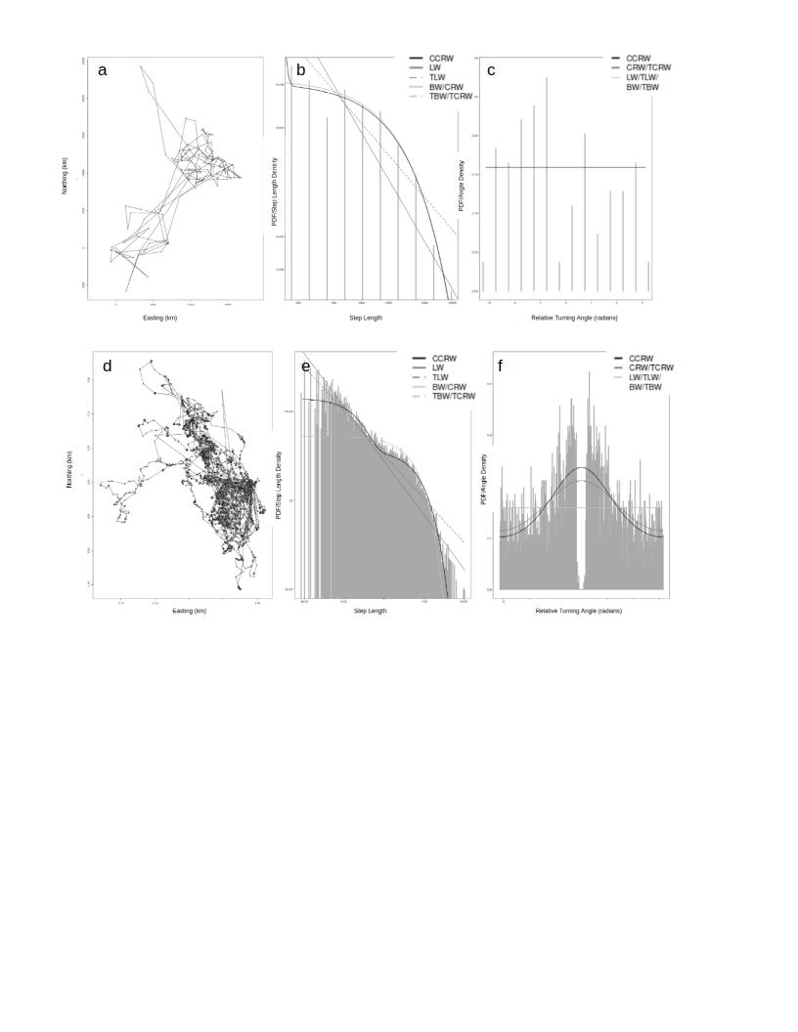

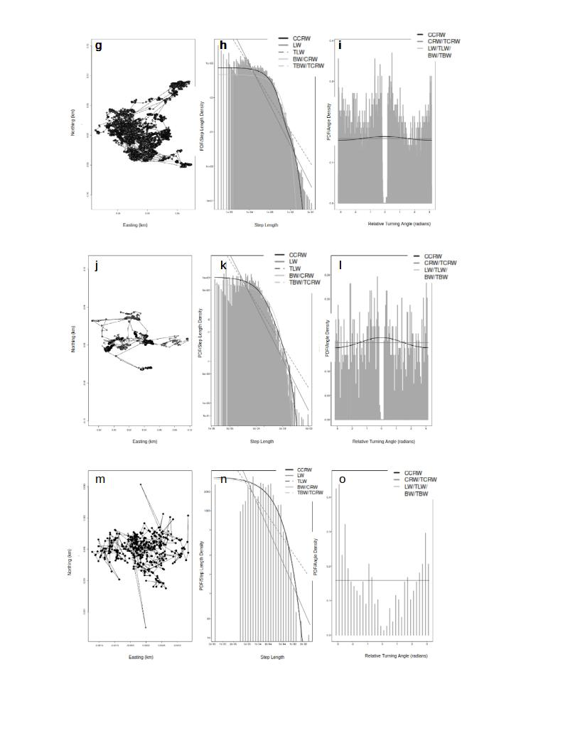

**Figure 1** - Movement paths and model fits of each herbivores: caribou **(a-c)**, african buffalo **(d-f)**, boutin alberta moose **(g-i)**, hebblewhite alberta moose **(j-l)**, and box turtles **(m-o)**. **Panels a,d,g,j,m** plot the actual path of the animal.

**Panels b,e,h,k,n** show the step length for each animal, in the dark solid grey and light solid grey you see the line of best fit for CCRW and Levy walk (LW) respectively. In all 5 of these plots you can see that CCRW fits the data better, especially in panel e where we have clear evidence of a multi-phase search pattern with CCRW models with a similar stair step share, while Levy models it as a single non-fluctuating decay curve. **Panels c,f,i,l,o** show the turning angle. Panels f,i,l all show CCRW to clearly fit the best while in c,o and CCRW and Levy walk perform the same.

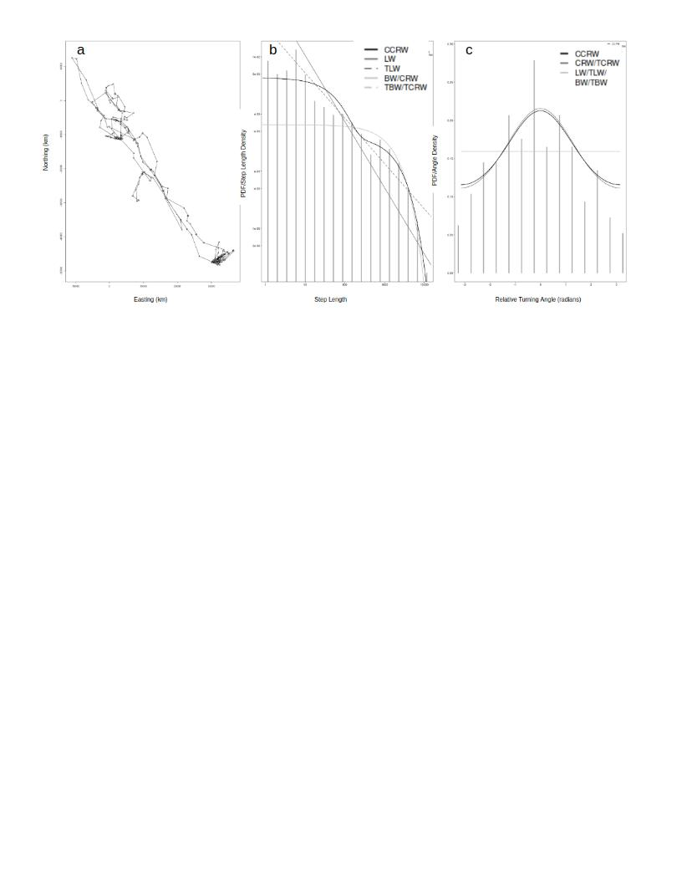

**Figure 2** - Movement path and model fits of the grizzly omnivore (a-c). The movement path of the grizzly bear is shown in **panel a**. The probability density function (PDF) of each different model corresponding to the step length and turning angle frequency is shown in **panel b and c**, respectively. 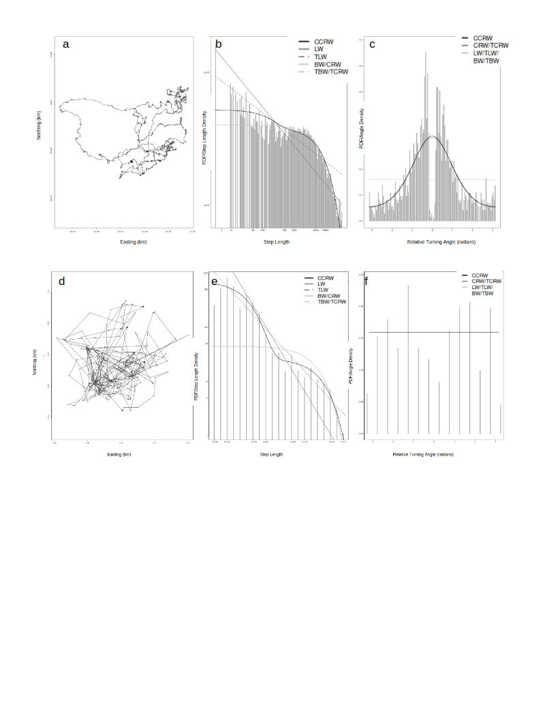

**Figure 3** - Movement paths and model fits for carnivores: polar bears (a-c) and tsavo lion (d-f). **Panel a and d** shows the path of each carnivore species. **Panel b and e** shows the PDF of the step length frequencies. **Panel c and f** shows the turning angle frequency of the carnivores

## Potential Sources of Error:

The way in which researchers choose to sample data affects the statistical results that are found. The location data of animals is recorded at discrete points. Depending on the needs of the researcher, they can sample uniformly across time, sample many data points around a specific time of day, or skip days entirely that aren’t representative of the animal. Each of these choices, along with the fact that collecting animal data isn’t a perfect science, introduces some amount of error in our analysis of their movement.

The very act of taking data at discrete points and translating those points into discrete movement models introduces bias to the turning angle computed [(Nams 2013)](https://paperpile.com/c/KA6cU5/tuhO). This paper focuses on movement modeled by correlated random walks (CRW), but applies generally to discrete modeling methods, including CCRW and Levy from our paper. If the data is sampled too frequently, the turning angle becomes more autocorrelated. If the data is sampled too sparsely, the animal is measured to travel shorter distances than normal.

In particular, this paper found that successive turning angles are positively correlated. Essentially, if an animal is measured to turn at a certain angle, it will tend to be measured to turn a similar angle on the next step. This effect is reduced with increased sampling rate. Thus, the data that we used, in particular the polar bear with 12 hour time steps, may include some amount of this error. This can be observed in turning angle data that spikes sharper than for other animals.

The methods by which we collect data also introduce error. Most of our data was collected through GPS tracking. David C. Ganskopp and Dustin D. Johnson collected data on the difference in location measured directly and through a GPS collar [(David C. Ganskopp and Dustin D. Johnson 2007)](https://paperpile.com/c/KA6cU5/S1B2). In the two studies on which this paper focuses, the first directly moved a set of 10 GPS collars and recorded differences, the second used GPS data acquired from cattle. The study on GPS collars found that collars that remained unmoved had an observed error of 3.9 m $±$ 0.76, with total error 8.1 m. The effect of error on mobile collars was not as significant. In the study on cattle data, it was similarly found that error in GPS data was largely accrued overnight when the cattle were relatively stationary.

The use of GPS collars also tend to drop some data points. A study on the effect of canopy cover, as well as other obstructions, found that the mean fix success rate was 87.7% [(Camp et al. 2016)](https://paperpile.com/c/KA6cU5/PXDC). This means that about 1 out of every 10 measurements taken with heavy canopy cover were unsuccessfully linked with GPS satellites, and the data point was dropped. Effects like this and chosen inconsistent time stepping were observed at several points in our data, shown in Figure G.

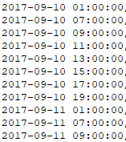 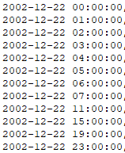

Figure G. Samples of data collected where time steps were chosen to be skipped (left) or chosen inconsistently (right). On the left data set, data collection times were chosen to be more frequent during the day and infrequent at night, and on the right the time scale the time scale was shifted from 1 hour increments to 4 hour increments.

Through our data processing methods, the dropping of data points, as well as uneven time step lengths introduce error in how we calculated dx and dy. If the time scale for a given step is longer than others, either from a missed data point or from chosen longer time scales as above, there will be a larger difference in measured GPS locations than for a smaller time step. Since we can’t uniformly predict when a longer time scale will be used across data collected for different applications, we can’t account for this effectively larger distance step. Therefore dx and dy for the longer step will be measured to be larger than the rest of the data. This affects our calculation of step length.

As shown in our results above, one of the components of finding the best random walk method is the fit to the step length plot. If there is some amount of error in our calculation of step length, there could be some error in the fit of our models. We tried to minimize this by inspecting the data for high GPS data loss rate or inconsistently chosen time steps. In some cases, we were able to combine data points to make it more consistent, but many studies were rejected for our analysis by these criteria. In the cases where there were long enough periods of usable data, we elected to keep the data for processing.

All of these errors rely on us being able to collect data through the best known methods for every animal. Smaller animals cannot wear large GPS collars. While some collars have been successfully developed for animals as small as a feral house cat [(Recio et al. 2011)](https://paperpile.com/c/KA6cU5/qram), measuring the movement of smaller animals still relies on older methods. Some of these other methods place restrictions on the size of the study region, and some even require the presence of humans in the general area. The former makes the study of some far moving animals more difficult and the latter may make the data unreliable in its entirety.

In total, without means of perfectly measuring the location of an animal at all points in time, some error is introduced into analysis that must be addressed.

## Conclusion & Discussion:

From our results we can conclude that the CCRW model fits animal movement better than the Levy Walk, regardless of the feeding guild of the animal. The fit of CCRW was not the same for each animal, but it was always the best fit. The model for some species, such as the polar bear, did not represent a great fit, so future work should be done to find a better fitting model.

One of the great difficulties we encountered during this project was acquiring data that fit the assumptions of the model implementations we used. We see no reason why these models should be limited to data with perfectly consistent time steps, so one very clear future avenue of research could be to modify and/or create new models that can handle data with semi-irregular time steps.

Additionally there is sample data inexistence of fish and bird populations. We excluded these animals in this study due to large inherent differences in how these types of animals move. Performing a similar study to elucidate the movement patterns of fish and birds would be a promising additional research project and we hypothesize would not match that of the land based mammals used here.

Project Contributions:

Chi Huynh:

* Data selection
* CCRW and Levy modeling on R
* Results

Michael Bradshaw:

* Data processing code
* Background from Auger-Methé et al
* Methods
* Abstract

Jacob McKean:

* Data selection
* Data processing debugging
* Research on sources of error and related work

## References:

[Auger-Méthé, Marie, Andrew E. Derocher, Craig A. DeMars, Michael J. Plank, Edward A. Codling, and Mark A. Lewis. 2016. “Evaluating Random Search Strategies in Three Mammals from Distinct Feeding Guilds.” *The Journal of Animal Ecology* 85 (5): 1411–21.](http://paperpile.com/b/KA6cU5/Vv6L)

[Bartumeus, F., J. Catalan, U. L. Fulco, M. L. Lyra, and G. M. Viswanathan. 2002. “Optimizing the Encounter Rate in Biological Interactions: Lévy versus Brownian Strategies.” *Physical Review Letters* 88 (9): 097901.](http://paperpile.com/b/KA6cU5/bBtU)

[Boutin, Stan A., Holger Bohm, Eric William Neilson, Eric William Neilson, and Corey de la Mare. 2015. “Wildlife Habitat Effectiveness and Connectivity Final Report.” August 2015.](http://paperpile.com/b/KA6cU5/EaAh) <https://www.researchgate.net/profile/Amanda-Droghini/publication/328319031_Wildlife_Habitat_Effectiveness_and_Connectivity_Final_Report_August_2015/links/5bc62b70458515f7d9bf899b/Wildlife-Habitat-Effectiveness-and-Connectivity-Final-Report-August-2015.pdf>[.](http://paperpile.com/b/KA6cU5/EaAh)

[Camp, Meghan J., Janet L. Rachlow, Rodrigo Cisneros, David Roon, and Reid J. Camp. 2016. “Evaluation of Global Positioning System Telemetry Collar Performance in the Tropical Andes of Southern Ecuador.” *Natureza & Conservação* 14 (2): 128–31.](http://paperpile.com/b/KA6cU5/PXDC)

[David C. Ganskopp, and Dustin D. Johnson. 2007. “GPS Error in Studies Addressing Animal Movements and Activities.” *Rangeland Ecology & Management* 60 (4): 350–58.](http://paperpile.com/b/KA6cU5/S1B2)

[Fryxell, John M., Megan Hazell, Luca Börger, Ben D. Dalziel, Daniel T. Haydon, Juan M. Morales, Therese McIntosh, and Rick C. Rosatte. 2008. “Multiple Movement Modes by Large Herbivores at Multiple Spatiotemporal Scales.” *Proceedings of the National Academy of Sciences of the United States of America* 105 (49): 19114–19.](http://paperpile.com/b/KA6cU5/drQg)

[Getz, Wayne M., Scott Fortmann-Roe, Paul C. Cross, Andrew J. Lyons, Sadie J. Ryan, and Christopher C. Wilmers. 2007. “LoCoH: Nonparameteric Kernel Methods for Constructing Home Ranges and Utilization Distributions.” *PloS One* 2 (2): e207.](http://paperpile.com/b/KA6cU5/Vve4)

[Green, David S., and Kay E. Holekamp. 2019. “Pastoralist Activities Affect the Movement Patterns of a Large African Carnivore, the Spotted Hyena (Crocuta Crocuta).” *Journal of Mammalogy* 100 (6): 1941–53.](http://paperpile.com/b/KA6cU5/d1dC)

[Kasiki, Samuel, Roland Kays, and Alex Mwazo. n.d. “Tsavo Lion Study.” Accessed May 5, 2021.](http://paperpile.com/b/KA6cU5/uNvS) <https://www.movebank.org/cms/webapp?gwt_fragment=page=studies,path=study220229>[.](http://paperpile.com/b/KA6cU5/uNvS)

[Naha, Dipanjan, Suraj Kumar Dash, Caitlin Kupferman, James C. Beasley, and Sambandam Sathyakumar. 2021. “Movement Behavior of a Solitary Large Carnivore within a Hotspot of Human-Wildlife Conflicts in India.” *Scientific Reports* 11 (1): 3862.](http://paperpile.com/b/KA6cU5/siWf)

[Nams, Vilis O. 2013. “Sampling Animal Movement Paths Causes Turn Autocorrelation.” *Acta Biotheoretica* 61 (2): 269–84.](http://paperpile.com/b/KA6cU5/tuhO)

[Palmer, Jamie L., Maris Brenn-White, Stephen Blake, and Sharon L. Deem. 2019. “Mortality in Three-Toed Box Turtles (Terrapene Mexicana Triunguis) at Two Sites in Missouri.” *Frontiers in Veterinary Science* 6 (November): 412.](http://paperpile.com/b/KA6cU5/wqtM)

[Peters, Wibke, Mark Hebblewhite, Nicholas DeCesare, Francesca Cagnacci, and Marco Musiani. 2013. “Resource Separation Analysis with Moose Indicates Threats to Caribou in Human Altered Landscapes.” *Ecography* 36 (4): 487–98.](http://paperpile.com/b/KA6cU5/7PRD)

[Recio, Mariano R., Renaud Mathieu, Paul Denys, Pascal Sirguey, and Philip J. Seddon. 2011. “Lightweight GPS-Tags, One Giant Leap for Wildlife Tracking? An Assessment Approach.” *PloS One* 6 (12): e28225.](http://paperpile.com/b/KA6cU5/qram)

[Viswanathan, G. M., S. V. Buldyrev, S. Havlin, M. G. da Luz, E. P. Raposo, and H. E. Stanley. 1999. “Optimizing the Success of Random Searches.” *Nature* 401 (6756): 911–14.](http://paperpile.com/b/KA6cU5/Px0t)