**SOCIAL_NETWORK_ADS:**

**Question 1**

**Aim:**

To recreate and visualize the given graph for the Social Network Adds Dataset.

**Work Done:**

The give graph can be achieved only by any one of the classification models. There are many classification models which include Decision tree, Naive Bayes, Kernel SVM, SVM , etc. But this graph was exactly visualizable in the random forest classification.

To do so, the first and foremost step is to import the dataset because only by using the dataset, the further implications can be done. But to import the dataset, the libraries must be imported from their respective places. After importing the dataset, the dataset must be checked for missing values. But in this case there are no missing values. Then the categorical data must either be encoded or ignored. Here the categorical data does not add much value to the output, so the categorical data column is ignored. After the data pre-processing, the data can be directly visualized or trained and tested. Here the data is split into training and test set and also fitting transformation. After all these, the random forest classifier is applied to the training set and then trained to do the same with the test set as well. After the model implication, the plotting is done as required. And finally the required output is received.

**Output:**

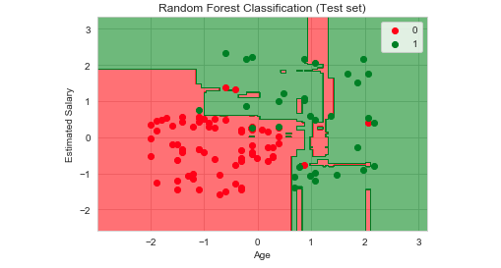

**QUESTION 2:**

**AIM:**

To predict which patient has daibetes

PROCEDURE:

The diabetes data set consists of 768 data points, with 9 features each

Outcome” is the feature we are going to predict, 0 means No diabetes, 1 means diabetes. Of these 768 data points, 500 are labeled as 0 and 268 as 1:

The k-NN algorithm is arguably the simplest machine learning algorithm. Building the model consists only of storing the training data set. To make a prediction for a new data point, the algorithm finds the closest data points in the training data set — its “nearest neighbors.”

First, Let’s investigate whether we can confirm the connection between model complexity and accuracy

OUTPUT:

