E-Commerce Revenue and Customer Satisfaction Analysis

1. Project Overview and Objective
This project involves cleaning, transforming, and analysing an e-commerce order dataset using Excel and creating an interactive Power BI dashboard to understand how revenue is generated and how satisfied customers are with their purchases. The dataset covers orders, products, regions, discounts, payment methods, delivery performance and customer ratings.
The main objective is to demonstrate data pre-processing techniques using Excel and to build an interactive Power BI dashboard that links revenue performance with customer satisfaction, so that sales, delivery and discount decisions can be made with evidence.

2. Data Sources
- Direct source link: https://datasetsearch.research.google.com/
Redirect source link: https://www.kaggle.com/datasets/abbas829/e-commerce-sales- analytics-dataset
- Source Description and Timeline: The dataset was downloaded from Google Dataset Search. It contains order-level e-commerce revenue and customer satisfaction with numerical and categorical column. Total dataset has 5000 rows but project purpose I took 500 rows only keep in dataset. Timeline: [2022 to 2023].
- Domain: E-Commerce / Retail / Sales Analytics

3. Problem Statement
- To analyse revenue performance across regions and product categories to identify top-performing areas and revenue trends over time.
- To study customer satisfaction through customer ratings and understand how it varies by product category, region and payment method.
- To evaluate the effect of delivery days on customer ratings and identify regions where delivery delays reduce satisfaction.
- To assess the impact of discounts on quantity sold and revenue, and to support better pricing, marketing and retention strategies.

4. Attribute (Column /Features) Details:
Attribute Name | Data Type | Description
Order ID | String (Text) | Unique identifier for each order
Order Date | Date | Date on which the order was placed
Customer ID | String (Text) | Unique identifier for each customer
Product Category | Categorical | Category of the product purchased
Region | Categorical | Region where the order was delivered
Quantity | Numeric (Integer) | Number of units purchased in the order
Unit Price | Numeric (Decimal) | Price of a single unit of the product
Discount | Numeric (Decimal / %) | Discount applied to the order
Payment Method | Categorical | Mode of payment used by the customer
Delivery Days | Numeric (Integer) | Number of days taken to deliver the order
Customer Rating | Numeric (Integer) | Rating given by the customer for the order
Revenue | Numeric (Decimal) | Total revenue earned from the order

5. Tools & Technologies
- Excel: Data cleaning, transformation, calculated fields and Pivot Tables.
- Power BI: DAX calculations, visualization, and interactive dashboard creation.

6. Data Pre-Processing (Excel / Power Query)
Tasks Performed:
- Data Cleaning & Transformation: Removed duplicate orders, handled missing values, standardised date and text formats, corrected data types, and checked for invalid values such as negative quantities or ratings outside the valid range.
- Calculated Fields: verified the Revenue column against Quantity, Unit Price and Discount. Create new column and perform revenue check and revenue difference.
Revenue check=ROUND(I2*J2*(1-K2),2)
I=Quantity, J=Unit Price, K=Discount.
Revenue difference= Revenue – Revenue check
- Filtering & Sorting: Organized data by region, product category and date to focus on relevant records and spot outliers.
- Pivot Tables: Generated Pivot Tables for revenue by region and category, average rating by category, average delivery days by region and monthly revenue, to get initial insights.
SCREENSHOT OF PIVOT TABLE
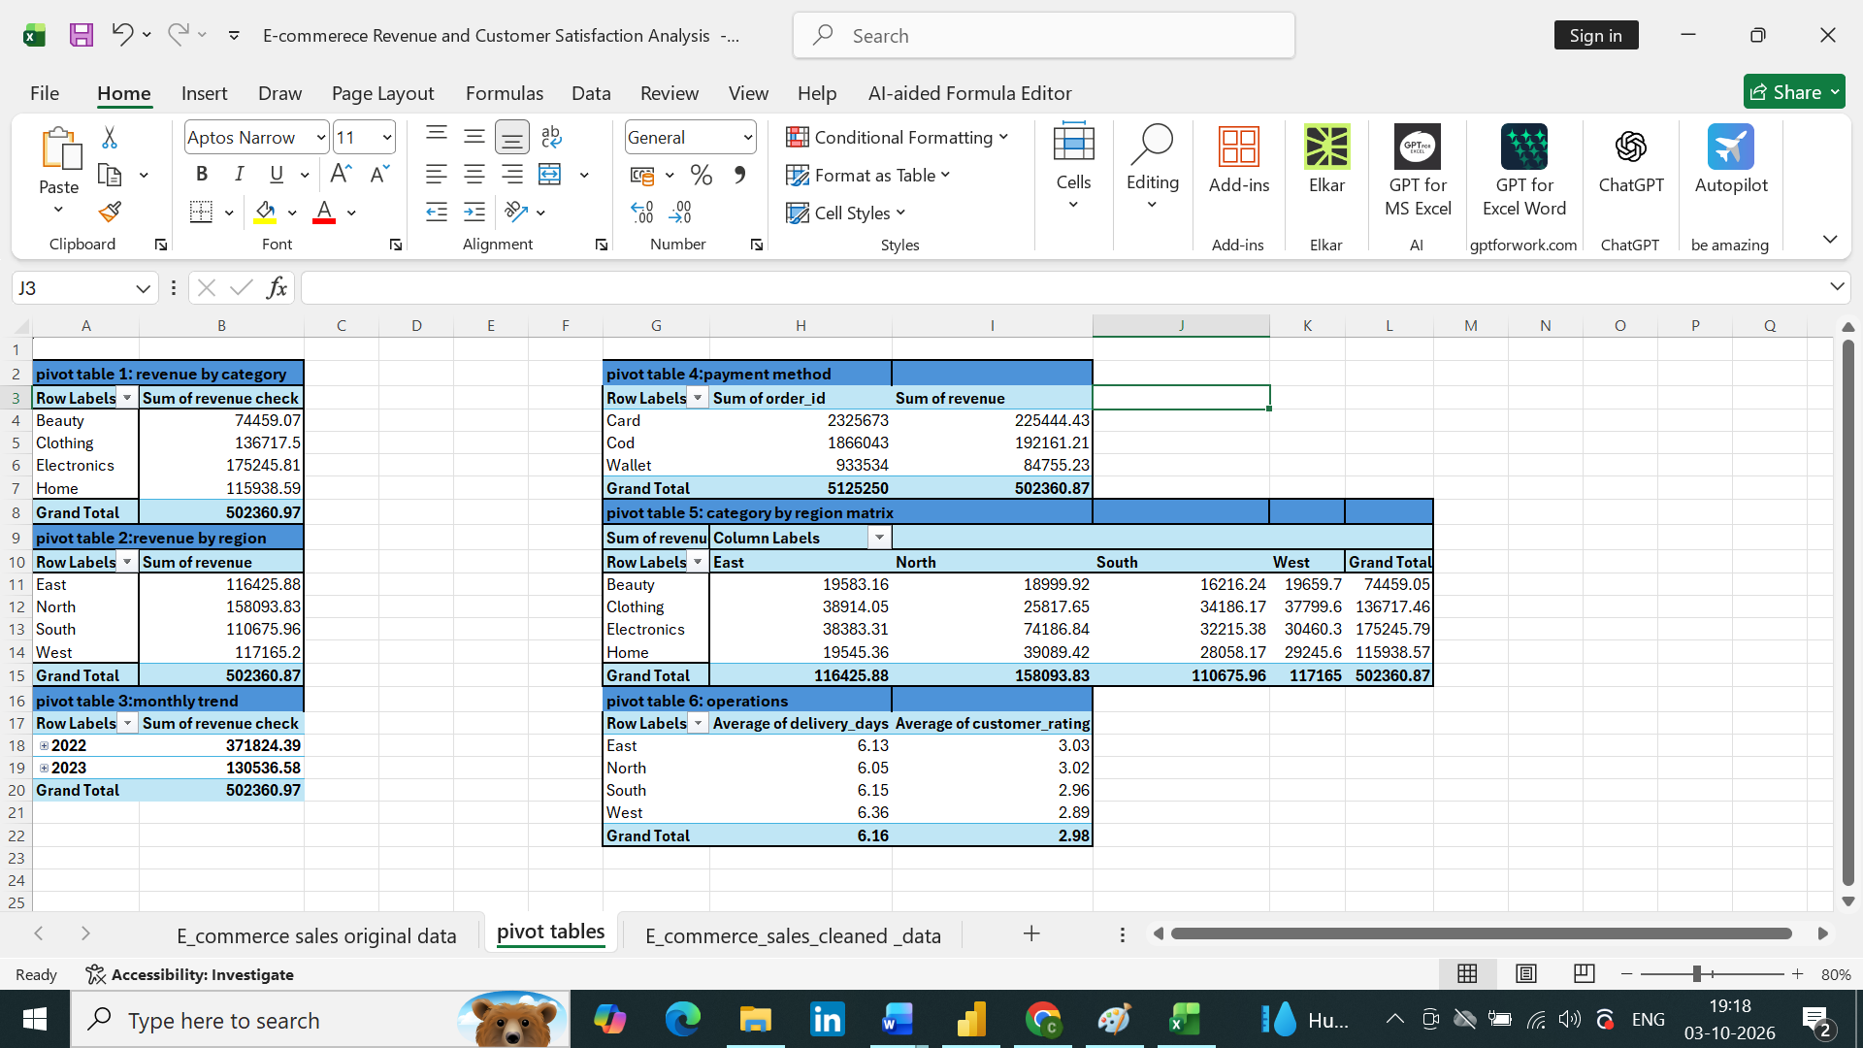

7. DAX (Power BI)
- Calculated Columns & DAX Measures: The following measures were created for the key metrics:
- Total Revenue = SUM ('E commerce sales cleaned data'[revenue])
- Total Orders = DISTINCTCOUNT ('E commerce sales cleaned _data'[order id])
- Total Quantity =SUM ('E commerce sales cleaned data'[quantity])
- Average Customer Rating = AVERAGE ('E commerce sales cleaned data' [Customer Rating])
- Average Delivery Days = AVERAGE ('E commerce sales cleaned data' [Delivery Days])
- Average Discount % = AVERAGE ('E commerce sales cleaned data' [Discount])

8. Analysis and Visualizations (Power BI)
Dashboard Features:
- Multiple visualizations based on the problem statements: KPI cards (Total Revenue, Total Orders, Average Order Value, Average Rating, Average Delivery Days); line chart for monthly revenue trend; bar chart for revenue by product category; map or bar chart for revenue by region; donut chart for payment method share; column chart for average rating by delivery days; matrix of region by category; and a table of top customers and orders.
- Interactive layout: Slicers for Year, Region, Product Category and Payment Method; drill-down from Year to Quarter to Month and from Region to Product Category; cross-filtering between visuals; and tooltips for extra detail.
- Bookmarks, titles and labels: Bookmarks to switch between the Revenue view and the Customer Satisfaction view and to reset filters. Every visual has a clear title, data labels and axis labels.
- Consolidated dashboard: One consolidated dashboard page combines revenue performance, customer satisfaction and delivery performance for quick decision-making.
SCREENSHOT OF DASHBOARD /REPORT
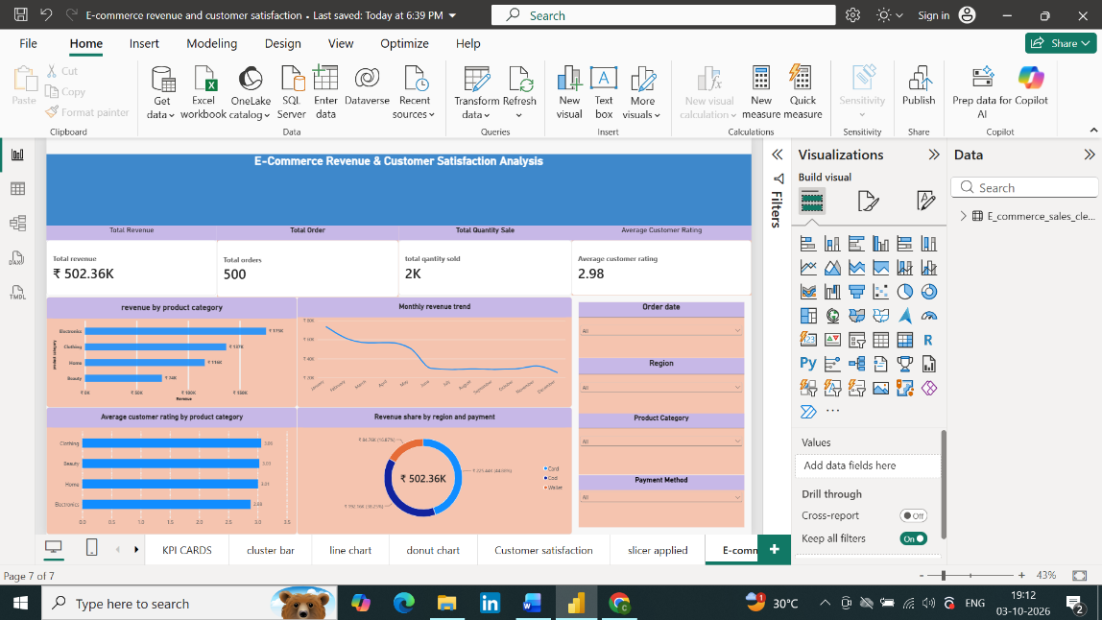

9. Insights & Conclusions
- Key Findings:
the top product category contributes [175K] of total revenue; [31.47%- North] is the highest-revenue region; average rating is [2.98] out of 5; average delivery days is [6.61] days.
- Analysis insights:
    - Descriptive: Shows what happened: total revenue, orders and quantity sold; revenue trend by month; revenue split by category, region and payment method; and the distribution of customer ratings.
    - Diagnosis: Shows why it happened: comparing delivery days with customer ratings to see whether slower delivery lowers satisfaction, and checking how discount levels relate to quantity sold and revenue by category and region.
    - Predictive: Shows what is likely to happen: using the monthly revenue trend and seasonality to estimate future revenue, and using the Power BI forecast feature on the line chart.
    - Prescriptive: Suggests what to do: improve delivery speed in regions with low ratings, focus marketing and stock on top-performing categories, and limit discounts that do not increase sales or satisfaction.
10. Conclusions
The integration of Excel and Power BI proved effective for end-to-end analysis of e-commerce data, from raw data to visual reporting. The analysis connects revenue with customer satisfaction and shows how region, product category, discount and delivery time influence business results, giving a clear base for decisions on sales, pricing and delivery.

