**DEMD PROJECT –FAST API USING HEROKU**

**CREATION OF FASTAPI END POINTS**

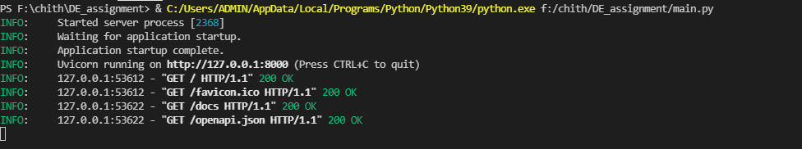

**LAUNCHING FASTAPI**

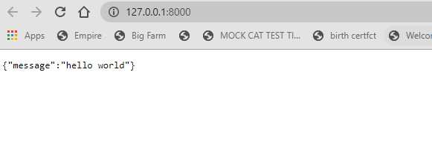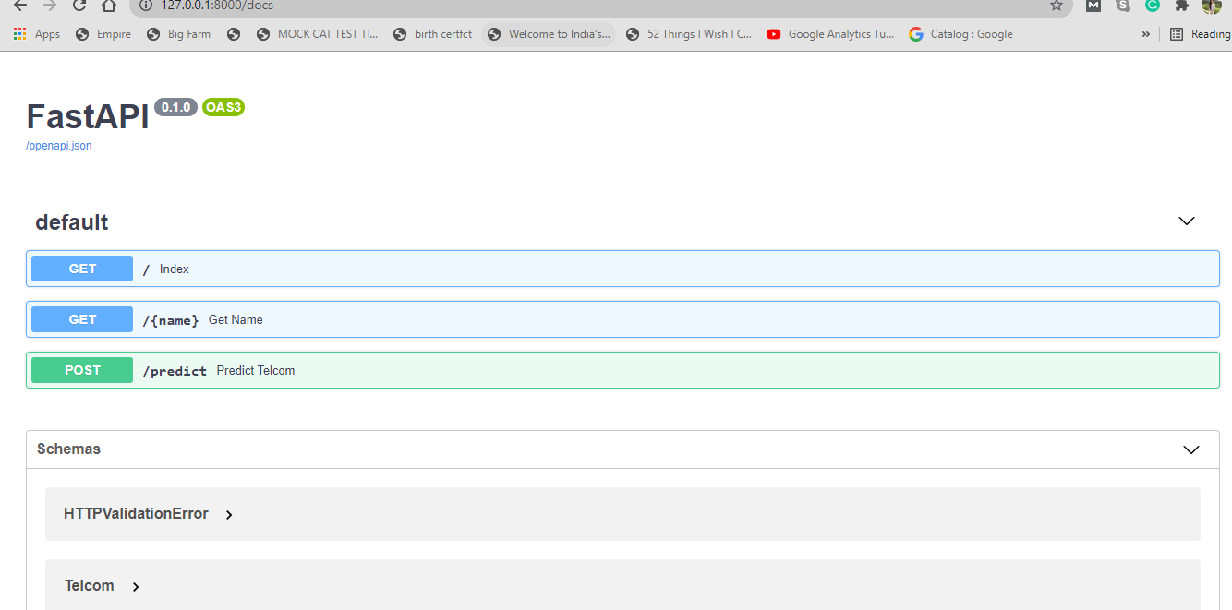

**GIVING INPUTS**

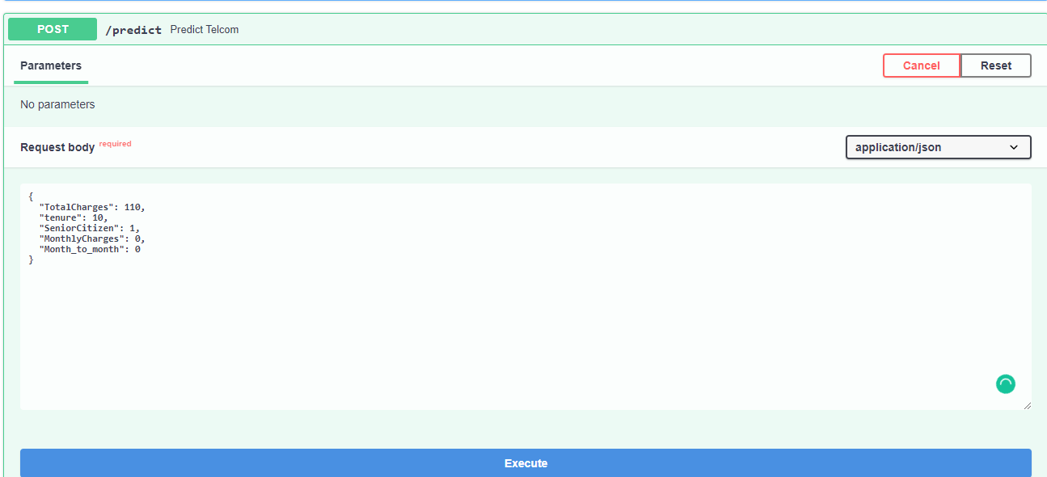

**OUTPUT-PREDICTION**

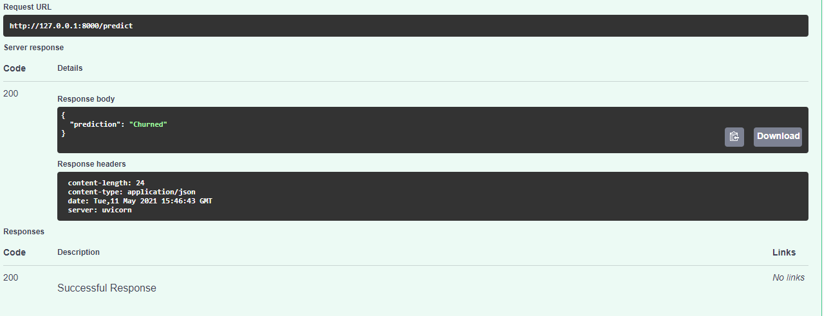

**BUILDING DOCKER**

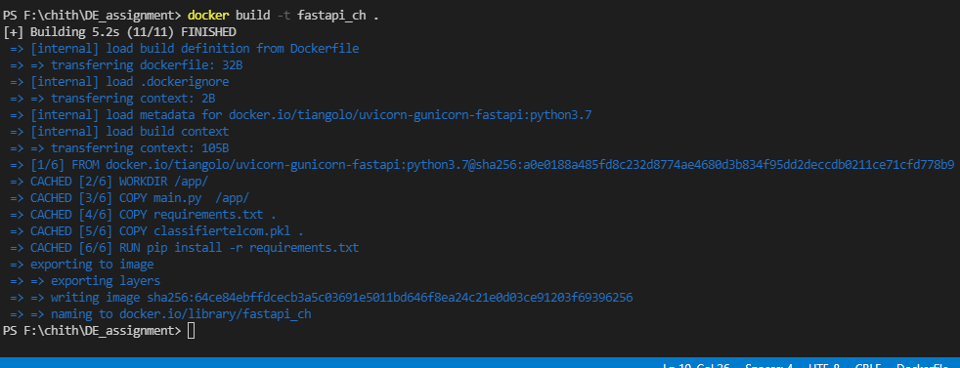

**CREATING HEROKU APP**

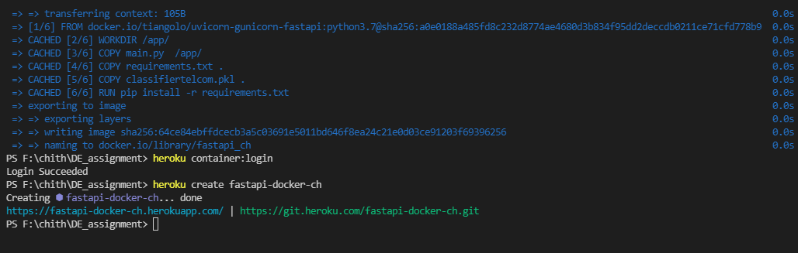

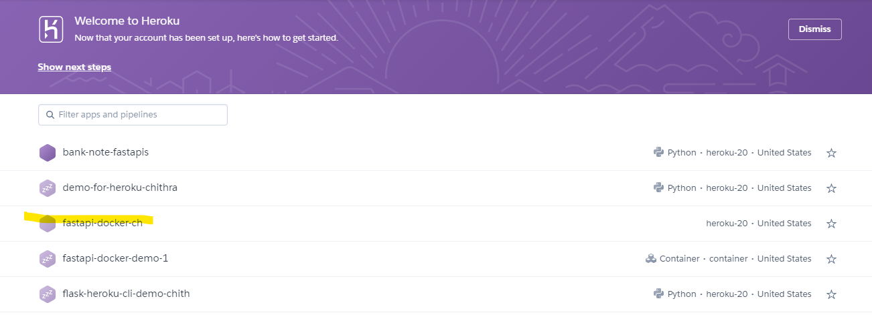

**DEPLOYMENT OF HEROKU APP**

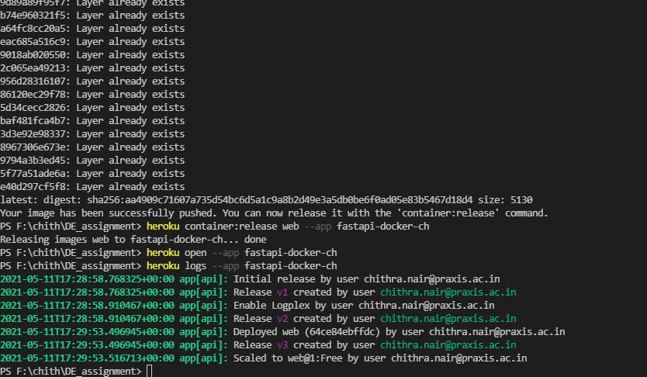

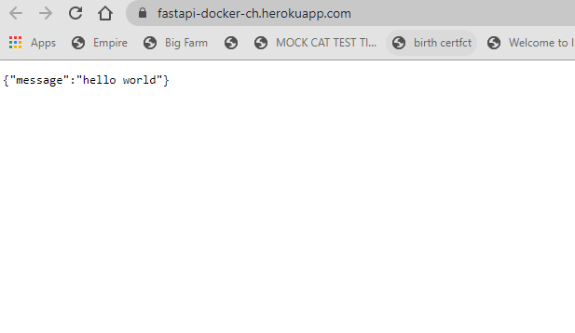

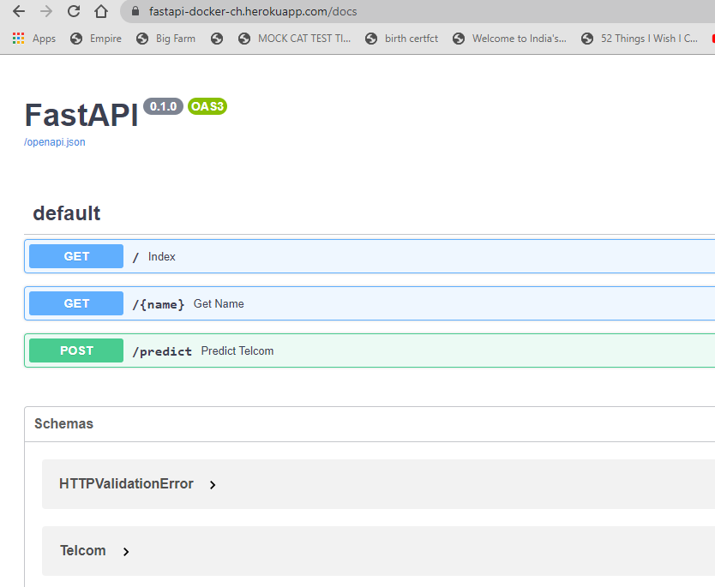

**GIVING INPUTS**

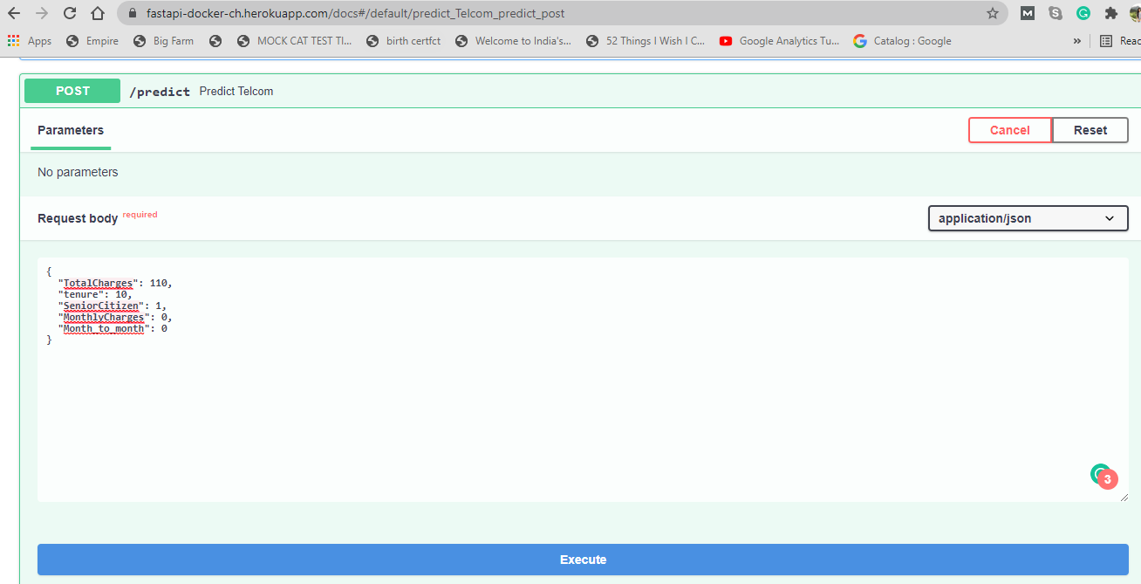

**OUTPUT SHOWING CHURNED**

