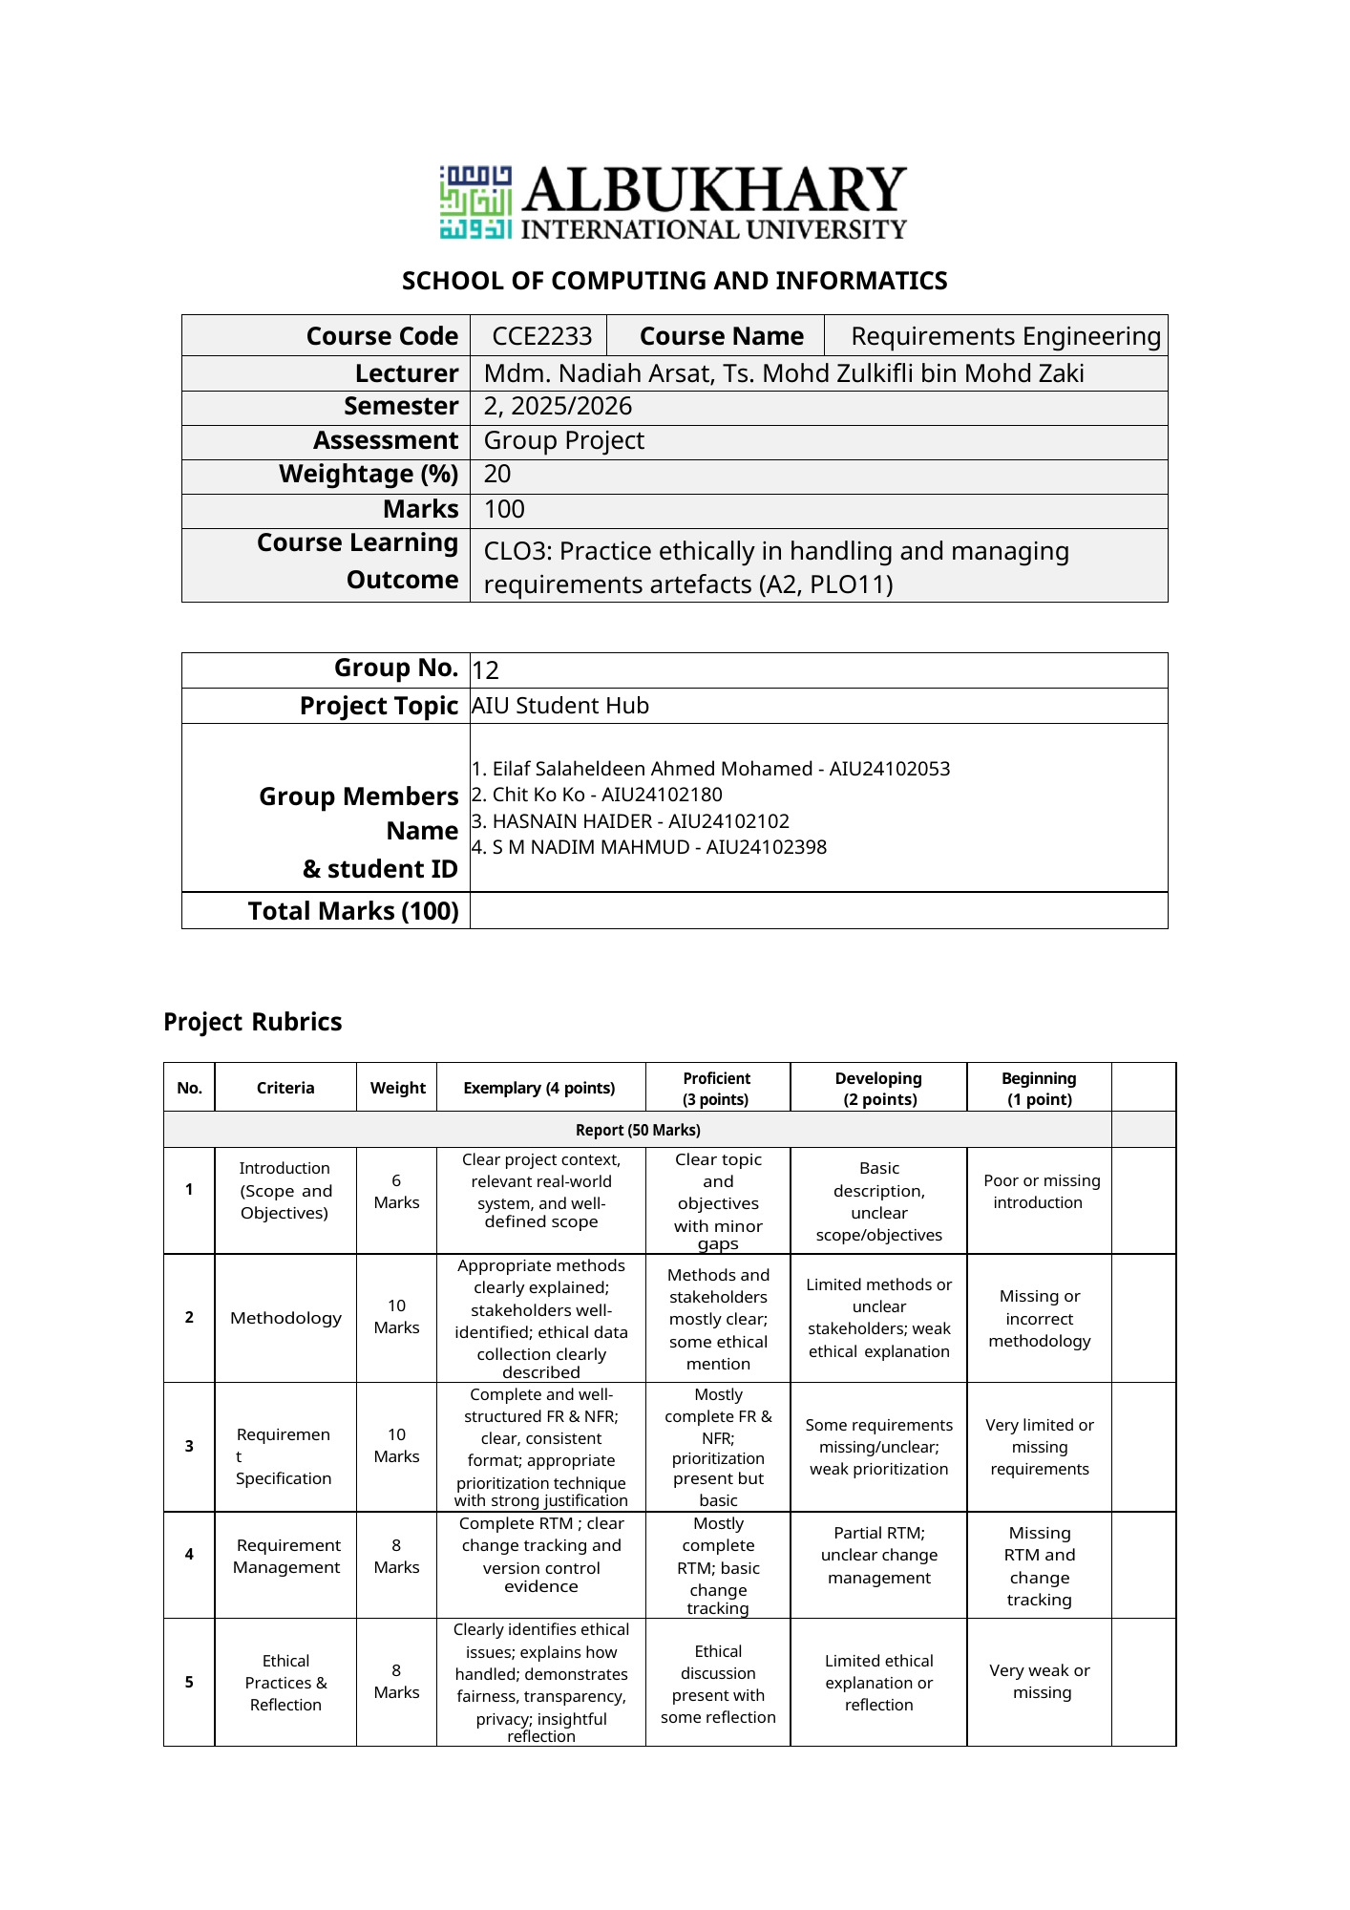
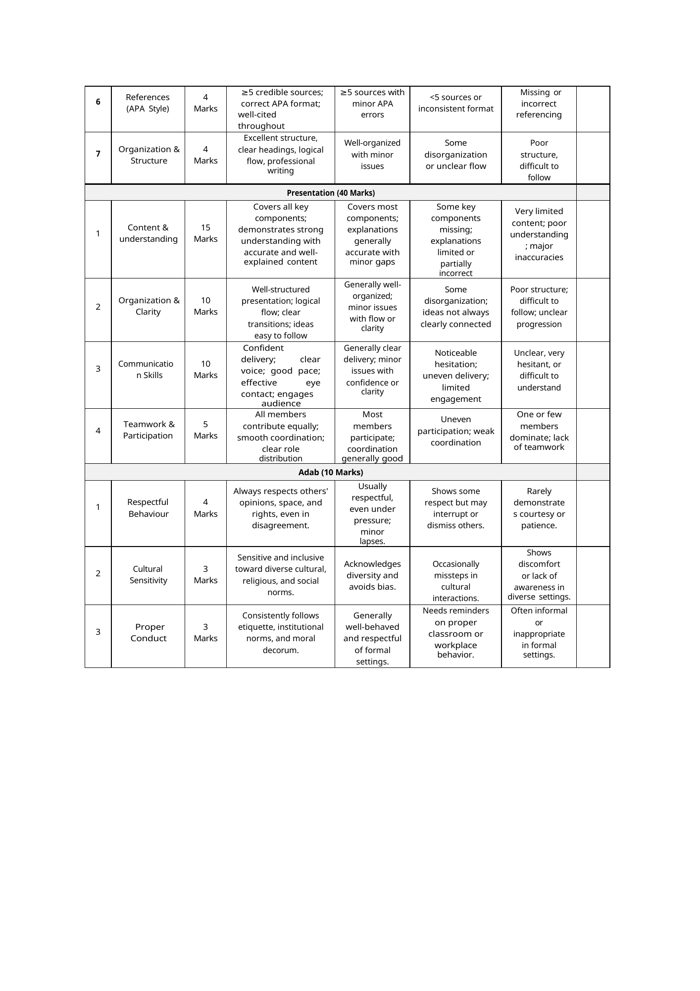

Table of Contents
Executive Summary ........................................ 4
1. Introduction ............................................. 4
2. Methodology .............................................. 5
3. Requirement Specification ................................. 7
4. Requirement Management .................................. 11
5. Ethical Practices ........................................ 14
6. Reflection ............................................... 15
7. Conclusion ............................................... 15
8. References ............................................... 16
Appendices ................................................. 17

Executive Summary
The AIU Student Hub is a centralized academic and logistical platform serving students, lecturers, and management at Albukhary International University (AIU). It functions as a daily attendance system, a communication channel between management departments and students for matters such as results, examinations, course registration, and exemptions, and a medium for student participation in SRC elections. Despite its importance, the existing system suffers from fragmented services, tedious processes, and exploitable security weaknesses. This report documents the requirements for an improved Student Hub based on a three-week requirement elicitation process conducted on the AIU campus. The project set out to apply structured requirements engineering practices to the AIU Student Hub. Specifically, it aimed to gather system requirements using a range of elicitation techniques, document those requirements systematically using established documentation methods, and manage and track changes to the requirements throughout the project lifecycle. To capture a complete picture of stakeholder needs, the team applied data triangulation across three elicitation techniques: an online student survey, semi-structured interviews with student representatives, lecturers, and management staff, and observation-based analysis of the existing Student Hub. The elicitation process yielded 25 functional requirements and 5 non-functional requirements for the AIU Student Hub. The methodological triangulation strategy proved more reliable than any single technique and, alongside careful ethical practice, was central to the project’s success.

1. Introduction

1.1 Project background and context
Student Hub is an AIU-based system designed to provide a centralized platform for students, lecturers, and management to perform academic and logistical processes with different departments at AIU. On a day-to-day basis, the hub serves as an attendance platform for students and lecturers. Moreover, the platform also serves as a communication hub for different management departments with students for matters related to results, examinations, course registration, and exemption. The hub also enables students to participate in decision-making by voting in SRC elections. All this makes the student hub an essential, frequently used system in AIU. However, several challenges face stakeholders when dealing with the system, including fragmented services, tedious processes, and exploitable security safeguards. In this report we outline the requirements for the Student Hub based on a 3-week elicitation process on the AIU campus.

1.2 Objectives
- Use different requirements elicitation tools to gather the requirements of the AIU student hub system
- Use proper requirement documentation techniques to systematically document the requirements of the system.
- Use requirement management tools to track the changes in the requirements

2. Methodology
Modern requirements engineering practices emphasize continuous stakeholder involvement and iterative refinement to accommodate evolving organizational and user needs (Zaveri et al., 2024), which guided the structured approach adopted below.

2.1 Elicitation techniques used
The table below maps each technique with the information we hoped to gain from it:

Req. ID | Elicitation techniques
Satisfier | Online student survey and semi-structured interviews with student representatives, lecturers, and management staff.urvey
Dissatisfier | Observation-based methods of the existing AIU student hub system.
Delighter | Creative brainstorming exercise in interviews with 2 lecturers and 3 management staff
Table 1. Elicitation techniques
Effective requirements elicitation requires systematic stakeholder engagement and structured information-gathering processes to ensure complete and accurate requirement capture (Hidalgo et al., 2025).

2.2 List of identified stakeholders and descriptions
Stakeholder identification is a critical activity in requirements engineering because different stakeholder groups possess different perspectives, priorities, and expectations regarding system functionality and quality attributes (Elneel et al., 2022).

2.2.1 Students
There are different tracks for students at AIU, including pre-college, undergraduate, or master's. The precollege students are enrolled in either the language center or the school for foundation studies. The undergraduate and master's programs are offered by the School of Business and Social Sciences (SBSS), School of Computing and Informatics (SCI), and School of Education and Human Sciences (SEHS). The AIU student body involves students from more than 60 countries with different digital fluency levels. Students have different expectations around the student hub system. The general expectation is that the system support different dimensions of their student life, including academic and logistical aspects as well as their overall welfare in the university Student survey results and student representative interviews were used to capture common issues such as repeated login, outdated interface design, attendance access, timetable notifications, SRC election security, and privacy concerns.

2.2.2 Lecturers
The lecturers supported by the system include both full-time and part-time lecturers. Each lecturer instructs a different number of courses; some courses are instructed by two lecturers together. The lecturer's needs include having a centralized system to share an attendance code with students. The system shall enable the lecturer to track student attendance.

2.2.3 AIU Management
Management staff at AIU include both high-level managers and staff in managerial positions. These stakeholders are interested in tracking the academic records of all students to have insights about their academic performance.

2.3 Ethical Considerations in Stakeholder Engagement
All elicitation activities followed accepted ethical guidelines for research involving human subjects. Before each interview, participants signed a written informed consent form explaining the study’s purpose, their role, and how their data would be handled; they could withdraw at any time without consequence, and no data from a withdrawn participant was used in the analysis. Participants could choose to remain anonymous or use their real name, and interviews were recorded only with explicit prior agreement, with all data handled to prevent re-identification. The online survey collected no personally identifying information such as names, emails, or student IDs, since anonymity was judged necessary for students to give honest feedback, including criticism of current procedures. A separate ethical issue arose when several survey responses showed signs of AI-generated content—generic, lacking personal context, and not representative of real student experience. Because such responses risked skewing requirement priorities, we addressed this by cross-referencing survey data with observation and interview findings to filter out implausible patterns and ground the analysis in verified input.

3. Requirement Specification

3.1 Functional and non-functional requirements

3.1.1 Functional Requirements
- FR 01: The system shall allow students to register to Student Hub using their student email and ID details.
- FR 02: The system shall allow students to log in to the system using the student username and password.
- FR 03: The system shall allow students to record their attendance for courses they have registered for by scanning the QR code.
- FR 04: The system shall allow students to view their attendance statistics for each course.
- FR 05: The system shall allow students to view their transcript for each semester.
- FR 06: The system shall allow students to register for offered courses.
- FR 07: The system shall allow students to vote on SRC elections using a two-step verification process.
- FR 08: The system shall allow students to request course exemption.
- FR 09: The system shall allow students to renew visas.
- FR 10: The system shall provide a dashboard for management to view student attendance details
- FR 11: The system shall allow management to generate and download student attendance reports by semester or faculty.
- FR 12: The system shall use role-based access control so that each management level can manage student data according to their role.
- FR 13: The system shall send alerts to management when a student's academic performance drops below a set level.
- FR 14: The system shall include an internship management module to record internship details.
- FR 15: The system shall allow lecturers to log in using their staff email and credentials
- FR 16: The system shall provide lecturers with a unified student attendance profile.
- FR 17: The system shall allow lecturers to generate student academic reports automatically.
- FR 18: The system shall allow the lecturer to update student attendance records by filling out a form with student name, course, and date.
- FR 19: The system shall recommend suitable courses based on academic history and previously failed courses.
- FR 20: The system shall notify students when prerequisite courses have not been completed.
- FR 21: The system shall allow lecturers to view advising records for students under their supervision.
- FR 22: The system shall automatically detect timetable conflicts for students during course registration.
- FR 23: The system shall allow students to access services offered by the AIU COF library.
- FR 24: The system shall allow students to view the remaining balance in AIU cafeteria coupon balance
- FR 25: The system shall allow students to view their timetable from the student hub

3.1.2 Nonfunctional Requirements
- NFR 01: The system shall be 99% available on a 24/7 basis.
- NFR 02: The system shall be able to serve >5000 students at the same time.
- NFR 03: The system shall work on both mobile and desktop.
- NFR 04: The system shall handle student data and passwords securely.
- NFR 05: The system shall provide 3 languages of support (Arabic, English, and Malay) for accessibility.

3.2 Requirement Prioritization
Below we map the requirements with their respective priorities using the MoSCoW technique, which is widely used to support effective requirement prioritization and decision-making in software projects involving multiple stakeholders (Vijayakumar et al., 2024). Note that ‘M’ refers to 'must have,' ‘S’ refers to 'should have,' and ‘C’ refers to 'could have.'

Req. ID | Description | MoSCoW Priority | Justification
FR 01 | The system shall allow students to register to Student Hub using their student email and ID details. | M | The system cannot work without student registration functionality.
FR 02 | The system shall allow students to log in to the system using the student username and password. | M | The system cannot work without student login functionality, as unauthorized access can lead to data manipulation.
FR 03 | The system shall allow students to record their attendance for courses they have registered for by scanning the QR code. | M | The attendance recording functionality is the core of the system, so it must be there.
FR 04 | The system shall allow students to view their attendance statistics for each course. | S | It’s important, but the system can still work without it as attendance will already be recorded.
FR 05 | The system shall allow students to view their transcript for each semester. | M | Viewing transcript functionality is the core of the system, so it must be there.
FR 06 | The system shall allow students to register for offered courses. | M | Course registration functionality is the core of the system, so it must be there.
FR 07 | The system shall allow students to vote on SRC elections using a two-step verification process. | S | It’s important, but the system can still work without it. Previously, students would vote manually.
FR 08 | The system shall allow students to request course exemption. | S | It’s important, but the system can still work without it, as not all students need it.
FR 09 | The system shall allow students to renew visas. | S | It’s important, but the system can still work without it, as they can use the ISSU form.
FR 10 | The system shall provide a dashboard for management to view student attendance details | M | The system cannot work without this dashboard functionality.
FR 11 | The system shall allow management to generate and download student attendance reports by semester or faculty. | M | The system cannot work without this reporting functionality.
FR 12 | The system shall use role-based access control so that each management level can manage student data according to their role. | M | The system cannot work without this role-based access functionality, as unauthorized access can lead to data leakage.
FR 13 | The system shall send alerts to management when a student's academic performance drops below a set level. | S | It’s important to develop this notification functionality, but the system can still work without it.
FR 14 | The system shall include an internship management module to record internship details. | S | It’s important to develop this internship tracking functionality, but the system can still work without it.
FR 15 | The system shall allow lecturers to log in using their staff email and credentials | M | The system cannot work without this functionality, as unauthorized access can jeopardize the integrity of academic records.
FR 16 | The system shall provide lecturers with a unified student attendance profile. | M | The system cannot work if lecturers cannot assess students’ attendance level, as there are consequences for students with attendance below 80%.
FR 17 | The system shall allow lecturers to generate student academic reports automatically. | M | The system cannot work without this report generation functionality.
FR 18 | The system shall allow the lecturer to update student attendance records by filling out a form with student name, course, and date. | M | The system cannot work without this functionality because sometimes students’ attendance needs to be updated from the back office.
FR 19 | The system shall recommend suitable courses based on academic history and previously failed courses. | C | This is a nice-to-have feature if time allows.
FR 20 | The system shall notify students when prerequisite courses have not been completed. | M | This is an important feature for verifying academic discipline, and the system cannot work without it.
FR 21 | The system shall allow lecturers to view advising records for students under their supervision. | S | This is an important feature, but the system can still work without it, as advisees can share their records with the advisor.
FR 22 | The system shall automatically detect timetable conflicts for students during course registration. | S | This is an important feature to ensure consistent class assignment, but the system can still work without it.
FR 23 | The system shall allow students to access services offered by the AIU COF library. | C | This is a nice-to-have feature if time allows
FR 24 | The system shall allow students to view the remaining balance in AIU cafeteria coupon balance | S | This is an important feature, but the system can still work without it, as students can do that at the cafeteria.
FR 25 | The system shall allow students to view their timetable from the student hub | S | This is an important feature but the system can still work without it
NFR 01 | The system shall be 99% available on a 24/7 basis. | M | Availability is a core quality requirement of the system, and the system cannot work without it.
NFR 02 | The system shall be able to serve >5000 students at the same time. | M | The system cannot work if it fails to accommodate all the student body at AIU.
NFR 03 | The system shall work on both mobile and desktop. | M | The system cannot work without it because some of the students do not have laptops
NFR 04 | The system shall handle student data and passwords securely. | M | The system cannot work without this quality because there are incentives for students to hack the account of others.
NFR 05 | The system shall provide 3 languages of support (Arabic, English, and Malay) for accessibility. | C | It’s a nice-to-have feature if time allows

4. Requirement Management

4.1 Requirements Traceability Matrix (RTM)
Requirement traceability helps maintain clear relationships between stakeholder needs, documented requirements, and future system changes throughout the software development lifecycle (Mucha et al., 2024).

Req. ID | Description | Source | Related Requirement | Status
FR 01 | The system shall allow students to register to Student Hub using their student email and ID details. | Student | N/A | Approved
FR 02 | The system shall allow students to log in to the system using the student username and password. | Student | FR 01 | Approved
FR 03 | The system shall allow students to record their attendance for courses they have registered for by scanning the QR code. | Student | FR 02 | Approved
FR 04 | The system shall allow students to view their attendance statistics for each course. | Student | FR 03 | Approved
FR 05 | The system shall allow students to view their transcript for each semester. | Student | FR 02, FR 06 | Approved
FR 06 | The system shall allow students to register for offered courses. | Student | FR 02 | Approved
FR 07 | The system shall allow students to vote on SRC elections using a two-step verification process. | Student | FR 02 | Proposed
FR 08 | The system shall allow students to request course exemption. | Student | FR 02 | Rejected
FR 09 | The system shall allow students to renew visas. | Student | FR 01 | Proposed
FR 10 | The system shall provide a dashboard for management to view student attendance details | Management | FR 03 | Approved
FR 11 | The system shall allow management to generate and download student attendance reports by semester or faculty. | Management | FR 10 | Approved
FR 12 | The system shall use role-based access control so that each management level can manage student data according to their role. | Management | FR 11 | Approved
FR 13 | The system shall send alerts to management when a student's academic performance drops below a set level. | Management | FR 05 | Proposed
FR 14 | The system shall include an internship management module to record internship details. | Management | FR 01 | Proposed
FR 15 | The system shall allow lecturers to log in using their staff email and credentials | Lecturers | N/A | Approved
FR 16 | The system shall provide lecturers with a unified student attendance profile. | Lecturers | FR 15 | Approved
FR 17 | The system shall allow lecturers to generate student academic reports automatically. | Lecturers | FR 15 | Proposed
FR 18 | The system shall allow the lecturer to update student attendance records by filling out a form with student name, course, and date. | Lecturers | FR 15 | Proposed
FR 19 | The system shall recommend suitable courses based on academic history and previously failed courses. | Students | FR 06 | Proposed
FR 20 | The system shall notify students when prerequisite courses have not been completed. | Students | FR 06 | Approved
FR 21 | The system shall allow lecturers to view advising records for students under their supervision. | Lecturers | FR 05 | Proposed
FR 22 | The system shall automatically detect timetable conflicts for students during course registration. | Students | FR 06 | Proposed
FR 23 | The system shall allow students to access services offered by the AIU COF library. | Students | FR 02 | Proposed
FR 24 | The system shall allow students to view the remaining balance in AIU cafeteria coupon balance | Students | FR 02 | Proposed
FR 25 | The system shall allow students to view their timetable from the student hub | Students | FR 02FR 02, FR 06FR 06 | Proposed

4.2 Change Management
Version | Date | Description | Author
StudentHub_SRS_v01 | May 23, 2026 | Created the document structure | Eilaf Salaheldeen Ahmed Mohamed
StudentHub_SRS_v02 | June 9, 2026 | Added Student requirements and placed formatting comments | Eilaf Salaheldeen Ahmed Mohamed
StudentHub_SRS_v03 | June 11, 2026 | Added the requirement traceability matrix and requirement prioritization. | Eilaf Salaheldeen Ahmed Mohamed
StudentHub_SRS_v04 | June 14, 2026 | Added management requirements and reported ethical considerations | HASNAIN HAIDER
StudentHub_SRS_v05 | June 15, 2026 | Edited requirement management and edited traceability matrix for management requirements | HASNAIN HAIDER
StudentHub_SRS_v06 | June 15, 2026 | Added lecturer requirements and added new student requirements | Chit Ko Ko
StudentHub_SRS_v07 | June 16, 2026 | Added management requirements in the requirement prioritization matrix | HASNAIN HAIDER
StudentHub_SRS_v08 | June 17, 2026 | Updated lecturer requirements and added them to the traceability matrix | Chit Ko Ko
StudentHub_SRS_v09 | June 18, 2026 | Edited justifications in requirement prioritization | S M NADIM MAHMUD
StudentHub_SRS_v10 | June 19, 2026 | Aligned requirement formatting across different categories (Student, Lecturer, and Management) | S M NADIM MAHMUD

5. Ethical Practices
One ethical issue that emerged during the survey process was that some students wanted to remove the 30-second reset for QR codes. Although this request reflected students' need for a more convenient attendance process, it conflicted with lecturers' need to protect the integrity of attendance records. Balancing convenience against control is a recurring tension in system access design, and the importance of role-based access and controlled information access is widely recognized as a fundamental mechanism for protecting sensitive organizational and user data (Wang et al., 2022).
Another issue was that some survey responses appeared to be AI-generated. This created a serious concern about data validity because those responses were generic and lacked grounded stakeholder experience useful for requirement generation.
Other ethical practices included informed consent for interviews. Each interviewee had read and signed the consent form, and the form asked whether they preferred to participate using their names or as anonymous participants. For anonymous participation, we used secure data handling to avoid revealing participants' identities.

6. Reflection
The main thing we have learned is that the success of requirement engineering depends on stakeholders' engagement. As we struggled to get students to fill out the surveys to help us understand their needs, we realized the elicitation process does not stop at identifying the stakeholders but rather goes a step further to make the engagement attractive for them. And making engagement attractive while being ethical was the hardest challenge we have faced.
The way we tackled it is through data triangulation; instead of relying on one elicitation technique, we combined three tools to maximize the data we can get about the stakeholders. This has helped us to learn resourcefulness and to utilize what we have to do the most good. We also learned a lot about the degree of interpersonal sensitivity needed to manage actual stakeholders. We had to learn how to ask questions that produced requirements without pressuring interviewees to give specific responses because interviewees' experience with requirements engineering varied. More broadly, each team member improved their ability in structured requirement documentation, elicitation, and management.

7. Conclusion
This report presents a structured requirements specification for the AIU Student Hub system, developed through an elicitation process involving students, lecturers, and management personnel. The team identified 25 functional requirements and 5 non-functional requirements covering the system's essential features, such as attendance management, course registration, academic reporting, and security, using a mix of online questionnaires, observational techniques, and semi-structured interviews.
This project's ethical component turned out to be more significant than expected. The rise of AI-generated survey responses highlighted a more general issue with digital participatory research: making sure that the data gathered accurately captures stakeholder experience. In addition to reducing this danger, our approach—methodological triangulation—produced a more comprehensive and convincing list of requirements than any one elicitation method would have. These findings also align with broader digital transformation initiatives occurring in higher education institutions worldwide, where universities increasingly seek to centralize academic and administrative services through integrated digital platforms (Farias-Gaytan et al., 2023).

8. References

Elneel, D. A., Fakharudin, A. S., Ahmed, E. M., Kahtan, H., & Abdullateef, M. (2022). Stakeholder identification overview and challenges in requirements engineering prospective. In Proceedings of the 2022 2nd International Conference on Computing and Information Technology (ICCIT 2022) (pp. 314–319). IEEE. https://doi.org/10.1109/ICCIT52419.2022.9711653
Farias-Gaytan, S., Aguaded, I., Wilberforce, T., & Ramírez-Montoya, M. (2023). Digital transformation initiatives in higher education institutions: A multivocal literature review. Education and Information Technologies, 28, 12351–12382. https://doi.org/10.1007/s10639-022-11544-0
Hidalgo, M., Yanine, F., Paredes, R., Frez, J., & Solar, M. (2025). What is the process? A metamodel of the requirements elicitation process derived from a systematic literature review. Processes, 13(1), 20. https://doi.org/10.3390/pr13010020
Mucha, J., Kaufmann, A., & Riehle, D. (2024). A systematic literature review of pre-requirements specification traceability. Requirements Engineering, 29, 119–141. https://doi.org/10.1007/s00766-023-00412-z
Vijayakumar, S., Krishna Prasad, K., & Raviraja Holla, M. (2024). Assessing the effectiveness of MoSCoW prioritization in software development: A holistic analysis across methodologies. EAI Endorsed Transactions on Internet of Things, 10. https://doi.org/10.4108/eetiot.6515
Wang, Y., Li, X., & Chen, Z. (2022). Role-based access control model for inter-system cross-domain in multi-domain environment. Applied Sciences, 12(24), 13036. https://doi.org/10.3390/app122413036
Zaveri, A. A., Jaafar, J., Yafi, E., & Shehmir, S. (2024). Evolution of requirements engineering in agile methodology – Literature review. Journal of Engineering Technology and Applied Physics, 6(2), 57–65. https://doi.org/10.33093/jetap.2024.6.2.9

Appendices
The appendices are organized by group member responsibility and include supporting links and visual evidence used during requirement elicitation and documentation.

Appendix 1: Eilaf Salaheldeen Ahmed Mohamed - Student Survey Resources
Resource / Evidence | Link or Location | Visual Evidence
Student survey questionnaire | Open survey form | 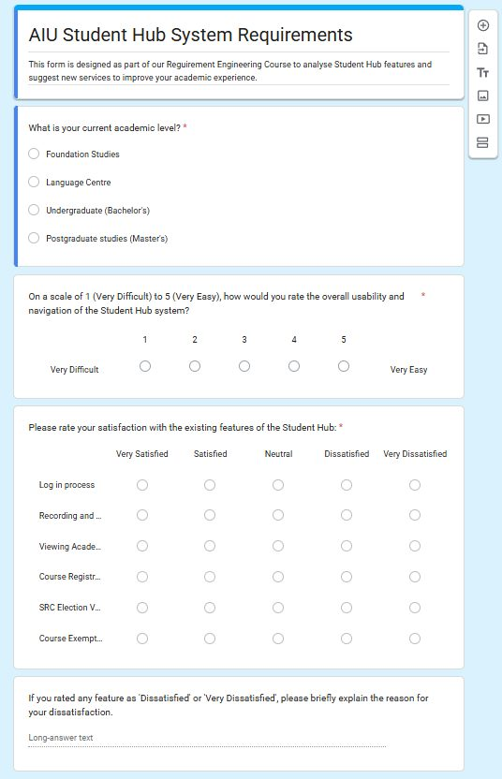
Survey response evidence | [Placeholder - insert Form Response Excel Sheet link manually] | 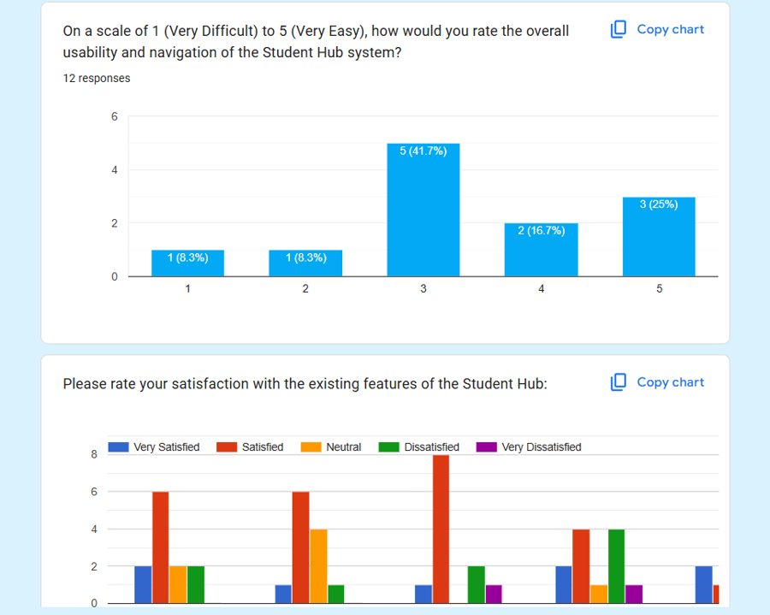
Student survey resource folder | Open resource folder | 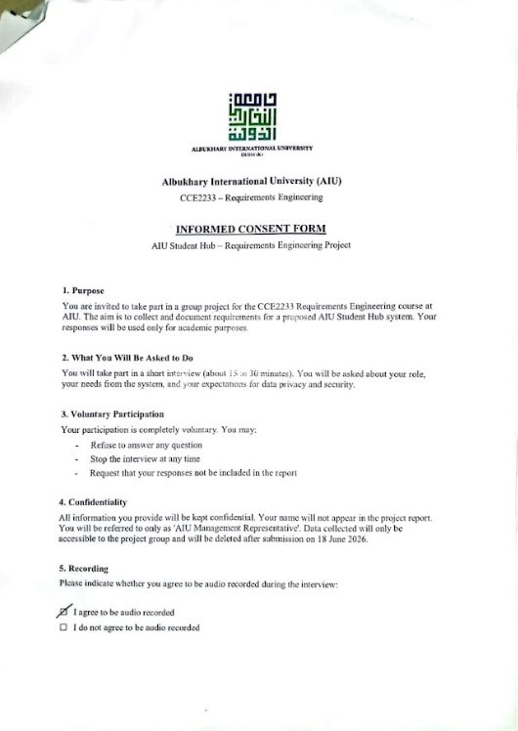

Appendix 2: Chit Ko Ko - Lecturer Interview Resources
Resource / Evidence | Link or Location | Visual Evidence
Lecturer resource folder | Open resource folder | 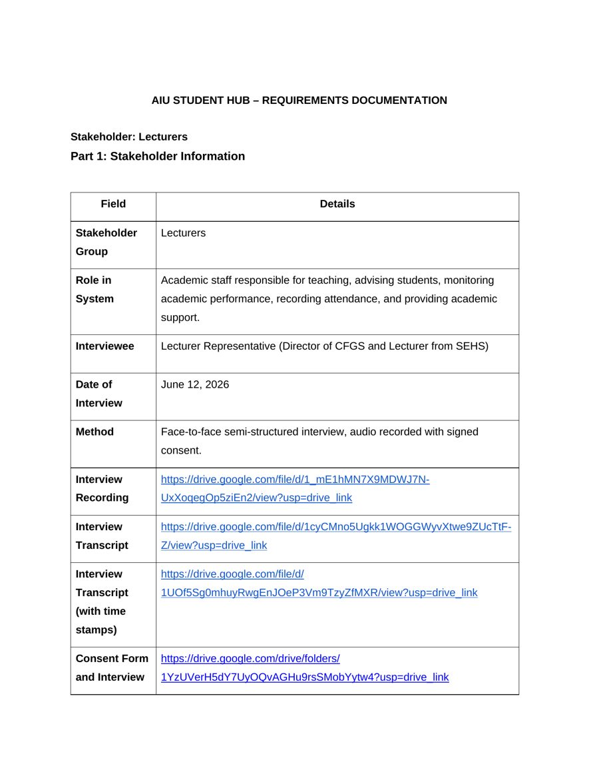
Interview recording | Open recording
Interview transcript and timestamped transcript | Open transcript folder | 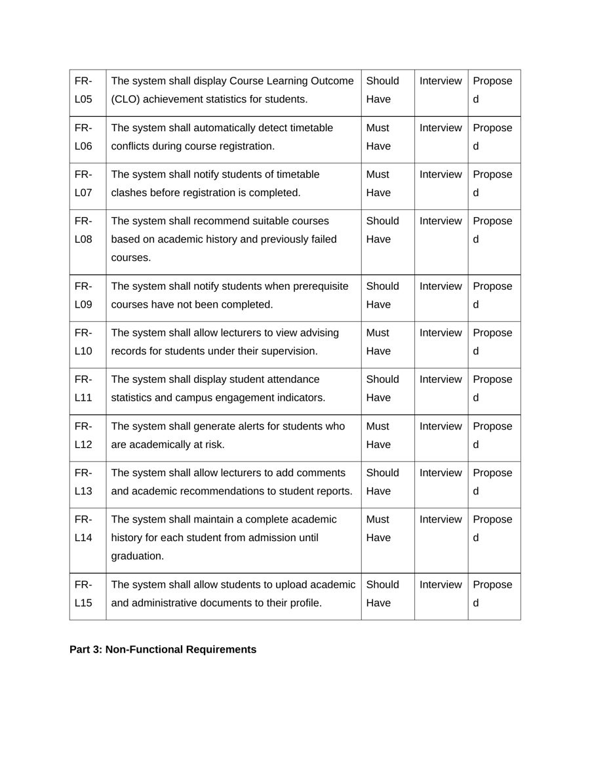
Consent form and interview form | Open consent/interview forms

Appendix 3: HASNAIN HAIDER - Management Interview Resources
Resource / Evidence | Link or Location | Visual Evidence
Management/staff resource folder | Open resource folder | 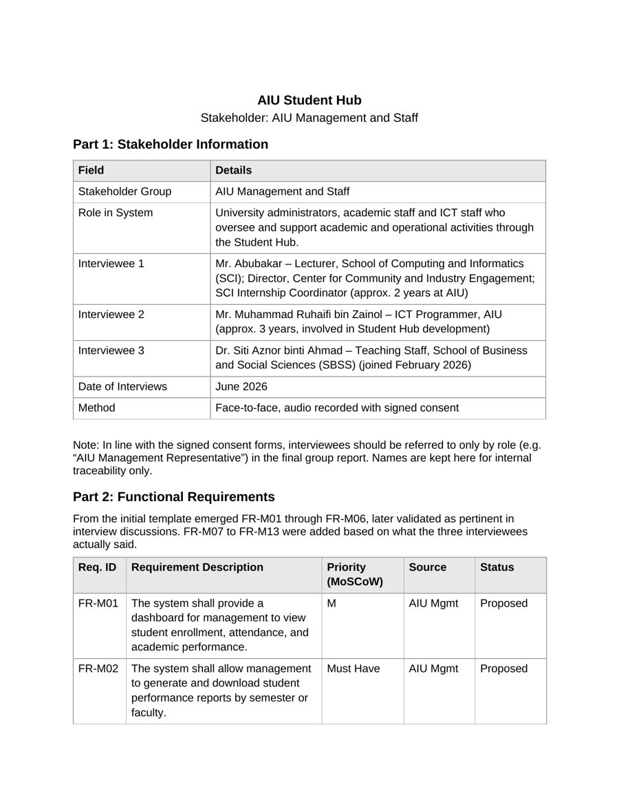
Management functional requirement evidence | Included in management resource folder | 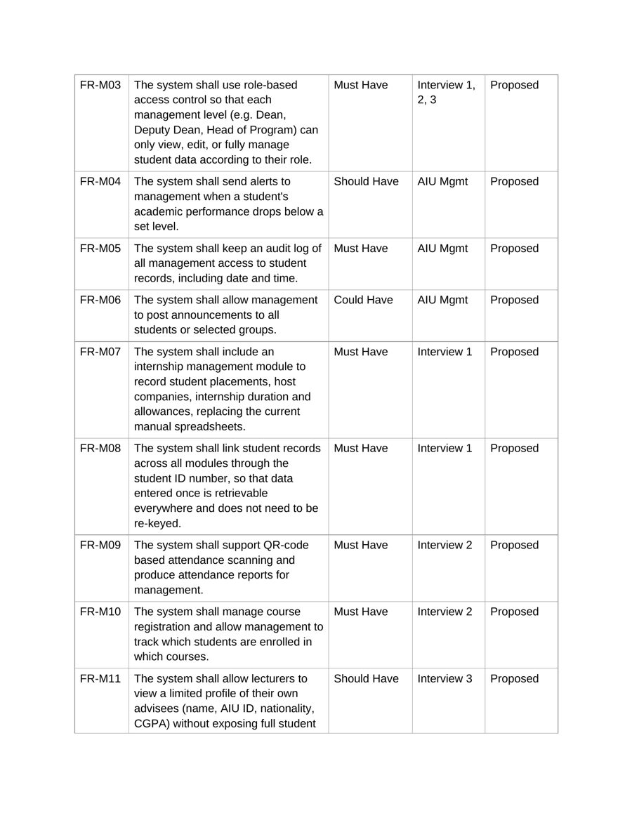
Management priority and ethical evidence | Included in management resource folder | 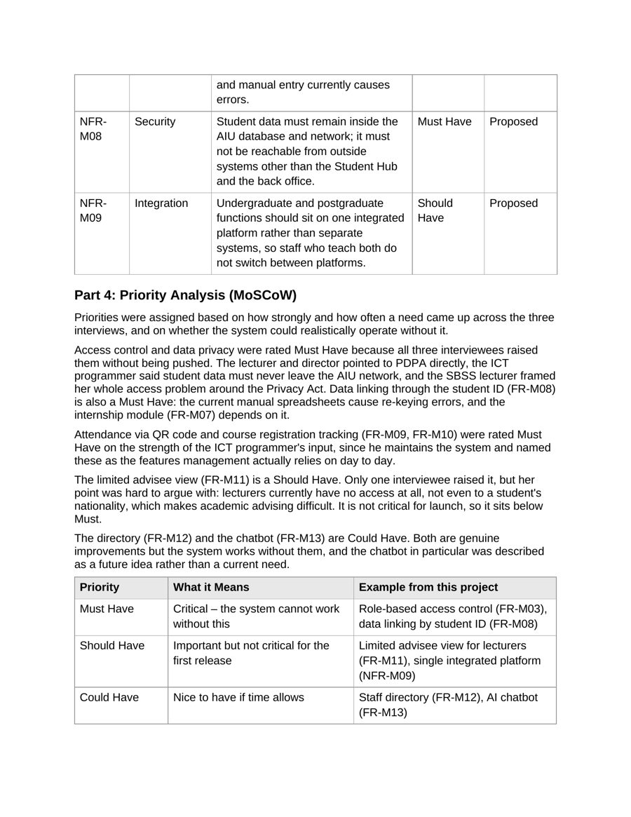

Appendix 4: S M NADIM MAHMUD - Student Interview Resources
Resource / Evidence | Link or Location | Visual Evidence
Student interview resource folder | Open resource folder | 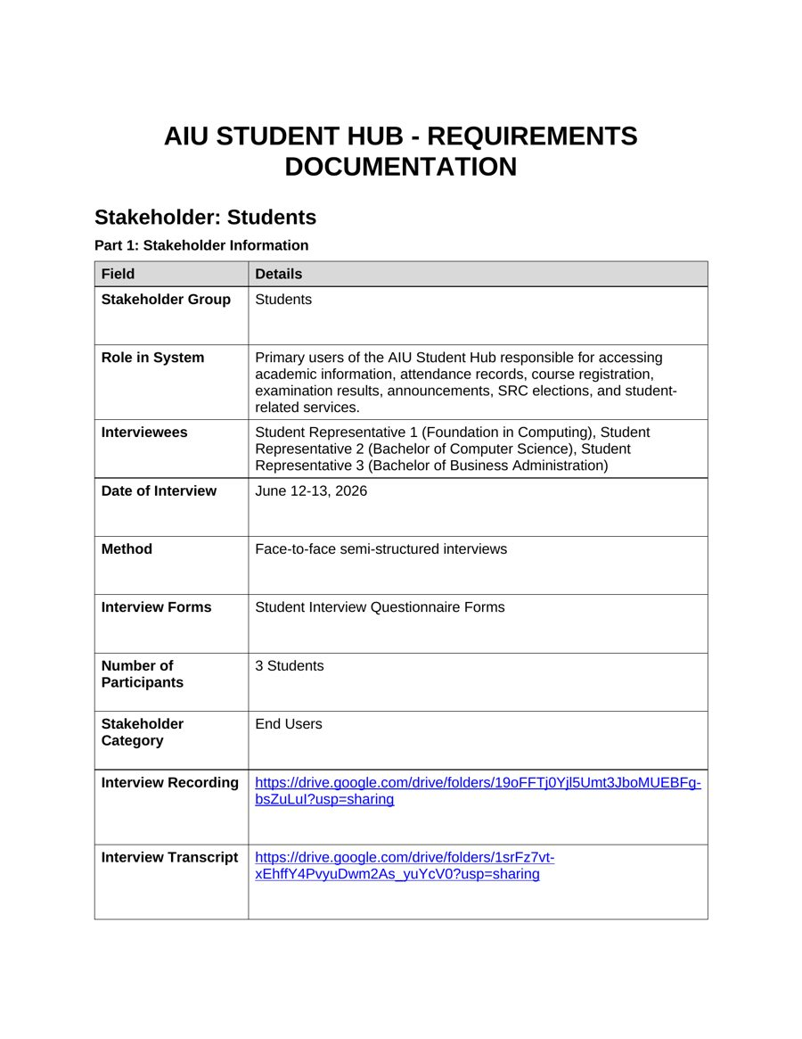
Interview recording | Open recording folder
Interview transcript and timestamped transcript | Open transcript folder | 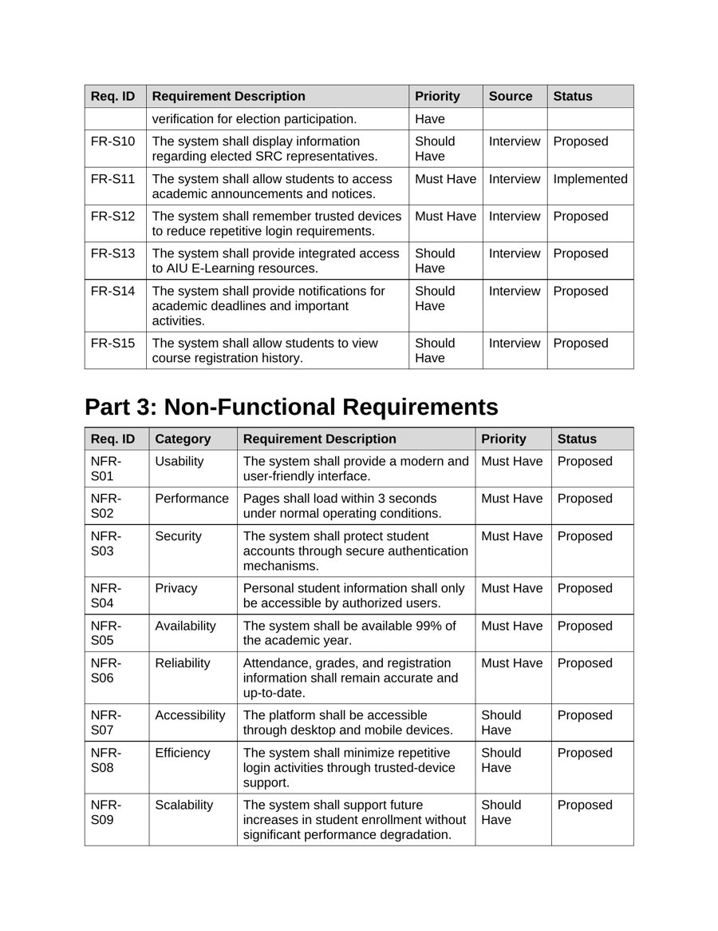
Consent form and interview form | Open consent/interview forms

Shared Group Resources
Resource / Evidence | Link or Location | Visual Evidence
Consent form template used by the group | Open consent form template | 
GitHub repository highlighting everyone's efforts | [Placeholder - insert GitHub repository link manually]

