CS 142 Advanced Web Design: CSS and Usability Spring 2014

Jayson Conyette-James, Sarah Clarke

Lauren Fiasconaro Photography

Version <1.0>

Table Of Contents

Time Log 3

Software Requirements Specifications 4

Introduction 4

Purpose 4

Definitions, acronyms, and abbreviations 4

Overall Description 4

Story Board 5

Assignment requirements 6

Specific requirements 7

|  |  |  |  |
| --- | --- | --- | --- |
| Time Log | | | |
| Estimated time to complete assignment => | | | __22___ Hours |
| Date | Time Spent  (in hours) | Description | Author |
| 4/20 | 2 | Project Specification created | Sarah Clarke |
| 4/20 | 1 | Storyboard completed | Sarah Clarke |
| 4/21 | .5 | Background image picked | Sarah Clarke |
| 4/21 | .5 | Colour scheme established based on image | Jayson James |
| 4/23 | 3 | Portfolio images collected | Sarah Clarke |
| 4/25 | 5 | Home page and main template created and styled | Jayson James |
| 4/26 | 5 | Bugs fixed in site responsiveness and added textual content to minor pages | Jayson James |
| 4/29 | 4 | Gallery template made | Sarah Clarke |
| 5/1 | 5 | Gallery slideshow funcionallity implemented | Sarah Clarke |
| 5/2 | 3 | Gallery table made | Sarah Clarke |
| 5/2 | 1 | Usability documents created | Sarah Clarke |
| 5/2 | .5 | Site emblem made | Jayson James |
| 5/2 | .5 | Navigation streamlined and embellished | Jayson James |
| 5/4 | 2 | Site finalized | Sarah Clarke |
| 5/4 | 4 | Usability testing performed | Jayson James and Sarah Clarke |
| 5/5 | 6 | Testing interpreted and analysis performed for consideration of site improvement | Jayson James and Sarah Clarke |
|  |  |  |  |
|  |  |  |  |
|  |  |  |  |
|  |  |  |  |
|  |  |  |  |
|  | 43 hours | <=Total Time Spent |  |
|  |  |  |  |

# Software Requirements Specifications

## Introduction

### Purpose

The purpose of this document is to describe the requirement specification for the web site “Lauren Fiasconaro photography”.

The intended audience for this document is the prospective developers of this site. The goal being that you can give this document to someone and they can make the site without having to ask any questions.

The web site to be created is a photography website for the artist, Lauren Fiasconaro; highlighting her published artwork and current catalog.

### Definitions, acronyms, and abbreviations

HTML – Hypertext markup language – used to define your conent.

PHP – Personal Home Page – language that helps to customize html.

CSS – Cascading Style Sheets – used to define the look of a web site.

W3 Validation – refers to both Html and CSS validation tool provided by the W3c.org. the html validator is located at:

<http://validator.w3.org/>

with the CSS validator located at:

<http://jigsaw.w3.org/css-validator/>

## Overall Description

This website will have a main page that will link out to the various galleries the artist has to display. This site will provide contact information for which to reach and commision the artist, as well as a biography and mission statement for artists goals and aspirations.

### Story Board

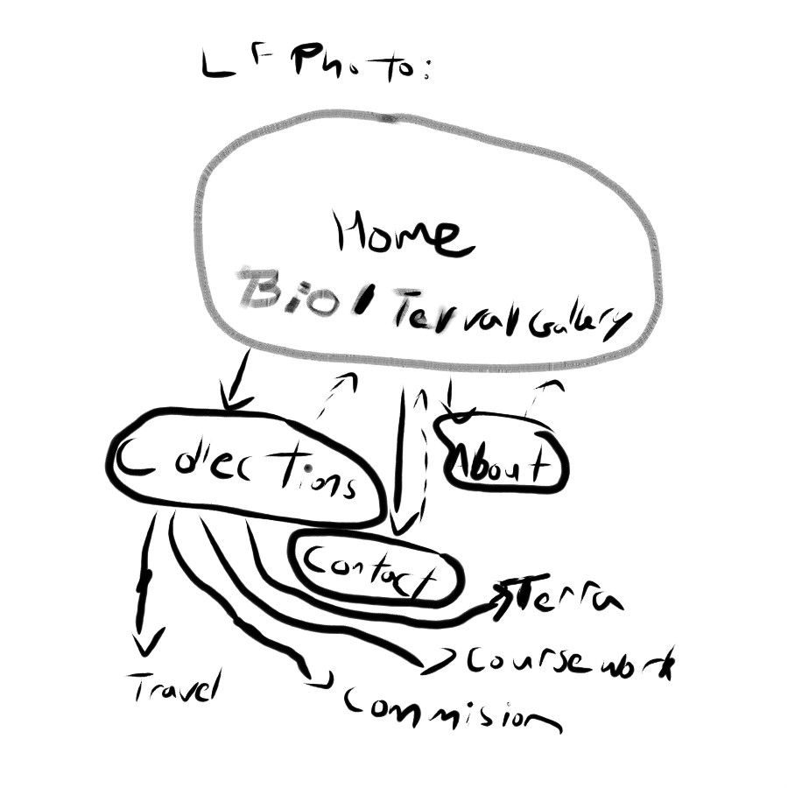

## Assignment requirements

1. *Location* – all files will be located in the public folder of your uvm account. The assignment web page and the submit process will detail the exact location. Failure to have your site located in the correct folder by the due dates will result in a zero on the assignment. Be sure to pay attention to the lowercase letters.
2. *Html Validation* – All pages will pass W3C Html validation for html 5.
3. *CSS Validation* – All pages will pass W3C CSS 3.0 validation.
4. *Meta Information* – All pages will contain a proper title tag, Meta tags (author, character set and description).
5. *CSS* – all pages will have a linked style sheet. Start off with my sample from the lectures.
6. *Navigation* – All pages will contain navigation to all other pages on the site using an ordered list. Be sure to enclose the navigation in the correct element.
7. *Content* – Each page will have a minimum of 150 words not counting titles, lists or links. Be sure to use the correct elements to hold your content.
8. *Browser compatibility* - This site will be checked on Firefox, Safari, Chrome and Internet Explorer.
9. *Responsive* - This site will be checked on: <http://quirktools.com/screenfly/>

## Specific requirements

1. Create php Pages:
   1. Home
      * 1. DISPLAY LINKS TO MOST IMPORTANT SITE MARKERS
           1. ABOUT ME, TERRA MORTALIS, COLLECTIONS

circle ircons for these links

* 1. Collections
     1. Terra Mortalis ( Thesis)
     2. Course Work(from school)
     3. Travel
     4. Commision
  2. Contact
  3. About Me

1. *Background Image of “rainleaf..jpeg” must be on all pages*
2. *Focus color scheme on black and white to promote focus on the artistic brilliance of the artist*
3. *Text color*: Links = White / Plain text = Black
4. Create a consistant nav across all pages that links to a,b,c, and d of created pages.
5. Love life <3