1.//using find function-To display information of all products admin>db.products.find()

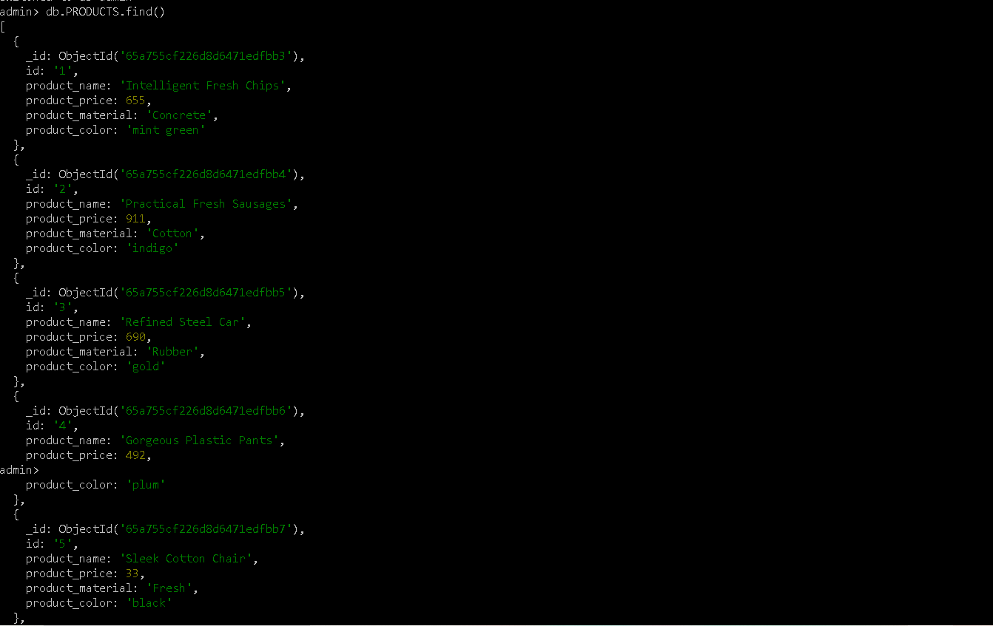

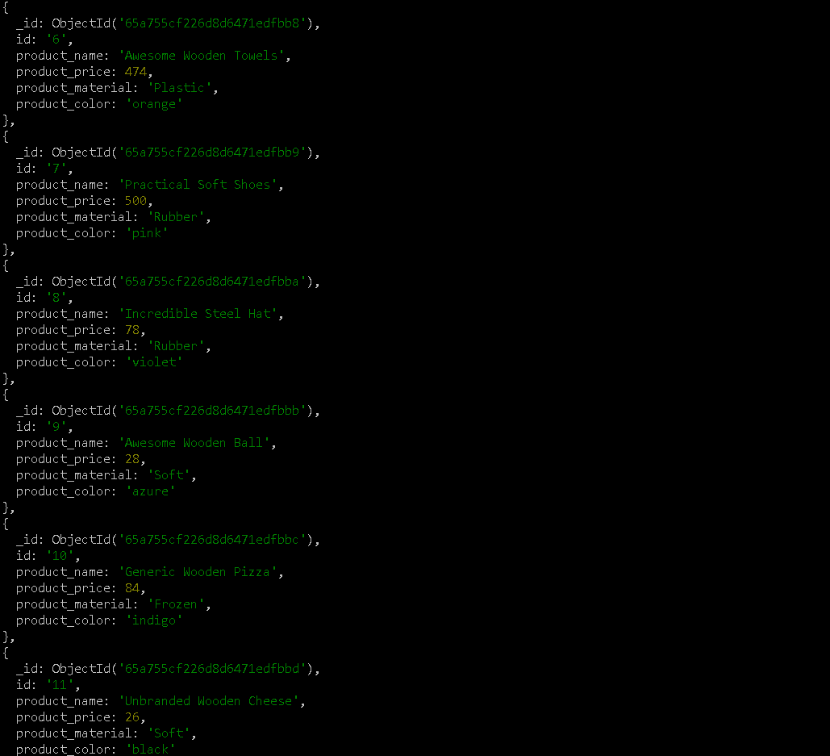

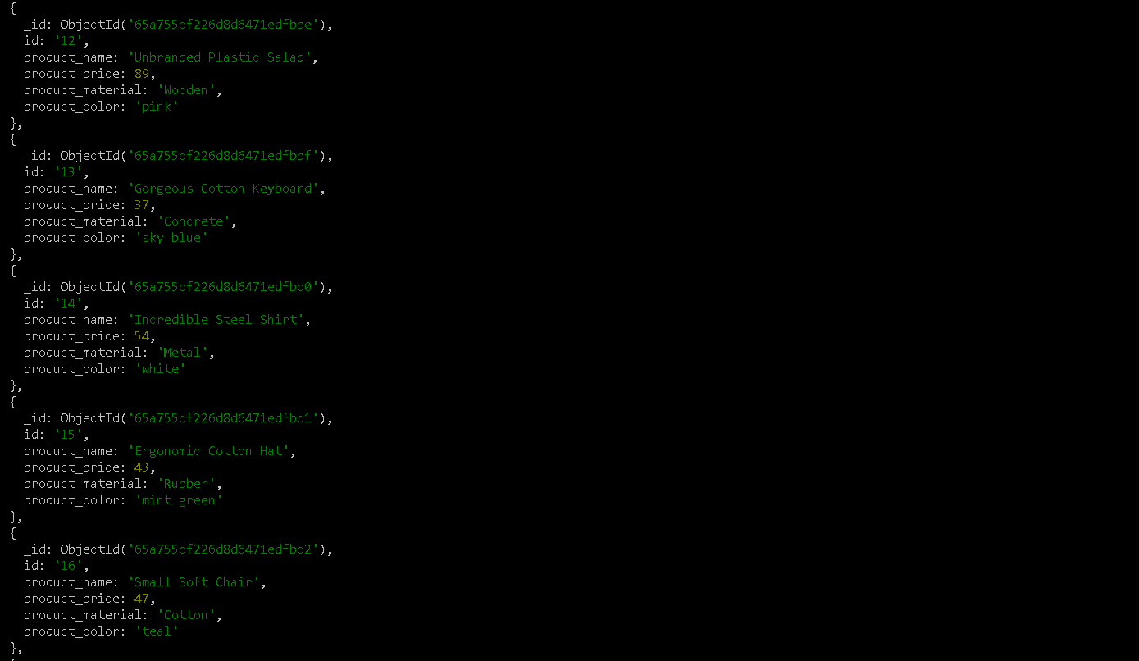

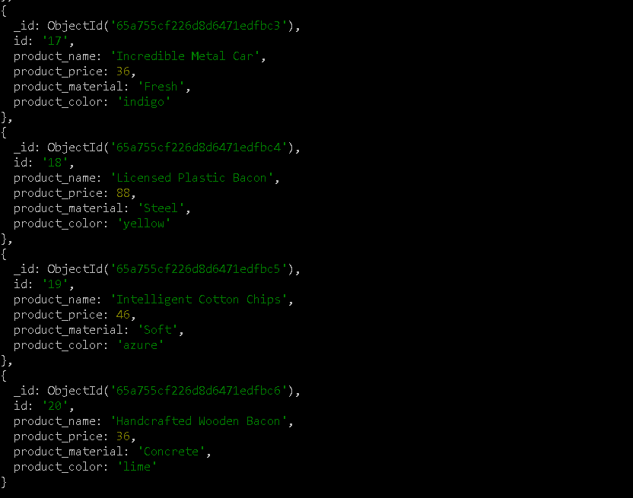

2.//find ,$gte,$lte function – to find product price b/n(400-800)

Db.products.find({product_price: {$gte:400, $lte:800 }})

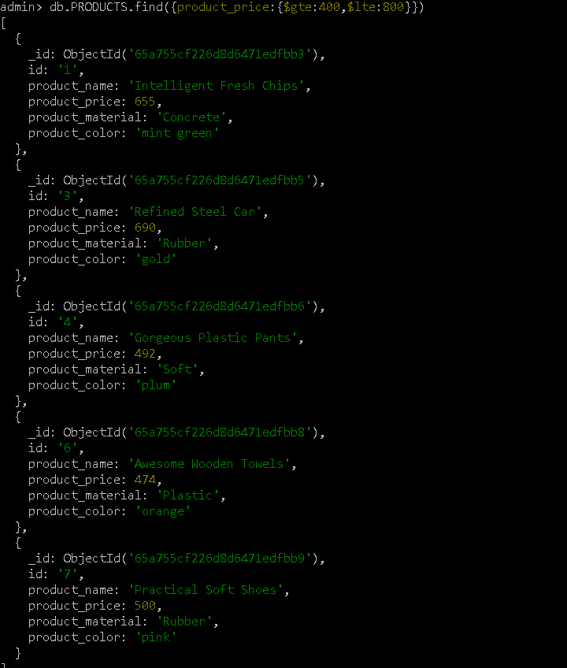

3.//find,$not,$gte,$lte function-to find price not between (400- 600)

Db.products.find({product_price:{$not:{$gte:400,$lte:600}}})

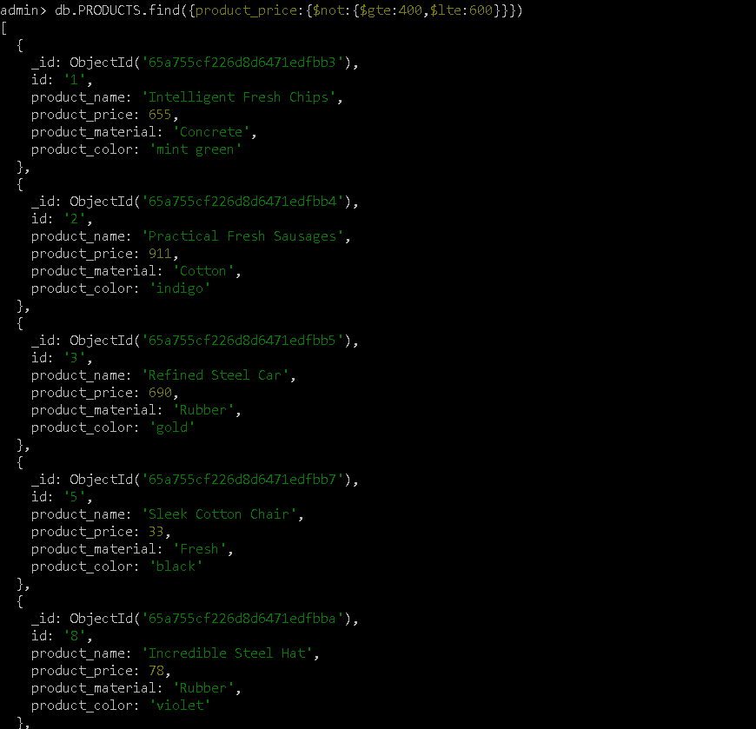

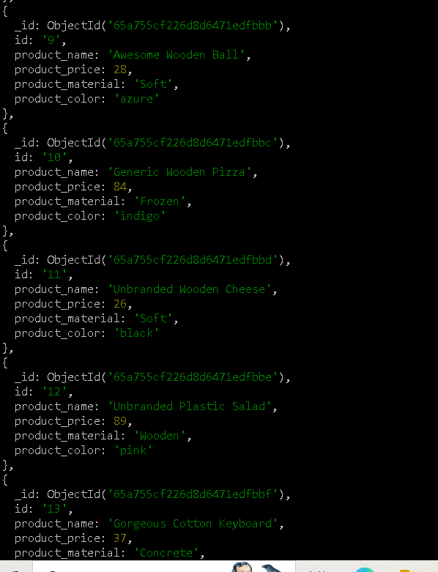

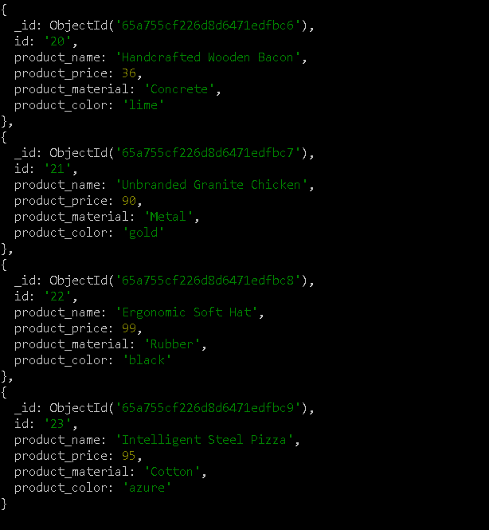

4.//using find ,$gt,limit func- to limit (4 products) greater than 500

Db.products.find({product_price:{$gt:500}}).limit(4)

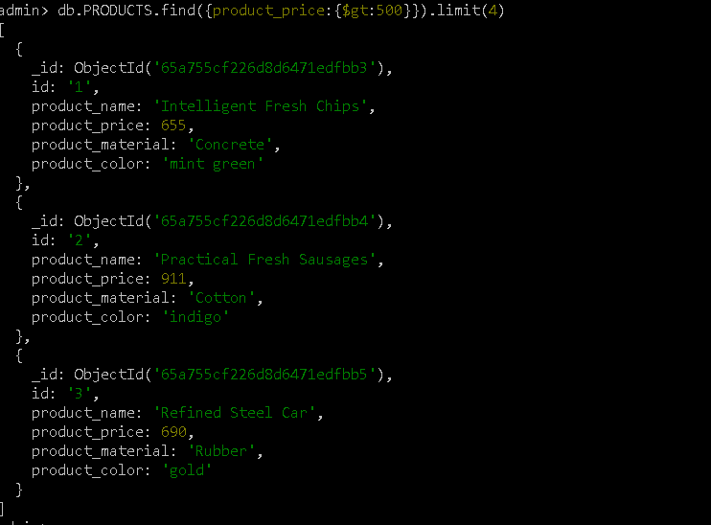

5.//find method to display product name and product material

Db.products.find({},{product_name:true,product_material:true} )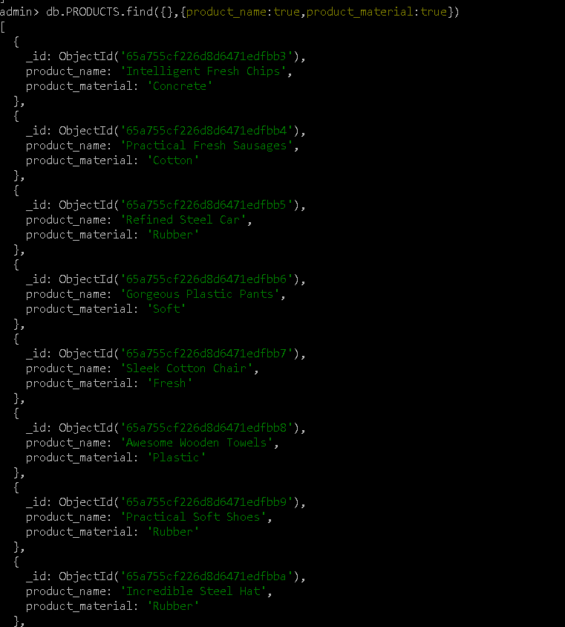

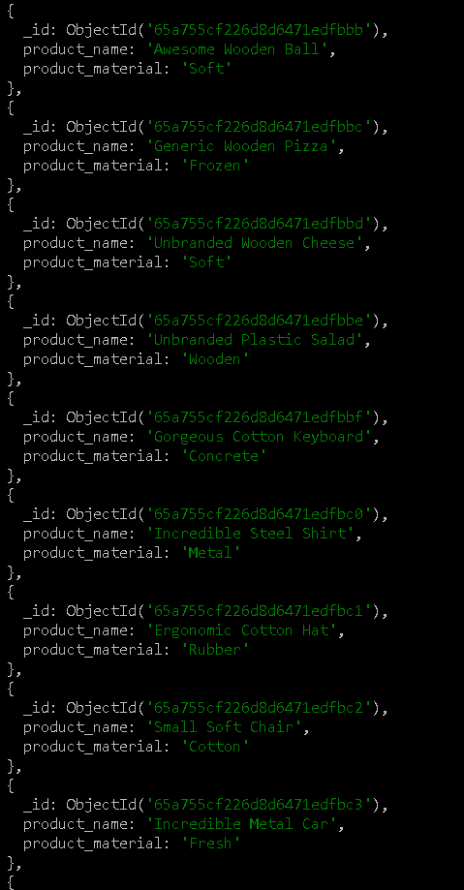

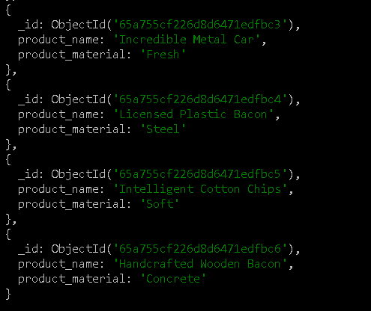

6.//find func-to find product id=10

Db.products.find({id:”10”})

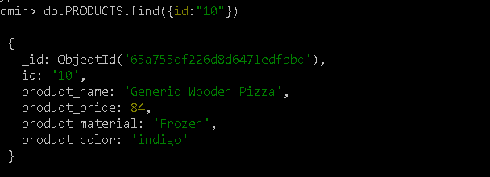

7.//find func-to find product_name and material

Db.products.find({},{product_name:true,product_material:true})





8.//find func-to find products contain soft material

Db.products.find({product_material:”soft”})

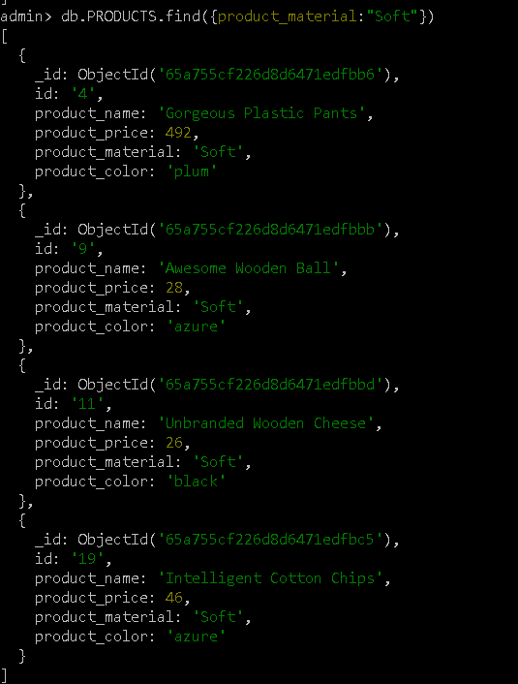

9.//find func-to find product color:indigo and price:492

Db.products.find({product_color:”indigo”,product_price=492})

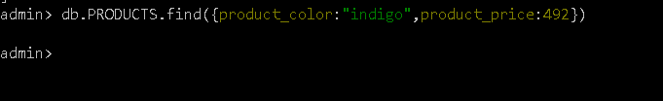

10//using dropdups -to delete product whose price is same

Db.products.ensureIndex({product_price:1},{unique:true,dropDups:true})

