ZEN database :

**Database**

**Tables**: Students

Mentors

Company

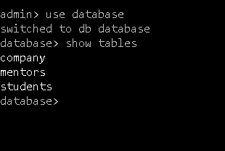

//Students table:

Db.students.insertMany([{field 1},{field 2},{field 3}… ])

Db.students.find()

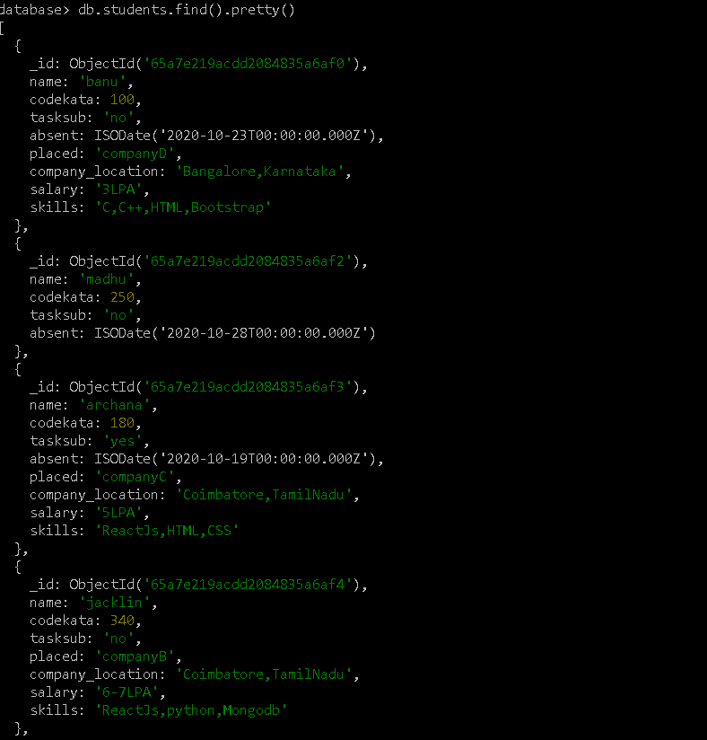

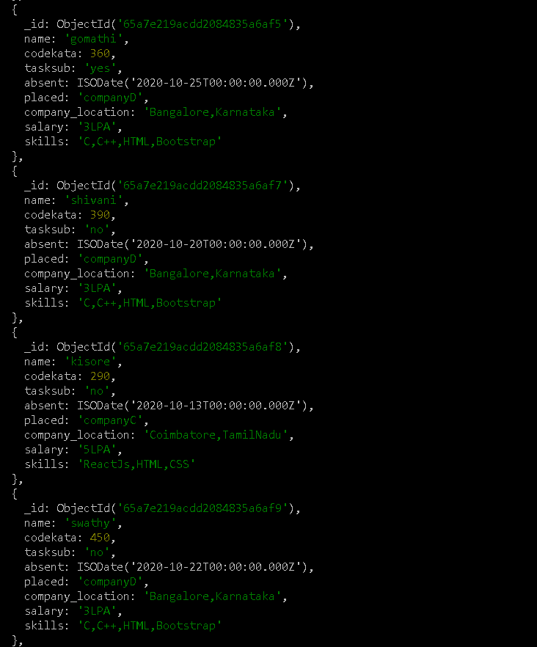

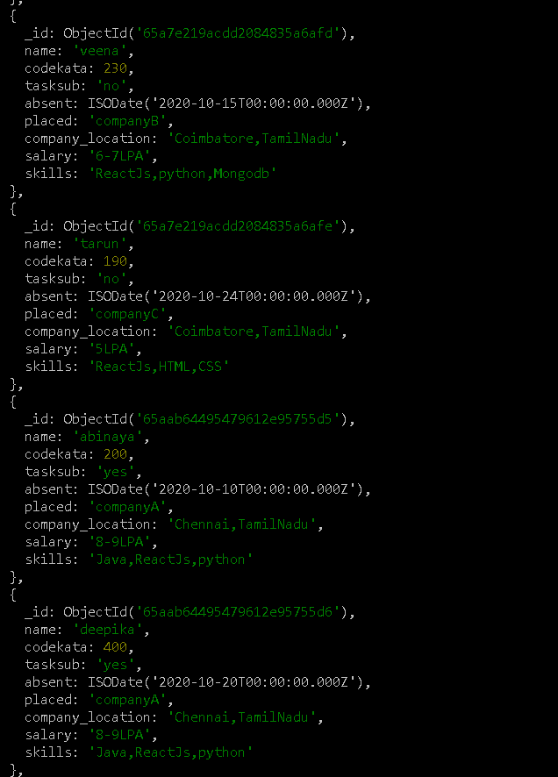

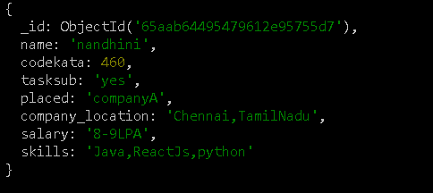

//Mentors table:

Db.mentors.insertMany([{field 1},{field 2},{field 3}… ])

Db.mentors.find().pretty()

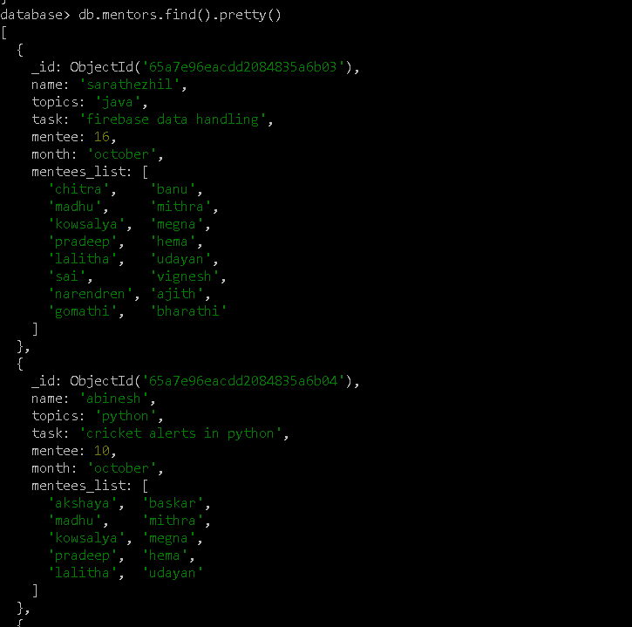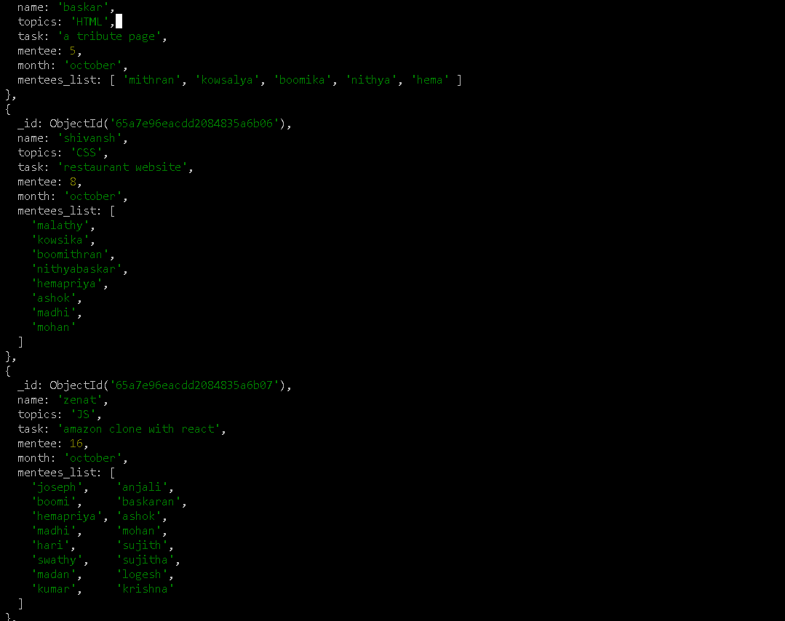

//Company table:

Db.company.insertMany([{field 1},{field 2},{field 3}… ])

Db.company.find().pretty()

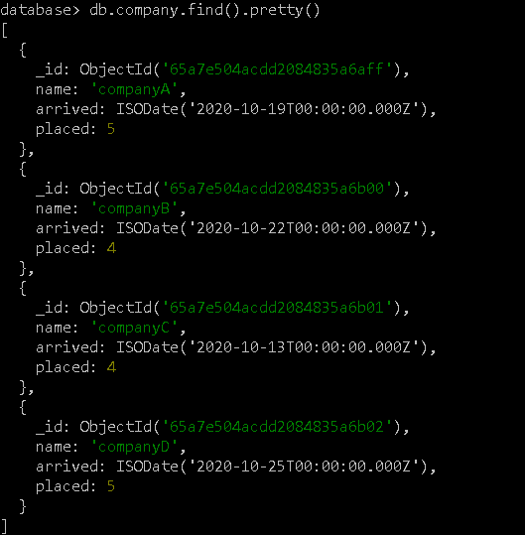

1.//using find –to find topics &task thought in october

Db.mentors.find({month:”October”},{topics:true,task:true})

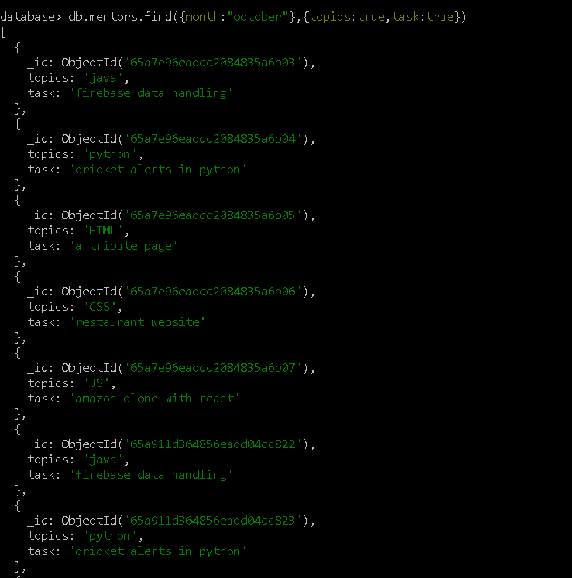

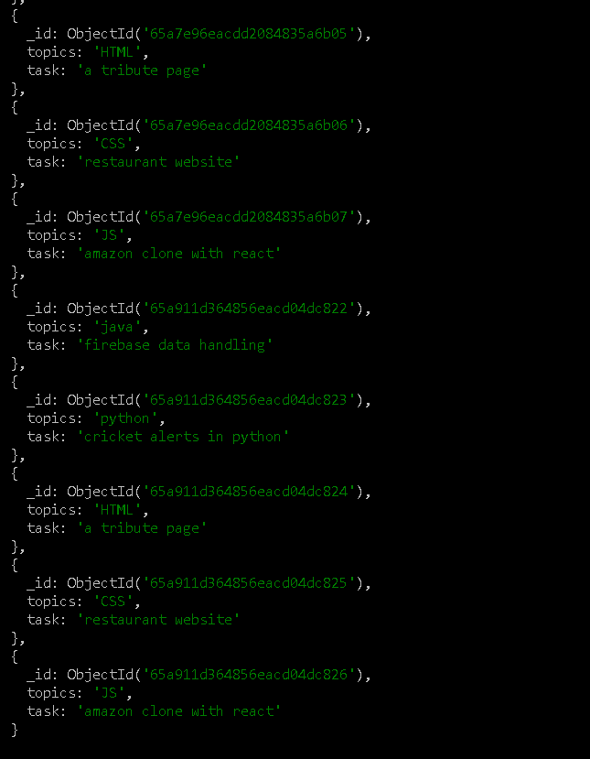

2.//using find –company drives appeared between 15 to 31 october

Db.company.find({arrived: {$gte: ISODate(“2020-10-15”),$lte: ISODate(“2020-10-31”)}},{name:true})

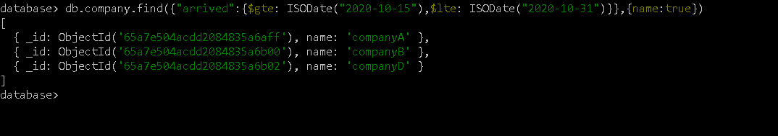

3.//using find,$exists function- to find company drives & students in placement.

Db.students.find({placed:{$exists:true}},{name:true,placed:true})

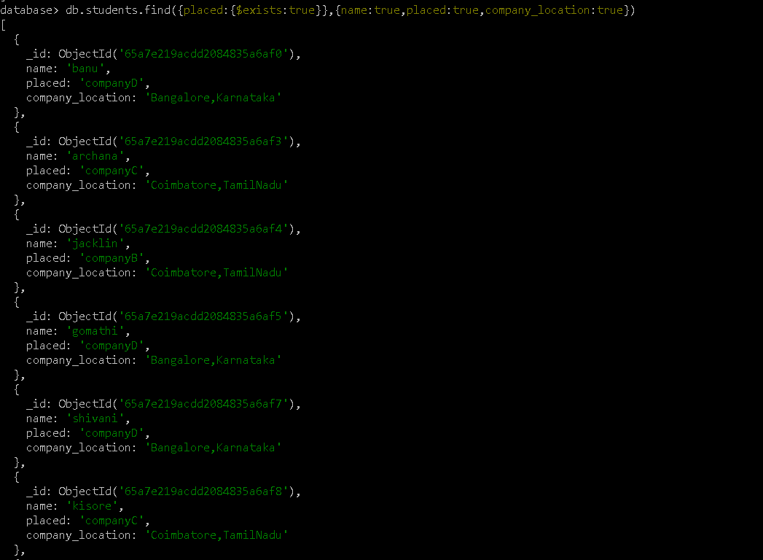

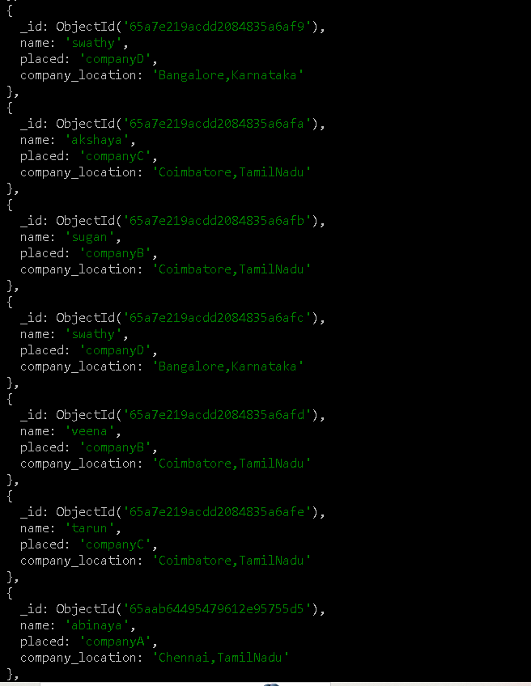

4.//using aggregate function & $sum- to find number of codekata solved

Db.students.aggregate([{$project:{ codekataTotal: {$sum: “$codekata” }}}])

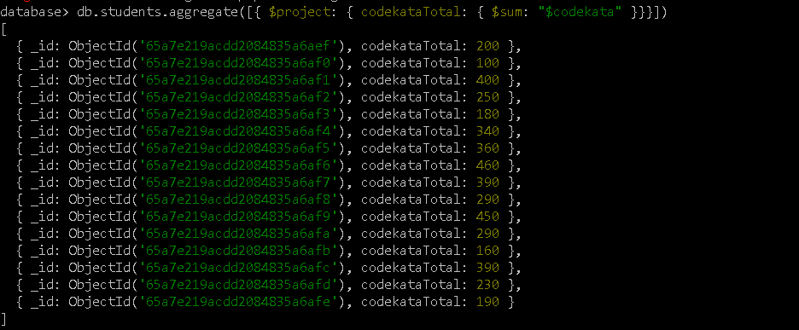

5.//using find & $gt –to find mentee count

Db.mentors.find({mentee:{$gt:15}})

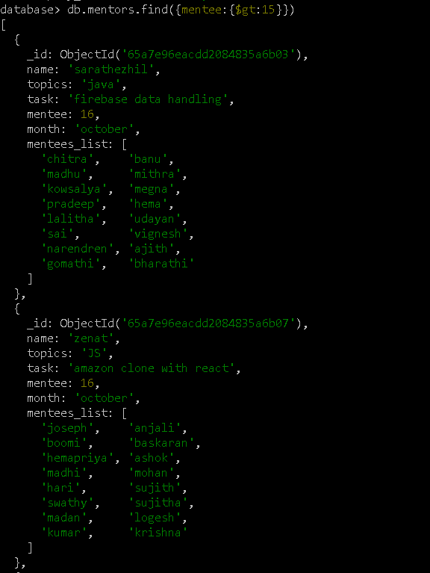

6.//using find, exists, gte, lte function - to find absentees and no task submission students

Db.students.find ({absent: {$exists: {$gte:ISODate(“2020-10-15”), $lte:ISODate(“2020-10-31” ) } },tasksub:”no”})

