//Database:Employees

//Table:Empl

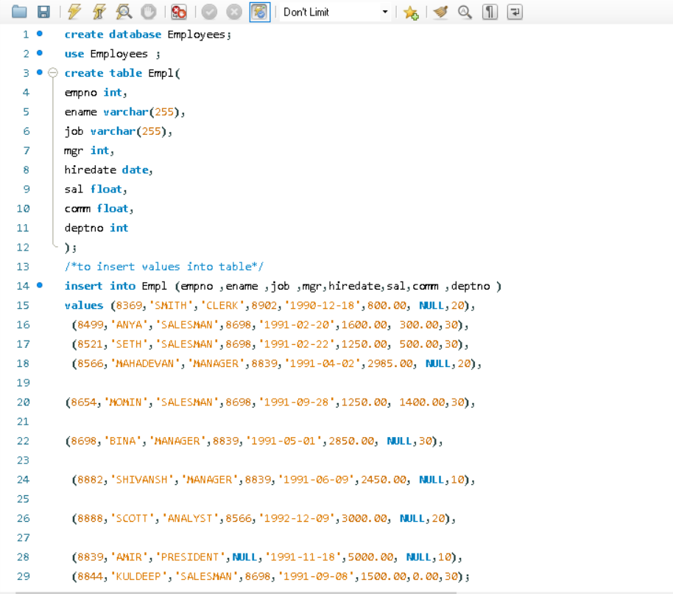

//Empl table

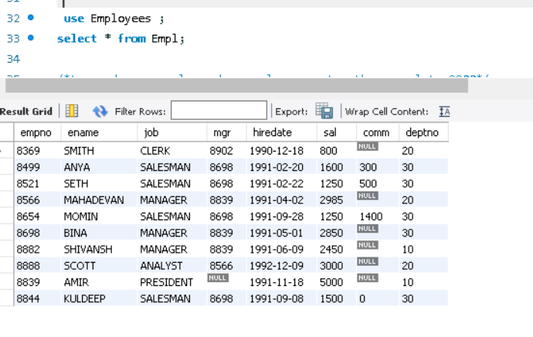

1. /*to read ename,salary where salary greater than equal to 2200*/

Select ename, sal from empl where sal not between 2500 and 4000; 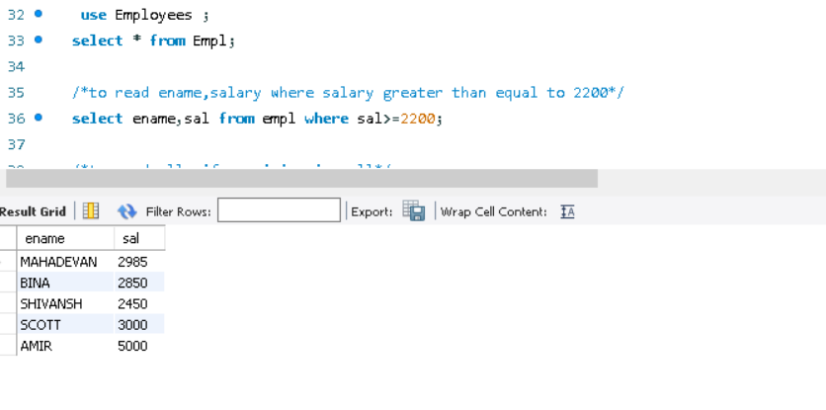 2. /*to read all ,if commision is null*/

Select * from empl where comm is null;

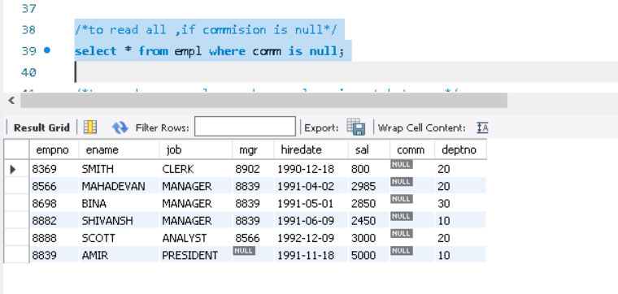

3. /*to read name ,salary ,whose salary is not between */

Select ename,sal from empl where sal not between 2500 and 4000;

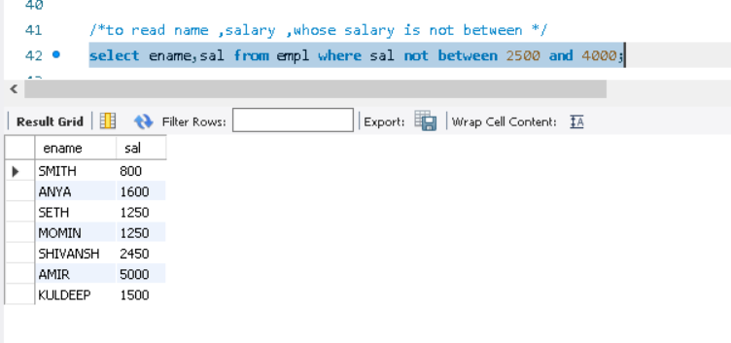

4. /*to read name,job,salary whose is not manager*/

Select ename,job,sal from empl where job !="manager";

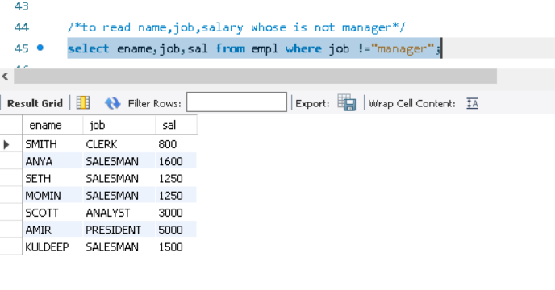

5. /*to read name whose 3rd letter in name is a */

Select ename from empl where ename like '__a%';

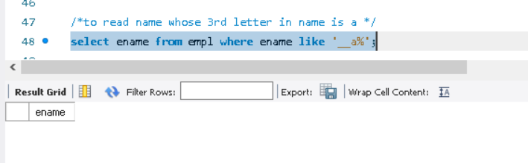

6. /*to read name whose last letter in name is t */

Select ename from empl where ename like '%t';

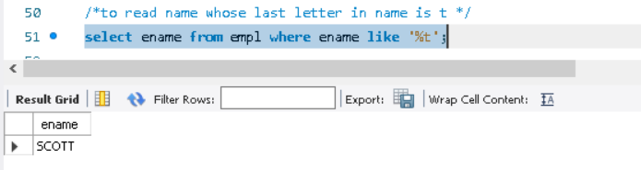

B. Program for jdbc connectivity with sql:

//Sql table:

