**GUVI-ZEN CLASS DB-MODEL**

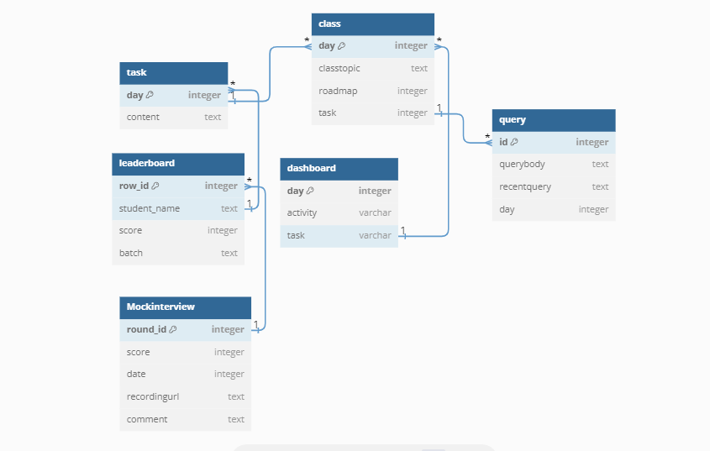

|  |
| --- |
| Class : |

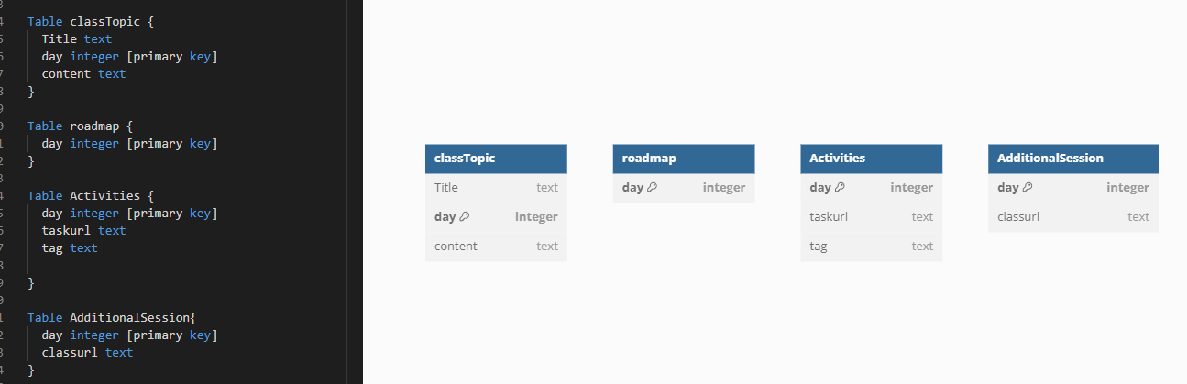

|  |
| --- |
| Dashboard: |

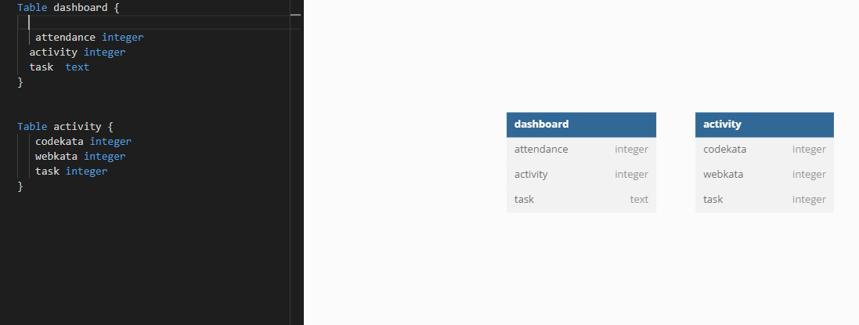

|  |
| --- |
| Queries: |

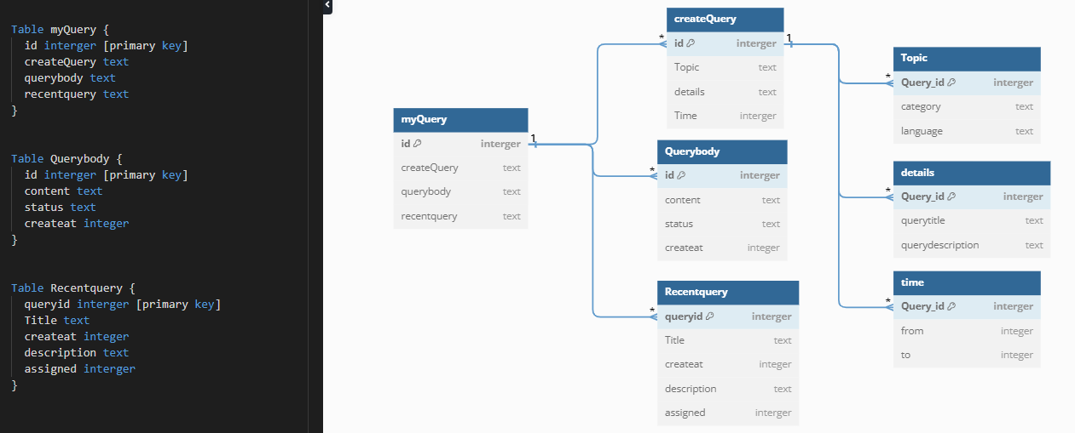

|  |
| --- |
| LeaderBoard |

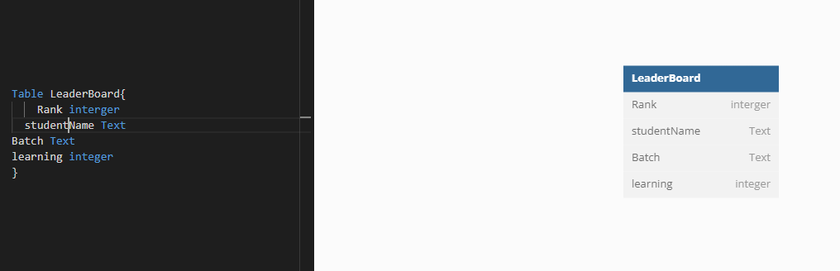

|  |
| --- |
| Syallabus: |

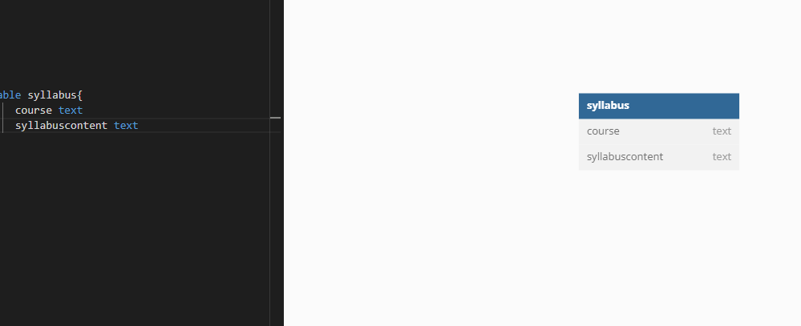

|  |
| --- |
| Requirement: |

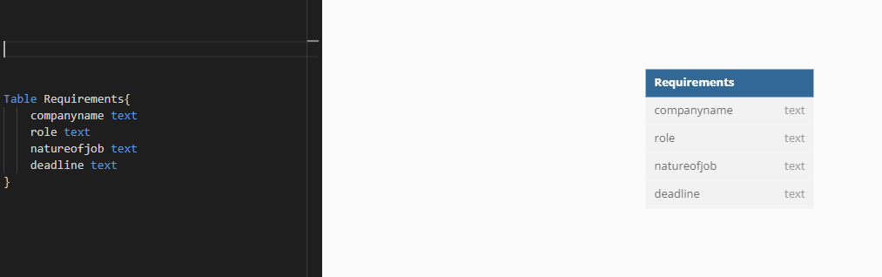

|  |
| --- |
| Interview |

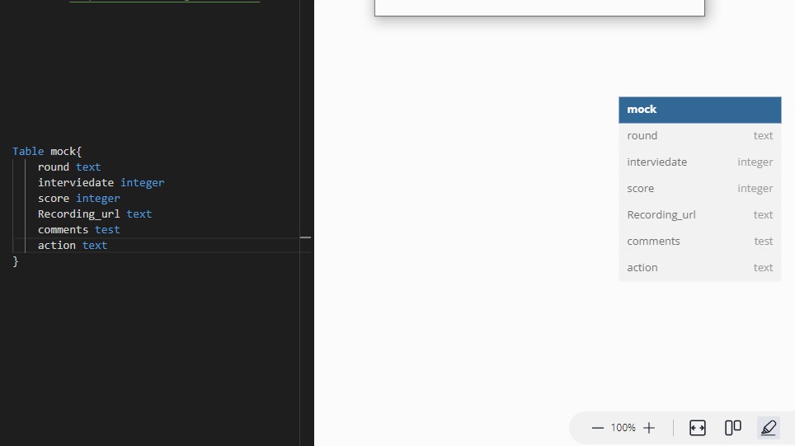

|  |
| --- |
| Portofolio Submission: |

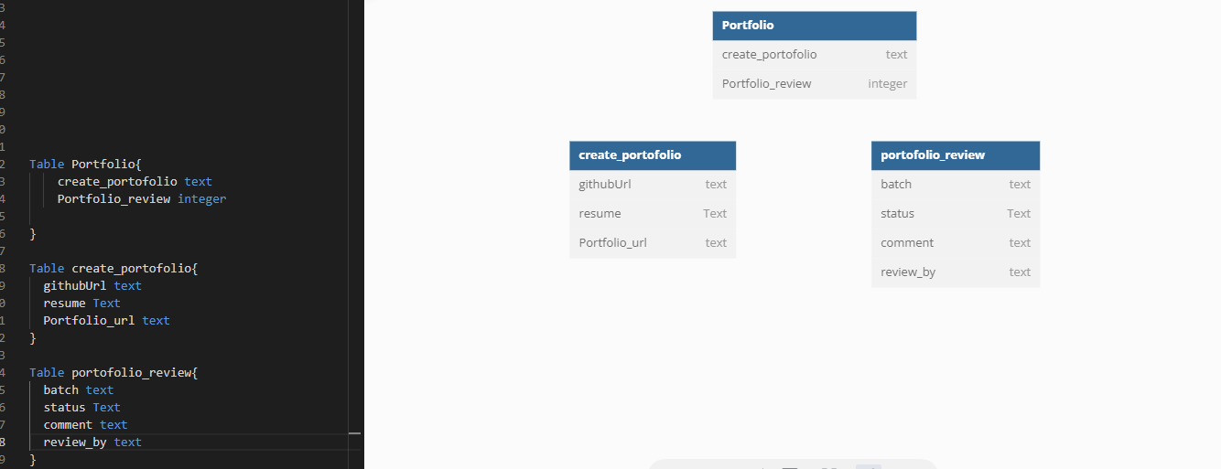

|  |
| --- |
| LeaveApplication: |

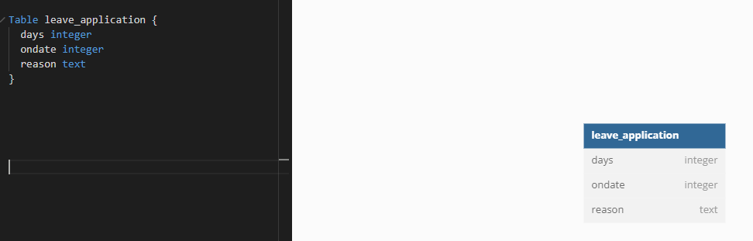

|  |
| --- |
| Placement: |

