**TASK 3**

Let obj1={name:”person1”,age:5};

Let obj2={age:5,name:”person1”};

let obj1={name:"person1",age:5};

let obj2={age:5,name:"person1"};

let key1=Object.keys(obj1).sort();

let key2=Object.keys(obj2).sort();

if(JSON.stringify(key1)===JSON.stringify(key2))

{

    console.log("It is Equal");

}

else{

    console.log("It is not Equal");

}

Output

It is equal

2.print countries flag in console:

<!DOCTYPE html>

<html lang="en">

    <head>

        <meta charset="utf-8">

        <meta name="viewport" content="width=device-width, initial-scale=1.0">

</head>

<body>

    <script>

let xhr = new XMLHttpRequest();

xhr.open("GET","https://restcountries.com/v3.1/all");

xhr.send();

xhr.onload=function(){

    let countryDetails=JSON.parse(xhr.responseText);

    console.log(countryDetails[i].flag);

};

        </script>

</body>

</html>

Output:

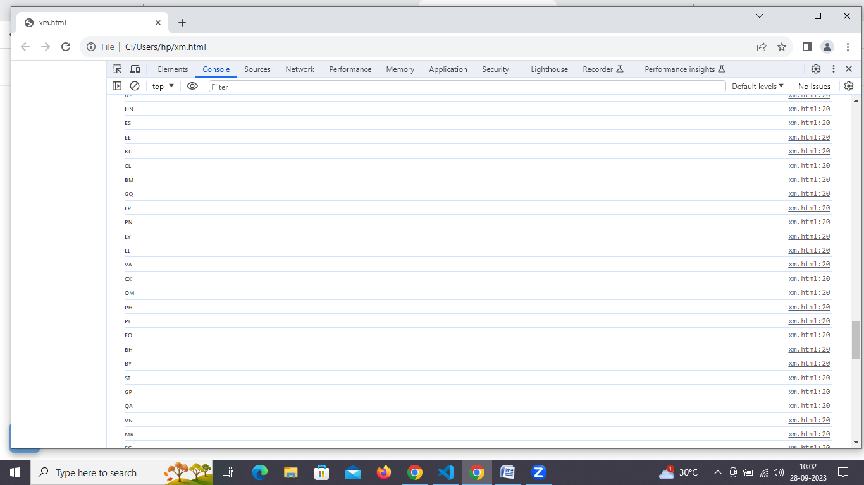

3.use the same rest countries and print all the region , name , subregion and population;

<!DOCTYPE html>

<html lang="en">

    <head>

        <meta charset="utf-8">

        <meta name="viewport" content="width=device-width, initial-scale=1.0">

</head>

<body>

    <script>

let xhr = new XMLHttpRequest();

xhr.open("GET","https://restcountries.com/v3.1/all");

xhr.send();

xhr.onload=function(){

    let countryDetails=JSON.parse(xhr.responseText);

for(i=0;i<countryDetails.length;i++) {

    console.log(countryDetails[i].flag,

    countryDetails[i].population,

    countryDetails[i].region,

    countryDetails[i].subregion,

    countryDetails[i].name.common

    );

}

};

        </script>

</body>

</html>

Output:

