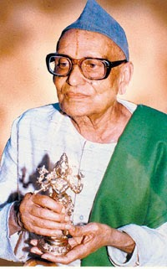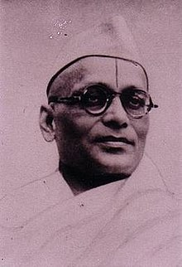

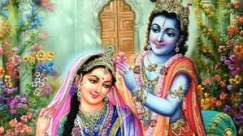





Name : Vishal. B.

Course : BCA 1st Year.

Subject : kannada.







Name : vinyas chandra.

Course : BCA 1st Year.

Subject : kannada.

