**Correlation**

1. Pair wise correlation matrix for all the variables (72, half are repetitive) :

RI Na Mg Al Si K

RI 1.0000000000 -0.19188538 -0.122274039 -0.40732603 -0.54205220 -0.289832711

Na -0.1918853790 1.00000000 -0.273731961 0.15679367 -0.06980881 -0.266086504

Mg -0.1222740393 -0.27373196 1.000000000 -0.48179851 -0.16592672 0.005395667

Al -0.4073260341 0.15679367 -0.481798509 1.00000000 -0.00552372 0.325958446

Si -0.5420521997 -0.06980881 -0.165926723 -0.00552372 1.00000000 -0.193330854

K -0.2898327111 -0.26608650 0.005395667 0.32595845 -0.19333085 1.000000000

Ca 0.8104026963 -0.27544249 -0.443750026 -0.25959201 -0.20873215 -0.317836155

Ba -0.0003860189 0.32660288 -0.492262118 0.47940390 -0.10215131 -0.042618059

Fe 0.1430096093 -0.24134641 0.083059529 -0.07440215 -0.09420073 -0.007719049

Ca Ba Fe

RI 0.8104027 -0.0003860189 0.143009609

Na -0.2754425 0.3266028795 -0.241346411

Mg -0.4437500 -0.4922621178 0.083059529

Al -0.2595920 0.4794039017 -0.074402151

Si -0.2087322 -0.1021513105 -0.094200731

K -0.3178362 -0.0426180594 -0.007719049

Ca 1.0000000 -0.1128409671 0.124968219

Ba -0.1128410 1.0000000000 -0.058691755

Fe 0.1249682 -0.0586917554 1.000000000

3.

**Null Hypothesis**: Correlation coefficient is equal to zero.

H0: r = 0

**Alternate Hypothesis**: population correlation coefficients significantly different from zero.

H1: r != 0

Significance level considered : 5%; i.e., P-value < .05 to reject H0

Confidence interval : 95%

Two sided interval

22 plots out of 36 plots were significantly different from 0.

Out of which, the ones with |correlation coefficient| > 4.5 are:

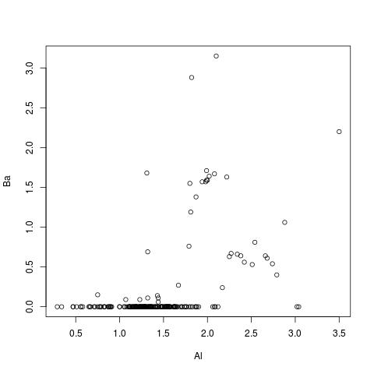

r = .479

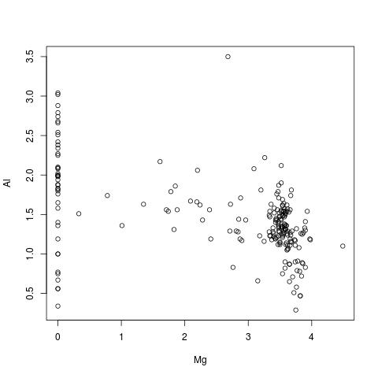

r = -.481

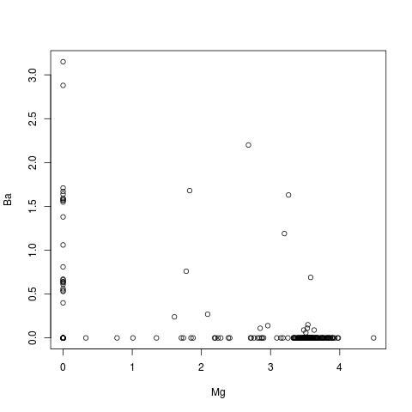

r = -.492

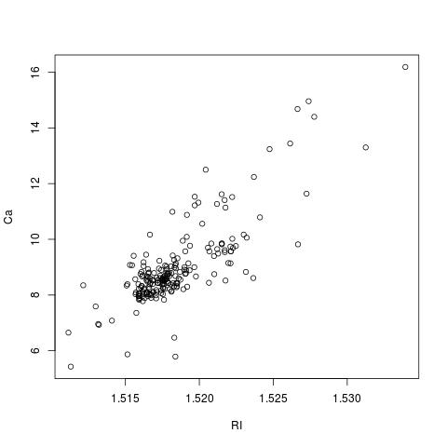

r = .81

**Results and observations:**

The plot with r = .81 shows linear association.

Other plots with a high correlation coefficient, and whose population correlation coefficients can be considered to be significantly different from zero do not seem to depict a linear association, hence results can be misleading.