- Import a CSV file containing monthly sales data for three food delivery apps (Zomato, Swiggy, Uber Eats) into Power BI and create a Waterfall chart to visualize the change in total orders from January to June.

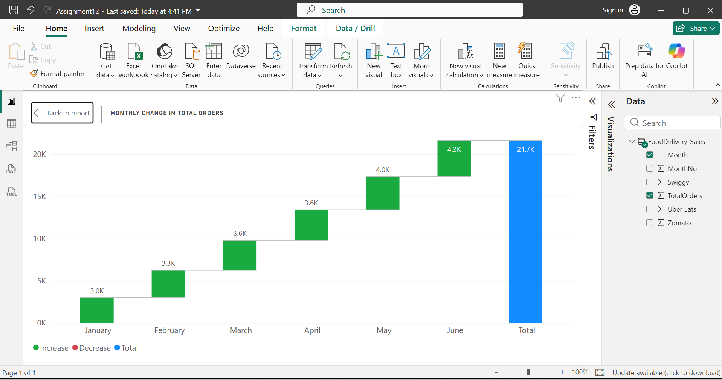
- Imported the FoodDelivery_Sales.csv dataset into Power BI Desktop. Created a Waterfall Chart by placing Month in the Category field and TotalOrders in the Y-axis (Values) field. The chart visualizes the month-to-month change in total food delivery orders from January to June, showing the overall increase in orders during the period.

- Using a dataset of user sign-ups for an IPL fantasy league app, build a Funnel chart in Power BI that shows the number of users at each stage: Visited App, Registered, Created Team, Joined League, Made Payment.

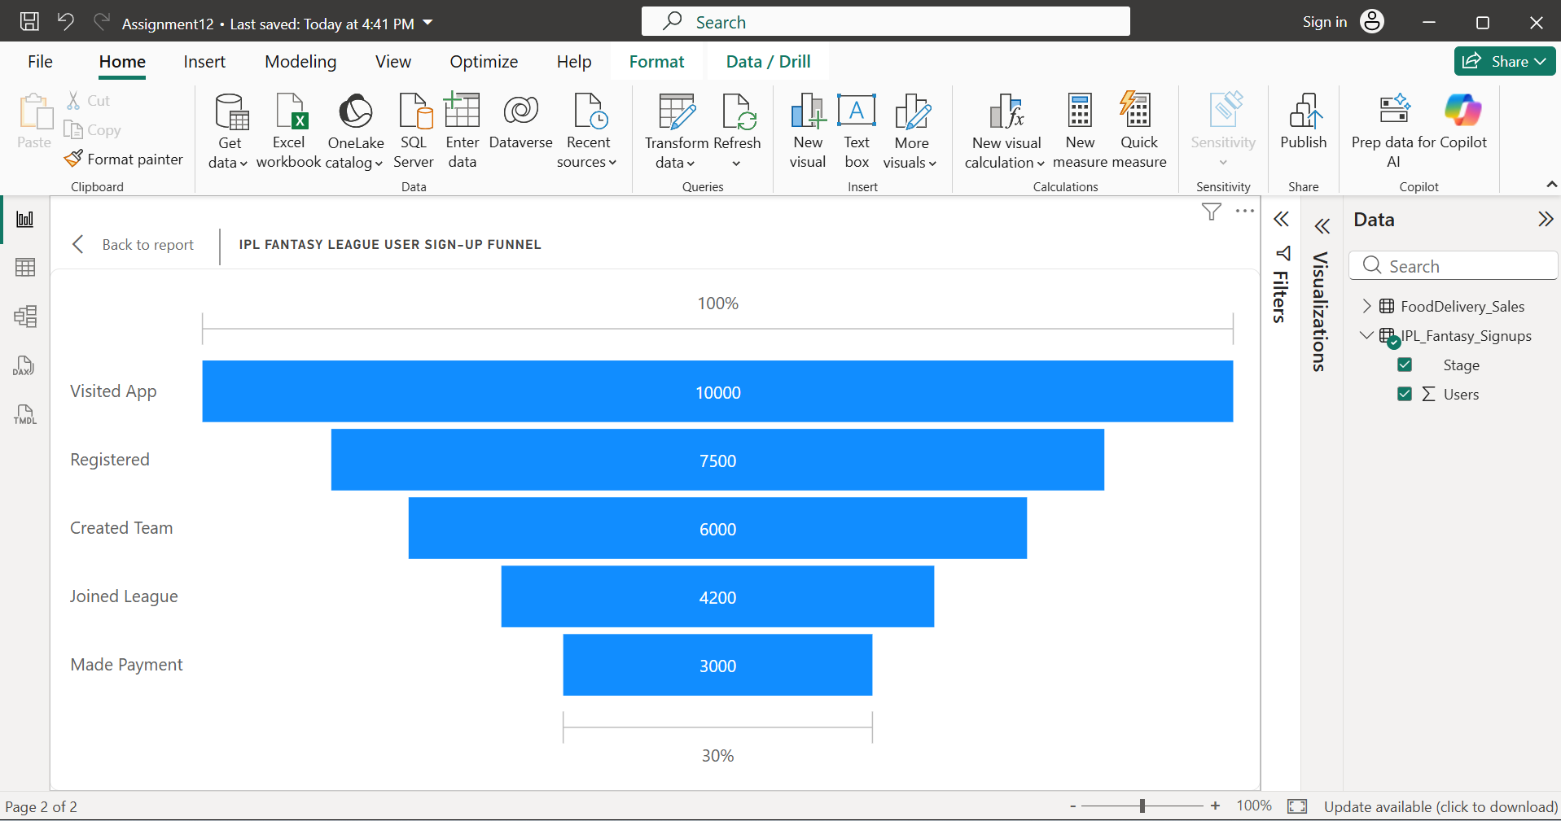
- Imported the IPL_Fantasy_Signups.csv dataset into Power BI Desktop. Created a Funnel Chart by placing Stage in the Category field and Users in the Values field. Added the title "IPL Fantasy League User Sign-up Funnel". The chart visualizes the number of users at each stage of the sign-up process, from Visited App to Made Payment, making it easy to identify where users drop off.

- Download a sample dataset with city-wise Flipkart order volumes across India and create a Map visual in Power BI to display which cities have the highest and lowest order counts.<br><br><em><strong>Hint:</strong> Use the city names as the location field and order volume as the size/color field in the Map visual.</em>

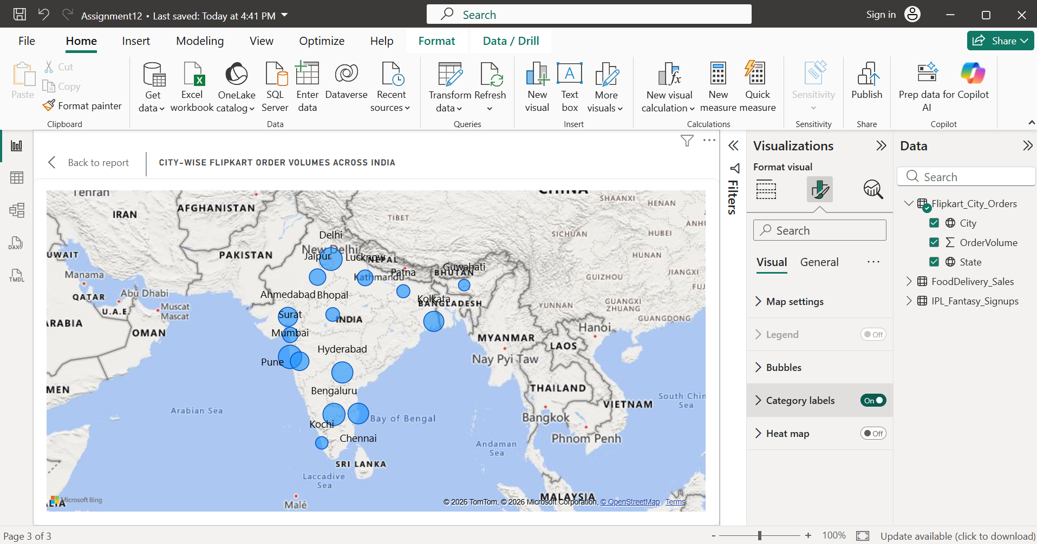
- Imported the Flipkart_City_Orders.csv dataset into Power BI Desktop. Created a Map visual by placing City in the Location field and OrderVolume in the Size field. Added State to improve map accuracy. The map displays the distribution of Flipkart order volumes across Indian cities, where larger bubbles represent higher order counts and smaller bubbles represent lower order counts.

- Given a dataset of movies released in 2023 with their genres and box office collections, create a TreeMap in Power BI to show collections by genre, and within each genre, by individual movie.

- Imported the Movies_2023_BoxOffice.csv dataset into Power BI Desktop. Created a TreeMap by placing Genre in the Category field, Movie in the Details field, and BoxOfficeCollection (₹ Crore) in the Values field. The TreeMap displays the total box office collections by genre, with individual movies shown as nested rectangles within each genre.
- It’s shown in the screenshot on next page:
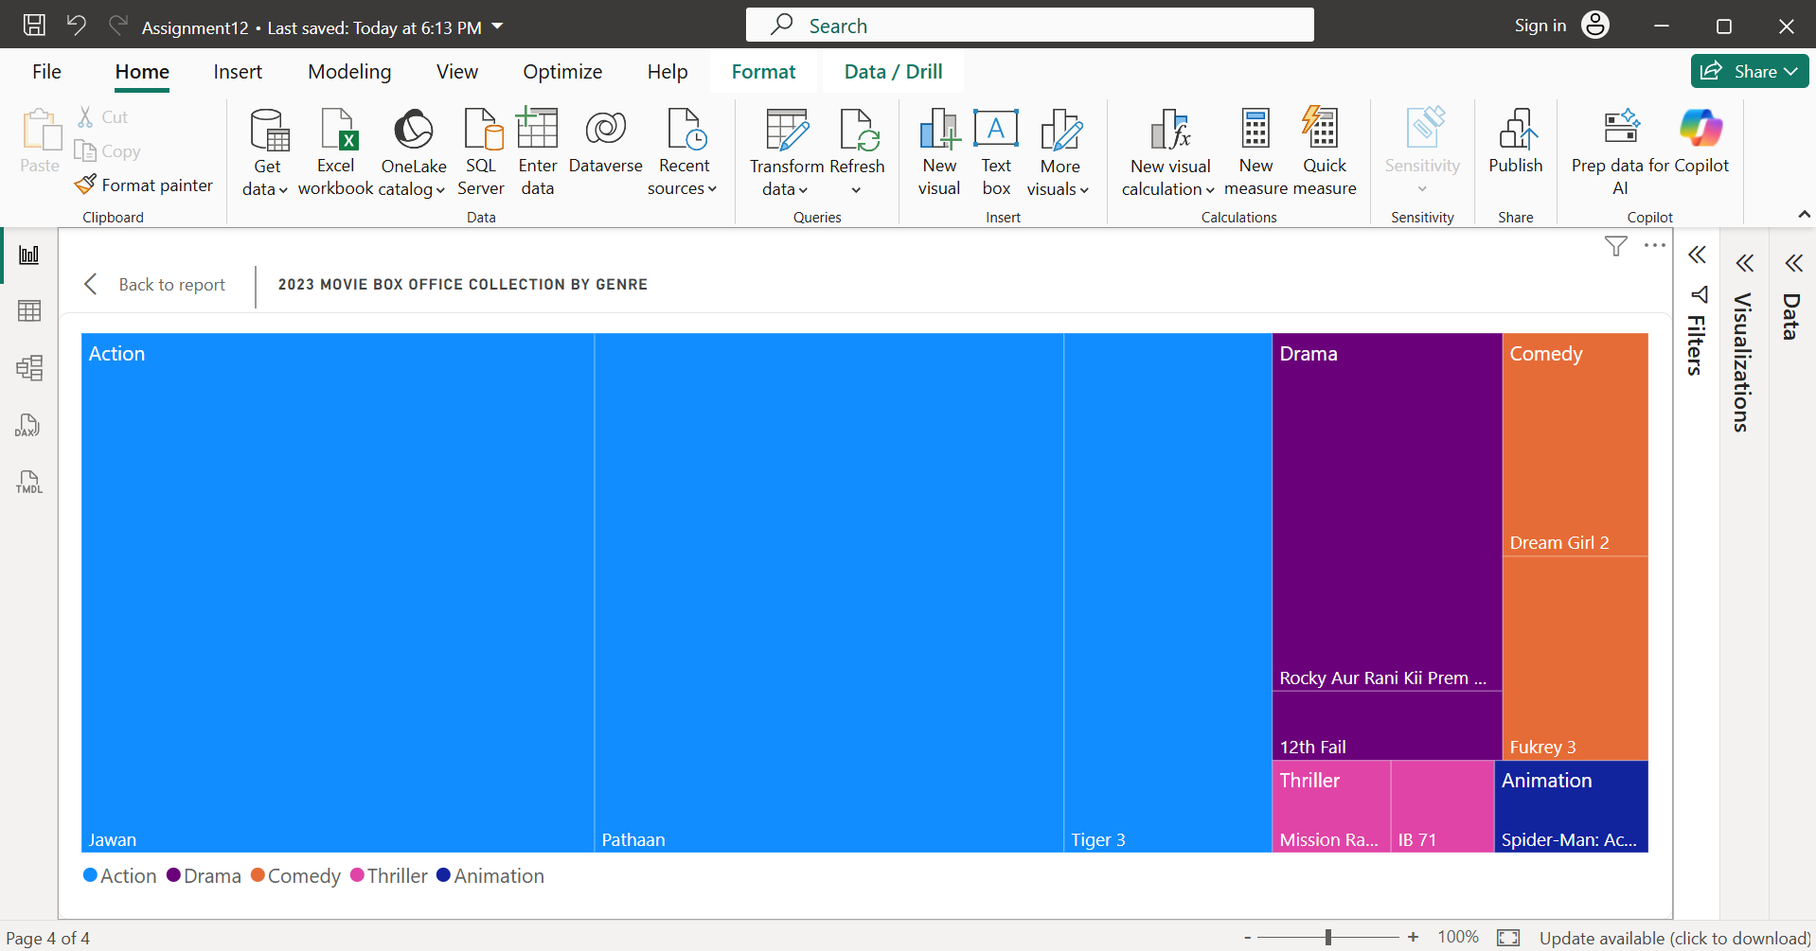

- Use Power BI's Scatter Chart visual to plot the relationship between average daily active users and average session duration for 10 popular Indian apps (e.g., Instagram, WhatsApp, Zomato, Flipkart). Identify any outliers and explain what they might mean.<br><br><em><strong>Constraint:</strong> Add data labels for at least two points you consider outliers.</em>

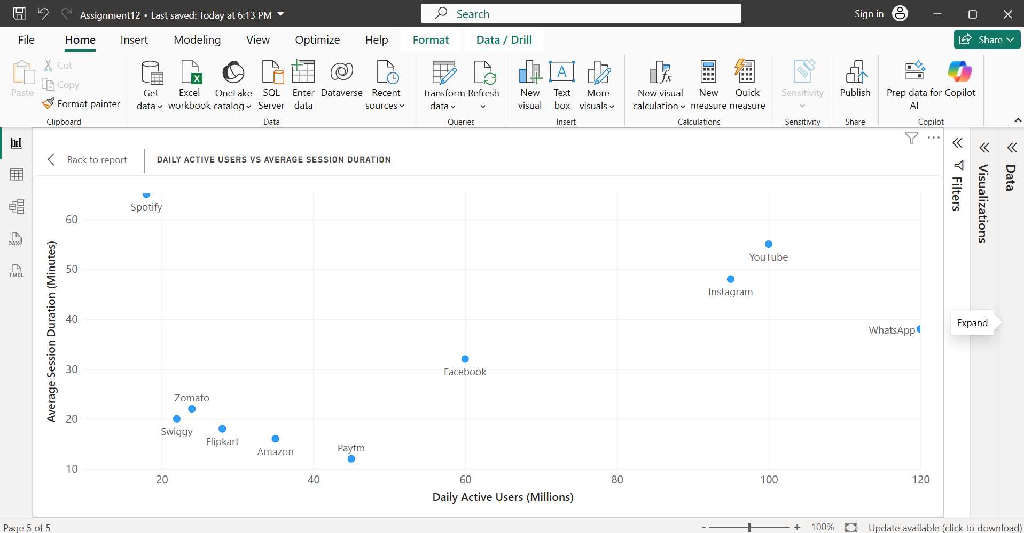
- Two clear outliers are:
  - Spotify
    - Daily Active Users: 18 million (low)
    - Average Session Duration: 65 minutes (very high)
    - Meaning: Although fewer people use Spotify compared to other apps, users spend much more time listening to music.
  - Paytm
    - Daily Active Users: 45 million
    - Average Session Duration: 12 minutes (very low)
    - Meaning: Users open Paytm mainly to complete quick transactions such as payments or recharges, so sessions are short.
- Imported the Indian_Apps_Usage.csv dataset into Power BI Desktop. Created a Scatter Chart by placing DailyActiveUsers (Millions) on the X-axis, AvgSessionDuration (Minutes) on the Y-axis, and App in the Values field. Enabled Category Labels. Spotify is an outlier because it has low daily active users but a very high average session duration, while Paytm has moderate daily active users but a very short average session duration, indicating quick user interactions.

