- Open a Power BI report with sales data and apply a Visual Level Filter to a bar chart so that it only displays products with sales greater than 500 units.

- A Visual Level Filter affects only the selected visual. In this example, applying the filter Sales Units > 500 ensures that the bar chart displays only products with sales greater than 500 units, while leaving other visuals on the report unchanged.
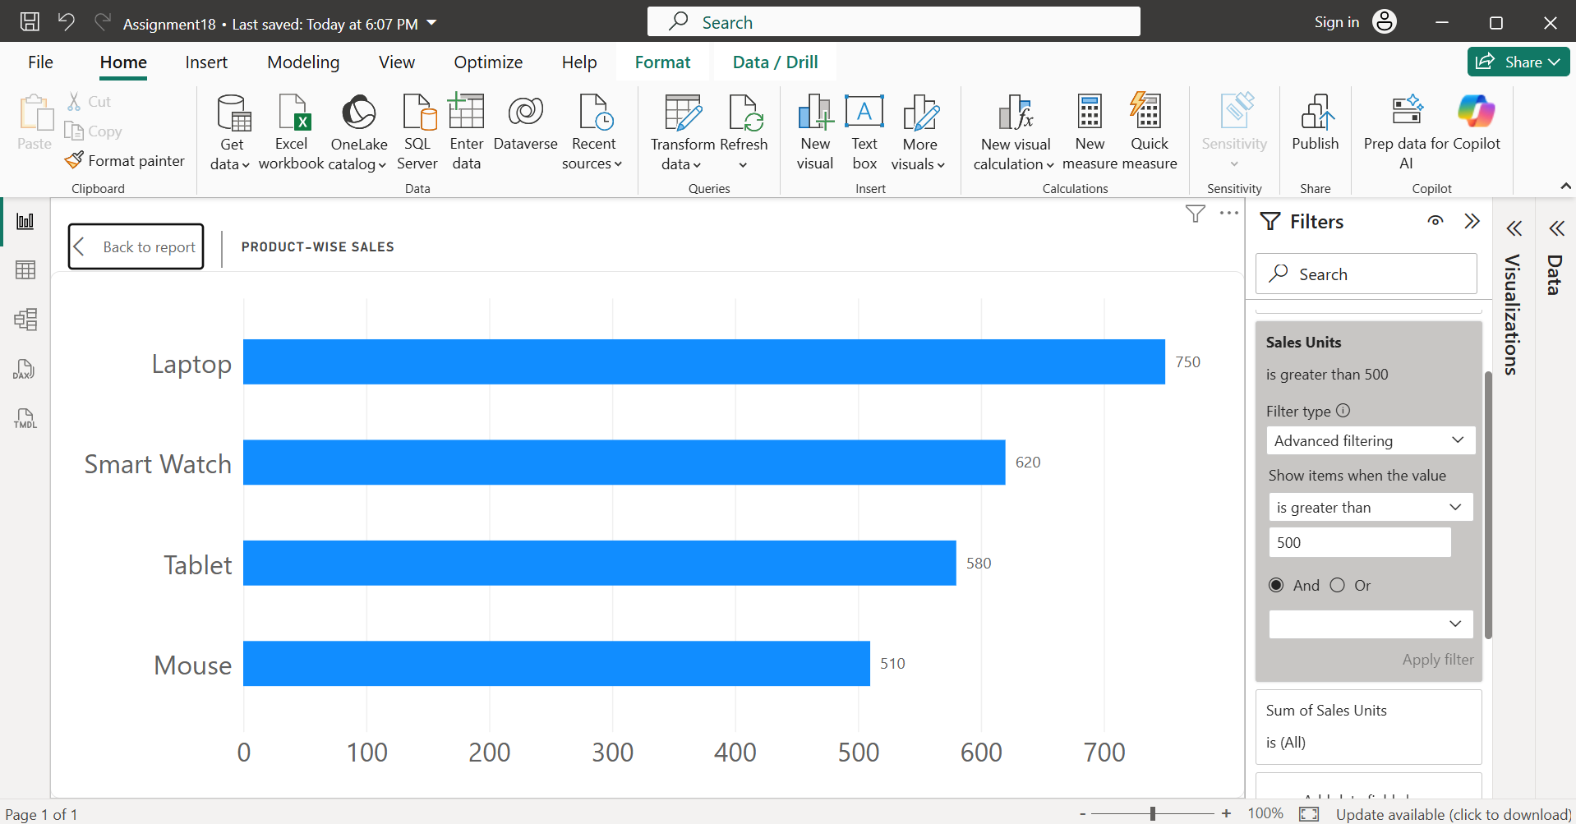
- Created a Bar Chart using Product and Sales Units.
- Then selected the bar chart, in the Filters pane, under Filters on this visual, added Sales Units.
- Set the filter condition to "is greater than 500."
- Applied the filter.
- Expected Output: The bar chart displays only the products with Sales Units greater than 500.

- Add a Page Level Filter to your dashboard that allows users to view only transactions from the city 'Ahmedabad' across all visuals on the current page.

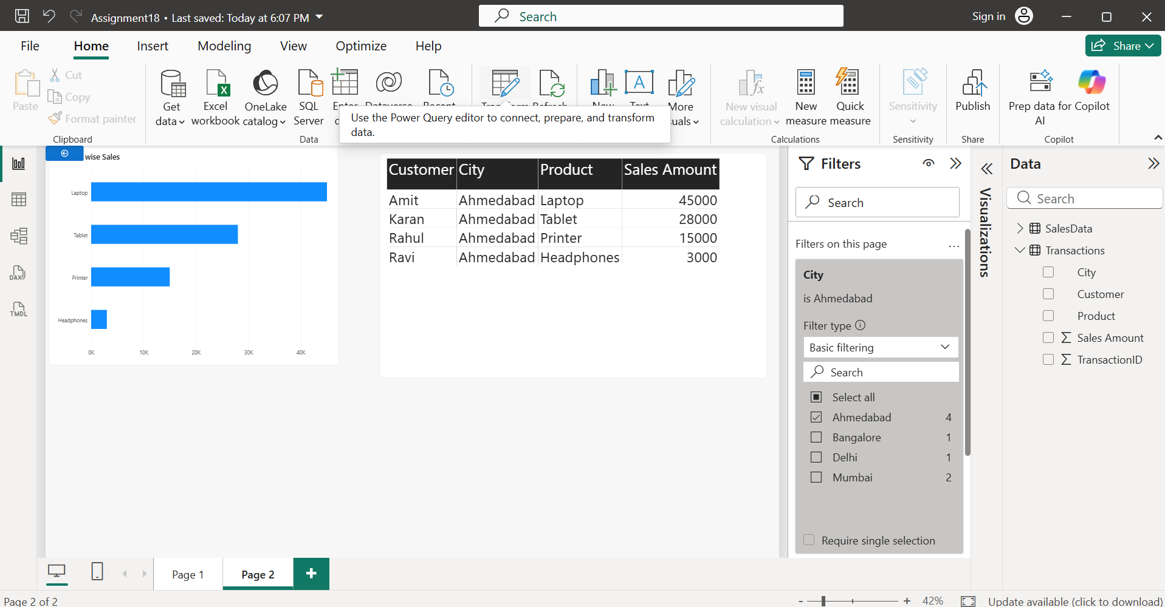
- A Page Level Filter applies the selected filter condition to every visual on the current report page. In this example, filtering the City field to Ahmedabad ensures that all charts, tables, and cards on the page display only Ahmedabad transactions, while other report pages remain unaffected.
- Created the bar chart and table visuals using the Transactions dataset.
- Clicked on an empty area of the report page.
- In the Filters pane, dragged the City field into Filters on this page.
- Selected only Ahmedabad from the list of cities.
- As a result, all visuals on the current page displayed only Ahmedabad transactions.
- Expected Output: Only transactions from Ahmedabad are displayed across all visuals on the current page.

- Insert a Slicer for 'Payment Method' (e.g., UPI, Card, Cash) and sync this slicer across two pages in your Power BI report so that the selected payment method filters both pages.

- A Slicer allows users to interactively filter report data. By using the Sync slicers feature, the same slicer selection is applied across multiple report pages. In this example, selecting a payment method such as UPI, Card, or Cash filters the visuals on both pages, providing a consistent filtering experience throughout the report.
- Create two report pages.
- Add a Slicer and drag the Payment Method field into it.
- Go to View -> Sync slicers.
- Enable Sync for both report pages.
- Select a payment method (e.g., Card).
- Expected Output: When Card is selected, both pages display only transactions done using Card.
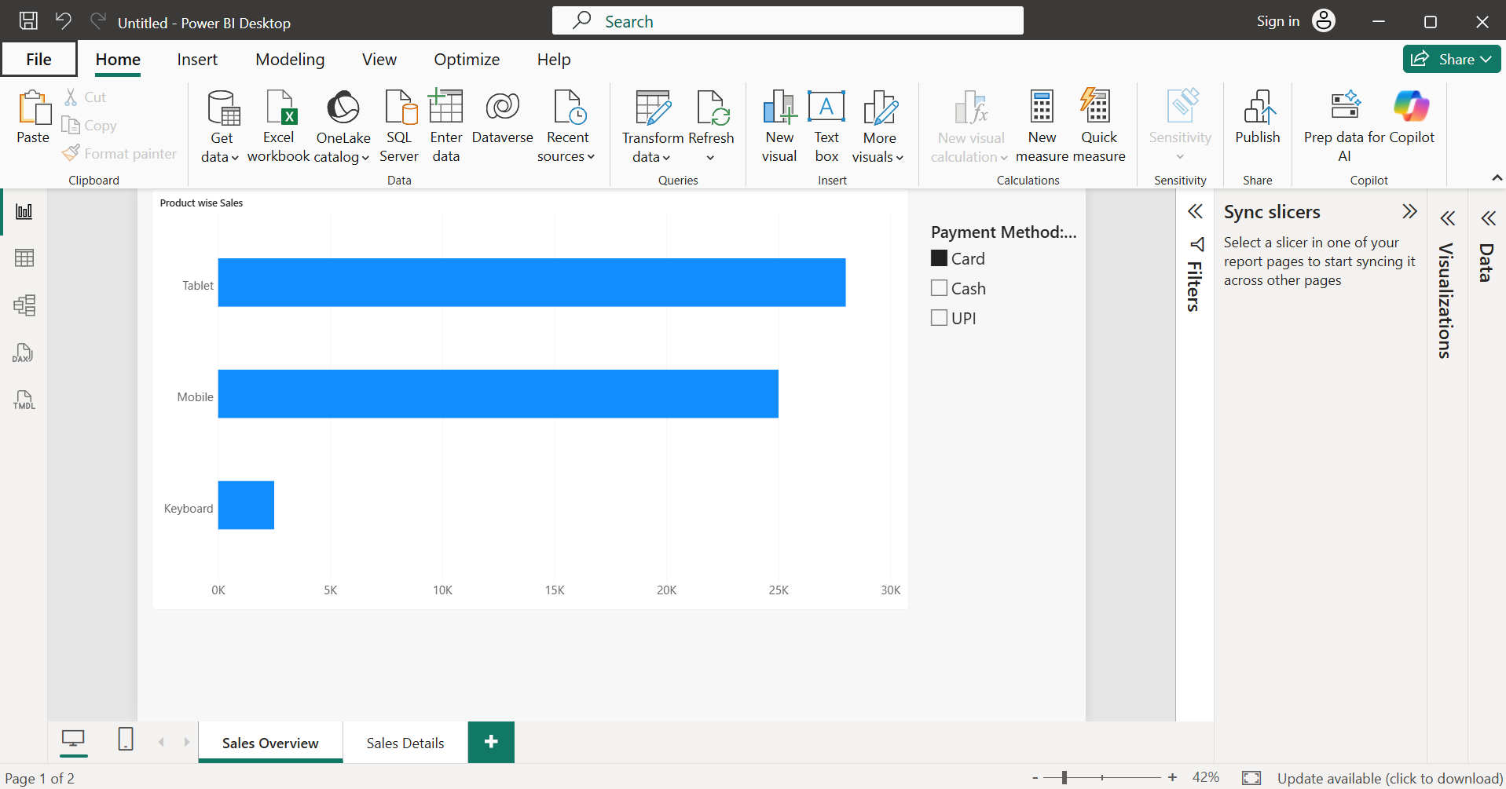
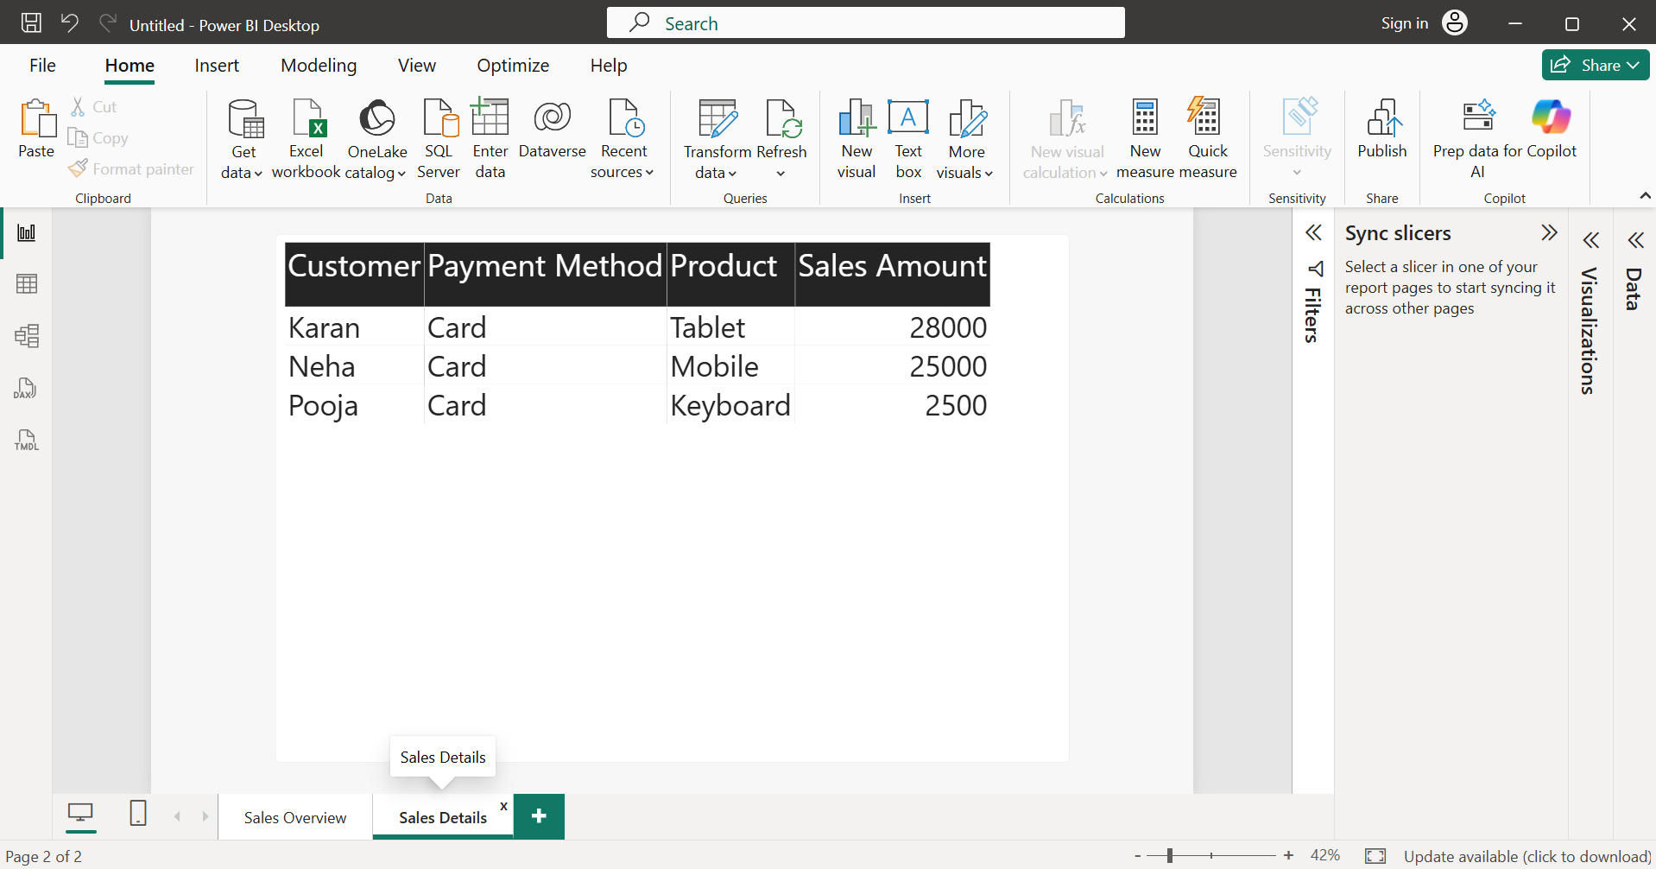
- This demonstrates how a synchronized slicer filters data consistently across multiple pages in a Power BI report.

- Create a navigation button using Bookmarks and Buttons in Power BI that lets users jump from the 'Overview' page to a 'Top Customers' page and back, updating the view accordingly.<br><br><em><strong>Hint:</strong> Use the 'Add Bookmark' and 'Action' features to set up the navigation.</em>

- Bookmarks save the current report view, and buttons can trigger those bookmarks. By assigning bookmarks to buttons, users can easily navigate between the Overview and Top Customers pages, making the report more interactive and user-friendly.
- Create two report pages: Overview and Top Customers.
- Go to View -> Bookmarks and create two bookmarks:
- Overview
- Top Customers
- Insert a button on the Overview page.
- Enable Action for the button.
- Set Type = Bookmark and select the Top Customers bookmark.
- Insert another button on the Top Customers page.
- Enable Action and set Type = Bookmark with the Overview bookmark.
- Expected Output:
  - Clicking Go to Top Customers opens the Top Customers page.
  - Clicking Back to Overview returns to the Overview page.
  - The report provides smooth navigation between the two pages using Bookmarks and Buttons.
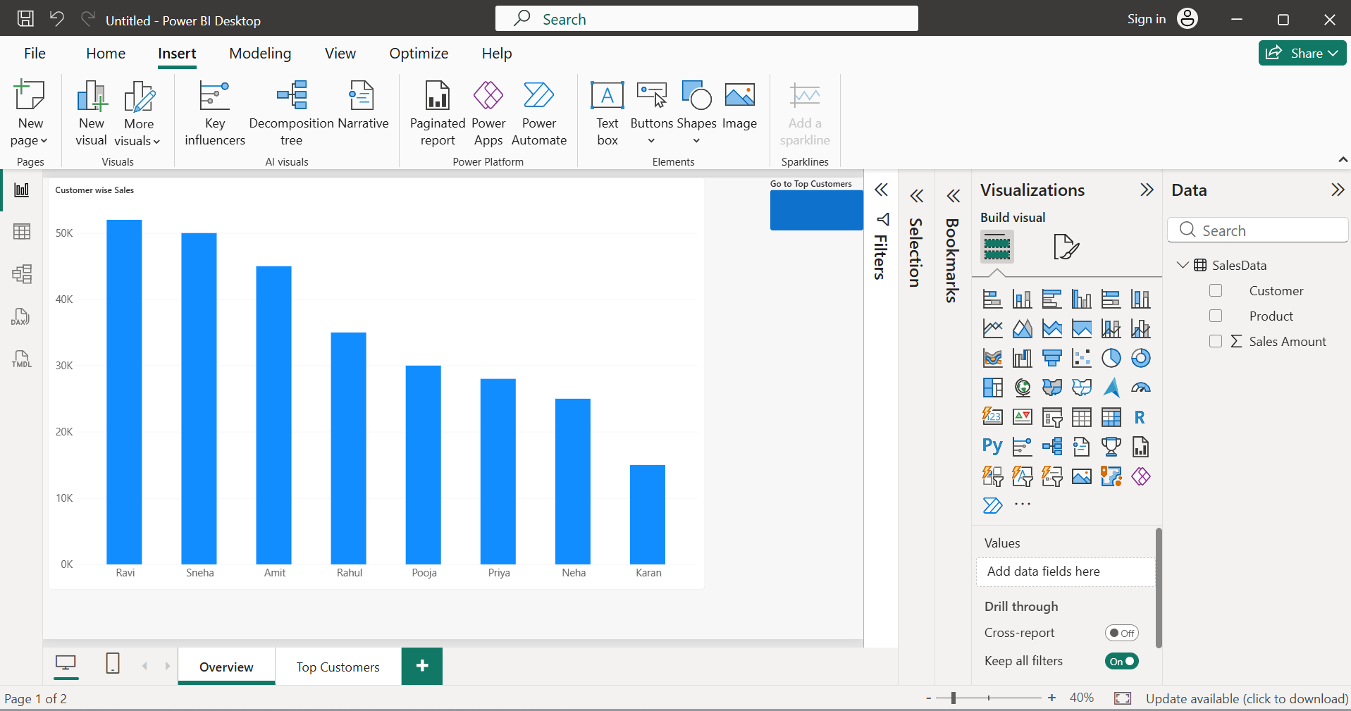
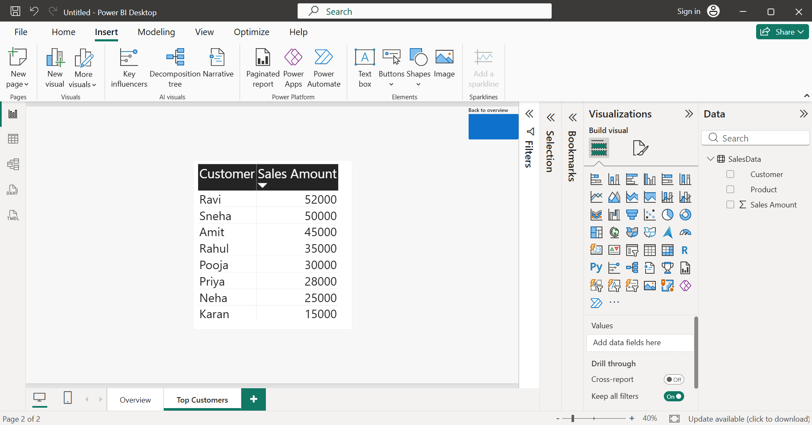

- Set up a Report Level Filter to show only data from the year 2023 throughout your entire Power BI report, regardless of the page or visual.

- A Report Level Filter applies a filter to the entire Power BI report. By filtering the Year column to 2023, all visuals on every page display only records from the year 2023, ensuring consistent data across the report.
- Created the ‘Year’ column
Year = YEAR(SalesData[Order Date])
- Create the Year column using the YEAR() function.
- Open the Filters pane.
- Under Filters on all pages, drag the Year field.
- Select only 2023.
- All pages and visuals in the report will now display only data from the year 2023.
- Expected Output: Only records from 2023 are visible throughout the report.
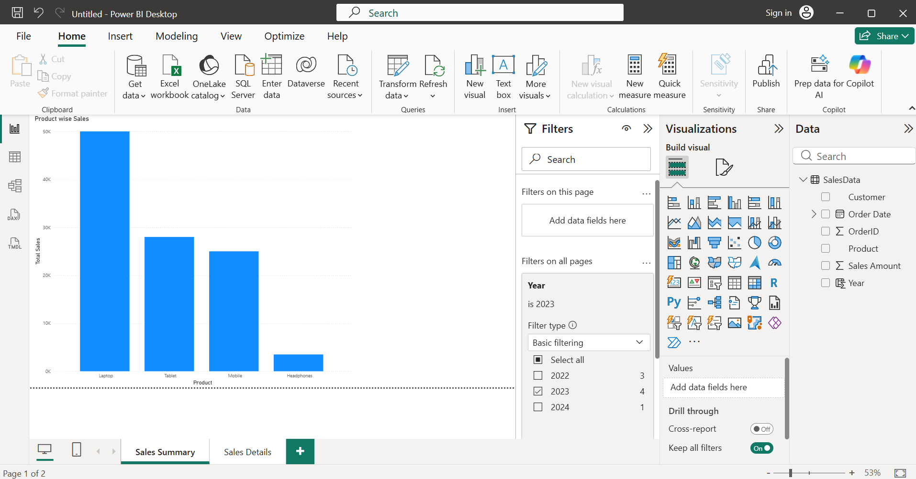
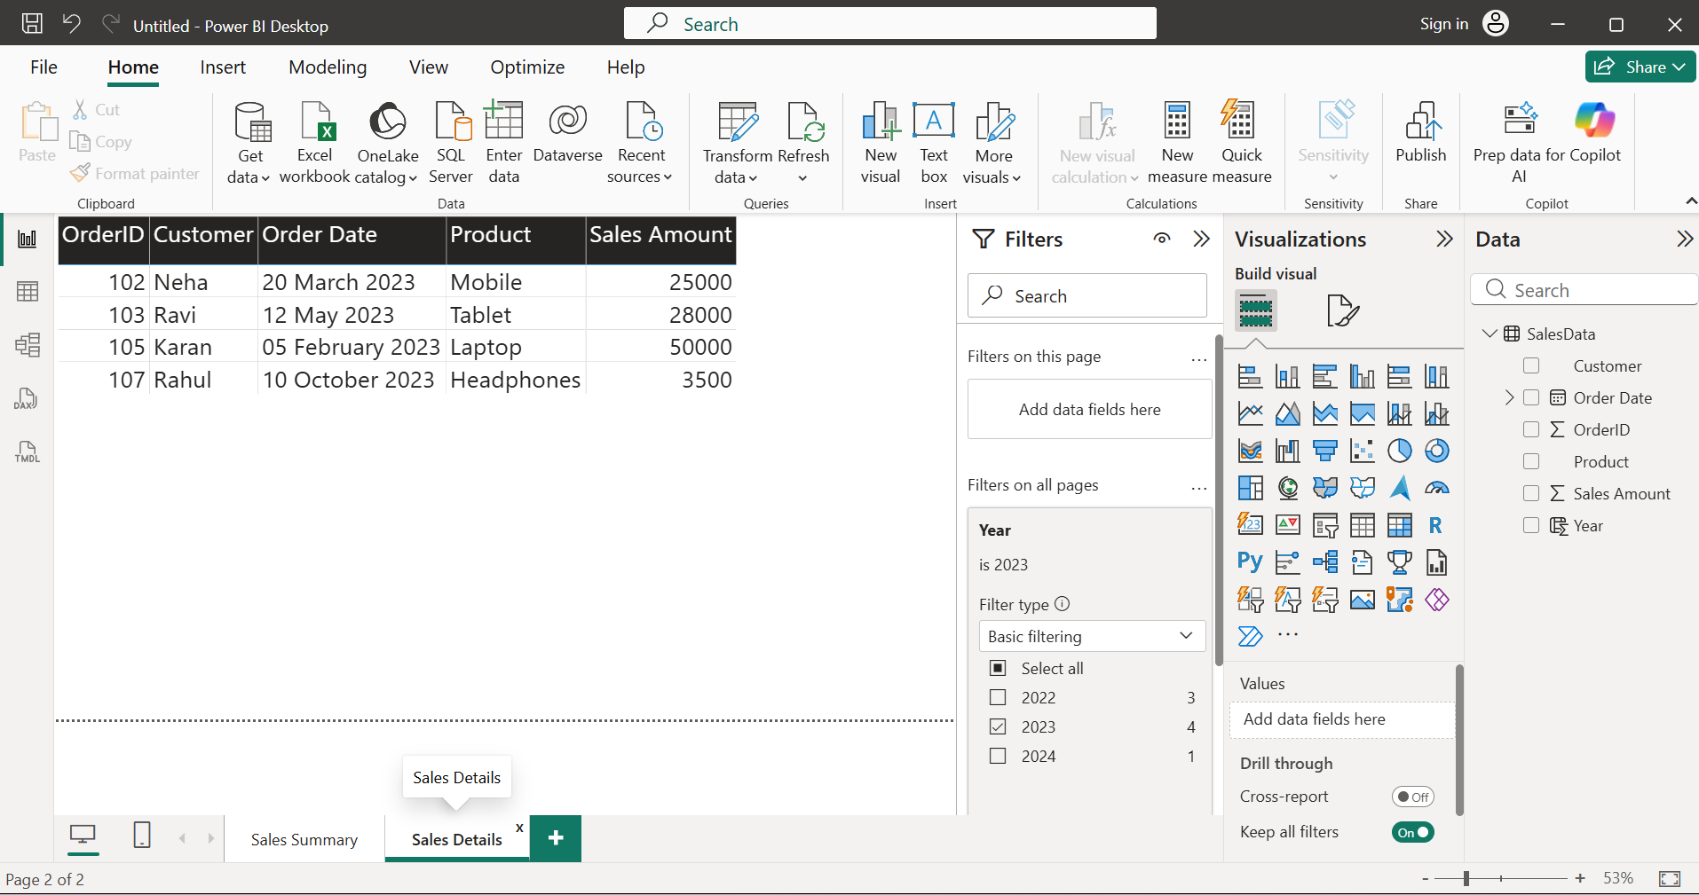
- This demonstrates the use of a Report Level Filter, which applies the selected filter to all pages and visuals in a Power BI report.

