Section A: Concept Application
- Compare the technical differences between Import and DirectQuery modes and identify which is suitable for a static CSV file.
Import Mode | Direct Query Mode
Data is loaded into Power BI memory. | Data remains in the source database.
Fast report performance. | Performance depends on the source database.
Requires refresh to update data. | Displays near real-time data.
Supports all Power BI features and  DAX functions. | Some DAX and modeling features are limited.
Best for Excel, CSV, and small to medium datasets. | Best for SQL Server, Oracle, Azure SQL, and other live databases.

- Explain the consequence of a "Text" data type on a Card visual displaying sales and identify where in the workflow to correct this.
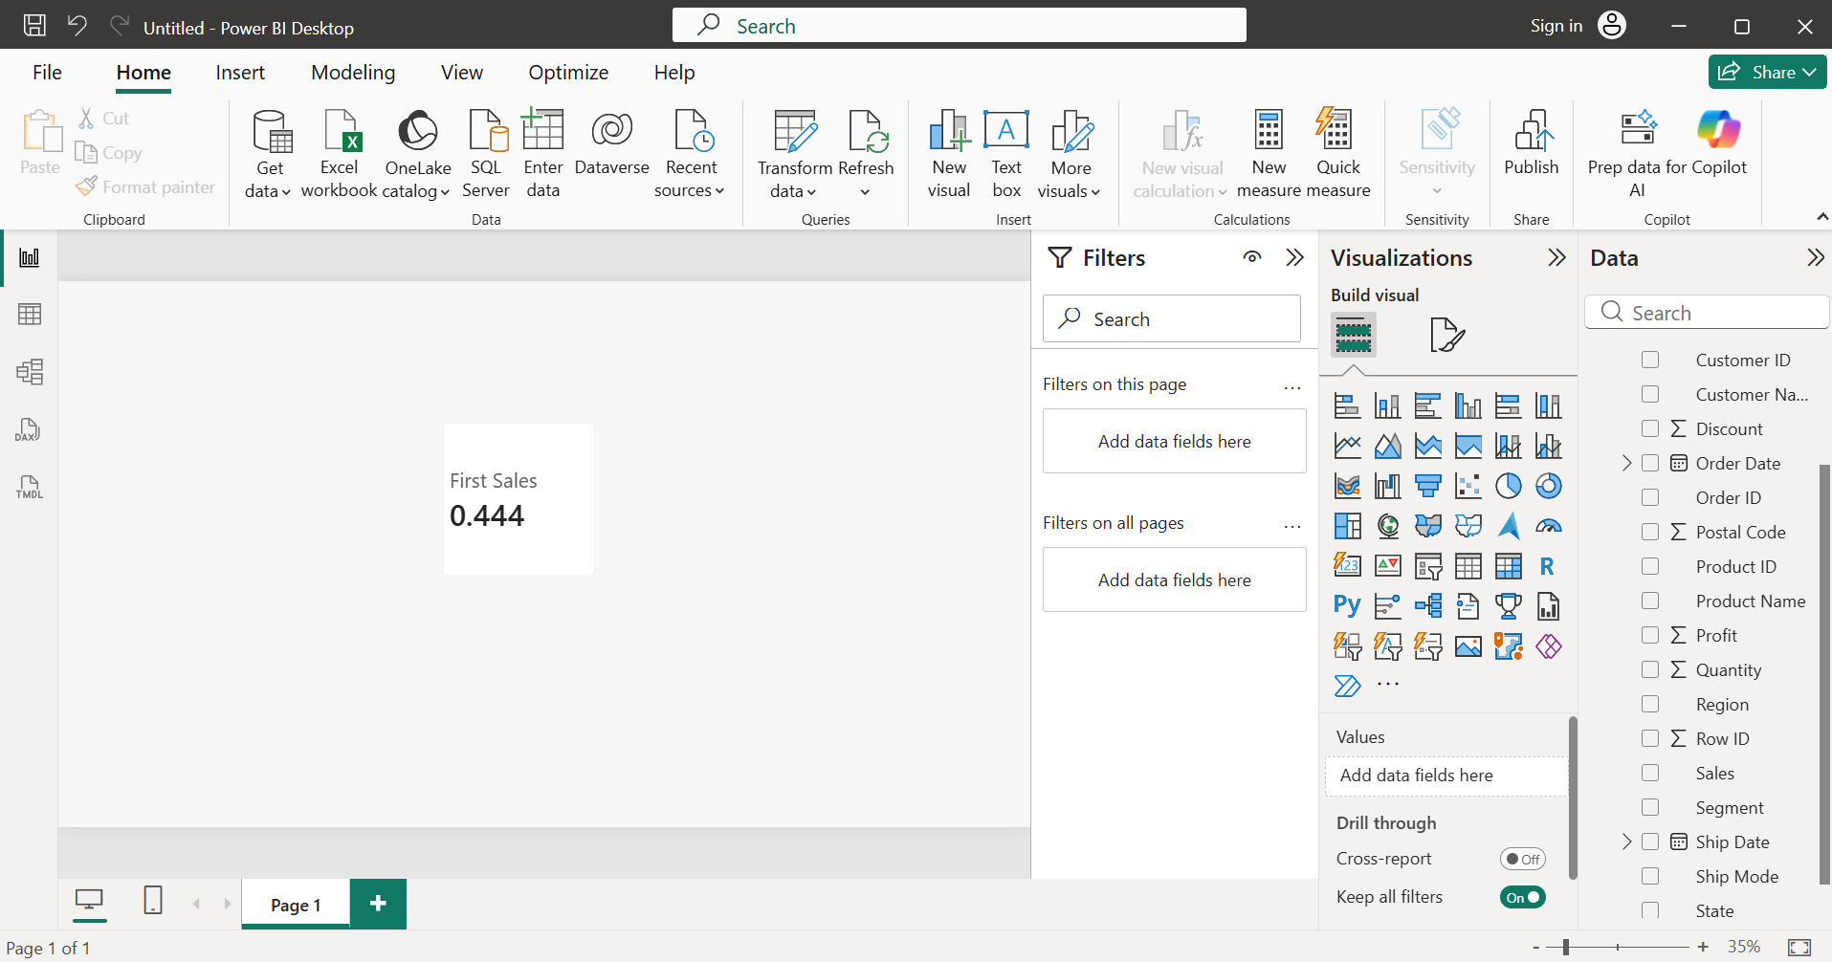

- When the Sales column is stored as Text, Power BI treats it as a text field instead of a numeric field. As a result, a Card visual cannot calculate numeric aggregations such as Sum or Average and instead defaults to text-based options like First or Last. The issue should be corrected in the Power Query Editor by changing the Sales column's data type to Decimal Number before loading the data into the report.
- After changing the Sales column to Decimal Number, Power BI recognizes it as numeric data and enables aggregations such as Average, Sum, Min, and Max. As shown below in the Card visuals, Power BI correctly calculates the Average Sales (229.86) and Minimum Sales (0.44), confirming that numeric calculations now work as expected.
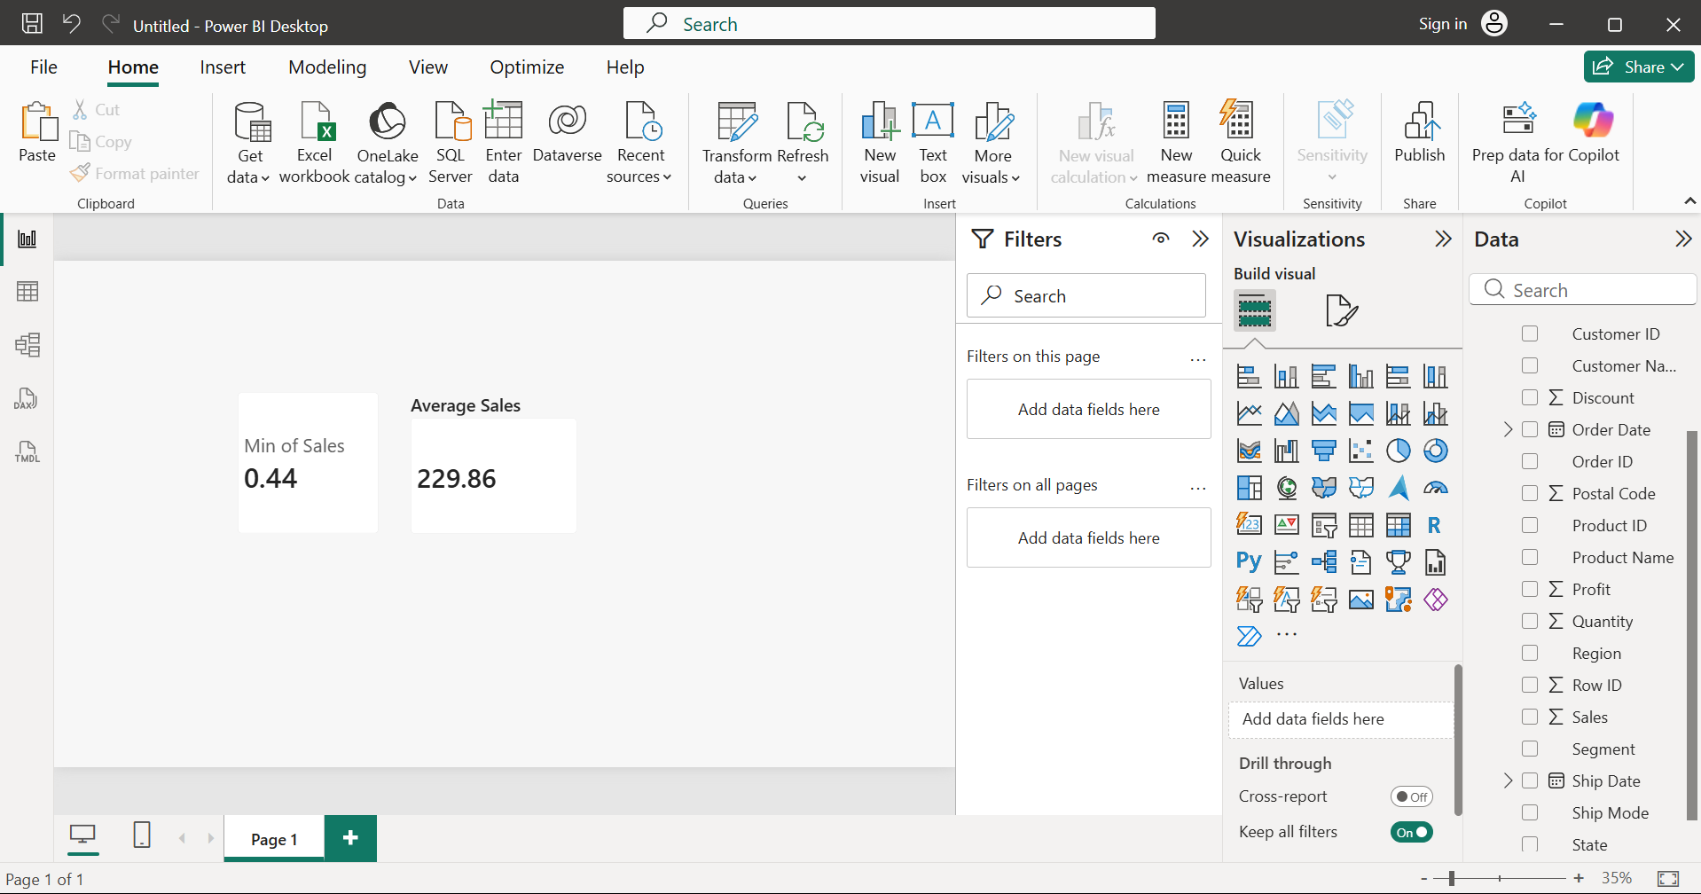

- Identify the specific menu or pane used to change a bar chart's sort order from alphabetical to descending by value.
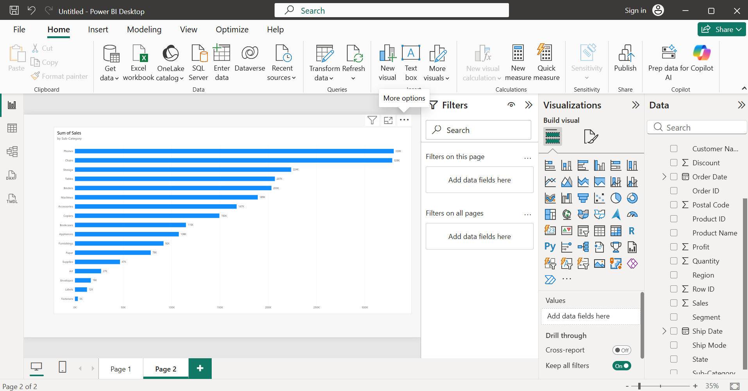
- The sort order of a bar chart is changed using the More options (⋯) menu located at the top-right corner of the visual. From this menu, select Sort by -> Sales (or the required value field) -> Descending to display the bars from highest to lowest value.

- Contrast filtering in Power Query versus using a visual-level "Top N" filter regarding their impact on other report visuals.
Power Query Filter | Visual-Level Top N Filter
Filters data before loading into the model. | Filters only the selected visual.
Removed rows are unavailable throughout the report. | Other visuals continue to use the full dataset.
Reduces model size and improves performance. | Keeps the complete dataset in the model.
Permanent until the query is changed. | Can be changed anytime without modifying the dataset.

- Describe how to modify a bar chart or use a DAX measure to show a region's percentage of total sales instead of absolute values.
- Screenshot showing DAX measure:
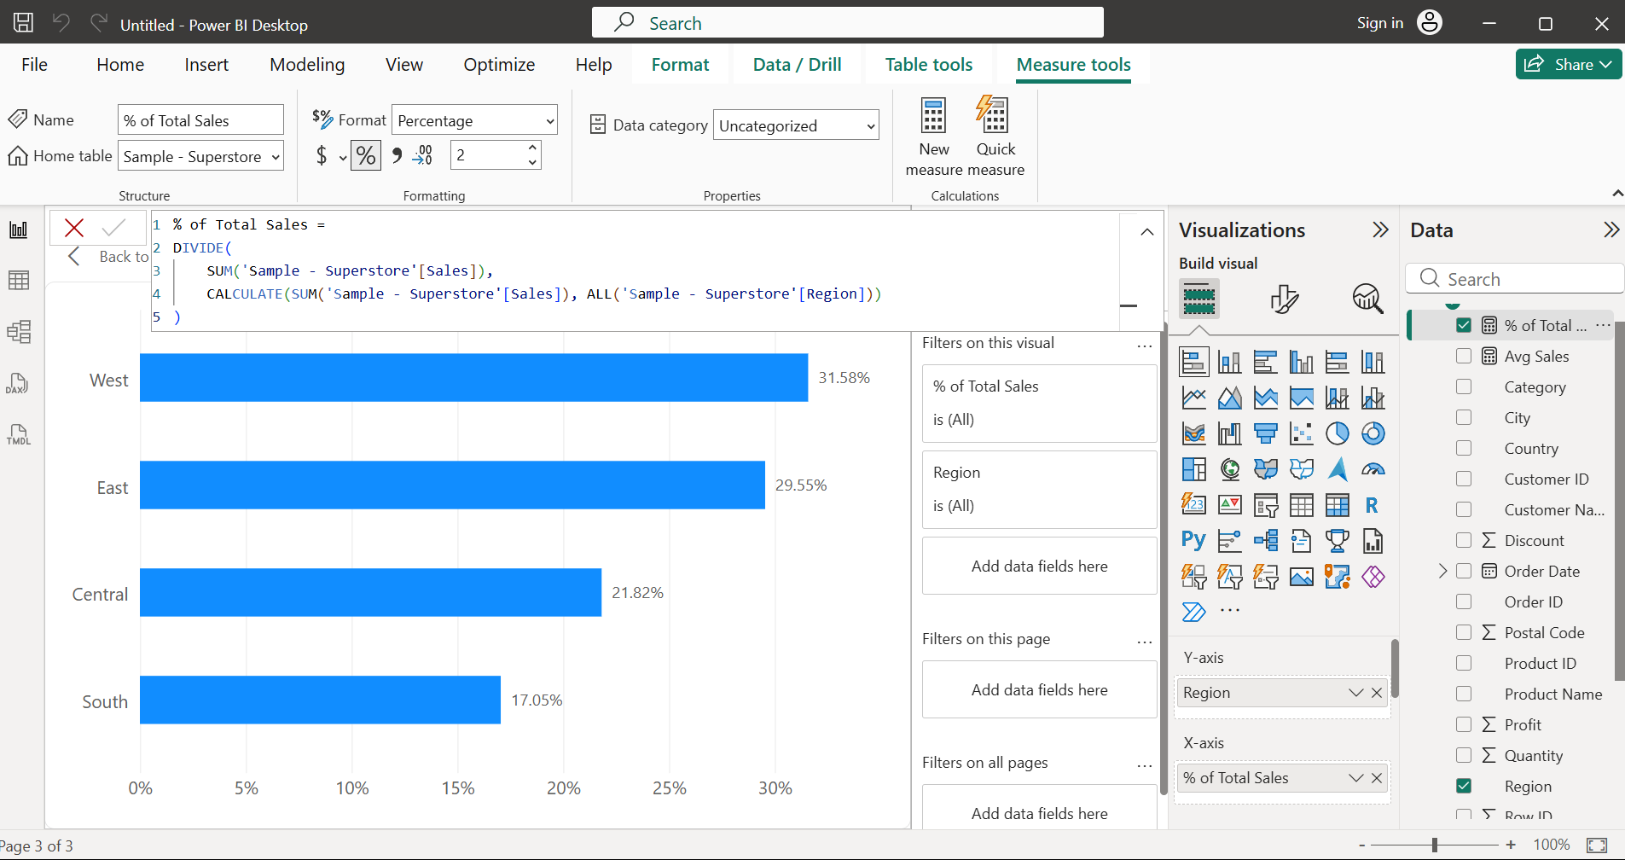
- Screenshot showing the bar chart displaying percentages:
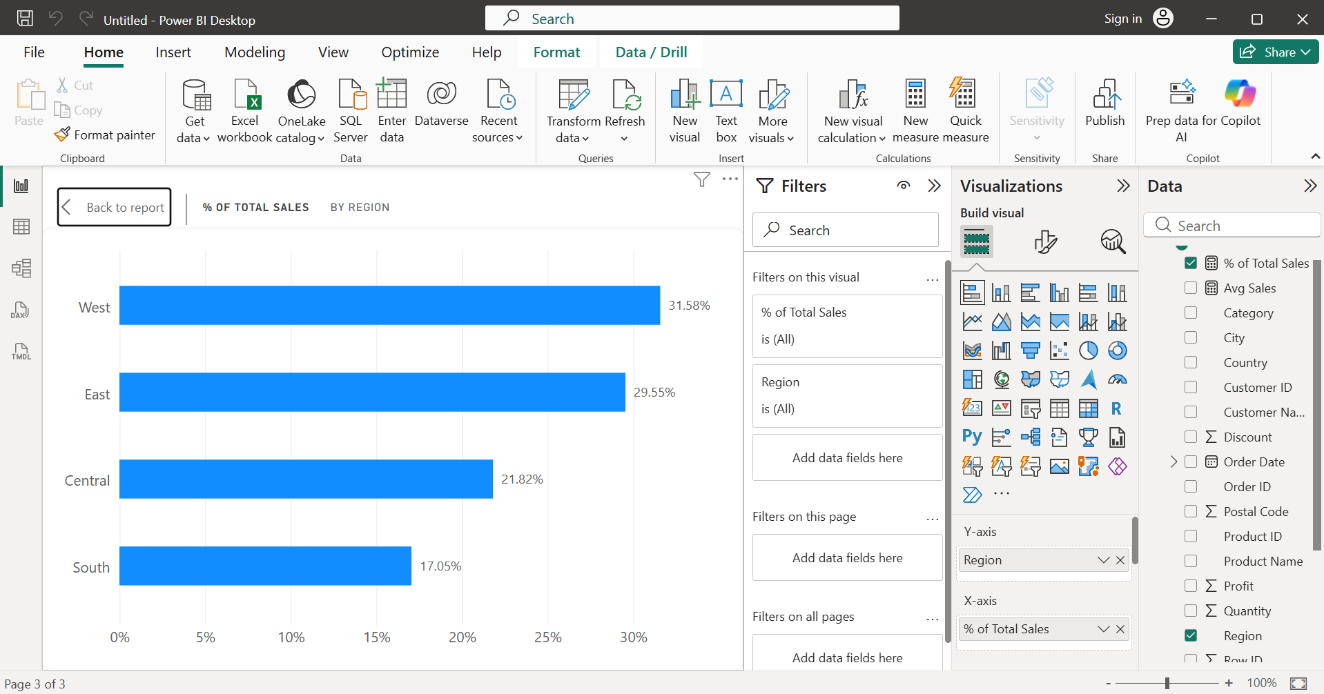
- To display each region's percentage of total sales, created a DAX measure that divides the sales of each region by the overall sales using the ALL() function. Added this measure to the bar chart instead of the Sales field and formatted it as a percentage. The chart then shows each region's contribution to total sales rather than absolute sales values.

- Explain why hardcoded file paths cause shared PBIX files to break and how to make a report portable for other users.
A hardcoded file path (e.g., C:\Users\Chitra\Documents\SalesData.xlsx) points to a specific location on one user's computer. When the PBIX file is shared, other users usually do not have the same folder structure or file location, causing Power BI to fail when refreshing the data because it cannot find the source file.
How to make a report portable:
To make the report portable, avoid hardcoded file paths by:
- Using Power Query Parameters to store the file or folder path, allowing users to update it easily.
- Storing data files in a shared location such as OneDrive, SharePoint, or a shared network folder that all users can access.
- Updating the data source using Data Source Settings instead of editing queries manually.

Section B: Practical Task
- Connect to the Kaggle Superstore dataset and use Power Query to replace null values in the "Postal Code" column with a default string.
- Power Query Editor with the Postal Code column selected:
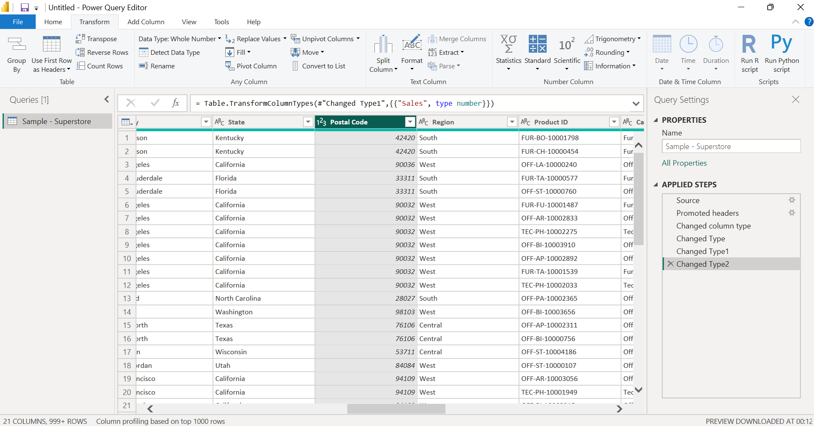
- The Replace Values dialog (or the transformed column showing "00000" instead of null values):
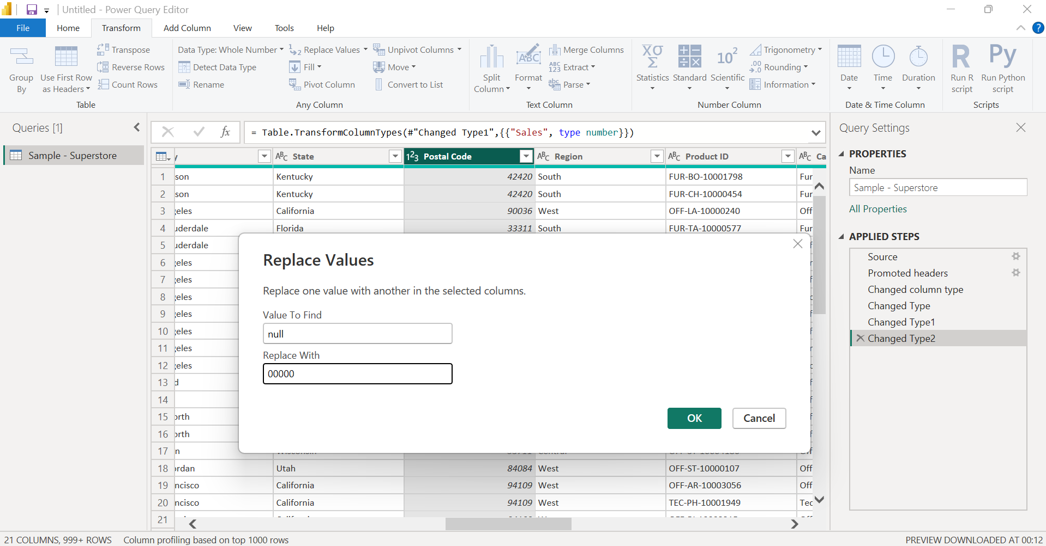
- The Applied Steps pane showing the Replaced Value step:
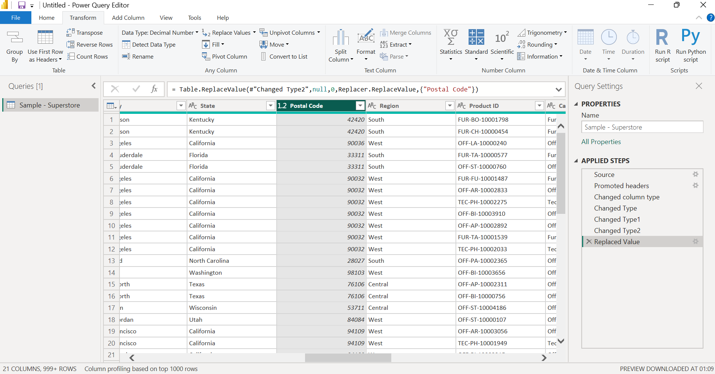
- The Postal Code column was cleaned in Power Query by replacing all null values with the default string "00000". This prevents missing values from causing issues during filtering, grouping, or reporting and improves overall data quality.
- Create a calculated column using DAX to categorize "Profit" into "High," "Medium," and "Low" based on a multi-condition IF statement.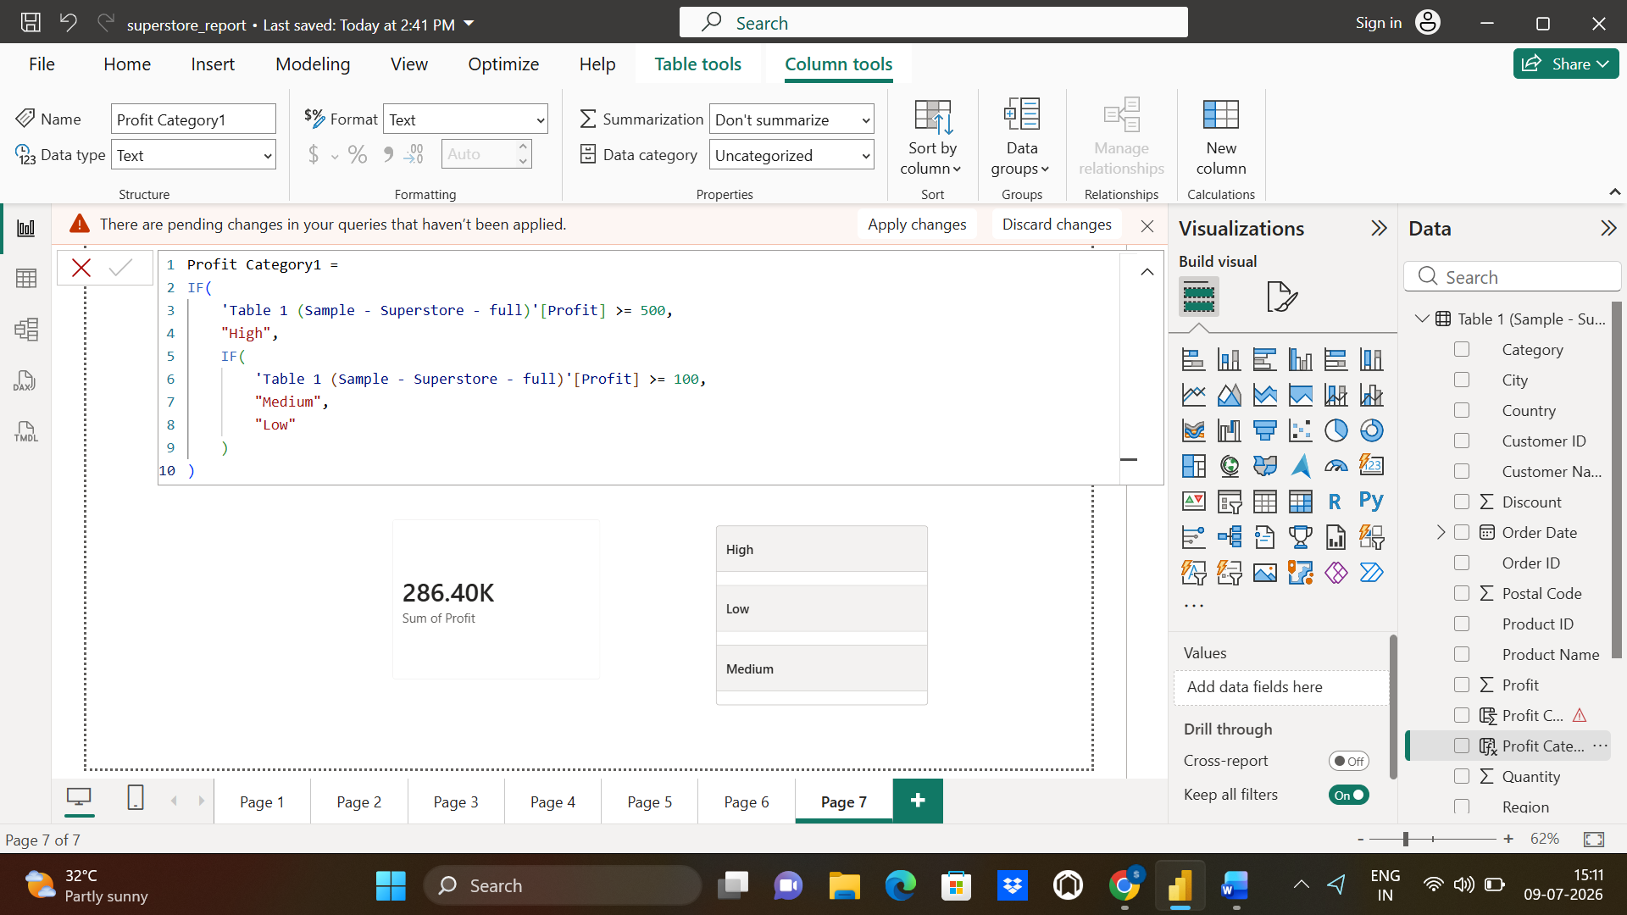

- Develop a dynamic measure using TOTALYTD to calculate Year-to-Date Sales and display it on a KPI Card visual.
- Created a date table using “new table”:
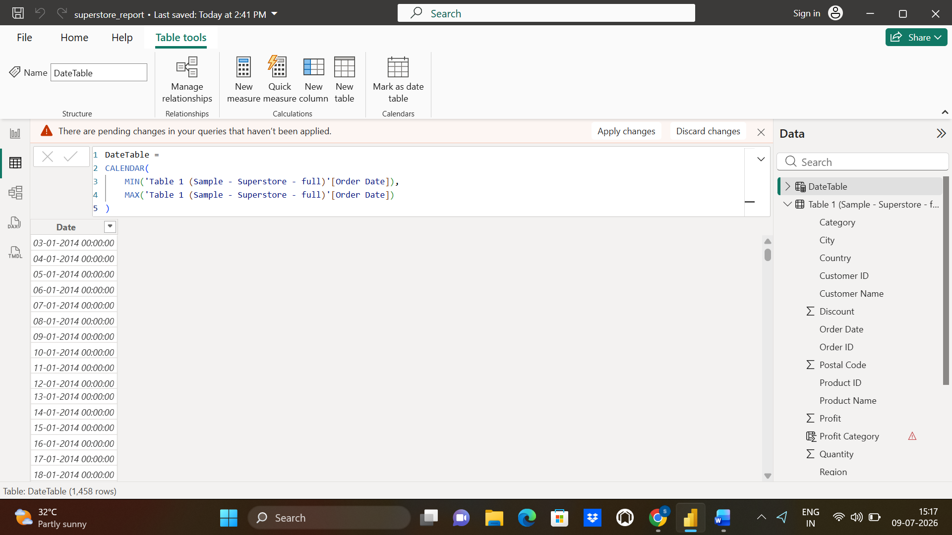
- Created a measure named "YTD Sales", to calculate Year-to-Date Sales and displaed it on a KPI Card visual.
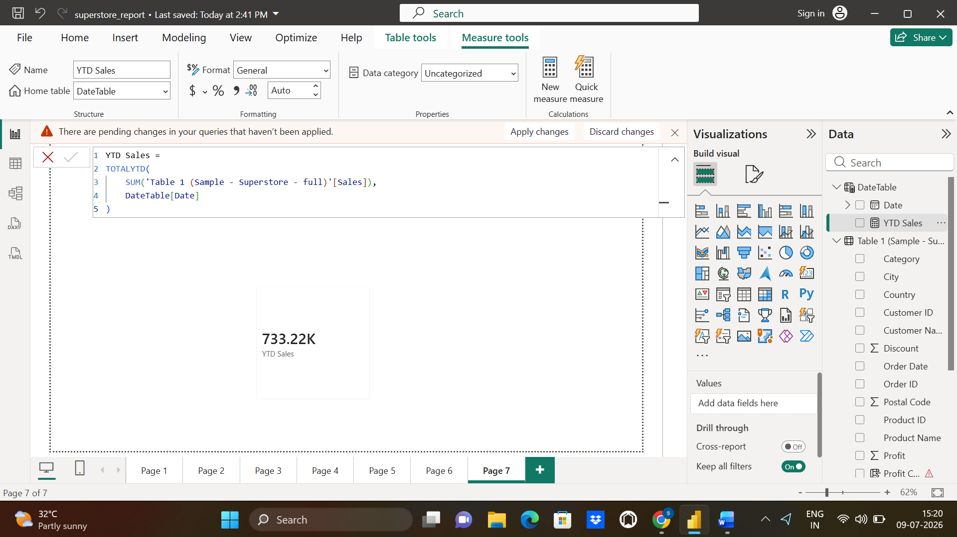

- Configure a Top N filter on a Bar Chart visual to display only the top 5 sub-categories by total profit margin.
- Bar Chart visual displaying only top 5 sub-categories by total profit margin.
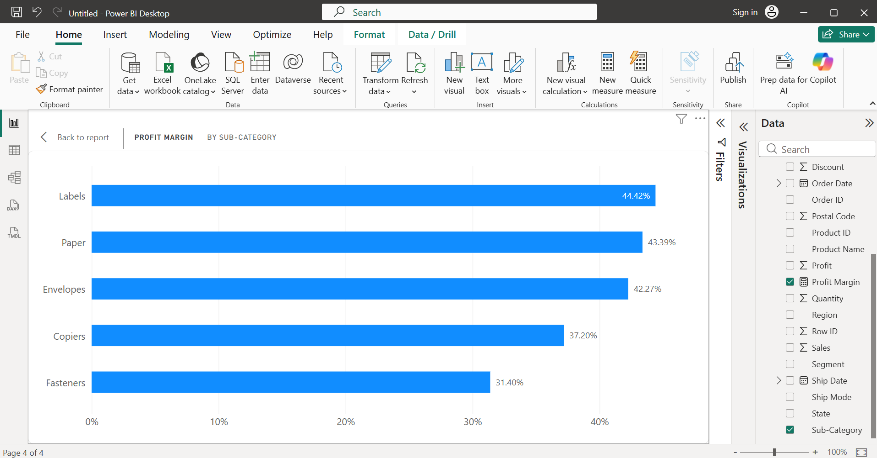
- A Top N visual-level filter was applied to the Sub-Category field. The filter was configured to display the Top 5 items based on the Profit Margin measure. This highlights the highest-performing sub-categories while reducing visual clutter.
Section C: Mini Project
- Title: Retail Profitability & Optimization Suite.
- Problem Statement: Analyze the Sample Superstore dataset to identify high-deficit product categories and optimize regional supply chain distribution.
- Dataset Recommendation: Sample Superstore Dataset
- Required Deliverables: Power BI .pbix file, DAX-calculated profit margin measures, Interactive map visual for regional loss identification, Summary of top 3 cost-saving recommendations.

Objective:
Developed an interactive Power BI dashboard using the Sample Superstore dataset to identify loss-making categories, analyzed regional sales and profit performance, and provided insights for improving business profitability.
Dashboard Features:
- KPI Cards for Total Sales, Total Profit, Profit Margin and Total Orders.
- Bar/Column charts showing category and regional performance
- Filled Map highlighting regional profit/loss distribution
- Treemap showing sales contribution by category
- Matrix with conditional formatting for profit analysis
- DAX measures for Profit Margin, Total Sales, Total Profit, Total Loss.
Key Insights:
- Technology generated the highest sales among all categories.
- The West region recorded the highest sales, while some states reported significant losses.
- Furniture showed comparatively lower profitability despite strong sales.
- Loss-making regions can be targeted for inventory and pricing optimization.
Top 3 Cost-Saving Recommendations:
- Reduce discounts on consistently loss-making products.
- Prioritize inventory in high-profit regions and categories.
- Review pricing and shipping costs for low-profit areas.
Power BI File:

