- Open Power BI Desktop, load the provided 'Sample Data' Excel file, and switch between Report View, Data View, and Model View to observe how the data is displayed differently in each.

- In Report View:
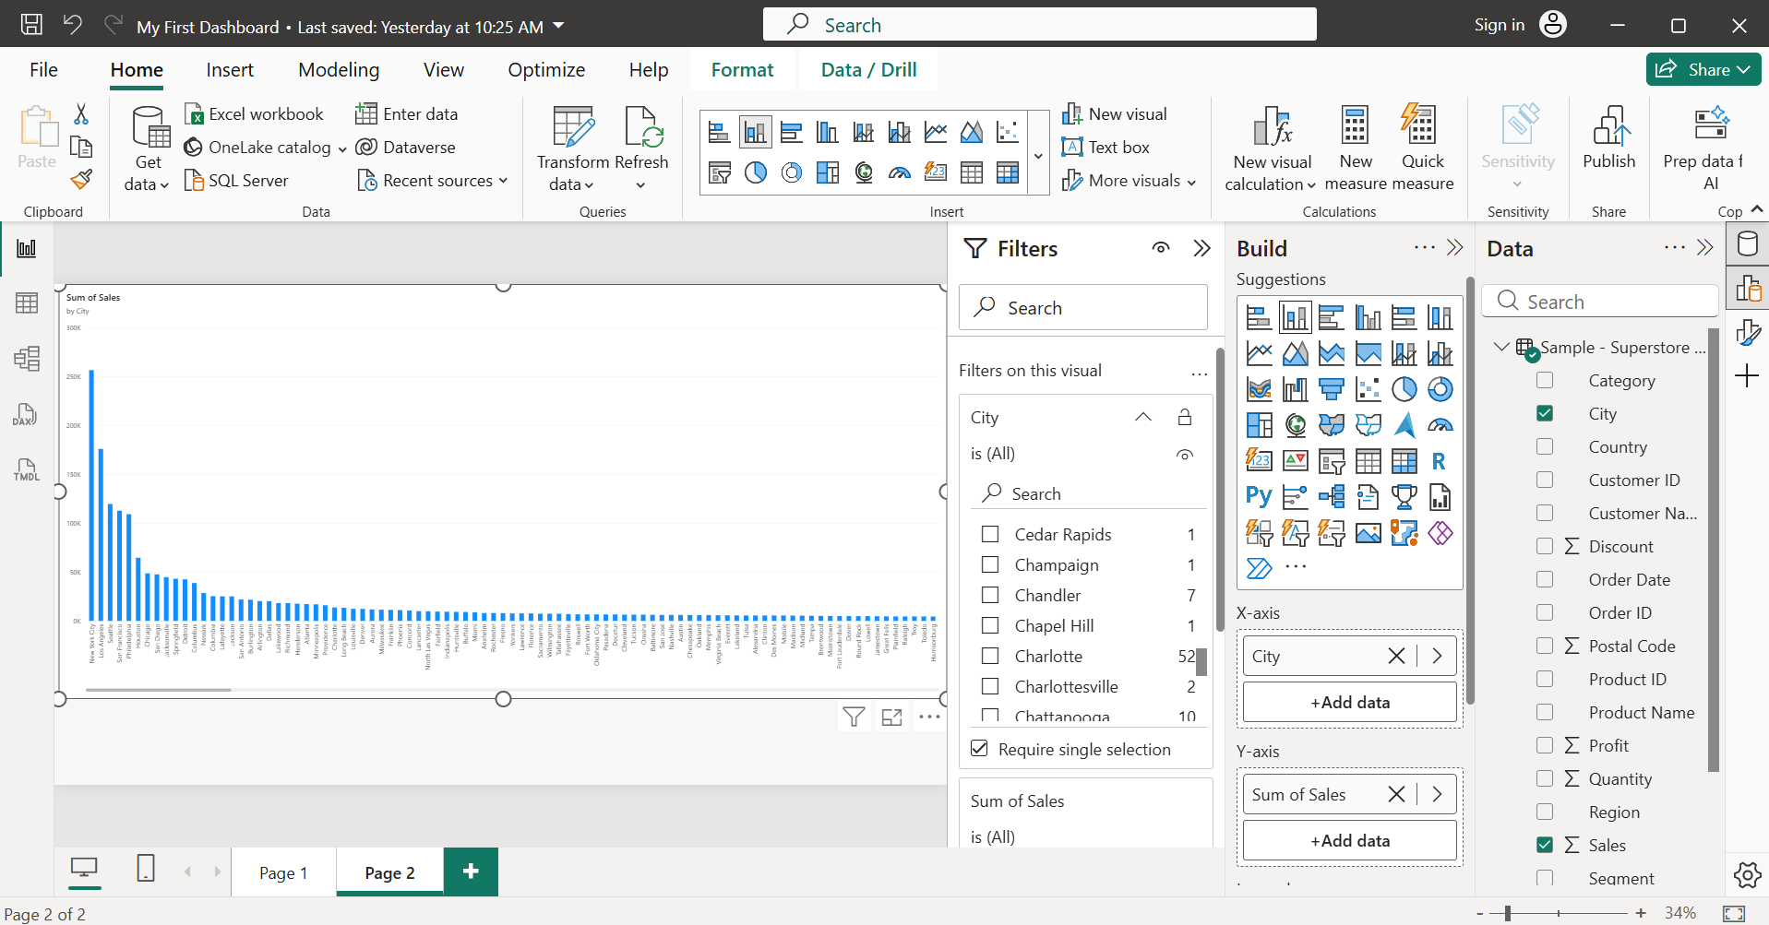

- In Data View:
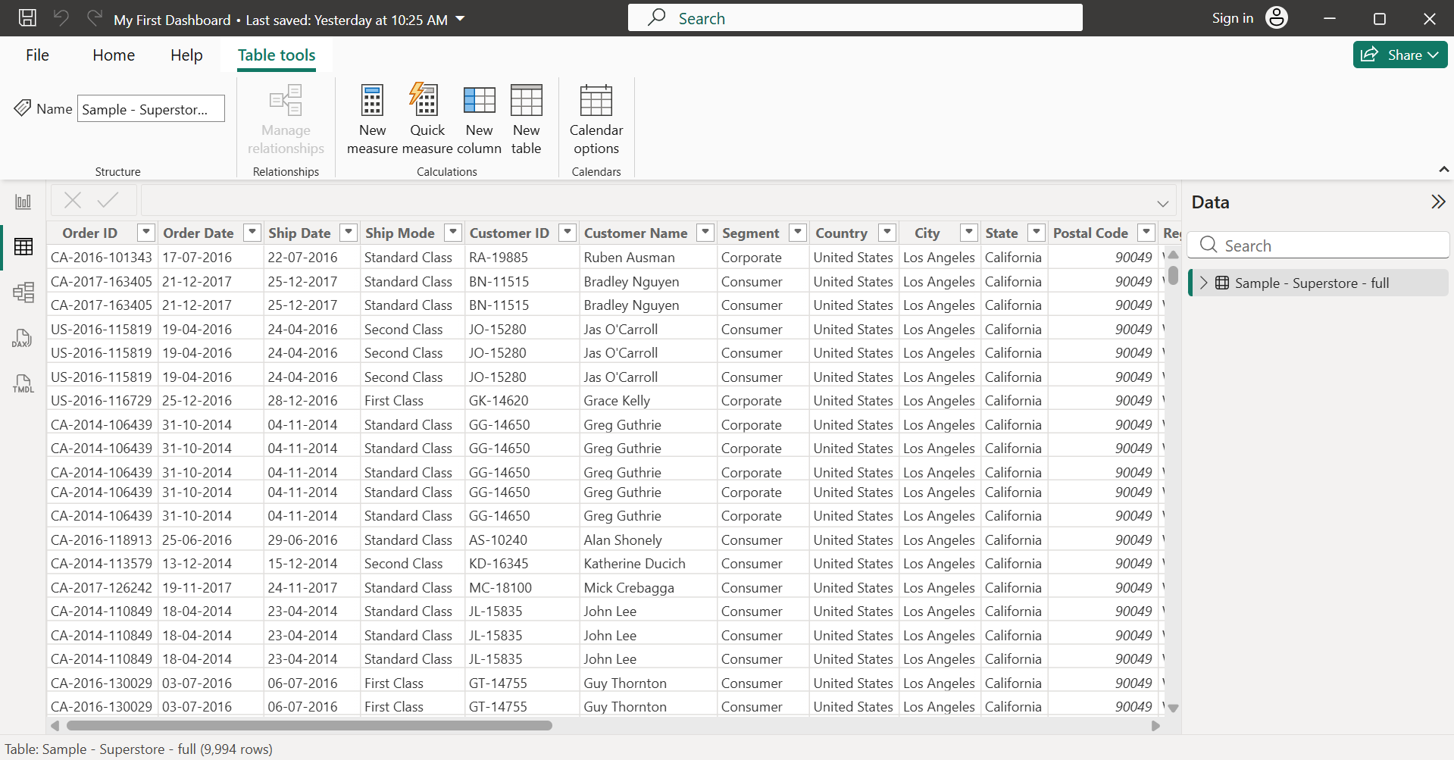

- In Model View:
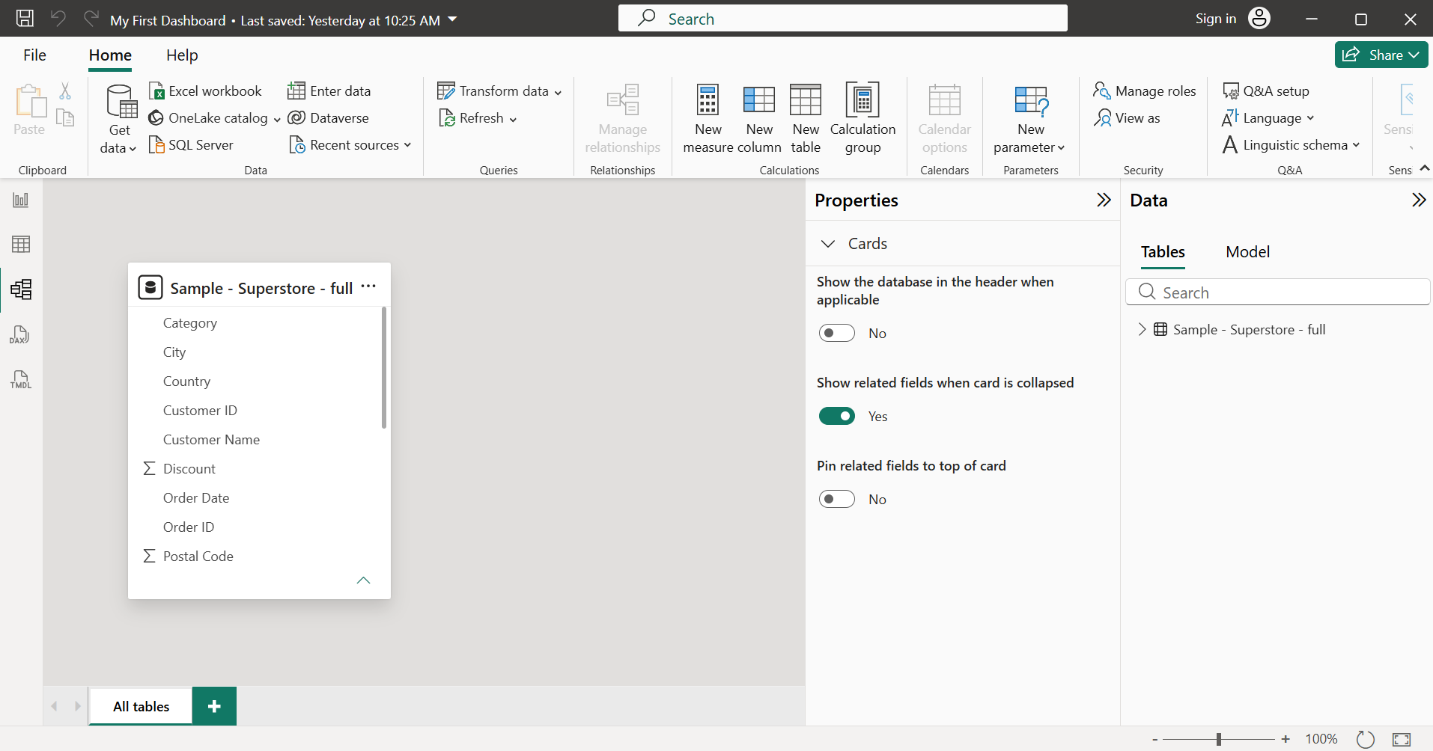

- In the Report View, use the Fields Pane to drag any two different fields onto the canvas and create two separate visualizations (for example, a bar chart and a pie chart).
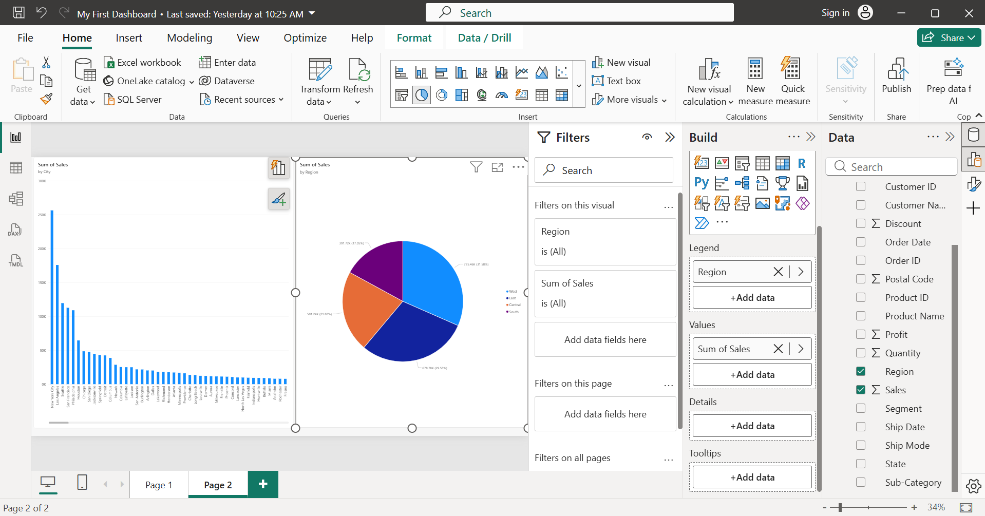

- Use the Filters Pane in Report View to add a filter that only shows data for a specific value (for example, filter to display sales data for one city or category only).
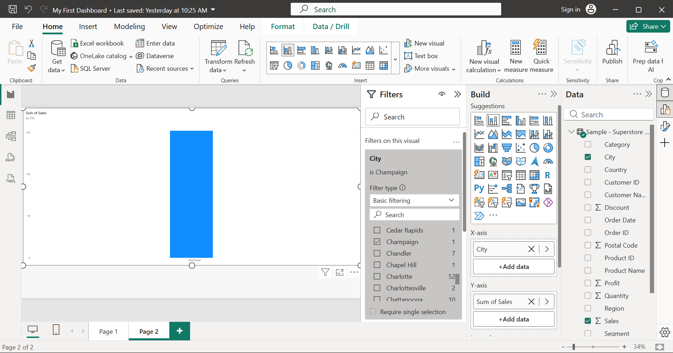

- Explore the Ribbon commands under the Home and Insert tabs: add a new page to your report, and then insert a text box with your name on it.
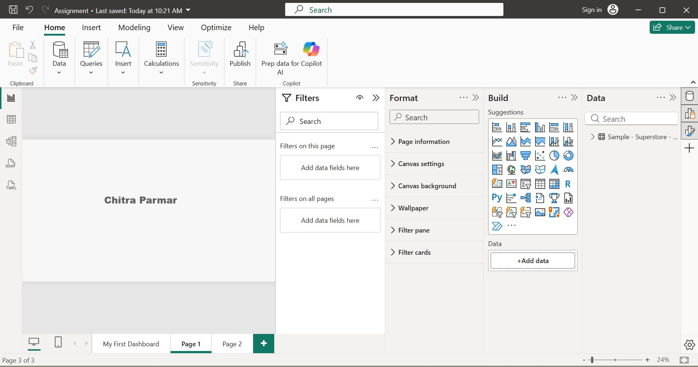

- Switch to the Model View and use the Visualizations Pane to check relationships between tables; then, rename one field in the Fields Pane to make it more readable (for example, change 'Cust_ID' to 'Customer ID').<br><br><em><strong>Hint:</strong> Right-click the field name to rename it directly in the Fields Pane.</em>
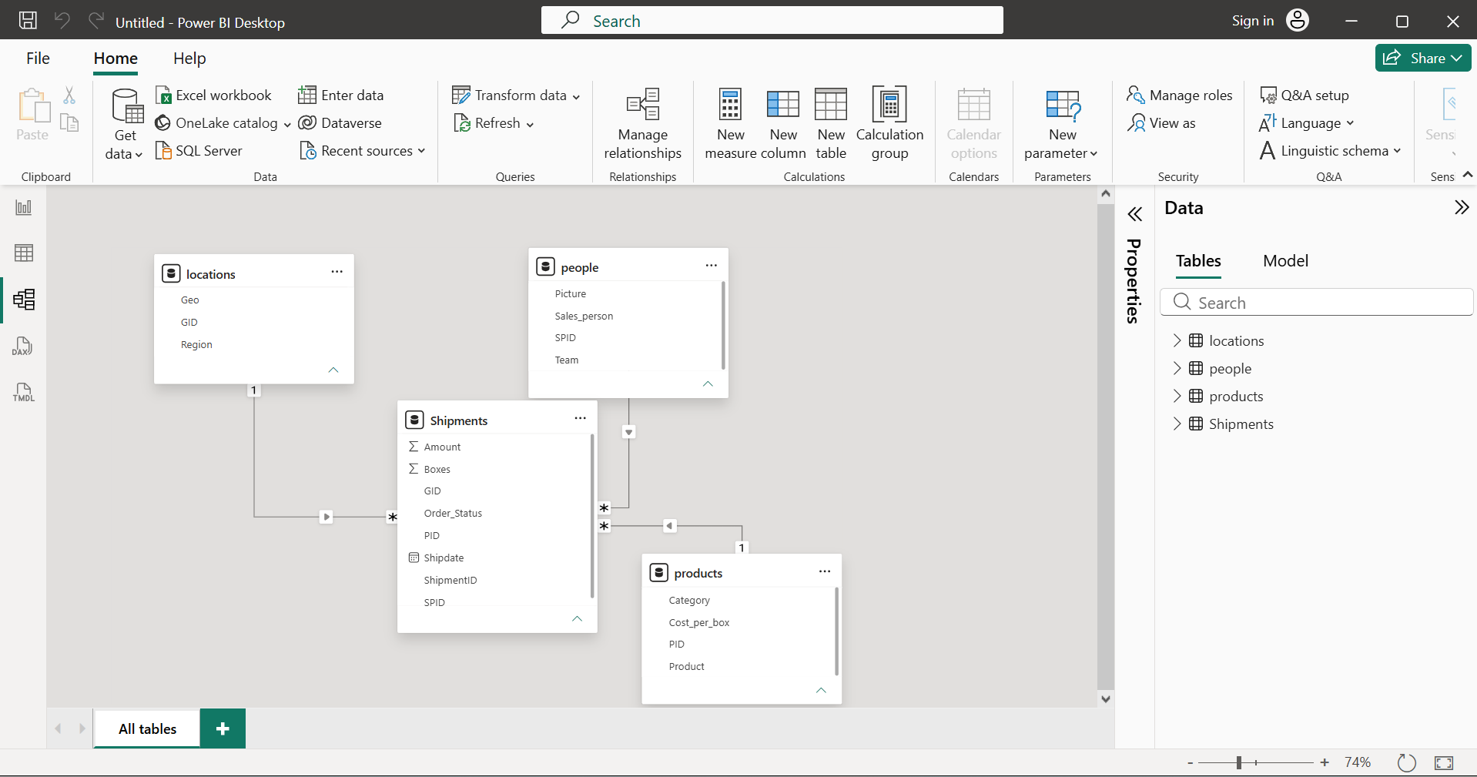

Screenshot After Renaming Fields:
